EN
EUROPEAN COMMISSION
Brussels, 11.3.2011
COM(2011) 120 final
2011/0053 (COD)
Proposal for a
DIRECTIVE OF THE EUROPEAN PARLIAMENT AND OF THE COUNCIL
relating to tyres for motor vehicles and their trailers and to their fitting
(Codification)

EXPLANATORY MEMORANDUM
1. In the context of a people’s Europe, the Commission attaches great importance to simplifying and clarifying the law of the Union so as to make it clearer and more accessible to citizens, thus giving them new opportunities and the chance to make use of the specific rights it gives them.
This aim cannot be achieved so long as numerous provisions that have been amended several times, often quite substantially, remain scattered, so that they must be sought partly in the original instrument and partly in later amending ones. Considerable research work, comparing many different instruments, is thus needed to identify the current rules.
For this reason a codification of rules that have frequently been amended is also essential if the law is to be clear and transparent.
2. On 1 April 1987 the Commission decided to instruct its staff that all acts should be codified after no more than ten amendments, stressing that this is a minimum requirement and that departments should endeavour to codify at even shorter intervals the texts for which they are responsible, to ensure that their provisions are clear and readily understandable.
3. The Conclusions of the Presidency of the Edinburgh European Council (December 1992) confirmed this, stressing the importance of codification as it offers certainty as to the law applicable to a given matter at a given time.
Codification must be undertaken in full compliance with the normal procedure for the adoption of acts of the Union.
Given that no changes of substance may be made to the instruments affected by codification, the European Parliament, the Council and the Commission have agreed, by an interinstitutional agreement dated 20 December 1994, that an accelerated procedure may be used for the fast-track adoption of codification instruments.
4. The purpose of this proposal is to undertake a codification of Council Directive 92/23/EEC of 31 March 1992 relating to tyres for motor vehicles and their trailers and to their fitting. The new Directive will supersede the various acts incorporated in it; this proposal fully preserves the content of the acts being codified and hence does no more than bring them together with only such formal amendments as are required by the codification exercise itself.
5. The codification proposal was drawn up on the basis of a preliminary consolidation, in 22 official languages, of Directive 92/23/EEC and the instruments amending it, carried out by the Publications Office of the European Union, by means of a data-processing system. Where the Articles have been given new numbers, the correlation between the old and the new numbers is shown in a table contained in Annex VIII to the codified Directive.

ê 92/23/EEC (adapted)
2011/0053 (COD)
Proposal for a
DIRECTIVE OF THE EUROPEAN PARLIAMENT AND OF THE COUNCIL
relating to tyres for motor vehicles and their trailers and to their fitting
(Codification)
(Text with EEA relevance)
THE EUROPEAN PARLIAMENT AND THE COUNCIL OF THE EUROPEAN UNION,
Having regard to the Treaty on the Functioning of the European Union, and in particular Article Ö 114 Õ thereof,
Having regard to the proposal from the European Commission,
After transmission of the draft legislative act to the national Parliaments,
Having regard to the opinion of the European Economic and Social Committee,
Acting in accordance with the ordinary legislative procedure,
Whereas:

ê
- Council Directive 92/23/EEC of 31 March 1992 relating to tyres for motor vehicles and their trailers and to their fitting has been substantially amended several times. In the interests of clarity and rationality the said Directive should be codified.

ê 92/23/EEC recital 4 (adapted)
- Ö Directive 92/23/EEC is one of the separate Directives of the EC type-approval system provided for in Directive 2007/46/EC of the European Parliament and of the Council of 5 September 2007 establishing a framework for the approval of motor vehicles and their trailers, and of systems, components and separate technical units intended for such vehicles (Framework Directive), and lays down Õ technical Ö prescriptions Õ which motor vehicles and their trailers must satisfy Ö relating Õ, inter alia, to pneumatic tyres. Ö Those technical prescriptions concern the approximation of the laws of the Member States to enable the EC type-approval procedure provided for in Directive 2007/46/EC to be applied in respect of each type of motor vehicle and trailer. Consequently the provisions laid down in Directive 2007/46/EC relating to motor vehicles and their trailers, and of systems, components and separate technical units intended for such vehicles, apply to this Directive. Õ

ê 92/23/EEC recital 6
- Rules on tyres should lay down common requirements concerning not only their characteristics, but also the requirements for the equipment of vehicles and their trailers with regard to their tyres.

ê 92/23/EEC recital 8 (adapted)
- It is desirable to take into account the technical requirements adopted by the UN Economic Commission for Europe in its Regulation No 30 (‘Uniform provisions concerning the approval of pneumatic tyres for motor vehicles and their trailers’), as amended, in its Regulation No 54 (‘Uniform provisions concerning the approval of pneumatic tyres for commercial vehicles and their trailers’), in its Regulation No 64 (‘Uniform provisions concerning the approval of vehicles equipped with temporary-use spare wheels/tyres’), Ö as amended, Õ Ö and in its Regulation No 117 ('Uniform Provisions Concerning the Approval Of Tyres With Regard To Rolling Sound Emissions And To Adhesion On Wet Surfaces'), as amended Õ, which are annexed to the Ö Agreement of the United Nations Economic Commission for Europe concerning the adoption of uniform technical prescriptions for wheeled vehicles, equipment and parts which can be fitted and/or be used on wheeled vehicles and the conditions for reciprocal recognition of approvals granted on the basis of these prescriptions (Revised 1958 Agreement) Õ.

ê
- This Directive should be without prejudice to the obligations of the Member States relating to the time-limits for transposition into national law and application of the Directives set out in Annex VII, Part B,
HAVE ADOPTED THIS DIRECTIVE:

ê 92/23/EEC (adapted)
Article 1
For the purposes of this Directive Ö the following definitions shall apply Õ:

ê 2001/43/EC Art. 1 pt. 2
(a) ‘tyre’ means any new pneumatic tyre including a winter tyre with holes for studs, in the form of original equipment or of a replacement, intended to be fitted to vehicles to which Directive 2007/46/EC applies. This definition does not cover winter tyres with studs;

ê 92/23/EEC
(b) ‘vehicle’ means any vehicle to which Directive 2007/46/EC applies;
(c) ‘manufacturer’ means the holder of the trade name or mark of vehicles or tyres.

ê 2001/43/EC Art. 1 pt. 3
Article 2
1. The requirements set out in Annex V shall apply to tyres intended to be fitted to vehicles first used on or after 1 October 1980.
2. The requirements set out in Annex V shall not apply to:
(a) tyres whose speed rating is less than 80 km/h;
(b) tyres whose nominal rim diameter does not exceed 254 mm (or code 10) or is 635 mm or more (code 25);
(c) T type temporary use spare tyres as defined in point 2.3.6 of Annex II;
(d) tyres designed only to be fitted to vehicles registered for the first time before 1 October 1980.

ê 2001/43/EC Art. 1 pt. 4 (adapted)
Article 3
1. Member States shall grant EC type-approval, under the conditions laid down in Annex I, to all types of tyres meeting the requirements of Annex II, and shall allocate to Ö them Õ an approval number as specified in Annex I.
2. Member States shall grant EC type-approval, under the conditions laid down in Annex I, to all types of tyres meeting the requirements of Annex V and shall allocate to Ö them Õ an approval number as specified in Annex I.
3. Member States shall grant EC type-approval to all vehicles in respect of their tyres under the conditions laid down in Annex III, where those tyres (including spare tyres, where appropriate) meet the requirements of Annex II and the requirements concerning vehicles laid down in Annex IV, and shall allocate to any such vehicle an approval number as specified in Annex III.

ê 92/23/EEC (adapted)
è1 2001/43/EC Art. 1 pt. 1
Article 4
The approval authority of a Member State shall, within one month of issuing or refusing an è1 EC type-approval ç Ö for a component Õ (tyre) or vehicle, send a copy of the relevant certificate, models of which are given in the Appendices to Annex I and Annex III, to the other Member States and, if requested, send the test report on any type of tyre approved.

ê 92/23/EEC
è1 2001/43/EC Art. 1 pt. 1
Article 5
No Member State may prohibit or restrict the placing on the market of tyres bearing the è1 EC type-approval ç mark.

ê 92/23/EEC (adapted)
è1 2001/43/EC Art. 1 pt. 1
Article 6
No Member State may refuse to grant è1 EC type-approval ç or national type-approval to a vehicle on grounds relating to its tyres if Ö those tyres Õ bear the è1 EC type-approval ç mark and are fitted in accordance with the requirements laid down in Annex IV.
Article 7
No Member State may prohibit the use of a vehicle on grounds relating to its tyres if Ö those tyres Õ bear the è1 EC type-approval ç mark and are fitted in accordance with the requirements laid down in Annex IV.

ê 92/23/EEC
Article 8
1. If, on the basis of a substantiated justification, a Member State considers that a tyre type or a vehicle type is dangerous although complying with the requirements of this Directive, it may, within its territory, provisionally prohibit the marketing of that product or subject it to special conditions. It shall immediately inform the other Member States and the Commission thereof, stating the grounds for its decision.
2. The Commission shall, within six weeks, consult the Member States concerned, following which it shall deliver its opinion without delay and take the appropriate steps.

ê 92/23/EEC (adapted)
è1 2001/43/EC Art. 1 pt. 1
3. If the Commission is of the opinion that technical adaptations to Ö this Õ Directives are necessary, such adaptations shall be adopted in accordance with the procedure laid down in Article 11. In this event, the Member State which has adopted safeguard measures may maintain them until the entry into force of the adaptations.
Article 9
1. The Member State which has granted the è1 EC type-approval ç Ö for a component Õ (tyre) or vehicle shall take the measures required in order to verify that production models conform to the approved type in so far as this is necessary and if need be in cooperation with the approval authorities in the other Member States. For this purpose, Ö that Õ Member State may at any time check the conformity of the tyres or vehicles to the requirements of this Directive. Such verification shall be limited to spot checks.
2. If Ö the Õ Member State Ö referred to in paragraph 1 Õ finds that a number of tyres or vehicles with the same approval marking do not conform to the approved type, it shall take the necessary measures to ensure that production models so conform. Where there is a consistent failure to conform, Ö those Õ measures may extend to a withdrawal of è1 EC type-approval ç. The authorities shall take the same measure if they are informed by the approval authorities of another Member State of such failure to conform.
3. The approval authorities of the Member States shall within one month notify each other using the relevant form shown in the Appendices to Annex I and Annex III of any withdrawal of è1 EC type-approval ç and of the reasons for such a measure.
Article 10
Any decision taken pursuant to the provisions adopted in implementation of this Directive to refuse or withdraw è1 EC type-approval ç for a tyre or è1 Ö for Õ a vehicle with regard to the fitting of its tyres implying a prohibition of marketing or of use shall set out in detail the reasons on which it is based. Every such decision shall be notified to the party concerned, who shall at the same time be informed of the remedies available to him under the laws in force in the Member States and of the time limits allowed for the exercise of such remedies.
Article 11
Any amendments necessary to adapt the requirements of Annexes I to VI to technical progress shall be adopted in accordance with the procedure Ö referred to Õ in Article 40(2) of Directive 2007/46/EC.

ê 2001/43/EC Art. 1 pt 6 (adapted)
Article 12
1. Member States may not:
(a) refuse to grant EC type-approval or national approval for a type of vehicle or type of tyre, or
(b) Ö refuse Õ the registration Ö or prohibit the Õ sale or entry into service of vehicles, and the sale or entry into service or use of tyres,
for reasons relating to the tyres and their fitting to new vehicles, if those vehicles or tyres comply with the requirements laid down in this Directive.
2. Member States may Ö not Õ grant EC type-approval, and shall refuse to grant national type-approval for those types of tyre which fall within the scope of this Directive and which do not meet the requirements of this Directive.
3. Member States may Ö not Õ grant EC type-approval or national approval for a type of vehicle, for reasons relating to its tyres or their fitting, if the requirements of this Directive are not met.
4. Member States shall:
(a) consider certificates of conformity accompanying new vehicles in accordance with the provisions of Directive 2007/46/EC as Ö not Õ being valid for the purposes of Article 26(1) of Ö that Õ Directive, if the requirements of this Directive are not met; and
(b) refuse the registration or prohibit the sale or entry into service of new vehicles which do not meet the requirements of this Directive.
5. The provisions of this Directive, shall apply for the purposes of Article 28 of Directive 2007/46/EC to all tyres which fall within the scope of this Directive, with the exception of tyres of class C1e, to which they shall apply as from 1 October 2011.

ê 92/23/EEC (adapted)
Article 13
Member States shall communicate to the Commission the texts of the main provisions of national law which they adopt in the field covered by this Directive.

ê
Article 14
Directive 92/23/EEC, as amended by the acts listed in Annex VII, Part A, is repealed, without prejudice to the obligations of the Member States relating to the time-limits for transposition into national law and application of the Directives set out in Annex VII, Part B.
References to the repealed Directive shall be construed as references to this Directive and shall be read in accordance with the correlation table in Annex VIII.
Article 15
This Directive shall enter into force on the twentieth day following that of its publication in the Official Journal of the European Union.

ê 92/23/EEC
Article 16
This Directive is addressed to the Member States.
Done at […]
For the European Parliament For the Council
The President The President
LIST OF ANNEXES

ê 2001/43/EC Art. 1 pt. 5 and Annex pt. 1 (adapted)
ANNEX I |  | Administrative provisions for the EC type-approval of tyres
 | Appendix 1 | Information document relating to EC type-approval for a type of tyre
 | Appendix 2 | EC type-approval certificate (tyres)
 | Appendix 3 | Information document relating to EC type-approval for a type of tyre relating to tyre/road noise emission
 | Appendix 4 | EC type-approval certificate (tyre/road noise emission)
ANNEX II |  | Requirements for tyres
 | Appendix 1 | Explanatory figure
 | Appendix 2 | List of symbols of load-capacity indices (LI) and corresponding maximum mass to be carried (KG)
 | Appendix 3 | Arrangement of tyre markings
 | Appendix 4 | Relationship between the pressure index and the units of pressure
 | Appendix 5 | Measuring rim, outer diameter and section width of tyres of certain size designations
 | Appendix 6 | Method of measuring tyre dimensions
 | Appendix 7 | Load/speed test procedure
 | Appendix 8 | Variation of load capacity index with speed; commercial-vehicle tyres radial and diagonal
ANNEX III |  | Administrative provisions for Ö EC Õ type-approval of vehicles with regard to the fitting of their tyres
 | Appendix 1 | Information document (vehicle)
 | Appendix 2 | EC type-approval certificate (vehicle)
ANNEX IV |  | Requirements for vehicles with regard to the fitting of their tyres
ANNEX V |  | Tyre/road noise emission
 | Appendix 1 | Test method for tyre-road sound levels, coast-by method
 | Appendix 2 | Test report
ANNEX VI |  | Specifications for the test site
Ö ANNEX VII Õ |  | Ö Repealed Directive with list of its successive amendments/List of time-limits for transposition into national law and application Õ
Ö ANNEX VIII Õ |  | Ö Correlation Table Õ
_____________

ê 2001/43/EC Art. 1 pt. 5 and Annex pt. 2
ANNEX I
ADMINISTRATIVE PROVISIONS FOR THE EC TYPE-APPROVAL OF TYRES

1. APPLICATION FOR THE EC TYPE-APPROVAL OF A TYPE OF TYRE
1.1. The application for EC type-approval for a type of tyre pursuant to Article 7(1) and (2) of Directive 2007/46/EC is to be submitted by the tyre manufacturer.
1.1.1. The application for EC type-approval pursuant to Annex II is to be accompanied, in triplicate, by a description of the tyre type as described in the information document in Appendix 1.
1.1.1.1. The application must be accompanied (all in triplicate) by a sketch, or a representative photograph, which identifies the tyre tread pattern and a sketch of the envelope of the inflated tyre mounted on the measuring rim showing the relevant dimensions (see points 6.1.1. and 6.1.2. of Annex II) of the type submitted for approval.
1.1.1.2. It must be accompanied either by the test report issued by the appointed technical service or by a number of samples to be determined by the approval authority.
1.1.2. The application for EC type-approval pursuant to Annex V is to be accompanied, in triplicate, by a description of the tyre type as described in the information document in Appendix 3.
1.1.2.1. The application must be accompanied (all in triplicate) by sketches, drawings or photographs of the tread pattern(s) that is/are representative of the type of tyres.
1.1.2.2. It must also be accompanied either by the test report issued by the appointed technical service or by a number of samples to be determined by the approval authority.
1.2. The manufacturer may apply for EC type-approval to be extended:
1.2.1. to include modified tyre types for EC type-approvals pursuant to Annex II and/or
1.2.2. to include additional tyre size designations and/or amended brand names or manufacturer's trade descriptions and/or tread patterns for EC type-approvals pursuant to Annex V.

ê 2005/11/EC Art. 1
1.3. The approval authority may accept the laboratories of the tyre manufacturers as approved test laboratories pursuant to Article 41 of Directive 2007/46/EC.

ê 2001/43/EC Art. 1 pt. 5 and Annex pt. 2 (adapted)

2. INSCRIPTIONS
2.1. Samples of a type of tyre submitted for EC type-approval must bear the applicant's clearly visible and indelible trade mark or name and must allow sufficient space for the inscription of the EC type-approval mark as required in section 4 of this Annex.

3. EC TYPE-APPROVAL
3.1. EC type-approval pursuant to Articles 8, 9 and 10 of Directive 2007/46/EC is to be granted and an EC type-approval number is to be issued in respect of any tyre type, submitted in accordance with point 1.1.1. Ö of this Annex Õ, which satisfies the requirements of Annex II.
3.1.1. Notice of approval or extension or refusal or withdrawal of approval or of production definitively discontinued in relation to a tyre type pursuant to Annex II must be communicated to the Member States in accordance with Article 8(7) and (8) of Directive 2007/46/EC.
3.1.2. EC type-approval pursuant to Articles 8, 9 and 10 of Directive 2007/46/EC is to be granted and an EC type-approval number is to be issued in respect of any tyre type, submitted in accordance with point 1.1.2. Ö of this Annex Õ, which satisfies the requirements of Annex V.
3.2.1. Notice of approval or extension or refusal or withdrawal of approval or of production definitely discontinued in relation to a tyre type pursuant to Annex V must be communicated to the Member States in accordance with Article 8(7) and (8) of Directive 2007/46/EC.
3.3. An EC type-approval number is to be assigned to each tyre type-approved. The same Member State must not assign the same number to another tyre type. In particular, approval numbers assigned pursuant to Annex II and EC type-approval numbers assigned pursuant to Annex V must be different.

4. EC TYPE-APPROVAL MARKING
4.1. Any tyre conforming to a type in respect of which EC type-approval has been granted pursuant to this Directive must bear the relevant EC type-approval mark.
4.2. The EC type-approval mark will consist of a rectangle surrounding the lower case letter ‘e’ followed by the distinguishing number of the Member State which has granted the type-approval as per Annex VII to Directive 2007/46/EC. The EC type-approval number will consist of the EC type-approval number shown on the certificate completed for the type, preceded by two figures: ‘00’ for commercial vehicle tyres, ‘02’ for passenger car tyres.
4.2.1. The rectangle forming the EC type-approval mark must have a minimum length of 12 mm and a minimum height of 8 mm. Letter(s) and number(s) must be at least 4 mm in height.
4.3. The EC type-approval marks and numbers, and any additional marks required in Annex II, section 3., the latter for the type-approval pursuant to the requirements of Annex II, must be affixed as prescribed in that section.
4.4. Approval numbers assigned pursuant to Annex V must be followed by the suffix ‘s’ where ‘s’ is an abbreviation for sound.
4.5. An example of the EC type-approval mark is given below:
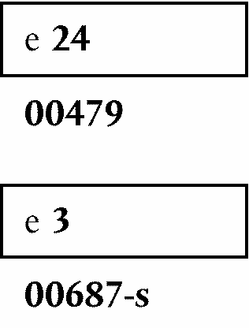
The tyre bearing the EC type-approval mark shown above is a commercial vehicle tyre (00) satisfying the EC requirements (e), for which the EC type-approval mark has been granted in Ireland (24) under the number 479 pursuant to Annex II and in Italy (3) under the number 687-s pursuant to Annex V.
Note: The numbers ‘479’ and ‘687’ (EC -mark type-approval numbers) and the number ‘24’ and the digit ‘3’ (letters and number of the Member States which granted the EC Ö type Õ approval) are for guidance only.
The approval numbers must be placed close to the rectangle and may be above, below, to the left or to the right. The characters of the approval number must all be on the same side of the ‘e’ and face in the same direction.

5. MODIFICATION OF A TYRE TYPE
5.1. If a tyre Ö EC Õ type-approved pursuant to Annex II or pursuant to Annex V has been modified, the provisions of Articles 13 to 16 of Directive 2007/46/EC shall apply.
5.2. If the tread pattern of a tyre has been modified in the case of type-approvals pursuant to Annex II, no repetition of the tests prescribed in Annex II is considered necessary.
5.3. In the case where tyre-size designations or trade marks are added to a range of tyres type-approved pursuant to Annex V, any requirement for retesting shall be determined by the type approval authority.
5.4. In the case of modification of the tyre tread pattern of a range of tyres approved pursuant to Annex V, a representative set of samples shall be retested unless the type approval authority is satisfied that the modification does not affect the tyre/road noise emissions.

6. CONFORMITY OF PRODUCTION
6.1. The general rules to ensure the conformity of production shall be adopted in accordance with the provisions laid down in Article 12 of Directive 2007/46/EC.
6.2. In particular, when checks are carried out in accordance with Appendix 1 to Annex V in order to check the conformity of production, if the noise level of the tyre tested does not exceed the limit values set out in point 4.2. of Annex V by more than 1 dB(A), the production shall be deemed to conform to the requirements of section 4 of Annex V.

ê 2001/43/EC Art. 1 pt. 5 and Annex pt. 3 (adapted)
Appendix 1
INFORMATION DOCUMENT No … RELATING TO EC TYPE-APPROVAL FOR A TYPE OF TYRE

ê 92/23/EEC
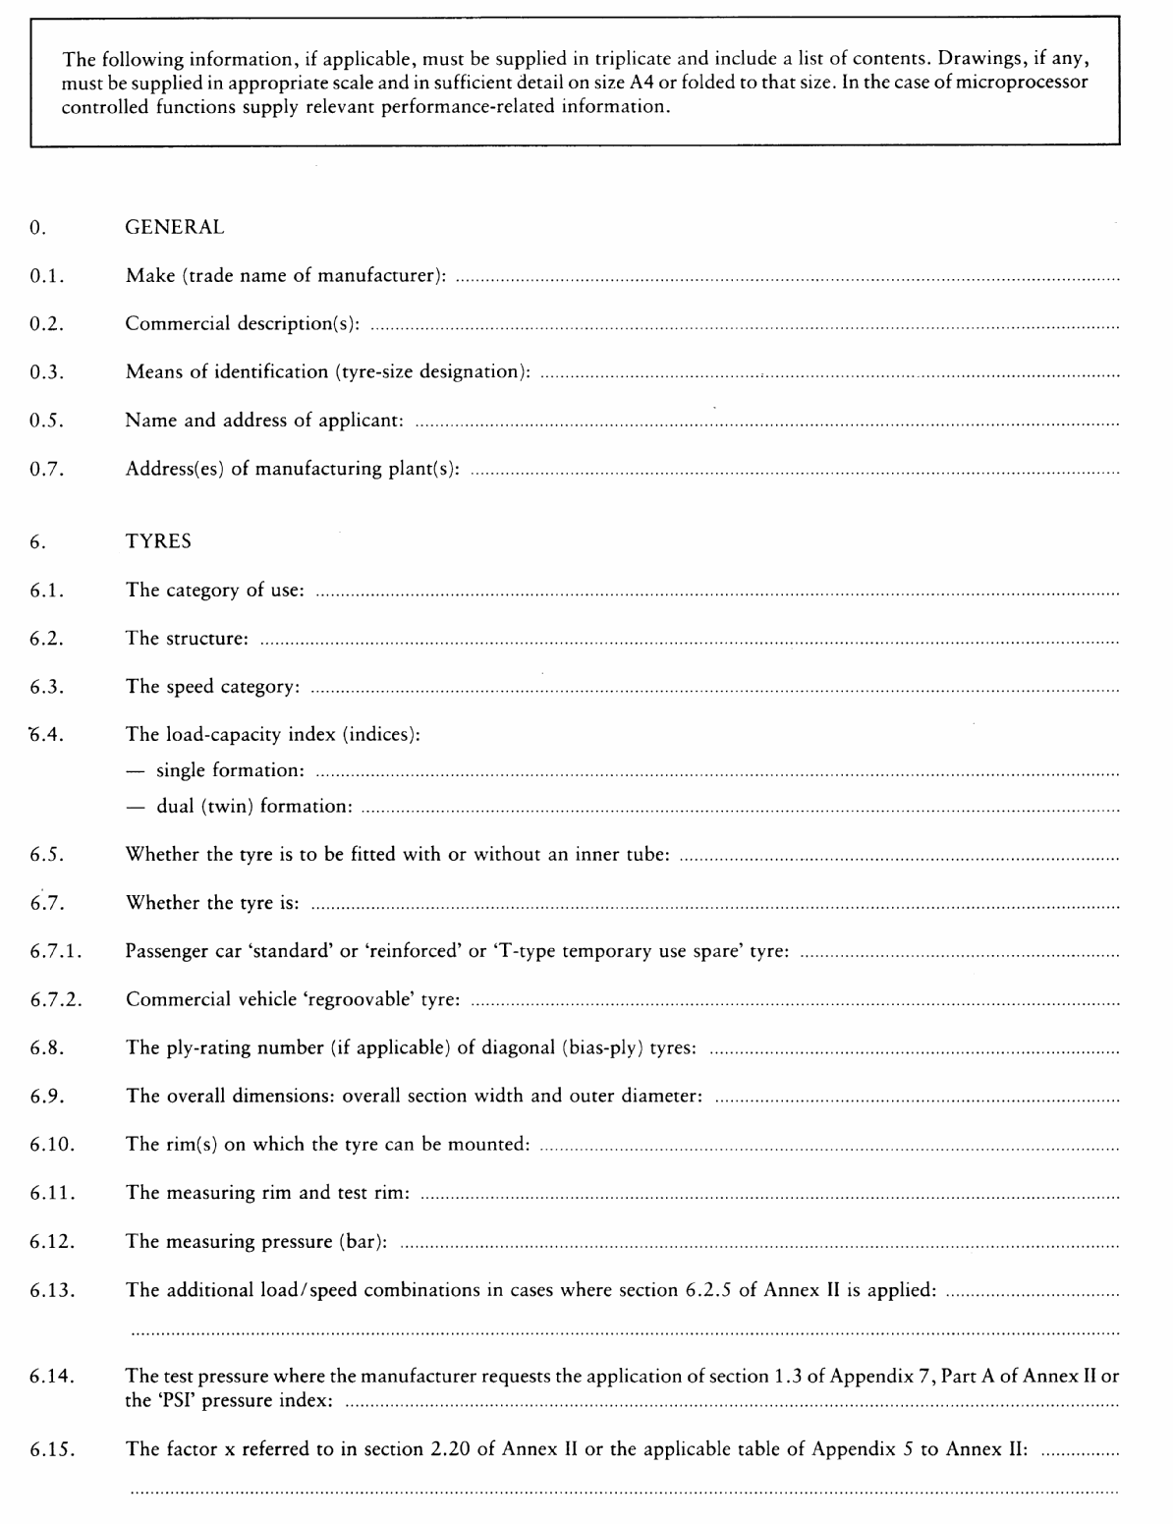

ê 2001/43/EC Art. 1 pt. 5 and Annex pt. 4
Appendix 2
EC TYPE-APPROVAL CERTIFICATE
(tyres)
MODEL
(maximum format: A4 (210 mm × 297 mm))

ê 92/23/EEC (adapted)
è1 2001/43/EC Art. 1 pt. 1
è2 2001/43/EC Art. 1 pt. 5 and Annex pt. 5

Stamp of
Administration
Communication concerning the:
- Ö EC Õ type-approval⁽¹⁾,
- extension of Ö EC Õ type-approval⁽¹⁾,
- refusal of Ö EC Õ type-approval⁽¹⁾,
- withdrawal of Ö EC Õ type-approval⁽¹⁾,
- discontinuation of production⁽¹⁾,
of a component with regard to Directive […] relating to tyres.
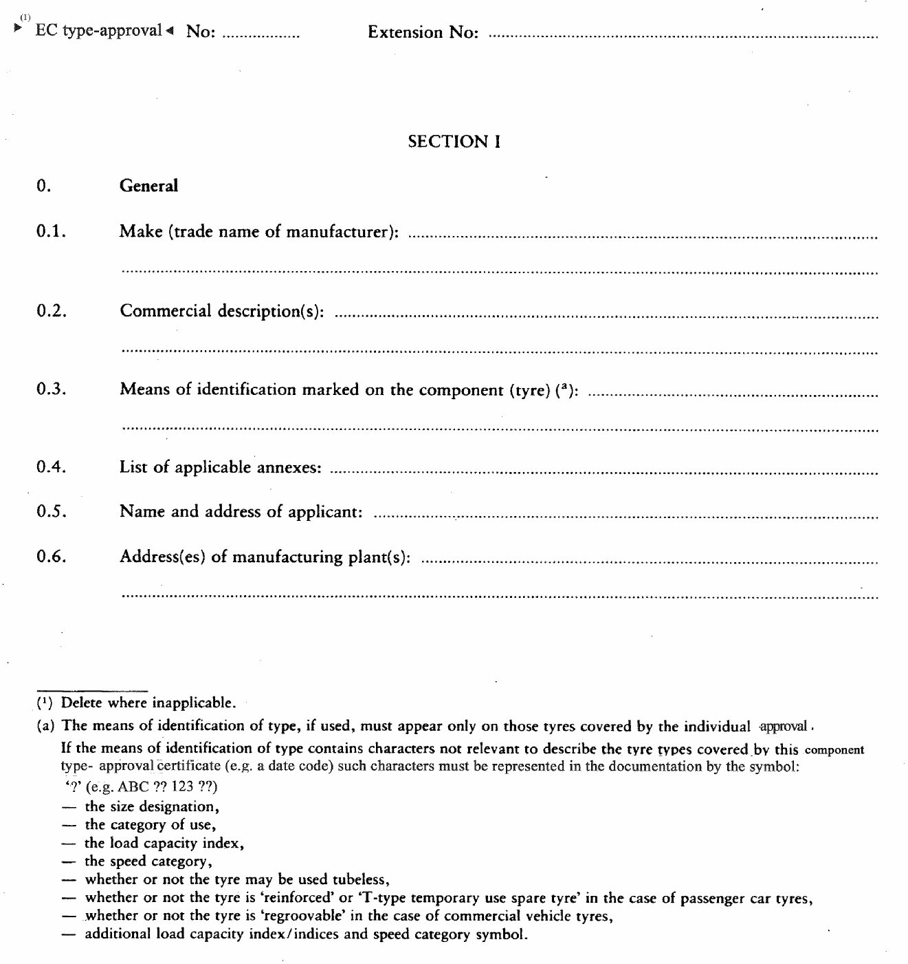
è1 ç è2 ç
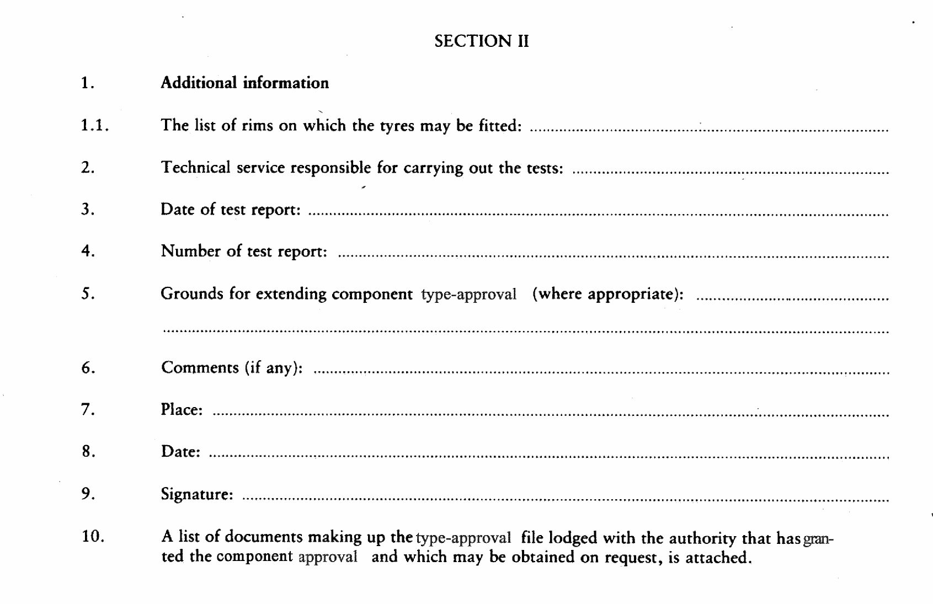

ê 2001/43/EC Art. 1 pt. 5 and Annex pt. 6 (adapted)
Appendix 3
INFORMATION DOCUMENT No…RELATING TO EC TYPE – APPROVAL FOR A TYPE OF TYRE RELATING TO TYRE/ROAD NOISE EMISSION

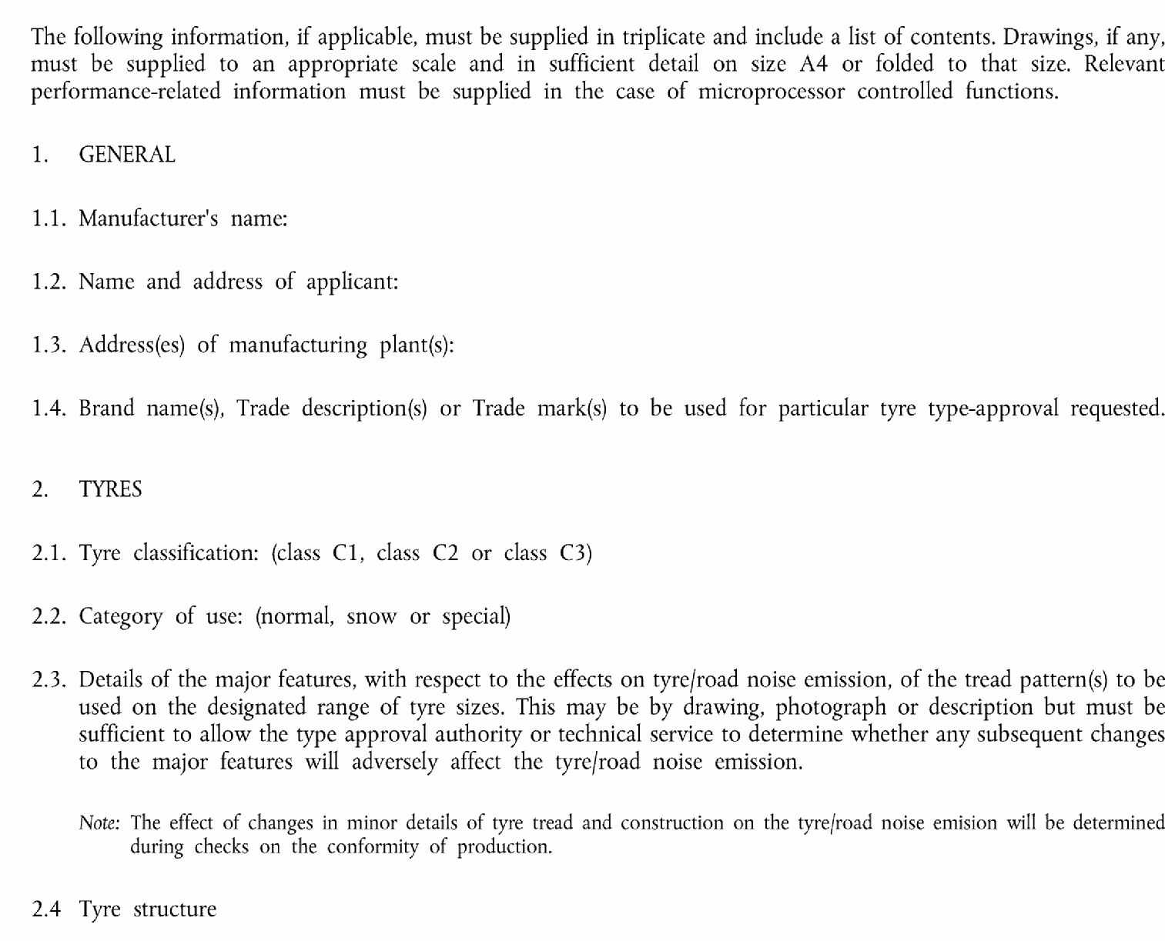
2.5. List of tread-pattern designations:
(specify for each trade mark or brand name and trade description the list of tyre designations as per point 2.17. of Annex II to Directive […] adding, in the case of class Cl tyres, the mark 'Reinforced' or ‘Extra Load’, if applicable).

ê 2001/43/EC Art. 1 pt. 5 and Annex pt. 6
Appendix 4
EC TYPE-APPROVAL CERTIFICATE
(tyre/road noise emission)
MODEL
(maximum format: A4 (210 mm x 297 mm))

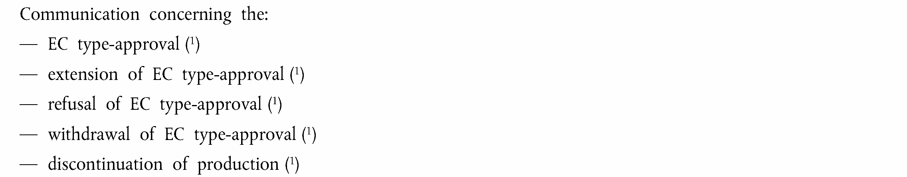
of a type of tyre with regard to Annex V to Directive […], relating to tyre/road noise emission.
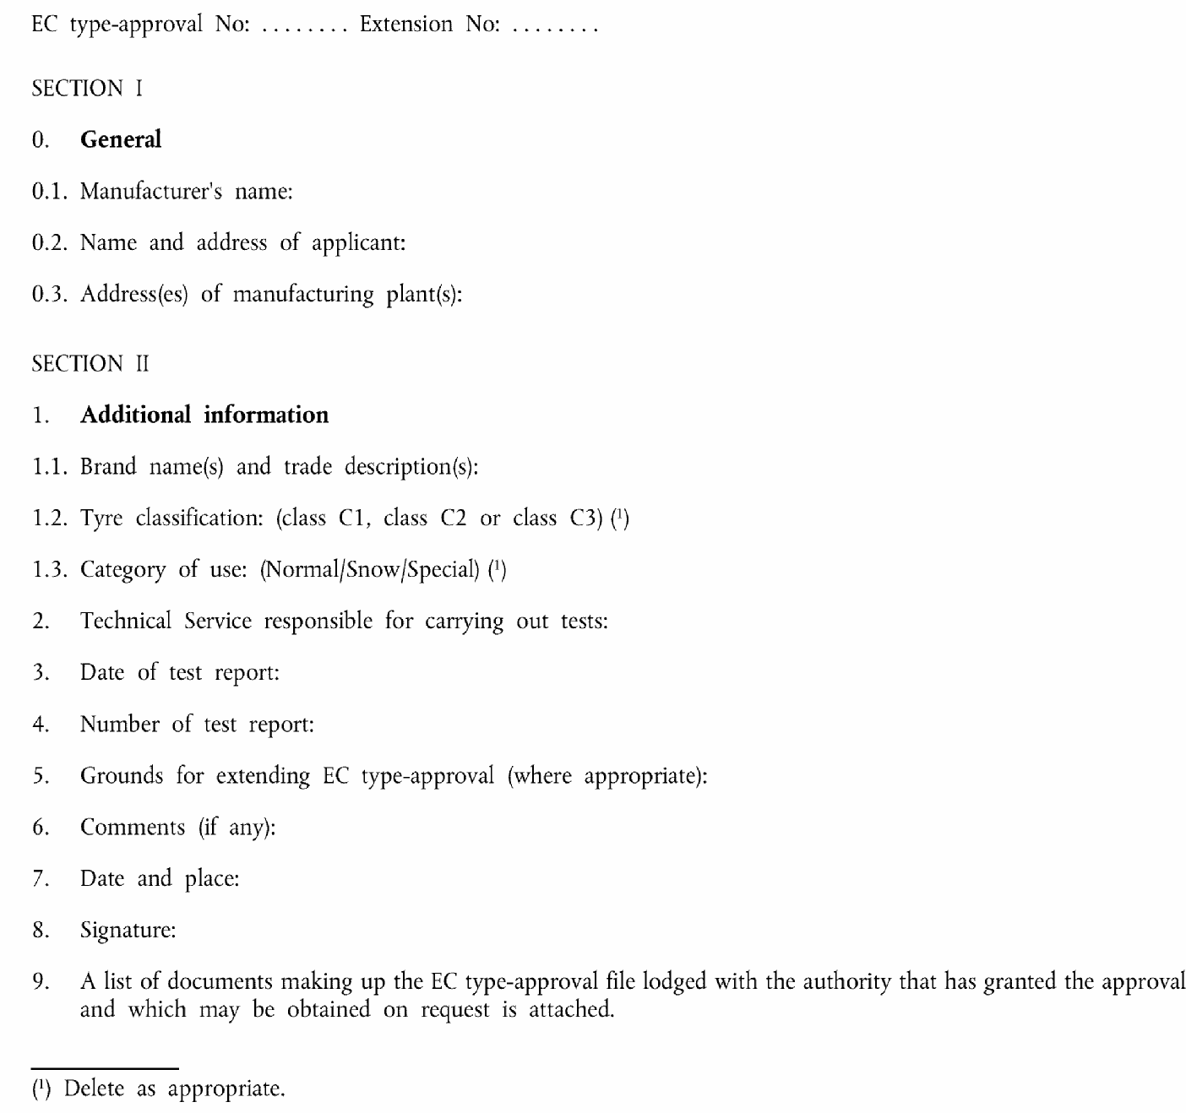
____________

ê 92/23/EEC (adapted)
è1 2001/43/EC Art. 1 pt. 1
ANNEX II
REQUIREMENTS FOR TYRES

1. DEFINITIONS

2. For the purposes of this Directive:
2.1. ‘type of tyre’ means a category of tyres which do not differ in such essential respects as:
2.1.1. manufacturer's name or trade mark;
2.1.2. tyre-size designation;
2.1.3. category of use:
- normal: normal road-use tyre,
- special: special-use tyre, e.g. tyre for mixed use (both on and off the road) and at restricted speed,
- snow tyre,
- temporary-use spare tyre
2.1.4. structure (diagonal (bias-ply), bias-belted, radial-ply);
2.1.5. speed category;
2.1.6. load capacity index;
2.1.7. tyre cross-section;
2.2. ‘snow tyre’ means a tyre the tread pattern and structure of which are primarily designed to ensure in mud and fresh or melting snow a performance better than that of a normal tyre. The tread pattern of a snow tyre generally consists of groove (rib) and/or solid-block elements more widely spaced than on a normal tyre;
2.3. ‘structure’ of a tyre means the technical characteristics of the tyre's carcass. The following structures are distinguished in particular:
2.3.1. ‘diagonal’ or ‘bias-ply’ describes a tyre structure in which the ply cords extend to the bead and are laid at alternate angles of substantially less than 90º to the centreline of the tread;
2.3.2. ‘bias-belted’ describes a tyre structure of diagonal (bias-ply) type in which the carcass is restricted by a belt comprising two or more layers of substantially inextensible cord material laid at alternate angles close to those of the carcass;
2.3.3. ‘radial’ describes a tyre structure in which the ply cords extend to the beads and are laid substantially at 90º to the centreline of the tread, the carcass being stabilised by an essentially inextensible circumferential belt;
2.3.4. ‘reinforce’ describes a tyre structure in which the carcass is more resistant than that of the corresponding standard tyre;
2.3.5. ‘temporary-use spare tyre’ means a tyre different from a tyre intended to be fitted to any vehicle for normal driving conditions; but intended only for temporary use under restricted driving conditions;
2.3.6. ‘T-type temporary-use spare tyre’ means a type of temporary-use spare tyre designed for use at inflation pressure higher than those established for standard and reinforced tyres;
2.4. ‘bead’ means the part of a tyre which is of such shape and structure as to fit the rim and hold the tyre on it;
2.5. ‘cord’ means the strands forming the fabric of the plies in the tyre;
2.6. ‘ply’ means a layer of rubber-coated parallel cords;
2.7. ‘carcass’ means that part of a tyre other than the tread and the rubber sidewalls which, when inflated, bears the load;
2.8. ‘tread’ means that part of a tyre which comes into contact with the ground;
2.9. ‘sidewall’ means the part of the tyre, excluding the tread, which is visible when the tyre, fitted to a rim, is viewed from the side;
2.10. ‘lower sidewall’ means the area below the line of maximum section width of the tyre, which is visible when the tyre, fitted to a rim, is viewed from the side;
2.11. ‘tread groove’ means the space between the adjacent ribs or blocks in the tread pattern;
2.12. ‘section width’ means the linear distance between the outsides of the sidewalls of an inflated tyre, excluding elevations due to labelling (marking), decoration or protective bands or ribs;
2.13. ‘overall width’ means the linear distance between the outsides of the sidewalls of an inflated tyre, including labelling (marking), decoration and protective bands or ribs;
2.14. ‘section height’ means a distance equal to half the difference between the outer diameter of the tyre and the nominal rim diameter;
2.15. ‘nominal aspect ratio Ra’ means one hundred times the number obtained by dividing the number expressing the nominal section height in millimetres by the number expressing the nominal section width in millimetres;
2.16. ‘outer diameter’ means the overall diameter of an inflated new tyre;
2.17. ‘tyre-size designation’:
2.17.1. means a designation showing:
2.17.1.1. the nominal section width. This width must be expressed in mm, except in the case of tyres for which the size designation is shown in the first column of the tables in Appendix 5;
2.17.1.2. the nominal aspect ratio, except in the case of tyres for which the size designation is shown in the first column of the tables in Appendix 5;
2.17.1.3. a conventional number ‘d’ (the ‘d’ symbol) denoting the nominal rim diameter and corresponding to the diameter of the rim expressed either in inches (number below 100 — see table) or in mm (numbers above 100) but not both.
The exhaustive range of values is shown in the table below:
Nominal rim diameter (the ‘d’ symbol)
Expressed in inches  (code) | Equivalence in mm  (reference point 6.1.2.1)
10 | 254
11 | 279
12 | 305
13 | 330
14 | 356
15 | 381
16 | 406
17 | 432
18 | 457
19 | 483
20 | 508
21 | 533
22 | 559
24 | 610
25 | 635
14,5 | 368
16,5 | 419
17,5 | 445
19,5 | 495
20,5 | 521
22,5 | 572
24,5 | 622
2.17.1.4. the letter ‘T’ in front of the nominal section width in case of T-type temporary-use spare tyres;
2.18. ‘nominal rim diameter (d)’ means the diameter of the rim on which a tyre is designed to be mounted;
2.19. ‘rim’ means the support for a tyre-and-tube assembly, or for a tubeless tyre, on which the tyre beads are seated;
2.20. ‘theoretical rim’ means the notional rim whose width would be equal to x times the nominal section width of a tyre; the value ‘x’ must be specified by the tyre manufacturer;
2.21. ‘measuring rim’ means the rim on which a tyre must be fitted for size measurements;
2.22. ‘test rim’ means the rim on which a tyre must be fitted for testing;
2.23. ‘chunking’ means the breaking away of pieces of rubber from the tread;
2.24. ‘cord separation’ means the parting of the cords from their rubber coating;
2.25. ‘ply separation’ means the parting of adjacent plies;
2.26. ‘tread separation’ means the pulling away of the tread from the carcass;
2.27. ‘tread-wear indicators’ mean projections within the tread-grooves designed to give a visual indication of the degree of wear of the tread;
2.28. ‘load-capacity index’ means one or two numbers which indicate the load the tyre can carry in single or in single and dual formation at the speed corresponding to the associated speed category and when operated in conformity with the requirements governing utilisation specified by the manufacturer. The list of these indices and their corresponding masses is given in Annex II, Appendix 2;
2.28.1. on passenger car tyres there must be one load index only;
2.28.2. on commercial vehicle tyres there may be one or two load indices, the first one for single formation and the second one, when present, for dual (twin) formation in which case the two indices are divided by a slash (/);
2.28.3. a type of tyre may have either one or two sets of load capacity indices depending on whether or not the provisions of point 6.2.5 are applied;
2.29. ‘speed category’, expressed by the speed category symbol as shown in the table in point 2.29.3;
2.29.1. in the case of a passenger car tyre, the maximum speed which the tyre can sustain;
2.29.2. in the case of a commercial vehicle tyre, the speed at which the tyre can carry the mass corresponding to the load capacity index;
2.29.3. The speed categories are as shown in the table below:
Speed category symbol | Corresponding speed  (km/h)
F | 80
G | 90
J | 100
K | 110
L | 120
M | 130
N | 140
P | 150
Q | 160
R | 170
S | 180
T | 190
U | 200
H | 210
V | 240
2.29.4. tyres suitable for maximum speeds higher than 240 km/h are identified by means of the letter code ‘Z’ placed within the tyre size designation;
2.29.5. a type of tyre may have either one or two sets of speed category symbols depending on whether or not the provisions of point 6.2.5 are applied;
2.30. ‘table: Variation of load capacity with speed’ means: the table, in Annex II, Appendix 8, showing as a function of the load capacity indices and nominal speed category symbols the load variations which a tyre can withstand when used at speeds different from that corresponding to its speed category symbol;
2.30.1. the load variations do not apply in the case of passenger car tyres nor, in the case of commercial vehicle tyres, to the additional load capacity indices and speed category symbol when the provisions of point 6.2.5 are applied;
2.31. ‘maximum load rating’ means the maximum mass the tyre is rated to carry:
2.31.1. in the case of passenger car tyres suitable for speeds not exceeding 210 km/h, the maximum load rating must not exceed the value associated with the load capacity index of the tyre;
2.31.2. in the case of passenger car tyres suitable for speeds exceeding 210 km/h, but not exceeding 240 km/h (tyres classified with speed category symbol ‘V’), the maximum load rating must not exceed the percentage of the value associated with the load capacity index of the tyre, indicated in the table below, with reference to the speed capability of the vehicle to which the tyre is fitted;
Maximum speed  (km/h) | Load  (%)
215 | 98,5
220 | 97
225 | 95,5
230 | 94
235 | 92,5
240 | 91
for intermediate maximum speeds linear interpolations of the maximum load rating are allowed;
2.31.3. for speeds exceeding 240 km/h (‘Z tyres’) the maximum load rating must not exceed the value specified by the tyre manufacturer with reference to the maximum speed capability of the vehicle to which it is fitted;
2.31.4. in the case of commercial vehicle tyres, the maximum load rating, both for single and for dual formation, must not exceed the percentage of the value associated with the relevant load capacity index of the tyre as indicated in the table ‘Load-capacity variation with speed’ (see point 2.30), with reference to the speed category symbol of the tyre and the speed capability of the vehicle to which the tyre is fitted. When additional load capacity indices and speed category symbols apply, those too are considered to determine the maximum load rating of the tyre;
2.32. ‘passenger car tyre’ means a tyre designed primarily, but not only, for passenger cars (motor vehicles in category M1) and their trailers (01 and 02);
2.33. ‘commercial vehicle tyre’ means a tyre designed primarily, but not only, for vehicles other than passenger cars (motor vehicles in categories M2, M3, N) and their trailers (03 and 04);
2.34. ‘tyre ground pressure (F/Ac)’ means the average until load transmitted by the tyre, through its contact area, to the road surface expressed as the ratio between the vertical force (F), in static conditions on the axis of the wheel and the tyre contact area (Ac) measured with the tyre inflated at the cold inflation pressure recommended for the intended type of service. It is expressed in kN/m²;
2.35. ‘tyre contact area (Ac)’ means the area of the flat surface contained within the virtual perimeter of the tyre footprint. It is expressed in m²;
2.36. ‘virtual perimeter of the tyre footprint’ means the convex polygonal curve circumscribing the smallest area containing all points of contact between the tyre and the ground;
2.37. ‘cold inflation pressure’ means the internal pressure of the tyre with the tyre at ambient temperature and does not include any pressure build up due to tyre usage. It is expressed in bar or kPa.

3. MARKING REQUIREMENTS
3.1. Tyres must bear:
3.1.1. the manufacturer's name or trade mark;
3.1.2. the tyre-size designation as defined in point 2.17;
3.1.3. an indication of the structure as follows:
3.1.3.1. on diagonal (bias-ply) tyres, no making or the letter ‘D’;
3.1.3.2. on radial-ply tyres, the letter ‘R’ placed in front of the nominal in diameter marking and, optionally, the word ‘RADIAL’;
3.1.3.3. on bias-belted tyres, the letter ‘B’ placed in front of the nominal rim diameter marking and, in addition, the words ‘BIAS-BELTED’;
3.1.4. an indication of the tyre's speed category by means of the symbol shown in point 2.29; in the case of tyres suitable for speeds higher than 240 km/h the speed category of the tyre must be indicated by the letter code ‘Z’ placed in front of the indication of the structure (see point 3.1.3);
3.1.5. the inscription ‘M + S’ (or alternatively ‘M.S.’ or ‘M & S’) in the case of a snow tyre;
3.1.6. the load-capacity index as defined in point 2.28;
3.1.6.1. however, in the case of tyres suitable for speeds higher than 240 km/h the indication of the load capacity index may be omitted;
3.1.7. the word ‘TUBELESS’ if the tyre is designed for use without an inner tube;
3.1.8. the word ‘REINFORCED’ if the tyre is a reinforced tyre;
3.1.9. the date of manufacture in the form of a group of three digits, the first two showing the week and the last one the year of manufacture;
3.1.10. in the case of commercial vehicle tyres which can be regrooved, the symbol ‘’ at least 20 mm in diameter, or the word ‘REGROOVABLE’, moulded into or on to each sidewall;
3.1.11. in the case of commercial vehicle tyres, an indication, by the ‘PSI’ index (see Appendix 4), of the inflation pressure to be adopted for the load/speed tests, as explained in Appendix7, Part B;
3.1.12. the additional load capacity index/indices and the speed category symbol in the case where the provisions of point 6.2.5 are applied.
3.2. Appendix 3 gives examples of the arrangement of tyre markings.
3.3. The tyre must also bear the è1 EC type-approval ç mark, the model of which is given in Annex I, point 4.5.

POSITION OF MARKINGS
3.4. The markings referred to in points 3.1 and 3.3 must be clearly and legibly moulded into or on to both sidewalls, and at least on one side on the lower sidewall, as follows:
3.4.1. in the case of symmetrical tyres, all the markings referred to Ö in point 3.4 Õ must be located on both sidewalls except the markings referred to in points 3.1.9, 3.1.11 and 3.3 which may be on one sidewall only;
3.4.2. in the case of asymmetrical tyres all the markings must be located on at least the outer sidewall.
(4.)
(5.)
(6.)

6.1. Dimensional requirements

6.1.1. Section width of a tyre
6.1.1.1. Except as provided by point 6.1.1.2, the section width is calculated by the following formula:
S = S₁ + K (A−A₁),
where:
S | = | the ‘section width’ expressed in mm and measured on the measuring rim;
S₁ | = | the ‘nominal section width’ in mm as shown on the sidewall of the tyre in the tyre-size designation as prescribed;
A | = | the width (expressed in mm) of the measuring rim, as shown by the manufacturer in the descriptive note, (see point 6.11 of Annex I, Appendix 1);
A₁ | = | the width (expressed in mm) of the theoretical rim; it is taken to equal S₁ multiplied by the factor x as specified by the tyre manufacturer (see point 6.15 of Annex I, Appendix 1); and K is taken to equal 0,4.
6.1.1.2. However, for the types of tyre for which the size designation is given in the first column of the tables in Appendix 5 A or 5 B, the measuring rim width (A) and the section width (S) are those given opposite the tyre size designation in those tables.

6.1.2. Outer diameter of a tyre
6.1.2.1. Except as provided by point 6.1.2.2, the outer diameter of a tyre is calculated by the following formula:
D = d + 0,02H
where:
— | D is the outer diameter expressed in mm,
— | d is the conventional number defined in point 2.17.1.3, expressed in mm,
— | H is the nominal section height in mm and is equal to S₁ × 0,01 Ra;
where:
— | Ra is the nominal aspect ratio,
all as shown on the sidewall of the tyre in the tyre-size designation in conformity with the requirements of section 3.
6.1.2.2. However, for the types of tyres for which the size designation is given in the first column of the tables of Appendix 5 the outer diameter is that given opposite the tyre size designation in those tables.

6.1.3. Method of measuring tyre dimensions
The actual dimensions of tyres are measured as prescribed in Appendix 6.

6.1.4. Tyre section width: specification of tolerance
6.1.4.1. The overall width of a tyre may be less than the section width determined pursuant to point 6.1.1 or shown in Appendix 5;
6.1.4.2. It may not exceed that value by more than the following:
6.1.4.2.1. diagonal (bias-ply) tyres: 6 % for passenger car tyres, 8 % for commercial vehicle tyres;
6.1.4.2.2. radial-ply tyres: 4 %; and
6.1.4.2.3. in addition, if the tyre has a special protective band, the figure as increased by the above tolerances may be exceeded by 8 mm.
6.1.4.2.4. However, for tyres of a section width exceeding 305 mm intended for dual (twin) mounting the nominal value must not be exceeded by more than 2 % for radial-ply or 4 % for diagonal (bias-ply) tyres.

6.1.5. Tyre outer diameter: specification of tolerance
The outer diameter of a tyre must not be outside the values Dmin and Dmax obtained from the following formulae:
Dmin | = | d + (2H × a)
Dmax | = | d + (2H × b)
6.1.5.1. for sizes listed in Appendix 5:
H = 0,5 (D — d) — (for references see point 6.1.2.2).
6.1.5.2. for other sizes not listed in Appendix 5:
‘H’ and ‘d’ are as defined in point 6.1.2.1.
6.1.5.3. coefficients ‘a’ and ‘b’ are respectively:
6.1.5.3.1. coefficient ‘a’ = 0,97;
6.1.5.3.2. coefficient ‘b’ for normal, special, snow or temporary-use spare tyres
Category of use | Passenger car tyres |  | Commercial vehicle tyres
Category of use | Radial | Bias | Radial | Bias
Normal | 1,04 | 1,08 | 1,04 | 1,07
Special | — | — | 1,06 | 1,09
Snow | 1,04 | 1,08 | 1,04 | 1,07
Temporary-use | 1,04 | 1,08 | — | —
6.1.5.4. For snow tyres the outer diameter (Dmax) established in conformity with Ö point 6.1.5 Õ may be exceeded by 1 %.

6.2. Load/speed test requirement
6.2.1. The tyre must undergo a load/speed test carried out in accordance with the relevant procedure described in Appendix 7.
6.2.2. A tyre which, after undergoing the relevant load/speed test, does not exhibit any tread separation, ply separation, cord separation, chunking or broken cords is deemed to have passed the test.
6.2.3. The outer diameter of the tyre, measured six hours after the load/speed test, must not be more than 3,5 % greater than the outer diameter as measured before the test.
6.2.4. Where application is made for the Ö EC type- Õapproval of a type of commercial vehicle tyre the load/speed combinations given in the table in Appendix 8 apply and, the load/speed test prescribed in point 6.2.1 need not be carried out for load and speed values other than the nominal values.
6.2.5. Where application (see point 6.13 of Appendix I to Annex I) is made for the Ö EC Õ type-approval of a type of commercial vehicle tyre which has a load/speed combination in addition to the one that is subject to the variation of load with speed given in the table in Appendix 8, the load/speed test prescribed in point 6.2.1 must also be carried out on a second tyre of the same type at the additional load/speed combination.
6.2.6. Where a tyre manufacturer produces a range of tyres it is not considered necessary to carry out a load/speed test on every type of tyre in the range. Worst-case selection may be made, at the discretion of the approval authority.

6.3. Tread-wear indicators
6.3.1. In the case of passenger car tyres the tread of the tyre must include not less than six transverse rows of tread-wear indicators, approximately equally spaced and situated in the wide grooves in the central zone of the tread, which covers approximately three quarters of the tread width. The tread-wear indicators must be such that they cannot be confused with the rubber ridges between the ribs or blocks of the tread.
6.3.2. However, in the case of tyres of dimensions appropriate for mounting on rims of a nominal diameter of 12″ or less, four rows of tread-wear indicators are acceptable.
6.3.3. The tread-wear indicators must give visual warning when the depth of the corresponding tread grooves has been reduced to 1,6 mm with a tolerance of + 0,6/- 0 mm.
Appendix 1
EXPLANATORY FIGURE
(see Annex II, section 2 and point 6.1)
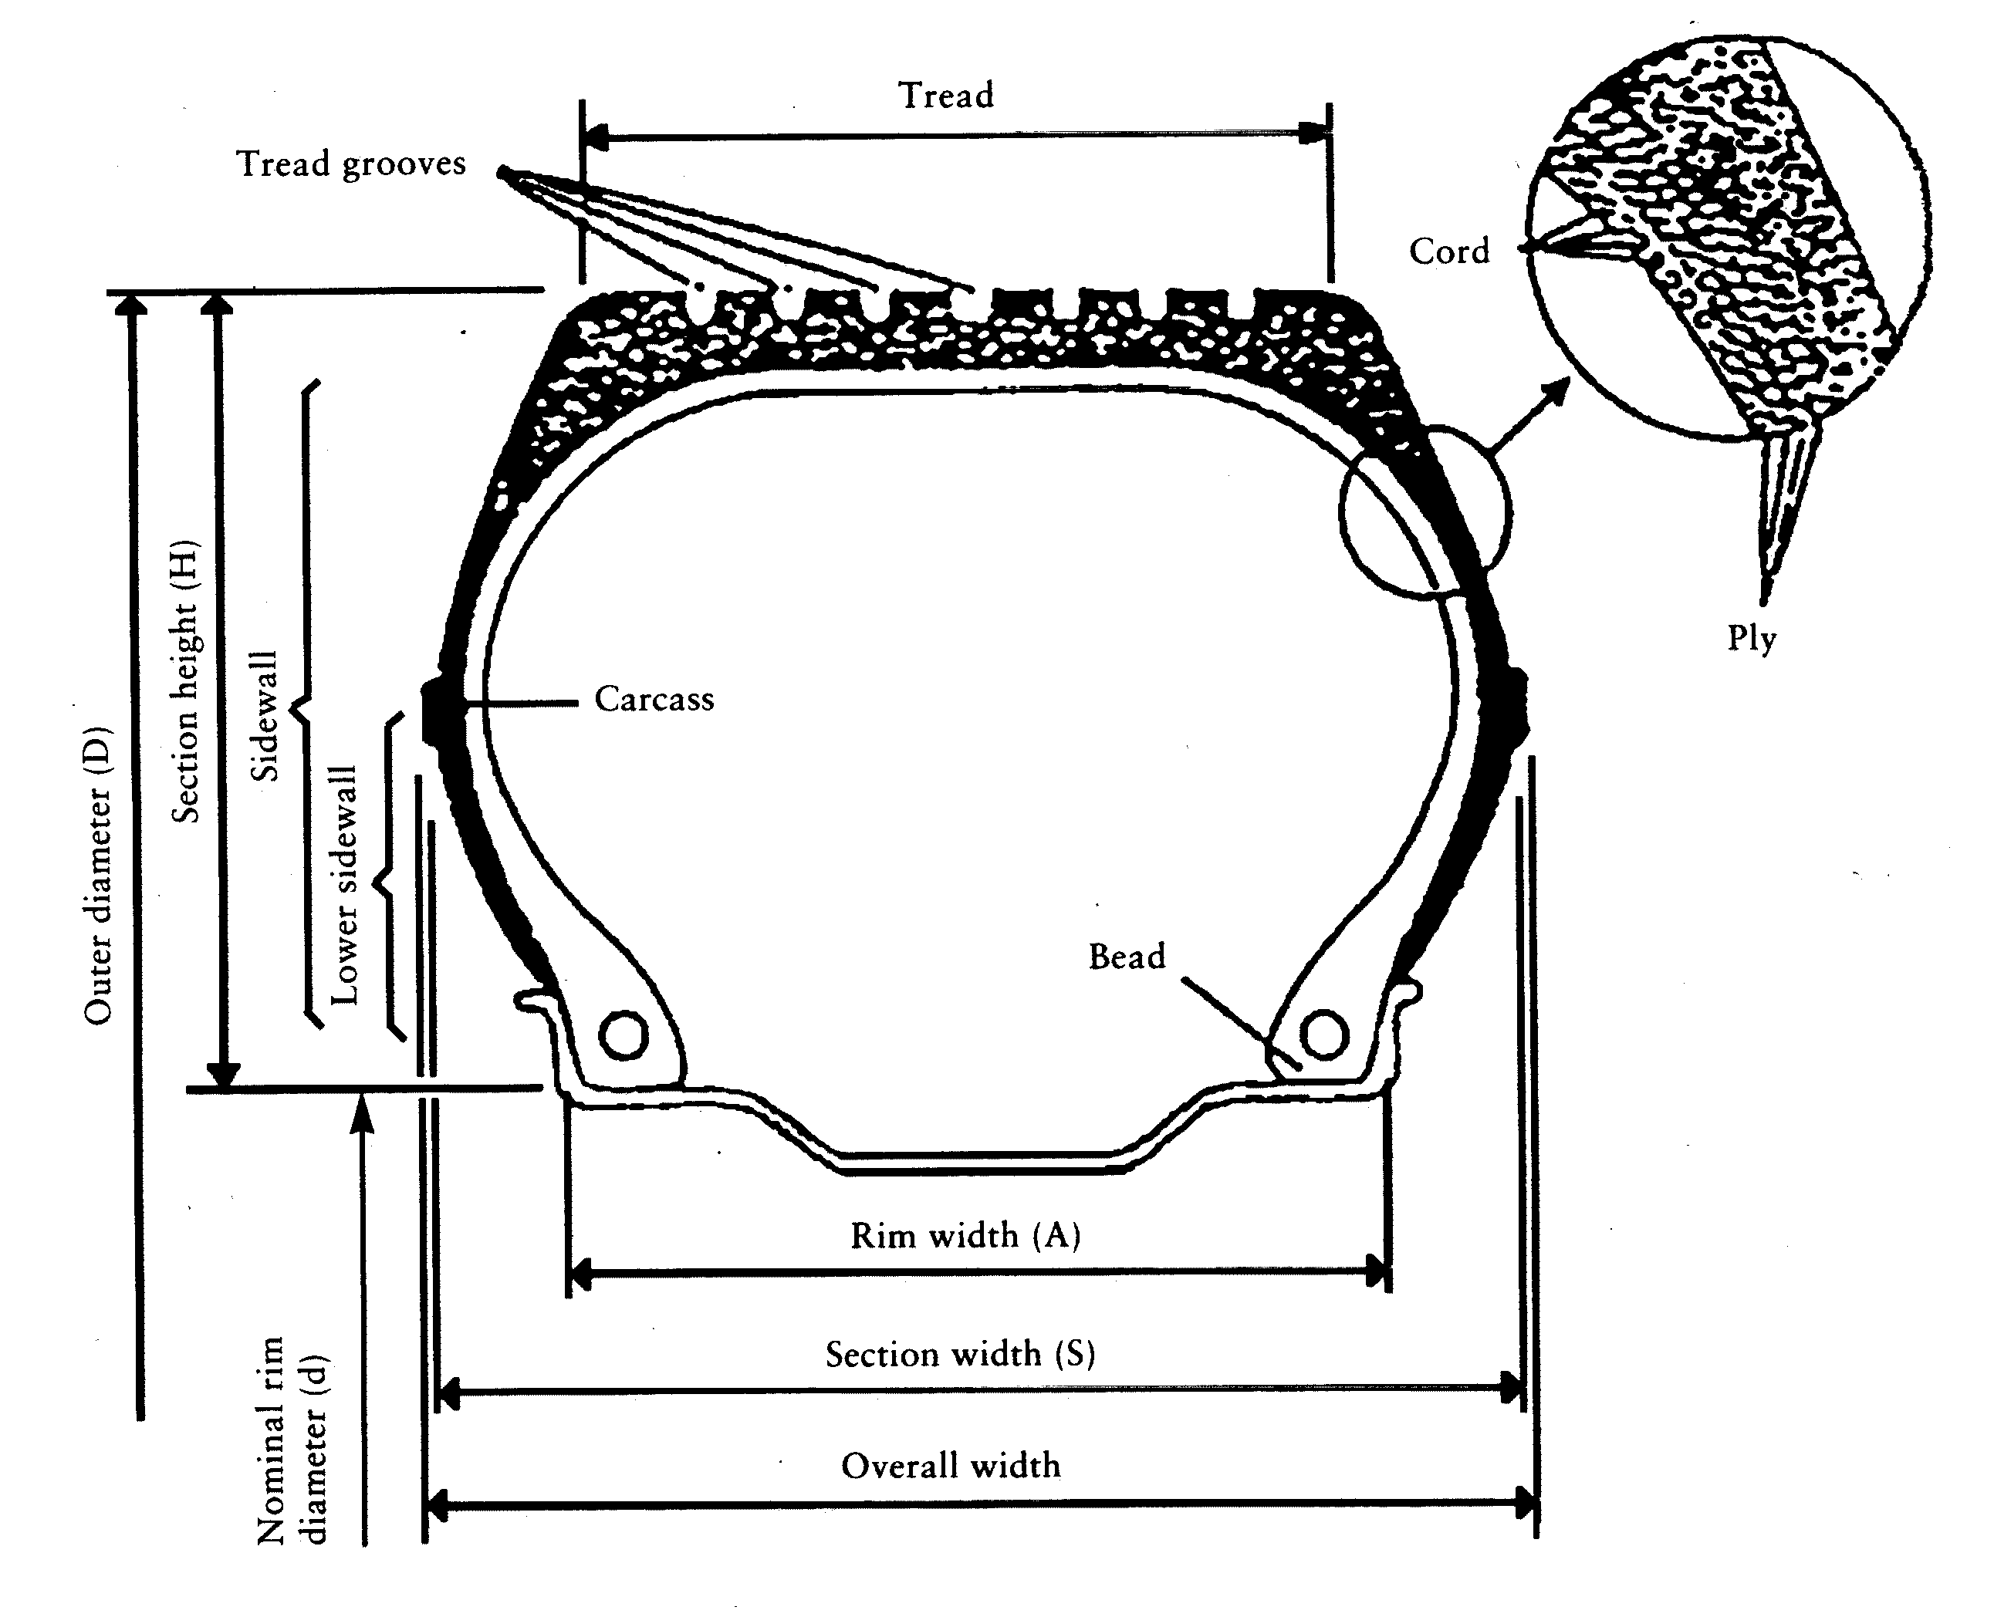
Appendix 2
LIST OF SYMBOLS OF LOAD-CAPACITY INDICES (LI) AND CORRESPONDING MAXIMUM MASS TO BE CARRIED (KG)
(see Annex II, point 2.28)
LI | Maximum |  | LI | Maximum |  | LI | Maximum |  | LI | Maximum
0 | 45 |  | 51 | 195 |  | 101 | 825 |  | 151 | 3 450
1 | 46,2 |  | 52 | 200 |  | 102 | 850 |  | 152 | 3 550
2 | 47,5 |  | 53 | 206 |  | 103 | 875 |  | 153 | 3 650
3 | 48,7 |  | 54 | 212 |  | 104 | 900 |  | 154 | 3 750
4 | 50 |  | 55 | 218 |  | 105 | 925 |  | 155 | 3 875
5 | 51,5 |  | 56 | 224 |  | 106 | 950 |  | 156 | 4 000
6 | 53 |  | 57 | 230 |  | 107 | 975 |  | 157 | 4 125
7 | 54,5 |  | 58 | 236 |  | 108 | 1 000 |  | 158 | 4 250
8 | 56 |  | 59 | 240 |  | 109 | 1 030 |  | 159 | 4 375
9 | 58 |  | 60 | 250 |  | 110 | 1 060 |  | 160 | 4 500
10 | 60 |  | 61 | 257 |  | 111 | 1 090 |  | 161 | 4 625
11 | 61,5 |  | 62 | 265 |  | 112 | 1 120 |  | 162 | 4 750
12 | 63 |  | 63 | 272 |  | 113 | 1 150 |  | 163 | 4 875
13 | 65 |  | 64 | 280 |  | 114 | 1 180 |  | 164 | 5 000
14 | 67 |  | 65 | 290 |  | 115 | 1 215 |  | 165 | 5 150
15 | 69 |  | 66 | 300 |  | 116 | 1 250 |  | 166 | 5 300
16 | 71 |  | 67 | 307 |  | 117 | 1 285 |  | 167 | 5 450
17 | 73 |  | 68 | 315 |  | 118 | 1 320 |  | 168 | 5 600
18 | 75 |  | 69 | 325 |  | 119 | 1 360 |  | 169 | 5 800
19 | 77,5 |  | 70 | 335 |  | 120 | 1 400 |  | 170 | 6 000
20 | 80 |  | 71 | 345 |  | 121 | 1 450 |  | 171 | 6 150
21 | 82,5 |  | 72 | 355 |  | 122 | 1 500 |  | 172 | 6 300
22 | 85 |  | 72 | 355 |  | 122 | 1 500 |  | 172 | 6 300
23 | 87,5 |  | 73 | 365 |  | 123 | 1 550 |  | 173 | 6 500
24 | 90 |  | 74 | 375 |  | 124 | 1 600 |  | 174 | 6 700
25 | 92,5 |  | 75 | 387 |  | 125 | 1 650 |  | 175 | 6 900
26 | 95 |  | 76 | 400 |  | 126 | 1 700 |  | 176 | 7 100
27 | 97,5 |  | 77 | 412 |  | 127 | 1 750 |  | 177 | 7 300
28 | 100 |  | 78 | 425 |  | 128 | 1 800 |  | 178 | 7 500
29 | 103 |  | 79 | 437 |  | 129 | 1 850 |  | 179 | 7 750
30 | 106 |  | 80 | 450 |  | 130 | 1 900 |  | 180 | 8 000
31 | 109 |  | 81 | 462 |  | 131 | 1 950 |  | 181 | 8 250
32 | 112 |  | 82 | 475 |  | 132 | 2 000 |  | 182 | 8 500
33 | 115 |  | 83 | 487 |  | 133 | 2 060 |  | 183 | 8 750
34 | 118 |  | 84 | 500 |  | 134 | 2 120 |  | 184 | 9 000
35 | 121 |  | 85 | 515 |  | 135 | 2 180 |  | 185 | 9 250
36 | 125 |  | 86 | 530 |  | 136 | 2 240 |  | 186 | 9 500
37 | 128 |  | 87 | 545 |  | 137 | 2 300 |  | 187 | 9 750
38 | 132 |  | 88 | 560 |  | 138 | 2 360 |  | 188 | 10 000
39 | 136 |  | 89 | 580 |  | 139 | 2 430 |  | 189 | 10 300
40 | 140 |  | 90 | 600 |  | 140 | 2 500 |  | 190 | 10 600
41 | 145 |  | 91 | 615 |  | 141 | 2 575 |  | 191 | 10 900
42 | 150 |  | 92 | 630 |  | 142 | 2 650 |  | 192 | 11 200
43 | 155 |  | 93 | 650 |  | 143 | 2 725 |  | 193 | 11 500
44 | 160 |  | 94 | 670 |  | 144 | 2 800 |  | 194 | 11 800
45 | 165 |  | 95 | 690 |  | 145 | 2 900 |  | 195 | 12 150
46 | 170 |  | 96 | 710 |  | 146 | 3 000 |  | 196 | 12 500
47 | 175 |  | 97 | 730 |  | 147 | 3 075 |  | 197 | 12 850
48 | 180 |  | 98 | 750 |  | 148 | 3 150 |  | 198 | 13 200
49 | 185 |  | 99 | 775 |  | 149 | 3 250 |  | 199 | 13 600
50 | 190 |  | 100 | 800 |  | 150 | 3 350 |  | 200 | 14 000
Appendix 3
ARRANGEMENT OF TYRE MARKINGS
(see Annex II, point 3.2)

PART A: PASSENGER CAR TYRES
Example of the markings to be borne by types of tyres placed on the market after notification of this Directive
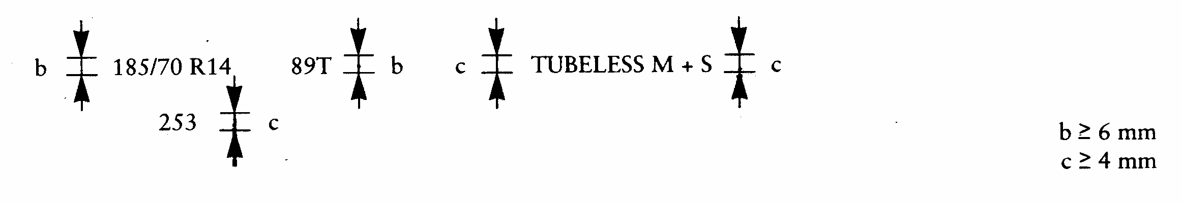
These markings define a tyre:
- having a nominal section width of 185,
- having a nominal aspect ratio of 70,
- of radial-ply structure (R),
- having a nominal rim diameter of 14,
- having a load capacity of 580 kg, corresponding to load index 89 in Appendix 2,
- classified in the speed category T (maximum speed 190 km/h),
- for fitting without an inner tube (‘tubeless’),
- of ‘snow’ type,
- manufactured during the twenty-fifth week of the year 1993.
The positioning and order of the markings constituting the tyre designation are as follows:
(a) the size designation, comprising the nominal section width, the nominal aspect ratio, the type of structure symbol (where applicable) and the nominal rim diameter, must be grouped as shown in Ö this Õ example: 185/70 R 14;
(b) the load index and the speed category symbol are placed near the size designation. They may either precede or follow it or be placed above or below it;
(c) the symbols ‘tubeless’, ‘reinforced’, and ‘M + S’ may be at a distance from the size designation.

PART B: COMMERCIAL VEHICLE TYRES
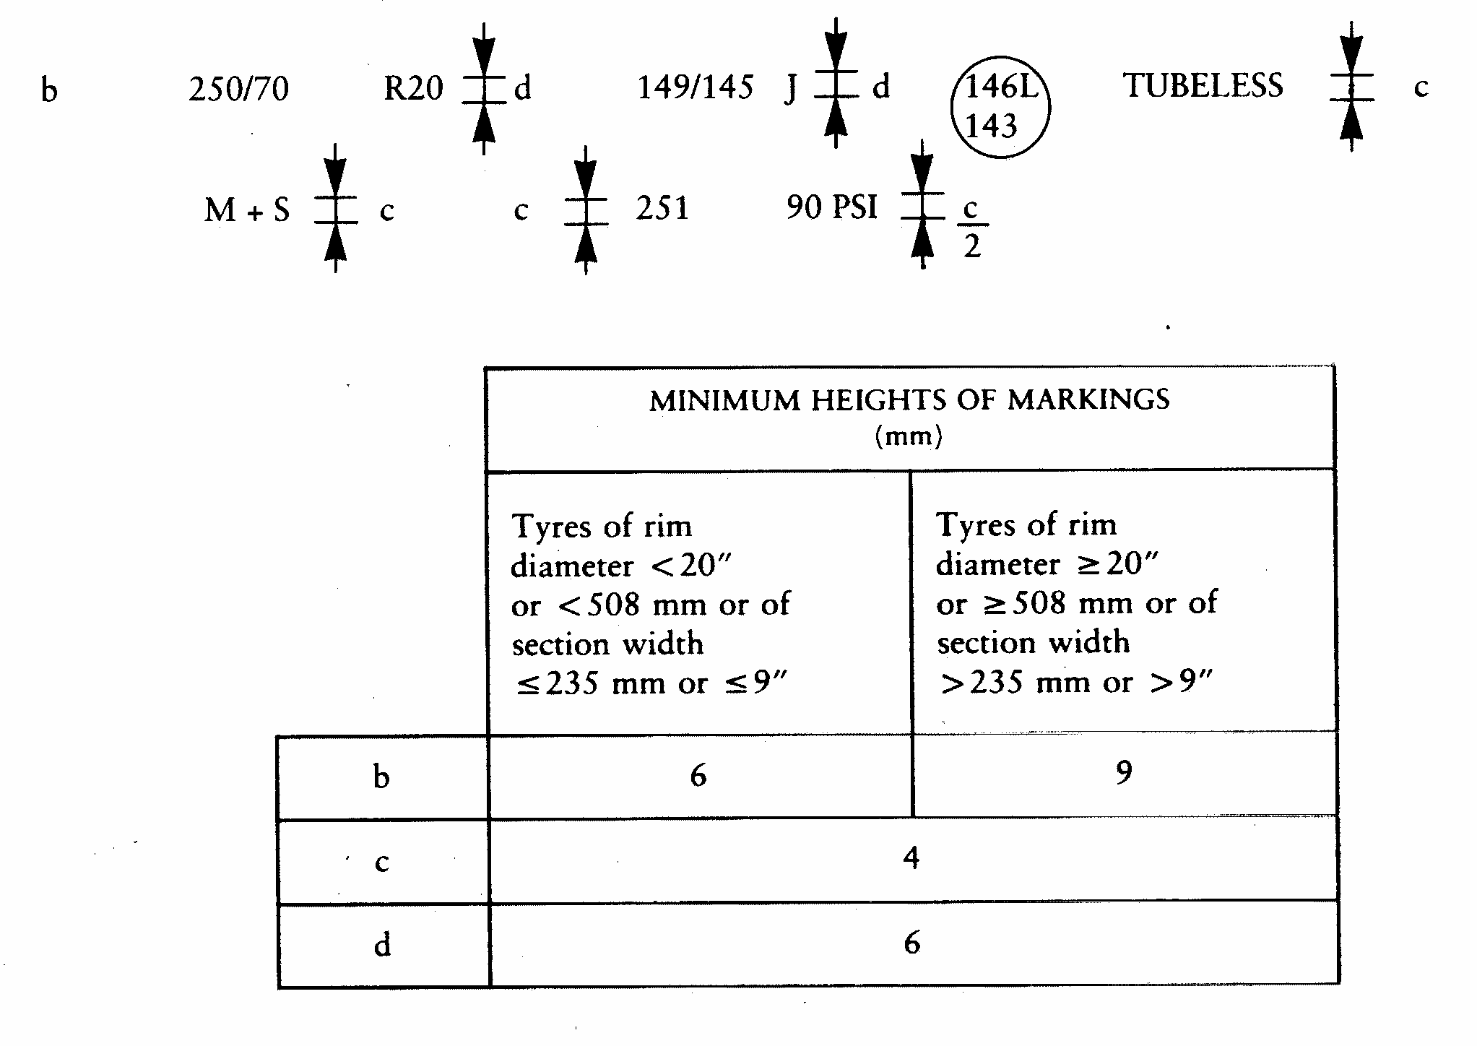
These markings define a tyre:
- having a nominal section width of 250,
- having a nominal aspect ratio of 70,
- of racial-ply structure (R),
- having a nominal rim diameter of 508 mm, for which the symbol is 20,
- having load capacities of 3 250 kg when single and 2 900 kg when twinned (dual), corresponding respectively to the load capacity indices 149 and 145 shown in Appendix 2,
- classified in the nominal speed category J (reference speed 100 km/h),
- able to be used additionally in speed category L (reference speed 120 km/h) with a load capacity of 3 000 kg when single and 2 725 kg when twinned (dual), corresponding respectively to the load capacity indices 146 and 143 shown in Appendix 2,
- for fitting without an inner tube ‘tubeless’,
- of ‘snow’ type,
- manufactured during the twenty-fifth week of the year 1991, and
- requiring to be inflated to 620 kPa for load/speed endurance tests, for which the PSI symbol is 90.
The positioning and order of the markings constituting the tyre designation are as follows:
(a) the size designation, comprising the nominal section width, the nominal aspect ratio, the type-of-structure symbol (where applicable) and the nominal rim diameter, must be grouped as shown in Ö this Õ example: 250/70 R 20;
(b) the load indices and the speed category symbol are placed together near the size designation. They may either precede or follow it or be placed above or below it;
(c) the symbols ‘tubeless’, ‘M + S’ and ‘regroovable’ may be at a distance from the size designation;
(d) if point 6.2.5 of Annex II is applied the additional load-capacity indices and speed-category symbol must be shown inside a circle near the nominal load-capacity indices and speed category symbol appearing on the tyre sidewall.
Appendix 4
RELATIONSHIP BETWEEN THE PRESSURE INDEX AND THE UNITS OF PRESSURE
(see Annex II, Appendix 7, Part B, point 1.3)
Pressure Index  (‘PSI’) | bar | kPa
20 | 1,4 | 140
25 | 1,7 | 170
30 | 2,1 | 210
35 | 2,4 | 240
40 | 2,8 | 280
45 | 3,1 | 310
50 | 3,4 | 340
55 | 3,8 | 380
60 | 4,2 | 420
65 | 4,5 | 450
70 | 4,8 | 480
75 | 5,2 | 520
80 | 5,5 | 550
85 | 5,9 | 590
90 | 6,2 | 620
95 | 6,6 | 660
100 | 6,9 | 690
105 | 7,2 | 720
110 | 7,6 | 760
115 | 7,9 | 790
120 | 8,3 | 830
125 | 8,6 | 860
130 | 9,0 | 900
135 | 9,3 | 930
140 | 9,7 | 970
145 | 10,0 | 1 000
150 | 10,3 | 1 030
Appendix 5
MEASURING RIM, OUTER DIAMETER AND SECTION WIDTH OF TYRES OF CERTAIN SIZE DESIGNATIONS
(see Annex II, points 6.1.1.2 and 6.1.2.2)

PART A: PASSENGER CAR TYRES

TABLE 1
Tyres in diagonal construction
Tyre size  designation |  | Measuring  rim width  (in inches) | Outer diameter (¹)  (in mm) | Section width (¹)  (in mm)
Super balloon series
 | 4,80-10 | 3,5 | 490 | 128
 | 5,20-10 | 3,5 | 508 | 132
 | 5,20-12 | 3,5 | 558 | 132
 | 5,60-13 | 4 | 600 | 145
 | 5,90-13 | 4 | 616 | 150
 | 6,40-13 | 4,5 | 642 | 163
 | 5,20-14 | 3,5 | 612 | 132
 | 5,60-14 | 4 | 626 | 145
 | 5,90-14 | 4 | 642 | 150
 | 6,40-14 | 4,5 | 666 | 163
 | 5,60-15 | 4 | 650 | 145
 | 5,90-15 | 4 | 668 | 150
 | 6,40-15 | 4,5 | 692 | 163
 | 6,70-15 | 4,5 | 710 | 170
 | 7,10-15 | 5 | 724 | 180
 | 7,60-15 | 5,5 | 742 | 193
 | 8,20-15 | 6 | 760 | 213
Low section series
 | 5,50-12 | 4 | 552 | 142
 | 6,00-12 | 4,5 | 574 | 156
 | 7,00-13 | 5 | 644 | 178
 | 7,00-14 | 5 | 668 | 178
 | 7,50-14 | 5,5 | 688 | 190
 | 8,00-14 | 6 | 702 | 203
 | 6,00-15 L | 4,5 | 650 | 156
Super low section series (²)
 | 155-13/6,15-13 | 4,5 | 582 | 157
 | 165-13/6,45-13 | 4,5 | 600 | 167
 | 175-13/6,95-13 | 5 | 610 | 178
 | 155-14/6,15-14 | 4,5 | 608 | 157
 | 165-14/6,45-14 | 4,5 | 626 | 167
 | 175-14/6,95-14 | 5 | 638 | 178
 | 185-14/7,35-14 | 5,5 | 654 | 188
 | 195-14/7,75-14 | 5,5 | 670 | 198
Ultra low section
 | 5,9-10 | 4,5 | 483 | 148
 | 6,5-13 | 4,5 | 586 | 166
 | 6,9-13 | 4,5 | 600 | 172
 | 7,3-13 | 5 | 614 | 184
(¹) Tolerances: see points 6.1.4 and 6.1.5 of Annex II.
(²) The following size designations are accepted:
185-14/7,35-14 or 185-14 or 7,35-14 or 7,35-14/185-14.

TABLE 2
Tyres in radial construction
Tyre size  designation | Measuring  rim width  (in inches) | Outer diameter (¹)  (in mm) | Section width (¹)  (in mm)
5,60 R 13 | 4 | 606 | 145
5,90 R 13 | 4,5 | 626 | 155
6,40 R 13 | 4,5 | 640 | 170
7,00 R 13 | 5 | 644 | 178
7,25 R 13 | 5 | 654 | 184
5,90 R 14 | 4,5 | 654 | 155
5,60 R 15 | 4 | 656 | 145
6,40 R 15 | 4,5 | 690 | 170
6,70 R 15 | 5 | 710 | 180
140 R 12 | 4 | 538 | 138
150 R 12 | 4 | 554 | 150
150 R 13 | 4 | 580 | 149
160 R 13 | 4,5 | 596 | 158
170 R 13 | 5 | 608 | 173
150 R 14 | 4 | 606 | 149
180 R 15 | 5 | 676 | 174
(¹) Tolerances: see points 6.1.4 and 6.1.5 of Annex II.

TABLE 3
Millimetric series — radial
Tyre size  designation (²) | Measuring  rim width  (in inches) | Outer diameter (¹)  (in mm) | Section width (¹)  (in mm)
125 R 10 | 3,5 | 459 | 127
145 R 10 | 4 | 492 | 147
125 R 12 | 3,5 | 510 | 178
135 R 12 | 4 | 522 | 184
145 R 12 | 4 | 542
155 R 12 | 4,5 | 550 | 155
125 R 13 | 3,5 | 536 | 127
135 R 13 | 4 | 548 | 137
145 R 13 | 4 | 566 | 147
155 R 13 | 4,5 | 578 | 157
165 R 13 | 4,5 | 596 | 167
175 R 13 | 5 | 608 | 178
185 R 13 | 5,5 | 624 | 188
125 R 14 | 3,5 | 562 | 127
135 R 14 | 4 | 574 | 137
145 R 14 | 4 | 590 | 147
155 R 14 | 4,5 | 604 | 157
165 R 14 | 4,5 | 622 | 167
175 R 14 | 5 | 634 | 178
185 R 14 | 5,5 | 650 | 188
195 R 14 | 5,5 | 666 | 198
205 R 14 | 6 | 686 | 208
215 R 14 | 6 | 700 | 218
225 R 14 | 6,5 | 714 | 228
125 R 15 | 3,5 | 588 | 127
135 R 15 | 4 | 600 | 137
145 R 15 | 4 | 616 | 147
155 R 15 | 4,5 | 630 | 157
165 R 15 | 4,5 | 646 | 167
175 R 15 | 5 | 660 | 178
185 R 15 | 5,5 | 674 | 188
195 R 15 | 5,5 | 690 | 198
205 R 15 | 6 | 710 | 208
215 R 15 | 6 | 724 | 218
225 R 15 | 6,5 | 738 | 228
235 R 15 | 6,5 | 752 | 238
175 R 16 | 5 | 686 | 178
185 R 16 | 5,5 | 698 | 188
205 R 16 | 6 | 736 | 208
(¹) Tolerances: see points 6.1.4 and 6.1.5 of Annex II.
(²) On certain tyres the rim diameter can be expressed in mm:
10″ | = | 255 |  | 12″ | = | 305 |  | 13″ | = | 330 |  | 14″ | = | 355
15″ | = | 380 |  | 16″ | = | 405 |  | (example: 125 R 225).

TABLE 4
70 Series — Radial (*)
Tyre size  designation | Measuring  rim width  (in inches) | Outer diameter (¹)  (in mm) | Section width (¹)  (in mm)
145/70 R 10 | 3,5 | 462 | 139
155/70 R 10 | 3,5 | 474 | 146
165/70 R 10 | 4,5 | 494 | 165
145/70 R 12 | 4 | 512 | 144
155/70 R 12 | 4 | 524 | 151
165/70 R 12 | 4,5 | 544 | 165
175/70 R 12 | 5 | 552 | 176
145/70 R 13 | 4 | 538 | 144
155/70 R 13 | 4 | 550 | 151
165/70 R 13 | 4,5 | 568 | 165
175/70 R 13 | 4,5 | 580 | 176
185/70 R 13 | 5 | 598 | 186
195/70 R 13 | 5,5 | 608 | 197
205/70 R 13 | 5,5 | 625 | 204
145/70 R 14 | 4 | 564 | 144
155/70 R 14 | 4 | 576 | 151
165/70 R 14 | 4,5 | 592 | 165
175/70 R 14 | 5 | 606 | 176
185/70 R 14 | 5 | 624 | 186
195/70 R 14 | 5,5 | 636 | 197
205/70 R 14 | 5,5 | 652 | 206
215/70 R 14 | 6 | 665 | 217
225/70 R 14 | 6 | 677 | 225
235/70 R 14 | 6,5 | 694 | 239
245/70 R 14 | 6,5 | 705 | 243
145/70 R 15 | 4 | 590 | 144
155/70 R 15 | 4 | 602 | 151
165/70 R 15 | 4,5 | 618 | 165
175/70 R 15 | 5 | 632 | 176
185/70 R 15 | 5 | 648 | 186
195/70 R 15 | 5,5 | 656 | 197
205/70 R 15 | 5,5 | 669 | 202
215/70 R 15 | 6 | 682 | 213
225/70 R 15 | 6 | 696 | 220
235/70 R 15 | 6,5 | 712 | 234
245/70 R 15 | 6,5 | 720 | 239
(*) Dimensional data applicable to some tyres in existence. For new approvals, dimensions calculated according to points 6.1.1.1 and 6.1.2.1 of Annex II apply.
(¹) Tolerances: see points 6.1.4 and 6.1.5 of Annex II.

TABLE 5
60 Series radial (*)
Tyre size  designation | Measuring  rim width  (in inches) | Outer diameter (¹)  (in mm) | Section width (¹)  (in mm)
165/60 R 12 | 5 | 504 | 167
165/60 R 13 | 5 | 530 | 167
175/60 R 13 | 5,5 | 536 | 178
185/60 R 13 | 5,5 | 548 | 188
195/60 R 13 | 6 | 566 | 198
205/60 R 13 | 6 | 578 | 208
215/60 R 13 | 6 | 594 | 218
225/60 R 13 | 6,5 | 602 | 230
235/60 R 13 | 6,5 | 614 | 235
165/60 R 14 | 5 | 554 | 167
175/60 R 14 | 5,5 | 562 | 178
185/60 R 14 | 5,5 | 574 | 188
195/60 R 14 | 6 | 590 | 198
205/60 R 14 | 6 | 604 | 208
215/60 R 14 | 6 | 610 | 215
225/60 R 14 | 6 | 620 | 220
235/60 R 14 | 6,5 | 630 | 231
245/60 R 14 | 6,5 | 642 | 237
265/60 R 14 | 7 | 670 | 260
185/60 R 15 | 5,5 | 600 | 188
195/60 R 15 | 6 | 616 | 198
205/60 R 15 | 6 | 630 | 208
215/60 R 15 | 6 | 638 | 216
225/60 R 15 | 6,5 | 652 | 230
235/60 R 15 | 6,5 | 664 | 236
255/60 R 15 | 7 | 688 | 255
205/60 R 16 | 6 | 654 | 208
215/60 R 16 | 6 | 662 | 215
225/60 R 16 | 6 | 672 | 226
235/60 R 16 | 6,5 | 684 | 232
(*) Dimensional data applicable to some tyres in existence. For new approvals, dimensions calculated according to points 6.1.1.1 and 6.1.2.1 of Annex II apply.
(¹) Tolerances: see points 6.1.4 and 6.1.5 of Annex II.

TABLE 6
High flotation tyres — radial
Tyre size  designation | Measuring  rim width  (in inches) | Outer diameter (¹)  (in mm) | Section width (¹)  (in mm)
27 × 8,50 R 14 | 7 | 674 | 218
30 × 9,50 R 15 | 7,5 | 750 | 240
31 × 10,50 R 15 | 8,5 | 775 | 268
31 × 11,50 R 15 | 9 | 775 | 290
32 × 11,50 R 15 | 9 | 801 | 290
33 × 12,50 R 15 | 10 | 826 | 318
(¹) Tolerances: see points 6.1.4 and 6.1.5 of Annex II.

PART B: COMMERCIAL VEHICLE TYRES

TABLE 1
Commercial vehicle tyres
RADIAL
NORMAL SECTION SIZES MOUNTED
ON 5º-TAPERED OR FLAT BASE RIMS
Tyre size  designation | Measuring-rim width  (in inches) | Outer diameter  (in mm) | Section width  (in mm)
6,50 R 20 | 5,00 | 860 | 181
7,00 R 16 | 5,50 | 784 | 198
7,00 R 18 | 5,50 | 842 | 198
7,00 R 20 | 5,50 | 892 | 198
7,50 R 16 and/or A16 or 1-16 | 6,00 | 802 | 210
7,50 R 17 and/or A17 or 1-17 | 6,00 | 852 | 210
7,50 R 20 and/or A20 or 1-20 | 6,00 | 928 | 210
8,25 R 16 and/or B16 or 2-16 | 6,50 | 860 | 230
8,25 R 17 and/or B17 or 2-17 | 6,50 | 886 | 230
8,25 R 20 and/or B20 or 2-20 | 6,50 | 962 | 230
9,00 R 16 and/or C16 or 3-16 | 6,50 | 912 | 246
9,00 R 20 and/or C20 or 3-20 | 7,00 | 1 018 | 258
10,00 R 20 and/or D20 or 4-20 | 7,50 | 1 052 | 275
10,00 R 22 and/or D22 or 4-22 | 7,50 | 1 102 | 275
11,00 R 16 | 6,50 | 980 | 279
11,00 R 20 and/or E20 or 5-20 | 8,00 | 1 082 | 286
11,00 R 22 and/or E22 or 5-22 | 8,00 | 1 132 | 286
11,00 R 24 and/or E24 or 5-24 | 8,00 | 1 182 | 286
12,00 R 20 and/or F20 or 6-20 | 8,50 | 1 122 | 313
12,00 R 22 | 8,50 | 1 174 | 313
12,00 R 24 and/or F24 or 6-24 | 8,50 | 1 226 | 313
13,00 R 20 | 9,00 | 1 176 | 336
14,00 R 20 and/or G20 or 7-20 | 10,00 | 1 238 | 370
14,00 R 22 | 10,00 | 1 290 | 370
14,00 R 24 | 10,00 | 1 340 | 370
Tolerances: see points 6.1.4 and 6.1.5 of Annex II.

TABLE 2
Commercial vehicle tyres
DIAGONAL
NORMAL SECTION SIZES MOUNTED ON
5º-TAPERED OR FLAT BASE RIMS
Tyre size  designation | Measuring-rim width  (in inches) | Outer diameter  (in mm) | Section width  (in mm)
7,00-16 | 5,50 | 774 | 198
7,00-20 | 5,50 | 898 | 198
7,50-16 and/or A16 or 1-16 | 6,00 | 806 | 210
7,50-17 and/or A17 or 1-17 | 6,00 | 852 | 210
7,50-20 and/or A20 or 1-20 | 6,00 | 928 | 213
8,25-16 and/or B16 or 2-16 | 6,50 | 860 | 234
8,25-17 and/or B17 or 2-17 | 6,50 | 895 | 234
8,25-20 and/or B20 or 2-20 | 6,50 | 970 | 234
9,00-16 | 6,50 | 900 | 252
9,00-20 and/or C20 or 3-20 | 7,00 | 1 012 | 256
9,00-24 and/or C24 or 3-24 | 7,00 | 1 114 | 256
10,00-20 and/or D20 or 4-20 | 7,50 | 1 050 | 275
10,00-22 and/or D22 or 4-22 | 7,50 | 1 102 | 275
11,00-20 and/or E20 or 5-20 | 8,00 | 1 080 | 291
11,00-22 and/or E22 or 5-22 | 8,00 | 1 130 | 291
11,00-24 and/or E24 or 5-24 | 8,00 | 1 180 | 291
12,00-18 | 8,50 | 1 070 | 312
12,00-20 and/or F20 or 6-20 | 8,50 | 1 120 | 312
12,00-22 and/or F22 or 6-22 | 8,50 | 1 172 | 312
12,00-24 and/or F24 or 6-24 | 8,50 | 1 220 | 312
13,00-20 | 9,00 | 1 170 | 342
14,00-20 and/or G20 or 7-20 | 10,00 | 1 238 | 375
14,00-22 and/or G22 or 7-22 | 10,00 | 1 290 | 375
14,00-24 and/or G24 or 7-24 | 10,00 | 1 340 | 375
15,00-20 | 11,25 | 1 295 | 412
16,00-20 | 13,00 | 1 370 | 446
Tolerances: see points 6.1.4 and 6.1.5 of Annex II.

TABLE 3
Commercial vehicle tyres
RADIAL
NORMAL SECTION SIZES
MOUNTED ON 15º-TAPERED RIMS
(DROP-CENTRE)
Tyre size  designation | Measuring-rim width  (in inches) | Outer diameter  (in mm) | Section width  (in mm)
8 R 17,5 | 6,00 | 784 | 208
8,5 R 17,5 | 6,00 | 802 | 215
9 R 17,5 | 6,75 | 820 | 230
9.5 R 17,5 | 6,75 | 842 | 240
10 R 17,5 | 7,50 | 858 | 254
11 R 17,5 | 8,25 | 900 | 279
7 R 19,5 | 5,25 | 800 | 185
8 R 19,5 | 6,00 | 856 | 208
8 R 22,5 | 6,00 | 936 | 208
9 R 19,5 | 6,75 | 894 | 230
9 R 22,5 | 6,75 | 970 | 230
9.5 R 19,5 | 6,75 | 916 | 240
10 R 19,5 | 7,50 | 936 | 254
10 R 22,5 | 7,50 | 1 020 | 254
11 R 19,5 | 8,25 | 970 | 279
11 R 22,5 | 8,25 | 1 050 | 279
11 R 24,5 | 8,25 | 1 100 | 279
12 R 19,5 | 9,00 | 1 008 | 300
12 R 22,5 | 9,00 | 1 084 | 300
13 R 22,5 | 9,75 | 1 124 | 320

TABLE 4
DIAGONAL
NORMAL SECTION SIZES
MOUNTED ON 15º-TAPERED RIMS
(DROP-CENTRE)
Tyre size  designation | Measuring-rim  width  (in inches) | Outer diameter  (in mm) | Section width  (in mm)
8-19,5 | 6,00 | 856 | 208
9-19,5 | 6,75 | 894 | 230
9-22,5 | 6,75 | 970 | 230
10-22,5 | 7,50 | 1 020 | 254
11-22,5 | 8,25 | 1 054 | 279
11-24,5 | 8,25 | 1 100 | 279
12-22,5 | 9,00 | 1 084 | 300
Tolerance: see points 6.1.4 and 6.1.5 of Annex II.

TABLE 5
Commercial vehicle tyres
RADIAL
‘WIDE BASE’ SIZES MOUNTED ON 15º-TAPERED RIMS
(DROP-CENTRE)
Tyre size  designation | Measuring-rim  width  (in inches) | Outer diameter  (in mm) | Section width  (in mm)
14 R 19,5 | 10,50 | 962 | 349
15 R 19,5 | 11,75 | 998 | 387
15 R 22,5 | 11,75 | 1 074 | 387
16,5 R 19,5 | 13,00 | 1 046 | 425
16,5 R 22,5 | 13,00 | 1 122 | 425
18 R 19,5 | 14,00 | 1 082 | 457
18 R 22,5 | 14,00 | 1 158 | 457
19,5 R 19,5 | 15,00 | 1 134 | 495
21 R 22,5 | 16,50 | 1 246 | 540

TABLE 6
DIAGONAL
‘WIDE BASE’ SIZES MOUNTED ON 15º-TAPERED RIMS
(DROP-CENTRE)
Tyre size  designation | Measuring-rim width  (in inches) | Outer diameter  (in mm) | Section width  (in mm)
15-19,5 | 11,75 | 1 004 | 387
15-22,5 | 11,75 | 1 080 | 387
16,5-19,5 | 13,00 | 1 052 | 425
16,5-22,5 | 13,00 | 1 128 | 425
18-19,5 | 14,00 | 1 080 | 457
18-22,5 | 14,00 | 1 156 | 457
19,5-19,5 | 15,00 | 1 138 | 495
21-22,5 | 16,50 | 1 246 | 540
Tolerances: see points 6.1.4 and 6.1.5 of Annex II.

TABLE 7
Commercial vehicle tyres
RADIAL
‘80’ SERIES MOUNTED ON 5º TAPERED OR FLAT-BASE RIMS
Tyre size  designation | Measuring-rim width  (in inches) | Outer diameter  (in mm) | Section width  (in mm)
12/80 R 20 | 8,50 | 1 008 | 305
13/80 R 20 | 9,00 | 1 048 | 326
14/80 R 20 | 10,00 | 1 090 | 350
14/80 R 24 | 10,00 | 1 192 | 350
14,75/80 R 20 | 10,00 | 1 124 | 370
15,5/80 R 20 | 10,00 | 1 158 | 384

TABLE 8
RADIAL
‘70’ SERIES MOUNTED ON 15º TAPERED RIMS
(DROP-CENTRE)
Tyre size  designation | Measuring-rim  width  (in inches) | Outer diameter  (in mm) | Section width  (in mm)
9/70 R 22,5 | 6,75 | 892 | 229
10/70 R 22,5 | 7,50 | 928 | 254
11/70 R 22,5 | 8,25 | 962 | 279
12/70 R 22,5 | 9,00 | 999 | 305
13/70 R 22,5 | 9,75 | 1 033 | 330

TABLE 9
RADIAL
‘80’ SERIES MOUNTED ON 15º TAPERED RIMS
(DROP-CENTRE)
Tyre size  designation | Measuring-rim  width  (in inches) | Outer diameter  (in mm) | Section width  (in mm)
12/80 R 22,5 | 9,00 | 1 046 | 305
Tolerances: see points 6.1.4 and 6.1.5 of Annex II.

TABLE 10
Commercial vehicle tyres
RADIAL
TYRES FOR LIGHT COMMERCIAL VEHICLES MOUNTED ON RIM OF
16″ DIAMETER AND OVER
Tyre size  designation | Measuring-rim  width  (in inches) | Outer diameter  (in mm) | Section width  (in mm)
6,00 R 16 C | 4,50 | 728 | 170
6,00 R 18 C | 4,00 | 782 | 165
6,50 R 16 C | 4,50 | 742 | 176
6,50 R 17 C | 4,50 | 772 | 176
6,50 R 17 LC | 4,50 | 726 | 166
6,50 R 20 C | 5,00 | 860 | 181
7,00 R 16 C | 5,50 | 778 | 198
7,50 R 16 C | 6,00 | 802 | 210
7,50 R 17 C | 6,00 | 852 | 210

TABLE 11
DIAGONAL
TYRES FOR LIGHT COMMERCIAL VEHICLES MOUNTED ON RIM OF
16″ DIAMETER AND OVER
Tyre size  designation | Measuring-rim  width  (in inches) | Outer diameter  (in mm) | Section width  (in mm)
6,00-16 C | 4,50 | 730 | 170
6,00-18 C | 4,00 | 786 | 165
6,00-20 C | 5,00 | 842 | 172
6,50-20 C | 4,50 | 748 | 176
6,50-17 LC | 4,50 | 726 | 166
6,50-20 C | 5,00 | 870 | 181
7,00-16 C | 5,50 | 778 | 198
7,00-18 C | 5,50 | 848 | 198
7,00-20 C | 5,50 | 898 | 198
7,50-16 C | 6,00 | 806 | 210
7,50-17 C | 6,00 | 852 | 210
8,25-16 C | 6,50 | 860 | 234
8,90-16 C | 6,50 | 885 | 250
9,00-16 C | 6,50 | 900 | 252
Tolerances: see points 6.1.4 and 6.1.5 of Annex II.

TABLE 12
Commercial vehicle tyres
RADIAL
TYRES FOR LIGHT COMMERCIAL VEHICLES MOUNTED ON 5º TAPERED RIMS
Rim diameter 12″ — 15″
(DROP-CENTRE)
Tyre size  designation | Measuring-rim  width  (in inches) | Outer diameter  (in mm) | Section width  (in mm)
‘Super balloon’ series
5,60 R 12 C | 4,00 | 570 | 150
6,40 R 13 C | 5,00 | 648 | 172
6,70 R 13 C | 5,00 | 660 | 180
6,70 R 14 C | 5,00 | 688 | 180
6,70 R 15 C | 5,00 | 712 | 180
7,00 R 15 C | 5,50 | 744 | 195
‘Low section’ series
6,50 R 14 C | 5,00 | 640 | 170
7,00 R 14 C | 5,00 | 650 | 180
7,50 R 14 C | 5,50 | 686 | 195
TYRES FOR LIGHT COMMERCIAL VEHICLES
MOUNTED ON 15º TAPERED RIMS
(DROP-CENTRE)
Tyre size  designation | Measuring-rim width  (in inches) | Outer diameter  (in mm) | Section width  (in mm)
7 R 17,5 C | 5,25 | 752 | 185
8 R 17,5 C | 6,00 | 784 | 208
Tolerances: see points 6.1.4 and 6.1.5 of Annex II.

TABLE 13
Commercial vehicle tyres
DIAGONAL
TYRES FOR LIGHT COMMERCIAL VEHICLES
MOUNTED ON 5º TAPERED RIMS
(DROP CENTRE)
Rim diameter 12″ — 15″
Tyre size designation | Measuring-rim  width  (in inches) | Outer diameter  (in mm) | Section width  (in mm)
‘Super balloon’ series
5,20-12 C | 3,50 | 560 | 136
5,60-12 C | 4,00 | 572 | 148
5,60-13 C | 4,00 | 598 | 148
5,90-13 C | 4,50 | 616 | 158
5,90-14 C | 4,50 | 642 | 158
5,90-15 C | 4,50 | 668 | 158
6,40-13 C | 5,00 | 640 | 172
6,40-14 C | 5,00 | 666 | 172
6,40-15 C | 5,00 | 692 | 172
6,40-16 C | 4,50 | 748 | 172
6,70-13 C | 5,00 | 662 | 180
6,70-14 C | 5,00 | 688 | 180
6,70-15 C | 5,00 | 714 | 180
‘Low section’ series
5,50-12 C | 4,00 | 552 | 142
6,00-12 C | 4,50 | 574 | 158
6,00-14 C | 4,50 | 626 | 158
6,50-14 C | 5,00 | 650 | 172
6,50-15 C | 5,00 | 676 | 172
7,00-14 C | 5,00 | 668 | 182
7,50-14 C | 5,50 | 692 | 192
‘Balloon’ series
7,00-15 C | 5,50 | 752 | 198
7,50-15 C | 6,00 | 780 | 210
‘Millimetric’ series
125-12 C | 3,50 | 514 | 127
165-15 C | 4,50 | 652 | 167
185-14 C | 5,50 | 654 | 188
195-14 C | 5,50 | 670 | 198
245-16 C | 7,00 | 798 | 248
17-15 C or | 5,00 | 678 | 178
17-380 C | 5,00 | 678 | 178
17-400 C | 19 × 400 mm | 702 | 186
19-400 C | 19 × 400 mm | 736 | 200
21-400 C | 19 × 400 mm | 772 | 216
Tolerances: see points 6.1.4 and 6.1.5 of Annex II.

TABLE 14
Commercial vehicle tyres
RADIAL
TYRES FOR LIGHT COMMERCIAL
VEHICLES MOUNTED ON 5º TAPERED RIMS (DROP-CENTRE) RIMS
‘Millimetric’ series
Tyre size designation | Measuring-rim width  (in inches) | Outer diameter  (in mm) | Section width  (in mm)
125 R 12 C | 3,50 | 510 | 127
125 R 13 C | 3,50 | 536 | 127
125 R 14 C | 3,00 | 562 | 127
125 R 15 C | 3,50 | 588 | 127
135 R 12 C | 4,00 | 522 | 137
135 R 13 C | 4,00 | 548 | 137
135 R 14 C | 4,00 | 574 | 137
135 R 15 C | 4,00 | 600 | 137
145 R 10 C | 4,00 | 492 | 147
145 R 12 C | 4,00 | 542 | 147
145 R 13 C | 4,00 | 566 | 147
145 R 14 C | 4,00 | 590 | 147
145 R 15 C | 4,00 | 616 | 147
155 R 12 C | 4,50 | 550 | 157
155 R 13 C | 4,50 | 578 | 157
155 R 14 C | 4,50 | 604 | 157
155 R 15 C | 4,50 | 630 | 157
155 R 16 C | 4,50 | 656 | 157
165 R 13 C | 4,50 | 596 | 167
165 R 14 C | 4,50 | 622 | 167
165 R 15 C | 4,50 | 646 | 167
165 R 16 C | 4,50 | 672 | 167
175 R 13 C | 5,00 | 608 | 178
175 R 14 C | 5,00 | 634 | 178
175 R 15 C | 5,00 | 660 | 178
175 R 16 C | 5,00 | 684 | 178
185 R 13 C | 5,50 | 624 | 188
185 R 14 C | 5,50 | 650 | 188
185 R 15 C | 5,50 | 674 | 188
185 R 16 C | 5,50 | 700 | 188
195 R 14 C | 5,50 | 666 | 198
195 R 15 C | 5,50 | 690 | 198
195 R 16 C | 5,50 | 716 | 198
205 R 14 C | 6,00 | 686 | 208
205 R 15 C | 6,00 | 710 | 208
205 R 16 C | 6,00 | 736 | 208
215 R 14 C | 6,00 | 700 | 218
215 R 15 C | 6,00 | 724 | 218
215 R 16 C | 6,00 | 750 | 218
225 R 14 C | 6,50 | 714 | 228
225 R 15 C | 6,50 | 738 | 228
225 R 16 C | 6,50 | 764 | 228
235 R 14 C | 6,50 | 728 | 238
235 R 15 C | 6,50 | 752 | 238
235 R 16 C | 6,50 | 778 | 238
17 R 15 C or | 5,00 | 678 | 178
17 R 380 C | 5,00 | 678 | 178
17 R 400 C | 19 × 400 mm | 698 | 186
19 R 400 C | 19 × 400 mm | 728 | 200
Tolerances: see points 6.1.4 and 6.1.5 of Annex II.

TABLE 15
Commercial vehicle tyres
DIAGONAL
WIDE-BASE TYRES FOR MULTIPURPOSE TRUCKS ON HIGHWAY, OFF-THE-ROAD AND AGRICULTURAL SERVICES
Tyre size designation | Measuring-rim width  (in inches) | Outer diameter  (in mm) | Section width  (in mm)
10,5-18 MPT | 9 | 905 | 270
10,5-20 MPT | 9 | 955 | 270
12,5-18 MPT | 11 | 990 | 325
12,5-20 MPT | 11 | 1 040 | 325
14,5-20 MPT | 11 | 1 095 | 355
14,5-24 MPT | 11 | 1 195 | 355
7,50-18 MPT | 5,50 | 885 | 208

TABLE 16
RADIAL WIDE-BASE TYRES FOR MULTIPURPOSE TRUCKS ON HIGHWAY, OFF-THE-ROAD AND AGRICULTURAL SERVICES
Tyre size designation | Measuring-rim width  (in inches) | Outer diameter  (in mm) | Section width  (in mm)
10,5 R 20 MPT | 9 | 955 | 276
12,5 R 20 MPT | 11 | 1 040 | 330
14,5 R 20 MPT | 11 | 1 095 | 362
14,5 R 24 MPT | 11 | 1 195 | 362
Tolerances: see points 6.1.4 and 6.1.5 of Annex II.

TABLE 17
Commercial vehicle tyres
RADIAL
‘FREE-ROLLING’ TYRES IN HIGHWAY SERVICE
Tyre size designation | Measuring-rim width  (in inches) | Outer diameter  (in mm) | Section width  (in mm)
5,00 R 8 | 3,00 | 467 | 132
6,00 R 9 | 4,00 | 540 | 160
7,00 R 12 | 5,00 | 672 | 192
7,50 R 15 | 6,00 | 772 | 212
8,25 R 15 | 6,50 | 836 | 234
10,00 R 15 | 7,50 | 918 | 275

TABLE 18
DIAGONAL
‘FREE-ROLLING’ TYRES IN HIGHWAY SERVICE
Tyre size designation | Measuring-rim width  (in inches) | Outer diameter  (in mm) | Section width  (in mm)
6,00-9 | 4,00 | 540 | 160
7,00-12 | 5,00 | 672 | 192
7,00-15 | 5,00 | 746 | 192
7,50-15 | 6,00 | 772 | 212
8,25-15 | 6,50 | 836 | 234
10,00-15 | 7,50 | 918 | 275
200-15 | 6,50 | 730 | 205

TABLE 19
DIAGONAL
‘75’ SERIES MOUNTED ON 15º TAPERED RIMS
Tyre size designation | Measuring-rim width  (in inches) | Outer diameter  (in mm) | Section width  (in mm)
7,25/75-16,5 or 7,25-16,5 | 5,25 | 695 | 182
8,00/75-16,5 or 8,00-16,5 | 6,00 | 724 | 203
8,75/75-16,5 or 8,75-16,5 | 6,75 | 752 | 224
9,50/75-16,5 or 9,50-16,5 | 7,50 | 781 | 245
Tolerances: see points 6.1.4 and 6.1.5 of Annex II.

TABLE 20
Commercial vehicle tyres
DIAGONAL
DIAGONAL AND RADIAL TYRES MOUNTED ON FLAT BASE OR DIVIDED RIMS
Tyre size designation | Measuring-rim width  (in inches) | Outer diameter  (in mm) | Section width  (in mm)
3,00-4 | 2,10 | 255 | 81
4,00-4 | 2,50 | 312 | 107
4,00-8 | 2,50 | 414 | 107
5,00-8 | 3,00 | 467 | 132
6,50-10 | 5,00 | 588 | 177
7,00-9 | 5,00 | 562 | 174
7,50-10 | 5,50 | 645 | 207
8,25-10 | 6,50 | 698 | 240
10,50-13 | 6,00 | 889 | 275
10,50-16 | 6,00 | 965 | 275
11,00-16 | 6,00 | 952 | 272
14,00-16 | 10,00 | 1 139 | 375
15 × 4,5-2 | 3,25 | 385 | 122
16 × 6-8 | 4,33 | 425 | 152
18 × 7-8 (¹) | 4,33 | 462 | 173
21 × 4 | 2,32 | 565 | 113
21 × 8-9 | 6,00 | 535 | 200
23 × 9-10 | 6,50 | 595 | 225
22 × 4,5 | 3,11 | 595 | 132
23 × 5 | 3,75 | 635 | 155
25 × 6 | 3,75 | 680 | 170
27 × 6 | 4,33 | 758 | 188
27 × 10-12 | 8,00 | 690 | 255
28 × 6 | 3,75 | 760 | 170
28 × 9-15 | 7,00 | 707 | 216
(8,15-15) | 7,00 | 707 | 216
29 × 7 | 5,00 | 809 | 211
29 × 8 | 6,00 | 809 | 243
9,00-15 | 6,00 | 840 | 249
2,50-15 | 7,50 | 735 | 250
3,00-15 | 8,00 | 840 | 300
(¹) Also marked 18 × 7.

RADIAL
Tyre size designation | Measuring-rim width  (in inches) | Outer diameter  (in mm) | Section width  (in mm)
6,50 R 10 | 5,00 | 588 | 177
7,00 R 15 | 5,50 | 746 | 197
7,50 R 10 | 5,50 | 645 | 207
15 × 4,5 R 8 | 3,25 | 385 | 122
16 × 6 R 8 | 4,33 | 425 | 152
18 × 7 R 8 | 4,33 | 462 | 173
560 × 165 R 11 | 5,00 | 560 | 175
680 × 180 R 15 | 5,00 | 680 | 189
Tolerances: see points 6.1.4 and 6.1.5 of Annex II.

TABLE 21
Tyres for trucks, buses, trailers and multipurpose passenger vehicles in normal highway service
DIAGONAL AND RADIAL
TYRES MOUNTED ON 5º DROP-CENTRE OR SEMI-DROP-CENTRE RIMS
Tyre size designation |  | Measuring-rim width  (in inches) | Section width  (in mm) (¹) | Outer diameter
Diagonal | Radial | Measuring-rim width  (in inches) | Section width  (in mm) (¹) | Highway tread  (in mm) (²) | Mud and snow  (in mm) (²)
6,00-16 LT | 6,00 R 16 LT | 4,50 | 173 | 732 | 743
6,50-16 LT | 6,50 R 16 LT | 4,50 | 182 | 755 | 767
6,70-15 LT | 6,70 R 15 LT | 5,00 | 191 | 722 | 733
7,00-13 LT | 7,00 R 13 LT | 5,00 | 187 | 647 | 658
7,00-14 LT | 7,00 R 14 LT | 5,00 | 187 | 670 | 681
7,00-15 LT | 7,00 R 15 LT | 5,50 | 202 | 752 | 763
7,00-16 LT | 7,00 R 16 LT | 5,50 | 202 | 778 | 788
7,10-15 LT | 7,10 R 15 LT | 5,00 | 199 | 738 | 749
7,50-15 LT | 7,50 R 15 LT | 6,00 | 220 | 782 | 794
7,50-16 LT | 7,50 R 16 LT | 6,00 | 220 | 808 | 819
8,25-16 LT | 8,25 R 16 LT | 6,50 | 241 | 859 | 869
9,00-16 LT | 9,00 R 16 LT | 6,50 | 257 | 890 | 903
D78-14 LT | DR 78-14 LT | 5,00 | 192 | 661 | 672
E78-14 LT | ER 78-14 LT | 5,50 | 199 | 667 | 678
C78-15 LT | CR 78-15 LT | 5,00 | 187 | 672 | 683
G78-15 LT | GR 78-15 LT | 6,00 | 212 | 711 | 722
H78-15 LT | HR 78-15 LT | 6,00 | 222 | 727 | 739
L78-15 LT | LR 78-15 LT | 6,50 | 236 | 749 | 760
F78-16 LT | FR 78-16 LT | 5,50 | 202 | 721 | 732
H78-16 LT | HR 78-16 LT | 6,00 | 222 | 753 | 764
L78-16 LT | LR 78-16 LT | 6,50 | 236 | 775 | 786
(¹) Overall tyre widths may exceed the above section widths by 8 %.
(²) Tolerance + 8 % of the difference between the above outer diameter and the nominal rim diameters.

TABLE 22
Tyres for trucks, buses, trailers and multipurpose passenger vehicles in normal highway service
DIAGONAL AND RADIAL
TYRES MOUNTED ON 15º DROP-CENTRE RIMS

TABLE 22.1
Tyre size designation |  | Measuring-rim width  (in inches) | Section width  (in mm) (¹) | Outer diameter
Diagonal | Radial | Measuring-rim width  (in inches) | Section width  (in mm) (¹) | Highway tread  (in mm) (²) | Mud and snow  (in mm) (²)
7-14,5 LT | — | 6,00 | 185 | 677 | —
8-14,5 LT | — | 6,00 | 203 | 707 | —
9-14,5 LT | — | 7,00 | 241 | 711 | —
7-17,5 LT | 7 R 17,5 LT | 5,25 | 189 | 758 | 769
8-17,5 LT | 8 R 17,5 LT | 5,25 | 199 | 788 | 799
(¹) Overall tyre widths may exceed the above section widths by 8 %.
(²) Tolerance + 8 % of the difference between the above outer diameters and the nominal rim diameters.

TABLE 22.2
Tyre size designation |  | Measuring-rim width  (in inches) | Section width  (in mm) (¹) | Outer diameter
Diagonal | Radial | Measuring-rim width  (in inches) | Section width  (in mm) (¹) | Highway tread  (in mm) (²) | Mud and snow  (in mm) (²)
8,00-16,5 LT | 8,00 R 16,5 LT | 6,00 | 203 | 720 | 730
8,75-16,5 LT | 8,75 R 16,5 LT | 6,75 | 222 | 748 | 759
9,50-16,5 LT | 9,50 R 16,5 LT | 6,75 | 241 | 776 | 787
10-16,5 LT | 10 R 16,5 LT | 8,25 | 264 | 762 | 773
10-17,5 LT | 10 R 17,5 LT | 8,25 | 264 | 787 | 798
12-16,5 LT | 12 R 16,5 LT | 9,75 | 307 | 818 | 831
30 × 9,50-16,5 LT | 30 × 9,50 R 16,5 LT | 7,50 | 240 | 750 | 761
31 × 10,50-16,5 LT | 31 × 10,50 R 16,5 LT | 8,25 | 266 | 775 | 787
33 × 10,50-16,5 LT | 33 × 12,50 R 16,5 LT | 9,75 | 315 | 826 | 838
37 × 10,50-16,5 LT | 37 × 14,50 R 16,5 LT | 11,25 | 365 | 928 | 939
(¹) Overall tyre widths may exceed the above section widths by 7 %.
(²) Tolerance + 8 % of the difference between the above outer diameter and the nominal rim diameters.

TABLE 23
Tyres for trucks, buses, trailers in normal highway service
DIAGONAL AND RADIAL TYRES MOUNTED ON 15º DROP-CENTRE RIMS
Tyre size designation |  | Measuring-rim width  (in inches) | Section width  (in mm) (¹) | Outer diameter
Diagonal | Radial | Measuring-rim width  (in inches) | Section width  (in mm) (¹) | Highway tread  (in mm) (²) | Heavy tread  (in mm) (²) | Mud and snow  (in mm) (²)
Normal-section tyres
7-22,5 | 7 R 22,5 | 5,25 | 178 | 878 | — | 894
8-19,5 | 8 R 19,5 | 6,00 | 203 | 859 | — | 876
8-22,5 | 8 R 22,5 | 6,00 | 203 | 935 | — | 952
9-22,5 | 9 R 22,5 | 6,75 | 229 | 974 | 982 | 992
10-22,5 | 10 R 22,5 | 7,50 | 254 | 1 019 | 1 031 | 1 038
11-22,5 | 11 R 22,5 | 8,25 | 279 | 1 054 | 1 067 | 1 037
11-24,5 | 11 R 24,5 | 8,25 | 279 | 1 104 | 1 118 | 1 123
12-22,5 | 12 R 22,5 | 9,00 | 300 | 1 085 | 1 099 | 1 104
12-24,5 | 12 R 24,5 | 9,00 | 300 | 1 135 | 1 150 | 1 155
12,5-22,5 | 12,5 R 22,5 | 9,00 | 302 | 1 085 | 1 099 | 1 104
12,5-22,5 | 12,5 R 24,5 | 9,00 | 302 | 1 135 | 1 150 | 1 155
Wide-base tyres
14-17,5 | 14 R 17,5 | 10,50 | 349 | 907 | — | 921
15-19,5 | 15 R 19,5 | 11,75 | 389 | 1 005 | — | 1 019
15-22,5 | 15 R 22,5 | 11,75 | 389 | 1 082 | — | 1 095
16,5-19,5 | 16,5 R 19,5 | 13,00 | 425 | 1 052 | — | 1 068
16,5-22,5 | 16,5 R 22,5 | 13,00 | 425 | 1 128 | — | 1 144
18-19,5 | 18 R 19,5 | 14,00 | 457 | 1 080 | — | 1 096
18-22,5 | 18 R 22,5 | 14,00 | 457 | 1 158 | — | 1 172
19,5-19,5 | 19,5 R 19,5 | 15,00 | 495 | 1 138 | — | 1 156
(¹) Overall tyre widths may exceed the above section widths by 6 %.
(²) Tolerance + 5 % of the difference between the above outer diameter and the nominal rim diameters.

TABLE 24
Tyres for trucks, buses, trailers in normal highway service
DIAGONAL AND RADIAL TYRES MOUNTED ON 5º DROP-CENTRE RIMS
Tyre size designation |  | Measuring-rim width  (in inches) | Section width  (in mm) (¹) | Outer diameter
Diagonal | Radial | Measuring-rim width  (in inches) | Section width  (in mm) (¹) | Highway tread  (in mm) (²) | Heavy tread  (in mm) (²) | Mud and snow  (in mm) (²)
— | 8R14LT | 7,00 | 216 | 667 | — | —
9-15LT | — | 8,00 | 254 | 744 | 755 | —
10-15LT | 10R15LT | 8,00 | 264 | 773 | 783 | —
10-16LT | — | 8,00 | 264 | 798 | 809 | —
11-14LT | — | 8,00 | 279 | 752 | 763 | —
11-15LT | 11R15LT | 8,00 | 279 | 777 | 788 | —
11-16LT | — | 8,00 | 279 | 803 | 813 | —
12-15LT | — | 10,00 | 318 | 823 | 834 | —
— | 9R15LT | 8,00 | 254 | 744 | 755 | 752
24 × 7,50-13LT | 24 × 7,50R13LT | 6,00 | 191 | 597 | 609 | 604
27 × 8,50-14LT | 27 × 8,50-14LT | 7,00 | 218 | 674 | 685 | 680
28 × 8,50-15LT | 28 × 8,50-15LT | 7,00 | 218 | 699 | 711 | 705
29 × 9,50-15LT | 29 × 9,50-15LT | 7,50 | 240 | 724 | 736 | 731
30 × 9,50-15LT | 30 × 9,50-15LT | 7,50 | 240 | 750 | 761 | 756
31 × 10,50-15LT | 31 × 10,50-15LT | 8,50 | 268 | 775 | 787 | 781
31 × 11,50-15LT | 31 × 11,50-15LT | 9,00 | 290 | 775 | 787 | 781
32 × 11,50-15LT | 32 × 11,50-15LT | 9,00 | 290 | 801 | 812 | 807
33 × 12,50-15LT | 33 × 12,50-15LT | 10,00 | 318 | 826 | 838 | 832
35 × 12,50-15LT | 35 × 12,50-15LT | 10,00 | 318 | 877 | 888 | 883
37 × 12,50-15LT | 37 × 12,50-15LT | 10,00 | 318 | 928 | 939 | 934
31 × 13,50-15LT | 31 × 13,50-15LT | 11,00 | 345 | 775 | 787 | 781
37 × 14,50-15LT | 37 × 14,50-15LT | 12,00 | 372 | 928 | 939 | 934
31 × 15,50-15LT | 31 × 15,50-15LT | 12,00 | 390 | 775 | 787 | 781
(¹) Overall tyre widths may exceed the above section widths by 6 %.
(²) Tolerance + 6 % of the difference between the above outer diameter and the nominal rim diameters.

TABLE 25
Tyres for trucks, buses and trailers in normal highway service
DIAGONAL AND RADIAL TYRES MOUNTED ON MULTI-PIECE BYMS
Tyre size designation |  | Measuring-rim width  (in inches) | Section width  (in mm) (¹) | Outer diameter
Diagonal | Radial | Measuring-rim width  (in inches) | Section width  (in mm) (¹) | Highway tread  (in mm) (²) | Heavy tread  (in mm) (²) | Mud and snow  (in mm) (²)
6,50-20 | 6,50R20 | 5,00 | 184 | 878 | — | 1 049
7,00-15TR | 7,00R15TR | 5,50 | 199 | 777 | — | 962
7,00-17 | 7,00R17 | 5,50 | 199 | 828 | — | 843
7,00-18 | 7,00R18 | 5,50 | 199 | 853 | — | 868
7,00-20 | 7,00R20 | 5,50 | 199 | 904 | — | 919
7,50-15TR | 7,50R15TR | 6,00 | 215 | 808 | — | 825
7,50-17 | 7,50R17 | 6,00 | 215 | 859 | — | 876
7,50-18 | 7,50R18 | 6,00 | 215 | 884 | — | 981
7,50-20 | 7,50R20 | 6,00 | 215 | 935 | — | 952
8,25-15TR | 8,25R15TR | 6,50 | 236 | 847 | 855 | 865
8,25-17 | 8,25R17 | 6,50 | 236 | 898 | 906 | 915
8,25-20 | 8,25R20 | 6,50 | 236 | 974 | 982 | 992
9,00-15TR | 9,00R15TR | 7,00 | 259 | 891 | 904 | 911
9,00-20 | 9,00R20 | 7,00 | 259 | 1 019 | 1 031 | 1 038
10,00-15TR | 10,00R15TR | 7,50 | 278 | 927 | 940 | 946
10,00-20 | 10,00R20 | 7,50 | 278 | 1 054 | 1 067 | 1 073
10,00-22 | 10,50R22 | 7,50 | 278 | 1 104 | 1 118 | 1 123
11,00-15TR | 11,00R15TR | 8,00 | 293 | 958 | 972 | 977
11,00-20 | 11,00R20 | 8,00 | 293 | 1 085 | 1 099 | 1 104
11,00-22 | 11,00R22 | 8,00 | 293 | 1 135 | 1 150 | 1 155
11,00-24 | 11,00R24 | 8,00 | 293 | 1 186 | 1 201 | 1 206
11,50-20 | 11,50R20 | 8,00 | 296 | 1 085 | 1 099 | 1 104
11,50-22 | 11,50R22 | 8,00 | 296 | 1 135 | 1 150 | 1 155
12,50-20 | 12,00R20 | 8,50 | 315 | 1 125 | — | 1 146
12,50-24 | 12,00R24 | 8,50 | 315 | 1 226 | — | 1 247
(¹) Overall tyre widths may exceed the above section widths by 6 %.
(²) Tolerance + 6 % of the difference between the above outer diameter and the nominal rim diameters.

TABLE 26
Tyres for trucks and trailers in highway service at restricted speeds
DIAGONAL AND RADIAL TYRES MOUNTED ON MULTI-PIECE RIMS
Tyre size designation |  | Measuring-rim width  (in inches) | Section width  (in mm) (¹) | Outer diameter
Diagonal | Radial | Measuring-rim width  (in inches) | Section width  (in mm) (¹) | Highway tread  (in mm) (²) | Mud and snow  (in mm) (²)
13,00-20 | 13,00R20 | 9,00 | 340 | 1 177 | 1 200
14,00-20 | 14,00R20 | 10,00 | 375 | 1 241 | 1 266
14,00-24 | 14,00R24 | 10,00 | 375 | 1 343 | 1 368
(¹) Overall tyre widths may exceed the above section widths by 6 %.
(²) Tolerance + 6 % of the difference between the above outer diameter and the nominal rim diameters.

TABLE 27
Tyres for mobile homes in highway service
DIAGONAL
Tyre size designation | Measuring-rim width  (in inches) |  | Section width  (in mm) (¹) |  | Outer diameter  (in mm) (²)
Tyres mounted on 15º drop-centre rims
7-14,5 MH |  | 6,00 |  | 185 |  | 677
8-14,5 MH |  | 6,00 |  | 203 |  | 707
9-14,5 MH |  | 7,00 |  | 241 |  | 711
Tyres mounted on 5º drop-centre and semi-drop-centre rims
7,00-15 MH |  | 5,50 |  | 202 |  | 752
(¹) Overall tyre widths may exceed the above section widths by 8 %.
(²) Tolerance + 8 % of the difference between the above outer diameter and the nominal rim diameters.

TABLE 28
Mining and logging tyres in intermittent highway service
DIAGONAL
Tyre size designation | Measuring-rim width  (in inches) | Section width  (in mm) (¹) | Outer diameter
Tyre size designation | Measuring-rim width  (in inches) | Section width  (in mm) (¹) | Traction tread  (in mm) (²) | Extra tread  (in mm) (²)
Tyres mounted on 15º drop-centre rims
7,00-20 ML | 5,50 | 199 | 919 | —
7,50-20 ML | 6,00 | 215 | 952 | —
8,25-20 ML | 6,50 | 236 | 992 | —
9,00-20 ML | 7,00 | 259 | 1 038 | 1 063
10,00-20 ML | 7,50 | 278 | 1 073 | 1 099
10,00-22 ML | 7,50 | 278 | 1 123 | 1 150
10,00-20 ML | 7,50 | 278 | 1 174 | 1 200
11,00-20 ML | 8,00 | 293 | 1 104 | 1 131
11,00-22 ML | 8,00 | 293 | 1 155 | 1 182
11,00-24 ML | 8,00 | 293 | 1 206 | 1 233
12,00-20 ML | 8,50 | 315 | 1 146 | 1 173
12,00-24 ML | 8,50 | 315 | 1 247 | 1 275
13,00-20 ML | 9,00 | 340 | 1 200 | —
13,00-24 ML | 9,00 | 340 | 1 302 | —
14,00-20 ML | 10,00 | 375 | 1 266 | —
14,00-24 ML | 10,00 | 375 | 1 368 | —
Tyres mounted on full-tapered bead seat rims
11,00-25 ML | 8,50 | 298 | 1 206 | 1 233
12,00-21 ML | 8,50 | 315 | 1 146 | 1 175
12,00-25 ML | 8,50 | 315 | 1 247 | 1 275
13,00-25 ML | 10,00 | 351 | 1 302 | —
14,00-21 ML | 10,00 | 375 | 1 266 | —
14,00-25 ML | 10,00 | 375 | 1 368 | —
Tyres mounted on 15º drop-centre rims
9-22,5 ML | 6,75 | 229 | 992 | —
10-22,5 ML | 7,50 | 254 | 1 038 | —
11-22,5 ML | 8,25 | 279 | 1 073 | —
11-24,5 ML | 8,25 | 279 | 1 123 | —
12-22,5 ML | 9,00 | 300 | 1 104 | —
Tyres mounted on 15º drop-centre rims
14-17,5 ML | 10,50 | 349 | 921 | —
15-19,5 ML | 11,75 | 389 | 1 019 | —
15-22,5 ML | 11,75 | 389 | 1 095 | —
16,5-19,5 ML | 13,00 | 425 | 1 068 | —
16,5-22,5 ML | 13,00 | 425 | 1 144 | —
18-19,5 ML | 14,00 | 457 | 1 096 | —
18-22,5 ML | 14,00 | 457 | 1 172 | —
19,5-19,5 ML | 15,00 | 495 | 1 156 | —
23-23,5 ML | 17,00 | 584 | 1 320 | —
(¹) Overall tyre widths may exceed the above section widths by 8 %.
(²) Tolerance + 6 % of the difference between the above outer diameter and the nominal rim diameters.
Appendix 6
METHOD OF MEASURING TYRE DIMENSIONS
(see Annex II point 6.1.3)

PART A: PASSENGER CAR TYRES
1.1. The tyre is mounted on the measuring rim specified by the manufacturer pursuant to point 6.11 of Annex I, Appendix 1.
1.2. The pressure in the tyre is then adjusted as follows:
1.2.1. in standard bias — belted tyres to 1,7 bar;
1.2.2. in diagonal (bias-ply) tyres to the pressure shown below (bar):
Ply-rating | Speed category
Ply-rating | L, M, N | P, Q, R, S | T, U, H, V
4 | 1,7 | 2,0 | —
6 | 2,1 | 2,4 | 2,6
8 | 2,5 | 2,8 | 3,0
1.2.3. in standard radial tyres to 1,8 bar,
1.2.4. in reinforced tyres to 2,3 bar, and
1.2.5. in T-type temporary-use spare tyres: to 4,2 bar.
2. The tyre, mounted on its rim, is conditioned at the ambient room temperature for not less than 24 hours, with the exception referred to in point 6.2.3 of Annex II.
3. The pressure is readjusted to that specified in point 1.2.
4. The overall width is measured by calliper at six equally-spaced points, account being taken of the thickness of the protective ribs or bands. The highest measurement so obtained is taken as the overall width.
5. The outer diameter is determined by measuring the maximum circumference and dividing the figure so obtained by π (3,1416).

PART B: COMMERCIAL VEHICLE TYRES
1. The tyre is mounted on the measuring rim specified by the manufacturer pursuant to point 6.11 of Appendix 1 to Annex I and is inflated to a pressure specified by the manufacturer pursuant to point 6.12 of Annex I, Appendix 1.
2. The tyre fitted on its rim is conditioned to the ambient temperature of the laboratory for at least 24 hours.
3. The pressure is readjusted to the value specified in section 1.
4. The overall width is measured by calliper at six equally-spaced points, account being taken of the thickness of the protective ribs or bands. The highest measurement so obtained is taken as the overall width.
5. The outer diameter is determined by measuring the maximum circumference and dividing the figure so obtained by π (3,1416).
Appendix 7
LOAD/SPEED TEST-PROCEDURE
(see Annex II, point 6.2)

PART A: PASSENGER CAR TYRES

1. Preparing the tyre
1.1. A new tyre is mounted on the test rim specified by the manufacturer pursuant to point 6.11 of Annex I, Appendix 1.
1.2. It is inflated to the appropriate pressure as given in the table below:
Test pressure (bar)
Speed category | Diagonal (bias-ply) tyres |  |  | Radial tyres |  | Bias-belted tyres
Speed category | Ply-rating |  |  | Standard | Reinforced | Standard
Speed category | 4 | 6 | 8 | Standard | Reinforced | Standard
L, M, N | 2,3 | 2,7 | 3,0 | 2,4 | — | —
P, Q, R, S | 2,6 | 3,0 | 3,3 | 2,6 | 3,0 | 2,6
T, U, H | 2,8 | 3,2 | 3,5 | 2,8 | 3,2 | 2,8
V | 3,0 | 3,4 | 3,7 | 3,0 | — | —
T-type temporary use spare tyres: to 4,2 bars.
1.3. The manufacturer may request, giving reasons, the use of an inflation pressure differing from those under point 1.2. In such a case the tyre is inflated to that pressure (see point 6.14 of Appendix 1 to Annex I).
1.4. The tyre-and-wheel assembly is conditioned at test-room temperature for not less than three hours.
1.5. The tyre pressure is readjusted to that specified in point 1.2 or 1.3.

2. Carrying out the test
2.1. The tyre-and-wheel assembly is mounted on a test axle and pressed against the outer face of a smooth wheel 1,70 m ± 1 % or 2 m ± 1 % in diameter.
2.2. Apply to the test axle a load equal to 80 % of:
2.2.1. the maximum load rating equated to the load capacity index for tyres with speed symbols L to H inclusive;
2.2.2. the maximum load rating associated with a maximum speed of 240 km/h for tyres with speed symbol ‘V’ (see point 2.31.2 of Annex II).
2.3. Throughout the test the tyre pressure must not be corrected and the test load must be kept constant.
2.4. During the test the temperature in the test-room must be maintained at between 20 ºC and 30 ºC or at a higher temperature if the manufacturer agrees.
2.5. The test is carried out without interruption in conformity with the following particulars:
2.5.1. time taken to pass from zero speed to initial test speed: 10 minutes;
2.5.2. initial test speed: prescribed maximum speed for the type of tyre, less 40 km/h in the case of the smooth wheel having 1,70 m ± 1 % in diameter or less 30 km/h in the case of the smooth wheel having 2 m ± 1 % in diameter;
2.5.3. successive speed increments: 10 km/h;
2.5.4. duration of test at each speed step except the last: 10 minutes;
2.5.5. duration of test at last speed step: 20 minutes;
2.5.6. maximum test speed: prescribed maximum speed for the type of tyre, less 10 km/h in the case of the smooth wheel having 1,70 m ± 1 % in diameter or equal to prescribed maximum speed in the case of the smooth wheel having 2 m ± 1 % in diameter.

3. Equivalent test methods
If a method other than that described in section 2 is used, its equivalence must be demonstrated.

PART B: COMMERCIAL VEHICLE TYRES

1. Preparing the tyre
1.1. Mount a new tyre on the test rim specified by the manufacturer pursuant to point 6.11 of Appendix 1 to Annex I.
1.2. Use a new inner tube or combination of inner tube, valve and flap (as required) when testing tyres with inner tubes.
1.3. Inflate the tyre to the pressure corresponding to the pressure index specified by the tyre manufacturer, pursuant to point 6.14 of Appendix 1 to Annex I.
1.4. Condition the tyre and wheel assembly at test room temperature for not less than three hours.
1.5. Readjust the tyre pressure to that specified in point 1.3.

2. Test procedure
2.1. Mount the tyre and wheel assembly on the test axle and press it against the outer face of a smooth power-driven test drum 1,70 m ± 1 % in diameter having a surface at least as wide as the tyre tread.
2.2. Apply to test axle a series of test loads expressed as a percentage of the load indicated in Appendix 2, opposite the load index moulded on the sidewall of the tyre, in accordance with the load/speed test programme shown in the Table below. When the tyre has load capacity indices for both single and twin utilisation, the reference load for single utilisation is taken as the basis for the test loads.
2.3. The tyre pressure must not be corrected throughout the test and the test load must be kept constant throughout each of the three test stages.
2.4. During the test the temperature in the test room must be maintained at between 20 ºC and 30 ºC or at a higher temperature if the manufacturer so agrees.
2.5. The load/speed test programme must be carried out without interruption.

3. Equivalent test methods
If a method other than that described in section 2 is used, its equivalence must be demonstrated.
LOAD/SPEED TEST PROGRAMME
Load index | Tyre speed category symbol | Test-drum speed (rev/min) (¹) |  | Load placed on the wheel as a percentage of the load corresponding to the load index
Load index | Tyre speed category symbol | Radial-ply tyre | Diagonal (bias-ply) tyre | 7 h. | 16 h. | 24 h.
122 or more | F | 100 | 100 | 66 % | 84 % | 101 %
122 or more | G | 125 | 100 | 66 % | 84 % | 101 %
122 or more | J | 150 | 125 | 66 % | 84 % | 101 %
122 or more | K | 175 | 150 | 66 % | 84 % | 101 %
122 or more | L | 200 | — | 66 % | 84 % | 101 %
122 or more | M | 225 | — | 66 % | 84 % | 101 %
121 or less | F | 100 | 100 | 66 % | 84 % | 101 %
121 or less | G | 125 | 125 | 66 % | 84 % | 101 %
121 or less | J | 150 | 150 | 66 % | 84 % | 101 %
121 or less | K | 175 | 175 | 66 % | 84 % | 101 %
121 or less | L | 200 | 175 | 70 % | 88 % | 106 %
 |  |  |  | 4 h. | 6 h. | 106 %
121 or less | M | 250 | 200 | 75 % | 97 % | 114 %
121 or less | N | 275 | — | 75 % | 97 % | 114 %
121 or less | P | 300 | — | 75 % | 97 % | 114 %
(¹) ‘Special-use’ tyres (see point 2.1.3. of Annex II) should be tested at a speed equal to 85 % of the test-drum speed prescribed above for equivalent normal tyres.
Appendix 8
VARIATION OF LOAD CAPACITY WITH SPEED
Commercial-vehicle tyres
RADIAL AND DIAGONAL
(see Annex II, points 2.30, 2.31 and 6.2.4)
Speed  (km/h) | Variation of load capacity (%)
Speed  (km/h) | All load indices |  |  |  | Load indices (¹)  ≥ 122 |  | Load indices (¹)  ≤ 121
Speed  (km/h) | Speed category symbol |  |  |  | Speed category symbol |  | Speed category symbol
Speed  (km/h) | F | G | J | K | L | M | L | M | N | P (²)
0 | + 150 | + 150 | + 150 | + 150 | + 150 | + 150 | + 110 | + 110 | + 110 | + 110
5 | + 110 | + 110 | + 110 | + 110 | + 110 | + 110 | + 90 | + 90 | + 90 | + 90
10 | + 80 | + 80 | + 80 | + 80 | + 80 | + 80 | + 75 | + 75 | + 75 | + 75
15 | + 65 | + 65 | + 65 | + 65 | + 65 | + 65 | + 60 | + 60 | + 60 | + 60
20 | + 50 | + 50 | + 50 | + 50 | + 50 | + 50 | + 50 | + 50 | + 50 | + 50
25 | + 35 | + 35 | + 35 | + 35 | + 35 | + 35 | + 42 | + 42 | + 42 | + 42
30 | + 25 | + 25 | + 25 | + 25 | + 25 | + 25 | + 35 | + 35 | + 35 | + 35
35 | + 19 | + 19 | + 19 | + 19 | + 19 | + 19 | + 29 | + 29 | + 29 | + 29
40 | + 15 | + 15 | + 15 | + 15 | + 15 | + 15 | + 25 | + 25 | + 25 | + 25
45 | + 13 | + 13 | + 13 | + 13 | + 13 | + 13 | + 22 | + 22 | + 22 | + 22
50 | + 12 | + 12 | + 12 | + 12 | + 12 | + 12 | + 20 | + 20 | + 20 | + 20
55 | + 11 | + 11 | + 11 | + 11 | + 11 | + 11 | + 17,5 | + 17,5 | + 17,5 | + 17,5
60 | + 10 | + 10 | + 10 | + 10 | + 10 | + 10 | + 15,0 | + 15,0 | + 15,0 | + 15,0
65 | + 7,5 | + 8,5 | + 8,5 | + 8,5 | + 8,5 | + 8,5 | + 13,5 | + 13,5 | + 13,5 | + 13,5
70 | + 5,0 | + 7,0 | + 7,0 | + 7,0 | + 7,0 | + 7,0 | + 12,5 | + 12,5 | + 12,5 | + 12,5
75 | + 2,5 | + 5,5 | + 5,5 | + 5,5 | + 5,5 | + 5,5 | + 11,0 | + 11,0 | + 11,0 | + 11,0
80 | 0 | + 4,0 | + 4,0 | + 4,0 | + 4,0 | + 4,0 | + 10,0 | + 10,0 | + 10,0 | + 10,0
85 | − 3 | + 2,0 | + 3,0 | + 3,0 | + 3,0 | + 3,0 | + 8,5 | + 8,5 | + 8,5 | + 8,5
90 | − 6 | 0 | + 2,0 | + 2,0 | + 2,0 | + 2,0 | + 7,5 | + 7,5 | + 7,5 | + 7,5
95 | − 10 | − 2,5 | + 1,0 | + 1,0 | + 1,0 | + 1,0 | + 6,5 | + 6,5 | + 6,5 | + 6,5
100 | − 15 | − 5 | 0 | 0 | 0 | 0 | + 5,0 | + 5,0 | + 5,0 | + 5,0
105 |  | − 8 | − 2 | 0 | 0 | 0 | + 3,75 | + 3,75 | + 3,75 | + 3,75
110 |  | − 13 | − 4 | 0 | 0 | 0 | + 2,5 | + 2,5 | + 2,5 | + 2,5
115 |  |  | − 7 | − 3 | 0 | 0 | + 1,25 | + 1,25 | + 1,25 | + 1,25
120 |  |  | − 12 | − 7 | 0 | 0 | 0 | 0 | 0 | 0
125 |  |  |  |  |  | 0 | − 2,5 | 0 | 0 | 0
130 |  |  |  |  |  | 0 | − 5 | 0 | 0 | 0
135 |  |  |  |  |  |  | − 7,5 | − 2,5 | 0 | 0
140 |  |  |  |  |  |  | − 10 | − 5 | 0 | 0
145 |  |  |  |  |  |  |  | − 7,5 | − 2,5 | 0
150 |  |  |  |  |  |  |  | − 10 | − 5 | 0
155 |  |  |  |  |  |  |  |  | − 7,5 | − 2,5
160 |  |  |  |  |  |  |  |  | − 10 | − 5
(¹) The load capacity indices refer to single operations (see point 2.28.2 of Annex II).
(²) Load variations are not allowed above 160 km/h. For speed category symbols Q and above, the speed category corresponding to the speed category symbol (see point 2.29.3 of Annex II) specifies the maximum speed permitted for the tyre.
_____________
ANNEX III
ADMINISTRATIVE PROVISIONS FOR THE Ö EC Õ TYPE-APPROVAL OF VEHICLES WITH REGARD TO THE FITTING OF THEIR TYRES

1. APPLICATION FOR THE è1 EC TYPE-APPROVAL ç OF A VEHICLE TYPE
1.1. The application for è1 EC type-approval ç of a vehicle type with regard to its tyres is submitted by the vehicle manufacturer or by his authorised representative.
1.2. It is accompanied, in triplicate, by a description of the vehicle type and of its tyres in terms of their tyre-size designation, speed category and load-capacity index, including any temporary-use spare unit(s), with which it may be fitted as described in the information document in Appendix 1.
1.3. A vehicle representative of the vehicle type to be approved must be submitted to the technical service responsible for conducting the approval tests.
1.4. The vehicle manufacturer or his representative may apply for the è1 EC type-approval ç to be extended to include tyres of additional tyre-size designations, speed categories or load-capacity indices or additional temporary-use spare unit(s).

2. è1 EC TYPE-APPROVAL ç OF A VEHICLE
2.1. è1 EC type-approval ç is granted and an è1 EC type-approval ç number issued in respect of any vehicle type submitted in accordance with section 1 which satisfied the requirements of this Directive.
2.2. Notice of approval or of extension or of refusal of approval of a vehicle type pursuant to this Directive is communicated to the Member States by means of a form conforming to the model in Appendix 2.
2.3. An approval number is assigned to each vehicle type approved. The same Member State must not assign the same number to another vehicle type.

3. MODIFICATION OF VEHICLE TYPE
3.1. Every modification of a vehicle type must be notified to the approval authority which approved it. That approval authority may then either:
3.1.1. consider that the modifications made are unlikely to have an appreciable adverse effect and that in any case the vehicle still meets the requirements; or
3.1.2. refuse to approve the modification.
3.2. Confirmation or refusal of approval, specifying the alterations, is communicated to the other Member States by the procedure specified in point 2.2.

4. CONFORMITY OF PRODUCTION
4.1. Every production vehicle to which this Directive applies must be so manufactured that it conforms to all of the relevant requirements of this Directive.
4.2. In order to verify that the requirements of point 4.1 are met, suitable controls of the production must be carried out.
4.3. The holder of the approval must in particular ensure the existence of procedures for effectively checking on compatibility between the characteristics of the vehicle and the characteristics of the tyres fitted as laid down within the framework of this Directive.
4.4. The approval authority which has granted type-approval may at any time verify the conformity control methods applicable to each production unit.
4.4.1. In every inspection, the test books and productions survey records must be presented to the visiting inspector.
4.5. The normal frequency of inspections authorised by the approval authority is one per year. In the case where negative results are recorded during one of these visits, the approval authority must ensure that all necessary steps are taken to re-establish the conformity of production as rapidly as possible.

5. PRODUCTION DEFINITIVELY DISCONTINUED
If the holder of an approval completely ceases to manufacture a type of vehicle approved in accordance with this Directive, he must so inform the authority which granted the approval. Upon receiving the relevant communication that authority must inform thereof the other approval authorities by means of a copy of the approval form bearing at the end, in large letters, the signed and dated annotation ‘PRODUCTION DISCONTINUED’.

ê 92/23/EEC (adapted)
è1 2001/43/EC Art. 1 pt. 1
Appendix 1
INFORMATION DOCUMENT No...
(vehicle)
IN ACCORDANCE WITH ANNEX I TO DIRECTIVE 2007/46/EC OF THE EUROPEAN PARLIAMENT AND OF THE COUNCIL RELATING TO è1 EC TYPE-APPROVAL ç OF A VEHICLE TYPE WITH REGARD TO THE FITTING OF ITS TYRES
(Directive […])
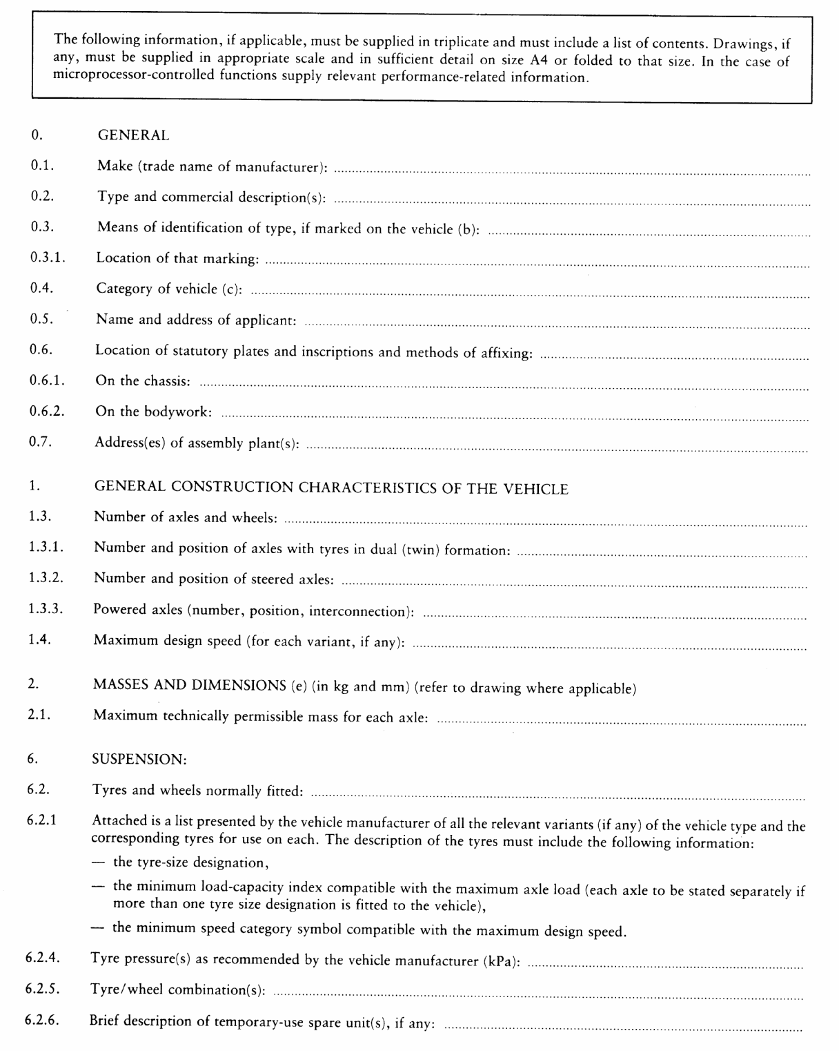

Appendix 2
MODEL
(maximum format: A4 (210 × 297 mm))
è1 EC TYPE-APPROVAL ç CERTIFICATE
(vehicle)
Stamp of
Administration
Communication concerning the:
- Ö EC Õ type-approval⁽¹⁾,
- extension of Ö EC Õ type-approval⁽¹⁾,
- refusal of Ö EC Õ type-approval⁽¹⁾,
of a type of vehicle with regard to Directive […] .
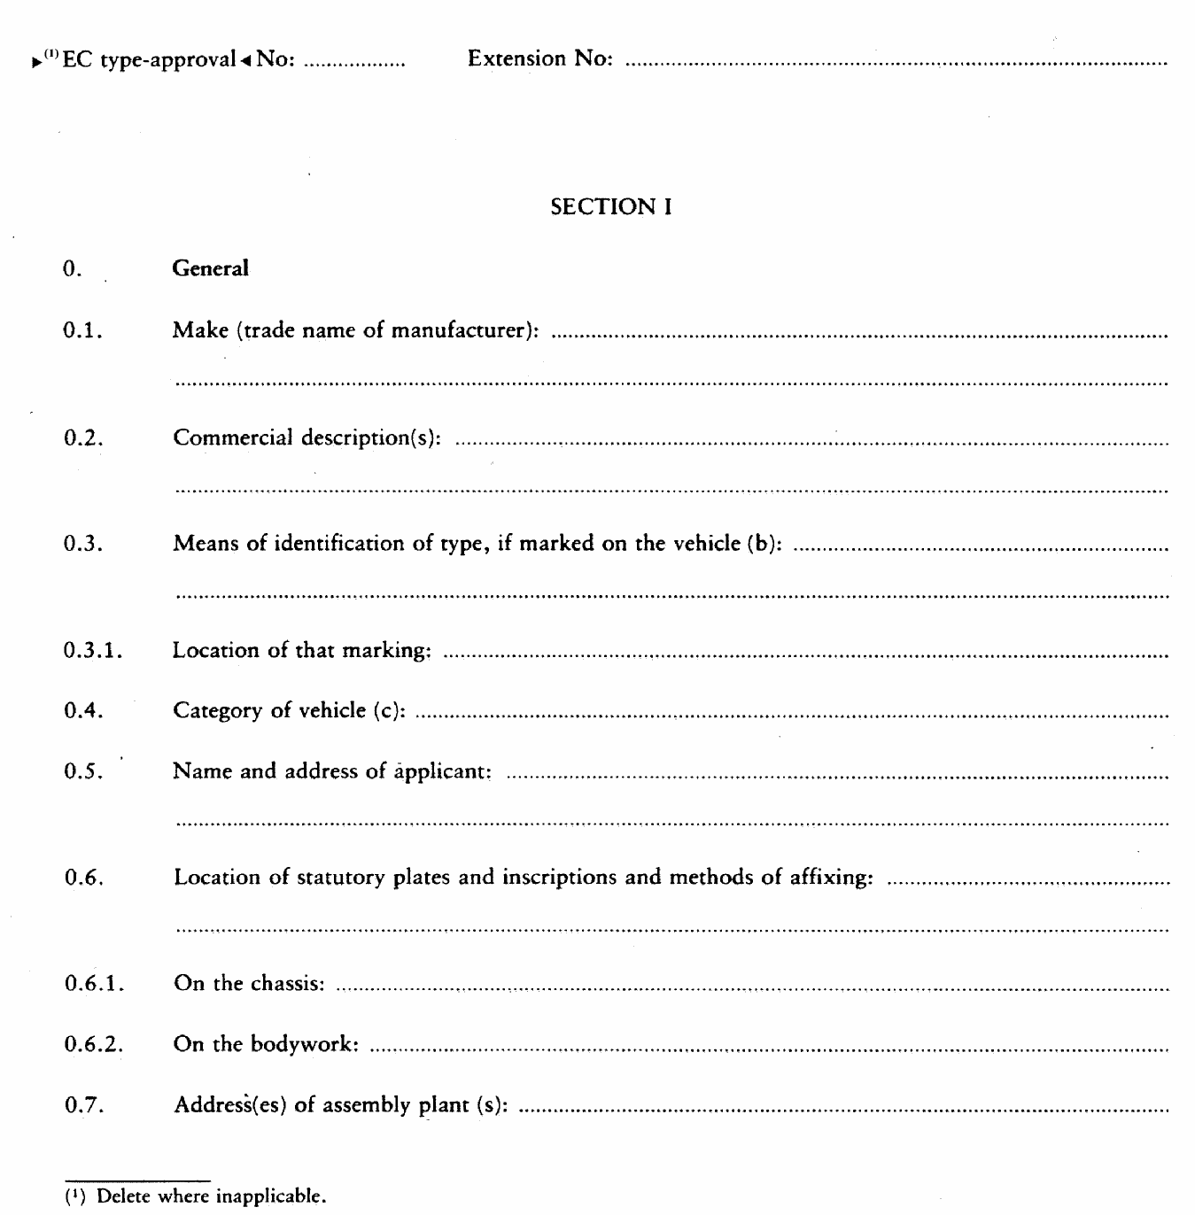

è1 ç
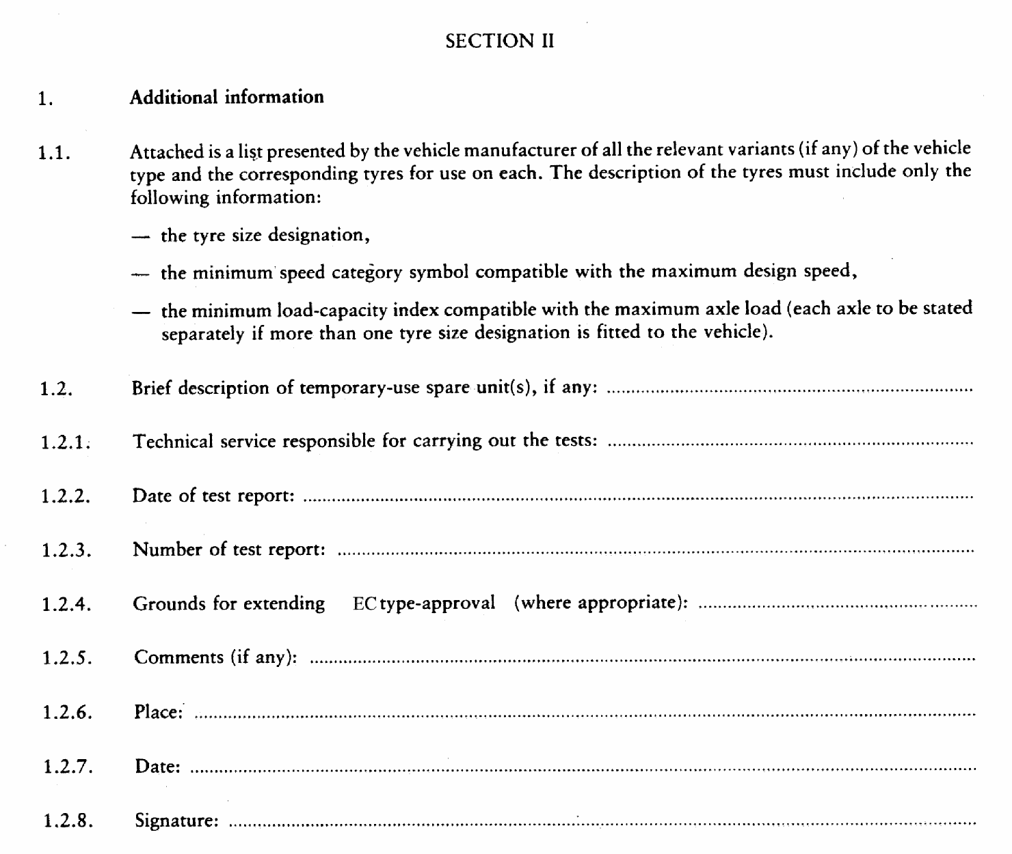
1.2.9. A list of documents making up the Ö EC Õ type-approval file lodged with the approval authority that has granted Ö EC Õ type-approval, which may be obtained on request, is attached.
_____________
ANNEX IV
REQUIREMENTS FOR VEHICLES WITH REGARD TO THE FITTING OF THEIR TYRES

1. DEFINITIONS

2. For the purpose of this Directive:
2.1. ‘approval of a vehicle’ means the approval of a vehicle type with regard to its tyres, including temporary-use spare tyres;
2.2. ‘vehicle type’ means a range of vehicles which do not differ significantly, at least as regards each variant of the vehicle type, in such essential aspects as would affect the tyre size designation, the speed category symbol or the load capacity index:
2.3. ‘wheel’ means a complete wheel consisting of a rim and a wheel disc;
2.4. ‘temporary-use spare wheel’ means a wheel different from one of the normal wheels on the vehicle type;
2.5. ‘unit’ means an assembly of a wheel and tyre;
2.6. ‘normal unit’ means a unit which is capable of being fitted to the vehicle for normal operation;
2.7. ‘spare unit’ means a unit which is intended to be exchanged for a normal unit in case of malfunction of the latter. A ‘spare unit’ may be either of the following:
2.7.0. ‘normal spare unit’, which is a unit that conforms to the normal unit of the vehicle type;
2.7.1. ‘temporary-use spare unit’, which is a unit that differs from the normal units of the vehicle type with regard to their principal characteristics (e.g. their tyre-size designation, functional dimensions, conditions of use or structure). It is intended for temporary use under restricted conditions. Temporary-use spare units may be of the following categories:

2.7.1.1. category 1
a unit consisting of a wheel which conforms to a wheel of a normal unit and a tyre which has principal characteristics (e.g. dimensions, structure) different to the normal tyre;

2.7.1.2. category 2
a unit consisting of a wheel and a tyre both having principal characteristics different to the normal unit and intended to be carried on the vehicle with the tyre inflated to the pressure specified for temporary use;

2.7.1.3. category 3
a unit consisting of a normal wheel and a tyre having principal characteristics different to a normal tyre and intended to be carried on the vehicle with the tyre folded and not inflated;

2.7.1.4. category 4
a unit consisting of a wheel and tyre both having principal characteristics different to a normal unit and intended to be carried on the vehicle with the tyre folded and not inflated;
2.8. ‘maximum mass’ means the maximum value stated by the vehicle manufacturer to be technically permissible for the vehicle;
2.9. ‘maximum axle load’ means the maximum value stated by the vehicle manufacturer to be technically permissible for the total vertical force between the contact surfaces of the tyres of the axle in question and the ground and resulting from the part of the vehicle mass supported by that axle. The sum of the axle loads may be greater than the value corresponding to the maximum mass of the vehicle;
2.10. ‘functional dimensions’ means dimensions derived from the size designation of the wheels and/or tyres (e.g. diameter, width, aspect ratio) and from the mounting of the unit to the vehicle (e.g. wheel offset);
2.11. ‘maximum design speed’ means the maximum speed approved for the vehicle type inclusive of the tolerance allowed for the conformity checks of the series production.

3. REQUIREMENTS FOR VEHICLES WITH REGARD TO THE FITTING OF THEIR TYRES

3.1. General

ê 2001/43/EC Art. 1 pt. 5 and Annex pt. 7
3.1.1. Subject to the provisions of point 3.7.4., every tyre fitted to a vehicle, including where applicable any spare, must bear the EC type-approval mark(s) as specified in section 4 of Annex I or the type-approval mark indicating compliance with UN/ECE Regulations Nos. 30 or 54. UN/ECE type-approval marks are considered to be equivalent only to the EC type-approval marks granted pursuant to Annex II.

ê 92/23/EEC

3.2. Tyre fitment
3.2.1. All of the tyres fitted to a vehicle, excluding any temporary use spare, must have the same structure (see Annex II point 2.3).
3.2.2. All of the tyres fitted to one axle must be of the same type (see Annex II point 2.1).
3.2.3. The space in which the wheel revolves must be such as to allow unrestricted movement when using the maximum permissible size of tyres within the suspension and steering constraints provided by the vehicle manufacturer.

3.3. Load capacity
3.3.1. Subject to the provisions of point 3.7, the maximum load rating (see Annex II point 2.31) of every tyre, including a spare tyre (if provided) with which a vehicle is fitted is:
3.3.1.1. in the case of a vehicle fitted with tyres of the same type in single formation: at least equal to half of the maximum axle load (see point 2.9) for the most heavily loaded axle, as declared by the manufacturer of the vehicle;
3.3.1.2. in the case of a vehicle fitted with tyres of more than one type, in single formation: at least equal to half of the maximum axle load (see point 2.9), as declared by the manufacturer of the vehicle, in respect of the relevant axle;
3.3.1.3. in the case of a vehicle fitted with passenger car tyres in dual (twin) formation: at least equal to 0,27 times the maximum axle load, as declared by the manufacturer of the vehicle, in respect of the relevant axle;
3.3.1.4. in the case of axles fitted with commercial vehicle tyres in dual (twin) formation: at least equal to 0,25 times, with reference to the load capacity index for dual application, the maximum axle load as declared by the manufacturer of the vehicle, in respect of the relevant axle.

3.4. Speed capacity
3.4.1. Every tyre with which a vehicle is normally fitted must have a speed category symbol (see Annex II, point 2.29) compatible with the maximum design speed of the vehicle (as declared by the vehicle manufacturer) or the applicable load/speed combination (see Annex II, point 2.30).
3.4.2. The above specification does not apply:
3.4.2.1. in the case of temporary use spare units for which point 3.8 applies;
3.4.2.2. in the case of vehicles normally equipped with ordinary tyres and occasionally supplied with snow tyres.
However, in this case the speed category symbol of the snow tyres must correspond to a speed either greater than the maximum design speed of the vehicle (as declared by the vehicle manufacturer) or not less than 160 km/h (or both).
If, nevertheless, the maximum design speed of the vehicles (as declared by the vehicle manufacturer) is greater than the speed corresponding to the speed category symbol of the snow tyres a maximum speed warning label, specifying the maximum speed capability of the snow tyres, must be displayed inside the vehicle in a prominent position readily visible to the driver.

3.5. Spare tyre
3.5.1. In the case where a vehicle is provided with a spare wheel its tyre must be:
3.5.1.1. the same type as one of the tyres fitted to or approved for the vehicle, or
3.5.1.2. a temporary-use spare tyre of a type suitable for use on the vehicle, in any position. However, no vehicle other than a vehicle of category M₁ may be fitted with a temporary-use spare tyre.
3.5.2. Every vehicle provided with a temporary-use spare unit must be provided with supplementary information clearly and permanently displayed on the temporary-use spare unit or on the vehicle near the spare unit or in the driver's handbook. At least the following information must be given:
3.5.2.1. an instruction to drive with caution when the temporary-use spare unit is fitted, and to install a normal unit as soon as possible;
3.5.2.2. a statement that operation of the vehicle is not permitted with more than one temporary-use spare unit fitted at the same time;
3.5.2.3. a clear indication of the inflation pressure specified by the vehicle manufacturer for the tyre of the temporary-use spare unit;
3.5.2.4. for vehicles equipped with category 3 or category 4 temporary-use spare units, a description of the procedure for inflating the tyre to the pressure specified for temporary use by means of the device referred to in point 3.6;

3.6. Inflating device of temporary-use spare unit:
3.6.1. if the vehicle is equipped with a category 3 or category 4 temporary-use spare unit, a device must be provided on the vehicle which permits the tyre to be inflated to the pressure specified for temporary use within a maximum of five minutes.

3.7. Special cases
3.7.1. In the case of trailers of categories 01 and 02 with operating speeds restricted to 100 km/h or less fitted with passenger car tyres in single formation, the maximum load rating of every tyre must be at least equal to 0,45 times the maximum mass for the most heavily loaded axle, as declared by the manufacturer of the trailer. For tyres in dual (twin) formation this factor is 0,24.
3.7.2. In the case of some special vehicles fitted with commercial vehicle tyres, the table ‘Variation of Load Capacity with Speed’ (see point 2.30 and Appendix 8 to Annex II) is not to be applied. In those cases the tyre maximum load ratings to check against the maximum axle loads (see points 3.3.1.2 and 3.3.1.4 of this Annex) are determined by multiplying the load corresponding to the load capacity index by an appropriate coefficient which is related to the type of vehicle and its use rather than to the maximum design speed of the vehicle. In such cases point 3.4.1 of this Annex does not apply. The appropriate coefficients are as follows:
3.7.2.1. 1,10 in the case of vehicles of category M3 when the vehicle is carrying standing passengers and the operating speed does not exceed 60 km/h. However, for operational reasons Member States may allow the operating speed to be increased to 80 km/h;
3.7.2.2. 1,15 in the case of such vehicles (M3) if they are intended for use only on urban routes with frequent stops;
3.7.2.3. 1,10 in the case of public utility vehicles of category N used at slow speeds over short distances in urban and suburban applications such as road sweepers or refuse collectors.
3.7.3. When a motor vehicle of category M1 is towing a trailer, the additional load imposed at the trailer coupling device may cause the tyre maximum load ratings to be exceeded, but not by more than 15 %, provided that the operating speed is restricted to 100 km/h or less and the inflation pressure increased by at least 0,2 bar is applied.
3.7.4. In the case of a vehicle which is fitted with tyres which are not passenger car tyres nor commercial vehicle tyres due to special conditions of use (e.g. agricultural tyres, industrial truck tyres, motor cycle tyres) the requirements of Annex II do not apply provided that the approval authority is satisfied that the tyres fitted are suitable for the operating conditions of the vehicle.

3.8. Specifications for temporary-use spare units
3.8.1. Every temporary-use spare tyre must have a speed category at least equal to 120 km/h (speed category symbol L).
3.8.2. When fitted to the vehicle for temporary use the outward facing surface of the wheel must exhibit a distinctive colour or colour pattern which is clearly different from the colour(s) of the normal units. If it is possible to attach a wheel cover to the temporary-use spare unit the distinctive colour or colour pattern must not be obscured by this wheel cover.
3.8.3. A maximum speed warning symbol must be permanently displayed on the outer face of the wheel in a prominent position and in accordance with the diagram below:
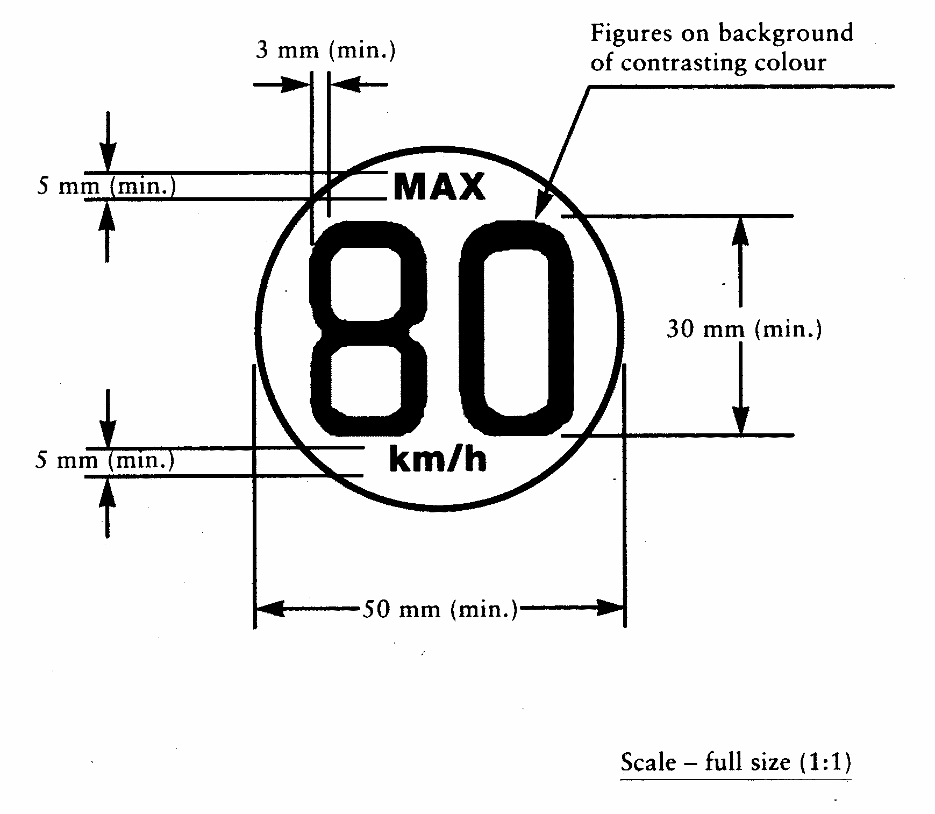
_____________

ê 2001/43/EC Art. 1 pt. 5 and Annex pt. 8
ANNEX V
TYRE/ROAD NOISE EMISSION

1. SCOPE
This Annex applies to the EC type-approval of tyres, as components, in respect of tyre/road noise emissions.

2. DEFINITIONS
For the purposes of this Annex, the definitions of Annex II shall apply, except for the definition under point 2.1., which shall read as follows:
2.1. ‘Type of tyre’
means, in relation to type-approval pursuant to this Annex (tyre/road noise emission), a range of tyres consisting of a list of tyre size designations (see point 2.17 in Annex II), brand names, trade marks and trade descriptions which do not differ in such essential characteristics as:
- the manufacturer's name
- the tyre classification (see point 2.4. of this Annex)
- the tyre structure (see point 2.1.4. of Annex II)
- the category of use (see point 2.1.3. of Annex II)
- for class C1 tyres. Reinforced or Extra Load
- the tread pattern (see 2.3 of Information Document, Annex I, Appendix 3).
Note: The effect of changes in minor details of tyre tread and construction on the tyre/road noise emission will be determined during checks on the conformity of production.
In addition, the following definitions shall also apply:
2.2. ‘Brand name or trade description’
means the identification for the tyre as provided by the tyre manufacturer. The brand name may be the same as the manufacturer and the trade description may coincide with the trade mark.
2.3. ‘Tyre/road noise emission’
means the noise arising from the contact between tyres in motion and the road surface.
2.4. For the purpose of this Annex, the following classification shall apply:
class C1 tyres | passenger car tyres (see point 2.32. of Annex II);
class C2 tyres | commercial vehicle tyres (see point 2.33. of Annex II) with load capacity index in single formation ≤ 121 and speed category symbol ≥ ‘N’ (see point 2.29.3. of Annex II);
class C3 tyres | commercial vehicle tyres (see point 2.33. of Annex II) with load capacity index in single formation ≤ 121 and speed category symbol ≤ ‘M’ (see point 2.29.3. of Annex II) or commercial vehicle tyres (see point 2.33. of Annex II) with load capacity index in single formation ≥ 122.

3. MARKING REQUIREMENTS
3.1. In addition to other marking requirements given in section 4 of Annex I and section 3 of Annex II, the tyre must bear the following markings:
3.1.1. the manufacturer's name or trade mark; the brand name, the trade description or the trade mark.

4. TYRE/ROAD NOISE EMISSION REQUIREMENTS

4.1. General requirements
A set of four tyres bearing the same tyre size designation and tread pattern that is representative of the range of tyres, shall be submitted to a tyre/road noise emission level test to be carried out as specified in Appendix 1.
4.2. The noise levels determined in accordance with point 4.5 of Appendix 1 shall not exceed the following limits:
4.2.1. Class C1 tyres, with reference to the nominal section width (see Annex II, point 2.17.1.1.) of the tyre that has been tested:
 |  | Limit values in dB(A)
Tyre Class | Nominal section width  (in mm) | A | B (¹) | C (¹) (²)
C1a | ≤ 145 | 72 (*) | 71 (*) | 70
C1b | > 145 ≤ 165 | 73 (*) | 72 (*) | 71
C1c | > 165 ≤ 185 | 74 (*) | 73 (*) | 72
C1d | > 185 ≤ 215 | 75 (**) | 74 (**) | 74
C1e | > 215 | 76 (***) | 75 (***) | 75
(*) Limit values in column A shall apply until 30 June 2007; Limit values in column B shall apply as from 1 July 2007.
(**) Limit values in column A shall apply until 30 June 2008; Limit values in column B shall apply as from 1 July 2008.
(***) Limit values in column A shall apply until 30 June 2009; Limit values in column B shall apply as from 1 July 2009.
(¹) Indicative figures only. Definitive figures will depend on amendment of this Directive following the report required in Article 3(2) of Directive 2001/43/EC.
(²) Limit values for column C will result from the amendment of this Directive following the report required in Article 3(2) of Directive 2001/43/EC.
4.2.1.1. For reinforced (or Extra Load) tyres (see Annex II, point 3.1.8.), the limit values in point 4.2.1. shall be increased by 1 dB(A)
4.2.1.2. For tyres classified in category of use ‘Special’, (see Annex II, point 2.1.3.), the limit values in point 4.2.1. shall be increased by 2 dB(A).
4.2.2. Class C2 tyres with reference to the category of use (see Annex II, point 2.1.3.) of the range of tyres:
Category of use | Limit value expressed in  dB(A)
Normal | 75
Snow | 77
Special | 78
4.2.3. Class C3 tyres, with reference to the category of use (see Annex II, point 2.1.3.) of the range of tyres:
Category of use | Limit value expressed  in dB(A)
Normal | 76
Snow | 78
Special | 79
Appendix 1
TEST METHOD FOR TYRE-ROAD SOUND LEVELS, COAST-BY METHOD

0. Introduction
The presented method contains specifications on measuring instruments, measurement conditions and the measurement method, in order to obtain the noise level of a set of tyres mounted on a test vehicle rolling at high speed on a specified road surface. The maximum sound pressure level is to be recorded, when the test vehicle is coasting, by remote-field microphones; the final result of a reference speed is obtained from a linear regression analysis. Such test results cannot be related to tyre noise measured during acceleration under power or deceleration during braking.

1. Measuring instruments

1.1. Acoustic measurements
The sound level meter or the equivalent measuring system, including the windscreen recommended by the manufacturer, shall at least meet the requirements of Type 1 instruments in accordance with IEC 60651, second edition.
The measurements shall be made using the frequency weighting A, and the time weighting F.
When using a system that includes a periodic monitoring of the A-weighted sound level, a reading should be made at a time interval not greater than 30 ms.

ê 2001/43/EC Art. 1 pt. 5 and Annex pt. 8 (adapted)

1.1.1. Calibration
At the beginning and at the end of every measurement session, the entire measurement system shall be checked by means of a sound calibrator that fulfils the requirements for sound calibrators of at least precision Class 1 according to IEC 942:1988. Without any further adjustment the difference between the readings of two consecutive checks shall be less than or equal to 0,5 dB. If this value is exceeded, the results of the measurements obtained after the previous satisfactory check shall be discarded.

ê 2001/43/EC Art. 1 pt. 5 and Annex pt. 8

1.1.2. Compliance with requirements
The compliance of the sound calibration device with the requirements of IEC 60942:1988 shall be verified once a year and the compliance of the instrumentation system with the requirements of IEC 60651:1979/A1:1993, second edition, shall be verified at least every two years by a laboratory which is authorised to perform calibrations traceable to the appropriate standards.

1.1.3. Positioning of the microphone
The microphone (or microphones) must be located at a distance of 7,5 m ± 0,05 m from track reference line CC′ (figure 1) and 1,2 m ± 0,02 m above the ground. Its axis of maximum sensitivity must be horizontal and perpendicular to the path of the vehicle (line CC′).

1.2. Speed measurements
The vehicle speed shall be measured with instruments with an accuracy of ± 1 km/h or better when the front end of the vehicle has reached line PP′ (figure 1).

1.3. Temperature measurements
Measurements of air as well as test surface temperature are mandatory. The temperature measuring devices shall be accurate within ± 1 ºC.

1.3.1. Air temperature
The temperature sensor is to be positioned in an unobstructed location close to the microphone in such a way that it is exposed to the airflow and protected from direct solar radiation. The latter may be achieved by any shading screen or similar device. The sensor should be positioned at a height of 1,2 m ± 0,1 m above the test surface level in order to minimise the influence of the test surface thermal radiation at low airflows.

1.3.2. Test surface temperature
The temperature sensor is to be positioned in a location where the temperature measured is representative of the temperature in the wheel tracks, without interfering with the sound measurement.
If an instrument with a contact temperature sensor is used, heat-conductive paste shall be applied between the surface and the sensor to ensure adequate thermal contact.
If a radiation thermometer (pyrometer) is used, the height should be chosen to ensure that a measuring spot with a diameter of ≥ 0,1 m is covered.

1.4. Wind measurement
The device must be capable of measuring the wind speed with a tolerance of ± 1 m/s. The wind shall be measured at microphone height. The wind direction with reference to the driving direction shall be recorded.

2. Conditions of measurement

2.1. Test site
The test site must consist of a central section surrounded by a substantially flat test area. The measuring section must be level; the test surface must be dry and clean for all measurements. The test surface shall not be artificially cooled during or prior to the testing.
The test track must be such that the conditions of a free sound field between the sound source and the microphone are attained to within 1 dB(A). These conditions shall be deemed to be met if there are no large sound reflecting objects such as fences, rocks, bridges or buildings within 50 m of the centre of the measuring section. The surface of the test track and the dimensions of the test site shall be in accordance with Appendix 2 of this Annex.
A central part of at least 10 m radius shall be free of powdery snow, tall grass, loose soil, cinders or the like. There must be no obstacle which could affect the sound field within the vicinity of the microphone and no persons shall stand between the microphone and the sound source. The operator carrying out the measurements and any observers attending the measurements must position themselves so as not to affect the readings of the measuring instruments.

2.2. Meteorological conditions
Measurements shall not be made under poor atmospheric conditions. It must be ensured that the results are not affected by gusts of wind. Testing shall not be performed if the wind speed at the microphone height exceeds 5 m/s.
Measurements shall not be made if the air temperature is below 5 ºC or above 40 ºC or the test surface temperature is below 5 ºC or above 50 ºC.

2.3. Ambient noise
The background sound level (including any wind noise) shall be at least 10 dB(A) less than the measured tyre-road sound emission. A suitable windscreen may be fitted to the microphone provided that account is taken of its effect on the sensitivity and directional characteristics of the microphone.
Any measurement affected by a sound peak which appears to be unrelated to the characteristics of the general sound level of tyres shall be ignored.

2.4. Test vehicle requirements

2.4.1. General
The test vehicle shall be a motor vehicle and be fitted with four single tyres on just two axles.

2.4.2. Vehicle load
The vehicle must be loaded such as to comply with the test tyre loads as specified in point 2.5.2. .

2.4.3. Wheelbase
The wheelbase between the two axles fitted with the test tyres shall for Class C1 be less than 3,50 m and for Class C2 and Class C3 tyres be less than 5 m.

2.4.4. Measures to minimise vehicle influence on sound level measurements
To ensure that tyre noise is not significantly affected by the test vehicle design the following requirements and recommendations are given.
Requirements:
(a) Spray suppression flaps or other extra device to suppress spray shall not be fitted.
(b) Addition or retention of elements in the immediate vicinity of the rims and tyres, which may screen the emitted sound, is not permitted.
(c) Wheel alignment (toe in, camber and castor) shall be in full accordance with the vehicle manufacturer's recommendations.
(d) Additional sound absorbing material may not be mounted in the wheel housings or under the underbody.
(e) Suspension shall be in such a condition that it does not result in an abnormal reduction in ground clearance when the vehicle is loaded in accordance with the testing requirement. If available, body level regulation systems shall be adjusted to give a ground clearance during testing which is normal for unladen conditions.
Recommendations to avoid parasitic sound:
(a) Removal or modification of components on the vehicle that any contribute to the background sound of the vehicle is recommended. Any removals or modifications shall be recorded in the test report.
(b) During testing it should be ascertained that brakes are not poorly released, causing brake noise.
(c) It should be ascertained that electric cooling fans are not operating.
(d) Windows and sliding roof of the vehicle shall be closed during testing.

2.5. Tyres

2.5.1. General
Four identical tyres of the same type and range must be fitted to the test vehicle. In the case of tyres with a load capacity index in excess of 121 and without any dual fitting indication, two of these tyres of the same type and range must be fitted to the rear axle of the test vehicle; the front axle must be fitted with tyres of a size suitable for the axle load and planed down to the minimum depth in order to minimise the influence of tyre/road contact noise while maintaining a sufficient level of safety. Winter tyres that in certain Member States may be equipped with studs intended to enhance friction shall be tested without this equipment. Tyres with special fitting requirements shall be tested in accordance with these requirements (e.g. rotation direction). The tyres must have full tread depth before being run-in.
Tyres are to be tested on rims permitted by the tyre manufacturer.

2.5.2. Tyre loads
The test load Q_{t} for each tyre on the test vehicle shall be 50 % to 90 % of the reference load Q_{r}, but the average test load Q_{t,avr} of all tyres shall be 75 % ± 5 % of the reference load Q_{r}.
For all tyres the reference load Q_{r} corresponds to the maximum mass associated with the load capacity index of the tyre. In the case where the load capacity index is constituted by two numbers divided by slash (/), reference shall be made to the first number.

2.5.3. Tyre inflation pressure
Each tyre fitted on the test vehicle shall have a test pressure P_{t} not higher than the reference pressure P_{r} and within the interval:
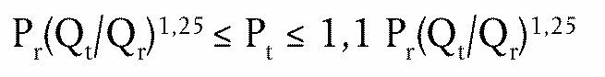
where P_{r} is the pressure corresponding to the pressure index marked on the sidewall.
For Class C1 the reference pressure is P_{r} = 250 kPa for ‘standard’ tyres and 290 kPa for ‘reinforced’ tyres, the minimum test pressure shall be P_{t} = 150 kPa.

2.5.4. Preparations prior to testing
The tyres should be ‘run-in’ prior to testing to remove compound nodules or other tyre pattern characteristics resulting from the moulding process. This will normally require the equivalent of about 100 km of normal use on the road.
The tyres fitted to the test vehicle shall rotate in the same direction as when they were run-in.
Prior to testing tyres shall be warmed up by running under test conditions.

3. Method of testing

3.1. General conditions
For all measurements the vehicle must be driven in a straight line over the measuring section (AA′ to BB′) in such a way that the median longitudinal plane of the vehicle is as close as possible to the line CC′.
When the front end of the test vehicle has reached the line AA′, the vehicle's driver must have put the gear selector on neutral position and switched off the engine. If abnormal noise (e.g. ventilator, self-ignition) is emitted by the test vehicle during the measurement, the test must be repeated.

3.2. Nature and number of measurements
The maximum sound level expressed in A-weighted decibels (dB(A)) shall be measured to the first decimal place as the vehicle is coasting between lines AA′ and BB′ (figure 1 — front end of the vehicle on line AA′, rear end of the vehicle on line BB'). This value will constitute the result of the measurement.
At least four measurements shall be made on each side of the test vehicle at test speeds lower than the reference speed specified in paragraph 4.1. and at least four measurements at test speeds higher than the reference speed. The speeds shall be approximately equally spaced over the speed range specified in paragraph 3.3.

3.3. Test speeds
The test vehicle speeds shall be within the range:
(i) from 70 km/h to 90 km/h for Class C1 and Class C2 tyres;
(ii) from 60 km/h to 80 km/h for Class C3 tyres.

4. Interpretation of results
The measurement shall be invalid if an abnormal discrepancy between the maximum value and the other values is recorded.

4.1. Determination of test result
Reference speed V_{ref} used to determine the final result will be:
(i) 80 km/h for Class C1 and Class C2 tyres;
(ii) 70 km/h for Class C3 tyres.

4.2. Regression analysis of noise measurements
The (not temperature corrected) tyre-road noise level L_{R} in dB(A) is determined by a regression analysis according to:
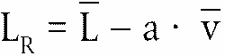
where:
is the mean value of the noise levels L_{i}, measured in dB(A):
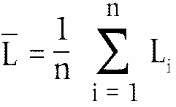
n is the measurement number (n ≥ 16),
 is the mean value of logarithms of speeds v_{i}:
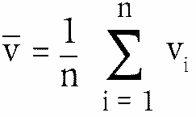
With
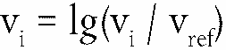
a is the slope of the regression line in dB(A):
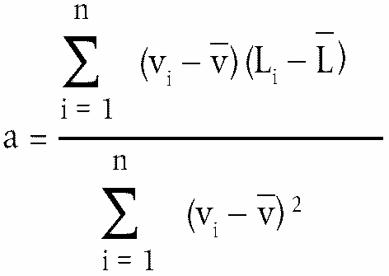

4.3. Temperature correction

ê 2001/43/EC Art. 1 pt. 5 and Annex pt. 8 (adapted)
For Ö Class C1 and Õ Class C2 tyres, the final result shall be normalised to a test surface reference temperature θ _{ref} by applying a temperature correction, according to the following:
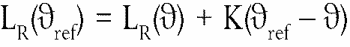
where θ is the measured test surface temperature,
θ_{ref} = 20 ºC,
For Class C1 tyres, the coefficient K is – 0,03 dB(A)/ºC when θ > θ_{ref} and K is – 0,06 dB(A)/ºC when θ < θ_{ref}.
For Class C2 tyres, the coefficient K is – 0,02 dB(A)/ºC.

ê 2001/43/EC Art. 1 pt. 5 and Annex pt. 8
If the measured test surface temperature does not change by more than 5 ºC within all measurements necessary for the determination of the sound level of one set of tyres, the temperature correction may be made only on the final reported tyre-road sound level as indicated above, utilising the arithmetic mean value of the measured temperatures. Otherwise each measured sound level L_{i} shall be corrected, utilising the temperature at the time of the sound recording.
There will be no temperature correction for Class C3 tyres.
4.4. In order to take account of any measuring instrument inaccuracies, the results according to point 4.3. shall be reduced by 1 dB(A).
4.5. The final result, the temperature corrected tyre-road noise level L_{R}(θ_{ref}) in dB(A), shall be rounded down to the nearest lower whole value.
Figure 1:
Microphone Positions for the Measurement
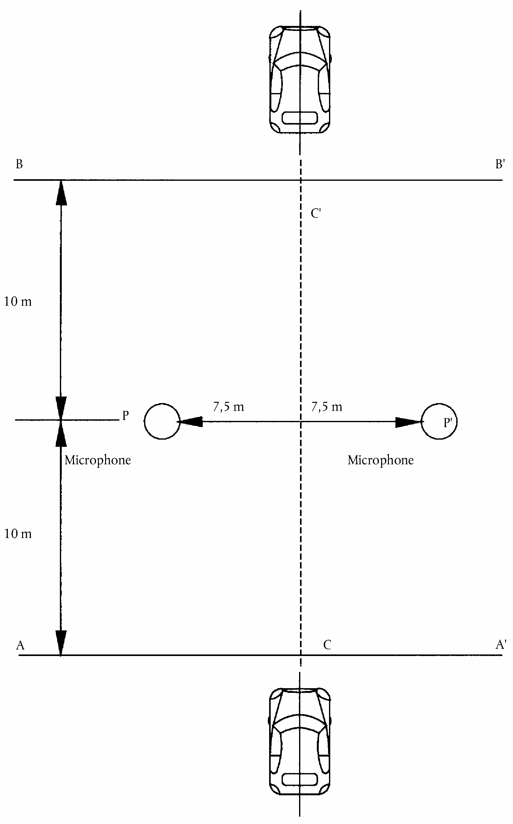
Appendix 2
TEST REPORT
The test report shall include the following information:
(a) meteorological conditions inclusive of air and test surface temperature for each test run,
(b) date and method of check on compliance of the test surface with ISO 10844:1994,
(c) test rim width,
(d) tyre data: manufacturer, brand name, trade name, size, load index, reference pressure,
(e) test vehicle description and wheelbase,
(f) type test load Q_{t} in N and in per cent of the reference load Q_{r} for each test tyre, average test load Q_{t,avr} in N and in per cent of the reference load Q_{r},
(g) cold inflation pressure in kPa for each test tyre,
(h) test speeds when the vehicle passed line PP′,
(i) maximum A-weighted sound levels for each test run and each microphone,
(j) the test result L_{R}: A-weighted sound level in decibel at reference speed, corrected for temperature (if applicable), rounded down to the nearest lower whole value.
(k) regression line slope.
_____________

ê 2001/43/EC Art. 1 pt. 5 and Annex pt. 9 (adapted)
ANNEX VI
SPECIFICATIONS FOR THE TEST SITE

1. Introduction
This Annex describes the specifications relating to the physical characteristics and the laying of the test track. These specifications based on a special standard describe the required physical characteristics as well as the test methods for these characteristics.

2. Required characteristics of the surface
A surface is considered to conform to this standard provided that the texture and voids content or sound absorption coefficient have been measured and found to fulfil all the requirements of points 2.1. to 2.4. and provided that the design requirements (point 3.2.) have been met.

2.1. Residual voids content
The residual voids content (VC) of the test track paving mixture shall not exceed 8 %. For the measurement procedure, see point 4.1.

2.2. Sound absorption coefficient
If the surface fails to comply with the residual voids content requirement, the surface is acceptable only if its sound absorption coefficient α ≤ 0,10. For the measurement procedure, see point 4.2. The requirement of points 2.1. and 2.2. is also met if only sound absorption has been measured and found to be α ≤ 0,10.
Note: The most relevant characteristic is the sound absorption, although the residual voids content is more familiar among road constructors. However, sound absorption needs to be measured only if the surface fails to comply with the voids requirement. This is justified because the residual voids content has relatively large uncertainties in terms of both measurements and relevance and some surfaces may therefore erroneously be rejected when based only on the voids measurement.

2.3. Texture depth
The texture depth (TD) measured according to the volumetric method (see point 4.3. ) shall be:
TD ≥ 0,4 mm

2.4. Homogeneity of the surface
Every practical effort shall be taken to ensure that the surface is made to be as homogeneous as possible within the test area. This includes the texture and voids content, but it should also be observed that if the rolling process results in more effective rolling at some places than others, the texture may be different and unevenness causing bumps may also occur.

2.5. Period of testing
In order to check whether the surface continues to conform to the texture and voids content or sound absorption requirements stipulated in this Annex, periodic testing of the surface shall be carried out at the following intervals:
(a) For residual voids content (VC) or sound absorption (α):
when the surface is new;
if the surface meets the requirements when new, no further periodical testing is required. If it does not meet the requirement when it is new, it may do so later because surfaces tend to become clogged and compacted with time.
(b) For texture depth (TD):
when the surface is new;
when the noise testing starts (NB: not before four weeks after laying);
then every twelve months.

3. Test surface design

3.1. Area
When designing the test track layout it is important to ensure that, as a minimum requirement, the area traversed by the vehicles running through the test strip is covered with the specified test material with suitable margins for safe and practical driving. This will require that the width of the track is at least 3 m and the length of the track extends beyond lines AA and BB by at least 10 m at either end. Figure 1 shows a plan of a suitable test site and indicates the minimum area which shall be machine laid and machine compacted with the specified test surface material. According to Annex V, Appendix 1, point 3.2., measurements have to be made on each side of the vehicle. This can be made either by measuring with two microphone locations (one on each side of the track) and driving in one direction, or measuring with a microphone only on one side of the track but driving the vehicle in two directions. If the latter method is used, then there are no surface requirements on that side of the track where there is no microphone.
Figure 1
Minimum requirements for test surface area
The shaded part is called ‘Test Area’.
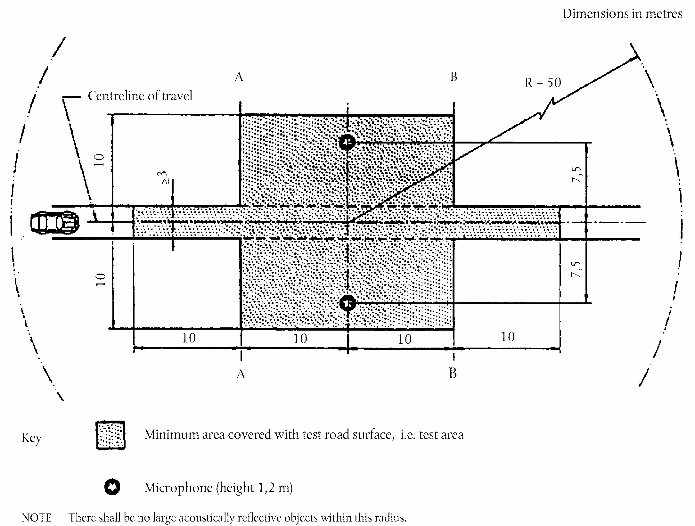

3.2. Design and preparation of the surface

3.2.1. Basic design requirements
The test surface shall meet four design requirements:
3.2.1.1. It shall be a dense asphaltic concrete.
3.2.1.2. The maximum chipping size shall be 8 mm (tolerances allow from 6,3 mm to 10 mm).
3.2.1.3. The thickness of the wearing course shall be ≥ 30 mm.
3.2.1.4. The binder shall be a straight penetration grade bitumen without modification.

3.2.2. Design guidelines
As a guide to the surface constructor, an aggregate grading curve which will give desired characteristics is shown in Figure 2. In addition, Table 1 gives some guidelines in order to obtain the desired texture and durability. The grading curve fits the following formula:
P (% passing) = 100(d/d_{max})1/2
where:
d | = | square mesh sieve size, in mm
d_{max} | = | 8 mm for the mean curve
 | = | 10 mm for the lower tolerance curve
 | = | 6,3 mm for the upper tolerance curve
Figure 2:
Grading curve of the aggregate in the asphaltic mix with tolerances
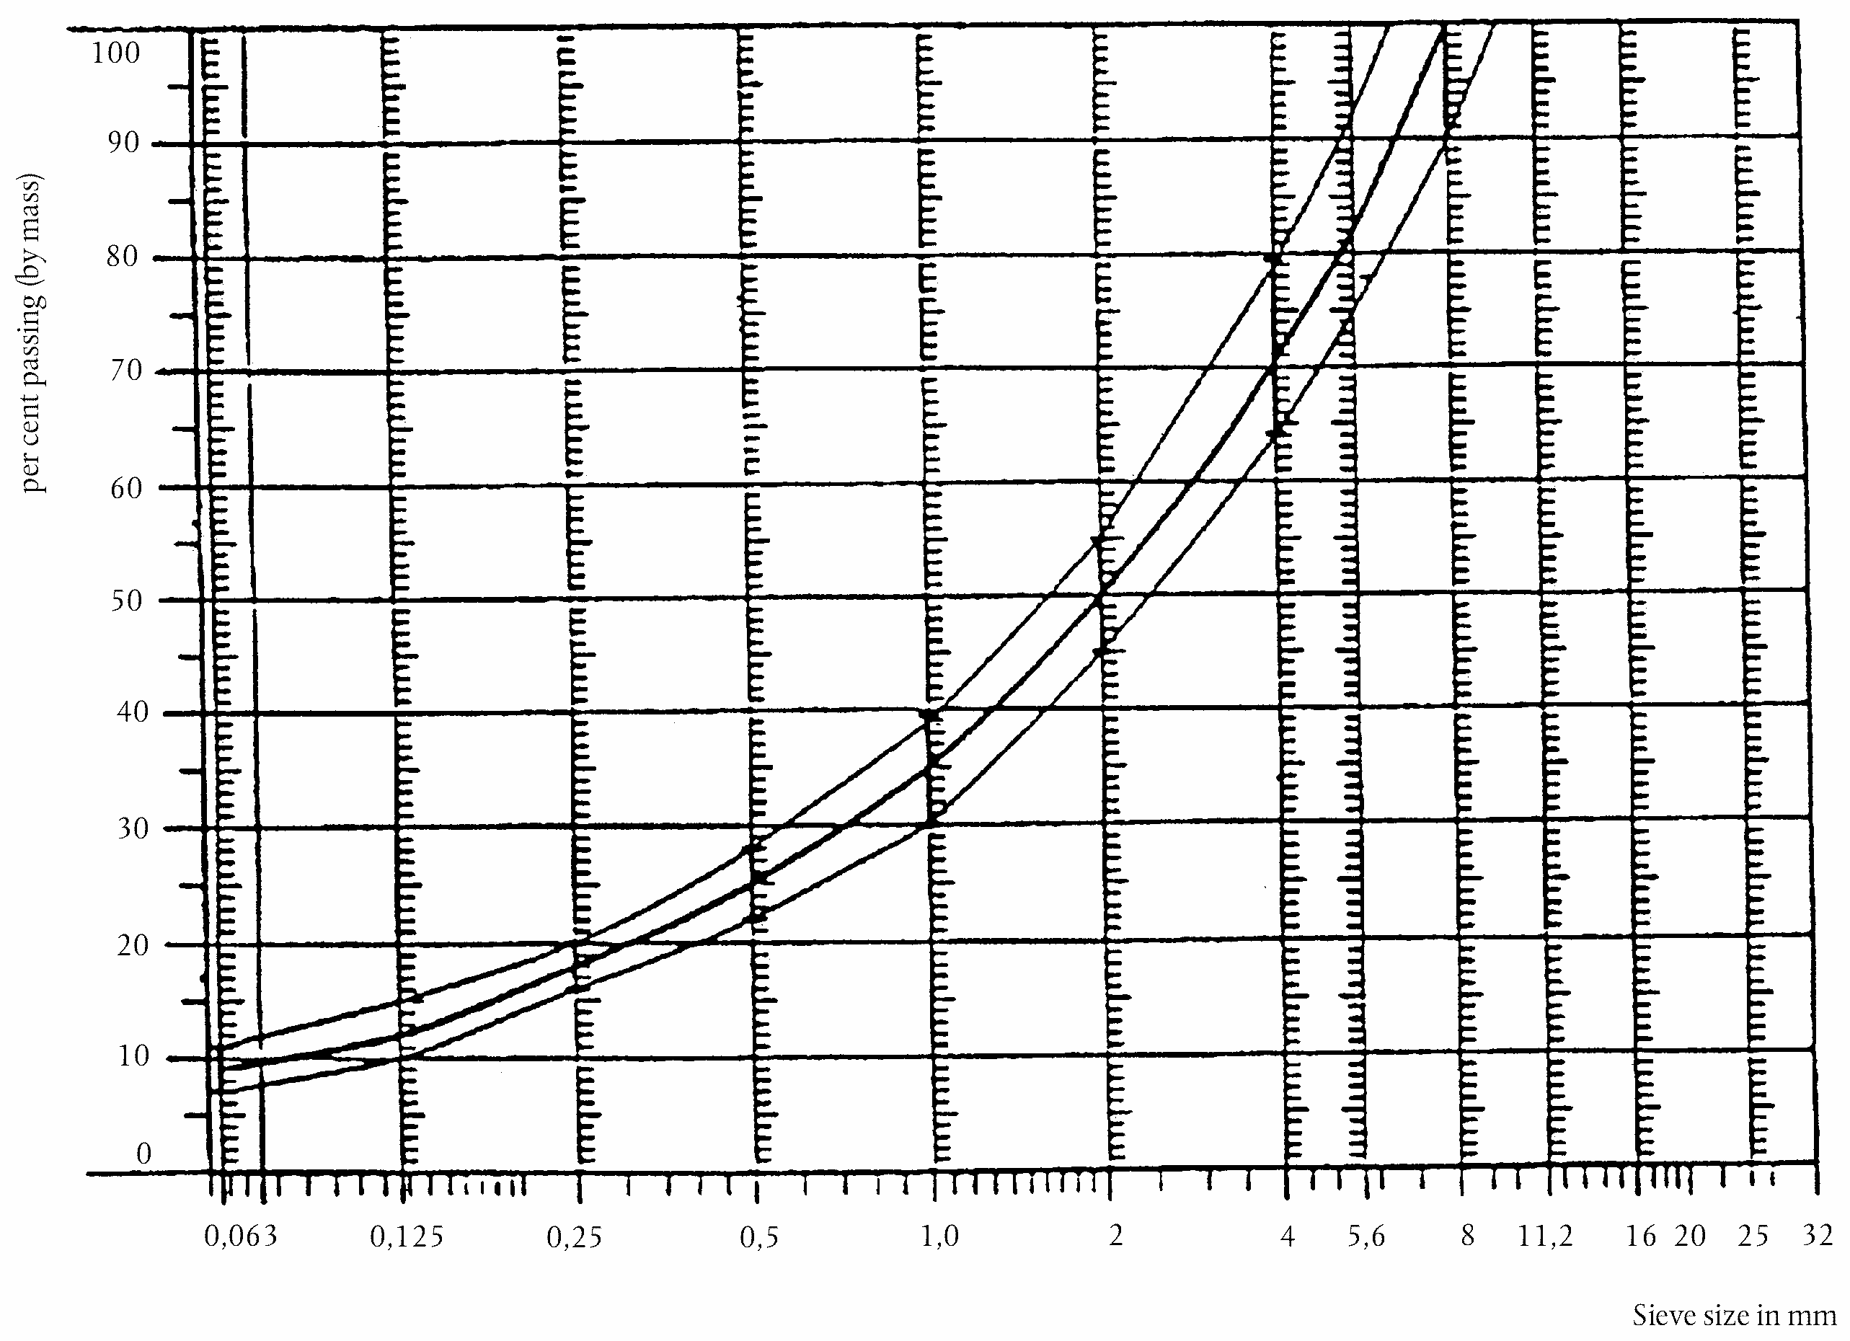
In addition to the above, the following recommendations are made:
(a) The sand fraction (0,063 mm < square mesh sieve size < 2 mm) shall include no more than 55 % natural sand and at least 45 % crushed sand.
(b) The base and sub-base shall ensure a good stability and evenness, according to best road construction practice.
(c) The chippings shall be crushed (100 % crushed faces) and of a material with a high resistance to crushing.
(d) The chippings used in the mix shall be washed.
(e) No extra chippings shall be added onto the surface.
(f) The binder hardness expressed as PEN value shall be 40-60, 60-80 or even 80-100 depending on the climatic conditions of the country. The rule is that as hard a binder as possible shall be used, provided this is consistent with common practice.
(g) The temperature of the mix before rolling shall be chosen so as to achieve by subsequent rolling the required voids content. In order to increase the probability of satisfying the specifications of points 2.1. to 2.4., the compactness shall be studied not only by an appropriate choice of mixing temperature, but also by an appropriate number of passings and by the choice of compacting vehicle.
Table 1
Design guidelines
 | Target values |  | Tolerances
 | By total mass of mix | By mass of the aggregate | Tolerances
Mass of stones, square mesh sieve (SM) > 2 mm | 47,6 % | 50,5 % | ± 5
Mass of sand 0,063 < SM < 2 mm | 38,0 % | 40,2 % | ± 5
Mass of filler SM <0,063 mm | 8,8 % | 9,3 % | ± 2
Mass of binder (bitumen) | 5,8 % | N.A. | ± 0,5
Max. chipping size | 8 mm |  | 6,3 – 10
Binder hardness | (see point 3.2.2. (f))
Polished stone value (PSV) | > 50
Compactness, relative to Marshall compactness | 98 %

4. Test method

4.1. Measurement of the residual voids content
For the purpose of this measurement, cores have to be taken from the track in at least four different positions which are equally distributed in the test area between lines AA and BB (see figure 1). In order to avoid non-homogeneity and unevenness in the wheel tracks, cores should not be taken in wheel tracks themselves, but close to them. Two cores (minimum) should be taken close to the wheel tracks and one core (minimum) should be taken approximately midway between the wheel tracks and each microphone location.
If there is a suspicion that the condition of homogeneity is not met (see point 2.4.), cores shall be taken from more locations within the test area.
The residual voids content has to be determined for each core, then the average value from all cores shall be calculated and compared with the requirement of point 2.1. In addition, no single core shall have a voids value which is higher than 10 %.
The test surface constructor is reminded of the problem which may arise when the test area is heated by pipes or electrical wires and cores must be taken from this area. Such installations must be carefully planned with respect to future core drilling locations. It is recommended to leave a few locations of size approximately 200 mm × 300 mm where there are no wires/pipes or where the latter are located deep enough in order not to be damaged by cores taken from the surface layer.

4.2. Sound absorption coefficient
The sound absorption coefficient (normal incidence) shall be measured by the impedance tube method using the procedure specified in ISO 10534-1:1996: ‘Acoustics — Determination of sound absorption coefficient and impedance by a tube method’.
Regarding test specimens, the same requirements shall be followed as regarding the residual voids content (see point 4.1). The sound absorption shall be measured in the range between 400 Hz and 800 Hz and in the range between 800 Hz and 1 600 Hz (at least at the centre frequencies of third octave bands) and the maximum values shall be identified for both of these frequency ranges. Then these values, for all test cores, shall be averaged to constitute the final result.

4.3. Volumetric macrotexture measurement
For the purpose of this standard, texture depth measurements shall be made on at least 10 positions evenly spaced along the wheel tracks of the test strip and the average value taken to compare with the specified minimum texture depth. See Standard ISO 10844:1994 for description of the procedure.

5. Stability in time and maintenance

5.1. Age influence
In common with any other surfaces, it is expected that the tyre-road noise level measured on the test surface may increase slightly during the first 6 — 12 months after construction.
The surface will achieve its required characteristics not earlier than four weeks after construction. The influence of age on the noise from trucks is generally less than that from cars.
Stability over time is determined mainly by polishing and compaction by vehicles driving on the surface. It shall be periodically checked as stated in point 2.5.

5.2. Maintenance of the surface
Loose debris or dust which could significantly reduce the effective texture depth must be removed from the surface. In countries with winter climates, salt is sometimes used for de-icing. Salt may alter the surface temporarily or even permanently in such a way as to increase noise and is therefore not recommended.

5.3. Repaving the test area
If it is necessary to repave the test track, it is usually unnecessary to repave more than the test strip (of 3 m width in figure 1) where vehicles are driving, provided the test area outside the strip met the requirement of residual voids content or sound absorption when it was measured.

6. Documentation of the test surface and of tests performed on it

6.1. Documentation of the test surface
The following data shall be given in a document describing the test surface:
6.1.1. The location of the test track.
6.1.2. Type of binder, binder hardness, type of aggregate, maximum theoretical density of the concrete (DR), thickness of the wearing course and grading curve determined from cores from the test track.
6.1.3. Method of compaction (e.g. type of roller, roller mass, number of passes).
6.1.4. Temperature of the mix, temperature of the ambient air and wind speed during laying of the surface.
6.1.5. Date when the surface was laid and contractor.
6.1.6. All or at least the latest test result, including:
6.1.6.1. the residual voids content of each core;
6.1.6.2. the locations in the test area from where the cores for voids measurements have been taken;
6.1.6.3. the sound absorption coefficient of each core (if measured). Specify the results both for each core and each frequency range as well as the overall average;
6.1.6.4. the locations in the test area from where the cores for absorption measurement have been taken;
6.1.6.5. texture depth, including the number of tests and standard deviation;
6.1.6.6. the institution responsible for tests according to points 6.1.6.1. and 6.1.6.2. and the type of equipment used;
6.1.6.7. date of the test(s) and date when the cores were taken from the test track.

6.2. Documentation of vehicle noise tests conducted on the surface
In the document describing the vehicle noise test(s) it shall be stated whether all the requirements of this standard were fulfilled or not. Reference shall be made to a document according to point 6.1. describing the results which verify this.
_____________

é
ANNEX VII
Part A
Repealed Directive with list of its successive amendments
(referred to in Article 14)
Council Directive 92/23/EEC |  | (OJ L 129, 14.5.1992, p. 95)
 | Point XI.C.I.23 of Annex I to the 1994  Act of Accession |  | (OJ C 241, 29.8.1994, p. 193)
 | Directive 2001/43/EC of the European Parliament and of the Council |  | (OJ L 211, 4.8.2001, p. 25)
 | Commission Directive 2005/11/EC |  | (OJ L 46, 17.2.2005, p. 42)
Part B
List of time-limits for transposition into national law and application
(referred to in Article 14)
Directive | Time-limit for transposition | Date of application
92/23/EEC | 30 June 1992 | 1 January 1993
2001/43/EC | 3 August 2002 | 4 February 2003
2005/11/EC | 31 December 2005 | 1 January 2006
_____________
ANNEX VIII

Correlation Table
Directive 92/23/EEC | This Directive
Article 1, introductory sentence | Article 1, introductory sentence
Article 1, first indent | Article 1, point (a)
Article 1, second indent | Article 1, point (b)
Article 1, third indent | Article 1, point (c)
Article 1a | Article 2
Article 2 | Article 3
Article 3 | Article 4
Article 4 | Article 5
Article 5 | Article 6
Article 6 | Article 7
Article 7 | Article 8
Article 8 | Article 9
Article 9 | Article 10
Article 10 | Article 11
Article 10a | Article 12
Article 11(1) | -
Article 11(2) | Article 13
- | Article 14
- | Article 15
Article 12 | Article 16
Annexes I-VI | Annexes I-VI
- | Annex VII
- | Annex VIII
____________

COM(87) 868 PV.
See Annex 3 to Part A of the Conclusions.
Entered in the legislative programme for […].
See Annex VII, Part A of this proposal.
OJ C [...], [...], p. [...].
OJ L 129, 14.5.1992, p. 95.
See Annex VII, Part A.
OJ L 263, 9.10.2007, p. 1.
Economic Commission for Europe document E/ECE/324(E3/ECE/TRANS/505) REV 1 — ADD 29, 1.4.1975 and its amendments 01, 02 and supplements.
Economic Commission for Europe document E/ECE/324(E/ECE/TRANS/505) REV 1 — ADD 53 and supplements.
Economic Commission for Europe document E/ECE/324(E/ECE/TRANS/505) REV 1 — ADD 63 and supplements.
Economic Commission for Europe document E/ECE/324(E/ECE/TRANS/505) REV 2— ADD 116 and its amendment 01 and supplements.
Published as Annex I to Council Decision 97/836/EC (OJ L 346, 17.12.1997, p. 78).
The technical requirements for tyres are similar to those of Regulations Nos 30 and 54 of the UN Economic Commission for Europe (UN/ECE).
See explanatory figure, Appendix 1.
See explanatory figure, Appendix 1.
See explanatory figure, Appendix 1.
See explanatory figure, Appendix 1.
See explanatory figure, Appendix 1.
See explanatory figure, Appendix 1.
See explanatory figure, Appendix 1.
See explanatory figure, Appendix 1.
See explanatory figure, Appendix 1.
See explanatory figure, Appendix 1.
See explanatory figure, Appendix 1.
See explanatory figure, Appendix 1.
See explanatory figure, Appendix 1.
See explanatory figure, Appendix 1.
Equivalence factor from inches to mm is 25,4.
In the case of passenger car tyres intended for vehicles designed for a maximum speed greater than 240 km/h (Z rated tyres), until uniform test procedures have been agreed the manufacturer of the tyre must satisfy the technical service that his test procedure and results are acceptable.
In the case of commercial vehicle tyres intended for vehicles designed for a maximum speed greater than 150 km/h, until uniform test procedures have been agreed the manufacturer of the tyre must satisfy the technical service that his test procedure and results are acceptable.
ISO 10844:1994 If a different test surface is defined by ISO, in the future, the reference standard will be amended accordingly.

