 | 
COUNCIL OF  THE EUROPEAN UNION |  |  | Brussels, 14 March 2011
 | Interinstitutional File:  2010/0390(COD) |  | 7707/11
ECOFIN 136
RELEX 260
COEST 88
NIS 24
CODEC 410
INST 151
PARLNAT 84

COVER NOTE
from: | The President of the Assembly of the Republic of Portugal, Jaime GAMA
date of receipt: | 14 March 2011
to: | President of the Council of the European Council
Subject: | Proposal for a Decision of the European Parliament and of the Council providing further macro-financial assistance to Georgia  [doc 5180/11 ECOFIN 9 RELEX 94 COEST 34 NIS 3 CODEC 140- COM(2010) 804 final]  -Opinion of the application of the principles of Subsidiarity and Proportionality

Delegations will find attached the above mentioned opinion.

________________________

Encl.:

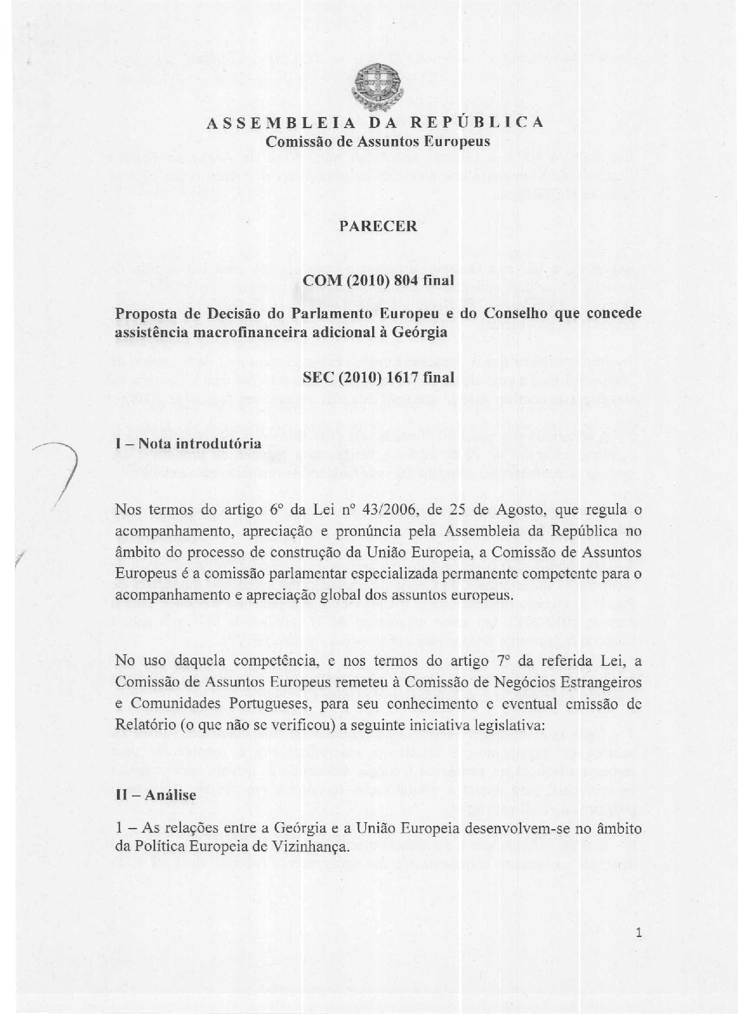
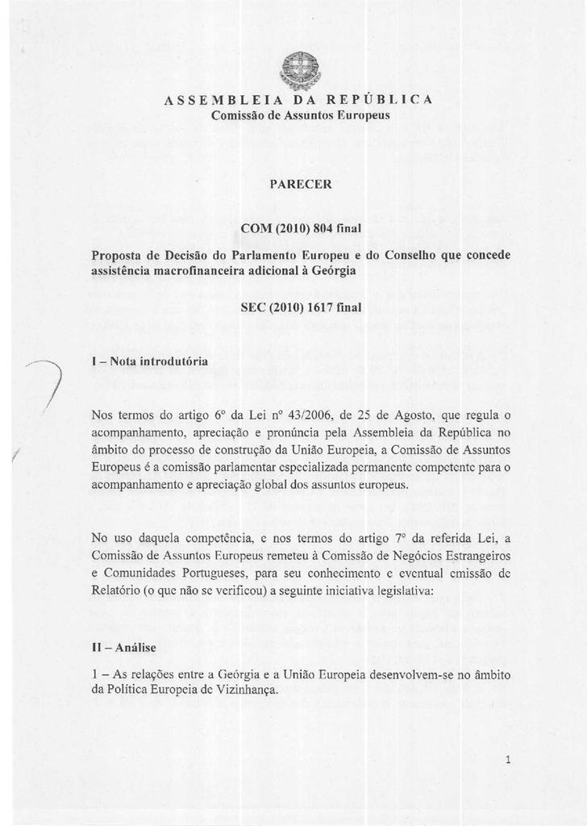
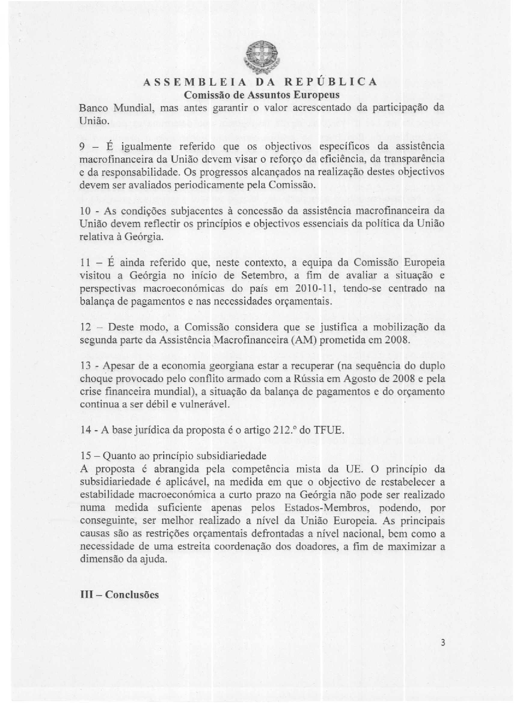

For other language versions, delegations are referred to the parliamentary EU information exchange site (IPEX) at the following address: http://www.ipex.eu/ipex/cms/home/Documents/pid/10

