 | 
COUNCIL OF  THE EUROPEAN UNION |  |  | Brussels, 16 March 2011
 | Interinstitutional File:  2010/0359 (CNS) |  | 7858/11
POSEIDOM 5
POSEICAN 5
POSEIMA 4
REGIO 19
INST 164
PARLNAT 95

COVER NOTE
from: | “Il Senato della Repubblica italiana”
date of receipt: | 15 March 2011
to: | President of the Council of the European Union
Subject: | Proposal for a COUNCIL DECISION amending Decision 2004/162/EC as regards the products that may benefit from exemption from or a reduction in dock dues  [doc. 18168/10 POSEIDOM 18 POSEICAN 18 POSEIMA 18 REGIO 108 - COM (2010) 749 final]  - Opinion of the application of the principles of Subsidiarity and Proportionality

Delegations will find attached the above mentioned opinion.

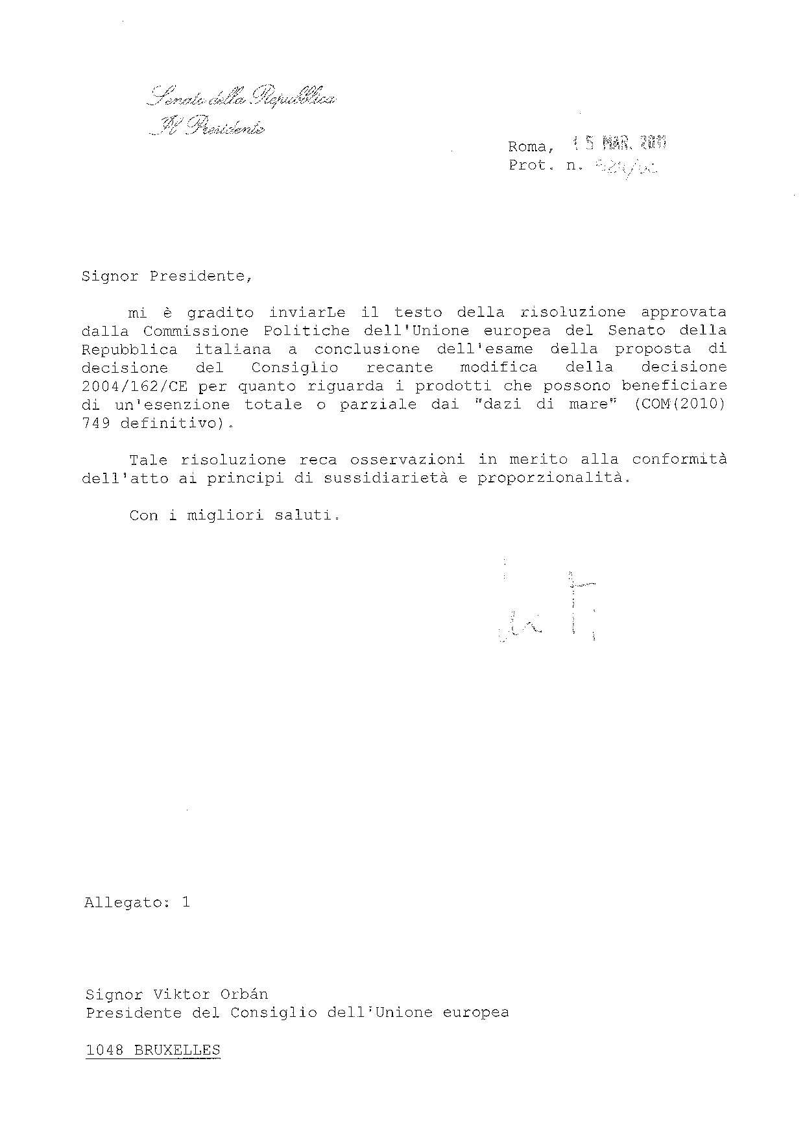

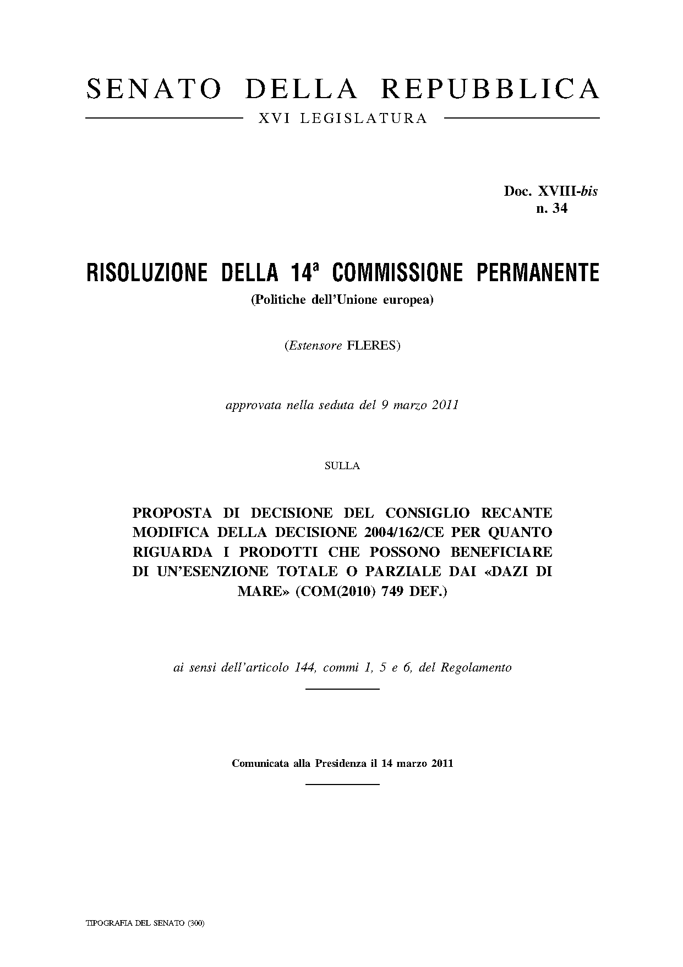
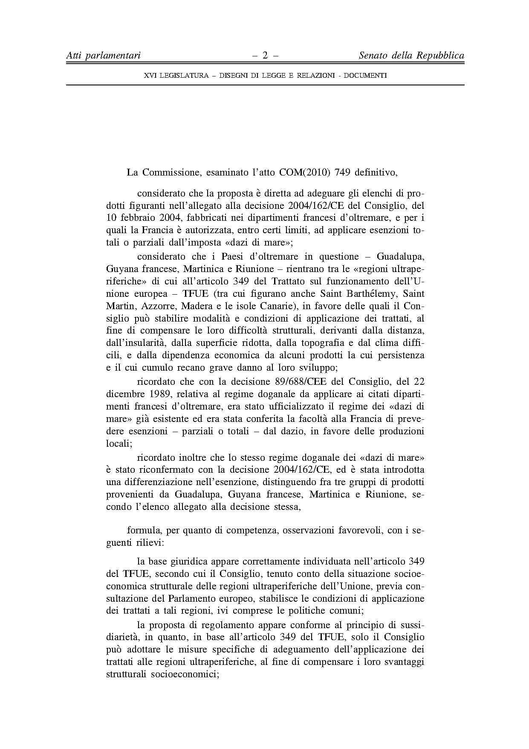
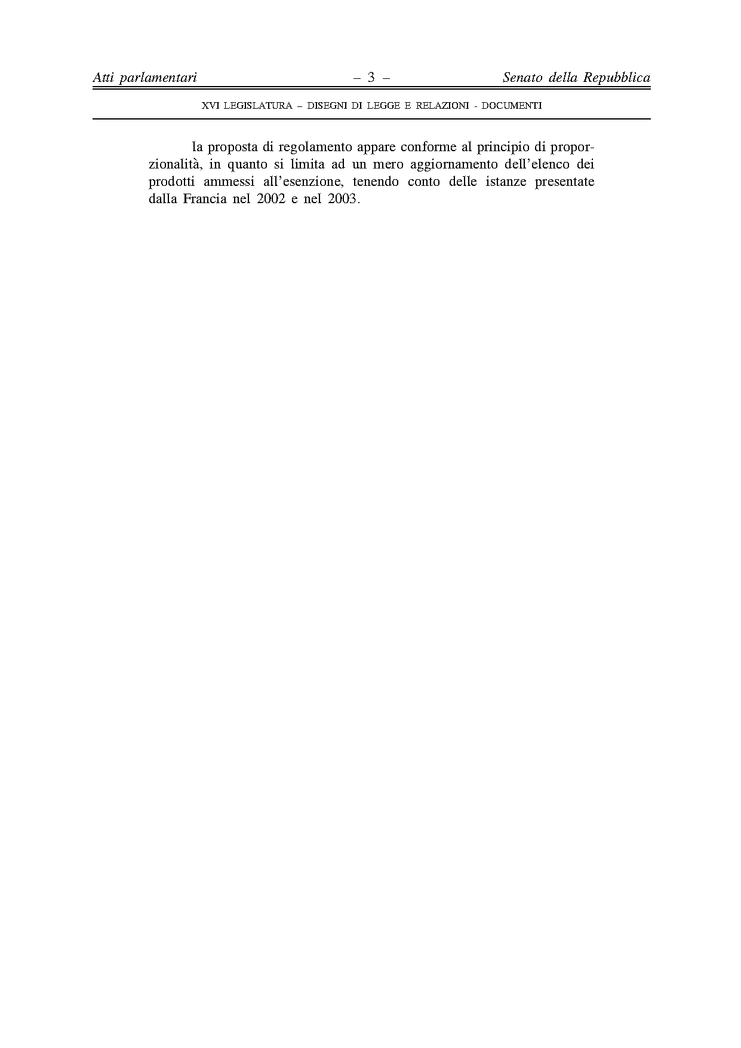


This opinion is available in English on the parliamentary EU information exchange site (IPEX) at the following address: http://www.ipex.eu/ipex/cms/home/Documents/pid/10

