 | 
COUNCIL OF  THE EUROPEAN UNION |  |  | Brussels, 15 March 2011
 | Interinstitutional File:  2010/0366 (COD) |  | 7786/11
AGRI 229
AGRIFIN 24
CODEC 421
INST 157
PARLNAT 90
FIN 180

COVER NOTE
from: | The Romanian Senate
date of receipt: | 15 March 2011
to: | Viktor Orbán, President of the Council of the European Union
Subject: | Proposal for a Regulation of the European Parliament and of the Council amending Council Regulation (EC) No 485/2008 on scrutiny by Member States of transactions forming part of the system of financing by the European Agricultural Guarantee Fund  [doc. 5283/11 AGRI 16 AGRIFIN 4 FIN 14 CODEC 54- COM (2010) 761 final]  - Opinion on the application of the Principles of Subsidiarity and Proportionality

Delegations will find attached a copy of the above letter.

________________________

ANNEX

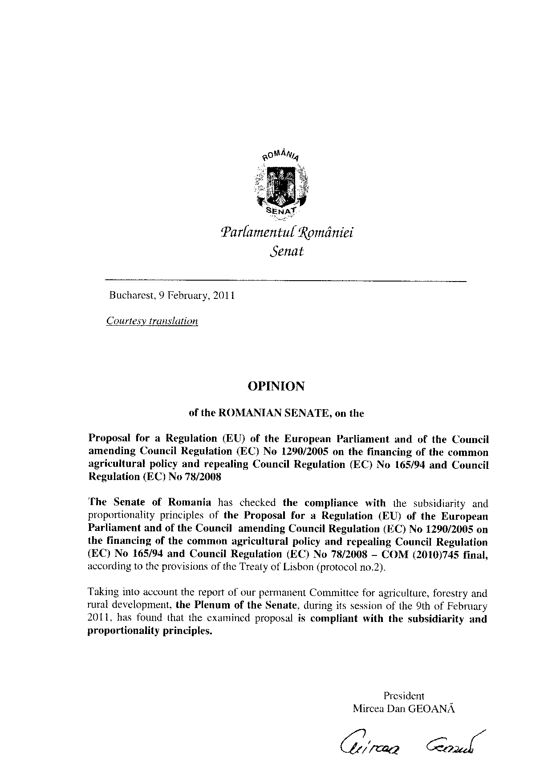
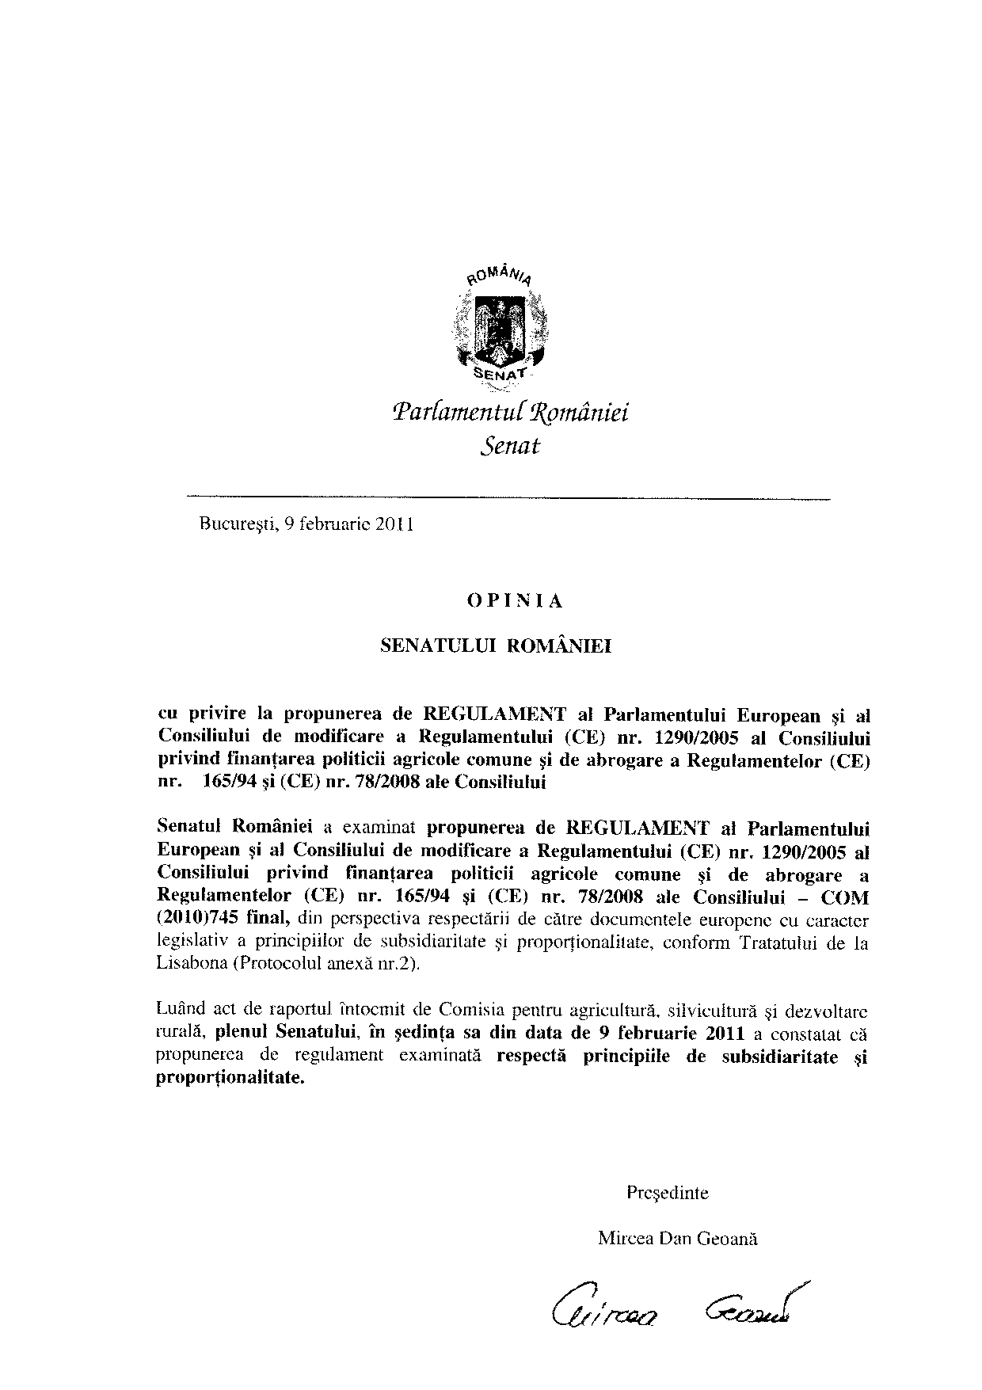

This opinion is available in English on the Interparliamentary EU information exchange Internet site (IPEX) at the following address: http://www.ipex.eu/ipex/cms/home/Documents/pid/10

