 | 
COUNCIL OF  THE EUROPEAN UNION |  |  | Brussels, 15 March 2011
 | Interinstitutional File:  2010/0272 (COD) |  | 7742/11
WTO 103
STIS 5
UD 62
CODEC 415
PARLNAT 88
INST 155

COVER NOTE
from: | the President of the Assembly of the Republic of Portugal
date of receipt: | 14 March 2011
to: | Mr Viktor ORBÁN, President of the Council of the European Union
Subject: | Proposal for a Regulation of the European Parliament and of the Council repealing Council Regulation (EC) No 1541/98 on proof of origin for certain textile products falling within Section XI of the Combined Nomenclature and released for free circulation in the Community, and on the conditions for the acceptance of such proof and amending Council Regulation (EEC) No 3030/93 on common rules for imports of certain textile products from third countries  [doc. 14603/10 WTO 334 STIS 11 UD 270 CODEC 980 - COM(2010) 544 final]  - Opinion on the application of the Principles of Subsidiary and Proportionality

Delegations will find attached the above-mentioned opinion.

________________________
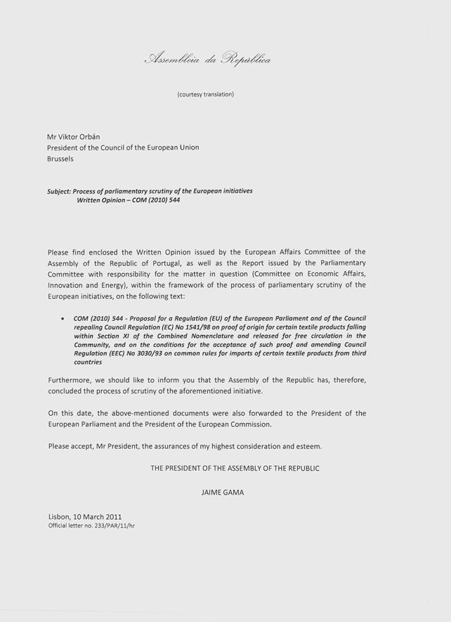

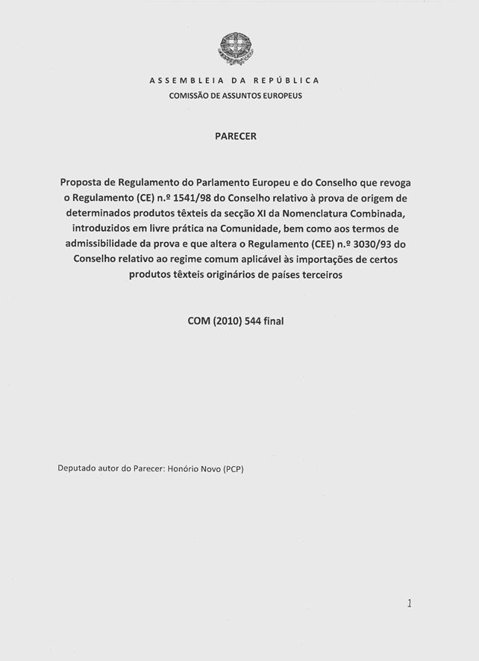
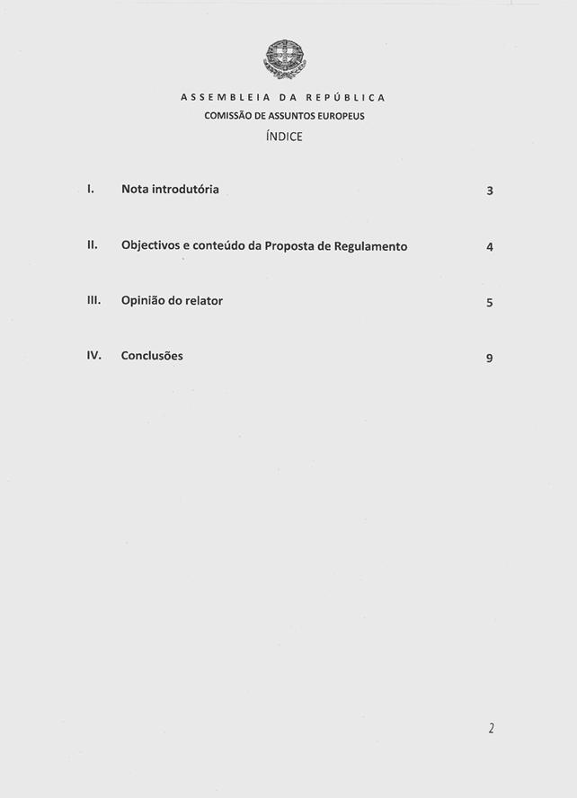
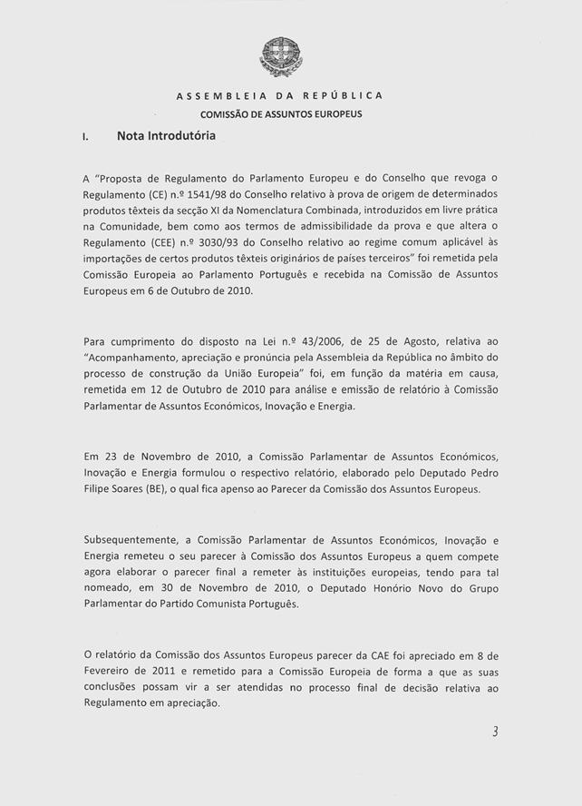
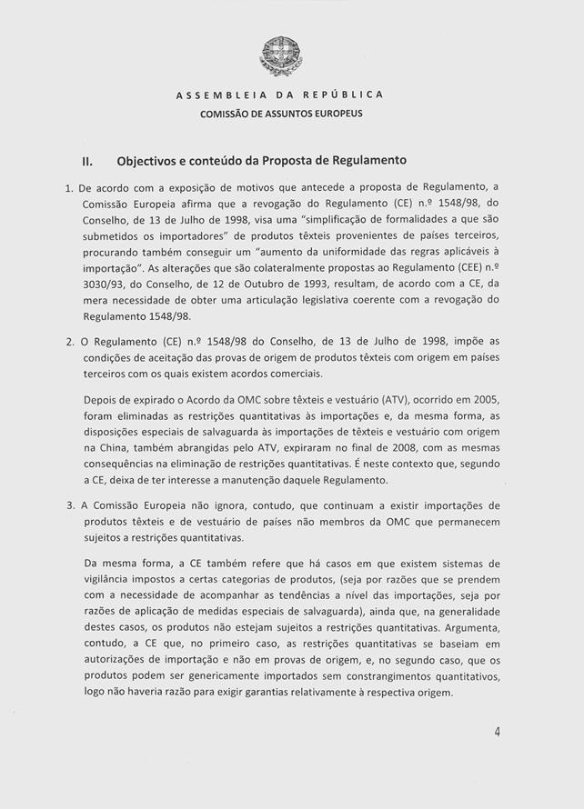
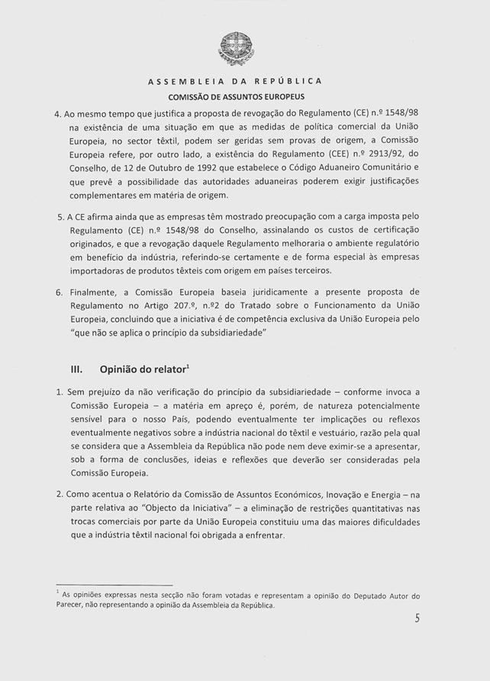
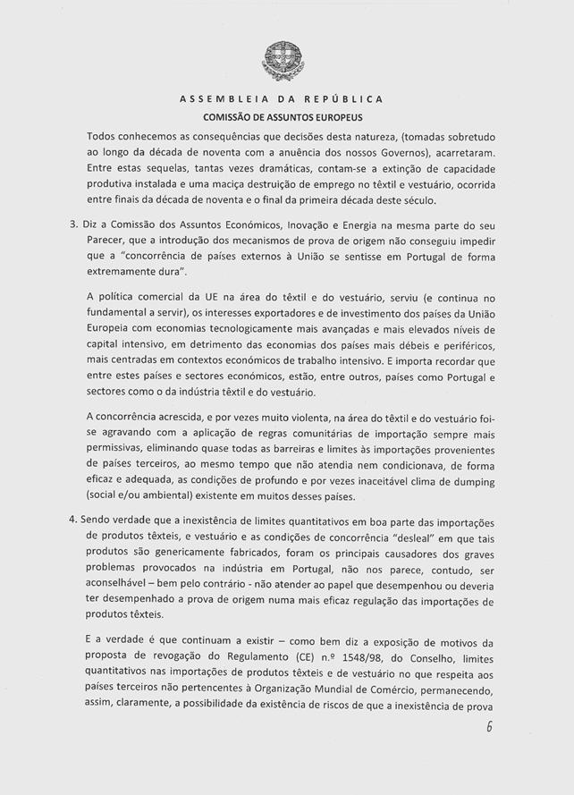
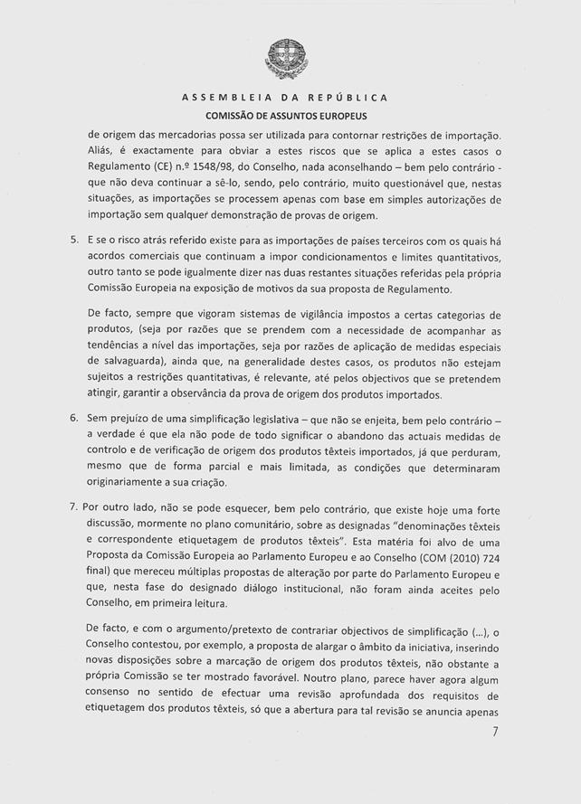
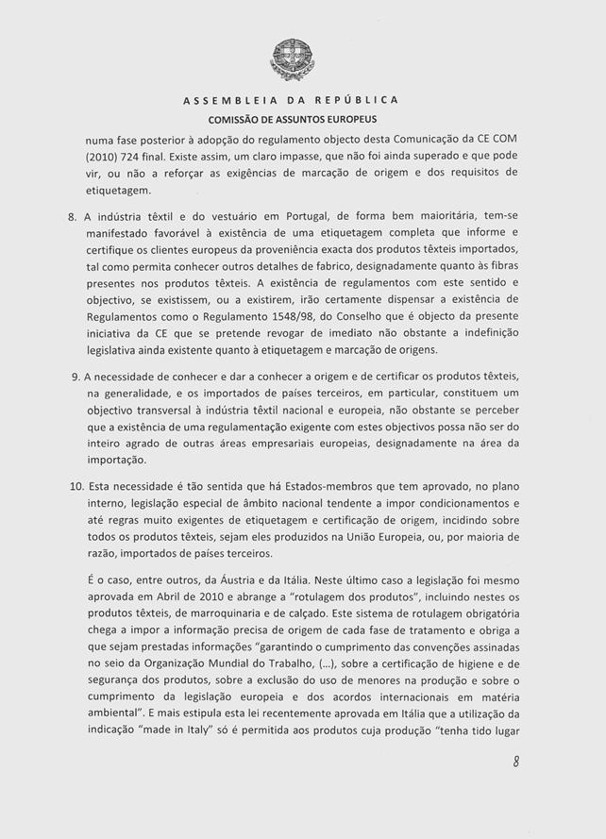
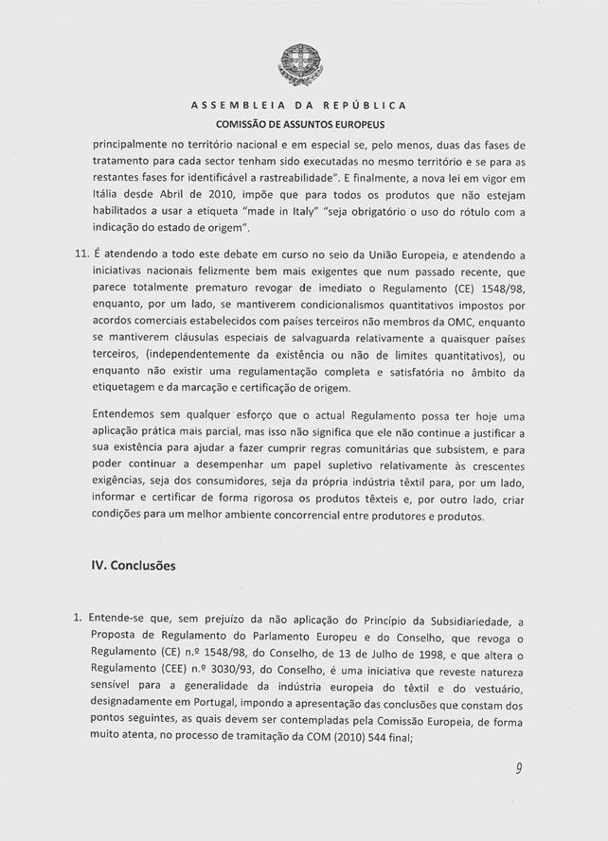
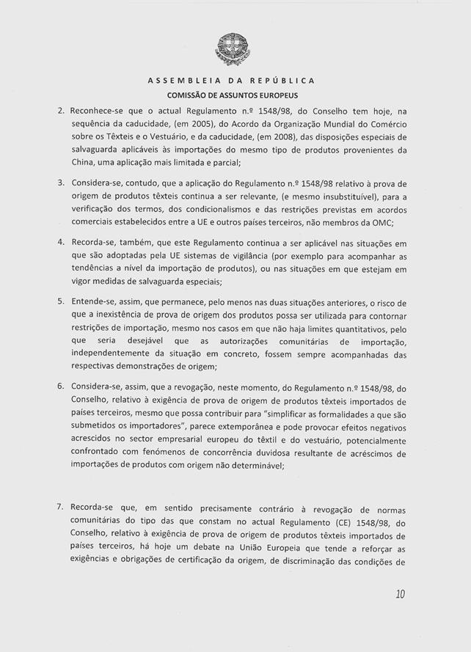
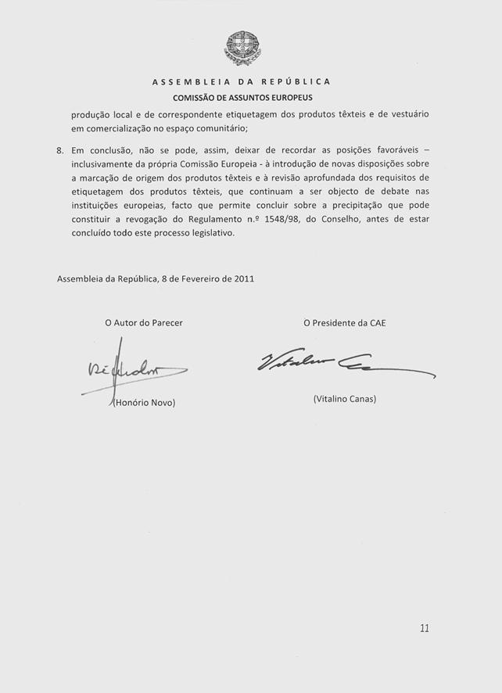
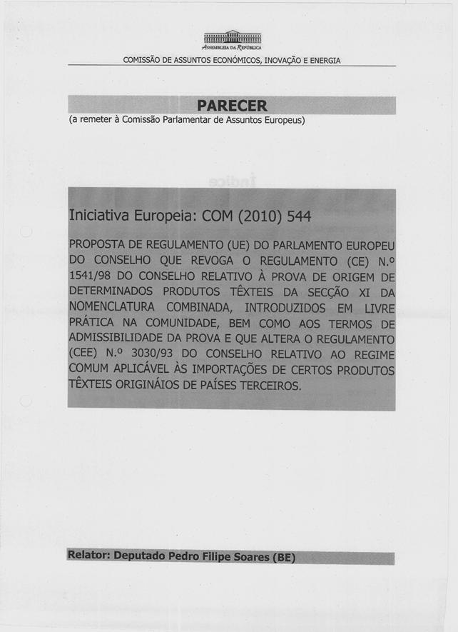
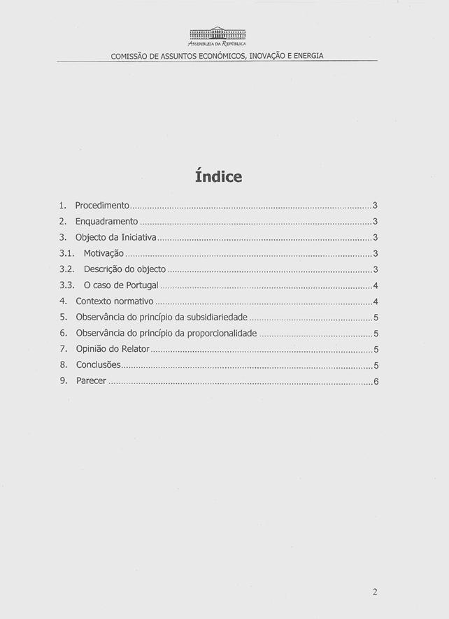
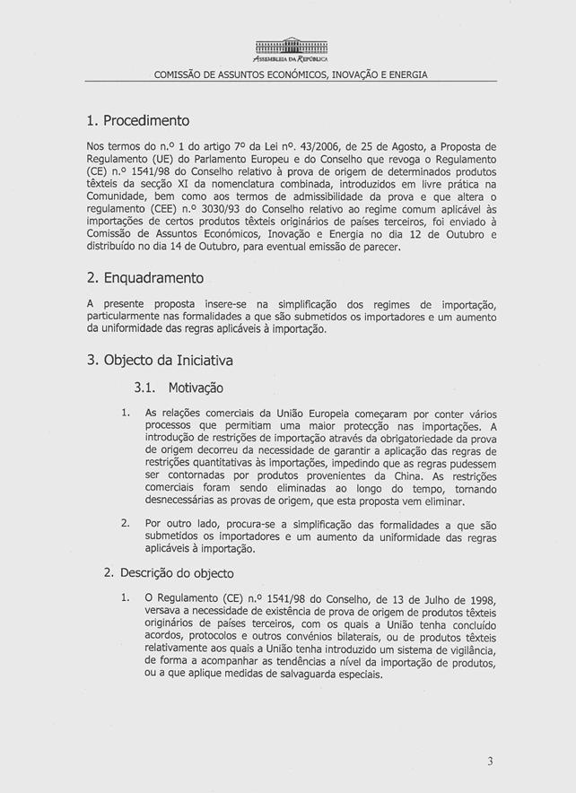
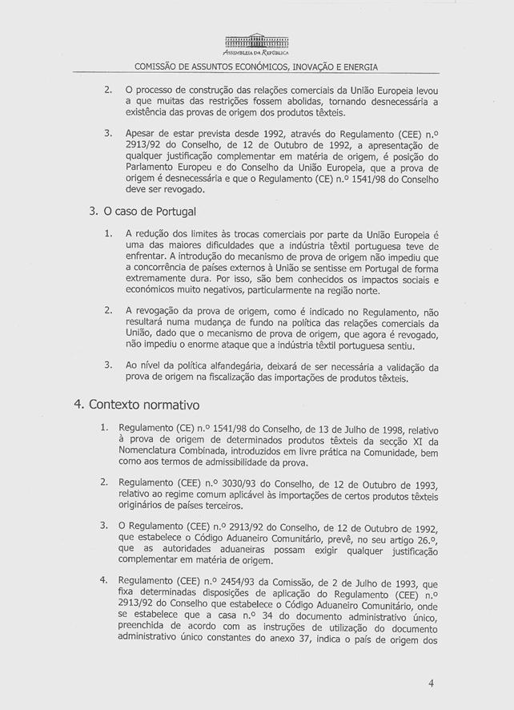
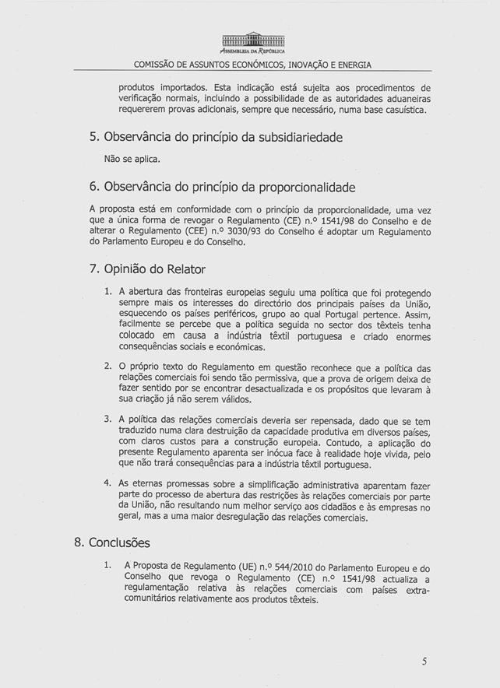
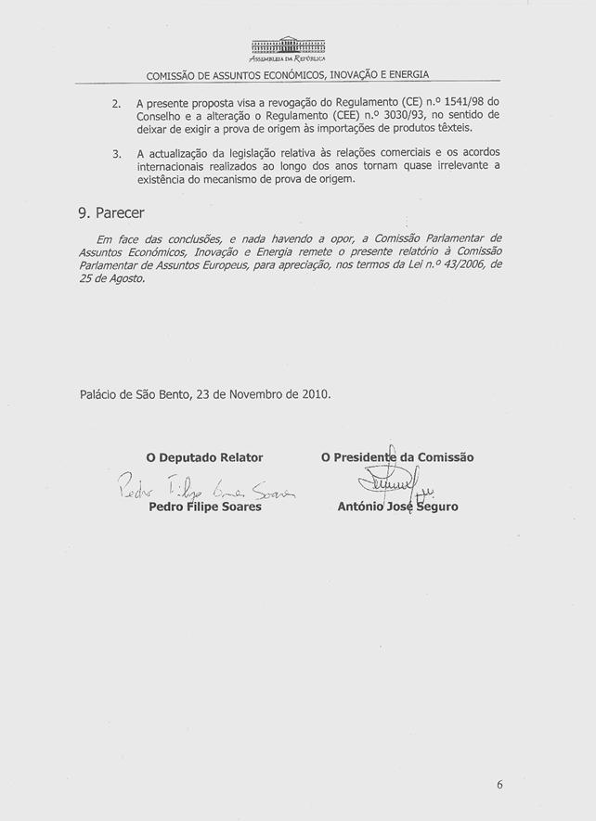

The translation can be found at the Interparliamentary EU information exchange site IPEX at the following address: http://www.ipex.eu/ipex/cms/home/Documents/pid/10.

