 | 
COUNCIL OF  THE EUROPEAN UNION |  |  | Brussels, 11 March 2011
 | Interinstitutional File:  2010/0359 (CNS) |  | 7740/11
POSEIDOM 4
POSEICAN 4
POSEIMA 3
REGIO 16
INST 154
PARLNAT 87

COVER NOTE
from: | The President of the Romanian Senate
date of receipt: | 11 March 2011
to: | President of the Europen Union
Subject: | Proposal for a COUNCIL DECISION amending Decision 2004/162/EC as regards the products that may benefit from exemption from or a reduction in dock dues  [doc. 18168/10 POSEIDOM 18 POSEICAN 18 PÖSEIMA 18 REGIO 108 - COM(2010) 749 final]  - Opinion on the application of the Principles of Subsidiarity and Proportionality

Delegations will find attached the above mentioned opinion.

________________________

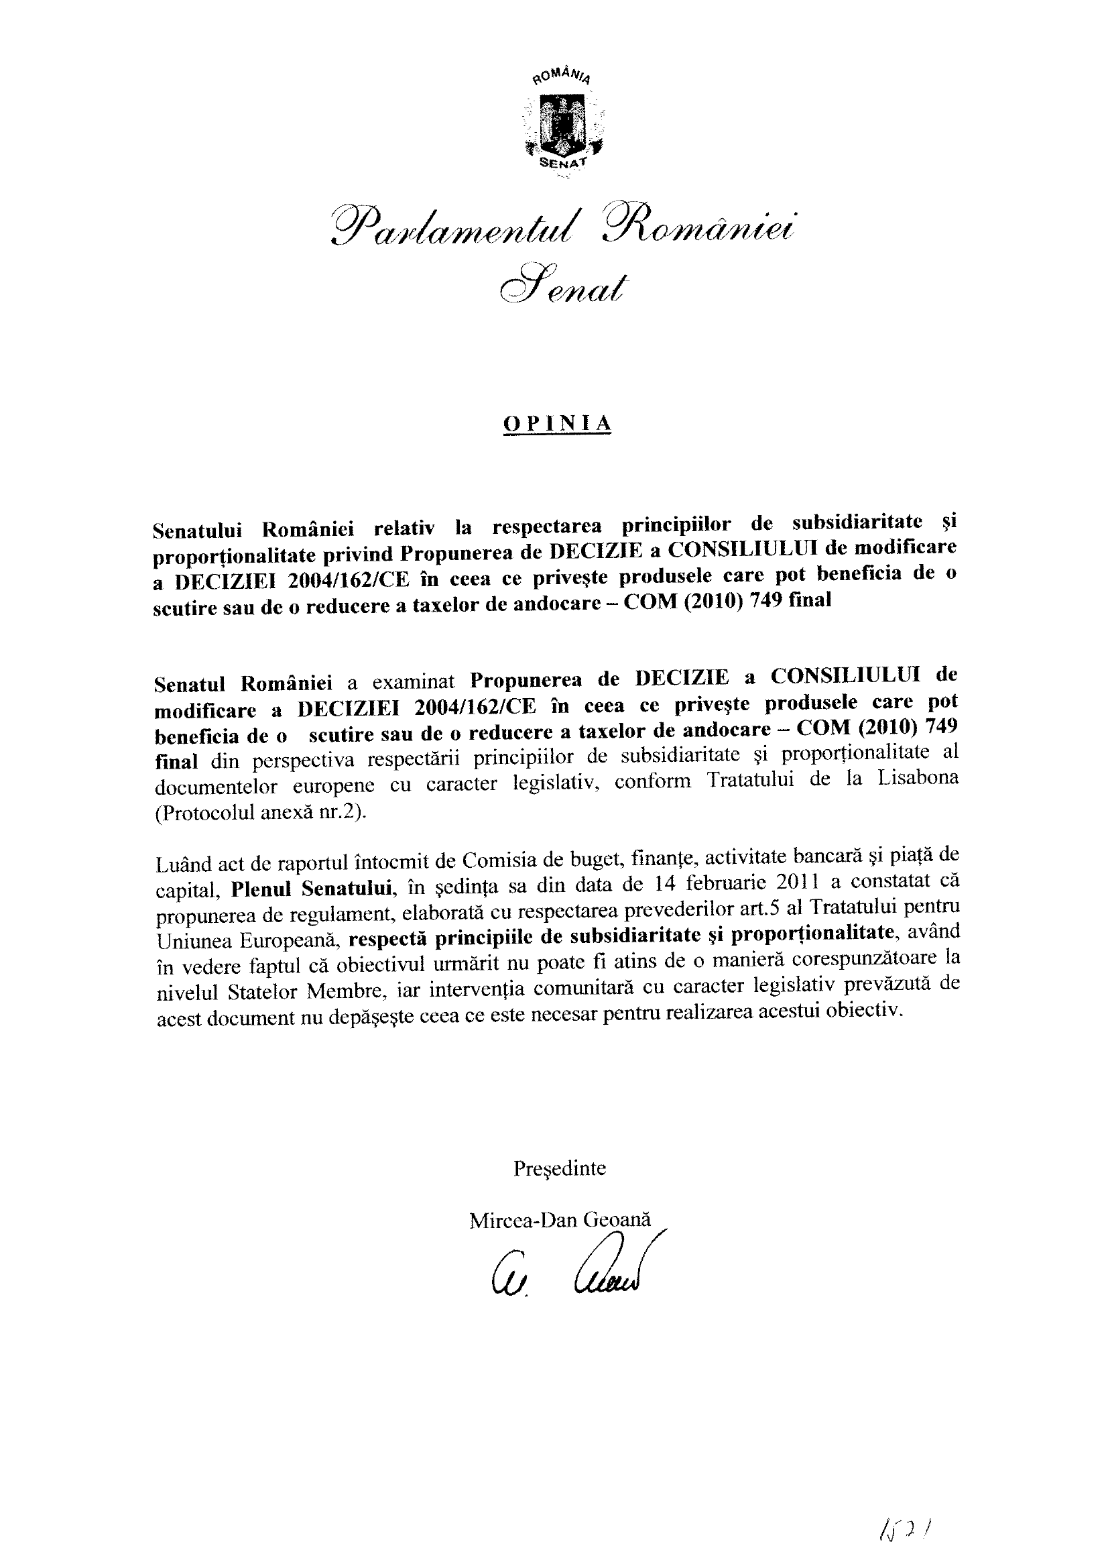

This opinion is available in English on the interparliamentary EU information exchange site (IPEX) at the following address: http://www.ipex.eu/ipex/cms/home/Documents/pid/10

