 | 
COUNCIL OF  THE EUROPEAN UNION |  |  | Brussels, 11 March 2011
 | Interinstitutional File:  2010/0373 (COD) |  | 7732/11
EF 30
ECOFIN 138
CONSOM 32
CODEC 414
INST 153
PARLNAT 86

COVER NOTE
from: | The President of the Romanian Senate
date of receipt: | 11 March 2011
to: | President of the Council of the European Union
Subject: | Proposal for a REGULATION OF THE EUROPEAN PARLIAMENT AND OF THE COUNCIL establishing technical requirements for credit transfers and direct debits in euros and amending Regulation (EC) No 924/2009  [doc. 18095/10 EF 216 ECOFIN 871 CONSOM 125 CODEC 1559 - COM (2010) 775 final]  - Opinion on the application of the Principles of Subsidiarity and Proportionality

Delegations will find attached the above mentioned opinion.

________________________

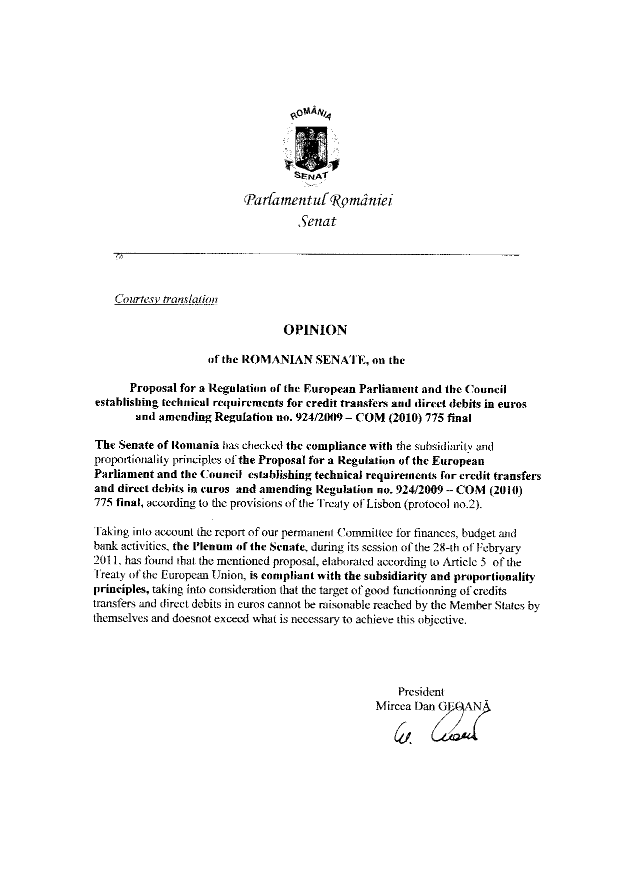
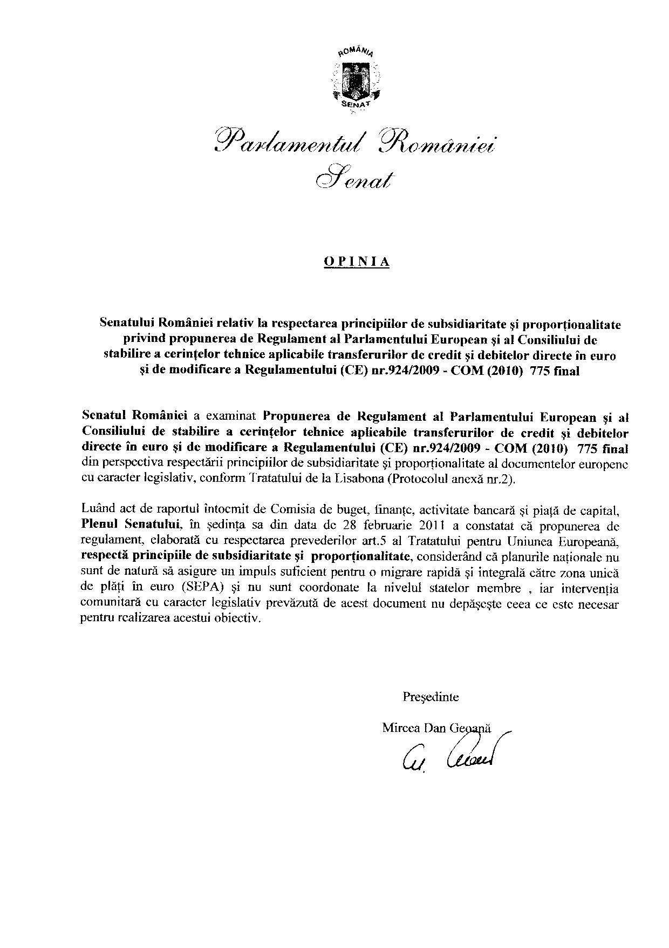

This opinion is available in English on the interparliamentary EU information exchange site (IPEX) at the following address: http://www.ipex.eu/ipex/cms/home/Documents/pid/10

