EN
EUROPEAN COMMISSION
Brussels, 30.3.2011
SEC(2011) 396 final

COMMISSION STAFF WORKING DOCUMENT
Accompanying document to the
REPORT FROM THE COMMISSION TO THE EUROPEAN PARLIAMENT, THE COUNCIL, THE EUROPEAN ECONOMIC AND SOCIAL COMMITTEE AND THE COMMITTEE OF THE REGIONS
2010 Report on the Application of the EU Charter of Fundamental Rights
COM(2011) 160 final
Introduction
The Charter of Fundamental Rights is the EU's bill of rights. With the entry into force of the Lisbon Treaty the Charter became legally binding. It is an historic breakthrough in reinforcing a Europe of rights and values. The Charter brings together in one text all the fundamental rights protected at Union level, spelling them out in detail and making them visible and predictable.
The Charter of Fundamental Rights: the EU's bill of rights

The Charter is not just a text setting out values and principles which can only be used in theory. The Charter was conceived to be an instrument that enables people to effectively enjoy fundamental rights in all the situations that are governed by EU law. It is a living instrument, which should be put in practice daily by the EU institutions, as well as by Member States only when they are implementing EU law.
In 2010, the European Commission adopted a Strategy to make sure the Charter is effectively implemented, so that people can enjoy their rights in practice. The objective is that the EU sets an example to ensure that the fundamental rights provided for in the Charter become reality. The Commission is taking action to achieve this objective: it verifies that EU laws are in compliance with the Charter at each stage of the legislative process – from the preparatory work in the Commission to the adoption of draft laws by the European Parliament and the Council, as well as when Member States apply them. To help do this, the Commission produced a "Fundamental Rights Check-List" to reinforce the evaluation of impacts on fundamental rights of its legislative proposals. The Commission also aims to better inform citizens where to turn for assistance in cases of violations of fundamental rights. To monitor progress, the Commission will present an Annual Report on the application of the Charter.
Fundamental Rights "Check-List"
1. Which fundamental rights are affected?
2. Are the rights in question absolute rights (which may not be subject to limitations, examples being human dignity and the ban on torture)?
3. What is the impact of the various policy options under consideration on fundamental rights? Is the impact beneficial (promotion of fundamental rights) or negative (limitation of fundamental rights)?
4. Do the options have both a beneficial and a negative impact, depending on the fundamental rights concerned (for example, a negative impact on freedom of expression and beneficial one on intellectual property)?
5. Would any limitation of fundamental rights be formulated in a clear and predictable manner?
6. Would any limitation of fundamental rights:
- be necessary to achieve an objective of general interest or to protect the rights and freedoms of others (which)?
- be proportionate to the desired aim?
- preserve the essence of the fundamental rights concerned?
Protecting fundamental rights in the EU: who does what?
In the European Union there is a clear legal requirement that fundamental rights must be protected. This protection is guaranteed by different institutions at national level and at EU level, depending on whether the Charter applies. When the Charter does not apply, national constitutional systems guarantee the respect of fundamental rights.
The Charter applies to all actions by EU institutions. The role of the Commission is to ensure that its legislative proposals respect the Charter. All EU institutions (and notably the European Parliament and the Council) are equally responsible for respecting the Charter throughout the legislative process. The Charter applies to Member States only when they are implementing EU law. If a national authority (administration or court) violates fundamental rights set out in the Charter when implementing EU law, the Commission can take the matter to the Court of Justice. The Commission is not a judicial body or a court of appeal against the decisions of national or international courts. Nor does it, as a matter of principle, examine the merits of an individual case, except if this is relevant to carry out its task of ensuring that the Member States apply EU law correctly. In particular, if it detects a wider problem, the Commission can contact the national authorities to have it fixed, and ultimately it can take a Member State to the Court of Justice. The objective of these proceedings is to ensure that the national law in question - or a practice by national administrations or courts - is aligned with the requirements of EU law.
At EU level
The Court of Justice of the European Union
The Court of Justice in Luxembourg is an institution of the European Union. It is the final authority in relation to the Treaties, the Charter and EU law. It makes sure that they are interpreted and applied in the same way across the Union, and that EU institutions and the Member States do what EU law requires of them.
The Court of Justice has long recognised fundamental rights as an “integral part of the general principles of EU law” by referring to the constitutional traditions common to the Member States and to the European Convention on Human Rights.

When individuals or businesses consider that an act of the EU institutions directly affecting them violates their fundamental rights, they can bring their case before the Court of Justice, which subject to certain conditions has the power to annul such act.
National authorities must apply the Charter when they follow rules laid down in EU law. Judges in the Member States, under the guidance of the Court of Justice, have the power to ensure that the Charter is respected by the Member States only when they are implementing EU law. Individuals may also obtain compensation or damages if their rights under EU law are violated.
At national level
Informing citizens on where to complain
Individuals may lose their rights for compensation if they miss a deadline for bringing a case to the right national court or authority when enforcing their rights.
The Commission intends to better inform people, jointly with national human rights institutions, ombudspersons and other relevant bodies, on where to turn to in case of a complaint. The protection for fundamental rights in the EU should not become an inextricable maze for individuals seeking to enforce their rights.
Where the Charter does not apply, citizens' fundamental rights are guaranteed by national authorities according to their constitutional systems. Member States have extensive national rules on fundamental rights, which are guaranteed by national judges and constitutional courts. If a situation does not relate to EU law, it is for the Member States alone to ensure that their obligations regarding fundamental rights are respected. Accordingly, complaints need to be directed to the national level in the first instance.
The European Court of Human Rights in Strasbourg also provides legal recourse of last resort for individuals who feel that their fundamental rights have been violated by a Member State - all of which have adopted the European Convention on Human Rights. The entry into force of the Lisbon Treaty requires the European Union to accede to the European Convention on Human Rights. When this process is completed, individuals who feel that their human rights have been violated by the EU will also be able to bring their case in front of the European Court of Human Rights. The European Court of Human Rights will therefore provide an external mechanism of control, regardless of which authority (national or EU) has adopted an act which might potentially violate a fundamental right.
The role of the European Court of Human Rights

The European Court of Human Rights
The Council of Europe is an international organisation of 47 European countries dealing with human rights, which has enacted the European Convention on Human Rights. It is distinct from the EU. All of the Member States of the EU are also members of the Council of Europe and bound by the Convention.
The European Court of Human Rights (located in Strasbourg) is an international court and an organ of the Council of Europe, which rules on applications alleging violations of the rights set out in the European Convention on Human Rights.

The Annual Report: the track record of the Charter
This Report is an essential tool in implementing the rights and freedoms in the Charter. It aims, for the first time, to illustrate by examples how the Charter is being applied. The Report informs the public on the situations in which they can rely on the Charter and on the role of the European Union in the field of fundamental rights. It identifies what has been done and what remains to be done for the effective application of the Charter. The Report is based on the actions of EU institutions and the analysis of letters from the general public and questions and petitions from the European Parliament. This Report covers the year 2010 and will be followed by yearly reports. In covering the full range of Charter provisions on an annual basis, future reports will track where progress is being made, or where new concerns are arising.

Overview of the letters and questions to the Commission on fundamental rights
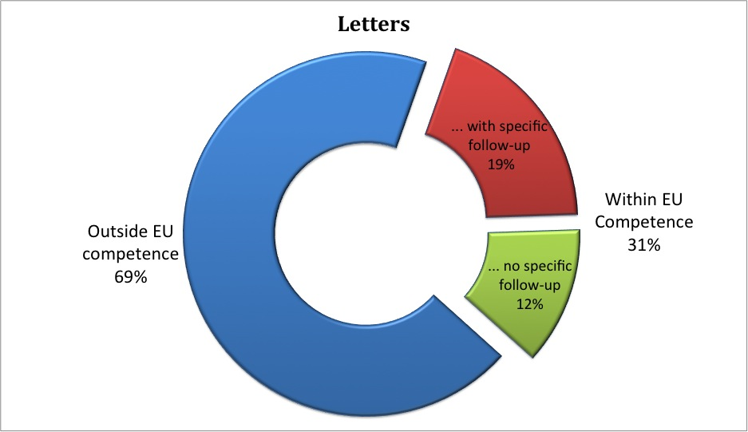
Among the letters from the general public on fundamental rights issues received by the Commission in 2010, approximately one third concerned situations where the Charter could apply. In several cases, the Commission requested information from the Member States concerned or explained to the complainant the applicable EU rules. In other cases, the complaints should in fact have been addressed to the national authorities or to the European Court of Human Rights in Strasbourg. Where possible, complainants were redirected to other bodies for more information (such as national data protection authorities).
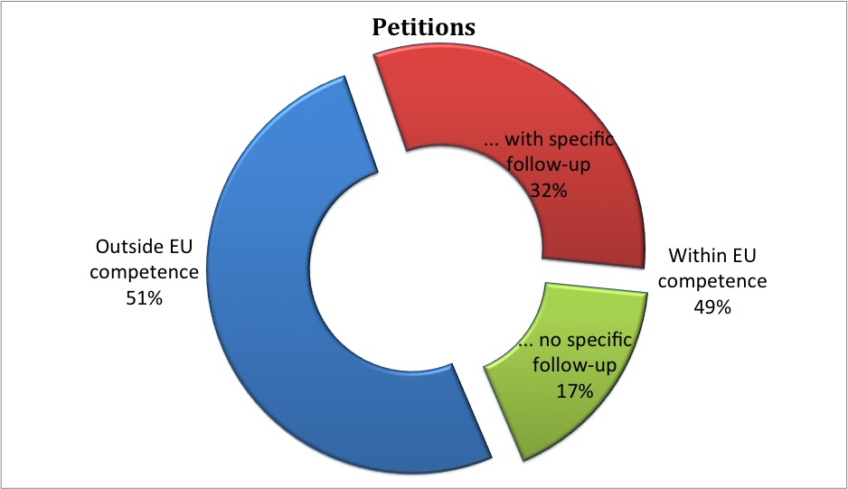
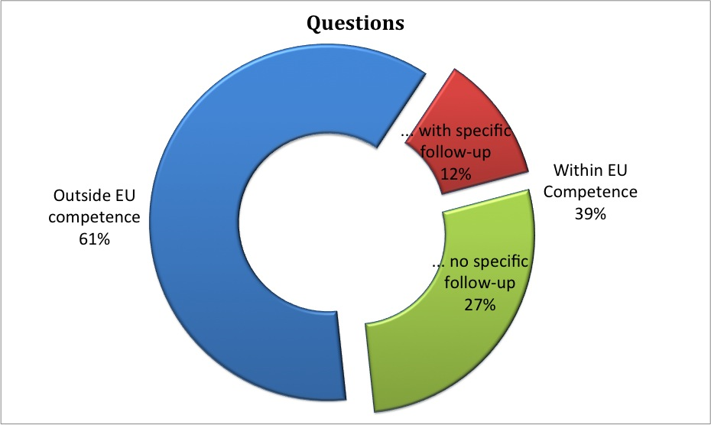
Among the questions and petitions from the European Parliament in 2010, approximately half concerned issues within EU competence. In several cases, the Commission contacted the Member States to obtain clarifications on alleged violations. The replies given by the Commission explained or clarified the relevant policies and ongoing initiatives.
The structure of the Report
The structure of the Report follows the six titles of the Charter itself: Dignity, Freedoms, Equality, Solidarity, Citizens’ rights and Justice. Each of the six chapters of the Report contains the following information on the application of the Charter:
- Examples of how the EU institutions and, where relevant, the Member States have applied the Charter in 2010;
- Questions and petitions from the European Parliament, and letters from the general public received in 2010 focusing on fundamental rights issues;
- Relevant case-law of the Court of Justice;
- Data gathered by the EU Agency for Fundamental Rights throughout 2010.

- Dignity

Human dignity

Right to life

Right to the integrity of the person

Prohibition of torture and inhuman or degrading treatment or punishment

Prohibition of slavery and forced labour
The Commission in 2010 proposed new EU rules to combat human trafficking, a practice explicitly prohibited by the Charter.
The Commission examined the impact on human dignity and other fundamental rights of security scanners at airports. This technology aims to enhance security on flights and the EU must make sure that rules on use of scanners protect human dignity and other fundamental rights, and the health of travellers.
Respect for human dignity is particularly important in the rules on common EU external borders. New EU rules on the interception of migrants at sea and rules governing the EU Border agency (FRONTEX) guarantee the respect of human dignity of all migrants.

Human dignity
Human dignity is the basis of all fundamental rights. It guarantees the protection of human person from being treated as a mere object by the State or by his fellow citizens. The rights and freedoms under the title Dignity, such as the right to life, and the prohibition of torture and slavery, must be respected so we can exercise other rights and freedoms in the Charter, for example freedom of expression and freedom of association. None of the rights laid down in the Charter may be used to harm the dignity of another person.
In 2010, the Commission received a number of letters from the general public, and questions and petitions from the European Parliament on this title, which were mainly related to the situation of irregular immigrants at the external borders and detention.
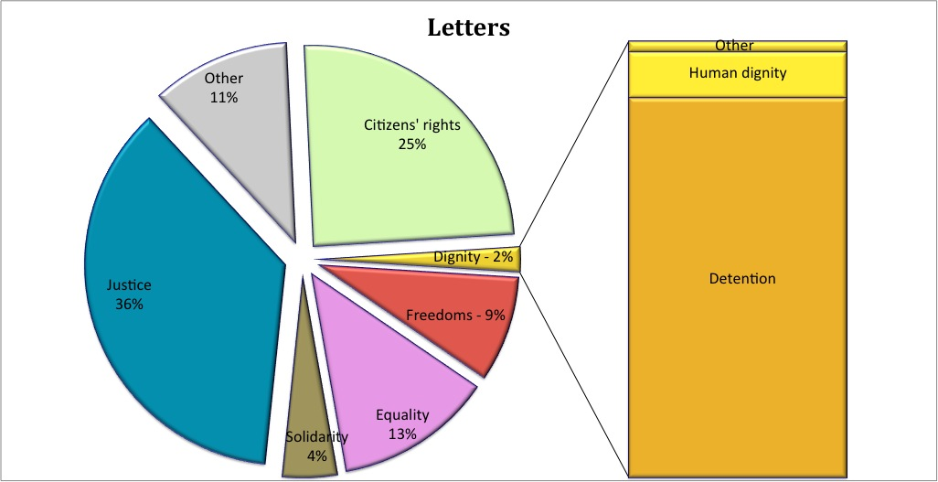
As a result, the Commission took action in several cases to ensure the respect of the Charter in relation to EU law. One such case concerned the respect of human dignity at the external borders of the Union, following allegations of maltreatment.
In a number of other cases brought to the attention of the Commission in 2010, the alleged violation of human dignity was not related to the implementation of EU law, such as alleged mistreatment in the context of routine police checks.
Respect for human dignity at EU external borders
Non-governmental organisations alerted the Commission to a number of cases of alleged maltreatment and violation of the human dignity of migrants by national border guards in one Member State.
Border management at the external borders of the so-called Schengen area is governed by EU law and the Commission intervened in this case.
With the creation of the Schengen area, Member States abolished border controls and only maintain them at borders with non-Schengen Member States and non-EU countries. National border guards must fully respect fundamental rights, including human dignity, when they follow EU rules on border management.
Respect for human dignity by the police within a Member State
In one case, an individual claimed to have been mistreated during a routine police check on the street, violating his human dignity.
Law enforcement issues such as routine police checks on the street conducted by the police are the responsibility of the Member States. There is no EU law in this area, meaning that the Charter cannot be invoked in this context and that the Commission cannot give any follow-up to such complaints.
The complainant should seek redress elsewhere, through the national courts, for example. The courts then apply the constitutional principles of the Member State concerned.
EU action in the field of aviation security aims at preventing acts of unlawful interference against civil aviation, such as seizure of an aircraft or transportation of a hazardous device. In 2010, new EU rules on aviation security came into force. The main principle of European as well as international rules in this field is to keep dangerous items such as arms, knives or explosives away from aircraft. For that reason, every passenger, piece of luggage and cargo departing from an EU airport, or coming from a third country and transferring through an EU airport, must undergo controls.
How is human dignity respected in the implementation of security scanners?
Guaranteeing the security of travellers includes the use of new technologies that can detect unsafe objects at airports. A security scanner is a device intended for screening persons entering restricted areas such as passengers boarding an aircraft to detect metallic and non-metallic objects carried on that person , some of which a metal detector would fail to recognise.
Security scanners and respect for human dignity
Some technologies of security scanners can reveal a detailed display of the human body, including possible medical conditions, such as prostheses and diapers.
This capability may compromise respect for human dignity and private life. Displaying the details about a person's body and his medical conditions indicates treating people as objects. This could violate the right for respect of human dignity, which requires that people are treated as subjects.
In 2010, the Commission adopted a Communication on the use of security scanners at EU airports. The Communication recalled the need to ensure the respect of human dignity and private and family life, the protection of personal data, the rights of the child, and identified that according to the technology used different health issues must be considered. The Commission took note of the possibility for opt-outs from the use of security scanners. The Communication presents the types of security scanners that are available on the market and are used for aviation security purposes, reports on their detecting capabilities and on their possible impact on human dignity and other fundamental rights.
The European Union strongly opposes the death penalty and has consistently backed its universal abolition, and continues to work towards this goal. The Commission was alerted to the fact that companies based in EU sell certain chemicals (sodium thiopental) to the US, which are then used in judicial executions. The Commission is considering amending EU rules that would avoid the export of pharmaceuticals for use in capital punishment and aims to present formal proposals in 2011.
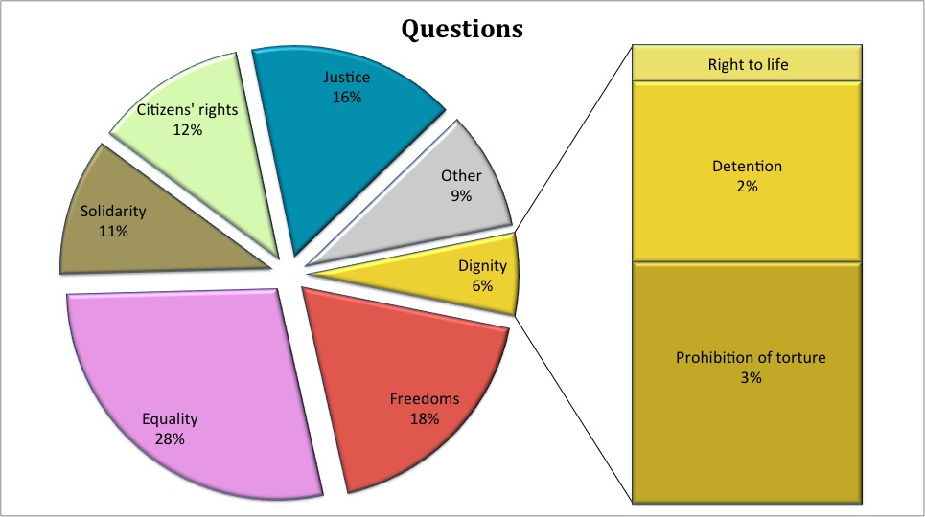
Prohibition of inhuman or degrading treatment
The Charter provides that no one shall be subjected to torture or to inhuman or degrading treatment or punishment.
This provision is particularly relevant in the context of implementing EU rules on border control, which provide common standards and procedures on controls at the external borders of the Schengen area. These rules guarantee respect for the fundamental rights of all travellers.
Border surveillance at the external sea borders in the Mediterranean Sea is a particularly challenging task. In 2010, the Commission proposed new rules to make border surveillance at sea more effective and at the same time to guarantee the respect of fundamental rights of migrants intercepted at sea. In particular, national authorities must inform the intercepted migrants about the proposed place of disembarkation, so that they can object being taken to countries where they could face torture. The needs of children, victims of trafficking, persons in need of urgent medical assistance or of international protection and other vulnerable groups must be observed.
EU rules on surveillance of sea borders
In 2010, the EU adopted new rules on border surveillance at sea which enhance border security and guarantee the respect for fundamental rights of migrants intercepted at sea.
For example, these rules require that national authorities inform migrants intercepted at sea about the proposed place of disembarkation, so they can object to being taken to countries where they could face torture.
The EU borders agency (FRONTEX) plays a key role in coordinating the action of the Member States. In 2010, the Commission also proposed amendments to the rules governing FRONTEX. The proposed amendments require that all persons participating in border control activities undertake training in fundamental rights, that any incidents during operations, including in relation to fundamental rights, must be reported to the national authorities and followed up, and that FRONTEX develops detailed guidelines on how to treat third-country nationals who are being returned to their home country (building on the best practice guidelines already in place). For example, an independent monitor must be present during return operations and report to the Commission on the compliance of operations with EU law.
The Commission has continued to follow the situation on the ground concerning the application of EU law by the Member States. In 2010, a number of national courts have referred questions to the Court of Justice on the transfer of asylum seekers to Greece in the framework of the EU rules on determining the Member State responsible for examining an asylum application. The Commission continued discussions with Greece regarding the failure to properly investigate reports of violations of fundamental rights. These proceedings also concern a breach of EU asylum legislation. The Commission is concerned about allegations of a failure to respect the right to effective access to a procedural system allowing an application for asylum to be made and properly assessed, and a number of legal provisions relating to the treatment of unaccompanied minor applicants for asylum.
Ill-treatment of migrants at the external border
Following a number of allegations of ill treatment of migrants at the border between Greece and Turkey, the Commission continued discussions with Greece, initiated in 2009, regarding the failure to fulfill its obligation to respect fundamental rights when implementing EU external border legislation.
EU law concerning the return of illegally staying third-country nationals takes full account of the importance of Member States respecting the fundamental rights of third-country nationals. The Return Directive includes a number of guarantees for the respect of fundamental rights of the potential returnees, in particular as regards the respect for the principle of non-refoulement, which prohibits returning people to countries where they could face torture. The deadline for transposition of most of the provisions of the Directive expired on 24 December 2010, and the Commission will continue to pay close attention to the transposition and application of the Directive by the Member States in 2011 and beyond. In 2010, the Commission provided assistance to the Member States on how to adapt national laws to the Return Directive while respecting the prohibition of inhuman and degrading treatment and other fundamental rights, by conducting regular meetings with Member States.
In 2010, the Commission received a number of letters from the general public on the issue of detention. They raised concerns about poor detention conditions due to prison overcrowding in national prisons, in the light of the requirements of the Council of Europe 'European Prison Rules'. Several letters complained about pre-trial detainees staying together with convicted prisoners. To discuss these issues, the Commission in 2010 started preparation for a Green Paper on detention.
Prohibition of trafficking in human beings
Trafficking in human beings is a new form of slavery that violates human dignity. The Charter explicitly prohibits trafficking in human beings. A report by the EU Agency for Fundamental Rights estimated that a significant number of people, mostly women and children, fall victim to trafficking for sexual exploitation, labour exploitation, domestic servitude, begging, and the removal of organs or other purposes.
In 2010, the Commission proposed new EU rules aiming to develop a comprehensive approach to human trafficking for the purpose of sexual and labour exploitation. These rules seek to achieve more effective prosecution by national authorities of human traffickers across borders. They propose uniform definitions and common standards on sanctions, liability and jurisdiction. If this proposal is adopted, the Member States would have to put in place mechanisms for the early identification of victims, as well as for the early provision of support to victims. Victims would also receive free legal counselling and legal representation. When the victims of trafficking are children, the proposal extends the protection measures to unaccompanied and separated children that are subject to exploitation. The new definition of trafficking only requires the recruitment or transfer and subsequent exploitation when children are involved, regardless whether children have been forced into exploitation. The proposal also protects children from the negative effects of court procedures by defining how to conduct interviews with child victims. When adopting laws on this issue, Member States must take into account the rights of defence of those accused in criminal procedures.
The Commission adopted a report on the implementation in Member States of EU ruleswhich require issuing residence permits to third-country nationals who are victims of trafficking. The objective of these rules is twofold. On the one hand, they protect fundamental rights of victims and ensure that there are measures in place to assist in their recovery (e.g. medical services, translation, and attendance to special needs of minors). On the other hand, they provide concrete incentives for victims, such as the issue of the residence permit, to cooperate in dismantling networks of traffickers.
- Freedoms

Right to liberty and security

Respect for private and family life

Protection of personal data

Right to marry and right to found a family

Freedom of thought, conscience and religion

Freedom of expression and information

Freedom of assembly and of association

Freedom of the arts and sciences

Right to education

Freedom to choose an occupation and right to engage in work

Freedom to conduct a business

Right to property

Right to asylum

Protection in the event of removal, expulsion or extradition
Among the rights and freedoms under this title, protection of personal data was the area of major interest. This was reflected in the number of questions by EU citizens and by the European Parliament. To respond to challenges such as the emergence of new technologies, the Commission set out a reform of existing EU rules in this area.
The right to property was also frequently mentioned in questions from the European Parliament, as well as in letters from the general public. The main issues were the restitution of nationalised or confiscated property by communist totalitarian regimes and national laws for the protection of the environment.
Freedom of religion was brought up in questions from the European Parliament mainly in relation to the wearing of the burqa or veils.
For the first time, the Court of Justice declared invalid a provision of EU law because it violated the Charter. The case concerns the publication of beneficiaries of EU agricultural subsidies, a practice which the Court found to be in violation of the right to respect for private life and the protection of personal data.

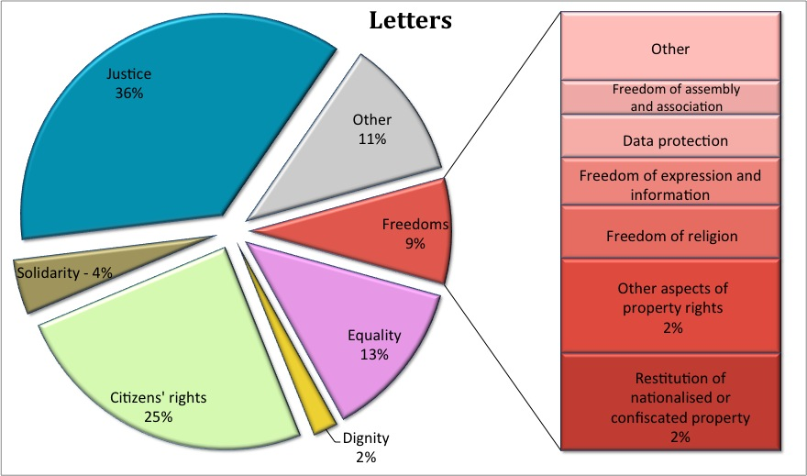
Respect for family life
The Charter guarantees the right of everyone to respect for his or her private and family life. EU free movement rules recognise the right to family life for all EU citizens who move and reside in another Member State. EU rules on family reunification recognise the right to family reunification for third-country nationals legally residing in the EU.
Respect for family life of an EU citizen
In 2010, the Commission drew the attention of the authorities of a Member State to the fact that their legislation did not guarantee the right to respect for family life in accordance with the case-law of the European Court Justice.
The Member State amended its legislation to ensure that EU citizens, who move to that Member State, can be joined or accompanied by their third-country family members without requiring that family members had previously resided in the EU.
The majority of the letters that the Commission received in 2010 in this area related to problems of EU citizens who wanted their family member, a third-country national, to join them in their own Member State. EU free movement rules apply to third country family members when EU citizens have exercised their right to free movement (for example, they reside in another Member State than their own). If problems concern third country family members of EU citizens not having exercised the right to free movement (e.g. a Spaniard in Spain), national law applies.
In 2010, the Commission continued to receive letters and questions related to the practice of the German Youth Welfare office (Jugendamt) of asking non-German parents to communicate with their children only in German under the supervision of the Jugendamt. According to the observations provided to the European Parliament Committee on Petitions, the German authorities take into primary consideration the best interests of the child and it is possible that the right to visit is exercised under surveillance to protect a child from the risk of abduction. The Charter only applies when the Member States follow rules laid down in EU law. The specific cases raised did not involve application of EU laws and were related to substantive decisions of national authorities.
The Court of Justice case Chakroun concerned the interpretation of the EU Family Reunification Directive in light of national legislation that imposes certain requirements on the amount of financial resources available to third-country nationals that wish to obtain a residence permit for their spouses. At stake was furthermore whether Dutch legislation can draw a distinction according to whether the family relationship arose before or after the third country national entered the territory of the host Member State in applying this income requirement. The Court highlighted that the provisions of this EU Directive have to be interpreted in the light of fundamental rights, in particular the respect for family life as enshrined in the Charter. It concluded that EU law precluded such provisions of national legislation.
Data protection
The Charter guarantees the protection of personal information and Europeans take a keen interest in these issues. The questions and concern of citizens cover a wide range of topics, from the use of personal data in the application of new technologies to the respect of data protection rules by third countries. What happens to personal data when boarding a plane, opening a bank account, or sharing photos online? How is this data used and by whom?
Google Street View
The issue of photographic panoramic views of European streets, provided by the company Google, was addressed several times in questions by the Members of the European Parliament.
This practice may involve the processing of personal data, in which case EU Data protection legislation is applicable.
Google must provide information in advance about the collection of data, such as taking pictures for its Street View service, not only through its website, but also by means of information in the national, regional or local press or by any other appropriate means. Individuals must have a possibility to object to the publication of personal data relating to them by means of a simple procedure.
Developments in technology make our daily lives easier, assisting us in communication and protecting us from certain dangers. But they can also present a challenge from the perspective of fundamental rights, as the use of personal data in the application of new technologies has an impact on privacy.
How is my personal data protected in the application of new technologies?
Social networking websites (for example Facebook and Twitter) offer extensive possibilities to interact with people and share photos, opinions and other information online. As these websites also contain personal data, which must be protected, the EU Data Protection Authorities reminded the companies who signed the Safer Social Networking Principles of their obligation to respect EU data protection rules. For example, personal data on social networking websites cannot be shared and further processed without the consent of the individuals concerned.
Dialogue with search engine operators
In 2010 the Commission reminded three major companies (Yahoo!, Microsoft and Google) of the need to cut down to six months the period that they store search data before it is made anonymous, which would align their policies with the EU data protection legislation.
A user's search history also contains a footprint of users' interest and personal relations and can therefore be considered as personal data.
Searching for information online (surfing) is part of a daily routine for many people. Even though many think they surf the Internet anonymously, this is often not the case, as they leave behind a history of what they have searched for online. Online advertising companies use this valuable information. This so-called online behavioural advertising means tracking users when they surf the Internet and building personal profiles over time, which are later used to provide them with advertising matching their search history. Such practice cannot be carried out at the expense of the rights of individuals to privacy and data protection. Search engines must inform clearly users of the fact that their behaviour on line may be recorded, and privacy settings must allow users to select by default the least intrusive option.

A number of questions from the European Parliament were related to EU funding on research into new technologies in the field of security, such as the project INDECT. This is a project through which the EU finances research into new methodologies and technologies, intended for police and other law enforcement authorities. The Commission has clarified that it remains the responsibility of the Member States to determine how to use these new technologies.
Fingerprinting of school children
The parent of a child at school complained to the Commission about the school taking photographs and fingerprints of pupils for issuing dinner cards and for monitoring the use of the school library.
Access control in schools involves the processing of personal data and therefore the EU rules on data protection apply. Before introducing such measures, school authorities should think carefully about whether or not they are necessary and proportional to achieve the intended aim. According to EU rules on data protection, personal data may only be collected in a fair manner, only if it is adequate, relevant and not excessive in relation to the purposes for which they are collected.
The Commission has asked the Member State concerned for more information, to establish if data protection rules were violated.

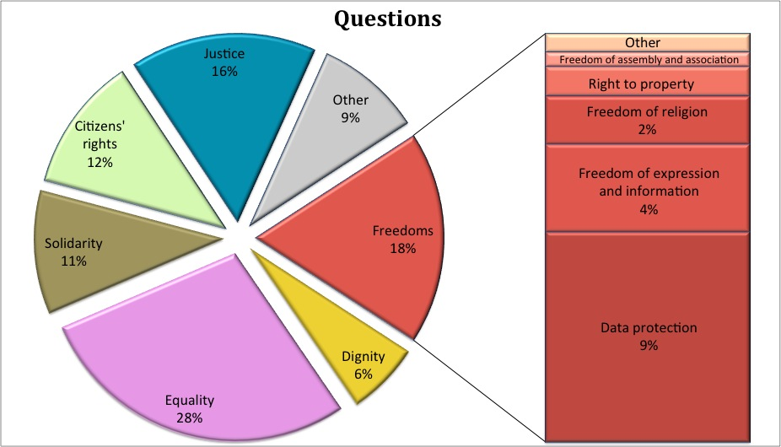
Personal data is sometimes transferred to countries outside the EU. This can raise a number of questions because the level of protection of personal data outside the EU can sometimes be lower. The Commission maintains a list of third countries where the level of protection of personal data is considered to be in line with EU rules on data protection, to where personal data may be transferred without additional safeguards. Transfers of personal data to all other countries may only take place if the EU exporter provides for the adequate protections of rights, in particular through special contracts between the EU exporter and the foreign importer which will receive and process the data in compliance with EU rules.
What happens to my personal data outside the EU - in third countries?
In 2010, the Commission received several requests on how personal data is protected in third-countries. The Commission has put in place a number of arrangements to protect EU citizens. Companies from United States can sign up to a set of principles called “Safe Harbor” providing an adequate level of data protection. If personal data is transferred between companies belonging to the same multinational corporation, binding corporate rules must be put in place and approved by the national data protection authorities involved. To facilitate and speed up the approval of these binding rules by national data protection authorities, these decisions are recognised automatically in 16 of the 27 Member States.
Stronger data protection guarantees were taken up in the agreement between the EU and the United States on the processing and transfers of data from the EU to the US for the purposes of the fight against terrorism (so called TFTP - Terrorist Finance Tracking Programme). The agreement was concluded on 28 June 2010 and contains specific provisions, such as the right of access to personal data processed by the US Treasury, the right to rectification, erasure or deletion of personal data and the right to administrative and judicial redress. The agreement was approved by the European Parliament and entered into force on 1 August 2010.
The Fundamental Rights Agency in its report identified the following main challenges for the data protection system in the EU: a) deficiencies of data protection authorities, b) lack of enforcement of the data protection systems, c) lack of rights awareness about data protection laws and authorities, d) lack of data protection in the former third pillar of the EU, e) exemptions from data protection for security and defence, and f) recent and ongoing technological developments (e.g. video surveillance).
A new strategy on data protection
Controlling your information, having access to your data, being able to modify or delete it – these are essential rights that have to be guaranteed in today's digital world.
To address these issues, the Commission set out a strategy on how to protect individuals' data in all policy areas, including law enforcement, while reducing red tape for business and guaranteeing the free circulation of data within the EU. The Commission will use this strategy together with the results of a public consultation in order to propose changes to EU rules on data protection.
How does the EU respond to the challenges in the area of data protection?
The Commission will continue to monitor the situation in the Member States, where doubts exist about the required complete independence of the Data Protection authority.
The Commission is also ensuring the correct application of the data protection rules in place. In 2010, the Commission dealt with fifteen infringement cases for alleged violation of the EU law on data protection. For example, the Commission warned Finland that its data protection law might be breaking EU rules because it does not protect personal tax information published in the media. Finnish data protection rules do not cover personal data that has been made public in the media. Under EU rules, personal data may only be collected for legitimate purposes, and may only be further processed for the specific purposes for which it is was collected.
The Court of Justice provided guidance on the interpretation of EU law by clarifying that Member States have to ensure that the authorities in charge of monitoring the processing of personal data are entirely free from any external and internal influence. Already the mere risk of influence on the supervisory bodies is considered enough by the Court of Justice to hinder independent performance of tasks.
Data protection and criminal law
Responding to petitions related to the deletion of personal data from police criminal records due to rehabilitation by national courts, the Commission explained that the EU law on data protection does not apply to processing operations concerning public security, defence, State security and the activities of the State in the area of criminal law.
The supervision of the lawfulness of the processing of this type of data falls within the competence of national data protection authorities, and should be raised with them.
Two cases before the Court of Justice concerned the issue of publishing the names and location of the beneficiaries of subsidies in the area of agriculture. EU rules required the publication of the names and location of beneficiaries of funds from the European Agricultural Guarantee Fund and the European Agricultural Fund for Rural Development on a website, specifying also the amounts received. Beneficiaries in Germany asked the Court not to publish the data relating to them, claiming that it would breach the right to data protection. The national court requested the Court of Justice to examine the validity of the EU rules on the publication of the data. The Court, referring to Articles 7 and 8 of the Charter, declared EU provisions on the publication of beneficiaries -natural persons- of the funds invalid. It recognised that in a democratic society, taxpayers have a right to be kept informed of the use made of public funds, but decided that the publication naming the beneficiaries who are natural persons and indicating the precise amounts received by them violates their right to respect for their private life and in particular to the protection of their personal data, as laid down in Articles 7 and 8 of the Charter. The EU institutions had not examined whether rules limiting the publication of data according to the periods for which the natural persons received aid, or the frequency or nature and amount of aid received, could have satisfied the requirement of transparency in providing public money to individuals.

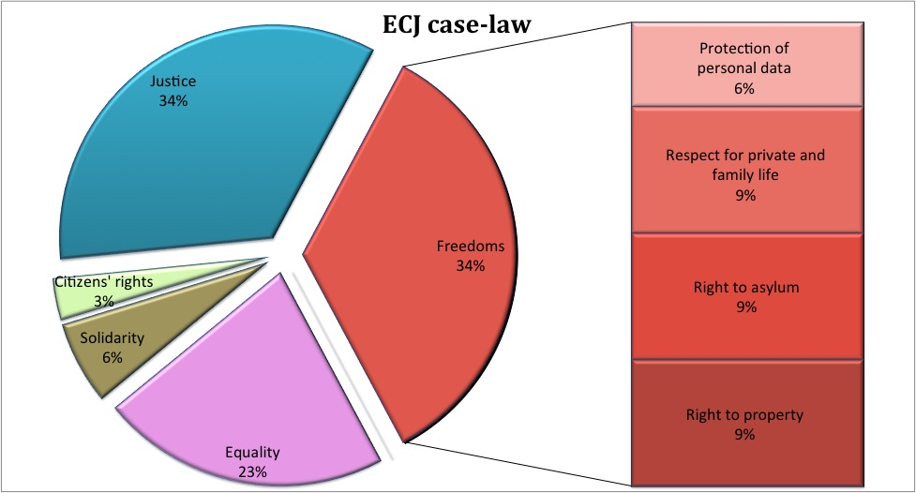
N.B.: The figure illustrates only the cases in which the Court directly quoted the Charter or referred to fundamental rights in the reasoning.
Freedom of religion
The Charter guarantees that everyone has the right to freedom of religion, which includes the freedom to change religion or to manifest it in worship, teaching, practice and observance.
The display of religious symbols (wearing of the burqa or veils and the display of crucifixes in schools) was frequently raised in questions and petitions from the European Parliament as well as letters from the general public. The issue of display of religious symbols in public buildings is an issue where Union law does not apply. The wearing of the burqa or veil raises a number of complex issues and involves various fundamental rights at the same time, in particular the freedom of religion and the principle of non-discrimination on the grounds of sex and religion. The issue falls under the scope of national law and Member States have adopted different approaches.
The Commission received a question from the European Parliament regarding the wearing of the burqa or veil in official premises of the EU. It replied that the entry into Commission buildings is subject to an identity check for security reasons. The Commission security guards must be able to verify that the physical appearance of the person seeking entry corresponds to the photograph on the identity card or other means of identification. When any person is dressed in such a way that all identifying characteristics, in particular the face, are hidden, a proper security check can not be carried out. In such cases, access to the Commission's buildings could be denied, following a proportionality assessment taking into account religious freedom, non-discrimination and the need to ensure the security of the Commission's officials, visitors and guests.
Freedom of expression
The Lithuanian Law on the protection of minors
In 2010, the Lithuanian authorities considered the adoption of a law, which provided that information on homosexuality is detrimental to minors and should therefore be banned. This proposal touched upon a number of issues falling within the scope of EU law, for example the rules on Audiovisual and Media Services Directive and the E-commerce Directive.
The Commission took the position that this could be contrary to the Charter, in particular the prohibition of discrimination and the freedom of expression. The Lithuanian Parliament suppressed the most contentious provision from the law, which entered into force in March 2010. The Commission is monitoring the implementation of the law to ensure that this complies fully with the principles set out in the Charter, in particular that of freedom of expression.
The Charter guarantees that everyone has the right to freedom of expression. This right includes freedom to hold opinions and to receive and impart information and ideas without interference by public authority and regardless of frontiers.
In 2010, a case was brought before the Court of Justice concerning the introduction by operators of a system for filtering electronic communications to identify users who damage copyright or related rights. This case raises issues related to freedom of expression, as a system for filtering all electronic communications could have an impact on this freedom. The Court has, until the end of 2010, not yet delivered its ruling.
The Commission received several letters from the general public and questions from the European Parliament on the issue of legislation (National Defence Strategy) adopted by the Romanian Supreme Defence Council (CSAT), which described the media as a security threat and vulnerability for Romania due to alleged press campaigns aimed at spreading false information about the activity of state institutions. The Commission replied that it is, within the scope of its competences, fully committed to ensure and promote the respect of freedom of expression. In this case, the Member State concerned did not act in the course of implementation of EU law and it is for the national authorities to ensure that their obligations regarding fundamental rights are respected.
The Commission was in contact with the Hungarian authorities concerning the national media law and raised concerns regarding its compatibility with the Audiovisual and Media Services Directive, and other provisions of EU law such as freedom of establishment, freedom to provide services and the Charter. Following the Commission's intervention, the Hungarian government agreed to amend the national media law using a fast track procedure so that it complies with the concerns raised by the Commission.
Freedom to conduct a business
The Charter recognises the freedom to conduct a business in accordance with Union law and national laws and practices. This Article is based on Court of Justice case-law which has recognised freedom to exercise an economic or commercial activity and freedom of contract, and on Article 119(1) and (3) of the TFEU, which recognises free competition. Arguably, these rights encompass that the legal system gives effect to the will of the parties. The freedom to conduct a business has to be taken into account in different areas of EU policy, including IT security and civil law.
In 2010, the Commission proposed amendments to EU rules on jurisdiction and the recognition and enforcement of judgments in civil and commercial matters. The proposal gives maximum effect to the will of the parties in business to business contracts by allowing them to agree on which court should have jurisdiction to settle any dispute (choice of forum) and whether to refer the matter to arbitration (arbitration clause). The impact assessment showed that this approach would enhance their freedom of contract and improve their situation in terms of the freedom to conduct a business.
How do EU rules on civil law take into account the freedom to conduct a business?
In recent years, the number of attacks against information systems has risen steadily in Europe. New concerns, such as the spread of malicious software creating 'botnets' - networks of infected computers that can be remotely controlled to stage large-scale, coordinated attacks - have emerged. To respond to these challenges, in 2010 the Commission proposed to amend EU rules for protecting information systems against attacks. These rules propose making a crime the use of tools for committing offences, making a crime the illegal interception of information systems and improving the European criminal justice and police cooperation. They also contain measures on storage of data and the exchange of data between law enforcement agencies, which are in compliance with EU data protection rules. The strengthening of the penalisation of the production, sale, procurement for use, import, distribution or otherwise making available of tools for cyber attacks was worded carefully in order not to criminalise lawful behaviour, such as the use of botnets by Internet security companies to test the effectiveness of their products. Criminalisation of such acts would violate the freedom to conduct a business, enshrined in the Charter.
How to protect information systems against attacks while respecting the freedom to conduct a business?
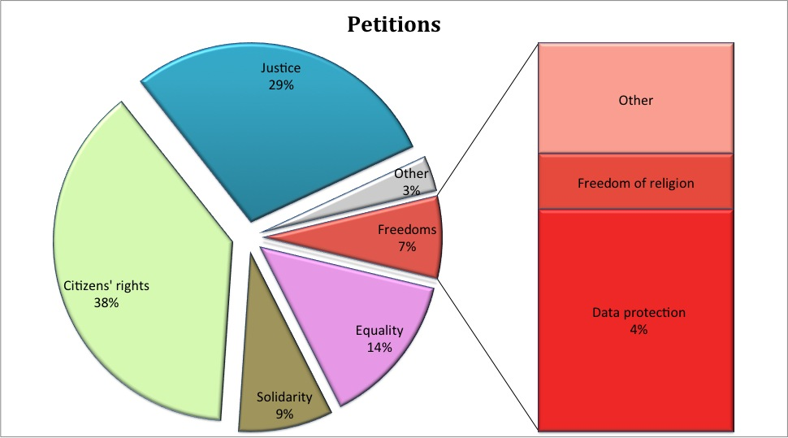

Right to property
The Charter protects the right of everyone to property, which includes the right to own, use, and dispose of lawfully acquired possessions. Issues related to the right to property were featured frequently in petitions from the European Parliament and in letters from the general public.
National laws regulating coastal areas
Several questions (as well as letters) concerned the implementation of the Spanish Coastal Law. This legislation, aimed at protecting the coast from abusive construction, applies to private property, which runs the risk of being demolished, as it is located in areas regulated by the Coastal law.
The Commission wrote to the Spanish authorities to ensure that Spanish Coastal Law is applied in conformity with the principle of non-discrimination on the ground of nationality as set out in the Charter.
One issue that was frequently raised with the Commission was the restitution of property nationalised or confiscated in Member States during the period of communist regimes. The petitions and letters referred in particular to the length of the procedures and administrative obstacles.
The Treaties provide that "the provisions of the Treaty shall in no way prejudice the rules in Member States governing the system of property ownership". It is therefore for Member States to determine the scope of property restitution and the choice of the conditions under which they agree to restore the property rights of former owners that were subject to expropriation decisions prior to the accession to the European Union.
Restitution of property nationalised or confiscated under communist regimes
An EU citizen wrote to the Commission complaining against the national authorities, which have rejected his request for restitution of property nationalised under the communist regime.
In situations where EU law does not apply, national legislation on the restitution of nationalised or confiscated property during the period of communist regimes falls under the national competence. The complainant should seek redress before national authorities, including the courts, in accordance with national law.
The Charter guarantees the protection of intellectual property.
How does the EU protect intellectual property?
In 2010, the Commission announced in the Communication Towards a Single Market Act proposals to promote and protect creativity. Their aim is to lay ground for an EU patent, to open up access to online content by improving the electronic management of copyright, and to fight against counterfeiting and piracy.
Right to asylum
The right to asylum is guaranteed by the Charter. The Commission received a number of letters from citizens, asylum seekers, and refugees concerning the implementation of EU asylum law. The EU is developing legislation on asylum.
In 2010, negotiations in the European Parliament and the Council on a number of legislative proposals tabled by the Commission were ongoing. These proposals are intended to amend some of the existing rules of the Common European Asylum System with the aim to ensure higher standards of protection and a more uniform treatment of asylum seekers in Member States. The Commission proposals contain in particular provisions on preventing arbitrary detention and on safeguarding human dignity with regard to detention conditions of asylum seekers. The proposals also aim to introduce greater care for ensuring family unity in asylum related decisions, prohibit the detention of unaccompanied minors and facilitate access to effective remedy for asylum applicants.
The Court of Justice case Hasan and others concerned Iraqi nationals whose refugee status was revoked in Germany, following the fall of Saddam Hussein's regime. The Court highlighted that the provisions of relevant EU legislation have to be interpreted in the light of fundamental rights, in particular the right to asylum as enshrined in the Charter. The Court gave a number of indications that help to ensure the proper application of relevant EU legislation by Member States.
Compatibility of national legislation with EU rules on asylum
A non-governmental organisation wrote to the Commission about the difficult situation of asylum seekers in a Member State, claiming the authorities did not ensure adequate access to the asylum procedure or material assistance. As a consequence, many asylum seekers were destitute and deprived of a fair opportunity to present their case, which resulted in a violation of their right to asylum.
According to EU rules on asylum, asylum seekers have a right to apply for asylum and to have their applications effectively examined by a Member State, on the basis of common criteria which determine who is genuinely in need of protection. EU rules entitle asylum seekers to reception conditions such as accommodation. It is the responsibility of national authorities to ensure that these rules are effectively enforced.
The Commission requested clarifications from the Member State and initiated infringement proceedings regarding the compatibility of national legislation with EU asylum rules, in particular the effective access to the asylum procedure and the reception conditions.
Right to asylum
A citizen of a third country wrote to the Commission that his application for asylum in a Member State was rejected and requested that the Commission grants him asylum.
EU rules determine the conditions and criteria for recognition of third country nationals or stateless persons who apply for asylum in a Member State. Only competent national authorities can grant international protection depending on the individual circumstances of each applicant.
The Commission replied that it has no competence to assess asylum applications and grant international protection to individual applicants. Individuals who consider that they are not granted the rights prescribed by EU law should seek redress before competent national authorities, including courts.
- Equality
Among the rights and freedoms under this title, the rights of the child were most frequently raised in letters, questions and petitions.
Surveys of the EU Agency for Fundamental Rights show that racism and xenophobia continue to be a problem for many ethnic and religious minorities in the European Union and confirm the situation of exclusion of Roma people in Europe.

Equality before the law

Non-discrimination

Cultural, religious and linguistic diversity

Equality between women and men

The rights of the child

The rights of the elderly

Integration of persons with disabilities

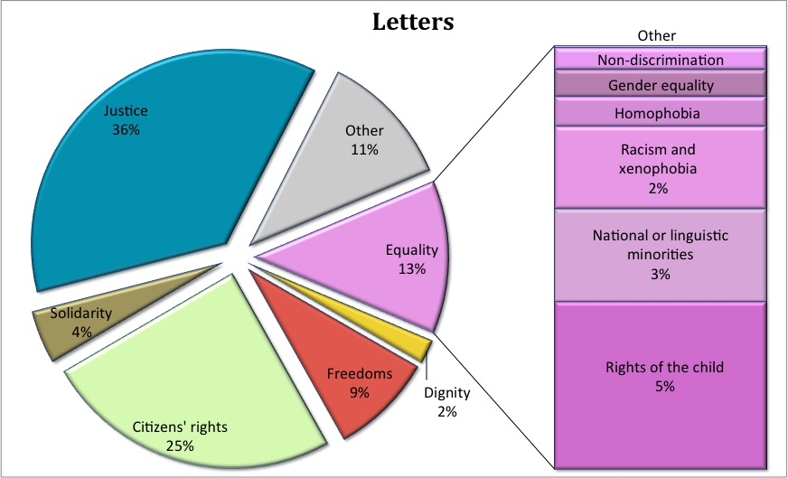
Non-discrimination
The Charter prohibits any discrimination based on any ground such as sex, race, colour, ethnic or social origin, genetic features, language, religion or belief, political or any other opinion, membership of a national minority, property, birth, disability, age or sexual orientation. The Charter also prohibits discrimination on the ground of nationality, within the scope of application of the Treaties and without prejudice to any of their specific provisions.
Discrimination based on racial or ethnic origin is equally a violation of the principle of equal treatment and is prohibited in the workplace and outside the workplace. People are protected by law if, for instance, employers refuse promotion or training because of a person’s racial or ethnic origin. Outside the workplace, people are protected if, for example, they are refused access to education or higher education institution solely because of their racial or ethnic origin.
Discrimination based on racial or ethnic origin
A person wrote to the Commission complaining that the public electricity company cut the electricity supply to all people in a district which was predominantly a Roma neighbourhood. This was done independently of whether the inhabitants had paid their bills.
The Commission contacted the Member States to request information and the situation was subsequently resolved.
What does the EU do to fight against discrimination?
In the area of employment and occupation, EU law prohibits discrimination on grounds of religion or belief, disability, age or sexual orientation. Employers must base job classification systems for determining pay on the same criteria, regardless of religion or belief, disability, age, or sexual orientation. They must also ensure reasonable accommodation to enable disabled people who are qualified to participate in training or paid labour. There are however situations where differences in treatment are authorised, such as: genuine occupational qualifications, differences in treatment on grounds of age, positive actions. These situations are limited and must be well justified.
Discrimination on ground of disability
A disabled person complained that she could not have access to a museum.
EU legislation currently provides for protection on the ground of disability only in the field of employment. The proposal for a new equal treatment Directive would cover these situations.
In 2010, the Commission continued to follow the negotiations in the Council on its proposal for a new anti-discrimination Directive intended to reduce discrimination on grounds of religion or belief, age, disability or sexual orientation beyond the workplace: access to goods and services such as banking, education, transport and health.
The Court of Justice referred to Article 21 of the Charter in the case Kücükdeveci with regard to discrimination on ground of age. The case concerned the notice periods which an employer must comply with in the case of dismissal. German legislation prescribed that notice periods increased progressively according to the length of the employment relationship. However, periods of employment completed by an employee before reaching the age of 25 are not taken into account for calculating the notice period. Ms Kücükdeveci, who started working in the company at the age of 18, was dismissed at the age of 28. The company calculated the notice period as if she had only three years’ length of service, although she had worked for the employer for ten years. No account was taken of the periods of employment completed before Ms Kücükdeveci was 25. She brought proceedings to challenge her dismissal, claiming that the legislation constituted discrimination on grounds of age, prohibited by European Union law. In her view, the notice period should have been longer, corresponding to ten years’ service and not to three years. The Court found that the German rules on dismissal are discriminatory as they contain a difference of treatment based on age, which cannot be justified.
Discrimination on grounds of political views in employment
A complainant brought a court case against his employer on the charge that he had been discriminated and harassed at work because of his views on his country's asylum system (which he claimed were protected as "belief").
The Austrian Supreme Court rejected that claim, stating that political views were not protected by EU and national equal treatment legislation.
He then wrote to the Commission stating that the Supreme Court should have referred to the Court of Justice for an interpretation of the relevant EU law. He also claimed a violation of his rights according to the Charter.
The Commission replied that it agreed with the Austrian Supreme Court's interpretation that political views were not covered by EU equal treatment legislation. Since the case falls outside the scope of EU law, there could be no violation of the Charter.
In 2010, the Commission frequently received complaints about alleged discrimination on a ground that is covered by EU law, but where EU law has been correctly transposed in the Member State concerned. If transposition is correct, and the complaint concerns an individual case of wrong application of the law, the individual concerned should seek guidance from the national equality body or bring legal action at national level.
Discrimination on grounds of sexual orientation at work
An individual wrote to the Commission complaining that he had been harassed at work because of his sexual orientation, and that he subsequently lost his job for this reason. He asked the Commission to ensure that the behaviour of the management of the company and of his co-workers is sanctioned.
The Commission replied that the relevant EU anti-discrimination rules had been transposed in national law of that Member State. The complainant should initiate proceedings before national courts. The Commission provided references to existing national case law relevant to his case, and contact details of the national Equality Body.
The Commission is keen to see the principle of non-discrimination on the basis of sexual orientation, as enshrined in the Charter, applied systematically in the preparation, adoption and implementation of EU law.
What does the prohibition of discrimination on ground of sexual orientation mean in practice?
EU citizens have the right to move and reside freely in another Member State, together with their families. The benefits of EU rules guaranteeing free movement and residence apply also to same-sex couples.
In its judgment Schalk and Kopf v. Austria the European Court of Human Rights (which is not an institution of the European Union) made a reference to the Charter and to provisions of two EU Directives (on family reunification and free movement) to strengthen the right to respect for private and family life under the European Convention of Human Rights by extending the notion of “family life” to same-sex couples. The European Court of Human Rights considered it "artificial" to maintain the view that, in contrast to a different-sex couple, a same-sex couple cannot enjoy ‘family life’ for the purposes of Article 8 of the European Convention.
Homophobia is a mixture of negative attitudes and feelings towards lesbian, gay, bisexual, and transgender people. It is an unacceptable violation of human dignity and it is incompatible with the founding values of the EU.
The EU Agency for Fundamental Rights reports that LGBT (lesbian, gay, bisexual and transgender) persons experience harassment, bullying and discrimination across the EU. According to this report, the majority of victims of homophobic crime do not complain to the police. Sometimes LGBT people face violent physical attacks. The Agency is preparing a survey on discrimination and hate crime towards LGBT people to be conducted in 2011. Hate speech on the Internet is a particularly worrying phenomenon and so is hate speech by public figures. An increasing number of known personalities, especially in sports, have stood up for LGBT rights and sent encouragements to fight against prejudices and stereotypes.
Although in most Member States LGBT people could freely exercise their right to freedom of assembly, the Agency reports that bans or administrative obstacles created problems for the organisation of peaceful public LGBT demonstrations in some Member States and that organised attacks against such demonstrations have taken place in others.
How can the EU contribute to the fight against homophobia?

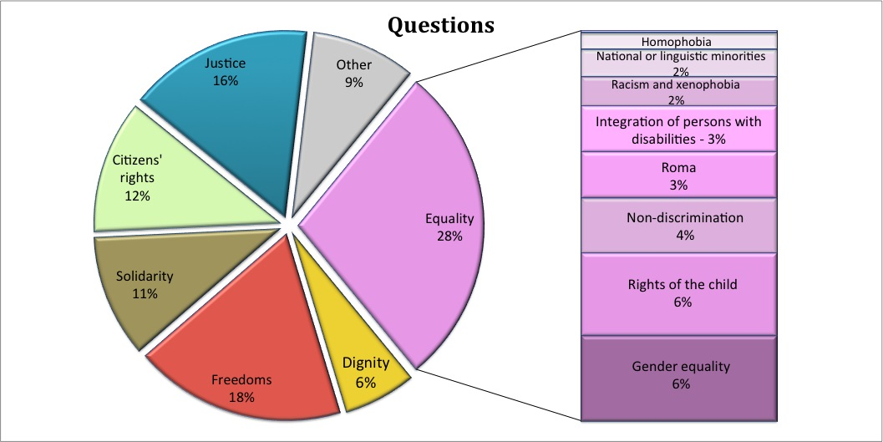

The Charter prohibits any discrimination on grounds of gender and enshrines the right to equal treatment between men and women.
How does the EU promote gender equality and fight discrimination on grounds of gender?
Equality between women and men must be ensured in employment, work and pay. In the workplace, men and women are protected against harassment and sexual harassment, as this is contrary to the principle of equal treatment. Women are also protected against any discriminatory practices on account of pregnancy. Men and women must be treated equally also as regard access to and supply of goods and services.
In 2010, the Commission reaffirmed its commitment to gender equality by adopting the Women’s Charter and a Strategy for Equality between Women and Men (2010-2015). The Commission pointed out that despite a general trend towards more equality in society and on the labour market, progress in eliminating gender inequalities remains slow. It defined challenges and action for the following five priority areas: equal economic independence; equal pay for equal work and work of equal value; equality in decision-making; dignity, integrity and an end to gender-based violence; and gender equality outside the EU. Achieving progress in all these areas would offer genuine choices to many women and men.
There was an important policy development with the adoption of a proposal of the Commission implementing the principle of equal treatment between women and men in self-employment. This proposal provides for a maternity allowance for female self-employed workers and female spouses and life partners, enabling them to interrupt their professional activities.
In 2010, the Commission received a number of complaints, which concerned claims of discrimination on the ground of gender in different areas.
Discrimination on ground of gender in employment
A British national complained to the Commission that he is discriminated against on ground of sex. He alleges that he was refused access to employment because he is a male, invoking the incompatibility of gender equality legislation in Northern Ireland with EU rules.
The Commission is investigating this case and has asked for information from national authorities.
Discrimination on ground of gender regarding refugee status
The Commission received a complaint arguing that the children of women with displaced person status are discriminated against by the Cypriot authorities. Contrary to children of men with displaced person status, they seem not to be entitled to refugee status and are therefore deprived of certain refugee benefits.
The Commission sent a request for information to Cyprus.

Surveys of the EU Agency for Fundamental Rights show that racism and xenophobia continue to be a problem for many ethnic and religious minorities in the European Union.
What does the EU do to fight against racism, xenophobia and related forms of intolerance?
The EU Agency for Fundamental Rights reported a general upward trend in recorded racist crime in 10 out of 12 Member States, which collected sufficiently robust criminal justice data. The number of antisemitic crimes rose in 2001-2008 in 5 out of 6 Member States, with adequate data in this field. Every tenth person with an immigrant or ethnic minority background interviewed for the EU-MIDIS survey in 2008 had been a victim of racist or xenophobic assault, threat or serious harassment in the past 12 months. Roma and Sub-Saharan Africans were reported to be particularly vulnerable to such crimes.
The majority of the people with an immigrant or ethnic minority background interviewed for the EU-MIDIS survey did not report to the police even though they had been victims of assaults or threats. The non-reporting of serious harassment was even higher – depending on the group, 75% to 90% of these incidents went unreported. The main reason for non-reporting was the victims' lack of confidence that the police could or would do anything in their case.
The EU has rules banning certain types of hate speech, for example rules requiring Member States to punish those who incite to violence or hatred in public on the basis of race, colour, religion, descent or national or ethnic origin. From 28 November 2010 the Member States had to comply with the EU legislation banning racist or xenophobic hate speech. These rules ensure that the same racist behaviour constitutes a crime in all Member States and prevent perpetrators from avoiding prosecution by moving to another Member State. The EU has also adopted rules requiring Member States to ensure that audiovisual media services (both broadcasts and on-demand services) originating in their territory do not contain any incitement to hatred based on race, sex, religion or nationality. If the Commission receives evidence about the provision of programmes in the EU with such content, it can launch an infringement procedure against the Member State.
Al-Aqsa TV
The Commission received a number of complaints regarding incitement to hatred on the basis of religion, nationality or race in the programmes broadcast by Al-Aqsa TV. The TV channel was broadcast through a French operated satellite and was accessible to viewers in the EU. Such incitement to hatred is prohibited by EU audiovisual rules.
In 2010, the Commission opened an infringement case against France. In June 2010, the French authorities requested that Al-Aqsa TV stops transmitting in EU, which it did. The Commission closed the infringement case and will continue to monitor new developments in close cooperation with the national authorities.
Hate crimes are criminal acts that are motivated by intolerance or hatred against a particular group. EU rules require that the Member States impose a higher penalty for crimes committed with a racist or xenophobic motivation.
In 2010, the Commission received a number of letters concerning various forms and manifestations of racism and xenophobia, targeted against different groups or individuals belonging to these groups (Jews, Muslims, Roma, etc.). The Commission intervenes in cases of racism and xenophobia when the respect of EU law is in question, such as the EU rules banning racist or xenophobic hate speech in TV broadcasting or those prohibiting discrimination. Several letters reporting cases of racist or antisemitic hate speech or violence brought to the attention of the Commission incidents that can show whether Member States have adapted national legislation to conform to EU rules.
Between 10 and 12 million Roma live in Europe. Many of them endure poverty, suffer discrimination and do not enjoy the same rights and opportunities as other EU citizens. Roma people have lower life expectancy, often live in precarious housing and are more frequently unemployed. Roma children often do not finish school. The reports on the situation of Roma published by the EU Agency for Fundamental Rights confirm the situation of exclusion of Roma people in Europe.
How can the EU improve the situation of Roma?
The integration of Roma requires that Member States and the European Union work together. The Commission is supporting these efforts by providing model approaches for the social and economic integration of Roma. The European Union supports the Member States financially to help integrate Roma communities with projects on housing, education and employment. The Roma Task Force, established by the Commission, aims to assist Member States in using these funds in a more effective way to ensure the integration of Roma people. On 21 December 2010, the Task Force reported its initial findings. It noted that while EU funds offer considerable potential for bolstering Roma inclusion, bottlenecks at national, regional and local levels are limiting their effective use by Member States. The Roma Task Force will continue its work in identifying concrete ways to enhance the funds’ uses. The results will be part of an EU framework for national Roma integration strategies in the Member States that will be presented by the Commission in spring 2011, for discussion in the European Parliament and the Council. A new study – released by the Commission on 21 December – analysed national Roma inclusion measures in 18 EU countries and identified a series of successful policy approaches. Integrated policies and projects addressing the multiple causes of social exclusion are the best ways to improve the situation of Roma in Europe, the study says.
Expulsions of Roma
In the summer of 2010, the French authorities proceeded to dismantle unauthorised camps on their territory and to serve expulsion orders and orders to leave the French territory to the occupants of these camps, mostly Romanian and Bulgarian Roma. Due to the fact that they concerned expulsions of EU citizens, the Commission examined the compatibility of these measures with EU rules on free movement.
National authorities have the right to decide to expel EU citizens or to withdraw their right of residence under certain strict and clear conditions. The Commission has been looking into whether these operations had been carried out in full compliance with these EU rules, in particular with the right of EU citizens to move and settle down in another EU country and the right not to be discriminated for belonging to a specific nationality.
Following the request of the Commission, the French authorities are changing their rules in order to bring them fully in line with EU rules on free movement. In order to provide legal certainty to Member States and EU citizens it is important that the procedural and substantive safeguards included in EU rules on free movement are fully and correctly transposed by and in the Member States.
When it comes to the integration of Roma, funding is not the only area that requires action. The rights enshrined in EU law must be properly enforced at national level. The Commission closely monitors the respect of the relevant EU rules, such as the Free Movement Directive, the antidiscrimination law and the law against hate speech.
In 2010, the Commission received a number of letters from citizens and associations as well as questions from the European Parliament concerning the situation of persons belonging to minorities. They concerned issues such as: the use of regional or minority languages in official contacts, spelling of names of persons belonging to minorities in official documents and of street names in areas where minorities are present, conditions of education for minorities and the impact of electoral laws on minority voters.
What does the EU do concerning national and linguistic minorities?
The respect for the rights of persons belonging to minorities is one of the founding values of the European Union, and is explicitly mentioned following the entry into force of the Lisbon Treaty. The Charter explicitly prohibits discrimination on the basis of membership of a national minority. The Commission ensures that Member States, when implementing EU law, respect the principle of non-discrimination provided in Article 21 of the Charter, which prohibits any discrimination.
In the area of language use, the Commission has developed a strategy to promote official, national, regional, minority and migrant languages in the EU. This strategy confirms the support of the Commission for all languages spoken in the European Union, including the languages spoken by minorities. The Commission confirmed that a concerted effort is required to ensure that, within existing resources, multilingualism is taken into account across a series of EU policy areas, including lifelong learning, employment, social inclusion, competitiveness, culture, youth and civil society, research and the media. The Strategy pointed out that a successful multilingualism policy could strengthen life chances of citizens: it may increase their employability, facilitate access to services and rights and contribute to solidarity through enhanced intercultural dialogue and social cohesion.
Use of minority languages in the Member States
An association representing a linguistic minority in one Member State wrote to the Commission complaining about various obstacles for this minority to use its own language in that Member State.
As the EU has no power to adopt laws on the use of minority languages, the Charter cannot be used and the Commission was not able to give any follow-up to the complaint.
The association may seek redress elsewhere, either through national authorities or the European Court of Human Rights.
It is important to remember that the Member States maintain general powers to take decisions about minorities and the use of languages on their respective territories. There is no EU law regulating the use of languages in Member States. The right to use a regional or a minority language falls under the responsibility of the Member States. The Council of Europe, an international organisation based in Strasbourg, plays a key role in that respect.
Issues related to the recognition of the status of a minority fall under the responsibility of Member States, which must use all means available to them in order to guarantee that fundamental rights are effectively protected, in accordance with the national and international rules.

Rights of the child
The Charter guarantees the right to such protection and care as is necessary for the well-being of children (Article 24 of the Charter). This Article is based on the United Nations Convention on the Rights of the Child, ratified by all 27 Member States. The Charter recognises children as bearers of autonomous rights, not just as subjects in need of protection. It recognises the need to protect children from abuse, neglect, violations of their rights and situations which endanger their well-being.
The Charter provides that best interests of the child must be a primary consideration in all actions relating to children. This principle applies to all actions concerning children. It includes children's right to maintain contact with both parents in case of a divorce, the right to express their views freely and for their views to be taken into consideration on matters which concern them. An important principle of the Charter is that when decisions are being made on what is in the best interests of children, children should have the opportunity to express their views and these views should be taken into account.
Right to information in criminal proceedings
The Commission adopted in 2010 a draft law to guarantee the right of suspects to receive information during criminal proceedings.
The proposal takes into account the children's best interests. It ensures that in the case of an arrest, children receive information about their rights in the proceedings in a manner that they can understand.
How are the best interests of children protected in EU legislation?
In 2010, the Commission discussed the rights of the child with a wide sample of children from all 27 Member States and from different backgrounds, including ethnic minorities. Children with special needs also participated in the discussions.
Some children are particularly vulnerable, and letters from the general public and questions from the European Parliament reflect this, in particular as regards children who live in poverty, children with special needs, children without parents and those living in care institutions, those who are trafficked or sexually abused, children from ethnic minorities, such as Roma, Sinti or traveller children, or children in migration need special protection.
In 2010, the issue of administrative decisions on the removal of the child from the custody of one or both parents was raised in a number of letters from the general public and questions from the European Parliament. Moreover, EU rules make it easier for the separating parents to know which court will be deciding in case of dispute over the custody of their child. They also make it easier for the parents to have court decisions recognised in another Member State, for example the decisions concerning custody of the child and how often and under what conditions the other parent may visit the child. Finally, in cases when a parent who does not have custody rights takes the child to another Member State and breaches the decision of the court (this is also known as 'parental abduction'), these rules make it easier to seek the child's return back to the carer. The Commission is not in a position to re-examine the merit of a decision made by a national court in individual cases concerning custody arrangements. These decisions can be appealed against in front of the competent national courts. The same can be said about national rules concerning custody of children.
How can EU rules help in cross-border custody cases?
The first judgement of the Court of Justice (the "Detiček case") after the entry into force of the Treaty of Lisbon in which the Court applied the Charter concerned custody rights after the break up of a marriage between parents from two different Member States.
The Detiček case
The divorce court in Italy, where the child was residing, awarded temporary custody to the father. The mother then took the child to Slovenia. After the Italian temporary judicial decision was recognised in Slovenia, the mother requested that provisional custody is awarded to her by the Slovenian court, arguing that the child had now settled in Slovenia with her mother and therefore circumstances had changed.
The Court applied the Charter and stated that not respecting an already issued and recognised Italian judicial decision would be contrary to the child's best interest. The child's fundamental right to maintain on a regular basis a personal relationship and direct contact with both parents guaranteed by the Charter would also be violated.

How can the EU help when children go missing?
Another area of concern in letters and parliamentary questions in 2010 was the issue of missing children. Children may go missing regardless of their age, gender or social status. When a child goes missing there are enormous risks involved; risks to their safety, mental and physical health, well-being and life. They can suffer violence and abuse. They can be trafficked or exposed to begging and prostitution. In 2010, the Commission received a number of letters and questions related to the problem of missing children.
In 2010, sexual exploitation of children and child pornography were raised in a number of questions and letters. Sexual exploitation of children can take many forms, such as forcing a child into prostitution, profiting from such acts, forcing a child to have sex, and paying money to have sex with children. In 2010, the Commission proposed new rules to fight sexual abuse of children and child pornography. This proposal is aimed at prosecuting offenders, preventing offences and protecting victims. It raises the level of protection and assistance provided to child victims, ensures that children have easier access to justice and do not suffer additional trauma in legal proceedings.
Dial 116 000: The European hotline for missing children
116 000 is a single telephone number reserved in all Member States as a hotline to report missing children and offer emotional help and support to the parents of the missing child. At the end of 2010, two years after the Commission reserved the number, the hotline was operational only in 13 Member States.
In 2010, the Commission in the Communication Dial 116 000: The European hotline for missing children identified the following obstacles preventing the implementation of the 116000 hotline:
- Lack of information about the existence of the reserved 116 000 number;
- Cost of running the hotline.
Thousands of children who are non-EU nationals and who arrive in the EU without their parents or guardians (unaccompanied children) represent one of the most vulnerable groups of children. According to the EU Agency for Fundamental Rights these children, even when under State care, may live in unsuitable accommodation (including in detention, waiting for a decision on their application for asylum), lack quality medical care, equal access to appropriate education and training. They can be victims of discrimination or even mistreated, and they are often insufficiently informed about legal procedures and opportunities available to them. These children are particularly vulnerable to becoming victims of organised crime, such as human trafficking, prostitution, sexual abuse, illegal human organ trade, or recruitment to engage in criminal activities. Based on a proposal by the Commission, the EU adopted in 2010 a plan to increase the protection of unaccompanied migrant children in the EU. This plan is based on the rights laid down in the Charter.
In 2010, the Commission also received many letters and questions concerning the quality of treatment of disabled children living separated from their parents in state institutions. The Commission has no powers under the Charter to intervene in this area. The Commission supports Member States in their efforts to provide institutional care and long-term care services to children with disabilities.
How does the EU protect unaccompanied children?
EU action plan for unaccompanied children
The plan, adopted in 2010, provides that unaccompanied children must be treated in accordance with the Charter. All actions must respect the best interests of an individual child.
Children should be protected from traffickers and criminal groups and all forms of violence or exploitation. Every effort should be made to find the family of the child and to reunite the child with his or her family provided that this is the best solution for the child involved. Every child must have access to legal representation.
A decision on the future of each child should be taken within the shortest time possible. Unaccompanied children should always be placed in an appropriate accommodation and treated in a way so that their physical and mental well-being is preserved.
Prohibition of detention of unaccompanied children in asylum procedures
In 2010, negotiations in the European Parliament and the Council continued on a number of legislative proposals in the area of asylum tabled by the Commission.
The Commission proposals provide for an absolute prohibition of the detention of unaccompanied children.

The rights of the elderly
The Charter provides that the Union recognizes and respects the rights of the elderly to lead a life of dignity and independence and to participate in social and cultural life.
The number of older people will rise rapidly over the coming years, notably as a result of the 'baby-boom' cohorts reaching retirement age. This will make it increasingly difficult for Member States to ensure that the elderly can lead a life of dignity and independence and that they can participate in social and cultural life. The Commission proposed, in September 2010, to designate 2012 as European Year for Active Ageing. The aim of this European Year is to raise awareness of ageing and its implications and to encourage stakeholders at all levels to take new initiatives that will remove obstacles to older people playing an active role on the labour market and in society and to ensure that they can stay autonomous for as long as possible. EU will promote longer active life and higher social participation of the elderly to the society and the empowerment of elderly people (who can contribute to the society through their experience and voluntary work).
EU supports research on the prevention of Alzheimer's disease. In the context of the Europe 2020 strategy, under the Innovation Union, the EU has launched a pilot European Partnership on Active and Healthy Ageing.
Integration of persons with disabilities
The Charter provides that the Union recognises and respects the right of persons with disabilities to benefit from measures designed to ensure their independence, social and occupational integration and participation in the life of the community.
To empower women and men with disabilities so they can enjoy their full rights and benefit fully from their participation in society, the Commission in 2010 launched the Disability strategy. The Strategy identifies eight priority areas: accessibility, participation, equality, employment, education and training, social protection, health and external action. In December 2010, the EU became party to the UN Convention on the Rights of Persons with Disabilities (UNCRPD). The Strategy defines EU mechanisms to implement this convention, which will supplement national action.

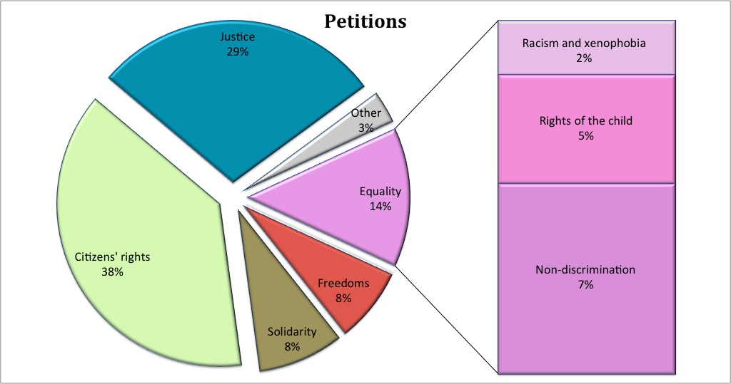

- Solidarity
Against the background of the current crisis with its grave socio-economic impacts, the Commission took action to apply EU instruments to the fundamental rights of workers. A number of important judgements of the Court of Justice used the Charter in order to clarify EU rules in this area.
Charter rights and freedoms under this title are implemented through a number of EU legislative acts. Title Solidarity contains several provisions, which provide guidance to EU institutions when drafting EU rules and to Member States only when they are implementing EU law.

Workers' right to information and consultation within the undertaking

Right of collective bargaining and action

Right of access to placement services

Protection in the event of unjustified dismissal

Fair and just working conditions

Prohibition of child labour and protection of young people at work

Family and professional life

Social security and social assistance

Health care

Access to services of general economic interest

Environmental protection

Consumer protection

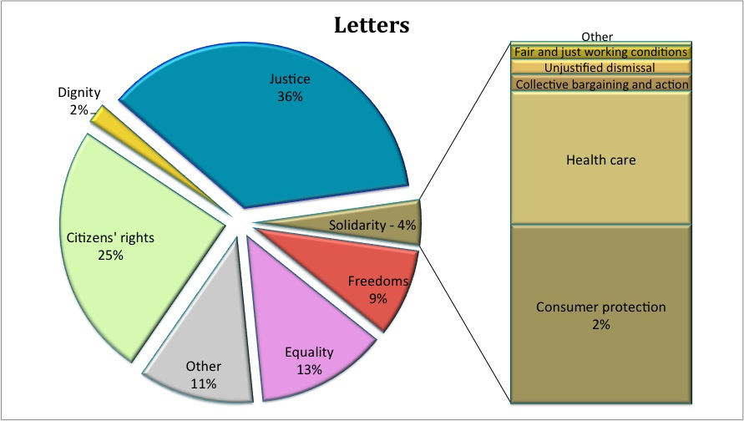
Workers' right to information and consultation
The Charter provides that workers or their representatives must, at the appropriate levels, be guaranteed information and consultation in good time in the cases and under the conditions provided for by EU law and national laws and practices.
Several EU Directives guarantee the right of workers to information and consultation at work. Against the background of the current crisis with its grave socio-economic impacts, the Commission deployed efforts in 2010 to enable the effective use of this fundamental right by workers affected by the restructuring or the closure of the companies employing them. The Commission launched a "fitness check" aiming at ensuring that current EU law is 'fit for purpose'. The Commission is focussing on the three EU laws providing for workers' right to information and consultation at national company level and aims to verify whether these laws are responsive to current and future challenges, taking also into account the current crisis, and to identify excessive burdens, gaps, inconsistencies and/or obsolete measures which may have appeared over time. This review closely associates governments and social partners, and is expected to produce concrete findings by 2012 on the effectiveness, efficiency and added value of existing EU rules, and on the need to take further action in this area. The Commission also supported best practices in the field of information and consultation of employees.
A text message (SMS) to workers that the factory is going to close
The employees of a shoe factory received a text message (SMS) while on holiday stating: ‘The Company will close on Monday. You will receive a letter informing you that you have been made redundant.' Upon their return, they found the factory closed.
The Commission in these cases referred to EU law which provides for employees' representatives to be informed and consulted in good time and in any case before the employer takes a decision to close the undertaking or to effect collective dismissals. The Member State in question had transposed EU law correctly.
In this case, the competent national authorities, and in particular the national courts, are there to ensure the correct and effective application of the EU law on informing and consulting workers, and to guarantee that employers fulfill their duties.
In 2010, shortcomings in this area were reflected in a series of parliamentary questions, for example in the cases of job losses at big automotive plants, of the closure of a plant with 1000 employees owned by a company invoking United States bankruptcy laws, and of the reorganisation of financial institutions. The Commission assisted Member States in the implementation process of the new legal framework for European Works Councils adopted in 2009. The changes to be implemented by June 2011 aim to ensure the effectiveness of employees’ transnational information and consultation rights.
How effective is the right to information and consultation of workers in EU-scale (multinational) undertakings?
In 2010, the Commission answered several parliamentary questions on concrete cases where employees have allegedly not been properly informed and consulted in restructuring cases.
As EU law currently stands, seagoing workers are excluded or may be excluded, if Member States so decide, from the EU Directives' provisions according to workers the right to information and consultation. The Commission launched two consultations with the European social partners in 2010, and is currently working on an impact assessment on the various options available with a view eventually to suppress this exclusion and extend to seagoing workers this fundamental right.
Right of collective bargaining and action
The Charter provides that workers and employers, or their respective organisations, have, in accordance with EU law and national laws and practices, the right to negotiate and conclude collective agreements at the appropriate levels and, in cases of conflicts of interest, to take collective action to defend their interests, including strike action.
There is no specific EU law regulating the conditions and consequences of the exercise of these rights at national level. Member States remain of course bound by the provisions of the Charter, including the right to strike, in instances where they implement EU law. Examples of such instances can be found in cases brought before the Court of Justice. The Laval case concerned mainly the question of whether Swedish trade unions may exercise the right to strike in order to force a Latvian company providing services in Sweden to negotiate on the working conditions of its posted workers including those which went beyond what was allowed by the EU Directive on posting of workers. In the wake of the Laval and other judgments, the Commission stepped up its efforts to promote debate with stakeholders and facilitate administrative cooperation among Member States in cases of posting of workers. In order to have a comprehensive and clear view of the issues at stake, the Commission carried out in 2010 major studies of the legal as well as economic and social effects of the posting of workers Directive with a view to reviewing the legal framework in the context of the provision of services.
Right to take industrial action
A Member of the European Parliament brought to the attention of the Commission that some trade unions had reached an agreement with their employer to continue manufacturing in Italy, preventing the threatened closure of the factory and the subsequent lay-offs of thousands of workers, in exchange for a reduction of the right to strike (guaranteed by the Italian Constitution). The exercise of this right would be punishable by disciplinary action, the ultimate sanction being dismissal.
The Commission replied that, although the right to take industrial action must be recognised as a fundamental right which forms an integral part of the general principles of EU law, there did not seem to be any link with any EU legislative act in this case. It was therefore for the competent Italian authorities, including the courts, to assess the legality of the restrictions on the exercise of the right to strike in this case, and to enforce the relevant national legislation with due regard for the applicable international obligations of the Member State.
In 2010, the Commission has been paying special attention to transnational company agreements. Transnational company agreements are texts resulting from transnational negotiations at corporate level covering situations located in the different countries where the European/multinational companies operate or which are affected by corporate decisions. So far, the Commission’s services have recorded some 200 transnational company agreements and joint texts in 100 companies employing together 9.8 million employees. These agreements usually deal with restructuring, reorganisation and anticipative measures, as well as with employment policy, mobility and training. They also deal with data protection, ethics, health and safety at work, working conditions and equal opportunities. They count among the most innovative actions in developing socially responsible companies. They are an effective tool for promoting the respect of fundamental rights in multinational companies and among their stakeholders.
Access to placement services
The Charter guarantees that everyone has the right of access to a free placement service.
The right of citizens to access placement services is implemented in the EU by the provision of services free of charge to jobseekers (both unemployed and job changers) by Public Employment Services (PES). In its Communication on 'Youth on the Move' of 15 September 2010, the Commission called upon the Member States to ensure that all young people are in a job, further education or activation measures within four months of leaving school. This may often require extending the support of Public Employment Services.
EURES, the co-operation network between the Commission and the Public Employment Services of the EEA Member States and other partner organisations, provides information, advice and recruitment/placement (job-matching) services for the benefit of workers and employers as well as any citizen wishing to benefit from the principle of the free movement of persons. In 2010 the EURES network further developed its service provision in the area of placements of mobile jobseekers and defined placement services to citizens as one of its strategic objective for the network. In 2010 the EURES network had around 2 million contacts with clients in the fields of information, advice and placement.

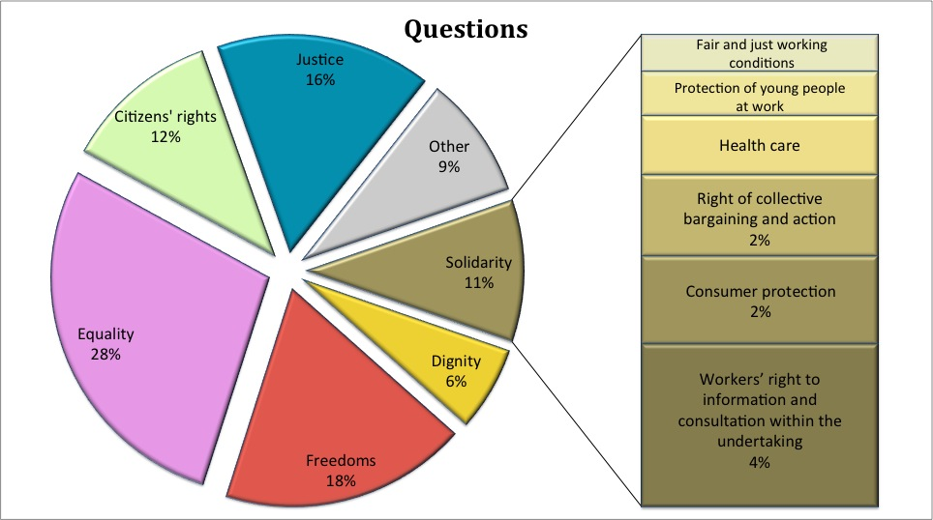
Protection in the event of unjustified dismissal
The Charter provides that every worker has the right to protection against unjustified dismissal, in accordance with EU law and national laws and practices.
EU legislation prohibiting discrimination on certain grounds, such as nationality, gender, racial or ethnic origin, religion or belief, disability, age or sexual orientation, covers also cases of unjustified dismissals. Some EU Directives in the area of workers' information and consultation provide also for the protection of employees’ representatives, in particular where they are dismissed on grounds of their status or functions as an employees’ representative.
In 2010, the Commission replied to several letters from citizens and parliamentary questions concerning individual dismissals. On several occasions, it clarified that, apart from the aforementioned instances, there are no specific EU rules prohibiting employers from dismissing individuals without mentioning any reason. Nor are there, as indicated above, any specific EU rules regulating the timing, the method or the consequences of individual dismissals. Individuals affected by a dismissal that they see as unjustified must take this matter to court in the Member State concerned.
Fair and just working conditions
The Charter guarantees that every worker has the right to working conditions which respect his or her health, safety and dignity. Every worker has the right to limitation of maximum working hours, to daily and weekly rest periods and to an annual period of paid leave
There is a substantial body of EU law in this area concerning in particular health and safety at work. The Commission continued to pay particular attention to the effective and correct implementation in the Member States of the Framework Health and Safety Directive, as this law determines the specific working conditions that should be ensured for every worker.
In 2010, the Commission adopted a Report on the implementation of the Working Time Directive , accompanied by a Staff Working Paper setting out the rules and rulings of the Court of Justice regarding organisation of Working Time. The Commission is currently undertaking a review of this Directive, based on a consultation of the social partners at EU level and on a detailed impact assessment, which is expected to lead to a proposal to amend the existing rules during 2011.
In 2010, the Court of Justice issued several judgments clarifying further the EU rules on maximum weekly working time, rest periods and paid annual leave. In one case a fire-fighter was required to work an average of 54 hours per week instead of the maximum average of 48 hours per week under the Directive. When the fire-fighter insisted on the 48-hour limit, he was moved to a different job against his will, where the 48-hour limit applied. The Court ruled that national rules which obliged a worker to work longer than 48 hours per week on average were contrary to the Working Time Directive and therefore unlawful, and that national rules allowing a public sector employer to transfer a worker compulsorily to another job for asking to work within the 48-hour limit were also unlawful. Although the Directive does not specifically lay down that a worker could not be penalised for insisting on their right not to exceed the Directive's limit to weekly working time, the Court based its reasoning upon Article 47 of the Charter which states that the law must give effective protection to legal rights.
In another case, the Court decided that workers employed in casual work in holiday and leisure centres are entitled to periods of rest. It was not enough for French law to restrict this type of work to a maximum of 80 days every year as this did not protect the workers' health and safety during working hours. The Court specifically mentioned how important it is to have rest breaks every day to help workers recover from work but also to prevent risks to their health and safety.
A third case dealt with the working conditions of part-time public servants in comparison to full-time workers. The Court found that it was unlawful to reduce the amount of paid annual leave a worker had been entitled to under a full-time job where he/she changes to a part-time job.
Protection of young people at work
The Charter provides that young people admitted to work must have working conditions appropriate to their age and be protected against economic exploitation and any work likely to harm their safety, health or physical, mental, moral or social development or to interfere with their education.
In 2010, the Commission services produced a report on the evaluation and impact of the application of the Directive on the protection of young people at work. The Directive has played a role in helping improve the legal protection afforded to young people. Young people would have been at greater risk of suffering work accidents than older workers, without the special protection afforded by the Directive. According to available data, the standardised incidence rate of accidents at work with more than three days lost for young workers fell from more than 3 % in 1995 to approximately 2.5 % in 2000 and 1.9 % in 2004. Although, surprisingly, the rate increased in 2005 to almost 2.8 % (in the EU-15), it dropped again to about 2.5 % in 2007. The corresponding rate for the overall workforce was about 2.8 % and 3.8 % for workers in the 18 – 24 age group. The standardised incidence rate of fatal accidents at work was also lower for young workers than that for the other two groups.
Social security
The Charter recognises the entitlement to social security benefits and social services providing protection in cases of maternity, illness, industrial accidents, dependency or old age, and in the case of loss of employment. Everyone residing and moving legally within the European Union is entitled to social security benefits and social advantages in accordance with Union law and national laws and practices. Member States are free to determine the details of their social security systems, including which benefits shall be provided, the conditions of eligibility, how these benefits are calculated, as well as how much contribution should be paid. However, European rules ensure that the application of the different national legislations respects the basic principles of equality of treatment and non-discrimination. They guarantee that migrant EU workers are treated alike with the national workers and that the application of the different national legislations does not adversely affect them.
Family benefits for EU citizens working in another Member State
The Commission received a request from a Polish national who lived with her children in Poland while her husband worked and lived in Austria. Her husband’s application for family benefits in Austria was refused on the ground that his children did not live with him under the same roof and were not part of the worker's household.
The Commission considered this as unacceptable because EU law provides that if children are mainly dependent on the worker they should be considered as family members and should therefore be entitled to the family benefits from the Member State of employment of the worker.
Following the intervention of the Commission the complainant was granted Austrian family benefits, including unpaid benefits from the past.
In 2010, the Commission continued to monitor the application of the EU rules on social security coordination to ensure that people moving across borders within the EU do not lose their entitlements to benefits. For instance in case of pensions, the EU rules guarantee that in each Member State the insurance record is preserved until the worker reaches pensionable age. Similarly, when dealing with a claim for unemployment benefits, institutions must take into account periods of insurance completed in other Member States if this is necessary to the entitlement to the benefit. For people working and residing in different Member States, EU law determines where they have to pay their social security contributions and which country is responsible to provide them healthcare or pay family benefits. In 2010, the Commission replied to a large number of complaints coming from individuals and took action wherever necessary.

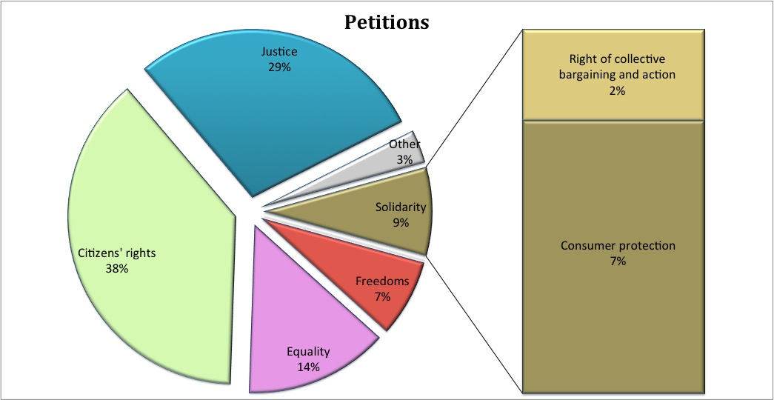
Consumer protection
The Charter provides that Union policies shall ensure a high level of consumer protection. This provision provides guidance to the EU institutions when drafting and applying EU legislation.
The objective of ensuring a high level of consumer protection guided the ongoing negotiations in the Council and the European Parliament on the proposed Directive on Consumer Rights and the Commission's work on the modernisation of the Package Travel Directive. Through infringement proceedings, the Commission made sure that the protection granted by different consumer protection directives, e.g. the Directive on the sale of consumer goods, is effectively guaranteed in national law.
In 2010, the Commission received a number of letters from the general public regarding consumer protection in various situations, such as faulty products, time share, package travel, insurance, distance (e.g. online) marketing of products and services and unfair commercial practices. As the Commission cannot intervene in disputes between consumers and operators, it informed citizens on the EU rules and referred them to the relevant national authorities and European Consumer Centres.
Consumer protection regarding package travel
An EU citizen who had bought a package holiday from a tour operator in another Member State did not receive a full refund when the tour operator became insolvent.
Following the complaint, the Commission contacted that Member State, which subsequently amended the national rules transposing the EU's Package Travel Directive, which protects consumers in such a situation.

- Citizens' rights

Right to vote and to stand as a candidate at elections to the European Parliament

Right to vote and to stand as a candidate at municipal elections

Right to good administration

Right of access to documents

European Ombudsman

Right to petition

Freedom of movement and of residence

Diplomatic and consular protection
While other titles of the Charter contain rights that benefit everyone in the EU, irrespective of their nationality, this title mainly contains rights of EU citizens - nationals of the Member States. Nevertheless, right to good administration, access to documents and freedom of movement also extend to non-EU nationals in certain situations.
Among the rights and freedoms under this title, freedom of movement and residence were the top issues in 2010, in terms of letters, questions and petitions to the Commission.
The main developments on EU Citizenship rights since the entry into force of the Lisbon Treaty are detailed in the "EU Citizenship Report 2010 – Dismantling obstacles to EU citizens' rights", and the "Report on progress towards effective EU citizenship 2007-2010", both published on 27 October 2010.

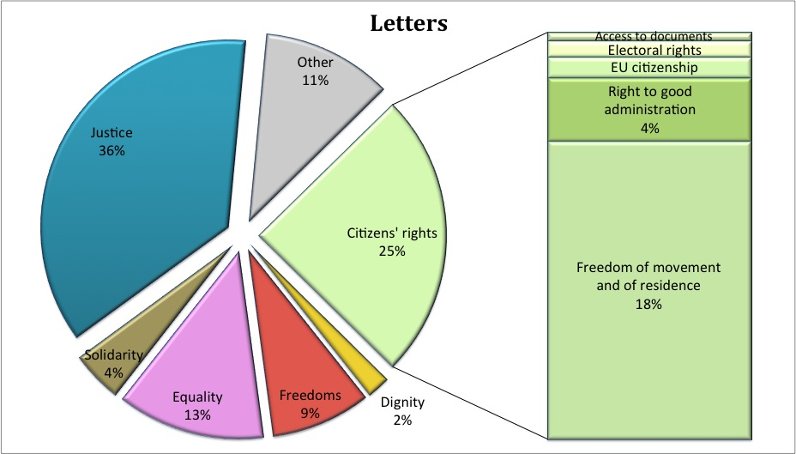

Right to vote and stand as a candidate at elections
The Charter guarantees the right of every EU citizen to vote in the European elections in whatever Member State they reside. The Charter also provides for the right of EU citizens to vote and to stand as candidates at municipal elections in the Member State in which they reside. These rights represent the cornerstone of democracy at the EU level. They are essential for connecting EU citizens with directly elected representatives at the EU level – Members of the European Parliament. They are also crucial in allowing EU citizens to influence the political environment at the local level – by voting or standing in the municipal elections when living in a Member State other than their own.
Voting in the Member State of residence
An EU citizen wrote to the Commission complaining about the conditions for enrolling as a voter when residing in a Member State other than his own.
He claimed his electoral rights were violated because of additional requirements imposed on him, namely to present an ID card issued by the country of residence.
The Commission contacted the Member State to ensure that national legislation does not impose additional requirements on citizens from other Member States when registering to vote. The Member State agreed to amend its legislation.
The report from the Commission on the 2009 European Parliament elections assessed the implementation of EU election rules. The report concludes that citizens are aware of their electoral rights. While in 2007 only 54% of the respondents knew that EU citizens have the right to vote in European elections in the Member State of residence, awareness of this right improved to 69% in 2010. Increasing numbers of EU citizens residing in a Member State other than their own exercised their right to vote.
The report presented measures for improving participation and for enforcing EU citizens' electoral rights. It revealed that a number of Member States only allow their own nationals to become members of political parties or to found one. This means that EU citizens from other Member States living there cannot fully participate in political life and exercise their electoral rights. The Commission has been looking into the legislation of these Member States and is taking appropriate measures to remedy this problem.
The Commission analysed how Member States respect EU election rules on early publication of results of the European Parliament elections. It will now take measures to ensure Member States follow these rules.
In 2010, the Commission finalised a comparative study on potential common EU principles regarding electoral arrangements. This study provides information on how EU electoral rules could be changed in the future.

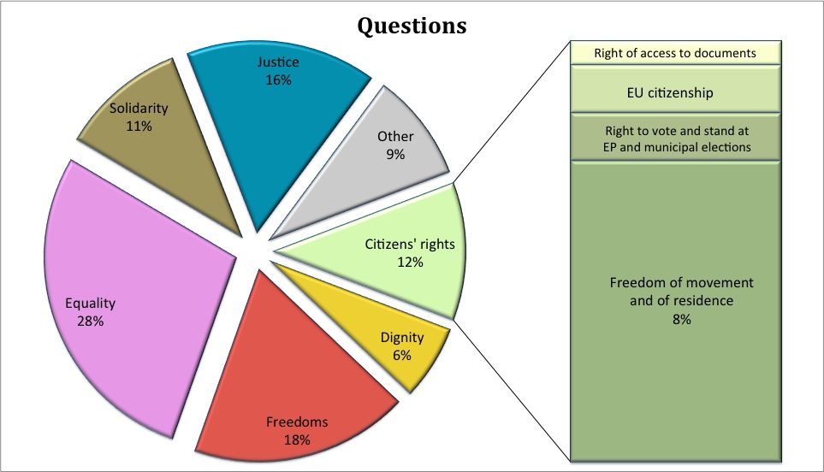
Right to good administration
Every person has the right to have his or her affairs handled impartially, fairly and within a reasonable time by the Institutions, bodies and agencies of the Union. It also includes the right to be heard and to receive a reply.
A huge number of enquiries is addressed by citizens to the Commission, whether by phone, e-mail or correspondence. The Commission commits itself to answer them in the most appropriate manner and as quickly as possible.
How does the Commission put into practice the right to good administration?
The Commission receives a large number of letters from the general public. Efficiently managing this correspondence can have a positive impact on the right to good administration. The general rule applied in the Commission is that every letter is registered and, with the exception of those that are unreasonable, repetitive or abusive, should receive a reply within 15 working days from the date of receipt of the letter. At the end of 2010, all Commission services had migrated to one common registering tool, called ARES, helping services to interact among themselves and to give quicker follow-up to correspondence. The Commission also takes care that replies are sent in the language of the author of the correspondence, provided that it was written in one of the official language of the Union.
For complaints and enquiries by citizens on the application of EU law, the Commission introduced CHAP ("Complaint Handling"), an IT tool for registering and managing this specific kind of correspondence. In 2010, 4020 files were created in CHAP (83% complaints against 17% inquiries).
CHAP interoperates with ARES and with EU Pilot, a tool developed by the Commission to address enquiries and complaints by citizens on application of EU law through dialogue with Member States. In 2010, three additional Member States joined the EU Pilot, bringing the total number of Member States participating at the end of 2010 to 18. EU pilot allows for early clarification on whether an infringement of EU law exists and its correction, thus avoiding recourse to formal infringement proceedings. It enables faster response to citizens' concerns and improves cooperation between the Commission and the Member States.
The right to good administration is relevant in different areas of EU law. One of them is competition, where the Commission is entrusted with making sure markets function properly (i.e. that competition in the internal market is not distorted because of anticompetitive agreements, abuses of dominant position or mergers). To achieve this, the Commission has the task of preventing or correcting behaviour that would restrain or distort competition. It has a wide range of inspection and enforcement powers (e.g. to investigate businesses, impose fines and/or remedies). This allowed the Commission to bring successful action against many companies because competition was distorted and harm to consumers and competitors was likely or had already occurred. In 2010, the Commission sanctioned several agreements between companies that fixed prices, over products as diverse as bathroom fittings and animal feed. Commission action saved consumers money by making sure they do not have to pay more for the same product, making a real difference to the daily lives of millions of Europeans.
What is the impact of the right to good administration on EU competition rules?
To provide transparency and better understanding in the light of the Right to good administration, the Commission in 2010 published explanations concerning how these procedures work in practice. This makes it easier for companies under investigation to understand how the investigation will proceed, what they can expect from the Commission and what the Commission will expect from them.
In 2010, the European Ombudsman dealt with 164 cases, where the citizen alleged that the administration had failed to reply adequately or at all.
Right to be heard regarding a ban on entry to Commission buildings
A person wrote to the European Ombudsman that the Commission imposed a ban on entry to Commission buildings against him on the grounds of alleged harassment of EU staff.
The European Ombudsman concluded that there had been a breach of the right to be heard as the complainant had not been given the possibility to present his observations before an entry ban was adopted.
How does the European Ombudsman put into practice the right to good administration?
Right of access to documents
The Charter guarantees that any EU citizen and any natural or legal person residing or having its registered office in a Member State, has a right of access to documents of the EU institutions, bodies, offices and agencies.
In 2010, the Commission received over 6.000 requests for access to documents, compared to about 5.000 in 2008 and 2009. As in the past, 4 out of 5 requests were granted at the initial stage. In 2010, the Commission received 184 confirmatory applications. Such applications are reassessed by case handlers acting independently from the ones that handled the initial application. This review has led to wider access being granted in around half the cases. In 2010, the European Ombudsman dealt with 22 cases concerning the fundamental right of access to documents.
The Court of Justice delivered several judgements concerning access to documents. In the first case the Court of Justice overruled the Court of First Instance in a case where access to a Commission document containing names of individuals was sought. The Commission had refused to disclose the names of persons that had not given their consent to disclosure. The Court concluded that the EU rules on the protection of personal data become applicable in their entirety. The Commission therefore had rightly verified if the data subjects had given their consent to the disclosure of personal data concerning them. The second case concerned access to Commission's administrative files in state-aid cases. The Court held an applicant can refute the general presumption of inaccessibility. An applicant can rebut the presumption and demonstrate that a particular document should not be covered by it or that there is an overriding public interest in disclosure. The third case concerned access to Commission submissions in Court cases. The Court held that there is a general presumption that disclosure of written submissions in pending Court cases would undermine the protection of the Court proceedings. In the three rulings, the Court interpreted the exceptions set out in EU rules on access to documents in relation with other relevant provisions: rules on state-aid, the Statute of the Court and the rules of procedure as well as rules on protection of personal data.

Right of access to clinical study reports on drugs
Researchers wrote to the European Ombudsman that the European Medicines Agency (EMA) denied their request for access to clinical study reports for two anti-obesity drugs.
The Ombudsman disagreed with EMA's assessment that the disclosure would undermine the drug producers' commercial interests and EMA then agreed to provide public access.
Right of access to data on absences on medical grounds by Members of the European Parliament
A journalist wrote to the European Ombudsman regarding the refusal by the European Parliament to provide statistics on absences of Members of the European Parliament on medical grounds.
The European Ombudsman consulted the European Data Protection Supervisor, who considered that individual Members of the European Parliament might be identified from the data requested.
The Ombudsman concluded that if the European Parliament undertook this data processing, it would infringe the rules on data protection and that the European Parliament was entitled to refuse the complainant's request.
Right to refer to the European Ombudsman
The Charter provides that any EU citizen and any natural or legal person residing or having its registered office in a Member State, has the right to refer to the European Ombudsman cases of maladministration in the activities of the EU institutions, bodies, offices and agencies, with the exception of the Court of Justice acting in its judicial role. In 2010, 2 667 individuals invoked their right to refer to the Ombudsman.
In 2010, the European Ombudsman received a number of letters from citizens in relation to problems they encounter with the Member States. Complaints against public authorities of the Member States are not within the European Ombudsman’s mandate. The European Ombudsman co-operates with national and regional ombudsmen in the European Network of Ombudsmen to ensure that complaints are dealt with quickly and effectively. In a number of cases, the European Ombudsman transferred a complaint he had received, or advised the complainant to turn to, a member of the Network.
A complaint within the competence of the national ombudsperson
A Czech living in Ireland and receiving jobseeker benefits got permission to travel to the Czech Republic to attend a course. While there, he sat for examinations on the day set for his return to Ireland. As a result of his delayed return, the Irish Department of Social Protection decided that he was not eligible for jobseeker benefits or even for a jobseeker allowance.
The European Ombudsman transferred the complaint to the Irish Ombudsman, who drew attention to the relevant EU rules. Irish authorities reviewed its decision and paid the jobseeker benefits arrears for the period in question and until his entitlement ran out. They also promised to re-examine his entitlement to a jobseeker allowance.

The Ombudsman considered that

Freedom of movement and residence
The Charter guarantees the right of every EU citizen to move and reside freely, in the respect of certain conditions, within the territory of the Member States. This fundamental right is also included in the Treaty on the Functioning of the EU. The EU has adopted legislation that puts the freedom of movement and residence into practice. Member States must adapt national rules to this EU legislation and the Commission monitors whether they have done so.
Does a third-country national, who is married to an EU citizen, need a visa to travel to another Member State?
An EU citizen lived in another Member State together with his wife, who is a third-country national. They wanted to go on holidays to another Member State and they wanted to know, if the wife would need a visa for this.
Her residence card is sufficient. According to the Free Movement Directive, EU citizens' family members holding a residence card do not need a visa to travel to another Member State in the Schengen area.
In 2010, the Commission undertook a structured dialogue with each Member State to examine their national rules and to make sure these respect EU rules on freedom of movement and residence adopted in 2004. The Commission also assisted the Member States in adapting their national legislations by conducting multilateral meetings of experts to exchange views, know-how and best practices, including on fighting against abuses and fraud regarding the right to free movement and residence.
A permanent residence card for third-country nationals, who are married to EU citizens living in another Member State
The Commission received a number of complaints by EU citizens who had been living for five years or more in another Member State with their spouse, a third country national. The EU citizen had already acquired the right of permanent residence in the host country, but the national authorities refused the right of permanent residence to the spouse.
As the condition of five years of continuous residence with an EU citizen was fulfilled, following contacts between the Commission and the Member States, the national authorities issued them with permanent residence cards.
The Commission received a number of complaints regarding the conditions of entry and residence of third-country family members of EU citizens. Therefore, in order to assist Member States with adapting national legislation to EU rules and, by the same token, to ease the identification of the appropriate solutions to individual cases in a consistent way, the Commission adopted a handbook for the implementation of the Schengen Visa Code with a chapter dedicated to processing of visa applications from family members of EU citizens.
To improve knowledge of EU citizens' rights, the Commission also published a reader-friendly guide for EU citizens on freedom to move and live in Europe. The web portal Your Europe was also launched as a one-stop-shop to help EU citizens easily find information about their rights and to provide them with practical tips when moving around the European Union.
In 2010, the Commission received requests regarding the blocking of the Greek port of Piraeus due to a strike. The Commission requested information from the Greek authorities as regards the industrial action and the way it was carried out. As the strike might have made it more difficult for EU tourists to reach their destinations, the blocking of the port raised concerns of compliance with EU law on free movement of EU citizens, goods and services. The Charter contains both the right to free movement for EU citizens and the right of workers and their organisations to take collective action to defend their interests, including strike action. National authorities must ensure that exercise of one fundamental right does not restrict another fundamental right in an unjustified manner. To provide guidance in similar situations of port or border blockades, the EU adopted rules requiring the national authorities to determine whether a blockade may be an obstacle to free movement and whether such an obstacle is justified and proportionate. In case of unjustified or disproportionate restrictions, national authorities must take all necessary and proportionate measures to prevent any obstacles to free movement caused by the actions of private individuals.

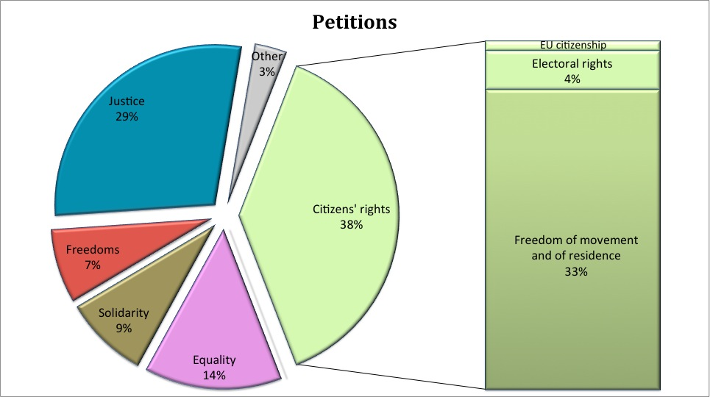
Diplomatic and consular protection
EU citizens travelling to a non-EU country in which their own country does not have an embassy or consulate have the right to turn for help to that of any other EU country and receive help under the same conditions as nationals of that country.
Every day EU citizens travel on business or leisure to countries outside the EU. More than 30 million EU citizens permanently live in non-EU countries. Sometimes EU citizens find themselves in a situation where they need assistance from an embassy or consulate. There are only three countries in the world where all Member States are represented: the United States, China and Russia. Several recent crises in non-EU countries directly affected EU citizens in non-EU countries (e.g. Egypt, earthquakes in Haiti and Chile, volcanic ash cloud).
The Charter guarantees the right of unrepresented EU citizens to seek diplomatic or consular protection from embassies or consulates of other Member States in third countries under the same conditions as nationals. EU citizens must be able to rely effectively on this right when travelling abroad. One of the ways of making this right effective is through providing information to the officials in representations in non-EU countries. In 2010, the Commission developed a training kit for consular officials informing them about EU rules on consular protection.
The Commission is building a website on consular protection dedicated to the citizen, providing the addresses of all the available embassies/consulates in the world and travel advice from Member States. It is preparing a legislative proposal on coordination and cooperation measures under the framework of the Lisbon Treaty to render this entitlement more effective.
Union citizenship
According to EU law, every person holding the nationality of a Member State is a citizen of the Union. Citizenship of the Union is additional to national citizenship and does not replace it.
Union citizenship does not compromise the principle of international law that States have the power to lay down the conditions for the acquisition and loss of nationality.
Acquisition and loss of nationality
A national of a non-EU country applied to obtain the nationality of a EU country, of which his father had been a national, but his application was rejected.
The national authorities refused to exempt him from taking a language test despite his medically recognised disability.
The Commission replied that it had no power to intervene in his case, explaining that each EU country is free to define the conditions for acquiring nationality and that it was for the national authorities to decide on his application in accordance with national law.
The Court of Justice of the EU has confirmed this principle in its case law. The Court ruled that, when exercising their power regarding nationality, Member States must have due regard to EU law. In its judgment in the Rottmann case, the Court ruled that national rules on nationality, if they affect rights protected by EU rules, are open to judicial review in the light of EU law. It concluded that a decision on withdrawing naturalisation, which has as a consequence not only loss of the nationality of the Member State of naturalisation but also the loss of citizenship of the Union, should be scrutinised by the national courts by reference to the principle of proportionality in the light of EU law.
- Justice

Right to an effective remedy and to a fair trial

Presumption of innocence and right of defence

Principles of legality and proportionality of criminal offences and penalties

Right not to be tried or punished twice in criminal proceedings for the same criminal offence
Most letters, questions and petitions handled by the Commission in this area concerned access to justice.
In 2010, key draft EU laws have been proposed or adopted to strengthen the right to a fair trial wherever citizens are in the EU, to make it easier for international couples wishing to divorce, and to facilitate access to justice for businesses and consumers.

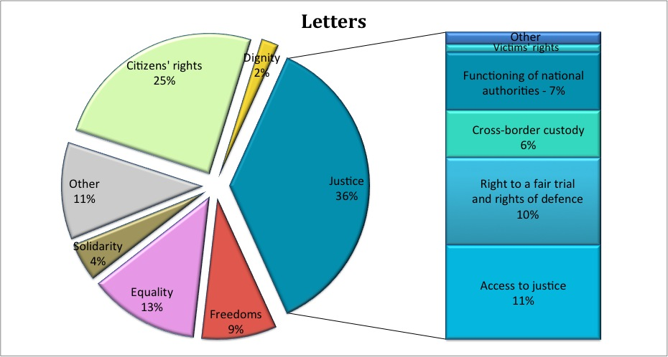
Right to an effective remedy
The Charter provides that when EU rules give a right to a person, he or she can go before a court in case this right is violated. This protection is called a right to an effective remedy, because it provides to individuals a legal solution decided by a tribunal when an authority used EU law in a wrong way. The right to effective remedy guarantees judicial protection against violations of any EU rule which grants rights to people. It plays therefore a key role for ensuring the effectiveness of all EU law.
What does the right to an effective remedy mean in practice?
In 2010, a number of judgements from the European Court referred to the right to effective remedy in a variety of areas such as social policy, telecommunication and consumer protection, competition, common foreign and security policy and legal aid.
The right to an effective remedy concerning legal aid
A German company sued the German government for not implementing EU directives but was lacking funds to make the necessary advance payment of court costs and to hire a lawyer. DEB applied for legal aid in order to cover the costs, but it was refused because German law provided for a condition of public interest.
The Court of Justice, in a ruling, stated that the principle of effective judicial protection applies also to companies seeking legal aid.
Dissatisfaction with national procedures
In 2010, the Commission received a number of letters from the general public expressing dissatisfaction with procedures before national authorities in areas outside EU law.
The Commission explained that the right to an effective remedy only applies in situations, falling within EU competence. In cases, which fall outside EU law, the national authorities, including the courts, guarantee the right to an effective remedy in accordance with national rules.

When doing business, travelling or living in another Member State than their own, individuals or companies should not be discouraged from exercising their rights and should have appropriate access to justice.
Under the current EU rules, a judgment given in one Member State does not automatically take effect in another Member State. In order to be enforced in another country, a court in that country first has to validate the decision and declare it enforceable. This is done in a special procedure that takes place after the judgment has been obtained and before concrete measures of enforcement can be taken. This makes cross-border litigation more cumbersome, time-consuming and costly than national litigation. In 2010, the Commission proposed to do away with unnecessary bureaucratic procedures, such as the intermediary court proceedings that are still needed before a judgement from one Member State is recognised in another, so as to ensure easier and more efficient access to justice. The abolition of the "exequatur" will lead to a situation where judgements issued in another Member State in civil and commercial matters will be treated like domestic judgements. The Commission also proposed to improve access to justice before the courts in Europe even when defendants are situated outside the Union.
How can citizens and businesses get court judgements recognised in other Member States?
Legal action in national courts against a defendant located outside the EU
A UK consumer signs a contract for a time-share apartment on the Turkish Riviera while on holiday. He then returns home and decides that he cannot afford the apartment and decides to end the contract.
Under the EU’s Time Share Directive, consumers can end contracts within 14 days. However, the Turkish seller refuses to reimburse the consumer. Under English law, no court in England has jurisdiction to hear the case. The consumer’s rights to be protected under the Time Share Directive are denied because of the lack of jurisdiction of English courts. The reformed "Brussels I" Regulation would give citizens and companies the same possibilities to sue in national courts when a defendant is located outside the EU.

In 2010, the EU adopted a Commission regulation that defines which laws apply in cases of cross-border divorces, where partners come from different Member States. These rules aim at bringing legal certainty to international couples wishing to divorce. The new legislation will give a choice as to which country's rules apply in case of divorce for couples with different nationalities, those living apart in different countries or those living together in a country other than their home country. Although this regulation does not directly concern access to justice, it can contribute to facilitating access to justice by improving legal certainty through defining which rules apply in such cases. This regulation aims to reduce "forum shopping" and to protect weaker partners during divorce disputes. Couples will be able to agree during the marriage which law would apply to their divorce. This will give them more legal certainty, predictability and flexibility and will help to protect spouses and their children from complicated and drawn-out procedures. International couples will have more control over their separation and protect weaker spouses from being put at an unfair disadvantage in divorce proceedings. Courts will have a common formula for deciding which country's law applies when couples cannot agree themselves. It has no effect on Member States' ability to define marriage. This regulation in limited situations permits Member States to disregard EU rules on divorce by quoting concerns regarding public order (exception of public order). In the application of rules on divorce, including the exception of public order, any discrimination based on any ground such as sex, race, colour, ethnic or social origin, genetic features, language, religion or belief, political or any other opinion, membership of a national minority, property, birth, disability, age or sexual orientation, shall be prohibited.
What about cross-border divorces?
In order to put in practice the "right" to effective remedy, the Commission is developing a number of initiatives to facilitate the access to justice. To help EU citizens, in 2010 the Commission introduced the European e-Justice Portal- a new direct service to citizens, accessible via the European e-justice Portal. The Portal contains information that enables EU citizens to become more aware of their rights and help them to make use of those rights (legal aid, mediation, translation, etc.). In 2011, the European e-Justice Portal will provide information on legal remedies in cases of alleged violations of fundamental rights. The EU also promotes training programmes on EU law for members of the judiciary in the EU (European Judicial Training Network). Members of the judiciary in Member States need to be familiar with EU rules, so they can apply them in concrete situations and safeguard fundamental rights.
How can access to justice be put into practice?
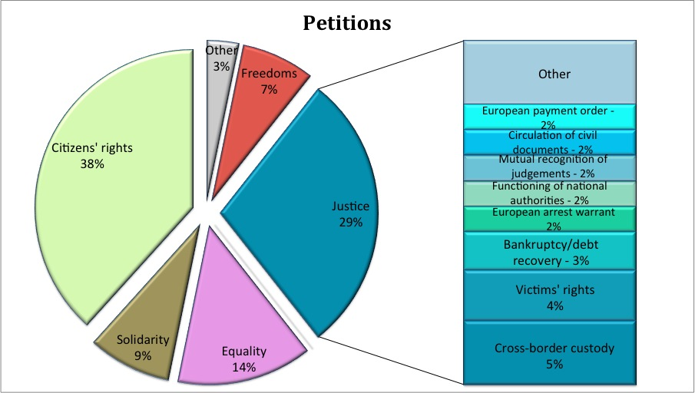
Right to a fair trial and right of defence
The right to a fair trial guarantees that everyone is entitled to a fair and public hearing, which must take place within a time frame by an independent and impartial tribunal. When an individual is involved in criminal proceedings, one of his fundamental rights is the guarantee of an independent and impartial tribunal. The right to a fair trial includes the right to a fair and public hearing within a reasonable time. Everyone is entitled to these rights, regardless of his nationality or what language they speak. The Charter also guarantees respect for the rights to a defence of anyone who has been charged. It guarantees in particular that the suspect understands the criminal proceedings against him, if he or she does not speak the language of the procedure.
How to reinforce the right to a fair trial and the right of defence?
To put these rights into practice, the EU is adopting common minimum standards in criminal procedure, taking into account the differences among Member States in the area of criminal law. In 2010 the EU adopted rules on the right to interpretation and to translation in criminal proceedings. These rules aim to improve the rights of suspects and accused persons who do not understand or speak the language of the proceedings. They provide common minimum standards throughout the EU. The rules grant suspects the right to interpretation during criminal proceedings. They also grant suspects the right to be provided with written translations of all documents which are essential to defend themselves and to safeguard the fairness of the proceedings. Essential documents include decisions depriving a person of his liberty, the charge/indictment and any judgment. The Commission's proposal was brought in parallel to an initiative tabled by a group of Member States. As the Commission's proposal was more ambitious, these elements were in the end integrated in the adopted proposal.
Suspects in criminal proceedings must know what their rights are in order to be able to exercise them. For this reason, in 2010 the Commission proposed rules requiring that suspects of a criminal offence must be informed of their rights in a language they understand. Anyone arrested either for a criminal offence or under a European Arrest Warrant must be informed in writing, in a document called a Letter of Rights, of their basic rights at the time of arrest and of what they are suspected. The Commission's proposal provides a model in all official EU languages. This will provide consistency for people crossing borders and limit translation costs as each Member State may use the Commission model.
The Commission is working on a third measure, on access to a lawyer, and undertook an extensive consultation exercise in the last part of 2010.

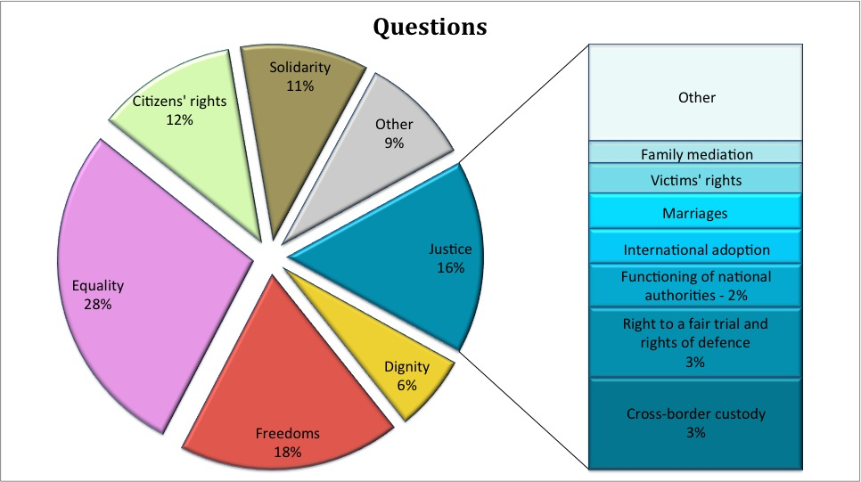

Communication from the Commission of 19 October 2010 on the Strategy for the effective implementation of the Charter of Fundamental Rights by the EU, COM/2010/0573 final, available at: http://eur-lex.europa.eu/LexUriServ/LexUriServ.do?uri=COM:2010:0573:FIN:EN:PDF
Examples of the application of the Charter by the Commission in the preparation of the initiatives adopted in 2010, and examples of the application of the Charter in the legislative process during 2010 before the European Parliament and the Council.
Examples of the application of the Charter by Member States when implementing EU law in 2010.
Questions from the European Parliament received in 2010 and petitions submitted to the European Parliament, for which the European Parliament requested in 2010 an opinion or follow-up from the Commission.
Case-law in which the Court directly quoted the Charter or referred to fundamental rights in the reasoning, published in 2010.
Data resulting from surveys and data collections on fundamental rights in the EU and published in thematic reports.
Regulation (EC) 300/2008, OJ L. 97, 09.04.2008, p.72, and its implementing legislation, in force since 29 April 2010.
COM(2010) 311 final, available at: http://ec.europa.eu/transport/air/security/doc/com2010_311_security_scanners_en.pdf
The Communication identified that the capture and processing of the image of an identified or unidentifiable person by security scanners in order to allow a human reviewer to perform the security relevant assessment falls under EU legislation on data protection. The criteria against which the scanning has to be assessed are i) whether the measure proposed is appropriate to achieve the objective (detection of non-metallic items and therefore a higher security level), ii) whether it does not go beyond what is necessary to achieve this objective and iii) whether there is no less intrusive means. The Commission in the Communication paid special attention to health aspects, reflecting the Charter obligation that, in the definition and implementation of all the Union's policies and activities, a high level of human health protection shall be ensured.
The Schengen area is an area within the EU without border controls. It includes the territories of the Member States that have decided to abolish border controls between them. External borders are borders between the Member States that have joined the Schengen area and non-Schengen Member States or third countries.
Council Decision of 26 April 2010 supplementing the Schengen Borders Code as regards the surveillance of the sea external borders in the context of operational cooperation coordinated by the European Agency for the Management of Operational Cooperation at the External Borders of the Member States of the European Union (2010/252/EU) (proposal adopted by the Commission on 27 November 2009; adopted by the Council on 26 April 2010), OJ L 111, 04.05.2010, p. 20-26.
Proposal for a Regulation amending Council Regulation (EC) No 2007/2004 establishing a European Agency for the Management of Operational Cooperation at the External Borders of the Member States of the European Union (FRONTEX), 24 February 2010, COM(2010) 61 final, available at: http://eur-lex.europa.eu/LexUriServ/LexUriServ.do?uri=COM:2010:0061:FIN:EN:PDF
Directive 2008/115 on common standards and procedures in Member States for returning illegally staying third-country nationals, OJ L 348, 24.12.2008, p.98.
EU Agency for Fundamental Rights Report "Child Trafficking in the EU: challenges, perspectives and good practices" (July 2009), available at: http://www.fra.europa.eu/fraWebsite/attachments/Pub_Child_Trafficking_09_en.pdf
Proposal for a Directive on preventing and combating trafficking in human beings, and protecting victims, repealing Framework Decision 2002/629/JHA, COM(2009) 136 final, available at: http://eur-lex.europa.eu/LexUriServ/LexUriServ.do?uri=COM:2010:0095:FIN:EN:PDF
Report from the Commission on the application of Directive 2004/81 on the residence permit issued to third-country nationals who are victims of trafficking in human beings or who have been the subject of an action to facilitate illegal immigration, who cooperate with the competent authorities, COM(2010) 493 final, available at: http://ec.europa.eu/commission_2010-2014/malmstrom/archive/COMM_PDF_COM_2010_0493_F_EN_RAPPORT.pdf
Council Directive 2004/81/EC of 29 April 2004 on the residence permit issued to third-country nationals who are victims of trafficking in human beings or who have been subject of an action to facilitate illegal immigration, who cooperate with the competent authorities, OJ L 261, 06.08.2004, p. 19.
Council Directive 2003/86/EC of 22 September 2003 on the right to family reunification, OJ L 251, 3.10.2003, p. 12-18.
ECJ, Case C-578/08, Chakroun, 4.3.2010.
Intelligent information system supporting observation, searching and detection for security of citizens in urban environment.
Austria, Belgium, Bulgaria, Czech Republic, Cyprus, France, Germany, Ireland, Italy, Latvia, Luxembourg, Malta, the Netherlands, Slovenia, Spain and the UK.
EU Agency for Fundamental Rights Report "Data Protection in the EU: the role of National Data Protection Authorities", available at: http://www.fra.europa.eu/fraWebsite/attachments/Data-protection_en.pdf
Directive 95/46/EC of the European Parliament and of the Council of 24 October 1995 on the protection of individuals with regard to the processing of personal data and on the free movement of such data, OJ L 281, 23.11.1995, p. 31-50.
Commission Press Release IP/10/673, 3.6.2010.
ECJ, C-518/07, Commission v. Germany, 9.3.2010.
ECJ, Joined cases C-92/09 and C-93/09, Volker und Markus Schecke, Eifert, 9.10.2010.
Relating to the judgement of the European Court of Human Rights of 3 November 2009, Case of Lautsi v. Italy.
ECJ, Case C-70/10, Scarlet, reference for a preliminary ruling from the Cour d’appel de Bruxelles (Belgium) lodged on 5.2.2010.
Directive 2010/13/EU of the EP and the Council of 10 March 2010 on the coordination of certain provisions laid down by law, regulation or administrative action in Member States concerning the provision of audiovisual media services (Audiovisual Media Services Directive), OJ L 95. 15.4.2010, p.1.
Proposal for a Regulation of the European Parliament and of the Council on jurisdiction and the recognition and enforcement of judgments in civil and commercial matters, COM/2010/748 final of 14.12.2010, available at: http://ec.europa.eu/justice/policies/civil/docs/com_2010_748_en.pdf
Proposal for a Directive of the European Parliament and of the Council on attacks against information systems and repealing Council Framework Decision 2005/222/JHA, COM(2010) 517 final, available at: http://eur-lex.europa.eu/LexUriServ/LexUriServ.do?uri=COM:2010:0517:FIN:EN:PDF
COM(2010) 608/final2, available at: http://eur-lex.europa.eu/LexUriServ/LexUriServ.do?uri=COM:2010:0608:REV1:EN:PDF#page=2
Proposal for a Regulation of the European Parliament and of the Council establishing the criteria and mechanisms for determining the Member State responsible for examining an application for international protection lodged in one of the Member States by a third-country national or a stateless person, COM(2008) 820 final, available at: http://eur-lex.europa.eu/LexUriServ/LexUriServ.do?uri=COM:2008:0820:FIN:EN:PDF Proposal for a DIRECTIVE OF THE EUROPEAN PARLIAMENT AND OF THE COUNCIL laying down minimum standards for the reception of asylum seekers, COM (2008), 815 final, available at: http://eur-lex.europa.eu/LexUriServ/LexUriServ.do?uri=COM:2008:0815:FIN:EN:PDF Proposal for a Directive of the European Parliament and of the Council on minimum standards for the qualification and status of third country nationals or stateless persons as beneficiaries of international protection and the content of the protection granted, COM(2009) 551 final, available at: http://eur-lex.europa.eu/LexUriServ/LexUriServ.do?uri=COM:2009:0551:FIN:EN:PDF
ECJ, Case C-175/08, Hasan and others, 2.3.2010.
Council Directive 2004/83/EC of 29 April 2004 on minimum standards for the qualification and status of third country nationals or stateless persons as refugees or as persons who otherwise need international protection and the content of the protection granted, OJ L 304, 30.9.2004, p. 12-23.
ECJ, Case C-555/07, Kücükdeveci, 19.1.2010.
Application no. 30141/04 of 24.6.2010.
On 17 May 2010, on the occasion of the International Day Against Homophobia, Herman Van Rompuy, President of the European Council, Jerzy Buzek, President of the European Parliament, and Viviane Reding, Vice-president of the European Commission and Commissioner for Justice, Fundamental Rights and Citizenship, jointly issued messages condemning homophobia.
EU Agency for Fundamental Rights Report "Homophobia and Discrimination on Grounds of Sexual Orientation and Gender Identity in the EU Member States: Part II – The Social Situation", March 2009, available at: http://www.fra.europa.eu/fraWebsite/attachments/FRA_hdgso_report-part2_en.pdf
See EU Agency for Fundamental Rights report above, section I.2.
In Lithuania the 2010 Baltic Pride was threatened with cancellation at short notice, and in Latvia, the right to organise marches continues to be challenged by authorities. However, LGBT NGOs subsequently succeeded to organise their events in Poland, Romania and Bulgaria. See EU Agency for Fundamental Rights report on "Homophobia, Transphobia and Discrimination on grounds of Sexual Orientation and Gender Identity, 2010 update", September 2010, available at: http://www.fra.europa.eu/fraWebsite/attachments/FRA-LGBT-report-update2010.pdf
Czech Republic, Hungary, Italy and Sweden. See note 39.
Communication from the Commission A Strengthened Commitment to Equality between Women and Men A Women's Charter Declaration by the European Commission on the occasion of the 2010 International Women's Day in commemoration of the 15th anniversary of the adoption of a Declaration and Platform for Action at the Beijing UN World Conference on Women and of the 30th anniversary of the UN Convention on the Elimination of All Forms of Discrimination against Women, COM(2010) 78 final, available at: http://eur-lex.europa.eu/LexUriServ/LexUriServ.do?uri=COM:2010:0078:FIN:EN:PDF
COM(2010) 491 final, available at: http://eur-lex.europa.eu/LexUriServ/LexUriServ.do?uri=COM:2010:0491:FIN:EN:PDF
Directive 2010/41/EU of the European Parliament and of the Council of 7 July 2010 on the application of the principle of equal treatment between men and women engaged in an activity in a self-employed capacity and repealing Council Directive 86/613/EEC, OJ L 180, 15.7.2010, p. 1-6.
See e.g. The EU Fundamental Rights Agency's Annual Report 2010, European Union Minorities and Discrimination Survey. Main Results Report 2009 and Antisemitism summary overview of the situation in the European Union 2001-2009.
EU Agency for Fundamental Rights Annual Report 2010, section 2.2. The 12 countries are Belgium, Czech Republic, Denmark, Germany, France, Ireland, Austria, Poland, Slovakia, Finland, Sweden and UK (England, Wales and Scotland).
Ibidem. The 5 countries are Austria, France, The Netherlands, Sweden and the UK. Germany experienced a slight downward trend (-0,3%).
Id. at 71-72. See also European Union Minorities and Discrimination Survey. Main Results Report 2009, p. 65 and 67.
Id. at 74.
Council Framework Decision 2008/913/JHA of 28 November 2008 on combating certain forms and expressions of racism and xenophobia by means of criminal law, OJ L 328 of 6.12.2008, p. 55.
Article 6 of the Directive 2010/13/EU of the EP and the Council of 10 March 2010 on the coordination of certain provisions laid down by law, regulation or administrative action in Member States concerning the provision of audiovisual media services (Audiovisual Media Services Directive), OJ L 95. 15.4.2010, p.1.
Article 4 of Framework Decision 2008/913/JHA, see above note 51.
Framework Decision 2008/913/JHA and Audiovisual Media Services Directive, see above notes 51 and 52.
Housing conditions of Roma and Travellers in the EU – Comparative report (October 2009), available at: http://www.fra.europa.eu/fraWebsite/attachments/ROMA-Housing-Comparative-Report_en.pdf The situation of Roma EU citizens moving to and settling in other EU Member States (November 2009), available at: http://fra.europa.eu/fraWebsite/attachments/Roma_Movement_Comparative-final_en.pdf
Communication on the social and economic integration of the Roma in Europe, COM(2010)133 final, available at: http://eur-lex.europa.eu/LexUriServ/LexUriServ.do?uri=COM:2010:0133:FIN:EN:PDF
Roma Integration: First Findings of Roma Task Force and Report on Social Inclusion, MEMO/10/701, 21.12.2010, available at: http://europa.eu/rapid/pressReleasesAction.do?reference=MEMO/10/701&type=HTML
Directive 2004/38/EC of the European Parliament and of the Council of 29 April 2004 on the right of citizens of the Union and their family members to move and reside freely within the territory of the Member States amending Regulation (EEC) No 1612/68 and repealing Directives 64/221/EEC, 68/360/EEC, 72/194/EEC, 73/148/EEC, 75/34/EEC, 75/35/EEC, 90/364/EEC, 90/365/EEC and 93/96/EEC, OJ L 158, 30.4.2004, p. 77–123.
Council Directive 2000/43/EC of 29 June 2000 implementing the principle of equal treatment between persons irrespective of racial or ethnic origin, OJ L 180, 19.7.2000, p. 22–26.
See above, note 51.
Article 2 of the Treaty on European Union, OJ C 115 , 9.5.2008, p. 1-388.
Communication from the Commission to the European Parliament, the Council, the European Economic and Social Committee and the Committee of the Regions - Multilingualism: an asset for Europe and a shared commitment, COM(2008) 566 final, available at: http://eur-lex.europa.eu/LexUriServ/LexUriServ.do?uri=COM:2008:0566:FIN:EN:PDF
The European Charter for Regional or Minority Languages (CETS 148) and the Framework Convention for the Protection of National Minorities are two instruments from the Council of Europe.
Eurobarometer Qualitative study on the Rights of the Child, October 2010, available at: http://ec.europa.eu/public_opinion/archives/quali/ql_right_child_sum_en.pdf
Council Regulation (EC) No 2201/2003 of 27 November 2003 concerning jurisdiction and the recognition and enforcement of judgments in matrimonial matters and the matters of parental responsibility, repealing Regulation (EC) No 1347/2000, OJ L 338, 23.12.2003, p.1-29.
ECJ, Case C-403/09 PPU, Detiček, 23.12.2009.
EU Agency for Fundamental Rights Report "Separated, asylum-seeking children in EU Member States", November 2010, available at: http://www.fra.europa.eu/fraWebsite/attachments/FRA-fullreport-sep-asylum-conference-2010_EN.pdf
Communication from the Commission on Action Plan on Unaccompanied Minors (2010 – 2014), COM(2010)213 final, available at: http://eur-lex.europa.eu/LexUriServ/LexUriServ.do?uri=COM:2010:0213:FIN:EN:PDF
The financial support was provided from European Social Fund and European Regional and Development Fund.
Communication European Disability Strategy 2010-2020: A Renewed Commitment to a Barrier-Free Europe, COM(2010) 636 final, available at: http://eur-lex.europa.eu/LexUriServ/LexUriServ.do?uri=COM:2010:0636:FIN:EN:PDF
Excluding the level of EU-scale undertakings which is regulated by the recently adopted European Works Council directive.
Budget heading 04.03.03.03 Information, Consultation and Participation of representatives of undertakings, available at: http://ec.europa.eu/social/main.jsp?catId=157&langId=en&callId=242&furtherCalls=yes See also budget heading 04.03.03.01 and Progress programme.
Article 153(5) of the Treaty on the Functioning of the EU (TFEU) stipulates that it does not apply to the right to strike.
ECJ, Case C-341/05, Laval, 18.12.2007.
Directive 96/71/EC of the European Parliament and of the Council of 16 December 1996 concerning the posting of workers in the framework of the provision of services, OJ L 018, 21.01.1997, p. 1-6.
Compare: ECJ, Case C-346/06, Rüffert, 3.4.2008 and ECJ, Case C-319/06, Commission v Luxembourg, 19.6.2008.
See: http://ec.europa.eu/social/main.jsp?catId=707&langId=en&intPageId=214
The central piece is the Council Directive 89/391/EEC of 12 June 1989 on the introduction of measures to encourage improvements in the safety and health of workers at work, OJ L 183, 29.6.1989, p. 1-8, which lays down general principles on the protection of workers' health and safety. Several specific directives cover a number of specific risks, e.g. exposure of workers to biological and chemical agents at work, noise, work at the construction sites, manual handling of loads, etc. Another important piece of legislation covers working time and regulates issues such as minimum daily and weekly rest periods, breaks, maximum weekly working time, night work and annual leave.
Directive 2003/88/EC of the European Parliament and of the Council of 4 November 2003 concerning certain aspects of the organisation of working time, OJ L 299, 18.11.2003, p. 9–19.
ECJ, Case C-243/09 Fuss (I), 14.10.2010.
ECJ, Case C-428/09 Isère, 14.10.2010.
ECJ, Case C-486/08, Zentralbetriebsrat der Landeskrankenhäuser Tirols, 22.4.2010.
Council Directive 94/33/EC of 22 June 1994 on the protection of young people at work, OJ L 216, 20.08.1994, p. 12-20.
Report on the election of Members of the European Parliament (1976 Act as amended by Decision 2002/772/EC, Euratom) and on the participation of European Union citizens in elections for the European Parliament in the Member State of residence (Directive 93/109/EC), COM(2010) 605 final, available at: http://eur-lex.europa.eu/LexUriServ/LexUriServ.do?uri=COM:2010:0605:FIN:EN:PDF
Council Directive 93/109/EC laying down detailed arrangements for the exercise of the right to vote and stand as a candidate in elections to the European Parliament for citizens of the Union residing in a Member State of which they are not nationals, OJ L 329, p. 34.
The 1976 Act on the election of the members of the European Parliament by direct universal suffrage, as amended by Council Decision of 25 June 2002 and 23 September 2002 amending the Act concerning the election of the representatives of the European Parliament by direct universal suffrage, annexed to Decision 76/787/ECSC, EEC, Euratom, OJ L 283, 21.10.2002, p. 1-4.
The explanations are outlined in three documents: Best Practices for antitrust proceedings, Best Practices for the submission of economic evidence (both in antitrust and merger proceedings) and Guidance on the role of the Hearing Officers in the context of antitrust proceedings.
The Best Practices should be read in conjunction with the relevant legislative, interpretative and administrative measures which govern proceedings before the Commission. Proceedings concerning the application of Articles 101 and 102 TFEU are in particular regulated by Regulation 1/2003 (OJ L 1, 4.1.2003, p.1) and the Implementing Regulation 773/2004 (OJ L 123, 27.4.2004, p.18). Also the Notices on access to file (OJ C 325, 22.12.2005, p.7) and handling of complaints (OJ C 101, 27.4.2004, p.65) as well as the Hearing Officers' Mandate (OJ L 162, 19.6.2001, p.21) contain numerous provisions that are relevant.
ECJ, Case C-28/08P, Commission v The Bavarian Lager Co Ltd, 29.6.2010.
Regulation (EC) No 1049/2001 of the European Parliament and of the Council of 30 May 2001 regarding public access to European Parliament, Council and Commission documents, OJ L 145, 31.05.2001, p.43-48.
Regulation (EC) No 45/2001 of the European Parliament and of the Council of 18 December 2000 on the protection of individuals with regard to the processing of personal data by the Community institutions and bodies and on the free movement of such data, OJ L 008, 12.01.2001, p. 1-22.
ECJ, Case C-139/07P, Commission v Technische Glaswerke Ilmenau GmbH, 29.10.2010.
ECJ, Joined cases C-514/07P, C-528/07P and C-532/07P, Commission/Association de la Presse internationale, 21.9.2010.
Articles 20(2), 21 and 45 TFEU.
Regulation (EEC) 1612/68 on freedom of movement for workers within the Community, OJ L 257, p. 2 and Directive 2004/38/EC on the right of citizens of the Union and their family members to move and reside freely within the territory of the Member States, OJ L 158, p. 77.
Decision establishing the Handbook for the processing of visa applications, 19 March 2010, COM(2010) 1620 final.
Freedom to move and live in Europe – A Guide to your rights as an EU citizen, available at: http://ec.europa.eu/justice/policies/citizenship/docs/guide_free_movement.pdf
Council Regulation (EC) No 2679/98 of 7 December 1998 on the functioning of the internal market in relation to the free movement of goods among the Member States, OJ L 337, 12.12.1998, p. 8-9.
Article 20(1) of the TFEU.
ECJ, Case C-135/08, Rottman, 2.3.2010.
The content and implications of this judgment are presented in more detail in the Report under Article 25 On progress towards effective EU citizenship 2007-2010, COM(2010) 602 final, available at: http://ec.europa.eu/justice/policies/citizenship/docs/com_2010_602_en.pdf
ECJ, Case C-243/09, Günter Fuß v Stadt Halle, 14.10.2010.
ECJ, Joined Cases C-317/08, C-318/08, C-319/08 and C-320/08, Alassini and others, 18.3.2010.
ECJ, Case C-407/08 P, Knauf Gips v European Commission, 1.7.2010.
ECJ, Case T-49/07, Sofiane Fahas v Council, 7.12.2010.
ECJ, Case C-279/09 DEB Deutsche Energiehandels- und Beratungsgesellschaft, 22.12.2010.
Proposal for a Regulation of the European Parliament and of the Council on jurisdiction and the recognition and enforcement of judgments in civil and commercial matters, COM/2010/748, available at: http://ec.europa.eu/justice/policies/civil/docs/com_2010_748_en.pdf
Council Regulation implementing enhanced cooperation in the area of the law applicable to divorce and legal separation, OJ L 343, 29.12.2010, p. 10-16; this regulation however implements enhanced cooperation between Belgium, Bulgaria, Germany, Spain, France, Italy, Latvia, Luxembourg, Hungary, Malta, Austria, Portugal, Romania and Slovenia and is therefore at present applicable only in those Member States, any other Member State having the possibility to join in at a later stage.
Available at: http://www.ejtn.net/en/
Directive 2010/64/EU of the European Parliament and of the Council of 20 October 2010 on the right to interpretation and translation in criminal proceedings, OJ L 280, 26.10.2010, p. 1–7.
Proposal for a Directive on the right to information in criminal proceedings, COM(2010) 392/3, available at: http://ec.europa.eu/justice/news/intro/doc/com_2010_392_3_en.pdf

