 | 
COUNCIL OF  THE EUROPEAN UNION |  |  | Brussels, 28 April 2011
 | Interinstitutional File:  2010/0250 (COD) |  | 9487/11
EF 58
ECOFIN 223
CODEC 701
INST 225
PARLNAT 129

COVER NOTE
from: | The President of the Italian Senate
date of receipt: | 20 April 2011
to: | President of the Council of the European Union
Subject: | Proposal for a REGULATION OF THE EUROPEAN PARLIAMENT AND OF THE COUNCIL on OTC derivatives, central counterparties and trade repositories  [doc. 13917/10 EF 117 ECOFIN 543 CODEC 879 - COM(2010) 484 final]  - Opinion on the application of the Principles of Subsidiarity and Proportionality

Delegations will find attached the above mentioned opinion.

________________________

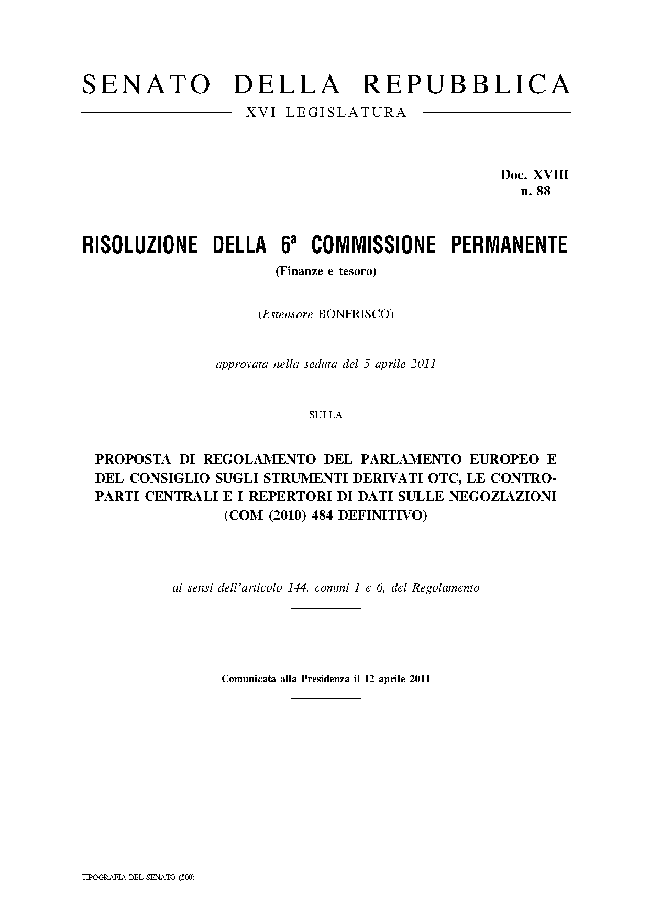
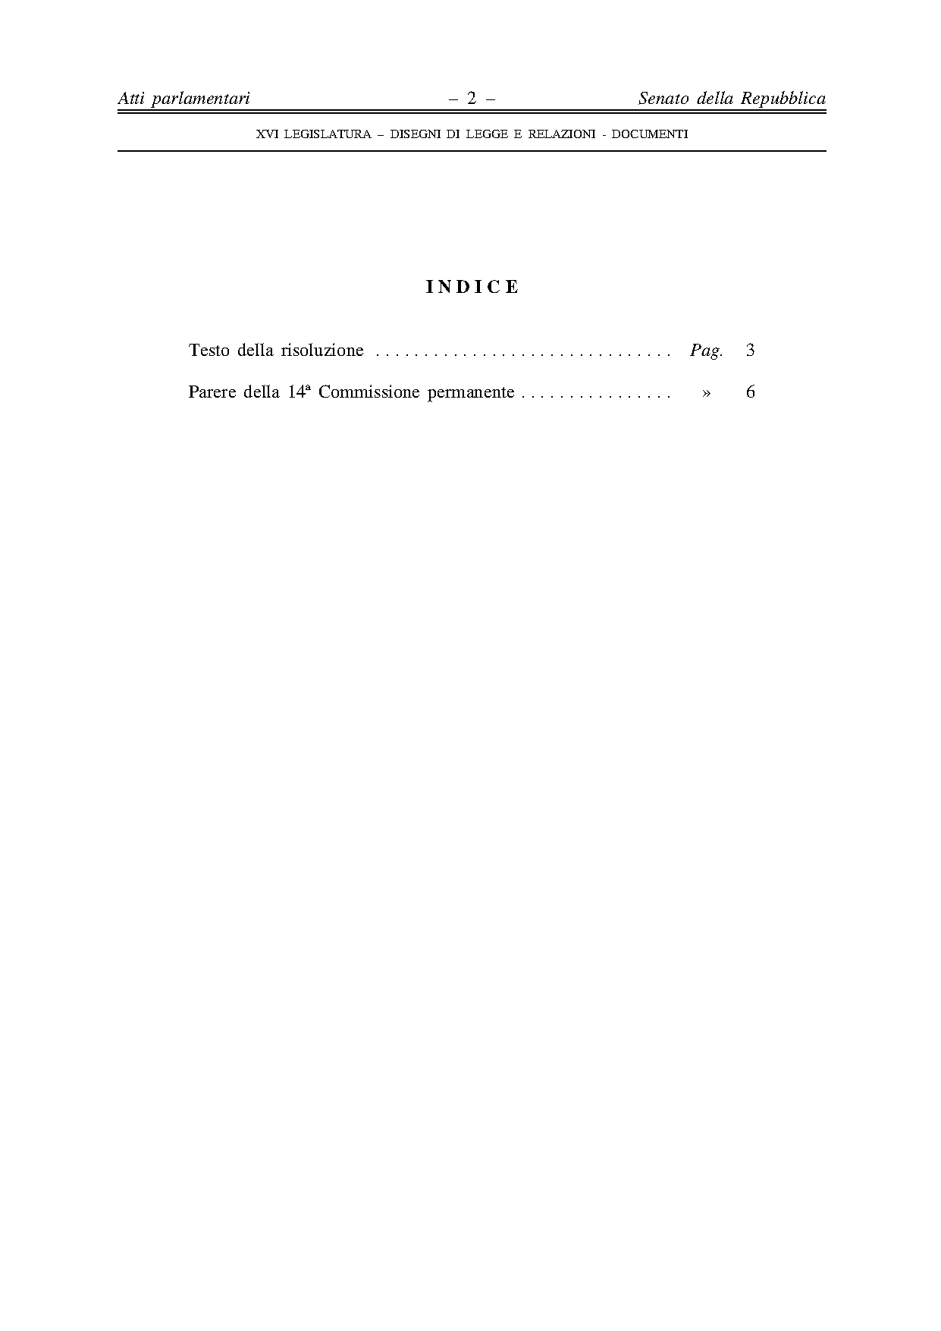
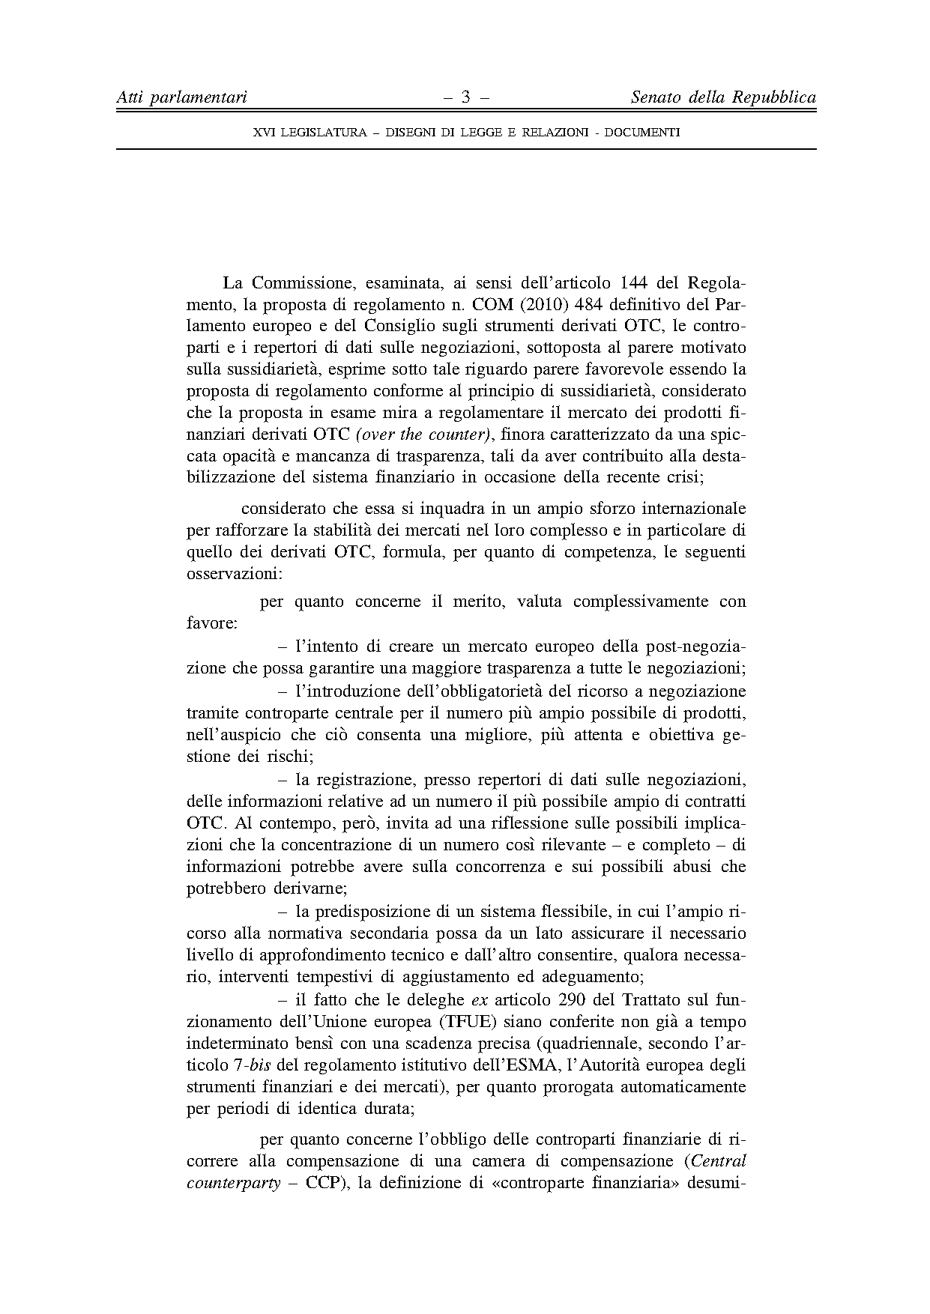
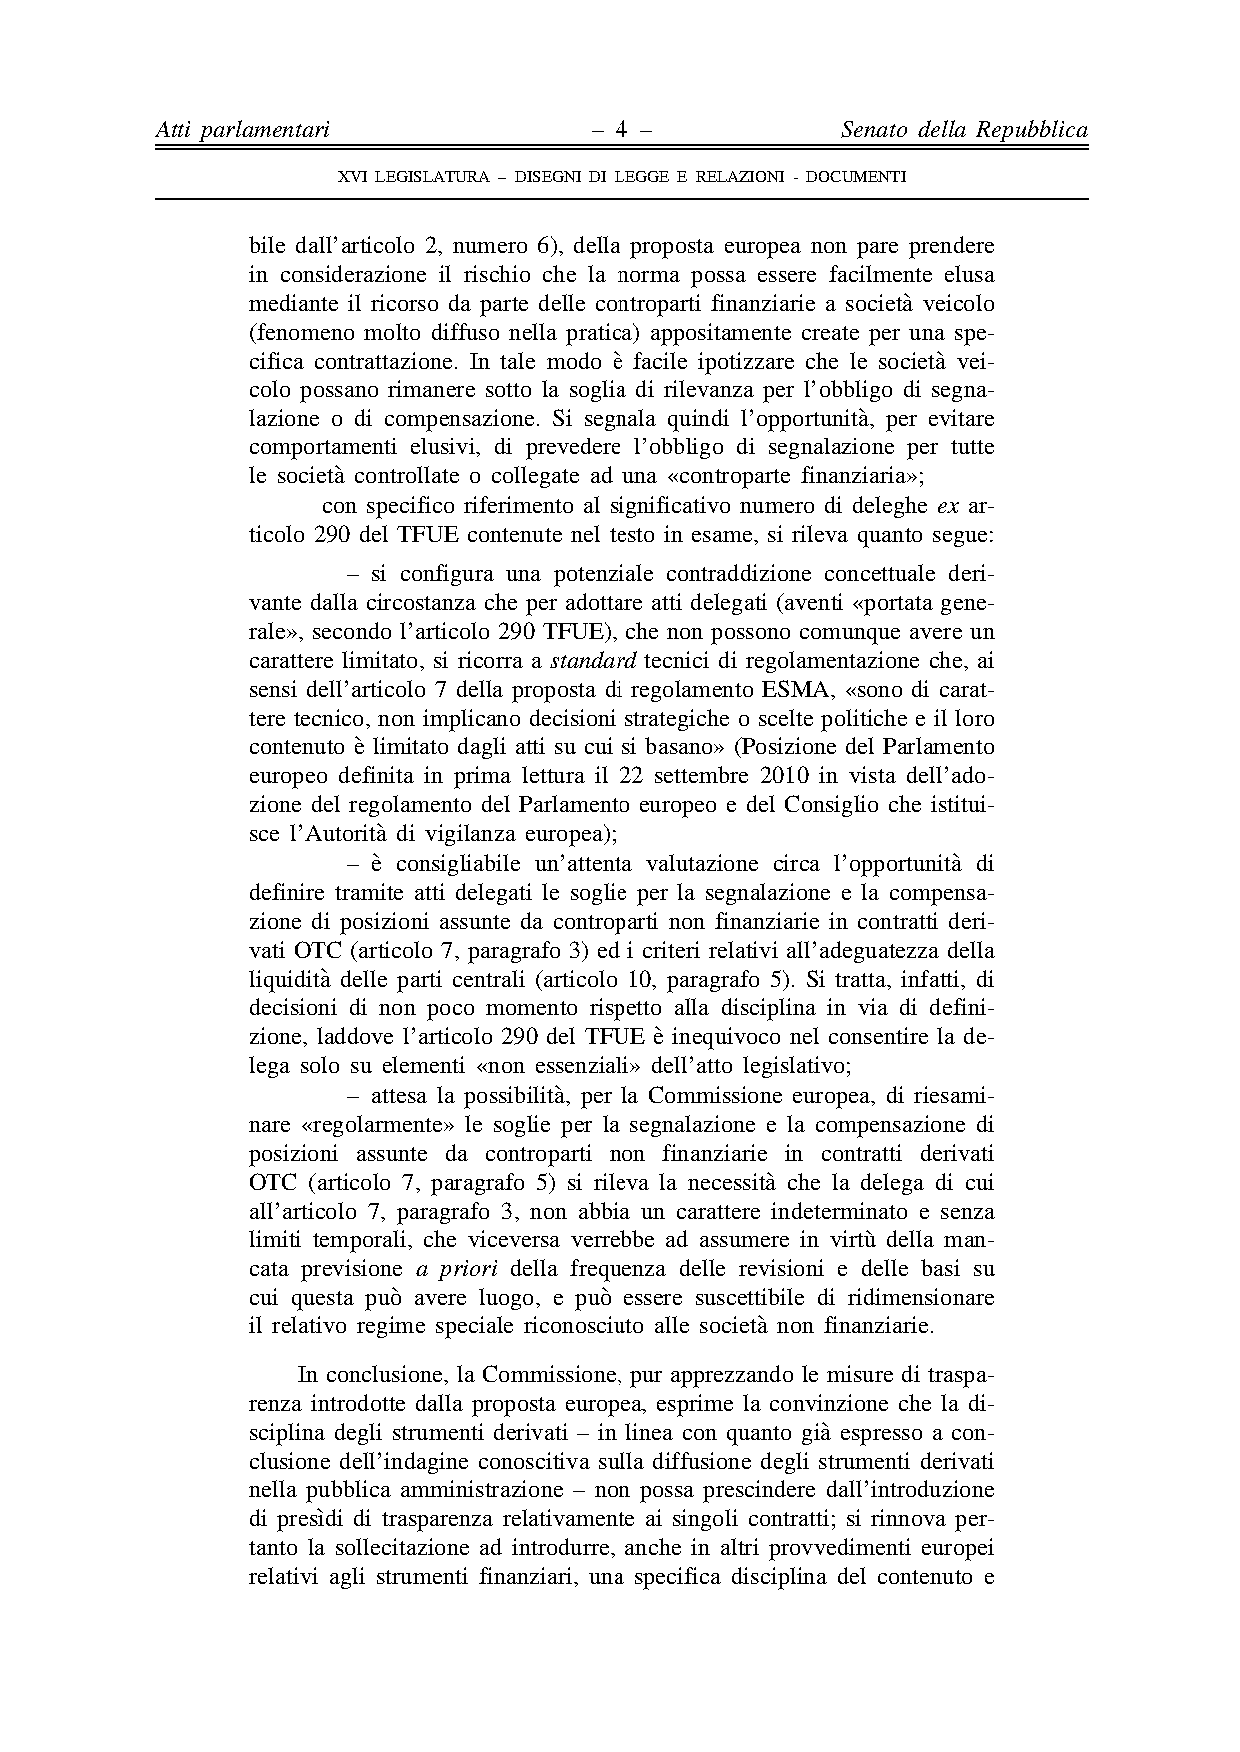
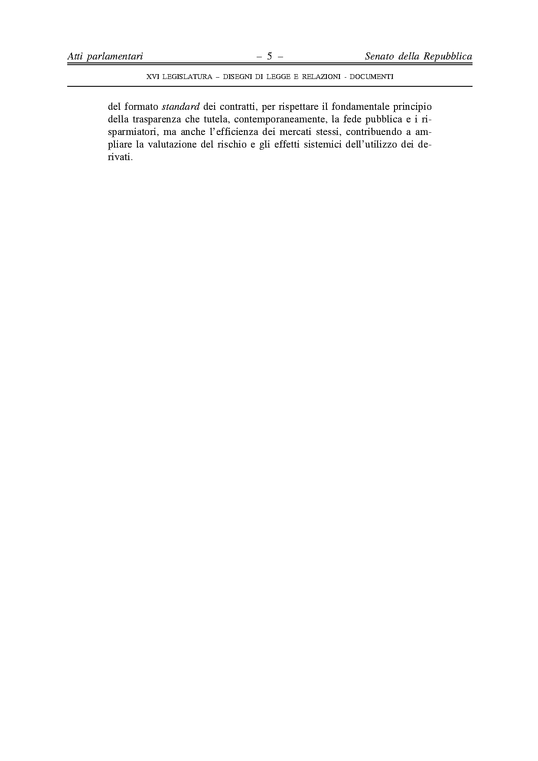
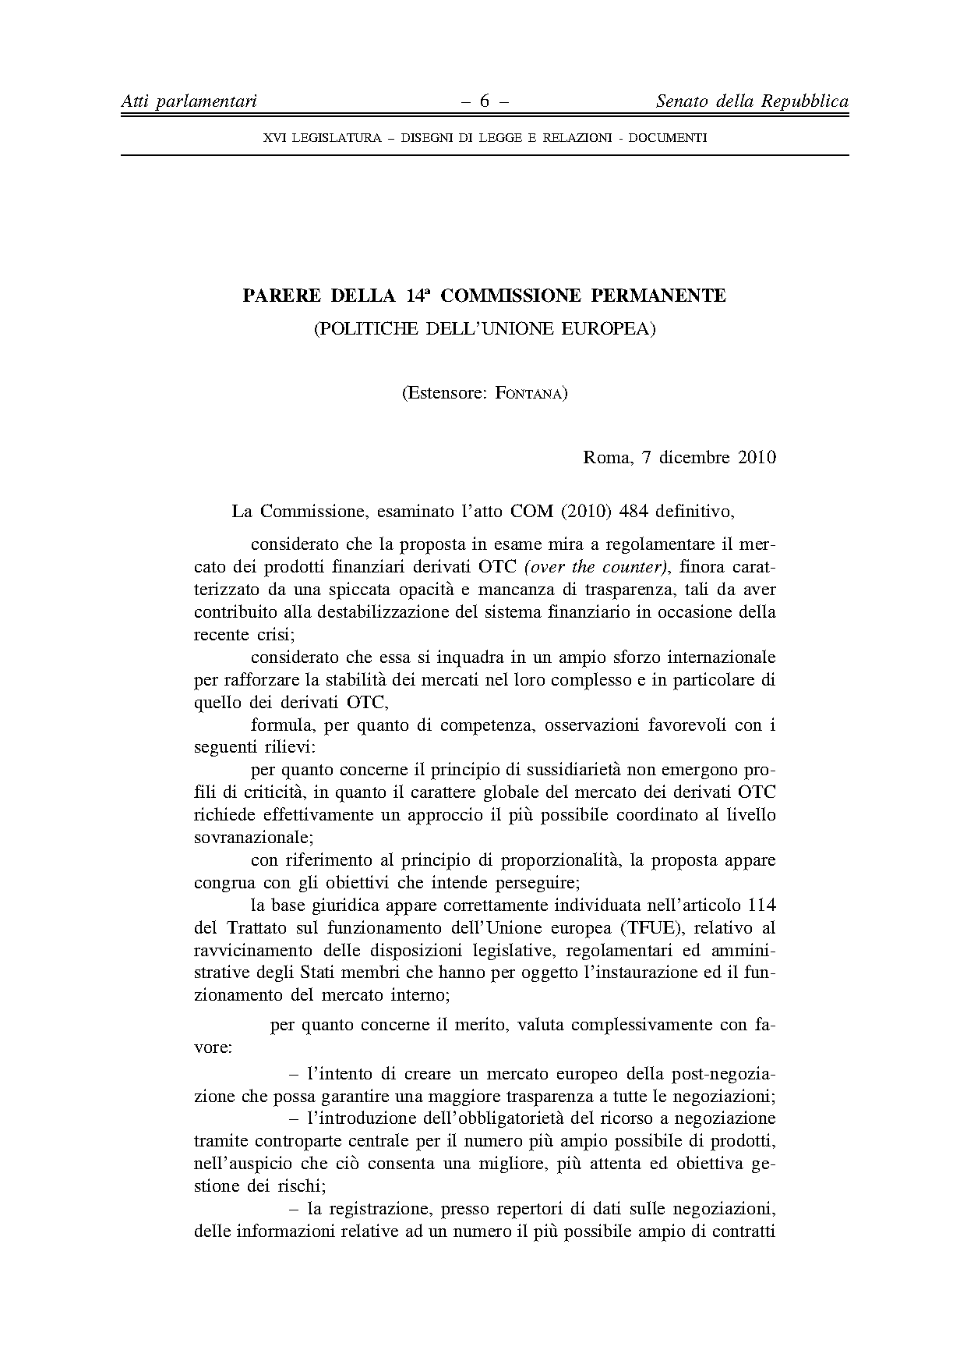
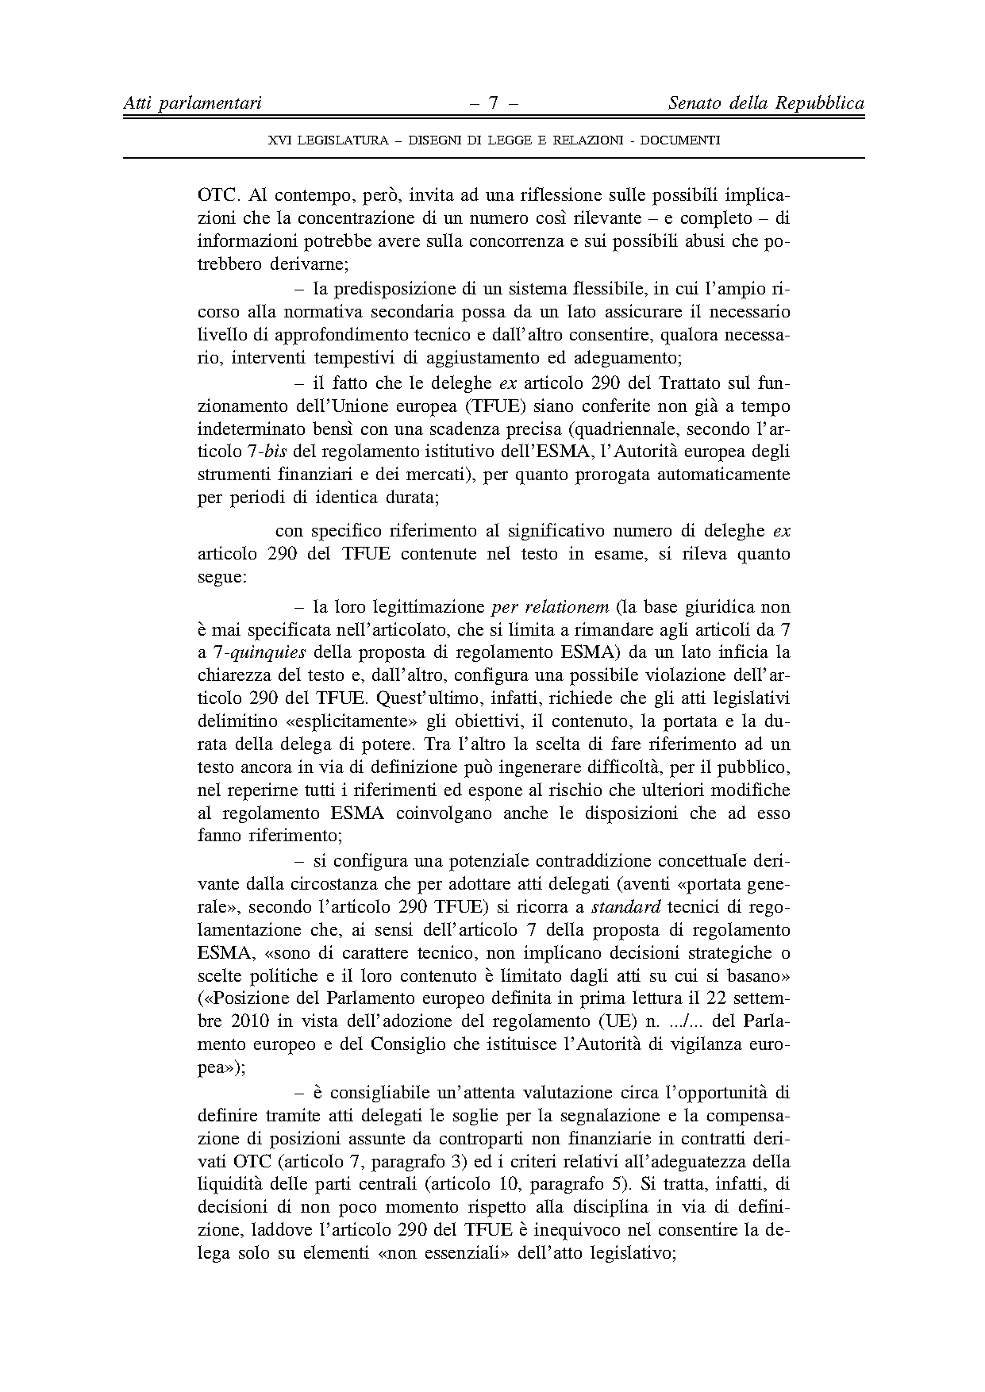
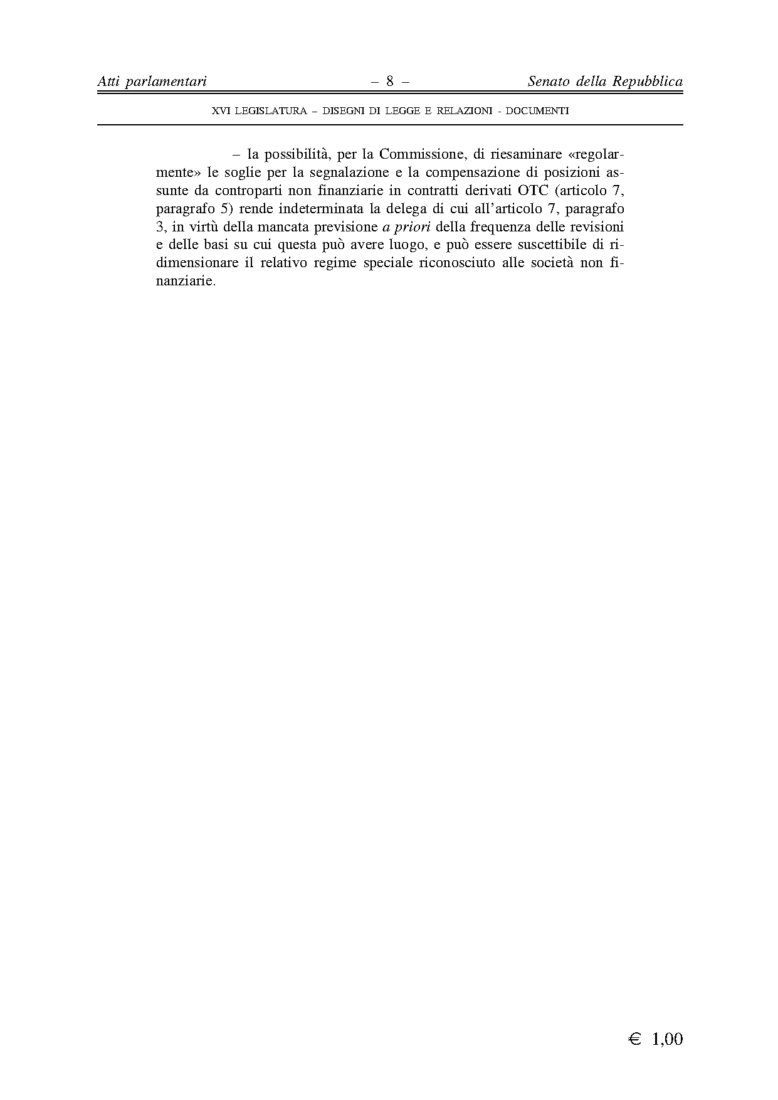

This opinion is available in English on the interparliamentary EU information exchange site (IPEX) at the following address: http://www.ipex.eu/ipex/cms/home/Documents/pid/10

