 | 
COUNCIL OF  THE EUROPEAN UNION |  |  | Brussels, 19 April 2011
 |  |  | 9295/11
ASIM 41
INST 220
PARLNAT 128

COVER NOTE
from: | Mr. Jaime Gama, President of Portuguese Assembly of the Republic
date of receipt: | 15 April 2011
to: | Mr. Victor Orban, President of the Council of the European Union
Subject: | Report from the Commission to the European Parliament and the Council - First annual report on Immigration and Asylum (2009)  [doc. ST 9273/10 ASIM 53 - COM (2010) 214 final]  - Opinion on the application of the Principles of Subsidiarity and Proportionality

Delegations will find attached a copy of the above letter.

________________________

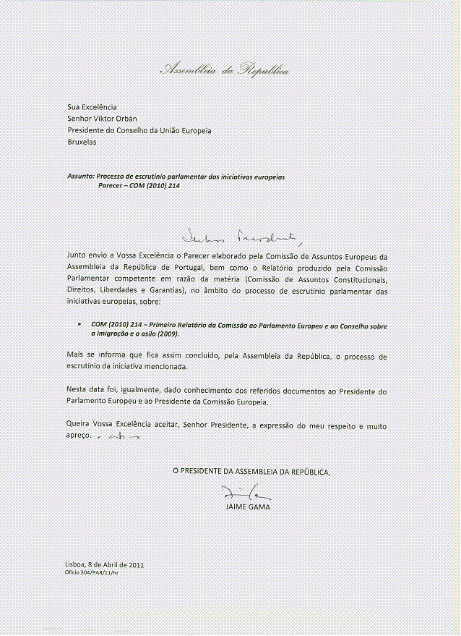
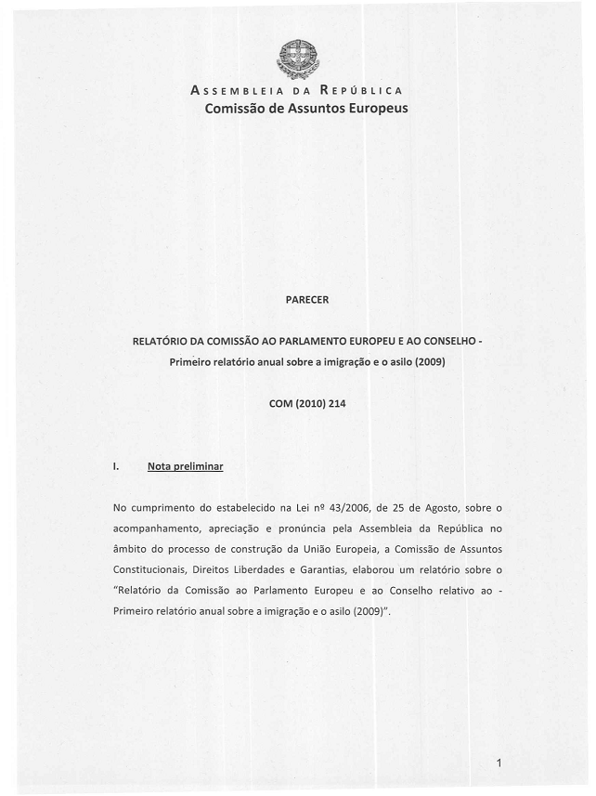
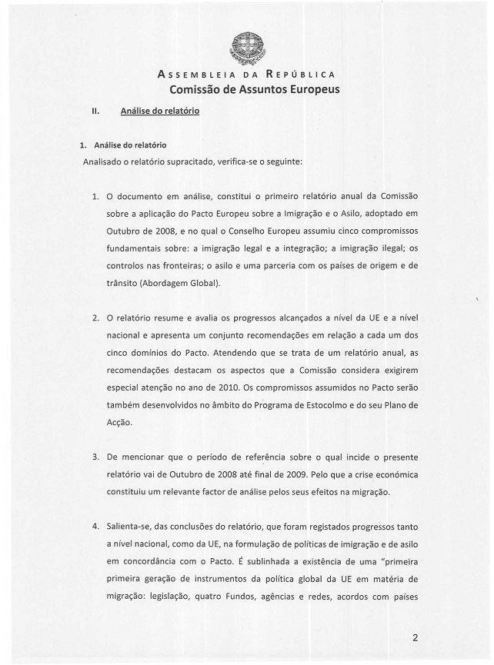
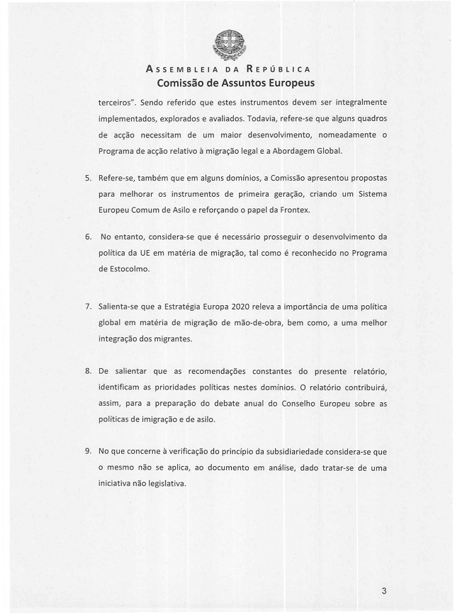
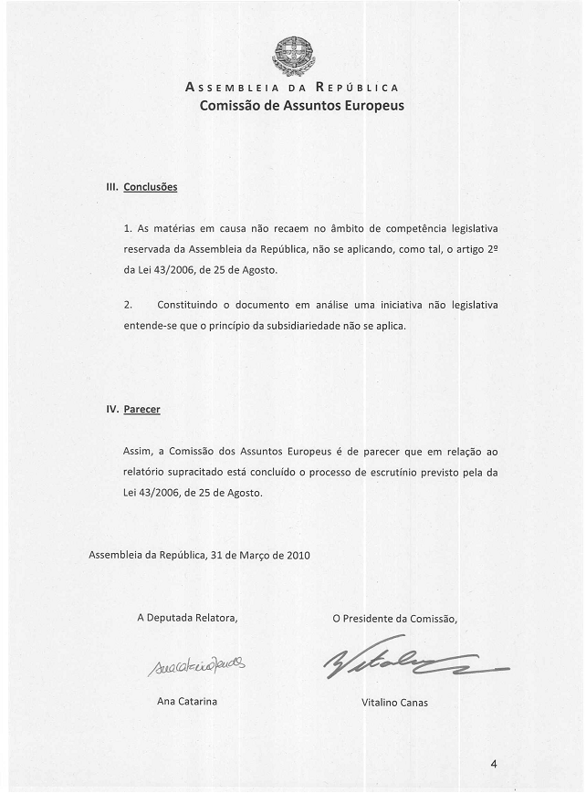
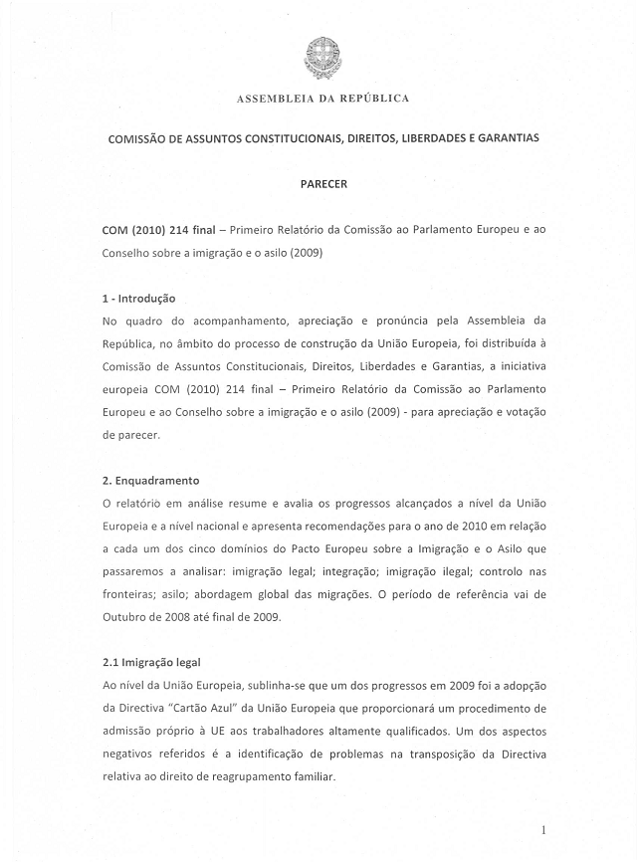
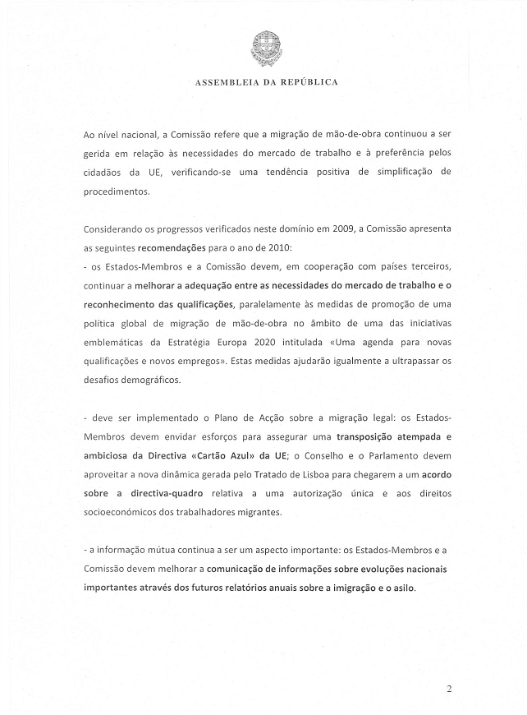
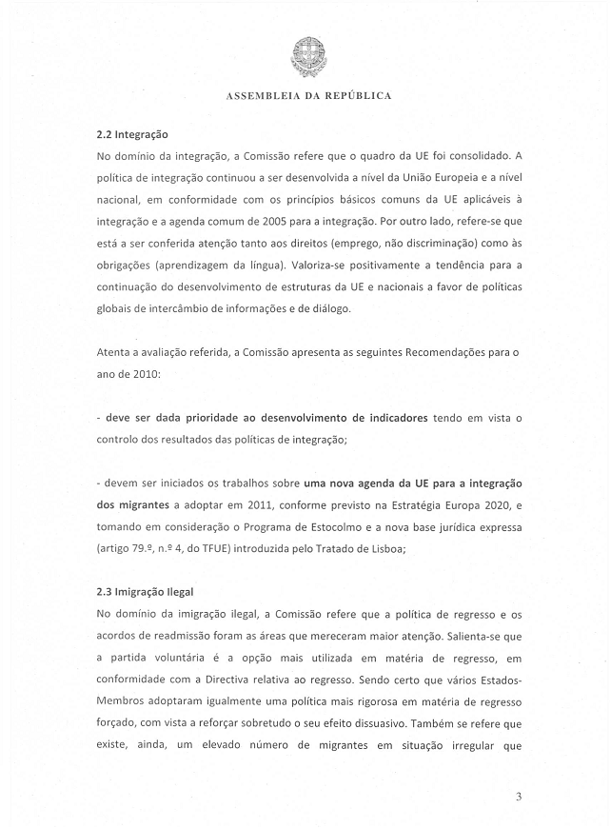
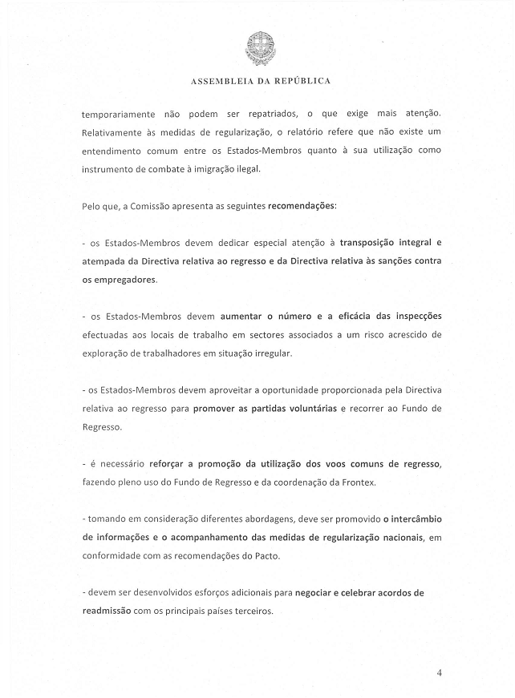
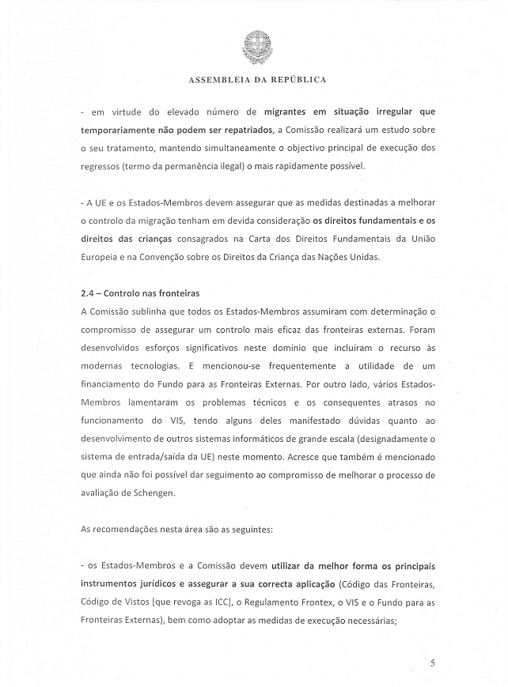
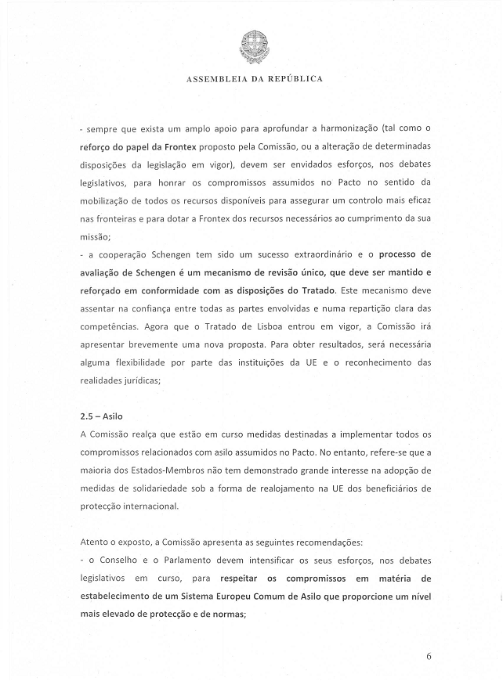
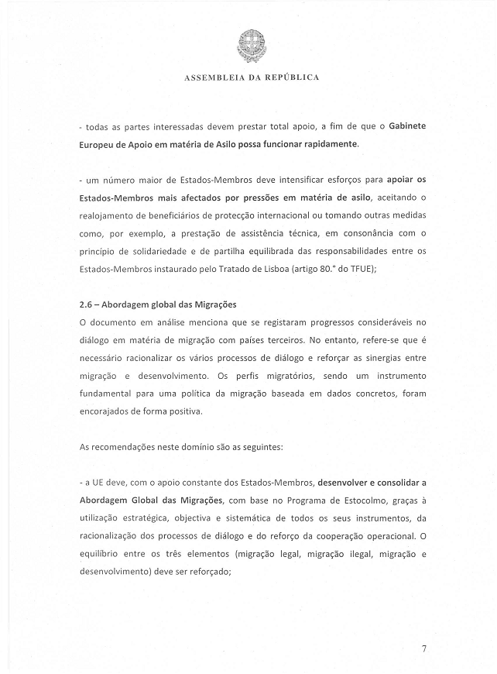
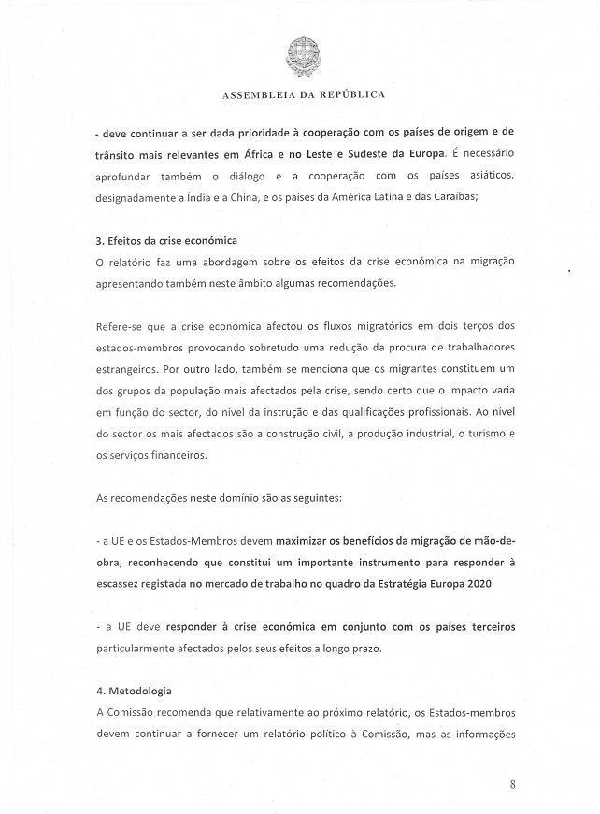
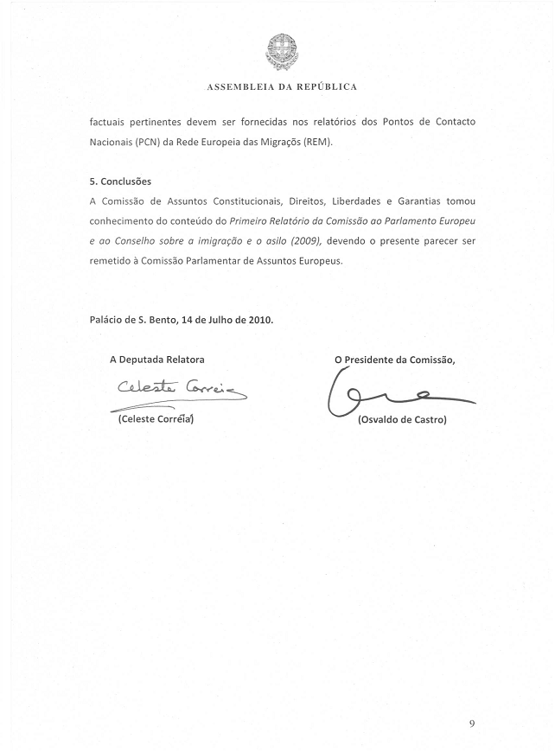

This opinion is available in English on the Interparliamentary EU information exchange Internet site (IPEX) at the following address: http://www.ipex.eu/ipex/cms/home/Documents/pid/10

