 | 
COUNCIL OF  THE EUROPEAN UNION |  |  | Brussels, 18 April 2011
 | Interinstitutional File:  2011/0002 (COD) |  | 9281/11
AGRI 312
ENT 96
ENV 304
CODEC 679
MI 216
INST 217
PARLNAT 125

COVER NOTE
from: | The President of the Italian Senate
date of receipt: | 23 March 2011
to: | General Secretariat of the Council of the European Union
Subject: | Proposal for a Directive of the European Parliament and of the Council amending Directive 2000/25/EC as regards the application of emission stages to narrow-track tractors  - Reasoned opinion on the application of the Principles of Subsidiarity and Proportionality

Delegations will find in Annex the reasoned opinion of the Italian Senate.

________________________

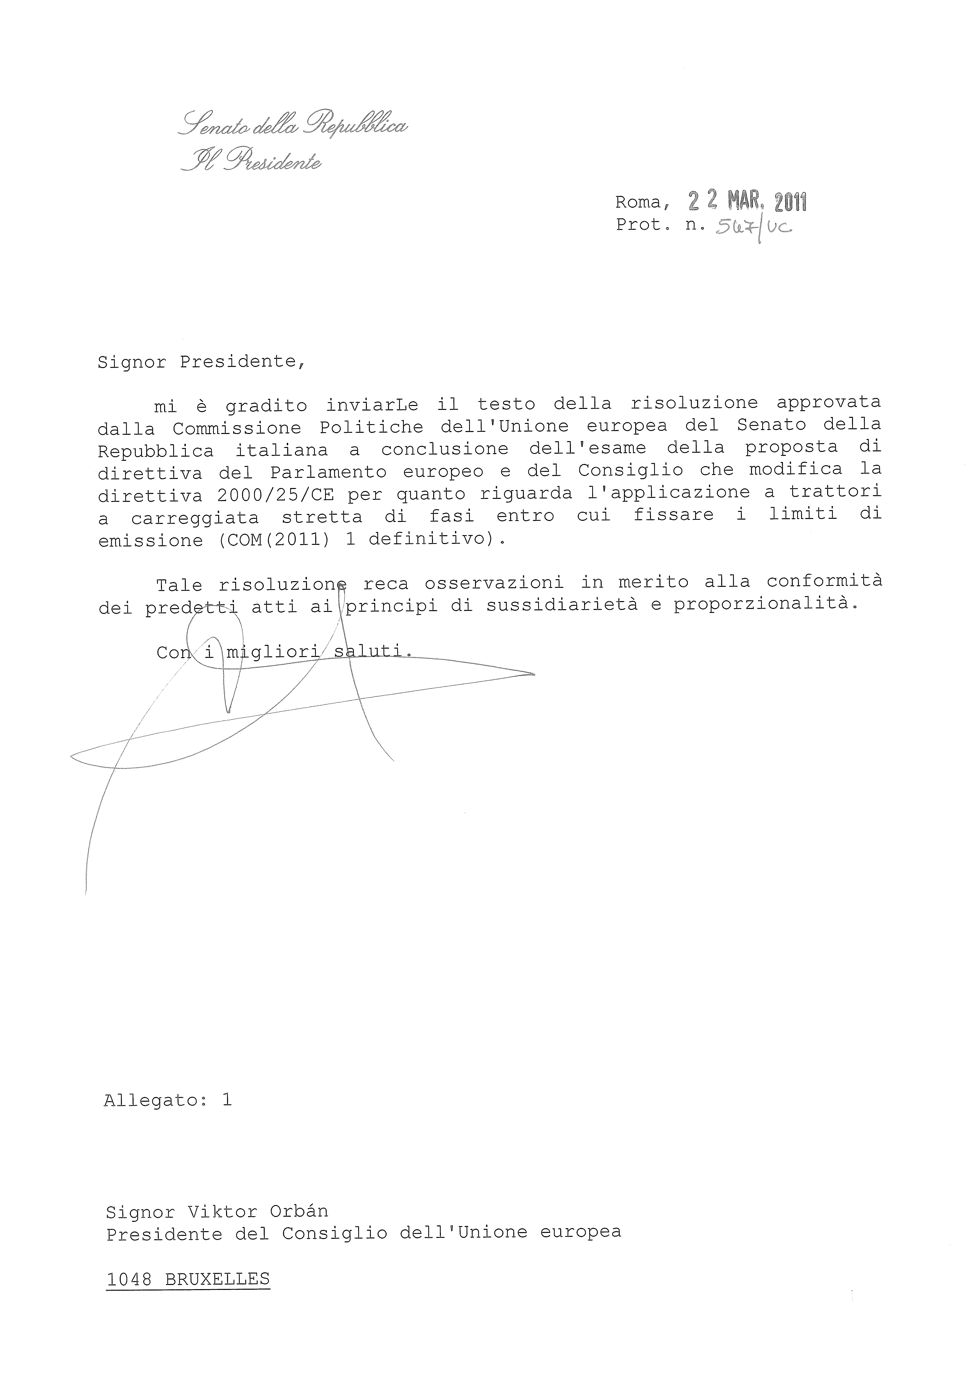
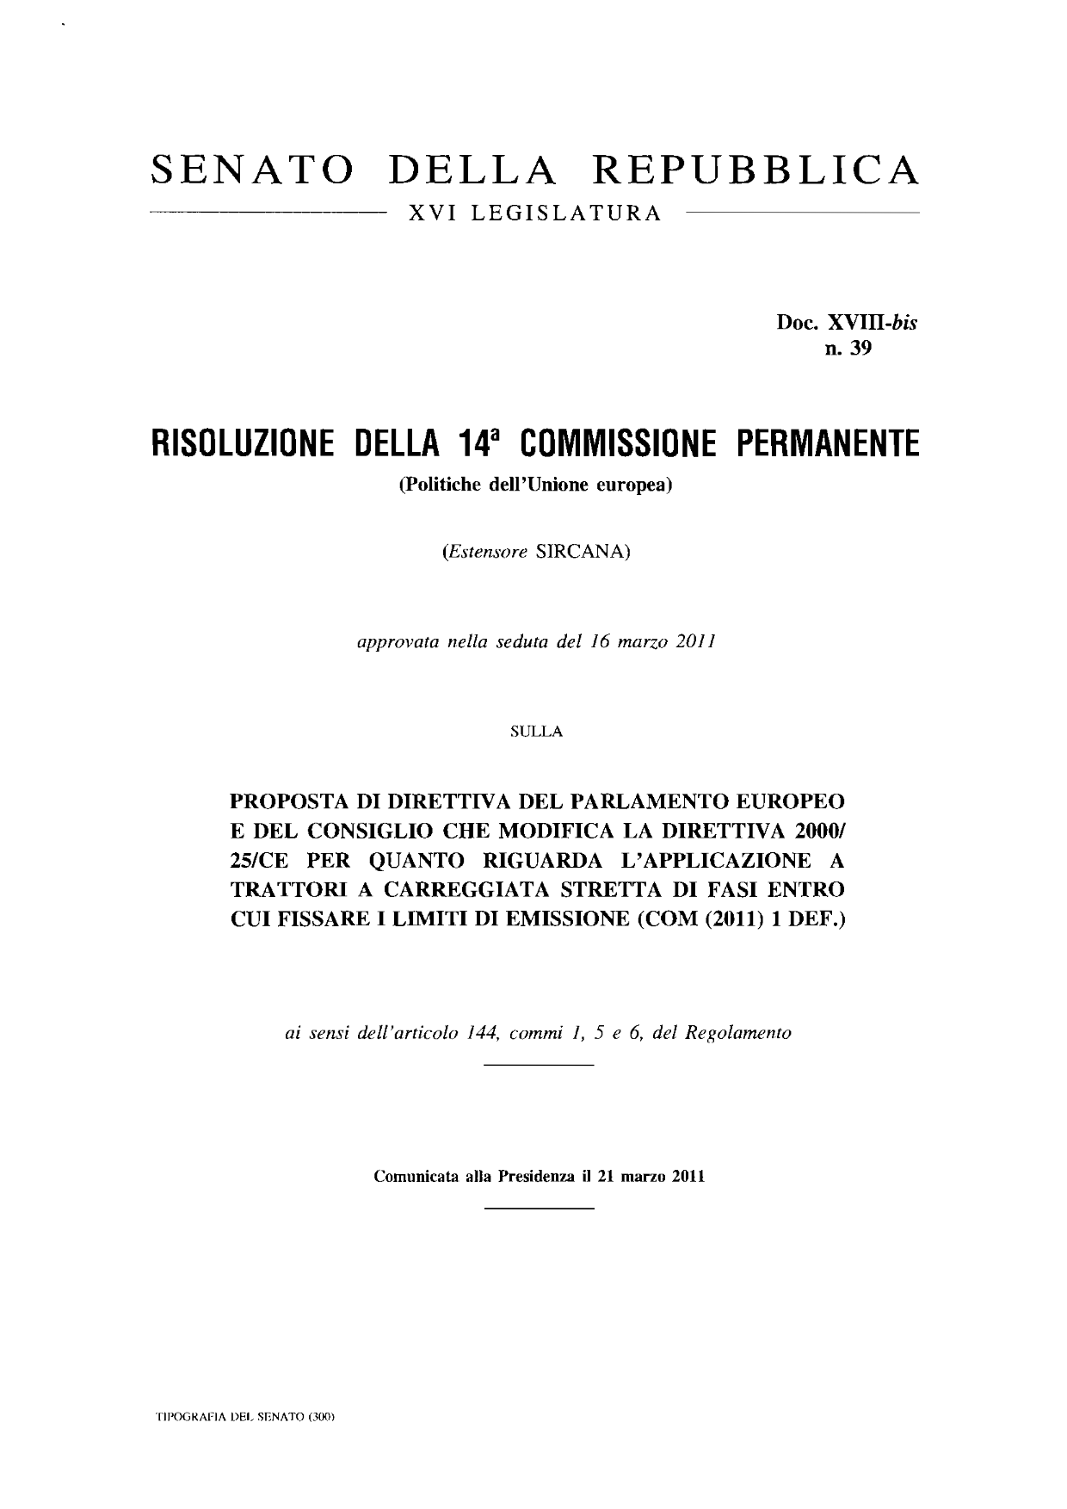
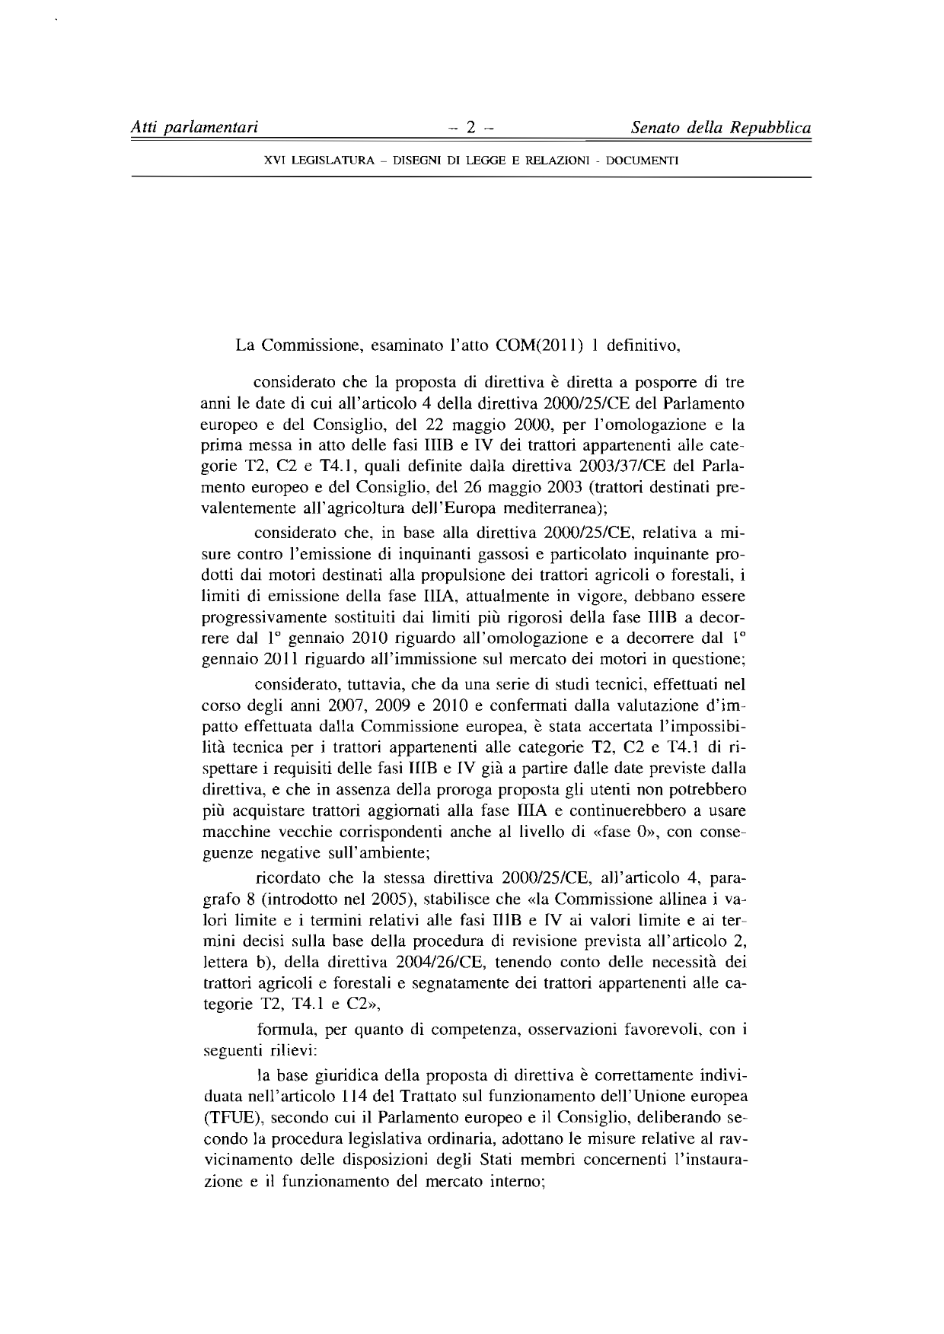
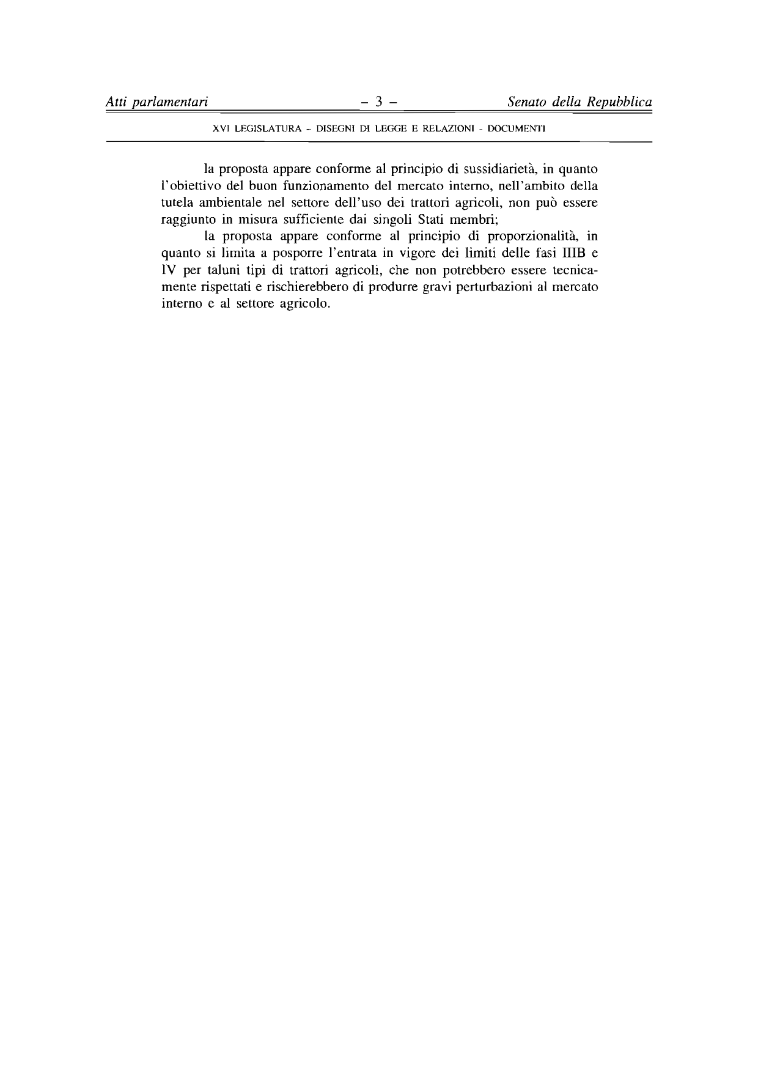

This opinion is available in English on the Interparliamentary EU information exchange Internet site (IPEX) at the following address : http://www.ipex.eu/ipex/cms/home/Documents/dossier_COD20110002/lang/en

