 | 
COUNCIL OF  THE EUROPEAN UNION |  |  | Brussels, 18 April 2011
 |  |  | 9257/11
COMPET 158
INST 216
PARLNAT 124

COVER NOTE
from: | Mr Jaime Gama, President of the Assembly of the Portuguese Republic
date of receipt: | 12 April 2011
to: | Mr Viktor Orbán, President of the Council of the European Union
Subject: | Communication from the Commission to the European Parliament, the Council, the European Economic and Social Committee and the Committee of the Regions - Smart Regulation in the European Union  [doc. 14421/10 COMPET 273 - COM (2010) 543 final]  - Opinion on the application of the Principles of Subsidiarity and Proportionality

Delegations will find in Annex the opinion of the Assembly of the Portuguese Republic.

________________________

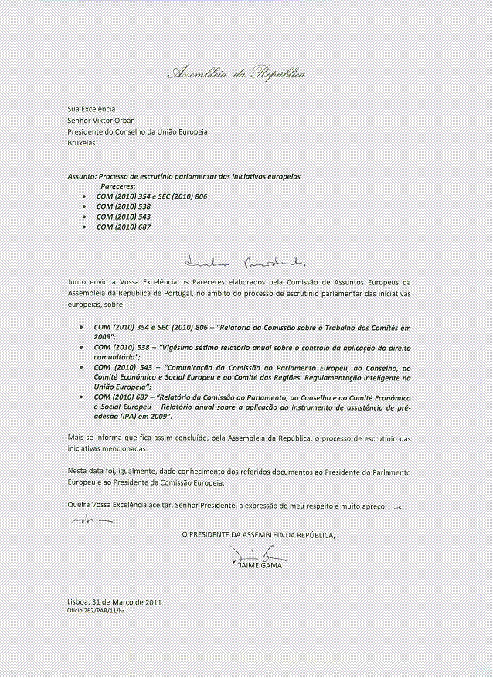
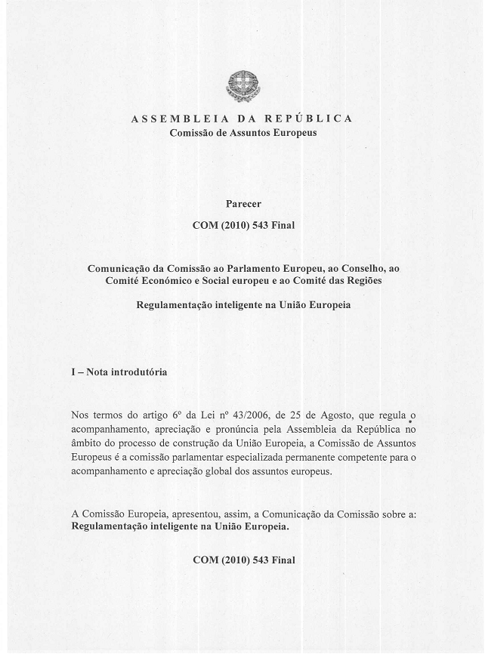
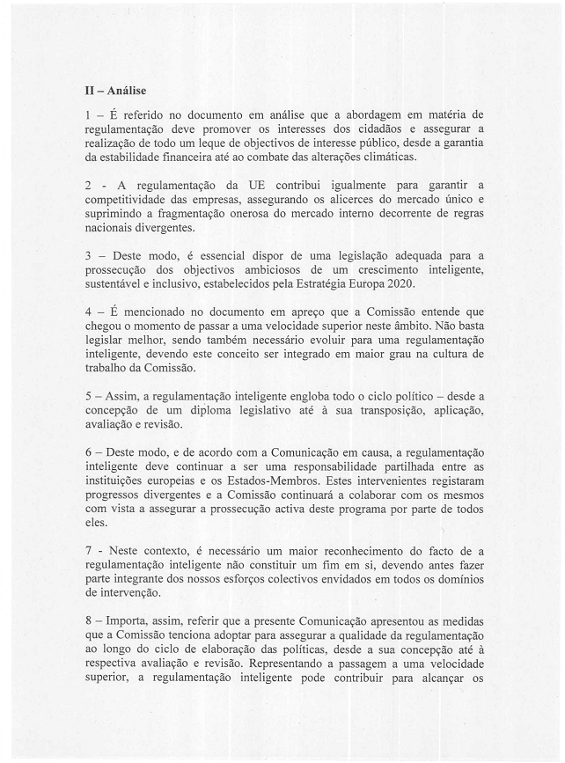
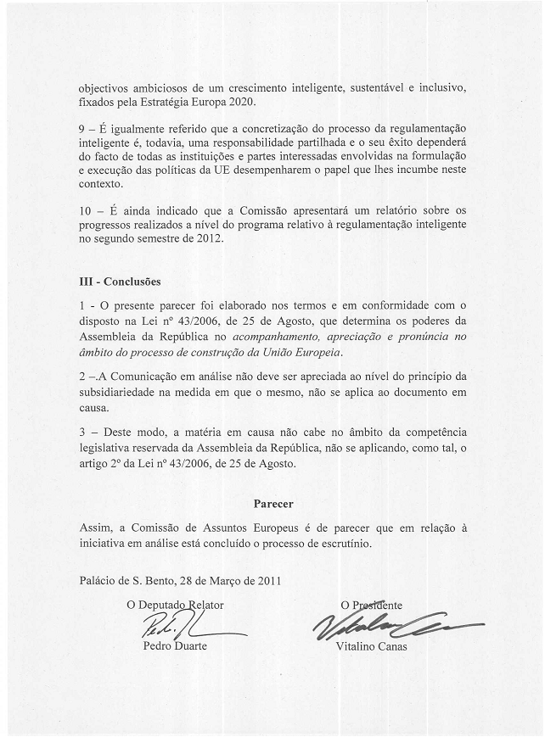

This opinion is available in English on the interparliamentary EU information exchange site (IPEX) at the following address http://www.ipex.eu/ipex/cms/home/Documents/dossier_COM20100543

