 | 
COUNCIL OF  THE EUROPEAN UNION |  |  | Brussels, 13 April 2011
 | Interinstitutional File:  2011/0023 (COD) |  | 8953/11
GENVAL 39
AVIATION 93
DATAPROTECT 31
CODEC 630
INST 201
PARLNAT 114

OPINION
from: | The Assembly of the Republic of Portugal
date of receipt: | 12 April 2011
to: | Council
Subject: | Proposal for a DIRECTIVE OF THE EUROPEAN PARLIAMENT AND OF THE COUNCIL on the use of Passenger Name Record data for the prevention, detection, investigation and prosecution of terrorist offences and serious crime  Doc. 6007/11 GENVAL 5 AVIATION 15 DATAPROTECT 6 CODEC 278 [COM(2011) 32 final]  - Opinion on the application of the Principles of Subsidiarity and Proportionality

Delegations will find attached the above mentioned Opinion.

_____________

Encl.
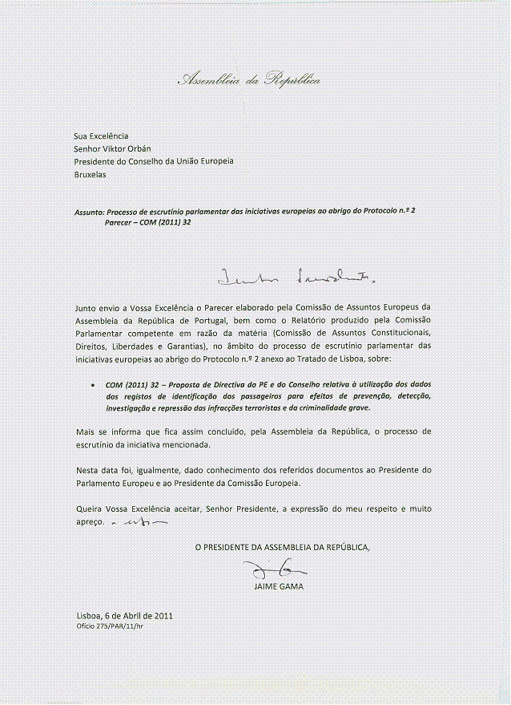
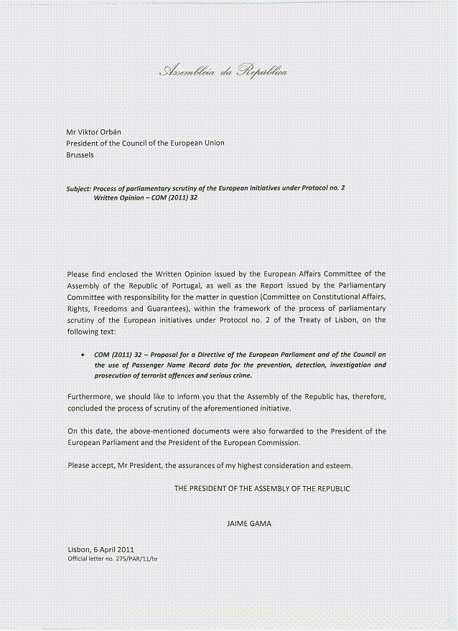

ANNEX

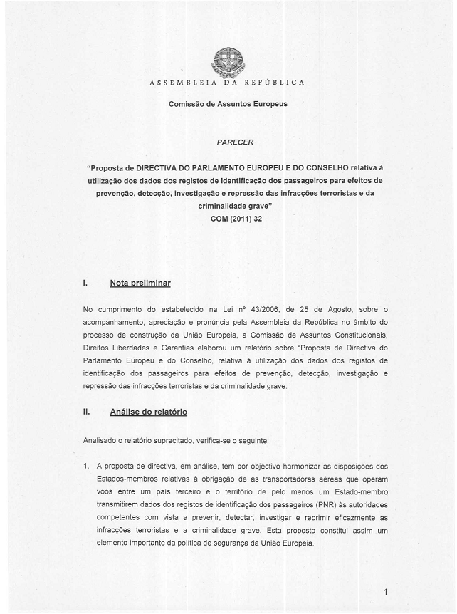
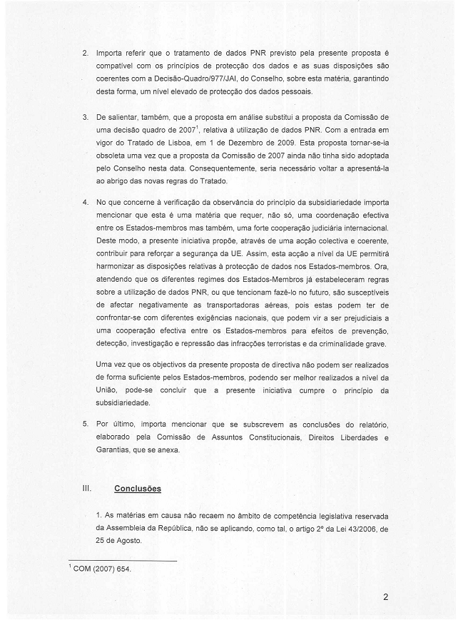
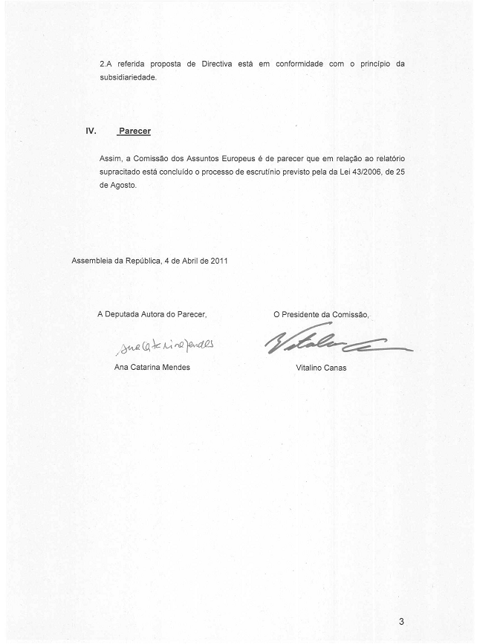
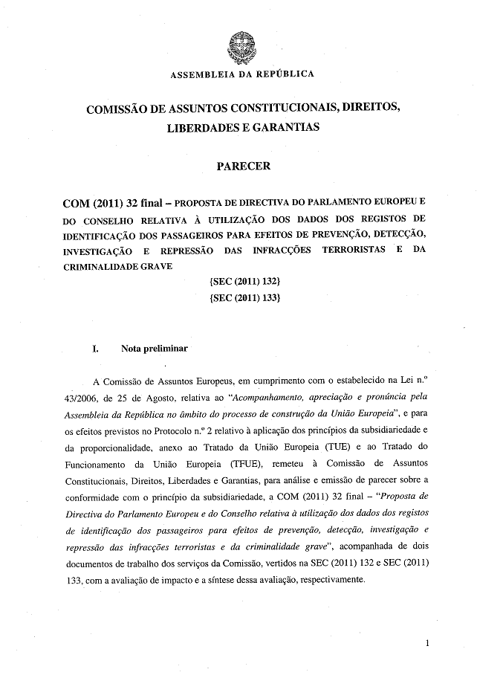
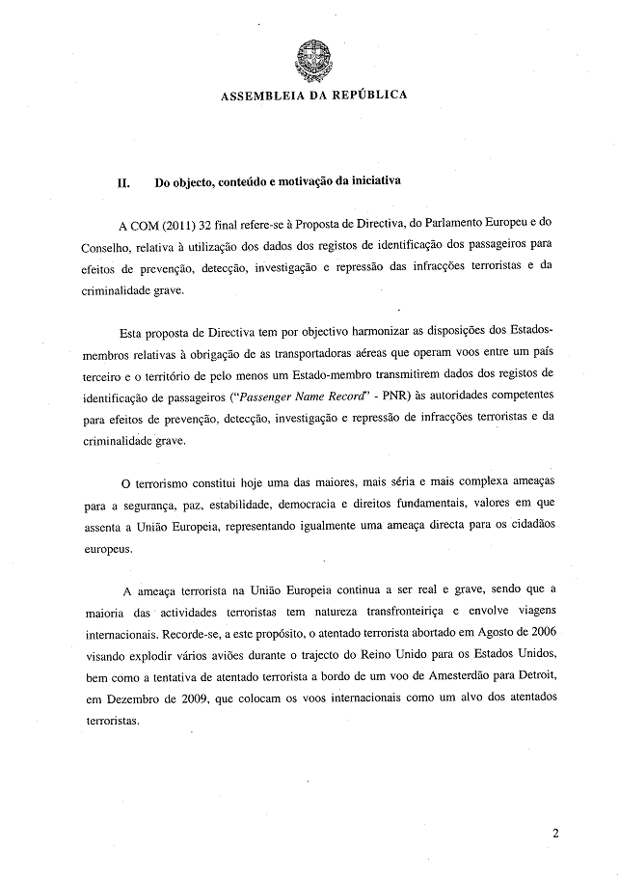
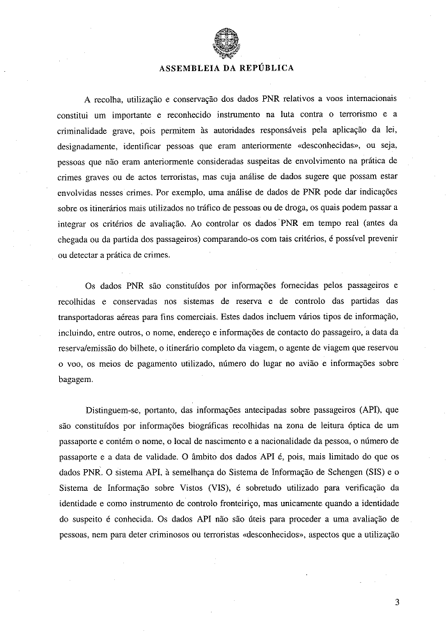
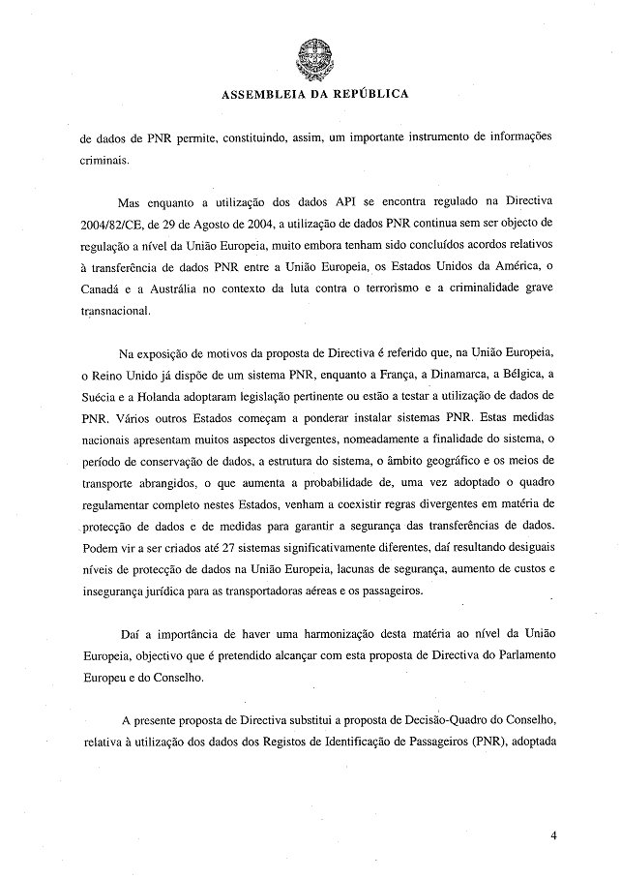
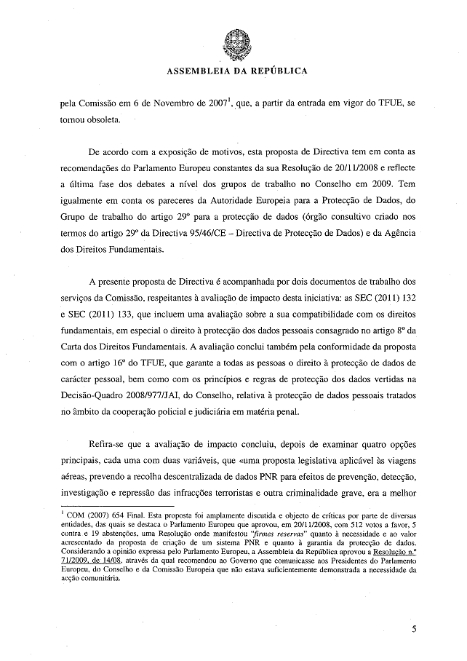
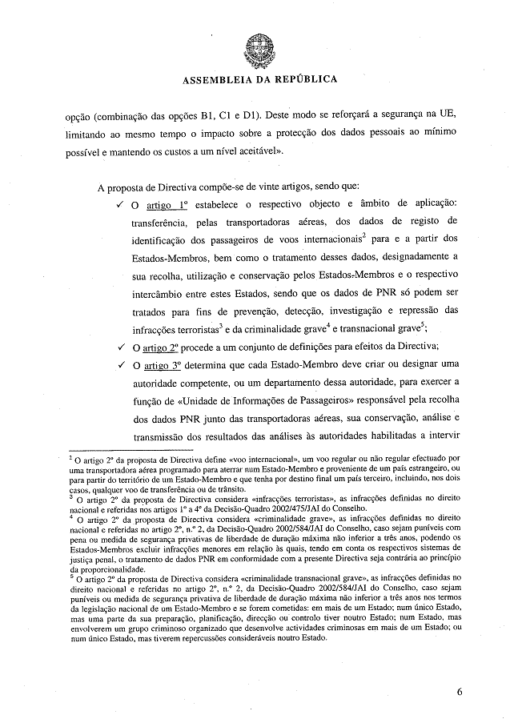
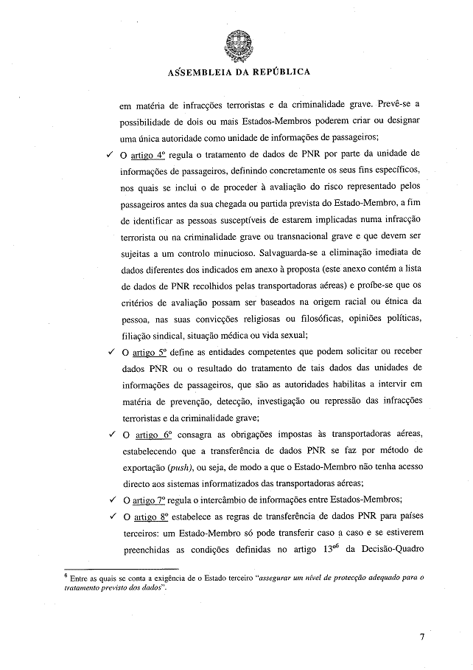
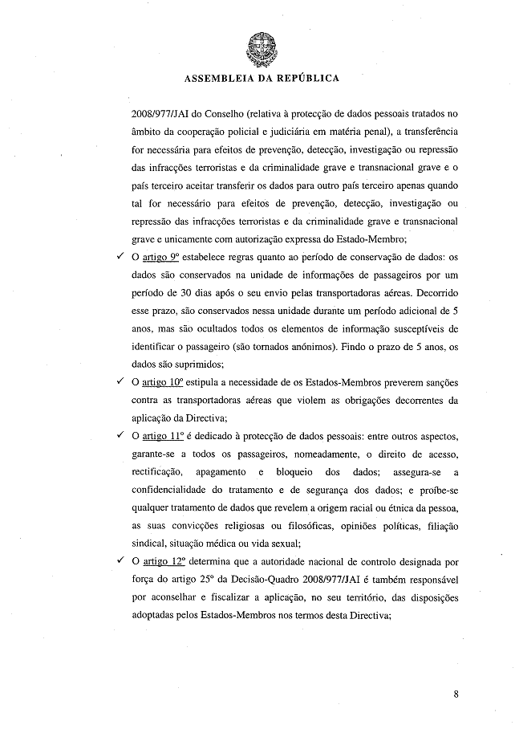
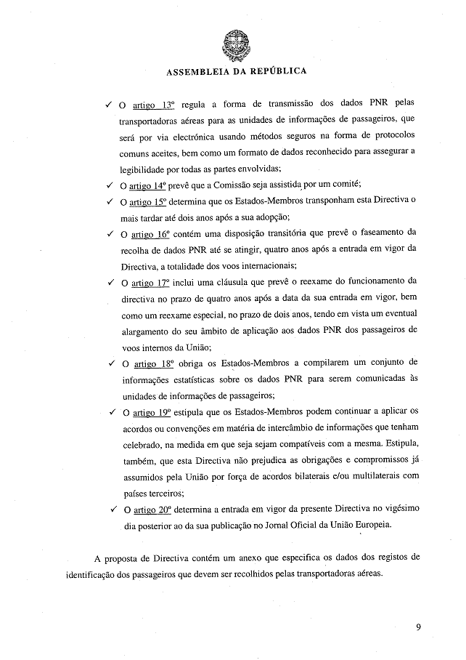
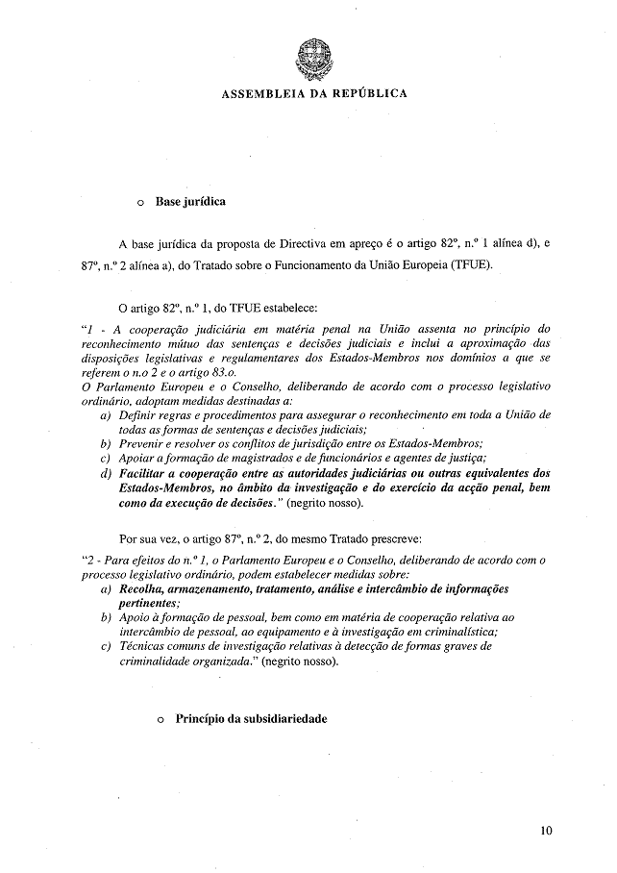
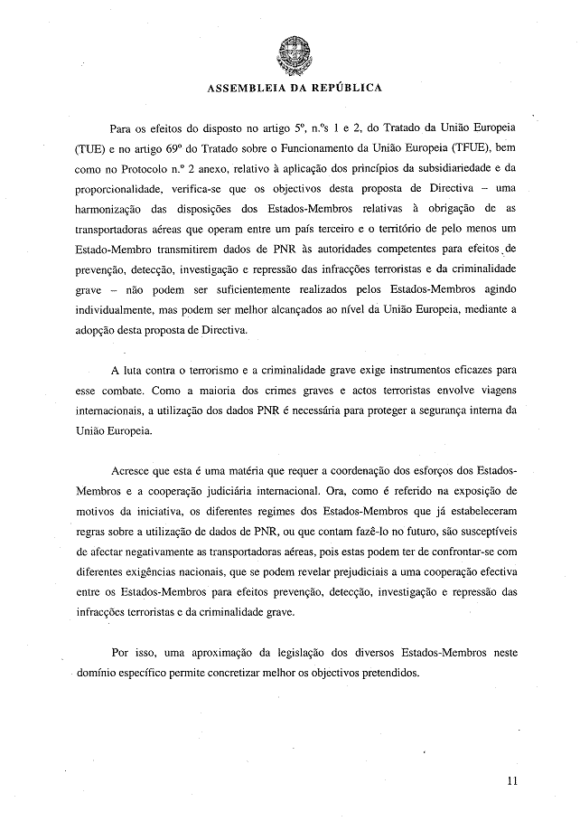
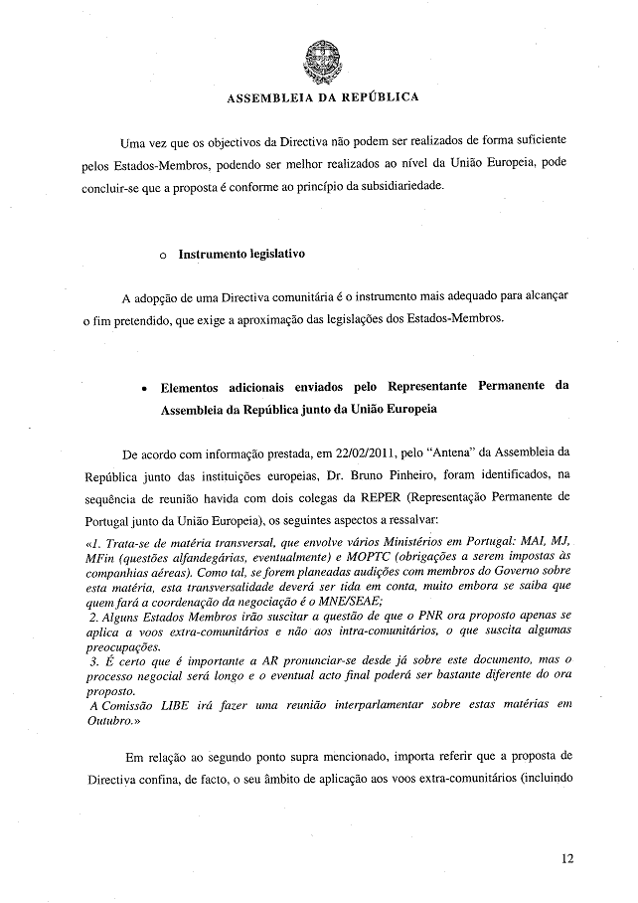
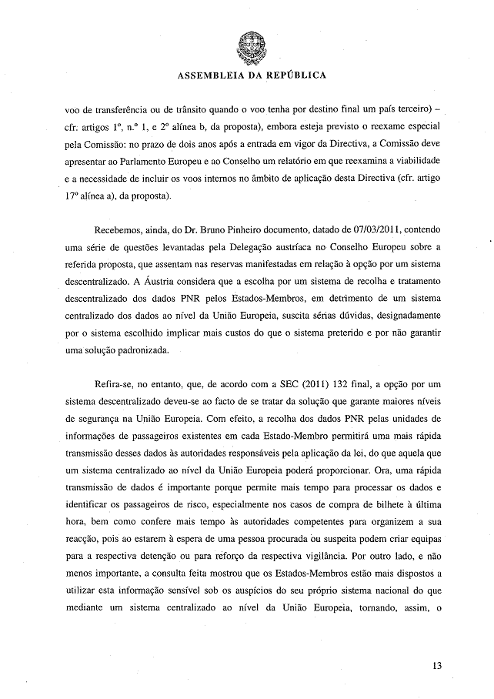
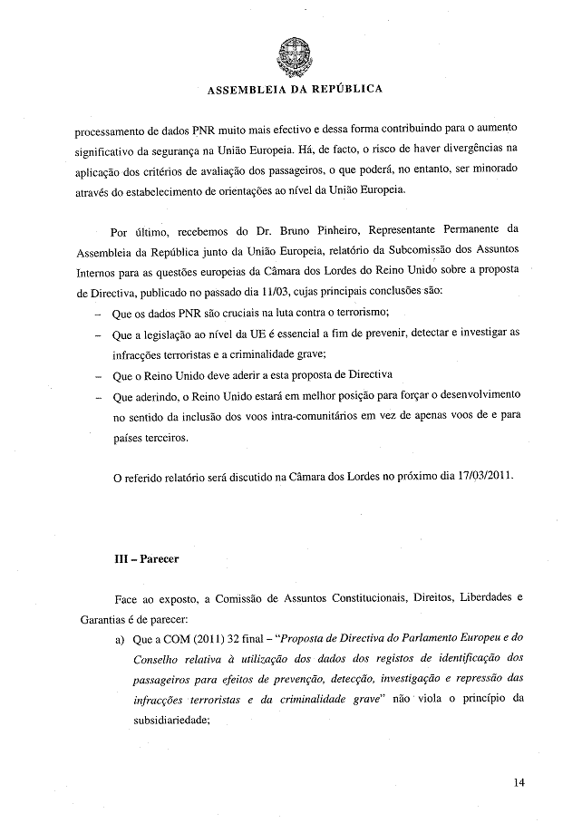
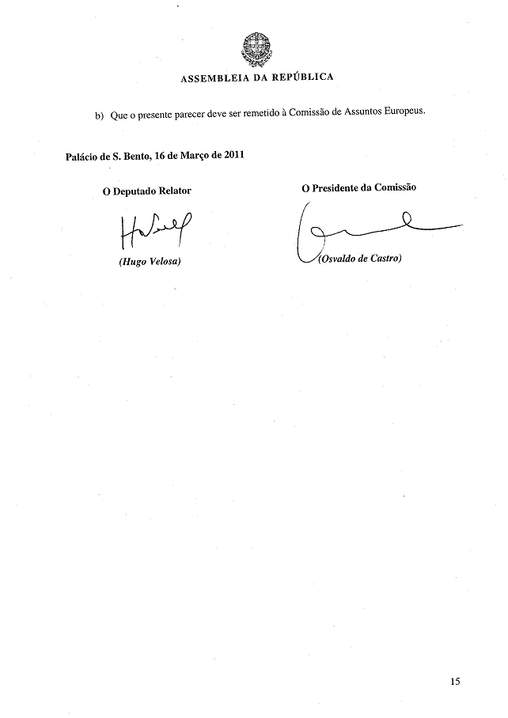

This opinion is available in English on the interparliamentary EU information exchange site (IPEX) at the following address: http://www.ipex.eu/ipex/cms/home/Documents/pid/10

