 | 
COUNCIL OF  THE EUROPEAN UNION |  |  | Brussels,11 April 2011
 | Interinstitutional File:  2011/0023 (COD) |  | 8840/11
GENVAL 37
AVIATION 88
DATAPROTECT 29
CODEC 617
INST 198
PARLNAT 113

OPINION
from: | The Senate of the Republic of Italy
date of receipt: | 8 April 2011
to: | Council
Subject: | Proposal for a DIRECTIVE OF THE EUROPEAN PARLIAMENT AND OF THE COUNCIL on the use of Passenger Name Record data for the prevention, detection, investigation and prosecution of terrorist offences and serious crime  Doc. 6007/11 GENVAL 5 AVIATION 15 DATAPROTECT 6 CODEC 278 [COM(2011) 32 final]  - Opinion on the application of the Principles of Subsidiarity and Proportionality

Delegations will find attached the above mentioned Opinion.

_____________

Encl.
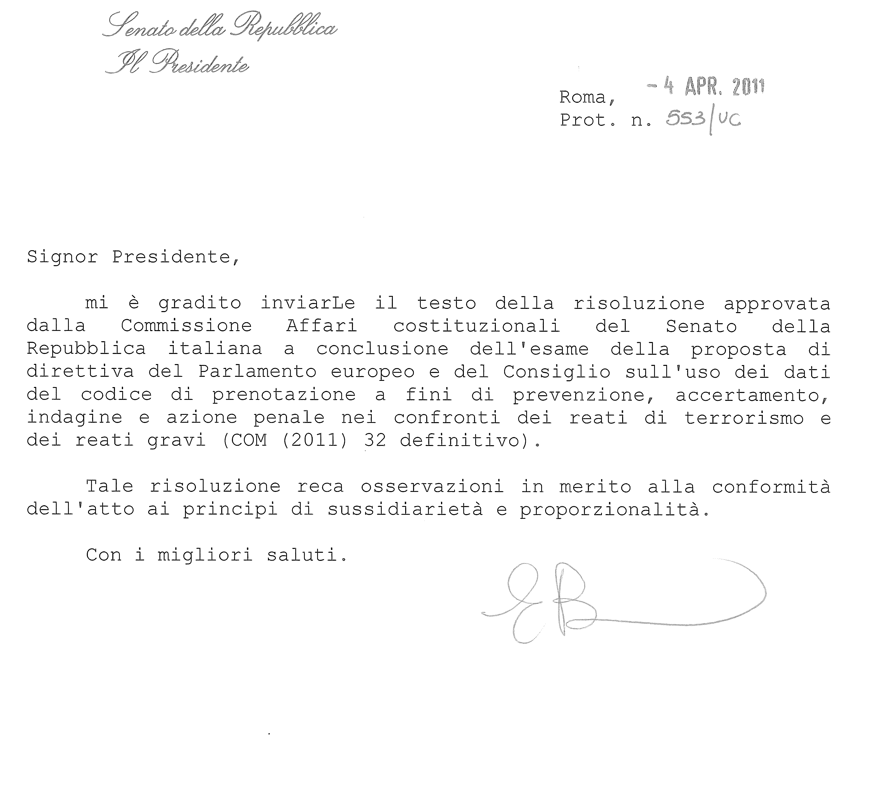

Allegato: 1

Signor Viktor Orbán
Presidente del Consiglio dell'Unione europea

1048 BRUXELLES

_____________

ANNEX

This opinion is available in English on the interparliamentary EU information exchange site (IPEX) at the following address: http://www.ipex.eu/ipex/cms/home/Documents/pid/10

