 | 
COUNCIL OF  THE EUROPEAN UNION |  |  | Brussels, 5 May 2011
 | Interinstitutional File:  2011/0058 (CNS) |  | 9788/11
FISC 46
INST 234
PARLNAT 136

COVER NOTE
from: | The President of the Assembly of the Republic of Portugal
date of receipt: | 29 April 2011
to: | The President of the Council of the European Union
Subject: | Proposal for a Council Directive on a Common Consolidated Corporate Tax Base (CCCTB)  [doc. 7263/11 FISC 23 - COM(2011) 121 final]  - Opinion on the application of the Principles of Subsidiarity and Proportionality

Delegations will find attached the abovementioned opinion.

________________________

Encl.

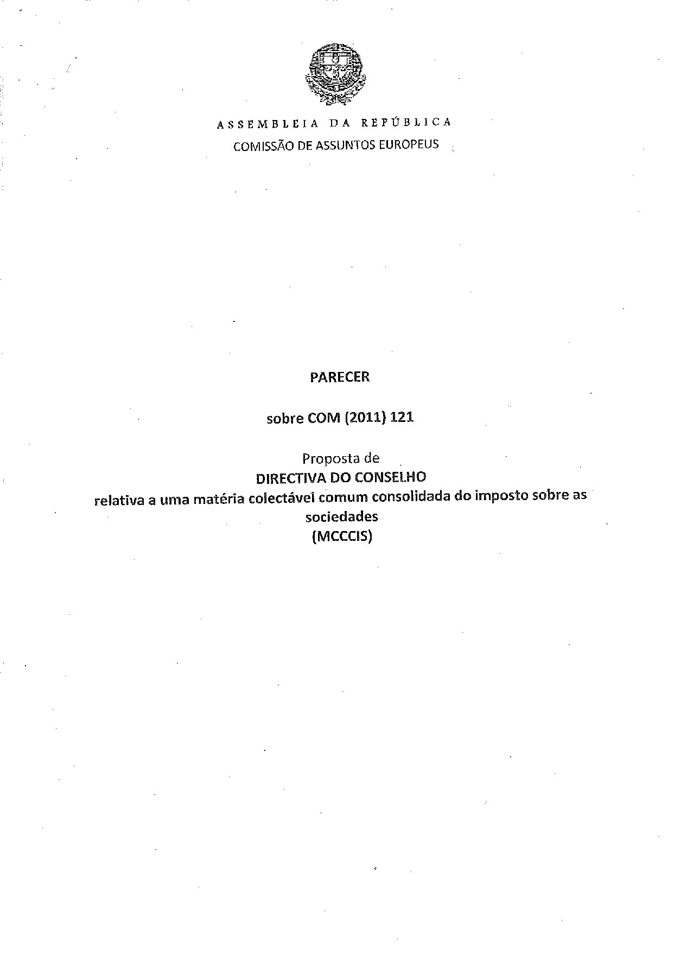

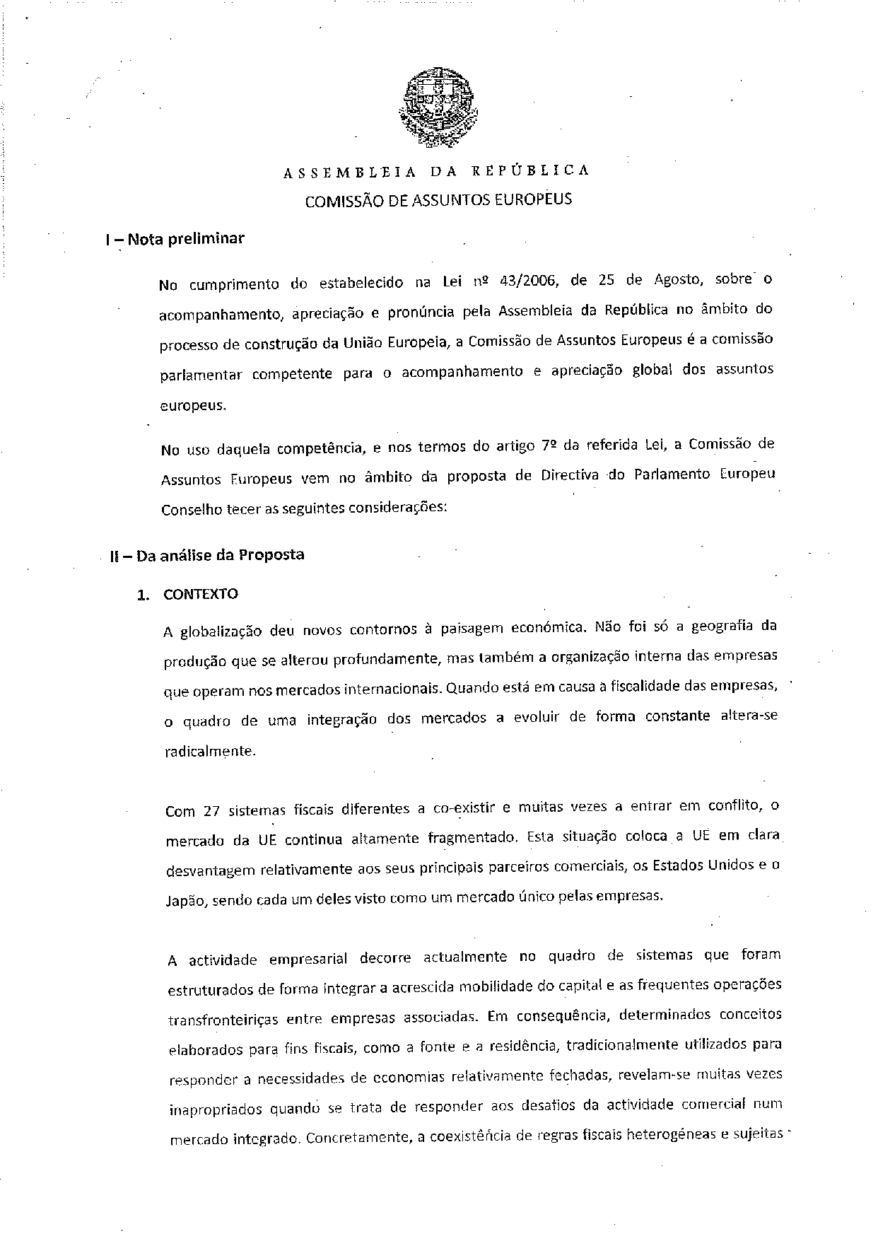

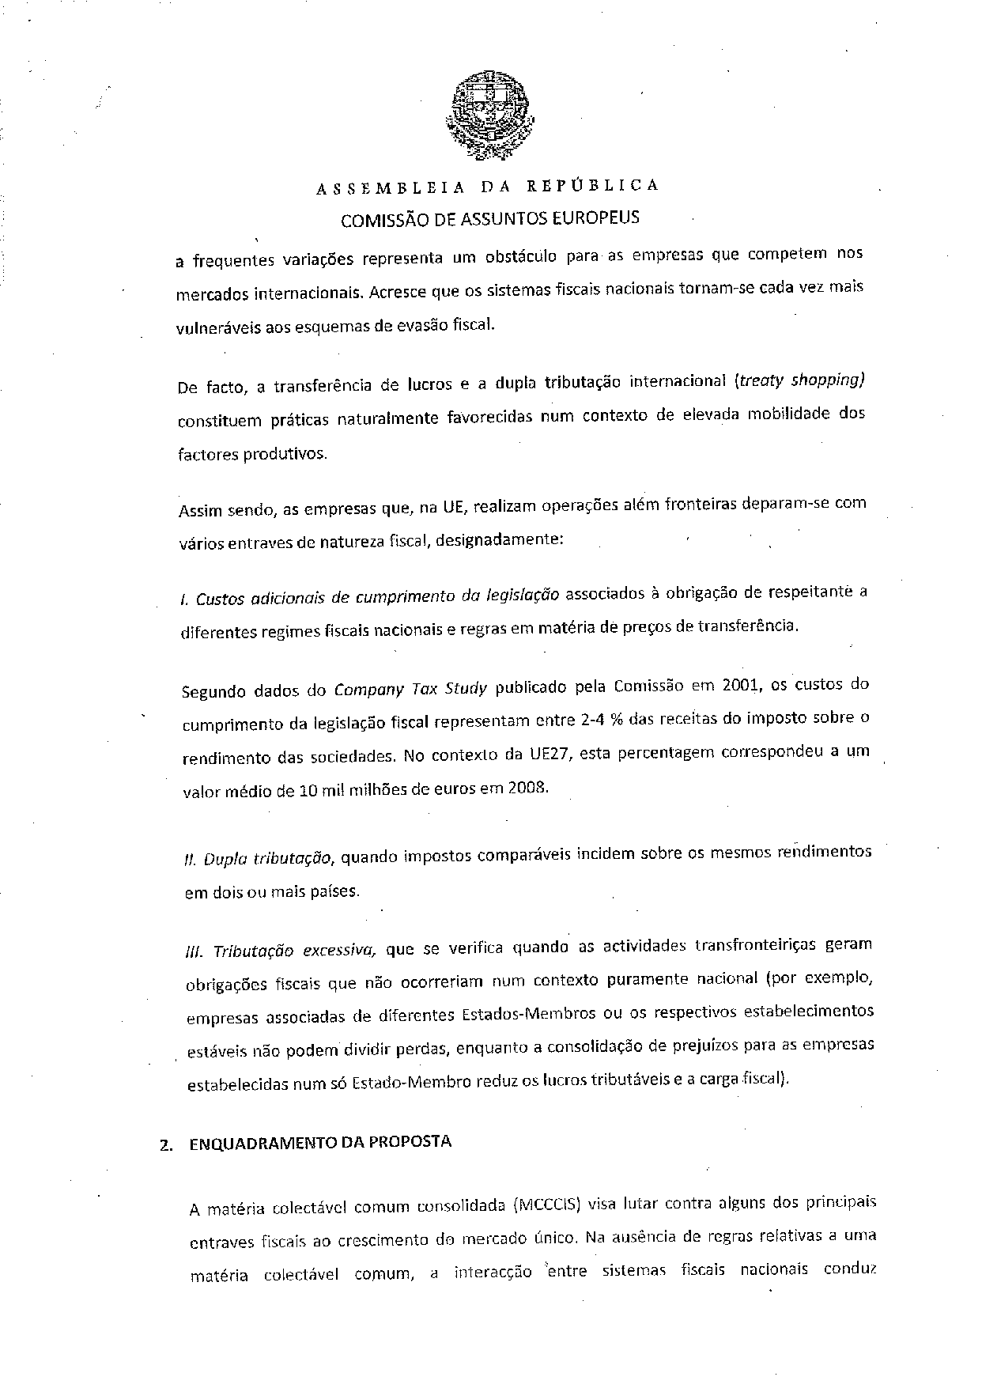

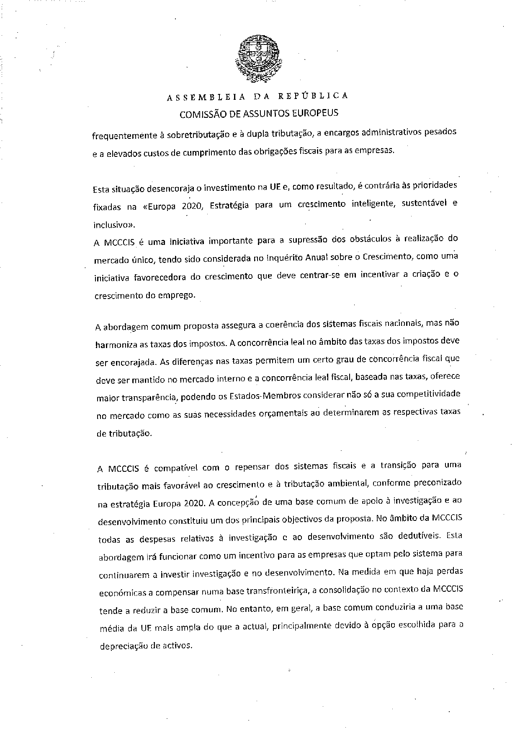

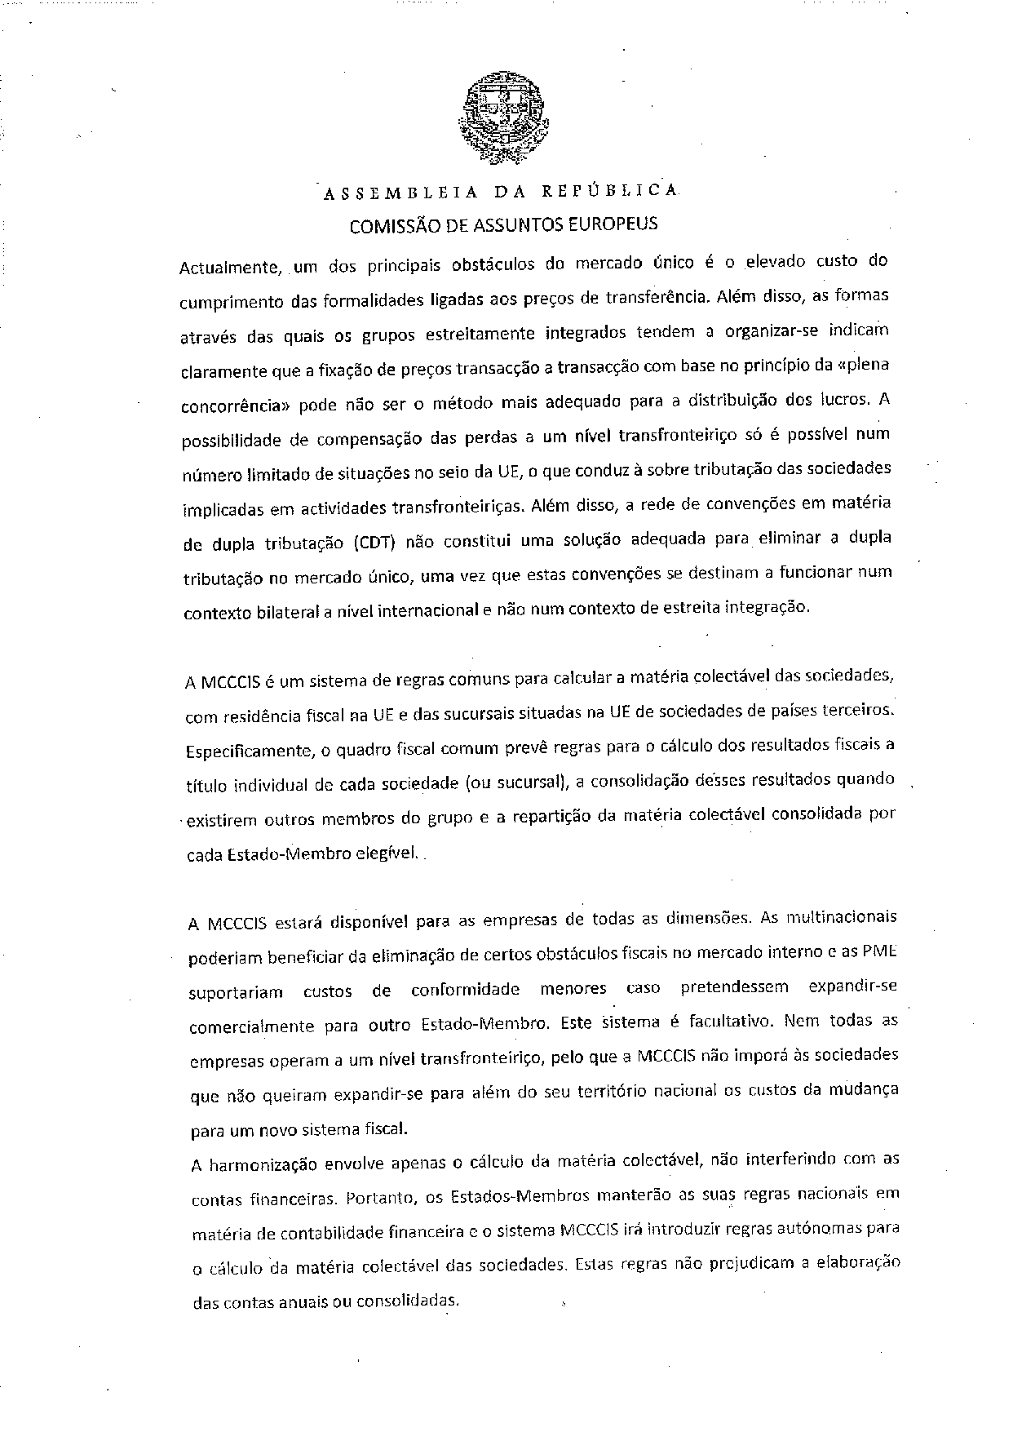

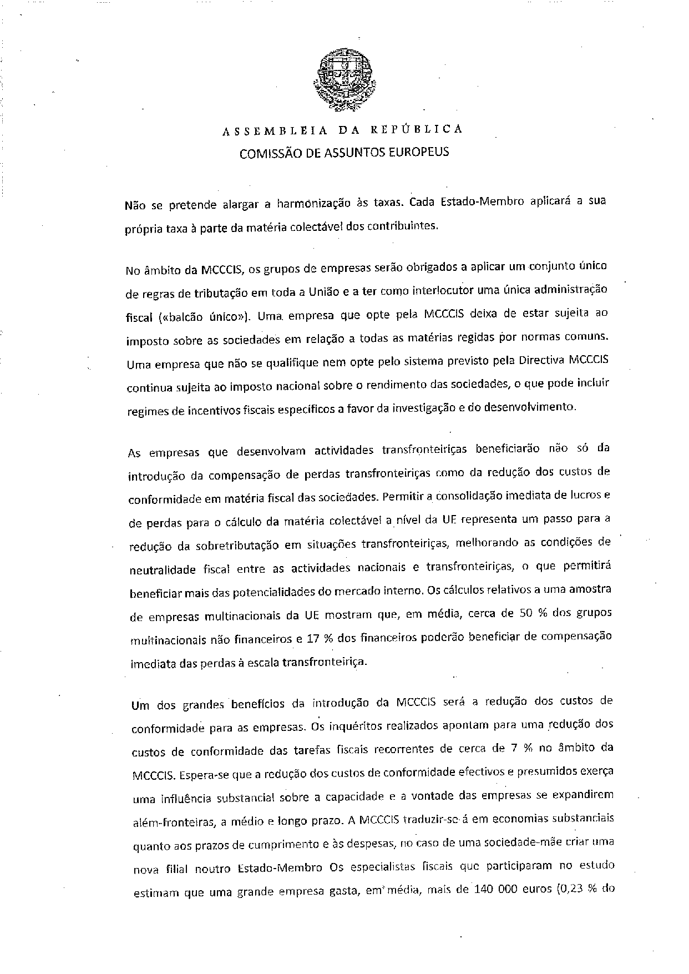

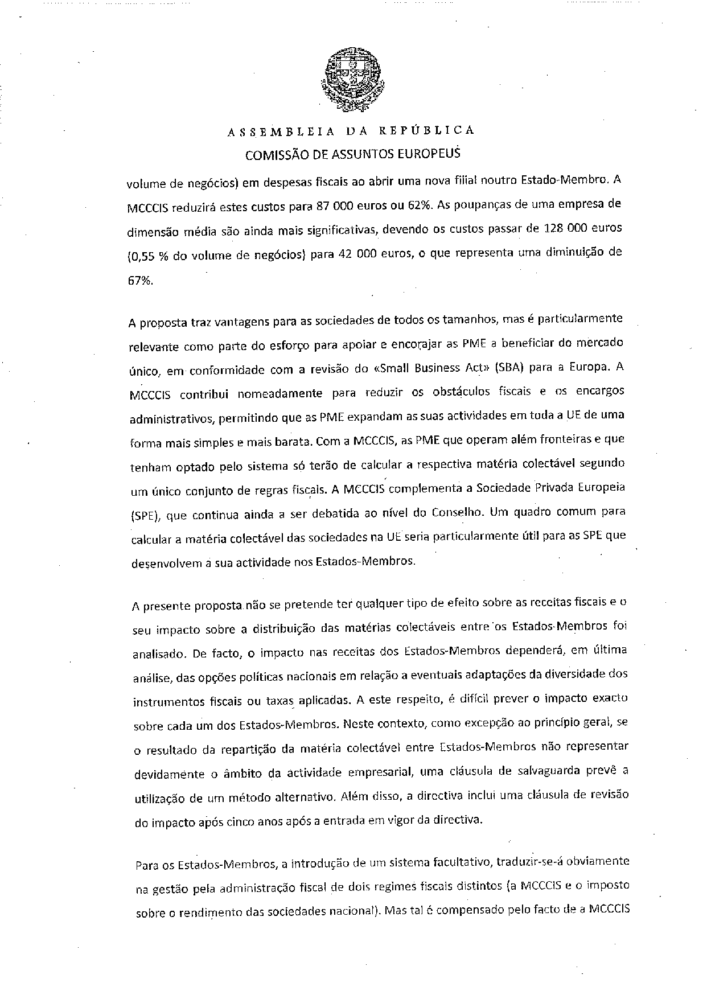

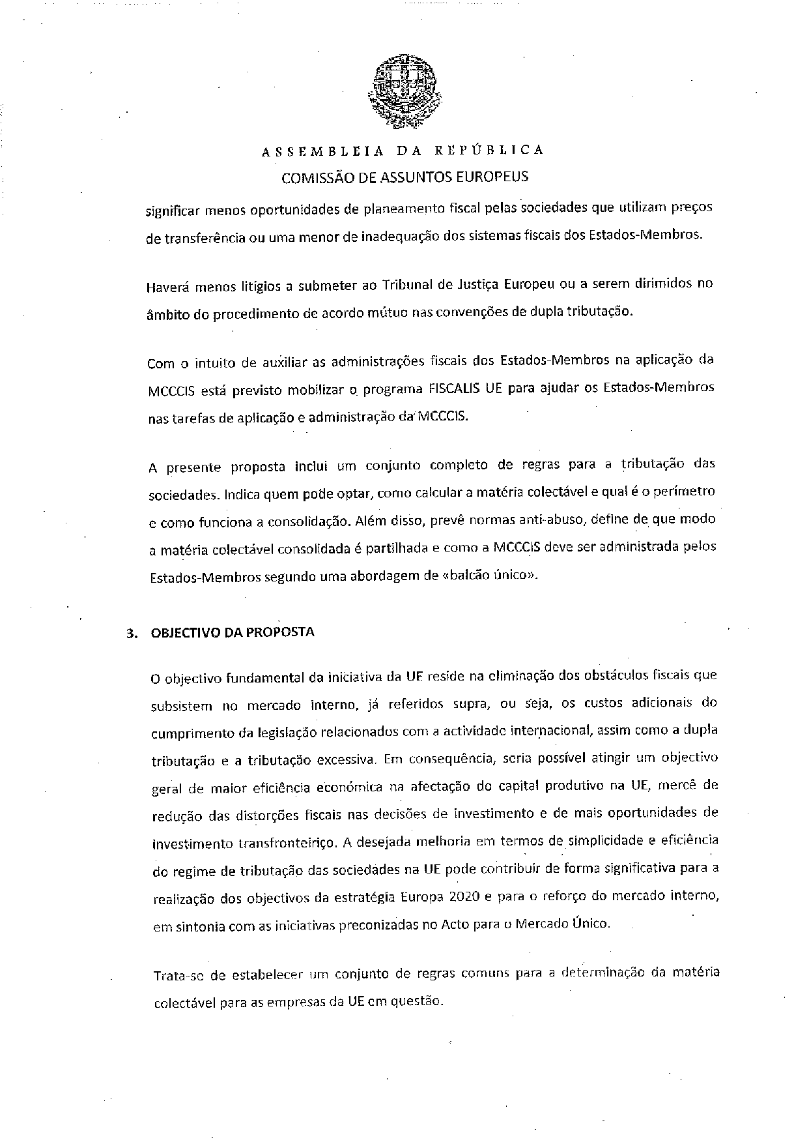

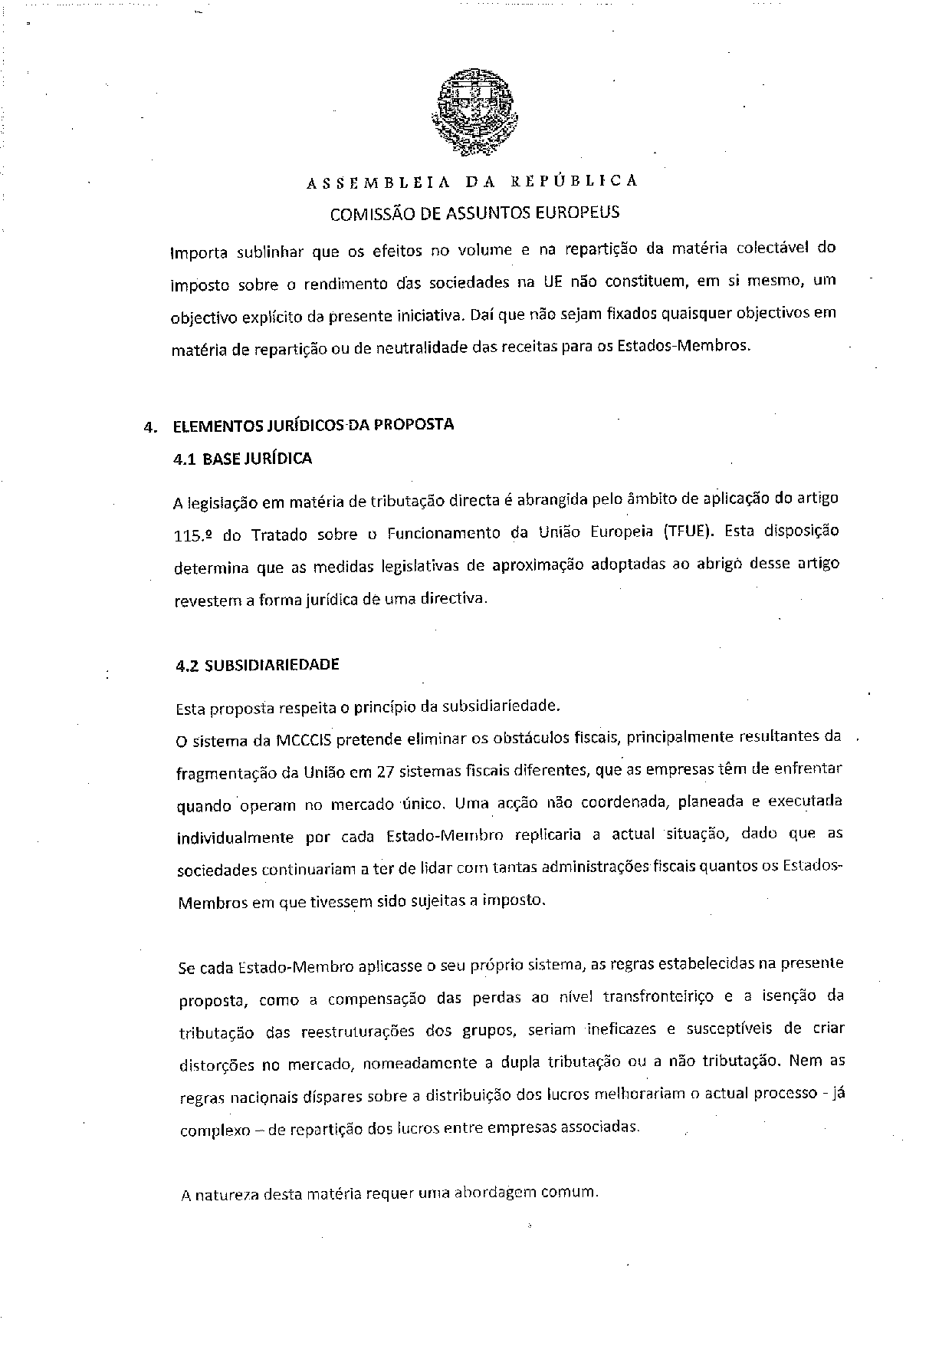

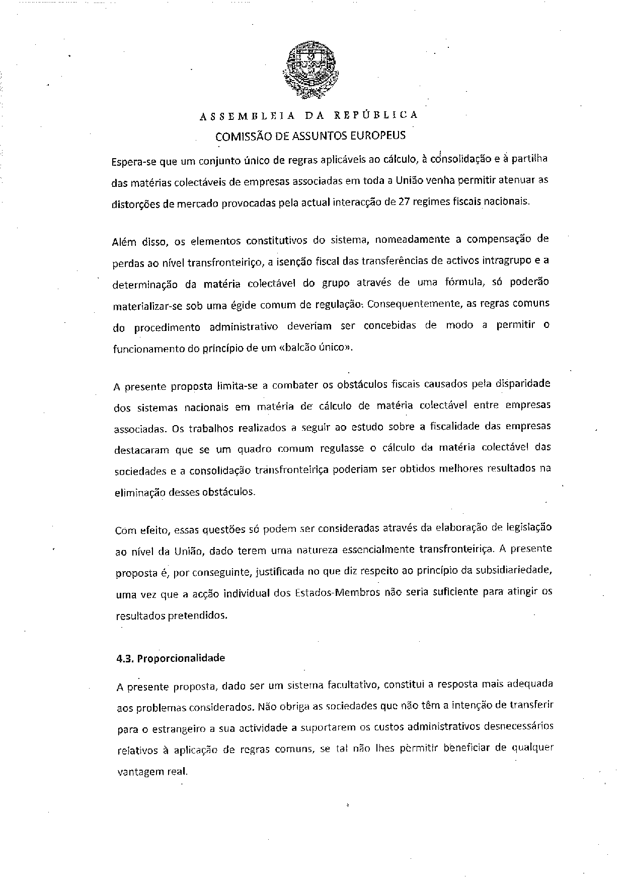

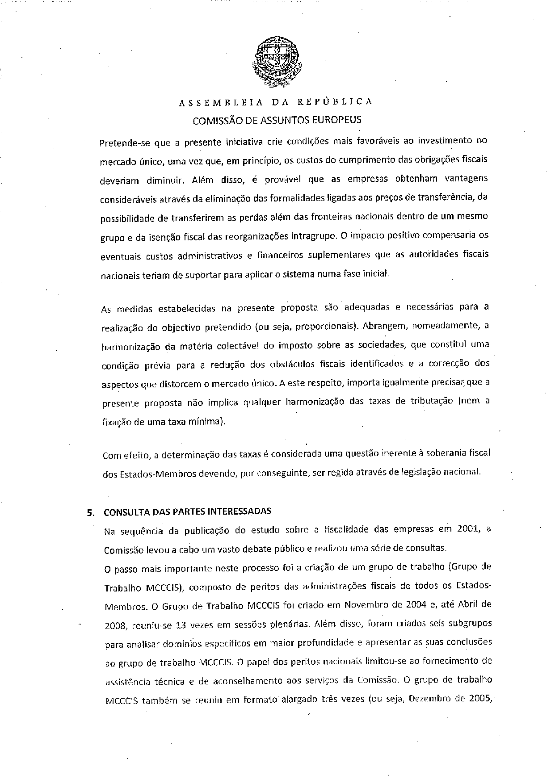

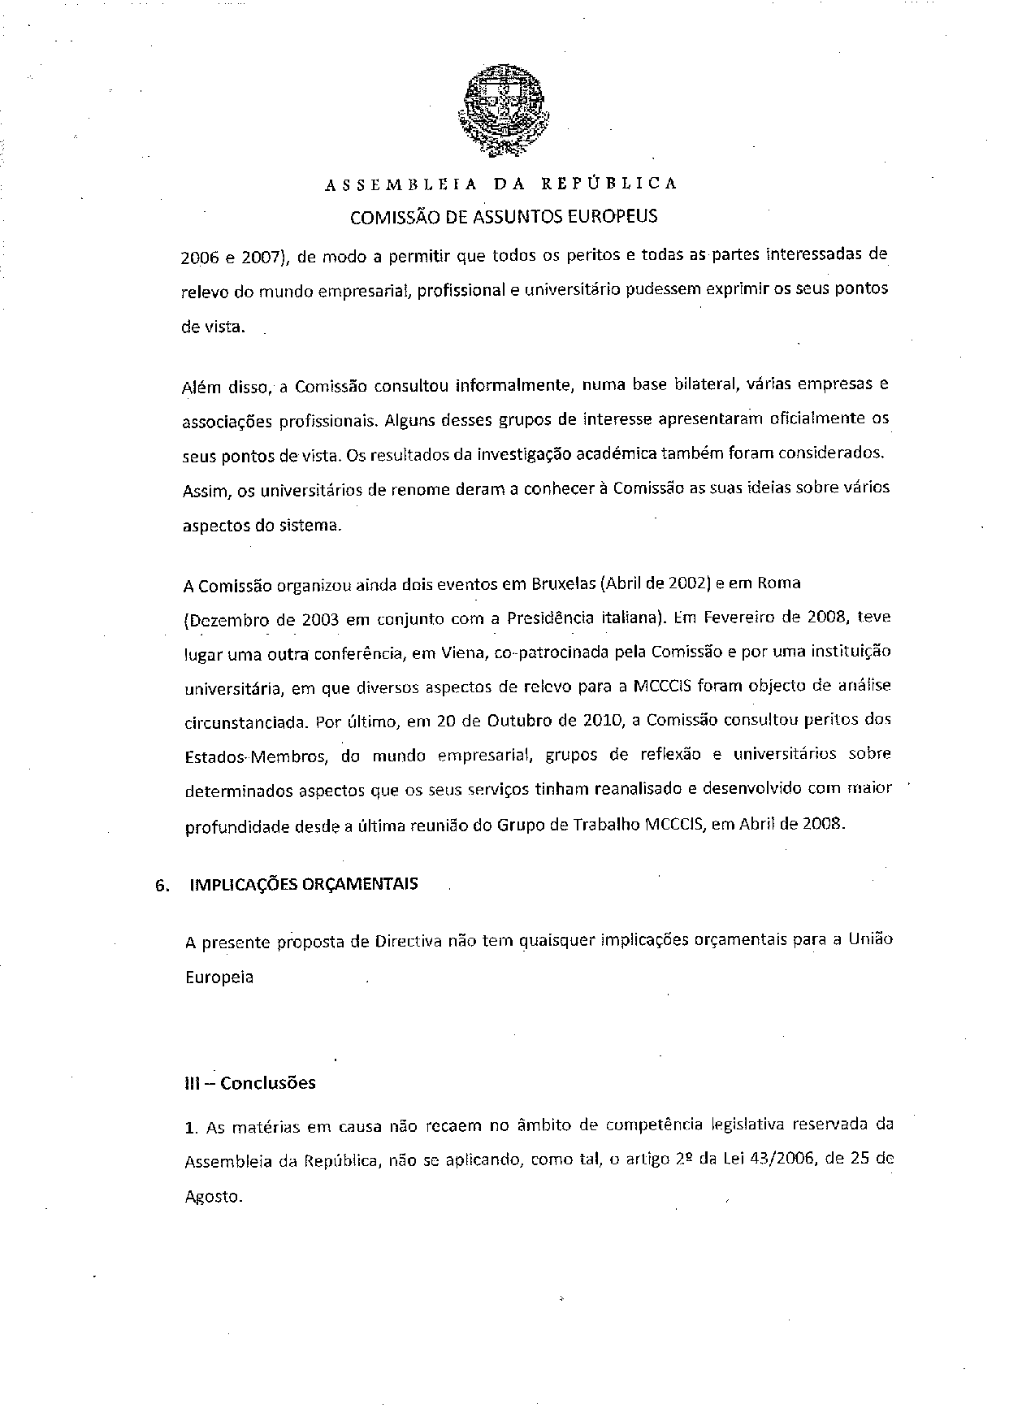

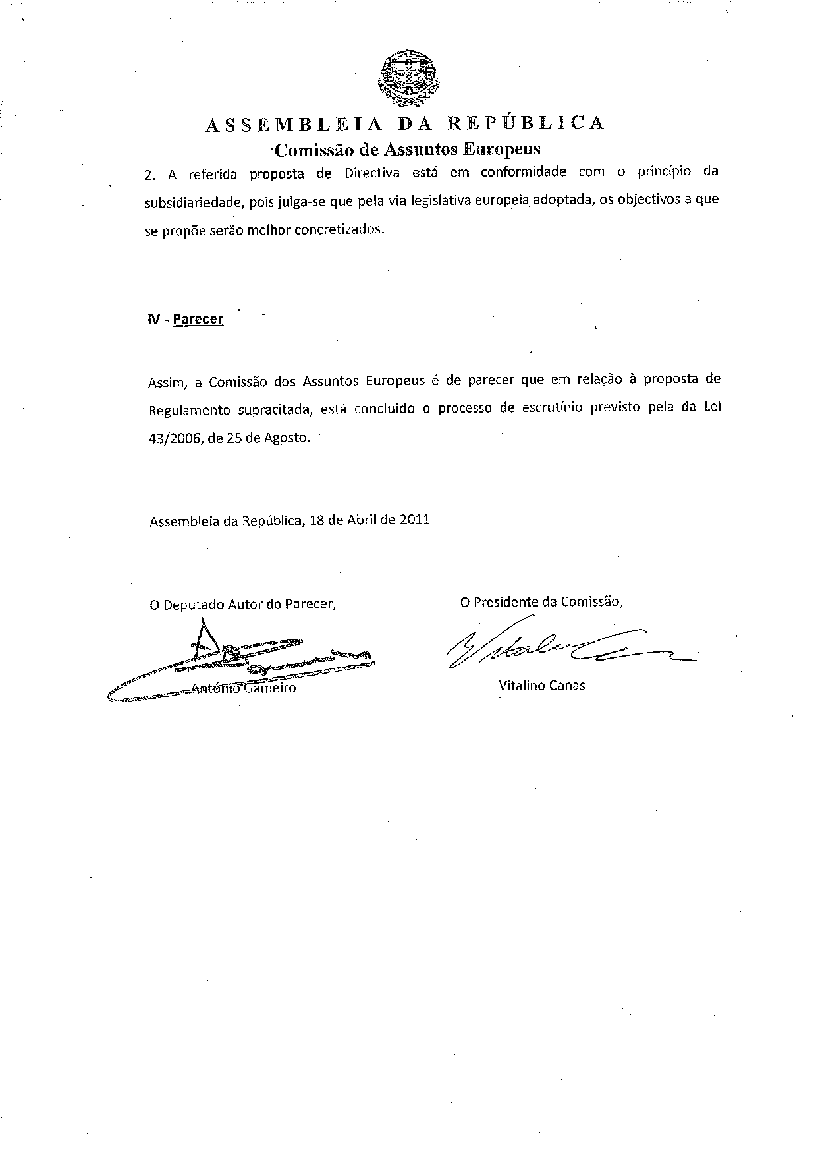

This opinion is available in English on the interparliamentary EU information exchange site (IPEX) at the following address: http://www.ipex.eu/ipex/cms/home/Documents/pid/10

