 | 
COUNCIL OF  THE EUROPEAN UNION |  |  | Brussels, 5 May 2011
 | Interinstitutional File:  2010/0262 (COD) |  | 9770/11
COMER 99
PESC 550
CONOP 26
ECO 56
UD 116
ATO 39
INST 233
PARLNAT 135

COVER NOTE
from: | The President of the Assembly of the Republic of Portugal
date of receipt: | 8 April 2011
to: | President of the Council of the European Union
Subject: | Proposal for a Regulation of the European Parliament and of the Council amending Regulation (EC) No 428/2009 setting up a Community regime for the control of exports, transfer, brokering and transit of dual use items [doc. 14933/10 COMER 175 PESC 1293 CONOP 65 ECO 85 UD 276 ATO 57 - COM(2010) 509 final]  - Opinionon the application of the Principles of Subsidiarity and Proportionality

Delegations will find attached the above mentioned opinion.

________________________

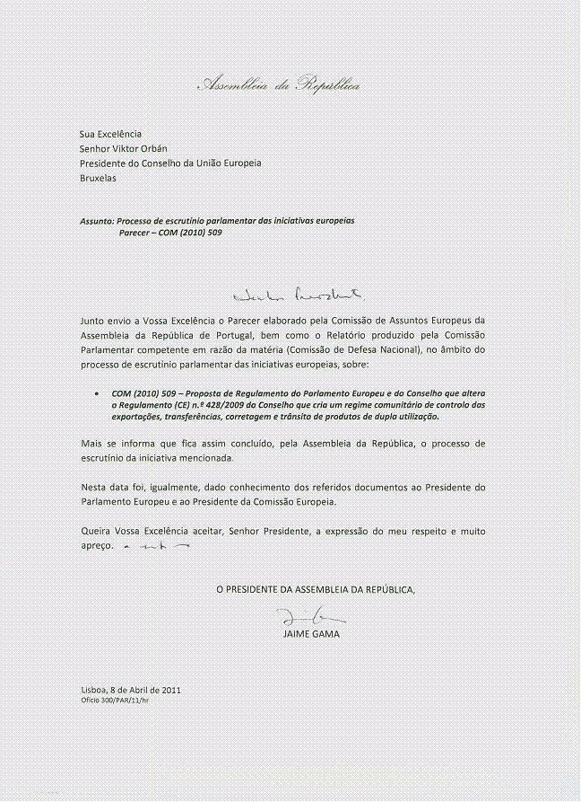

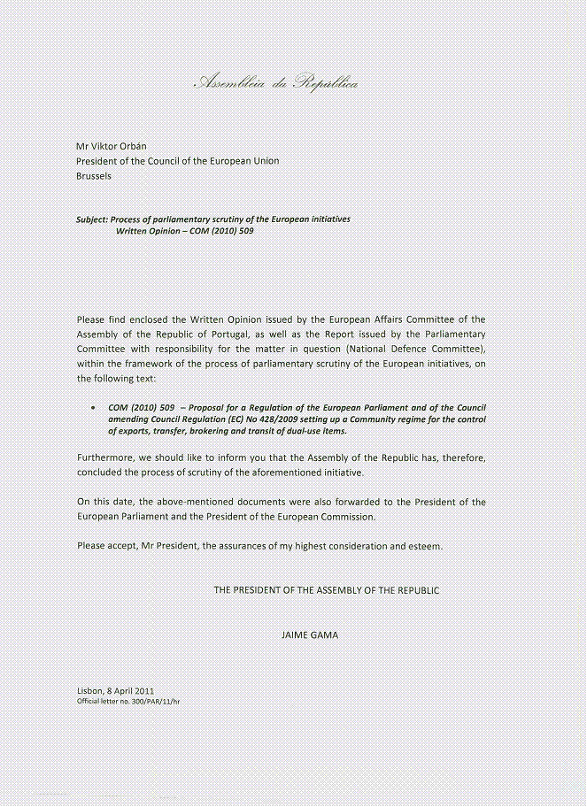

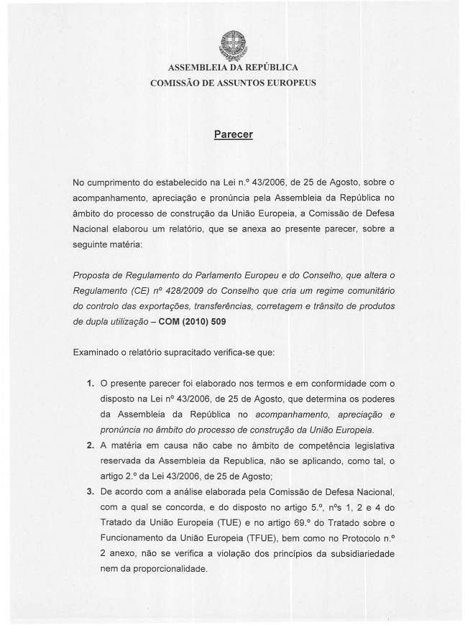

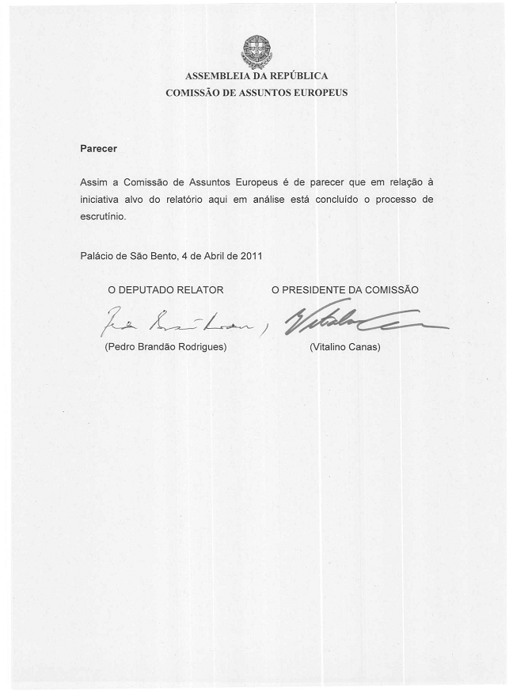

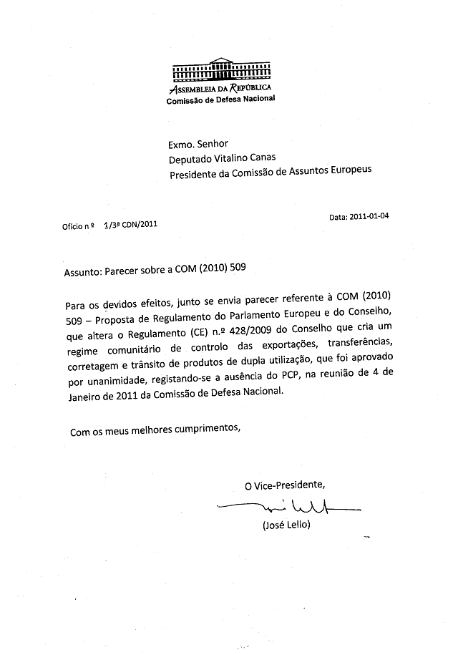

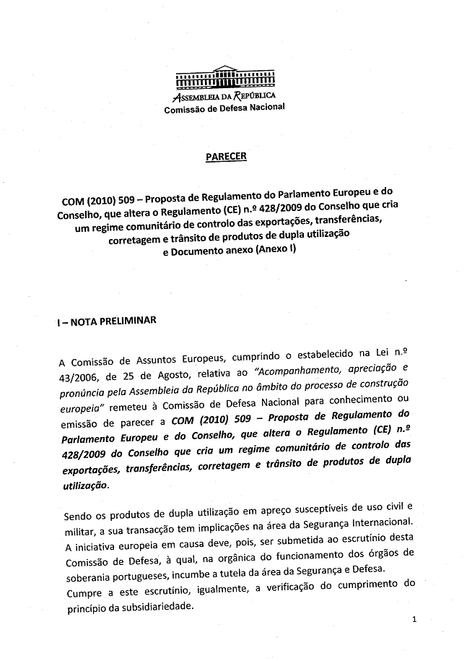

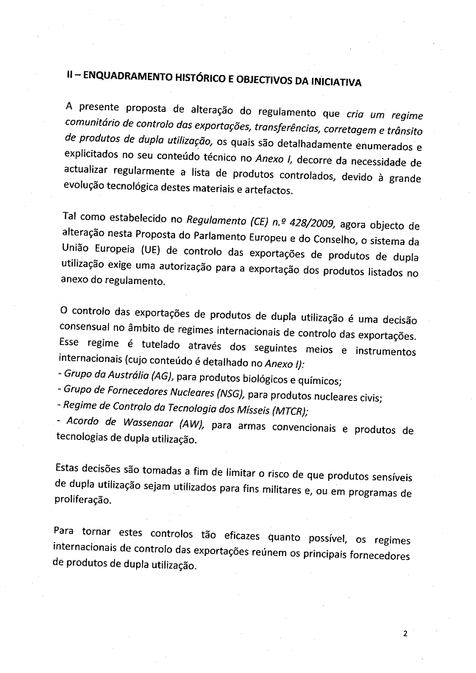

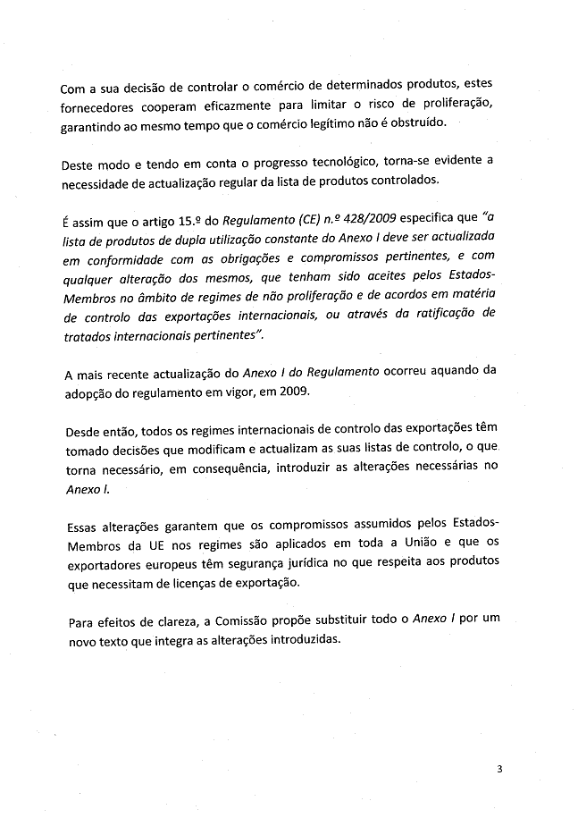

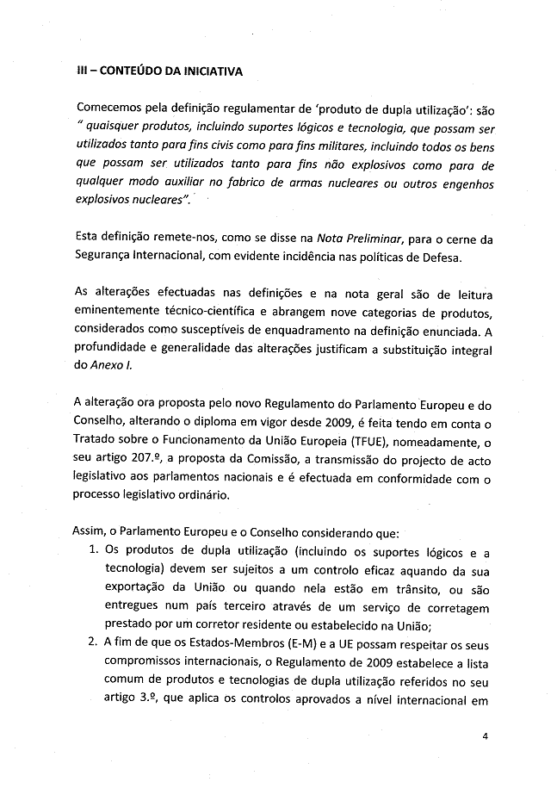

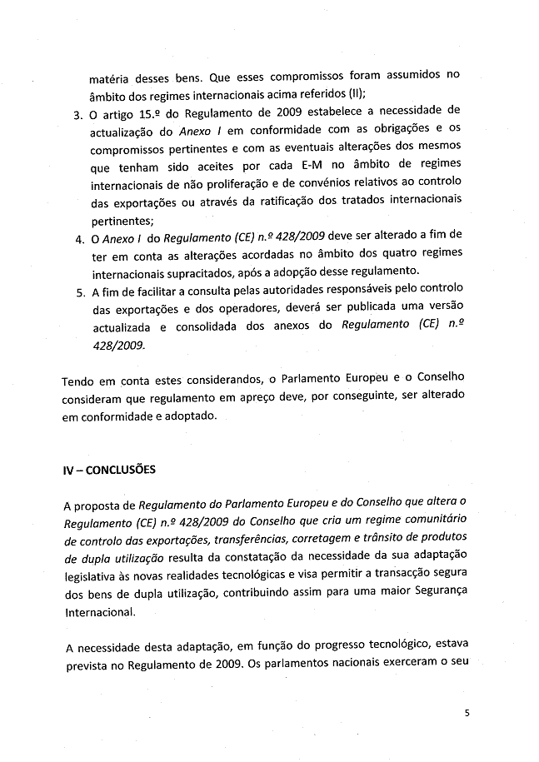

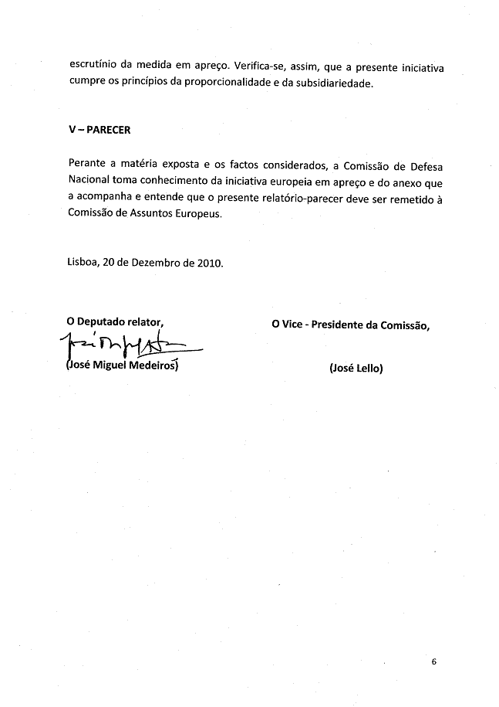

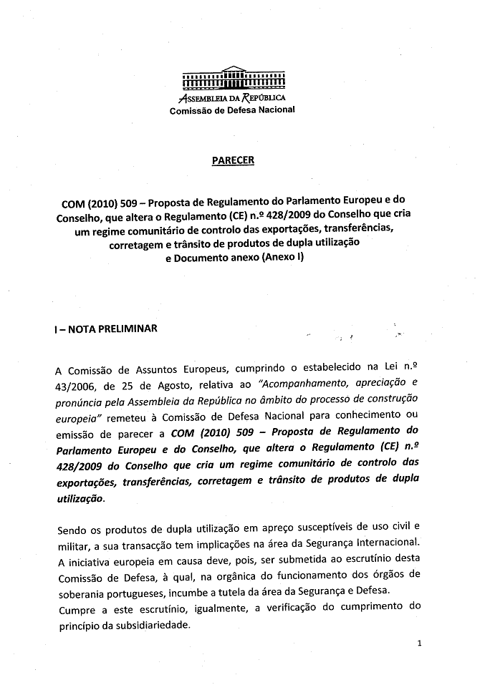

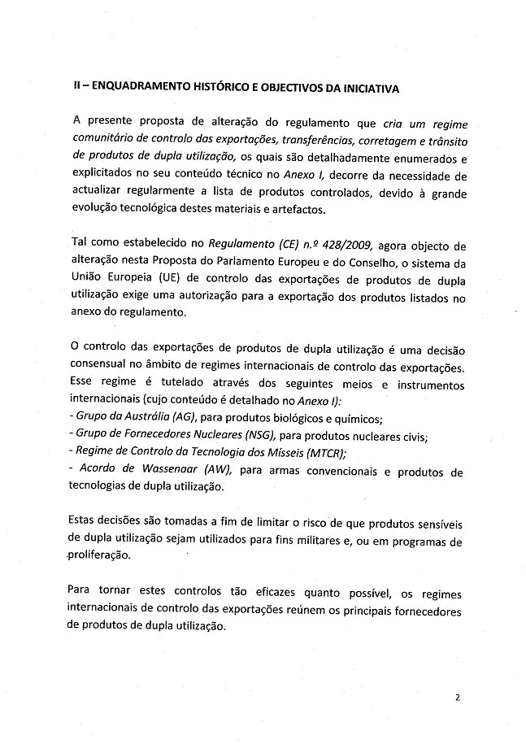

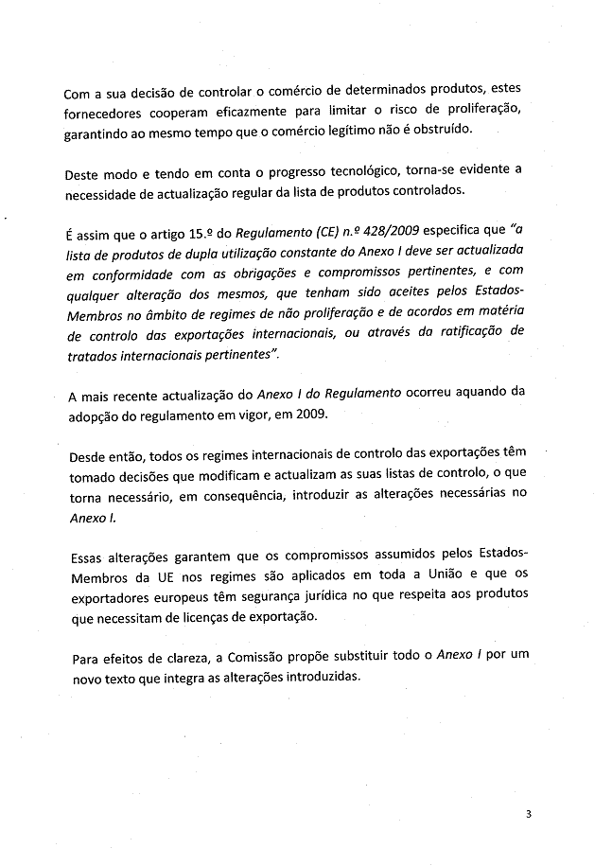

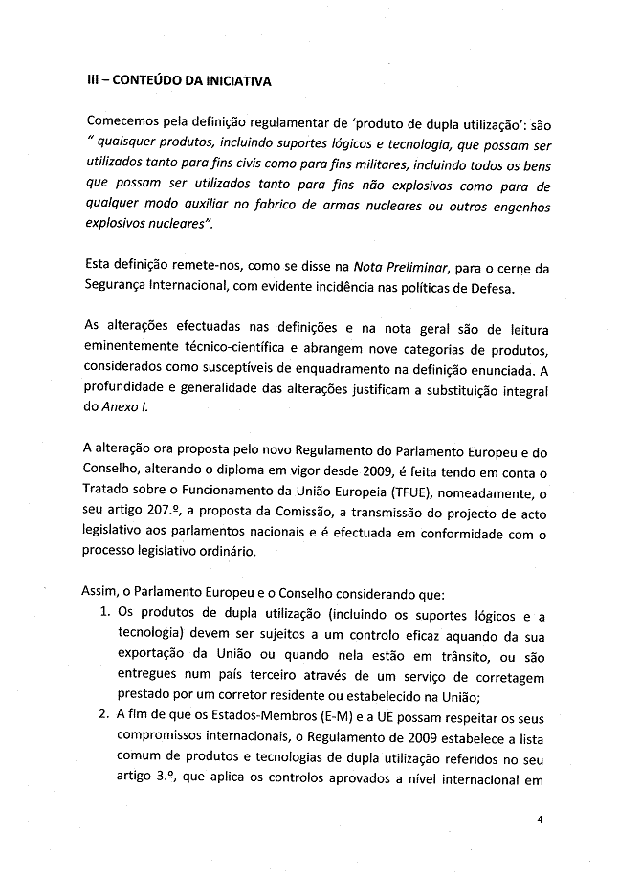

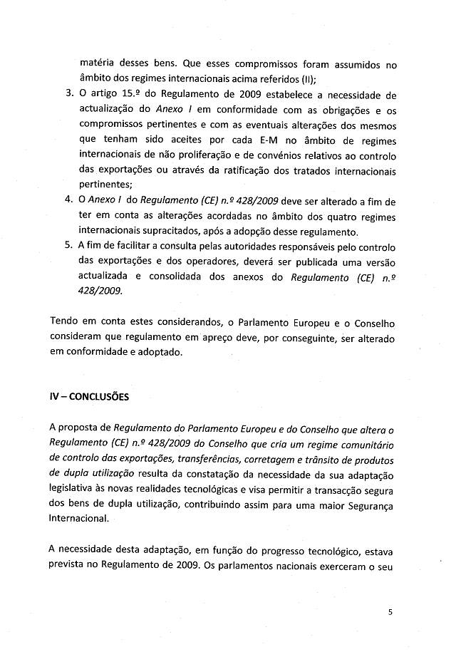

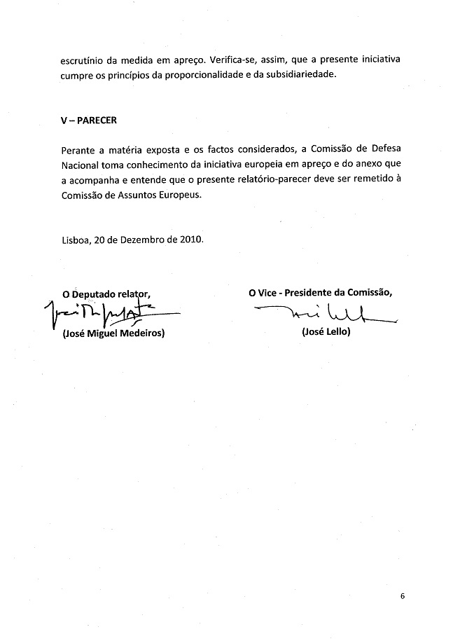

This opinion is available in English on the Interparliamentary EU information exchange site (IPEX) at the following address: http://www.ipex.eu/ipex/cms/home/Documents/pid/10

