 | 
COUNCIL OF  THE EUROPEAN UNION |  |  | Brussels, 5 May 2011
 | Interinstitutional File:  2006/0084 (COD) |  | 9682/11
GAF 6
FIN 290
INST 232
PARLNAT 134
CODEC 744

COVER NOTE
from: | Mr Jaime GAMA, President of the Assembly of the Republic of Portugal
date of receipt: | 29 April 2011
to: | Mr Viktor ORBÁN, President of the Council of the European Union
Subject: | Amended Proposal for a Regulation of the European Parliament and of the Council amending Regulation (EC) No 1073/1999 concerning investigations conducted by the European Anti-fraud Office (OLAF) and repealing Regulation (EURATOM) No 1074/1999 [doc. 7897/11 GAF 4 FIN 182 CODEC 446 - COM(2011) 135 final]  - Reasoned opinion in accordance with Article 6 of Protocol No 2 on the application of the principles of subsidiarity and proportionality

Delegations will find attached a copy of the above letter.

________________________

ANNEX

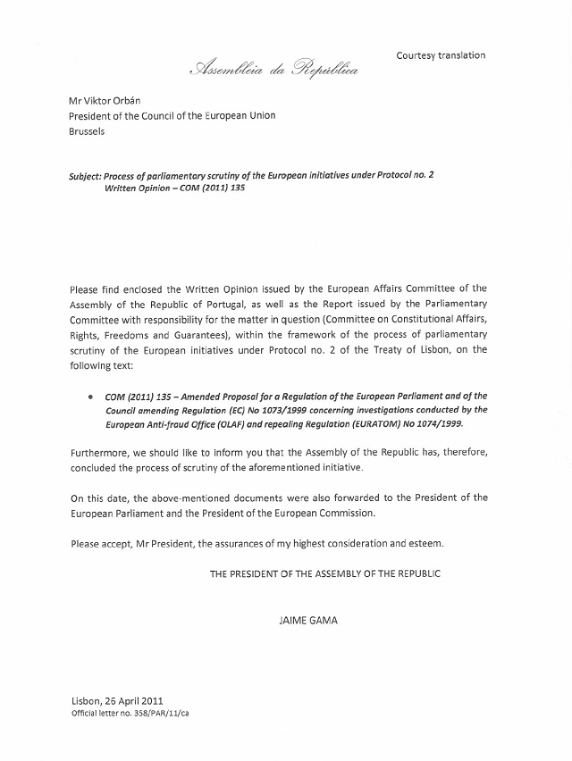

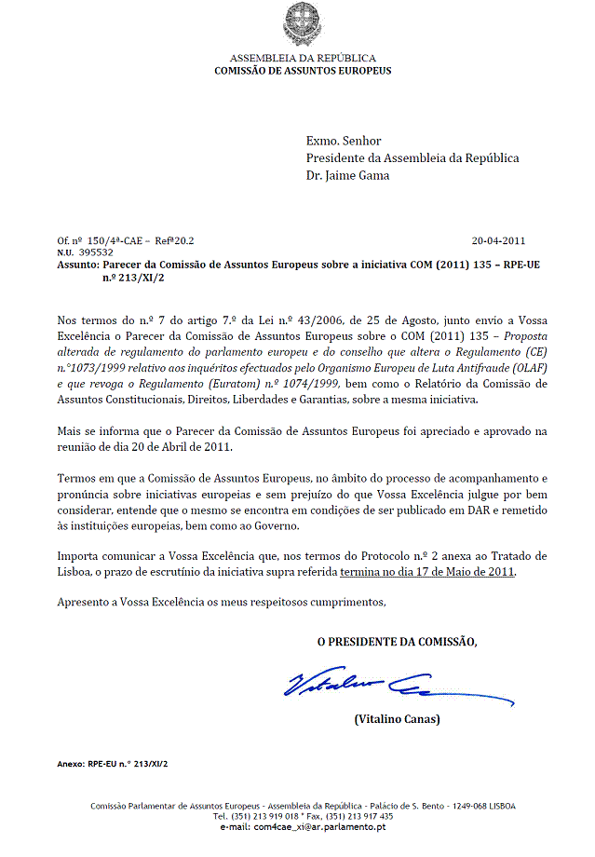

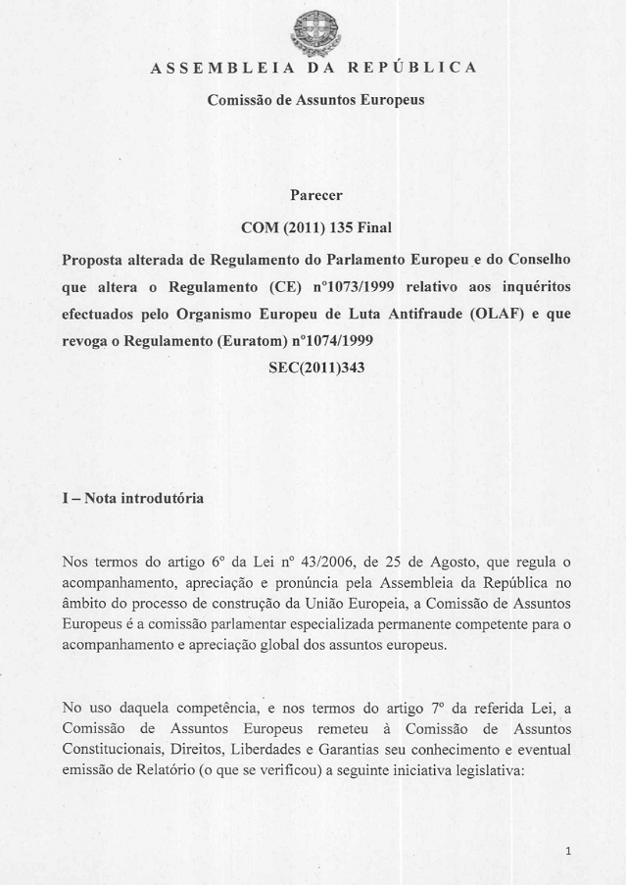

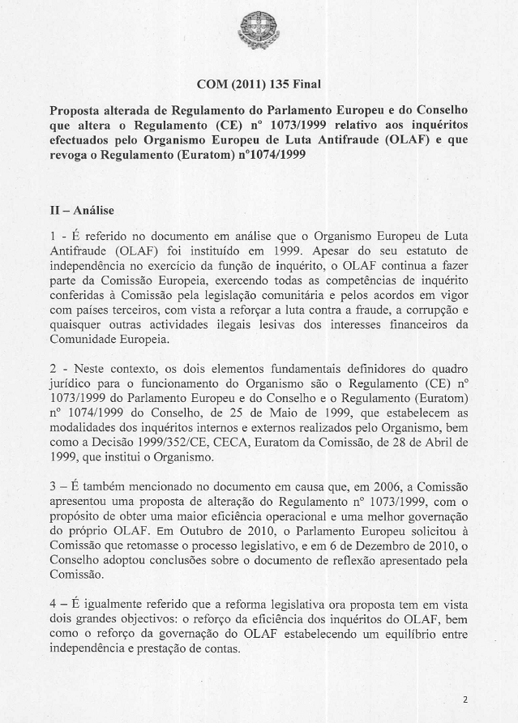

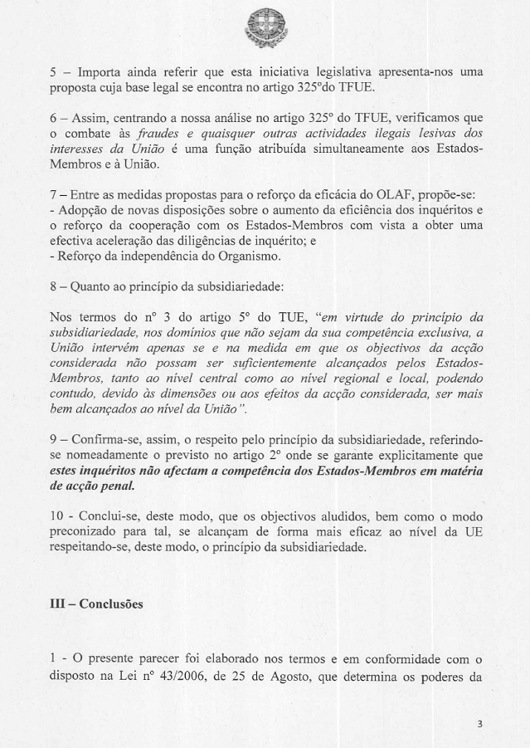

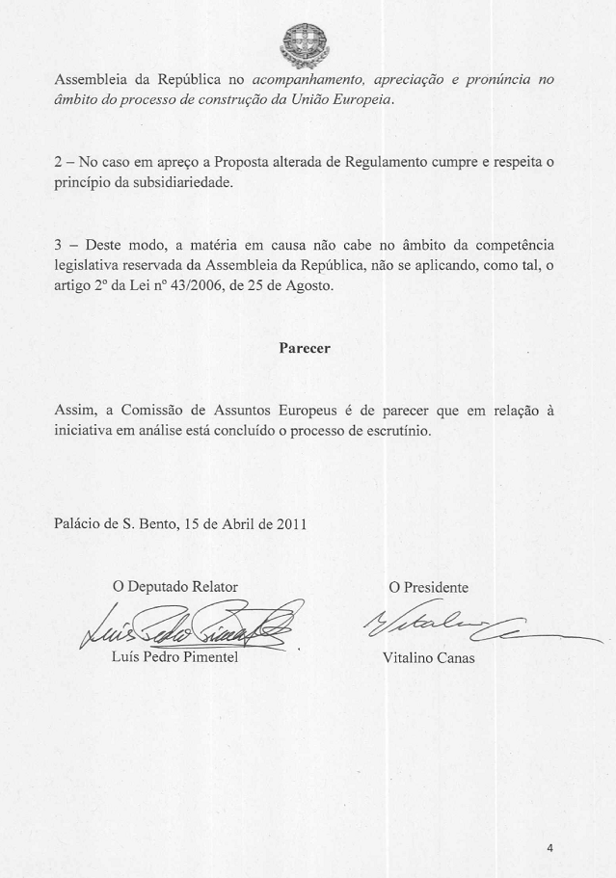

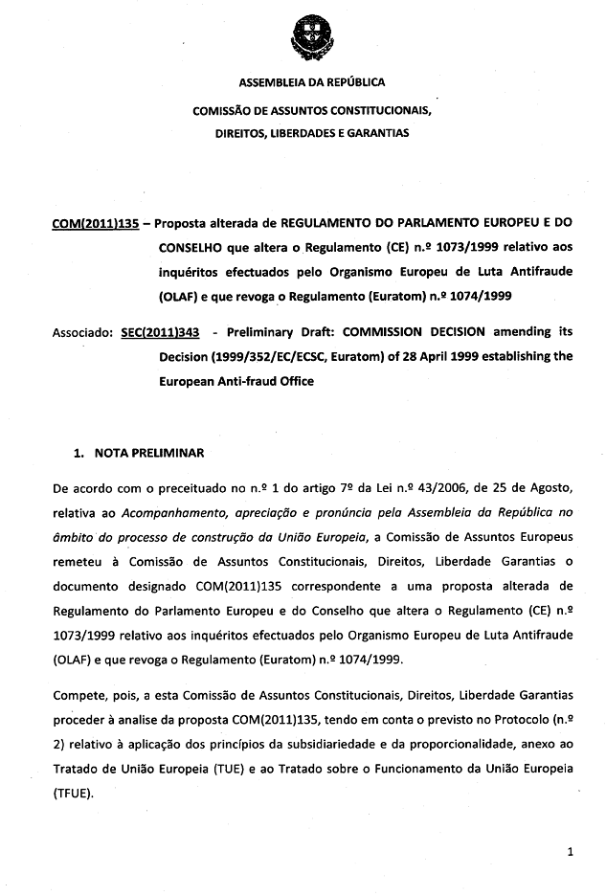

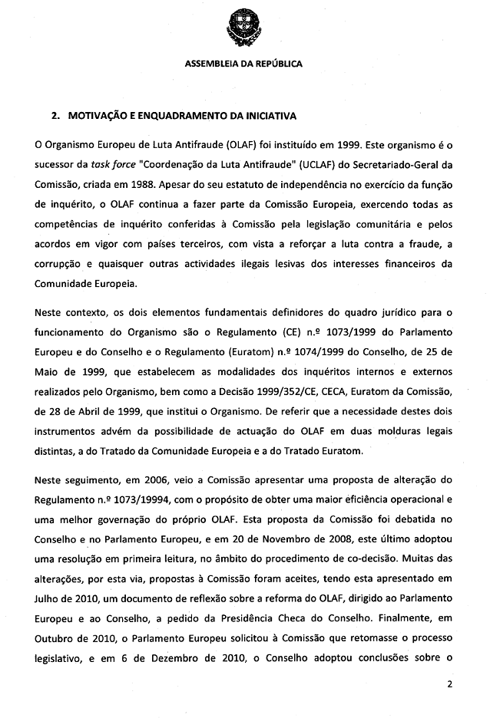

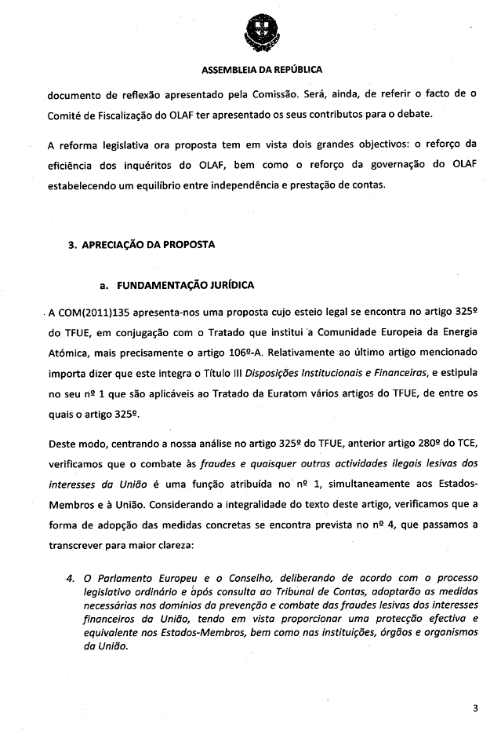

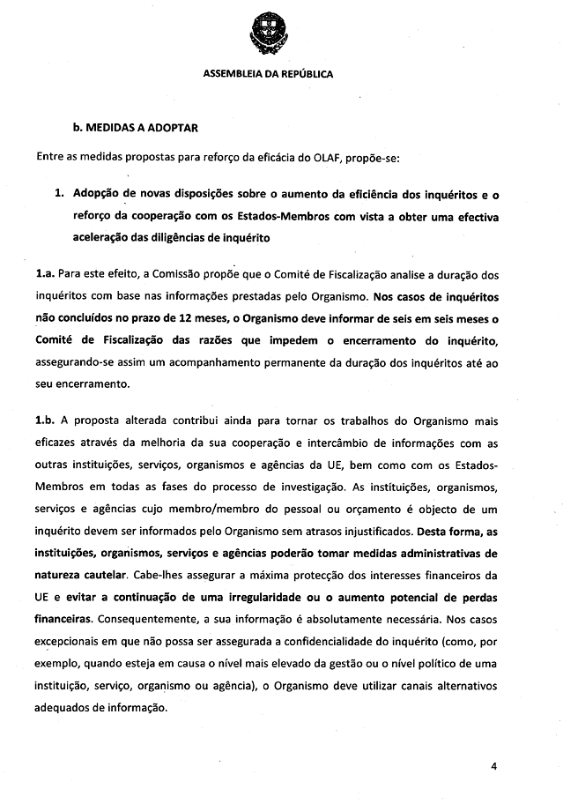

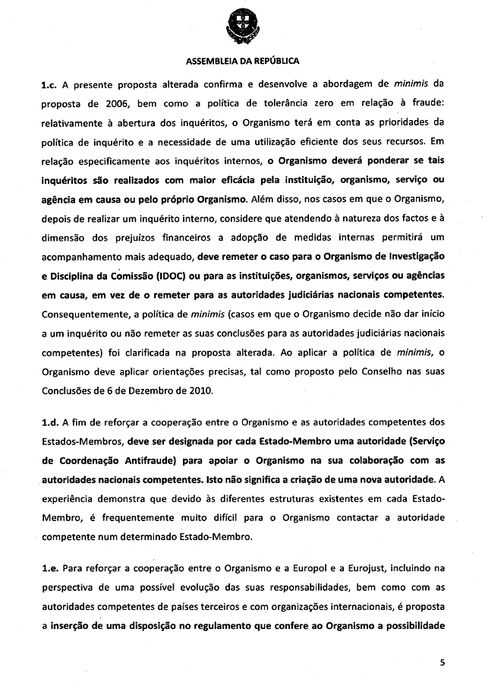

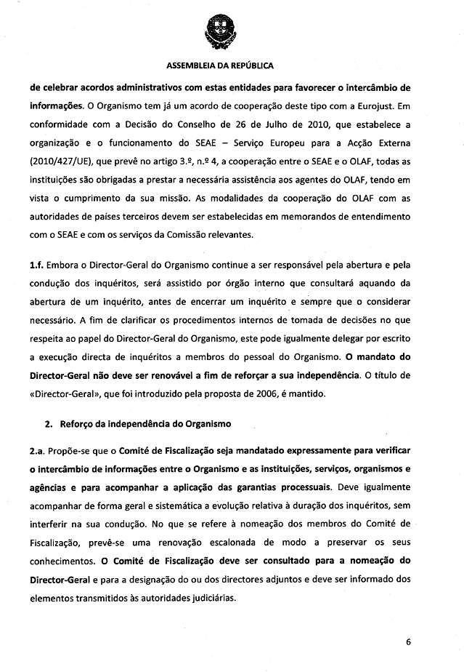

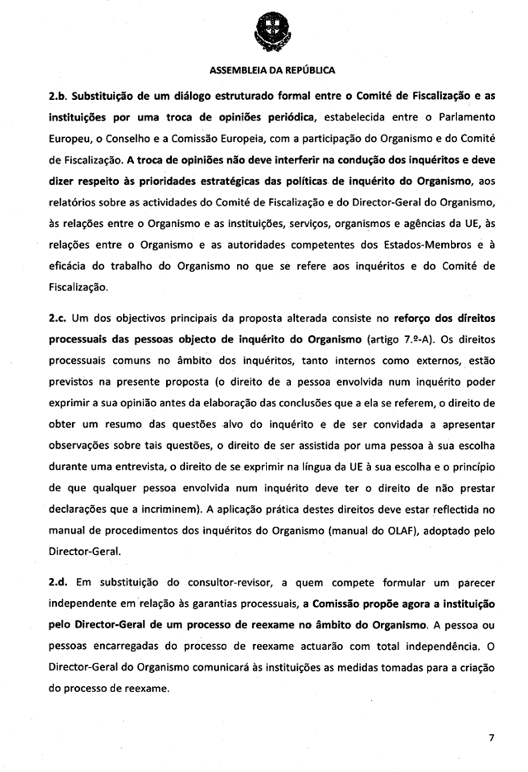

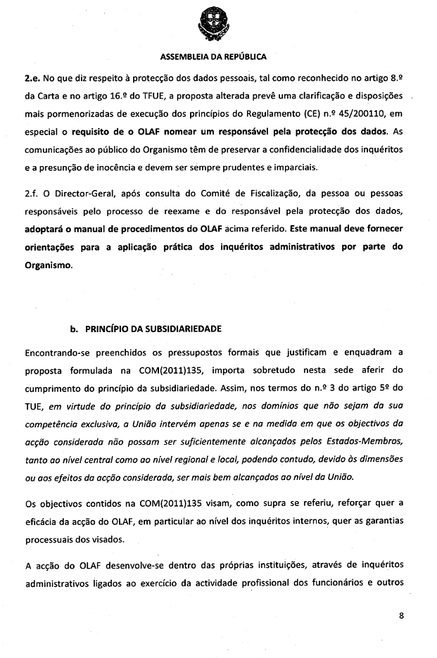

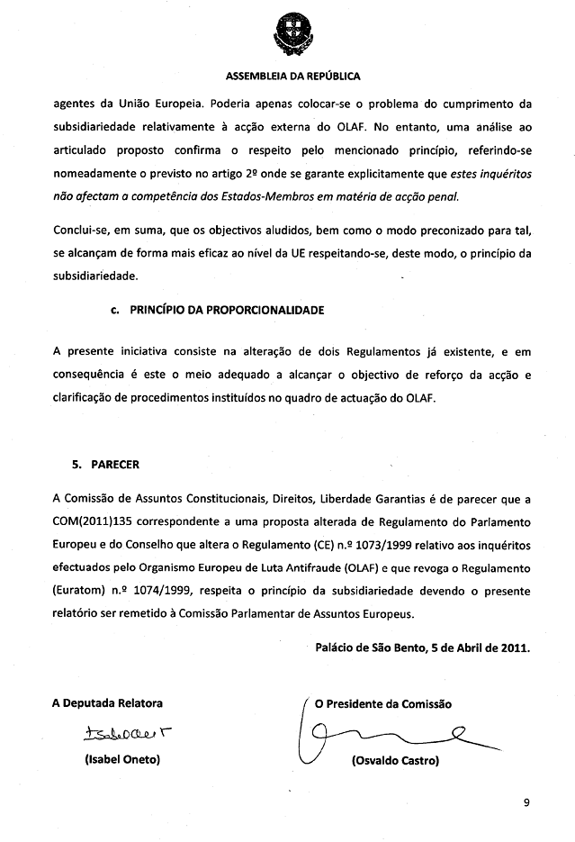

For other available language versions of the opinion, reference is made to the Interparliamentary EU information exchange Internet site (IPEX) at the following address: http://www.ipex.eu/ipex/cms/home/Documents/pid/10.

