 | 
COUNCIL OF  THE EUROPEAN UNION |  |  | Brussels, 5 May 2011
 | Interinstitutional File:  2011/0051 (COD) |  | 9617/11
FRONT 58
CODEC 727
INST 229
PARLNAT 132
COMIX 287

COVER NOTE
from: | The President of the Senate of the Republic of Italy
date of receipt: | 20 April 2011
to: | Viktor Orbán, President of the Council of the European Union
Subject: | Proposal for a Regulation of the European Parliament and of the Council amending Regulation (EC) No 562/2006 of the European Parliament and of the Council establishing a Community Code on the rules governing the movement of persons across borders (Schengen Borders Code) and the Convention implementing the Schengen Agreement  [doc. 7661/11 FRONT 31 CODEC 404 COMIX 158 - COM(2011) 118 final]  - Opinion on the application of the Principles of Subsidiarity and Proportionality

Delegations will find attached a copy of the above opinion.

________________________

Encl.:

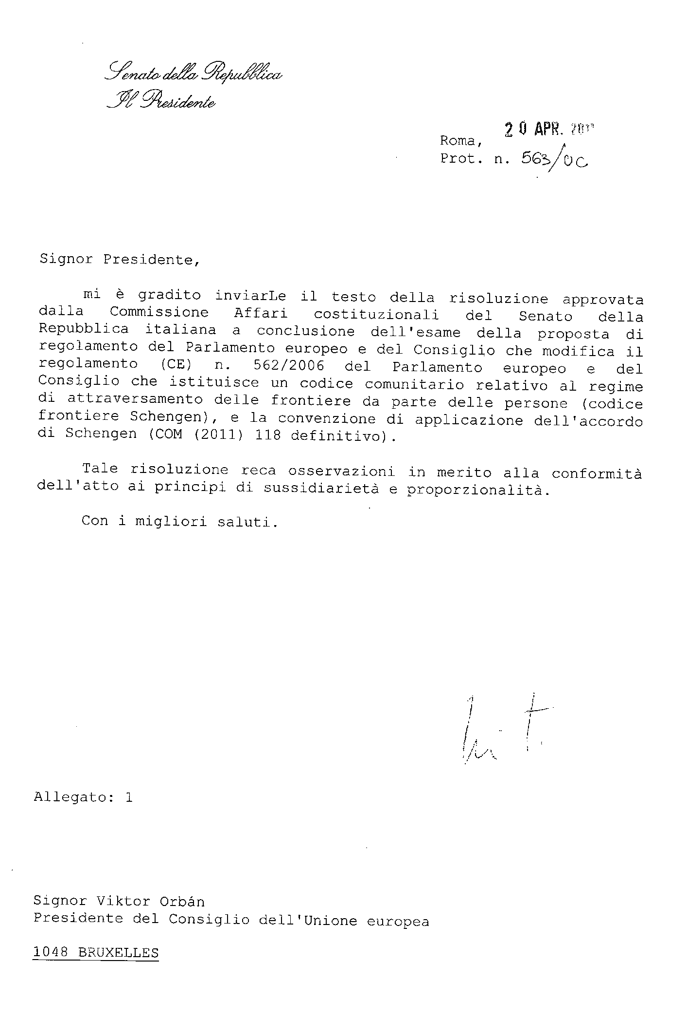
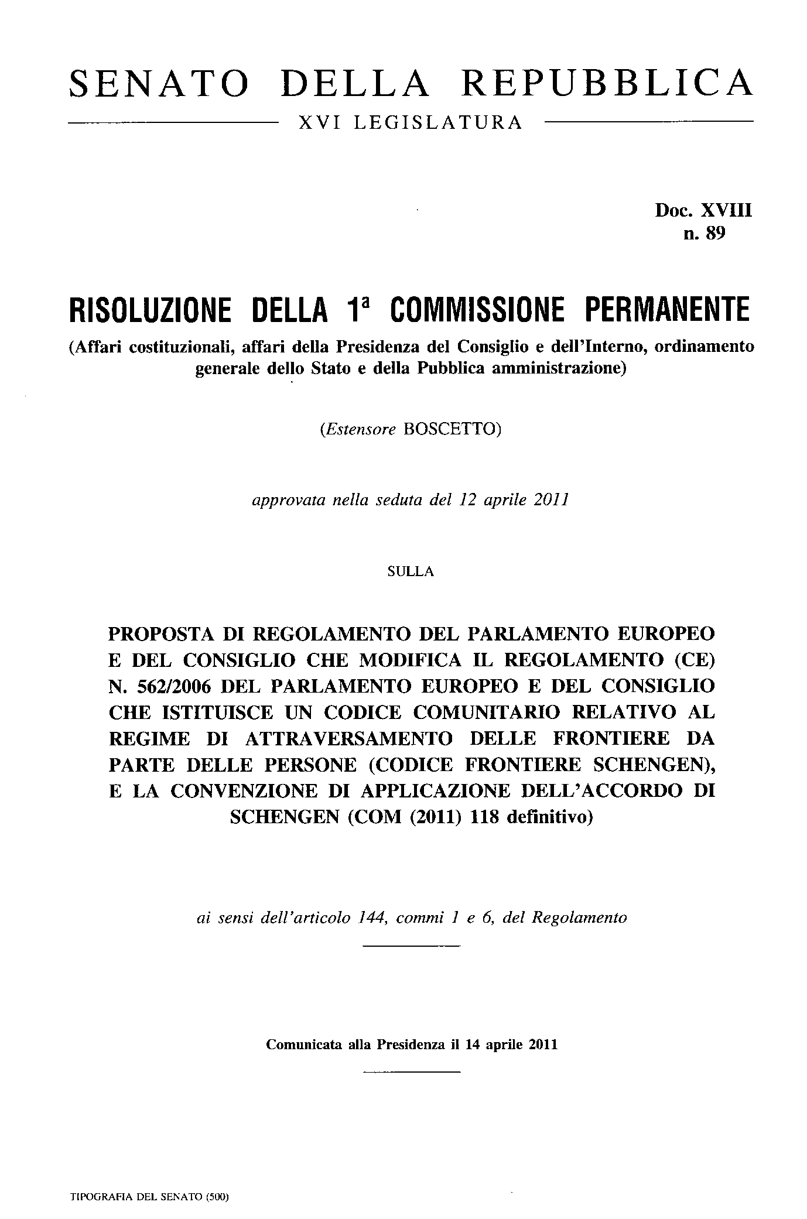
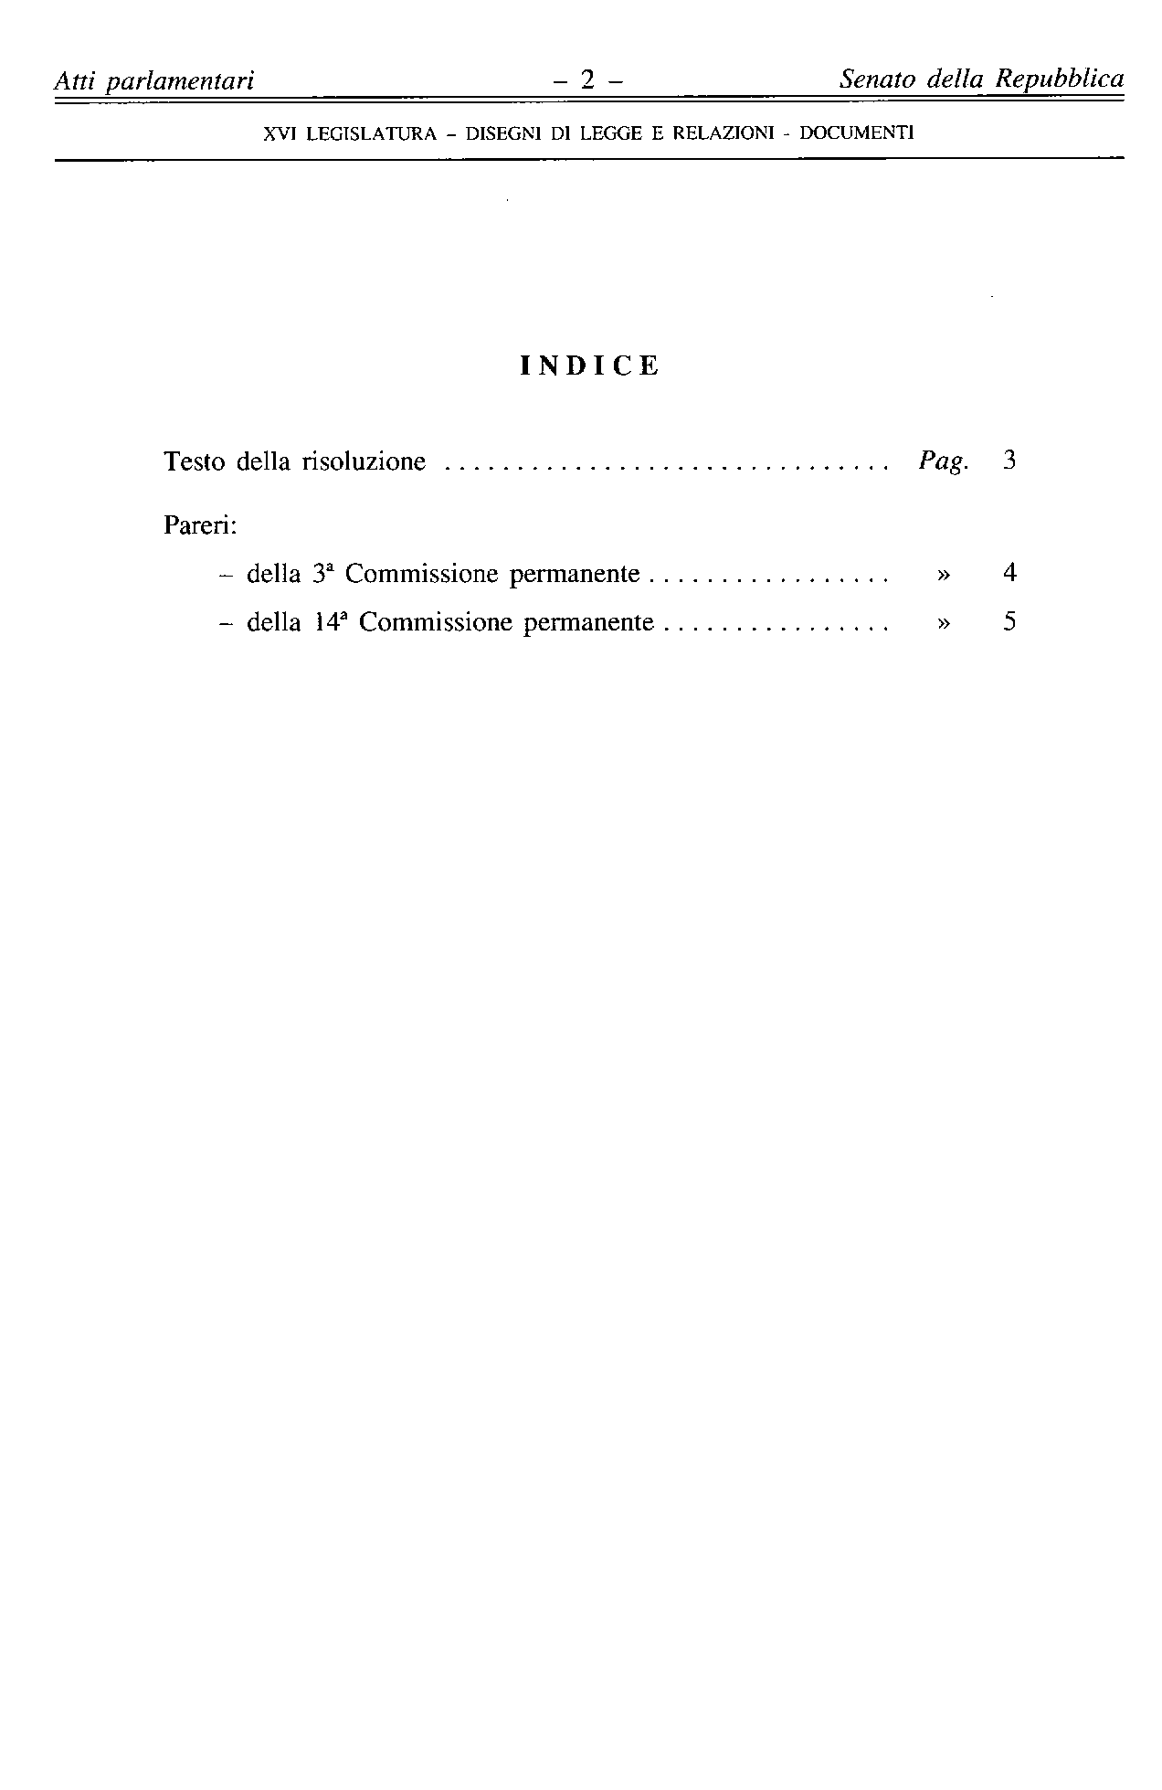
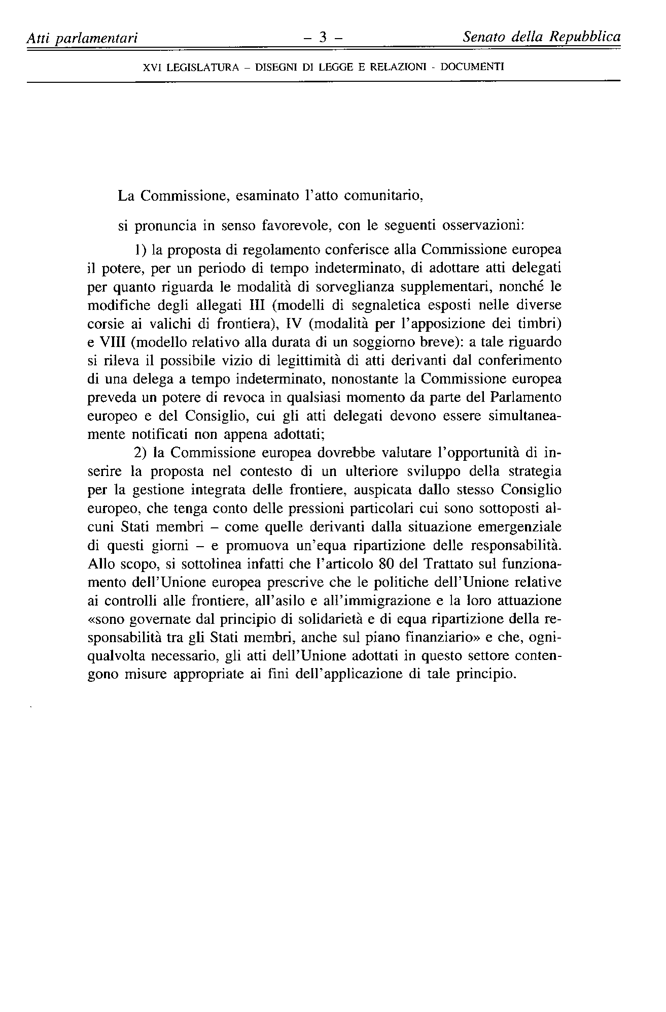
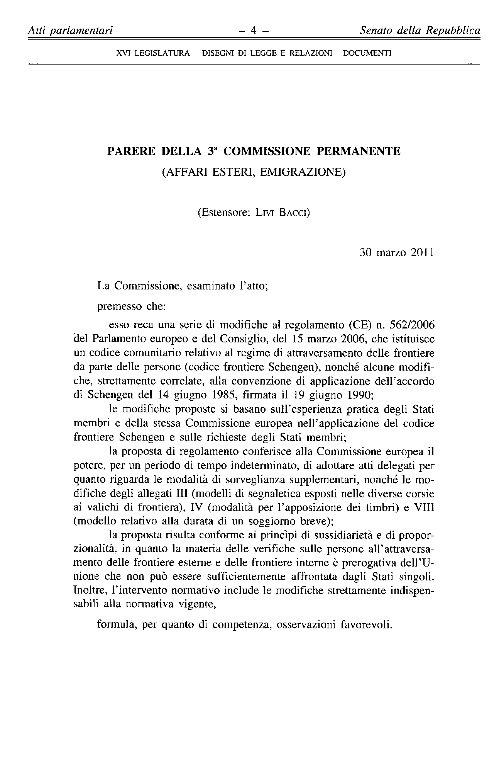
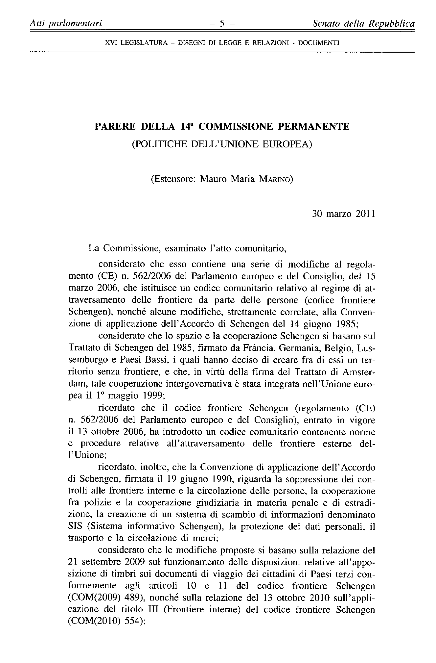
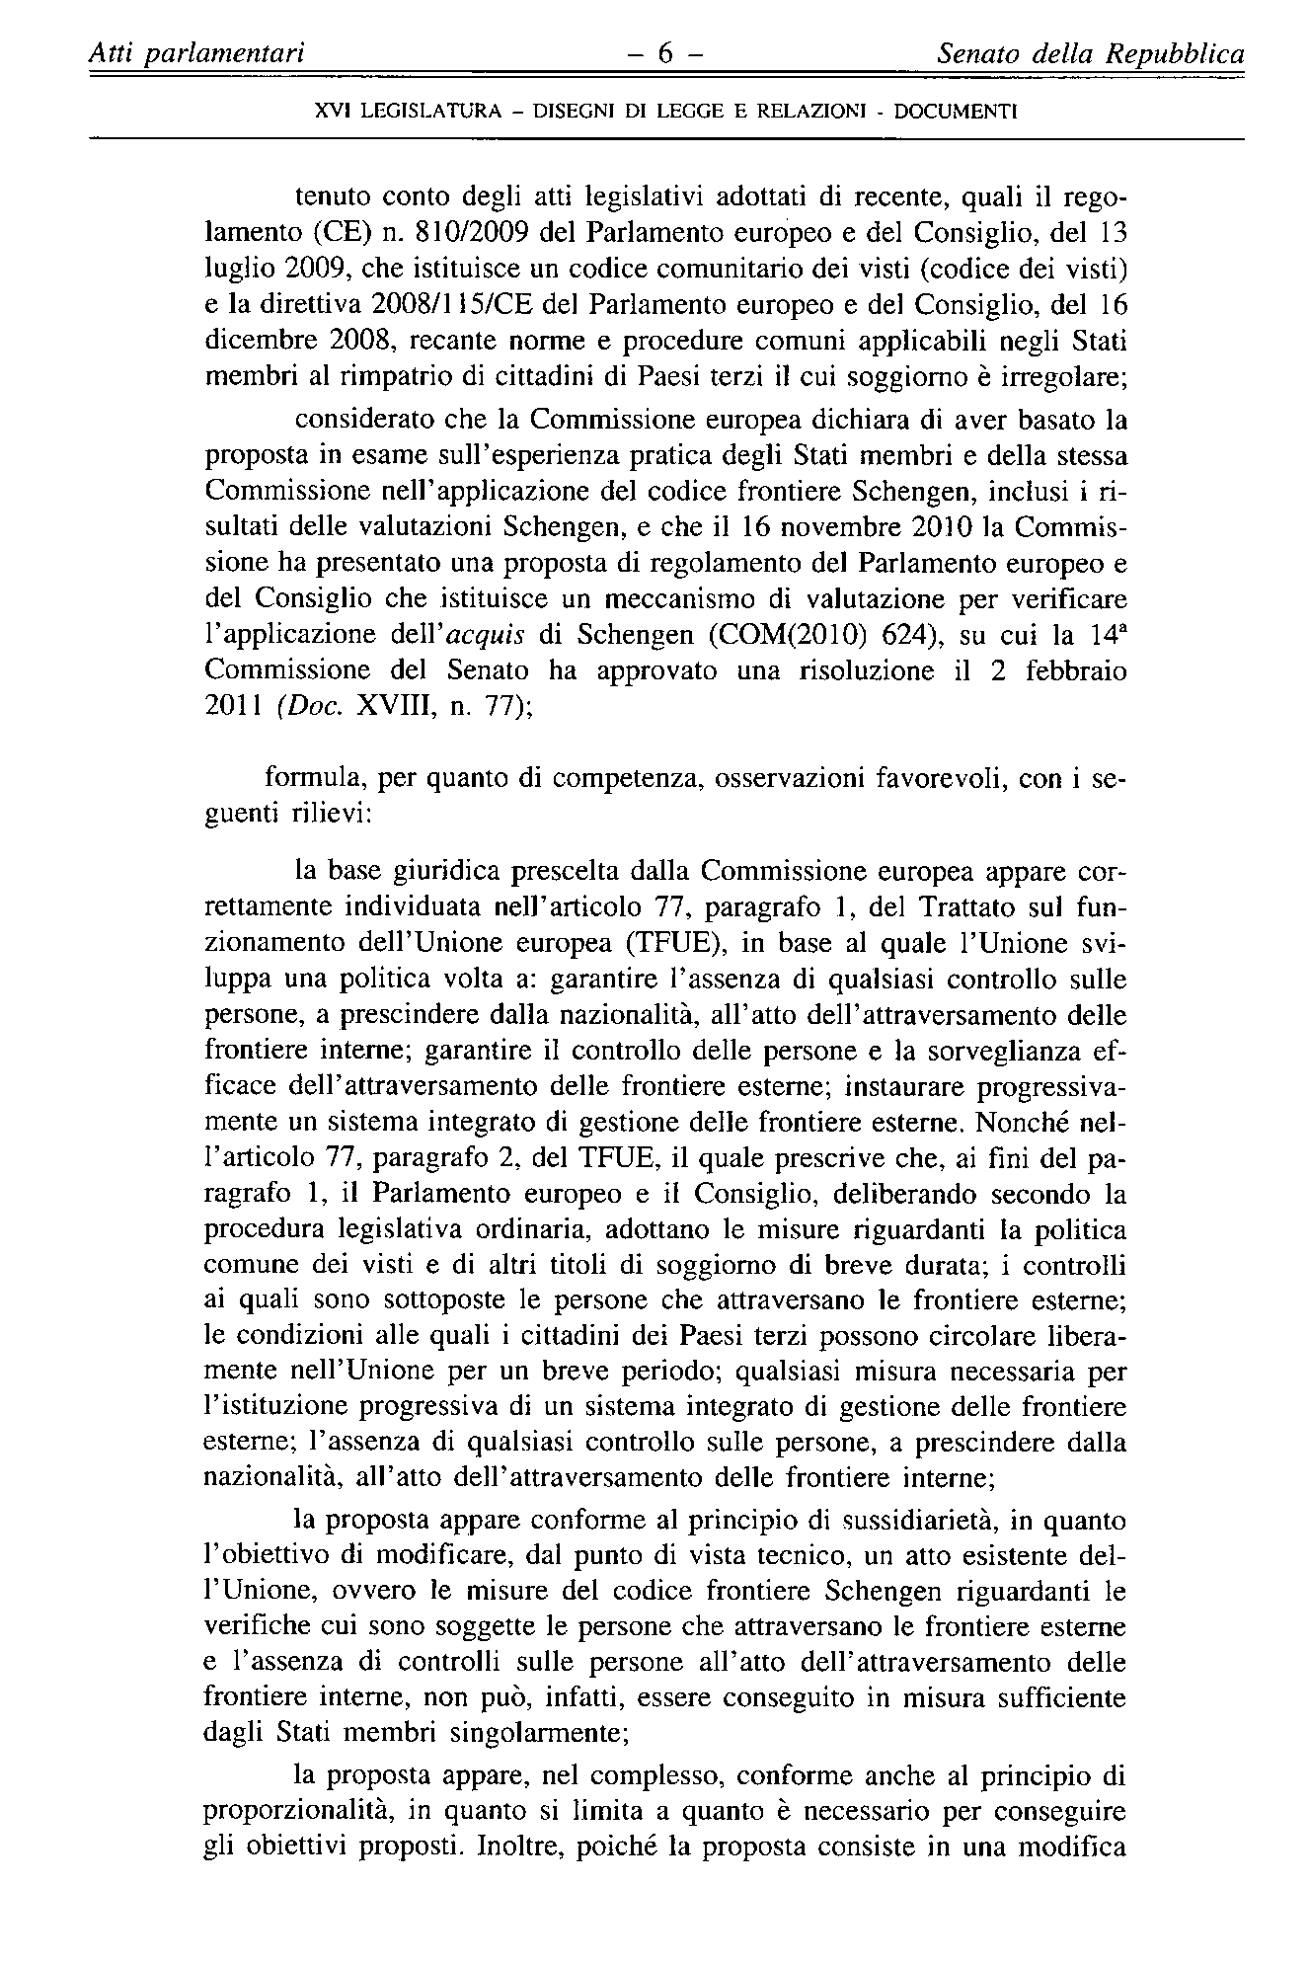
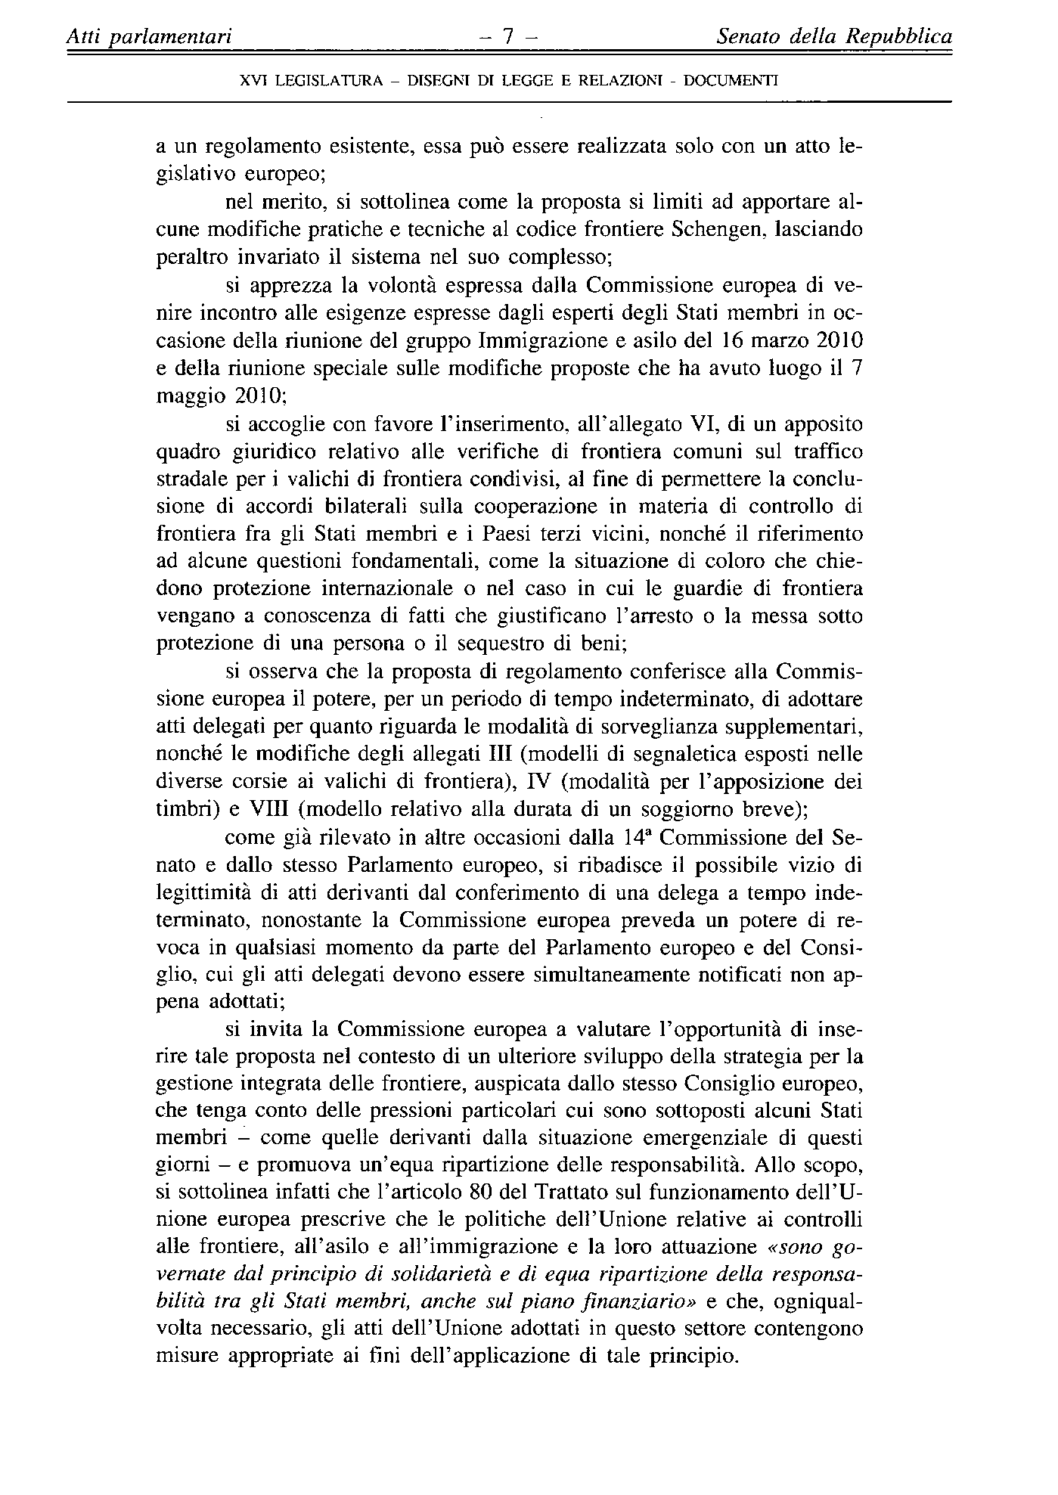

The translation can be found at the Interparliamentary EU information exchange site IPEX at the following address: http://www.ipex.eu/ipex/cms/home/Documents/pid/10

