REPORT FROM THE COMMISSION TO THE EUROPEAN PARLIAMENT AND THE COUNCIL
on the implementation of Regulation 2038/2006 on multiannual funding for the action of the European Maritime Safety Agency in the field of response to pollution caused by ships for the period 2007-2009

Introduction
Regulation 2038/2006 provides a financial envelope to the European Maritime Safety Agency (thereafter "the Agency") to finance actions in the field of response to pollution caused by ships.
In accordance with Article 8 of the above Regulation, the Commission hereby reports on the results of the utilisation of these funds for the period 1 January 2007 until 31 December 2009.
The preparation of this report was done in close cooperation with the Agency, which produced a substantial contribution, with input resulting from the Agency's external evaluation in 2008, an audit from the Commission's Internal Audit Service in 2009 and a stakeholder consultation in March 2010. The matter was also discussed at several meetings of the Agency's Administrative Board.
In accordance with Article 15(2)(g) of Regulation 1406/2002, the Agency has provided annual reports concerning the financial execution of the detailed plan for the Agency's pollution preparedness and response activities for the years 2007 to 2010. These reports are available on the Agency's Website.
The Commission shares the analysis presented by the Agency in its contribution. The following main conclusions can be drawn for the period 2007-2009.

Tasks of the Agency in the field of pollution response
The tasks of the Agency cover both accidental and illegal discharges. Initially, they were focused on oil pollution. However, since 2007 the Agency has also been active in the field of maritime pollution caused by hazardous and noxious substances (e.g. chemicals).
In accordance with Regulation 2038/2006 and Directive 2005/35/EC on ship source pollution, the three main tasks of the Agency in the field of response to pollution caused by ships are the following:
(a) Operational assistance to Member States
The Agency offers a network of stand-by oil spill response vessels to "top up" Member States response capacity when affected by a spill. It also provides a satellite based oil spill detection and monitoring service called "CleanSeaNet" and information on chemical spills through the "MAR-ICE" network.
(b) Cooperation and coordination
The Agency is liaising with pollution response experts of Member States as well as with existing Regional Agreements and the International Maritime Organisation (IMO).
(c) Information
The Agency collects, analyses and disseminates information on best practices, techniques and innovation in the field of marine pollution preparedness and response.

budget
The total envelope allocated to the Agency to finance the above actions during the period from 1st January 2007 until 31 December 2013 amounts to 154 million euros (see Article 4 of Regulation 2038/2006). Of this amount, around 60 million euros (i.e. almost 40 %) were committed during the first three years. This corresponds to a proportionate use of the funds available.
Between 1st January 2007 and 31 December 2009, about 98 % of the commitments were dedicated to financing operational assistance, predominantly the network of stand-by oil spill response vessels. The remaining 2 % were dedicated to cooperation and information (see table in Annex).
Payments amount to around 48 million euros. The fact that payments are below commitments can be explained by a number of factors. Payments under multi-annual contracts may be spread over a number of years, sometimes beyond the reference period. Besides, delays in relation to new contracts for stand-by vessels or unsatisfactory services by satellite image providers have also resulted in lower payments.

Adequacy of the financial framework
It follows from the information gathered that the envelope allocated to the Agency is adequate. It has allowed the Agency to have in place in 2009 a network of 13 fully equipped stand-by oil spill response vessels which can be mobilised simultaneously and which are covering most of the EU coastline. It has also allowed the Agency to develop the CleanSeaNet system offering an oil spill monitoring service by satellite to 24 European coastal States (including Croatia and Norway) while only 12 of these coastal States had previous experience in this field. Feedback from stakeholders is also positive on the coordination and information actions provided for by the Agency under the framework.
The fact that the financial framework is multiannual is essential to allow the conclusion of multiannual contracts with the industry. Such contracts are needed both in relation to stand-by oil spill response vessels and for organising CleanSeaNet.
Finally, the adequacy of the financial framework is confirmed in the longer term by the fact that the Agency foresees the commitment of up to 97% of the overall financial envelope by the end of 2013.

Efficiency and added value of the system in place
The measures financed so far under the framework are cost efficient and provide added value. Besides, the use of public procurement procedures guarantees that the best value for money is obtained.
In accordance with the detailed plan for the Agency's pollution and preparedness activities adopted by the Agency's Administrative Board, oil spill response vessels have not been built or acquired by the Agency, as this would not have been cost efficient considering their frequency of use. Instead, vessels are contracted from commercial operators through a system ensuring that they are both adequately fitted and available upon request. Figures show that choosing this system instead of buying vessels has reduced costs by around 60% per year even though providing 60% more storage. The "transferable call option" on the equipment allowing passing it on to another ship is essential as it minimises investment losses in case of change of contractor.
The primary responsibility to respond to an incident is, and remains, with national authorities whose investments vary considerably. However, spill scenarios drawn up by the Agency, essentially based on major incidents having occurred in the past (e.g. the Erika and the Prestige), clearly show that the affected Member State would have benefited from substantial savings, should the network of vessels have been in place at the time.
Organising the oil spill detection and monitoring system at EU level is also less costly (by around 20 %) and more efficient than doing it at national level. Indeed, on average, one image acquired covers the needs of nearly two coastal States (with 6.391 images ordered, the Agency was able to reply to 11.886 national requests). The rigorous quality control system put in place by the Agency also ensures that payments are only made when contractual specifications are fully met.

Scope for improvement beyond the financial framework
The Commission notes that a number of improvements, outside the financial framework, remain possible.
Firstly, the ratification by all Member States of the relevant international conventions is essential to create a common minimum level of preparedness and response. It is therefore regrettable that the International Convention on Oil pollution Preparedness, Response and Co-operation, 1990 (OPRC 1990) and the Protocol to the Convention on pollution incidents by Hazardous and Noxious Substances of 2000 (OPRC-HNS Protocol 2000) have not yet been ratified by all Member States. Similarly, the conventions setting up the international compensation regime for the victims of spills resulting from accidents involving tankers (CLC 92, Fund 92, and Supplementary Fund 2003) have not yet been ratified by all Member States.
Secondly, the availability of discharging facilities for oil recovered at sea seems to be a common problem across Europe. The "lightering clause" inserted by the Agency in vessels contracts (i.e. the provision according to which the contractor may be requested to find a suitable lightering vessel), contributes to addressing the issue but cannot replace appropriate solutions at national level.
Finally, the follow-up of potential oil spills detected by the CleanSeaNet service could be improved in some Member States. While the Agency is in charge of delivering the oil spill detection and monitoring service, it is up to the national authorities to confirm a possible spill and undertake appropriate follow-up against the polluter. The overall rate of confirmation (27%) hides strong regional imbalances based on national verification capabilities in particular by aerial surveillance. This bears the risk that unscrupulous ship operators might carry out illegal discharges in regions where the follow-up is less stringent.

Conclusions
In conclusion, the budget dedicated to oil pollution response by the European Maritime Safety Agency is adequate and the measures financed so far under the framework are cost efficient and provide added value.
The Commission proposed in October 2010 a modification of EMSA's Founding Regulation, which includes inter alia the provision that the affected Member State may request EMSA's assistance also in the case of marine pollution caused by oil and gas installations. However, the Commission does not consider necessary to propose a modification to the multiannual financial framework in Regulation 2038/2006.
The Commission will use the Agency's contribution to this report in the context of the preparation of the next financial programming.
ANNEX
EMSA Pollution Preparedness and Response Activities
Financial Summary 2007-2009
 | Commitments  in EUR | Payments  in EUR
Network of Stand-by Oil Spill Response Vessels | 46,363,654.42 | 34,559,298.86
Exercises | 1,157,500.00 | 1,082,555.37
Improvements | 5,324,730.86 | 4,547,630.50
CleanSeaNet Operations | 2,859,946.40 | 4,671,731.14
Support to CleanSeaNet Users | 358,270.53 | 223,995.50
CleanSeaNet Service Development | 2,673,615.53 | 2,283,212.01
Co-operation and co-ordination | 564,458.95 | 347,445.45
Activities in the field of HNS response | 79,100.00 | 37,564.23
Information Dissemination | 50,054.79 | 61,138.64
Related missions | 475,052.70 | 379,498.10
Total | 59,906,384.18 | 48,194,069.80
Note: In the two areas, where payments are exceeding commitments, some payments are related to commitments made prior to 2007.
Overview of the allocation of funding
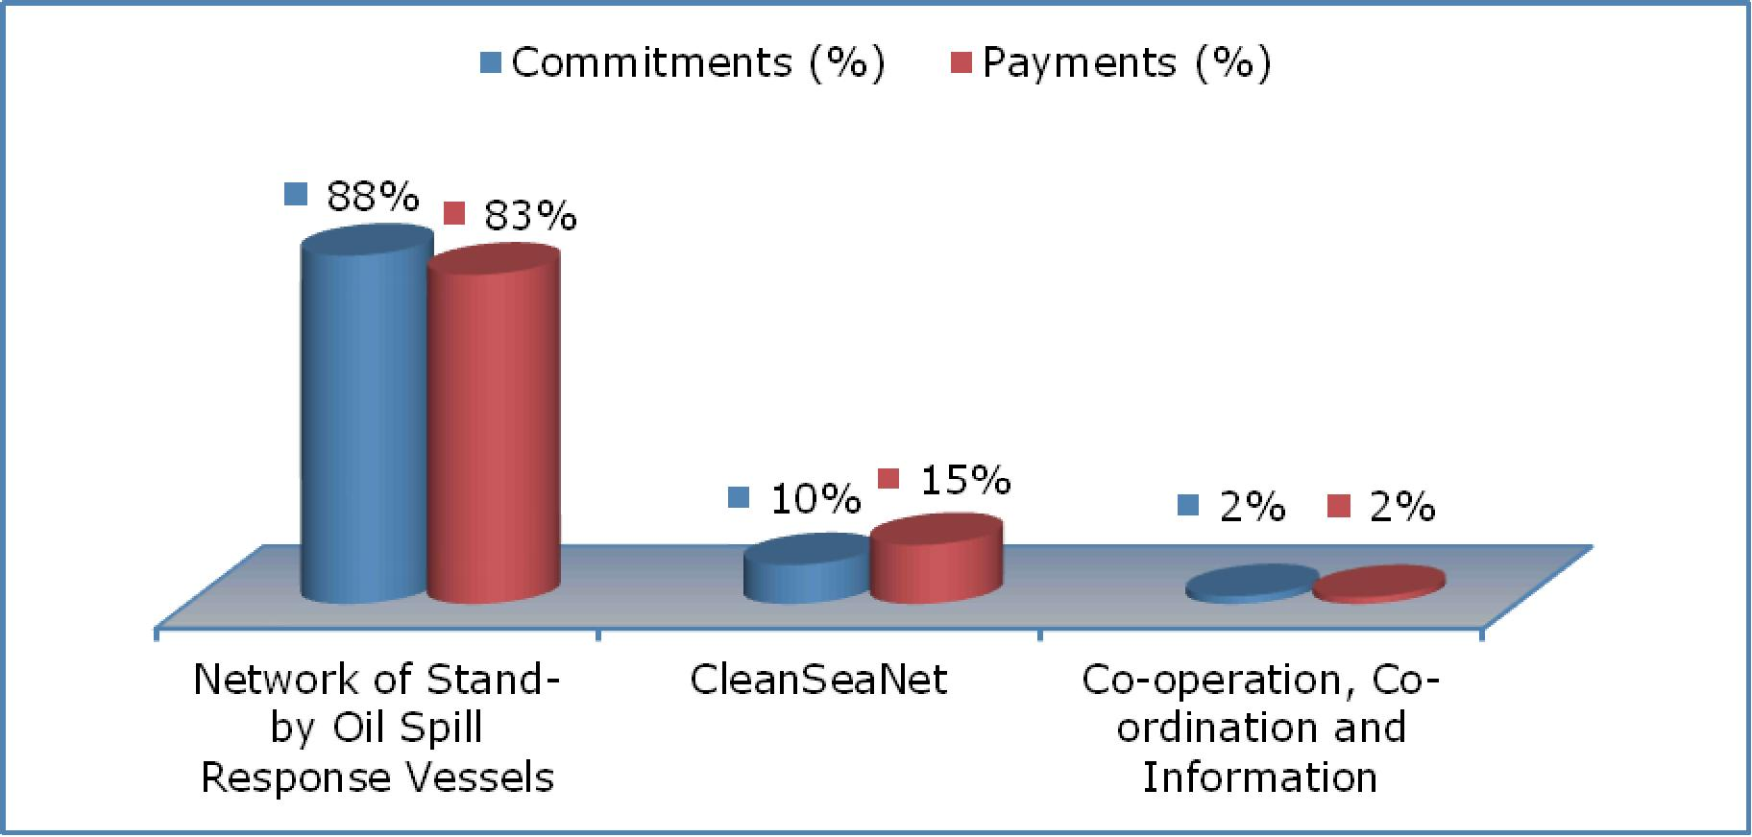

Regulation (EC) No 2038/2006 of the European Parliament and of the Council of 18 December 2006 on multiannual funding for the action of the European Maritime Safety Agency in the field of response to pollution caused by ships and amending Regulation(EC) n° 1406/2002 (OJ L 394 of 30.12.2006, p. 1. See also corrigendum in OJ L 30 of 3.2.2007 p. 12).
Available on EMSA's website at: https://extranet.emsa.europa.eu/index.php?option=com_joomdoc&task=cat_view&gid=298&Itemid=100005
Regulation (EC) No 1406/2002 of the European Parliament and of the Council of 27 June 2002 establishing a European Maritime Safety Agency (OJ L 245 of 29.03.2003, p. 10).
Directive 2005/35/EC of the European Parliament and of the Council of 7 September 2005 on ship-source pollution and on the introduction of penalties for infringements (OJ L 255, 30.9.2005, p. 11)
The network was further extended since then. Vessels are at the disposal of all Member States regardless of their actual area of operation. Maps can be found in the Agency's contribution referenced in footnote 2.
Protocol of 1992 to amend the International Convention on Civil Liability for Oil Pollution Damage, 1969.
Protocol of 1992 to amend the International Convention on the Establishment of an International Fund for Compensation for Oil Pollution Damage, 1971.
Protocol of 2003 to the International Convention on the Establishment of an International Fund for Compensation for Oil Pollution Damage, 1992.
COM(2010)611 of 28.10.2010.

