TABLE OF CONTENTS
INTRODUCTION 2
BACKGROUND 2
OBJECTIVES OF THE PROGRAMME 3
DIFFERENT TYPES OF ACTION UNDER THE PROGRAMME 4
MANAGEMENT OF THE PROGRAMME 5
COMMISSION INITIATIVES 11
SPECIFIC PROJECTS 12
SPECIFIC PROJECTS IN THE FIELD OF COMPETITION LAW 20
OPERATING GRANTS 21
CONCLUSIONS AND RECOMMENDATIONS 23

INTRODUCTION
The Decision of the European Parliament and of the Council of 25 September 2007 which establishes for the period 2007-2013 the Specific Programme ‘Civil Justice’ provides that the Commission MUST present to the European Parliament and the Council an interim evaluation report on the results obtained and the qualitative and quantitative aspects of the implementation of the Programme no later than 31 March 2011.
This report complies with that obligation: it describes progress on the programme since its adoption in September 2007 and summarises its main achievements.
The initial measures financed under the programme did not start until just under three years ago. Only a few of these measures have been completed. Consequently, the report will focus on the programme's structure and management.
The report also discusses some of the questions which will be the focus of the preparations for the next financial programming exercise.
The proposed evaluation is based in particular on:
- the statistical and budgetary data held by the Commission and the experience it has acquired since the previous financing programme;
- statistical and budgetary data, and impressions as regards the effectiveness of the programme in supporting the Commission's political activities;
- an analysis of the working of the programme;
- an exchange of ideas during an informal meeting with most of the Member States' representatives on the programme committee, which was wholly devoted to this evaluation. The meeting was held in Brussels on 11 January 2011.
The Commission will also present, no later than 31 December 2014, a final evaluation report on the programme which will use performance indicators to determine whether its objectives have been achieved.

BACKGROUND
The programme follows on from earlier programmes: Grotius (1996–2000), Grotius-civil (2001), Schuman (1999–2001) and, for 2002–2006, the general Community framework of activities to facilitate the implementation of judicial cooperation in civil matters.
The purpose of the Grotius programme was to facilitate judicial cooperation between Member States by fostering mutual knowledge of legal and judicial systems. It was intended for legal practitioners and provided funding for training, exchanges and work-experience projects, organisation of meetings, studies and research, and the dissemination of information.
The Robert Schuman project was implemented between 1999 and 2001 with a view to promoting and supporting measures aimed at improving awareness of Community law within the legal professions. The general objective was to gradually improve the application of Community law throughout the EU.
The Commission then proposed the establishment of a new framework programme on judicial cooperation in civil matters for the period 2002-2006. The new programme was adopted by the Council in the spring of 2002. It focused in particular on projects leading to more concrete results and on the need for a closer link to the programme's objectives and the priorities set out in the conclusions of the Tampere European Council. The programme’s main new feature was the possibility of financing NGO activities and projects carried out at the initiative of the Commission.
On 6 April 2005 the Commission published a Communication to the European Parliament and to the Council with a view to establishing a General Programme ‘Fundamental Rights and Justice’ for the period 2007–2013. This consisted of four proposals for decisions, including a proposal for a Council decision establishing a specific Criminal Justice programme and a decision of the European Parliament and of the Council establishing a Civil Justice programme.
These two programmes will establish a European area of justice based on the principle of mutual recognition of court rulings, cooperation between judicial authorities in civil and criminal matters, and the fostering of trust. They are also intended to facilitate access to the courts and hence to facilitate the lives of European citizens, and to involve stakeholders and civil society in the debate on justice.
The Criminal Justice and Civil Justice programmes differ in that they have different legal bases (Article 31 EU for criminal justice and Article 61 EC for civil justice), but their management methods are similar, which means that they are, generally speaking, consistent.
The Civil Justice programme was belatedly adopted under the co-decision procedure at the end of September 2007, which led to delays in the publication of the calls for proposals and the selection of projects. The time has been made up.

OBJECTIVES OF THE PROGRAMME
The main objectives of the programme are to finance measures to promote judicial cooperation and so contribute to the establishment of a true European area of justice in civil matters. More specifically, the intention is to:
- promote judicial cooperation in order to contribute to the creation of a true European area of justice in civil matters;
- encourage the removal of barriers to the smooth functioning of cross-border civil proceedings in Member States;
- improve the daily life of individuals and businesses by enabling them to assert their rights throughout the European Union, notably by fostering access to the courts;
- improve the contacts, exchange of information and networking between the judicial and administrative authorities and the legal professions, in particular by promoting judicial training courses aimed at improving mutual understanding between these authorities and professions.
Each year, a new work programme and new calls for proposals are published. The work programme and calls for proposals set out in detail the priorities for the year in terms of calls for proposals and every stage of the selection procedure:
- no particular priority was defined in 2007, however;
- the overall priority for the grant programme in 2008 and 2009 was e-justice.
- the overall priority in 2010 was again e-justice, together with training for professionals working for the judicial system.
- a number of priorities have been adopted for 2011.
The definition of precise priorities will certainly make the programme more effective. Yet they are regarded only as an indication: the annual work programmes state that innovative projects falling outside the areas defined as priorities will not be penalised. In other words, the priorities are rather theoretical.
The annual work programmes also determine the rates of Community cofinancing and the maximum and minimum thresholds governing this financing.
For each year the cofinancing rate has been set at 80% of eligible costs, whereas it was only 60% under the previous programme. As of 2009, however, the thresholds of €50 000 and €200 000 were raised to €75 000 and €500 000.
The programme is targeted at, inter alia, legal practitioners, national authorities and European Union citizens in general.
Access to the programme is open to public or private organisations and institutions, including professional organisations, universities, research institutes and legal and judicial training institutes for legal practitioners, international organisations and Member States' non-governmental organisations.
The programme is open to all Member States except Denmark. The candidate and accession countries and the Western Balkan countries taking part in the stabilisation and association process can take part in the programme subject to certain conditions.

DIFFERENT TYPES OF ACTION UNDER THE PROGRAMME
The programme provides for various types of action, including:
- Projects at the initiative of the Commission
These include specific projects initiated by the Commission such as studies and research, opinion polls and surveys, formulation of indicators and common methodologies, collection, development and dissemination of data and statistics, seminars, conferences and meetings of experts, organisation of public campaigns and events, development and maintenance of websites, preparation and dissemination of information material, support for and management of networks of national experts, and analytical, monitoring and evaluation activities.
The Commission uses procurement procedures for these activities.
- Specific projects
These include specific transnational projects of Community interest presented by an authority or any other body of a Member State, an international organisation or a non-governmental organisation, and involving in any case at least two Member States or at least one Member State and one other State which can be either an accession country or a candidate country.
The following countries may take part in these projects: the accession countries, the candidate countries and the Western Balkan countries included in the stabilisation and association process in accordance with the conditions laid down in the association agreements or additional protocols thereto relating to participation in Community programmes concluded or to be concluded with those countries. At the time of writing, no non-Member country satisfied the conditions for taking part in the programme.
NB: Every year €800 000 is set aside to finance specific projects for the training of legal practitioners in the field of European competition law. This is the subject of separate calls for proposals.
- Operating grants
The programme may finance the activities of non-governmental organisations or other entities pursuing an aim of general European interest in accordance with the general objectives of the programme under the conditions set out in the annual work programmes.
It will be seen later that the rather cryptic wording of this provision has led to some problems.
- The bodies mentioned in the legal basis
The programme provides for operating grants to cofinance expenditure arising from the work programmes of the European Network of Councils for the Judiciary and the Network of the Presidents of the Supreme Judicial Courts of the European Union, provided that the grants are used to achieve an objective of European general interest.
- The European Judicial Network;
The programme is also designed to facilitate the operation of the European Judicial Network in civil and commercial matters established by Council Decision 2001/470/EC.

MANAGEMENT OF THE PROGRAMME
- Financial resources
Financial programming, in millions of euro, is as follows:
 | 2007 | 2008 | 2009 | 2010 | 2011 | 2012 | 2013 | Total
Civil Justice | 14.4 | 14.7 | 15.3 | 15.8 | 16.0 | 16.5 | 17.1 | 109.3
The relevant budget heading is 18.06.07.
The Civil Justice programme receives a much higher allocation than the previous programme. The table below shows the difference in allocations between the programme on civil judicial cooperation (five years) and the current programme (first five years). However, it must not be forgotten that the current programme includes operating expenditure of the European judicial network and specific projects in the field of competition (€800 000 a year), which is managed by the Directorate-General for Competition.
Green: Civil Justice 2007-2011
Red: Civil judicial cooperation 2002-2006
The graph on the next page shows the breakdown of the available budget between programme activities, year by year.
Please note the rather modest allocations set aside for grants (specific transnational projects), which form the core of the programme.
BREAKDOWN IN THE AVAILABLE BUDGET BY TYPE OF ACTIVITY
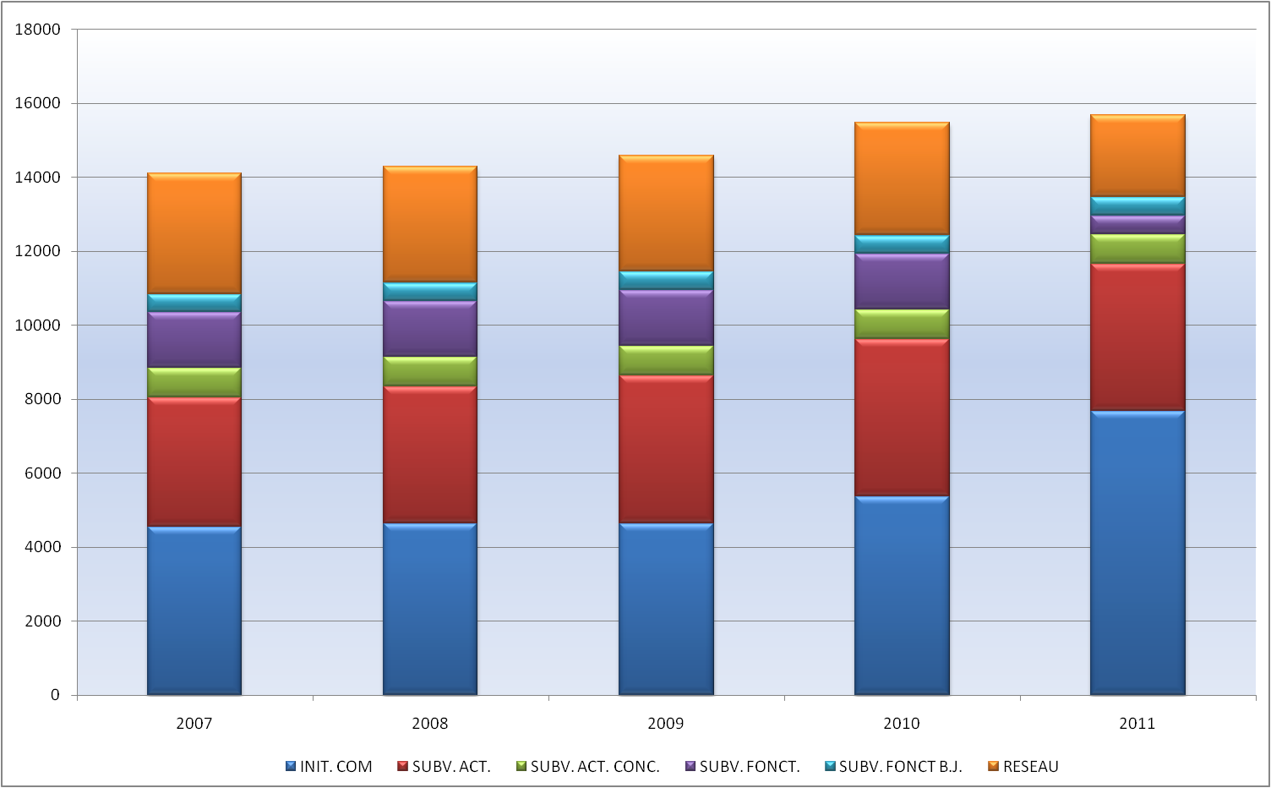
Blue: Projects at the initiative of the Commission
Red: Grants for projects
Green: Grants for competition projects
Violet: Operating grants
Pale blue: Operating grants referred to in the legal basis
Orange: Network
- The life-cycle of a project
Like many European programmes, the Civil Justice programme, the ‘specific projects’ part at least, is implemented in a specific cycle lasting several years. The cycle starts in the first year with an annual work programme.
The work programme is adopted by the Commission, assisted by the programme committee in accordance with the management procedure. At the informal meeting on 11 January 2011, the Member States' representatives all expressed a wish to be more involved in decision-making on the work programme, which is equivalent to a financing decision, and in project selection, though here the committee is acting only within the framework of the consultation procedure.
The work programme is followed by calls for proposals, the selection of the most relevant projects, the signing of contracts and the first disbursements. Execution takes place in the second year. After a maximum of two years of activity, the project leaders have three more months to present the final report and accounts. In other words, for a call issued in year n, the final payments are made in year n+2, or even n+3.
The substance of the call is adapted each year to take account of new priorities set out in the annual work programme (linked to progress in Community work on civil justice) and of the experience of previous years.
The different stages of the selection procedure, which may appear to be very long as it takes up to eight months between the publication of the call and the signing of the grant contracts, are as follows:
The applications must be received at the latest by the date indicated in the call for proposals. Since 2008 applicants have been asked to fill in their forms and to attach all the necessary documents using an IT system called Priamos.
Use of this system makes it possible to avoid handling paper files (thus several evaluators can work at the same time), to prevent files from being lost and to avoid complaints as regards the date of receipt.
An internal selection committee consisting of Commission officials examines the proposals, checking the following in succession:
- exclusion and eligibility criteria
- selection criteria
- award criteria (the actual evaluation).
The various criteria are set out in the calls for proposals, an example of which can be found in Annex 2 (work programme and call for proposals for 2010).
If the proposals comply with the eligibility and selection conditions, the committee evaluates them and grades them according to the various award criteria.
The committee classifies the eligible proposals according to the marks obtained and, depending on the available budget, indicates the ones it recommends for selection.
The consultative committee provided for in the basic decision meets to discuss the above proposals. To date, the committee has issued favourable opinions by consensus on the proposals submitted to it in the calls for proposals for 2007, 2008, 2009 and 2010.
The meetings may be replaced by a written procedure.
The Commission adopts the list of proposals to be cofinanced (Award decision). The list shows the maximum amounts for each grant. These amounts may be revised if the budgets presented by the candidates are not completely eligible or correctly presented.
As soon as a fully eligible budget is communicated to the Commission, the necessary appropriations are committed and a grant agreement is presented to the potential beneficiary. The project can start following signature of the agreement by both parties. The first financing tranche, currently 70%, is then paid.
The projects generally last for 12 to 24 months starting from the first day of the month following the date when the last of the two parties signs the grant agreement or an alternative date chosen by the beneficiary, where appropriate.
Throughout the period of activity, the project is monitored by a Commission official who deals with all questions raised by the beneficiary.
Most of the questions raised by beneficiaries during the implementation of their projects are about the budget (increase in some costs or which heading to place costs under).
Beneficiaries often want to extend the length of the project because they have not managed to complete all the planned activities or because they have had problems in organising the conferences/seminars or getting all the participants/speakers together for a particular date.
Sometimes one of the project partners decides to withdraw, thus jeopardising implementation of the project.
Change of staff (due to illness, maternity leave, etc.) is another problem frequently encountered by project leaders.
The final report (concerning the technical and financial aspects) must be sent by the beneficiary to the Commission within three months of the end of the project, together with the request for final payment.
The balance is paid within 45 days following the approval of these documents by the Commission.
Project supervision is carried out in several stages.
During the selection process: the Commission's financial services check that the budgets are eligible and correctly laid out. Failing this, project leaders are contacted so that they can correct errors, and grant agreements are concluded only when all the budgetary conditions have been met.
During implementation of the projects, it is possible for a Commission official to take part in activities such as the conferences and seminars. No interim report is required, however.
At the end of the projects, the balance is paid to the recipient only after approval of the final report by the Commission, with respect to both substance and financial aspects.
Documentary evidence such as invoices, etc. supplied with the report is examined by the financial services on a sample basis.

COMMISSION INITIATIVES
During the period under review, actions taken at the initiative of the Commission were as follows:
- Maintenance of Internet sites and databases already set up under the previous programme
The European judicial atlas is an IT tool in the form of a data base that is accessible via the Internet and available in every EU official language. The purpose of the tool is to provide user-friendly access to information relevant for judicial cooperation in civil matters.
It enables professionals and the general public to easily identify which authorities to contact and is particularly useful for:
- finding courts with territorial jurisdiction
- serving documents
- taking evidence
- enforcing judgments
- other issues.
Moreover, the procedures involved will be made easier where possible by giving users access to an IT tool based on forms that must be filled in when applying the different legal instruments.
JURE is a database developed by the Commission and containing information on the case law of the European Court of Justice and Member States' courts, on the interpretation of Council Regulation (EC) No 44/2001 of 22 December 2000 on jurisdiction and the recognition and enforcement of judgments in civil and commercial matters, and on the interpretation of the 1968 Brussels Convention and the 1988 Lugano Convention.
It is a powerful search tool mainly intended to facilitate access to comprehensive, regularly updated information. The information is accessible free of charge to all, including legal professionals from all over the EU.
Summaries of the judgments in this database are available in German, English and French and in the language of origin of the judgment.
JURE is updated constantly on the basis of contributions by legal professionals and revised by the Commission.
- Studies
The Commission has financed a series of studies under the Civil Justice programme, including the following:
A study carried out by the Swiss Institute of Comparative Law on the application of foreign law by courts and extrajudicial authorities. This study should help establish whether a common approach to this issue is desirable at European level and, if so, what should be done.
A study on adoption lists adoption-related laws, procedures and practices in the 27 Member States and the difficulties encountered by European citizens who wish to carry out an international adoption. This study will consider the possibility of creating a European procedure for such cases.
The authors of a study on legal aid will focus on the implementation of the relevant 2003 Directive and the 1980 Hague Convention.
Another study under way will provided the basis for the Commission report provided for in the Rome I Regulation on the law applicable to contractual obligations.
Lastly, a study has been sent to the Commission on the subject of crossborder debt recovery that will serve for the drafting of the Commission's proposal to create a 'European freezing order'.
- Promotional and information activities
The 'European Day of Civil Justice' on October 25 each year, which is organised with the Council of Europe, gives the public a chance to learn more about the working of civil justice and thus enable people to gain greater access to the courts Since 2007 this initiative has been coupled with the 'Crystal Scales of Justice' prize.
- Conferences
An example is the joint conference in the field of family law organised by the Commission and the Hague Conference on Private International Law.

SPECIFIC PROJECTS
Between 2007 and 2010 158 proposals for specific transnational projects were received, of which 86 were selected and 72 rejected.
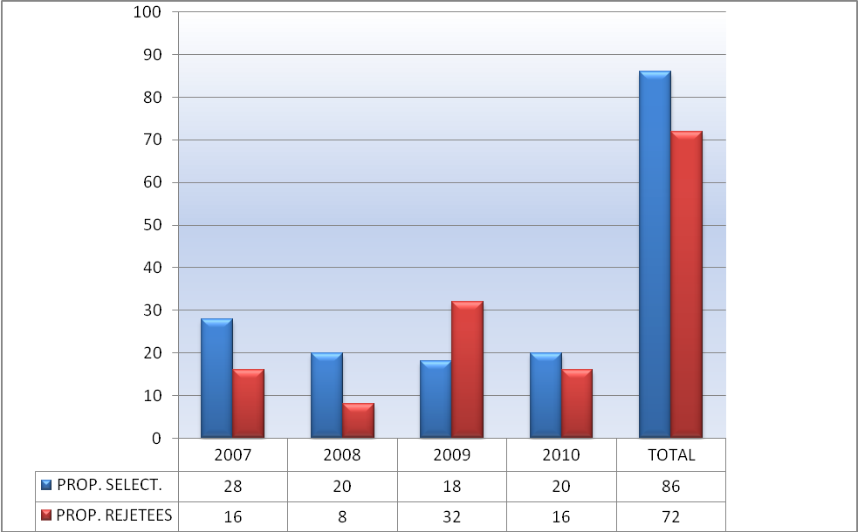
Blue: Selected proposals
Red: Rejected proposals
These projects cover a wide range of topics, touching on almost every area of civil justice. The topics covered most often are mediation and e-justice.
- Breakdown by type of beneficiary
The following pie chart gives the breakdown of selected projects by type of beneficiary.
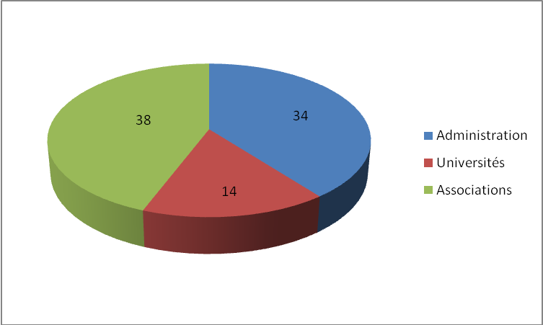
Blue: Administration
Red: Universities
Green: Associations
- Geographic breakdown
Organisations of 19 of the 26 Member States participating in the programme (Denmark does not take part) have submitted proposals for specific projects and had at least one proposal selected.
All the Member States apart from Denmark and Cyprus have been involved in a project at least once, either as project leader or partner.
That said, the geographic breakdown needs some qualification: organisations of just five countries (Germany, Italy, Spain, Belgium and France) accounted for a little over two thirds of the proposals received since 2007 and of the selected projects. Organisations from these countries are also the most frequent partners in projects led by others.
Since the start of the programme German organisations have been the best represented at all levels of participation. Under the previous programme it was the Italians by a large margin.
Organisations from countries such as Austria, Estonia, the Netherlands, Portugal and Romania often participate as partners.
On average, a project brings together just over three partners from different countries, including the project leader.
The tables below show the geographic breakdown of the projects selected.
Red: Other EU15 (10 MS)
Blue: New MS (12 MS)
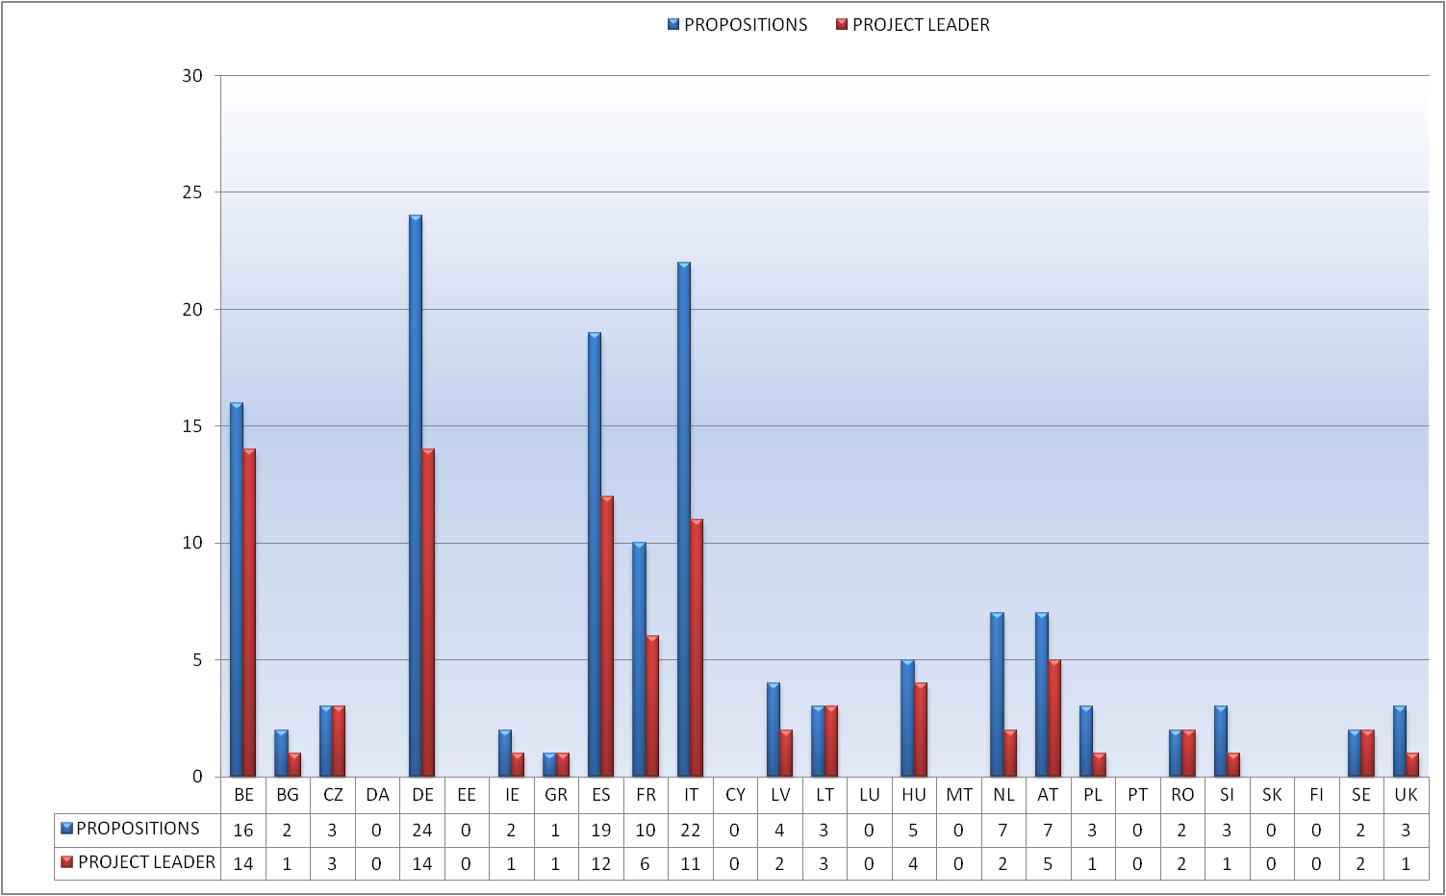
Blue: Proposals
Red: Project leader
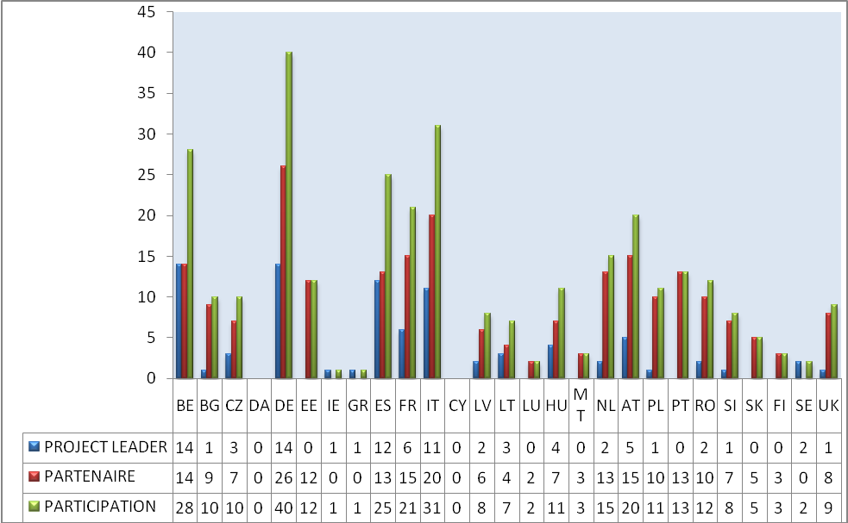
Blue: Project leader
Red: Partner
Green: Participation
- Breakdown by budget
The table below gives a breakdown of the projects selected by the amount of cofinancing. The over-representation of projects with European matching funds of between €101 000 and €200 000 is explained by the fact that the work programmes for the first two years had a cap of €200 000.
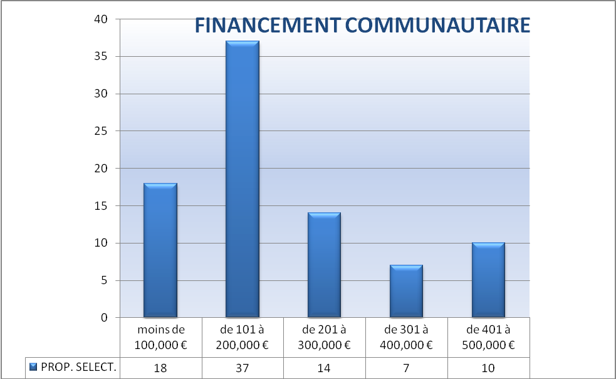
Title: Community financing
Blue: Selected proposals
Columns: under €100 000, from €101 000 to 200 000, from €201 000 to €300 000, from €301 000 to €400 000, from €401 000 to 500 000.

SPECIFIC PROJECTS IN THE FIELD OF COMPETITION LAW
The annual work programmes earmark a budget of €800 000 each year to cofinance specific projects on the implementation of European competition law.
The selected projects concerned judicial cooperation between national judges and their training in various aspects of European competition law, in particular the rules applicable to undertakings and state aid.
Most projects involved training activities, whether in the form of conferences/seminars or training in the strict sense of the term.
The table below lists grant beneficiaries over the last three years:
The Academy of European Law (ERA) in Trier has carried out almost half the training projects cofinanced (13 of 29).
Judges of all EU nationalities have received training.
Since 2007, when competition law was added to the Civil Justice Programme, a growing number of judges (and public prosecutors and other legal professionals) have received training: 499 in 2007, 678 in 2008, and 747 in 2009.

OPERATING GRANTS
- Grants awarded following a call for proposals
The possibility of cofinancing the work programmes of NGOs did not attract many offers in the first three years (19), of which only a few were selected (six different organisations were selected in the first three years, one three times and another twice).
As not enough of the funds earmarked for such actions were committed (approximately 30%, 50% and 60% of the funds available during the first three years of the programme), the Commission radically cut the indicative allocation from 2011 on (down to €150 000 instead of €500 000).
We will return to the reasons for this lack of interest and the lessons to be drawn in the conclusions of this report.
Green: Proposals
Red: Selected
- Grants to bodies referred to in the basic decision
Article 4(d) of the Decision of 25 September 2007 provides for the possibility of awarding operating grants to two named networks: the European Network of the Presidents of the Supreme Judicial Courts of the European Union and the European Network of Councils for the Judiciary. This provision merely means that these organisations are not required to compete in a call for proposals. However, they must submit a work programme at the start of the year and a final report; these are scrutinised by the Commission before it pays any prefinancing or the balance.
The Presidents of the Supreme Judicial Courts of the European Union wished to meet as an association, the Constituent Assembly of which was held on 10 March 2004 at the French Court of Cassation with financial support from the European Commission (AGIS programme).
The Presidents' Network offers European authorities the opportunity of consulting the Supreme Courts and the Courts benefit from occasions that stimulate debate. Its members meet at conferences to discuss issues of common interest and courses are organised for members of supreme courts within the framework of the Exchange Programme for Judicial Authorities in conjunction with the European Judicial Training Network.
Since 2006 the Network has developed, with the support of the European Commission, a shared case-law portal of the Supreme Courts that will enable members to search all the national case-law databases.
The activities of this network are of particular importance in the field covered by the Civil Justice Programme, especially its case-law portal.
The grant to the European Network of Councils for the Judiciary enabled it to constitute itself as an association in 2008 and commence activity.

CONCLUSIONS AND RECOMMENDATIONS
- Conclusions
The programme started up little more than three years ago and few of the initiatives financed have been completed. It is thus still too early to make an in-depth analysis of the programme's impact and results.
However, it can be seen already that the projects financed, both those undertaken at the initiative of the Commission and specific projects, are contributing to the fulfilment of the programme's objectives and, more generally, respond to the Commission's desire to promote knowledge of European law in the field of civil justice and its correct implementation.
Major Commission initiatives already under way (the Judicial Atlas, database, information campaigns, conferences and studies) are designed to keep legal professionals, and even the general public, informed about recent developments in European civil law in various complementary ways. Particular emphasis is laid on practical and relevant information that can be accessed using new communication technologies.
The possibility of cofinancing NGOs' work programmes, which has a more limited share of the budget, attracted only a few applications in the first three years and of those only six organisations were selected.
There is no doubt about the relevance of the objectives of the Civil Justice Programme, which extends the impact of the legislative work of the Commission and sometimes provides inputs upstream. Like previous programmes, the Civil Justice Programme plays an important role in supporting European justice policy. The activities financed with quite modest grants help civil society organisations and Member States to make an effective contribution to the formulation and smooth implementation of European law.
In addition, the programme is efficiently managed, despite the limited human resources, as the Commission's partners generally agree.
- Recommendations
There are still some recommendations that could be made to make the programme even more effective, however.
- How can the programme be made more attractive?
While the quality of the projects financed appears indisputable, it must be admitted that not many proposals are received and their geographic spread is not very wide (see graphs above). The Commission has received just over 150 proposals in four years whereas it was expecting between 100 and 150 in the first year (this figure, given in the work programmes under the heading 'expected results', was revised downwards after three years).
There are various explanations for this, the main ones being:
- the very technical nature of the topics covered by the programme (much more technical than Daphne III, Fundamental Rights and Justice or even Criminal Justice), which means that only the 'initiated' submit proposals;
- small organisations have difficulty in finding partners and their own sources of cofinancing;
- the programme is little known outside the inner circle of 'clients';
- potential candidates' fear of complex procedures.
While the first of these difficulties is intrinsic to the very nature of the programme, it is possible to deal with the three others by doing two things:
- better publicising the programme, particularly through presentations in the Member States to reach more grassroots organisations and tell them how to apply, how to design a good project and how to find partners. The Commission works in partnership with the national authorities concerned, which are responsible for bringing together the relevant associations. Visits of this type to several Member States since 2008 have raised participation from these States.
- simplifying procedures. Desired by all stakeholders, simplification is an exercise that must unite the requirements of transparency, sound financial management and equal treatment of partners. Current procedures lead to unacceptably long delays between the publication of calls for proposals and the start-up of projects. They are caused by a plethora of administrative steps that are disproportionate to the amounts involved (deadline for submitting proposals, internal procedures of the Commission, discussions on budgets with the recipients, committee procedures, etc.).
- Better defined priorities that are more in line with the Commission's policy priorities
The setting of priorities should focus more on political activities and promote projects that meet these priorities.
More attention should be paid to the dissemination of project results in order to ensure better visibility of both the results and the programme as a whole.
- More European added value
Financing should be concentrated on projects that have a real European dimension and offer the most significant European added value. To achieve this objective we should finance larger projects. To do this the necessary provisions should be incorporated in the annual work programmes and the next basic decision.
The Commission's proposed basic decision for the current programme required the participation of at least three States, while the final text provides for no more than two (and even 'national' projects may be accepted under the Criminal Justice programme).
- Operating grants
As noted above, the operating grants component of the programme has so far produced disappointing results, which may be attributable to declining enthusiasm for this type of grant, but another reason is the fact that most of the proposals received tend to be closer to specific projects than annual work programmes. In addition, the European dimension is very difficult to identify in this type of activity (except for the true European networks which were the main target of the Commission's proposal).
Given the workload created by the publication of an annual call for proposals for operating grants and the results obtained, the Commission should consider discontinuing this in 2014.
- Links between the programmes: should they be merged?
Various ways of reforming the programme may be considered with an eye to the next financial programming period starting in 2014, including a merger with the twin Criminal Justice programme. The programmes were kept separate in 2007 because of their different legal bases, which called for different adoption procedures, but this is no longer the case since the entry into force of the Lisbon Treaty.
Accordingly, the Commission might consider proposing a 'Justice' programme bringing together the current Civil and Criminal Justice programmes.

No 1149/2007/EC, OJ L 257, 3.10.2007, p. 16.

