 | 
COUNCIL OF  THE EUROPEAN UNION |  |  | Brussels, 13 September 2011
 | Interinstitutional File:  2011/0147(COD) |  | 14163/11
SOC 766
CODEC 1438
ECOFIN 575
FSTR 38
COMPET 388
INST 405
PARLNAT 199

COVER NOTE
from: | The President of the Assembly of the Republic of Portugal
date of receipt: | 12 September 2011
to: | Mr Donald Tusk, President of the Council of the European Union
Subject: | Proposal for a Regulation of the European Parliament and of the Council amending Regulation (EC) No 1927/2006 on establishing the European Globalisation Adjustment Fund  [doc. 12122/11 SOC 609 ECOFIN 463 FSTR 25 COMPET 343 CODEC 111 - COM(2011)336 final]  - Opinion on the application of the Principles of Subsidiarity and Proportionality

Delegations will find attached the above mentioned opinion.

____________________

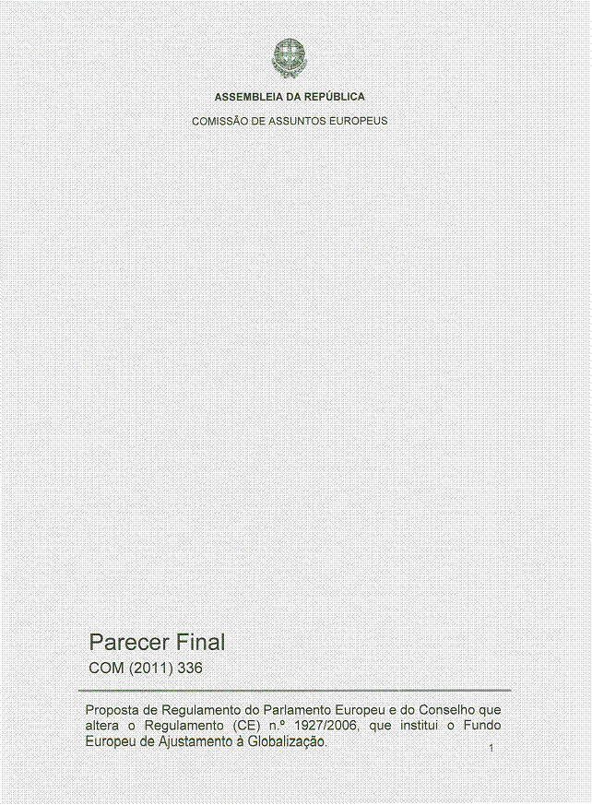
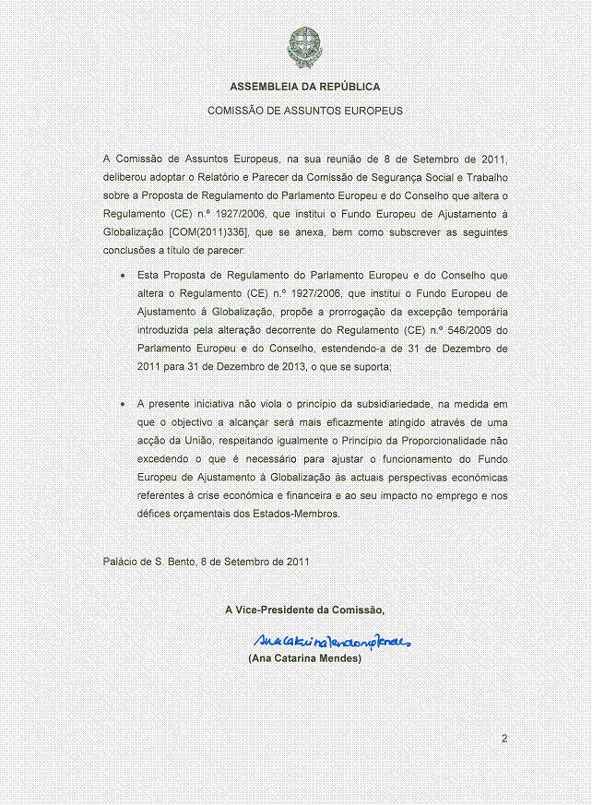

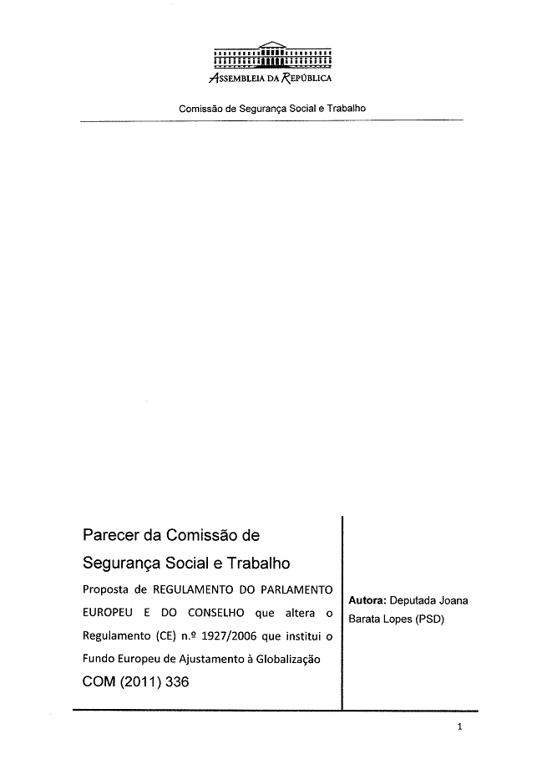
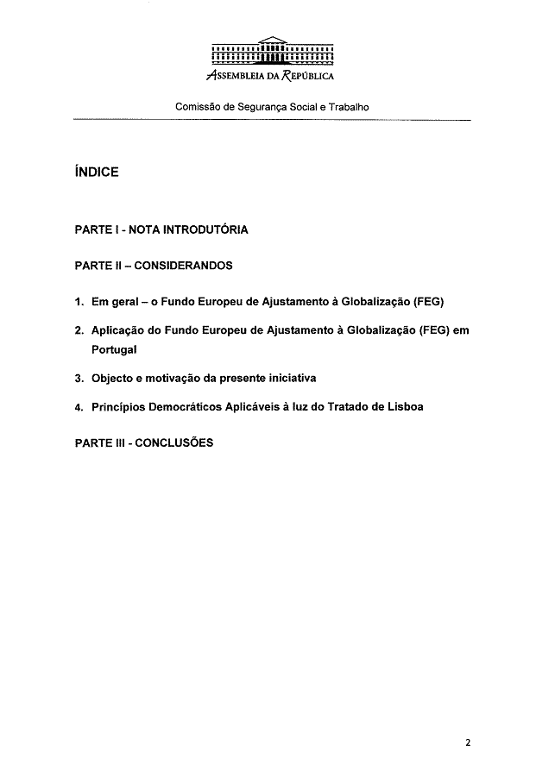
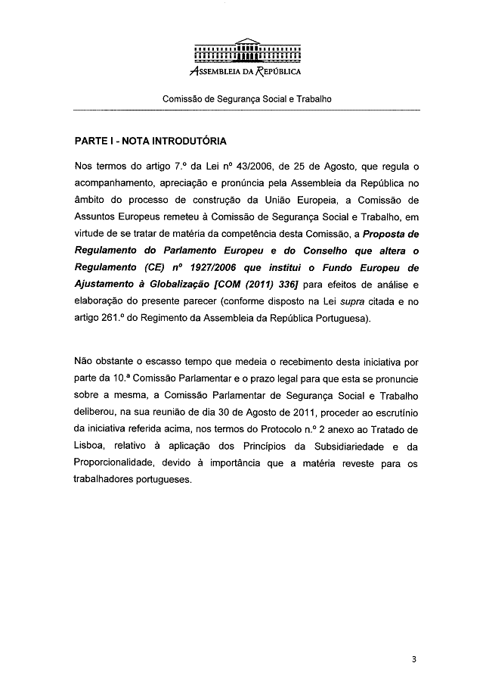
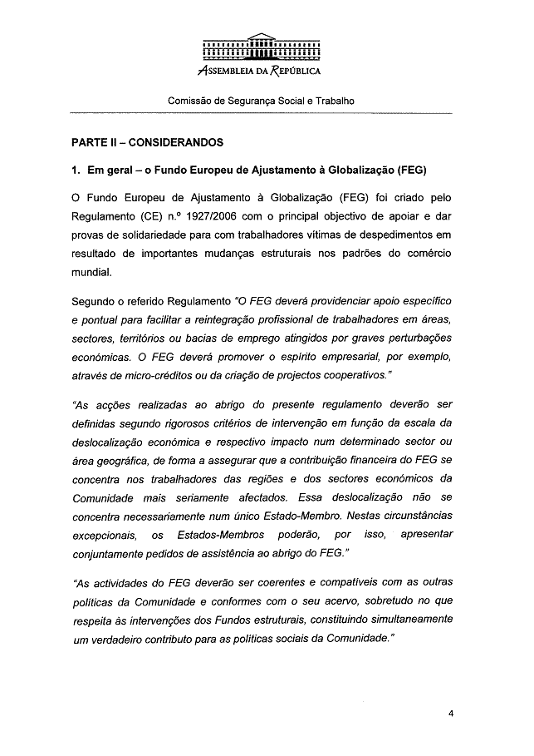
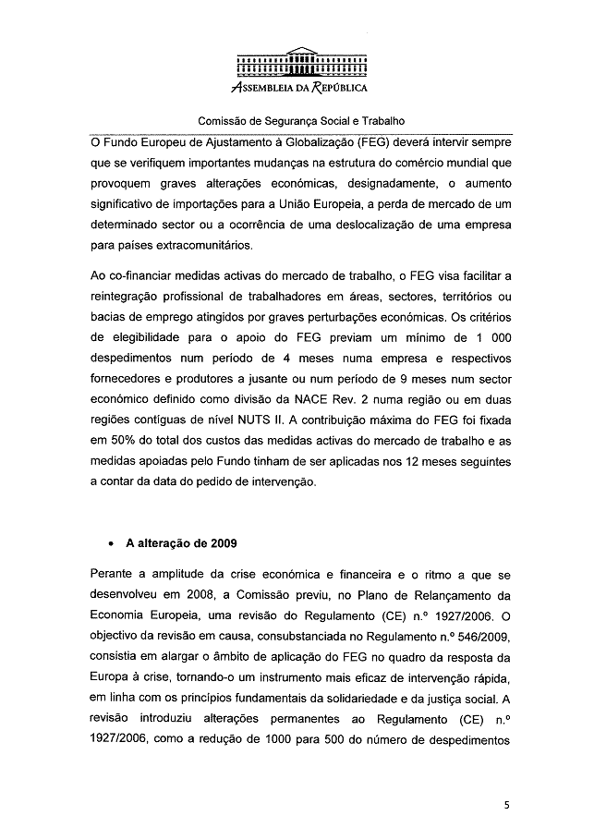
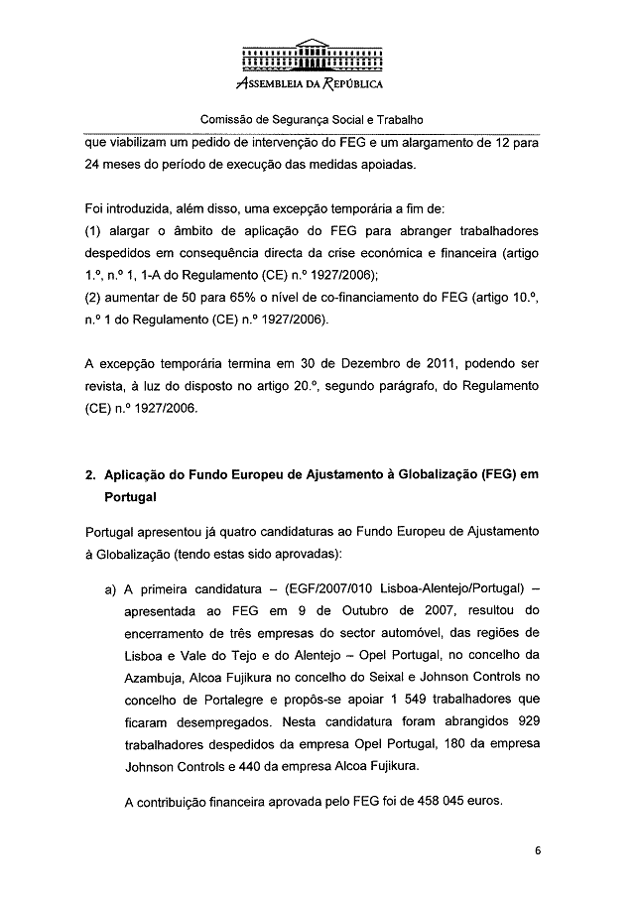
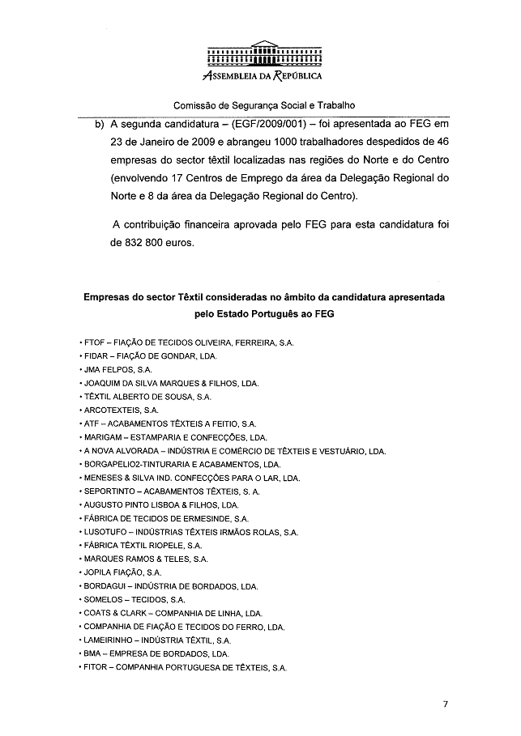
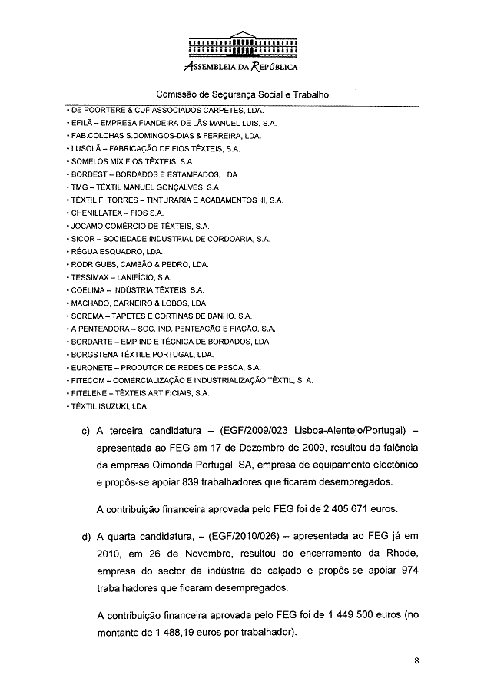
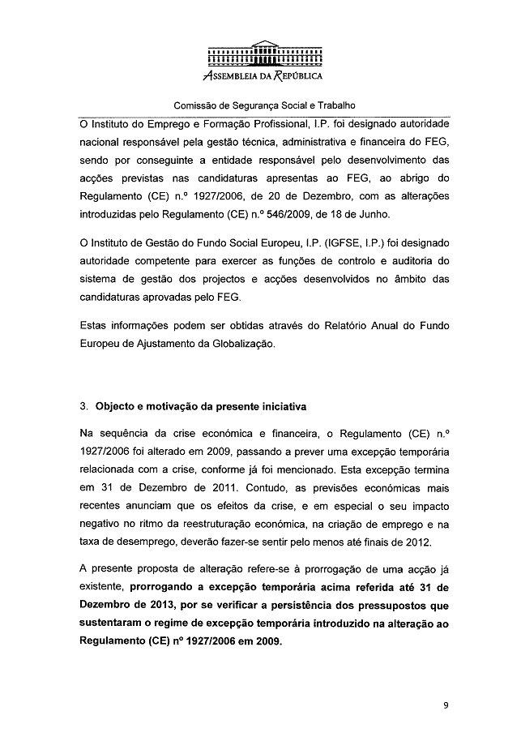
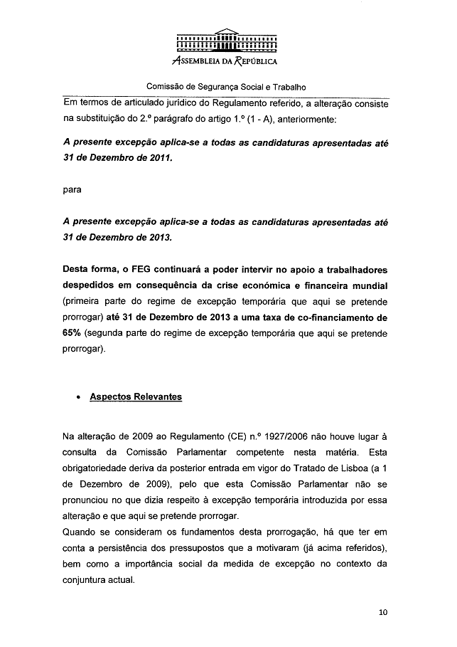
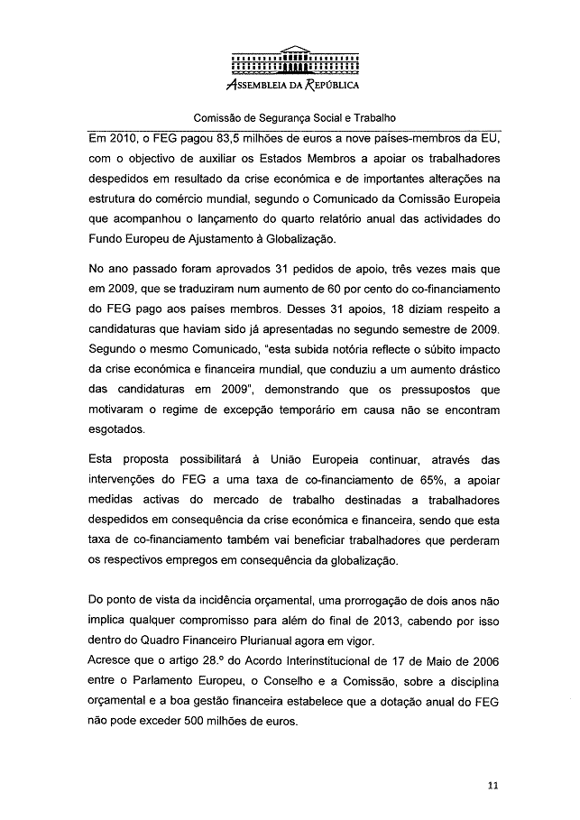
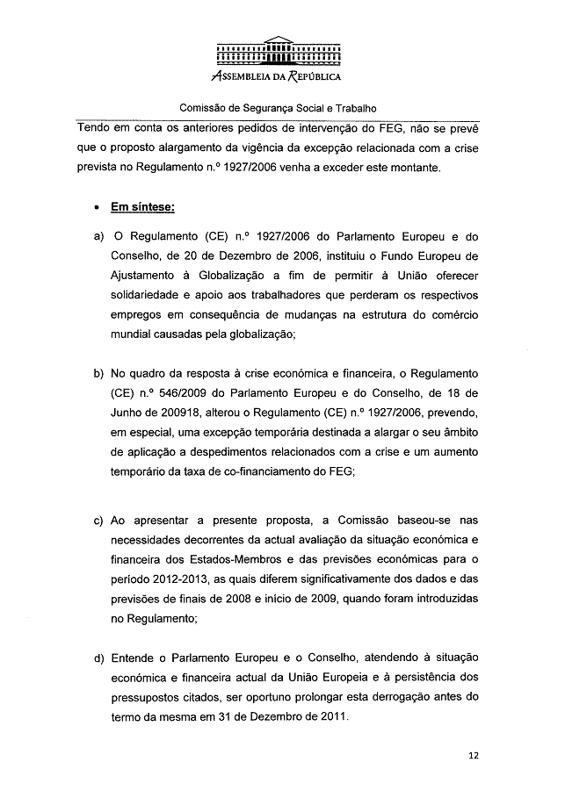
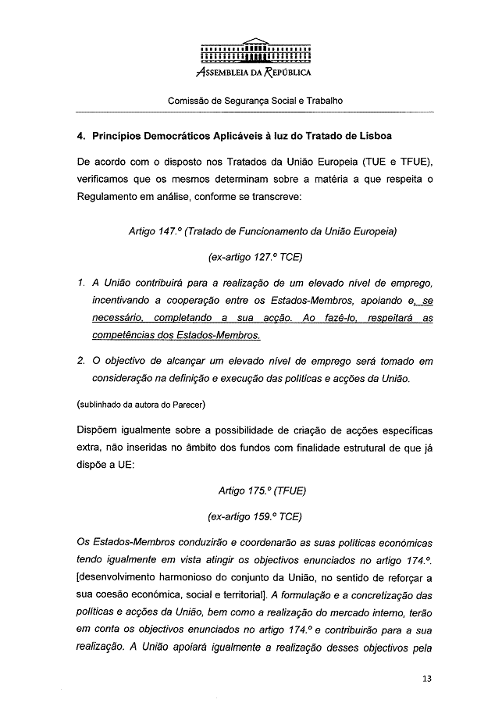
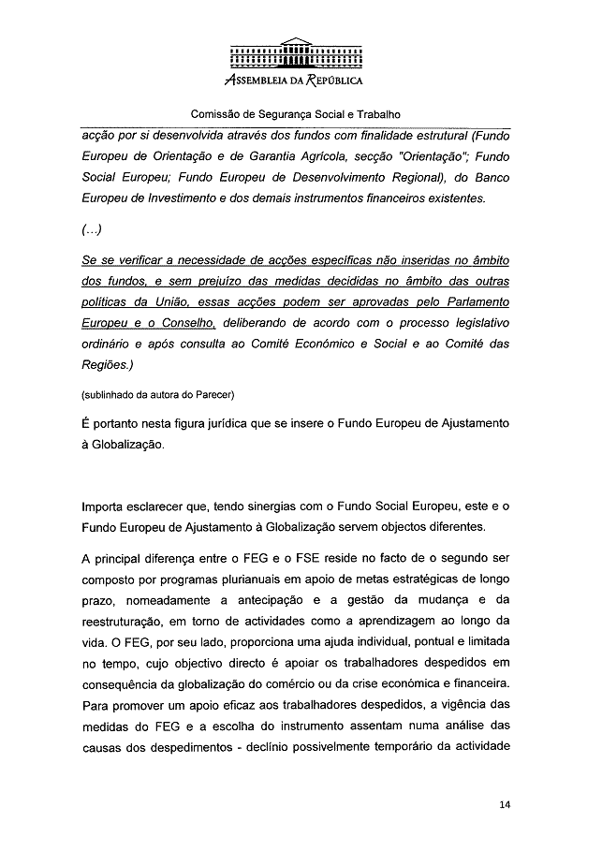
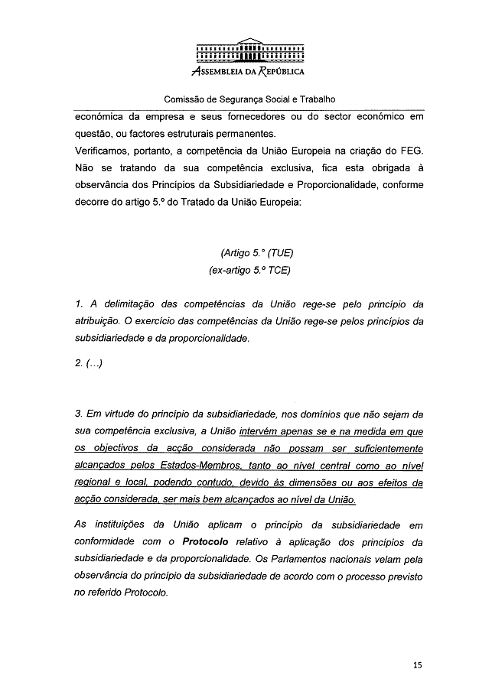
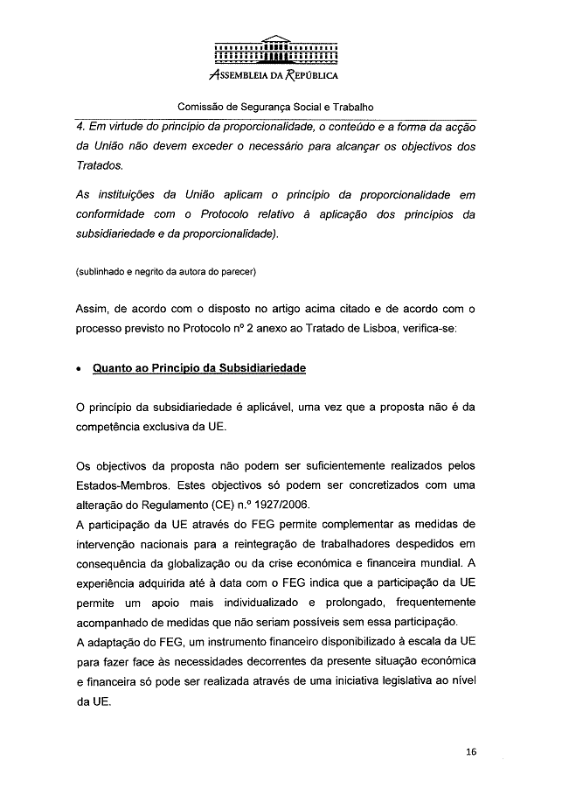
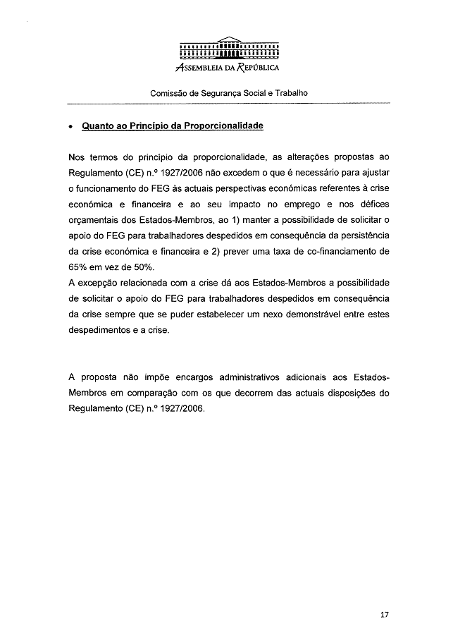
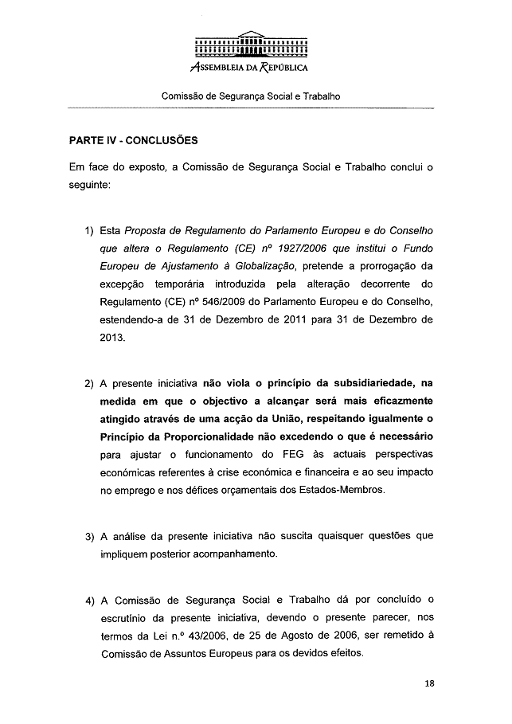
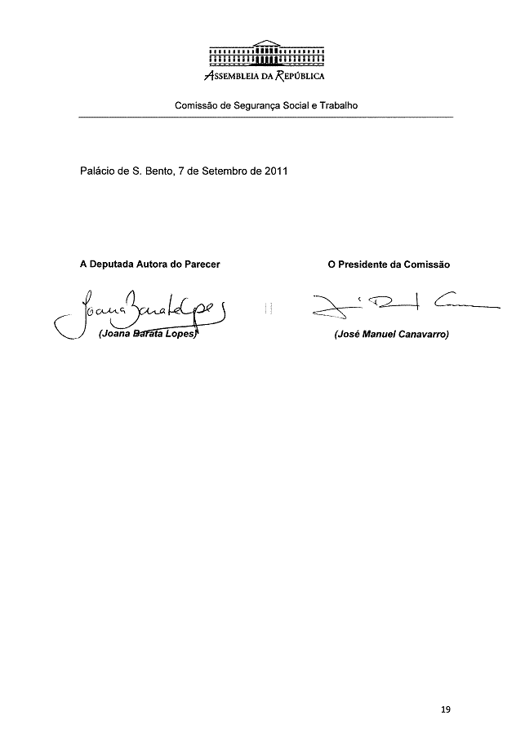

For available translations of this opinion see the interparliamentary EU information exchange site (IPEX) at the following address: http://www.ipex.eu/ipex/cms/home/Documents/pid/10

