 | 
COUNCIL OF  THE EUROPEAN UNION |  |  | Brussels, 15 September 2011
 | Interinstitutional File:  2011/0150 (COD) |  | 14265/11
COMPET 399
IND 105
MI 429
RECH 303
ENT 191
TELECOM 125
CODEC 1454
INST 410
PARLNAT 202

COVER NOTE
from: | the Assembly of the Portuguese Republic
date of receipt: | 9 September 2011
to: | the Council of the European Union
No. Cion prop. | 11300/11 and 11300/1/11 REV 1 (en,fr,hu,mt) COMPET 262 IND 81 MI 301 RECH 178 ENT 135 TELECOM 92 CODEC 989 - COM(2011) 315 final
Subject: | Proposal for a Regulation of the European Parliament and of the Council on European Standardisation and amending Council Directives 89/686/EEC and 93/15/EEC and Directives 94/9/EC, 94/25/EC, 95/16/EC, 97/23/EC, 98/34/EC, 2004/22/EC, 2007/23/EC, 2009/105/EC and 2009/23/EC of the European Parliament and of the Council  - Opinion on the application of the Principles of Subsidiarity and Proportionality

Delegations will find attached for information a copy of the above opinion.

________________________

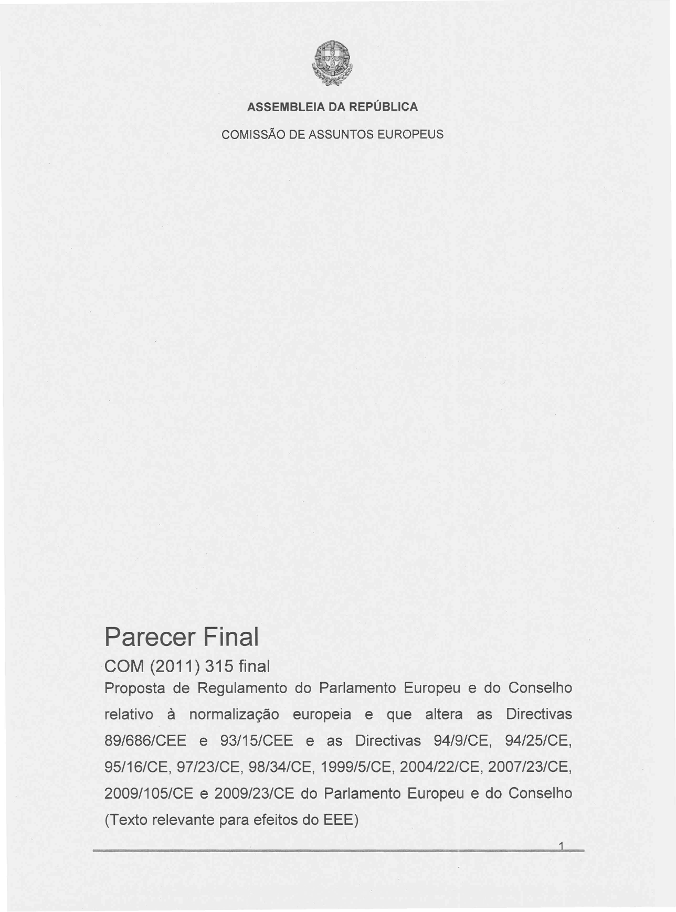
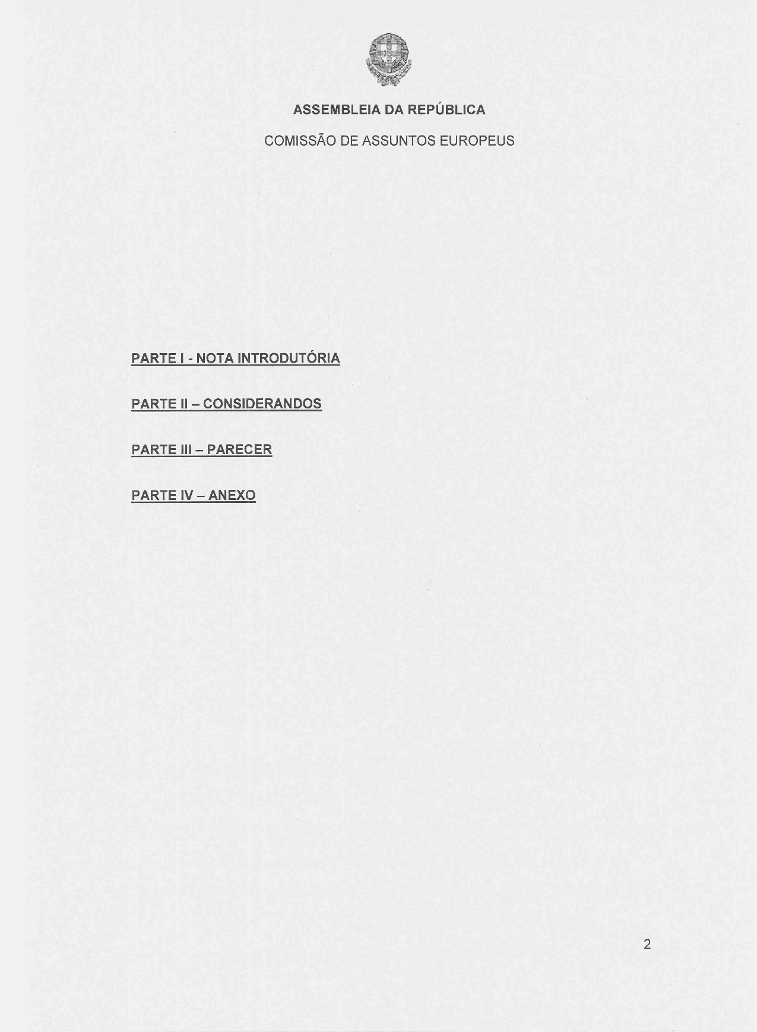
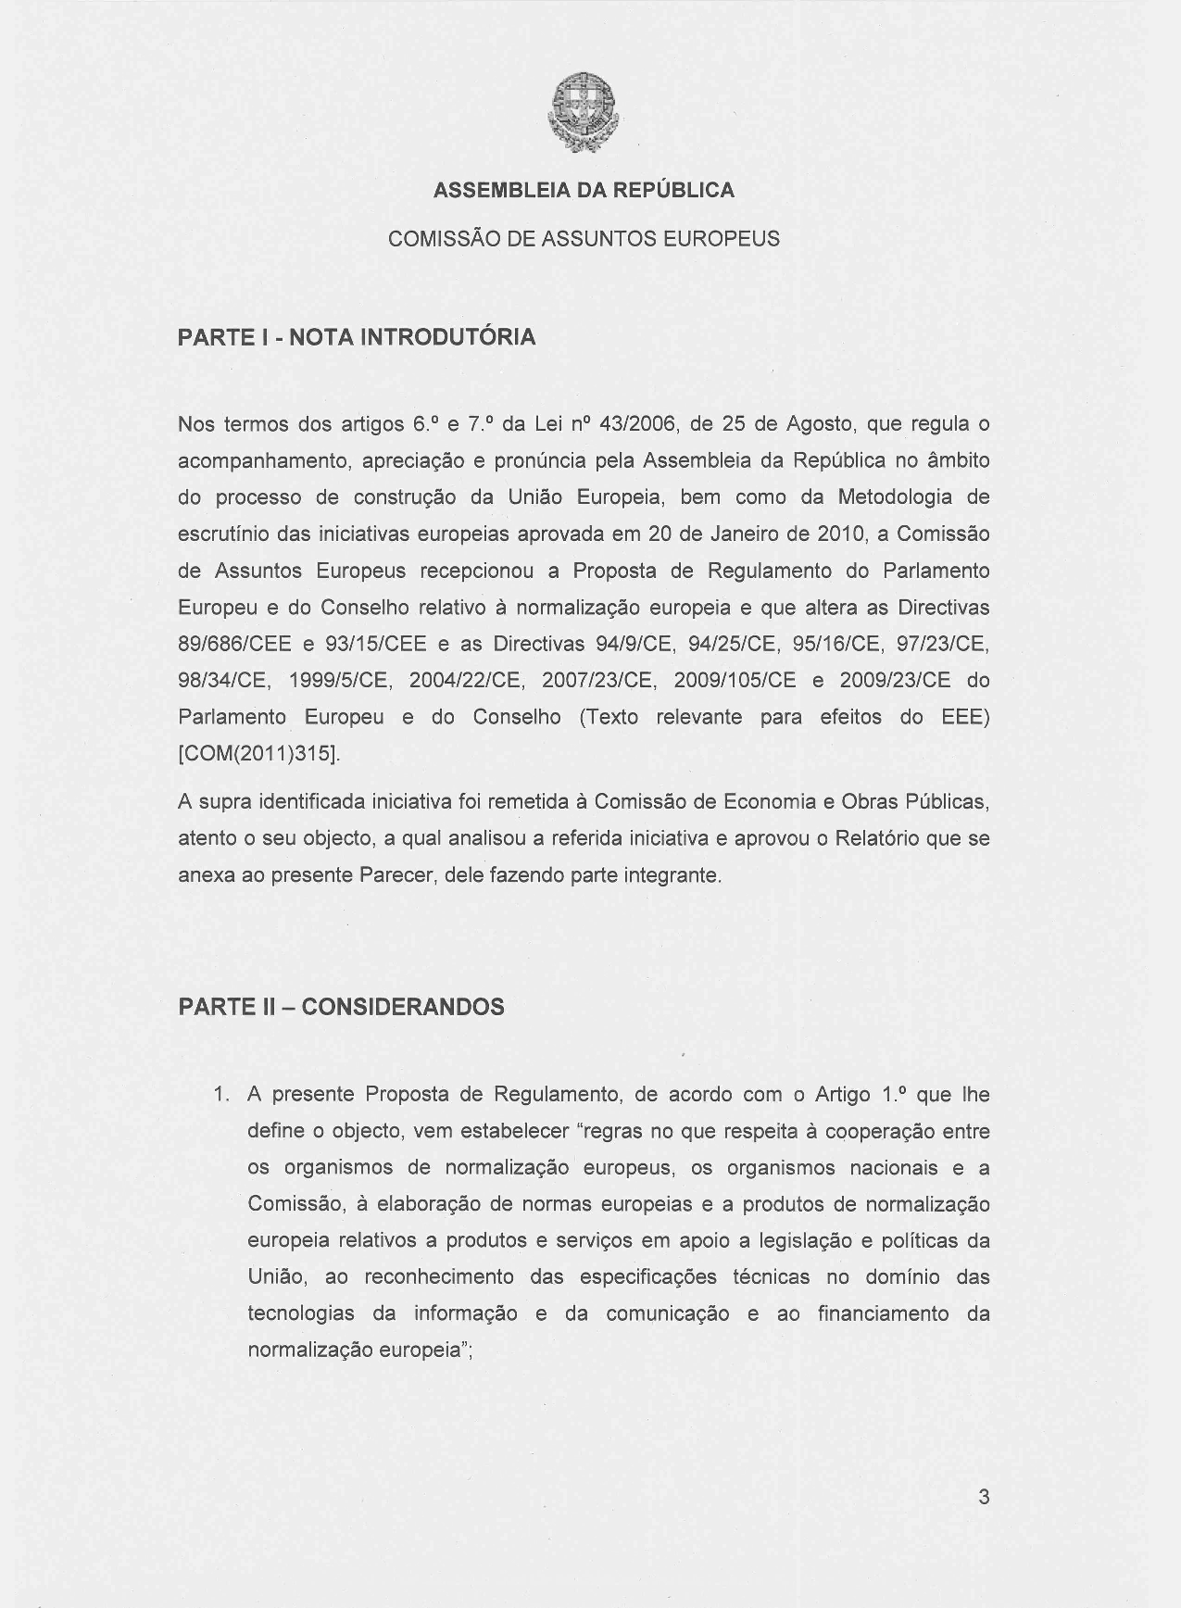
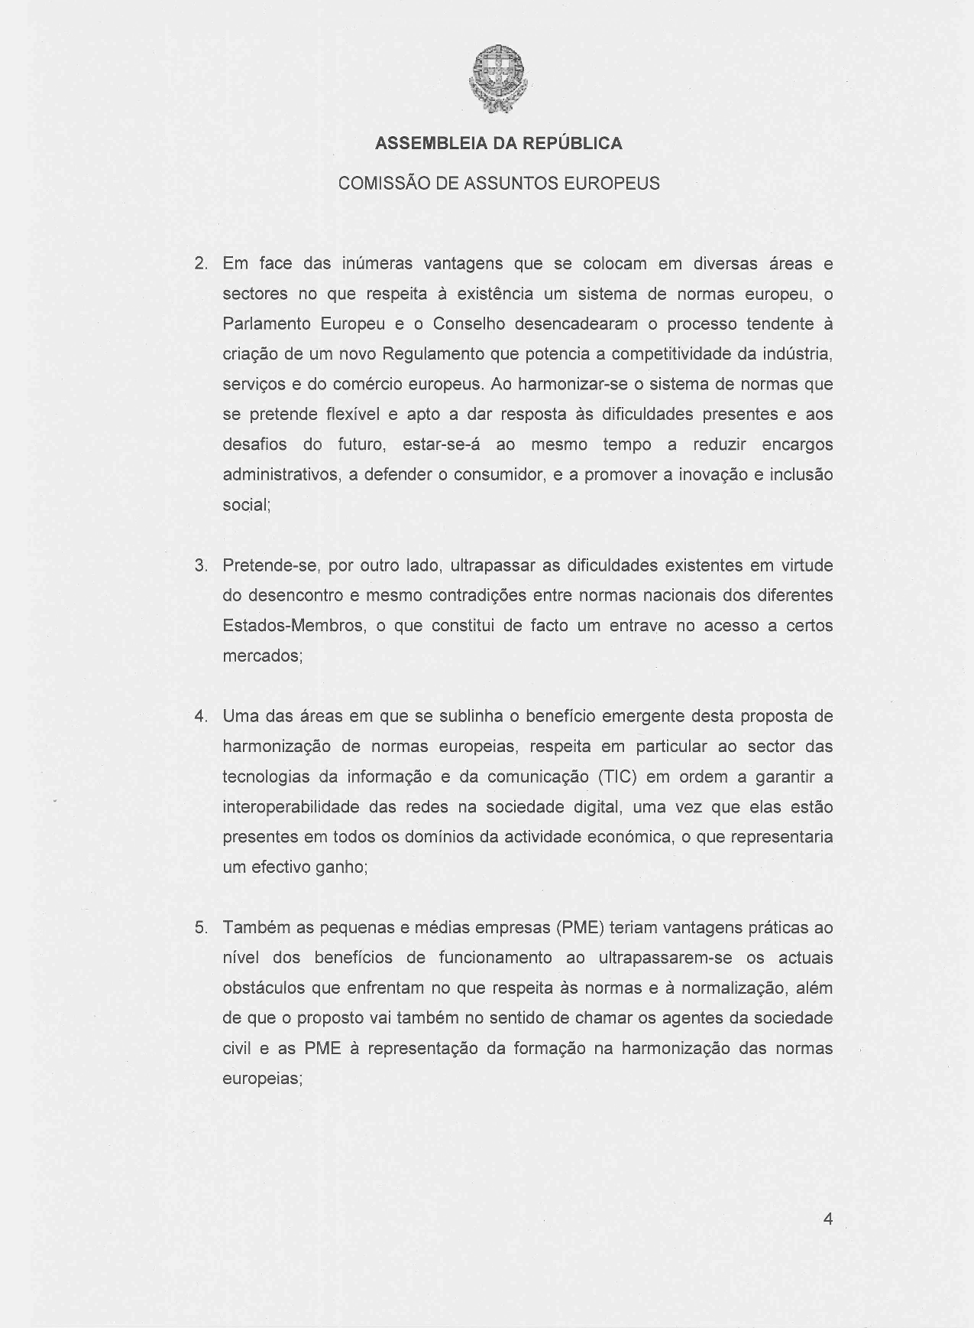
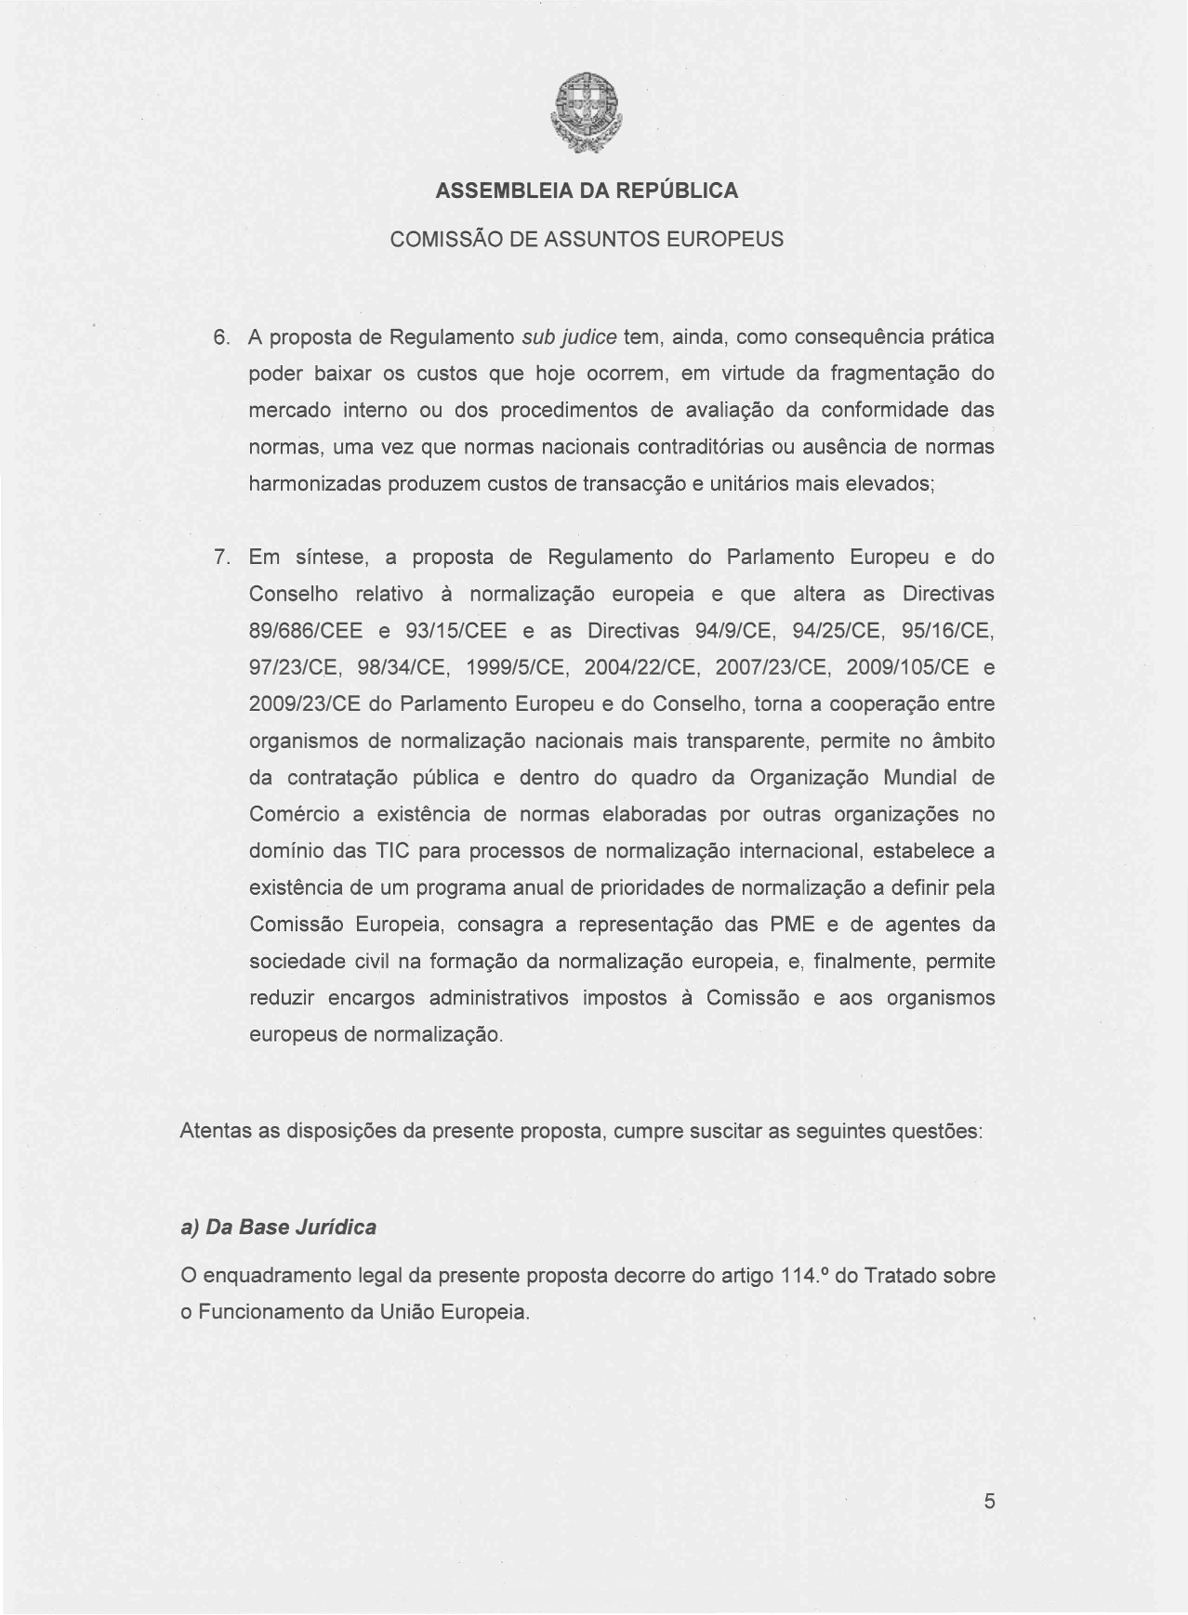
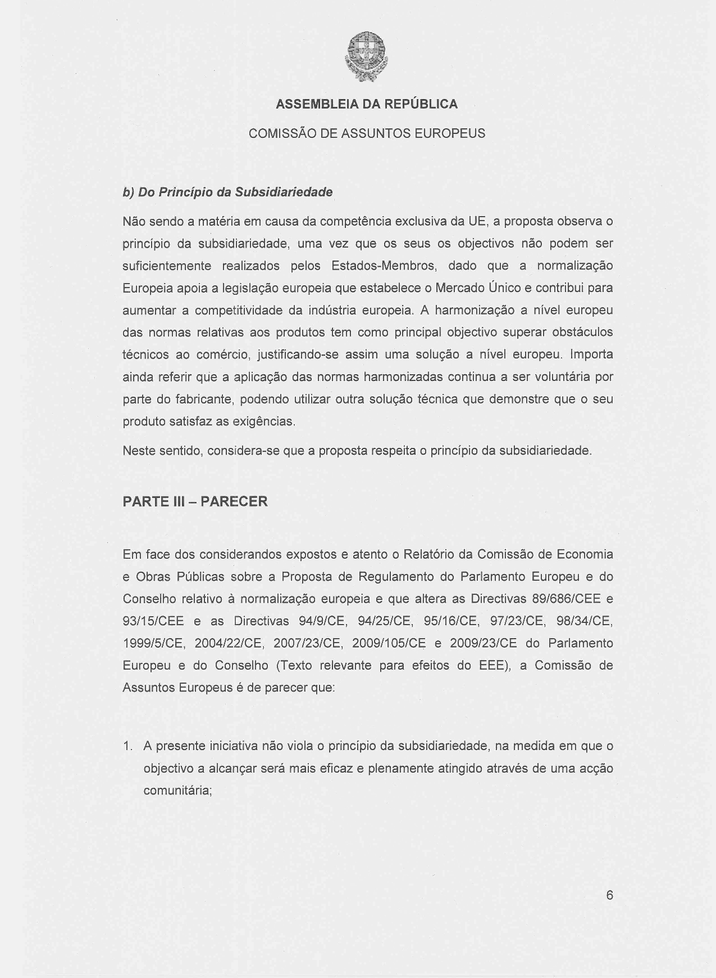
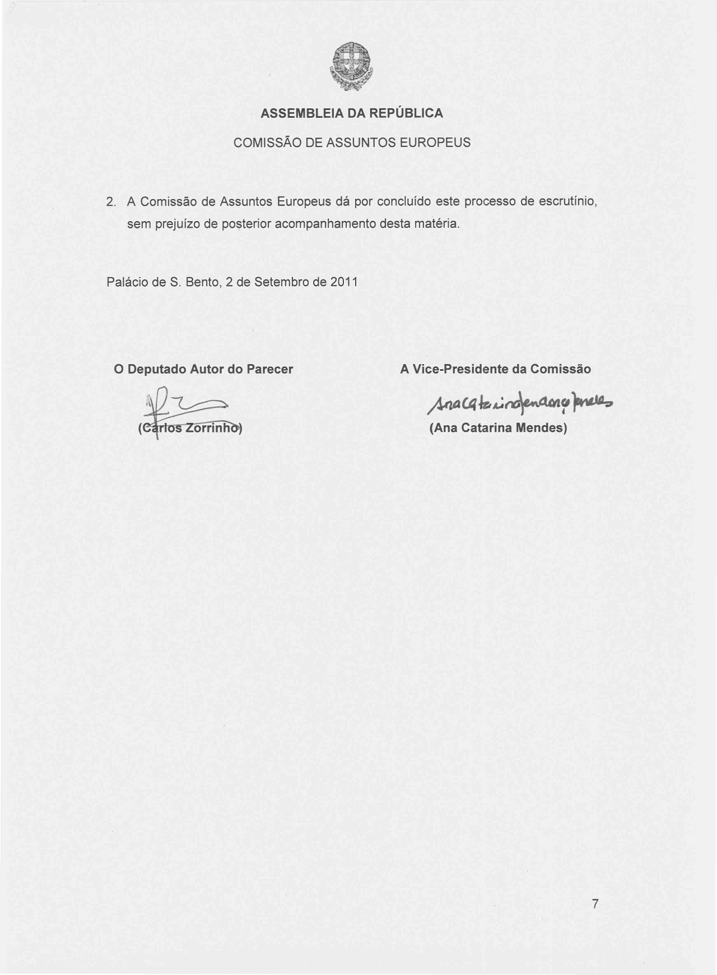
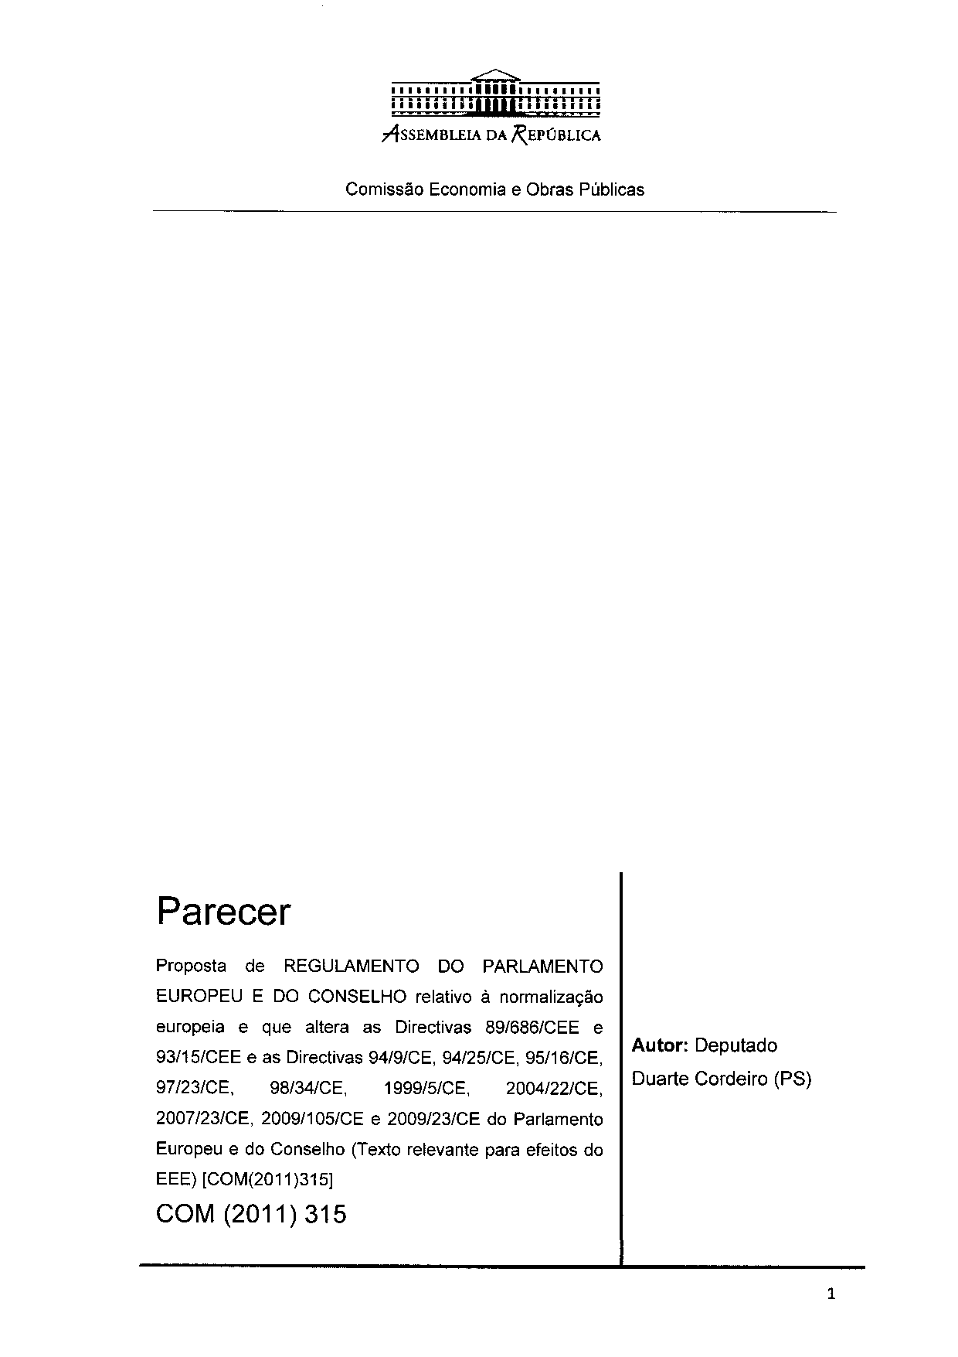
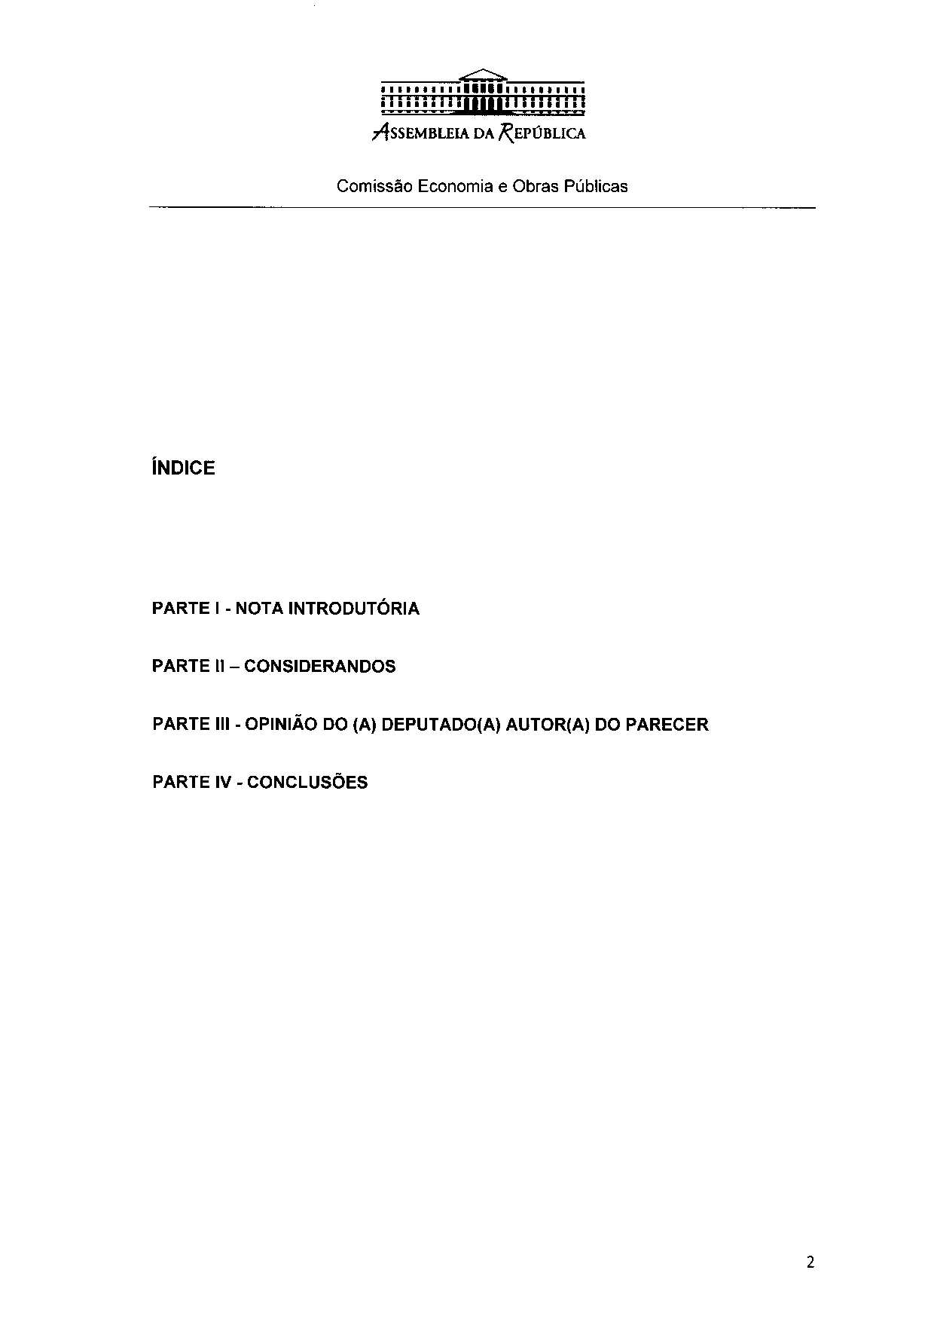
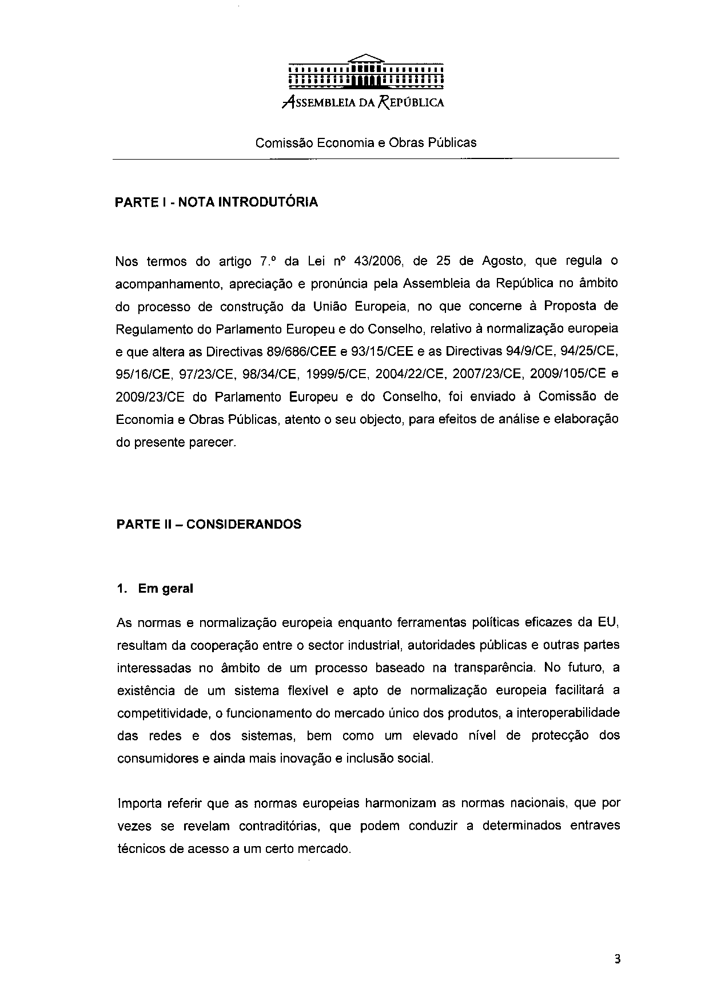
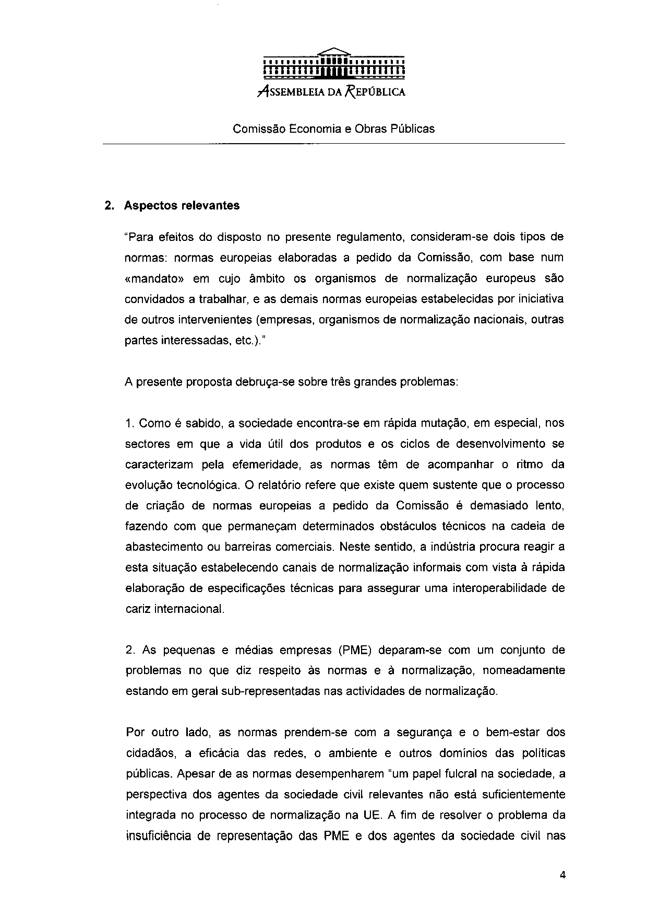
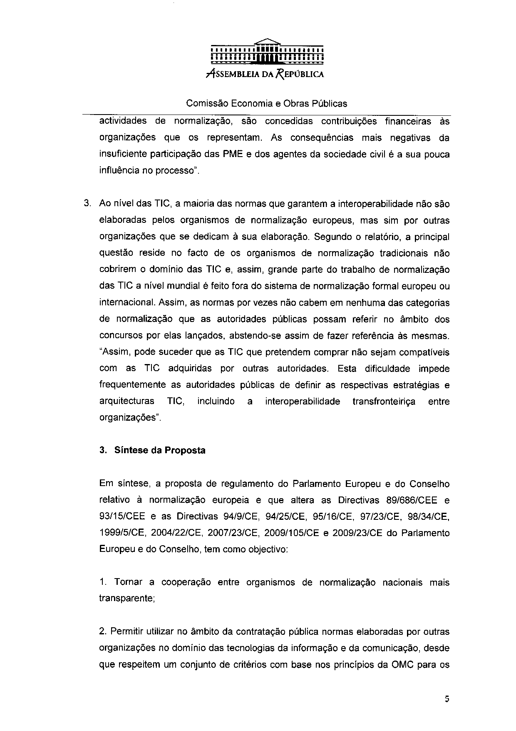
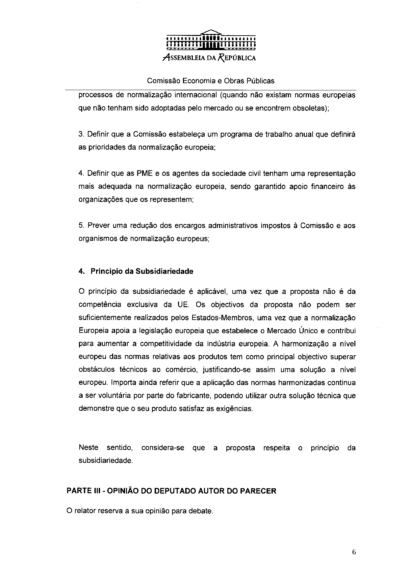
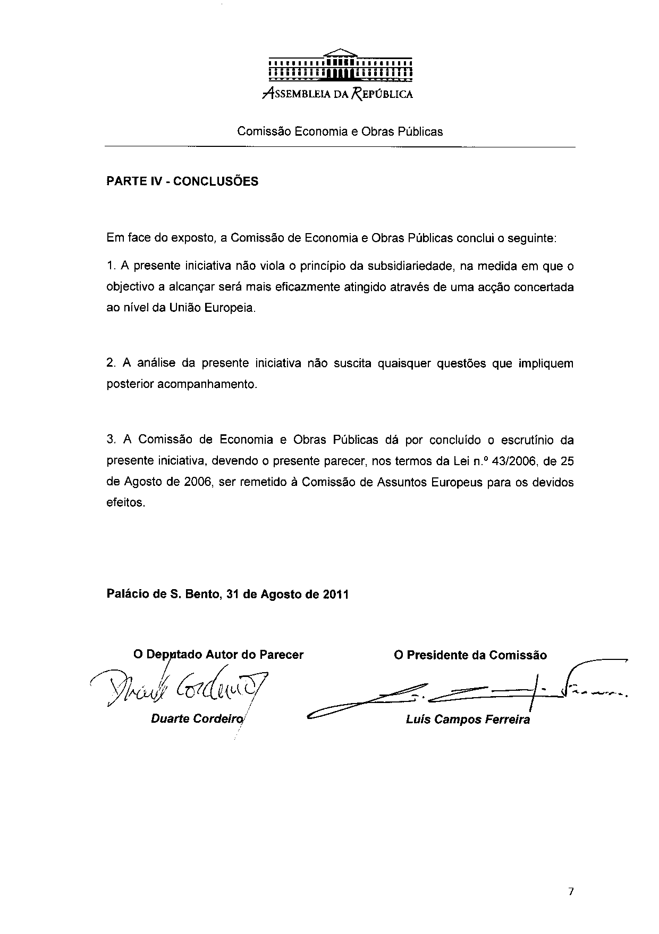

The translation can be found at the Interparliamentary EU information exchange site IPEX at the following address: http://www.ipex.eu/IPEXL-WEB/dossier/document/COM20110315FIN.do#dossier-COD20110150

