 | 
COUNCIL OF  THE EUROPEAN UNION |  |  | Brussels, 15 September 2011
 | Interinstitutional File:  2011/0058 (CNS) |  | 14222/11
FISC 116
INST 407
PARLNAT 201

COVER NOTE
from: | The President of the Italian Senate
date of receipt: | 26 July 2011
to: | The President of the Council of the European Union
Subject: | Proposal for a Council Directive on a Common Consolidated Corporate Tax Base (CCCTB)  [doc. 7263/11 FISC 23 - COM(2011) 121 final]  - Opinion on the application of the Principles of Subsidiarity and Proportionality

Delegations will find attached the abovementioned opinion.

________________________

Encl.

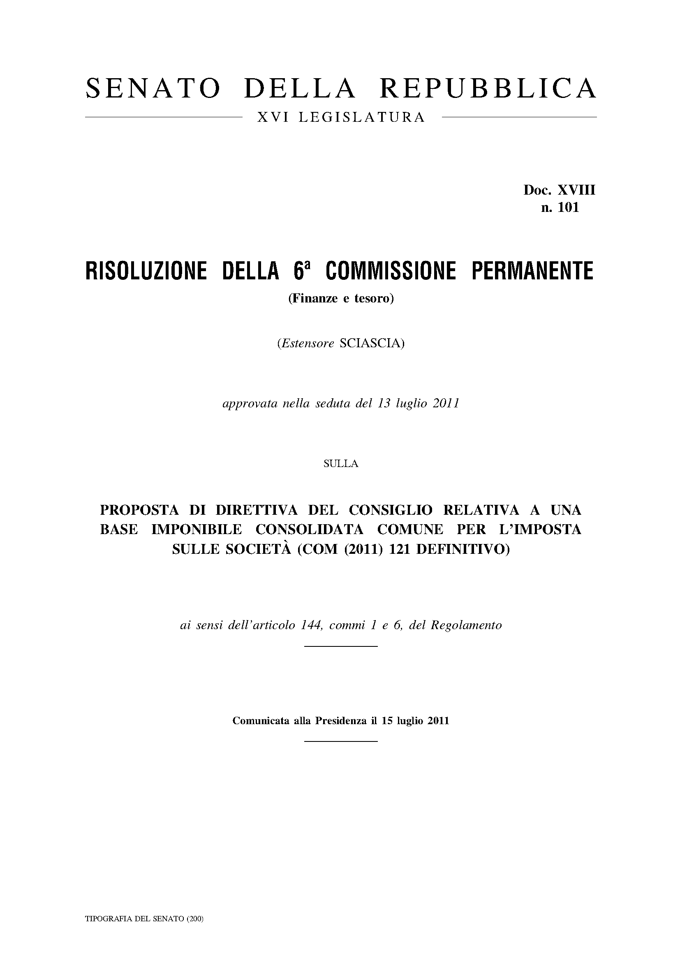

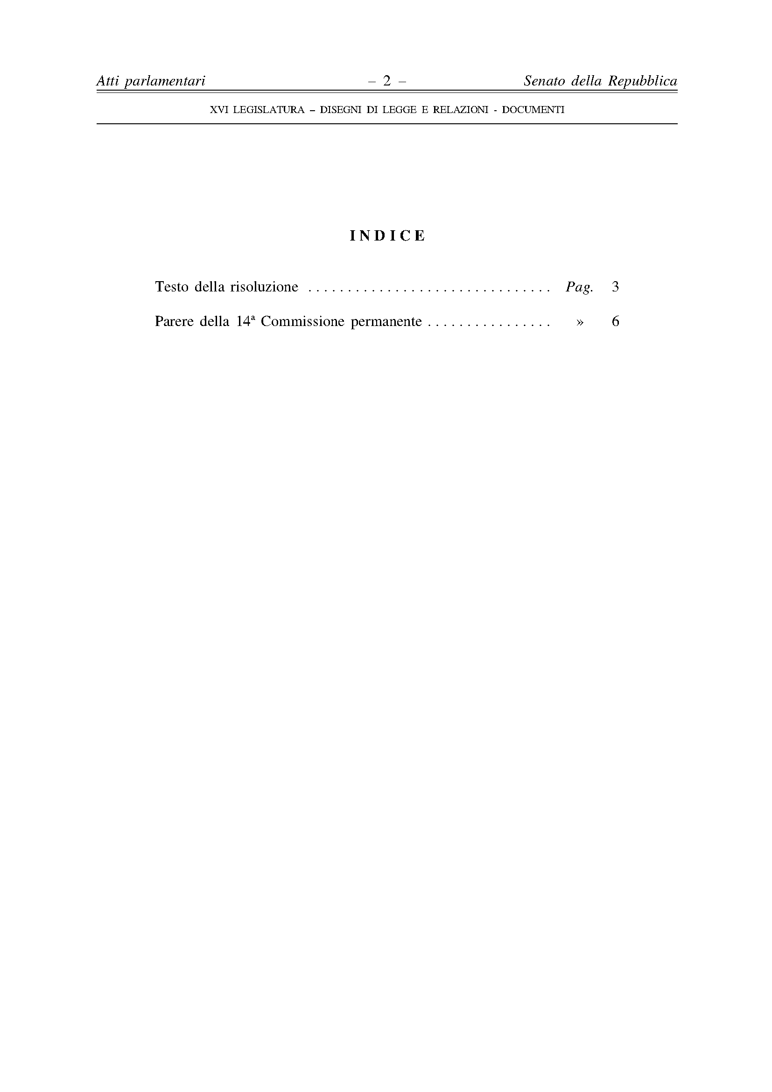

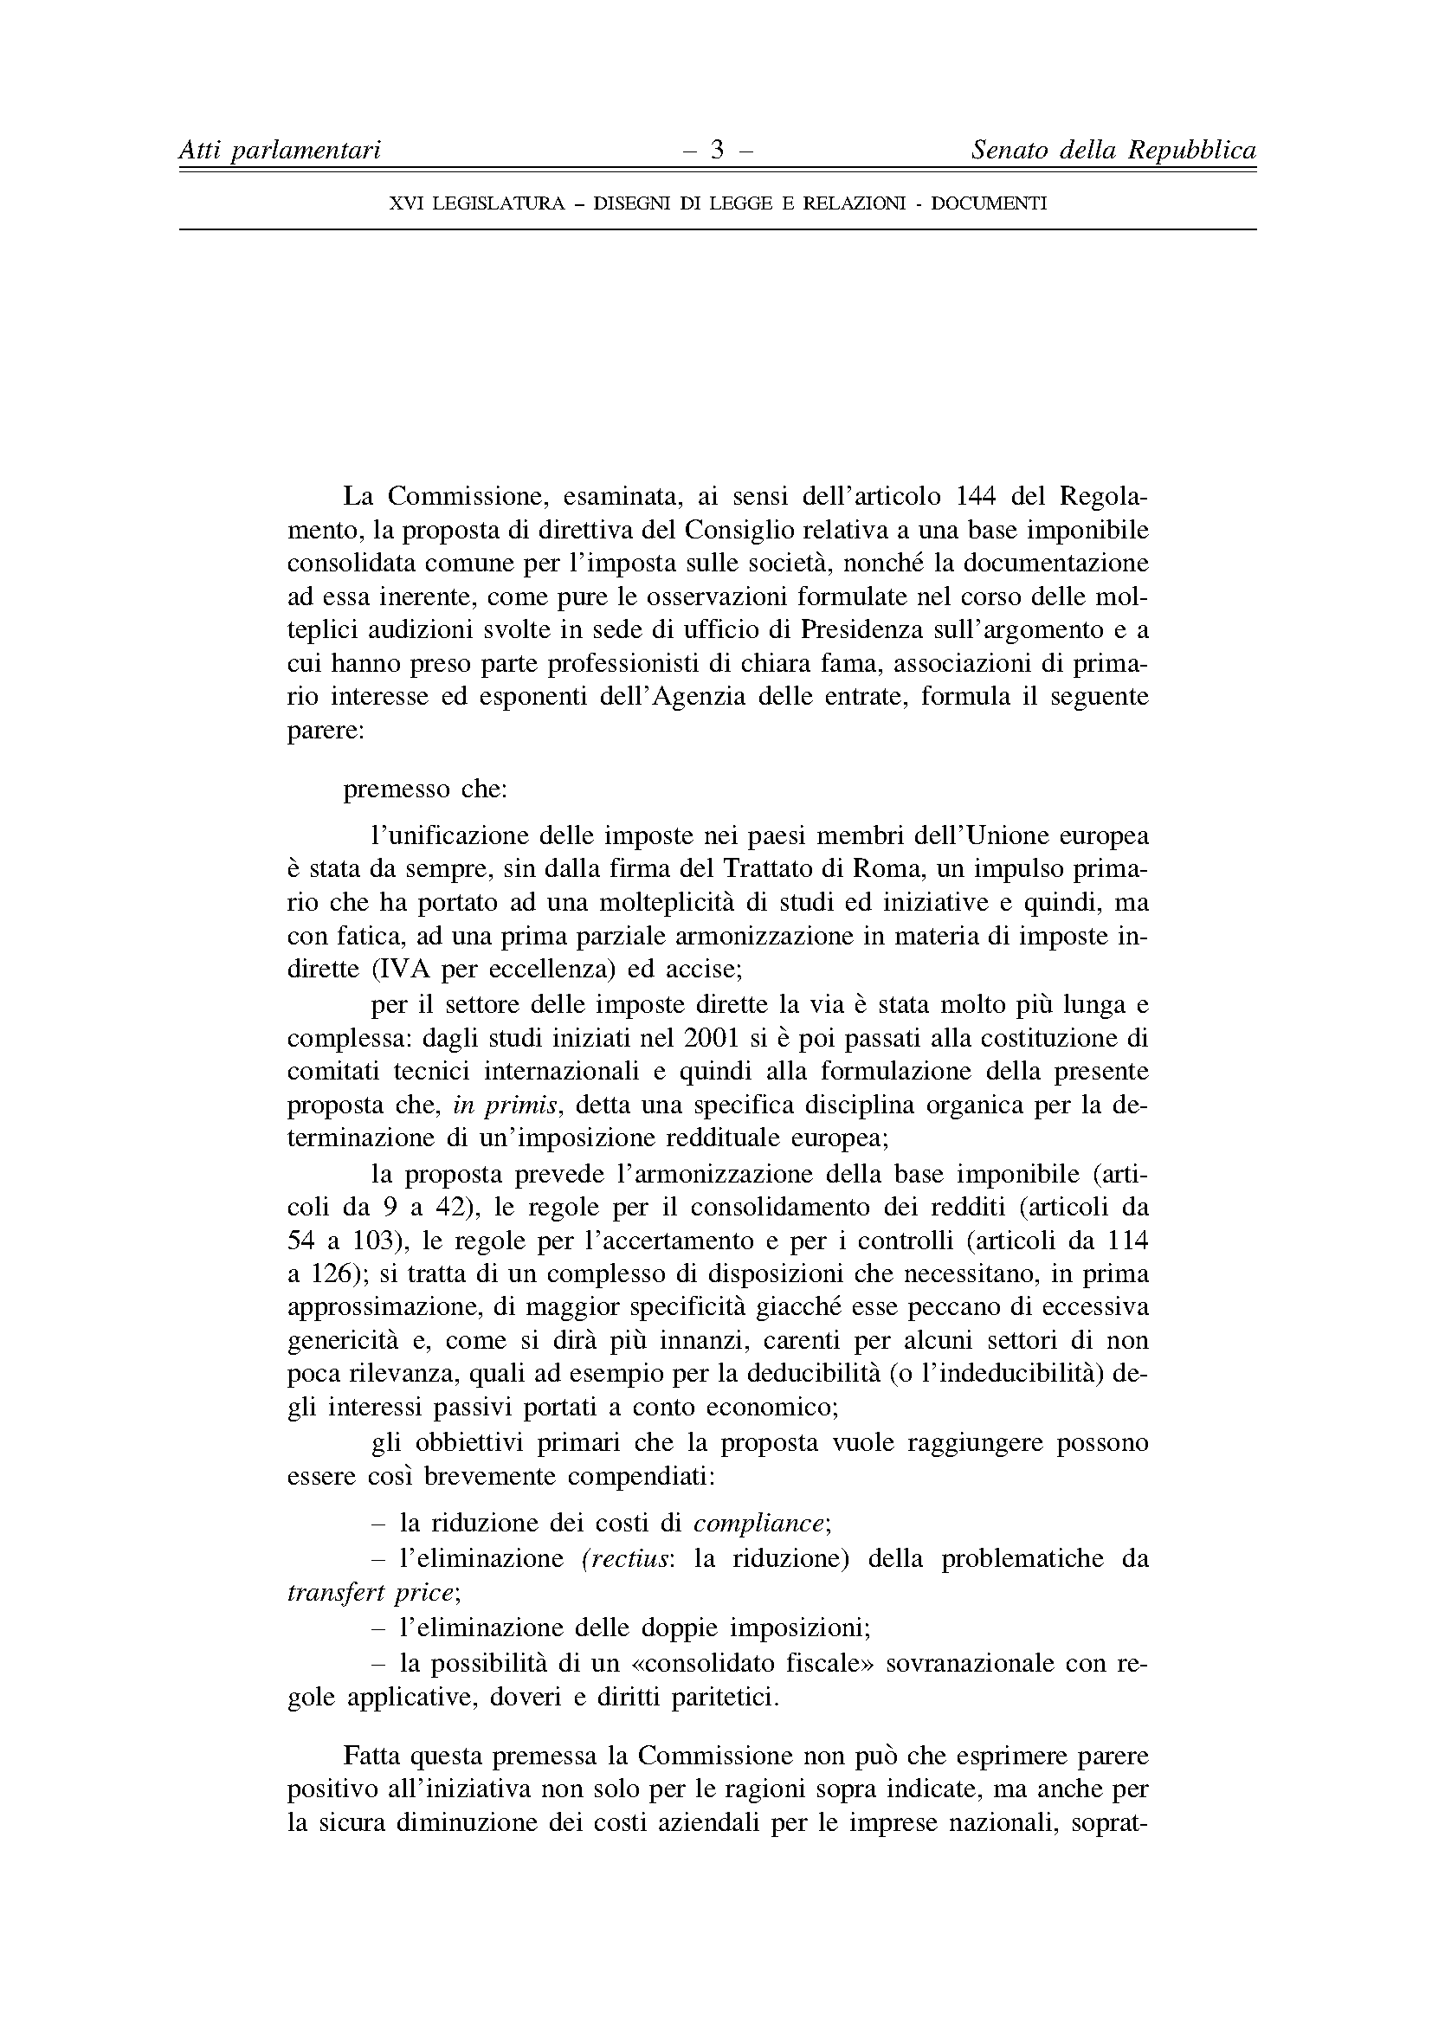

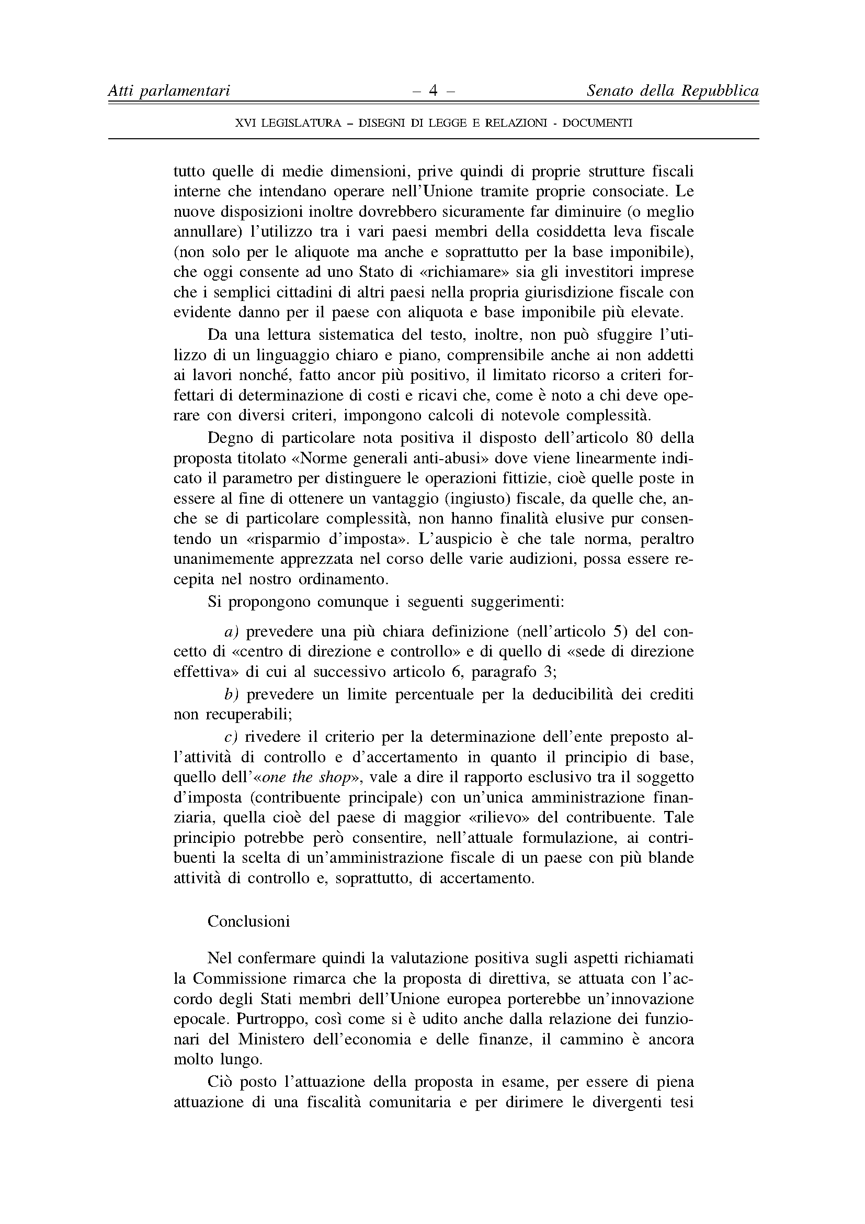

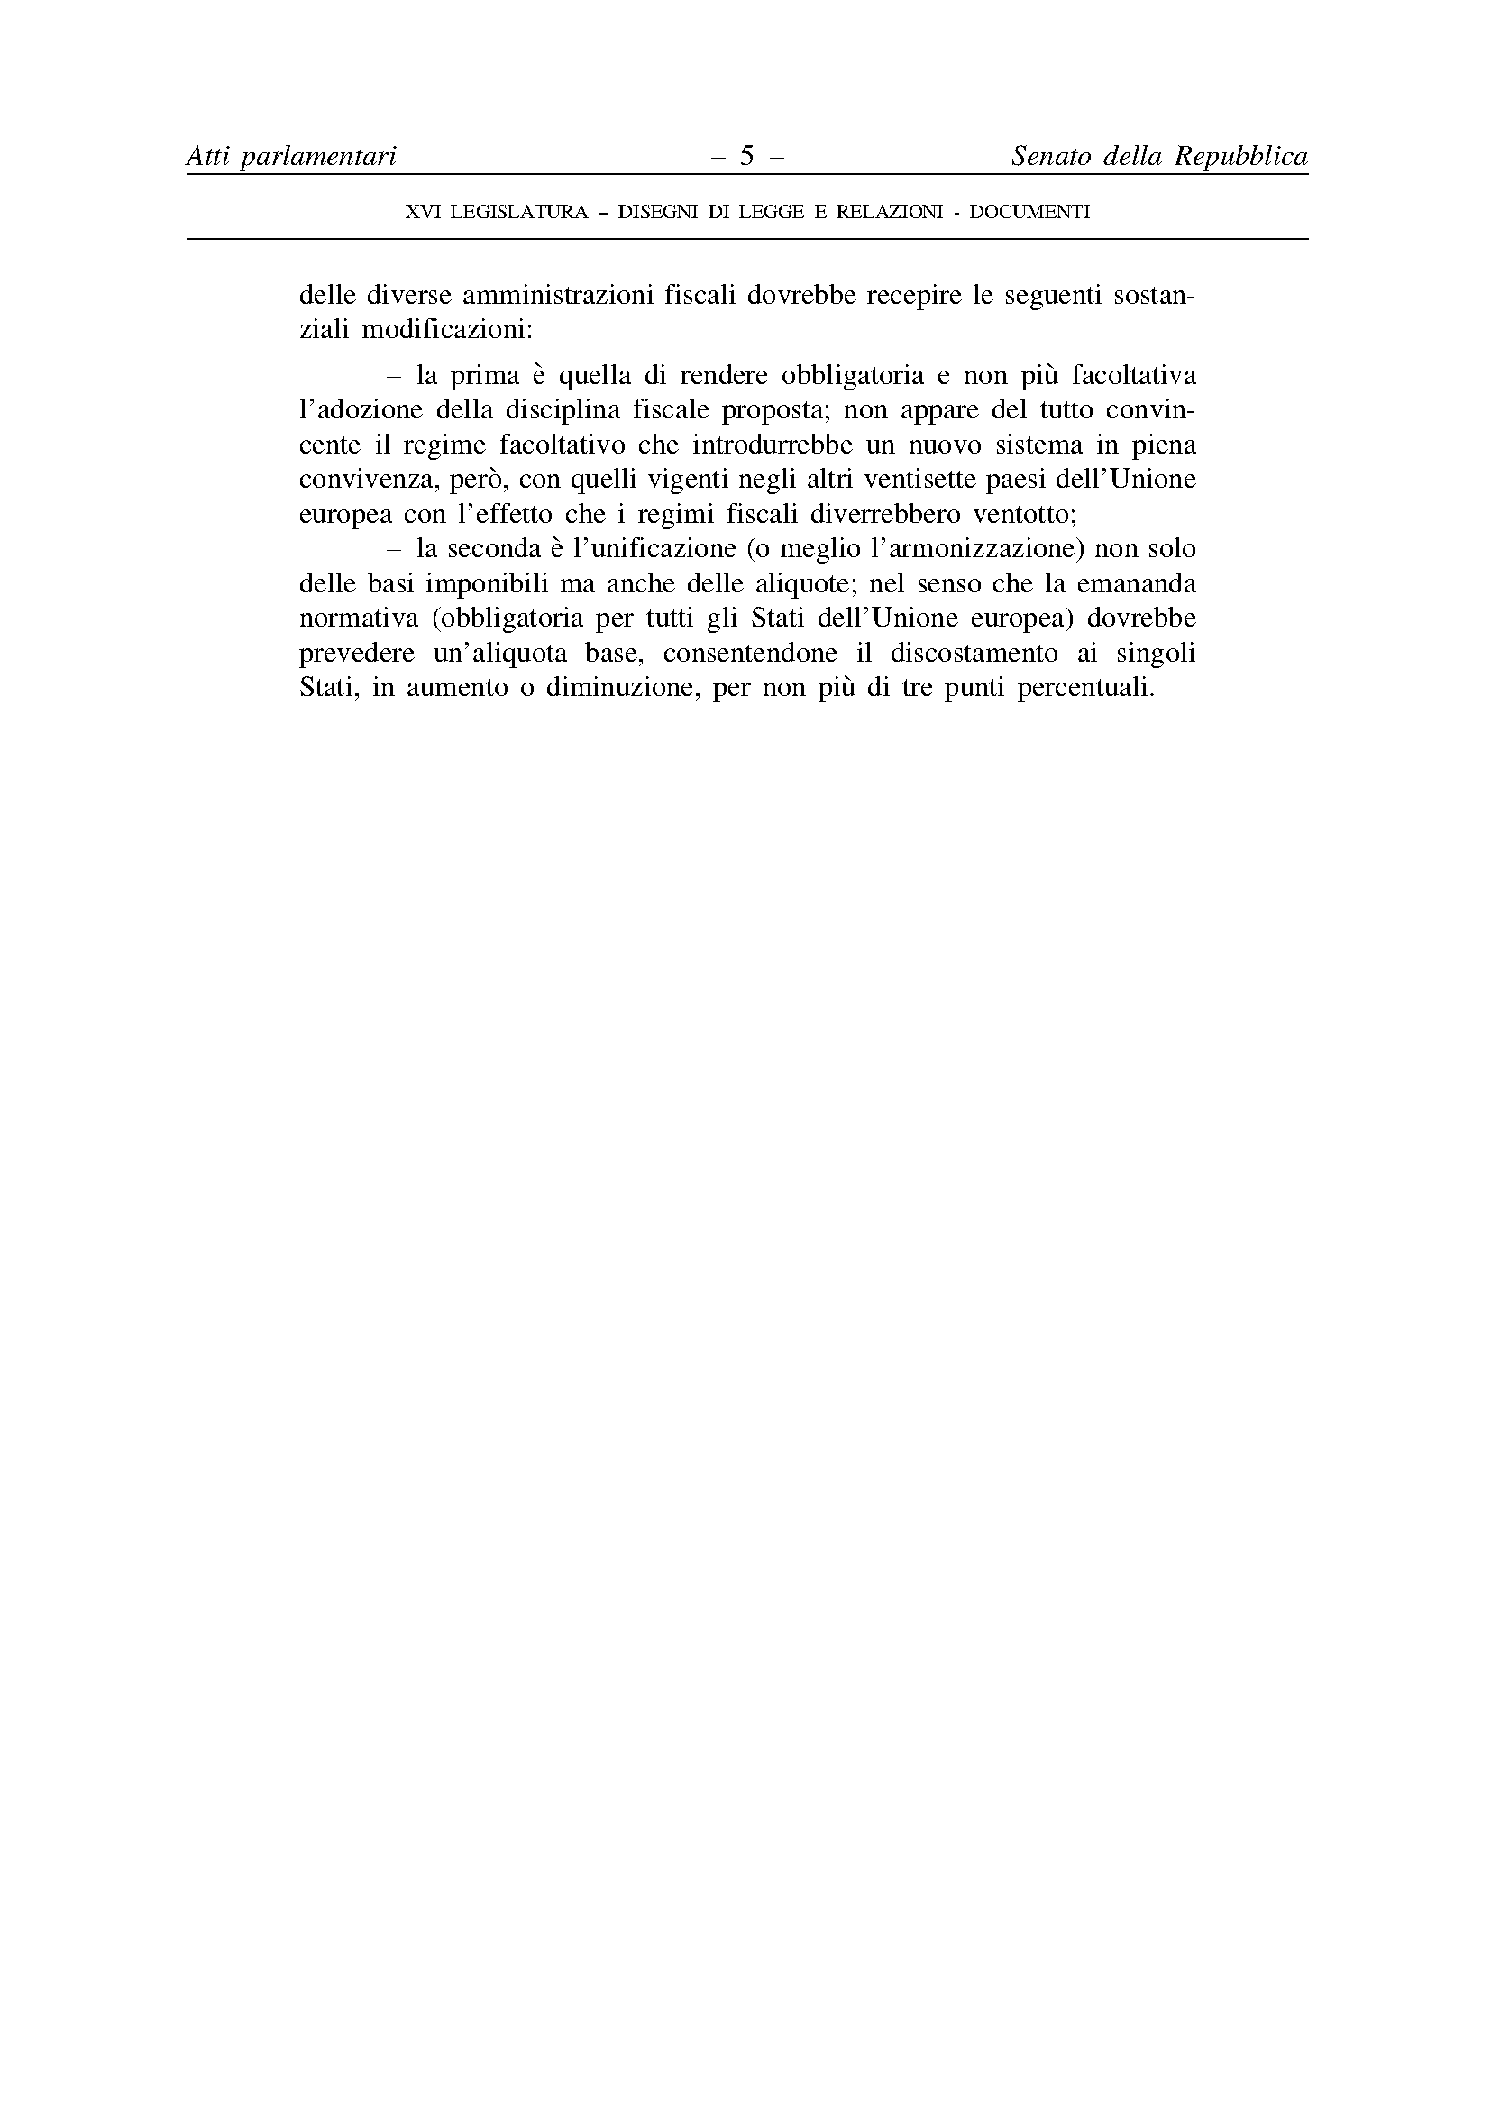

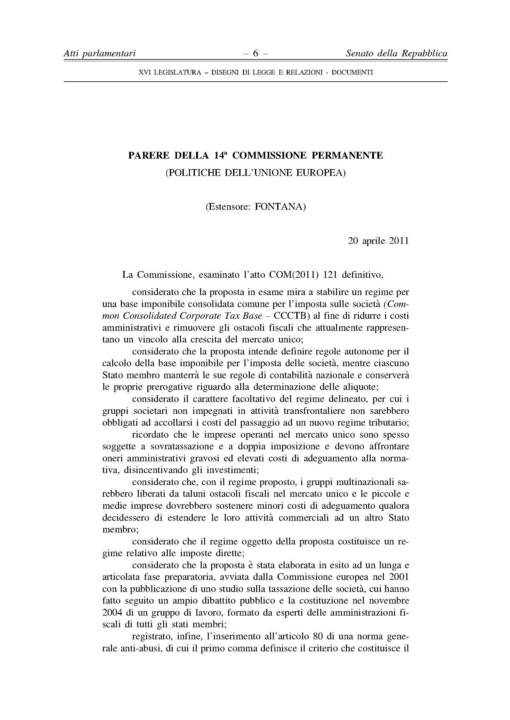

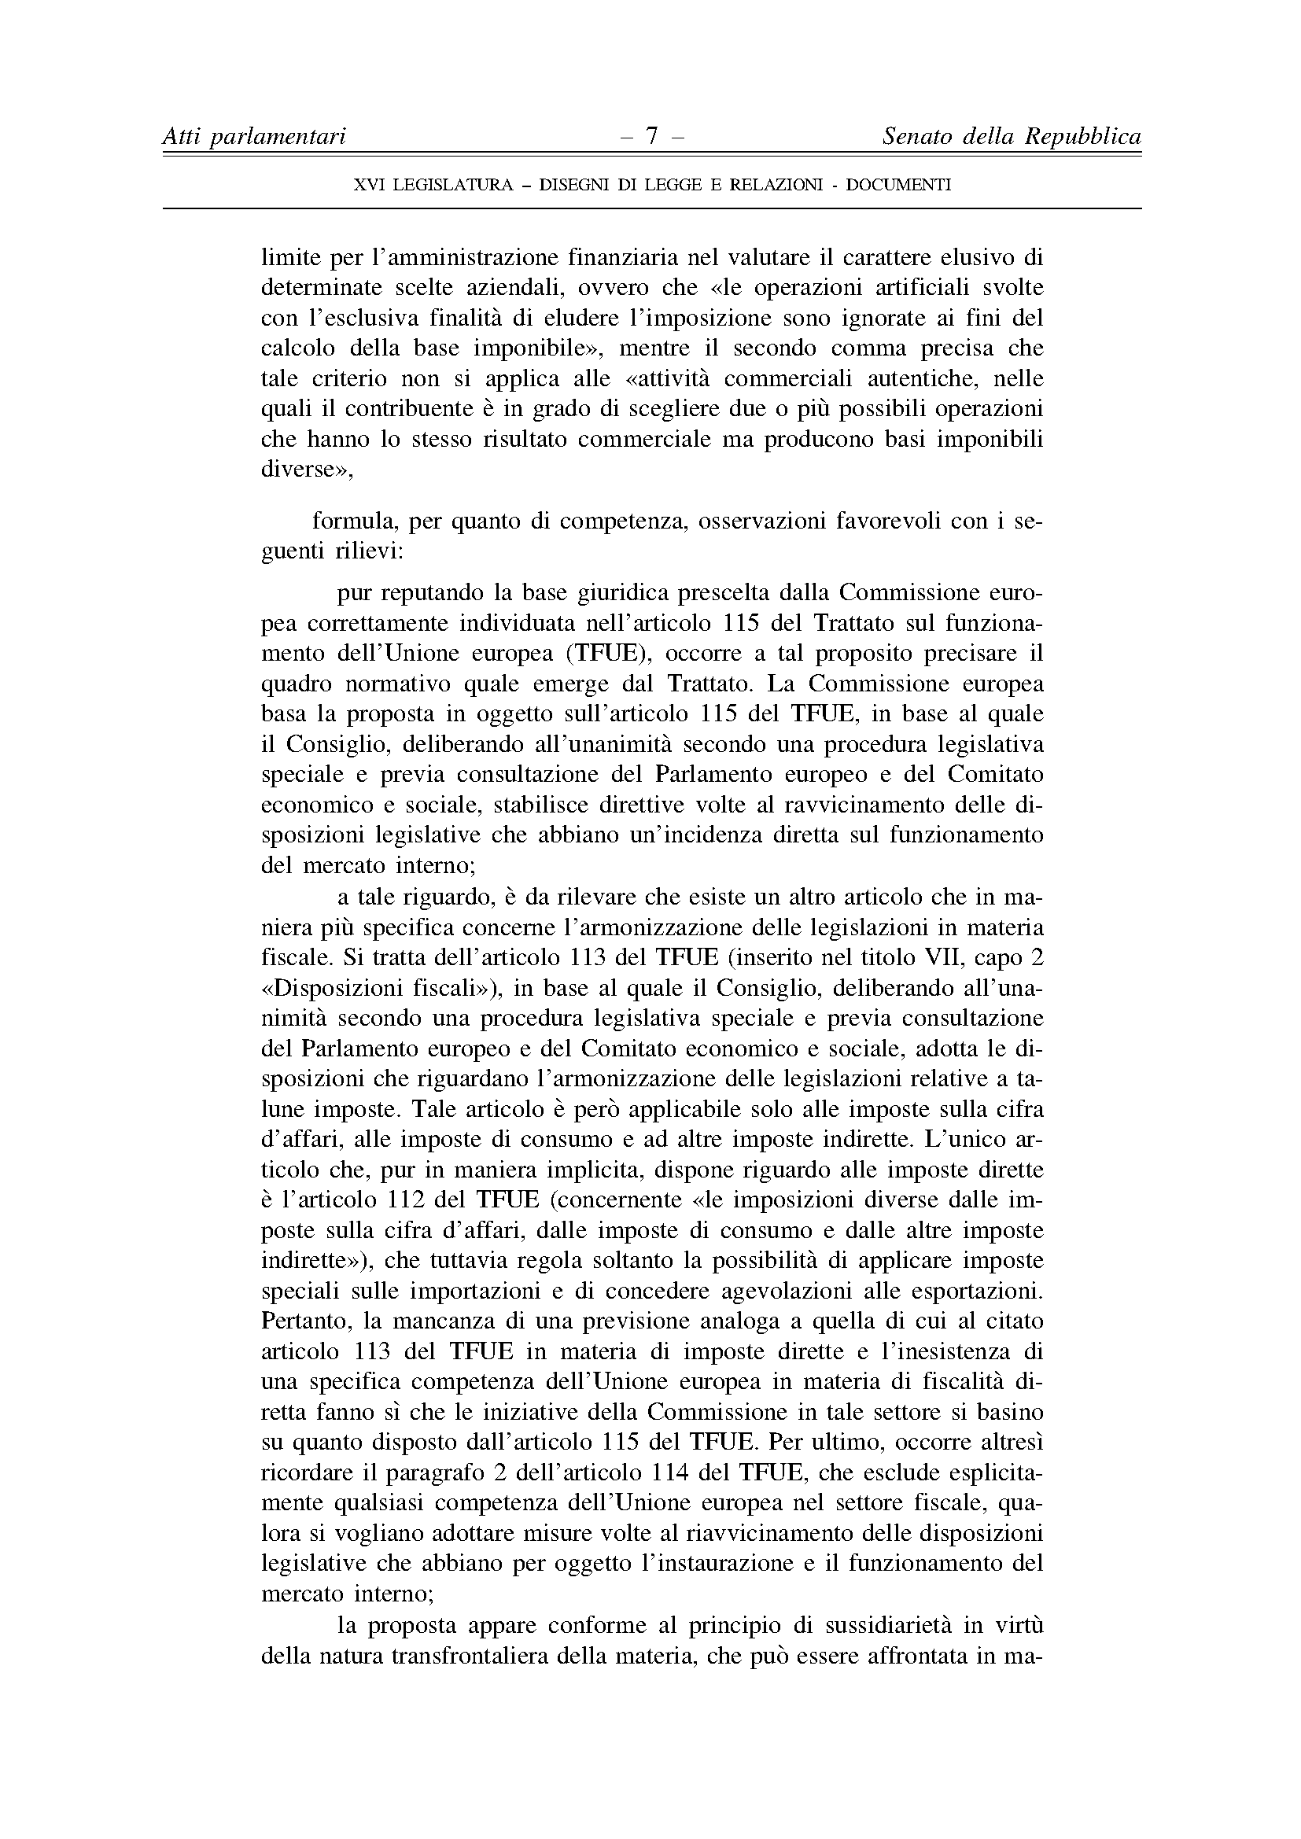

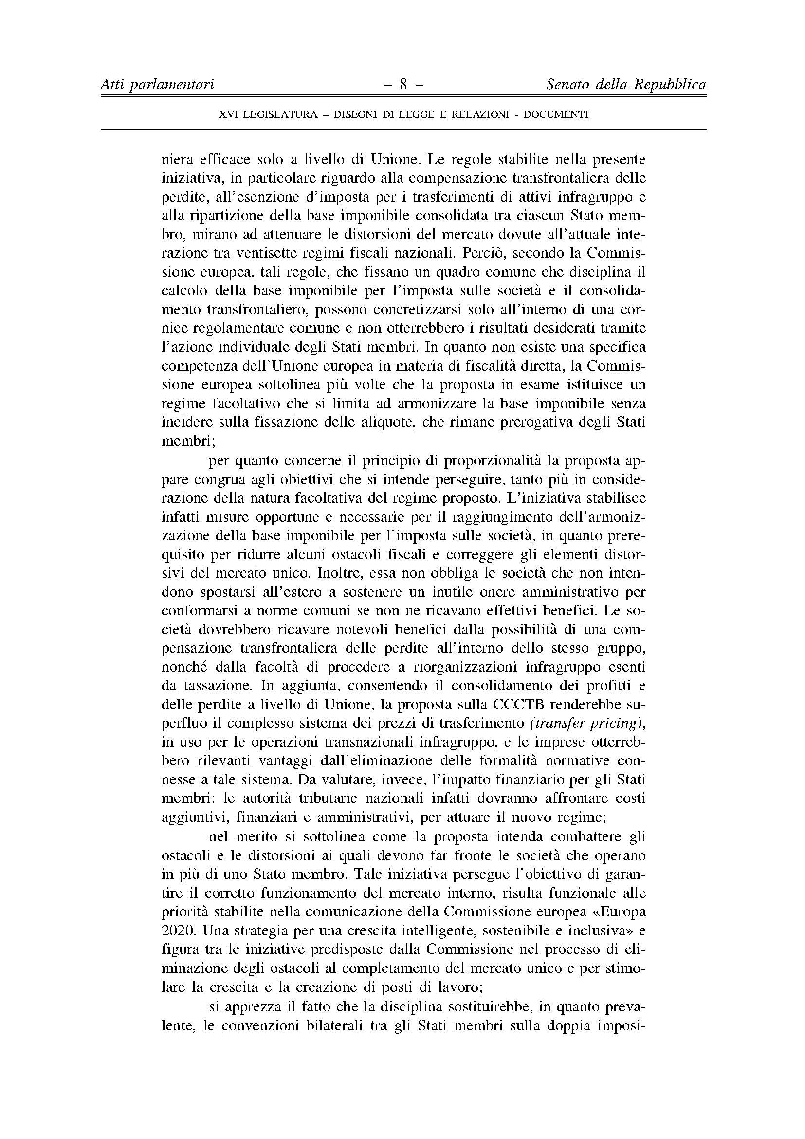

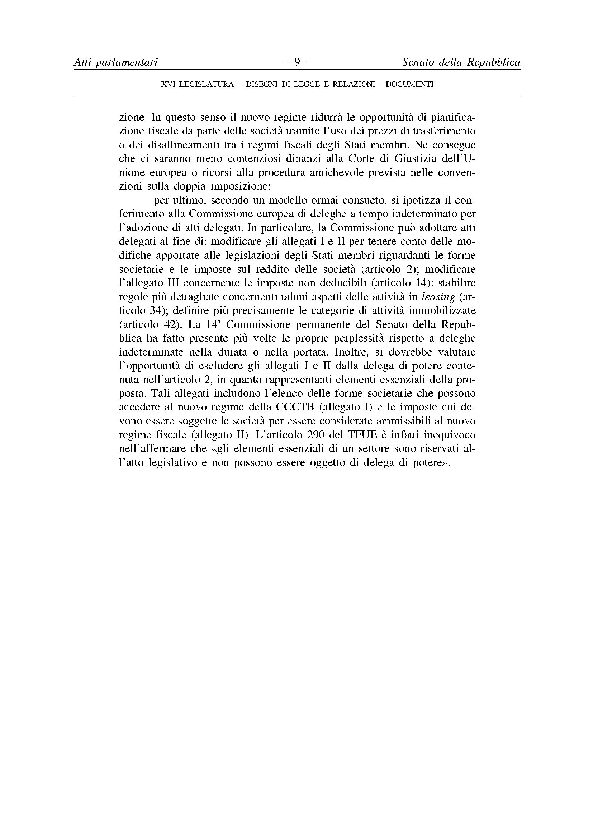

This opinion is available in English on the interparliamentary EU information exchange site (IPEX) at the following address: http://www.ipex.eu/IPEXL-WEB/search.do

