REPORT FROM THE COMMISSION TO THE EUROPEAN PARLIAMENT AND THE COUNCIL
Annual report to the European Parliament and the Council on the activities of the EURODAC Central Unit in 2010

Introduction

Scope
Council Regulation EC/2725/2000 of 11 December 2000, concerning the establishment of 'EURODAC' for the comparison of fingerprints for the effective application of the Dublin Convention (hereinafter referred to as 'EURODAC Regulation'), stipulates that the Commission shall submit to the European Parliament and the Council an annual report on the activities of the Central Unit. The present eighth annual report includes information on the management and the performance of the system in 2010. It assesses the output and the cost-effectiveness of EURODAC, as well as the quality of its Central Unit’s service.

Legal and policy developments
On 11 October 2010, the Commission adopted the Amended proposal for a Regulation of the European Parliament and of the Council concerning the establishment of 'EURODAC' for the comparison of fingerprints for the effective application of Regulation (EC) No […/…] [establishing the criteria and mechanisms for determining the Member State responsible for examining an application for international protection lodged in one of the Member States by a third-country national or a stateless person].
The Amended proposal of October 2010 replaced the proposal adopted by the Commission in September 2009, which, together with the accompanying proposal for a Council Decision regarding access for law enforcement authorities, lapsed with the entry into force of the Treaty on the Functioning of the European Union (TFEU) and the abolition of the pillar system. In accordance with the Communication on the consequences of the entry into force of the Treaty of Lisbon for ongoing inter-institutional decision-making procedures, such a proposal was to be formally withdrawn and replaced with a new proposal to take account of the new framework of the TFEU.
However, with a view to progressing on the negotiations on the asylum package and facilitating the conclusion of an agreement on the EURODAC Regulation, the Commission considered it more appropriate not to replace the lapsed September 2009 proposal for a Council Decision. For these reasons, the Commission also withdrew, from the EURODAC proposal, those provisions dealing with access for law enforcement purposes.
Furthermore, the Commission considered that a swifter adoption of the new EURODAC Regulation would facilitate the timely set up of the Agency for the operational management of large-scale IT systems in the area of freedom, security and justice, since that Agency is intended to be responsible for the management of EURODAC.
The Amended proposal of October 2010 is currently being discussed by the Council and the European Parliament.

THE EURODAC CENTRAL UNIT

Management of the system
Given the increasing amount of data to manage (some categories of transactions have to be stored for 10 years), the natural obsolescence of the technical platform (delivered in 2001) and the unpredictable trends of the EURODAC transaction volume, an upgrading of the EURODAC system has been carried out by the Commission. The IT project, called EURODAC PLUS, was aimed at a) replacing the obsolete IT infrastructure, b) increasing the overall system capacity and performance, c) ensuring a faster, more secure and more reliable data synchronisation between the Production System and the Business Continuity System. In 2010, the Provisional Acceptance Tests (PAT) and the Operational Acceptance Test (OAT) were successfully completed.
The Provisional Acceptance Test took place between March and August 2010 and was aimed at testing the full compliance of the new system with the established system requirements. The Operational Acceptance Test (OAT) was aimed at testing the full compliance of EURODAC PLUS with the Member States' existing IT systems and included the active involvement of 6 Member States (Bulgaria, Estonia, Finland, Germany, Slovenia and United Kingdom). It started on 9 August 2010 and was completed successfully on 13 September 2010.
The last phase of the project – the Final Acceptance Test – involved the parallel operations of the old and the new system for 3 consecutive months and the comparison of the results on a daily basis. The Final Acceptance Test started in November and was completed in February 2011.

Quality of service and cost-effectiveness
The Commission has taken the utmost care to deliver a high quality service to the Member States, who are the final end-users of the EURODAC Central Unit. Member States were fully informed about any service unavailability, which was on each occasion exclusively due to activities related to the upgrade of EURODAC (EURODAC PLUS). Overall, in 2010 the EURODAC Central Unit was available 99.76% of the time.
The expenditure for maintaining and operating the Central Unit in 2010 was €2,115,056.61. The increase in the expenditure compared to previous years (€1,221,183.83 in 2009, €605,720.67 in 2008) is explained by the upgrade of the EURODAC system (EURODAC PLUS). The fixed price for the implementation of EURODAC PLUS is €3,055,695.49: 20% (€611,139.10) was paid in 2009, 60% (€1,833,417.29) was paid in 2010 and the remaining 20% (€611,139.10) will be paid in 2011.
Some savings were made by the efficient use of existing resources and infrastructures managed by the Commission, such as the use of the s-TESTA network. The Commission also provided (via the ISA Programme) the communication and security services for exchange of data between the Central and National Units. These costs, initially intended to be borne by each Member State in accordance with Article 21 (2) and (3) of the Regulation, were in the event covered by the Commission making use of the common available infrastructures.

Data protection and data security
Article 18 paragraph 2 of the EURODAC Regulation establishes a category of transactions which provides for the possibility to conduct so-called 'special searches' on the request of the person whose data are stored in the central database in order to safeguard his/her rights as the data subject to access his/her own data.
As pointed out in previous annual reports, during the first years of operation of EURODAC, high volumes of 'special searches' triggered concerns about possible misuse of the purpose of this functionality by national administrations.
In 2010, a total of 66 such searches were conducted which represents a slight increase in comparison with 2009 (42) and 2008 (56). This figure nevertheless indicates that the volume of special searches seems to have stabilised at an acceptable level when compared with the most recent high in 2007 (195).
In order to better monitor this phenomenon, the Commission has included in its proposal for the amendment of the EURODAC Regulation a requirement for Member States to send a copy of the data subject's request for access to the competent national supervisory authority.

Figures and findings
The annex attached to the present annual report contains tables with factual data produced by the Central Unit for the period 01.01.2010 – 31.12.2010. The EURODAC statistics are based on records of (1) fingerprints from all individuals aged 14 years or over who have made applications for asylum in the Member States ('category 1'), (2) fingerprints of persons who were apprehended when crossing a Member State's external border irregularly ('category 2'), or (3) persons who were found illegally present on the territory of a Member State (in case the competent authorities consider it necessary to check a potential prior asylum application) ('category 3').
EURODAC data on asylum applications are not comparable with those produced by Eurostat, which are based on monthly statistical data provided by the Ministries of Justice and of the Interior. There are a number of methodological reasons for the differences. First, the Eurostat data include all asylum applicants, i.e. of any age. Second, their data is collected with a distinction made between persons applying for asylum during the reference month (which may also include repeat applications) and persons applying for asylum for the first time.

Successful transactions
A 'successful transaction' is a transaction which has been correctly processed by the Central Unit, without rejection due to a data validation issue, fingerprint errors or insufficient quality.
In 2010, the Central Unit received a total of 299,459 successful transactions, which represents a decrease of 15.3% compared with 2009 (353,561).
The increasing trend of the previous years with regard to the number of transactions of data of asylum seekers ('category 1') was broken in 2010, which saw a decrease to 215,463 (9%) requests compared with 2009 (236,936) and 2008 (219,557).
The trend regarding the number of persons who were apprehended in connection with an irregular crossing of an external border ('category 2') followed the same pattern as in 2009. After reaching 61,945 in 2008, the number of transactions fell to 31,071 in 2009, and in 2010 the number fell to 11,156 transactions. Greece, Italy and Spain continue to be the Member States that introduced by far the most such transactions. While remaining the one with the most transactions in 2010, Greece introduced significantly fewer transactions (4,486) than in 2009 (18,714). Likewise, Italy (from 7,300 to 2,485) and Spain (from 1,994 to 1,674) saw drops in the number of transactions in 2010 compared with 2009, with the drop in the figures for Italy being particularly significant.
In 2010, the same 6 Member States (the Czech Republic, Iceland, Latvia, Luxemburg, Norway and Portugal) as in the previous year did not send any 'category 2' transactions. As explained in the 2009 report, the issue of divergence between the number of category 2 data sent to EURODAC and other sources of statistics on the volume of irregular border crossings in the Member States, highlighted by the EURODAC statistics, is due to the definition in Article 8(1) of the EURODAC Regulation. This issue will be clarified in the framework of the on-going revision of the EURODAC Regulation.
The total number of 'category 3' transactions (data of persons apprehended when illegally residing on the territory of a Member State) fell in 2010 (to 72,840) compared with 2009 (85,554). Ireland remains the only Member State which did not send any 'category 3' transactions.
Even though 'category 3' searches are not obligatory under the EURODAC Regulation, the Commission encourages Member States to use this possibility before initiating return procedures under Directive 2008/115/EC of the European Parliament and of the Council of 16 December 2008 on common standards and procedures in Member States for returning illegally staying third-country nationals. In the cases mentioned by the EURODAC Regulation, such a search could help establish whether the third country national has applied for asylum in another Member State where he/she should be returned in application of the Dublin Regulation.

'Hits'

Multiple asylum applications ('Category 1 against category 1' hits)
From a total of 215,463 asylum applications recorded in EURODAC in 2010, 24.16% were recorded as 'multiple asylum applications' (i.e. second or more), which means that in 52,064 cases, the fingerprints of the same person had already been recorded as a 'category 1' transaction in the same or another Member State. In 2009, the same figure was 55,226 (23.3%). However, the practice of some Member States to fingerprint upon take back under the Dublin Regulation results in a distortion of the statistics on multiple applications: taking and transmitting again the fingerprints of the applicant upon arrival after a transfer under the Dublin Regulation falsely indicates that the applicant applied again for asylum. The Commission intends to solve this problem and, in its proposal for the amendment of the EURODAC Regulation, has introduced the requirement that transfers should not be registered as new asylum applications.
Table 3 of the Annex shows for each Member State the number of applications which corresponded to asylum applications previously registered in either another ('foreign hits') or in the same Member State ('local hits').
In 2010, a total of 35% of all multiple applications were local hits. In a number of Member States (Belgium, Bulgaria, Cyprus, the Czech Republic, Ireland, Italy, Poland, Slovakia, UK) this figure even exceeds 50%. The percentage of local hits in 2009 was 38.8%. Indicating cases where a person who has applied for asylum in a Member State makes a new application in the same Member State, local hits in fact reflect the notion of subsequent application under Article 32 of Council Directive 2005/85/EC of 1 December 2005 on minimum standards on procedures in Member States for granting and withdrawing refugee status.
Foreign hits give an indication of the secondary movements of asylum seekers in the EU. As in previous years, the statistics confirm that the secondary movements witnessed do not necessarily follow the 'logical' routes between neighbouring Member States. For instance, France continued to receive the highest number of foreign hits from asylum seekers who previously lodged an application in Poland (2,081). The same pattern can be observed in the UK where the highest number of foreign hits occurred against data from Italy (484). The statistics on foreign hits are not a one-way street from the countries with an external land border or those bordering the Mediterranean to the more northerly Member States. However, the statistics which indicate secondary flows to the countries with an external land border or those bordering the Mediterranean can to a large degree be attributed to the practice of some Member States to fingerprint upon take back under the Dublin Regulation.

'"Category 1" against "category 2"' hits
These hits give an indication of routes taken by persons who irregularly entered the territories of the Member States before applying for asylum. In 2010, as in 2009, most hits occurred against data sent by Greece (6,934) and Italy (3,752). The numbers for Hungary (545), Bulgaria (545), France (530) and Spain (238) were also quite significant. However, it is striking that with respect to Bulgaria (96%) and France (71.9%) most of these hits were in fact local hits.
When comparing 2010 with 2009 a slight increase from 65.2% to 73.4% in the cases of persons apprehended in connection with an irregular border-crossing, who later decide to lodge an asylum claim, can be observed. However, when comparing the absolute number of hits, there is a dramatic decrease from 20,363 in 2009 to 11,939 in 2010.
The majority of those who entered the EU illegally via Greece (5,930), and moved on, travelled to Germany (1,478), France (886), the UK (645) or Sweden (635). Those who moved on after having entered illegally via Italy mainly went to Switzerland (1,222), Sweden (642) or Germany (419). Of those entering via Spain (238) most moved on to either France (98), Belgium (39) or Switzerland (39), while those who moved on after having had their fingerprints taken in Hungary (545) mainly moved on to the neighbouring countries of Austria (160) or Germany (82).

'Category 3 against category 1' hits
These hits give indications as to where illegal migrants first applied for asylum before travelling to another Member State. It has to be borne in mind, however, that submitting 'category 3' transactions is not mandatory and that not all Member States use the possibility for this check systematically.
The available data indicate that the flows of persons apprehended when illegally residing in another Member State from the one in which they claimed asylum mostly end up in a few Member States, in particular Germany (6,652), Switzerland (2,542), the Netherlands (3,415), France (2,232) and Austria (1,668).

Transaction delay
The EURODAC Regulation currently only provides a very vague deadline for the transmission of fingerprints, which can cause significant delays in practice. This is a crucial issue since a delay in transmission may lead to results contrary to the responsibility principles laid down in the Dublin Regulation. The issue of exaggerated delays between taking fingerprints and sending them to the EURODAC Central Unit was pointed out in the previous annual reports and highlighted as a problem of implementation in the Evaluation Report.
Just as in the previous year, 2010 saw a further overall increase in the average delay of transmissions, i.e. the time elapsed between the taking and sending of fingerprints to the Central Unit of EURODAC. This increase can largely be attributed to Greece where the average delay for the transmission of 'category 2' data went from 36.35 days to 54.99 days which is also the longest delay for any category of data in any Member State. Other Member States with significant delays were Iceland, Malta, the Netherlands, Romania and the UK. The Commission must reiterate that a delayed transmission can result in the incorrect designation of a Member State by way of two different scenarios outlined in previous annual reports: 'wrong hits' and 'missed hits'.
In spite of this development, the total number of hits missed because of a delay in the transmission of fingerprints declined between 2009 (1,060) and 2010 (362).
As in the previous year, it is noteworthy that the overwhelming majority of missed hits can be attributed to a delay in transmission by Greece, namely 353 (97.5%). And the pattern regarding the distribution of wrong hits also followed the same pattern as in 2009 in that delays in the transmission by Denmark resulted in 46 wrong hits out of a total of 83. On the basis of the above results, the Commission again urges the Member States to make all necessary efforts to send their data promptly in accordance with Articles 4 and 8 of the EURODAC Regulation.

Quality of transactions
In 2010, the average rate of rejected transactions for all Member States increased to 8.92%, up from 7.87% in 2009. The following 10 Member States had a rejection rate of 10% or above: Malta (19.42%), Estonia (16.67%), Portugal (16.45%), France (13.58%), the Netherlands (12.33%), Germany (12.24%), the UK (11.77%), Lithuania (11.74%), Sweden (10.39%) and Iceland (10%). 12 Member States had an above-average rejection rate.
The rejection rate did not depend on technology or weaknesses in the system. The causes of the rejection rate were mainly related to the low quality of the fingerprints images submitted by Member States, human error or the wrong configuration of the sending Member State’s equipment. On the other hand, in some cases these figures included several attempts to send the same fingerprints after they were rejected by the system for quality reasons. While acknowledging that some delay can be caused by the temporary impossibility of taking fingerprints (damaged fingertips or other health conditions hindering the prompt taking of fingerprints), the Commission reiterates the problem of generally high rejection rates already underlined in previous annual reports, and the Commission urges Member States to provide specific training of national EURODAC operators, as well as to configure their equipment correctly in order to reduce the rejection rate.

Conclusions
The EURODAC Central Unit provided satisfactory results throughout 2010 in terms of speed, output, security and cost-effectiveness.
In 2010, the overall volume of transaction fell by 15.3% (to 299,459), with decreases in all 3 categories of transactions. The number of 'category 1' transactions fell by 9% (to 215,463), while the number of 'category 2' transactions dropped by 64% (to 11,156) and the number of 'category 3' transactions fell by 14.8% (to 72,840).
The average rate of rejected transactions for all Member States increased to 8.92% in 2010, up from 7.87% in 2009.
Concerns remain about the persisting and in some cases even increasing delays in the transmission of data to the EURODAC Central Unit.
ANNEX
Table 1: EURODAC Central Unit, Database content status the 31/12/2010
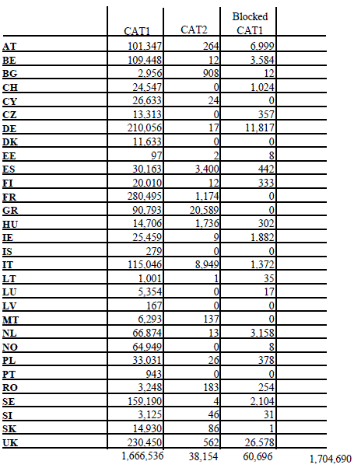
Table 2: Successful transactions to the EURODAC Central Unit, in 2010
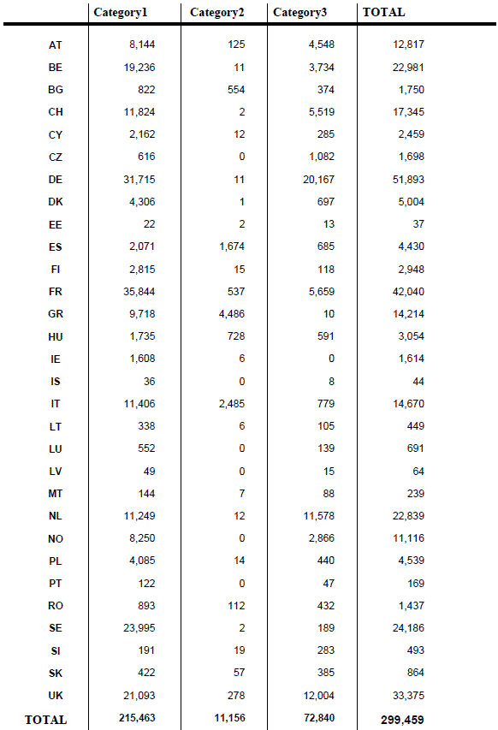
Table 3: Hit repartition – Category 1 against Category 1, in 2010
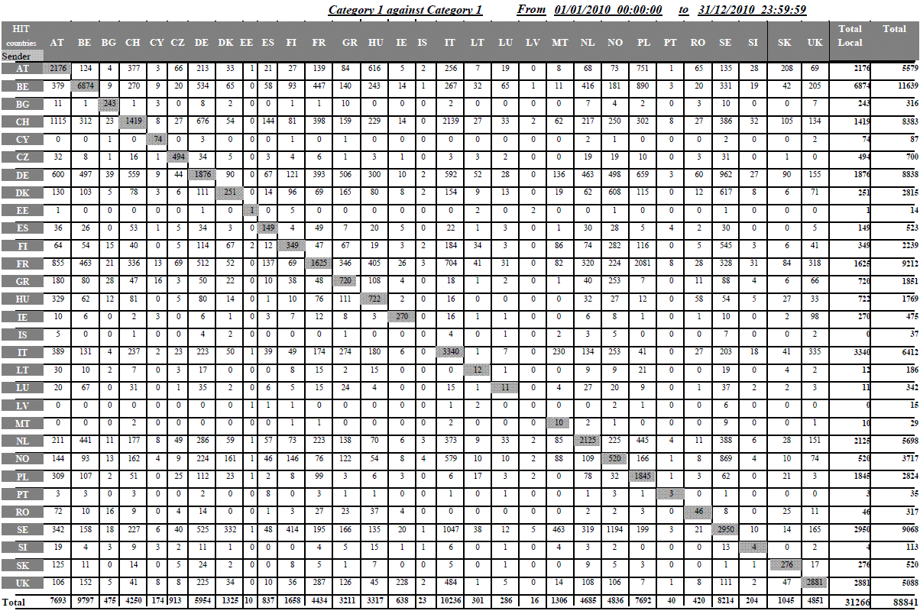
Table 4: Hit repartition – Category 1 against Category 2, in 2010
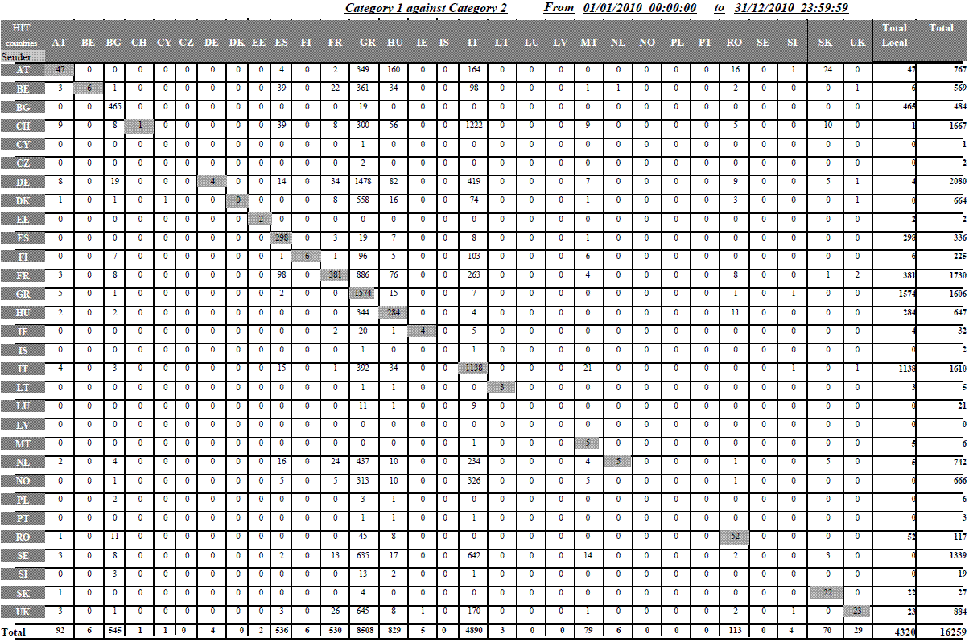
Table 5: Hit repartition – Category 3 against Category 1, in 2010
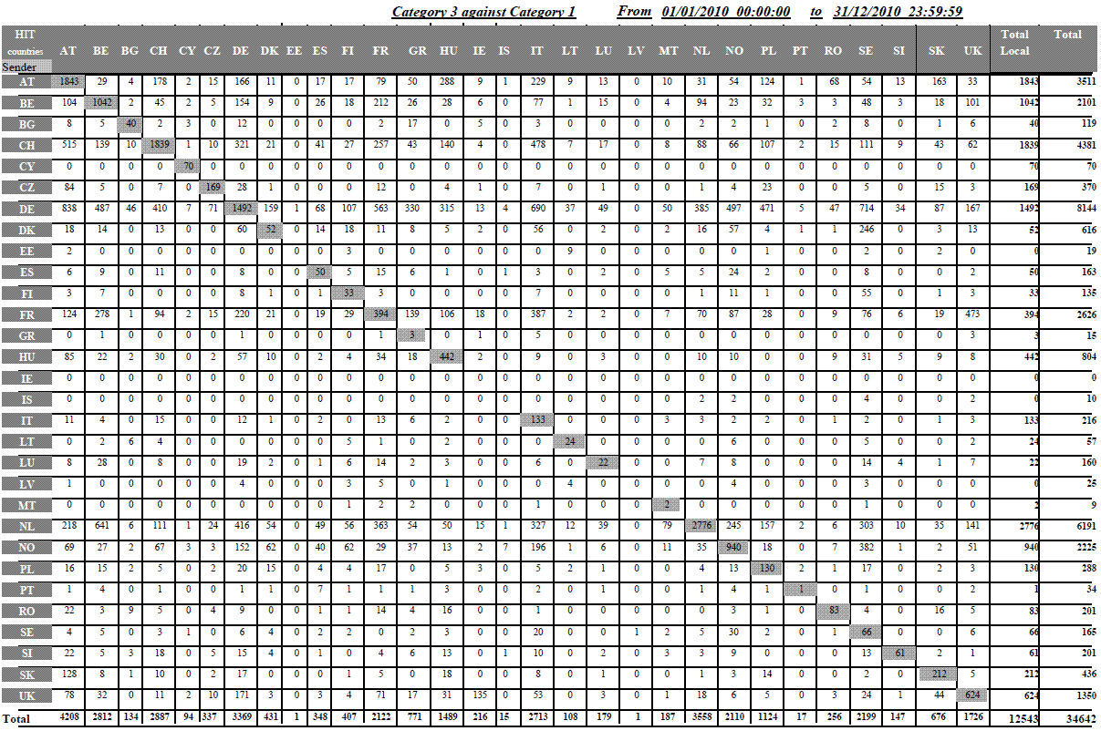
Table 6: Rejected transactions, percentage in 2010
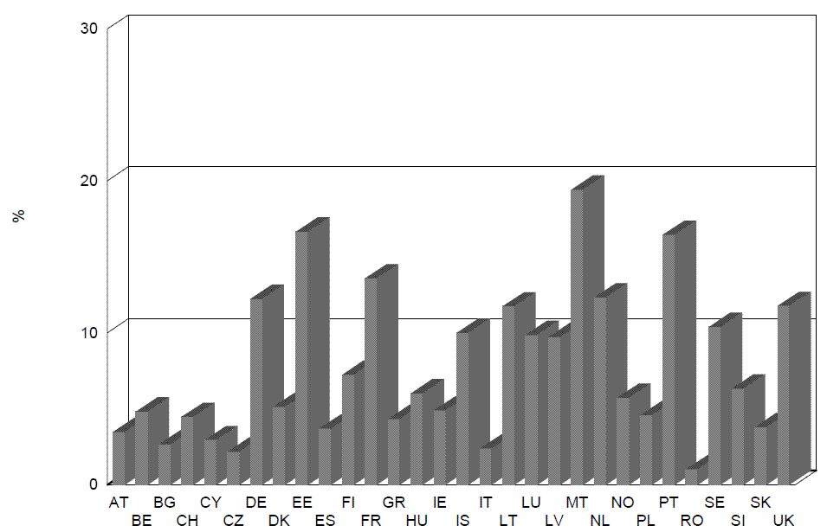
Table 7: Average time between the date of taking the fingerprints and their sending to the EURODAC Central Unit, in 2010
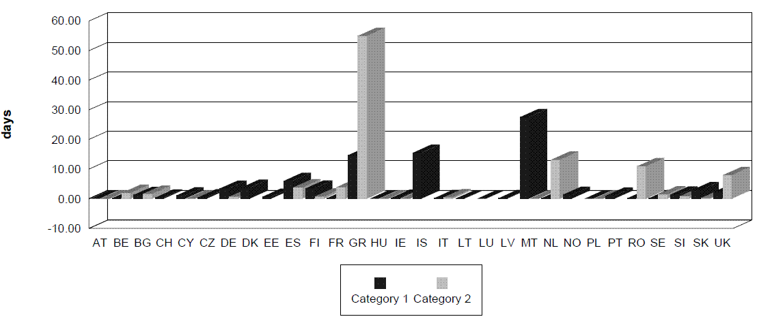
Table 8: Category 1 against Category 1 hit in wrong sense, in 2010
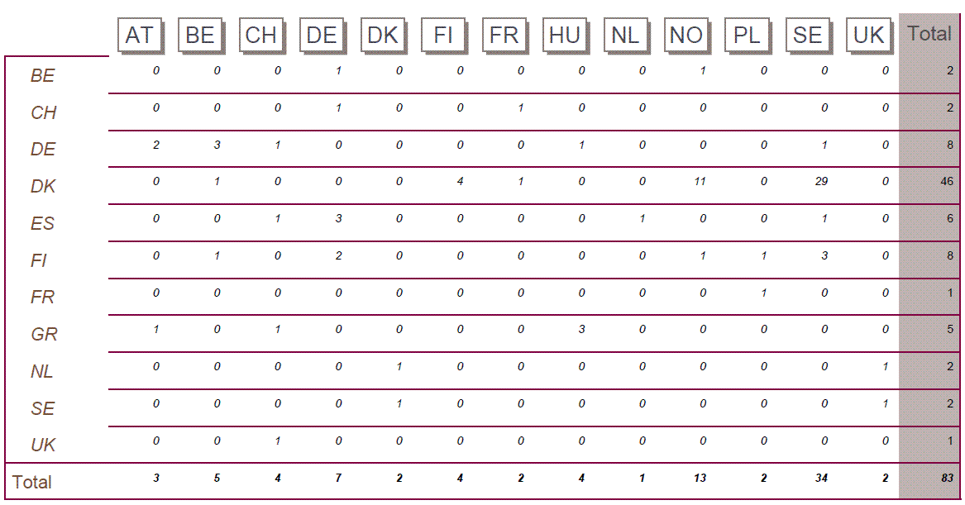
Table 9: Distribution of CAT1/CAT2 hits missed because a delay when sending the CAT2, in 2010
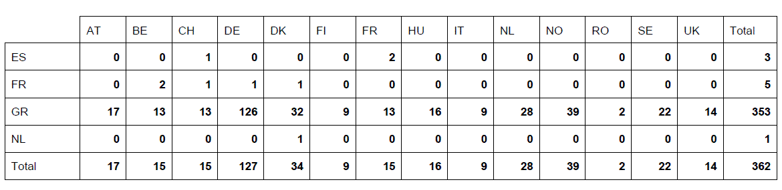
Table 10: Distribution of hits against blocked cases (art. 12 of the EC Regulation 2725/2000), in 2010
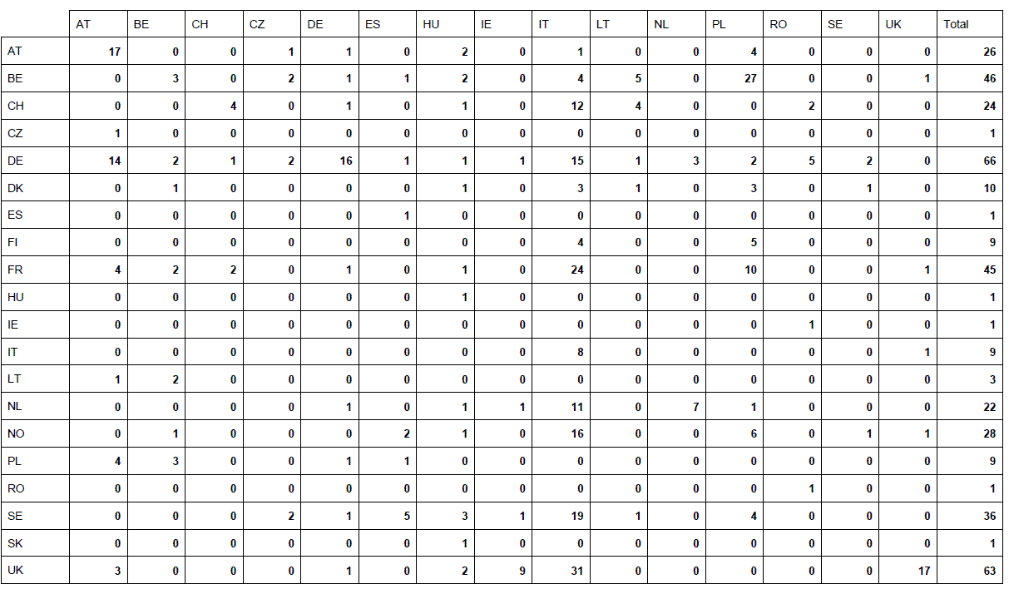
Table 11: Count of category 9 per Member State, in 2010
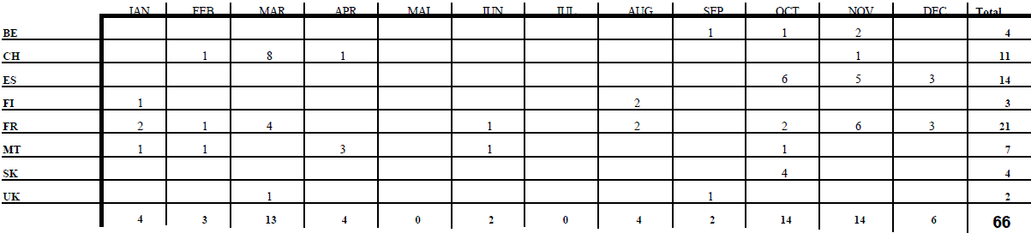

OJ L 316, 15.12.2000, p.1.
Article 24(1) EURODAC Regulation.
COM(2010) 555 final.
COM(2009) 344 final.
COM(2009) 665 final/2.
COM(2010) 96 final
The EURODAC Regulation provides for the implementation of a Central Unit managed by the European Commission containing an Automated Fingerprint Identification System (AFIS) which shall receive data and transmit 'hit – no hit' replies to the national Units (National Access Points) in each Member State. The EURODAC Regulation and its Implementing Rules identify the responsibilities for the collection, transmission and comparison of the fingerprint data, the means through which the transmission can take place, the statistical tasks of the Central Unit and the standards that are used for the data transmission.
S-TESTA (secured Trans-European Services for Telematics between Administrations) network provides a generic infrastructure to serve the business needs and information exchange requirements between European and National administrations.
ISA (Interoperability Solution for European Public Administrations) is the new programme to improve electronic cooperation among public administrations in EU Member States. It is the follow-on of the previous programme IDA II (Interchange of Data between Administrations) and IDABC (Interoperable Delivery of European eGovernment Services to public Administrations, Businesses and Citizens).
Table 2 of the Annex details the successful transactions per Member State, with a breakdown by category, between 1 January 2010 and 31 December 2010.
'Each Member State shall, in accordance with the safeguards laid down in the European Convention on Human Rights and in the United Nations Convention on the Rights of the Child, promptly take the fingerprints of all fingers of every alien of at least 14 years of age who is apprehended by the competent control authorities in connection with the irregular crossing by land, sea or air of the border of that Member State having come from a third country and who is not turned back.'
OJ L 348 of 24.12.2008.
Article 11 '(…) As a general rule there are grounds for checking whether the alien has previously lodged an application for asylum in another Member State where: (a) the alien declares that he/she has lodged an application for asylum but without indicating the Member State in which he/she made the application; (b) the alien does not request asylum but objects to being returned to his/her country of origin by claiming that he/she would be in danger, or (c) the alien otherwise seeks to prevent his/her removal by refusing to cooperate in establishing his/her identity, in particular by showing no, or false, identity papers.'
The statistics concerning local hits shown in the tables may not necessarily correspond to the hit replies transmitted by the Central Unit and recorded by the Member States. The reason for this is that Member States do not always use the option, provided by Art. 4(4), which requests the Central Unit to search against their own data already stored in the Central database. However, even when Member States do not make use of this option, the Central Unit must, for technical reasons, always perform a comparison against all data (national and foreign) stored in the Central Unit. In these concrete cases, even if there is a match against national data, the Central Unit will simply reply 'no hit' because the Member State did not ask for the comparison of the data submitted against its own data.
OJ L 326 of 13.12.2005.
In the scenario of the so-called 'wrong hit', a third-country national lodges an asylum application in a Member State (A), whose authorities take his/her fingerprints. While those fingerprints are still waiting to be transmitted to the Central Unit (category 1 transaction), the same person could already present him/herself in another Member State (B) and ask again for asylum. If this Member State B sends the fingerprints first, the fingerprints sent by the Member State A would be registered in the Central database later then the fingerprints sent by Member State B and would thus result in a hit from the data sent by Member State B against the data sent by the Member State A. Member State B would thus be determined as being responsible instead of the Member State A where an asylum application had been lodged first.
In the scenario of the so-called 'missed hit', a third-country national is apprehended in connection with an irregular border crossing and his/her fingerprints are taken by the authorities of the Member State (A) he/she entered. While those fingerprints are still waiting to be transmitted to the Central Unit (category 2 transaction), the same person could already present him/herself in another Member State (B) and lodge an asylum application. At that occasion, his/her fingerprints are taken by the authorities of Member State (B). If this Member State (B) sends the fingerprints (category 1 transaction) first, the Central Unit would register a category 1 transaction first, and Member State (B) would handle the application instead of Member State A. Indeed, when a category 2 transaction arrives later on, a hit will be missed because category 2 data are not searchable.
A transaction may be rejected due to a data validation issue, fingerprint errors or insufficient quality (see also section 3.1. ibid).

