Table of Contents

Annex 1 - The basic principles of cohesion policy 3
Annex 2 - Explanation of modelling assumptions 8
Annex 3 - Ex-ante conditionality 14
Annex 4 – Thematic concentration 17
Annex 5 - Summary of evaluations, reports, studies and policy documents 19
Annex 6 - SMART objectives 25
Annex 7 - ESF allocation shares 2007-2013 30
Annex 8 - List of Abbreviations 31
Annex 9 - Overview of the assessment of potential changes in regulatory requirements related to delivery on administrative costs and burdens 32

Annex 1 - The basic principles of cohesion policy
Cohesion policy is one of the most far-reaching tools of intervention available to the European Union. Having begun as a small-scale funding scheme for retraining workers and later for providing support to lagging regional economies, it has developed into a fully-fledged development policy that covers all the Member States of the Union. Its share of the budget, initially less than 16% of the EC budget, now represents 35.7% of the EU's budget in the 2007-2013 period. Cohesion policy supports every year many thousands of projects. It assists the implementation of EU policies in many areas, from transport to employment, competitiveness, environment, research and innovation, and climate change. It directly connects national, regional and local administrations with the EU, and influences the way they plan, design and implement regional development policies. This gives concrete meaning to the promotion of "economic, social and territorial cohesion, and solidarity among Member States," which the Treaty sets out as a central aim of the European Union.
The Treaty lays down the basis for a cohesion policy designed to promote "a harmonious development of the Union and, in particular, to reduce disparities between the levels of development of the various regions and the backwardness of least favoured regions", while paying particular attention to areas that are characterised by specific vulnerabilities. The Lisbon agenda of 2000 added a new dimension to the policy. Cohesion policy is no longer only a tool to accompany market integration and address its territorial consequences, but is a lever to promote development at national, regional and local level in line with EU-wide long term policy priorities. This motivation is further enhanced by the Europe 2020 Strategy and the introduction, with the European semester, of greater coordination of Member States' fiscal and macro-economic policies. As the Communication on the Europe 2020 Strategy pointed out, "cohesion policy and its structural funds, while important in their own right, are key delivery mechanisms to achieve the priorities of smart, sustainable and inclusive growth in Member States and regions". Most recently, cohesion policy played a role in the EU response to the economic and financial crisis within the framework of the European Economic Recovery Plan, contributing to contain the effects of the crisis and to provide an anti-cyclical stimulus to the economy.
Current system of funding
The basic architecture of cohesion policy funding is centred on three Funds, the European Social Fund (from 1957), the European Regional Development Fund, created in 1975, and the Cohesion Fund, set up in 1994. For the 2007-2013 period, the European Agricultural Rural Development Fund (EARDF or rural fund) and the European Fisheries Fund (EFF), which financed interventions in the area of rural development and fisheries respectively, were moved out of cohesion policy and included in their respective policy areas.
The European Fund for Regional Development (ERDF), the European Social Fund (ESF) and the Cohesion Fund contribute to three objectives: Convergence, Regional Competitiveness and Employment, and European Territorial Cooperation. While all funds contribute to the Convergence objective, the ESF and ERDF contribute to Regional Competitiveness and Employment and only the ERDF to the third objective.
The objective of the Convergence objective is to promote growth-enhancing conditions and factors leading to real convergence of the least-developed Member States and regions. In EU-27, this objective concerns – within 18 Member States – 84 regions with a total population of 154 million, and per capita GDP at less than 75 % of the Community average, and – on a “phasing-out” basis – another 16 regions with a total of 16.4 million inhabitants and a GDP only slightly above the threshold, due to the statistical effect of enlargement. The amount available under the Convergence objective is €282.8 billion, representing 81.5 % of the total. It is split as follows: €199.3 billion for the Convergence regions, while €14 billion is reserved for the “phasing-out” regions and €69.5 billion for the Cohesion Fund, the latter applying to 15 Member States.
The Regional Competitiveness and Employment objective aims at strengthening regional economies' competitiveness and attractiveness, as well as employment. First, development programmes help regions to anticipate and promote economic change through innovation and the promotion of the knowledge society, entrepreneurship, the protection of the environment, and the improvement of their accessibility. Second, more and better jobs are supported by adapting the workforce to changes in the labour market and by investing in human capital. In EU-27, a total of 168 regions are eligible, representing 314 million inhabitants. Within these, 13 regions with a total of 19 million inhabitants represent so-called “phasing-in” areas and are subject to special financial allocations due to their former status as “Objective 1” regions. The amount of €55 billion – of which €11.4 billion is for the “phasing-in” regions – represents just below 16% of the total allocation. Regions in 19 Member States are concerned with this objective. The former programmes Urban II and Equal are integrated into the Convergence and Regional Competitiveness and Employment objectives.
The European Territorial Cooperation objective aims at strengthening cross-border co-operation through joint local and regional initiatives, transnational co-operation aiming at integrated territorial development, and interregional co-operation and exchange of experience. The concerned population amounts to 181.7 million people (37.5 % of the total EU population). All EU regions and citizens are covered by one of the existing 13 transnational co-operation areas. €8.7 billion (2.5 % of the total) available for this objective is split as follows: €6.44 billion for cross-border, €1.83 billion for transnational and €445 million for inter-regional co-operation.
Cohesion policy for 2007-2013 (Heading 1B) | € billion
Structural Funds, of which | 277.658
ERDF | 198.941
ESF | 78.716
Cohesion Fund | 69.752
Total Heading 1B | 347.410

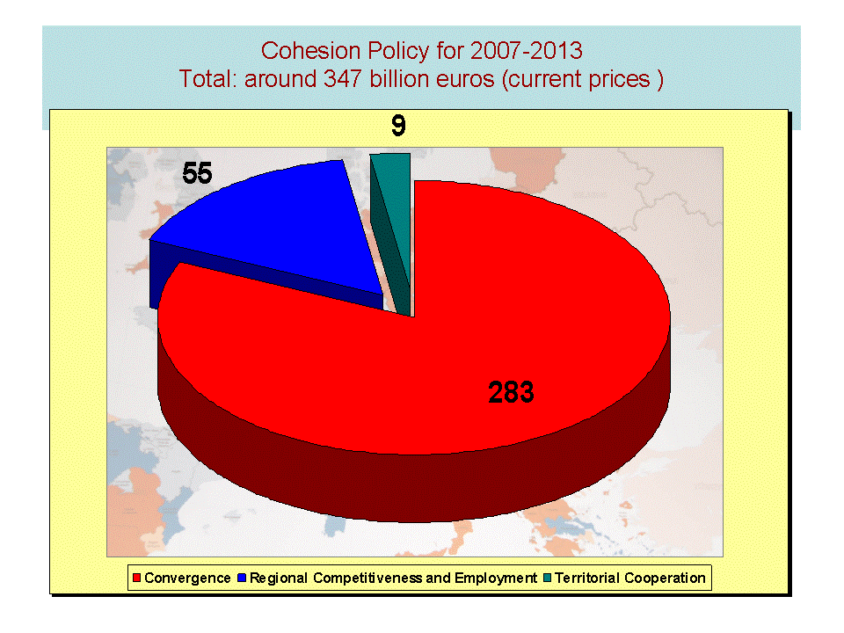

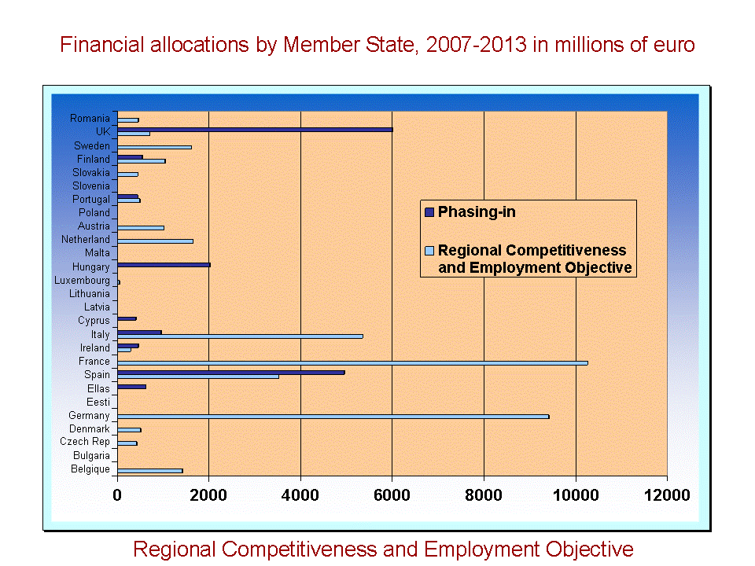
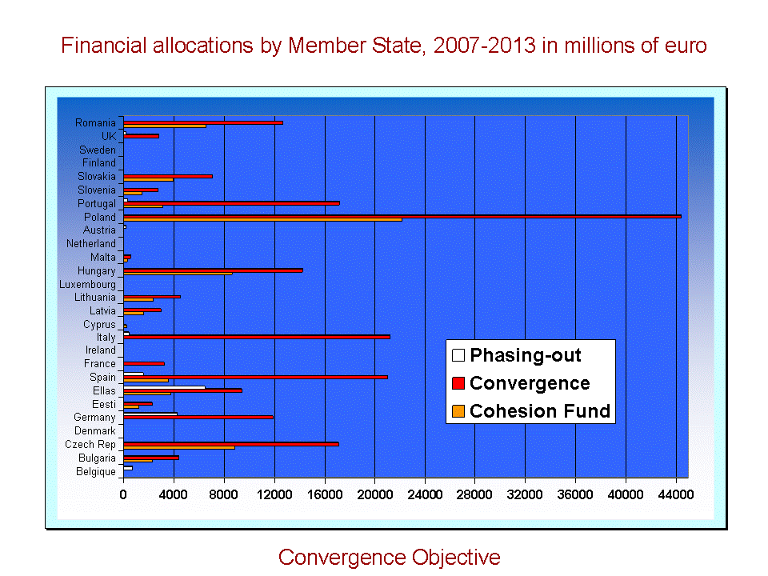
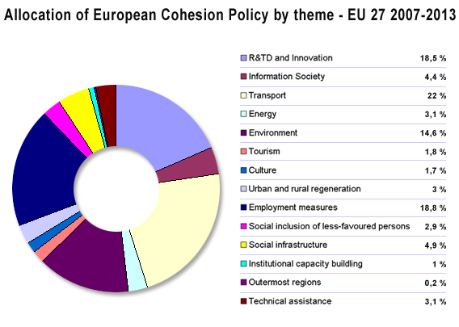
Annex 2 - Explanation of modelling assumptions
The modelling frameworks
The impact analysis of geography options as well as the effects of thematic concentration was carried out with three complementary modelling exercises. The three exercises best explore the comparative advantages and complementarities of different models and approaches. The first model analysis was carried out with HERMIN. It is a model which includes the 27 Member States with differentiated parameters representing the national economies. It covers the different investment categories under cohesion policy. The second model used is QUEST, a micro-founded dynamic general equilibrium model, which covers all 27 Member States in an interlinked way. The third analysis used two models, the GTAP model, a global CGE model. The model contains less country detail than the other two models but has a trade focus to be able to analyse the effects of the integration of the new Member States. This specific analysis is accompanied by an analysis of the GMR model, which identifies regionally differentiated policies within a country.
The main focus of the analyses is the impact of different geographical and thematic options on major macroeconomic indicators such as growth in GDP and in employment, in order to find the economically most advantageous. The models also display other indicators such as the development of the trade,
The models allow differentiating the impact between more and less developed regions which depends on level of GDP, growth potential and structure of the economy. Accordingly, the impact will vary between a region with a high share of agriculture or manufacturing (which is often the case of less developed regions) and a region with a high share of market services (which is often the case of more developed regions).
The models differentiate the impact of different types of investment in sectors also in terms of short and long run effects. For instance some have most of their impact in the long run (e.g. investments into human capital) while others also have significant effects in the short run (e.g. infrastructure). These assumptions are based on the results of the mainstream economic literature.
Main assumptions:
Eligibility of regions:
The expected eligibility status for the modelling uses observed data of regional GDP/head (i.e. data of the years 2005, 2006 and 2007), i.e. the data available in December 2010. Based on this data the assumed allocations per countries were calculated.
The eligibility of regions in the statistical analysis as presented in the report changed in spring 2011 when more recent regional data became available and the average moved to 2006, 2007 and 2008. Additional changes were introduced when the revised statistics for Greek regions became available. Therefore, there are differences in the eligibility and population cover used for the modelling analysis and the analysis of eligibility, population cover and allocations used in the region. More recent data will become available in spring 2012 such that, eligibility in the statistical analysis will be re-assessed using a 3-year average of 2007-2008-2009. Hence, changes in actual eligibility may occur, especially in cases where regions show GDP/head values close to the eligibility thresholds. Due to the lack of reliable and comparable regional projections, it is difficult to assess the impact of the crisis on eligibility, because also the EU GDP which serves as 100 is negatively affected.
Budget:
The modelling analysis was carried out between the end of 2010 until January 2011. A number of key policy variables which are significant drivers of the modelling results were unknown at that time.. Therefore, assumptions are made on the basis of current eligibility rules and thresholds as well as on the current budget allocation for cohesion policy. To simplify the financial simulations, it is assumed that the current budget for cohesion policy cannot be exceeded (EUR 346 billion in current prices).
In the modelling of options, differences lie in the amount of financial support received by the different regions. The basis for eligibility is the latest statistical average, i.e. 2005-2007 for regional eligibility and 2006-2008 for national eligibility. This introduces a number of changes as compared to the current situation. The aid intensities per region then are taken and multiplied with the latest population data which results in the budget allocation per region and country. The budget allocations in the options vary therefore depending on the assumed eligibility and aid intensities.
Further assumptions are that the budget period remains at 7 years. The co-financing rates remain as in the current period, i.e. max. 50% in more developed and max. 75% in less developed regions.
The macro stimulus in each option used in the modelling analysis is different. Option 1 uses a cohesion policy budget of €301.6 billion, option 2 of €310.8 billion and option 3 of €235.7 billion (real in 2011 prices). The size of the impact on major economic variables such as GDP and employment of course respond to the size of the stimulus as well as where and on where the investments are targeted to (e.g. infrastructure, R&D, etc). Particularly option 3 has a significantly lower macro stimulus but a focus on the less developed countries with usually higher GDP growth rates. This option does not analyse what would happen with the saved budget of €75.1 billion for the EU budget (difference between option 2 and 3).
Thematic concentration
The assumptions cover the categories of investments in the options. Thematic concentration means focusing investments on core Europe 2020 objectives and targets, particularly on soft investments in the more developed regions. In the option of thematic concentration investments under the ERDF are concentrated on R&D expenditure, innovation and human capital and consequently lower investments in the area of infrastructure and business support. There were limitations as to the modelling work that could be done. Ideally, the modelling work would have also looked at thematic concentration in other areas like climate change or environment, but the limitations of the models did not allow for this.
To analyse the quantitative impact of greater concentration on EU priorities, the QUEST and the HERMIN models simulated greater thematic concentration to show a shift from investment in infrastructure and business support to greater concentration on human capital and R&D and innovation. For more developed regions, the options used in the QUEST and HERMIN models include a complete shift in investment towards human capital, R&D and innovation. For less developed regions, the options used included a significant increase in investment in human capital, R&D and innovation. For some particular regions, the modelling options represent a doubling of investment in human capital, R&D and innovation.
Formally, the rate of return for a give type of investment (e.g. research, infrastructure, human capital) corresponds to the ratio between one euro invested and the resulting impact (gain or loss) in terms of a given economic variable (e.g. GDP, employment). The impact includes all direct and indirect effect of the investment including their development over time. The rate of return is therefore not the result of one single assumption but reflects the structure of the modelled economy (e.g. what are the lead sectors, what is the productivity), many of the assumption it contains concerning the links between economic variables as well as the estimates/calibrated values of the model's parameters.
Both models project results for a period of time over which an initial investment at the beginning of the period develops. The positive effects of soft investments on main economic variables in the two modelling systems tend to develop only over the medium term with a lasting effect, while investments into infrastructure and business support tend to have immediate effects. This is in line with empirical studies (see below). The choice of parameter and functional forms of both models allow for such simulations.
As part of the elements determining the rates of return, both HERMIN and QUEST include parameters capturing the more or less direct effect of categories of investment on key variables. HERMIN contains so-called output and productivity elasticities meant to capture the direct impact of investment in physical infrastructure, human resources or RTD on the output and the productivity of some key activity sectors considered in the model. The table below provides values for these elasticities. These values are based on empirical literature e.g Aschauer (1989), Wylie (1995), or Holtz-Eakin (1994).

Table 1: Examples of output elasticities used in the Hermin model
Type of ECP investment | HERMIN sector | HERMIN
Physical infrastructure | Manufacturing output | 0.20
Physical infrastructure | Market services output | 0.05
Physical infrastructure | Manufacturing productivity | 0.10
Physical infrastructure | Market services productivity | 0.05
Human resources | Manufacturing output | 0.20
Human resources | Market services output | 0.05
Human resources | Manufacturing productivity | 0.10
Human resources | Market services productivity | 0.05
RTD | Manufacturing output | 0.05
RTD | Market services output | 0.01
RTD | Manufacturing productivity | 0.05
RTD | Market services productivity | 0.025

Similar types of parameters are included in QUEST. However, the model is very different in mechanism and structure from HERMIN (e.g. in the functional forms which describe the behaviour of market agents). Therefore, there is no direct correspondence between the parameters used in the two models. For instance, the value for the output elasticity of public capital (infrastructure) is 0.1 in QUEST while the parameter capturing return to schooling on the (skill-specific) efficiency unit of labour is set at 0.07 following Mincer (1974).
Specific assumptions for the options
The options combine a number of factors of geographical concentration vary the extreme options of full coverage with focus on the poorest countries only. Similarly, the options for thematic concentration of investments differ between a traditional infrastructure and business support focused development approach and an approach with significantly higher investments into human capital, research and development and innovation.
Option 1: Status quo
The status quo foresees a full coverage of regions, i.e. cohesion policy will be available for less and more developed regions. For regions leaving the category of less developed regions a phasing out support is foreseen. This support is digressive over time. This option assumes no thematic concentration, i.e. the structure of investments remains the same as in the current period.
Table 1 summarises the main assumptions on the eligibility. as well as the budgetary characteristics.
Table 1: Main eligibility and financial characteristics: status quo
Status quo | - current Cohesion Fund allocation of countries with GNI/head < 90%
Status quo | - current Convergence allocation of regions with GDP/head < 75%
Status quo | - phasing-out support for former Convergence regions which exceed 75% in terms of GDP/head
Status quo | - current RCE allocation if available, otherwise current average RCE aid intensity
 |  | Budget allocation | Population covered (in millions) | Average aid intensity per capita (in €)
Convergence Objective (lagging regions) |  | 71% | 119.2 | 1760
Phasing- out of Convergence |  | 8% | 35.6 | 700
Regional Competitiveness and Employment Objective (more developed regions in more and less developed MS)) |  | 21% | 343.9 | 190
Total |  | 100% | 498.7 | 610

The actual assumed cohesion policy funding in the modelling exercise differs slightly, because of the shift of averages for eligibility. The models use a budget of €301 billion which is based on eligibility and population statistics of 2005, 2006 and 2007. The table which uses averages of 2006, 2007, and 2008 yields a budget of €297 billion.
Option 2: Growth enhancing policy in line with Europe 2020 objectives
Again cohesion policy covers all regions in the EU, however with the difference that an intermediate region category covers all regions between 75% and 90% GDP/capita.
The option foresees thematic concentration. For more developed regions, the options used in the QUEST and HERMIN models include a complete shift in investment towards human capital, R&D and innovation. For less developed regions, the options used included a significant increase in investment in human capital, R&D and innovation. For some particular regions, the modelling options represent a doubling of investment in human capital, R&D and innovation. The GMR model was also used in a more stylised analysis, foreseeing a shift in thematic concentration from 30% and 50% (from infrastructure/business support to human capital/R&D/innovation).
Table 2: Main eligibility and financial characteristics of Option 2: full coverage with intermediate category of regions
Option 2 | - current Cohesion Fund allocation of countries with GNI/head < 90%
Option 2 | - current Convergence allocation of regions with GDP/head < 75%
Option 2 | - Intermediate regions between GDP/head of 75% and 90%. Aid intensities depend on their GDP per capita.
Option 2 | - current RCE allocation if available, otherwise current average RCE aid intensity
 |  | Budget allocation | Population covered (in millions) | Average aid intensity per capita (in €)
Less developed regions |  | 68% | 119.2 | 1760
Intermediate regions |  | 13% | 72.4 | 620
More developed regions |  | 18% | 307.1 | 180
Total |  | 100% | 498.7 | 630

The modelling uses a cohesion fund budget of 310.8 billion based on the eligibility and population cover of the average statistics of 2005, 2006, 2007. The budget represented by the latest eligibility calculations presented in this table is €323.5 billion.
Option 3: Convergence policy for lagging Member States only
This option concentrates only on Member States eligible for the Cohesion Fund. Regarding the broad development needs and the objective lack of infrastructure and business development, no thematic concentration on forms of soft investments is foreseen.
Table 3: Main eligibility and financial characteristics of Option 4: Increased geographical concentration on lagging Member States
Option 4 | current Cohesion Fund allocation of countries with GNI/head < 90%
Option 4 | current Convergence (and RCE) allocation of regions within countries with GNI/head < 90%
 | Budget allocation | Population covered (in millions) | Average aid intensity per capita (in €)
Total | 100% | 114 | 1750
This option has the lowest budget of all options. The model analysis assumes €235.8 billion, while the most recent eligibility calculations show a budget of €198.4 billion.
Limitations of the models
As noted in one of the articles with the modelling results for cohesion policy spending in the 2000-2006 period, "it is important to point out that the success or failure of EU Cohesion Policy programmes should not exclusively be judged on the basis of its effect on gross domestic product. The objective of Cohesion policy is to foster social and economic cohesion and to achieve real convergence in the Union. GDP is the yardstick most commonly used, and GDP per capita is the measure on which eligibility for Cohesions support is determined, and this is therefore the logical first measure to use in an assessment. But one should be aware that even as an indicator of market activity, gross domestic product is not a measure without flaws. Alternative measures like gross national product, which includes net capital paid to and from abroad, or net national income, which includes profits exported and imported, may be preferred. But more generally, other measures of wellbeing should also be taken into account in a wider assessment of EU Cohesion Policy. It should also be stressed that these results are based on a macroeconomic analysis and depend crucially on the underlying assumption that the money is spent efficiently. Hence, this aggregate macroeconomic modelling approach gives an estimate of the potential effect of Cohesion spending and the long run output gains reflect the assumed productive impact of investment in infrastructure, human capital and R&D in the model.
Annex 3 - Ex-ante conditionality

INTRODUCTION

In its Communication "A budget for Europe 2020", the Commission highlights the increased use of conditionalities as a major hallmark of the next set of financial programmes and instruments.

"To reinforce performance, new conditionality provisions will be introduced to ensure that EU funding is focussed on results and creates strong incentives for Member States to ensure the effective delivery of Europe 2020 objectives and targets through cohesion policy. Conditionality will take the form of both ex ante conditions that must be in place before funds are disbursed and ex post conditions that will make the release of additional funds contingent on performance." In addition, it underlines that

A Task Force on Conditionality has discussed the rationale for, and the past experiences with, conditionality in the framework of cohesion policy as well as the forms it conditionality might take and how it could be applied. Member States and EU institutions expressed broad support for the application of ex-ante conditionality which respects the following principles:

- directly linked to cohesion policy
- limited in number applicable to a programme
- based on strong ownership, tailored to specific contexts
- reflecting constitutional arrangements and distribution of competences between national and regional levels
- based on objective criteria for assessment
- based on joint agreement between the Commission and the Member State
- proportional application and not leading to increase in administrative burden.

Definition of ex-ante conditionality
- The annex to the Common Provisions Regulation contains ex ante conditionalities and criteria for assessing their fulfilment. The conditionalities will be based on the work undertaken jointly by the Commission services in the framework of the thematic task forces.

- The ex-ante conditionalities would be divided into a) thematic b) general ex-ante conditionalities. The thematic ex-ante conditionalities would be specific to the thematic objectives of cohesion policy (e.g. the existence of a national/regional smart specialisation strategy for the thematic objective "strengthening innovation, technological development and research"). They can either relate to the thematic objective as a whole or to an investment priority as part of it. For example, under the thematic objective 'Protecting the environment and promoting the use of sustainable resources', if the programme only includes investments in the water sector, only the ex-ante conditionality related to the water sector would need to be assessed for this thematic objective. The general ex-ante conditionalities would relate to horizontal aspects of programme implementation (for example institutional and administrative capacity, public procurement).

Application mechanism
- When preparing the programming documents, Member States carry out a self-assessment to ascertain whether the ex ante conditionalities have been met for the thematic objectives selected. The results of this assessment will be presented in the Partnership Contract.
- Where ex ante conditionalities are not fulfilled at the date of transmission of the Partnership Contract, Member States shall set out in a summary of the actions to be taken at national and regional level, to ensure their fulfilment not later than by 31 December 2016 and the timetable for their implementation. The detailed actions relating to the fulfilment shall be set out in the relevant operational programmes.
- The Commission shall assess the information provided on the fulfilment of ex ante conditionalities in the framework of its assessment of the Partnership Contract and operational programmes.
- When adopting the programme, the Commission may decide to suspend all or part of interim payments to an operational programme pending the satisfactory completion of actions to fulfil an ex ante conditionality. The failure to complete actions to fulfil an ex ante conditionality by the deadline set out in the operational programme shall constitute a basis for suspending payments by the Commission.
- In the annual implementation reports, Member States would set out information on action taken to fulfil the commitments in the operational programme. In the reports on the implementation of the Partnership contract in 2017 and 2019, Member States would also set out whether the commitments in relation to ex ante conditionalities have been fulfilled and of the steps taken to fulfil them. This would be assessed in the context of the performance review.
Chart 1 Application mechanism

Annex 4 – Thematic concentration
This Annex explains how the calculations have been made for the table under Option 2 of the indicative allocations for the ERDF. The categories of expenditure for the 2007-2013 period have been used to simulate the allocations and have been regrouped around each of the thematic objectives proposed in the indicative menu for the 2014-2020 period.

 | EUR (for all Funds; the ESF, ERDF and CF) | Categories of expenditure (2007-2013)
(a) strengthening innovation, technological development and research; | 45.833.518.664 | 01, 02, 03, 04, 07, 74
(b) enhancing accessibility to and use and quality of information and communication technologies; | 11.545.628.197 | 10, 11, 12, 13
(c) enhancing the competitiveness of small and medium-sized enterprises; | 13.273.398.707 | 09, 14, 15, 68
(d) improving the quality and performance of education and training systems at all levels and increasing participation in tertiary and equivalent education. | 28.437.942.290 | 72, 73, 75
(e) Supporting the shift towards a low-carbon economy in all sectors | 13.342.296.223 | 06, 28, 39, 40, 41, 42, 43, (1/2) 49, 78
(f) Promoting climate change adaptation and risk prevention | 5.926.147.222 | (1/2) 49, 53
(g) Protecting the environment and promoting sustainable use of resources | 38.886.616.880 | 44, 45, 46, 47, 48, 50, 51, 54, 55
(h) Upgrading Europe’s energy network | 1.788.128.270 | 33, 34, 35, 36, 37, 38
(i) Promoting sustainable transport and removing bottlenecks in key network infrastructures | 80.668.583.725 | 17, 18, 19, 20, 21, 22, 23, 24, 25, 26, 27, 29, 30, 31, 32, 52
(j) Increasing labour market participation of women and men, reducing structural unemployment and promoting job quality | 2.636.916.208 | 69
(k) Developing a skilled workforce responding to labour market needs and promoting lifelong learning | 31.268.923.308 | 62, 63, 64, 65, 66, 67, 80
(l) Promoting social inclusion and combating poverty, including through access to affordable, sustainable and high quality public services | 20.402.721.990 | 70, 71, 76, 77, 78, 79
Other growth-enhancing investments | 50.278.561.378 | 08, 56, 57, 58, 59, 60, 61, 81, 82, 83, 84, 85, 86
TOTAL: | 344,289,383,061

Annex 5 - Summary of evaluations, reports, studies and policy documents
Evaluations & Impact Assessment | Studies
Policy Documents

Evaluations & Impact Assessments
- Expert Evaluation Network Delivering Policy Analysis on the Performance of Cohesion Policy 2007-2013 (Contract 2009CE160AT075 - CAT039), prepared by Applica and Ismeri, 5 February 2010
- Evaluation on the Potential for Regional Policy Instruments, 2007-2013, To Contribute To the Lisbon And Göteborg Objectives for Growth, Jobs and Sustainable Development (Contract 2007CE160AT041), prepared by Nordregio (Sweden), 22 July 2009
- Study on the Translation of Article 16 of Regulation EC 1083/2006 for Cohesion policy programmes 2007-2013 co-financed by the ERDF and the Cohesion Fund), prepared by the Public Policy and Management Institute, Lithuania in partnership with Net Effect (Finland) and Racine (France), 15 September 2009.
- Analysis of the Impact of Cohesion Policy - A note explaining the HERMIN-based simulations (Contract 2006CE160AT035), prepared by John Bradley, Gerhard Untiedt, Timo Mitze, 4 May 2007
- The Potential Impact of the Fiscal Transfers under the EU Cohesion Policy Programme, Directorate-General for Economic and Financial Affairs, Economic Papers, Number 283 – June 2007.
- Study on the Economic Impacts of Convergence Interventions (2007-2013), (Contract 2006CE160AT022), ECOMOD, November 2007
- Strategic Evaluation on Innovation and the knowledge based economy in relation to the Structural and Cohesion Funds, for the programming period 2007-2013 (Contract 2005CE160AT015), prepared by Technopolis in association with Ismeri, Merit, Logo Tech and Lacave, Allemand & Associes Consultants, 24 October 2006
- Strategic Evaluation on Environment and Risk Prevention under Structural and Cohesion Funds for the Period 2007-2013 (Contract 2005CE160AT016), prepared by GHK Brussels in association with Ecolas, Institute for European Environmental Policy, Cambridge Econometrics, 7 November 2006
- Strategic Evaluation on Transport Investment Priorities under Structural and Cohesion Funds for the Programming - Period 2007-2013 (Contract 2005CE16AT014), prepared by ECORYS Nederland BV in co-operation with: Spiekermann & Wegener (Germany) and: Allied Progress Consultants (Czech Republic), Breshkov (Bulgaria), Consultrans (Spain), Cycleplan (Estonia), ECORYS Polska (Poland), Fundeuropa (Portugal), Omega Consult (Slovenia), Trademco (Greece), Transman (Hungary), Transport Research Institute (Slovak Republic), STDO (Romania), October 2006
- Ex Post Evaluation of Cohesion Policy Programmes 2000-2006 financed by the European Regional Development Fund in Objective 1 and 2 Regions - Work Package 1: Coordination, Analysis and Synthesis, prepared by Applica, Ismeri, The Vienna Institute for International Economic Studies, April 2010.
- Ex post evaluation of cohesion policy programmes 2000-2006 co-financed by the European Fund for Regional Development (Objectives 1 and 2) – Work package 2: Data feasibility study, prepared by ADE, April 2008.
- Ex-post evaluation of Cohesion Policy Programmes 2000-2006 co-financed by the URBAN II Community Initiative (2001-2006) and URBACT I Programme (2003-2006), ECOTEC, June 2010.
- Work Package 3: Macroeconomic modeling Hermin Final Report Analysis of EU Cohesion Policy 2000-2006 using the CSHM: Aggregate impacts and inter-country comparisons, prepared by John Bradley - EMDS - Economic Modelling and Development Systems and Gerhard Untiedt - GEFRA – Gesellschaft für Finanz- und Regionalanalysen, 11 November 2009
- Analysis of EU Cohesion Policy 2000-2006 using the CSHM: Sectoral impacts, prepared by John Bradley - EMDS - Economic Modelling and Development Systems and Gerhard Untiedt - GEFRA – Gesellschaft für Finanz- und Regionalanalysen, 12 November 2009
- A Model-based Analysis of the Impact of Cohesion Policy Expenditure 2000-06: Simulations with the QUEST III endogenous R&D model, prepared by Janos Varga and Jan in 't Veld, DG Economic and Financial Affairs European Commission, September 2009
- Work package 4: Structural Change and Globalisation, prepared by CSIL, Centre for Industrial Studies, Milan, Italy, Joanneum Research, Graz, Austria, Technopolis Group, Brussels, Belgium in association with Nordregio, the Nordic Centre for Spatial Development, Stockholm, Sweden and KITE, Centre for Knowledge, Innovation, Technology and Enterprise, Newcastle, UK, January 2010
- Work Package 5a: Transport, prepared by Steer Davies Gleave, January 2010-06-08
- Work package 5b: Environment and Climate Change, prepared by ADE, Agrotec, Bio Intelligence Service and Orbicon, October 2009
- Work Package 6: support for enterprise and innovation
- Work Package 6a: A survey of support for enterprise and innovation, prepared by Mikkel Holm-Pedersen, Jeremy Millard, Kristian Pedersen - Policy and Business Analysis, May 2009
- Work Package 6b: Enterprise support – key results from the 30 programmes spending the most in this field, prepared by Ramboll, this study is ongoing - results are expected in the first half of 2010
- Work Package 6c: Support for enterprise and innovation – econometric and counterfactual methods, prepared by GEFRA – Gesellschaft für Finanz- und Regionalanalysen GbR, Münster, IAB – Institut für Arbeitsmarkt- und Berufsforschung, Forschungseinrichtung der Bundesagentur für Arbeit, Nürnberg, this study is ongoing - results are expected in the first half of 2010.
- Work package 7: Effectiveness of the Cohesion Policy: Gender Equality and Demographic Change, prepared by IRS, Istituto per la Ricerca Sociale and CSIL, Centre for Industrial Studies, July 2009
- Work Package 8: Modelling transport, prepared by the Joint Research Centre of the Commission, no date
- Work Package 9: Rural development, prepared by Metis GmbH, May 2009
- Work Package 10: Efficiency (major projects), prepared by RGL Forensics, Faber Maunsell/Aecom and Frontier Economics, 25 October 2009
- Work Package 11: Management and implementation, prepared by Metis GmbH and Starthclyde University – EPRC Glasgow, 7 July 2009
- Evaluation of ESF support to gender equality, prepared by GHK with Fondazione Bradolini, January 2011
- Evaluation of the ESF contribution to the EES, prepared by Rambøll with Eureval, Matrix and SEOR, October 2010
- Evaluation of the ESF support to the integration of migrants and ethnic minorities in the labour market, prepared by CSES with PPMI – Oxford Research, Finalisation pending
- Evaluation of the capacity of ESF delivery systems to attract and support OP target groups, prepared by Eureval in cooperation with Ecorys and Ramboll. Finalisation pending.
- Ex-post evaluation of the ESF (2000-2006), prepared by LSE Enterprise Ltd with Vision & Value, Red2Red Consultores, Expanzio Consulting ltd and Deutschland Denken! E.V, December 2010
- Ex-post evaluation of the 2000-2006 ESF support to the Open Method of Coordination in Social Protection and Social Inclusion, prepared by IRS with the Tavistock Institute, Rehabilitation Foundation and The Research Institute for Quality of Life, December 2009
- Ex-post evaluation of the 2000-2006 ESF: Impact on functioning of the labour market and investment in human capital infrastructure through support to systems and structures, prepared by ISMERI Europa with Groupe Amnyos, July 2010
- Ex-post evaluation of EQUAL Community Initiative, prepared by METIS with Kantor Management Consultants SA, March 2010
- Thematic Evaluation of the Structural Funds’ Contributions to the Lisbon Strategy, prepared by the Danish Technological Institute, February 2005
- Evaluation of the benefits drawn by EU-15 countries as a result of cohesion policy implementation in the Czech Republic. By EEIP, 21 December 2010

Studies
- "An agenda for a reformed cohesion policy: a place-based approach to meeting European Union challenges and expectations", Independent Report prepared at the request of Danuta Hübner, Commissioner for Regional Policy by Fabrizio Barca, April 2009. http://ec.europa.eu/regional_policy/policy/future/pdf/report_barca_v0306.pdf
- Mario Monti (2010), "A new strategy for the single market. At the service of Europe's economy and society". Report to the President of the European Commission. Brussels.
- Iain Begg (2009), Future of Cohesion Policy in richer regions, European Institute, London School of Economics & Political Science.
- Davies, S. (2011) "Interactions between EU Funds: Coordination and Competition", IQ-Net Thematic Paper No. 28(2).
- Regional Challenges in the perspective of 2020 (Contract 2008CE160AT060 & 2008CE16CAT022) prepared by ISMERI, 19/11/2009.
- The regional impact of technological change in 2020 (contract 2008CE160AT068 & 2008CE16CAT026) prepared by ETEPS, 14/07/2010.
- Regional Governance in the context of Globalisation (contract 2008CE160AT090 & 2008CE160AT092) prepared by SWECO, 02/07/2010
- Cohesion policy and sustainable development (contract 2009CE160AT069 & 2009CE16CAT035) prepared by Institute for European Environmental Policy, final report foreseen on june 2011.
- Regional Challenges in the perspective of 2020 - phase 2 (contract 2009Ce160AT058 & 2009CE16CAT028) prepared by Österreichisches Institut für Raumplanung, 23/06/2011.
- Cohesion Policy in a global context (contract 2009CE160AT068 & 2009CE16CAT034) prepared by University of Stratclyde
- Reform perspectives for Cohesion Policy in the budget review process. By Alina-Stefania Ujupan, 25/04/2009
- How small are the Regional Gaps? How small is the Impact of Cohesion Policy? By Daniel Tarschys. January 2011
- Human capital in the EU: trends and challenges from a regional perspective. Prepared by Dr Rolf Derenbach. (November 2009)
- Geographic mobility in the European Union: Optimising its economic and social benefits. Prepared by the Institute for the Study of Labour, NIRAS Consultants A/S, The Swedish National Labour Market Board. (April 2008)
- Modelling of Labour Markets in the European Union, Final Report prepared by Institute for Advanced Studies and the University of St. Gallen. (July 2009)
- Flexicurity: Indicators on the coverage of certain social protection benefits for persons in flexible employment in the European Union, Alphametrics Ltd., 2009.
- The Interaction between Local Employment Development and Corporate Social Responsibility, Austrian Institute for SME Research et al., 2009
- The role of the Public Employment Services related to 'Flexicurity' in the European Labour Markets, Danish Technological Institute et al., 2009.
- Benefit systems and their interaction with active labour market policies in the new Member States, Ecorys, 2008.
- Report on the focus group discussion on proportionality, financial engineering and the involvement of local actors in the ESF post 2013. Finalisation pending.
- Study on Measuring Employment Effects, prepared by Centre for Strategy & Evaluation Services, UK, June 2006
- Analysing ERDF co-financed innovative projects: case studies and comparative analyses, prepared by Technopolis Group, April 2008
- "The Financial management control and audit of EU Cohesion Policy: contrasting views of challenges, idiosyncrasies and the way ahead", IQ net Thematic paper no 23 (2), European Policies Research Centre, University of Strathclyde. http://www.eprc.strath.ac.uk/iqnet/downloads/IQ-Net_Reports(Public)/ThematicPaper23(2)Final.pdf
- “The Potential of Regional Policy Instruments 2007-2013 to Contribute to the Lisbon and Göteborg Objectives for Growth, Jobs and Sustainable Development”, Nordregio, 2009
- Study on the return of ESF investment in Human Capital. Prepared by Eureval, Ecorys, Ramboll. August 2010.
- Feasibility study of output-based and result-oriented conditionality systems for the European Social Fund. Prepared by Deloitte. November 2010
- Assessment of administrative and institutional capacity building interventions and future needs in the context of European Social Fund by Ecorys. December 2010.
- Attila Varga (2009) An integrated knowledge production and SCGE model developed for policy impact analysis. IAREG FP 7 Project Deliverable 5.3. December 2009.

Policy Documents
- http://ec.europa.eu/regional_policy/consultation/terco/index_en.htm
- 4th Report on Economic and Social Cohesion http://ec.europa.eu/regional_policy/sources/docoffic/official/reports/cohesion4/index_en.htm
- 5th Report on Economic and Social Cohesion, November 2010, http://ec.europa.eu/regional_policy/sources/docoffic/official/reports/cohesion5/pdf/5cr_en.pdf
- Sixth progress report on economic and social cohesion - Creative and innovative regions. Communication from the Commission to the European Parliament and the Council, COM (2009) 295, 25 June 2009. http://ec.europa.eu/regional_policy/sources/docoffic/official/reports/interim6_en.htm
- Commission Communication, "Cohesion policy: Strategic Report 2010 on the implementation of the programmes 2007-2013", COM(2010)110 final, 31.03.2010
- Staff Working Document accompanying the Commission Communication, "Cohesion policy: Strategic Report 2010 on the implementation of the programmes 2007-2013", SEC(2010) 360 final, 31.03.2010.
- New Skills for New Jobs: Action Now. A report by the Expert Group on New Skills for New Jobs prepared for the European Commission, February 2010.(available at: http://ec.europa.eu/social/main.jsp?catId=822&langId=en)
- Social Situation Report 2009, 2008 and 2007. European Commission. (available at: http://ec.europa.eu/social/main.jsp?catId=675&langId=en)
- Employment in Europe: 2009, 2008 and 2007. European Commission (available at: http://ec.europa.eu/social/main.jsp?catId=119&langId=en)
- ESF studies (Prepared by Bernard Brunhes International)
- ESF support to active labour market policies and public employment services. (February 2010)
- ESF and Adaptability of enterprises and continuing training of workers. (October 2009)
- ESF and developing human potential in research and innovation. (August 2009)
- ESF support to Labour mobility. (September, 2009)
- ESF support to Education and lifelong learning. (April 2010)
- ESF support for women, gender mainstreaming and conciliation of work and private life. (March 2010).
- ESF support for health and long-term care. (June 2010).
- ESF support for Roma (March 2010) .
- ESF support for sustainable development and eco-technologies (2010)
- ESF support for Migrants and minorities (2010)
- ESF support for Urban areas and local employment (2010).
- ESF support for Older workers (2010)
- ESF support for people with disabilities (2010)
- ESF support for Institutional capacity (2010)
- ESF support for Entrepreneurship (2010)
- ESF support for Young people (2010)
- Commission communications and reports
- "Green Paper on Territorial Cohesion – turning territorial diversity into strength", Communication from the Commission to the Council, the European Parliament, the Committee of the Regions and the European Economic and Social Committee, 2008.
Annex 6 - SMART objectives
This annex sets out why it is not possible to set SMART objectives for cohesion policy, as recommended by the Impact Assessment guidelines.
Among the criticisms of cohesion policy in the current debate, one of the most telling is that the policy's objectives are unclear. These criticisms take a number of different forms:
- Without clear objectives, it is not possible to define the most appropriate set of policy areas nor assemble the most efficient set of policy instruments;
- Without clear objectives, it is not possible to evaluate cohesion policy nor take evidence based policy decisions;
- It is difficult to communicate to the broader public the goals of a policy which is many different things at the same time;
- The multiplication of objectives makes it difficult to set priorities and can lead to contradictory situations and unexpected outcomes;
- The lack of clear policy objectives means that it is difficult to focus on results;
- The objectives that have been set are unrealistic;
- The objectives of the policy do not take into account sufficiently the concerns that are relevant to European citizens in the 21st century such as sustainability and globalisation or changes in our understanding of the drivers of economic growth such as the role of agglomeration or governance.
By its nature as a place-based, multisectoral policy operating in the highly complex territorial system, it is clear that cohesion policy will never be possible to reduce it to a very limited number of "SMART" objectives. Furthermore, the policy has evolved with changing priorities. However, it has done so in a manner with a gradual accumulation of objectives.

The objectives of cohesion policy
The basic goal of cohesion policy has remained largely unchanged since the Treaty of Rome – a focus on harmonious development and the reduction of differences between the various regions and the backwardness of the less favoured regions. Later treaties introduced rural areas, islands and areas in industrial decline. The concept of cohesion (introduced in the Single European Act) has been broadened to include economic, social and territorial dimensions. Since the early 90s, the definition of objectives has evolved in the following manner:
The objective for lagging regions has remained broadly unchanged (with a shift in emphasis from development and adjustment to convergence and growth).
The objective for regions outside lagging regions has evolved from a number of geographically targeted objectives (industrial regions, rural regions) to thematic targeting (mainly competitiveness and employment)
Human capital objectives have been integrated into the convergence and competitiveness objectives.
A new objective of territorial cooperation has been progressively introduced.
A number of horizontal and territorial objectives have been introduced which cut across these core objectives. These include sustainable development, urban development, renewal of urban areas, support for areas affected by natural handicaps etc.
The 2006 reform introduced the community strategic guidelines which "give effect" in a non-binding manner to the priorities of the EU and, in particular, the integrated guidelines.

Assessment of the objectives of cohesion policy
It is obvious that clearer policy objectives would facilitate better policy making. But it is important to examine the extent to which further simplification/clarification/updating of objectives is feasible or necessary.
Paradoxically, one of the areas of greatest difficulty is where the policy is defined most clearly – the Convergence objective. Beyond the difficulties of assessing policy impacts (in particular, the definition of the counterfactual), there is considerable differences within the academic community on how convergence should be defined. In the literature, different yardsticks have been defined such absolute, conditional and club convergence which all correspond to different conceptions of what the policy is seeking to achieve. A step forward has been made in the current regulation with the focus on growth, but the lack of an explicit formulation of what the policy is trying to achieve allow critics to choose measures (such as equalisation) that are clearly unrealistic. However, it is clear that any such definition should be adapted to the reality of European integration and enlargement. Indeed, it may be that the objective of convergence can never be meaningfully defined in a European context and that it may be helpful in to examine proxy objectives related to improved capacity for growth or competitiveness. The Europe 2020 strategy gives here a hook with its growth definitions.
Some critics argue that there are no clear objectives for cohesion policy, by drawing attention to the number of objectives. This argument is overstated.
The Structural Funds regulation does contain a hierarchy of objectives, where lower order objectives are subordinate to higher order objectives. For example, the promotion of innovation is a sub-objective of the general objective of promoting competitiveness.
Many of the sub-objectives reflect real economic mechanisms (making use of unexploited economic potential, removal of infrastructure bottlenecks, endogenous development, productive investment, local economic development, improvement of human capital, administrative efficiency). However, this could be made more explicit.
In addition, in the current period, the Community Strategic Guidelines (CSG) are very often identified as a source of multiplication of objectives. This is a misunderstanding of their role, as they propose non-binding priorities within the context of the objectives of the regulation. However, the CSG raise a more fundamental issue, which is the relationship of cohesion policy goals with other EU goals. The CSG clearly have added value in making explicit the link between cohesion policy and other complementary policy objectives such as the Lisbon Agenda, but it is equally the case that they have become a wish list of expenditure on other less relevant EU priorities. This situation tends to reinforce the impression that cohesion policy is merely a pot of money rather than an economic development policy.
Another criticism is that even if objectives are properly set, the reality on the ground is often driven by expenditure and regional objectives. This criticism is perhaps more founded, given the flexibility accorded to Member States in the current programming period and the lack of performance conditionality within the programmes. This is clearly an outcome of the negotiations.
Finally, the objectives of the policy are weakened by the lack of a clear overall narrative for the policy. The objective of reducing regional disparities does not take place within a national context. Rather, it takes place within a process of integration which combines allocation effects (trade creation, diversion, elimination of rents etc.), framework conditions (EMU, environmental legislation) distribution effects from rich to poor Member States and enlargement. Most commentators agree that EU integration sets in motion complex processes of structural change that have unpredictable patterns across the EU. As a number of commentators have noted, the single market may cause some regions to catch-up and others to lag further. In this context, the focus on improving sustainable growth prospects within the single market is a common denominator, which cuts across all objectives.

Trade-offs
By its nature, the setting of objectives for cohesion policy will always be complex. There may be scope for improving the definition and implementation of the policy's objectives. However, such improvement would require trade-offs:
Should the objectives of cohesion policy be made more constraining in programmes? This could be achieved either by reducing the categories of expenditure (no more basic infrastructure in competitiveness region), increasing conditionalities or a combination of both. The trade-off here is between flexibility and effectiveness.
Should cohesion policy be made more restrictive as regards its relationship with other EU policies, and in particular in addressing future challenges? There are clear pressures on cohesion policy to integrate other EU policy objectives such as transport, climate change adaptation, shift to the low carbon economy, health and other preoccupations, mainly through greater expenditure. A more restrictive approach would focus on double dividend objectives such as energy efficiency, economic/labour market aspects of health, etc. but with a strong focus on sustainable growth. The trade-off here may be pressure to create other funding mechanisms outside cohesion policy.
For those policy areas, where there are clear overlaps should much stronger links be pursued in the delivery of objectives? The best example is the Europe 2020 process, where there could be scope to create much stronger links between support for endogenous potential measures and structural reform under the micropillar. The trade-off here is one of flexibility within cohesion policy against better policy integration on the ground.
1988

I. OBJECTIVES AND TASKS OF THE STRUCTURAL FUNDS
Article 1 - Objectives
Community action through the Structural Funds, the EIB and other existing financial instruments shall support the achievement of the general objectives set out in Articles 130a and 130c of the Treaty by contributing to the attainment of the following five priority objectives:
1. promoting the development and structural adjustment of the regions whose development is lagging behind (hereinafter referred to as ´Objective 1');
2. converting the regions, frontier regions or parts of regions (including employment areas and urban communities) seriously affected by industrial decline (hereinafter referred to as ´Objective 2');
3. combating long-term unemployment (hereinafter referred to as ´Objective 3');
4. facilitating the occupational integration of young people (hereinafter referred to as ´Objective 4');
5. with a view to reform of the common agricultural policy:
(a) speeding up the adjustment of agricultural structures, and
(b) promoting the development of rural areas (hereinafter referred to as ´Objective 5 (a) and 5 (b)').
2006
Objectives
1. The action taken by the Community under Article 158 of the Treaty shall be designed to strengthen the economic and social cohesion of the enlarged European Union in order to promote the harmonious, balanced and sustainable development of the Community. This action shall be taken with the aid of the Funds, the European Investment Bank (EIB) and other existing financial instruments. It shall be aimed at reducing the economic, social and territorial disparities which have arisen particularly in countries and regions whose development is lagging behind and in connection with economic and social restructuring and the ageing of the population.
The action taken under the Funds shall incorporate, at national and regional level, the Community's priorities in favour of sustainable development by strengthening growth, competitiveness, employment and social inclusion and by protecting and improving the quality of the environment.
2. To that end, the ERDF, the ESF, the Cohesion Fund, the EIB and the other existing Community financial instruments shall each contribute in an appropriate way towards achieving the following three objectives:
(a) the Convergence objective, which shall be aimed at speeding up the convergence of the least-developed Member States and regions by improving conditions for growth and employment through the increasing and improvement of the quality of investment in physical and human capital, the development of innovation and of the knowledge society, adaptability to economic and social changes, the protection and improvement of the environment, and administrative efficiency. This objective shall constitute the priority of the Funds;
(b) the Regional competitiveness and employment objective, which shall, outside the least-developed regions, be aimed at strengthening regions' competitiveness and attractiveness as well as employment by anticipating economic and social changes, including those linked to the opening of trade, through the increasing and improvement of the quality of investment in human capital, innovation and the promotion of the knowledge society, entrepreneurship, the protection and improvement of the environment, and the improvement of accessibility, adaptability of workers and businesses as well as the development of inclusive job markets; and
(c) the European territorial cooperation objective, which shall be aimed at strengthening cross-border cooperation through joint local and regional initiatives, strengthening transnational cooperation by means of actions conducive to integrated territorial development linked to the Community priorities, and strengthening interregional cooperation and exchange of experience at the appropriate territorial level.
3. Under the three objectives referred to in paragraph 2, assistance from the Funds shall, according to their nature, take into account specific economic and social features, on the one hand, and specific territorial features, on the other. The assistance shall, in an appropriate manner, support sustainable urban development particularly as part of regional development and the renewal of rural areas and of areas dependent on fisheries through economic diversification. The assistance shall also support areas affected by geographical or natural handicaps which aggravate the problems of development, particularly in the outermost regions as referred to in Article 299(2) of the Treaty as well as the northern areas with very low population density, certain islands and island Member States, and mountainous areas.
Annex 7 - ESF allocation shares 2007-2013
ESF Shares of current programming 2007-2013
 | (ESF as % of ERDF+ESF) |  |  |  | % of 3 funds (including Cohesion Fund)
 | Convergence Objective | Regional Competitiveness and Employment Objective | Total Convergence and Competitiveness Objectives | Total | total
BE | 29,6% | 62,0% | 52,0% | 47,6% | 47,6%
BG | 27,0% | 0,0% | 27,0% | 26,2% | 17,4%
CZ | 21,2% | 36,0% | 21,6% | 21,1% | 14,1%
DK | 0,0% | 50,0% | 50,0% | 39,6% | 39,6%
DE | 29,3% | 49,6% | 36,8% | 35,7% | 35,7%
EE | 17,4% | 0,0% | 17,4% | 17,2% | 11,4%
IE | 0,0% | 50,0% | 50,0% | 41,4% | 41,4%
EL | 26,7% | 20,1% | 26,4% | 26,1% | 21,4%
ES | 23,2% | 33,1% | 25,9% | 25,5% | 22,9%
FR | 28,2% | 43,8% | 40,1% | 37,9% | 37,9%
IT | 17,4% | 50,3% | 24,8% | 24,1% | 24,1%
CY | 0,0% | 30,0% | 30,0% | 28,4% | 18,9%
LV | 18,6% | 0,0% | 18,6% | 18,1% | 12,0%
LT | 23,0% | 0,0% | 23,0% | 22,7% | 15,0%
LU | 0,0% | 50,0% | 50,0% | 39,6% | 39,6%
HU | 22,1% | 24,0% | 22,3% | 21,9% | 14,4%
MT | 20,1% | 0,0% | 20,1% | 19,9% | 13,2%
NL | 0,0% | 50,0% | 50,0% | 43,9% | 43,9%
AT | 29,4% | 46,0% | 43,5% | 34,7% | 34,7%
PL | 22,6% | 0,0% | 22,6% | 22,1% | 14,7%
PT | 35,6% | 32,8% | 35,5% | 35,2% | 30,2%
RO | 29,1% | 0,0% | 29,1% | 28,4% | 18,9%
SI | 28,1% | 0,0% | 28,1% | 27,4% | 18,1%
SK | 20,9% | 7,9% | 20,1% | 19,6% | 13,0%
FI | 0,0% | 38,8% | 38,8% | 36,9% | 36,9%
SE | 0,0% | 42,5% | 42,5% | 37,4% | 37,4%
UK | 37,2% | 48,6% | 45,2% | 41,8% | 41,8%
EU27 | 24,6% | 43,5% | 28,5% | 27,6% | 22,1%
Shares of current programming: Source:SFC2007, extracted 12/01/2011

Annex 8 - List of Abbreviations

CF – Cohesion fund
COTER - Commission for Territorial Cohesion Policy
CSF - Common Strategic Framework
CSG - Community Strategic Guidelines
EAFRD - European Agricultural Fund for Rural Development
EDP - Excessive Deficit Procedure
EFF - European Fisheries Fund
EGF - European Globalisation Adjustment Fund
EIB – European Investment Bank
ERDF - European Regional Development Fund
ESF - European Social Fund
ETS - Emissions Trading System
EU – European Union
EU-12 – Members States of the European Union that have joined the EU since 1st May 2004
EU-15 – Member States of the European Union before 1st May 2004
EU-27 - Members States of the European Union that have joined the EU since 1st January 2007
GDP – Gross Domestic Product
GHG – Green House Gases
GMR - Geographic Macro and Regional Modeling
GNI - Gross National Income
IA – Impact Assessment
IASG - Impact Assessment Steering Group
ICT - Information and Communication Technologies
NRP - National Reform Programme
NSRF - National Strategic Reference Frameworks
OECD - Organisation for Economic Co-operation and Development
OP - Operational Programme
R&D – Research and Development
RCE - Regional Competitiveness and Employment Objective
SGP - Stability and Growth Pact and Fiscal Policy
SMEs – Small and Medium Enterprises
RTD - Research and Technological Development

Annex 9 - Overview of the assessment of potential changes in regulatory requirements related to delivery on administrative costs and burdens
At the end of 2010 DG Regional Policy commissioned a study to assess the effect of various regulatory changes, and notably simplifications of EU requirements on the administrative costs of national and regional authorities and on the administrative costs of beneficiaries. The preliminary results of the study are available; the final results should be submitted to DG Regional Policy by the end of September 2011.
The assessment covers a significant number of modifications that could be expected to have an impact on administrative costs and burdens including the potential measures for simplification. The modifications that are being tested are associated with changes in:
- the programming approach, such as the introduction of the partnership contract and increased thematic concentration;
- the set up of management and control systems, such as the possibility to merge currently existing authorities and move to a system of national accreditation;
- monitoring and reporting arrangements, such as the introduction of obligatory common indicators at EU level;
- implementation rules, such as the introduction of extensive e-services and electronic information exchange between the administration and the beneficiaries, more harmonised eligibility rules and a standard flat rate for the overheads of projects;
- changes in financial management arrangements, such as introduction of compulsory annual closure of projects and thus reduced periods for audits and document retention.
A separate study is ongoing under the aegis of DG Employment and Social Affairs to test the effects of different arrangements for the use of simplified costs and payments based on performance.
Main conclusions
The results of the preliminary assessment are encouraging in view of the 25% reduction target. The simplification of EU requirements could reduce the administrative burden of beneficiaries by approximately 20% (compared to the period 2007-2013). Combined with the requirement to tackle excessive administrative burden at national level and regional level, achievement of the 25% reduction target at EU level is possible.
While the anticipated reduction in administrative costs on national and regional administrations is more limited, the cumulative effect of various changes proposed would amount to a reduction of approximately 7% of current administrative costs.
The effect of regulatory changes at national and regional level
The baseline for administrative costs related to the management of Cohesion Policy was established in 2010 for the period 2007-2013. The data indicated that the largest administrative costs are associated with processes with are carried out routinely and repeatedly: project selection and management verifications to determine the eligibility off expenditure. The total costs related to one-off processes, even those which require significant administrative effort such as programming, are more limited in comparison.
The figures below are based on a preliminary assessment, but do serve to provide an overview of the likely magnitude of the reduction of administrative costs and burdens that different simplification measures can bring about.
The preliminary assessment of potential changes in requirements for 2014-2020 indicates that for ERDF and Cohesion Fund:
- The administrative work load and administrative costs at national and regional level are influenced by the choices made in programming and the general set-up of management and control systems, as these bring about structural changes permeating the entire delivery system.
- Therefore substantial potential for reduction of management of administrative costs is linked to the reduction of management and control layers i.e. set up of a single authority responsible for management and control of programmes, as envisaged by the proposal of the Commission for the triennial revision of the Financial Regulation and to increased thematic concentration in the programming stage to reduce area of intervention.
- Nevertheless it was also ascertained that use of e-services and the simplification of eligibility rules (in the form of simplified costs for instance) reduces the work load at national and regional level.
- The results for different arrangements of national accreditation are largely inconclusive, due to very limited information on the details of specific arrangements and exemptions.
- Changes in closure arrangements, the introduction of annual closure arrangements were not considered to have a significant effect, given that these costs represent a small proportion of total administrative costs.
- In total, the reduction of administrative costs could amount to 7% of the present level. The reductions in administrative work load are anticipated to be greater.
The effect of regulatory changes at the level of beneficiaries
As regards the administrative burden of beneficiaries, the preliminary analysis indicates that:
- Significant simplification potential in terms of administrative burden is associated with the use of advanced e-services for all information exchange between the administration and the beneficiaries. A leap towards E-cohesion policy across the EU could reduce the burden of beneficiaries by 11%.
- The remaining proposals assessed (primarily simplification and harmonization of eligibility rules and annual closure which affects the requirements of document retention) could lead to a combined reduction of approximately 9%. Therefore some changes, such as shorter retention periods linked to annual closure, would reduce the burden of beneficiaries more than the costs of the administration.
- The cumulative effect of all the simplification measures analyzed can therefore lead to an indicative reduction of 20% in total of the current administrative burden for the beneficiaries of cohesion policy. Given that not all potential avenues for reduction of administrative burden were covered by the assessment, the actual effects could extend beyond that.
Additional measures to reduce administrative burden
- A general principle in the Common Provisions regulation will be included which will describe the respective roles of the Commission and the Member States in relation to each of the Funds with the aim of reducing the administrative burden for beneficiaries..
- Member States shall also be required to provide an action plan to reduce the burden of beneficiaries and define targets for this purpose in their operational programmes (and a summary in the partnership contract).
- Thus in addition to the reduction of 20% resulting from the simplification of EU legislation, an additional reduction of 5-10% could be attained by simplification on national rules and procedures to implement EU regulations and by reduction of national gold plating (adding national requirements on top of EU rules).
Preconditions and constraints for the achievement of significant reductions in administrative burden
- The issue of administrative costs needs to be balanced with other aspects which are essential for the success of Cohesion Policy. Changes in regulatory requirements can have notable effects on the level of assurance and on performance of the policy, presenting tradeoffs in some areas and win-win situations in others.
- Since the assessment carried out is forward looking, it can only provide an indicative estimation at EU level. The actual potential for reduction of costs and burdens can vary extensively across Member States and regions.
- The achievement of effects reported is subject to preconditions. In some cases the proposals for EU regulations can introduce possibilities, not obligations, for simplification, which need to be applied and implemented at national and regional level for the simplification to reach the beneficiaries. In some Member States and regions institutional drag can be substantial and the initial assessment shows that in certain areas there is a risk of "gold plating" (putting in place additional national requirements on top of EU requirements), limiting the effect of changes at EU level on the burden of beneficiaries.

http://ec.europa.eu/economy_finance/research/macroeconomic_models_en.htm
http://ec.europa.eu/regional_policy/sources/docgener/evaluation/evalsed/sourcebooks/method_techniques/modelling/macroeconomic_models/index_en.htm
https://www.gtap.agecon.purdue.edu/models/default.asp
Attila Varga (2009) An integrated knowledge production and SCGE model developed for policy impact analysis. IAREG FP 7 Project Deliverable 5.3. December 2009.
Aschauer, D. 1989. “Is Public Expenditure Productive?”, Journal of Monetary Economics, Vol. 3, 177-200; Holtz-Eakin D. (1994), “Public-sector capital and the productivity puzzle”, Review of Economics and Statistics, 76 (1), 12-21; Wylie, P., (1995), "Infrastructure and Canadian Economic Growth 1946-1991", Canadian Business Economics, vol. 3, no 2, 40-52.
Mincer, J. (1974). Schooling, Experience, and Earnings. Columbia University Press, New York.
Over 7 years.
Over 7 years
Over 7 years.
Janos Varga and Jan in 't Veld (2009) "A Model-based Analysis of the Impact of Cohesion Policy Expenditure 2000-06: Simulations with the QUEST III endogenous R&D model", Economic Papers No. 387, October 2009, p. 39.
Ex-post conditions are defined in the fiche on the performance framework.
Communication from the Commission to the European Parliament, the Council, the European Economic and Social Committee and the Committee of the Regions "A budget for Europe", SEC (2°11)867, 868 final p. 9.
The Conditionality Task Force was set up upon the request of the informal meeting of ministers responsible for regional policy of 22-23 November Liège, which invited the Commission to examine the various aspects of conditionality relevant for cohesion policy in dialogue with Member States and other EU institutions.
This table presents one way of prioritising investments around the current categories of expenditure (2007-2013). There are limitations in the way the different investments can be presented. In particular, the ex-post allocation of a category of expenditure to a thematic objective necessarily has a degree of subjectivity. For instance the institutional capacity building thematic objective is absent in this simulation. Moreover, other innovative growth-enhancing investments which can be co-financed by cohesion policy can not easily be included in the table. Therefore, the innovative growth-enhancing investments refers to investments in specific territories, such as the outermost regions, business support measures in the tourism, cultural and creative industries, preservation of cultural heritage as well as integrated projects for urban and rural regeneration.
Introduced as a footnote in a protocol concerning the Mezzogiorno.
There are many different measures of convergence ranging from strong to weak – whether the gap between all regions is getting smaller, whether poorer regions are growing faster than richer regions, whether regions are converging to their full economic potential (steady state), whether poorer regions are performing better than they would have without support.
Study "Measuring the impact of changing regulatory requirements to administrative cost and administrative burden of managing EU structural funds (ERDF and Cohesion Fund)”, to be finalised in autumn 2011.

