Annex 6 Aid for Trade monitoring report 2011

CONTENTS
1. Main messages 2
2. The rationale of Aid for Trade 3
3. EU and its Member States strategic efforts 5
4. Trade Related Assistance (TRA): EU and Member States make progress 6
4.1. Strong increase of TRA commitments towards Africa 10
5. Total 'wider' Aid for Trade: sustaining high levels 12
5.1. EU AfT share in total ODA substantial and stable 13
5.2. Wider Aid for Trade: commitments translating into disbursements 15
5.3. Wider Aid for Trade: mainly grants 15
5.4. AfT by Member States; levels stabilised 16
5.5. Aid for Trade by category; considerable increase in Building Productive Capacity 18
5.6. Wider Aid for Trade geographical distribution 22
5.7. Aid for Trade to LDCs – stable share of total 23
6. Increasing TRA and Aid for Trade to the ACP– particularly through regional programmes in Sub-Saharan Africa 24
7. Effective delivery of Aid for Trade 27
7.1. Ownership 28
7.2. Joint AfT operations and harmonisation moderate progress 33
7.3. Regional dimension of Aid for Trade 35
8. LDCs and EU AfT 39
9. AfT monitoring & evaluation 43

Main messages
The outcome of this year's AfT monitoring exercise demonstrates that both the EU and its Member States are substantially advancing in implementing the EU AfT Strategy. The results point to a strengthening of EU engagement in AfT, both in terms of volume commitments as well as on enhancing the impact of AfT delivery on the ground:
The EU combined annual AfT reached EUR 10.5 billion in 2009, maintaining the all-time high registered the year before and a substantial increase was reported for EU TRA, bringing the collective amount to nearly EUR 3 billion, well above the target to spend (as from 2010) EUR 2 billion per year on TRA.
Reports from the EU Delegations and Member States Embassies point to moderate improvement in the processes that underpin both the volumes and the effectiveness of AfT, such as; addressing trade in the partner-donor policy dialogue; improved coordination to develop and implement trade strategies; availability of trade needs assessments; joint operations and harmonisation; and the inclusion of strategic economic regional integration priorities in national development plans.
In order to sustain this advance of the EU AfT agenda and to further strengthen its impact on the world's poorest, enhanced endeavours by the EU and Member States are essential in the following key areas:
- Enhancing AfT support to the LDCs by increasing attention to the capacity of LDCs to formulate and implement trade development strategies in support of inclusive growth and to further capitalise on the potential of the Enhanced Integrated Framework in this respect;
- Improve the effectiveness of AfT identified at country level, including by making better use of trade needs assessments, enhancing the effectiveness of platforms intended to support the development of trade related strategies; and acting on opportunities for increasing joint operations;
- Step up support for regional integration, building further on existing initiatives such as the EU Aid for Trade packages for the ACP countries and increasing attention to regional issues in assistance provided at the national level; and
Support partner countries' own monitoring of results and impact of Aid for Trade and the progress of their trade development strategies

The rationale of Aid for Trade
Increased participation in world trade has the potential to be an engine for growth and poverty reduction in developing countries by generating revenues and employment, lowering prices on essential goods and promoting technology transfer and increased productivity. Market opening and strengthened international trade rules provide new opportunities, but are not on their own sufficient to generate trade, especially in the poorest countries. Many countries face internal "behind the border" constraints such as a lack of productive capacity, , excessive red tape and inability to meet standards in high value export markets - all of which impact negatively on the competitiveness of developing country exports and undermine the potential benefits of increased imports. Trade-related development assistance- known as Aid for Trade (AfT) - targets these “supply-side” constraints. It also strengthens countries’ capacity to negotiate and implement trade agreements to reap the most benefit from increasing trading opportunities.
EU and EU Member States adopted a joint AfT Strategy on 15 October 2007 that aims at supporting all developing countries, particularly the Least Developed Countries (LDCs), to better integrate into the world trading system and to use trade more effectively in promoting the overarching objective of eradicating poverty in the context of sustainable development.
The strategy embraces the full AfT agenda, as identified by the 2006 WTO AfT Taskforce (Box 1).
Box 1: The WTO Aid for Trade Initiative and its AfT categories
Aid for Trade entered the WTO agenda with the Doha Development Round. In 2005, several donors, including the EU and its Member States, made commitments to increase their trade-related support. In December 2005, the WTO Ministerial Conference in Hong Kong set up a Task Force to ‘operationalise Aid for Trade’.
In its 2006 recommendations, this Task Force stated that ‘Projects and programmes should be considered as Aid for Trade if these activities have been identified as trade-related development priorities in the recipient country’s national development strategies’. It specified six groups of activities that it considered to constitute Aid for Trade. Categories 1, 2 and 6 correspond to ‘classical’ ‘trade-related assistance’ (TRA). TRA and the remaining categories are usually referred to together as ‘the wider Aid for Trade agenda’. Examples of support provided in these AfT areas are given below.
To increase transparency, the OECD/DAC, who collects the data, has sought to streamline reporting on the AfT categories identified by the Task Force. In particular, it has endeavoured to link each AfT category to one or more specific codes in the general Creditor Reporting System, to which donors report on all their ODA.
Trade-Related Assistance (TRA)
Category 1 — Trade policy and regulations: trade policy and planning, trade facilitation, regional trade agreements, multilateral trade negotiations, multi-sector wholesale/retail trade and trade promotion. Includes training of trade officials, analysis of proposals and positions and their impact, support for national stakeholders to articulate commercial interests and identify trade-offs, dispute issues, and institutional and technical support to facilitate implementation of trade agreements and to adapt to and comply with rules and standards.
Category 2 — Trade development: includes all support aimed at stimulating trade by domestic firms and encourage investment in trade-oriented industries, such as trade-related business development and activities aimed at improving the business climate, privatisation, assistance to banking and financial services, agriculture, forestry, fishing, industry, mineral resources and mining, tourism. This Category is the trade-related subset of Category 4 (which includes all building productive capacity of a trade-related and non-trade-related nature - see below).
Category 6 — Other trade-related needs: Refers to programmes supporting trade in sectors not comprised in the other five categories, such as vocational training or public sector policy programmes. Is also used to report on larger cross-sectoral programmes with important subcomponents in the other AfT categories. This is useful, as the CRS methodology requires the use of one single CRS code per reported programme, an approximation which limits in some cases the ability of the CRS to capture TRA. (for further details see Annex 5)
Wider Aid for Trade agenda: TRA plus further categories:
Category 3 — Trade-related infrastructure: physical infrastructure including transport and storage, communications, and energy generation and supply.
Category 4 — Building productive capacity: Includes business development and activities aimed at improving the business climate, privatisation, assistance to banking and financial services, agriculture, forestry, fishing, industry, mineral resources and mining, tourism. Includes trade- and non-trade-related capacity building.
Category 5 — Trade-related adjustment: This code was created by OECD/DAC at the end of 2007. It covers contributions to the government budget to assist with the implementation of recipients’ own trade reforms and adjustments to trade policy measures taken by other countries; and assistance to manage balance of payments shortfalls due to changes in the world trading environment.
Every year since the adoption of the EU AfT Strategy, the Commission prepares a comprehensive monitoring report in order to assess progress in implementing the commitments taken on by the EU and its Member States as regards sustaining high volume and increasing results and effectiveness.
Box 2: Key sources of data for the report
This year’s monitoring report is based largely on three sources of data:
- The OECD/DAC Creditor Reporting System (CRS), to which most EU Member States (15 out of 27) provide quantitative data on their Official Development Assistance (ODA);
- The responses to an EU questionnaire provided by 89 EU Delegations in Developing Countries. In 61 cases, the responses were prepared jointly with EU Member States providing bilateral Aid for Trade in the partner country in question;
- EU Member States' responses to the "Monterrey questionnaire" on which the EU Accountability Report 2011 on Financing for Development is based;
- OECD/WTO AfT questionnaire for EU Member States.
This is done in close coordination with the AfT reporting that is carried out by the WTO and the OECD, in the context of the monitoring of global AfT (Box 2). This year’s report is the fourth EU monitoring report and is, in contrast to last year's self-standing Commission Staff Working Document, integrated in the EU Accountability Report 2011 on Financing for Development. It should be noted that the methodology of reporting on TRA is complex and has changed over time (Box 3).
Box 3: Reporting TRA remains complex
The change in methodology from the Doha Trade-Capacity-Building Database to CRS in 2007 and the new definitions create some limitations in the comparisons of figures over time. The amounts captured in the former database as "Trade Policy and Regulation" (cat. 1) and "Trade development" (cat. 2) are nowadays split into three categories, namely categories 1 and 2 and 6 "Other trade-related needs". Due to the definitions of codes in the CRS, it is not possible to continue counting some activities as TPR or TD, since they have different CRS purpose codes and so they are captured in category 6.
It is therefore not possible to compare figures post-2006 directly with previous years, but it would be correct to compare the evolution of the Trade-related assistance (categories 1, 2 and 6) globally, whereas TRI and BPC numbers can be compared individually. As regards total Aid for Trade, figures prior to 2007 do not include Category 5 and 6, which at the time did not exist. Therefore AfT comparisons before and after 2007 need to be taken with caution.
How is TRA and Aid for Trade counted before and after 2007?
Until 2006
TRA = Category 1 (TPR) + Category 2 (TD) (note that Category 6 did not exist at the time)
Source: Doha Database (ad hoc reporting by donors)
Aid for Trade = Category 1 (TPR) + Category 3 (TRI) + Category 4 (BPC) (note that Category 5 and 6 did not exist
at the time, limiting the possibility of comparing figures pre-2007 with those used from 2007)
Source: OECD/CRS (regular reporting by OECD members)
From 2007
TRA = Cat 1 (TPR) + Cat 2 (TD) + Cat 6 (Other Trade-Related Needs)
Source: OECD CRS + ad hoc questionnaire for Category 6

EU and its Member States strategic efforts
This year’s report is set in the aftermath of the economic crisis, in a climate generally concerned with economic recovery and growth. The past year has seen the pursuit of multilateral negotiations as well as the advancement of bilateral trade negotiations in several regions. Together with the continued negotiations of EU ACP economic partnership agreements these two processes help to generate interest in trade related policies, trade development strategies, and Aid for Trade. Two important international conferences are also in the making with important links to the AfT agenda: the Fourth UN LDC Conference and the Busan Aid Effectiveness conference. The G20 is establishing itself on the international arena and is manifesting a will to engage in making trade work for low income countries, both through trade and aid and cooperation measures. These factors, multiplied via partner countries’ own direct interest in the same issues converge towards a continued high EU and Member States engagement in the Aid for Trade agenda.
Whilst the EU AfT strategy is a joint strategy to which EU Member States have signed up, several Member States have also adopted specific AfT strategies in line with their national development policies as shown in previous years’ reports. This year Member States have undertaken further strategic AfT efforts, both to strengthen national AfT policies and implement AfT strategies.
Sixteen Member States and the EU responded to the OECD/WTO AfT questionnaire which is intended to acquire information on the progress by individual donor countries with a particular focus on outcomes of AfT strategies and programmes. This year's responses demonstrated that Member States and the EU generally continue their engagement without significantly altering their strategy. Yet, six Member States adjusted their national AfT strategy since 2008 (DK, LU, ES, FR, UK, FI), enhancing the focus on a range of areas, such as regional integration’ and ‘economic growth’ and with enhanced engagement with the private sector reported by DK, FI and the UK. In parallel, six Member States, (SE, NL, IT, DE, FI) foresee further changes in their strategies in the near future. Although the specific future thematic focus is not sufficiently clear yet in these cases, AfT clearly remains a priority in overall Member States Development policies as well as for the EU.

Trade Related Assistance (TRA): EU and Member States make progress
Trade-Related Assistance comprises of three categories as set out in Box 1: 'trade policy and regulation'; 'trade development' and 'other trade related needs'. By the end of 2005, the EU made specific financial commitments in relation to these two areas, pledging to strive to increase its collective expenditures on them to EUR 2 billion per year from 2010 – EUR 1 billion by the EU and EUR 1 billion in bilateral aid from the Member States. Last year's monitoring report showed that the EU and Member States already met their EUR 2 billion target for TRA in 2008. In 2009, the EU as a whole continued to increase its TRA commitments substantially, reaching almost EUR 3 billion, compared to EUR 2.4 in 2008.
The figure 1 below illustrates the substantial overall increase from 2001 onwards, with a relatively moderate increase for the 2001–2005 period. It is clear that the substantial increase over the 2005-2009 period can be mainly attributed to commitments coming from Member States, which increased from EUR 0.47 billion in 2005 to EUR 2 billion in 2009. Compared to 2008, TRA allocated by EU Member States increased by 50% in 2009 – an annual increase of EUR 0.693 billion.
Figure 1 – Trade Related Assistance (EU and EU Member States, EUR billion)
Source: OECD CRS Database, Doha Development Database, Monterrey Questionnaire 2011
Table 1 shows that the level of individual TRA Member State commitments, while increasing, varied substantially from year to year since 2001. It also demonstrates that only a few Member States make up the lion share of overall commitments: Four Member States make up 76% of total commitments in TRA provided by Member States in 2009: Germany (34%), the UK (17%), Spain (15%) and Belgium (10%).
Table 1 Level of individual TRA Member State commitments
(EUR million) | 2001 | 2002 | 2003 | 2004 | 2005 | 2006 | 2007 | 2008 | 2009
Austria | 2 | 1 | 0 | 2 | 8 | 5 | 14 | 24 | 18
Belgium | 11 | 8 | 52 | 46 | 28 | 52 | 33 | 58 | 204
Bulgaria | - | - | - | - | - | 0 | 0 | 0 | 0
Cyprus | - | - | - | - | - | - | - | - | -
Czech Rep. | 0 | - | - | - | 0 | 0 | 0 | 0 | 0
Denmark | 13 | 5 | 35 | 4 | 28 | 48 | 48 | 73 | 97
Estonia | - | - | - | - | - | 0 | 0 | 0 | -
Finland | 3 | 6 | 9 | 0 | 15 | 33 | 2 | 51 | 91
France | 31 | 129 | 100 | 65 | 83 | 106 | 215 | 16 | 84
Germany | 91 | 81 | 89 | 64 | 81 | 31 | 238 | 680 | 700
Greece | 4 | 6 | 2 | 1 | 0 | 4 | 6 | 4 | 5
Hungary | 0 | - | 0 | - | - | - | - | - | -
Ireland | 0 | 0 | 0 | 0 | 0 | 5 | 8 | 16 | 0
Italy | 7 | 9 | 1 | 8 | 4 | 6 | 15 | 29 | 38
Latvia | - | - | - | - | - | 0 | 0 | 0 | 0
Lithuania | - | - | - | - | - | 0 | 0 | 0 | 0
Luxembourg | - | 0 | 0 | 0 | 0 | 0 | 0 | 0 | -
Malta | - | - | - | - | - | - | - | - | -
Netherlands | 43 | 67 | 128 | 61 | 81 | 196 | 126 | 62 | 73
Poland | - | - | - | - | - | - | - | 0 | -
Portugal | 1 | 15 | 2 | 1 | 2 | 1 | 0 | 2 | 4
Romania | - | - | - | - | - | - | 0 | 0 | -
Slovakia | - | - | - | - | - | - | - | - | -
Slovenia | - | - | - | - | - | 1 | 1 | 2 | 0
Spain | 1 | 1 | 3 | 2 | 7 | 57 | 73 | 212 | 315
Sweden | 8 | 5 | 18 | 9 | 46 | 25 | 29 | 36 | 75
United Kingdom | 59 | 54 | 41 | 36 | 90 | 106 | 32 | 92 | 347
EU Member States | 276 | 388 | 482 | 299 | 473 | 677 | 841 | 1 359 | 2 052
EU | 592 | 566 | 733 | 811 | 695 | 902 | 1 032 | 1 007 | 911
Grand Total | 867 | 954 | 1 215 | 1 110 | 1 168 | 1 579 | 1 874 | 2 366 | 2 964
Source: OECD CRS Database, Doha Development Database, Monterrey Questionnaire 2011, EU

Table 2 distinguishes the TRA breakdown by categories and shows that the strong 2008/2009 increase of Member States commitments can be explained by a strong increase of TRA category 2 "Trade development" which represents close to 80% of total Member States TRA commitments.
As far as the EU is concerned, TRA commitments slightly declined, reaching EUR 0.91 billion in 2009. In contrast to Member States commitments, the EU TRA commitments since 2001 have been three-quarters for TD and one quarter for TPR, although they were much more evenly split in 2008 and 2009 (one third for each category).

Table 2 Trade Related Assistance by Category: 2001-2009 (EUR million)
EU | 2001 | 2002 | 2003 | 2004 | 2005 | 2006 | 2007 | 2008 | 2009
1. TPR | 26 | 122 | 191 | 98 | 123 | 328 | 212 | 238 | 316
2. TD | 566 | 444 | 543 | 713 | 572 | 575 | 570 | 317 | 263
6. Other | - | - | - | - | - | - | 250 | 452 | 332
Total | 592 | 566 | 733 | 811 | 695 | 902 | 1 032 | 1 007 | 911

EU Member States | 2001 | 2002 | 2003 | 2004 | 2005 | 2006 | 2007 | 2008 | 2009
1. TPR | 42 | 72 | 45 | 48 | 106 | 157 | 130 | 220 | 293
2. TD | 233 | 316 | 437 | 252 | 367 | 518 | 709 | 1 058 | 1 615
6. Other | - | - | - | - | - | - | - | 79 | 143
Total | 275 | 388 | 482 | 299 | 473 | 675 | 840 | 1 357 | 2 052

EU + EU Member States | 2001 | 2002 | 2003 | 2004 | 2005 | 2006 | 2007 | 2008 | 2009
1. TPR | 68 | 194 | 236 | 146 | 229 | 485 | 343 | 458 | 609
2. TD | 799 | 760 | 979 | 964 | 938 | 1 093 | 1 279 | 1 375 | 1 878
6. Other | - | - | - | - | - | - | 250 | 530 | 476
Total | 867 | 954 | 1 215 | 1 110 | 1 168 | 1 578 | 1 872 | 2 364 | 2 963
Sources: OECD CRS, Doha Development Database, Monterrey Questionnaire 2011 (for Cat.6), EU
Trade Development (TD) makes up the bulk of the combined EU and Member States TRA commitments since 2001 (80% on average between 2001 and 2009) and has more than doubled since 2001.
Trade Policy and Regulations (TPR) also increased, from EUR 458 million in 2008 to EUR 609 million in 2009 (+33%). Other Trade Related needs (Category 6) amounted to EUR 476 million in 2009, with contributions from three Member States (IT, NL, ES and the UK); commitments in this category 6 represented only 16% of total TRA in 2009.

Strong increase of TRA commitments towards Africa
EU and Member States TRA volumes towards Africa have increased substantially compared to 2008, having overtaken Asia as the region receiving the largest share of EU TRA as shown in Figure 2. EU commitments in 2009 towards Africa reached EUR 1.1 billion, representing 40% of all TRA (compared 25% in 2008).
Asia received the second largest share of TRA (EUR 0.67 billion), followed by Latin America (EUR 0.47 billion), Europe (EUR 0.14 billion) and Oceania (EUR 0.02 billion). A large amount (EUR 0.43 billion) is classified as "unspecified" and includes programmes with a regional and global coverage. Further details are given in Annex 5 which shows the top 20 receiving countries and regions of EU and Member States TRA. The annex demonstrates increasing TRA commitments in regional programmes on the African continent (EUR 577 million) and bilateral programmes in India (EUR167 million) and China (EUR 142 million). Other significant recipient countries with 2009 TRA commitments exceeding EUR 50 million are Bangladesh, Ghana, Peru and Tunisia. More detailed information for each 'EU configured' region, broken down by TRA category and at country level is provided in Annex 5.

Figure 2 Trade Related Assistance by OECD Region
(bilateral & regional programmes, EU + EU Member States, in EUR million)
Source: OECD CRS

Total 'wider' Aid for Trade: sustaining high levels
The AfT concept has widened over the years to include more general support for infrastructure and productive sectors, whereas the original scope of AfT did not stretch far beyond TRA, i.e. supporting beneficiaries to formulate and implement trade policies.

Last year's report indicated an all-time high of total EU and Member States Aid for Trade commitments in 2008; the latest data for 2009 (Figure 3) show that this high level was not an isolated event: The commitments increased slightly (+1.4%) in 2009 and reached a total of almost EUR 10.5 billion - EUR 7.1 billion from EU Member States and EUR 3.3 billion from the EU (Figure 16).
When looking at the trend over several years by comparing the total AfT 2007 – 2009 average with the 2004-2006 average, total AfT increased from EUR 6.270 billion to EUR 9.286 billion (+48%).
Figure 3 Aid for Trade (EU and EU Member Staes, in EUR billion)
Source: OECD CRS Database, Doha Development Database, Monterrey Questionnaire 2011
The EU and its Member States accounted for about 37% of AfT from the world’s major bilateral and multilateral donors in 2008-2009 and is together the world's largest provider of AfT as shown in Figure 4. This is a substantial increase compared to 2004-2005, when their share was 30% of the total. The EU on its own is after Japan the world largest donor of AfT, representing 11.4% of the world's total.
Figure 4 Aid for Trade by all major donors in EUR billion
Source: OECD CRS, Monterrey Questionnaire, EU

EU AfT share in total ODA substantial and stable
Providing AfT remains a priority in EU development support. EU and Member States AfT, as a share of total EU and EU Member States ODA, was at its lowest in 2006 (14%) (Figure 5). Since then, the share of AfT in total ODA has been regularly increasing, and in 2009, it accounted for 22% of total aid, above the previous peak recorded in 2001. When examining the EU and Member States share of AfT in ODA separately, the increasing share of EU AfT as part of overall EU ODA becomes evident, reaching 28% in 2009 after a stable increase since 2007. Data for EU Member States show a lower AfT share (20%), albeit significantly higher than the period before 2008.
Figure 5 Aid for Trade in Total ODA (EU and EU Member States, in EUR billion
Source: OECD CRS, Monterrey Questionnaire, EU

Wider Aid for Trade: commitments translating into disbursements
This report mainly looks at commitments, since AfT reporting at global level in multilateral fora is primarily done in commitments, as well as AfT pledges made in the WTO context. However, one of the reasons for the change to using the OECD CRS is that it also provides data on AfT disbursements. Figure 6 compares combined EU and Member States AfT volumes measured as commitments and disbursements. It shows that EU AfT disbursements have increased steadily since 2003. Since disbursements include expenditure for on-going programmes committed in previous years, it can be misleading to compare commitments and disbursements for a given year. However, as was the case in last year's data, the level of disbursements in 2008 and 2009 is comparable to the amount committed in the previous two years (2006 and 2007). This suggests that, as is usual, commitments are being translated into actual disbursements with a slight lag.

Figure 6 – Aid for Trade Disbursements & Commitments (EU +Member States, EUR billions)
Source: OECD CRS

Wider Aid for Trade: mainly grants
ODA grants represent the largest part of AfT provided by EU and EU Member States (70% in 2009), followed by ODA loans (23%) and Equity investments (7%) (Figure 7). In addition, ODA grants increased in 2009 (EUR 7.0 billion against EUR 6.0 billion in 2008) at the expense of ODA loans (minus EUR 0.5 billion).
Figure 7 – Aid for Trade by type of flow (EU+Member States, EUR billions)
Source: OECD CRS

AfT by Member States; levels stabilised
Interestingly in 2009, while EU AfT commitments almost maintained its increasing trend, albeit at a slower pace (+25% in 2008 compared to +9.5% in 2009), AfT from Member States practically stabilised (after having increased by 50% in 2008). This slowdown is largely the result of lower commitments in 2009 by FR and DE, as shown in Table 3. Yet they remain the largest Member States donors of AfT; together with the UK accounting for more than 60% of total AfT from EU Member States

Table 3 Amounts of AfT by Country: 2000-2009
(EUR million) | 2000 | 2001 | 2002 | 2003 | 2004 | 2005 | 2006 | 2007 | 2008 | 2009
Austria | 18 | 15 | 63 | 21 | 17 | 27 | 26 | 44 | 51 | 58
Belgium | 86 | 114 | 186 | 135 | 178 | 155 | 156 | 209 | 221 | 389
Bulgaria |  |  |  |  |  |  | 0 | 0 | 0 | 0
Cyprus |  |  |  |  |  |  | - | - | -
Czech Rep. |  |  |  |  |  |  | 3 | 3 | 0 | 0
Denmark | 495 | 81 | 206 | 188 | 367 | 410 | 189 | 255 | 173 | 251
Estonia |  |  |  |  |  |  | 0 | 0 | 0
Finland | 29 | 31 | 41 | 38 | 43 | 100 | 64 | 84 | 135 | 256
France | 301 | 635 | 329 | 466 | 527 | 755 | 744 | 1 017 | 1 738 | 1 090
Germany | 613 | 962 | 816 | 776 | 889 | 1 138 | 1 495 | 1 213 | 2 036 | 1 889
Greece |  |  | 6 | 4 | 12 | 14 | 22 | 11 | 10 | 13
Hungary |  |  |  |  |  |  | - | - | -
Ireland | 18 | 19 | 19 | 22 | 26 | 20 | 29 | 30 | 52 | 44
Italy | 152 | 105 | 164 | 187 | 70 | 310 | 239 | 111 | 186 | 202
Latvia |  |  |  |  |  |  | 0 | 0 | 0 | 0
Lithuania |  |  |  |  |  |  | 0 | 0 | 1 | 0
Luxembourg |  | 3 | 2 | 15 | 14 | 11 | 12 | 27 | 28 | 22
Malta |  |  |  |  |  |  | - | - | -
Netherlands | 221 | 343 | 463 | 303 | 461 | 384 | 686 | 510 | 466 | 515
Poland |  |  |  |  |  |  | - | - | 0
Portugal | 23 | 30 | 17 | 8 | 41 | 61 | 7 | 47 | 13 | 66
Romania |  |  |  |  |  |  | - | 0 | 0
Slovakia |  |  |  |  |  |  | - | - | -
Slovenia |  |  |  |  |  |  | 1 | 1 | 2 | 0
Spain | 225 | 253 | 306 | 366 | 247 | 135 | 561 | 474 | 701 | 757
Sweden | 143 | 192 | 135 | 170 | 150 | 200 | 259 | 267 | 225 | 247
United Kingdom | 998 | 631 | 422 | 670 | 286 | 665 | 480 | 380 | 1 240 | 1 335
EU MS | 3 322 | 3 413 | 3 175 | 3 369 | 3 327 | 4 384 | 4 975 | 4 685 | 7 279 | 7 137
EU | 1 277 | 1 741 | 2 036 | 1 903 | 1 444 | 2 117 | 2 563 | 2 436 | 3 056 | 3 345
Grand Total | 4 599 | 5 154 | 5 210 | 5 272 | 4 770 | 6 501 | 7 538 | 7 120 | 10335 | 10 482
Source: OECD CRS Database, Doha Development Database, Monterrey Questionnaire 2011, EU

More detailed information on the AfT development in each Member States is presented in the EU Member States Donor Profiles in Annex 7, which also contains the breakdown by AfT category. Specific details on major EU and Member States’ AfT project commitments exceeding EUR 50 million are provided in Annex 3.
In terms of the financial sources that the EU has at its disposal, the European Development Fund (EDF) contributed the largest amount of EU AfT in 2009, (EUR 1.8 billion in 2009, or 59% of the total EU AfT), followed closely by the EU budget (CEC) with EUR 1.2 billion (41% of the total EU AfT) (Figure 8). It should be noted however, that this report does not include 2008 and 2009 amounts of ODA projects funded through the "own sources" of the European Investment Bank. A discussion is still ongoing between OECD and European Commission on the relevance of including certain types of loans as ODA.

Figure 8 Aid for Trade by EU source (EUR billion)
Source: OECD CRS

Aid for Trade by category; considerable increase in Building Productive Capacity
Figure 9 illustrates the trend for total EU and Member States’ AfT for each AfT category. Commitments for building productive capacity (BPC in the Figure) have increased considerably in recent years, and reached a record high of EUR 5.6 billion in 2009, representing 56% of total AfT. This covers support to agriculture, fisheries, banking, business industry etc. The second biggest category—trade-related infrastructure (TRI), which covers transport, storage, communication and energy—has followed a much more fluctuating path; commitments decreased from EUR 4.9 billion in 2008 to EUR 3.8 billion in 2009, after having increased by 76% in 2008. This can be explained by the fact this category covers large infrastructure projects for which substantial commitments are made on an irregular basis.
Due to the nature of the support – institution building, technical assistance, training etc, commitments for trade policy and regulations (TPR) are on a much smaller scale (6% of total AfT in 2009). They increased by about 33% in each of 2008 and 2009, a clear indication of the continued attention to EU And Member States' support to the capacity of developing countries to formulate and implement trade policy. Activities in the trade-related adjustment (TRAdj) category have only been reported for ACP countries, and in limited amounts (in 2009 the total for this category was EUR 11.3 million), because the relevant sector code was added to the CRS only in 2008. As a consequence, TRAdj commitments are not shown in the graph. Most programmes under category 6 'other trade-related assistance' are in EU Neighbourhood countries and Europe as in these regions programmes more often cover areas that go beyond the sectors covered by Aid for Trade. They can be part of broader government advice or public reform projects in several sectors and as such reported as “Multi-sector Aid”. A total of 67 projects were included in this category in 2009 representing a total amount of 333 million Euros.
Figure 9 Aid for Trade by Category (EU + EU Member States, in EUR billion)
Source: OECD CRS, EU
A total of 67 projects were included under Category 6 in 2009 representing a total amount of 333 million Euros (Box 4).
Box 4: Reporting on categories 5 and 6
Many of the programmes under the Other Trade-related Assistance category were reported as “Multi-sector Aid” (EUR 253 million), mainly in countries covered by the EU's enlargement policy and European Neighbourhood Policy as they are part of broader government advice or public reform projects in several sectors. The main reason is that the programmes more often cover more areas than the sectors covered by Aid for Trade in these regions and are therefore reported as “Multi- sector Aid”. In 2009, 20 Category 6 programmes were reported as “Multi-sector Aid”, of which 16 in the Neighbourhood or Europe. Examples are the Integrated Border Management project in the former Yugoslav Republic of Macedonia (EUR 3.5 million) and the Support to the implementation of the Action Plan programme in Jordan (EUR 20 million), which includes specific trade components such as capacity building for the improvement of the customs services and simplification and modernisation of customs procedures. Annex 6 provides the overall list of programmes under Category 6 for the year 2009
The following charts show the trend in Member States and EU contributions for the three main AfT categories. Trade Policy and Regulations has been increasing since 2007 for both EU and EU Member States, with a simultaneous growth of 33% in 2009 (Figure 10). In 2009, TPR represented a more important category in total AfT for the EU than for EU Member States countries (10% against 4%).

Figure 10 Support to Trade policy and Regulations (EU + EU Member States, in EUR million)
Source: OECD CRS, EU
Overall EU and Member States commitments in the area of Trade Related Infrastructure (TRI) decreased from EUR 4.9 billion in 2008 to EUR 3.8 billion in 2009 (minus 22%) (Figure 11). This decline can be attributed to both the EU (-33%) and its Member States, albeit to a lesser extent (minus 17%). Yet, TRI remains important, representing respectively 37% of EU and 38% of Member States' AfT. Figure 12 shows that transport & storage is the largest sub-category for the last decade followed by Energy.
Figure 11 Support to Trade-related Infrastructure (EU + EU Member States, in EUR billion)
Source: OECD CRS, EU

Figure 12 Aid for Trade by sector in Trade Related Infrastructure (EU+Member States EUR billion)
Source: OECD CRS, EU
Building Productive Capacity (BPC) is the largest AfT category both for EU (52%) and Member States (58%). Commitments are significantly larger for Member States (EUR 4 billion in 2009) than for the EU (EUR 1.6 billion in 2009) (Figure 13). The BPC commitments from the EU more than doubled between 2008 and 2009, whereas Member States BPC commitments increased by 7% in the same period. Figure 14 shows that agriculture has consistently been the largest sub-sector, with a substantial increase in 2009, Banking & Financial is the second largest sub-sector, growing almost to par with Agriculture in 2008.
Figure 13 Support to Building productive capacity (EU + EU Member States EUR billion)
Source: OECD CRS

Figure 14 Aid for Trade by Sector in Cat 4 BPC (EU + EU Member States, in EUR billion)

Source: OECD CRS

Wider Aid for Trade geographical distribution
Efforts under the EU AfT strategy cover all developing country regions, as reflected in the Figure 15. Compared to the 2000-2004 average, 2009 EU AfT commitments increased for all regions. Comparing with the 2005-2009 average, 2009 commitments only decreased for Europe and North of Sahara (between 2008 and 2009 from EUR 1.3 billion to EUR 0.7 billion in Europe and from EUR 1.5 billion to EUR 0.8 billion in North of Sahara.
Africa accounted for the largest share of AfT from the EU and its Member States; commitments amounted to EUR 4.1 billion corresponding to 41% of total AfT in 2009. Last year's report indicated that the relative share of Sub-Saharan Africa was decreasing to the benefit of North Africa. However, the 2009 data demonstrates a reverse trend with almost stable commitments in North of Sahara and substantial increases in Sub-Saharan Africa. The South of Sahara region received by far the largest amounts of AfT of all regions.
Asia received the second largest share of AfT (22% of total in 2009), followed by America (11%), Europe (7%) and Oceania (1%). As for TRA, the AfT classified as 'unspecified' (which includes programmes with global coverage) increased substantially in recent years and reached almost EUR 1.9 billion in 2009 representing 19% of total TRA. This is mainly due to three large global commitments to the EU Food Facility which were reported as geographically “unspecified” (global coverage).

Figure 15 Aid for Trade by OECD Region (bilateral & regional programmes EU + EU Member States EUR billion)
Source: OECD CRS
Detailed information on the distribution by sub-regions, recipient countries and AfT categories is given in Annexes 1. Annex 4 lists AfT commitments by the top 20 receiving partner countries, which include Morocco (EUR 438 million), India (EUR 425 million), China (EUR 359 million), Afghanistan (EUR 273 million), Kenya (EUR 255 million) and Uganda (EUR 217 million). Regional programmes represent 14% of total EU and Member States AfT in 2009, led by “South of Sahara, regional” (EUR 423 million) and “Africa, regional” (EUR 391 million).

Aid for Trade to LDCs – stable share of total
Special attention to the situation of LDCs is merited ahead of this year's conference on Least Developed Countries (LDC IV). Moreover, the EU Strategy on AfT explicitly refers to supporting LDCs to better integrate into the rules-based world trading system and to more effectively use trade in promoting the overarching objective of eradication of poverty in the context of sustainable development. This section is about the EU quantitative commitments made towards LDCs, whereas chapter 8.4 will address in detail the challenges of AfT delivery in LDCs.
The share of AfT to LDCs as percentage of total AfT from EU and EU Member States remained relatively stable at 22% in 2009, down from 24% in 2008, as shown in Figure 16. LDCs accounted for EUR 2.3 billion in 2009, compared to EUR 7.8 billion to non-LDCs. Interestingly, the figure also demonstrates that the LDC share of EU AfT (30% in 2009) has been continuously higher than the LDC share of Member States AfT (19% in 2009), despite a decreasing LDC share of EU AfT as compared to 2008.
Figure 16 EU Aid for Trade to LDCs EU + EU Member States EUR billion
Source: OECD CRS

Increasing TRA and Aid for Trade to the ACP– particularly through regional programmes in Sub-Saharan Africa
ACP countries receive specific attention in the EU AfT strategy, including in relation to their ongoing regional integration efforts. The assessment of progress in implementing the AfT agenda for this group is therefore a key issue in each EU AfT report. This section includes data on both TRA and the wider AfT to ACP countries. 2009 showed a very important increase in both AfT and TRA to ACP countries. Total EU TRA commitments reached EUR 1.16 billion, almost triple the 2008 level. The ACP share of total recipient countries increased 17 percentage points to 40% of the total. There was a particularly strong increase in regional programmes from both the EU as well as Member States which were up six fold compared to 2008, almost entirely allocated to Africa.
As regards wider AfT, commitments to ACP countries increased 18% in 2009, reaching a new all-time high of EUR 3.6 billion (Figure 17). The ACP share of total AfT delivered by the EU and its Member States increased four percentage points to 36% in 2009. Again, the overall increase can mainly be attributed to increasing commitments in regional programmes (more than doubling from EUR 0.4 billion in 2008 to EUR 0.9 billion in 2009), while commitments to bilateral programmes remained stable (EUR 2.7 billion).
Table 4 sets out the total EU TRA commitments to ACP countries which accounts for EUR 1.16 billion in 2009. The EU commitments to ACP increased substantially in 2009, both in absolute figures (+ EUR 740 million) as well as in share of total recipient countries (+17% percentage points). This strong increase can be seen in bilateral commitments, but even more so in regional programmes, from both the EU as well as Member States, which were up six fold when compared with 2008, almost entirely allocated to Africa.
Table 4 Trade Related Assistance dedicated to ACP countries
EU+EU Member States (million) | 2008 | 2009
ACP countries (bilateral) | 333 | 570
ACP (Regional) | 86 | 590
- ACP (Africa, Regional) | 57 | 240
- ACP (N&C America, Regional) | 5 | 37
- ACP (Oceania, Regional) | 0 | 16
- ACP (South of Sahara, Regional) | 24 | 297
Total ACP | 419 | 1 159
Non ACP | 1 414 | 1 772
TOTAL | 1 833 | 2 932
% ACP | 23% | 40%
Source: OECD CRS
As regards wider AfT, the 2009 data for ACP countries point to a strong increase compared to 2008 of 16%, reaching a new all-time high of EUR 3.6 billion. In turn, the ACP share of total AfT delivered by the EU and its Member States increased to 36% in 2009 (Figure 17). As AfT commitments to ACP bilateral programmes remained stable (EUR 2.7 billion), the overall increase can mainly be attributed to the increasing commitments in regional programmes as noted above for TRA. Commitments in wider AfT regional programmes more than doubled, from EUR 0.4 billion in 2008 to EUR 0.9 billion in 2009.
Figure 17 – Aid for Trade ACP Countries (EU+Member States EUR billions)
Source: OECD CRS

Figure 18 Aid for Trade to ACP Countries by Region
(bilateral programmes EU + Member States EUR millions)
Source: OECD CRS

Figure 18 shows that the increase in EU and Member States commitments through bilateral programmes is particularly relevant in East Africa and the Caribbean and to a lesser extent in Central Africa. The increase in regional allocations is already demonstrated in previous sections. Figure 19 illustrates that these very substantial increases are mainly taking place in regional programmes classified under 'South of Sahara' and 'Africa', which both represent 90% of regional programmes in the ACP. Detailed information on the distribution by ACP sub-regions and AfT categories are given in the Annexes.
Figure 19 – Aid for Trade to ACP Countries by Region
(regional programmes, EU + Member States , EUR millions)
Source: OECD CRS

Effective delivery of Aid for Trade
As in last year's monitoring exercise the European Commission submitted a questionnaire to EU Delegations and invited them to provide a reply jointly with EU Member States present in the country and active in sectors covered by AfT. In addition to collecting important feedback from the field on how the AfT agenda is progressing at country and regional level, this exercise also helped catalyse and facilitate a discussion on AfT matters in the partner country in question.
This year's Field questionnaire aimed at deepening the understanding of a series of key issues that emerged from last year's analysis, namely the indications that:
- As regards Aid effectiveness, great potential for more joint EU and EU Member States work on AfT in the partner countries was signalled (a doubling appeared possible).
- In the majority of countries where the EU and Member States deliver AfT comprehensive trade needs assessments had been carried out recently, but there were still countries where EU and Member States appeared to provide AfT in the absence of such analysis.
- The share of EU and Member States ODA that LDCs allocate to AfT was smaller than is the case for developing countries on the whole, and has not increased much over the past three years, despite the apparent trade related needs of these countries.
- Regional integration was increasingly seen as a priority at headquarter levels, but in many partner countries there appeared to be much room for strengthening the support to these processes.
EU delegations and EU Member States’ embassies in 89 partner countries across the developing world completed the Field questionnaire – up from 77 responses last year. 50 of the respondents are based in the ACP States, 17 in Asia, 12 in Latin America and 10 in the Neighbourhood country group. 36 of the total responses came from field offices in LDCs. Most Member States significantly involved in AfT in the partner countries provided input to the questionnaire (almost 70% of cases).
75% of last year's respondents participated in this year's exercise as well. Of those who did not, three are in Africa, three in Latin America, two in Oceania, one in Asia and one in Neighbourhood regions. 22 new countries from Africa, Latin America, Asia, the Caribbean and the Neighbourhood group were covered by the exercise this year.
The feedback received from the questionnaire has been cross-checked with the EU Member States and the EU headquarters’ responses to the WTO/OECD AfT questionnaire, used by the OECD to collect information ahead of the third WTO Global AfT Review 2011. In most cases there is quite good correlation between the field reports and the headquarter assessments.
As a point of caution, it should be noted that several of the WTO/OECD questions explore whether there has been progress on various issues since 2008. A negative response to that question need not necessarily indicate that the present situation is bad - it could simply mean that the state of affairs was good already in 2008

Ownership
Improvement in addressing trade in the EU donor – partner policy dialogue
AfT volumes depend largely on the extent to which partner countries mainstream trade related issues into their development strategies, in turn dependent on their capacity to formulate trade development strategies. One measure of the demand, or potential demand, for aid for trade is the degree to which donors and partners address trade related issues in their policy dialogue. This section explores how the nature of policy dialogue has changed since 2008.
In 44 out of 89 partner countries, EU Delegations and Member States representations report that trade is a regular topic in their policy dialogue with the partner country. This accounts for almost 50%, which is a considerable improvement compared to the 33% of positive responses to last year’s questionnaire. However, in 37 partner countries trade is a topic of policy dialogue only to a limited extent, and in eight cases not at all.
The Member States responses to the OECD/WTO questionnaire confirm these findings - half of the EU Member States report significant to moderate improvements since 2008. Perhaps not surprisingly, trade appears as a more regular topic in policy dialogues between donors and regional communities (reported by eight Member States) as compared to the policy dialogue between donor and partner countries (reported by five Member States).
The Caribbean, Oceania, Neighbourhood and Asia stand out in the inclusion of trade as a topic in the donor-partner policy dialogue (Figure 20). Several regions in Africa appear to lag behind.
In 9% of partner countries, EU donors indicated that civil society was always included in the dialogue. In 40% of cases, civil society was sometimes included in the policy dialogue. This corresponds to the EU and Member States responses to the OECD questionnaire. Similarly, nine Member States out of 16, and the EU, report that private sector is sometimes involved in the policy dialogue (eight in relation to policy dialogue with the regional communities). Two Member States report that the private sector is always involved in their dialogue with partners.
Figure 20 - Dialogue on Aid for Trade

Increasing partner country demand for AfT
Compared to 2008, an increasing demand for AfT is reported in about 50% of partner countries. Of these 8% report a significant increase. The Member States responses to the OECD questionnaire support these in-country findings and also report on increasing demand for specific regional integration programmes. Five donors (FR, UK, SE, DE, BE) attribute this increasing demand to the ongoing EPA negotiations.
A particularly strong increase of AfT demand is indicated for neighbourhood countries (70%). Explanations given for this increase relate to the partners' WTO agenda (Ukraine accession, accession process Lebanon, Yemen, defining Trade policy Palestinian authority), launch of EU-Ukraine FTA negotiations, financial crisis impact' on trade (Kyrgyzstan) and increasing emphasis on the need for increased market access to the EU (Pakistan following the floods' impact on the textile export sector).
In other regions, in addition to such external factors, EU actions are also cited as leading to a higher prioritization of trade in the partners' development agenda. For example, high level bilateral contacts in area of Trade in the context of ASEAN-EU dialogue (EU Trade commissioner visit to region) are said to have contributed to the increasing demand for AfT by the Philippines.
Actions at operation level can further stimulate trade being taken up in the policy dialogue with the country. In Laos, for example, an ongoing EU funded development programme is said to have facilitated a regular policy dialogue on trade with the government. Internal donor resources also play a role in limiting or improving dialogue on trade with the partner country, as in Malaysia where the EU delegation has a full-time trade officer since late 2009 to coordinate dialogue with the partner.
It is interesting to note that the Field responses do not actually support the notion that there would be a clear link between the inclusion of trade issues in the policy dialogue and demand for Aid for Trade. On the contrary, there appears to be rather little correlation between these two elements and more in-depth analysis appears necessary to understand fully the interlinkages.

Coordination processes to develop and implement trade strategy in place in small majority
Effective and sustainable delivery of trade-related support requires effective ownership by partner countries. This is another reason why trade policy and trade development strategies needs to be embedded in the partner’s own development strategies.
One measure of effective ownership can be the existence of national coordination processes to develop and implement trade strategies. With regard to this, almost half of the EU Field responses report that the partner country has effective national coordination processes in place to develop and implement an integrated trade strategy (Figure 21). 47% refer to the active existence of an intra-ministerial/institutional committee to coordinate trade issues. 50% of partner countries are said to have active platforms in place for the inclusion of stakeholders in the process (in particular the private sector). And in 45% of partner countries covered, EU donors report on the active existence of government-donor coordination mechanisms in specific intervention areas (such as agriculture or other productive sectors, transport etc) where trade issues are addressed. The other half of the countries are said either not to have such coordination processes, or to have them formally but not use them actively.

Figure 21 National coordination processes
Responses received from Field offices point to a many challenges that need to be addressed in order to enhance the effectiveness of such coordination processes. Passiveness and fragmentation of the private sector is cited as an obstacle to the functionality of a platform for inclusion of private sector. In other cases the processes, although existing formally, are not always operating fully, face difficulties in leading to concrete decisions and follow-up actions or are confronted with challenges enforcing decisions made. Reasons are generally related to lack of capacity, understaffing and difficulty in organized private sector representation due to different interests among the private sector players.
Box 5 Trade Related Assistance success story in Vietnam
The EU co-financed Multilateral Trade Assistance Project III (MUTRAP) in Vietnam supports the capacity of the Ministry of Industry and Trade to deliver on its core policy making responsibilities in the areas of trade and competition policy. The involvement of a wide range of stakeholders such as the private sector, universities/research institutes, as well as line ministries has been crucial for the success of the project. Other factors that contributed to effective delivery include the strong alignment to the country's strategies and plans, strong ownership by the partner government and in-built flexibility which permitted to adapt the project to a rapidly changing trade environment. In short, the project has accompanied Vietnam in its vision to fully integrate in the global trading and economic system. Vietnam is now an important player in defining trade policy at regional level and it fully participated in all multilateral trade fora.
Slight improvement in trade needs assessment but findings not always reflected in trade strategy
Effective AfT needs to be based on a sound country trade strategy, based in turn on a comprehensive trade needs assessment (TNA). The strategy needs to be mainstreamed into the national development plan, and followed by the formulation of more detailed action plans in specific sectors where priorities and resources needed (to achieve the expected results) are clearly defined, and preferably translated into the country expenditure framework. Last year's field replies show that in practice this is not always the context in which the EU and its Member States provide AfT. In fact, one third of the replies to last year's questionnaire highlighted a lack of country ownership in the sense of a sound country trade strategy based on a comprehensive TNA.
This year's exercise showed that in half of the partner countries a comprehensive trade needs assessment has been undertaken in the last 5 years (or partially in 17% of partner countries). This is a modest improvement compared to situation signalled in the 2008 responses, but still seems to imply that in at least one third of partner countries EU and its Member States are providing AfT on the basis of an out of date or non-existent trade needs assessment. However, going one step further it appears that even if a recent comprehensive trade needs assessment is available, findings are only fully reflected in the trade strategy of the country in about 60% of the cases.
Two regions stand out in the number of TNA undertaken in the last 5 years: EAC (80%) and West Africa (71%). However, only in 40% and 30% of cases are TNA findings said to be reflected in the partner' trade strategy.
Key challenges reported in this domain include questionable quality of the TNA and large time lapse between carrying out the assessment and issuing the report resulting in out of date recommendations. The absence of a coherent and sufficiently thorough trade strategy in which to reflect TNA findings is reported to be a difficulty in a number of countries, even though the TNA findings may feed the creation of a trade strategy. On a positive note, several partner countries are currently in the process of developing a trade strategy in which TNA findings are likely to be fed in.
In follow up to last year’s findings that much of EU aid for trade appeared to be provided in the absence of an up-to-date trade needs assessment, this year's questionnaire explored further what alternative methods were used to define AfT priorities where a comprehensive trade needs assessment is not available. One field office indicated that the design of the EU-funded export development project was based on a specific request of government and a consensus between government and private sector on priority needs. It takes also account of the broad development goals outlined in the partner country's national development plan, and the specific experience of EU support to private sector development and exports under a project implemented from 2004-2009. Another field office would then rely on consultation of sector groups covering private sector and regional integration, as well as consultation of relevant ministries. Yet others referred to the existence of clear public policies on trade, commerce and competitiveness. And others reported relying on specific country reports in individual trade related areas (such as SPS). Some indicated that the older needs assessment was not questioned. Yet others reported having engaged in very substantial consultation processes with groups of public and private stakeholders - the latter was cited for several countries for which official consultations platforms as discussed above were not active.
Even though it is in all likelihood possible to pin down country priorities through other means that a written trade needs assessment, this year’s responses seem to indicate that effectiveness and efficiency could be much increased through support for a more systematic tackling of trade issues in many partner countries, through strengthened support for institutionalised national consultation processes and regular updating of trade needs assessments around which donors and other stakeholder could align their support

Joint AfT operations and harmonisation moderate progress
Last year's replies highlighted important potential for more joint work on AfT programming and delivery. No joint assistance programmes were reported in more than two thirds of countries, but 71% of respondents said there is potential for more joint work. The report suggested that "there is room for at least doubling the number of countries in which EU joint AfT activities take place". It also showed that in 2008 alone, the number of new EU and EU Member States AfT projects was significantly high in many countries (for instance, more than 200 new AfT projects were registered for India, Vietnam, China, Peru, Bolivia, Tanzania, Mozambique, Morocco, Brazil, Nicaragua respectively). This section aims at understanding in more detail recent trends and possible actions that could be taken to improve on joint work, at least between the EU and EU Member States.
This year’s field responses indicate that in 21% of partner countries, EU donors significantly improved their donor coordination compared to 2008 (in terms of joint needs assessments, joint implementation, joint monitoring/evaluation etc). Moderate improvement is reported by 43% of respondents. Coordination with other non-EU donors also improved, but somewhat less - 14% reported a significant improvement and 43% a moderate one.
The responses to the OECD questionnaire support this finding - nine out of 16 Member States indicate that harmonisation of AfT strategies between Member States have been progressing at a moderate pace. No Member State characterized the overall improvement as ‘significant’ – so their "aggregate" response "hide" the important progress experienced by some field offices.
As regards the particular areas which have seen improved harmonisation, Member States most often referred to co-financing and joint implementation (nine and eight Member States, respectively) and to a lesser extent to joint needs assessment. An area in which a coordinated joint approach is less frequent appears to be monitoring and evaluation.
Figure 22 shows that improved EU donor coordination, compared to 2008, is particularly reported in EAC, Caribbean, Oceania and Neighbourhood partner countries.

Figure 22 - Joint operations and harmonisation
The main constraints reported for realising joint operations include: The absence of a clear and effective partner counterpart (at the national or regional level) leading the agenda and holding donors to account. Differences in procedures (different programming cycles) and strategic approaches of the EU, its Member States and other donors is emphasised as an important obstacle for enhanced joint operations (Barbados/OECS, Guyana, Tunisia). The EU delegation in Jamaica highlighted that the fact that the majority of Member States have trade projects at regional level poses difficulties for national level donor coordination.
Nevertheless, EU Delegations and Member States representations also reported several good examples to improve joint work on AfT:
- The establishment of a thematic group on agriculture will enhance the harmonization of donors (EU and non-European) in the Moroccan agricultural strategy "Plan Maroc Vert".
- Owing to regular meetings of present EU donors' Heads of Cooperation and numerous formal and informal technical meetings taking place between the 6 EU donors in Burundi (EU, NL, BE, UK, DE, FR), intra-EU coordination is effective.
- The EU delegation in Azerbaijan reported that now that the legal framework for joint cooperation exists (e.g. Memo of Understanding between GTZ and the EU), there is no formal constraint other than the good will of both parties and demand-driven requests from the partner side. Several donor coordination meetings with EU Member States, non EU donors and other development partners (loans providers) are planned in 2011.
Box 6 A joint donor public private partnership in Côte d’Ivoire
The project Market-oriented Promotion of Certified Sustainable Cocoa Production (PPDC) in Côte d’Ivoire was designed as public-private partnership between the German Development Cooperation, US Agency for International Development (USAID) and private partners Kraft Foods and the cocoa trader Armajaro. The main objective of the project was to improve the living conditions of cocoa farmers through the production of sustainable ‘Rainforest Alliance Certified’ cocoa. The public-private partnership secured that cocoa production followed the direction needed by the market. In addition, market access could be assured beforehand, given the commitment made by the private partners to purchase output, provided it was of the required quality. This gave farmers the security to invest their time and money in improved production technology. Due to the project's positive results, its model is subsequently applied in Ecuador (Rainforest Alliance certification) and in Ghana, Côte d’Ivoire, and Nigeria (Certification Capacity Enhancement).

Regional dimension of Aid for Trade
Support for regional integration has been a cornerstone of EU development cooperation for decades. The regional level is therefore important for the delivery of AfT, in particular for regions deeply engaged in regional integration efforts. This is fully recognised in the EU AfT strategy which underlines the EU's commitment to applying aid effectiveness principles at regional level by supporting regional partners’ capacity to own and lead AfT, coordinating programming, pursuing more streamlined delivery modes and enhancing cooperation with other donors.
However, certain difficulties need to be overcome; lack of articulated demand for regional AfT; lack of coherence between national and regional priorities; lack of credible lending authorities at regional level; lack of effective coordination at regional level; difficulties in monitoring and evaluating at regional level; and lack of credible mutual accountability mechanisms at regional level. Despite these stumbling blocks, there is an increasing interest in support for regional integration as part of the EU Aid for Trade agenda.
The EU support to regional integration has traditionally largely been focussed on the regional integration organisations, such as CARICOM, SADC, ECOWAS etc. In past years there has however been a realisation of the necessity to support regional integration also through activities at the national level, and build capacity of national actors to pursue the regional integration efforts effectively. In line with this, this year's field questionnaire sought to identify the degree to which regional integration was an element of the national aid for trade agenda.
As a result, the field responses indicate that in 54% of partner countries EU donors supported (of which 40% partially) the partner country in strengthening the inclusion of strategic economic regional integration priorities in the national development plan or trade strategy. 64% of responses report that this is an improvement compared to 2008 - (54% reported some improvement against 10% considerable improvement).
When grouping the responses by sub-region, a strongly diverging picture emerges, again. EU donors appear particularly to have supported the inclusion of regional economic integration in national development plans or trade strategies in EAC and the Caribbean (60%) and to a somewhat lesser extent in Latin America and Neighbourhood (50%) (Figure 23). In the first two regions this is reported as some or considerable improvement since 2008.
In the case of the Caribbean, EU donors have focused their attention on regional integration in the framework of the Economic Partnership Agreement (EPA) implementation. The EU directed commitments mainly through the EDF Regional Indicative Programme aiming to link up to a roadmap developed by CARIFORUM. This roadmap aims to specify the strategic orientations and priorities of the regional policy agenda to which Caribbean members have been involved to secure a higher ownership of regional activities at national level. Other regional priorities supported by EU donors at national level include the CSME (CARICOM single market and economy in Haiti, and the EU private sector development programme PSDP in Jamaica.
The EU support for regional integration also has a strong EPA component in EAC, where, contrary to the Caribbean, the EPA is still to be concluded. EU support to regional integration in EAC partners may be provided following the finalisation of the Development matrix prepared by the EAC countries in the framework of the EPA negotiations
EU donors also referred to the Trade Mark East Africa Programme which is a regional aid delivery mechanism to provide a platform for scaling-up of AfT to East Africa and supported by several EU Member States donors. The programme has among others supported the Ugandan Ministry of EAC affairs to promote regional economic integration in the national development plan.
Note-worthy is the relatively low score of other African regions where donors are supporting regional integration initiatives at national level, such as ESA, SADC, Central and West Africa. Although regional integration is more advanced in some regions than in other, this would however not fully explain the diverging responses from the EU field offices.
Supporting regional integration at national level is however accompanied by numerous challenges as reported from EU donors in SADC and ESA partners:
- In Botswana, trade is not part of the EU donor - partner government dialogue.
- The absence of a national Trade Strategy, as is the case in Swaziland, impedes EU donors to support regional economic integration priorities.
- For one country, respondents from EU field offices reported very little genuine regional concern from the partner in the policy dialogue with donors and indicated that having a constructive dialogue in itself is already a challenge.
- In the case of the EU Delegation in Madagascar, raising awareness in defining a clear strategy for regional integration remains a priority. However, following the difficult political situation EU cooperation is currently suspended. When cooperation with Madagascar will resume, the regional component and the implementation of regional AfT packages will be among the priorities, as Madagascar multiple RECs membership (COMESA, SADC, IOC) does not yet allow for benefiting from regional markets as trade within the region is still marginal.
- Malawi is an encouraging example, where EU Technical Assistance (e.g. legal experts) is helping to ensure that national frameworks can meet regional and international standards; and supporting regional dialogue.

Figure 23 - Regional dimension of Aid for Trade
From the donor side an important limiting factor is that conditions attracting additional funds from other donors, including EU Member States that have bilateral development programmes, are often not met, in particular for reasons of lack of capacity of the recipient countries and regions to prioritise their needs and objectives within well structured and realistic strategies. While in Western Africa, the PAPED (the EPA Development Programme) is an attempt to overcome this obstacle, the effective donor responses for West Africa so far indicate that support has been given to the partner to strengthen the inclusion of strategic economic regional integration priorities in the national development plans or trade strategies only in 8% of cases.
EU donors present in West Africa also reported on what they see as key priorities that need to be addressed at national level in order to help economic regional integration to advance.
Various priorities are mentioned, but some general priorities applicable to the region can be observed:
- Improvement and reinforcement of trade related infrastructure, as well as facilitation of movements of goods and people (simplification of customs formalities etc.) are recognized as critical to facilitate the movement of people and goods across the borders and make regional integration a more tangible objective for most West African partners (Burkina Faso, Sierra Leone, Ghana, Liberia, Mali and Nigeria).
- The need to fight corruption in order to advance the regional integration agenda is reported.
- Reports from Ghana consider the diversification and increase of production capacities and intra-regional trade development and facilitation of access to international markets, as key regional priorities that are to be reflected in the national plan.
- Donor responses from Benin and Sierra Leone emphasize the importance of raising awareness of partner government officials and politicians about ECOWAS' political objectives and implementation of its legislation in fields as (finance, trade, food safety, competition, services and transport).
Strengthen political dialogue on economic development and regional trade in general (Burkina Faso) and raising awareness of the potential for trade in the region (Liberia) are also reported as key priority to address at national level. Political will from the partner side is essential
EU donors are actively supporting regional integration also at regional level, through the dialogue with the Regional Economic Communities. Throughout the programming process the EU has pointed to a need to strengthen trade related programmes.
- Regional economic integration, in particular in the field of trade related areas, is one of DE focal points of co-operation with the SADC Secretariat.
- The UK/DFID TradeMark Southern Africa agenda is comprehensive (trade, infrastructure, trade related) and feeds directly into the Tripartite agenda (EAC, SADC, COMESA).
Box 7 A regional approach of the Caribbean Trade and Private Sector Development programme
The EU funded Caribbean Trade and Private Sector Development Programme CTPSD – Caribbean Export Component aims to strengthen the capacity of Caribbean Export to provide export development and investment support services both directly through activities for the benefit of firms in the Caribbean region which are currently involved in export or have export potential, and indirectly via public or private Business Support Organisations. EU support is channelled via regional organisations, in order to take better advantage of economies of scale in the provision of services for increased export capacity, building regional knowledge and networks. Whilst the regional character of the programme was part of its strength, it also entailed some challenges, such as tailoring the regional call for proposals to country specificities (language issues for instance).

LDCs and EU AfT
The 2010 EU AfT monitoring report noted that in LDCs, a smaller share of overall EU ODA is allocated to AfT than is the case for developing countries in general. The reasons for this were explored with the EU field offices in this year’s data collection exercise.
Trade related policy dialogue in LDCs
13 of the 37 LDC donor respondents (35%) reported that Trade issues were a regular element of policy dialogue in their partner countries. 18 (49%) said that it was so only to a limited extent. 6 said that trade was not part of the dialogue at all. The other respondents had not noted any important changes, except for in one case where it had worsened. These responses are at least partially consistent with the findings of last year's report, where 60% (17 out of 31) of EU donors in LDCs indicated that the EU and its Member States regularly address the issue of AfT in their policy dialogue with key state and non-state actors.
Interestingly, in 12 countries (32%), the policy dialogue was considered to have improved on as compared to the situation in 2008. This should be compare with the 'total sample' for which 45 % had noted an improvement. As the baseline situation was better in the total sample, this would suggest that despite progress, LDCs are not catching up with the other developing countries on this front.
Comments relating to the reasons for changes or lack of changes in the LDC policy dialogue related often to either progress or stagnation in multilateral, regional or bilateral trade negotiations – when these were advancing, trade was, logically, of greater importance in the policy dialogue. Other reasons cited was that several countries were in a crisis or post crisis situation, leading to a generally scaled down dialogue or a focus on basic constitutional and socio-economic issues. In some cases, catalytic effects of international meetings were cited, or workshops organised in the context of programmes such as the EU Trade.Com. In one country there had been the introduction of the Donor Group on Trade and Private Sector Development- a platform for coordinating the engagement of donors with the government in the area of trade and private sector development, but this had not yet had the time to reflect in intensified dialogue. One Delegation reported that in general, there is more policy dialogue on the wider aid for trade agenda then on Trade Related Assistance as such (2 first categories of AfT)..
AfT demand in LDCs
As many as 19 joint responses (more than 50%) considered that demand for Aid for Trade had increased since 2008. 11 said it had not. Three said it had increased significantly. When comparing these responses with the general sample, there is no striking difference.
The reasons given for increased demand, relate to regional and multilateral trade negotiations affect demand for AfT positively or inclusion of trade and private sector into the national development strategy. The existence of a Trade Related Project was considered a good entry point for further dialogue and demand. The Enhanced Integrated Framework was mentioned in some instances as a positive contribution, through its help to clarify trade related needs.
National coordination mechanisms in LDCs
In 11 of the 37 LDCs (30%), EU field offices considered that there were national coordination mechanisms in place to coordinate a trade policy: (featuring inter-ministerial and inter-institutional coordination). A further 16 (43%) said that such mechanisms existed formally, but were not actively used. In 9 countries, such mechanisms were said not to exist. This can be compared with the 2009 responses, when in 26 out of 31 cases, EU donors in LDCs considered that the partner country owned the process of trade and AfT policy formulation, although only six of these (21 %) ‘considerably’. The questions were not asked in the same way as before, but at least do not seem to be contradicted with the findings of last year’s report.
It should be noted that LDCs responses indicate a lower degree of availability and use of trade policy coordination mechanisms in LDCs as compared to the total sample (Here 50% indicate that such mechanisms are available and used, and another 27 % indicates that they are available but not used).
For some countries, the coordination may work well in one area (agriculture), and less well in others (industry and trade), due to sensitivities of the partner government. One response cited the lack of representative private sector structures as one problem. Yet another explained that whilst there are coordination mechanisms organised around related sectors or programmes, such as Agriculture, Reconstruction, infrastructure and land issues, energy, there is, however, no donor coordination group linked to the more narrowly defined trade issues, nor linked to the broader aid for trade agenda or the Enhanced Integrated Framework (EIF) Secretariat. Trade is sometimes addressed but the issues are not sufficiently linked to those strategies and vice versa. Other countries reported on attempts to build linkages between such existing groups, in order to better capture trade related support efforts. Some countries had Interministerial committees in context of EPA negotiations, WTO and Integrated Framework in place, with civil society participation to some extent. For several countries private sector coordination groups including government and donors were being in place. Other countries were referring to the EIF as something about to start and expressed hopes that this would help improve the platforms. There were also quite a number of reports on EIF not using fully its potential in this regard. One country reported of relatively sophisticated coordination processes which nevertheless did not result in concrete decisions and follow-up actions and considered that monitoring and pro-active coordination of A4T needed to improve.
Yet another country explained that there was no effective coordination process in place (e.g. absence of a comitology) as a result of a weak institutional framework and insufficient capacities in terms of trade knowledge and staff resources. Despite political willingness at ministerial level to push forward the trade policy dialogue, an effective policy formulation and dialogue remains a considerable challenge without a strong administration in place that can accompany the process at technical level. An on-going EU grants contract was providing a small contribution to improve this situation. Another response highlighted that coordination mechanisms existed but enforcement of decisions was difficult to pursue, but that this specific aspect would be addressed in an upcoming Competitiveness Strategy. Finally, it was also mentioned that a forum had existed, but that its effectiveness had been reduced recently in view of the fact that it was developed to support the previous political party in power.
Trade needs assessments in LDC
It was again explored whether the LDCs had carried out a comprehensive trade needs assessment in the past 5 years: There were 21 positive answers (57%), 14 negative (38%), and 2 said partially. This indicates if anything a potential worsening on earlier year when 22 out of 31 (79%) LDCs were said to have undertaken a comprehensive trade needs assessment in the last 5 years. The score is relatively comparable to the total sample, in which 44/89 (50 %) said they had, and 30/89 (34%) said they had not, and 15/89 (17%) said they had done so partially.
Out of those having indicated that a trade needs assessment had been carried out in the past five years, seven responded that findings had been incorporated fully in the national trade strategy; eight said that the country did not have a trade strategy; and seven said that that was partially the case.
All in all, this seems to indicate a strong need to continue to work with LDCs on their strategic priorities in trade, closely linked to overall efforts to enhance inclusive growth.
Within the total sample, 24 out of 44 (54%) said their needs assessment was incorporated, of another 14 (31%) it was so partially. 11 (of which eight LDCs) respondents said there was no trade strategy.
For those whose needs assessment was older than five years, the mode of operation would be to use other sources, ad hoc coordination with the government or other actors, using consultants for identification missions, or simply considering that the existing needs assessment, even if old, was still relevant. In other cases, support was aligned on the governments trade priorities directly (even if no needs assessment was available). Other approaches have been to encourage the government to update its needs assessment. Several appear to be awaiting the DTIS update. In one case, alignment on a regional strategy was cited.
EU donors in LDCs were also asked whether their host country in their opinion should increase attention to trade related issues. Out of the 37 respondents, 28 considered that the country should do so, seven further indicated that they should do so partially. Two said that they should not. They commented, respectively, that Trade was already an implicit and important policy objective; and that attention is already high. The same field offices also commented, however, that the policy objective could be better defined in a clear strategy; and that the commitments made under regional agendas rarely appeared in policy, and that trade procedures could be simplified cheaply and easily, thus somehow contradicting the statement that attention was sufficient
Main LDCs constraints to increasing attention to trade
In terms of main constraints to increasing attention to trade, 21 responses consider that this was the country’s low capacity to identify needs and priorities. Eight said this was important, and six said it was less important or not important.
Eight responses considered that the most important or important was insufficient availability of donor resources; but 25 considered that this was not important or less important.
Low absorption capacity was considered the most important or an important constraint for 33 respondents. Two said it was less important or not important.
“Other more pressing priorities" were mentioned by 15 respondents as important, (no one said very important), but a whole 15 said that they were not sure about the answer to this question.
Taken together this indicates a need to focus more on the LDCs partner countries capacity to position trade issues in their development strategy to identify more clearly the trade related needs, and to place more attention to the issue of absorption capacity. Whilst the first issues is one linked to training, studies, institution building etc with relatively known "recipes", the second is more complex.
Finally, a series of questions were asked about the contribution of the Enhanced Integrated Framework, the special multi-donor programme in support of LDC trade capacity. Compared to the past year, eight respondents saw an increased contribution but another eight did not. 20 said it was too early to assess/they were not sure/ or it was not applicable.
One response indicated that relevant institutional framework (including National EIF Implementation Unit) was only slowly falling into place. Another indicated that there was very little information on the programme in the country, despite the fact that it had started in 2004. In one country, training for officials of the Trade Ministry and for private sector representatives was planned, but other activities had not yet been seen. For another country, there was a reported effort to revitalise the Enhance Integrated Framework, which would foresee the update of an old (2003) DTIS. This had however been delayed due to weaknesses of the involved consultant and due to the restructuring of the Ministry. In once country, the process should enter into its active phase early 2011, but was delayed due to the electoral process. Another response referred to an EIF project being approved in January 2010 but could not provide information about its implementation or impact.
In one country the Action matrix was considered vague and overloaded. In another, a programmes supported by Sweden in the area of rehabilitation of rural roads and investment climate reform was said to have substantially contributed to creating a more enabling environment in terms of regulatory and physical infrastructure, including in the area of trade facilitation, whereby trade capacities have been enhanced. In one country, implementation of EIF tier 1 project activities was yet to roll out in-country. One field response argued that the process was still too slow for the donor facilitator being able to perform well its role. For the moment, reviving the process was the priority. In yet another country the preparation for the Enhanced Integrated Framework tier I project was finished and the project proposal was submitted to the WTO committee for approval. In one country IF Window 2 project continued to be implemented during 2010 and were useful. A negative aspect, was that a lot of time was spent managing some smaller projects, at the expense of using the limited resources to get a trade sector program in place and use the several funding options already available in the country.
In one country, the EIF was reported as a work in progress. The DTIS had made an impact on actions in the trade sector, but had not yet effectively delivered. One country had received the first batch of Tier 1-funding half-way through 2010, but was still in the process of setting up the national implementation unit which is resourced through this funding. There was concern that EIF in this country would remain ineffective before the implementation unit is fully operational. In one country, there have been a few new projects that are going to be implemented and coordinated by the national EIF structure.

AfT monitoring & evaluation
In the context of the difficult economic crisis that Europe experienced and resulting austerity plans, there is a growing pressure for enhanced accountability as regards the results of development spending. This is particular valid for AfT where concrete output is less visible and difficult to measure as compared to some other aid sectors. Together with the OECD and WTO, the EU is placing increasing attention on the improvement of monitoring and evaluation of AfT. This issue was addressed with specific questions in the AfT survey to EU field offices, in order to receive feedback from the field on the main challenges, on good practice, and on the focus of future work on monitoring and evaluation.
Asked about the difficulties that donors encounter in assessing AfT programmes and projects, EU field offices considered the difficulty in obtaining in-country data as the most important challenge (69% of respondents). The difficulty in identification of quantifiable objectives for intervention was rated as another important hurdle (67%). To a slightly lesser extent the difficulty in defining suitable indicators is considered as an important challenge (57%).
A key aim of monitoring and evaluation is to feedback results into the government's trade development strategy for which specific process need to be in place. From the responses to the EU field office questionnaire it appears that this is not often the case. Only 3% of respondents report that this 'significantly' applies and 37% 'moderately'. This is clearly an area where further work is required.
Monitoring and evaluation was also addressed in the OECD questionnaires: Nine Member States responses indicate that AfT Monitoring has moderately improved.
As regards owning of the monitoring process, Member States reported that they use a combination of own monitoring, partner countries’ monitoring processes and joint monitoring arrangements.
In the evaluation of AfT strategies, programmes and projects, Member States report a number of challenges they face in decreasing order of importance: 'Difficulty of assigning trade outcomes to the programme' considered by seven Member States as most important (DK, FR, SE, NL, DE, FI, BE), followed by ‘difficulty in identifying quantifiable objectives’ which is considered ‘most important’ by four Member States (IE, FR, FI, CZ).
On the relevance of monitoring AfT at the global level, replies from the OECD/WTO questionnaire showed that a strong majority (13 out of 16) of Member States consider this useful (LU, IE, FR, UK, NL, LI, IT, HU, DE, FI, CZ, BE, ES). Seven Member States report the main challenges in global monitoring as the collection of data, the development of indicators and attribution of results (IE, FR, UK, PT, NL, DE, FI). The broad definition of AfT is considered as problematic by three Member States (FR, DK, SE).
These elements confirm that whilst monitoring and evaluation remain an important element of the Aid for Trade initiative and of the implementation of the EU AfT strategy, there is a growing and stronger need for improved guidance and more focused work with donors and partner countries on mapping how Aid for Trade brings good or bad results, and how well the support by donors fits with the partner countries strategies. This work requires a more focused analysis, at country level, in the specific sub-sectors of AfT projects and programmes, with the objective of improved quality of design and result-oriented monitoring by including more systematically appropriate indicators and well defined intervention logics in AfT programmes.

Aid for Trade sub-annexes

- Detailed sub-regional AfT breakdown
- Detailed sub-regional TRA breakdown
- List of 2009 EU + Member State Aid for Trade programmes > EUR 50 million
- 20 countries and regions receiving most of EU and Member States AfT in 2009
- 20 countries and regions receiving most of EU and Member States TRA in 2009
- Category 6 in EU AfT 2009, EUR thousands
Detailed sub-regional AfT breakdown
WEST AFRICA
(EUR million) | 2000 | 2001 | 2002 | 2003 | 2004 | 2005 | 2006 | 2007 | 2008 | 2009
1.TPR | 0.4 | 2.7 | 2.1 | 1.9 | 4.4 | 4.5 | 14.4 | 6.7 | 2.1 | 44.9
3.TRI | 222.5 | 119.2 | 165.8 | 388.3 | 259.5 | 557.6 | 230.4 | 273.7 | 668.4 | 271.1
4.BPC | 261.1 | 268.7 | 244.9 | 250.9 | 240.9 | 297.0 | 279.6 | 332.4 | 283.1 | 355.9
5.TRAdj | 0.0 | 0.0 | 0.0 | 0.0 | 0.0 | 0.0 | 0.0 | 0.0 | 0.6 | 0.0
6.Other TR Needs | 0.0 | 0.0 | 0.0 | 0.0 | 0.0 | 0.0 | 0.0 | 0.0 | 0.0 | 5.6
TOTAL | 483.9 | 390.6 | 412.9 | 641.1 | 504.8 | 859.1 | 524.4 | 612.9 | 954.2 | 677.6
Source: OECD CRS
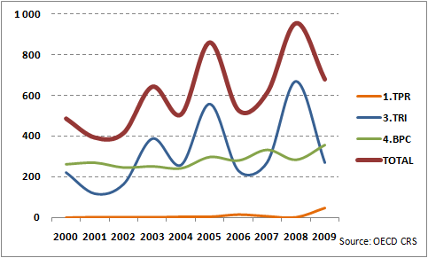

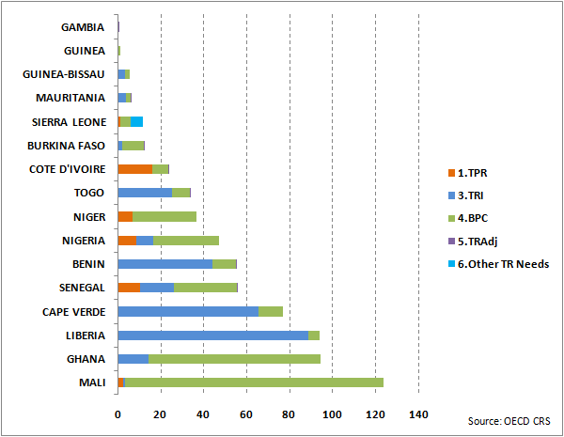
CENTRAL AFRICA
(EUR million) | 2000 | 2001 | 2002 | 2003 | 2004 | 2005 | 2006 | 2007 | 2008 | 2009
1.TPR | 0.1 | 0.0 | 0.4 | 0.0 | 0.0 | 0.0 | 0.2 | 5.6 | 2.3 | 29.1
3.TRI | 79.3 | 164.2 | 155.5 | 83.2 | 56.3 | 184.7 | 304.9 | 111.0 | 198.0 | 233.2
4.BPC | 40.7 | 46.9 | 92.6 | 75.6 | 49.6 | 66.6 | 83.1 | 90.5 | 58.4 | 49.6
5.TRAdj | 0.0 | 0.0 | 0.0 | 0.0 | 0.0 | 0.0 | 0.0 | 0.0 | 0.0 | 0.0
6.Other TR Needs | 0.0 | 0.0 | 0.0 | 0.0 | 0.0 | 0.0 | 0.0 | 0.0 | 0.0 | 0.0
TOTAL | 120.1 | 211.1 | 248.6 | 158.8 | 105.8 | 251.3 | 388.3 | 207.1 | 258.6 | 311.9
Source: OECD CRS
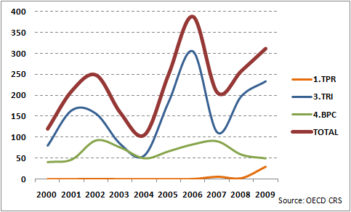
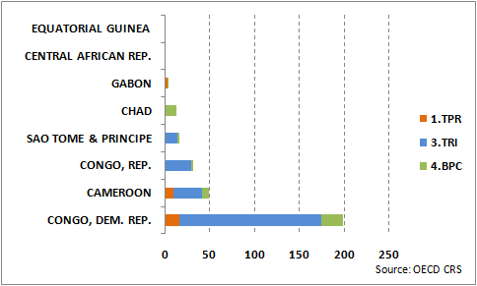

EAC (East African Community)
(EUR million) | 2000 | 2001 | 2002 | 2003 | 2004 | 2005 | 2006 | 2007 | 2008 | 2009
1.TPR | 1.1 | 0.9 | 0.0 | 0.6 | 0.6 | 9.5 | 3.1 | 2.4 | 7.5 | 27.3
3.TRI | 229.7 | 182.0 | 99.8 | 106.5 | 138.2 | 331.8 | 183.1 | 182.4 | 122.9 | 565.5
4.BPC | 144.1 | 124.3 | 123.8 | 108.9 | 126.4 | 116.3 | 159.1 | 98.6 | 230.1 | 225.0
5.TRAdj | 0.0 | 0.0 | 0.0 | 0.0 | 0.0 | 0.0 | 0.0 | 0.0 | 0.4 | 0.0
6.Other TR Needs | 0.0 | 0.0 | 0.0 | 0.0 | 0.0 | 0.0 | 0.0 | 0.0 | 0.0 | 0.0
TOTAL | 374.9 | 307.2 | 223.7 | 216.0 | 265.2 | 457.6 | 345.3 | 283.4 | 360.9 | 817.8
Source: OECD CRS
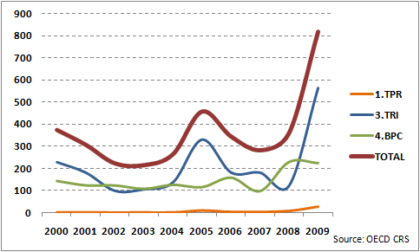
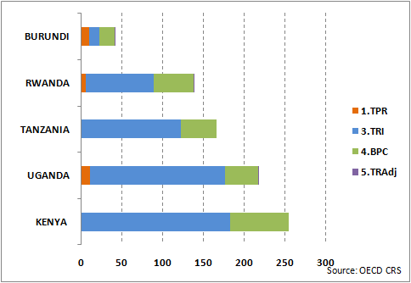
East Africa (excluding EAC)
(EUR million) | 2000 | 2001 | 2002 | 2003 | 2004 | 2005 | 2006 | 2007 | 2008 | 2009
1.TPR | 3.6 | 0.2 | 0.5 | 0.5 | 0.6 | 2.3 | 8.8 | 5.4 | 1.0 | 2.3
3.TRI | 94.8 | 113.6 | 183.4 | 280.3 | 206.3 | 388.9 | 316.0 | 200.6 | 510.4 | 135.8
4.BPC | 234.0 | 112.4 | 116.7 | 186.4 | 113.3 | 174.6 | 188.0 | 151.7 | 167.3 | 327.7
5.TRAdj | 0.0 | 0.0 | 0.0 | 0.0 | 0.0 | 0.0 | 0.0 | 0.0 | 2.2 | 0.3
6.Other TR Needs | 0.0 | 0.0 | 0.0 | 0.0 | 0.0 | 0.0 | 0.0 | 0.0 | 0.0 | 0.9
TOTAL | 332.4 | 226.3 | 300.6 | 467.2 | 320.2 | 565.7 | 512.9 | 357.7 | 680.9 | 467.0
Source: OECD CRS
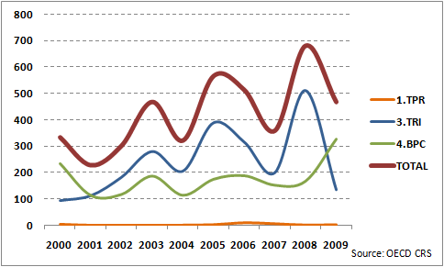
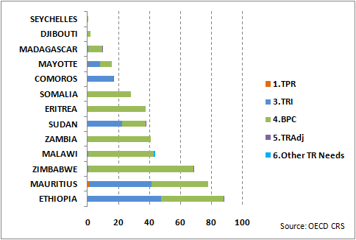
SOUTHERN AFRICA
(EUR million) | 2000 | 2001 | 2002 | 2003 | 2004 | 2005 | 2006 | 2007 | 2008 | 2009
1.TPR | 0.5 | 0.4 | 0.1 | 0.2 | 3.9 | 1.8 | 4.3 | 1.9 | 18.3 | 3.0
3.TRI | 102.4 | 80.4 | 127.1 | 148.7 | 41.7 | 244.6 | 86.7 | 121.2 | 228.8 | 82.8
4.BPC | 94.4 | 193.1 | 143.6 | 84.0 | 69.3 | 240.1 | 157.2 | 158.8 | 158.9 | 115.4
5.TRAdj
6.Other TR Needs | 0.0 | 0.0 | 0.0 | 0.0 | 0.0 | 0.0 | 0.0 | 0.0 | 0.0 | 0.0
TOTAL | 197.3 | 273.9 | 270.8 | 232.8 | 114.9 | 486.5 | 248.2 | 282.0 | 405.9 | 201.2
Source: OECD CRS
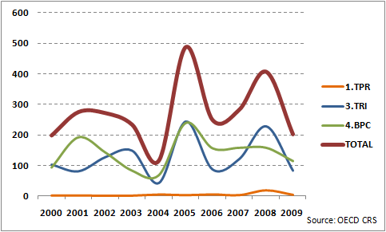
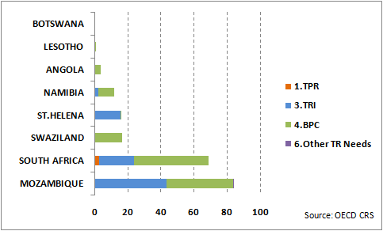
CARIBBEAN
(EUR million) | 2000 | 2001 | 2002 | 2003 | 2004 | 2005 | 2006 | 2007 | 2008 | 2009
1.TPR | 0.1 | 0.3 | 0.0 | 0.0 | 0.1 | 1.6 | 5.0 | 0.8 | 0.1 | 0.1
3.TRI | 81.5 | 69.6 | 21.6 | 53.5 | 62.9 | 38.9 | 17.6 | 26.9 | 26.7 | 193.2
4.BPC | 182.8 | 110.0 | 82.0 | 26.9 | 97.2 | 73.3 | 73.9 | 94.8 | 94.9 | 67.3
5.TRAdj | 0.0 | 0.0 | 0.0 | 0.0 | 0.0 | 0.0 | 0.0 | 0.0 | 0.8 | 10.9
6.Other TR Needs
TOTAL | 264.4 | 179.8 | 103.6 | 80.4 | 160.1 | 113.7 | 96.5 | 122.4 | 122.4 | 271.6
Source: OECD CRS
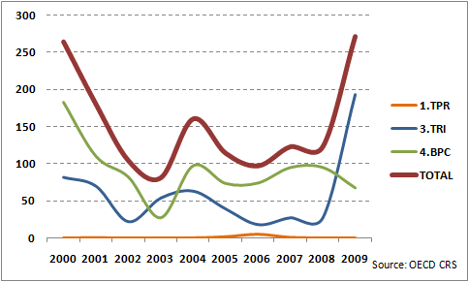
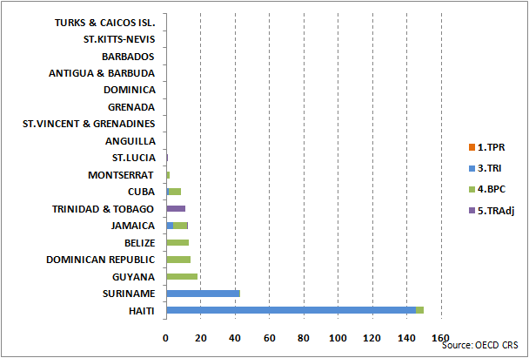

PACIFIC
(EUR million) | 2000 | 2001 | 2002 | 2003 | 2004 | 2005 | 2006 | 2007 | 2008 | 2009
1.TPR | 0.0 | 0.0 | 0.0 | 0.0 | 0.0 | 0.0 | 0.0 | 3.2 | 0.0 | 0.1
3.TRI | 13.3 | 14.6 | 9.0 | 10.1 | 10.2 | 11.4 | 0.1 | 2.3 | 0.7 | 23.4
4.BPC | 14.7 | 5.0 | 55.6 | 11.7 | 8.6 | 13.5 | 8.0 | 7.2 | 10.4 | 8.8
5.TRAdj | 0.0 | 0.0 | 0.0 | 0.0 | 0.0 | 0.0 | 0.0 | 0.0 | 0.0 | 0.0
6.Other TR Needs
TOTAL | 28.0 | 19.6 | 64.6 | 21.8 | 18.8 | 24.9 | 8.1 | 12.7 | 11.1 | 32.2
Source: OECD CRS
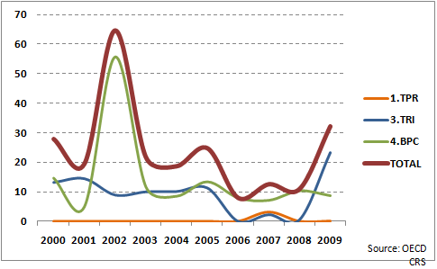
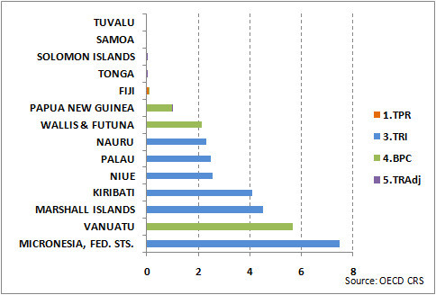
NEIGHBOURHOOD
(EUR million) | 2000 | 2001 | 2002 | 2003 | 2004 | 2005 | 2006 | 2007 | 2008 | 2009
1.TPR | 6.0 | 1.9 | 77.3 | 63.4 | 1.1 | 22.2 | 16.8 | 24.0 | 78.7 | 3.3
3.TRI | 167.5 | 94.7 | 329.0 | 334.3 | 342.0 | 393.4 | 453.9 | 692.5 | 1316.5 | 632.9
4.BPC | 296.8 | 200.5 | 297.2 | 223.9 | 130.8 | 244.5 | 354.3 | 315.2 | 435.7 | 410.7
5.TRAdj | 0.0 | 0.0 | 0.0 | 0.0 | 0.0 | 0.0 | 0.0 | 0.0 | 0.0 | 0.0
6.Other TR Needs | 0.0 | 0.0 | 0.0 | 0.0 | 0.0 | 0.0 | 0.0 | 0.0 | 0.0 | 0.2
TOTAL | 470.4 | 297.2 | 703.4 | 621.6 | 473.8 | 660.2 | 825.1 | 1031.7 | 1830.9 | 1047.1
Source: OECD CRS
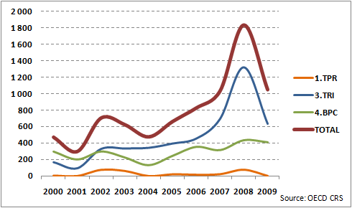
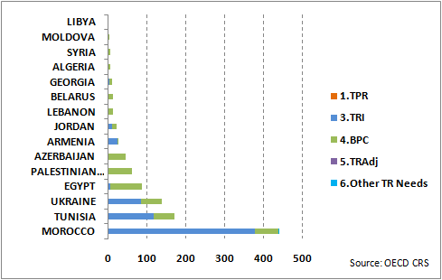
ENLARGEMENT
(EUR million) | 2000 | 2001 | 2002 | 2003 | 2004 | 2005 | 2006 | 2007 | 2008 | 2009
1.TPR | 3.9 | 0.2 | 0.1 | 17.0 | 8.9 | 8.5 | 45.7 | 3.8 | 66.4 | 30.2
3.TRI | 128.0 | 130.8 | 301.7 | 313.8 | 167.3 | 169.1 | 460.1 | 218.7 | 484.8 | 229.1
4.BPC | 96.1 | 124.1 | 319.7 | 91.3 | 125.2 | 202.6 | 131.8 | 209.1 | 493.7 | 258.8
5.TRAdj | 0.0 | 0.0 | 0.0 | 0.0 | 0.0 | 0.0 | 0.0 | 0.0 | 0.0 | 0.0
6.Other TR Needs
TOTAL | 228.0 | 255.0 | 621.6 | 422.2 | 301.3 | 380.2 | 637.6 | 431.6 | 1044.9 | 518.1
Source: OECD CRS
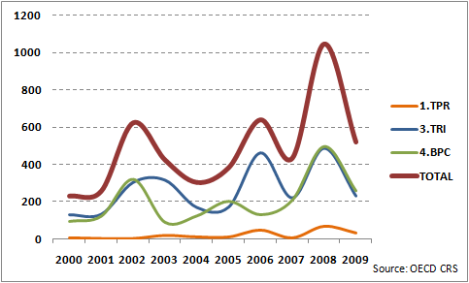
* under UNSCR 1244/1999
LATIN AMERICA
(EUR million) | 2000 | 2001 | 2002 | 2003 | 2004 | 2005 | 2006 | 2007 | 2008 | 2009
1.TPR | 14.0 | 14.0 | 9.2 | 5.1 | 39.5 | 16.0 | 18.7 | 6.0 | 17.0 | 60.2
3.TRI | 116.1 | 181.2 | 154.0 | 89.1 | 95.1 | 7.3 | 15.5 | 35.0 | 82.8 | 168.0
4.BPC | 169.3 | 236.7 | 292.9 | 206.5 | 209.7 | 211.9 | 174.8 | 317.9 | 260.2 | 347.3
5.TRAdj
6.Other TR Needs | 0.0 | 0.0 | 0.0 | 0.0 | 0.0 | 0.0 | 0.0 | 0.0 | 0.0 | 0.2
TOTAL | 299.3 | 432.0 | 456.1 | 300.7 | 344.3 | 235.2 | 209.0 | 358.9 | 360.0 | 575.7
Source: OECD CRS
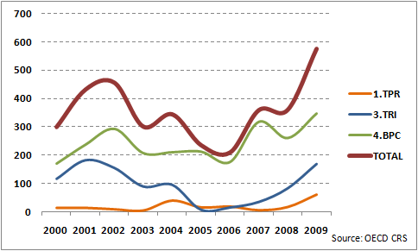
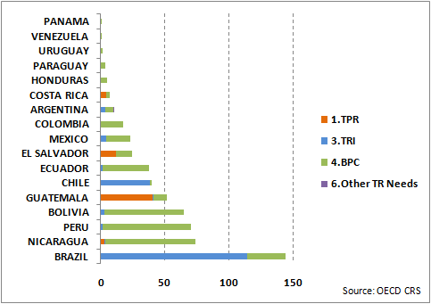
SOUTH ASIA
(EUR million) | 2000 | 2001 | 2002 | 2003 | 2004 | 2005 | 2006 | 2007 | 2008 | 2009
1.TPR | 8.5 | 0.6 | 0.8 | 28.5 | 5.0 | 4.4 | 17.8 | 1.2 | 30.6 | 2.0
3.TRI | 235.5 | 309.6 | 167.9 | 177.9 | 179.3 | 342.2 | 196.3 | 147.2 | 354.7 | 244.8
4.BPC | 248.8 | 163.3 | 167.1 | 266.9 | 97.7 | 192.0 | 280.8 | 304.7 | 402.0 | 377.3
5.TRAdj
6.Other TR Needs
TOTAL | 492.8 | 473.6 | 335.8 | 473.3 | 282.0 | 538.7 | 495.0 | 453.2 | 787.3 | 624.1
Source: OECD CRS
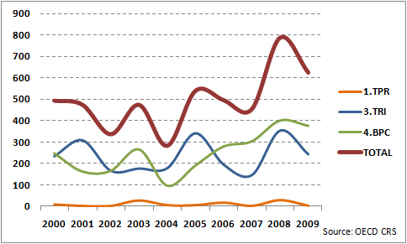
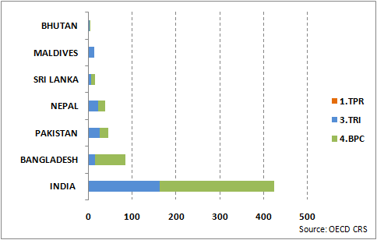
MIDDLE EAST
(EUR million) | 2000 | 2001 | 2002 | 2003 | 2004 | 2005 | 2006 | 2007 | 2008 | 2009
1.TPR | 0.5 | 0.2 | 7.0 | 0.0 | 0.0 | 0.0 | 6.5 | 0.0 | 0.3 | 0.0
3.TRI | 20.2 | 12.8 | 0.1 | 36.9 | 44.5 | 79.1 | 6.8 | 22.5 | 29.3 | 10.9
4.BPC | 10.5 | 0.3 | 4.3 | 5.5 | 55.9 | 22.2 | 1.2 | 1.2 | 5.4 | 136.5
5.TRAdj
6.Other TR Needs
TOTAL | 31.2 | 13.3 | 11.4 | 42.5 | 100.4 | 101.3 | 14.4 | 23.7 | 35.0 | 147.4
Source: OECD CRS
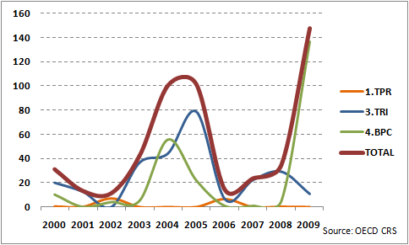
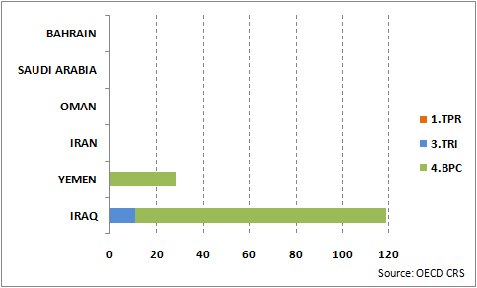
CENTRAL ASIA
(EUR million) | 2000 | 2001 | 2002 | 2003 | 2004 | 2005 | 2006 | 2007 | 2008 | 2009
1.TPR | 0.1 | 0.0 | 0.0 | 0.0 | 1.2 | 0.1 | 0.0 | 0.6 | 0.1 | 0.0
3.TRI | 2.1 | 31.1 | 0.0 | 12.6 | 3.0 | 39.7 | 0.1 | 66.7 | 47.8 | 9.6
4.BPC | 5.2 | 17.1 | 6.0 | 17.1 | 12.0 | 14.5 | 16.5 | 42.9 | 27.0 | 47.6
5.TRAdj
6.Other TR Needs
TOTAL | 7.4 | 48.2 | 6.1 | 29.6 | 16.2 | 54.2 | 16.6 | 110.2 | 74.9 | 57.3
Source: OECD CRS
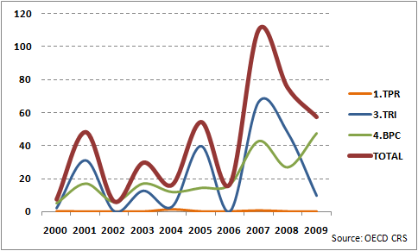
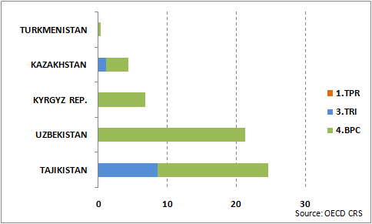
ASEAN
(EUR million) | 2000 | 2001 | 2002 | 2003 | 2004 | 2005 | 2006 | 2007 | 2008 | 2009
1.TPR | 7.2 | 0.9 | 0.1 | 12.2 | 8.8 | 4.1 | 7.9 | 26.1 | 20.8 | 0.5
3.TRI | 129.3 | 240.6 | 168.5 | 46.4 | 133.1 | 161.4 | 239.1 | 175.5 | 74.8 | 178.6
4.BPC | 140.9 | 182.7 | 159.3 | 196.9 | 210.7 | 234.1 | 189.6 | 290.7 | 187.4 | 152.3
5.TRAdj
6.Other TR Needs
TOTAL | 277.4 | 424.1 | 328.0 | 255.4 | 352.7 | 399.7 | 436.6 | 492.4 | 283.1 | 331.3
Source: OECD CRS
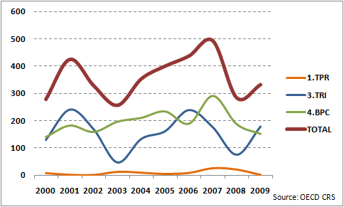
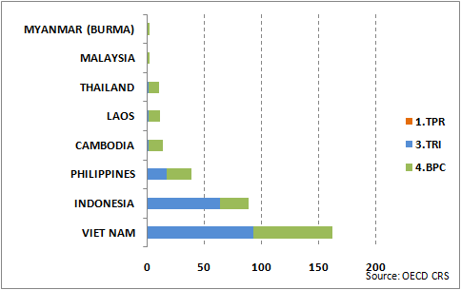
ASIA (other)
(EUR million) | 2000 | 2001 | 2002 | 2003 | 2004 | 2005 | 2006 | 2007 | 2008 | 2009
1.TPR | 2.0 | 1.9 | 22.6 | 0.3 | 4.8 | 21.7 | 13.4 | 0.6 | 63.7 | 47.9
3.TRI | 67.5 | 256.3 | 103.2 | 232.5 | 180.2 | 179.3 | 340.4 | 93.8 | 298.0 | 263.9
4.BPC | 157.6 | 106.2 | 62.1 | 129.9 | 128.5 | 104.7 | 63.2 | 87.1 | 276.5 | 333.9
5.TRAdj
6.Other TR Needs
TOTAL | 227.1 | 364.3 | 187.9 | 362.7 | 313.6 | 305.8 | 417.0 | 181.5 | 638.1 | 645.7
Source: OECD CRS
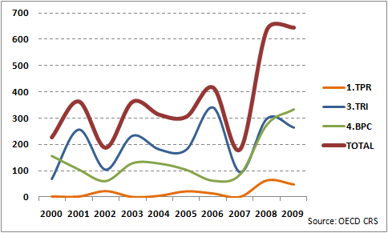
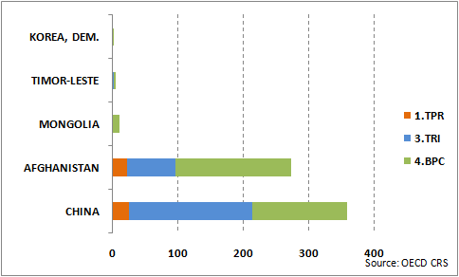
REGIONAL
(EUR million) | 2000 | 2001 | 2002 | 2003 | 2004 | 2005 | 2006 | 2007 | 2008 | 2009
1.TPR | 42.4 | 43.5 | 73.8 | 106.3 | 67.2 | 132.5 | 321.9 | 254.1 | 149.7 | 358.1
3.TRI | 226.8 | 301.2 | 282.7 | 236.3 | 246.3 | 274.6 | 585.4 | 381.5 | 405.1 | 530.2
4.BPC | 495.3 | 892.9 | 579.1 | 602.8 | 782.4 | 660.2 | 1451.1 | 1269.2 | 1398.5 | 2397.8
5.TRAdj | 0.0 | 0.0 | 0.0 | 0.0 | 0.0 | 0.0 | 0.0 | 0.0 | 0.0 | 0.0
6.Other TR Needs
TOTAL | 764.5 | 1237.7 | 935.5 | 945.4 | 1095.9 | 1067.3 | 2358.5 | 1904.8 | 1953.3 | 3286.2
Source: OECD CRS
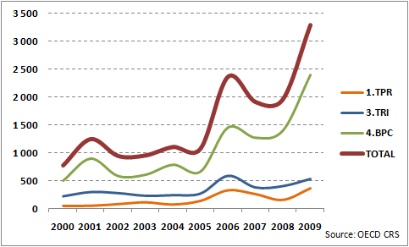
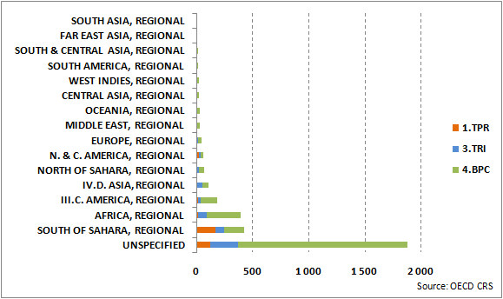
Detailed sub-regional TRA breakdown
WEST AFRICA

(EUR million) | 2008 | 2009
1.TPR | 2.1 | 44.9
2.TD | 49.8 | 154.0
6.Other TR Needs | 0.0 | 5.6
TOTAL | 51.9 | 204.5
Source: OECD CRS
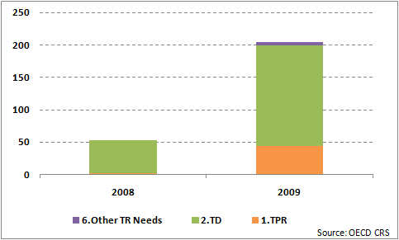
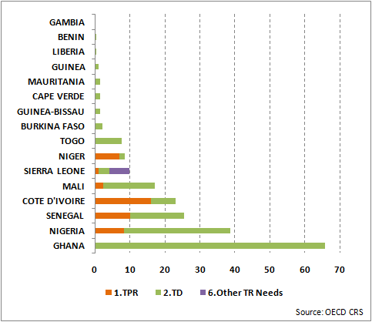

CENTRAL AFRICA

(EUR millon) | 2008 | 2009
1.TPR | 2.3 | 29.1
2.TD | 16.8 | 14.1
6.Other TR Needs
TOTAL | 19.1 | 43.2
Source: OECD CRS
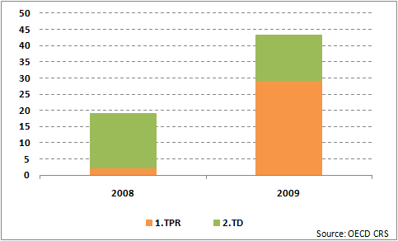

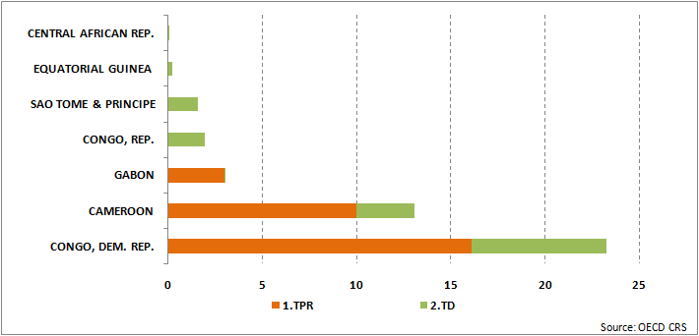

EAC (East African Community)

(EUR million) | 2008 | 2009
1.TPR | 7.5 | 27.3
2.TD | 94.2 | 98.7
6.Other TR Needs
TOTAL | 101.8 | 126.0
Source: OECD CRS
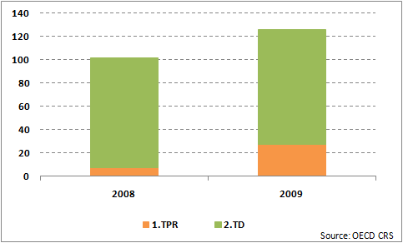

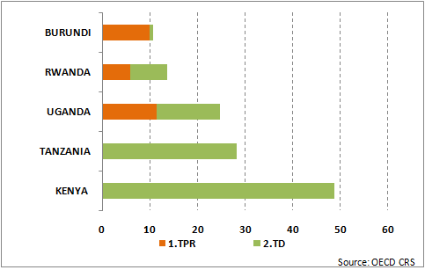
EAST AFRICA EXCL. EAC

(EUR million) | 2008 | 2009
1.TPR | 1.0 | 2.3
2.TD | 41.9 | 83.1
6.Other TR Needs | 0.0 | 0.9
TOTAL | 42.9 | 86.3
Source: OECD CRS
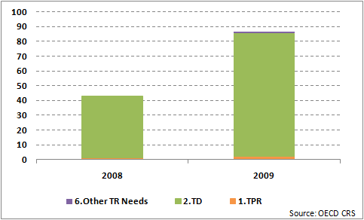
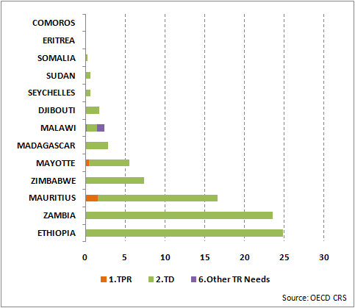
SOUTHERN AFRICA

(EUR million) | 2008 | 2009
1.TPR | 18.3 | 3.0
2.TD | 23.5 | 58.7
6.Other TR Needs | 0.0 | 0.0
TOTAL | 41.7 | 61.7
Source: OECD CRS
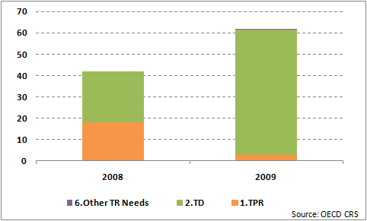
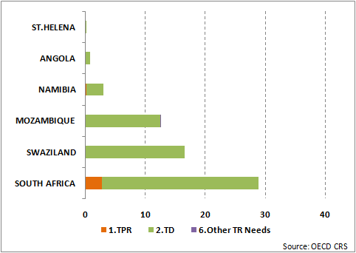
CARIBBEAN

(EUR million) | 2008 | 2009
1.TPR | 0.1 | 0.1
2.TD | 74.3 | 49.3
6.Other TR Needs
TOTAL | 74.4 | 49.4
Source: OECD CRS
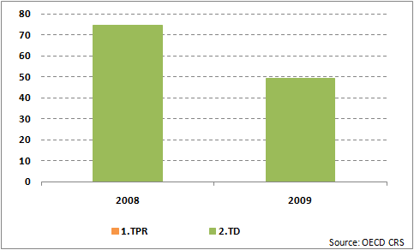
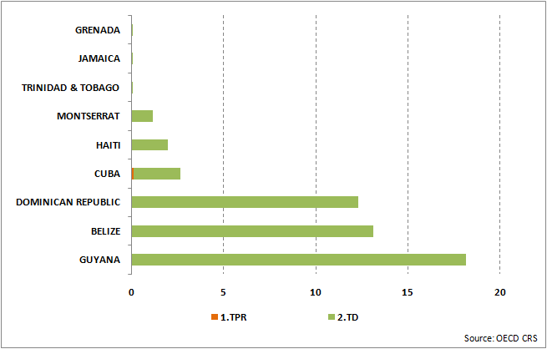
PACIFIC

(EUR million) | 2008 | 2009
1.TPR | 0.0 | 0.1
2.TD | 8.1 | 6.5
6.Other TR Needs
TOTAL | 8.1 | 6.6
Source: OECD CRS
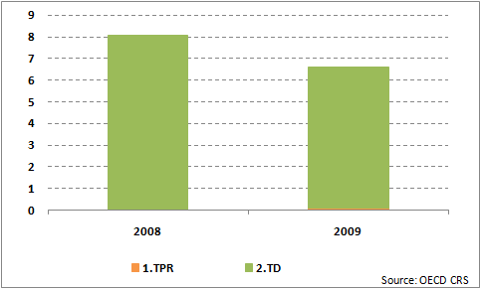
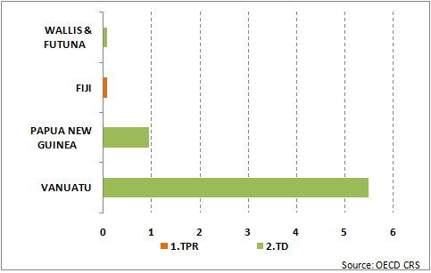
NEIGHBOURHOOD

(EUR million) | 2008 | 2009
1.TPR | 78.7 | 3.3
2.TD | 203.6 | 167.0
6.Other TR Needs | 0.0 | 0.2
TOTAL | 282.3 | 170.5
Source: OECD CRS
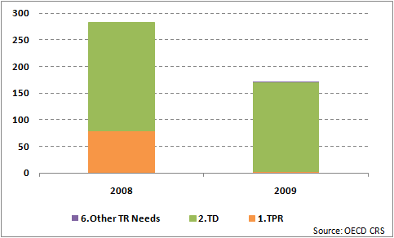
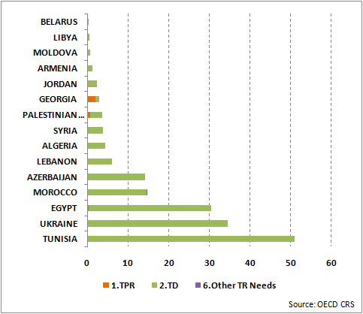
ENLARGEMENT

(EUR million) | 2008 | 2009
1.TPR | 66.4 | 30.2
2.TD | 95.5 | 48.4
6.Other TR Needs
TOTAL | 161.9 | 78.7
Source: OECD CRS
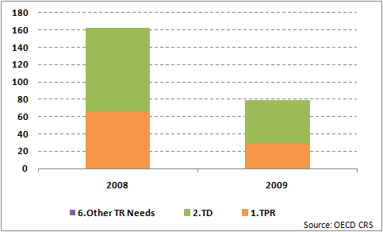

LATIN AMERICA

(EUR million) | 2008 | 2009
1.TPR | 17.0 | 60.2
2.TD | 124.5 | 190.7
6.Other TR Needs | 0.0 | 0.2
TOTAL | 141.6 | 251.1
Source: OECD CRS
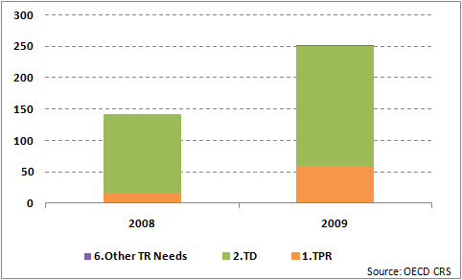
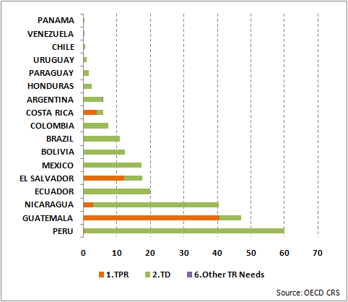
SOUTH ASIA

(EUR million) | 2008 | 2009
1.TPR | 30.6 | 2.0
2.TD | 124.8 | 265.2
6.Other TR Needs
TOTAL | 155.4 | 267.2
Source: OECD CRS
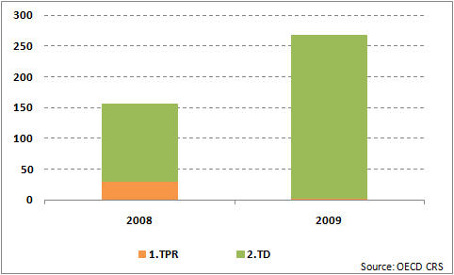

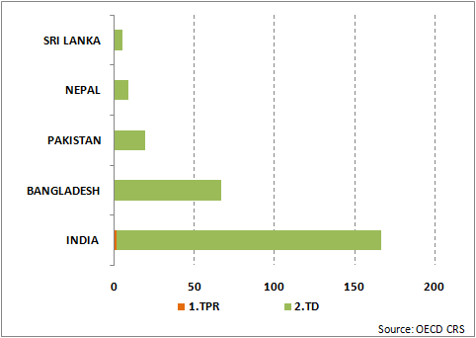
MIDDLE EAST

(EUR million) | 2008 | 2009
1.TPR | 0.3 | 0.0
2.TD | 1.4 | 18.0
6.Other TR Needs
TOTAL | 1.7 | 18.0
Source: OECD CRS
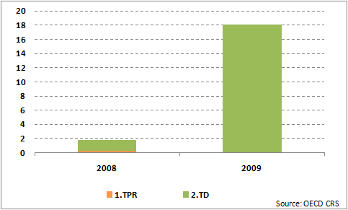

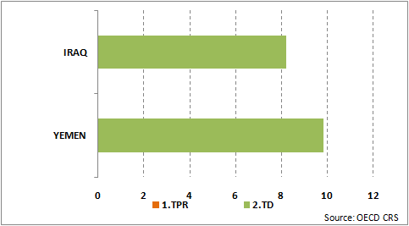
CENTRAL ASIA

(EUR million) | 2008 | 2009
1.TPR | 0.1 | 0.0
2.TD | 9.0 | 38.7
6.Other TR Needs
TOTAL | 9.0 | 38.8
Source: OECD CRS
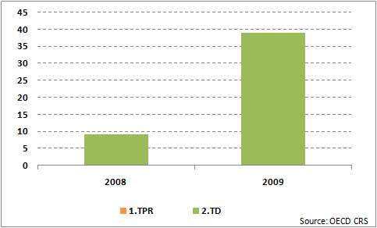

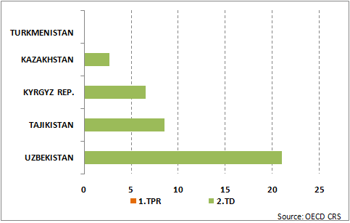
ASEAN

(EUR million) | 2008 | 2009
1.TPR | 20.8 | 0.5
2.TD | 58.5 | 46.1
6.Other TR Needs
TOTAL | 79.4 | 46.6
Source: OECD CRS
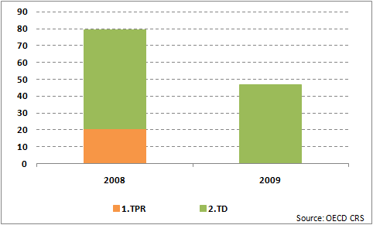

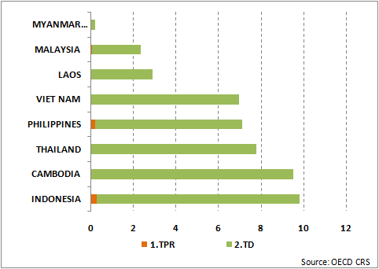
ASIA (other)

(EUR million) | 2008 | 2009
1.TPR | 63.7 | 47.9
2.TD | 134.5 | 134.7
6.Other TR Needs
TOTAL | 198.2 | 182.6
Source: OECD CRS
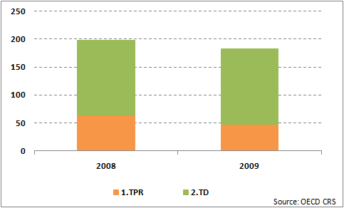

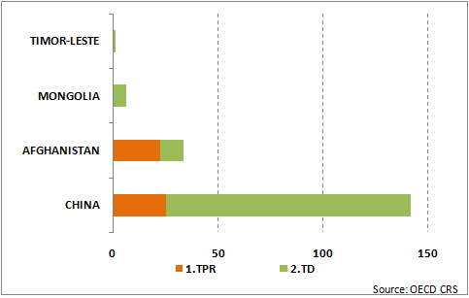
REGIONAL

(EUR million) | 2008 | 2009
1.TPR | 149.7 | 358.1
2.TD | 314.4 | 942.3
6.Other TR Needs
TOTAL | 464.1 | 1300.4
Source: OECD CRS
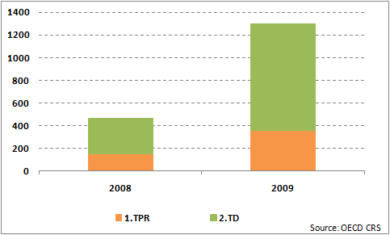

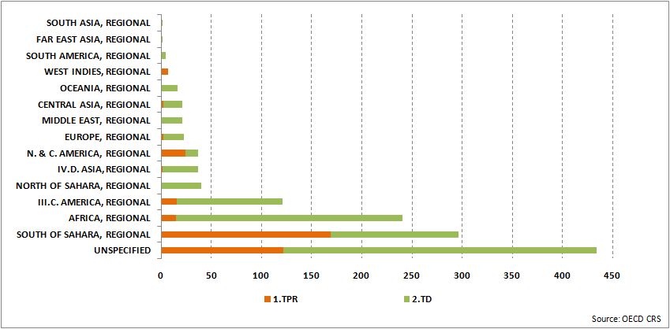
List of 2009 EU + Member State Aid for Trade programmes > EUR 50 million

Donor | Recipient | AfT  category | TRA  category | Purpose | Commitment (EUR million)
EU Funds | Unspecified | 4 | 0 | Agricultural policy & admin. mgmt. | 313.9
EU Funds | Unspecified | 4 | 0 | Agricultural policy & admin. mgmt. | 262.0
EU Funds | Haiti | 3 | 0 | Road transport | 145.0
EU Funds | Unspecified | 4 | 0 | Agricultural policy & admin. mgmt. | 131.8
United Kingdom | Africa, regional | 4 | 2 | Formal sector financ. intermediaries | 123.5
EU Funds | Uganda | 3 | 0 | Road transport | 122.0
France | Unspecified | 4 | 0 | Agricultural research | 107.0
Spain | Tunisia | 3 | 0 | Power generation/renewable sources | 105.0
France | Morocco | 3 | 0 | Rail transport | 104.0
Germany | Brazil | 3 | 0 | Power generation/renewable sources | 100.3
Italy | Iraq | 4 | 0 | Agricultural policy & admin. mgmt. | 100.0
Spain | Morocco | 3 | 0 | Solar energy | 100.0
Belgium | Unspecified | 4 | 2 | Informal/semi-formal fin. intermed. | 95.0
Germany | America, regional | 4 | 2 | Formal sector financ. intermediaries | 94.9
EU Funds | Kenya | 3 | 0 | Road transport | 88.2
EU Funds | Turkey | 4 | 0 | Agricultural policy & admin. mgmt. | 85.5
Germany | India | 4 | 2 | Formal sector financ. intermediaries | 85.0
Germany | India | 3 | 0 | Electrical transmission/distribution | 70.0
Germany | China | 3 | 0 | Water transport | 70.0
EU Funds | Tanzania | 3 | 0 | Road transport | 70.0
Netherlands | Unspecified | 3 | 0 | Power generation/renewable sources | 68.0
United Kingdom | Afghanistan | 4 | 0 | Financial policy & admin. management | 67.3
EU Funds | Ukraine | 3 | 0 | Transport policy & admin. management | 65.0
United Kingdom | India | 4 | 2 | Formal sector financ. intermediaries | 60.6
EU Funds | Turkey | 3 | 0 | Transport policy & admin. management | 60.3
EU Funds | Liberia | 3 | 0 | Road transport | 60.2
Germany | China | 4 | 2 | Formal sector financ. intermediaries | 60.0
France | Morocco | 3 | 0 | Road transport | 60.0
France | Kenya | 3 | 0 | Electrical transmission/distribution | 60.0
Portugal | Cape Verde | 3 | 0 | Road transport | 60.0
EU Funds | Congo, Dem. Rep. | 3 | 0 | Water transport | 60.0
Spain | South of Sahara, regional | 4 | 2 | Business support services & institutions | 55.0
United Kingdom | Zimbabwe | 4 | 0 | Agricultural development | 51.1
Source: OECD CRS

20 countries and regions receiving most of EU and Member States AfT in 2009

(EUR million) | 2000 | 2001 | 2002 | 2003 | 2004 | 2005 | 2006 | 2007 | 2008 | 2009
Unspecified | 384 | 557 | 592 | 451 | 742 | 559 | 1 036 | 1 045 | 1 065 | 1 881
Morocco | 108 | 54 | 127 | 239 | 222 | 120 | 211 | 167 | 789 | 438
India | 149 | 228 | 100 | 236 | 63 | 234 | 223 | 255 | 391 | 425
South of Sahara, regional | 158 | 145 | 90 | 239 | 146 | 190 | 298 | 149 | 126 | 423
Africa, regional | 42 | 253 | 42 | 99 | 37 | 30 | 229 | 161 | 243 | 391
China | 205 | 348 | 115 | 280 | 186 | 228 | 317 | 106 | 461 | 359
Afghanistan | 2 | 3 | 39 | 64 | 103 | 63 | 76 | 62 | 161 | 273
Kenya | 61 | 121 | 16 | 111 | 34 | 190 | 150 | 116 | 39 | 255
Uganda | 74 | 73 | 78 | 22 | 78 | 117 | 61 | 35 | 76 | 217
Congo, Dem. Rep. | 4 | 18 | 86 | 17 | 15 | 34 | 69 | 73 | 68 | 199
Turkey | 64 | 24 | 212 | 162 | 2 | 102 | 187 | 149 | 554 | 199
America, regional | 12 | 88 | 61 | 19 | 19 | 20 | 83 | 115 | 113 | 182
Tunisia | 141 | 96 | 315 | 48 | 81 | 32 | 116 | 40 | 332 | 172
Tanzania | 236 | 109 | 87 | 69 | 96 | 125 | 62 | 41 | 185 | 166
Viet Nam | 104 | 220 | 66 | 110 | 146 | 168 | 324 | 317 | 52 | 162
Haiti | 5 | 3 | 3 | 2 | 36 | 11 | 7 | 6 | 5 | 150
Brazil | 26 | 100 | 28 | 28 | 17 | 35 | 23 | 67 | 33 | 144
Ukraine |  |  |  |  |  | 60 | 93 | 122 | 171 | 138
Rwanda | 3 | 4 | 41 | 12 | 15 | 20 | 45 | 61 | 49 | 138
Mali | 65 | 24 | 20 | 19 | 138 | 69 | 32 | 109 | 189 | 124
Sub-Total | 1 844 | 2 468 | 2 119 | 2 228 | 2 174 | 2 408 | 3 641 | 3 196 | 5 106 | 6 434
Others | 2 755 | 2 686 | 3 091 | 3 044 | 2 596 | 4 093 | 3 893 | 3 670 | 4 696 | 3 578
Total | 4 599 | 5 154 | 5 210 | 5 272 | 4 770 | 6 501 | 7 533 | 6 866 | 9 802 | 10 012
Source: OECD CRS
20 countries and regions receiving most of EU and Member States TRA in 2009

(EUR million) | 2008 | 2009
Unspecified | 209 | 434
South of Sahara, regional | 24 | 297
Africa, regional | 57 | 240
India | 87 | 167
China | 96 | 142
America, regional | 36 | 121
Bangladesh | 45 | 67
Ghana | 17 | 66
Peru | 12 | 60
Tunisia | 29 | 51
Kenya | 4 | 49
Guatemala | 4 | 47
Nicaragua | 8 | 40
North of Sahara, regional | 3 | 40
Nigeria | 1 | 39
Asia, regional | 91 | 37
North & Central America, regional | 5 | 37
Ukraine | 54 | 34
Afghanistan | 99 | 33
Egypt | 5 | 30
Sub-Total | 886 | 2 031
Others | 947 | 901
Total | 1 833 | 2 932
Source: OECD CRS
Category 6 in EU AfT 2009
Country | Region | Commitment (in Euro million) | DAC Code name
BELIZE | Caribbean | 10.000 | Rural development
BELIZE | Caribbean | 1.800 | Public sector policy and administrative management
N.&C. AMERICA, REGIONAL | N.&C. AMERICA, REGIONAL | 3.000 | Public sector policy and administrative management
ERITREA | East Africa | 1.300 | Strengthening civil society
NAMIBIA | Southern Africa | 1.500 | Public sector policy and administrative management
TURKEY | Enlargement | 54.800 | Multisector aid
Unspecified | Unspecified | 2.000 | Environmental policy and administrative management
NORTH OF SAHARA, REGIONAL | NORTH OF SAHARA, REGIONAL | 60.000 | Multisector aid
EUROPE, REGIONAL | EUROPE, REGIONAL | 25.000 | Multisector aid
BOLIVIA | Latin America | 12.000 | Employment policy and administrative management
EUROPE, REGIONAL | EUROPE, REGIONAL | 9.521 | Multisector aid
NORTH OF SAHARA, REGIONAL | NORTH OF SAHARA, REGIONAL | 11.601 | Multisector aid
EUROPE, REGIONAL | EUROPE, REGIONAL | 10.782 | Multisector aid
Unspecified | Unspecified | 3.136 | Multisector aid
Unspecified | Unspecified | 1.893 | Multisector aid
JORDAN | Neighbourhood | 20.000 | Multisector aid
LEBANON | Neighbourhood | 8.000 | Public sector policy and administrative management
EGYPT | Neighbourhood | 20.000 | Multisector aid
NORTH OF SAHARA, REGIONAL | NORTH OF SAHARA, REGIONAL | 4.000 | Research/scientific institutions
THAILAND | Asean | 4.500 | Multisector aid
CENTRAL ASIA, REGIONAL | CENTRAL ASIA, REGIONAL | 8.000 | Security system management and reform
GEORGIA | Neighbourhood | 8.400 | Multisector aid
ALBANIA | Enlargement | 1.627 | Multisector aid
BOLIVIA | Latin America | 10.000 | Employment policy and administrative management
ALBANIA | Enlargement | 460 | Multisector aid
CROATIA | Enlargement | 6.444 | Multisector aid
CROATIA | Enlargement | 1.112 | Multisector aid
The former Yugoslav Republic of Macedonia | Enlargement | 2.910 | Public sector policy and administrative management
The former Yugoslav Republic of Macedonia | Enlargement | 3.570 | Multisector aid
TURKEY | Enlargement | 13.340 | Public sector policy and administrative management
TURKEY | Enlargement | 950 | Public sector policy and administrative management
SOUTH AMERICA, REGIONAL | SOUTH AMERICA, REGIONAL | 10.850 | Multisector aid

BE, CZ, DE, DK, ES, FI, FR, HU, IE, IT, LI, LU, NL, PT, SE, UK
EU regional configurations vs OECD regional configurations
37 responses were received from EU Field offices in LDCs (i.e. 42% of the total, 31 from ACP, 6 from Asia). In 25 out of the cases, the response was prepared jointly by all the EU donors active in the country in question. In of the countries, EU and/or EU Member States have programmes that can be considered as falling under an AfT category (list examples). In 6 further cases, the EU only (i.e. no Member States ) is providing AfT.
Classified in category 2 by OECD CRS but not included in TRA in Monterrey Questionnaires

