TABLE OF CONTENTS
1. BUDGET PROCEDURE 7
1.1. Financial Framework 2007-2013. 7
1.2. Preliminary Draft Budget 2010 8
1.3. Draft Budget 2010 8
1.4. Amending Letter for 2010 8
1.5. Adoption of the 2010 budget 8
1.6. Revenue assigned to EAGF 8
1.7. Temporary restructuring amounts in the sugar sector 9
1.8. Part of the EAGF budget in total EU budget 9
2. CASH POSITION AND MANAGEMENT OF APPROPRIATIONS 10
2.1. Management of appropriations 10
2.1.1. Appropriations available for the 2010 financial year (see also section 1 of this working document): 10
2.1.2. Expenditure section of the EU budget in relation to EAGF: 11
2.1.3. Revenue section of the EU budget in relation to EAGF: 11
2.1.4. Execution of appropriations available for the 2010 financial year: 11
2.1.5. Assigned revenue received under shared management 12
2.1.6. Execution (excluding Sugar Restructuring Fund and TRDI EU 10) 12
2.1.7. Sugar sector: Temporary restructuring amounts. Sugar Restructuring Fund 13
2.1.8. Execution of Transitional Instrument for the financing of Rural Development for the new Member States (TRDI EU 10) 13
2.1.9. Budget execution - Expenditure under centralised direct management made by the Commission 14
2.1.10. Budget execution - Expenditure under centralised direct management made by the Commission - Automatic carryover from 2009 15
2.2. Monthly payments 15
2.2.1. Monthly payments to Member States 15
2.2.1.1. Monthly payments on the provision for expenditure 15
2.2.1.2. Decisions on monthly payments for 2010 16
2.2.1.3. Reductions and suspensions of monthly payments 16
2.2.2. Centralised direct expenditure by the Commission 17
3. THE IMPLEMENTATION OF THE 2010 EAGF BUDGET 17
3.1. Introduction 17
3.2. The uptake of the EAGF budget appropriations 17
4. COMMENTS ON IMPLEMENTATION OF 2010 EAGF BUDGET 18
4.1. Chapter 05 02: Interventions in agricultural markets 18
4.1.1. Introduction 18
4.1.2. Article 05 02 01: Cereals 18
4.1.3. Article 05 02 03: Refunds on Non-Annex I products 19
4.1.4. Article 05 02 04: Food programmes 19
4.1.5. Article 05 02 05: Sugar 20
4.1.6. Article 05 02 06: Olive oil 20
4.1.7. Article 05 02 07: Textile plants 20
4.1.8. Article 05 02 08: Fruits and vegetables 20
4.1.9. Article 05 02 09: Products of the wine-growing sector 21
4.1.10. Article 05 02 10: Promotion 22
4.1.11. Article 05 02 11: Other plant products/measures 22
4.1.12. Article 05 02 12: Milk and milk products 23
4.1.13. Article 05 02 13: Beef and veal 24
4.1.14. Article 05 02 15: Pig meat, eggs and poultry, bee-keeping and other animal products 25
4.2. Chapter 05 03: Direct Aids 25
4.2.1. Article 05 03 01: Decoupled direct aids 25
4.2.2. Article 05 03 02: Other direct aids 26
4.2.3. Article 05 03 03: Additional amounts of aid 27
4.3. Chapter 05 04: Rural Development 27
4.3.1. Article 05 04 01: Rural Development financed by the EAGGF-Guarantee. Completion of earlier programmes (2000 to 2006) 27
4.4. Chapter 05 07: Audit of agricultural expenditure 28
4.4.1. Article 05 07 01: Control of agricultural expenditure 28
4.4.2. Article 05 07 02: Settlement of disputes 28
4.5. Chapter 05 08: Policy strategy and coordination 28
4.5.1. Article 05 08 01: Farm accountancy data network (FADN) 28
4.5.2. Article 05 08 02: Surveys on the structure of agricultural holdings 29
4.5.3. Article 05 08 03: Restructuring of systems for agricultural surveys 30
4.5.4. Article 05 08 06: Enhancing public awareness of the common agricultural policy 30
4.5.5. Article 05 08 09: EAGF – Operational technical assistance 30
5. COMMENTS ON THE IMPLEMENTATION OF THE EAGF BUDGET FOR POLICY AREAS 11 AND 17 30
5.1. Fisheries markets (Chapter 11 02) 30
5.1.1. Article 11 02 01: Intervention in fishery products 30
5.1.2. Article 11 02 03: Fisheries programme for the outermost regions 31
5.2. Veterinary and phyto-sanitary measures expenditure (Chapters 17 01 and 17 04) 32
5.2.1. Generalities 32
5.2.2. Details 32
5.2.2.1. Item 17.040101 Animal disease eradication and monitoring programmes 32
5.2.2.2. Item 17.040201 – Other measures in the veterinary, animal welfare and public health field 33
5.2.2.3. Item 17.040301 – Emergency fund for veterinary complaints and other diseases of animal contaminations which are a risk to public health 33
5.2.2.4. Item 17.040401 Plant-health measures – Expenditure on operational management 34
5.2.2.5. Item 17.040701 Food and feed control – Expenditure on operational management 34
5.2.2.6. Item 17.010401– Plant-health measures – expenditure on administrative measures 34
5.2.2.7. Item 17.010405 – Food and feed control - expenditure on administrative measures 34
5.2.2.8. Item 17.010407 – Animal disease eradication and emergency fund - expenditure on administrative management. 34
5.2.2.9. Item 17.010431 Executive agency for health and consumers – Subsidy for programmes under Heading 2 34
5.2.3. Article 17.0302 - SANCO tobacco: Community Tobacco Fund 36
6. IMPLEMENTATION OF ASSIGNED REVENUE 38
6.1. Revenue assigned to EAGF 38
6.2. Assigned revenue concerning temporary restructuring amounts in sugar sector 39
6.3. Sugar Restructuring Fund 39
7. BREAKDOWN BY TYPE OF EXPENDITURE 39
8. SPECIFIC ACTIVITIES 40
8.1. Supply of food from intervention stocks for benefit of needy in the Community 40
Total 42
Total 43
Total 44
8.2. Promotion measures – payments by Member States 44
9. CONTROL MEASURES 45
9.1. Introduction 45
9.2. Integrated Administration and Control System (IACS) 46
9.3. Market measures 47
9.4. Application of Council Regulation (EC) No 485/2008 (ex-post controls) 47
10. CLEARANCE OF ACCOUNTS 48
10.1. Conformity clearance - introduction 48
10.2. Conformity clearance – audits and decisions adopted in 2010 48
10.2.1. Audits 48
10.2.2. Conformity decisions 49
10.3. Financial clearance 50
10.3.1. Introduction 50
10.3.2. Decisions 50
10.3.2.1. Financial clearance for financial years 2006, 2007 and 2008 50
10.3.2.2. Financial clearance decision for the financial year 2009 51
10.4. Appeals brought before the Court of Justice against clearance decisions 51
10.4.1. Judgments handed down 51
10.4.2. New appeals 51
10.4.3. Appeals pending 52
11. RELATIONS WITH PARLIAMENT AND WITH THE EUROPEAN COURT OF AUDITORS 52
11.1. Relations with Parliament 52
11.2. Relations with the European Court of Auditors 52
11.2.1. Mission of the European Court of Auditors 52
11.2.2. Annual Report 2009 53
11.2.3. Special Reports by the Court of Auditors 54
12. BASIC RULES GOVERNING EAGF AND AMENDMENTS MADE IN 2010 54
12.1. Checks 54
12.2. Clearance of accounts 55
12.3. Public storage 55
13. ANNEXES 56

BUDGET PROCEDURE

Financial Framework 2007-2013.
CAP expenditure is funded within the current financial framework as agreed in the Inter-institutional Agreement between the European Parliament and the Council in May 2006, amended to take into account the Galileo-programme in 2007, the reprogramming of rural development in 2008 and the European Economic Recovery Package (EERP) in 2009. CAP expenditure is part of Heading 2: Preservation and management of natural resources. A specific sub-ceiling has been decided for market related expenditure and direct aids within this heading.
To take account of the transfer of amounts to rural development due to compulsory modulation (including the increase from the CAP Health Check) increase, to the reform of the cotton, tobacco and wine sectors as well as to the voluntary modulation decided for the UK, the expenditure ceiling for market measures and direct aids had to be reduced accordingly.
The CAP amounts included in heading 2 of the financial framework (2007-2013) are:
(in EUR million current prices)
Heading 2* | 2007 | 2008 | 2009 | 2010 | 2011 | 2012 | 2013
Total a), b)  of which:  -Rural development a), c), d)  -Market related expenditure and direct aids, c) | 55 143  10 902  44 753 | 59 193  13 303  44 592 | 56 333  14 002  44 887 | 59 955  14 364  44 276 | 60 338  14 436  44 467 | 60 810  14 617  44 710 | 61 289  14 817  44 939

*) Preservation and Management of Natural resources
a) After reprogramming of rural development (1 469 Mio €).
b) After transfer of EUR 1 600 million to Galileo in 2007 and of EUR 2 000 million to the European Economic Recovery Package in 2009.
c) After transfer into Rural Development of the lower expected expenditure resulting from the reforms of the tobacco, cotton and wine CMOs and from the compulsory and voluntary (UK) modulation Art. 136 of Regulation 73/2009 (SE+DE) and reduction due to financing of the European Economic Recovery Plan (Commission Decision No 2010/273 EU).
d) Including the reinforcement of Rural Development by EUR 1 020 million included in the European Economic Recovery Package, of which EUR 600 million is financed in 2009 within heading 2 while, for 2010, EUR 420 million has been allocated to Rural Development on the basis of the amended Commission Decision No 636/2006.

Preliminary Draft Budget 2010
The 2010 Preliminary Draft Budget (PDB) was adopted by the Commission and proposed to the Budgetary Authority on 29.04.2009. The commitment appropriations proposed for the European Agricultural Guarantee Fund (EAGF) under heading 2 of the Financial Framework 2007-2013 totalled EUR 43 744.9 million.

Draft Budget 2010
The Council adopted the 2010 Draft Budget in July 2009. The commitment appropriations of EAGF were reduced by EUR 354.9 million as compared to the PDB to EUR 43 389.98 million.

Amending Letter for 2010
In October 2009 the Commission adopted Amending Letter (AL) No 2 to the 2010 PDB, setting commitment appropriation requirements for EAGF at EUR 44 049.8 million which was higher by EUR 304.9 million compared to the Preliminary Draft Budget. This increase mostly involved an amount of EUR 280 million foreseen for the specific support for the dairy sector following the dairy crisis.

Adoption of the 2010 budget
The Council held its second reading in November 2009. The commitment appropriations of EAGF were reduced by EUR 231 million, compared to the level included in the Amending Letter, to EUR 43 818.8 million which now included EUR 300 million for the specific support for the dairy sector as well as an increase in the negative expenditure relating to the accounting clearance of EAGF accounts by – EUR 230 million.
The European Parliament adopted the 2010 budget in its plenary session of December 2009.
The voted EAGF commitment appropriations amounted to EUR 43 819.8 million in total, Within this total, commitment appropriations amounting to EUR 4 395.3 million were foreseen for market measures under chapter 05 02 while EUR 39 273.0 million were foreseen for direct aids under chapter 05 03. Furthermore, the 2010 budget foresaw commitment appropriations of EUR 371.9 million for veterinary and phyto-sanitary measures under policy area 17-Health and Conumer Protection and EUR 30.5 million for fisheries markets under policy area 11-Maritime Affairs and Fisheries.
For details, please see annex 1.

Revenue assigned to EAGF
In accordance with Article 34 of the CAP Financing Regulation (EC) No 1290/2005, the receipts originating from financial corrections under conformity clearance decisions, from irregularities and from the milk levy are designated as revenue assigned to the financing of EAGF expenditure. This assigned revenue can be used, partly or wholly, to cover the financing of EAGF expenditure if the budget appropriations granted by the Budgetary Authority are not sufficient to finance the expenditure incurred by the Member States. In the case where all or part of this revenue is not used, then, it will be automatically carried over into the following budget year in order to finance budgetary needs of that year.
At the time of establishment of the 2010 budget, an estimate of the revenue was made both for the amount expected to be collected in the course of the 2010 budget year as well as of the amount which was expected to be carried over from the budget year 2009 into 2010. This estimate was taken into consideration when the Budgetary Authority adopted the 2010 budget. Specifically:
- Revenue from the conformity clearance corrections and from irregularities was estimated at EUR 600.0 million and EUR 91.0 million respectively while the receipts from the milk levy were estimated at EUR 98.0 million. Thus, the total amount of assigned revenue expected to be collected in the course of the 2010 budget year was estimated at EUR 789.0 million.
- The amount of assigned revenue expected to be carried over from the budget year 2009 into 2010 was estimated at EUR 133.0 million.
The total amount of EUR 922.0 million was taken into consideration by reducing the appropriations requested for the operational funds for producer organisations in the fruits and vegetables sector by EUR 222.0 million and for the single payment scheme by EUR 700.0 million. After taking account of these amounts, the Budgetary Authority eventually granted appropriations amounting to EUR 547.0 million and EUR 28 480.0 million respectively for these schemes.

Temporary restructuring amounts in the sugar sector
The temporary restructuring amounts in the sugar sector, as set out in article 11 of Council Regulation (EC) No 320/2006, are treated as assigned revenue intended to finance the sugar restructuring aid and other aids foreseen in the Sugar Restructuring Fund. For each marketing year, starting with 2006/07 up to 2008/09, these amounts relate to the sugar, inulin syrup and isoglucose quantitative quotas held by operators in each Member State and they are to be paid by the Member States into the Fund in two instalments, the deadlines of which are 31 March and 30 November respectively for each year.
At the time of establishment of the 2010 budget, the estimate of this revenue expected to be transferred to the EU budget within the year amounted to EUR 606.8 million. At the same time, an amount of EUR 717.9 million was expected to be carried over from the budget year 2009 into 2010.

Part of the EAGF budget in total EU budget
The final EAGF budget's (commitment appropriations) part of the total EU budget for the period 2003–2010 appears in annex 2.

CASH POSITION AND MANAGEMENT OF APPROPRIATIONS

Management of appropriations

Appropriations available for the 2010 financial year (see also section 1 of this working document):
In EUR
Expenditure section of budget (1) | Commitment appropriations | Payment appropriations | Revenue section of budget (AR) (2) | Forecasts
1. Initial appropriations for EAGF | 43 819 801 768 | 43 917 807 586 | 1. Conformity clearance | 600 000 000
2. Amending budgets | 0 | 0 | 2. Irregularities | 91 000 000
3. Sub-Total Initial appropriations for EAGF of which | 43 819 801 768 | 43 917 807 586
3a. Appropriations for shared management (excluding TRDI EU 10) (3) | 43 360 100 000 | 43 360 100 000 | 3. Super levy from milk producers | 98 000 000
3b. Appropriations under centralised management (4) | 459 701 768 | 341 107 586 | 4. Temporary restructuring amounts for sugar sector (5) | 607 000 000
3c. Appropriations for TRDI EU 10 | 0 | 216 600 000 | Total forecast of AR | 1 396 000 000
4. Transfer to / out of EAGF in the year | -83 529 | 45 666 471
5. Final appropriations for EAGF of which | 43 819 718 239 | 43 963 474 057
5a. Appropriations for shared management (excluding TRDI EU 10) | 43 360 100 000 | 43 360 100 000
5b. Appropriations under centralised management | 459 618 239 | 400 024 057
5c. Appropriations for TRDI EU 10 (6) | 0 | 203 350 000
(1) Appropriations entered in the 2010 budget, taking into account the assigned revenue expected to be collected in 2010 and the revenue carried over from 2009 to 2010 in accordance with Article 10 of the Council Regulation (EC) No 1605/2002.
(2) AR: Assigned revenue to be collected. There are no amounts of revenue entered on the revenue line (p.m.), but the forecasted amount is indicated in the budget remarks.
(3) TRDI: Transitional Rural Development Instrument for EU 10.
(4) 80% of commitment appropriations concern expenditure for veterinary and phyto-sanitary measures under policy area 17 - Health and Consumer Protection). The rest concern equally expenditure for policy strategy and coordination under policy area 05 - Agriculture and rural development and for fisheries markets under policy area 11 - Maritime Affairs and Fisheries.
(5) This revenue is used to provide appropriations for the payment of Sugar Restructuring Fund aids.
'(6) In the course of the budget year, the original payment appropriations of EUR 216.6 million were decreased to EUR 203.35 million through an internal budget transfer.

Expenditure section of the EU budget in relation to EAGF:
The initial commitment appropriations for 2010 totalled EUR 43 819 801 768. This was a net amount taking account of the forecasted assigned revenue to be collected in 2010 and the one carried over from 2009 to 2010. The initial payment appropriations amounted to EUR 43 917 807 586. The appropriations for the Transitional Instrument for the financing of Rural Development for the new Member States (TRDI EU 10) and the majority of the appropriations for expenditure under centralised direct management made by the Commission are differentiated appropriations.
In financial year 2010, there were transfers to and out of EAGF of commitment and payment appropriations. The commitment and payment appropriations finally available to the EAGF after those transfers for the 2010 financial year amounted to EUR 43 819 718 239 and EUR 43 963 474 057 respectively.

Revenue section of the EU budget in relation to EAGF:
For details, please see point 1.6.

Execution of appropriations available for the 2010 financial year:
In EUR
 | Execution of commitment appropriations | Execution of payment appropriations
Shared management (non-differentiated appropriations): | 43 932 376 108.90 | 43 932 376 108.90
Expenditure under centralised management (1) | 443 936 238.44 | 344 004 974.21
TRDI EU 10 | 0.00 | 199 348 292.50
Total (including Sugar Restructuring Fund)  Sugar Restructuring Fund  Total (excluding Sugar Restructuring Fund) | 44 376 312 347.34  330 297 466.97  44 046 014 880.37 | 44 475 729 375.61  330 297 466.97  44 145 431 908.64
(1) The total expenditure under centralised direct management includes an amount of
EUR 4.98 million funded by assigned revenue.
For the financial year 2010, the actual amount of commitment appropriations used amounted to EUR 44 376 312 347.34 while that for payment appropriations amounted to EUR 44 475 729 375.61.

Assigned revenue received under shared management
In EUR
Assigned revenue (excluding Temporary restructuring amounts)
Forecasted revenue | 789 000 000.00
Revenue received | 1 010 533 194.90
Difference | 221 533 194.90
For details, please see points 1.6 and 6.1.

Execution (excluding Sugar Restructuring Fund and TRDI EU 10)
In EUR
Expenditure under shared management (excluding Sugar Restructuring Fund and TRDI - EU10) (1)
 | Final appropriations (C1) | Assigned revenue appropriations (C4) | Carry over of assigned revenue appropriations (C5) from 2009
Appropriations | 43 360 100 000.00 | 1 010 533 194.90 | 141 516 300.99
Execution | 43 355 125 532.33 | 105 436 808.61 | 141 516 300.99
Appropriations cancelled | 4 974 467.67 | - | 0.00
Carry over to 2011 | - | 905 096 386.29 | -
(1)Commitment appropriations = payment appropriations.
Appropriations available for financing measures under management shared with Member States (excluding expenditure under centralised direct management by the Commission) amounted to EUR 43 360.1 million compared to actual expenditure of
EUR 43 355.1 million.
The 2010 appropriations coming from assigned revenue amounted to
EUR 1 010.5 million of which an amount of EUR 105.4 million was used in chapters 05 02 and 05 03. The remaining amount of EUR 905.1 million is automatically carried over to budget year 2011.
Part of the appropriations coming from assigned revenue received in 2009 was not used in financial year 2009 and was automatically carried forward to 2010 (C5 fund source). These appropriations amounted to EUR 141.5 million and had to be used first in accordance with Article 10 of the Financial Regulation. It should be noted that all appropriations (EUR 141.5 million) carried over from financial year 2009 have been fully used in accordance with the Financial Regulation.

Sugar sector: Temporary restructuring amounts. Sugar Restructuring Fund
In EUR
Temporary restructuring amounts |  | Sugar Restructuring Fund
Revenue section of budget |  | Expenditure section of budget
 | Amount |  | Final appropriations (C1) |  | Appropriations from AR (C4) | Carry over of appropriations from 2009 AR (C5)
Forecast revenue | 607 000 000.00 | Appropriations |  | pm | 606 762 831.87 | 768 291 439.67
Revenue received | 606 762 831.87 | Execution (1) |  | - | -3 959 109.00 | 334 256 575.97
 |  | Appropriations cancelled |  | - | - |  | 0
 |  | Carry over to 2011 |  | - | 610 721 940.87 |  | 434 034 863.70
(1) Commitment appropriations = payment appropriations

Execution of Transitional Instrument for the financing of Rural Development for the new Member States (TRDI EU 10)
In EUR
TRDI EU 10 | Commitment appropriations | Execution of commitment appropriations | Payment appropriations (1) | Execution of payment appropriations | Remaining
2010 | 0.00 | 0.00 | 203 350 000.00 | 199 348 292.50 | 4 001 707.50
(1) At the end of the year, the original payment appropriations of EUR 216.60 million were reduced to
EUR 203.35 million
There were no commitment appropriations for TRDI EU10. The original payment appropriations foreseen in the 2010 budget totalled EUR 216.6 million. The final payment appropriations after transfer to finance other programmes amounted to
EUR 203.35 million. Payments made in 2010 amounted to EUR 199.4 million and related to the commitments (RAL) of 2006.

Execution of outstanding commitment appropriations from previous years:
TRDI EU 10 | Outstanding commitments (RAL) | Execution of payment appropriations | Outstanding commitments
2006 | 218 321 875.90 | 199 348 292.50 | 18 883 583.40

Budget execution - Expenditure under centralised direct management made by the Commission
In EUR
Expenditure under centralised direct management | Commitment appropriations | De-commitments | Payment appropriations | Carry over to 2011 (2)
Appropriations (C1) (1) | 459 618 239.00 | - | 400 024 057.00 | -
Execution (C1) | 438 956 113.58 | - | 314 076 513.37 | 31 740 465.18
Appropriations cancelled | 20 662 125.42 | - | 85 947 543.63 | -
(1) Includes transfers to / out EAGF: -EUR 83 529 for commitment appropriations and EUR 58 916 471 for payment appropriations
(2) Carry over to 2011 only for non-differentiated appropriations
Commitment appropriations of EUR 459.6 million were foreseen for expenditure under centralised direct management in the 2010 budget. An amount of EUR 439 million was committed in 2010. The balance of these appropriations, EUR 20.6 million, was cancelled. 80% of commitment appropriations concern Policy area 17-Veterinary and phyto-sanitary measures expenditure. The rest concern equally Policy area 05-Agriculture and Rural Development and Policy area 11-Maritime Affairs and Fisheries.
Since 2007, and in accordance with article 149 of the Financial Regulation, the majority of EAGF appropriations for expenditure under centralised direct management made by the Commission are differentiated appropriations. The automatic carry over to 2011, which relates only to non-differentiated appropriations, amounts to EUR 31.7 million.
For details, please see annex 5 and 6.

Budget execution - Expenditure under centralised direct management made by the Commission - Automatic carryover from 2009
In EUR
Carry over from 2009 to 2010 | Commitments | De-commitments | Payments | Cancelled appropriations
Carried over appropriations | 31 370 402.92 | 1 437 178.36 | 29 592 744.15 | 340 480.41
The automatic carry over from 2009 to 2010 only concerned expenditure under centralised direct management for non-differentiated appropriations. As indicated in the table above, an amount of EUR 31.4 million was carried over from 2009 to 2010. In 2010 an amount of EUR 1.4 million from this carry over was de-committed. The payments made amounted to EUR 29.6 million and the amounts cancelled totalled EUR 0.3 million.
For details, please see annex 6.

Monthly payments

Monthly payments to Member States

Monthly payments on the provision for expenditure
Council Regulation (EC) No 1290/2005 of 21 June 2005 on the financing of the Common Agricultural Policy states in Article 15 that "monthly payments shall be made by the Commission … for expenditure performed by Member States' accredited paying agencies during the reference month". Monthly payments shall be made to each Member State at the latest on the third working day of the second month following that in which the expenditure is incurred.
The monthly payments are a reimbursement of net expenditure (after deduction of revenue) which has been already carried out and are made available on the basis of the monthly declarations forwarded by the Member States. The monthly booking of expenditure and revenue is subject to checks and corrections on the basis of the detailed declaration. Moreover, these payments will become final following the accounting clearance of accounts decisions.
Payments made by the Member States from 16.10.2009 to 15.10.2010 are covered by the system for monthly payments. The remaining payments are made directly by the Commission for a limited number of measures.
For financial year 2010, the total net amount of monthly payments made was EUR 42 315 080 082.3.

Decisions on monthly payments for 2010
For the financial year 2010, the Commission adopted twelve decisions on monthly payments. Furthermore, an additional monthly payment decision, adjusting those already granted for the total expenditure chargeable to the year, was adopted in December 2010. For details, please see Annex 4 of the present working document.

Reductions and suspensions of monthly payments
In 2010, a correction of – EUR 28.0 million was made to the monthly payments effected to the Member States. The most important categories of corrections are detailed in the following points.
a. Reductions of the monthly payments as a result of the non-compliance with the payment deadlines
Pursuant to Article 16 of Council Regulation (EC) No 1290/2005 concerning the budgetary discipline, certain Member States did not always respect the payment deadlines fixed by the Community legislations for the payment of aids to beneficiaries.
The payment deadlines were introduced, on the one hand, to ensure an equal treatment between the beneficiaries in all the Member States and, on the other hand, to avoid the situation in which delays of payments resulted in aids no longer having the expected economic effect. Moreover, any scope for payments in accordance with the administrative practices of the different paying services would not allow the correct application of the budget discipline.
Due to the exceeding of the payment deadlines, the Commission decided on two occasions, jointly with the monthly payments, reductions for a total amount of
– EUR 16.3 million.
b. Reductions of the monthly payments as a result of overspending the financial ceilings
For some aid measures financed by EAGF, financial ceilings are determined in the sectoral regulations, which have to be adhered to. Expenditure exceeding these ceilings is considered as "non eligible expenditure" and has to be corrected.
These corrections lead to reductions of the monthly payments. Due to the overspending of the financial ceilings the Commission made financial corrections for a total amount of – EUR 6.7 million.
c. Reductions of the monthly payments as a result of the non-declaration of certain amounts
Pursuant to Article 11(4) of Council Regulation (EC) No 320/2006 of 20 February 2006 establishing a temporary scheme for the restructuring of the sugar industry in the Community, the Commission deducted a sum equivalent to the restructuring amount not collected (– EUR 3.8 million) for the marketing year 2009/2010 from the monthly payments.
Pursuant to Article 5(1)(c) of Commission Regulation (EC) No 883/2006 of 21 June 2006 laying down detailed rules for the application of Council Regulation (EC) No 1290/2005 as regards the keeping of accounts by the paying agencies, declarations of expenditure and revenue and the conditions for reimbursing expenditure under the EAGF and the EAFRD, the Commission deducted a sum equivalent to the amount for clearance not collected (– EUR 7.1 million) from the monthly payments, and reimbursed a sum equivalent to the amount for clearance that was misbooked (+ EUR 11.1 million).

Centralised direct expenditure by the Commission
In certain cases, the Commission makes payments directly for certain measures. These concern payments for veterinary and plant-health measures (policy area 17), payments for certain fisheries market measures (policy area 11) and payments for certain measures which do not have the character of traditional market measures, in particular certain actions related to controls, promotion measures, measures of research on tobacco and information on the agricultural policy.
For details, please see annex 5 and 6.

THE IMPLEMENTATION OF THE 2010 EAGF BUDGET

Introduction
The 2010 agricultural year was characterised by an increase in agricultural output prices, both in the EU and in world markets. The favourable situation in agricultural markets was further supported by the overall general economic situation as countries gradually started emerging from the deepest recession in decades. The level of EAGF expenditure and the use of available commitment appropriations for market measures, kept almost at its 2009 level, was influenced mostly by the increased needs to cover cereals intervention, the operational funds for producer organisations in the fruits and vegetables sector and by the payment of the aid for the measures taken by the Commission in the dairy sector in 2009. As regards direct payments, the level of EAGF expenditure was higher compared to the one of 2009 because of the continuing phasing-in of these payments to the EU-12 in 2010.

The uptake of the EAGF budget appropriations
The implementation of the budget amounted to EUR 44 046.0 million. This expenditure was funded by the budget's initial appropriations, by using the entire amount of assigned revenue, of EUR 141.7 million, carried over from 2009 and a part of the assigned revenue collected in 2010 amounting to EUR 105.4 million out of a total EUR 1 010.5 million.
Within Policy area 05-Agriculture and Rural Development, the expenditure for market measures amounted to EUR 3 983.8 million and for direct aids to
EUR 39 675.7 million. The expenditure incurred for direct aids exceeded the budget’s voted appropriations and it was partly covered by transfers of appropriations from other items of the budget and partly by the revenue which was assigned to the EAGF budget.
Furthermore, the aforementioned total implementation amount includes expenditure for Policy area 11-Fisheries market measures of EUR 30.4 million as well as expenditure amounting to EUR 359.9 million for Policy area 17-veterinary and phyto-sanitary measures.
For details of the budget's implementation by Policy area, please see annexes 7 and 8.
Annex 16 presents a breakdown of the expenditure on market measures, direct payments and audit of agricultural expenditure by item and by Member State.

COMMENTS ON IMPLEMENTATION OF 2010 EAGF BUDGET
A brief commentary on the implementation of the agricultural budget's appropriations is presented hereafter based on details appearing in the annexed tables:
- Annexes 7 and 8: Analysis of execution of the 2010 EAGF budget. The expenditure incurred for each item of the budget appears in column 6. Columns 2, 3 and 4 indicate, respectively, the source and amount of funding which originates either from voted appropriations or from transfers of assigned revenue and of voted appropriations from other items of the budget.
- Annex 9: Assigned revenue (C4) collected and used in 2010
- Annex 10: Assigned revenue (C5) carried over from 2009 and used in 2010.
This presentation is made at the level of each chapter, article and item of the agricultural budget.

Chapter 05 02: Interventions in agricultural markets

Introduction
Total payments for this area of the budget amounted to EUR 3 983.8 million and they were funded by the budget’s voted appropriations amounting to EUR 4 395.3 million. The appropriations, thus, made available were transferred to other items of the budget in order to cover additional expenditure needed for the single payment scheme and for the accounting clearance of EAGF accounts. As regards assigned revenue, EUR 1.9 million was used to cover the expenditure incurred in the fruits and vegetables sector and the available balance was carried forward to 2011. (NB: Details for this sector appear in point 4.1.8 here below). In items where the budget's appropriations were under-spent, the available appropriations were transferred to other items of the budget in order to cover additional expenditure as needed.
Annex 8 presents these details at the level of each budget item.

Article 05 02 01: Cereals
In general, the 2010 climatic conditions have been relatively favourable for cereals with the exception of durum wheat in Italy which was affected by high levels of rain and the drought in Spain and Portugal as of springtime. The result was a cereals harvest of approximately 295 million tonnes which was significant (above the five-year average of 289 million tonnes) although still being lower than the record harvest of 2008/2009. This harvest allowed cereals stocks to be replenished but led to a general decline of cereals prices. Therefore, the overall market situation was difficult in 2010 which necessitated intervention purchases to keep it balanced, in particular, for barley whose price was standing below its intervention price in many Member States.
As regards intervention stocks, they increased from around 1.56 million tonnes at the start of the year to around 5.56 million tonnes by the end of the year. Underlying this global quantity, however, there were variations in the stock levels for individual cereals. For bread-making wheat, stocks increased from 0.08 million tonnes at the start of the year to a level of 0.23 million tonnes by the end of the year. Similarly for barley, stocks increased from 0.93 million tonnes at the start of the year to a level of 5.33 million tonnes by the end of the budget year while for maize stocks went from 0.56 million tonnes at the start of the year to 0.003 million tonnes by the end of the year. In the course of the budget year, purchases of cereals into intervention amounted to 5.56 million tonnes involving intakes of 0.24 million tonnes of bread-making wheat and 5.32 million tonnes of barley while sales of cereals from intervention stocks amounted to 1.56 million tonnes involving 0.09 million tonnes of bread-making wheat, 0.92 million tonnes of barley and 0.552 million tonnes of maize. The higher quantities of cereals purchased compared to the quantity initially forecasted in the 2010 budget and the consequent increase in technical and other costs led to incurring expenditure amounting to EUR 95.7 million. Therefore, in addition to the budget's voted appropriations for this item, its funding was additionally covered by transfers of voted appropriations from other items of the budget amounting to
EUR 21.7 million.
With regard to intervention for starch, the 2010 budget forecasted payments for the potato starch premium amounting to 92% of the eligible potato starch quota out of which Member States incurred payments amounting to EUR 39.7 million, ie: 96.8% of the amount initially forecasted.

Article 05 02 03: Refunds on Non-Annex I products
The expenditure incurred for export refunds for processed agricultural products amounted to EUR 51.3 million thus, under-spending the budget’s voted appropriations by –EUR 62.7 million. Member States incurred lower expenditure than foreseen mainly for the payment of refunds for both sugar and dairy products incorporated in the exported processed agricultural products. However, it has to be noted that this lower expenditure concerned mainly the dairy sector refunds as the Commission set the refund rate at 0 in November 2009 following the significant improvement in the dairy market compared to its condition at the time when the Amending Letter for the 2010 budget year was being established.

Article 05 02 04: Food programmes
With regard to the distribution of agricultural products to deprived persons, certain Member States did not completely implement their approved 2010 distribution plan for cereals and skimmed milk powder. Furthermore, Member States declared smaller administrative, transfer and transport costs for their 2010 distribution operations in 2010 and left the remainder to be declared in 2011 budget year. These factors resulted in under-spending of the 2010 budget's voted appropriations by – EUR 34.5 million.

Article 05 02 05: Sugar
Export refunds for sugar had been set at zero since the end of September 2008. Therefore, the 2010 budget foresaw only the payments for outstanding export refund balances which were estimated at EUR 12.0 million while Member States actually paid a lower amount of EUR 9.8 million, thus, under-spending the 2010 budget's voted appropriations by approximately EUR 2.2 million.
No sugar was purchased into public storage in 2010. The initial stock of sugar was 0.034 million tonnes. Almost all this quantity, with the exception of 9 tonnes, was distributed to the most deprived persons under the 2010 plan. The liquidation of all the quantity of sugar in public storage resulted in a net overall gain of
– EUR 11.4 million for the 2010 budget.

Article 05 02 06: Olive oil
Following unfavourable conditions in the olive oil market, the Commission introduced private storage aid for olive oil. However, the quantity of olive oil for which private storage aid was paid was approximately 4% smaller than the quantity forecasted in the 2010 budget, thus, leading to under-spending the budget's voted appropriations by –EUR 1.1 million.
With regard to the aid for the financing of quality improvement work programmes for approved operators’ organisations, the Member States concerned incurred lower payments related to the balances retained in the budget for the 2009/2010 part of these programmes leading to under-spending the appropriations retained in the 2010 budget by –EUR 2.8 million.

Article 05 02 07: Textile plants
With regard to the processing aids for long flax fibre and for short flax and hemp fibre, the overall expenditure incurred amounted to EUR 18.8 million, thus, under-spending the appropriations foreseen in the 2010 budget by –EUR 1.2 million because of the smaller quantities of short flax fibre for which the processing aid was paid.
The expenditure incurred by Member States for the national restructuring programmes for cotton was as foreseen in the 2010 budget.

Article 05 02 08: Fruits and vegetables
Under the reform of this sector, the payment of export refunds for fruits and vegetables was discontinued from 1 January 2009. However, the 2010 budget included appropriations for the payment of outstanding balances dating before this date which were estimated at EUR 2.0 million. The expenditure incurred for these balances amounted to EUR 0.4 million for the exports of both fresh and processed fruits and vegetables, thus, under-spending the budget’s appropriations by
–EUR 1.6 million.
For operational funds for producer organisations which aim at financing their production quality improvement, promotion and commercialisation programmes,
EUR 769.0 million were the total credit requirements estimated to be necessary to cover the expenditure forecasted to be incurred by the Member States concerned. Out of this total amount, the Budgetary Authority granted appropriations amounting to
EUR 547.0 million because it took account of estimated revenue amounting to
EUR 222.0 million which had been assigned to the funding of this scheme in the 2010 budget. Member States eventually incurred payments amounting to
EUR 690.0 million which were higher compared to the budget's voted appropriations. These payments were covered by transfer of voted appropriations from other items of the budget amounting to EUR 142.3 million and by part of the revenue, amounting to EUR 0.67 million, which had been assigned to this sector.
The payments incurred by Member States for aid to producer groups for preliminary recognition were higher compared to the appropriations retained in the 2010 budget, thus, leading to an over-execution of these appropriations by EUR 5.2 million as a larger number of producer groups entered into this scheme. This over-execution was covered by a transfer of voted appropriations from other items of the budget amounting to EUR 5.2 million.
The School Fruit Scheme started with the school year 2009/2010 whereby a definitive allocation of EU aid to each participating Member State was established for the period from 1 August 2009 to 31 July 2010. While the amount allocated to the participating Member States amounted to the regulatory ceiling of EUR 90.0 million per school year, it was forecasted that payments amounting to EUR 60.0 million were estimated to be made under the 2010 budget. However, as this was the first year of implementation of the scheme, certain Member States informed the Commission that they will not be able to fully execute the amounts allocated to them. By the end of the 2010 budget year, Member States incurred payments amounting to EUR 29.4 million, thus, under-spending the budget's appropriations by –EUR 30.6 million. It is expected that part of the payments for the school year 2009/2010 will be made in the 2011 budget year.
Under Other Measures (fruit and vegetables) involving payment of still outstanding balances for older measures in the fruits and vegetables sector, Member States incurred expenditure amounting to EUR 2.1 million which was higher compared to the appropriations of EUR 0.8 million retained in the 2010 budget, thus, leading to an over-execution of these appropriations by EUR 1.3 million. This over-execution was covered by using approximately EUR 1.3 million from the revenue assigned to this sector and collected in the course of 2010.

Article 05 02 09: Products of the wine-growing sector
The wine sector was reformed as of budget year 2009. Currently, the principal measures left in this sector are the national support programmes and the grubbing up scheme. For the rest of the measures, the 2010 budget included appropriations destined to cover the estimated still outstanding balances of payments concerning these measures and some quantities left in store.
Export refunds for wine were discontinued from the marketing year 2008/09. The 2010 budget included appropriations amounting to EUR 3.0 million for the payment of possible outstanding balances dating before this marketing year. Member States incurred expenditure for such balances amounting to EUR 0.7 million, thus, under-spending the budget's appropriations by –EUR 2.3 million.
Member States incurred payment for the private storage of alcohol amounting to
EUR 1.0 million. With regard to the public storage of alcohol, following the reform of the wine sector no intervention purchases of alcohol are possible. The sales of existing stock amounted to EUR 0.98 million hl and they were made, through a number of calls for tender, at an average price of EUR 34/hl as opposed to the 2010 budget's initial estimate of EUR 37/hl. The final stock of alcohol amounted to
0.63 million hl for which end-of-year depreciation amounting to EUR 1.97 million was paid to Member States. The final overall expenditure for the storage of alcohol amounted to EUR 12.1 million and it led to over-spending the 2010 budget’s voted appropriations by EUR 5.1 million which was covered by transfer of voted appropriations from other items of the budget.
Aids paid for the use of concentrated and rectified must were higher than the estimated still outstanding balances for which appropriations were retained in the 2010 budget, thus, resulting in an over-spending of the budget's appropriations by
EUR 0.6 million which was covered by transfer of voted appropriations from other items of the budget.
For the restructuring and conversion of vineyards, Member States declared recoveries of payments made in previous budget years amounting to –EUR 5.14 million.
With regard to the national support programmes, Member States incurred slightly lower expenditure of – EUR 14.0 million, compared to the amounts foreseen in these programmes, which were nevertheless satisfactorily implemented at approximately 99% of foreseen appropriations.
With regard to the grubbing up scheme, Member States incurred lower expenditure, mainly, because of the smaller area for which the aid was paid compared to the area forecasted in the 2010 budget, thus, leading to under-spending the budget’s appropriations by –EUR 11.3 million.

Article 05 02 10: Promotion
With regard to promotion measures paid by Member States, Member States did not pay all the amounts foreseen in the promotion decisions taken by the Commission. Total payments amounted to EUR 46.4 million, thus, leading to under-executing the 2010 budget's appropriations by –EUR 9.6 million.
With regard to promotion measures paid directly by the European Community, the Commission committed almost all the amount of EUR 1.2 million foreseen in the 2010 budget.

Article 05 02 11: Other plant products/measures
Aids for a quantity of dried fodder of 3.7 million tonnes were retained in the 2010 budget for the marketing year 2009/10 and for the advances to be paid for the marketing year 2010/11. Member States incurred expenditure for these aids as forecasted in the budget.
The expenditure incurred by Member States for the POSEI programmes amounted to
EUR 234.2 million, thus, over-spending the 2010 budget's appropriations by
EUR 3.2 million which was covered by transfer of voted appropriations from other items of the budget. This over-spending concerned primarily the POSEIDOM and POSEICAN programmes.
With regard to the Community fund for tobacco, the EU's contribution towards Member States' tobacco reconversion plans amounted to EUR 0.7 million, thus, under-spending the 2010 budget's appropriations by –EUR 0.3 million.

Article 05 02 12: Milk and milk products
The sector's appropriations were based on expected needs arising from the 2009 difficult dairy market situation. Eventually, despite higher payments made for the sector in 2010, the budget's voted appropriations were under-implemented primarily because of the significant improvement of the dairy market conditions prevailing in late 2009 which led the Commission to set the export refund rate for dairy products at zero in November 2009 and stopped the inflow of skimmed milk powder and butter in public storage.
As regards export refunds, the Commission having set the export refund rate for dairy products at zero in November 2009, Member States incurred payments amounting to
EUR 186.4 million, thus, under-spending the 2010 budget’s appropriations by
-EUR 262.6 million.
The aforementioned improvement in the dairy market stopped the inflow of skimmed milk powder and butter in public storage while, on the other hand, the existing stock started being reduced, principally, from removals destined for free distribution to the most deprived persons under the 2010 plan. These stocks were further reduced from rejection of earlier intakes which did not meet quality standards as well as from the resumption of sales of butter and skimmed milk powder under normal conditions.
Specifically as regards public storage of skimmed milk powder, purchases amounted to only 808 tonnes while removals amounted to 0.072 million tonnes as opposed to 0.2 million tonnes and to 0.11 million tonnes respectively which were forecasted in the 2010 budget. The insignificant volume of purchases and the smaller volume of removals led to savings in both technical and financial costs as well as to significant savings to depreciation costs at the time of entry. Furthermore, the removals, involving both rejection of earlier intakes and quantities destined for free distribution to the most deprived persons, were valued at prices which were higher than the book value of the stored skimmed milk powder, thus, leading to the realisation of net gains for the budget. The combined effect of these factors led an overall net gain for the public storage of skimmed milk powder account amounting to –EUR 5.5 million.
As regards the private storage aid for butter, the appropriations foreseen in the 2010 budget amounted to EUR 22.0 million while the expenditure incurred amounted to
EUR 10.6 million because of the lower volume of butter for which this aid was paid for 2010. Furthermore as regards public storage of butter, no purchases were made while removals amounted to 0.077 million tonnes as opposed to 0.067 million tonnes and to 0.03 million tonnes respectively which were forecasted in the 2010 budget. The lack of purchases led to savings in both technical and financial costs. The removals, involving both rejection of earlier intakes, quantities destined for free distribution to the most deprived persons as well as sales of butter in the internal market, were valued at prices which were higher than the book value of the stored butter, thus, leading to the realisation of net gains for the budget. Finally, the high level of prices for butter did not make necessary the payment of the end-of-year depreciation which was foreseen in the 2010 budget. The combined effect of these factors led an overall net gain for the public storage of butter account amounting to
–EUR 20.4 million.
Under the specific uses for butterfat scheme, the 2010 budget retained appropriations amounting to EUR 1.0 million for the payment of outstanding balances of this aid relating to previous marketing years. The expenditure incurred was lower, thus, resulting in under-spending the budget’s appropriations by –EUR 0.3 million.
With regard to private storage for cheese, payments were made for quantities which were 64% lower than the ones foreseen in the 2010 budget, thus, under-spending the budget’s appropriations by –EUR 3.4 million.
With regard to school milk, the quantities distributed were lower than the quantities retained in the 2010 budget, thus, leading to an under-execution of the corresponding appropriations by –EUR 7.1 million.
With regard to the specific support for the dairy sector, Member States made payments amounting to EUR 293.8 million out of the foreseen amount of
EUR 300.0 million.

Article 05 02 13: Beef and veal
The quantity of meat exported with refunds was approximately the same as the one retained in the 2010 budget but the export refund rate paid for fresh meat was 13% higher. Member States paid export refunds amounting to EUR 16.7 million with outstanding balances still to be paid in 2011. As a consequence, the corresponding appropriations were under-spent by approximately –EUR 1.3 million.
As regards exports of live animals, the estimated quantities exported were higher than the ones foreseen in the 2010 budget. Member Sates paid export refunds amounting to EUR 8.7 million with still outstanding balances to be paid in 2011, thus, over-spending the budget’s appropriations by approximately EUR 1.7 million which was funded by transfer of voted appropriations from other items of the budget.
With regard to the exceptional market support measures, ie: the Over Thirty Months Scheme (OTMS) and the Older Cattle Disposal Scheme (OCDS), the 2010 budget foresaw appropriations amounting to EUR 1.0 million for the payment of still outstanding balances from previous marketing years. Expenditure incurred amounted to EUR 7.0 million thus, over-spending the 2010 budget’s appropriations by
EUR 6.0 million which was funded by transfer of voted appropriations from other items of the budget.
Under other measures, Member States declared recoveries of payments made in previous budget years amounting to –EUR 7.78 million.

Article 05 02 15: Pig meat, eggs and poultry, bee-keeping and other animal products
The expenditure incurred by Member States for export refunds for fresh and frozen pig-meat and for sausages amounted to EUR 18.8 million, thus, under-spending the budget’s appropriations by -EUR 9.2 million because of the smaller quantity of sausages exported as well as because the payments for outstanding balances for export refunds of previous marketing years were smaller than the estimate included in the 2010 budget.
With regard to export refunds for eggs, the exported quantities for all types of eggs decreased by 25% compared to the quantities retained in the 2010 budget while the export refund rates for all types of exported eggs also decreased. Consequently, Member States incurred lower than expected expenditure thus under-spending the 2010 budget’s appropriations by –EUR 2.0 million.
For export refunds for poultry, the exported quantities for all types of poultry increased by approximately 20% compared to the quantities retained in the 2010 budget while the export refund rates paid remained unchanged. These elements resulted in over-spending the budget’s appropriations by EUR 10.7 million which was funded by transfer of voted appropriations from other items of the budget.
The payments incurred by Member States for specific aid for bee-keeping were slightly higher compared to the appropriations retained in the 2010 budget, thus, leading to an over-execution of these appropriations by EUR 0.3 million which was funded by transfer of voted appropriations from other items of the budget.

Chapter 05 03: Direct Aids
The voted appropriations for this chapter of the 2010 budget amounted to
EUR 39 273.0 million while payments amounted to approximately
EUR 39 675.7 million. This level of EAGF expenditure was higher compared to the level of 2009 because of the continuing phasing-in of these aids to the EU-12 in 2010. The apparent over-implementation was, primarily, attributable to the single payment scheme and it was covered partly by the revenue which was assigned to this scheme in the 2010 budget and partly by transfers of appropriations from other items of the budget.
Annex 8 presents these details at the level of each budget item.

Article 05 03 01: Decoupled direct aids
The appropriations of this article cover principally the expenditure for the single payment scheme (SPS) as well as for the single area payment scheme (SAPS) which is applied by 10 out of the EU-12 Member States. Both payment schemes are paid independently of production but on certain conditions e.g. respect of cross-compliance.
With regard to the single payment scheme, the Budgetary Authority granted appropriations amounting to EUR 28 480.0 million because it took account of the revenue assigned to this budget item amounting to EUR 700.0 million. Hence, the total available appropriations for the funding of this scheme's needs amounted to
EUR 29 180.0 million. However, the Member States concerned incurred expenditure amounting to EUR 29 070.9 million. This expenditure was funded by the budget's voted appropriations of EUR 28 480.0 million as well as by part of the revenue assigned to this scheme amounting to EUR 244.9 million and by transfers of appropriations from other items of the budget amounting to EUR 346.1 million.
The difference between the scheme’s initially estimated requirements amounting to
EUR 29 180.0 million and its final execution amounting to expenditure of
EUR 29 070.9 million shows that a number of Member States did not make full use of their single payment scheme financial envelope. This can be due to leftover balances in the national reserves, to farmers activating only part of their payment entitlements, to the application of sanctions for not complying with the scheme's eligibility conditions. However, it should be pointed out that the rate of implementation in most Member States concerned has increased compared to last year's rate, thus, indicating an improvement in the overall management of the SPS's financial envelopes.
With regard to the single area payment scheme, the Member States concerned incurred payments amounting to EUR 4 460.9 million, thus, resulting in an under-execution of the 2010 budget's appropriations by –EUR 36.1 million. This under-execution is due to the fact that, in some Member States, the total eligible area declared by farmers is smaller than the area fixed in the legislation and which is used for the purpose of calculating the maximum rate of aid per hectare.
With regard to the separate sugar payment scheme, the Member States concerned did not pay the totality of their corresponding budgetary ceilings, thus, resulting in an under-execution of the 2010 budget's appropriations by –EUR 2.0 million.
With regard to the separate fruit and vegetables payment scheme, the Member States concerned made payments amounting to EUR 12.2 million, i.e.: an amount almost equal to the envelope of EUR 12.0 million foreseen in the 2010 budget.

Article 05 03 02: Other direct aids
The appropriations of this article cover expenditure for other direct aids for which Member States have chosen to maintain a limited link between the payment of these aids and production for a number of sectors, under well defined conditions and within clear limits, in order to avoid the abandonment of this production.
With regard to these schemes, the Commission had estimated that appropriations amounting to EUR 5 995.0 million (after modulation) were required in 2010. However, Member States incurred expenditure amounting to EUR 5 847.0 million, thus, under-spending the budget’s appropriations by –EUR 148.0 million.
Thirty schemes are funded under this article. For most of these schemes, the Member States concerned incurred expenditure which was lower than the budget's retained appropriations such as:
- Crops area payments: -EUR 10.1 million mainly because of a penalty of
EUR 6.0 million imposed by the Commission to one of the participating Member States for having advanced to farmers amounts of aid which were higher than the amount due. The remaining amount is most probably due to the eligible area claimed by farmers in 2009 being slightly less than the base area;
- Supplementary aid for durum wheat traditional production zones:
-EUR 2.5 million because the area sown with durum wheat has actually been less than the reference area that was used as base area for fixing the amount of aid per hectare;
- Suckler cow premium: -EUR 22.9 million probably due to a small decrease in the herd as well as to the application of sanctions for not complying with the scheme's eligibility conditions;
- Beef special premium: -EUR 2.9 million mainly due to the current level of production being lower compared to the one observed during the reference period;
- Beef slaughter premium for calves: -EUR 7.3 million equally due to the current level of production being lower compared to the one observed during the reference period;
- Beef slaughter premium for adults: -EUR 7.0 million also due to the current level of production being lower compared to the one observed during the reference period;
- Sheep and goat premium: -EUR 11.1 million because one of the Member States concerned was not able to adapt on time the changes in the regulation which allowed for the payment of a higher premium per animal;
- Area aid for cotton: -EUR 37.3 million because in one of the Member States concerned, eligible areas were lower than the base area, also due to a strengthening of the eligibility requirements.
On the other hand, 2 of the Member States concerned incurred expenditure for the aid for energy crops which was EUR 7.7 million higher than the budget's retained appropriations and which was funded by transfer of voted appropriations from other items of the budget.

Article 05 03 03: Additional amounts of aid
The appropriations of this article intended to cover still outstanding balances for the additional amount of aid paid to farmers in the EU-15 Member States in order to compensate for the modulation applicable to their first EUR 5 000 or less of direct payments. Out of the appropriations amounting to EUR 6.0 million retained in the 2010 budget for this aid, Member States incurred payments amounting to
EUR 3.7 million, thus, under-implementing the budget’s appropriations by
-EUR 2.3 million.

Chapter 05 04: Rural Development

Article 05 04 01: Rural Development financed by the EAGGF-Guarantee. Completion of earlier programmes (2000 to 2006)
No commitment appropriations can be made anymore for these programmes. At the same time, Member States were declaring recoveries of previously paid advances. The final net amount recovered under this article was equal to –EUR 7.1 million.

Chapter 05 07: Audit of agricultural expenditure

Article 05 07 01: Control of agricultural expenditure
This article involves the measures taken in order to reinforce the means of on-the-spot controls and to improve the systems of verification so as to limit the risk of frauds and irregularities in detriment of the Community budget. It also includes the amounts credited into the EAGF budget through the corrections based on the accounting clearance procedure and on the procedure relating to the reduction/suspension of advances.
The European Community directly financed measures mostly for the purchase of satellite images within the framework of the Integrated Administrative and Control System (IACS) by committing the amount of EUR 6.5 million foreseen in the 2010 budget for Monitoring and preventive measures-Direct payments by the European Union.
With regard to the accounting clearance of previous years' accounts, the total amount of corrections amounted to approximately –EUR 54.4 million and originated, mainly, from the 4 accounting clearance decisions adopted by the Commission (Commission decisions 2010/56/EU, 2010/61/EU, 2010/62/EU and 2010/258/EU) within the year and from the reduction/suspension of advances which were deducted from the Member States reimbursements because payment deadlines were not respected. The 2010 budget retained appropriations amounting to –EUR 310.0 million for these corrections. The Commission closed this account by transferring voted appropriations amounting to EUR 256.0 million from other items of the budget and by using assigned revenue of EUR 0.2 million carried over from 2009 into 2010.
With regard to the conformity clearance of previous years' accounts, positive corrections amounting to EUR 5.1 million were adopted by the Commission (Commission decision 2010/152/EU) within the year. The 2010 budget did not retain any appropriations for such positive corrections which were eventually funded by transferring voted appropriations of the same amount from other items of the budget.

Article 05 07 02: Settlement of disputes
The appropriations of EUR 3.0 million foreseen in this article of the 2010 budget intended to cover expenditure for which the Commission may be held liable by decision of a court of justice, including the cost of settling claims for damages and interest. No such expenditure was incurred in 2010.

Chapter 05 08: Policy strategy and coordination

Article 05 08 01: Farm accountancy data network (FADN)
Appropriations committed with regard to the cost of data collection on approximately 85 876 farm holdings under this network amounted to approximately
EUR 13.8 million, thus, under-executing the 2010 budget’s commitment appropriations by -EUR 0.2 million.

Article 05 08 02: Surveys on the structure of agricultural holdings
Appropriations committed with regard to cost of data collection on the structure of holdings amounted to approximately EUR 15.0 million, thus, under-executing the 2010 budget’s commitment appropriations by -EUR 0.3 million.

Article 05 08 03: Restructuring of systems for agricultural surveys
Appropriations committed with regard to the cost of operating the MARS meteorological system amounted to approximately EUR 1.5 million, thus, committing all the appropriations foreseen in the 2010 budget.

Article 05 08 06: Enhancing public awareness of the common agricultural policy
Appropriations committed with regard to the cost of actions, fairs and publications aimed at improving the level of understanding of the CAP amounted to
EUR 7.0 million versus the amount of EUR 8.0 million retained in the 2010 budget.

Article 05 08 09: EAGF – Operational technical assistance
Appropriations committed with regard to operational technical assistance for the EAGF amounted to approximately EUR 1.1 million versus the amount of
EUR 2.1 million retained in the 2010 budget.

COMMENTS ON THE IMPLEMENTATION OF THE EAGF BUDGET FOR POLICY AREAS 11 AND 17

Fisheries markets (Chapter 11 02)

Article 11 02 01: Intervention in fishery products
Commitment and payment appropriations for the intervention in fishery products totalled EUR 15 500 000, among which EUR 2 000 000 in payment appropriations to finance the preparatory action in view of the creation of a European Markets Information Service. Commitment and payment appropriations were executed for a total sum of EUR 15 443 546 and EUR 10 353 608 respectively, i.e. a difference of
EUR 56 453 and EUR 7 142 392 respectively (see tables below).
The implementation rate for payment appropriation is 60% (74% in 2009 and 82% in 2008). For 2010, claims equal to 97,5% of the total payment appropriations were submitted. A number of these requests (corresponding to 43% of the total payment appropriations) were not fully substantiated by the Member States and were duly suspended, which is the main reason for the under-execution.
A second reason relates to the preparatory action for which only 24% (EUR 484 000) of the payment appropriations could be implemented. Payments have had to be delayed due to the need for the contractor to revise some of the deliverables.

Article 11 02 03: Fisheries programme for the outermost regions
Commitment appropriations for the five outermost regions, i.e. the Azores, Madeira, the Canary Islands, French Guiana and Reunion, totalled EUR 14 996 768, which corresponds to the maximum amount provided by the compensation scheme. 100% of the commitment appropriations were committed.
All payments have been suspended in 2010 as a consequence of the action plan elaborated and implemented by DG MARE in view of lifting the reservation of the Director General (declaration of assurance on 2009).
This issue has been analysed by the concerned services of DG MARE and by the Legal Service of the Commission. A definitive position on these payments was taken in early March 2011: the Legal Service came to the conclusion that these payments are eligible and that consequently, the suspension could be lifted.

Veterinary and phyto-sanitary measures expenditure (Chapters 17 01 and 17 04)

Generalities
More than 95% of the C1 commitment credits available from the 2010 budget have been used; an amount of EUR 338 190 288 out of EUR 354 901 471 available for the operational and administrative credits for veterinary and plant health measures has been committed. A bit more than 90% of the C1 payment appropriations has been used for these measures; an amount of EUR 269 259 831 out of EUR 295 747 822 available was paid.
Via transferts of credits the payment appropriations for the eradication/surveillance programmes (item 17.040101) and the emergency fund (item 17.040301) have been increased by respectively EUR 33 million and EUR 26 million. This increase was needed to cover the co-financing by the EU of the administration of the vaccines against bluetongue in 2009 and the emergency vaccination against bluetongue in 2007/2008. As in previous years, there have been some internal transfers of commitment and payment appropriations.

Details

Item 17.040101 Animal disease eradication and monitoring programmes
The amount of available credits (all sources) was EUR 277.2 million. After a transfer of credits, executed in the autumn of 2010, an amount of a bit more than
EUR 274 million was committed (152 commitments) according to the details mentioned below. This is more or less in line with the number of commitments made in 2009 (163 commitments):
- EUR 68 160 000 for the bluetongue programmes,
- EUR 77 840 000 for the TSE,BSE and scrapie programmes,
- EUR 98 740 000 for the traditional eradication programmes,
- EUR 4 915 000 for avian influenza survey programmes and,
- EUR 24 427 000 for the salmonella control programmes.
As stated above, payment appropriations were increased, via transfert of credits, with EUR 33 million in order to cover payments towards the administration of vaccines against bluetongue. The co-financing of this measure was decided in the middle of 2009. Payment credits were executed via 154 C1 payments for an amount of
EUR 187.5 million. Almost EUR 9 million of payment appropriations remained unspent. This is mainly due to the fact that "expensive" programmes were submitted to audits ex ante. However these audits were not closed at the end of 2010. Payments towards these programmes were therefore limited to the first outcomes of the audits. The balance will be paid after closure of the audits. No payments were made on C4 or C5 appropriations.

Item 17.040201 – Other measures in the veterinary, animal welfare and public health field
The budget authority increased the commitment envelope from EUR 17.5 million to
EUR 18.5 million. Only 67.72% of EUR 12 528 635 of the available envelope was committed. Some envisaged actions in 2010 were not executed: purchase of emergency vaccines for EUR 2.5 million and the contribution towards the EU-FMD trust fund for EUR 2 million.
The payment credits were executed via 207 payments (all from C1) up to a total sum of EUR 6.941 million. The under execution (a bit more than 50%) of the payment credits is due to the fact that the production of the foot-and-mouth antigens (42 million doses) could not take place in 2010 as envisaged. Therefore, a carry-over of approximately EUR 6 million to 2011 was requested.

Item 17.040301 – Emergency fund for veterinary complaints and other diseases of animal contaminations which are a risk to public health
The initial envelop of EUR 30 million was decreased via internal transfers to almost
EUR 23 million (EUR 5 million went to the feed and food line and EUR 2 million went to the plant health line). Due to the favourable animal health situation of the recent past almost EUR 8 million remained unspent. The envelope of the payment appropriations was increased by EUR 26 million in order to be able to pay for the emergency vaccination against bluetongue in 2007/2008. These payments are the second/third tranche. It is expected that the balance towards this action will be paid in 2011 once the ex ante audits will be closed.
Via 28 payments, an amount of almost EUR 51 million has been paid (99.08% of the available envelope). The bulk went to the above mentioned emergency vaccination against blue tongue (EUR 30 million), followed by the payment towards the old Italian SVD dossier from 2006/2007 (EUR 16 million).

Item 17.040401 Plant-health measures – Expenditure on operational management
The commitment appropriations have been increased via internal transfers from
EUR 3.2 million to a bit more than EUR 8 million. This increase was needed to cover the financing of the EU contribution towards the eradication of harmful organisms in different Member States (solidarity action).The commitment appropriations available were 100% used.
Payment appropriations have been increased by almost EUR 4 million to
EUR 6.272 million. However, it has not been possible to proceed at the year end with payments towards solidarity actions in different Member states.

Item 17.040701 Food and feed control – Expenditure on operational management
Commitment appropriations were increased by almost EUR 5 million to reach almost EUR 31 million which was 100 % used. EUR 14 million was committed for the European reference laboratories, EUR 13 million went to the action "beter training for safer food and the balance was for other actions (listeria, IT,….).
Payment appropriations were also increased from EUR 19 million to
EUR 26.5 million. However, a bit more than EUR 5 million was not spent due to the late presentation of invoices for better training for safer food and the reduced request for advances from the European reference laboratories.

Item 17.010401– Plant-health measures – expenditure on administrative measures
The allocated credit amount was EUR 0.250 million. Almost EUR 0.1 million was not committed because an envisaged action couldn't be launched in time. No significant payment was made in 2010.

Item 17.010405 – Food and feed control - expenditure on administrative measures
A bit more than 86% of EUR 0.675 million available was committed. For these commitments, only 39.6% was paid.

Item 17.010407 – Animal disease eradication and emergency fund - expenditure on administrative management.
Almost 85% of the envelope of EUR 0.250 million was committed. No payment was made in 2010.

Item 17.010431 Executive agency for health and consumers – Subsidy for programmes under Heading 2
These appropriations are intended to cover the subsidy for expenditure of the Agency’s staff and administration. They were used for more than 96%.
Details of the commitments (C1) done in 2010 financial year by Member State are given in annex12.

Article 17.0302 - SANCO tobacco: Community Tobacco Fund
All commitment appropiations available in the 2010 budget (EUR 16.9 million), have been used to fund information programmes of the anti-smoking ‘HELP 2.0 – for a life without tobacco’ campaign.
This large media campaign is conceived with a special focus on young people and addresses tobacco prevention, cessation and the dangers of passive smoking in the 27 European Union Member States. This initiative is based on an interactive concept, the “Tips”, which allows full participation of its main target: the campaign is co-designed by young people at all stages. It is one of the largest public health awareness-raising initiatives ever organised in the world.
"Help TV Campaign" was launched on "World No Tobacco Day 31st May 2010" on 136 national TV channels across 27 Member States, with a Pan-European TV campaign following in September, based uniquely on the prevention theme ‘Cloud’ advert. The three adverts, addressing cessation, prevention and passive smoking, were based around the “tips” concept which is at the heart of the Help campaign – the films show a young European’s absurd tip on how to tackle a smoking issue, and then lead the audience to real advice available on the Help website. 25,900 spots were broadcast in 2010, with a total of 517 522 000 contacts achieved in the 15-34 year old target group.
The TV campaign is systematically pre and post-tested by Ipsos, the survey-based market research company. Interviews with 26,000 Europeans following the broadcast of the TV campaign are the basis for in-depth evaluation of the impact of the “Help” message across Europe. The Ipsos results show that the Help campaign had a wide reach and the key messages were clearly understood as 43% of all Europeans and 67% of Europeans under 25 years old saw the TV adverts; 90%of young Europeans understood that help was available and 89% of young Europeans recalled that the campaign said a website/phone was also available to provide help.
Online Campaign: In order to reach its core audience (15-24 year olds), the HELP campaign’s presence in the webosphere was reinforced with specific online campaigns and an investment in online search. The campaigns were present on youth-oriented national websites in all European countries and on pan-European sites such as Facebook, Yahoo, MSN and YouTube. Original creatives were used in order to catch the attention of web users and bring them to the Help website. A total of
2 150 million impressions were achieved in 2009 and 2010.
Press and public relations were capitalised upon by the Help campaign in 2010 as a unique way to enter the everyday lives of our targets and reinforce the power and reality of the Help message. The purpose of the PR activities in 2010 was to obtain maximum editorial coverage about Help in the print press, on the Internet and on radio and television. In total over 2,400 press cuttings related to the Help campaign were collected.
A widespread in-the-field activity took place as part of the local relay of the Help campaign in 2009 and 2010. Over 750 events took place across the 27 Members States, including a major launch of the campaign around World No Tobacco Day in 2009 and 2010, at the Brussels 20 km race. The general public could carry out CO (carbon monoxide) measurements at the Help stands, an interactive and entertaining way to make visitors aware of the effects of tobacco on their health. Over
235,000 CO tests were carried out over the two years.
The new and improved Help campaign website (www.help-eu.com), active in 22 languages, was launched following a consultation with young people, and boasts even more interactive features including the “MyHelp Space” personalised page, a relay of all the campaign actions (films, events, tips, Helpisodes) and videos featuring serious advice from anti-smoking experts. It received nearly 8.9 million visitors in 2009 and 2010.
In line with the “tips” strategy at the heart of the campaign, the Help website invites users to contribute their own absurd or serious tips in the form of home-made videos and posters, as well as screening tip videos recorded at Help events. Over 3,200 tips were collected in the field and on the website in 2009 and 2010.
For the first time ever, the Help website was also accompanied by “Help in your Pocket” in 2010, a mini-site accessible through your mobile, which allows users to get help whenever and wherever they are.
The "Help 2.0" campaign is today one of the largest public health awareness-raising initiatives ever organised in the world.

IMPLEMENTATION OF ASSIGNED REVENUE
Policy area 05-agriculture and rural development

Revenue assigned to EAGF
The assigned revenue actually carried over from 2009 into 2010, amounted to EUR 141.7 million and has entirely been used in financing expenditure of the 2010 budget year in accordance with article 10 of the Financial Regulation. This amount covered expenditure of EUR 0.7 million for the operational funds for producer organisations, of EUR 140.7 million for the single payment scheme, of
EUR 0.2 million for the accounting clearance of previous years' accounts and of
EUR 0.2 million for the surveys on the structure of agricultural holdings.
As far as the assigned revenue collected in 2010, the annexed annex 10 shows that this revenue amounted to EUR 1 010.5 million and it originated from:
- The corrections of the conformity clearance procedure which amounted to approximately EUR 735.1 million.
- The receipts from irregularities which amounted to approximately EUR 172.4 million.
- The milk levy collections which amounted to approximately EUR 103.0 million.
- A part of the assigned revenue collected in 2010 amounting to EUR 105.4 million was used in order to cover expenditure incurred within the year:
- EUR 1.2 million was used to cover expenditure for other measures in the fruits and vegetables; and
- EUR 104.2 million was used to cover expenditure for the single payment scheme.
The balance of the assigned revenue collected in 2010 amounting to EUR 905.1 million was automatically carried over into the 2011 budget in order to fund budgetary needs of that year.
For details please see annex 9 and 10.

Assigned revenue concerning temporary restructuring amounts in sugar sector
The total amount of assigned revenue paid by Member States in 2010 was EUR 606.8 million equal to the initially estimated amount. In addition, the assigned revenue carried over from 2009 into 2010 amounted to EUR 768.3 million. Therefore, the total amount of assigned revenue available to the EU budget in 2010 in the form of temporary restructuring amounts came to EUR 1 375.1 million.
After the aid payments made to the beneficiaries of the sugar restructuring fund, the temporary restructuring amounts present a balance of EUR 1 044.8 million which was carried forward into 2011.
For details please see annex 9 and 10.

Sugar Restructuring Fund
In the course of the 2010 budget year, Member States made total net payments for aids to the restructured sugar industry, for diversification aids as well as for aids to sugar refining which amounted to approximately EUR 330.3 million. These aids were paid from the aforementioned revenue originating from the temporary restructuring amounts in the sugar sector and specifically from the assigned revenue carried over from 2009 into 2010.
For details, please see annex 9 and 10.

BREAKDOWN BY TYPE OF EXPENDITURE
The total EAGF expenditure amounts to EUR 44 046.0 million (excluding the Sugar Restructuring Fund). Hereafter, this expenditure is presented broken down into the most significant categories along with the percentage that these represent in the total EAGF expenditure for 2010:
Storage
Expenditure for storage amounted to EUR 93.6 million, i.e.: 0.21% of the total. The main products involved were cereals, wine, olive oil and cheese.
Export refunds
Spending on export refunds amounted to EUR 385.1 million, i.e.: 0.87% of the total and it related mainly to dairy products, pig-meat, non-annex I products and beef meat.
Other market measures
In addition to storage and export refunds, the expenditure for other market measures expenditure amounted to EUR 3 454.8 million, i.e.: 7.84% of the year's total. This category covers expenditure mainly relating to cereals, food programmes, fruit and vegetables, wine, milk and milk products, beef and veal and pig meat. This expenditure incorporates other minor amounts and it includes the corrections arising from the audit of agricultural expenditure.
Direct payments
Expenditure for direct payments amounted to EUR 39 675.7 million, i.e.: 90.1% of the total.
Direct expenditure under centralised management
This expenditure amounting to EUR 443.9 million, i.e.: 1.01% was paid directly by the Commission and it mostly covered the expenditure relating to veterinary and phyto-sanitary measures as well as to farm accounting and agricultural surveys.
Rural development
No commitment appropriations were foreseen in the 2010 budget for the Guarantee Section of the ex-EAGGF. At the same time, Member States declared recoveries of previously paid amounts of -EUR 7.1 million.
The evolution of this breakdown by type of expenditure for the period 2005-2010 is presented in annex 32.

SPECIFIC ACTIVITIES

Supply of food from intervention stocks for benefit of needy in the Community
In the particularly harsh winter 1986/87, the Community organised an emergency programme for the supply of foodstuffs to the most deprived persons in the Community for a limited period.
When this emergency programme ended, the Community received many calls for this type of measure to be applied on a permanent basis. The Commission submitted a proposal to the Council, which adopted it as Regulation (EEC) No 3730/87 laying down general rules for the supply of food from intervention stocks to designated organisations for distribution to the most deprived persons in the Community. The Commission then adopted an implementing regulation (Commission Regulation (EEC) No 3149/92). In 2007, Council Regulation (EEC) No 3730/87 was repealed and provisions for this scheme were integrated in article 27 of the "Single CMO" Regulation.
Since 1987, the Commission has adopted a distribution plan each year specifying the budget resources and quantities of products allocated to the Member States involved in the scheme.
In 2010, a total of 19 Member States wished to take part in the action. The appropriations were shared among the participating Member States according to the number of persons at risk of poverty and the GNI based on the most recent Eurostat statistics, together with the needs for food aid reported by Member States authorities to the Commission. The annual plan was established after consultation of the charities. It was administered at national level by the authorities of the participating Member States. Each Member State designated the organisations that had to distribute food to the needy.
In 2010, products available in EU intervention stocks were sufficient to meet almost completely the demands of the participating Member States. In paricular, almost 90% of the expenditure on food procurement was sourced from intervention stocks of sugar, cereals, butter and skimmed milk powder. Only for cereals, additional market purchases were needed. The measure also allowed the transfer of cereals, sugar, butter and skimmed milk powder from the Member States where stocks were available, to Member States where such stocks were necessary to implement the scheme but unavailable in Community storage.
The annual plan 2010 was published on 20 November 2009 as Commission Regulation (EC) 1111/2009, the financial resources made available for the participating Member states to implement the plan accounted for EUR 478 million while final appropriations for this measure from the budget amounted to
EUR 500 million.
In the 2010 plan, the budget appropriations allocated to each participating Member State amounted to:
TABLE 1
2010 Plan – Allocation of budget appropriations
Member State | EUR
Belgium | 7 806 433
Bulgaria | 8 565 832
Czech Republic | 133 893
Estonia | 761 012
Ireland | 818 816
Greece | 20 044 478
Spain | 52 623 664
France | 78 103 609
Italy | 122 456 856
Latvia | 5 119 849
Lithuania | 8 859 115
Luxembourg | 107 483
Hungary | 14 770 126
Malta | 698 841
Poland | 97 405 034
Portugal | 22 516 761
Romania | 29 951 704
Slovenia | 2 619 927
Finland | 4 636 567
Total | 478 000 000
Within the aforementioned allocations, the quantities of each type of product to be withdrawn from Community intervention stocks for distribution to the most deprived persons amounted to:
TABLE 2
2010 Plan – Allocation of public storage products – (In tonnes)
Member State | Cereals | Butter | Skimmed milk powder | Sugar
Belgium | 29.067 | 1.285 | - | 1.507
Bulgaria | 54.104 | - | - | 1.724
Czech Republic | 302 | 20 | 22 | 9
Estonia | 5.147 | - | 1 | -
Ireland | - | 350 | - | -
Greece | 64.397 | - | 5.889 | -
Spain | 181.248 | 9.335 | 1.603 | 3.483
France | 168.998 | 13.033 | 12.050 | 3.247
Italy | 283.206 | 20.000 | 18.166 | 4.006
Latvia | 22.951 | - | 969 | -
Lithuania | 40.317 | 145 | 1.212 | 1.182
Hungary | 95.687 | - | - | 1.938
Malta | 4.740 | - | - | -
Poland | 387.305 | 1.901 | 17.952 | 10.823
Portugal | 47.522 | 5.079 | 1.826 | 1.045
Romania | 135.555 | - | 4.500 | 5.577
Slovenia | 9.810 | - | 600 | 289
Finland | 25.371 | - | 500 | -
Total | 1.555.726 | 51.148 | 65.290 | 34.832
Allocation for Luxembourg for the purchase of milk powder on the EU market:
EUR 101 880.
Equally, within the aforementioned allocations, the budget appropriations to each participating Member State for purchases of cereals on the market for distribution to the most deprived persons were:
TABLE 3
2010 Plan – Allocation of budget appropriations for purchase of cereals on the market
Member State | Cereals (in EUR)
Belgium | 1.117.572
Bulgaria | 2.080.196
Czech Republic | 11.600
Estonia | 197.884
Ireland | -
Greece | 2.475.950
Spain | 6.968.699
France | 6.497.704
Italy | 10.888.824
Latvia | 882.424
Lithuania | 1.550.130
Luxembourg | -
Hungary | 3.679.017
Malta | 182.233
Poland | 14.891.236
Portugal | 1.827.127
Romania | 5.211.876
Slovenia | 377.183
Finland | 975.485
Total | 59.815.140

For the 2010 budget year, the participating Member States spent approximately
EUR 465.5 million for the food programmes, as detailed in the following table:
TABLE 4
Expenditure declared on the 2010 plan until October 2010
Member State | EUR
Belgium | 7 631 260
Bulgaria | 8 366 252
Czech Republic | 41 884
Estonia | 728 416
Ireland | 776 129
Greece | 9 707 245
Spain | 54 822 092
France | 77 860 521
Italy | 123 097 056
Latvia | 4 905 645
Lithuania | 8 757 132
Luxembourg | 100 422
Hungary | 14 503 320
Malta | 718 506
Poland | 95 697 294
Portugal | 21 631 557
Romania | 29 436 017
Slovenia | 2 704 584
Finland | 4 003 408
Total | 465 488 740

Promotion measures – payments by Member States
The legal basis for information and promotion programmes for agricultural products implemented in the EU and elsewhere is provided by Council Regulation (EC) No 3/2008 and Commission Regulation (EC) No 501/2008.
Programmes are submitted by representative professional and inter-professional organisations to Member States; which are responsible for programme management once the Commission has confirmed the selection and agreed the part-financing. The rate of co-financing of the action plans is 50%. In 2008, the Council accepted an increase of this percentage up to 60% for specific promotion actions concerning fruit and vegetables for school pupils and information on responsible drinking patterns and harm linked to hazardous alcohol consumption.
The rules also allow the financing of promotion and information measures carried out on the initiative of the Commission (sending trade missions to third countries and providing the latter with information on protected designations of origin, protected geographical indications and organic production).
In 2010, 29 new promotion programmes were approved by two separate Commission decisions concerning both the internal market and in third countries, and payments made by Member States from the EU budget for promotion measures amounted to EUR 46.4 million, compared to the 2010 budget appropriations of EUR 56 million. This discrepancy was mainly due to temporary under consumption of certain programmes as well as, for some activities realised in third countries, favourable dollar/Euro exchange rate. Last but not least, the impact of unexpected events has to be mentioned and, in particular, the abandonment of 1 promotion programme in the milk sector, the contract of which was duly signed at the beginning of 2010 but its realisation never started.

CONTROL MEASURES

Introduction
The EU legislation provides for a comprehensive system of management and controls which relies on four levels:
(a) compulsory administrative structure at the level of Member States, centred around the establishment of paying agencies and an accreditation authority at high level which is competent for issuing and withdrawing the agency’s accreditation. The decision for issuing the accreditation is based on a detailed review by an external audit body;
(b) detailed systems for controls and dissuasive sanctions to be applied by those paying agencies, with common basic features and special rules tailored to the specificities of each aid regime;
(c) ex-post controls by independent audit bodies on the paying agencies' annual accounts and the functioning of their internal control procedures (under Regulation (EC) No 885/2006) and by special departments on aid measures other than direct payments covered by the IACS (checks based on Regulation (EC) No 485/2008);
(d) clearance of accounts through the Commission (both annual financial clearance and multi-annual conformity clearance).
These four levels establish a comprehensive system for the management and control of agricultural expenditure. It includes, on the one hand, all the necessary building blocks to guarantee a sound administration of the expenditure at Member States’ level and, on the other hand, allows the Commission to counter the risk of financial losses as a result of any deficiencies in the set-up and operation of those building blocks through the clearance of accounts procedure.
Article 9(1) of Regulation (EC) No 1290/2005 provides for the general obligation of Member States to ensure that transactions financed by the EAGF and the EAFRD are carried out and executed correctly, to prevent and deal with irregularities and to recover amounts unduly paid.
In complement to this general obligation, there is a system of controls and dissuasive sanctions of final beneficiaries which reflects the specific features of the regime and the risk involved in its administration.
The controls are carried out by the paying agencies or by delegated bodies operating under their supervision and effective, dissuasive and proportionate sanctions are imposed if the controls reveal non-compliance with EU rules. The system generally provides for exhaustive administrative controls of 100% of the aid applications, cross-checks with other databases where this is considered appropriate as well as pre-payment on-the-spot controls of a sample of transactions ranging between 1% and 100%, depending on the risk associated with the regime in question. For example, the control rate in the framework of the Integrated Administration and Control System (IACS) is normally 5%. If the on-the-spot controls reveal a high number of irregularities, additional controls must be carried out. The sample of transactions is determined on a risk and/or random basis.
In addition, for most regimes which are not subject to the IACS, on top of the primary and secondary control levels, ex-post controls must be carried out in accordance with Regulation (EC) No 485/2008.

Integrated Administration and Control System (IACS)
Council Regulation (EC) No 73/2009 and Commission Regulation (EC) No 1122/2009 contain the rules on the IACS.
A fully operational IACS consists of: a computerised database, an identification system for agricultural parcels and farmers claiming aid, a system for identification and registration payment entitlements, aid applications and integrated controls system (claim processing, on-the-spot checks and sanctioning mechanisms) and a system for identifying and registering animals where applicable. The IACS is fully automated and provides highly efficient controls by maximising the use of computerised and remote controls.
This system foresees a 100% administrative control covering the eligibility of the claim, complemented by administrative cross-controls with standing databases ensuring that only areas or animals that fulfil all eligible requirements are paid premium and by a minimum 5% of on-the-spot checks to check the existence and eligibility of the area or the animals claimed.
The use of standing databases, which are appropriately updated, is well adapted to the schemes whereby aids are directly paid to the farmers and based on the surfaces or on the number of animals, in that the risk can be reduced to the lowest levels.
For the financial year 2010, the IACS covered some 89% of the EAGF-expenditure. Furthermore, the relevant components of the IACS are applicable to the rural development measures, which are based on area or number of animals. Such measures include, inter alia, agri-environment and animal welfare measures, less-favoured areas and areas with environmental restrictions and afforestation of agricultural land.
The Commission services verify the effectiveness of Member States' IACS and homogenous implementation by means of both on-the-spot auditing and general supervision based on annually supplied financial and statistical data. It has been established already for some years now that the IACS provides an excellent and cost effective means of ensuring the proper use of EU funds.

Market measures
Market refunds not covered by the IACS comprise other aid schemes, for example export or storage aid, which are governed by specific rules as regards controls and sanctions, as set out in the sector-based regulations.
Aids are paid on the basis of claims, often involving the lodging of administrative and/or end-use securities, which are systematically (100%) checked administratively for completeness and correctness. The more financially important aid schemes are also subject to regular accounting controls performed in situ on commercial and financial documents.

Application of Council Regulation (EC) No 485/2008 (ex-post controls)
Regulation (EC) No 485/2008 provides for an ex-post control system which is a complement to the sectoral control systems described above. The system constitutes an extra layer of control which contributes to the assurance that transactions have been carried out in conformity with the rules or otherwise allows recovering the unduly paid amounts.
The ex-post scrutiny is to be carried out by a body in the Member State, which is independent of the departments within the paying agency responsible for the pre-payment controls and the payments. It covers a wide range of CAP subsidies including export refunds, processing and production subsidies etc. In fact, the ex-post scrutiny covers all subsidies paid to beneficiaries from EAGF (except payments covered by IACS and those excluded by Regulation (EC) No 2311/2000).
In 2010, 4 missions were carried out to review Member State's implementation of scrutiny under R.485/2008 (FI, RO, SE and SK). The missions showed that in general checks pursuant to Regulation (EC) No 485/2008 function well in the Member States. In addition 4 Member States were monitored more closely by desk audit as to their efforts to carry out the minimum number of scrutinies more timely (BE, ES, CY and LV).
In 2010 Member States scrutiny services completed ex-post controls in respect of the budget items subject to scrutiny for which payments were made in financial year 2008. The annual reports on the scrutiny period July 2009-June 2010 shows 90% of the planned scrutinies were completed and 9% of planned scrutinies was ongoing. The regulation also foresees Member States providing mutual assistance in the performance of scrutinies. In the 2009/2010 scrutiny period nearly 200 such requests were fulfilled.

CLEARANCE OF ACCOUNTS

Conformity clearance - introduction
It is primarily the Member States' responsibility to satisfy themselves that transactions are carried out and executed correctly via a system of control and dissuasive sanctions. Where Member States fail to meet this requirement, the Commission applies financial corrections to protect the financial interests of the EU.
The conformity clearance relates to the legality and regularity of transactions. It is designed to exclude expenditure from EU financing which has not been effected in compliance with EU rules, thus shielding the EU budget from expenditure that should not be charged to it (financial corrections). In contrast, it is not a mechanism by which irregular payments to beneficiaries are recovered, which according to the principle of shared management is the sole responsibility of Member States.
Financial corrections are determined on the basis of the nature and gravity of the infringement and the financial damage caused to the EU. Where possible, the amount is calculated on the basis of the loss actually caused or on the basis of an extrapolation. Where this is not possible, flat-rates are used which take account of the severity of the deficiencies in the national control systems in order to reflect the financial risk for the EU.
Where undue payments are or can be identified as a result of the conformity clearance procedures, Member States are required to follow them up by recovery actions against the final beneficiaries. However, even where this is not possible because the financial corrections only relate to deficiencies in the Member States' management and control systems, financial corrections are an important means to improve these systems and thus to prevent or detect and recover irregular payments to final beneficiaries. The conformity clearance thereby contributes to the legality and regularity of the transactions at the level of the final beneficiaries.

Conformity clearance – audits and decisions adopted in 2010

Audits
The following table presents an overview of the conformity missions and their coverage in respect of financial year 2010, broken down per ABB-activity:
Financial Year 2010 | ABB 02 | ABB 03 | ABB 04¹⁾ | Total²⁾
Number of conformity audits with missions carried out³⁾ | 40 | 39 | 37 | 116
¹⁾ concerns only EAFRD, thus excluding the EAGGF Guidance section.
²⁾ Not including 11 audits covering cross-compliance, 4 audits covering entitlements and 3 audits covering irregularities.
³⁾ If an audit covers more than one ABB, it is allocated to all ABB covered by that audit.

Conformity decisions
During the financial year 2010, three conformity decisions were adopted which had a financial impact in the year. These decisions resulted in the exclusion from EU financing of a total of EUR 733.34 million covering expenditure in the financial years from 1996-2008:
- Decision 2009/721/EC of 24 September 2009 – 31st Decision, amount of
EUR 177.68 million,
- Decision No 2010/152/EC of 11 March 2010 – 32nd Decision, amount of
EUR 330.25 million,
- Decision No 2010/399/EC of 15 July 2010 – 33rd Decision, amount of
EUR 225.41 million.
The breakdown according to sectors is as follows:
 |  |  | in EUR million
 | Decision 31 | Decision 32 | Decision 33
Area aids / Arable crops | 104.89 | 66.17 | 195.72
Cotton, flax and hemp, silk worms | 0 | 105.45 | 0
Dried fodder and seeds | 0 | -2.24 | 0
Export Refunds | 11.12 | 10.41 | 0.13
Financial Audit | 10.6 | -0.24 | 5.47
Fruit and vegetables | 5.06 | 54.65 | 6.88
Intervention storage | 0.17 | 8.33 | 10.82
Irregularities | -0.15 | 0 | 0
Livestock premiums | 6.16 | 17.32 | 0.94
Milk Products | 0.2 | 0.37 | 0
Olive oil and oils and fats | 33.32 | -0.2 | 1.3
Rural development | 6.31 | 68.24 | 4.17
Grand Total | 177.68 | 330.25 | 225.41
The amounts are excluding the overlapping financial corrections.
Regulation (EC) No 1290/2005 introduced an automatic clearing mechanism for non recovered irregular payments after 4 years or, in case the recovery is challenged in national courts, 8 years after the establishment of the irregularity. The financial consequences of non recovery are shared by the Member State concerned and the EU on a 50 %-50 % basis. The Commission may still decide to charge the Member State for 100 % in cases of negligence by the Member State.
Regarding financial year 2009, Member States reported the information about recovery cases by 1 February 2010. The Member States recovered around
EUR 111 million during financial year 2009, and the outstanding amount still to be recovered from beneficiaries at the end of that financial year was EUR 1 115 million. The financial consequences of non recovery for cases dating from 2005 or 2001 account to EUR 34.7 million to the Member States. Around EUR 21 million were borne by the EU budget for cases reported irrecoverable during financial year 2009.

Financial clearance

Introduction
The financial clearance covers the completeness, accuracy and veracity of paying agencies' accounts as well as the internal control systems set up by these paying agencies. Within this framework, DG AGRI pays particular attention to the certifying bodies’ conclusions and recommendations (where weaknesses are found), following their reviews of the paying agencies’ compliance with the accreditation criteria. As part of this review, the DG AGRI departments also cover aspects relating to conformity issues and protecting the financial interests of the EU as regards the advances paid, securities obtained and intervention stocks.
The Commission adopts an annual clearance of accounts decision clearing the paying agencies' annual accounts on the basis of the certificates and reports from the certifying bodies, but without prejudice to any subsequent decisions to recover expenditure which proves not to have been in accordance with the EU rules. The Commission must clear the accounts and adopt its clearance decision by 30 April of the year following the financial year in question.

Decisions

Financial clearance for financial years 2006, 2007 and 2008
In respect of financial year 2006 and 2007, only the EAGF accounts of ARBEA (Italy) were still outstanding. The total amount still to be cleared was
EUR 124 million in financial year 2006 and EUR 101 million in financial year 2007, representing 0.2 % of total annual expenditure. These accounts have now been proposed for clearance in a Commission Decision adopted in the course of February 2011.
In respect of financial year 2008, and following the clearance of the EAGF accounts of ARBEA (Italy) which has been proposed together with the above-mentioned Decisions, only the accounts of OPEKEPE (Greece) are still outstanding in respect of EAGF. The amount still to be cleared is EUR 2 461 million.

Financial clearance decision for the financial year 2009
On 30 April 2010, the Commission adopted a Decision clearing the annual accounts of 74 paying agencies in respect of their expenditure financed under the EAGF. By means of its decision, it cleared amounts of EUR 39 197.4 million.
EUR 4 351 million were still to be cleared, concerning the paying agencies
Baden-Württemberg, Hessen, IBH and Helaba (Germany), AGEA and ARBEA (Basilicata) and PIAA (Romania). All these accounts have been cleared in the meantime, either in the Commission Decision adopted on 30 November 2010 (for the German paying agencies) or in the Commission Decision adopted in the course of February 2011 (for AGEA ARBEA and PIAA).
Therefore, all the accounts have now been cleared in respect of financial year 2009.

Appeals brought before the Court of Justice against clearance decisions

Judgments handed down
In the financial year 2010 the Court handed down 2 judgments in appeals brought by the Member States against clearance decisions.
In financial year 2010 the Court rejected appeals brought in the following cases:
- judgment of 22 April 2010 in case T-274/08 brought by Italian Republic,
- judgment of 22 April 2010 in case T-275/08 brought by Italian Republic.

New appeals
In the financial year 2010, 8 new appeals were brought by the Member States against clearance decisions:
- T-469/09 brought by Hellenic Republic on 23 November 2009
- T-486/09 brought by Republic of Poland on 4 December 2009
- T-491/09 brought by Kingdom of Spain on 3 December 2009
- T-500/09 brought by Italian Republic on 7 December 2009
- T-215/10 brought by Hellenic Republic on 11 May 2010
- T-230/10 brought by Kingdom of Spain on 21 May 2010
- T-241/10 brought by Republic of Poland on 24 May 2010
- T-453/10 brought by Northern Ireland Department of Agriculture and Rural Development on 24 September 2010.

Appeals pending
The situation as at 15 October 2010 with regard to appeals pending is shown, together with the amounts concerned, in annex 34.

RELATIONS WITH PARLIAMENT AND WITH THE EUROPEAN COURT OF AUDITORS

Relations with Parliament
The European Parliament is, together with the Council, part of the EU’s budgetary authority. It is thus one of the most important discussion partners of the Commission on budgetary matters and therefore on the EAGF.
Three EP committees are involved in the discussions and the preparation for the plenary on agricultural budgetary matters. These are the Committee on Agriculture and Rural Development, the Committee on Budgets and the Committee on Budgetary Control.
The Committee on Budgetary Control monitored the correct implementation of the 2008 budget. It was asked to draw up the Parliamentary Decision (OJ L 252, 25 September 2010) by which discharge (in respect to the implementation of the general budget of the European Union for the 2008 financial year) was granted to the Commission on 5 May 2010.

Relations with the European Court of Auditors

Mission of the European Court of Auditors
The European Court of Auditors is responsible for the Union's audit. Articles 285 to 287 of the Treaty on the Functioning of the European Union provide that the Court shall audit the Union finances with a view to improving financial management and reporting on the use of public funds. The Court of Auditors should provide the European Parliament and the Council with a statement of assurance as to the reliability of the accounts and the legality and regularity of the underlying transactions. This statement, which can be complemented by specific assessments for various policy areas, is of prime importance to the budgetary authority in its deliberations on granting discharge to the Commission for the implementation of the budget.
As part of its work, the Court carries out numerous audits within the Commission services. Court officials frequently visit the Directorate-General for Agriculture and Rural development to gather facts and figures needed for the Court's opinions, as well as its annual and special reports. In the light of these investigations the Court frequently makes suggestions and recommendations to the Commission on how to improve its financial management and make supervisory and control systems more effective.

Annual Report 2009
Each year the Court of Auditors draws up a report which over several chapters scrutinises the management of the Union's budget for the previous financial year. This report is forwarded to the other institutions of the Union and is published, together with the Commission replies to the observations of the Court of Auditors, in the Official Journal of the European Union.
According to international audit practices contradictory meetings are held between the auditor (Court of Auditors) and the auditee (Commission) before the report is published. In these meetings the Court's findings and conclusions and the Commission's arguments and replies are discussed with a view to reaching full agreement on the underlying facts.
The annual report for the 2009 financial year presented a revised structure. Former chapters on the Commission's internal control system and on budgetary management were merged into the DAS chapter and the policy group chapters. As a result, the numbering of the latter was altered and DG AGRI activities, including the European Agricultural Guarantee Fund expenditure, are now covered in chapter 3 "Agriculture and natural resources" of the Court's annual report. The Court of Auditors concludes as regards the legality and regularity of the underlying transactions that the estimated error rate for the policy group "Agriculture and natural resources" lies between 2% and 5%. The Commission considers that the error rate is just above 2%, thus confirming the overall positive assessments of previous years.
The main findings by the Court and the replies given by the Commission concern the following domains:
Regularity of transactions in agriculture and rural development (3.18-3.23; 3.70; Annex 3.1)
Systems related to regularity of transactions in agriculture and rural development (3.27–3.49; 3.71-3.74; Annex 3.2)
Recoveries (3.50-3.51)
The Commission's clearance of accounts procedures (3.52–3.56; Annex 3.5)
The annual activity report of the Director General for Agriculture and Rural Development (3.65-3.68; Annex 3.3)
The follow-up to previous observations is included in Annex 3.4 and relates to issues such as interest rate subsidies, simplification in the area of rural development, IACS and SPS.
Like in previous years, the Court's statement of assurance is included in Chapter 1 "Statement of Assurance and supporting information".

Special Reports by the Court of Auditors
In calendar year 2010, the Court published four special reports in the field of agriculture:
Special report No 10/2010 "Specific measures for agriculture in favour of the outermost regions of the Union and the smaller Aegean islands", published on 22 December 2010;
Special report No 07/2010 "Audit of the clearance of accounts procedure", published on 29 October 2010;
Special report No 06/2010 "Has the reform of the sugar market achieved its main objectives?", published on 10 November 2010;
Special report No 05/2010 "Implementation of the Leader approach for rural development", published on 16 November 2010.

BASIC RULES GOVERNING EAGF AND AMENDMENTS MADE IN 2010

Checks
- Council Regulation (EC) No 485/2008 of 26 May 2008 on scrutiny by Member States of transactions forming part of the system of financing by the European Agricultural Guarantee Fund (Codified version) (OJ L 143, 3.6.2008, p. 1);
- Commission Regulation (EC) No 4/2004 of 23 December 2003 laying down detailed rules for the application of Council Regulation (EEC) No 4045/89 on scrutiny by Member States of transactions forming part of the system of financing by the Guarantee Section of the European Agricultural Guidance and Guarantee Fund (OJ L 2, 6.1.2004, p. 3);
as last amended by Regulation (EC) No 40/2006 of 10 January 2006 (OJ L 8, 13.1.2006, p. 4);
- Council Regulation (EC) No 73/2009 of 19 January 2009 (OJ L30, 31.1.2009, p. 16) establishing common rules for direct support schemes for farmers under the common agricultural policy and establishing certain support schemes for farmers, amending Regulations (EC) No 1290/2005, (EC) No 247/2006, (EC) No 378/2007 and repealing Regulation (EC) No 1782/2003;
as last amended by Commission Regulation (EU) No 360/2010 of 27 April 2010 (OJ L 106, 28.4.2010, p. 1–4 )
- Commission Regulation (EC) No 1122/2009 of 30 November 2009 (OJ L 316, 2.12.2009, p. 65) laying down detailed rules for the implementation of Council Regulation (EC) No 73/2009 as regards cross-compliance, modulation and the integrated administration and control system, under the direct support schemes for farmers provided for that Regulation, as well as for the implementation of Council Regulation (EC) No 1234/2007 as regards cross-compliance under the support scheme provided for the wine sector and repealing Commission Regulation (EC) No 796/2004 of 21 April 2004 (OJ L 141, p. 18);
as last amended by Commission Regulation (EU) No 146/2010 of 23 February 2010 (OJ L 47, 24.2.2010, p. 1–3)

Clearance of accounts
- Council Regulation (EC) No 1290/2005 of 21 June 2005 on the financing of the common agricultural policy (OJ L 209, 11.8.2005, p. 1), as last amended by Regulation (EC) No 473/2009 of 25 May 2009 (OJ L 144, 9.6.2009, p. 3);
- Commission Regulation (EC) No 885/2006 of 21 June 2006 laying down detailed rules for the application of Council Regulation (EC) No 1290/2005 as regards the accreditation of paying agencies and other bodies and the clearance of the accounts of the EAGF and of the EAFRD (OJ L 171, 23.6.2006, p. 90),
as last amended by Regulation (EC) No 1034/2008 of 21 October 2008 (OJ L 279, 22.10.2008, p. 13).

Public storage
(a) Basic rules
- Council Regulation (EC) No 1290/2005 of 21 June 2005 on the financing of the common agricultural policy (OJ L 209, 11.8.2005, p.1), as last amended by Regulation (EC) No 473/2009 of 25 May 2009 (OJ L 144, 9.6.2009, p. 3);
- Council Regulation (EC) No 1234/2007 of 22 October 2007 establishing a common organisation of agricultural markets and on specific provisions for certain agricultural products - Single CMO Regulation - (OJ L 299, 16.11.2007, p.1), as last amended by Regulation (EU) No 513/2010 of 15 June 2010 (OJ L 150, 16.06.2010, p.40-41);
- Commission Regulation (EEC) No 3149/92 of 29 October 1992 laying down detailed rules for the supply of food from intervention stocks for the benefit of the most deprived persons in the Community (OJ L 313, 30.10.1992, p. 50), as last amended by Regulation (EC) No 46/2010 of 19 January 2010 (OJ L 14, 20.1.2010, p. 1);
- Commission Regulation (EC) No 884/2006 of 21 June 2006 laying down detailed rules for the application of Council Regulation (EC) No 1290/2005 as regards the financing by the European Agricultural Guarantee Fund (EAGF) of intervention measures in the form of public storage operations and the accounting of public storage operations by the paying agencies of the Member States (OJ L 171, 23.6.2006, p. 35), as last amended by Regulation (EC) No 720/2009 of 6 August 2009 (OJ L 205, 7.8.2009, p. 15);
- Commission Regulation (EU) No 1272/2009 of 11 December 2009 laying down common detailed rules for the implementation of Council Regulation (EC) No 1234/2007 as regards buying-in and selling of agricultural products under public intervention (OJ L349 29.12.2009, p. 1), as last amended by Regulation (EU) No 742/2010 of 17 August 2010 (OJ L 217, 18.8.2010, p. 4);

(b) Depreciation on buying in
- Commission Regulation (EC) No 1011/2009 of 26 October 2009 fixing the depreciation coefficients to be applied when agricultural products are bought in, for the 2010 accounting year (OJ L 280, 17.10.2009, p 42);
(c) Additional depreciation at the end of the financial year
- Commission Decision C (2010) 7022 of 13 October 2010 (not published) fixing the amounts and detailed rules for the depreciation of stocks of certain agricultural products bought into public intervention by the Republic of Bulgaria, the Czech Republic, the Hellenic Republic, the Kingdom of Spain, the French Republic, the Republic of Cyprus, the Republic of Hungary, the Portuguese Republic and the Republic of Finland during the 2010 financial year;
(d) Uniform interest rate
- Commission Regulation (EC) No 1012/2009 of 26 October 2009 fixing the interest rates to be used for calculating the costs of financing intervention measures comprising buying-in, storage and disposal for the 2010 EAGF accounting year (OJ L 280, 27.10.2009, p. 44);
(e) Standard amounts
- Commission Decision C(2009) 6772 of 11 September 2009 (not published) fixing, for the 2010 accounting year, the standard amounts to be used for financing physical operations arising from the public storage of agricultural products.

ANNEXES
ANNEXES
General
1. EAGF budgetary procedure for 2010
2. Part of ex-EAGGF-Guarantee & EAGF budget in the EU budget, 2004 to 2010

Cash position and management of appropriations
3. Summary of outturn for 2010
4. Monthly reimbursements to Member States in the 2010 financial year
5. Direct payments by the European Commission in the 2010 financial year. Part I (Diff.Appr.)
6. Direct payments by the European Comm. in the 2010 financial year. Part II (Non-Diff. Appr.)

Budget outturn

7. EAGF 2010 Analysis of Budget execution – Part I: Summary Table
8. EAGF 2010 Analysis of Budget execution – Part II: Detailed Table
9. EAGF 2010 Analysis of execution of Assigned revenue C4
10. EAGF 2010 Analysis of execution of Assigned revenue C5
11. EAGF 2010 Veterinary & Plant Health measures. Budget execution financed by EAGF
12. EAGF 2010 Veterinary & Plant Health measures. Budget execution by MS financed by EAGF
13. EAGF 2010 Expenditure for Direct aids by measure and by Member State
14. EAGF 2010 Expenditure for Export refunds by Member State
15. EAGF 2010 Expenditure for Intervention in storage
16 EAGF 2010 Expenditure by Item and by Member State
17. EAGF 2010 Breakdown expenditure
18 EAGF 2010 Expenditure by sector according to the economic nature of the measures
19. EAGF 2010 Quantity & value of products in public intervention stores of the intervention ag.
20. Evolution of EAGF Expenditure by Article. Financial years 2007 to 2010
21. Evolution of EAGF Expenditure by sector and type of action. Financial years 2007 to 2010
22. Evolution of EAGF Expenditure by sector. Summary table. Financial years 2007 to 2010
23. Evolution of EAGF Expenditure by sector and in % terms. Financial years 2004 to 2010
24. Evolution of EAGF Expenditure by Member State & in % terms. Financial years 2003 to 2010
25. Evolution of EAGF Direct aids expenditure by measure. Financial years 2007 to 2010
26. Evolution of EAGF Direct aids expenditure by sector. Financial years 2007 to 2010
27. Evolution of EAGF Direct aids expenditure by article. Financial years 2007 to 2010
28. Evolution of EAGF Total Direct aids expenditure. Financial years 2003 to 2010
29. Evolution of EAGF Export refunds expenditure by sector. Financial years 2003 to 2010
30. Evolution of EAGF Export refunds expenditure by MS. Financial years 2005 to 2010
31. Evolution of EAGF Storage expenditure. Analytical table. Financial years 2003 to 2010
32. Evolution of EAGF Breakdown expenditure. Financial years 2005 to 2010
33. EAGF 2010 Expenditure. Details by item and by Member State

Clearance of accounts

34. Appeals against Clearance of Accounts Decisions pending on 15 october 2010.
35. Financial corrections (Decisions 1 - 33) by Decision and financial year
________________________________________________________
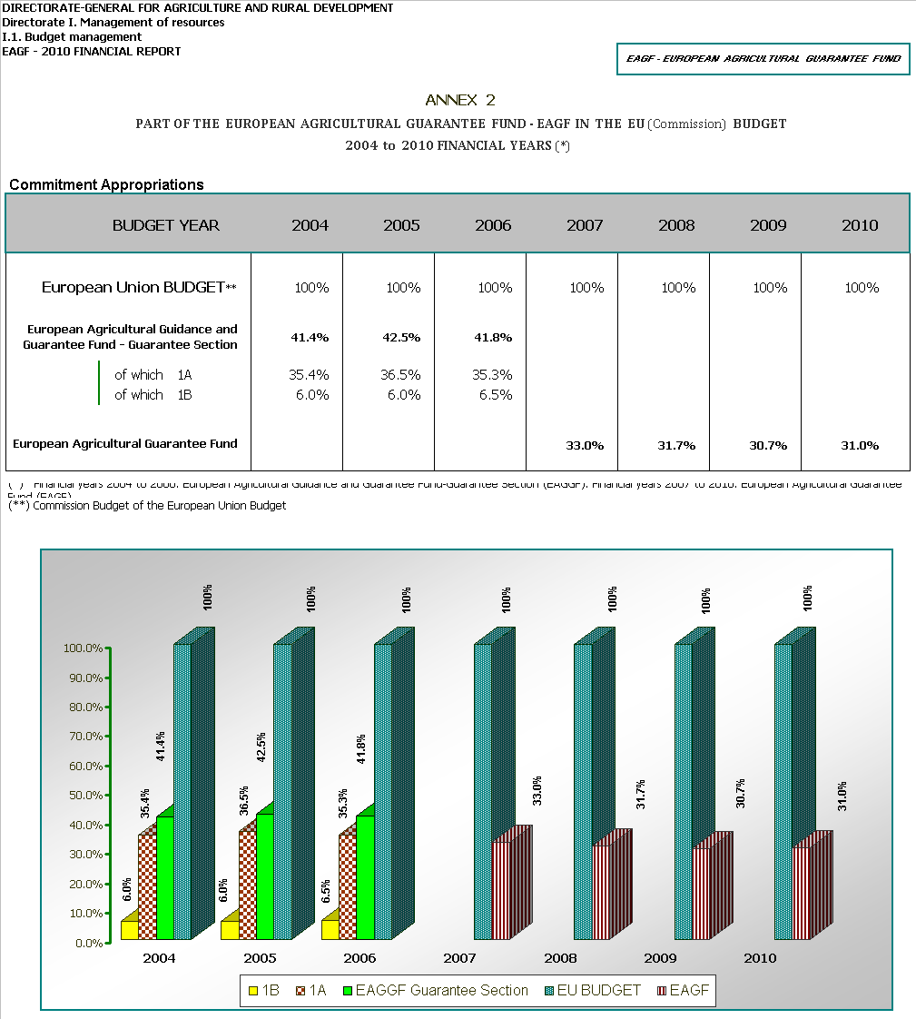
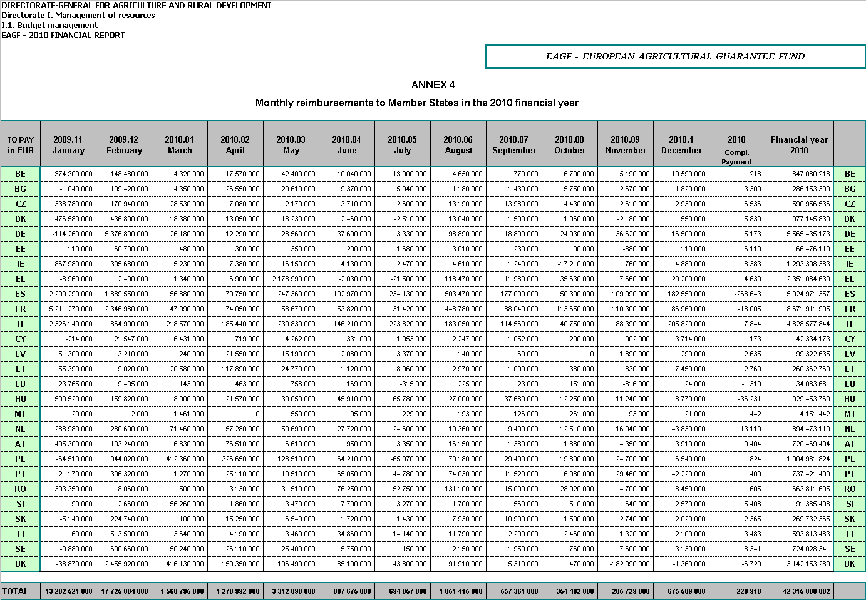
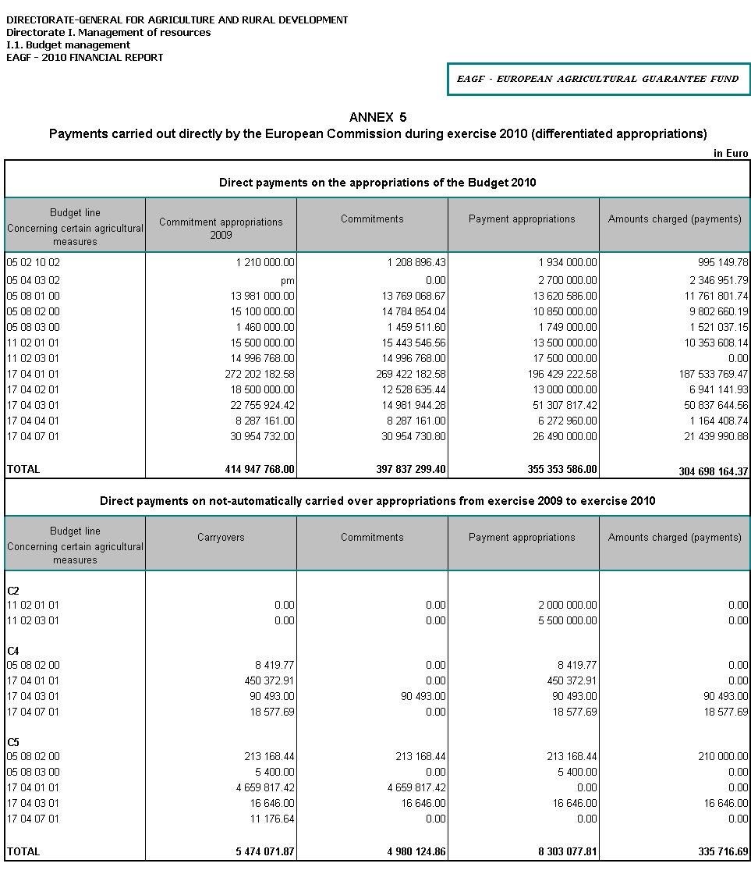
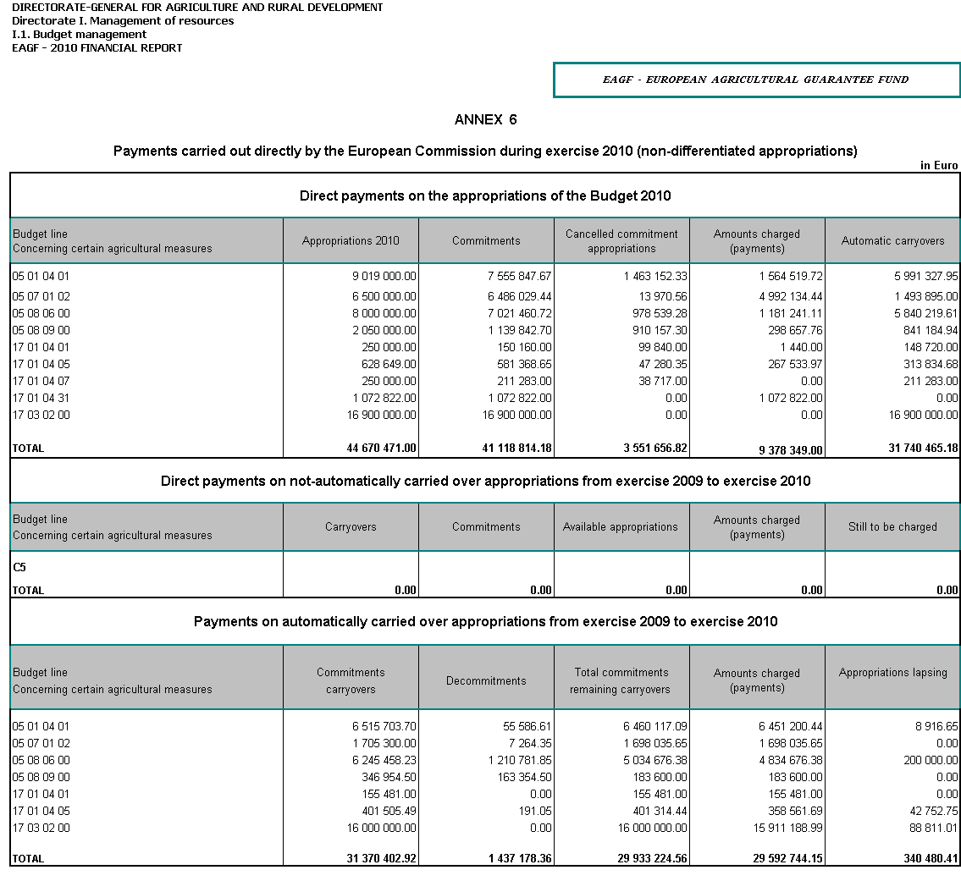
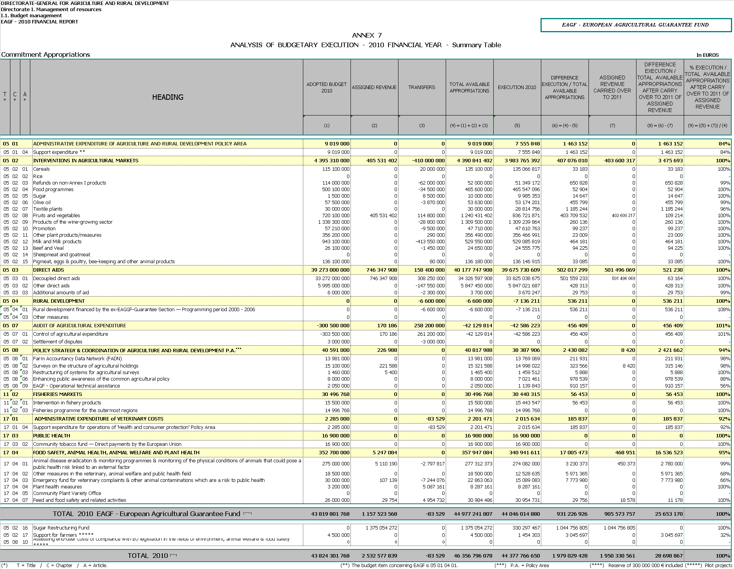
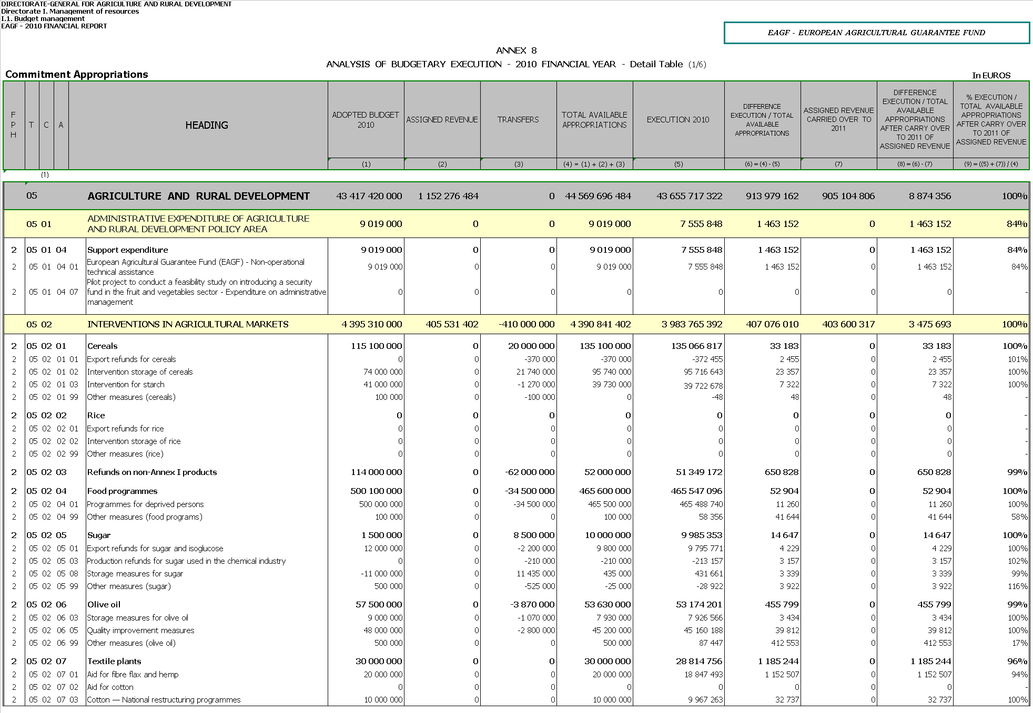
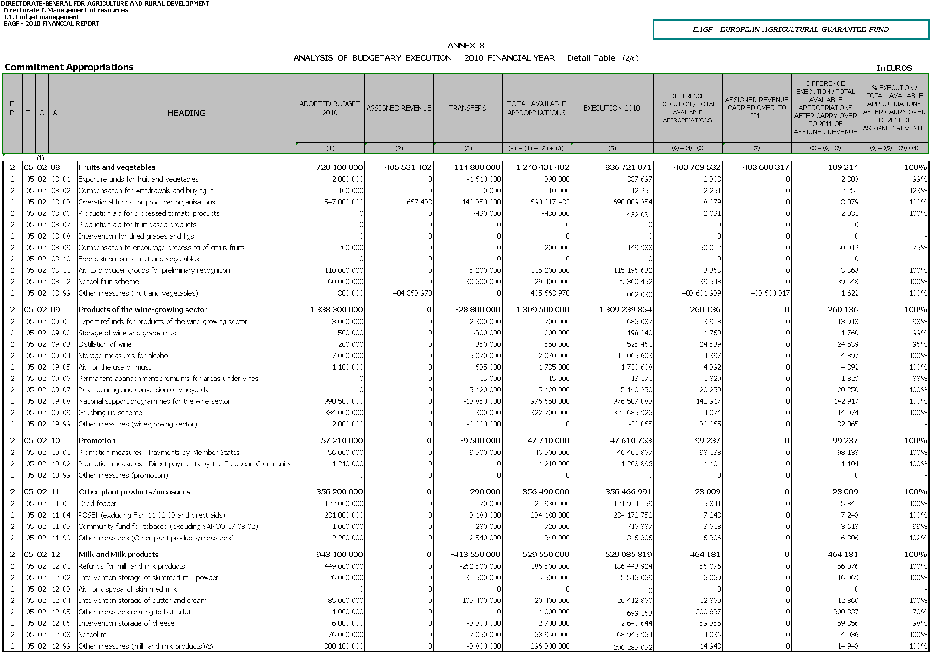
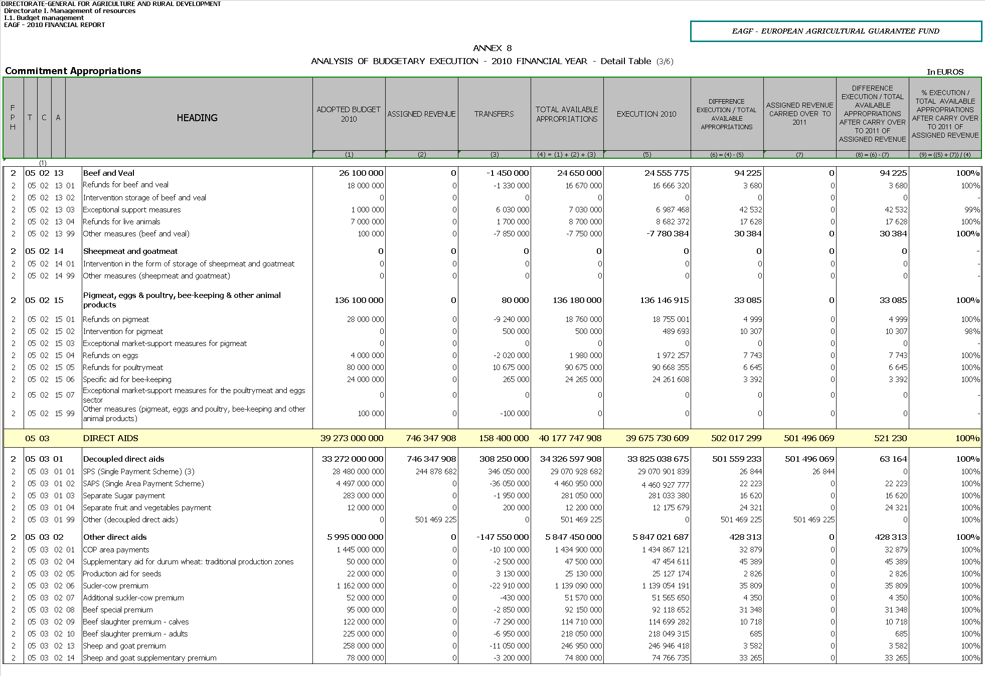
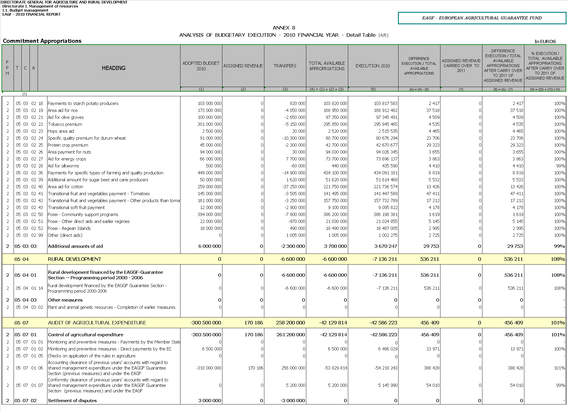
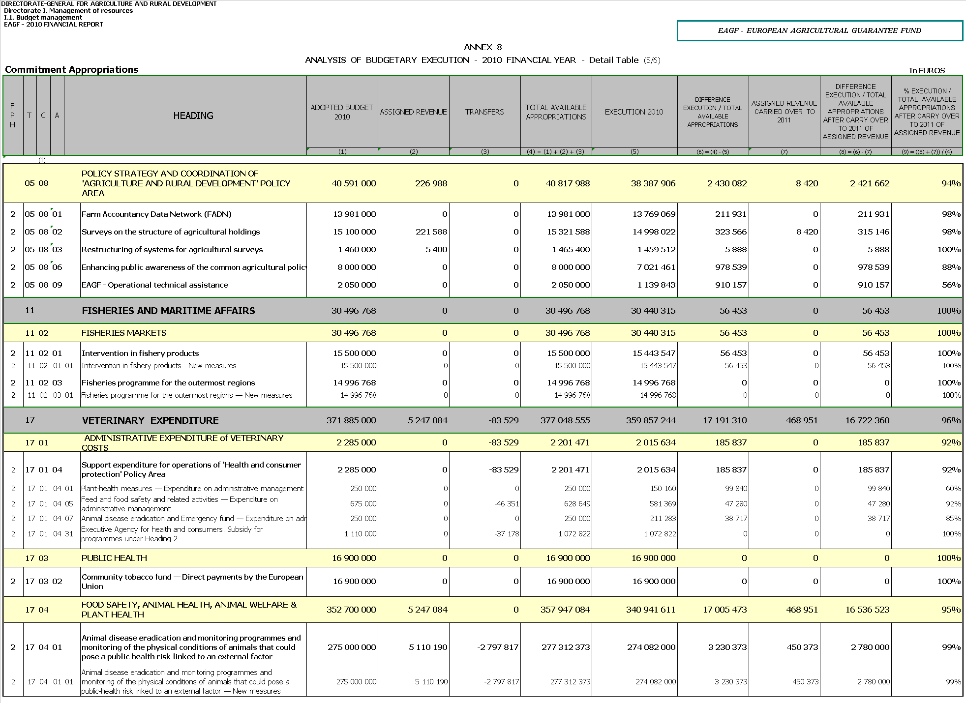
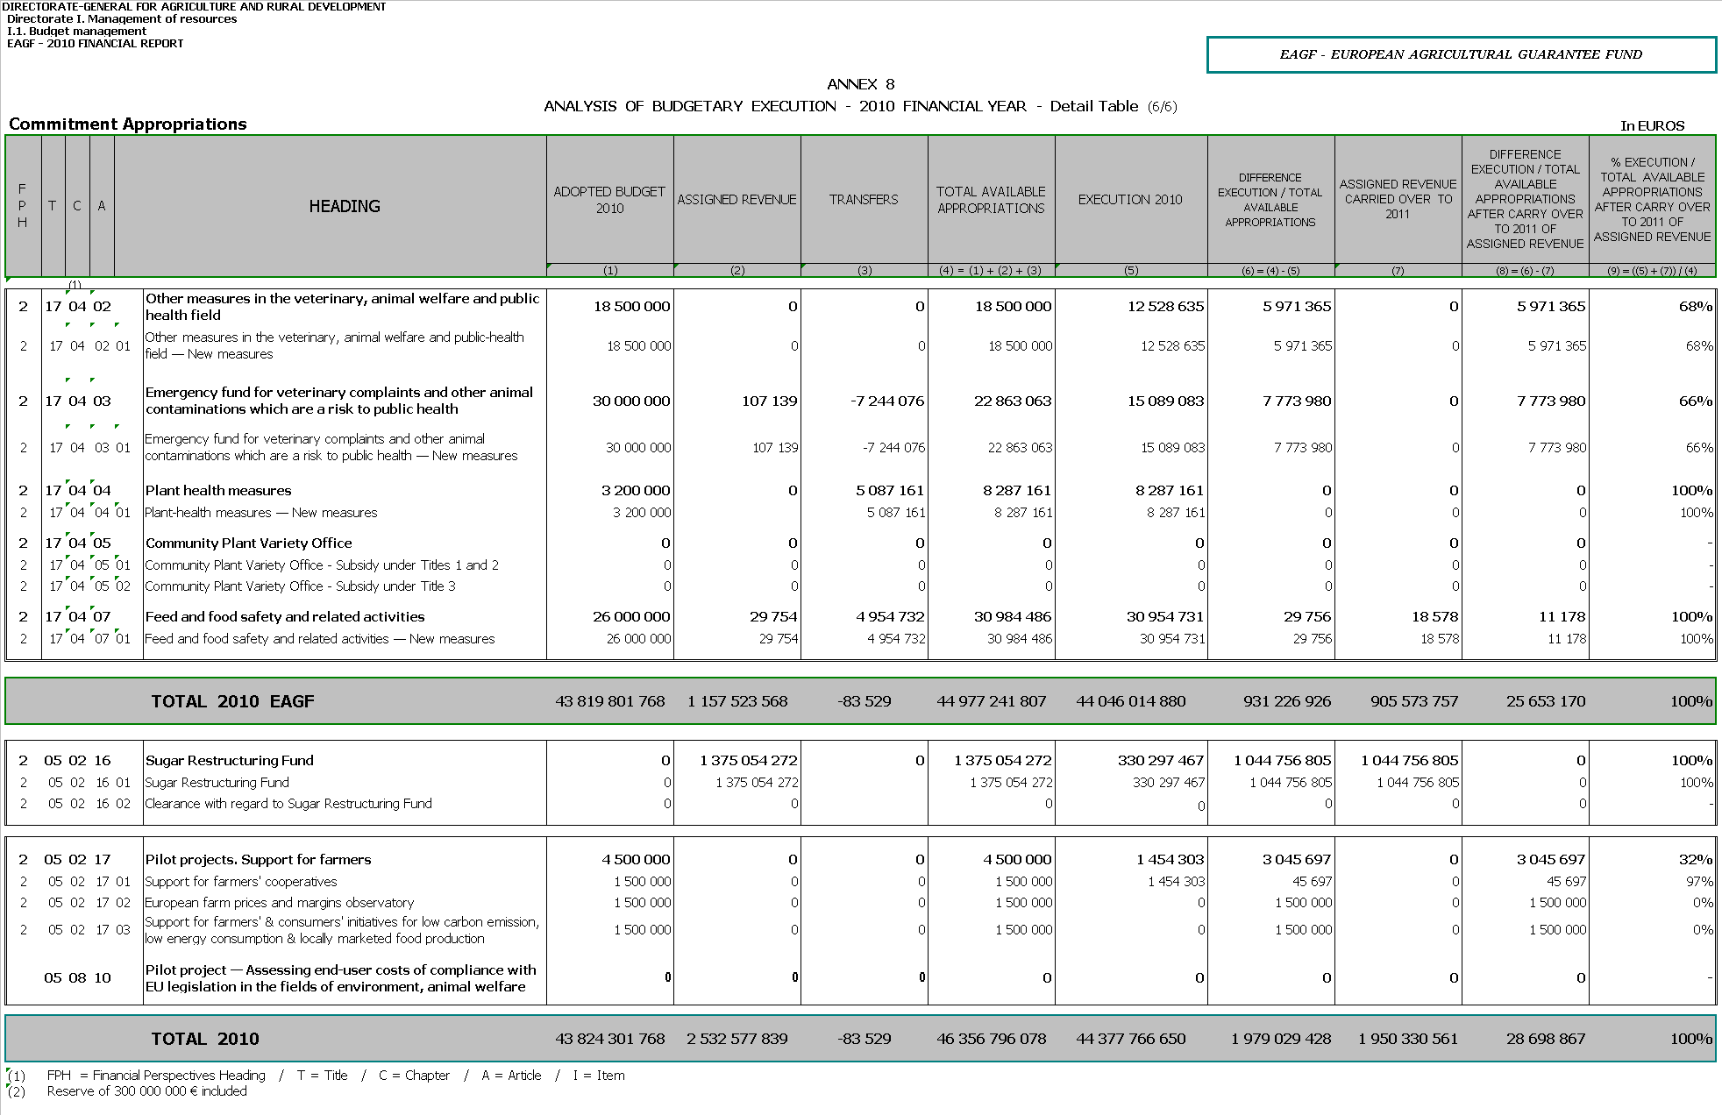
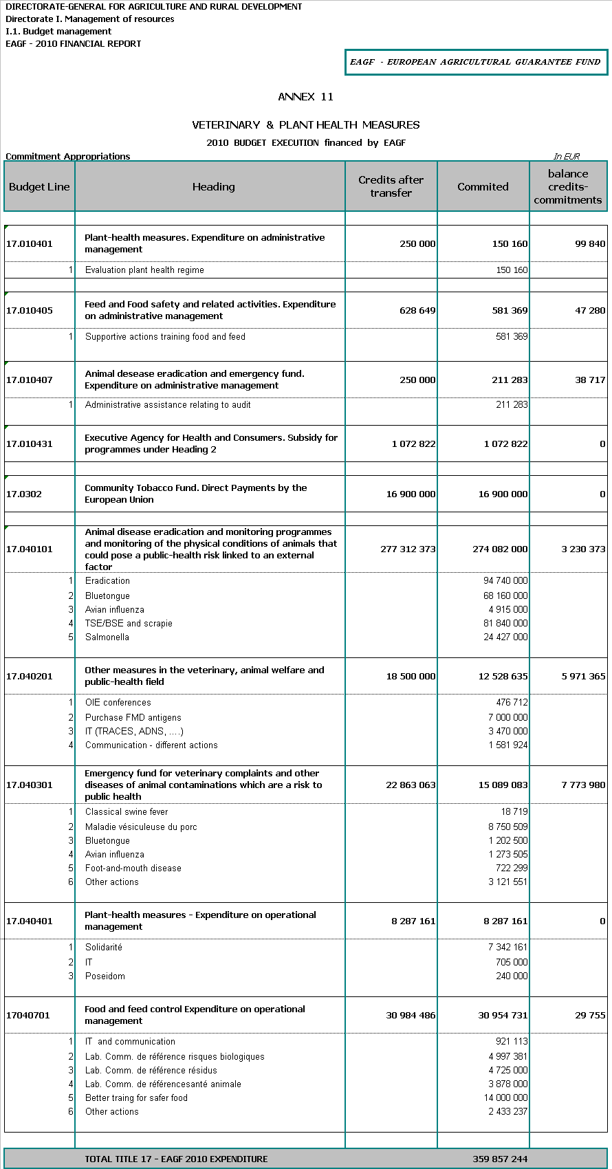
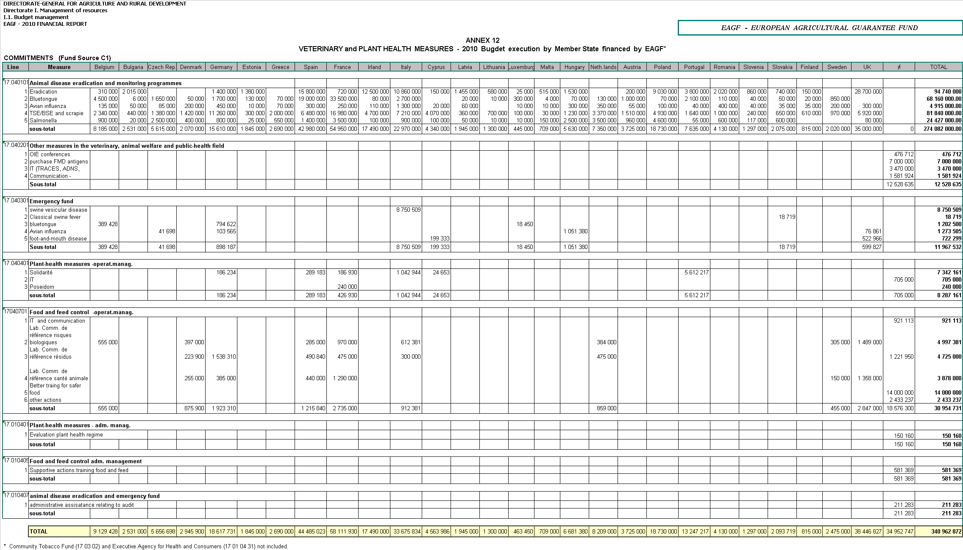
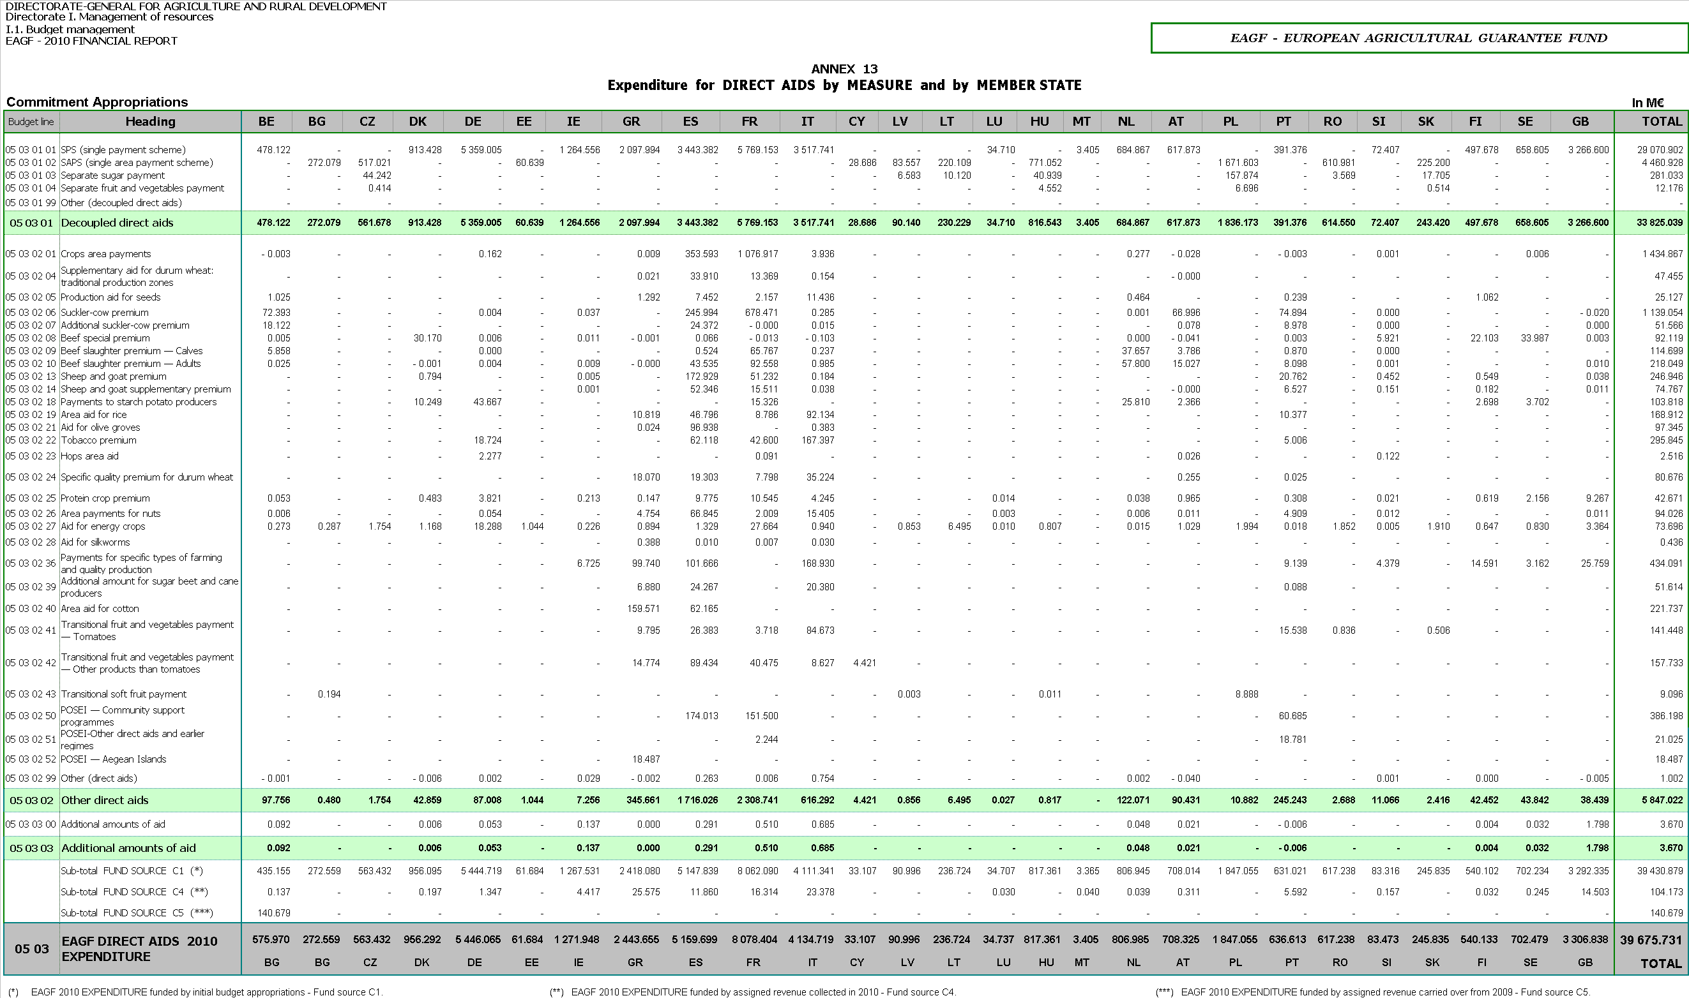
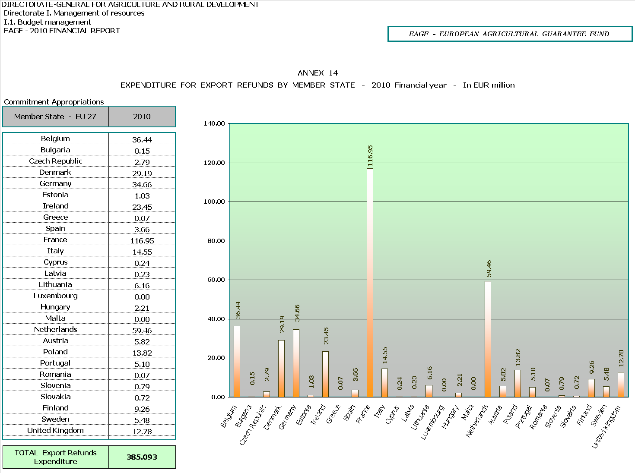
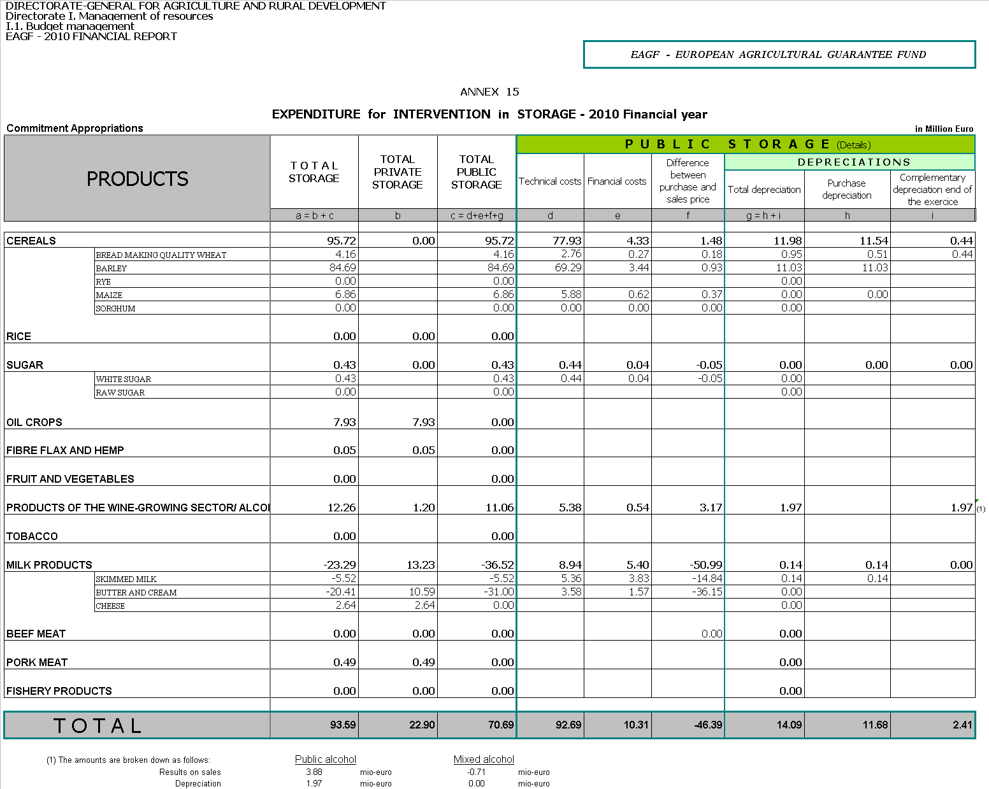
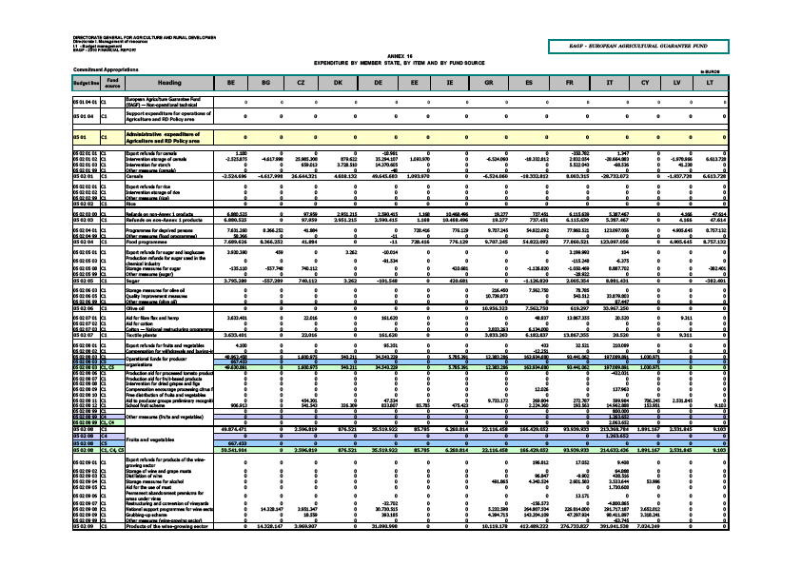
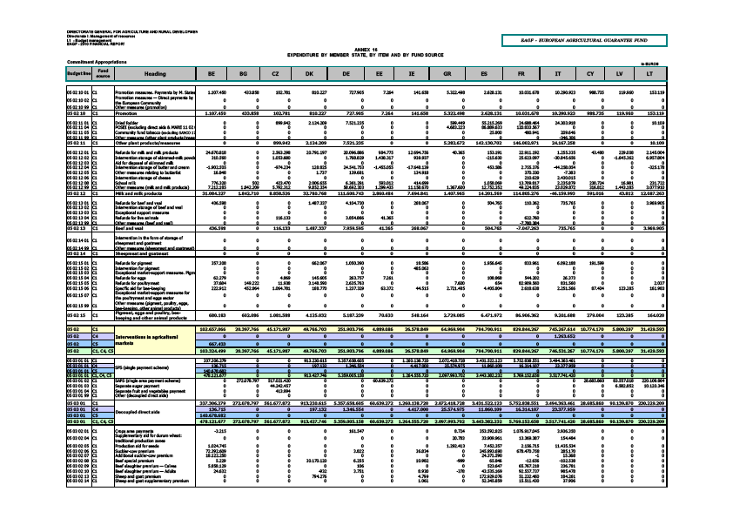
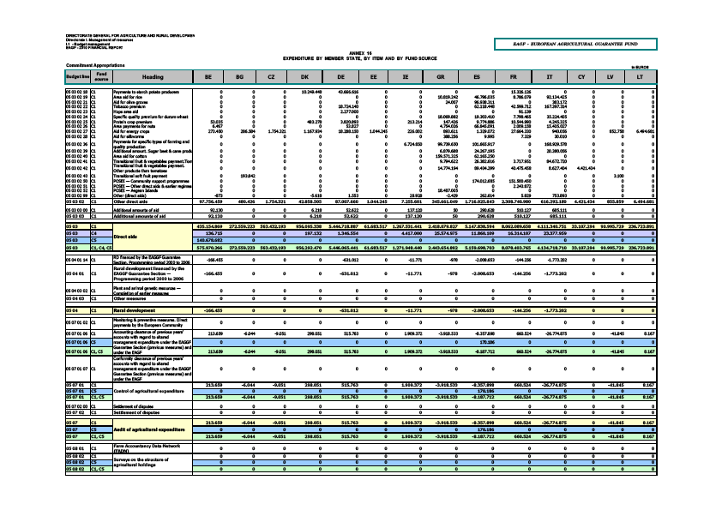
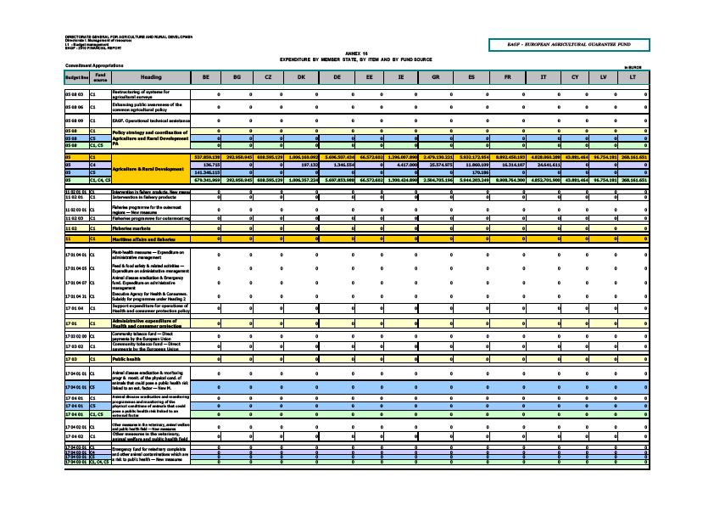
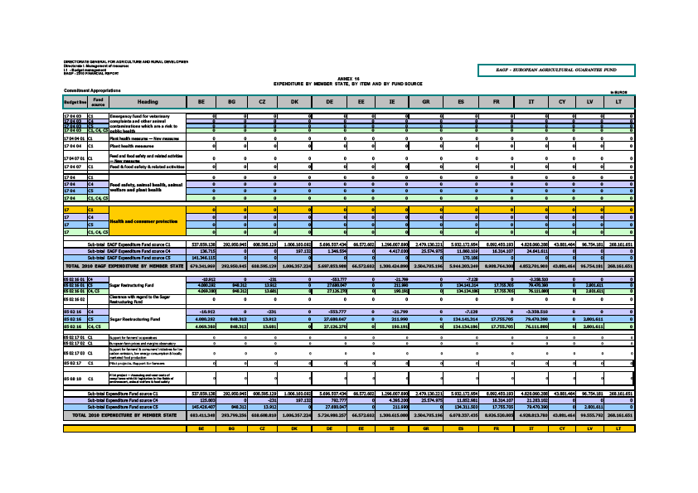
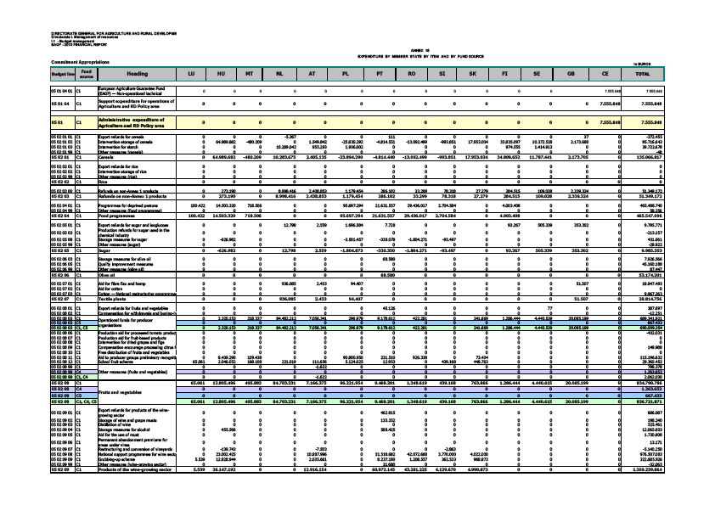
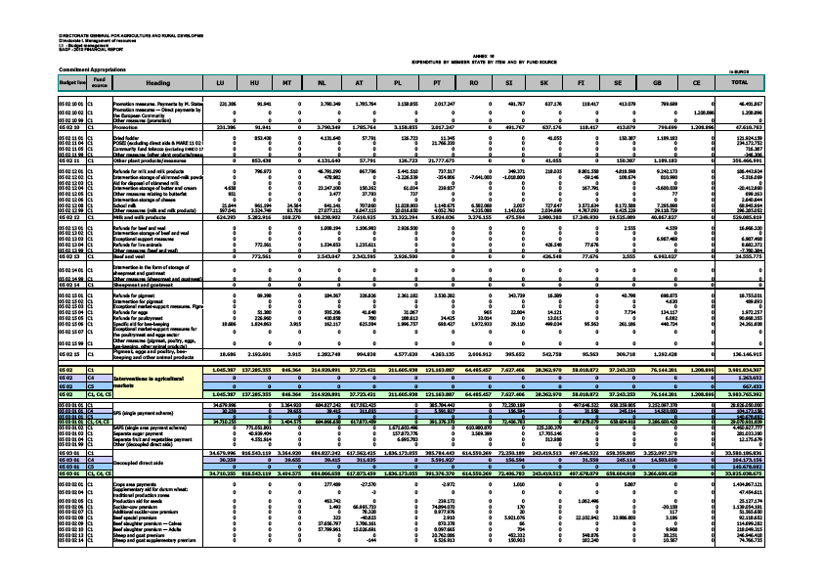
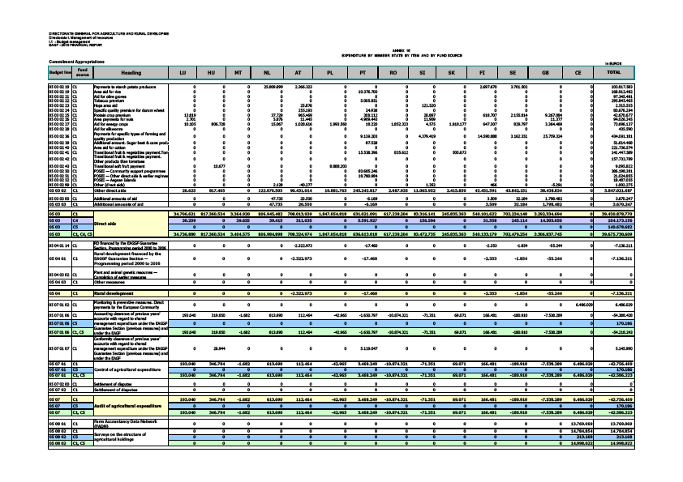
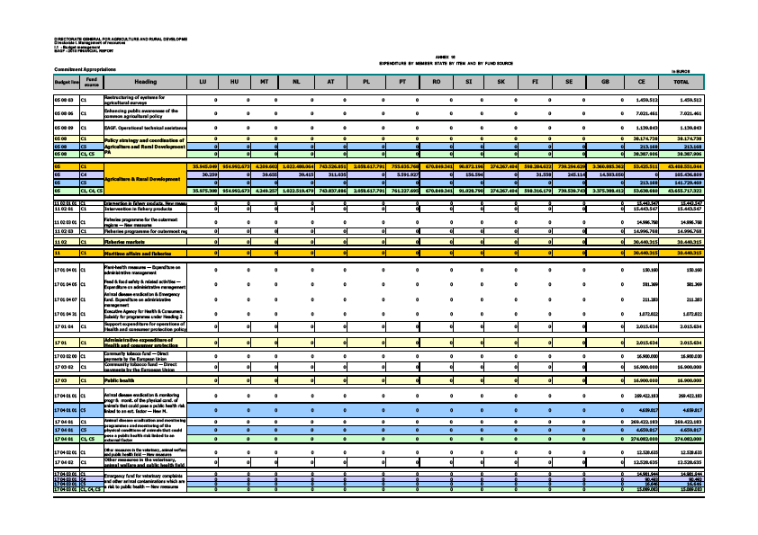
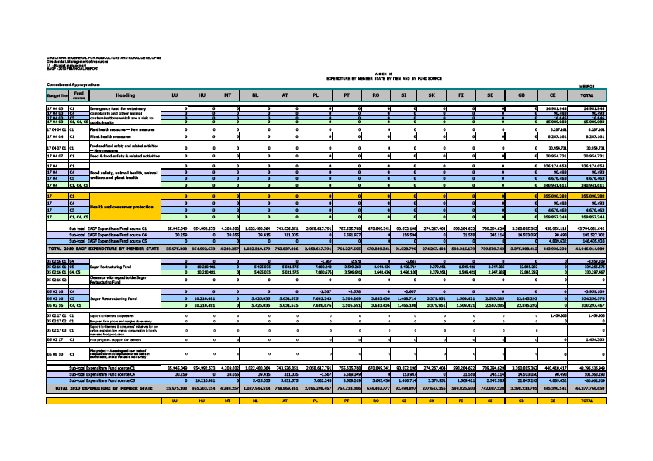
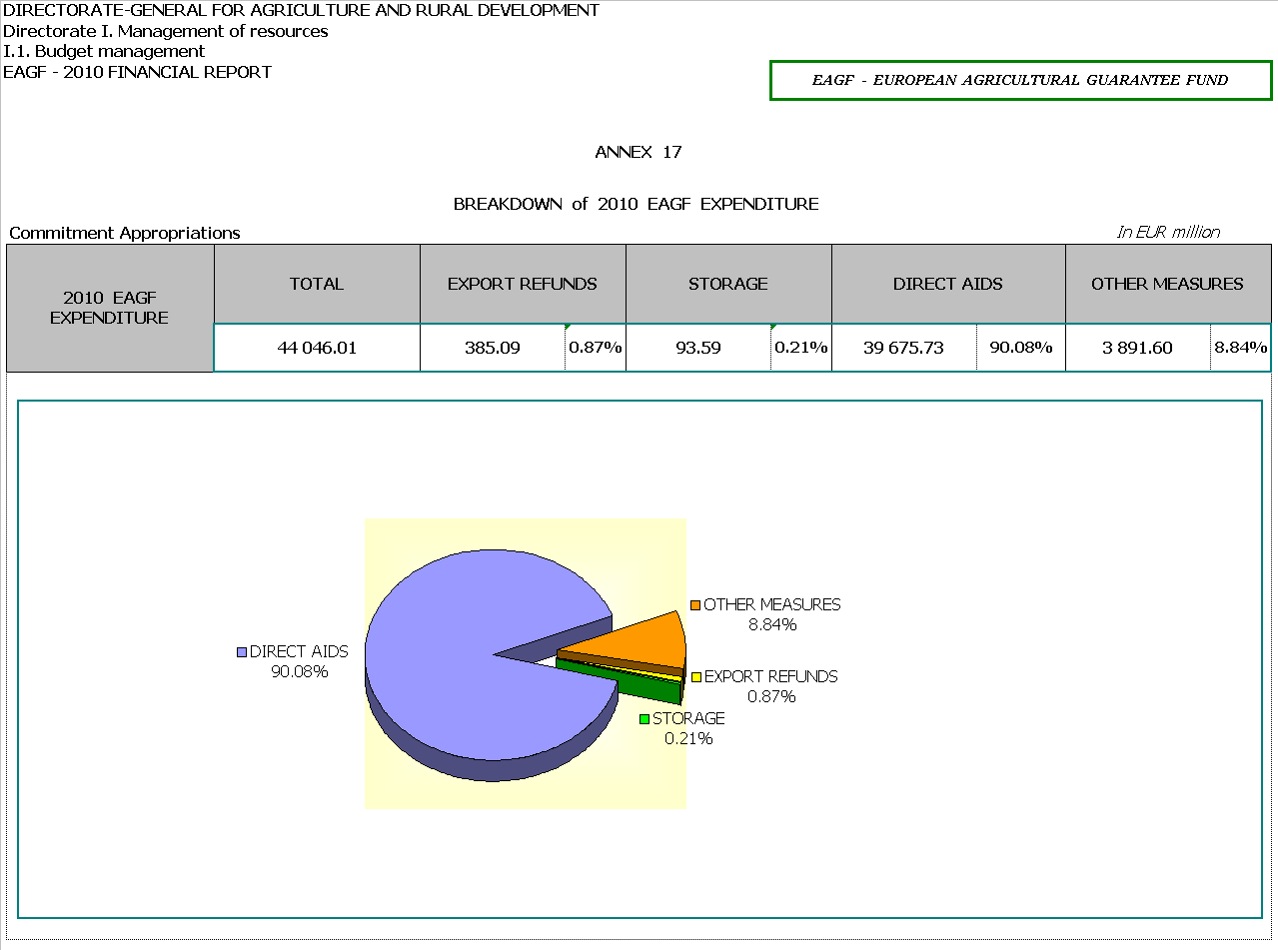

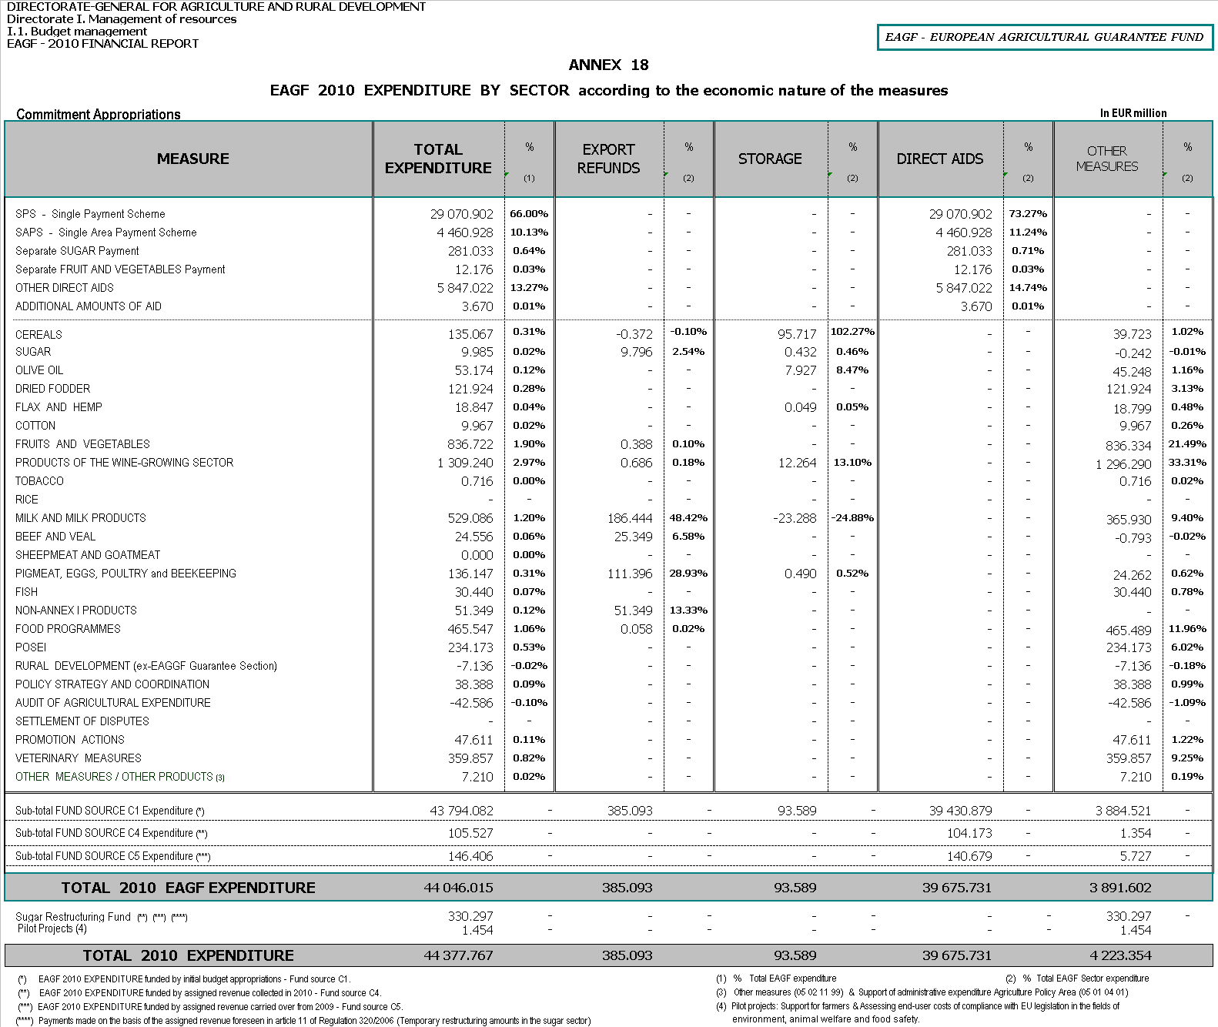
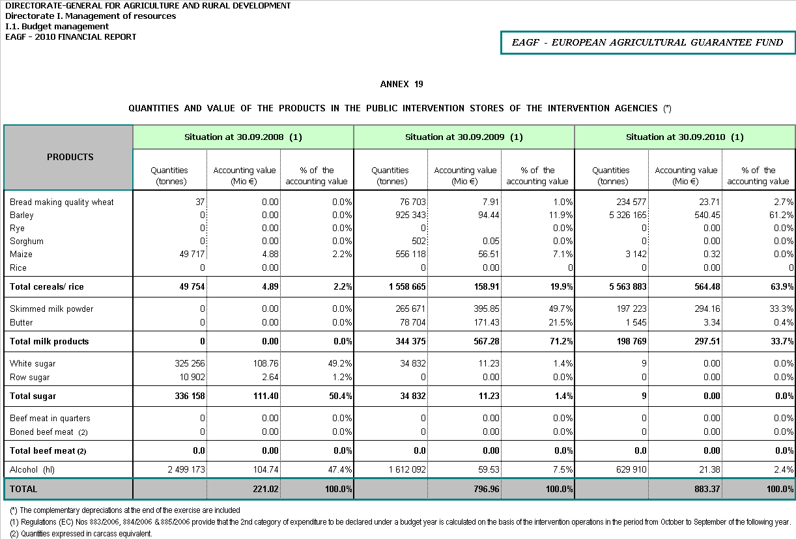
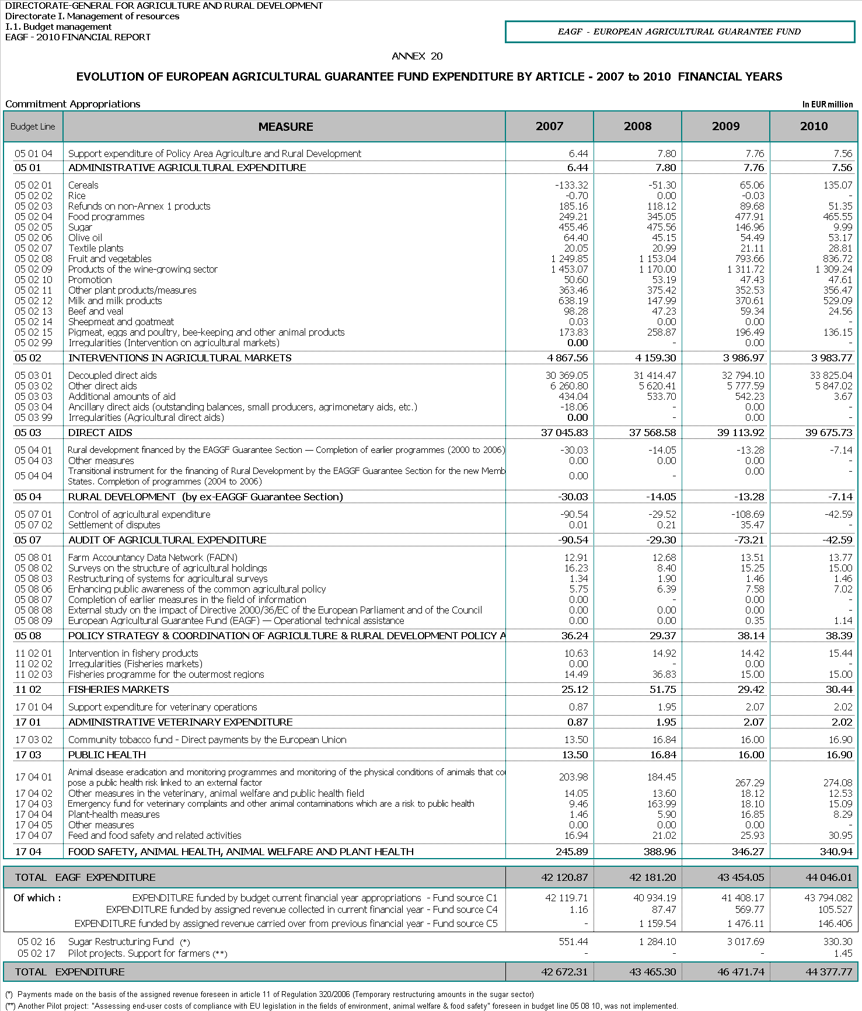

This procedure is presented in annex 1.
The amount of 300 million foreseen for the specific support for the dairy sector was initially in reserve.
These amounts are not entered in the revenue lines of the budget (article 670 for the revenue assigned to the EAGF) but they are mentioned in the budgetary comments for this article.
These amounts are not entered in the revenue lines of the budget (article 680 for the temporary restructuring amounts for the sugar sector) but they are mentioned in the budgetary comments for this article.
p.m.: "pour mémoire".
An amount of EUR 0.2 million, which is not included in this amount, was also transferred for item 050802.
RAL: "Reste à liquider", commitments outstanding.
OJ L 209 of 11.8.2005, p. 1.
These monthly declarations of expenditure are transmitted by the Member States by the declaration of the 10th of the month N+1.
The detailed declarations are transmitted monthly by the Member States (by table 104) on the 20th of the month N+1.
OJ L58 of 28.2.2006, p. 42.
OJ L171 of 23.6.2006, p. 1.
This amount includes payments of EUR 4.8 million made for policy area 17 on the basis of both assigned revenue carried over from 2009 into 2010 and of assigned revenue freshly collected in 2010.
This amount includes payments of EUR 0.2 million made on the basis of assigned revenue carried over from 2009 into 2010.
Rural development financed by the ex-European Agricultural Guidance and Guarantee Fund-Guarantee Section (EAGGF) –Programming period 2000-2006.
OJ L 313, 30.10.1992, p. 50.
Council Regulation (EC) No 1234/2007 of 22 October 2007, OJ L 299, 16.11.2007, p. 1.
OJ L 306, 20.11.2009, p. 5.
OJ L 171, 23.6.2006, p. 90–110.
OJ L 143, 3.6.2008, p. 1–9.
OJ L 209, 11.08.2005, p. 1.
OJ L30, 31.1.2009, p.16.
Commission Regulation (EC) No 1122/2009 of 29 October 2009 laying down detailed rules for the implementation of Council Regulation (EC) No 73/2009 as regards cross-compliance, modulation and the integrated administration and control system, under the direct support schemes for farmers provided for that Regulation, as well as for the implementation of Council Regulation (EC) No 1234/2007 as regards cross-compliance under the support scheme provided for the wine sector provided for in Council Regulation (EC) No 479/2008.
OJ L 265, 19.10.2000, p. 10.
The total amount of conformity corrections was EUR 735.12 million as it included conformity corrections of EUR 1.8 million which were part of accounting clearance decisions. The corrections which were part of conformity decisions are allocated as in the table.
This amount includes overlapping corrections of EUR 6.21 million (i.e. for corrections which are offset either completely or partially by previous corrections).
OJ C 303, 9.10.2010, p.1.

