ERASMUS FOR ALL

The EU Programme for Education, Training, Youth and Sport

A new programme to address new challenges
This Communication complements the proposal for a Regulation of the European Parliament and of the Council establishing ‘Erasmus for All’: a single Programme for Education, Training, Youth and Sport for the 2014-2020 period. The Programme reflects the priorities of the Europe 2020 strategy and its flagship initiatives. It represents a crucial investment in people, an investment that will benefit both individuals and society as a whole by contributing to growth and ensuring prosperity.
Education and training are now more important than ever for innovation, productivity and growth, especially in the context of the current economic and financial crisis, and yet the potential of Europe’s human capital remains underexploited. More needs to be done to ensure that education and training systems deliver the knowledge and skills needed in an increasingly globalised labour market, helping young people while making lifelong learning a reality for all. The role of education and training for employment, also through traineeships, is particularly important for young people who are the hardest hit by the crisis. In addition, there are still many gender inequalities in education: while women have surpassed men in both participation and attainment in higher education, the fields of study remain segregated, with women notably underrepresented in science and engineering; boys perform less well on reading literacy and tend to leave school early more often than girls.
A concerted effort to reach the EU benchmark of less than 15 % of low achievers in basic skills by 2020 would lead to long-term aggregated economic gains for the EU. Raising the ratio of people with higher education to 40 % would contribute to increasing GDP per capita in the EU by 4 %. Ensuring education and training systems can deliver the skills needed on the labour market will contribute to reaching the Europe 2020 target for employment (75%).
The Programme’s European added value will be: to help citizens acquire more and better skills, enhance the quality of teaching in educational institutions both in the EU and beyond, support Member States and non-EU partner countries in modernising their education and training systems and making them more innovative, and promote youth participation in society as well as the construction of a European dimension to grassroots sports. At the same time, the budget constraints of the EU and its Member States require a focus on results and cost-effectiveness, a concentration of efforts to enhance systemic impact, and a reduction in administrative and operational costs.
The key to delivering this added value is to strengthen the links and synergy between the Programme and the main EU policy priorities and processes, particularly the implementation of the Europe 2020, Education and Training 2020 and Youth Strategies and the priorities of the EU external action. Spending priorities must be driven by common priorities and policy development; in this respect, the recent Communication on the modernisation of higher education highlights the key policy issues which need to be supported to enhance the attainment levels, quality, attractiveness and internationalisation of higher education systems, as well as their relevance for innovation.

Building on past achievements and lessons learnt
The evaluations show that the 2007-2013 EU programmes have already achieved significant systemic impact, far beyond the benefits to individual participants. International cooperation in higher education has shown that the EU has become a world reference and a source of inspiration in terms of higher education reforms. Moreover, they have been instrumental in promoting the use of innovative approaches inter alia to curriculum development and transparency. In the area of non-formal learning, EU support has had a strong impact on individuals’ educational and professional development and has inspired and shaped policy initiatives such as the European Voluntary Service.
However, there is a complexity of multiple programmes and actions which must give way to a simpler, streamlined architecture, one which strikes a better balance between harmonisation and flexibility. For example, the Lifelong Learning Programme has six sub-programmes, more than 50 objectives and over 60 actions. The Youth in Action Programme focuses on the mobility and (non-formal) learning of young people, while approximately 80 % of the Lifelong Learning Programme funding also benefits youth. Some actions lack the critical mass required for long-lasting impact, or have a high administrative cost.
International cooperation in higher education is also characterised by the fragmentation between different EU instruments implementing similar objectives and actions. The Commission is currently funding five higher education cooperation programmes with different parts of the world:
- Erasmus Mundus focuses mainly on mobility, offering scholarships to attend high quality joint masters courses and doctoral programmes, and supporting university consortia working with different parts of the world.
- Tempus is a capacity-building programme for the modernisation of higher education, through cooperation projects between EU universities and their counterparts from the Western Balkans and neighbourhood countries;
- Alfa and Edulink have similar objectives covering Latin America and ACP countries.
- The Commission has also set up a programme for cooperation with industrialised countries, which funds joint and double degree projects, joint mobility projects and policy activities.
All these higher education programmes have similar goals; they fund comparable, albeit slightly different types of action, following different timetables, and with different implementation modalities and procedures. Excessive fragmentation entails the risk of overlaps, complicates access of potential beneficiaries, and limits the scope for efficiency gains, critical mass and cost-effectiveness.
With a new focus on priorities which will increase EU added value and systemic impact, actions supported will contribute to the efforts of achieving more jobs and growth in line with Europe 2020 objectives. Economies of scale can be significant if actions of a similar nature have similar implementing rules and procedures, simplifying the work both of beneficiaries and management bodies. Building on the considerable successes of the 2007-2013 programmes, Erasmus for All will address their weaknesses, as identified in the evaluations, and enhance synergies with other sources of EU funding. In particular, while the new Programme will focus on various actions with a transnational character, the structural funds will support national and regional efforts in inter alia modernising education establishment infrastructure, supporting the upgrading of skills and training as well as mobility of people in the labour market and increasing access to under-represented groups into education and training. Marie-Curie actions under Horizon 2020 will support researchers' mobility. In order to fully exploit synergies with Horizon 2020, joint degrees at PhD level will be taken forward exclusively by Marie-Curie actions.
Erasmus for All will:
- increase coherence and strengthen the lifelong learning approach, by linking support to formal and non-formal learning throughout the education and training spectrum;
- broaden the scope for structured partnerships, both between different sectors of education and with business and other relevant actors;
- provide flexibility and incentives, so that budget allocation between activities, beneficiaries and countries better reflects performance and impact.
The ‘Erasmus’ name is widely recognised among the general public in EU and non-EU participating countries as a synonym of EU learner mobility but also European values such as multiculturalism and multilingualism. Rather than preserve an increasingly complex multiplicity of brand names, the programme will be named ‘Erasmus for All’. Public and private bodies within the main education sectors covered by the Programme may use this brand name.
Furthermore, for the purpose of communication and dissemination, the brand name will be associated with the main education sectors as follows: ‘Erasmus Higher Education’, associated with all types of higher education in Europe and internationally; ‘Erasmus Training’, associated with vocational education and training as well as adult learning; ‘Erasmus Schools’, associated with school education; and ‘Erasmus Youth Participation’, associated with non-formal learning among young people.

Architecture and key actions of the Programme

A streamlined architecture
The Lifelong Learning Programme, international higher education and Youth in Action Programmes share the same general objectives and support activities which can be grouped into three broad categories: learning mobility; cooperation between education institutions or youth organisations; and EU or international policy cooperation. They have similar management structures (e.g. calls for proposals for transnational cooperation) and delivery methods (direct management by the Commission, or indirect through Executive and National Agencies). Therefore, in order to ensure greater coherence, synergy and simplification, and allow for innovative funding mechanisms, the architecture of the proposed Programme will support three types of key action, which are complementary and mutually reinforcing:
- Learning mobility of individuals: Mobility will represent a significant share of the increased overall budget. This increase, together with a focus on the quality of mobility as well as a concentration of priorities and efforts, should increase the critical mass and impact beyond the individuals and institutions involved.
- Cooperation for innovation and good practices: There will be a stronger focus on strengthening innovative partnerships between educational institutions and business. For higher education, the emphasis will be on capacity building, concentrating on neighbourhood countries as well as strategic partnerships with developed and emerging economies.
- Support for policy reform: Policy reform will be targeted at: strengthening the tools and impact of the open methods of coordination in education, training and youth; implementing the Europe 2020 strategy and promoting the policy dialogue with third countries and international organisations.
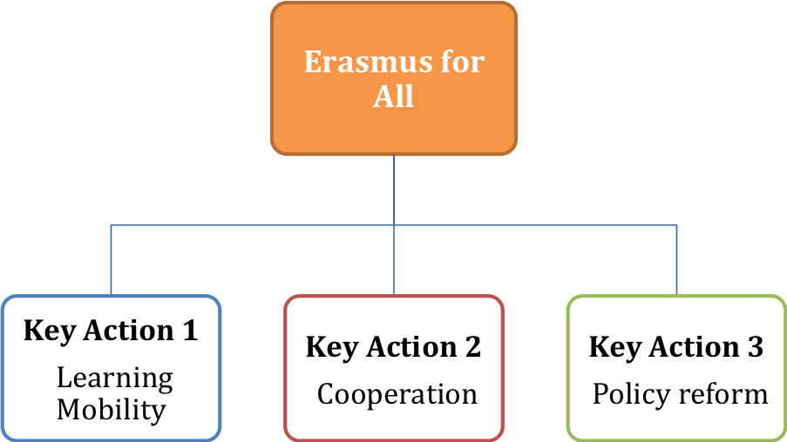
International dimension
There are currently five programmes for cooperation with third countries in higher education. These will be streamlined into the three key actions of the Programme, again with a strong emphasis on mobility:
- Support for high-quality joint degrees and scholarships for students and staff worldwide will be extended beyond the comparatively small number of universities which can participate at the moment.
- The management of international mobility will be based on the current Erasmus system, whereby scholarships are awarded on the basis of inter-institutional agreements.
- Funds will be allocated according to the thematic and geographical priorities of EU external action.
- Capacity-building measures for the modernisation of higher education systems will also be streamlined; cooperation with neighbourhood countries will be reinforced by merging capacity building and mobility actions to ensure a systemic impact. Actions currently funded by Alfa, Edulink and the former Asialink programmes will be delivered as capacity-building, development and modernisation support through joint projects with universities from the EU and from Latin America, Asia and Africa.
Specific actions
In the light of its specific efforts to promote excellence in education and research on EU integration, the Jean Monnet Initiative will continue as a separate activity within the Programme and will share its delivery mechanisms. Similarly, in order to exploit the potential for simplification and streamlining of the Multiannual Financial Framework architecture, EU-level cooperation in the field of Sport will be treated as a separate activity within the Programme.

Key Action 1: Learning mobility of individuals
Mobility for transnational learning — studying at a partner institution, teaching, gaining work experience, undergoing training or participating in a volunteering or exchange project abroad — has clear added value and can only be effectively promoted at European level. Learning mobility has the potential to: raise the level of key competences and skills of high importance to the labour market and society; reinforce participation of young people in democratic life; and to enhance the modernisation and internationalisation of education institutions, both to the benefit for EU and third countries. Mobility will therefore be strengthened and remain the core element across the Programme, with a strong emphasis on mobility for students in higher education.
With the Commission’s proposed budget, the Programme could provide mobility opportunities to around 5 million learners over the seven-year period. Currently, around 400 000 EU mobilities are supported annually. This figure could be increased to 700 000 on average, reaching 900 000 in the last year, including learners and staff. It is estimated that international mobility to and from third countries will benefit around 135 000 people over the seven-year period. However, mobility is not an end in itself. There will be stronger EU added value under the Programme, which will strengthen the outcomes and conditionality attached to mobility, and require that mobility be set within a coherent institutional development strategy.
The main criterion for funding will be quality, demonstrated through educational content and teaching and learning methods, recognition of learning outcomes, linguistic and intercultural preparation, and improved arrangements within host organisations.
Erasmus for All support for mobility will focus on four key activities:
- Staff mobility, in particular for teachers, trainers, school leaders and youth workers.
- Mobility for higher education students (including joint/double degrees) and vocational education and training students.
- Erasmus Master for master degree mobility of higher education students, through a new loan guarantee mechanism.
- Youth mobility, including volunteering and youth exchanges.
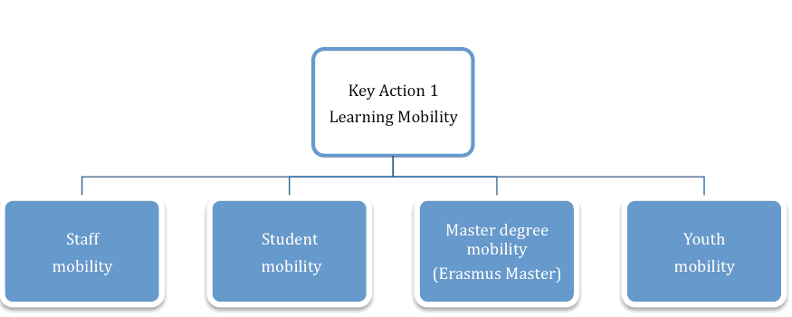
Staff mobility: Research is unanimous with respect to the key role of teachers and school leaders in raising the performance of learners and education systems. To promote excellence in teaching, develop innovative and successful teaching/learning methods and foster quality in institutions, staff mobility will be significantly strengthened in all education sectors, including long-term school staff mobility. More opportunities are also foreseen for the learning mobility of youth workers, given their role as multipliers and for stepping up the exchange of good practices among youth organisations.
Staff mobility foreseen for the period | 1 000 000 beneficiaries
Higher education students: To reflect the increasing internationalisation of the higher education sector, Erasmus learning mobility activities will be substantially reinforced and expanded internationally, including to neighbourhood countries, to contribute to the benchmark of 20 % mobility of higher education graduates. This will allow European students to be mobile internationally and non-European students to spend time learning within the EU, thus encouraging the circulation of talent and increasing the attractiveness of European higher education, to the mutual benefit of EU and non-EU higher education institutions and systems.
Joint degrees: Building on the success of Erasmus Mundus, which has been implemented with industrialised countries, the Programme will strengthen support for degree mobility within joint high-quality study programmes, implemented by EU and non-EU universities. This action will be open to additional funding from interested partner countries.
Joint degree mobility | 34 000 beneficiaries
Erasmus Master: Masters degrees are essential for raising qualification levels in higher education and for helping students acquire the advanced skills of knowledge-intensive jobs. While the Bologna reforms have created more opportunities, there is far too little degree mobility taking place in the EU. This is partly because national student support schemes, where they exist, tend to be limited in scope and the support they provide cannot be taken to another Member State. Moreover, students usually do not have sufficient collateral against which to secure a loan, making the risk premium prohibitive — particularly when the borrower proposes to study abroad. The problem is particularly acute for students wishing to complete a full Masters degree programme in another Member State where tuition fees are likely to be high. In order to address this, Erasmus for All will establish a student loan guarantee scheme which will offer the possibility for Master level students doing a full degree programme in another EU or EEA country to access loans at favourable conditions.
Erasmus Master students, benefiting from the loan guarantee scheme | 330 000 beneficiaries
Vocational education and training students: Opening up access for young vocational education and training students to methods, practices and technologies used in other countries will help to improve their employability in a global economy: work-based learning is critical for employability at all education levels, particularly in the current context of extremely high youth unemployment, and the need to increase the quality and attractiveness of this sector in many European countries. For these reasons funding for the mobility of these students will be substantially increased.
Transnational traineeships in enterprises have a high potential to enhance employability and will be considerably boosted for students both in vocational education and training and higher education. The aim is to reinforce the link between education and business, foster entrepreneurship and facilitate the transition from education to the world of work. Whenever possible, they will target areas of country or sector-based skills gaps.
Higher education student mobility, within EU and beyond | 2 165 000 beneficiaries
Vocational education and training student mobility | 735 000 beneficiaries
TOTAL | 2 900 000 beneficiaries
- of which traineeships | 700 000 beneficiaries
Non-formal learning: Non-formal learning complements formal learning experiences. In such a setting mobility has a strong influence on the personal development, social inclusion, active citizenship and employability of young people. The impact is particularly important for disadvantaged young people. Therefore, mobility of young people through youth exchanges and volunteering will be increased
Youth mobility | 540 000 beneficiaries

Key Action 2: Cooperation for innovation and good practices
Transnational cooperation projects are essential to encourage transparency, openness and excellence, and to facilitate exchange of good practices between institutions. In order to contribute to the governance and implementation of Europe 2020 and open method of coordination activities, the Programme will provide strengthened support to cooperation projects aimed at developing, transferring and implementing innovative education, training and youth practices. Finally, the new programme will boost international cooperation and capacity building in third countries.
Erasmus for All support for cooperation will focus on four key activities:
- Strategic partnerships between education establishments/youth organisations and/or other relevant actors.
- Large-scale partnerships between education and training establishments and business, in the form of Knowledge Alliances for higher education and Sector Skills Alliances.
- IT support platforms, including e-Twinning.
- Capacity building in third countries, with a strong focus on neighbourhood countries.
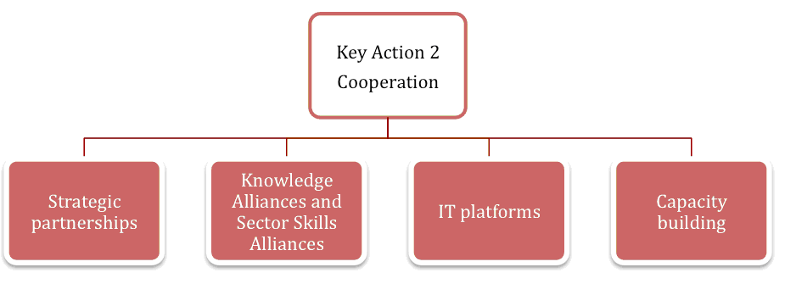
Strategic partnerships: In response to the growing need for more innovative approaches in education, strategic partnerships will encompass a variety of cooperation agreements, differing in financial scope, aiming to strengthen transnational cooperation between education institutions/youth organisations and/or other actors. The Programme will link mobility and cooperation activities and enhance systemic impact (e.g. cooperation projects between schools could cover both curriculum development and staff exchanges). Similarly, to encourage a European dimension in national volunteering schemes, support can be used to open up such schemes to transnational mobility. Building on the lessons learnt from the 2007-2013 programmes (Comenius Regio, Youth in Action), partnerships involving regional and local authorities and linking actors from different sectors will be encouraged to foster innovative, more integrated lifelong learning approaches, more efficient use of resources and higher quality mobility schemes.
Strategic partnerships/institutions involved | 23 000 partnerships and 115 000 institutions
To promote innovation and employability of learners, the Programme will enhance cooperation with business, through large-scale transnational projects.
Knowledge Alliances: The Europe 2020 flagship initiative ‘Innovation Union’ highlighted the critical importance of helping universities modernise and enhance quality and innovation, via ‘Knowledge Alliances’. These are structured partnerships between higher education institutions and businesses, which develop innovative ways of producing and sharing knowledge, foster creativity and entrepreneurship and design and deliver new curricula and qualifications. The Programme will respond to the very high level of interest in the business and education sectors for this type of cooperation to generate innovation and growth in Europe.
Sector Skills Alliances: Sectoral projects between businesses and education and training providers to create new sector-specific curricula, to develop innovative ways of vocational teaching and training and to put the EU wide recognition tools into practice.
Knowledge Alliances and Sector Skills Alliances/ institutions and enterprises involved | 400 alliances and 4 000 institutions
IT support platforms and virtual mobility: In response to the need for alternative forms of mobility, the Programme will assign a greater role to IT support platforms. Such platforms can, at very low extra cost, deliver peer learning and exchange of good practices to a greatly enlarged group of potential beneficiaries. Open educational resources such as e-courses and virtual mobility are also increasingly important for the international attractiveness of educational institutions. The e-Twinning initiative in school cooperation will be significantly strengthened and inspire similar initiatives for vocational education and training, adult learning and youth. It will be opened up to neighbourhood countries.
Information Technology platforms | 3 platforms
International cooperation and capacity building: Cooperation with third countries will be fully integrated into the key actions of the Programme, in line with EU external policy priorities, building on the experience of the 2007-2013 programmes, particularly Tempus and Erasmus Mundus. It will aim at improving the quality, relevance and governance of higher education, through bottom-up projects implemented by international consortia. In response to the strong political call to reinforce support to the EU’s neighbourhood countries, the Programme will support the capacity building of institutions and the modernisation of higher education systems through cooperation and structural measures. It will closely link these activities to student and staff mobility. The Programme will also contribute to modernising systems and building local capacities in Asia, Latin America and ACP countries, as well as supporting cooperation projects in the non-formal learning field.
Higher education capacity building cooperation projects | 1 000 projects

Key Action 3: Support for policy reform
Evidence-based policy making, strong country analysis and multilateral surveillance are all critical for the achievement of Europe’s strategic priorities. Mutual learning at EU and international level has proven its worth in terms of the effectiveness of education investments and in helping Member States implement new policies and reforms. The various EU transparency tools created under the Lifelong Learning Programme have had an immense impact. More than 10 million people are already using the ‘Europass’ online CV in their search for a job.
Erasmus for All support for policy reform will focus on three key activities:
- Support to open methods of coordination (ET 2020, EU youth strategy) and the European Semester (Europe 2020).
- EU tools: valorisation and implementation.
- Policy dialogue (stakeholders, third countries, international organisations).
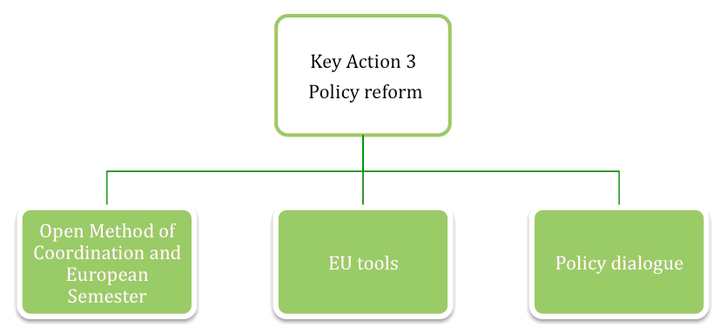
The Programme will strengthen support to activities which help steer the EU agenda for education, training and youth, in particular through the open methods of coordination: the development of indicators, statistics and benchmarks and the monitoring of trends and policy developments; peer learning and reviews; policy analysis; and comparative studies. The Programme will increase support for the national implementation of EU transparency tools (e.g. EQF, ECTS, ECVET) and EU wide networks. It will support the implementation of the ‘U-Multirank’ performance-based ranking and information tool for profiling higher education institutions, aiming to improve the transparency of the higher education sector radically, with first results in 2013.
The Programme will also support specific policy agendas for thematic priorities, including the Modernisation Agenda for Higher Education, the Bologna process (higher education) and the Copenhagen process (vocational education and training), the Agenda for Schools of the 21st Century, the European Agenda for Adult learning and the structured dialogue with young people, including operating support to the European Youth Forum and to partnerships with representative youth NGOs. It will also support and intensify the implementation of the eight key competences for lifelong learning set out in the 2008 European framework.
Support for policy reform will aim to achieve the specific objectives of the ET2020 strategy, and to reach the Europe 2020 targets in the field of education and human capital. Through the open method of coordination, the Programme will concentrate on the main policy themes which contribute to these key EU objectives: promoting the use of ICT in schools, as well as at all levels of formal education; raising the literacy levels of young and adult Europeans; reducing early school leaving; promoting excellence and stronger links between education, research and innovation; intensifying language learning alongside transversal competences such as learning to learn and entrepreneurship.
Policy dialogue will be intensified with third countries as well as with neighbouring countries, but also with strategic partners in the emerging and developed countries, in line with EU external policy priorities.

Jean Monnet Initiative
Launched in 1989, the programme is now present in 62 countries throughout the world and around 740 universities offer Jean Monnet courses as part of their curricula. Between 1990 and 2009, the Jean Monnet Initiative has helped to set up approximately 3,500 projects in the field of European integration studies, including 141 Jean Monnet European Centres of Excellence, 775 Chairs and 2,007 permanent courses and European modules. Based on experience and good practices from the Initiative, the Programme will stimulate teaching and research on European integration in the EU Member States and worldwide (notably in candidate and neighbourhood countries). A diversification of studies will be encouraged, as will a more balanced geographical scope and the participation of a new generation of teachers.
In the light of their internationally recognised academic excellence in a large number of disciplines relevant to European integration, the Programme will continue to provide specific support to the College of Europe (in Bruges and Natolin), with a view to extending its activities to the neighbourhood countries and to the European University Institute, so as to develop its capacity to promote good governance of EU policies. Both institutions will be invited to reinforce their mutual cooperation. Other academic institutions active in the field of European integration will have access to the Programme in line with the added value of their activities.
For institutions interested in securing recognition of the quality of their European integration studies programmes, the Commission will create a Jean Monnet label of excellence. The Jean Monnet Professors’ network also serves as a think tank to support EU governance and policy-making. The dialogue between the academic world and policy-makers will consequently be strengthened.

Sport Action
With a view to developing the European dimension in sport, the Programme will provide support for the following activities:
- transnational collaborative projects;
- non-commercial European sporting events of major importance;
- strengthening of the evidence base for policy making in the field of sport;
- capacity building in sport;
- dialogue with relevant European stakeholders.
The Programme will focus on: strengthening good governance and the knowledge base for sport in the EU; promoting health-enhancing physical activity; exploiting the potential of sport to foster social inclusion, promoting dual careers through education and training of athletes; and tackling transnational threats such as doping match fixing, violence, racism and intolerance.
The Programme beneficiaries will be public bodies or civil society organisations active in the area of grassroots sport. The supported projects and networks will mainly serve to implement and monitor guidelines and recommendations adopted by Member States and/or sports organisations in areas such as good governance, dual careers, and participation levels in sports and physical activity.

Budget and implementation
Evaluations of the current programmes stress that the most effective and efficient way to deliver results is through the system of EU and National Agencies. Financial audits of the agencies and the Court of Auditors assessment show that there have been extremely low error rates in management practice (below 2 %). The Programme will therefore build on the existing core system while strengthening delivery mechanisms to lower administrative and management costs.

Budget
Table 1 and graph 1 illustrate the proposed share of funding among the main actions. On the basis of experience and in view of the enhanced emphasis on mobility, around two thirds of the budget will be allocated to learning mobility. While cooperation and policy reform are critically important in terms of policy impact, they will naturally have more limited budgetary implications because of the nature of the activities. For its international component, the Programme is in line with the priorities of the EU’s external policy. Flexibility will be built into the annual budget allocation, so as to respond to events in the international context.
TABLE 1: INDICATIVE BUDGET ALLOCATION BY TYPE OF ACTION FOR EDUCATION, TRAINING AND YOUTH (excluding Jean Monnet, sport and administrative expenditure)
Key Actions and activities | Approximate % of total | Focus of activities
Key Action 1: Learning mobility of individuals | 66% | Staff, higher education and vocational education and training students, joint masters degrees, Erasmus Master (student loan guarantee facility), youth
Key Action 2: Cooperation for innovation and good practices | 26% | Strategic partnerships, knowledge alliances, sector skills alliances and IT platforms
Key Action 3: Support for policy reform | 5% | Support to Europe 2020 governance and the open method of coordination
Operating grants to National Agencies | 3%
GRAPH 1: BUDGET ALLOCATION BY TYPE OF ACTION FOR THE PROGRAMME
While its architecture will be organised according to the three key actions, access to the Programme will be open to the main sectors currently benefiting from the Lifelong Learning Programme and Youth in Action Programme. Table 2 and graph 2 illustrates a simulation of the possible distribution of funding by sector, based on the priorities and specific activities set out above, as compared to the 2007-2013 situation. It is important to note, however, that the figures should be taken as tentative estimates. In the course of the Programme's implementation it will be possible to identify and report on the uptake of the budget by main sectors of education, training and youth. The simulation illustrates that the budget proposed for the Programme would allow all the different educational sectors and the youth non-formal learning sector to increase funding levels.
TABLE 2: POSSIBLE FUNDING LEVELS BY SECTOR 2014-2020, COMPARED TO THE 2007-2013 PROGRAMMES (€ Million, EU-27)
Erasmus for All | 2007-2013 programmes* | Average year  2014-2020 | % Increase | Concentration
Erasmus Higher Education (including tertiary VET) | 585 | 1100 – 1150 | 85 %-95 % | Students, staff, joint programmes, masters, strategic partnerships, knowledge alliances
Erasmus Higher Education -International dimension (heading 4 funding) | 220** | 259 | 17% | Students, staff, capacity building in particular in neighbourhood countries
Erasmus Training (VET and adult learning) | 330 of which 60 for adult learning | 500 – 540 of which around 110 for adult learning | 50 % — 60 % overall, around 80 % for adult learning | Students, staff, strategic partnerships, sector skills alliances, IT platforms
Erasmus Schools | 180 | 250 – 275 | 40 % -55 % | Staff, strategic partnerships, IT platforms
Erasmus Youth Participation | 150 | 190 – 210 | 25 % — 40 % | Young people, staff, strategic partnerships, IT platforms
Operating grant (NAs) | 55 | 63 | 15 %
Policy support | 75 | 92 | 20 %
Jean Monnet | 30 | 45 | 50 %
Sport | NA | 34 | NA
* Regroups activities funded in 2010 covering EU27 indexed 2017.
** This is an indicative estimation of the level of funding allocated to international cooperation in the area of Higher Education.

GRAPH 2: POSSIBLE YEARLY FUNDING EVOLUTION 2014-2020 COMPARED TO 2007-2013

A number of separate policy priorities and activities will be mainstreamed into the three types of key actions. Multilingualism will be supported through the mobility of learners and language teachers, cooperation to develop innovative tools and methods for language education and policy support for the reform of language teaching and linguistic diversity in education systems.
A number of activities will become streamlined, better-targeted priorities, with new activities to reflect new challenges (e.g. a significant increase in staff mobility to support quality in vocational education and training institutions). Schools will be encouraged to engage in transnational partnerships and cooperation agreements with their peers in other EU countries, so as to enhance the impact of EU support and promote synergies between different forms of cooperation, such as virtual mobility, pupil and staff mobility and pedagogical projects.
Conversely, some activities will be reduced or discontinued in view of their more limited systemic impact, their excessive cost, or the existence of other sources of EU funding supporting similar activities. These include study visits, preparatory visits and adult workshops; Erasmus intensive programmes (to be incorporated in more wide-ranging activities aimed at intense cooperation among higher education institutions); continuing training of adults in the labour market (to be channelled through other EU funding, in particular the European Social Fund).
Minimum allocation of funds per sector: The implementation of the programme will cater for adequate allocations for each of the five main broad sectors in order to avoid that the funding allocated to the main categories of stakeholder and beneficiary is reduced below the levels guaranteed by the programmes for the 2007-2013 period. The corresponding indicative allocations expressed in percentage of the total budget (Heading 1) would be: 25 % for higher education; 17 % for vocational education and training and adult learning (of which 2 % for adult learning); 7 % for schools; and 7 % for youth. These allocations have been drawn from the current situation to ensure continuity in the minimum guarantee given to the main education sectors. These minima leave a considerable margin, from which all sectors are likely to benefit. By way of illustration, in the Lifelong Learning Programme all education sectors absorb funds in excess of their minimum guaranteed amount.

Implementation
The Programme and its management provisions in particular will emphasise streamlining, simplification and a performance-based allocation of funds. At the same time, implementation will take into account the need for flexibility and differentiation to counterbalance the streamlining efforts.
To simplify and streamline, the Programme will reduce the number of activities supported in the 2007-2013 programmes from 75 to 11 (4 mobility activities, 4 cooperation activities, 3 policy support activities). It will use more flat-rate grants to increase efficiency. Successful examples, such as the flat rate grants for Erasmus student mobility, will be widely used for mobility actions. With the National Agencies no longer managing individual applications for mobility, the administrative workload will be reduced.
The reduction by 85% in the number of activities compared to the present situation will allow an efficiency gain estimated at 30% of the system through streamlining the programme's architecture and focus on systemic impact. The gain stems from the reduction of the inherent complexity of a programme based on much fewer objectives, concentration on key actions, mainstreaming of horizontal activities and discontinuation of overlapping, less efficient or too small actions.
A further 10% productivity gain could be expected from the adoption of common tools following the merge of the programmes and the establishment of a single coordinating National Agency per country. The gain would stem from the commonality of overhead expenditure and the economies of scale linked to it: a single IT system to manage the funds entrusted to National Agencies, one set of rules, reduced number of financial transactions, etc. Already today administrative costs of Agencies are much lower for the larger Lifelong Learning Programme than for the smaller Youth in Action Programme (4.5% against 8%).
Thus, the aim will be, through the cumulative effect of simplification, to reach a productivity increase of up to 40 %. Overall the combined effect would raise the amount managed per person (full time equivalent) from € 6 to 10 million.
Controls will be based on the single audit principle: Each Member State, through the designated national authority, will monitor and supervise at national level the activities related to the programme; the National Agency will be responsible to control the programme beneficiaries and the Commission, to avoid overlaps, will oversee and coordinate the control system and set minimum requirements. The controls will be largely risk based. These measures are starting to be implemented already in the current programmes.
The resulting simplified and streamlined architecture would be easily scalable with low marginal costs and an increase of the budget in the order of 70%, as proposed by the Commission's Multiannual Financial Framework Communication, could be accommodated with the current level of resources.
The Erasmus Master (masters student loan guarantee scheme), will be delivered through a trustee, with a mandate to implement it on the basis of fiduciary agreements setting out the detailed rules and requirements governing the implementation of the financial instrument as well as the respective obligations of the parties.
Implementing provisions will boost fund allocations based on performance and EU added- value on the basis of qualitative and, wherever possible, quantitative criteria. For key action 1 (mobility), 25 % of the funds allocated to National Agencies will be distributed on the basis of quantifiable principles such as budget implementation, number of individuals on the move and the implementation of the National Agencies work programmes. This is the same share as the performance-based allocation already applicable in Erasmus. The proposal is to build on that experience. The remaining budget will be allocated to National Agencies essentially on the basis of the size of the population. Qualitative criteria to increase EU added value will apply in particular to key actions 2 (cooperation) and 3 (policy reform), such as the level of institutional and resource commitment of the stakeholders entering a partnership, or the link between open method of coordination activities and the challenges as identified in Europe 2020 governance.
Whilst ensuring stability in funding levels, thus avoiding a stop-and-go approach, the budget allocation for the international dimension of the Programme will follow the geographic, development and policy priorities established for EU external action. Planning and reporting systems will be put in place to ensure and track mobility flows to and from the different regions outside the EU.
In setting out this Communication and the proposal for the new Programme, the Commission has consulted widely: with education institutions’ leaders, teachers, researchers and students, with businesses and social partners, with governments and international bodies, as well as with stakeholders active in the youth field.

Erasmus for All: investing in our future
The EU faces one of the most challenging times since its origin. There will be no sustainable solution to the crisis without a manifest pledge to achieve both excellence and equity through education, promote mobility, and shape a European identity based on the multiculturalism and diversity that characterises the European model.
The sole way forward is to invest in Europe's people. The new Erasmus for All Programme aims at giving the chance to millions of persons, across Europe but also worldwide, to benefit from a unique international experience. Through the integration of education, training, youth and sport, the Programme will create a streamlined structure to allow for more people to benefit and to increase its reach and impact. By capitalising in one Europe's soundest successes, the Erasmus programme, the new "Erasmus for All" will promote international mobility by bringing Erasmus to schools, vocational education and training, master level degrees and specific youth areas such as volunteering.
The pivotal role of the EU as a catalyst to generate economic dynamism and political stability can only be ensured if private, public, national and international actors clearly state their unequivocal commitment to build the future on the basis of education and training.

European Expert Network on Economics of Education (EENEE), policy brief, Sept. 2011.
Polish Presidency report on sources of growth in Europe, entitled ‘Towards a European consensus on growth’, October 2011.
COM(2011) 567 of 20.9.2011.
Erasmus, Comenius, Leonardo, Grundtvig, Transversal programme, Jean Monnet.
Lifelong Learning Programme (including Erasmus, Comenius, Leonardo, Grundtvig), Erasmus Mundus Tempus, bilateral cooperation programmes with industrialised countries, Edulink, Alfa and Youth in Action as well as the Sport preparatory actions 2009-2011.
Programme whose name accounts for the important findings of the Nobel Prize winner: Marie Sklodowska Curie
Horizon 2020 programmes and schemes, including the European Institute of Innovation and Technology (EIT), and the Knowledge Alliances under Erasmus for All, share a common, overarching goal: increase Europe's innovation capacity. However, they contribute to addressing Europe's innovation gap in a complementary manner: Horizon 2020, by promoting stronger links between research and innovation (without covering education activities); the EIT, through the full integration of the so-called Knowledge Triangle (research, innovation and education); and the Knowledge Alliances through enhanced cooperation between education and innovation.
EQF: European Qualifications Framework; ECTS: European Credit Transfer and Accumulation System; ECVET: European Credit System for Vocational Education and Training
Recommendation of the European Parliament and of the Council of 18.12.2006 on Key competences for lifelong learning.
Support will be given fully in line with Action 68 of the Digital Agenda which encourages Member States to mainstream eLearning in national policies for the modernisation of education and training.
The current and future budget situations are not fully and directly comparable. Estimates are based on the main types of action supported under the 2007-2013 and 2014-2020 programmes. Some expenditures currently counted as part of a sector’s budget are excluded, since they will be common (e.g. operating grants to National Agencies and policy support activities). Performance-based allocation cannot be estimated accurately in advance.
Excluding Jean Monnet initiative and Sport.

