The global S&T landscape is changing
ANNEX 3: EU S&T PERFORMANCE AND INVESTMENT
The last decade has already seen a shifting centre of gravity of scientific and economic activity towards Asia. If one takes the 5 Asian countries (China, Japan, Korea, Singapore and Taiwan) for the latest year:
- 38% of researchers worldwide came from these countries in 2008 compared with 30% in 2000; over the same period the EU's share fell from 22.4% to 21.7%;
- These countries represented 29% of global R&D in 2008 compared with 22% in 2000; over the same period the EU's share fell from 27% to 24%;
- The Asian-5 accounted for 15% of all high impact scientific publications in 2007, up from 10% in 2000; over the same period the EU's share dropped from 33.2% to 32.4%;
- They applied for 28% of all (PCT) patents in 2007, twice the share they had in 2000; the EU meanwhile saw its share decline from 36% to 32%.
Figure 1: Participation in global R&D - % shares

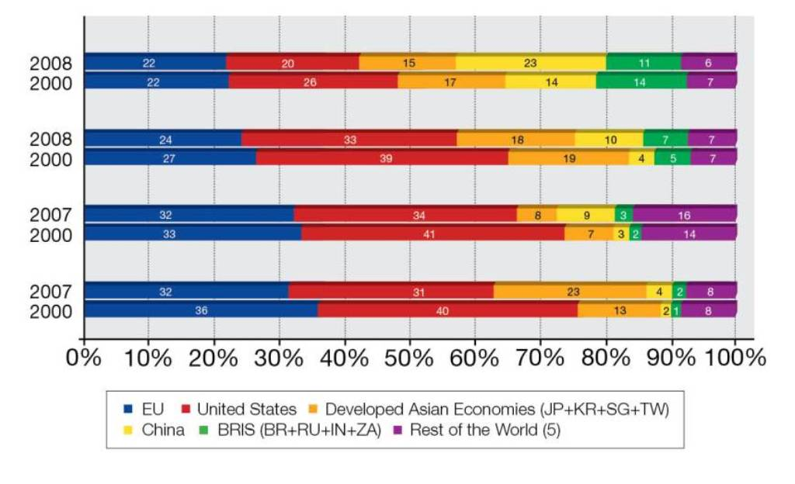
Researchers (FTE)
GERD⁽²⁾
High Impact publications ⁽³⁾
Patent applications ⁽⁴⁾

Source: DG Research and Innovation
Data: Eurostat, OECD, UNESCO, Science Metrix/ Scopus (Elsevier)
Notes: (1) Elements of estimation were involved in the compilation of the data
(2) GERD: shares were calculated from values in current PPS€.
(3) (i) Top10% most cited publications – fractional counting method; (ii) ASIAN-5 does not include Singapore and Taiwan.
(4) Patent applications under the PCT (Patent Cooperation Treaty) at international phase, designating the European Patent Office
(5) The coverage of the Rest of the World is not uniform for all indicators.
If current trends continue over the next three decades, the emerging economies could be as important economically and scientifically as the advanced economies. Under conservative assumptions for growth and for R&D spending, the emerging economies could be investing the same volume of R&D as the G7 countries by 2050 (see Figure 2), and by 2020, they could already be investing more than the EU. This expansion of R&D spending by the emerging countries should inevitably lead to their producing more patents in the coming decades. As seen in Figure 3, whereas the G7 currently account for 85% of PCT patent applications compared with only 8% for the E7 countries, by 2050 the G7 share could have diminished to 50%, with the E7 countries at nearly the same level (46%).
Figure 2: Long-term trends in R&D spending
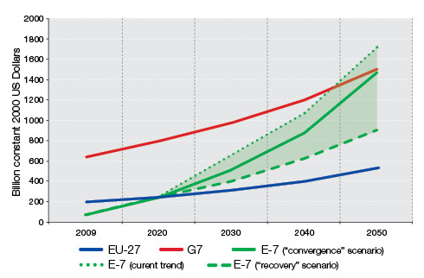
Source: DG Research and Innovation
Data: HSBC estimates of GDP growth, OECD, World Bank
Note: i) "G7" is the group of seven industrialized nations: Canada, France, Germany, Italy, Japan, UK and the US; "E7" is a group of rapidly emerging economies: Brazil, China, India, Indonesia, Mexico, Russia and Turkey
ii) The 3 scenarios are as follows (1) In the "current trend" scenario, the projections are entirely based on the trend observed during the period 1996-2007. The maximum R&D intensity for each country is limited at 5%. (2) The "convergence" scenario assumes that R&D expenditures for all countries will continue along the current trend, but for E7 countries once an R&D intensity of 3% is reached the annual R&D intensity growth for that country is limited to 1%. (3) The "Recovery" scenario assumes that G7 countries will - by 2020 - spend at least 3% of GDP into research (political commitment) and will continue to increase their investments. After 2020, it is assumed that the annual growth rate of R&D intensity in G7 will be the average annual growth rate during the period 1990-2020.
Figure 3: Long-term trends in world shares of PCT patents
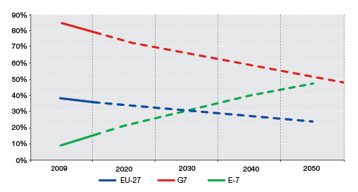
Source: DG Research and Innovation
Data: OECD patent database
Note: The graph is based on the assumption that R&D spending in the E7 and the G7 will evolve in line with the "convergence scenario" in Figure 2. It assumes a gradually increasing propensity to patent (patent/business R&D ratio) for the E7 countries, and a stable propensity for the G7. Data are for patent applications filed under the PCT, at international phase, designating the European Patent Office (the PCT is a system facilitating the worldwide filing of patent applications).
Europe needs research and innovation to recover from the economic crisis, and to boost growth and jobs, but the context for investment is difficult
In this competitive global setting, Europe needs to set itself on a path towards a strong recovery from the economic crisis. But this will not be easy. Following the crisis R&D investment has slowed. For the EU as a whole, the decrease in nominal R&D expenditure was about 3 billion euro (-1.32%, from 239.7 billion in 2008 euro to 236.8 billion euro in 2009).
The total government R&D budget for EU-27 increased in 2009 (to 88.6 billion euros, from 86.2 in 2008). In the medium term, the need for fiscal consolidation may place further pressure on the ability of some European governments to maintain their investment in R&D. Business investment in R&D was more affected than public investment in 2009. In EU's business sector, R&D expenditure decreased by -3.07% that year in nominal terms.
The EU is still lagging behind in terms of the percentage of its GDP invested in R&D. In 2008 EU R&D intensity was 1.92, compared with 2.77 for the US and 3.44 for Japan. The 2009 figure shows an increase (2.01), but this is largely due to falling GDP.
Private R&D in Europe has largely stagnated at around 1.2% of GDP over the last decade, whereas business R&D intensity grew rapidly in Japan (from 2.2% to 2.7%) and South Korea (from 1.7% to 2.5%) over the same period, and more than doubled in China (from 0.5% to 1.1%).
While many fast growing firms are born as SMEs, their R&D intensity is lower in Europe (0.25 in 2007) than it is for the US (0.30) and South Korea (0.56). This lack of investment is in turn reflected in the smaller role played by "young leading innovators" or Yollies – R&D intensive firms which rapidly grow into world leaders due to substantial R&D efforts.
And Europe's competitiveness and innovative performance are weak
In Europe total factor productivity stagnated in the last decade compared with around 7% increase since 2000 in the US and Japan. Various studies have pointed to the need to improve the productivity of service sector by increasing R&D in services.
While analyses show that growth in trade in manufacturing is largely driven by high technology industries, the EU's performance in high technology is far from strong. The share of high-tech and medium-high-tech products in EU exports is lower than that of its main trading partners - 47% in 2008, compared with 60% for the US, 71% for South Korea, and 75% for Japan. Taking a broader view, the overall innovation performance gap has broadened with the US and Japan, while emerging countries are catching up.
One of the weaknesses of Europe's innovation system is the poor links between public and private research actors, which lower its capacity to maximise the use of local knowledge. The EU produces only 36 scientific co-publications per million population which involve public-private collaboration, whereas the US produces 70 and Japan 56.
These weak science-industry links, combined with Europe's underinvestment in private R&D have an impact upon its capacity to introduce technological innovation. In 2007, the EU produced 4 PCT patent applications per billion euro of GDP, slightly below the United States and much lower than Japan and South Korea, which produced 8 and 7 respectively. In 2009, the economic revenues obtained from the licensing of these patents, which in part relates to their quality and usefulness, amounted to 0.2% of the total GDP in Europe. In contrast, these revenues were more than double and triple in Japan and the United States. Moreover, this gap has widened considerably during the past decade.
Globally, the EU is failing to close the innovation performance gap with its main international competitors: the US and Japan. Although the trends in most EU Member States are promising despite the economic crisis, progress is not fast enough. While the EU still maintains a clear lead over the emerging economies of India and Russia, Brazil is making steady progress, and China is catching up rapidly. Within the EU, Sweden is the most impressive performer followed by Denmark, Finland and Germany. The UK, Belgium, Austria, Ireland, Luxembourg, France, Cyprus, Slovenia and Estonia, in that order, form the next group (Figure 4).
All the innovation leaders have higher than average public-private co-publications per million of population, which points to good linkages between the science base and businesses. All Europe's most innovative countries also excel in the commercialisation of their technological knowledge, as measured by their performance in terms of license and patent revenues from abroad.
Figure 4: EU Member States’ innovation performance

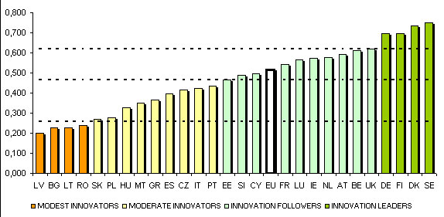
Source: DG Enterprise and DG Research and Innovation, Innovation Union Scoreboard 2010
Note: Average performance is measured using a composite indicator building on data for 24 indicators going from a lowest possible performance of 0 to a maximum possible performance of 1. Average performance in 2010 reflects performance in 2008/2009 due to a lag in data availability. The performance of Innovation leaders is 20% or more above that of the EU27; of Innovation followers it is less than 20% above but more than 10% below that of the EU27; of Moderate innovators it is less than 10% below but more than 50% below that of the EU27; and for Modest innovators it is below 50% that of the EU27

Europe also needs to raise scientific quality
While 15% of US scientific publications are among the top 10% most cited publications worldwide, only 11% of EU publications fall into this category. Meanwhile, China had 7% of its publications in the top ranking in 2007, compared with just under 5% in 2000.
When it comes to academic institutions, of the 386 most active research universities in the world 45% are in Europe and 32% in the US. But only eight of the 76 universities in the world with the highest citation impact are located in the EU. 67 are located in the US.
This pattern of the EU falling behind in terms of quality is continued if one looks across different fields. Figure 5 shows a number of S&T areas that relate to the fields of the EU Framework Programme. It can be seen that in almost all areas the US has significantly more publications in the top 10% most cited than does the EU.
Figure 5: Percentage of scientific publications in the top 10% most cited (2000-2009)

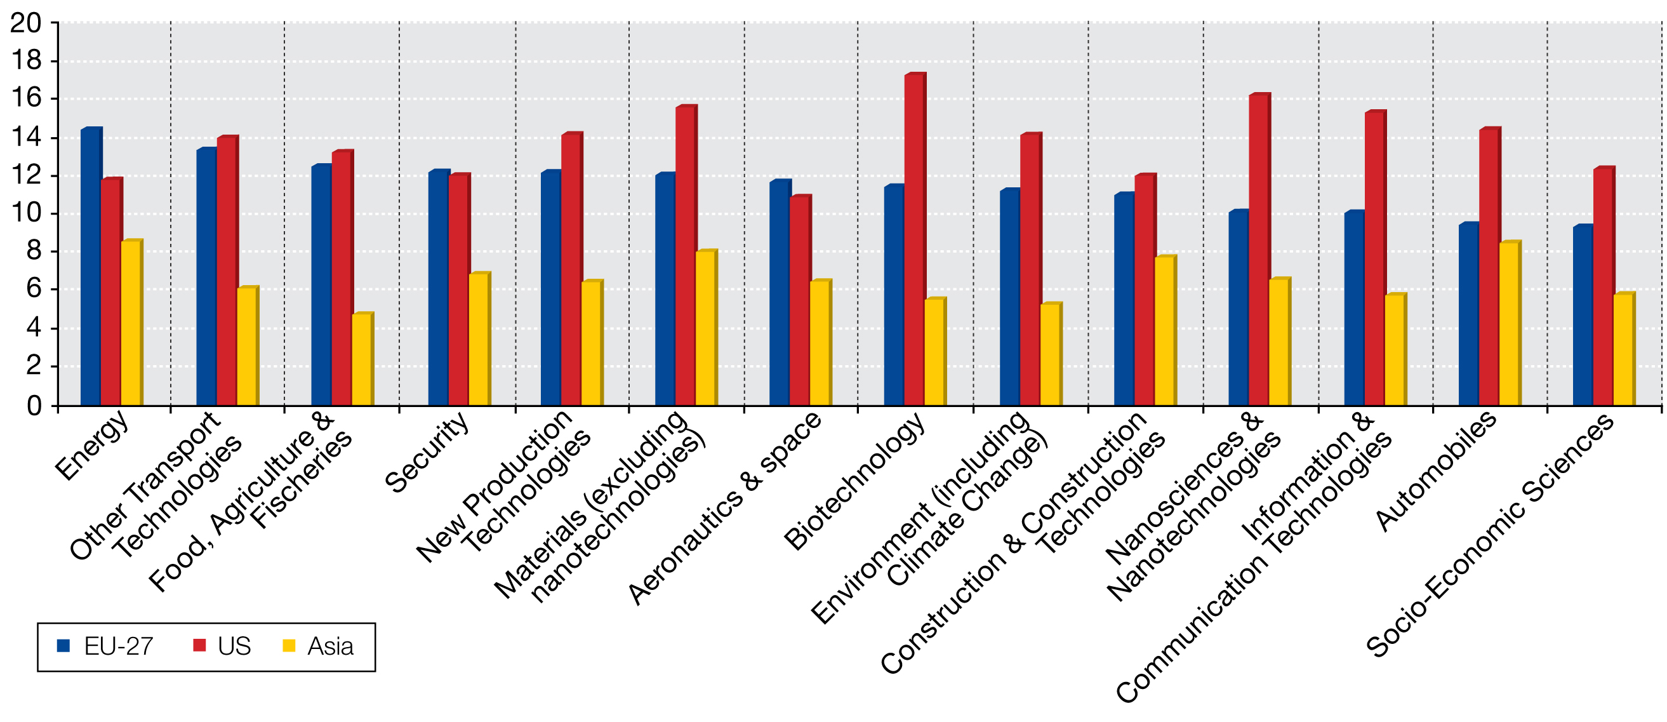
Source: DG Research and Innovation
Data: Science Matrix/ Scopus (Elsevier)
Figure 6: Scientific performance in key fields

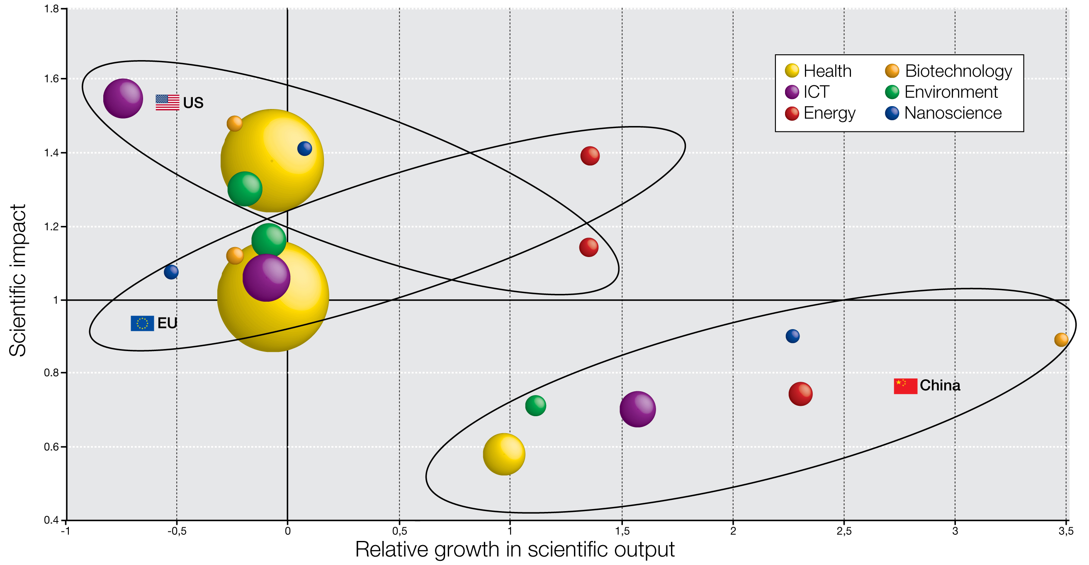

Source: DG Research and Innovation
Data: Science Metrix / Scopus (Elsevier)
Notes: Scientific impact = Average of relative citations computed for 2000-2006 publications (with sliding citation time window [N;N+3]) A value above 1 means a country is cited more often than the world average.
Relative growth in scientific output 2005-2009 compared with 2000-2004. Expressed as the absolute difference in percentage points between growth of country X and the world average growth of publications in the field
Size of bubble is proportional to the volume of publications.
If one looks at scientific impact in key fields in relation to the growth in scientific output in these fields (Figure 6), two trends emerge clearly. Firstly, in the areas of health, environment, nanoscience, biotechnology and ICT Europe's impact falls behind that of the US (albeit that in the environment field its publication output is growing slightly faster). Secondly, while China is still behind the EU and the US in these fields in terms of scientific impact and in terms of publication volume, its output is growing at a much faster rate.
And gain a technological lead over its competitors
When it comes to the development of new technologies, Europe needs to rise to the challenge of global competition. It is relatively strong in certain more traditional fields such as automobiles, aeronautics, other transport and construction, where it must seek to maintain its large share of global patents (see Figure 7). However, in a number of technology areas Europe is behind its competitors. This is certainly true for some key enabling technologies: for example in nanotechnology the EU has
28% of world patents compared with 45% for the US and 24% for Asia; in biotechnology it has 30% versus 48% for the US and 19% for Asia; while in ICT the EU has 29% of global patents, the US 40% and Asia 30%. The EU also lags in terms of patents in key areas for the future, notably health, energy, space and security.
If one takes a combined look at Europe's relative performance in both science and technology across various fields (Figure 8), one sees that it is ahead of the US in terms of both science and technology output in the field of aeronautics and space. However, Europe is weaker than the US in the fields of nanotechnology, biotechnology and ICT, as well as in health and new production technologies.

Figure 7: Patent shares 2000-2009 (PCT applications)

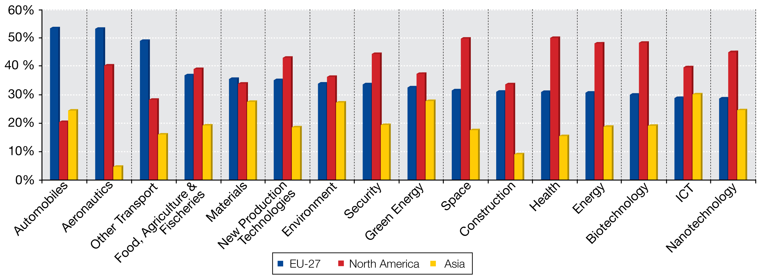

Source: DG Research and Innovation
Data: EPO PATSTAT database (from a study by Research Division INCENTIM, MSI, Faculty of Business & Economics, K.U.Leuven, Università Commerciale Luigi Bocconi, KITES)

These estimates are based upon GDP growth forecasts made by HSBC (The World in 2050 – Quantifying the Shift in the Global Economy, HSBC, 4 January 2011). They assume that G7 R&D spending evolves based on the trend observed during the period 1996-2007. For E7, they assume that R&D expenditure evolves according to the 1996-2007 trend until a country reaches an R&D intensity of 3%, and then after this the annual R&D intensity growth for that country is limited at 1%.
Source Eurostat: Government Budget Appropriations or Outlays on R&D
Bruegel Policy Brief, August 2010, R.Veugelers and M.Cincera.
DG ECFIN 2010
For example, the report of the CREST OMC 3% Working Group on "Promoting the role of R&D in services" 2009.
"Science, Technology and Industry Scoreboard", OECD 2009 (p.86)
European Innovation Scoreboard, 2010
European Innovation Scoreboard, 2010
European Innovation Scoreboard 2010. Data for 2008.
Patent applications under the Patent Cooperation Treaty, at international phase, designating the EPO by country of residence of the inventor. Source OECD.
Source Eurostat.
Source: Science Metrix, Scopus (Elsevier)
According to the latest edition of the Shanghai Ranking,

