ANNEX 5: INFORMATION ON ECONOMETRIC MODELLING
USED IN THE REPORT (NEMESIS)
DESCRIPTION, ASSUMPTIONS AND RESULTS

Nemesis is a general equilibrium model built by a European Commission-funded consortium of European research institutes under the 5th Framework Programme. Nemesis has been used by the European Commission for the ex-ante impact assessment of FP7 and for assessing the macro-economic impact of achieving the objective of investing 3 percent of Europe's GDP in research and innovation ("3 percent objective"), by the OECD, by a number of French government institutions, etc.
For the CSF impact assessment, DG Research & Innovation developed, in collaboration with the DEMETER consortium operating Nemesis, 5 different future-oriented scenarios: (1) Business-as-usual; (2) Common Strategic Framework for Research and Innovation; (3) Common Strategic Framework for Research and Innovation + achievement of the 3 percent objective; (4) Renationalisation; and (5) Discontinuation.
These scenarios were operationalised through a number of key model parameters including the real EU and national research and innovation funding growth rates; the allocation of EU research and innovation funding to EU Member States, to basic vs. applied research, and to sectors; the EU and national research and innovation funding crowding-in fators and multipliers; the intersectorial and international spillovers. The scenarios and the specific assumptions underpinning each of them are detailed in Table 1 below. The difference between the BAU, CSF and other scenarios hinged mainly on the scale of EU research and innovation funding, and on the size of the crowding-in effect and the economic multiplier associated with the intervention.
All BAU assumptions were based on academic literature. The BAU FP and national net private sector funding crowding-in effects of 0.7 and 0.5, for instance, were derived directly from Guellec and Van Pottelsberghe (2000), European Commission (2004).
The CSF assumptions were necessarily based on deduction and analogy. Because of simplification and therefore enhanced industrial participation, and because of closer knowledge triangle coordination and therefore enhanced valorisation of research results, crowding-in effects and economic multipliers, for instance, were assumed to be higher than those associated with the BAU option.
The DEMETER consortium produced for each of these scenarios results on GDP, exports, imports, and employment through 2030. In the figures below, these results are presented as deviations from the business-as-usual scenario.
Impact of the different options on GDP
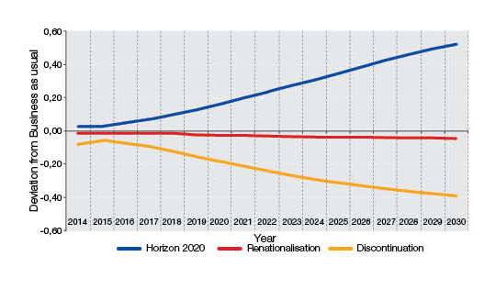

Impact of the different options on exports
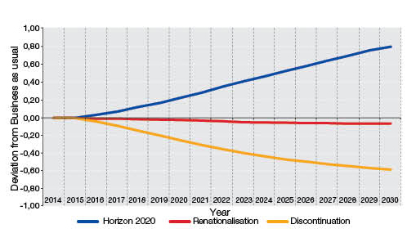

Impact of the different options on imports

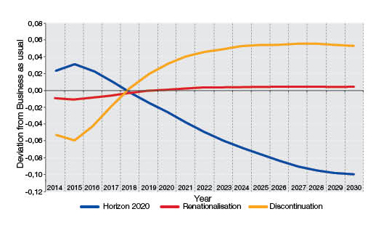

Impact of the different options on Employment

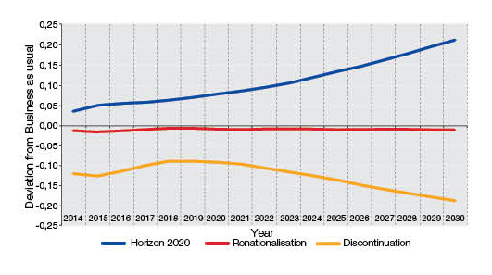
 | Business as usual | Preferred |  | Renationalisation | Discontinuation - Cost of non-Europe
 | Business as usual | CSF | CSF+3% | Renationalisation | Discontinuation - Cost of non-Europe
FP funding real growth rate 2014-2020 | €8,31 billion (2014 prices) spent in 2014; thereafter adjusted for inflation (2%) only | 2014: 10,70 billion; 2015: 11,40 billion; 2016: 12,12 billion; 2017: 12,87 billion; 2018: 13,65 billion; 2019: 14,45 billion; 2020: 15,27 billion (current prices, no need anymore to adjust for inflation; already done) | 2014: 10,70 billion; 2015: 11,40 billion; 2016: 12,12 billion; 2017: 12,87 billion; 2018: 13,65 billion; 2019: 14,45 billion; 2020: 15,27 billion (current prices, no need anymore to adjust for inflation; already done) | €8,31 billion (2014 prices) spent in 2014; thereafter adjusted for inflation (2%) only | €8,31 billion (2014 prices) spent in 2014; thereafter adjusted for inflation (2%) only (negative effect)
FP funding real growth rate 2021-2030 | Continuation of above | Increase further every year by 450 million and adjust for inflation (2%) | Increase further every year by 450 million and adjust for inflation (2%) | Continuation of above | Continuation of above (negative effect)
National funding real growth rate 2014-2020 | Constant (latest available) national R&D intensity | Constant (latest available) national R&D intensity | Reach National Reform Plan (NRP) R&D intensity objectives by 2020 (sent) | Constant (latest available) national R&D intensity | Constant (latest available) national R&D intensity reduced by discontinued FP amount
National funding real growth rate 2021-2030 | Continuation of above | Continuation of above | Once objectives reached, constant R&D intensity | Continuation of above | Continuation of above
Allocation of FP funding to EU MS | Like under FP7 | Based on innovation performance | Based on innovation performance | Like under FP7 | Like under FP7 (negative effect)
Allocation of FP funding to basic and applied research | 40% basic, 60% applied | 40% basic, 60% applied | 40% basic, 60% applied | 40% basic, 60% applied | 40% basic, 60% applied
Allocation of FP applied research funding to sectors within MS | Grandfathering | Grandfathering | Grandfathering | Grandfathering | Grandfathering
FP funding crowding-in factor for the private sector (net additional funding generated) | 0.9 | 1.1 | 1.1 | 0.7 | 0.9 (negative effect)
FP funding crowding-in factor for the public sector | 0.5 | 0.5 | 0.5 | 0 | 0.5 (negative effect)
National funding crowding-in factor for the private sector (net additional funding generated) | 0.7 | 0.7 | 0.7 | 0.7 | 0.7
National funding crowding-in factor for the public sector | 0 | 0 | 0 | 0 | 0
Multiplier for R&D resulting from EC funding | 6 percent better than national | 15 percent better than national | 15 percent better than national | National | National
Multiplier for R&D resulting from national funding | National | National | National | National | National
Intersectorial spillovers | + | + | + | + | +
International spillovers | + | + | + | + | +

