This annex aims to provide an overview of the outputs, effects and impacts achieved by the Framework Programmes for Research and Technological Demonstration (FP), the Competitiveness and Innovation Programme (CIP), and the European Institute of Technology and Innovation (EIT). As required by the Commission's impact assessment guidelines, past FP achievements were discussed at length in the April 2005 ex-ante impact assessment accompanying the proposal on FP7. In order to avoid duplication, this annex focuses as far the FP is concerned in the first place on evidence produced since that date. For this reason, the evidence presented below pertains in particular to FP6 and FP7.
ANNEX 1: PAST ACHIEVEMENTS AND LESSONS LEARNED

SUMMARY ON PAST ACHIEVEMENTS AND LESSONS LEARNED

The different programmes integrated into the Common Strategic Framework for Research and Innovation – the FP, the CIP and EIT - have achieved large impacts in the course of their history.

FP achievements

The FP has involved large numbers of top ("A-team") EU and extra-EU researchers in thousands of first-rate, mixed (firms, universities, research institutes), cross-border projects – projects that in the absence of EU funding would not have been carried out, postponed, or scaled down in financial terms, in terms of scope and ambition, or in terms of the number of partners involved - to carry out excellent, often inter-disciplinary, collaborative research on a very wide range of topics.
The FP has facilitated the training and pan-European/extra-European mobility of researchers, enhanced the quality of doctoral training (including through industrial doctorates), added to the research capabilities of participating institutions, and formalised and oriented the R&D and innovation processes of in particular small organisations (e.g. SMEs), young organisations (e.g. start-ups), and organisations from recent Member States and candidate countries.
The FP has produced new knowledge embodied in large numbers of influential (because highly-cited) (co-) publications and enhanced the development of new products and processes; the development and use of new tools and techniques; the design and testing of models and simulations; the production of prototypes, demonstrators, and pilots; and other forms of technological development.
The FP has generated large numbers of patents and enabled participants to increase their turnover and profitability, raise their productivity, increase their market share, obtain access to new markets, reorient their commercial strategy, improve their competitive position, enhance their reputation and image, and reduce commercial risk. In addition, the results of FP direct and indirect actions have supported EU-level policy formulation.
The FPs' positive impacts on innovation have translated, down the line, into large-scale positive macro-economic, social and environmental impacts.
The FP has produced so-called "structuring effects": durable changes in the EU research and innovation landscape. If it were not for the FP, the European Research Council, promoting excellence across Europe, would not have been created; the EU would then have been left with a landscape of compartmentalized national research councils, but would have had no funding mechanism to promote EU-wide competition for funds and to encourage higher scientific quality in frontier research. Thanks to the Marie Curie Actions, the EU has created the right framework for researchers' careers and free movement of knowledge. The EU leads in the creation and use of research infrastructures of pan-European importance: thanks to EU leadership, for the first time, a pan-European strategy on research infrastructures (the so-called ESFRI roadmap) has been developed and is now being implemented. Collaborative research projects, international cooperation actions, mobility actions, and research infrastructure actions have generated durable, cross-sectoral, inter-disciplinary research and innovation networks across Europe as well as with the world's most dynamic and fastest growing research nations that have remained alive after the end of EU funding. European Technology Platforms and ERA-NETs have served as useful focusing devices that have helped stakeholders identify and explain their R&D needs jointly, easing the process of developing mutually supportive policies at EU and Member State levels. Joint Technology Initiatives have focused and aligned key actors in their respective areas, serving as a support to develop coherent sectorial strategies. Article 185 and Joint Programming initiatives have achieved a better coordination of R&D in Europe and supported a more coherent use of resources.

CIP achievements
According to a recent 'Final Evaluation' of the EIP component of the CIP, the programme is performing well and on track to achieve the levels of activity anticipated in the CIP Decision and ex-ante impact assessment. Surveys carried out under the evaluation have demonstrated the utility of the programme (it directly meets identified needs) and its European added value. The evaluation found that existing financial instruments are supporting a substantial number of SMEs and administered efficiently, and that most innovation-related actions are seen as well-focused and appropriate. The Final Evaluation issued several recommendations, mostly aimed at expanding the existing activities launched within the current EIP and making them more comprehensive and consistent. The eco-innovation funding scheme for first application and market replication projects within the EIP helped a number of enterprises to bring their innovative goods to the market.
The ICT Policy Support Programme component of CIP has been able to bring Member States together to test deployment of innovative ICT applications at real scale in several important policy areas. These actions aimed at stimulating demand and facilitating formation of markets in areas with high untapped potential such as cross-border e-health services. They also helped to reduce fragmentation of markets for innovative ICT products and services, slow consensus and standardisation processes, lack of interoperability, diverging legislation and national practices. However, it is still too early to identify whether this potential is being realised as most pilots were launched in 2008 or later, and most are still grappling with mid-term implementation. The ICT-PSP is complimentary to the initiatives of FP7, especially in supporting interoperability and attracting a broader constituency (i.e. public authorities) to facilitate the uptake of technologies (Eureval, 2009; Pogorel et al., 2009).

EIT achievements
The main achievements of the EIT since the establishment of the EIT headquarters in April 2010 have been primarily in setting up its own structure and the development of each Knowledge and Innovation Community (KIC) as a single legal entity led by a Chief Executive Officer. The EIT also set up the EIT Foundation in September 2010 in the Netherlands as a new, flexible financing tool to leverage philanthropic funds in support of educational and entrepreneurial activities bringing the EIT and its KICs closer to European society.

While European research and innovation programmes have been successful, there are important lessons to be learned from the past, from stakeholder feedback, and from analytical studies. Research, innovation and education should be addressed in a more coordinated manner and in coherence with other policies and research results better disseminated and valorised into new products, processes and services. The intervention logic of EU support programmes should be developed in a more focused, concrete, detailed and transparent manner. Programme access should be improved and start-up, SME, industrial, EU12 and extra-EU participation increased. Monitoring and evaluation need to be strengthened (for details see section 3).

DETAILED EVIDENCE ON PAST ACHIEVEMENTS

THE FP ACHIEVES A VAST REACH

Through thousands of contracts, the FP reaches tens of thousands of participants from a variety of sectors, from a large number of EU and non-EU countries, and from a wide range of disciplines.

The case of collaborative research is illustrative. Collaborative research constitutes the largest component of the Framework Programme. It accounted for 70% of the budget under FP6 and accounts for 64% of the budget under FP7. A statistical analysis performed on shared-cost action participation data across FPs shows that the FP funds large numbers of projects bringing together different types of participants from all Member States as well as from other countries.
- The FP funds thousands of research projects and participations with critical mass: From FP2 to FP5, the growth in the collaborative research budget was accompanied by increases in the number of collaborative research projects (from 2779 in FP2 to 6712 in FP5) and participations (from 13 000 to 44 000). As from FP6, more emphasis was put on achieving a 'critical mass' of resources within a project: fewer projects were funded but they became of a greater size than before. The average number of participations per project doubled (from 6.5 to 13) and the average Commission funding per project increased by 278%, from €1.4 million to €3.9 million. The average EU funding per participation also increased from € 196 000 to € 283 000. FP7 appears to maintain this trend towards larger projects with higher funding per project and per participation (Table1).
Table 1: The changing features of FP shared-cost research actions
Indicators | FP2-EU-12 | FP3-EU-15 | FP4-EU-15 | FP5-EU-15 | FP6-EU-25 | FP7-EU-27
Indicators | 1987-1991 | 1990-1994 | 1994-1998 | 1998-2002 | 2002-2006 | 2007-2013
 | Definitive data | Definitive data | Definitive data | Definitive data | Definitive data | Partial  data
No. of projects | 2779 | 3292 | 2949 | 6709 | 3110 | 2455
No. of participations (000) | 13 | 18 | 21 | 41 | 40 | 25
Average no. of participations per project | 4,7 | 5,6 | 7 | 6,2 | 13 | 10
Average no. of different Member States per project | 3 | 3,5 | 4,2 | 3,7 | 6 | 6
Average EU funding per project (€000) | 1202 | 1218 | 1160 | 1405 | 3928 | 4069
Average EU funding per participation (€000) | 256 | 218 | 165 | 200 | 283 | 378

Source: DG Research & Innovation
- FP research funding and participations are allocated in a balanced manner to different types of research actors: Available shared-cost action data show an increasingly balanced allocation of funding and participations to the different types of research actors: business enterprises, research centres, and higher education institutions. Business enterprises initially accounted for the largest share of funding and participations. Research centres and higher education institutions gradually increased their shares over time. FP7 appears to have stopped and even reversed, in terms of both, funding and participations, the decline in business enterprise participation (Figures 1&2).

Figure 1: How is FP funding shared between the main research actors? (% of FP funding received by type of participant)
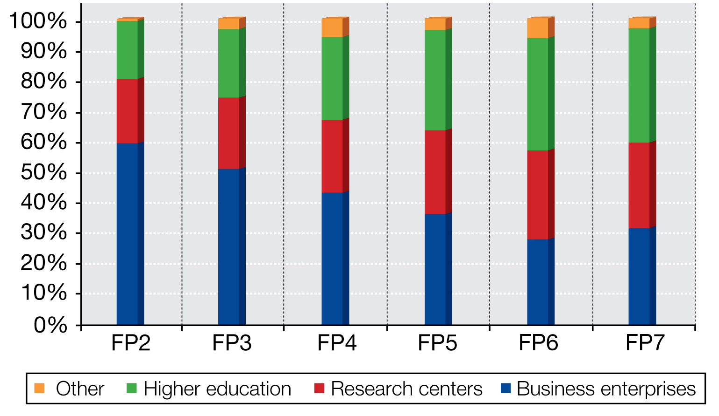
Note: * Partial FP7 data (to 01.2011); Source: DG Research & Innovation
Figure 2: How is FP participation shared between the main research actors? (% of FP participations by type of participant)
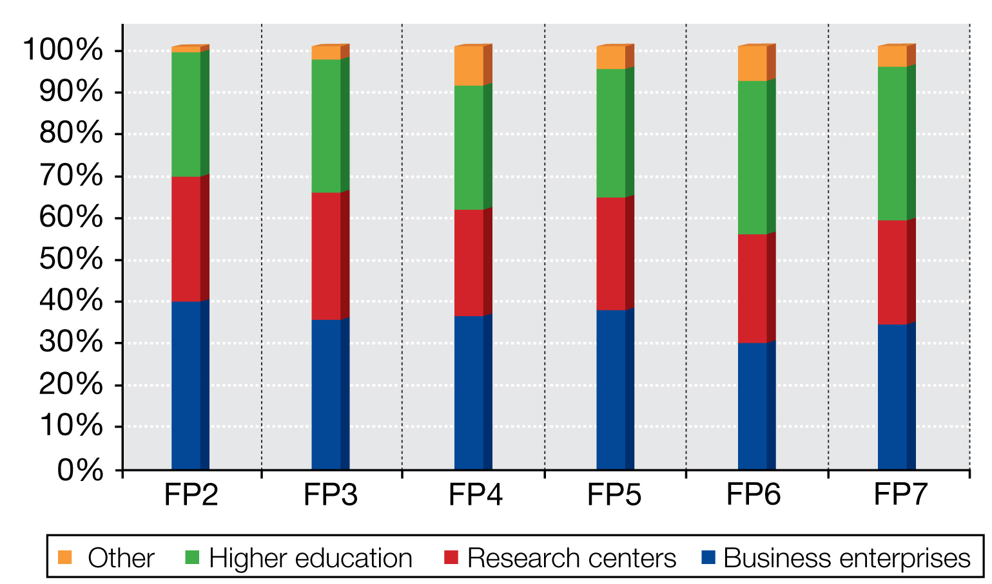
Note: * Partial FP7 data (to 01.2011); Source: DG Research & Innovation

- FP collaborative research actions involve a significant number of SMEs

SMEs accounted for 19.1% of FP7 shared cost action participations so far and 15.8% of FP7 shared cost funding disbursed so far (only MS). Among 'Private for profit' participants (mainly business enterprises), SMEs accounted for 49.5% of participations and 45.1% of funding. For shared cost actions, the 15 percent SME participation target appears to be achieved.

The FP succeeds in attracting and supporting highly performing SMEs. 34 of the 500 fastest growing enterprises in Europe in the year 2010 had participated in the FP, almost all of them several times.

Table 2. FP6 and FP7 participations and funding by country
Countries |  | FP6 |  |  |  | FP7*
 |  | Participations |  | FP funding |  | Participations |  | FP funding
 |  | No | % | mln € | % | No | % | mln € | %
Member States | DE - Germany | 7.089 | 15,80% | 2.338 | 19,17% | 5.041 | 15,09% | 1.954 | 18,1%
Member States | UK - United Kingdom | 5.146 | 11,47% | 1.583 | 12,98% | 3.600 | 10,78% | 1.322 | 12,3%
Member States | FR - France | 5.007 | 11,16% | 1.572 | 12,89% | 3.378 | 10.1% | 1.324 | 12,3%
Member States | IT - Italy | 4.344 | 9,68% | 1.139 | 9,35% | 3.243 | 9,71% | 976 | 9,1%
Member States | ES - Spain | 2.915 | 6,50% | 716 | 5,88% | 2.218 | 6,60% | 686 | 6,4%
Member States | NL - Netherlands | 2.562 | 5,71% | 827 | 6,79% | 1.953 | 5,85% | 711 | 6,6%
Member States | SE - Sweden | 1.692 | 3,77% | 533 | 4,37% | 1.226 | 3,67% | 432 | 4,0%
Member States | BE - Belgium | 1.645 | 3,67% | 470 | 3,85% | 1.516 | 4,54% | 465 | 4,3%
Member States | EL - Greece | 1.434 | 3,20% | 322 | 2,64% | 1.013 | 3.00% | 299 | 2,8%
Member States | AT - Austria | 1.208 | 2,69% | 323 | 2,65% | 900 | 2,69% | 297 | 2,8%
Member States | DK - Denmark | 1.096 | 2,44% | 303 | 2,49% | 682 | 2,04% | 253 | 2,4%
Member States | PL - Poland | 944 | 2,10% | 141 | 1,16% | 569 | 1,70% | 114 | 1,1%
Member States | FI - Finland | 902 | 2,01% | 264 | 2,16% | 792 | 2,40% | 284 | 2,6%
Member States | PT - Portugal | 683 | 1,52% | 125 | 1,03% | 532 | 1,59% | 125 | 1,2%
Member States | HU - Hungary | 594 | 1,32% | 99 | 0,81% | 377 | 1,13% | 65 | 0,6%
Member States | CZ - Czech Republic | 582 | 1,30% | 91 | 0,75% | 376 | 1,13% | 67 | 0,6%
Member States | IE - Ireland | 447 | 1,00% | 119 | 0,98% | 398 | 1,19% | 130 | 1,2%
Member States | SI - Slovenia | 310 | 0,69% | 54 | 0,45% | 249 | 0,75% | 47 | 0,4%
Member States | RO - Romania | 237 | 0,53% | 28 | 0,23% | 286 | 0,86% | 42 | 0,4%
Member States | BG - Bulgaria | 187 | 0,42% | 23 | 0,19% | 166 | 0,50% | 20 | 0,2%
Member States | SK - Slovakia | 155 | 0,35% | 21 | 0,17% | 120 | 0,36% | 20 | 0,2%
Member States | EE - Estonia | 146 | 0,33% | 21 | 0,17% | 120 | 0,36% | 20 | 0,2%
Member States | LT - Lithuania | 131 | 0,29% | 15 | 0,13% | 101 | 0,30% | 13 | 0,1%
Member States | CY - Cyprus | 102 | 0,23% | 15 | 0,12% | 92 | 0,28% | 17 | 0,2%
Member States | LV - Latvia | 89 | 0,20% | 12 | 0,10% | 62 | 0,19% | 7 | 0,1%
Member States | LU - Luxembourg | 73 | 0,16% | 16 | 0,13% | 55 | 0,16% | 11 | 0,1%
Member States | MT - Malta | 37 | 0,08% | 5 | 0,04% | 44 | 0,13% | 5 | 0,0%
Member States | JRC | 148 | 0,33% | 29 | 0,24% | 119 | 0,36% | 33 | 0,3%
Member States | Total Member States | 39.757 | 88,59% | 11.176 | 91,67% | 29.109 | 87,13% | 9.740 | 90,5%
Candidate Countries | HR - Croatia | 63 | 0,14% | 8 | 0,07% | 78 | 0,23% | 13 | 0,1%
Candidate Countries | IS - Iceland | 64 | 0,14% | 18 | 0,15% | 48 | 0,14% | 11 | 0,1%
Candidate Countries | MK - FYROM | 33 | 0,07% | 3 | 0,02% | 29 | 0,09% | 3 | 0,0%
Candidate Countries | TR - Turkey | 194 | 0,43% | 31 | 0,25% | 185 | 0,55% | 30 | 0,3%
Candidate Countries | Total Candidate Countries | 354 | 0,79% | 60 | 0,49% | 340 | 1,02% | 58 | 0,5%
Associated countries | CH - Switzerland | 1.380 | 3,07% | 336 | 2,76% | 1.156 | 3,46% | 420 | 3,9%
Associated countries | IL - Israel | 493 | 1,10% | 147 | 1,20% | 388 | 1,16% | 142 | 1,3%
Associated countries | NO - Norway | 770 | 1,72% | 211 | 1,73% | 516 | 1,54% | 180 | 1,7%
Associated countries | Total Associated Countries | 2.648 | 5,90% | 695 | 5,70% | 2.161 | 6,47% | 755 | 7,0%
Third Countries | US - United States | 113 | 0,25% | 11 | 0,09% | 166 | 0,50% | 20 | 0,2%
Third Countries | AU - Australia | 58 | 0,13% | 3 | 0,02% | 69 | 0,21% | 2 | 0,0%
Third Countries | CA - Canada | 66 | 0,15% | 2 | 0,01% | 68 | 0,20% | 2 | 0,0%
Third Countries | JP - Japan | 16 | 0,04% | 1 | 0,00% | 26 | 0,08% | 2 | 0,0%
Third Countries | CN - China | 224 | 0,50% | 28 | 0,23% | 153 | 0,46% | 17 | 0,2%
Third Countries | IN - India | 66 | 0,15% | 9 | 0,08% | 125 | 0,37% | 20 | 0,2%
Third Countries | BR - Brazil | 92 | 0,20% | 12 | 0,09% | 82 | 0,25% | 12 | 0,1%
Third Countries | RU - Russian Federation | 263 | 0,59% | 39 | 0,32% | 203 | 0,61% | 30 | 0,3%
Third Countries | Rest of the world | 1.186 | 2,64% | 153 | 1,25% | 908 | 2,72% | 110 | 1,0%
 | Total | 44.880 |  | 12.192 |  | 33.410 |  | 10.768
Note: * Partial FP7 data (to 01.2011); Source: DG Research & Innovation
- The FP brings together participants from a large number of countries: EU Member States, associated countries and third countries: No less than 243 countries participated in FP6 including 27 EU Member States, 5 Associated Countries, 3 Candidate Countries and 108 third countries from all continents. After the Member States and Associated Countries, the so-called BRIC countries (Brazil, Russia, India, China) accounted for most FP participations and funding (Table 2).
- The FP brings together participants from a large number of regions: FP6 funding reached 256 of the 271 EU27 Member State regions (NUTS 2 level), from Crete and Cyprus in the South to Lapland (FI) in the North and from Algarve (PT) to the Black Sea (RO).
- The extent of involvement in the FP of individual EU Member States, associated countries, and EU regions is in line with their economic and research capabilities.
FP collaborative research funding is awarded on the basis of scientific excellence, not nationality, large economies with large research capabilities like Germany, France, the United Kingdom and Italy therefore account for the highest share of both FP funding and participations (Table 2, Figure 3). The opposite is true for smaller and new Member States, which do not have the research capabilities to absorb large amounts of FP funding. The statistical analysis shows that there is a very strong correlation (0,98) between the magnitude of FP funding received by a Member State and the size of its economy: the share of FP funding received by a country is in 96% related to its share of the EU GDP.
The same pattern is replicated at regional level: FP participations and funding are concentrated in regions where research activities are concentrated. The top regional recipients of FP funding are the well-known European centres of scientific excellence and innovation performance, including Northern Italy, Bavaria, Oxfordshire, Rhone-Alps and capital regions, like London, Madrid and Ile-de France (Figure 4).

Figure 3: Involvement in FP7 is aligned with country's scientific performance and research capabilities

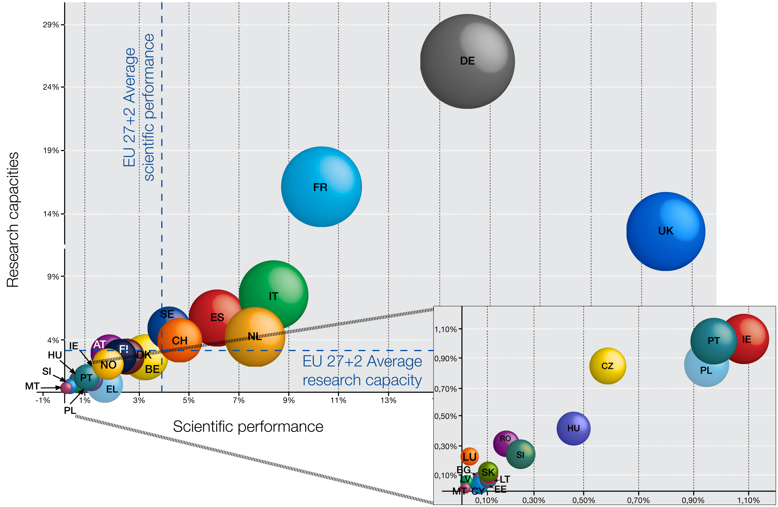
Source: DG Research & Innovation,
Data: Eurostat,, Science Metrix / Scopus (Elsevier)
Note: Research capacities=share of EU27+NO+ CH GERD
Scientific performance= share ofEU27+NO+CH highly cited publications
Size of bubble is proportional to FP7 funding received

Figure 4. Top 25 regional recipients of FP6 funding
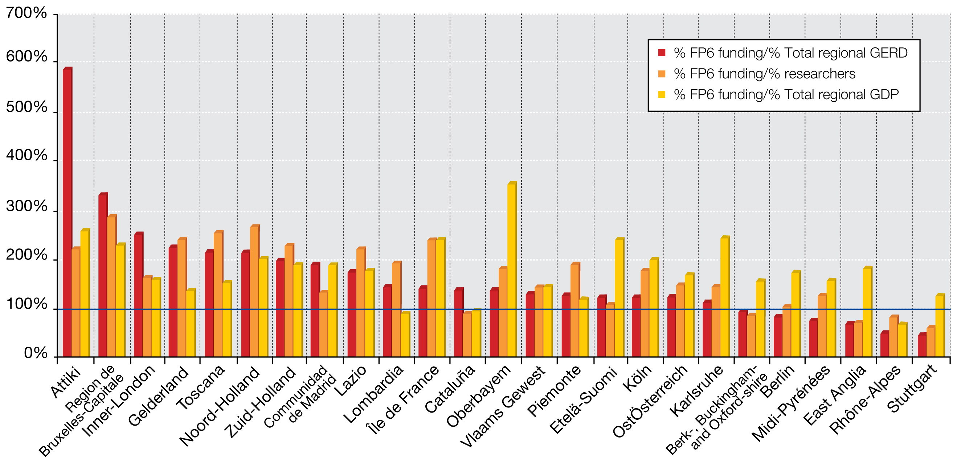
Source: DG Research & Innovation, Data for EU 27
- Small and new EU Member States and their regions participate more intensely and benefit more from the FP than their research and economic capabilities and scientific and technological performance would suggest
When ranking Member States in terms of their share of FP participations or funding divided by their share of EU GDP, European researchers or GERD, smaller Member States tend to receive more funding and account for more participations than their economic performance and research capabilities could suggest. (Figures 5, 6, 7 & 8).
Figure 5: New Member States participate more intensively in the FP6
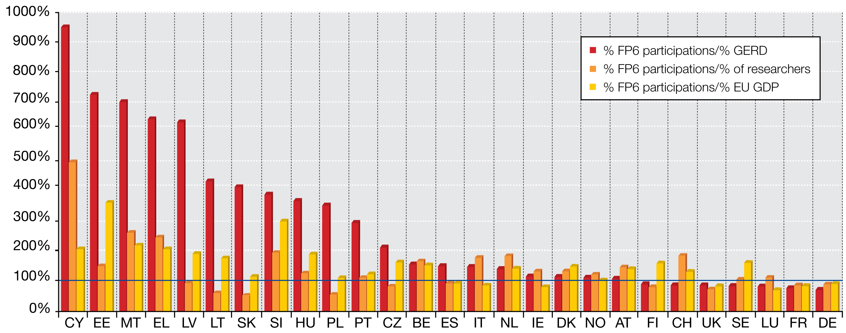
Source: DG Research & Innovation, Data for EU 27+NO+CH

The statistical analysis was performed on the Framework Programmes participation data extracted from the central FP contract management database, CORDA. The shared-cost, collaborative-research actions filter was applied, what implies that i.e. in FP6 only Integrated projects, STREPs and Networks of Excellence data were considered. The scope of data varies from one FP to another, as the FP instruments and rules for participation evolved and the labels attached in the databases to FP participants also changed. This makes the data difficult to analyse and the comparison required certain regrouping of data. Moreover, the incomplete data on participants' SME status is a major drawback of FP databases. This situation improved for FP7 reporting.

