Figure 6: New Member States participate more intensively in the FP7
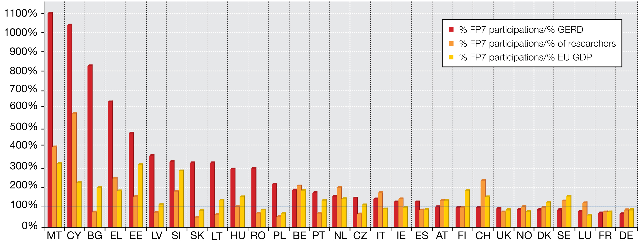
Source: DG Research & Innovation, Data for EU 27+NO+CH

Figure 7: Smaller MS benefit more from FP6 funding in relative terms

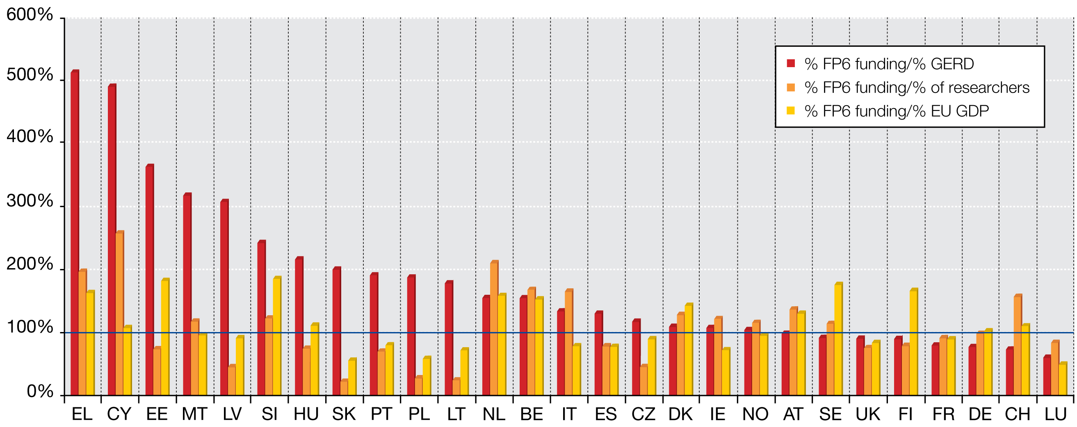

Source: DG Research & Innovation, Data for EU 27+ NO+CH
Figure 8: Smaller MS benefit more from FP7 funding in relative terms

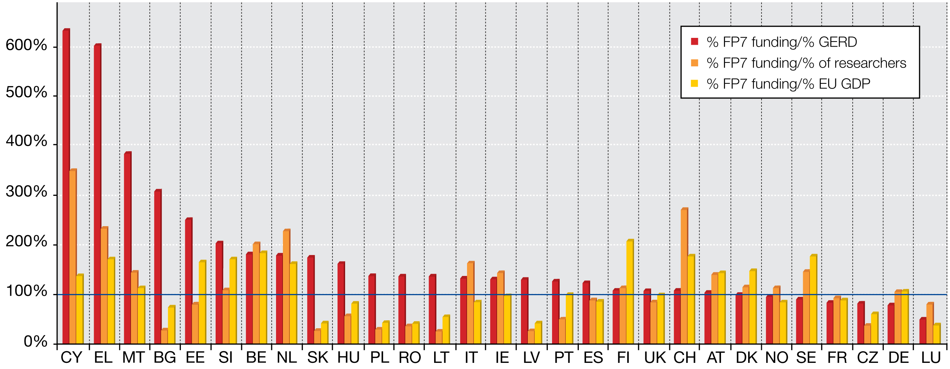
Source: DG Research & Innovation, Data for EU 27+ NO+CH

At regional level as well, peripheral and less research-intensive regions obtain much more FP6 funding per euro of research investment (GERD) than more research-intensive regions. This is particularly true for EU-10 regions, which obtain up to 5 times more than their research investment would suggest (Figure 9). In conclusion, it could be put that FP is an important alternative source of funding for less favoured regions and contributes to filling in the investment gap.

Figure 9: EU-10 regions benefit more from FP funding in relative terms

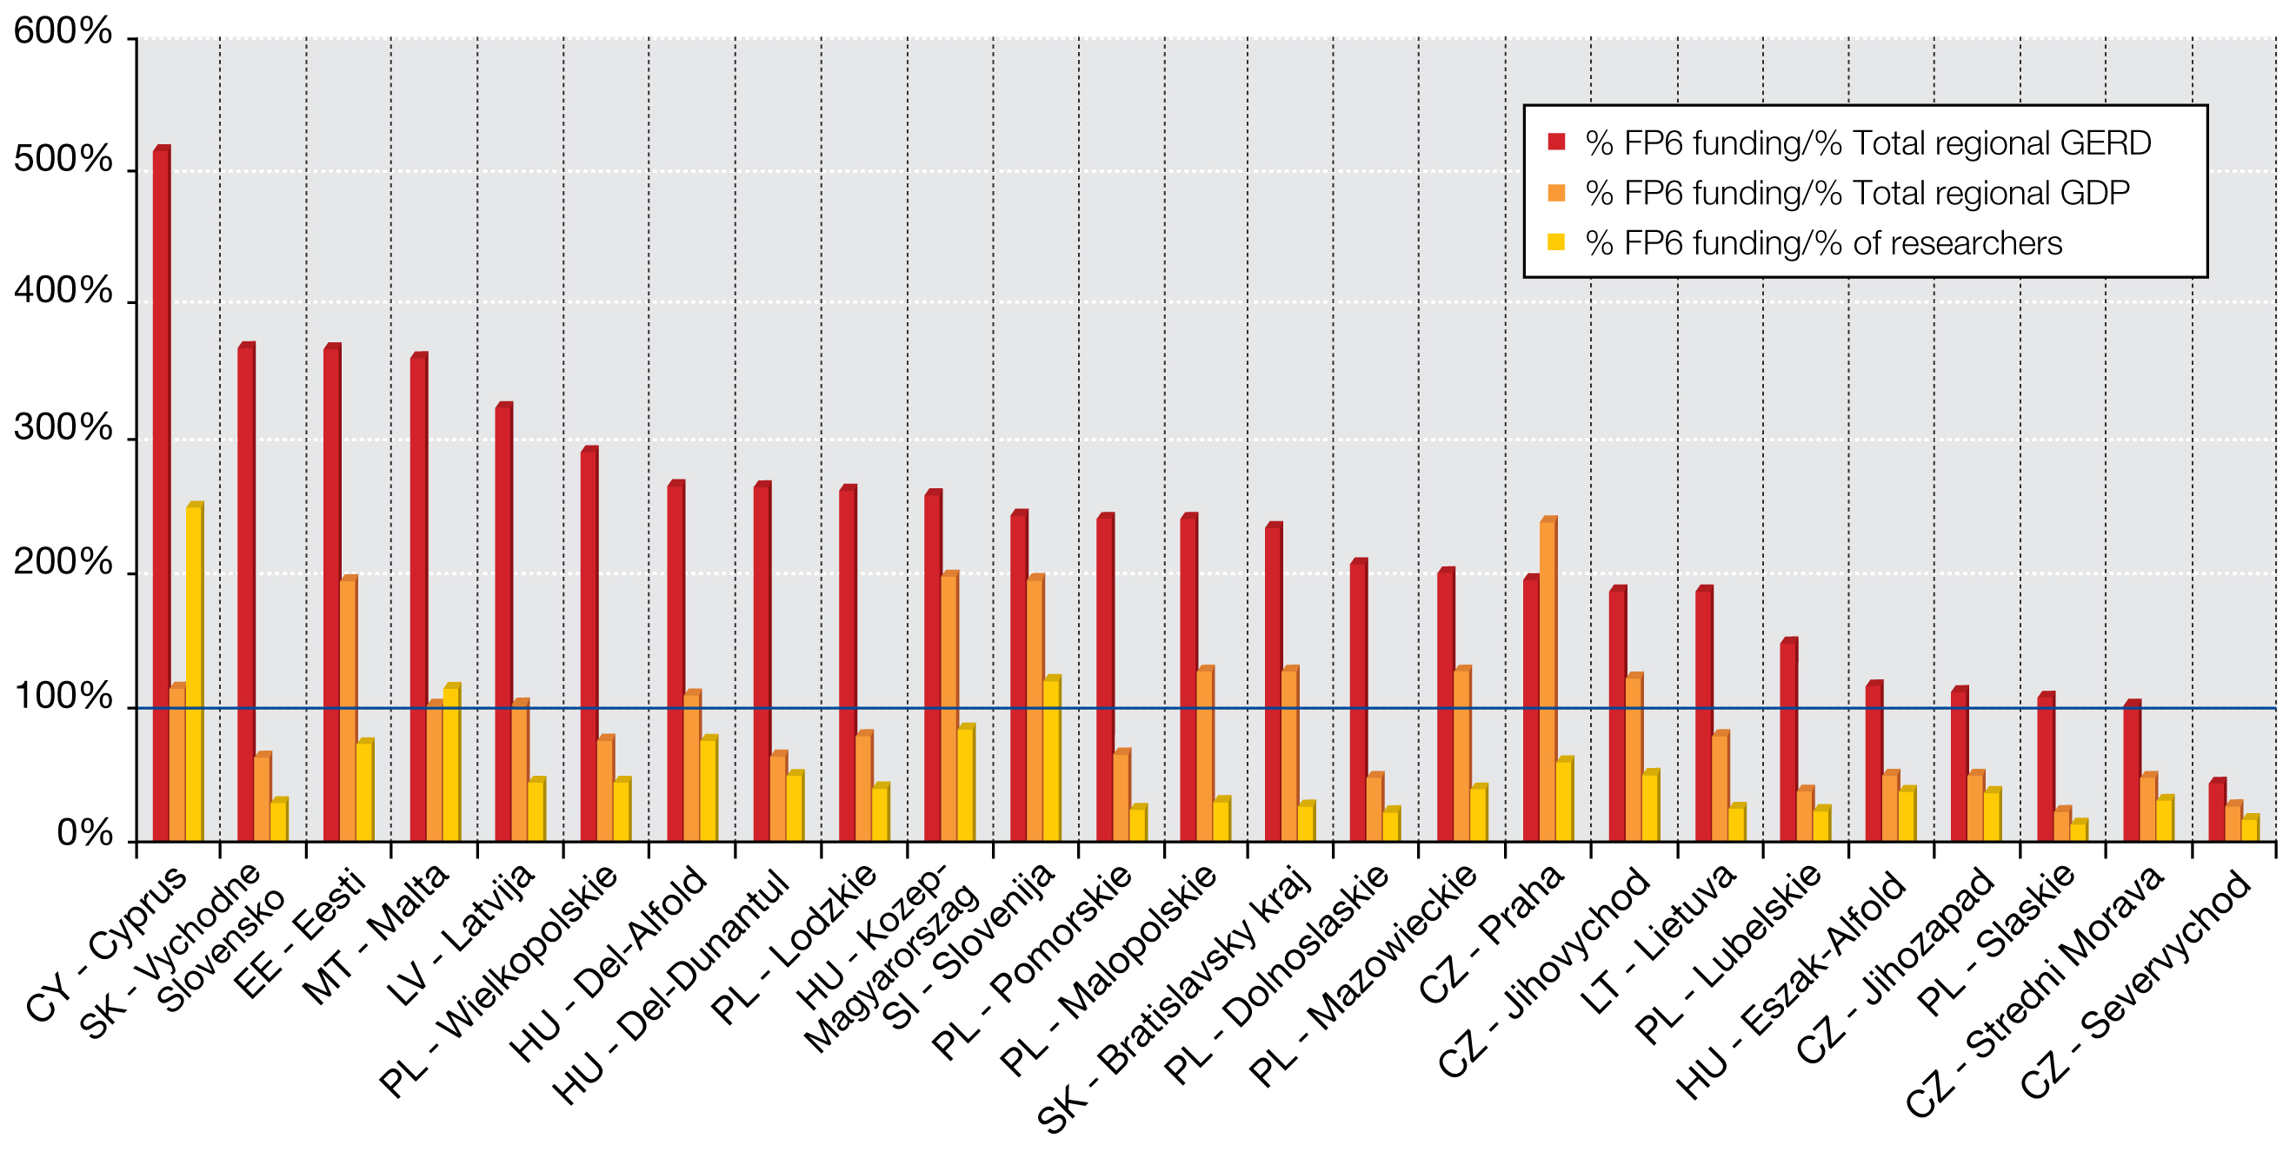

Source: DG Research & Innovation

New Member States also participate more intensely in the FP and receive more FP funding than their scientific (share of top 10% most cited publications) or technological performance (share of PCT (Patent Cooperation Treaty) patents) would suggest (Figure 10, 11, 12 & 13).

Figure 10: New Member States participate more intensely in FP6
than their R&D output would suggest

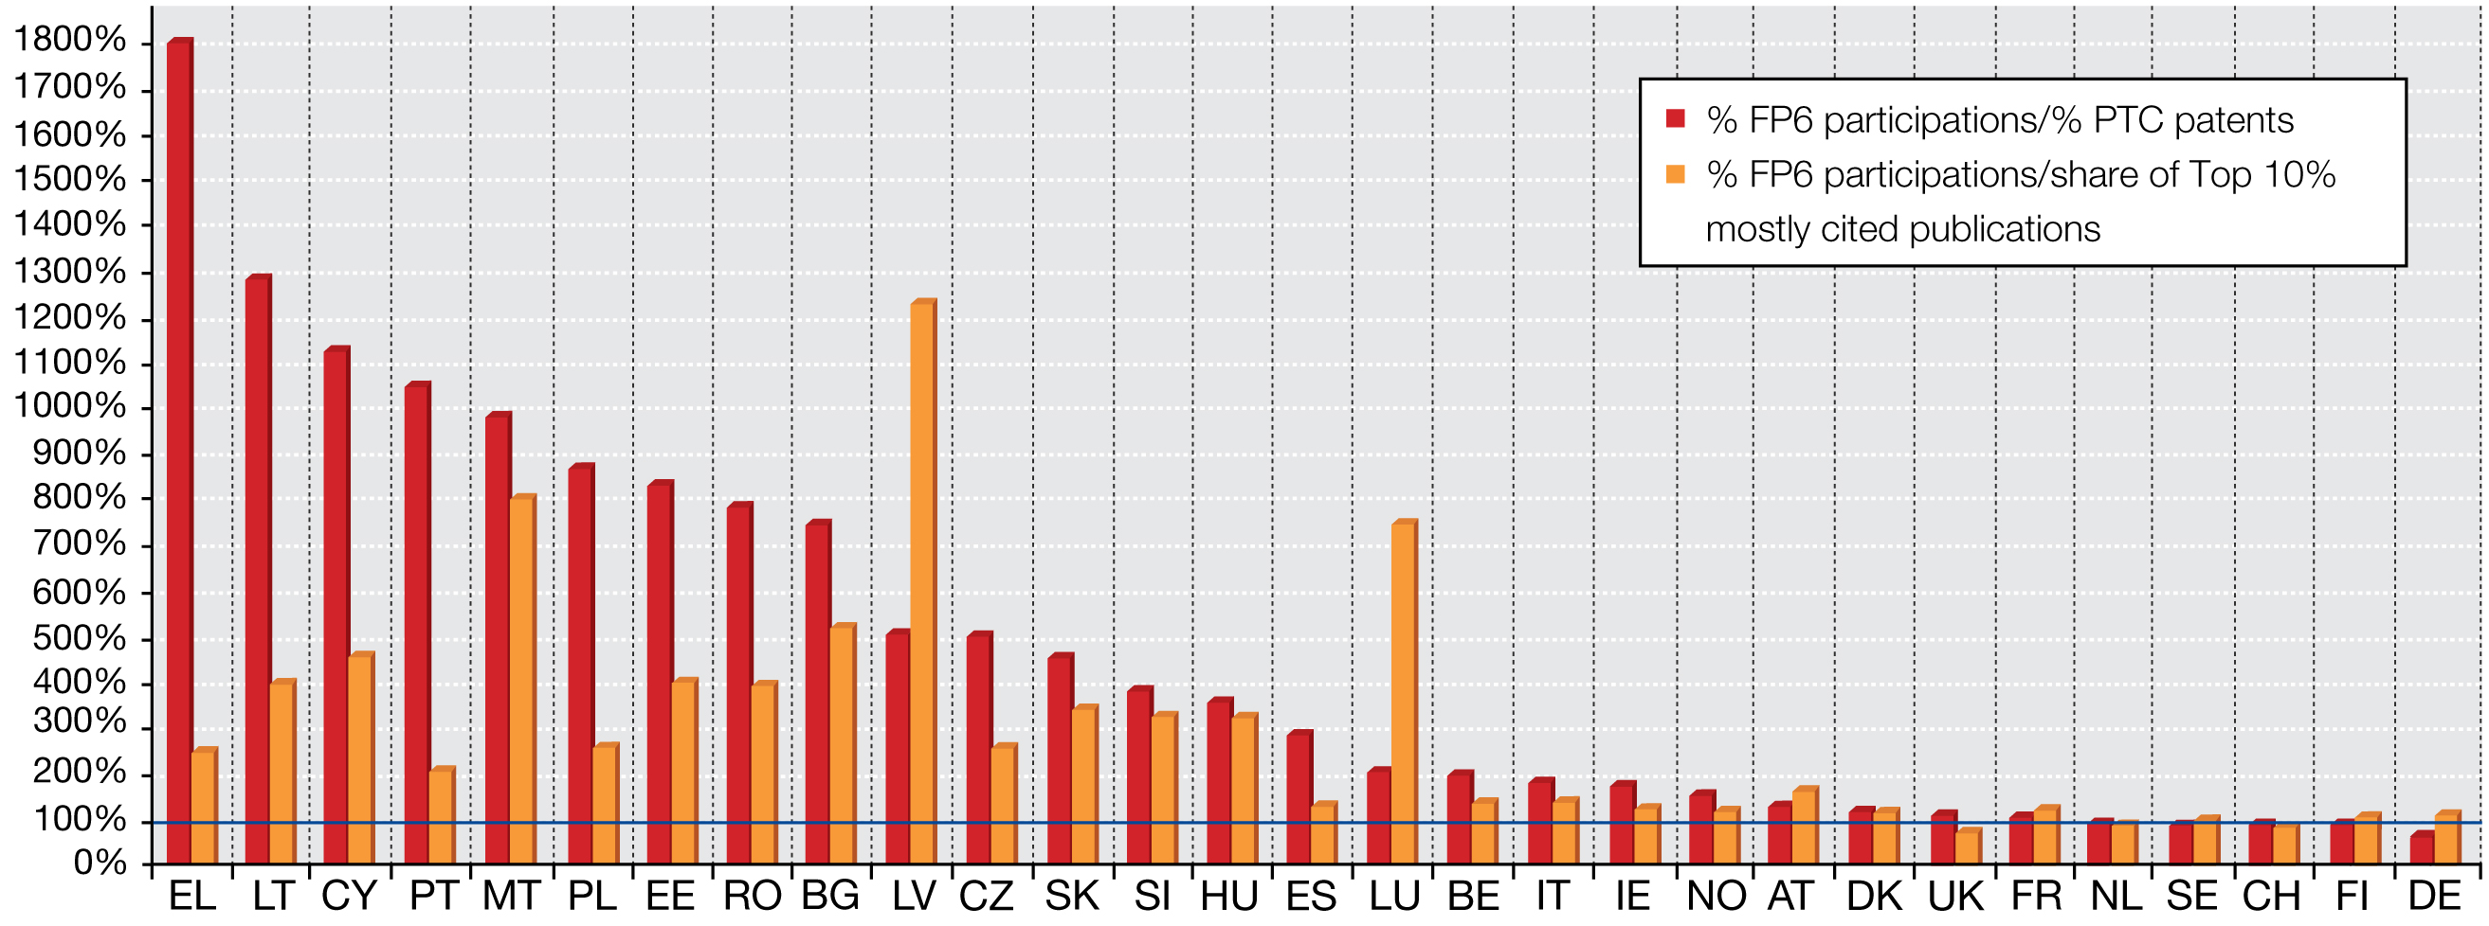
Source: DG Research & Innovation, Data for EU 27+ NO+CH

