Figure 8: European S&T performance relative to the US
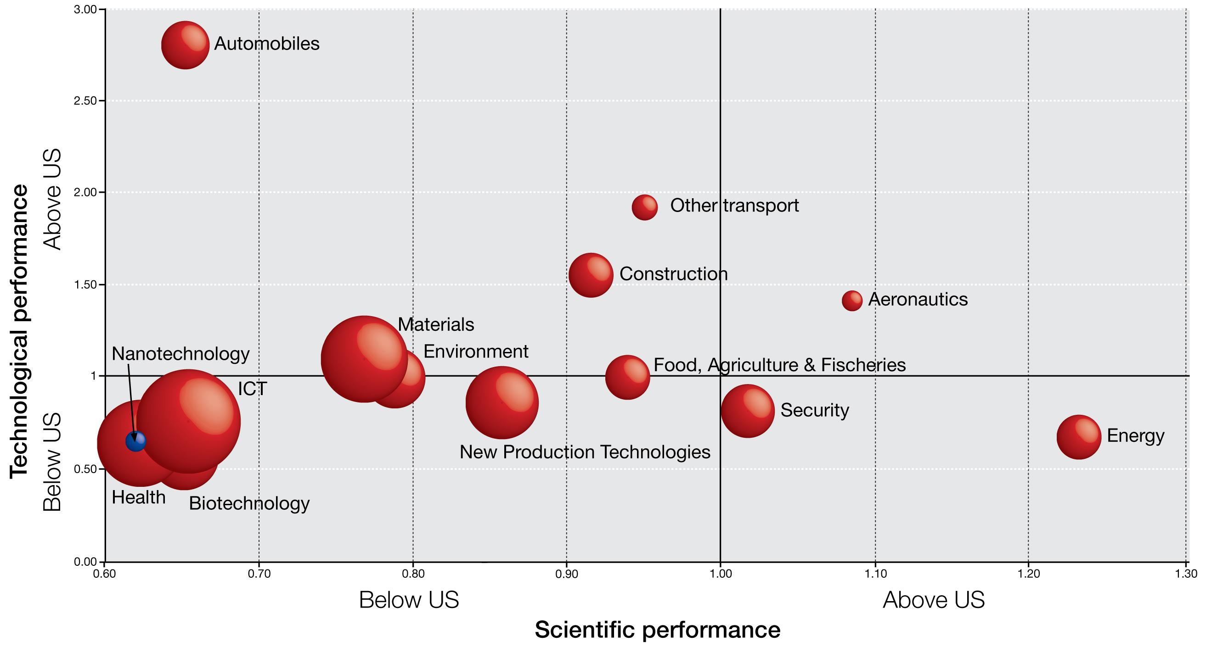

Source: DG Research and Innovation
Data: PCT patents - EPO PATSTAT database (from a study by Research Division INCENTIM, MSI, Faculty of Business & Economics, K.U.Leuven, Università Commerciale Luigi Bocconi, KITES)
Scientific publications - Science Metrix / Scopus (Elsevier)
Notes:
1) Scientific performance is measured in terms of the % of publications in the top 10% most cited category (2000-2006 publications with sliding citation window [N, N+3]). On the X axis the percentage for the EU is divided by that for the US.
(2) Technological performance is measured by the share of global PCT patents for the period 2000-2009 (Patents filed under the Patent Co-operation Treaty (PCT), at international phase, that designate the EPO).
On the Y axis the share for the EU is divided by that for the US.
(3) The size of the bubbles = number of EU-27 patents in the technology field

While better harnessing its research and innovation to tackle societal challenges
The EU faces serious challenges across a number of key areas, including health, energy and the environment. However, when it comes to science and innovation, Europe's performance in these areas is mixed. For example:
- The EU devotes considerable resources to environmental sciences (in 2008 it invested 5 euros per capita, compared with just 2 for the US and Japan). It also leads the field in patenting related to air and water pollution control, solid and waste management and renewable energies. For these fields combined it has 35% of all patents, compared with 22% for the US and 20% for Japan.
- In health related research the US is the world leader. In terms of public budgets, the US devoted more than 0.2% of GDP to such research, while the EU invested 0.05%. Companies in the US invest almost the twice as much in health R&D compared with their EU counterparts. As a consequence the US leads in patents related to medical technologies, accounting for almost half of all world patents (49% of PCT patent filings), while the EU's share is only one quarter. When it comes to pharmaceuticals, the US also leads with 42% share of patents worldwide, while the EU has 28%..
Figure 9 gives an overview of Europe's technological performance across a range of fields compared with that of North America and Asia. Europe's strength in renewable energy and certain environmental technologies can be clearly observed. However, in a number of key areas, either directly related to societal challenges or in certain enabling fields which will underpin future advances, Europe is faced with strong competition.
Figure 9: Europe's technological performance compared with North America and Asia

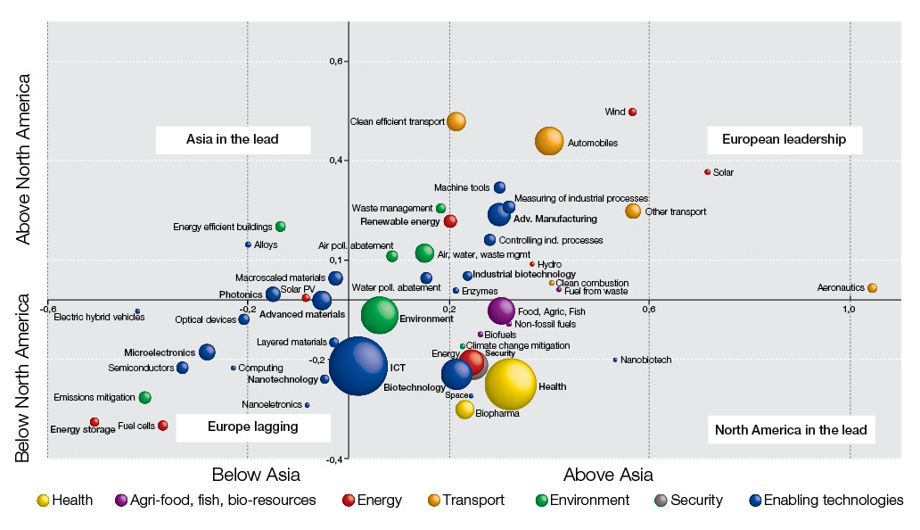
Source: DG Research and Innovation
Data: OECD patent database and specific studies. Europe covers EU27, Iceland, Norway and Switzerland; Asia covers Japan, China, South Korea, Singapore and Chinese Taipei.

Figure 10: Highly cited (top 1%) scientific articles by type of collaboration, 2006-08
as a percentage of highly cited scientific articles worldwide
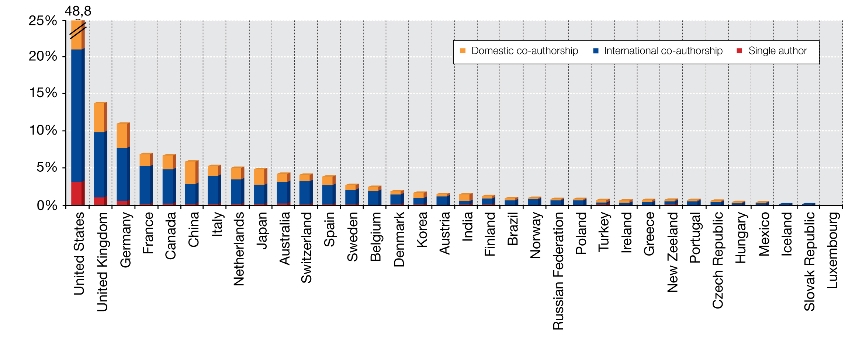
Source: DG Research and Innovation
Data: OECD, Measuring Innovation: A New Perspective (2010)
And investing in R&D in a more coordinated way
"Integrating the research base by overcoming fragmentation in research" is the first recommendation made in the Interim Evaluation of the Seventh Framework Programme (FP).The national fragmentation of public R&D funding is perceived both as a sub-optimal use of public funding for R&D and as a factor undermining the S&T performance of Europe.

The EU needs to increase the effectiveness of its investment in research and innovation through greater coordination and collaboration. Transnational collaboration in science is known to produce higher impact results and stimulate excellence. International co-authorship results, on average, in publications with higher citation rates than purely domestic papers (Figure 10).

Indeed, Europe's scientific impact is higher in those fields where European countries collaborate more:

- The highest share of EU scientific publications involving cross-border European collaboration is found in 'Physics and Astronomy', 'Multidisciplinary sciences' and 'Earth and Environmental sciences' (Figure 11).
- And it is in these disciplines where one observes the highest impacts. In the five countries that publish a large part of all EU publications (Germany, France, the United Kingdom, Spain, Italy), publications in these disciplines are more frequently cited than a (world) 'average' publication in the same disciplines, and these disciplines are systematically among the disciplines with the highest impact scores in France, Germany and the United Kingdom (see Figure 12). This also holds true in most other EU countries.
- For most countries 'Multidisciplinary sciences' also ranks very high in terms impact, in particular in Germany, France and the United Kingdom where it ranks first.
Figure 11: EU-27 co-publications by main scientific fields, 2006 as % of all EU-27 publications ⁽⁴⁾
(in parenthesis: total number of publications of the field)

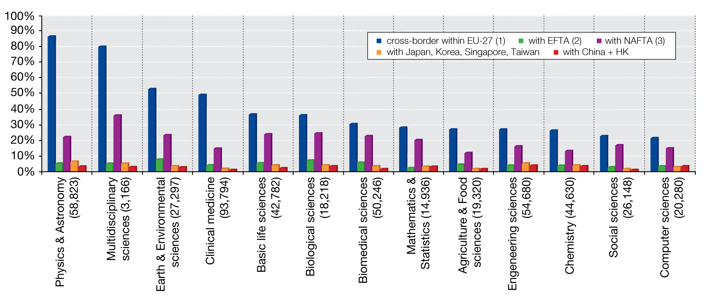

Source : DG Researchand Innovation
Data: CWTS-Leiden University / Thomson Reuters, own calculations
Notes: (1) Co-publications involving authors with addresses in at least two Member States
(2) Publications involving at least one author with an address in EU-27 and at least one author with an adress in Switzerland, Iceland, Norway or Liechtenstein
(3) idem (2) with the US, Canada or Mexico
(4) The four categories are not mutually exclusive, as authors based in several world regions may be involved in a given EU-27 publication.
Figure 12: Rank of Astronomy, Physics, Earth and Environmental sciences among 38 scientific disciplines⁽¹⁾ according to field normalized impact score 2005-2007

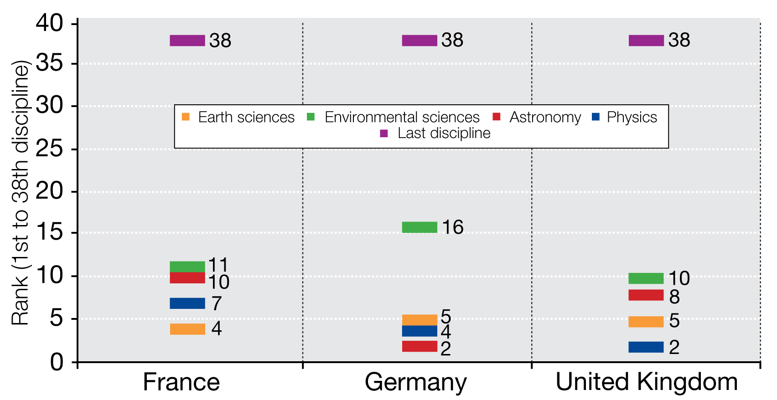

Source: DG Research and Innovation
Data: CWTS-Leiden University / Thomson Reuters
Note: (1) The 38 scientific disciplines cover all natural sciences, social sciences and humanities.

Europe can also make more efficient and effective use of its resources through pooling and sharing them. A good example is that of large scale research infrastructures, where the sharing of costs and access makes sound economic sense.

- The amount of funds required for their construction cannot be provided by a single European State. The total estimated cost of the 51 research infrastructures of the European Scientific Forum for Research Infrastructures (ESFRI) Roadmap is in the order of 84% of total annual capital expenditure in the EU, or 2.7 times the amount of total 2007-2013 Structural Funds earmarked for research infrastructures in the EU.
- In addition, the scientific community that can best make use of one of these facilities is relatively limited in a single country, so that the level of investments for building and operating the facility is incommensurate with the number of domestic users, resulting in a sub-optimal exploitation of these investments.
- Indeed the actual value added of some of these large-scale infrastructures is precisely the pooling of data, the multiplication and diversification of experimental cases and contexts that a single country could not gather alone.
Yet in spite of these benefits of coordination, a recent review of national R&D programmes in 11 European countries showed that very few of them in Europe are genuinely open, in the sense of allocating funding to foreign-based research performers under conditions which are close to the ones applied to domestic actors. The prevailing national approaches to R&D collaboration in Europe are to use EU-level instruments (for trans-national coordination of research activities) rather than opening national funding sources to foreign-based research actors.
However even the trans-national coordination of public R&D funding remains limited: only about 11.1% of public R&D funding in the EU (27 Member States' national R&D budgets plus FP) can be considered as "coordinated public funding of R&D. Of this, 7.5% is attributable to the FP and just 3.6% to various forms of coordinated national funding. Figure 13 shows more detail of these latter forms of coordinated national funding, illustrating how much countries devote from their national R&D budgets to trans-nationally coordinated research. Overall, more than 95% of national R&D budgets are spent nationally without coordination across countries.
Figure 13: National public funding of trans-nationally coordinated research by category ^{(1),}
as a % of total national GBAORD, 2008
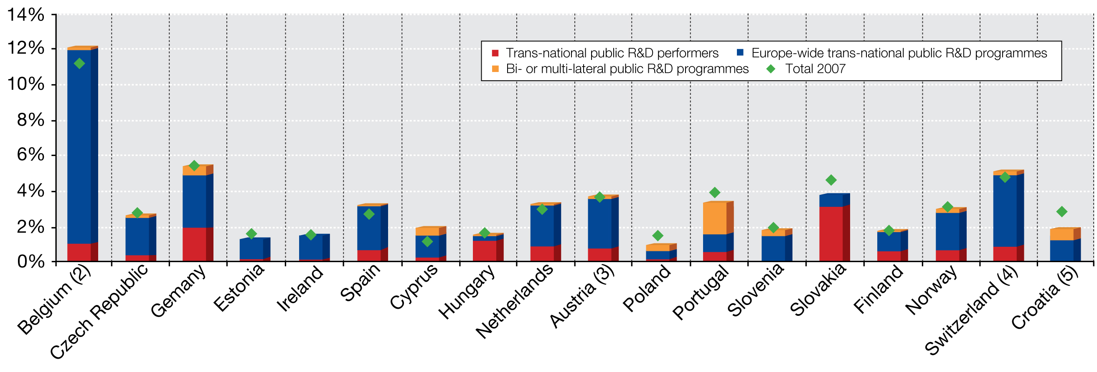

Source: DG Research and Innovation
Data: Eurostat
Notes: (1) Experimental data.
(2) BE: Data of some regional authorities in Belgium are probably not included.
(3) AT: federal or central government only.
(4) CH: 2007 value uses 2006 GBAORD as denominator.
(5) HR: 2007 value uses 2008 GBAORD as denominator.

OECD STI Scoreboard 2009
OECD, 2009
Measuring Innovation: A New Perspective, OECD 2010
Source : OECD "STI Scoreboard 2009". Data on medical technology and pharmaceutical patents are PCT filings for the period 2004-2006.
(1) For each technology field the graph shows on the X axis the global market share of Europe in terms of EPO/PCT patents compared with the market share of Asia (expressed as a logarithm), and the Y axis shows the market share of Europe compared with the market share of North America (expressed as a logarithm). The size of each bubble is proportional to the number of patents by European inventors in the field. (2) The broad technology domains are shown in bold. (3) Data relate to the period 2003-2005.
Data for broad technology domains taken from a study by Research Division INCENTIM, MSI, Faculty of Business & Economics, KULeuven, Università Commerciale Luigi Bocconi, KITES); Data for enabling technologies taken from "European Competitiveness in Key Enabling Technologies" by Birgit Aschhoff, Dirk Crass, Katrin Cremers, Christoph Grimpe, Christian Rammer (ZEW, Mannheim), Felix Brandes, Fernando Diaz-Lopez, Rosalinde Klein Woolthuis, Michael Mayer, Carlos Montalvo (TNO, Delft), May 28th, 2010 (Study commissioned for European Commission DG Enterprise); All other data from OECD Patent Database.
Interim Evaluation of the Seventh Framework Programme, report of the Expert group, November 2010.
Physics, Astronomy, Earth sciences and Environmental sciences
That is, the field-normalized impact scores of these disciplines are above 1 (with the exception of Earth sciences and Environmental sciences in Italy).
As of early 2011, 10 research infrastructures of the ESFRI Roadmap are in the implementation phase and 41 in the preparatory phase (including 3 research infrastructures of the European Strategy for Particle Physics, as approved by the CERN Council).
'Capital expenditure on R&D' includes expenditure on fixed assets used in R&D activities such as land and buildings and also expenditure on equipment, research instruments and computer software. The other category of R&D expenditure, called 'current cost' includes labour costs and the non-capital purchase of materials and supplies (Frascati Manual).
Study "Investments in joint and open R&D programmes and analysis of their economic impact" funded by DG Research and Innovation, forthcoming.
Recent reviews of R&D programmes in several European countries found that linking national research programmes to EU priorities under the FP, or planning large infrastructures according to EU directions, and using EU-level instruments such as ERA-NETs, are various ways to encourage international collaboration in R&D : (1) Monitoring progress towards the ERA, European Commission, ERAWATCH Network, 2009, available at: http://cordis.europa.eu/erawatch/index.cfm?fuseaction=reports.home. (2) National mapping of open R&D programmes in the study "Investments in joint and open R&D programmes and analysis of their economic impact" funded by DG Research, forthcoming.
This comprises (i) trans-national public R&D performers located in Europe: CERN, EMBL, ESO, ESRF, ILL, JRC. Future research infrastructures of the ESFRI Roadmap will belong to this category (ii) Europe-wide trans-national public R&D programmes and agencies: ESA, EMBO, ESF, EUREKA, ERA-NET, ERA-NET+, JTIs (public funding part: ENIAC, ARTEMIS), Art. 185 (Europe-Developing Countries Clinical Trials Platform, Eurostars and Ambient assisted living for the elderly). The Joint Programming Initiatives belong to this category (iii) bi- or multi-lateral public R&D programmes established between Member States governments and with candidate countries and EFTA countries.

