Figure 11: New Member States participate more intensely in FP7
than their R&D output would suggest

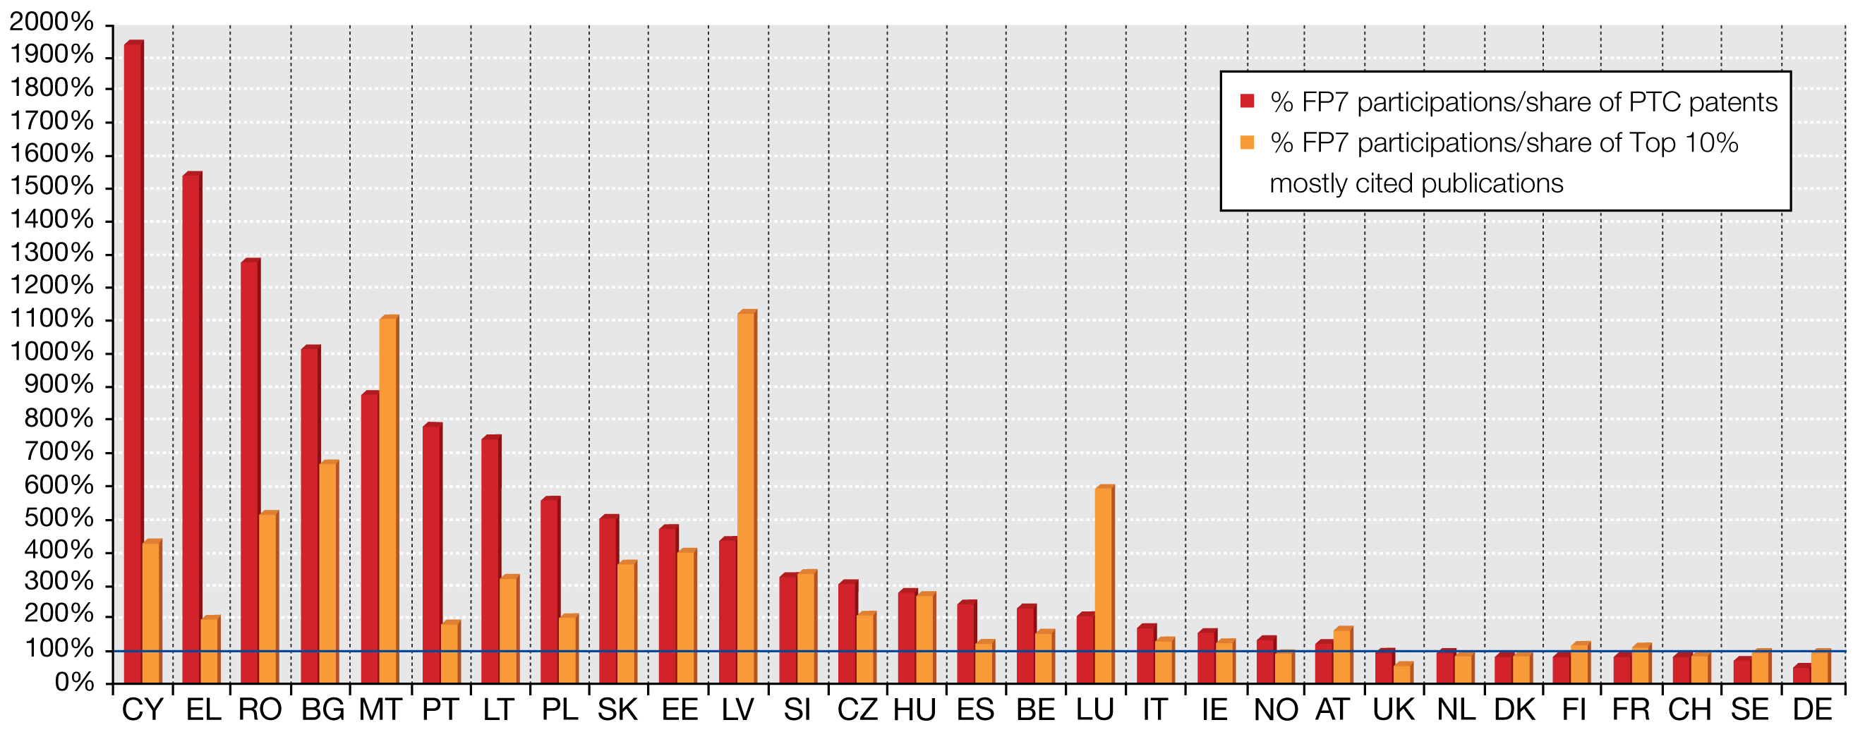
Source: DG Research & Innovation, Data for EU 27+NO+CH

Figure 12: New and Smaller Member States benefit more from FP6
than their R&D output would suggest

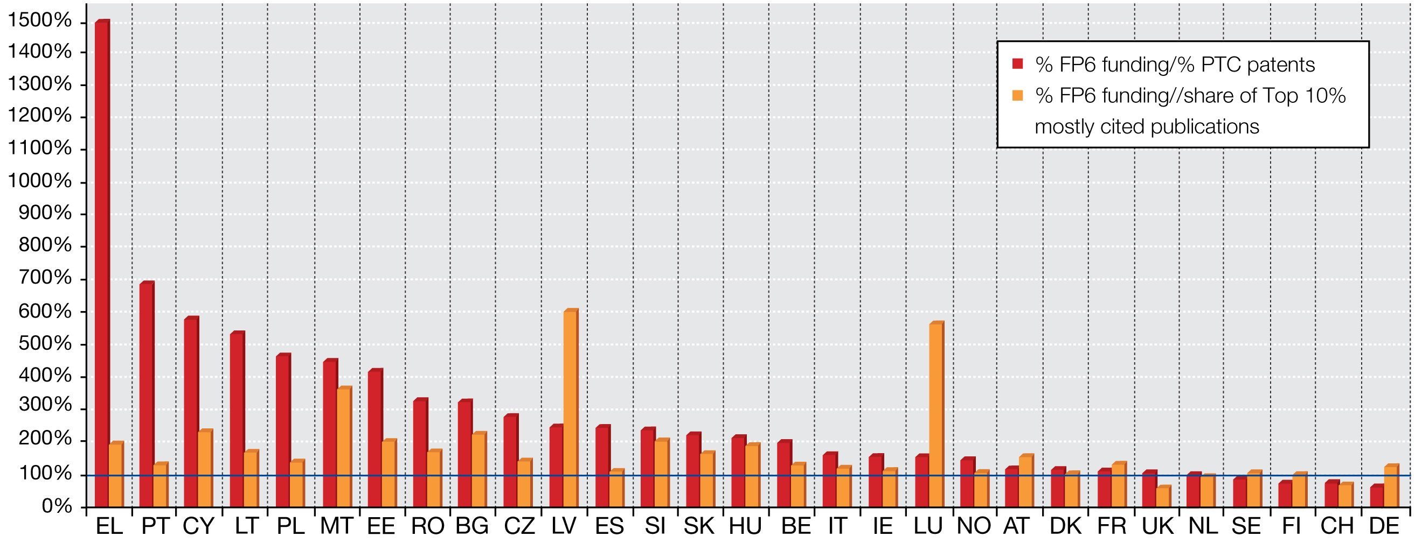
Source: DG Research & Innovation, Data for EU 27+NO+CH

Figure 13: New and Smaller Member States benefit more from FP7
than their R&D output would suggest

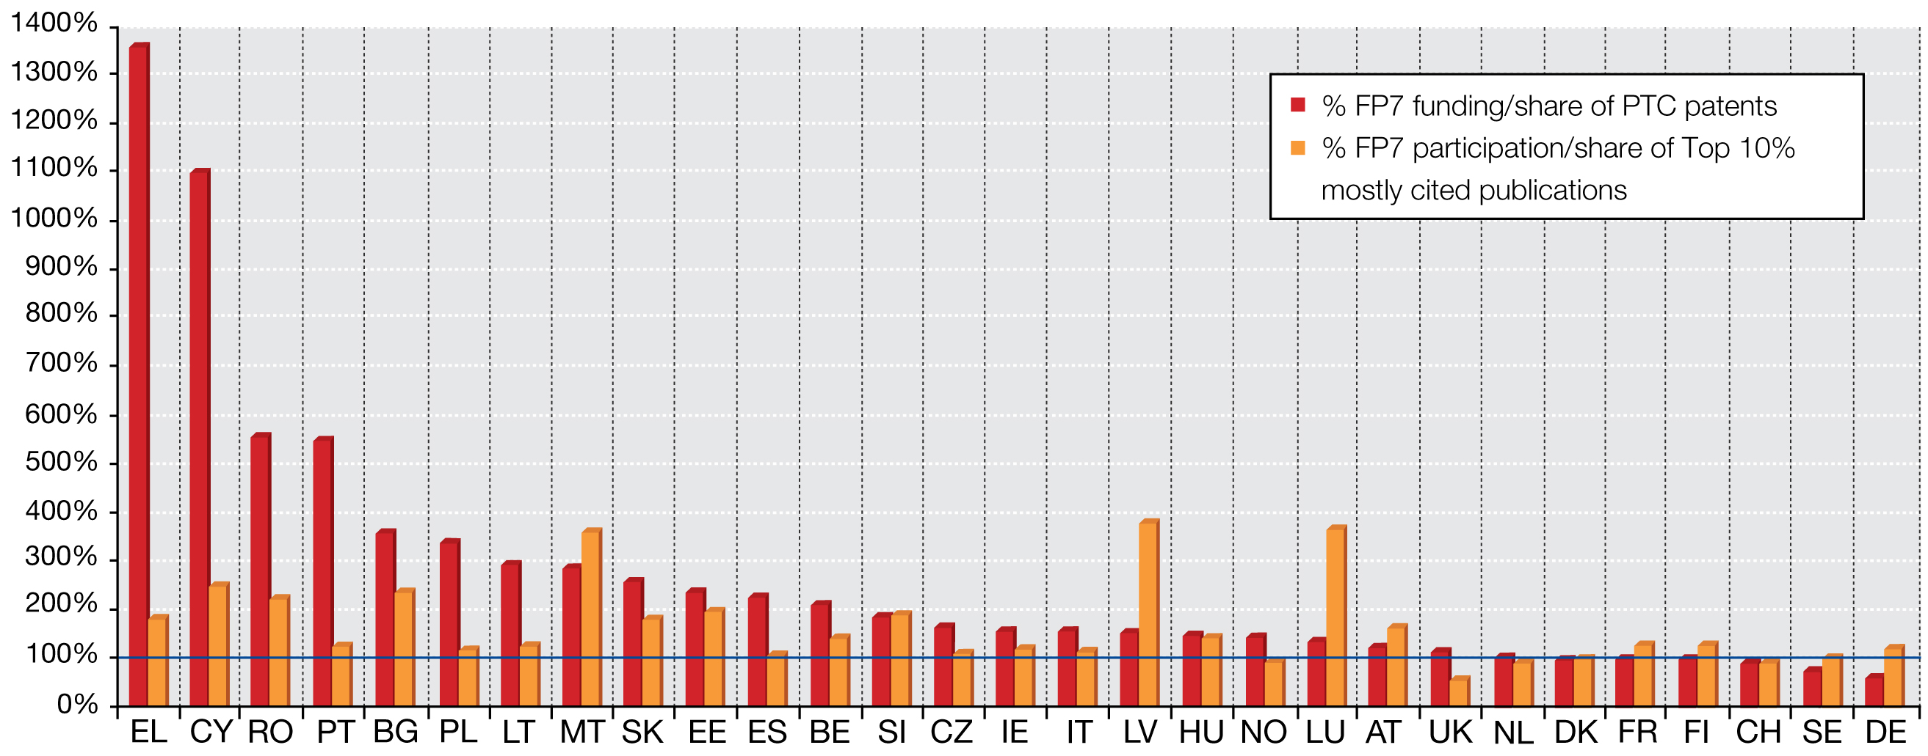

Source: DG Research & Innovation, Data for EU 27+NO+CH

- The benefits from FP participations go beyond FP funding received: A Member State obtains, in average, 29€ of net knowledge return from every 1€ invested in the FP.

Participating in a FP collaborative research project offers access to EU-wide knowledge exchange networks. In other words, a single project participant benefits from and accesses the funding received by all project participants combined. An analysis of national knowledge returns from the FP, which takes account of the collaborative research network multiplier, shows that all countries enjoyed net positive knowledge returns under FP6. The average return was 29€ per 1€ invested for the EU 27, Norway and Switzerland (Figure 14). This represents an increase of about 8€ compared to FP5.

The size of these returns tends to be inversely related to a country's number of FP participations. Countries with a smaller number of participations (smaller and new Member States) benefit from higher net knowledge returns than countries with a larger number of FP participations (larger EU economies). This is probably linked with the fact that smaller numbers of FP participations translate into a pattern of widely dispersed single participations per project, while a larger number of FP participations translates into a pattern where regularly two or three participants from a country are present in a project.

Figure 14: Net knowledge return per 1€ invested in the FP6

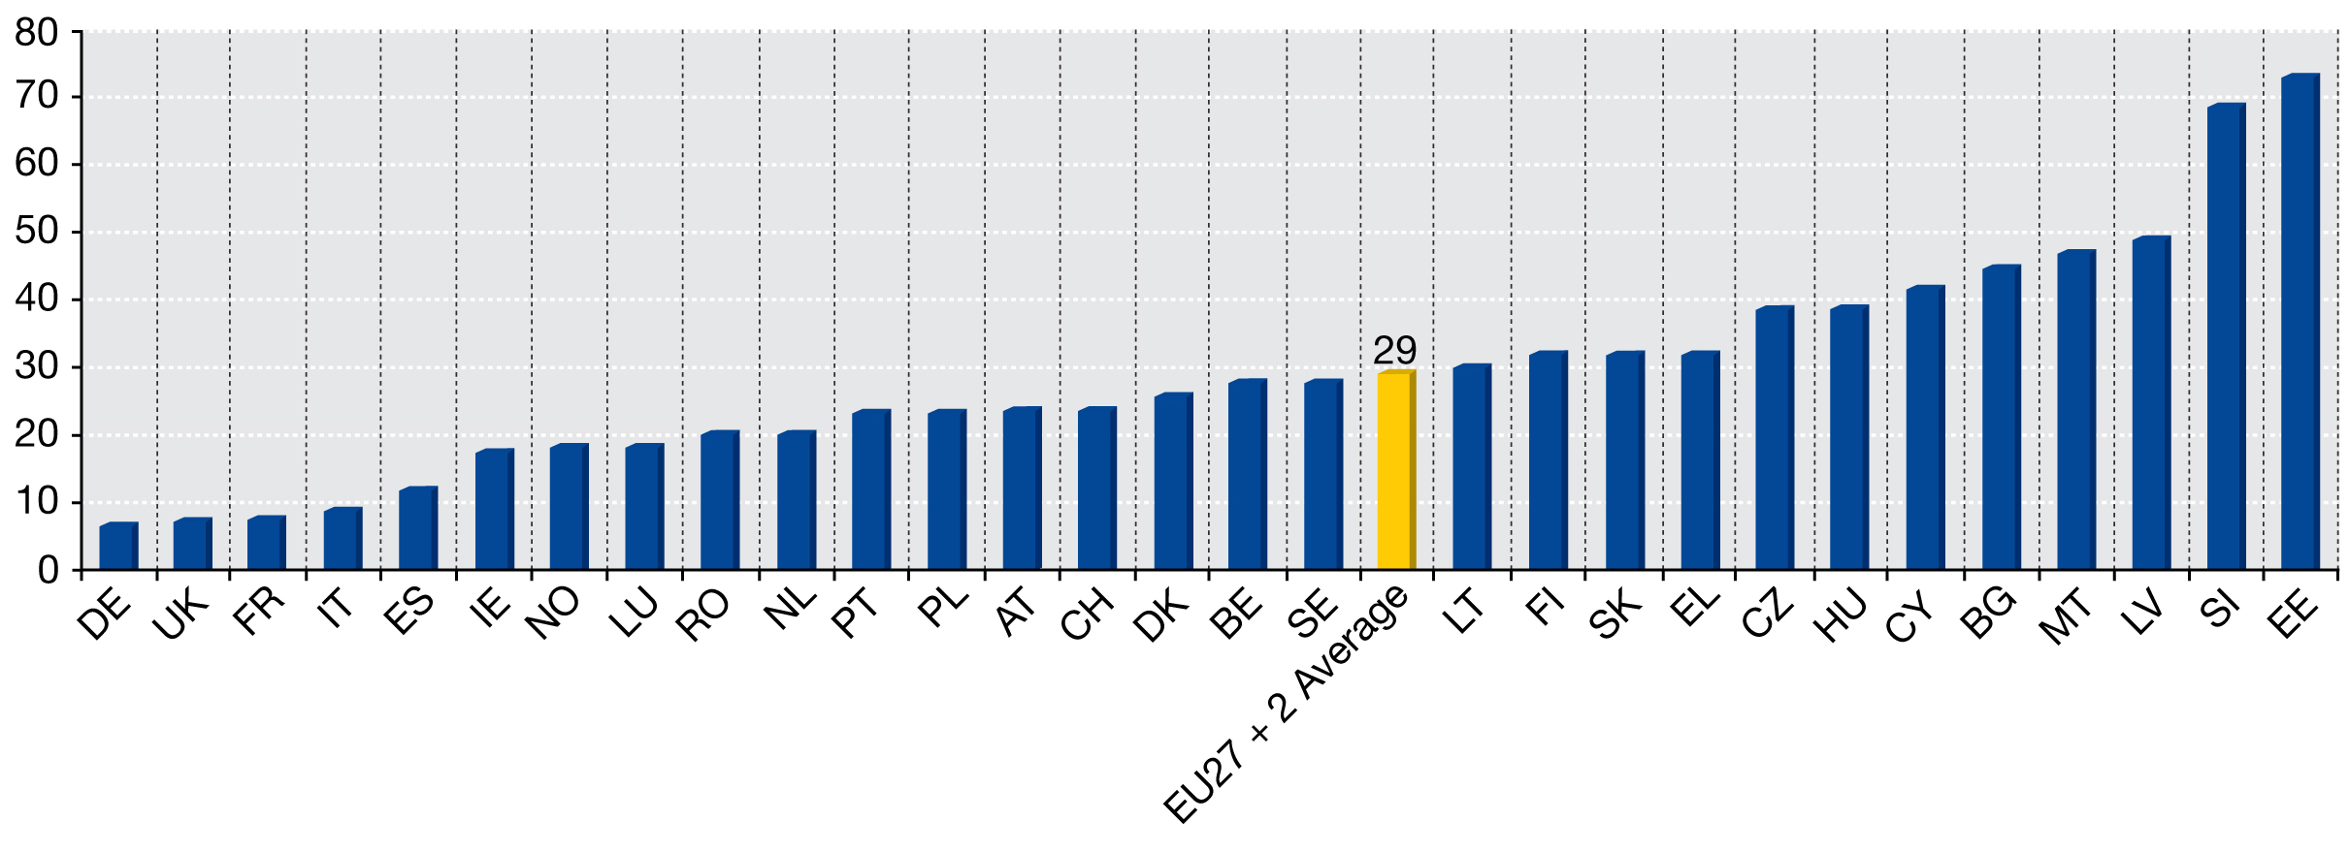

Source: DG Research & Innovation,

Note: [Value of shared-cost contracts in which each country participating (no double counting))/Contribution to FP shared cost actions budget) – 1]; EU-27 + 2( NO and CH) contribution to FP6 shared-cost actions budget calculated on the basis of the shared of their GDP in the EU27+NO+CH GDP.

THE FP INVOLVES TOP (A-TEAM) RESEARCHERS AND ORGANISATIONS IN HIGH-QUALITY RESEARCH

The FP6 ex-post evaluation (Rietschel et al., 2009) concluded that FP6 involved top-quality researchers in first-rate projects performing high-quality research. This conclusion was based on:
- A FP-wide bibliometric study: This study demonstrated that the publication and citation performance of FP project 'lead scientists' is better than that of their non-FP peers (EPEC, 2009).
- Thematic bibliometric evidence: An ex-post impact assessment of the 'Global Change and Ecosystems' sub-priority found, based on peer review and bibliometric indicators, that the work was of high scientific quality (EPEC, 2008).
- The FP5&6 Innovation Impact study: This study found that, compared to the average company in their sector, FP industrial participants are more R&D-intensive, more innovative, better networked and more focused on international markets, and patent more (Polt et al., 2008).
- A FP6-wide participation survey: This study found that participants with high and very high R&D capabilities represented around 80% of all FP6 survey respondents. Under FP5, the share was 60% (IDEA Consult, 2009c).
- Self-assessments submitted to the FP6 expert group: Twenty-four Commission research managers provided self-assessments to the FP6 ex-post evaluation expert group. Eight said independent reviews had confirmed that nearly all the research in their portfolio was of international standard. Another 7 said that at least two-thirds was of international standard.
- The pan-European perception of the quality of FP-funded research: In many countries, the receipt of FP funding is seen as a quality indicator for the scientists, research groups and organisations involved. For this reason, some research councils actively support EU applications while some universities provide matching funding.
- The extra-European perception of the quality of FP-funded research: Third country researchers have a positive image of the FPs in general and FP6 in particular. They associate the programme with top-class research and believe that the FP provides better career references for participants, is better in mobilising top-class researchers and institutes, and provides better funding opportunities than other similar (competing) programmes.

The FP interim evaluation (Annerberg et al., 2010) concluded that  excellence seemed to have been at the heart of the great bulk of FP7 funded projects and reaffirmed the finding of the FP6 ex-post evaluation that EU funding is not just for the B-team, but attracts A-team members. This conclusion was based on:
- An analysis of FP7 top funding recipients: The FP7 interim evaluation concluded that "there can be little doubt that FP7 attracts the top EU researchers from universities and RTOs" since "the list of organisations that have obtained the largest amounts of funding from FP7 can be read as a Who’s Who of European research quality".
- An analysis of FP7 collaborative research proposal evaluation scores: FP proposals are peer-reviewed and scored according to three criteria: scientific excellence, project management quality, and potential impact. The mean score for 'scientific quality' was 4.4 out of 5 (minimum 4) and the mean sum for the three criteria 13.1 out of 15, far above the minimum of 10 specified in the programme rules and according to the evaluation expert panel an objective measure of average proposal quality.
- An analysis of ERC proposal evaluation scores: The FP7 interim evaluation concluded that the ERC is attracting applications of high quality as some 56% of the total number of applications was evaluated as above the threshold set by the evaluation criteria.
- Self-assessments submitted to the FP7 expert group: Seven out of 10 self-assessments submitted to the evaluation expert panel said that 'nearly all' or 'a majority' of the research funded was world-leading. The other self-assessments said there was not yet enough information to judge.

The quality of FP participants is also demonstrated by an analysis of FP participation data:
- The FP supports Europe's industrial R&D champions: All FP6 and FP7 shared-cost action top industrial participants (in terms of funding, in terms of participations) are European companies figuring in the ranking of 'Top 1000 Global R&D Investing Firms'. The top FP6 industrial participant, for instance, was Siemens AG (€46,4 million, 150 participations) while the top FP7 industrial participant so far is SAP AG (€53 million, 55 participations).
- The FP funds Europe's most excellent universities: About half of the 50 FP6 shared-cost action top university participants rank among the world's best 100 universities while 94 percent rank among the world's best 400 universities (Academic Ranking of World Universities 2010). The top 100 European universities in the 2008 Leiden ranking received about half of the FP7 funding disbursed at that time to European higher education institutions.
- The FP provides support to Europe's leading public research centres: Leading European public research centres like the Max Planck Gesellschaft, the Fraunhofer Gesellschaft, the CNRS and the Commissariat à l'Energie Atomique are top FP participants occupying key positions in FP projects and networks. Under FP6, for instance, these four institutes accounted for €562,9 million of funding and 1244 participations.
- The FP connects Europe with global centres of excellence: 8 of the world's top 10 non-European universities (Academic Ranking of World Universities 2010) participated in FP6 and FP7-funded collaborative research: MIT, the California Institute of Technology, and the Universities of Harvard, Berkeley, Princeton, Stanford, Columbia and Chicago. Moreover, in both FP6 and FP7, one could find other world centres of excellence participating like the Universities of Tokyo and Kyoto, Universities of Toronto, British Columbia and Melbourne, as well as Australian National University.

Other evidence concurs:
- According to a Dutch FP impact study (Technopolis), "bibliometric research and over 100 interviews held in the Netherlands, confirmed that the European research programmes produce high quality research and attract the best European researchers".
- According to EC-commissioned study on ICT research performance in FP (Bocconi University, 2010): "DG INFSO projects have been highly effective in attracting top quality researchers and research teams from the research fields relevant for the ICT area".
- As demonstrated by a study analysing participation of Top European universities (selected with Leiden crown indicator) in the FP6 they had a key role in terms of participation and funding, with a leading role in coordination of projects (JRC-IPTS, 2009).

FP RESEARCH IS OFTEN HELPFULLY INTER-DISCIPLINARY
- There is substantial evidence that inter-disciplinary research is more productive than mono-disciplinary research. In this respect, the FP7 interim evaluation (Annerberg et al., 2010) concluded that the FP promotes cross-disciplinary research in an implicit and generic way through work programmes and calls for proposals that target certain problems, challenges or application areas. Virtually all Commission self-assessments submitted to the evaluation expert panel gave scores of 5 or 6 out of 6 for cross-disciplinarity.
- An EC-commissioned evaluation of FP6 environmental research (EPEC, 2008) concluded that several projects addressed new issues and initiated new approaches, in particular research with a strong interdisciplinary component.

THROUGH THE FP, LARGE NUMBERS OF SCIENTISTS ARE TRAINED
- Training is the core preoccupation of the FP's Marie Curie actions, which promote cross-border, cross-sectoral and cross-disciplinary researcher mobility, as well as skills and career development:
  - The FP6 ex-post evaluation (Rietschel et al., 2009) noted that FP human resource actions are almost universally judged to be a major success. FP6 human resources and mobility schemes involved 8, 000 organisations and supported some 12,500 fellows.
  - The FP7 interim evaluation (Annerberg et al., 2010) noted that the specific programme People is making a valuable contribution to the development of researcher human capital and that "the Marie Curie actions, through their bottom-up approach, have promoted excellence and have had a pronounced structuring effect on the research landscape". In the period 2007-2010, 38 calls were launched and concluded in People programme resulting in nearly 5,500 projects retained for funding. During that period, over 6,400 researchers benefited from individual fellowships and grants to enhance their career prospects. Nearly 400 ITN and IAPP networks were selected for funding providing training and knowledge transfer to more than 6,500 researchers.
  - The German Federal Ministry of Education and Research noted that the FP offers good opportunities for supporting upcoming scientists. Young scientists become involved in international research networks and have the opportunity to perform research at foreign institutions within the framework of mobility programmes. In particular, universities and non-university research institutions emphasize the opportunities for supporting young talent through participation in the mobility programmes (Federal Ministry of Education and Research, 2009).
- There is a training element in European Research Council advanced grants, with preliminary analysis of the financial reports revealing that advanced grant teams typically consist of two doctoral students and two post-docs in addition to the principal investigator (Annerberg et al., 2010).
- Training is also provided through the FP's research infrastructure actions, which facilitate access to unique and expensive infrastructures of European importance. Nine out of 10 researchers say that without FP funding they would not have been able to access vital research facilities, which is often a precondition for successful frontier research. Under FP6, about half of the 26 000 users who benefited from access were young researchers (undergraduate, postgraduate and post-doc). This highly trained personnel forms an invaluable human capital resource for serving current and future industrial needs (Table 3).

Table 3: Status of users at research infrastructures during FP6
Researcher status | Total | %
Experienced researchers | 12 804 | 49
Post-doctoral researchers | 4 633 | 18
Post-graduate | 7 050 | 27
Undergraduate | 1 275 | 5
Technicians | 303 | 1
Total | 26 065 | 100

- Large numbers of scientists have been trained through FP-funded collaborative research:
  - According to an EC-commissioned evaluation of the FP5 Growth programme, projects had generated or were expected to generate 2,152 doctorates (Ramboll Management and Matrix Knowledge Group, 2008).
The CASCADE Network of Excellence (FP6) - a highly multi-disciplinary network dealing with chemical contaminants - developed an extensive training featuring a wide array of scientific disciplines, including risk assessment, toxicology, biochemistry, molecular biology, mouse genetics, in-silico and in-vitro methodologies that led to the establishment of an international post-doc programme (CASCADE-FELLOWS).
  - According to a survey among FP5-7 project coordinators in the areas of Food, Agriculture and Fisheries and Biotechnology research, almost 80% of projects trained at least one PhD student and 73% at least one post-doctoral researcher. 18% of projects trained more than 10 PhDs, which provides evidence of the impact of the FP on the training of young researchers. Significant efforts were also made the train other personnel: over 50% of projects trained graduate, technical and administrative personnel (EC, 2011h).
  - According to an Austrian FP impact study (Technopolis, 2010b), "it is important to note that training of young researchers not only occurs in the human resources oriented measures (People Programme and ERC Starting Grant) but also in the 'traditional' cooperative FP projects".
  - According to an Irish evaluation of FP6, each project produced, on average, 2.3 newly trained/qualified personnel (Forfas, 2009).

THE FP IMPROVES PARTICIPANTS' R&D AND INNOVATION CAPABILITIES
- The FP7 interim evaluation (Annerberg et al., 2010), referring to a UK evaluation of the FP identifying important participant capability impacts (see below), considered it "reasonable to infer that similar outcomes will have occurred elsewhere".
- A study of FP6 behavioural additionality (IDEA Consult, 2009b) found that FP-funding increased FP participant organisations' ability to network with universities, public research institutes and firms; that FP project management experience was already or would be used in other R&D and innovation projects within the organisation; and that FP-funding helped to formalise the R&D and innovation processes, in particular for very small and young organisations and for organisations coming from candidate countries.
- A study of the impact of FP6 on new Member States (COWI, 2009) found that FP6 "had an important impact on research organisations' interests and capacity in networking and … inspired a networking approach to the management and implementation of research projects with more focus on cooperation, consortia- creation, multi-disciplinarity, communication and management skills". It also produced "an increase in skills and research capabilities of its key research staff" and resulted in the "development of administrative capacity/competence to handle international project management processes".
- A FP6-wide participant survey (IDEA Consult, 2009c) concluded as follows: "The learning effects of participating in a project under FP6 appear to be high for individual organizations. Much of the experience gained, both technological and managerial, can and will be used again in future R&D projects".
- A survey among FP6-IST programme participants (WING, 2009) found that more than 80% of participants consider that EU projects have enabled them to significantly extend their knowledge base and RTD capability, develop new skills and competence and explore new technology paths that they would have not addressed otherwise. The same share of participants highlighted the important impact of their FP participation on networking and the building of new long-term strategic partnerships allowing them to gain access to complementary expertise.
- The same survey-based study (WING, 2009) showed that around 75% of industrial participants found that their participation has helped improve their innovation capacity and explore new opportunities, including the successful re-use of knowledge developed within projects in another context (WING 2009).
- An Irish evaluation of FP6 participation (Forfas, 2009) found that "the primary benefits came in the form of improved relationships and networks, increased knowledge and capabilities (both scientific and technological), and enhanced reputation and image".
- A Spanish evaluation of FP6 participation (Zabala Innovation Consulting SA (2010) found that "for 52% of the surveyed researchers, participation in the FP6 contributed to strengthening their research teams, above all due to the scientific excellence offered by the acquisition of capabilities and abilities during the project".
- A Swedish longitudinal evaluation of FP participation (VINNOVA, 2008) found that "FP money has been one of the factors enabling the [automotive] industry in general, and Volvo AB in particular, to maintain the high level of technological capabilities that have so far protected vehicles design and production activities in Sweden, which from a scale logic are anomalous". It noted that "the survey confirmed the earlier finding that capacity building was an important aspect of the FP projects and also showed more clearly that participants were involved because of the opportunities for technical learning offered".
- A UK evaluation of FP6 and FP7 found that the FP has a big impact on the nature and extent of UK researchers' international relationships and networks, as well as on their knowledge base and scientific capabilities. Other notable outcomes include increased scientific reputation, an improved ability to attract and retain world-class researchers and a positive impact on researcher careers. Lastly, FP has a positive impact on the attitudes, outlook and connectedness of individual researchers, as well as serving as a training ground for project management and administration.

THE FP PRODUCES LARGE NUMBERS OF HIGH-QUALITY, OFTEN COLLABORATIVE SCIENTIFIC OUTPUTS
- According to an EC-commissioned evaluation of the FP5 Growth programme (Ramboll Management and Matrix Knowledge Group, 2008), projects had generated or were expected to generate 18,974 publications.
- According to an EC-commissioned study on FP6 network effects (AVEDAS et al., 2009), the number of publications produced between one year after the starting month of the project and the end of 2007 by the principal investigators of 2003-2005 FP6 projects (n=1,312) amounted to 32,466.
- According to the same study, FP6 projects produced increased co-publication activity between project partners, i.e. two partners from the same FP6 project published one or more articles together after having participated together in FP6. Publications from FP6 principal investigators, either with or without other FP6 partners, had a 50% higher impact than the world average. Co-publications by collaborating FP6 partners had significantly higher impact (around 2 times the world average) than publications in which FP6 partners did not co-publish.
- According to an EC-commissioned evaluation of FP6 environmental research (EPEC, 2008), EU environmental research is leading in several environmental research areas. According to peer reviewers, the scientific and technological impact of EU environmental research is particularly high for projects in three areas: climate change (4.6/5), water and soils (4.5/5), and natural hazards (4.4/5). According to a bibliometric analysis, three areas of EU environmental research can be distinguished for their higher impact factor: climate change, water and soils, and biodiversity and ecosystems. Climate change in particular is the area in the sub-priority "global change and ecosystems" that receives the highest ranking in almost al types of impact, especially as regards scientific impacts. All projects in the Climate change area are unanimously qualified as being of high scientific quality, producing "excellent new science".
- According to a German evaluation of FP6 (Federal Ministry of Education and Research, 2009), scientific personnel participating in FP6 stated that a substantial part of their publications was due to their participation in the FP.
- According to an Irish evaluation of FP6 (Forfas, 2009), each project produced, on average, 12.7 publications (of which 5.3 in refereed journals and books) and 5.2 conferences, seminars or workshops.
- Bibliometric analyses of FP6 projects (EPEC, 2009) indicate a high productivity of papers in high-quality journals by FP funded scientists in the Food, Agriculture and Fisheries and Biotechnology area. For FP6 Food, coordinators were found to perform better than non-FP funded peers.
- The results of survey performed by DG Research & Innovation among FP5-7 coordinators showed that the EU funded research in Food, Agriculture and Fisheries and Biotechnology area produced on average 4.4 publications per project. Some projects have produced particularly high numbers of publications in peer review journals (e.g. 400 publications by fisheries projects SEAFOODPLUS and IMAQUANIM; 120 publications by the agriculture FP6 project EUSOL).
- An analysis undertaken by the EC showed that around 50% of all FP6 projects in the domain of ICT produced at least one scientific article included in a high-impact journal (ISI Web of Science - ISI WoS) database and that 82% of projects produced at least one other publication outside the WoS database. For FP7-ICT, the share of projects reporting at least one scientific article in the ISI WoS database was 32% (at the end of the first two years of the programme), and 71% of projects under FP7-ICT produced at least one other publication outside of the ISI WoS database.

THE FP PRODUCES NUMEROUS TECHNOLOGICAL OUTPUTS AND INNOVATIONS
- For firms, FP collaborative research projects are more than self-financed collaborative research projects focused on risky, complex and long-term exploration rather than on short-term exploitation. So firms participate in the FP mainly to achieve knowledge- and technology-related objectives, less to achieve direct commercialisation-related objectives. In addition, FP projects are not and should not be assessed as stand-alone R&D activities; they form part of a wider portfolio of R&D projects.
- Notwithstanding the above, the FP has a significant positive impact on innovation and competitiveness: FP-funded research produces large numbers of patents, innovations and micro-economic benefits:
  - An EC-commissioned evaluation of the FP5 Growth programme (Ramboll Management and Matrix Knowledge Group, 2008) found that – although exploitation was not the primary objective - exploitation objectives were achieved in 54 percent of the projects. Projects had generated or were expected to generate:
    - The creation of 248 spin-off companies
    - 3,724 prototypes, demonstrators, pilots
    - Some 7.2 billion euro additional sales
    - 891 million euro in cost reduction
    - 1,077 patent applications
    - 204 registered designs and other forms of IPR protection
    - The safeguarding of 37,588 jobs and 8,038 new jobs
    - 310 inputs into technical standards
  - According to an EC-commissioned study on FP6 behavioural additionality (IDEA Consult, 2009b), projects would have led to a smaller range of potential applications and a smaller number of marketable products if continued without FP6 funding.
  - According to an EC-commissioned study on FP6 network effects, FP6 resulted in increased competitiveness of the European Research Area because of inter alia the development of new and improved research methods and techniques and more commercial or industry-based approaches in the research. The same study found the following answers for the question "what outcomes has the FP6 led to that your organisation would not have achieved if it had not been involved in FP6?": "New or improved commercial products, services": about 2.8 out of 5; "Patents, intellectual property": about 2.9 out of 5.
  - According to an FP6-wide survey (IDEA Consult, 2009c), industrial organisations clearly expected commercial returns. Almost half of them (47 percent) stated they were likely to very likely, and 60 percent of this group expected these returns within 2 years (90 percent within 5 years).
  - According to the FP5&6 Innovation Impact study, a great majority of FP participants reported at least one form of commercialisable output (new or improved processes, products, services, standards) stemming from their FP project and a large number even recorded more than one of such outputs; an econometric analysis showed that the FP produces output additionality – a positive impact on the innovative sales of firms participating in the FP; and small and medium-sized enterprises indicated the most positive results in terms of innovation in FP projects.
  - According to a Finnish evaluation of FP6 (TEKES, 2008), "commercialisable output is not the core objective of the FPs but EU collaboration nonetheless contributes significantly to the creation of innovation".
  - According to a German evaluation of FP6 (Federal Ministry of Education and Research), scientific personnel participating in FP6 stated that a substantial part of their patent applications was due to their participation in the FP. Large, export-oriented companies as well as companies in the field of cutting-edge technology and the knowledge-intensive service sector were more likely to take part in FP6 than in federal or Länder programmes among other reasons because participation tended to have a positive effect both with regard to the extent of their own R&D activities and the commercial success of innovations.
  - According to an Irish evaluation of FP6 (Forfas, 2009), each project produced, on average, 0.1 patent applications, 0.4 new or significantly improved commercial product or services, and 0.4 new or significantly improved scientific or industrial processes.
  - A Swedish long-term evaluation of the FP (VINNOVA, 2008) found significant impacts on the ability to compete in vehicles and in electronics (especially telecommunications). In ICT, FP participation in European and global standardisation had been a key factor in building the Swedish telecommunications industry’s position in mobile telephony, while in vehicles, the FP had, together with complementary national programmes, been instrumental in supporting the Swedish industry’s technical specialisations, especially in safety and combustion.
  - According to a Swiss evaluation of FP5 and FP6 (State Secretariat for Education and Research, 2009), participation generated both knowledge and jobs.
  - According to a UK evaluation of the FP (Technopolis, 2010), a majority of UK business participants stated that their involvement in the FP had yielded important commercial benefits. In terms of immediate project outputs, a significant proportion of business respondents reported having made or gained access to new or significantly improved tools or methodologies and in a large minority of cases, firms reported the creation of formal elements of intellectual property. Beyond these immediate project results, around 20 percent of businesses stated that their participation had made significant contributions to the development of new products and processes and in around 10 percent of cases organisations reported increased income and market share. Lastly, company interviews suggested that FP participation had made a significant contribution to the competitiveness of leading players in several niche technology markets, from inkjets to photonics.
  - An econometric analysis of Round 3 Community Innovation Survey micro-data covering 18 European countries carried out by the Joint Research Centre's (JRC) Institute for Prospective Technological Studies (IPTS) found that the FP has a positive impact on incremental innovation (new to the firm) and, even more, on radical innovation (new to the market). The FP fosters collaboration and has a positive impact on R&D intensity via collaboration and directly. The higher the R&D intensity, the more incremental and radical innovation.
  - An analysis of 2006 Community Innovation Survey micro-data confirmed the above results by showing that FP participants collaborate more, patent more, and are more innovative than non-participants.
  - The EC-commissioned analysis of Prospects for Research and Innovation in Food, Agriculture, Fisheries and Biotechnologies (Report from Independent Experts to the European Commission, 2011a) concluded that, scientific productivity in some FP6 Food research projects was combined with strong technological outputs (patents and innovation, in particular in biotechnology and food projects) and/or with attention to policy needs (in the remaining areas of research). This suggests a cross-fertilisation between science, technology and policy development that has contributed to excellence.
  - The results of survey performed by DG Research & Innovation among FP5-7 coordinators (Coordinator Survey, 2010) showed that the EU funded research in Food, Agriculture and Fisheries and Biotechnology area produced on average 0.5 patent and 0.69 new innovative products per project funded.
  - The EC-commissioned analysis of impact of FP agricultural and forestry research (Report from Independent Experts to the European Commission, 2011b), concluded that a significant proportion of projects had developed more “technological” than “scientific” results, the average of technological invention being four per project in FP6. Where the nature of the research allowed it, projects successfully delivered on patents and new products. For example in the area of plant health research nearly 15% of projects led to patent applications and 30% to commercial products, models and processes.
  - An analysis of random sample of projects funded by Security Theme in FP7 showed that they produced 0.51 patents or other forms of Intellectual Property per project.
  - Evidence from the Community Innovation Surveys shows that 340 firms from the manufacturing sector of food and beverages that have introduced a new product or new process have received funds from FP5 and FP6 programmes what suggest a significant role of the FPs funding in improving the innovation performance of firms

Figure 15: FP participants collaborate more than non-participants

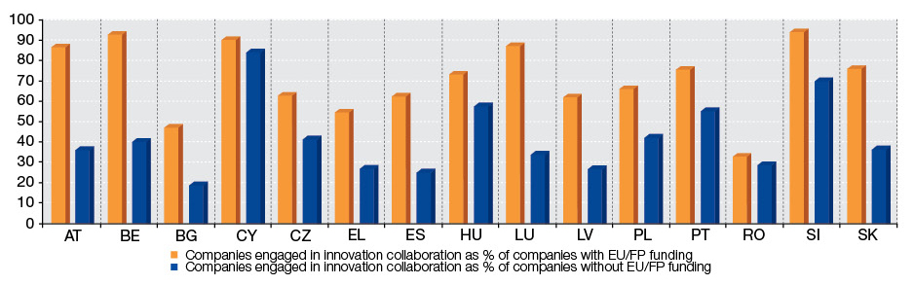Source: Eurostat- Note: Data concern manufacturing sector

Figure 16: FP participants are more innovative than non-participants
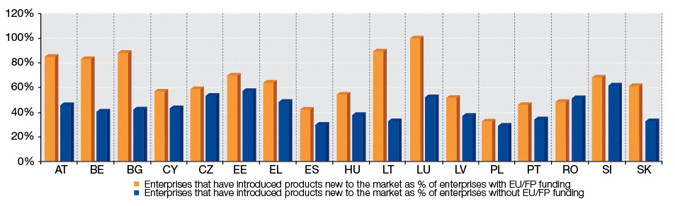

Source: Eurostat- Note: Data concern manufacturing sector.

EU RESEARCH & INNOVATION PROGRAMMES SUPPORT EUROPEAN AND NATIONAL POLICIES
- According to an EC-commissioned evaluation of the FP5 Growth programme (Ramboll Management and Matrix Knowledge Group, 2008), projects had generated or were expected to generate 423 inputs into EU legislative texts.
- According to an EC-commissioned evaluation of FP6 environmental research (EPEC, 2008), EU environmental research contributes to the knowledge base and development of methods and tools for environment related policy. The study found that:
  - At the international level, EU research related to climate change contributed to the International Panel on Climate Change (IPCC), either directly, through individual researchers involved in the IPCC review, or through references to EU-funded projects in IPCC reports.
  - In the domain of environment and health, there were strong links with EU policy priorities, most notably with the implementation of the Environment and Health Action Plan 2004-2010 as well as with the implementation of European Directives.
  - All natural hazards projects contributed to some extent to regional, national and European policies in the field of natural hazards, guidelines and standards.
  - Water and soil projects played a large role in the formulation and implementation of the Water Framework Directive.
  - Earth observation projects had direct impacts on policy-making through the use of their outcomes by stakeholders such as IPCC and WMO.
- According to an Irish evaluation of FP6 (Forfas, 2009), each project counted, on average, 0.4 new or significantly improved regulation or policy.
- Research in the field of security contributed to development of EU policies in the domains such as EU internal security, EU disaster response capacity, the EU CBRN and Explosives Action Plans, the Critical Infrastructure Protection, Health Security or also violent radicalisation, privacy and data protection. Since 2007 a total number of 20 Council and Commission policy documents reflect the use of security research resulting data (Table 4)
Table 4. Impact of FP7 Security Research as addressed in EU policy documents
 | 03/2011 | 2010 | 2009 | 2008 | 2007
Commission Communications | 1 | 3 | 2 | 2 |  | 8
Commission other policy docs | 1 |  | 2 |  |  | 3
Council conclusions/ declarations |  |  | 1 | 2 | 1 | 4
Council policy docs other |  | 3 | 1 | 1 |  | 5
 | 2 | 6 | 6 | 5 | 1 | 20
Source: SG Vista + Council Secretariat
- According to a survey among FP5-7 coordinators in the area of Food, Agriculture and Fisheries and Biotechnology research (Coordinator Survey, 2010) more than 60% of FP projects have provided inputs to European policies, 56% to national policies, and 25% to international agreements.
- The analysis of the EURLEX database demonstrates that 73 separate FP projects in the fields of Food, Agriculture and Fisheries and Biotechnology where quoted 103 times by different EU produced documents. The average new decision support tool/policy recommendations per project is estimated to respectively 2, 1.7, 1 and 0,8 per project in the field of Fisheries & Aquaculture, Agriculture, Food and Biotechnologies (EC, 2011h).
- The analysis of FP5-FP7 funded research (Report from independent experts to the European Commission, 2011b) in plant and animal health has had a great impact on the further development of legislative measures governing disease surveillance, control and eradication, animal welfare and use of wastes. New methods were also developed which became initially European and later international standards. Results from the animal health projects have had a great influence on the work of the World Organisation for Animal Health (OIE), for example to develop international standards for disease control, animal welfare and trade, recognized by the World Trade Organisation (WTO).
- The analysis of FP5-FP7 funded research (Report from independent experts to the European Commission, 2011c) in the fisheries and aquaculture areas has had significant impact on the formulation and implementation of the Common Fisheries Policy, in particular with regards to developing the scientific basis of fisheries management, monitoring of stocks, environmental requirements and developing sustainable aquaculture with an increased involvement of research institutes from Mediterranean Partner countries, new member states and candidate countries.

THE FP PRODUCES STRUCTURING EFFECTS: DURABLE CHANGES IN THE EUROPEAN RTDI LANDSCAPE
- Through the FP, the European Research Council was created, which promotes excellence across Europe:
  - The European Research Council would not have been created without an EU initiative. The EU would then have been left with a landscape of compartmentalized national research councils, but would have had no funding mechanism to promote EU-wide competition for funds and to encourage higher scientific quality in frontier research.
  - The FP7 interim evaluation (Annerberg et al., 2010) noted that there is evidence suggesting that a level of compatibility (even calibration) has developed between the ERC and national research councils as the latter increasingly 'accept' the ERC evaluation results as a basis for awarding grants to highly-rated researchers who fail to be funded by ERC. The ERC suggests that national research councils or agencies are adopting similar funding schemes to the ERC model, and ERC grantees are often offered improved conditions by their host institutions, while ERC applicants are offered national funding.
- Because of the FP, the EU leads in the creation and use of research infrastructures of pan-European importance:
  - Thanks to EU leadership, for the first time, a pan-European strategy on research infrastructures (the so-called ESFRI roadmap) has been developed and is now being implemented. No less than 10 next generation European infrastructures [e.g. IAGOS (In-service Aircraft for a Global Observing System), ESS (European Spallation Source) and SHARE (Survey of Health, Ageing and Retirement in Europe)] are currently being built by groups of Member States and these facilities would not have seen the light of day if it were not for EU action. In addition, without EU funding measures to facilitate access to unique and expensive infrastructures, 9 out of 10 researchers say that they would not have been able to access vital research facilities, which is a often a precondition for successful frontier research. For example:
    - The IA-SFS project has created the largest network of free electron lasers and synchrotrons in the world, serving several thousand European scientists and allowing a wide range of applications.
    - The European Grid Infrastructure gives European researchers access to the aggregated processing power of 200 000 computers in the world's largest distributed computing infrastructure ever built, with over 290 sites in more than 50 countries.
  - The Global Monitoring for Environment and Security (GMES) provide the EU with independent data and products that assist in emergencies, support crisis response and allow to benefit from 'global' economies of scale, i.e: .the 'Urban Atlas' service developed in GMES, allowed a ten-fold reduction of mapping costs of urban areas.
- Thanks to FP mobility and career actions, a framework for training and career development of researchers and free movement of knowledge is being created:
  - The Marie Curie Actions set standards for innovative research training, provide right skills for researchers to match the market needs and promote attractive career development for researchers from all nationalities at all levels of their career;
  - The Marie Curie programme sets standards of attractive employment conditions open recruitments for all EU-researchers, and aligns national fellowship programmes to the principles of the European Researchers Charter and Code of Conduct for the Recruitment of Researchers through the co-funding mechanism.
- The FP makes it easier for private companies to develop and implement joint strategic research agendas, which help to boost their competitiveness and stimulate smart, sustainable and inclusive growth:
  - An important achievement of the Framework Programme has been to establish instruments and mechanisms (e.g. European Technology Platforms, Joint Technology Initiatives) that facilitate the joint development and implementation of strategic research agendas by the private sector and for public-private partnership. These strategic research agendas have played a key role in boosting the competitiveness of the sectors involved.
  - The FP6 ex-post evaluation (Rietschel et al., 2009) noted that initiatives like European Technology Platforms (ETPs) were clearly useful and successful: these trans-national focusing devices and smaller-scale efforts at policy coordination helped stakeholders identify and explain their needs jointly, eased the process of developing mutually supportive policies at European and Member State levels, and were likely to lead to changes in funding patterns.
The FP7 interim evaluation (Annerberg et al., 2010) noted that JTIs have focused and aligned key actors in their respective areas, serving as a support to develop coherent sectorial strategies. In the case of ARTEMIS and ENIAC, these aligning processes have involved new actors, including SMEs that have previously not taken part in strategic discussions at European level
- The FP helps bring together compartmentalized national research funding across borders so as to achieve the scale needed to tackle important societal challenges:
  - One of the pioneering achievements of the Framework Programme has been to establish instruments and mechanisms (e.g. ERA-NET, Article 185) for the joint programming of Member State research. This has led to a new approach to research funding involving countries pooling and coordinating their own national funds across borders.
  - The FP6 ex-post evaluation (Rietschel et al., 2009) noted that initiatives like ERA-NETs were clearly useful and successful: these trans-national focusing devices and smaller-scale efforts at policy coordination helped stakeholders identify and explain their needs jointly, eased the process of developing mutually supportive policies at European and Member State levels, and were likely to lead to changes in funding patterns.
  - According to the same FP6 ex-post evaluation, ERA-NETs considerably changed the views of policymakers and implementers. ERA-NETs enabled RTD funders to appreciate the value of cooperating and coordinating research activities and to change their practices. ERA-NETs enabled cooperative priority setting by sharing strategic intelligence. ERA-NETs encouraged the synchronisation of national research programmes. Small countries like Norway found that ERA-NETs enabled them to fill gaps in the national research portfolio and increased the exposure of national research performers to competition. Many of the ERA-NETs made good progress toward issuing joint calls and added value to the European RTD funding portfolio. In some cases joint calls involved large amounts of money and in a handful of areas the common programming which resulted was in areas of national significance, producing quite large calls, e.g. €35m and €15m in the Plant Genomics network.
  - An evaluation of ERA-NET Plus – which facilitates joint calls through topping up the joint national funding with FP7 funds (33% of the joint call) - found that it is contributing to the pooling national resources, succeeding in bringing together efforts to meet joint challenges, and acting in some cases as a bridging mechanism (Annerberg et al., 2010).
  - An Interim Evaluation of the 'Ambient Assisted Living' (AAL) Article 185 concluded that it made progress towards its objectives and that its overall direction was positive. The evaluation report added that it was a remarkable achievement that, in just a few years, the countries supporting the AAL programme engaged in such close cooperation. It was strong evidence of their interest that they increased their financial contributions significantly beyond the minimum required. AAL also achieved a high level of SME participation at about 40% compared with less than 20% in the first call of the FP7 ICT & Ageing Programme (Annerberg et al., 2010).
- FP-funded collaborative research produces cross-border, cross-sectoral, inter-disciplinary networks that are durable, well structured, and well integrated into global innovation networks:
  - The FP produces large numbers of cross-border links and networks:
    - JRC-IPTS (2011) argues that the "FPs have been pivotal for transforming informal nation-based networks of research collaborations within epistemic communities of academics and industrial researchers into formal collaboration arrangements between organisations at European level. The networks formed by the organisations have become almost as important an outcome of FPs as the scientific and technological results of research projects conducted by them".
    - Protogerou et al. (2010) found that ICT collaborative research funded under FP4, FP5 and FP6 had produced complex networks and that the introduction of new instruments in FP6 had considerably increased interconnectivity compared with the previous FPs, thus contributing to the implementation of the European Research Area initiative.
    - An analysis of FP participation data shows that under FP6, the number of trans-national collaborative links reached 400 000 (Figure 17), more than double the number of links created under FP5. This increase of connections in FP6 is due to a changing dynamic at the project level: the average number of participants per project doubled from FP5 to FP6 and the average number of Member States per project increased from 4 to 6 (Table1). After four years of implementing FP7, the number of collaborative links almost reached that of FP5, namely 154.000. However it seems that at the end of FP7 less collaborative links will be created than under FP6, as the projects, in average engage less participations.
Figure 17: Collaborative links (national+international) established through
FP funded shared-cost actions

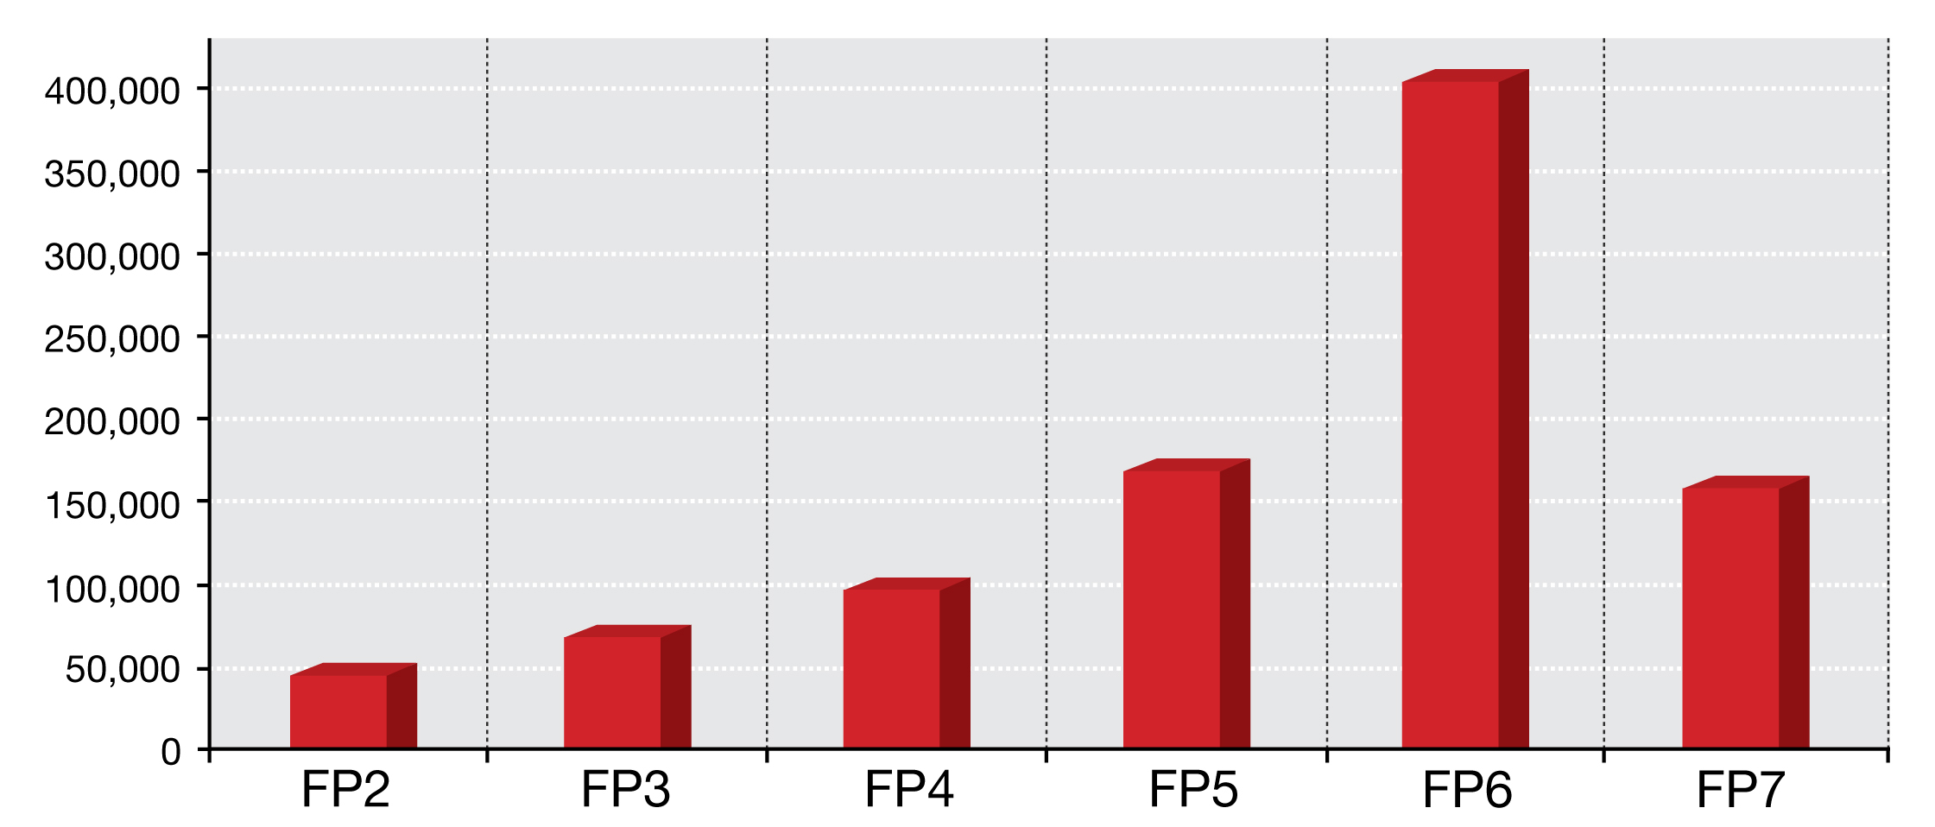

Source: DG Research & Innovation

Note: * Partial FP7 data (to 01.2011);

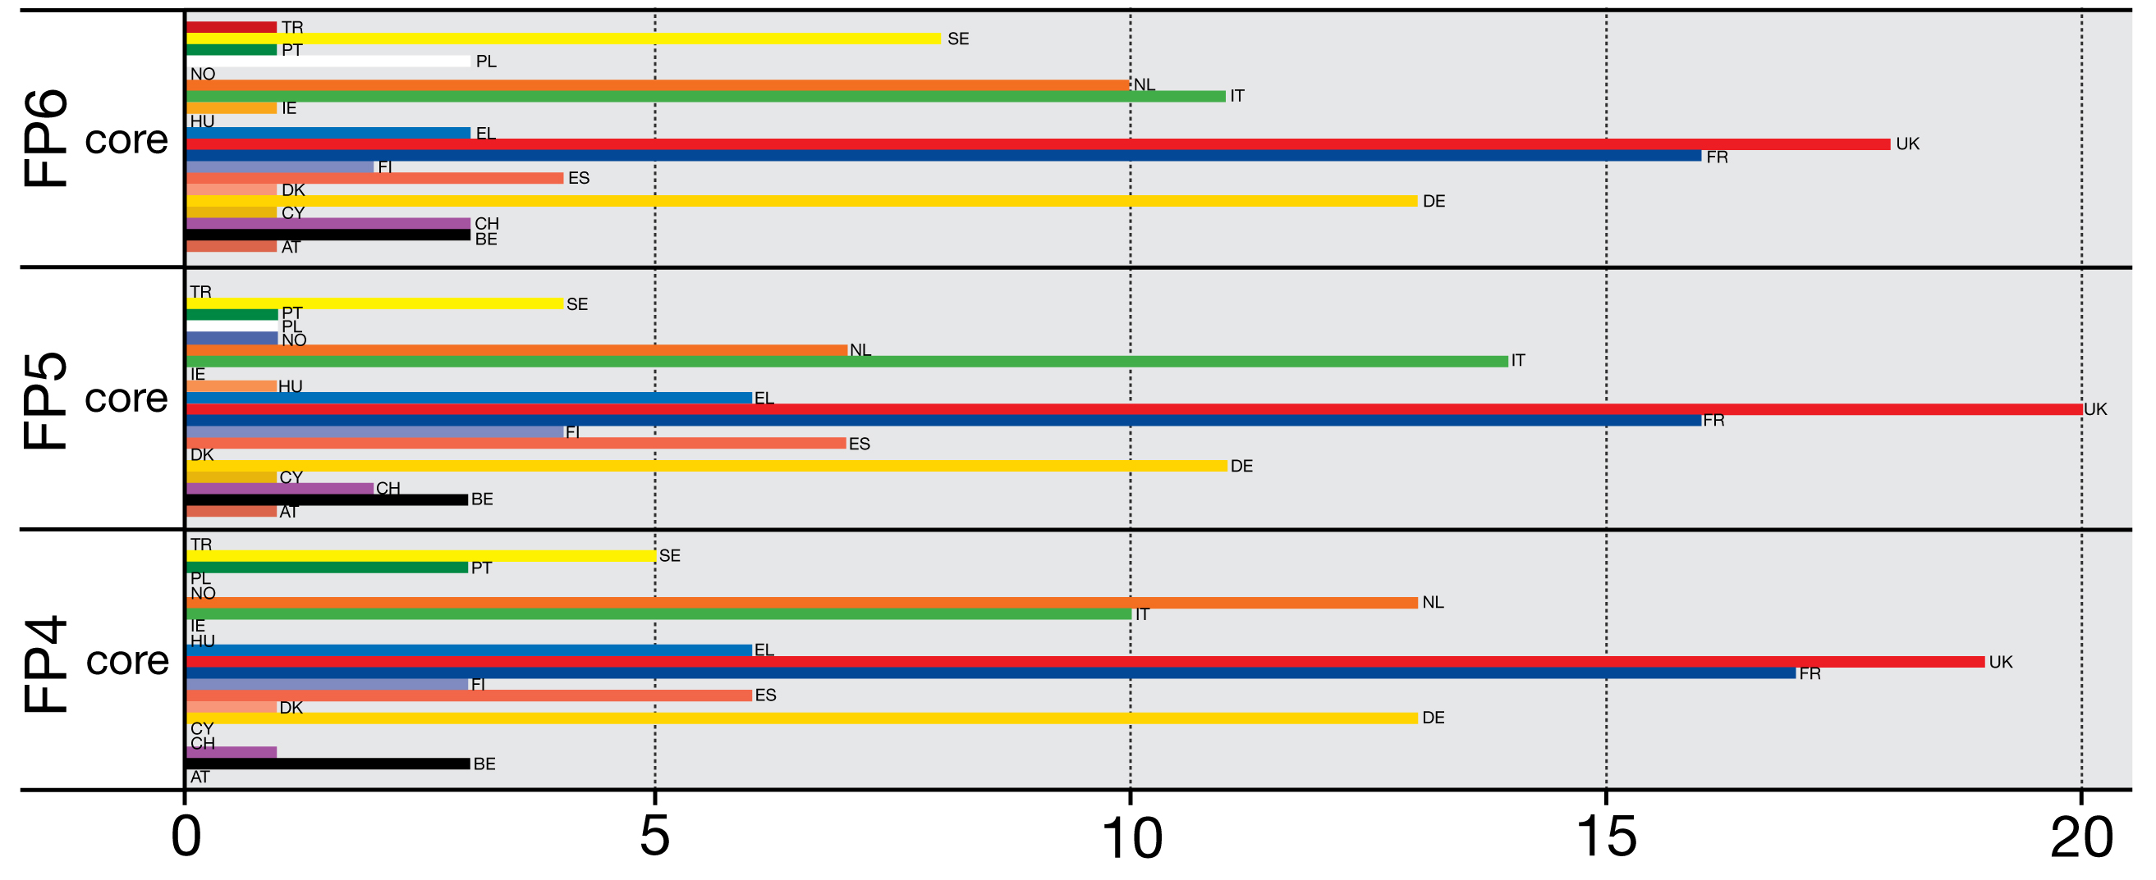
Figure 18: FP core organisations: percentage distribution by countries and FP

Source:JRC IPTS (2011)
  - The networks created by the FP are well structured:
    - JRC-IPTS (2011) shows that, over time, FP collaborative research networks have increased in size and created a highly dense and integrated structure. At the core of this structure, well-connected organisations (mainly higher education organisations and research centres) are situated, which not only participate in a large number of projects but are also directly linked with a large number of other core organisations and local partners. These key FP players come from across the EU and associated countries but the majority are from France, Germany, the United Kingdom, Italy and the Netherlands (Figure 18).
    - The same study shows that this group of key players, which participate in most projects and create most collaborative links, has not been renewed since FP2 (table 5).
    - Protogerou et al. (2010) found that ICT collaborative research funded under FP4, FP5 and FP6 had produced complex networks structured around a core of organizations, mainly universities and research institutes assuming a very influential role over time.
    - The FP6 ex-post evaluation (Rietschel et al., 2009) found that, in the area of IST, FP-funded projects had produced networks involving key 'hubs' (for example, the Fraunhofer Institutes) connected to large numbers of participants.
    - An EC-commissioned FP6-wide study of FP6 network effects (AVEDAS et al., 2009) found that there was a high degree of organisational embeddedness and network stability in the FP. In each of the five FP6 thematic areas, there was a small number of closely-knit organisations in the core that dominated the network, i.e. they were highly connected to one another through several projects, while the remaining organisations were in the network periphery and connected to the core but not connected to one another. The actors in the core – the central actors coordinating the projects – were primarily large national research associations (e.g., Fraunhofer Gesellschaft, CNRS, INSERM) and universities in all thematic areas except in IST where industry was also a central actor.
  - The networks created by the FP are durable:
    - According to an EC-commissioned FP6-wide survey (IDEA Consult, 2009c), 56 percent of respondents had already participated in FP5. In addition, 86 percent of respondents said they would continue to collaborate with other members on new activities after the network funding had been discontinued, demonstrating the value placed on the relationships that had been built.
    - In the same vein, a study by JRC-IPTS (2011) shows that the share of organisations 'returning' to the FP increases from one FP to another reaching 50% in FP6 (Table 5). This points to a perfect balance between network stability and renewal.

Table 5. Distribution of returning actors and new entrants within the 100 core organisations (%)
 | FP1 |  | FP2 |  | FP3 |  | FP4 |  | FP5 |  | FP6
 | Core | All | Core | All | Core | All | Core | All | Core | All | Core | All
Old Boys | 0 | 0 | 87 | 23.3 | 100 | 36.9 | 100 | 26.5 | 100 | 34.6 | 100 | 49.4
New Entrants | 100 | 100 | 13 | 76.7 | 0 | 63.1 | 0 | 73.5 | 0 | 65.4 | 0 | 50.6

Source: JRC IPTS (2011)
  - The networks created by the FP are well integrated into global innovation networks:
    - In the area of IST, the FP6 ex-post evaluation (Rietschel et al., 2009) found that there was a strong overlap between FP networks and patenting and ICT business networks pointing to the fact that the FP is well integrated into global innovation networks.
- FP mobility actions promote the same kinds of durable cross-border, cross-sectoral, inter-disciplinary networks:
  - The FP6 ex-post evaluation (Rietschel et al., 2009) noted that by establishing working relations across Europe’s knowledge infrastructure, Marie Curie actions have been a major driver towards the ERA and also provided opportunities for European researchers to build long-term relationships with colleagues outside Europe.
  - According to the survey launched among Marie Curie fellows in FP6 (The Evaluation partnership, 2010), 90% of them considered that the grant helped them to make significant new professional contacts and 70% of them intended to maintain these links.
- The FP structurally increases the attractiveness of Europe as a place to carry out research:
  - The FP7 interim evaluation (Annerberg et al., 2010) noted that the specific programme People has been an important instrument to make Europe attractive to the best researchers and to implement the EU’s career development policy.
  - It also noted that, according to an analysis by the ERC Executive Agency, a significant share of all applicants have been working in the US, indicating that the programme is having an effect on attracting top researchers back to Europe.
- Indirectly and directly, the FP influences the design of Member State research policies, especially in the EU12:
  - Marie Curie Actions set a valuable bench-mark for the working conditions and employment standards of EU-researchers with active participation in the ‘European Partnership for Researchers’ and the ‘Code of conduct for the recruitment of researchers’, promoting mobility and better careers for researchers in Europe.
  - The Open Method of Coordination (OMC), including exercises such as policy mix peer reviews, helped Member States devote more effort to the Barcelona goal.
  - The Science in Society programme had some remarkable structuring effects on ERA in the field of participatory technology assessment, capacity-building of civil society organizations, and promoting open science in academic journals.
  - According to an EC-commissioned study on the impact of FP6 on the EU12 (COWI, 2009):
    - Several new Member States (especially Poland, Lithuania and Romania) have been inspired by the FP to take a more networked approach to funding, moving from single-beneficiary to multi-beneficiary projects.
    - In several new Member States (e.g. Romania and Lithuania, and to lesser extent also Poland, Czech Republic and Slovenia), FP6 priorities have effectively substituted 'national' priorities.
    - In some of the new Member States (Romania, Lithuania, Poland), FP6 has been a vehicle for a transformation and re-orientation of the research policy planning where the programmatic qualities of the FP6 have been used. These qualities include: (1) the strategic and 'applied' approach to research with priority areas; (2) the planning horizon (e.g. adopting a 2007-2013 time horizon); (3) the evaluation procedure for national research proposals.
    - To stimulate an international reorientation of national research, some countries (Romania, Lithuania, Poland) reward submission of FP6 proposals in national research evaluation procedures, using a standardised 'uplift' (for instance in Romania, where an FP6 submitted proposal automatically receives a 5 point bonus; out of 100 points).

THE EU RESEARCH AND INNOVATION PROGRAMMES PRODUCE LARGE MACRO-ECONOMIC IMPACTS
Studies show that EU funding produces large macro-economic impacts:
- See Annex 5: An extensive body of academic economics literature has demonstrated that R&D produces large-scale macro-economic effects.
- The FP7 ex-ante impact assessment identified large-scale FP macro-economic effects:
  - €1 of Framework Programme funding leads to an increase in industry added value of between €7 and €14.
  - Member States' own evaluations also demonstrate the high impact of the FP: the FP’s annual contribution to, for instance, UK industrial output exceeds £3 billion.
  - On the basis of the NEMESIS econometric model, the long-term FP7 macro-economic impact was estimated at an extra 0.96 percent of GDP, an extra 1.57 percent of exports, and a reduction by 0.88 percent of imports
- The potential value added generated by eco-innovation pilot and market replication projects under CIP could be calculated in some € 3.4 million per million € invested (DG ENV, ref. Varma, 2007).
- Each € 1 of EU budget invested in the CIP venture capital facility has mobilised € 6.8 of other private or public funds (EC, 2011g).
THE FP PRODUCES LARGE SOCIAL IMPACTS
Studies show that EU funding produces large employment and other social impacts:
- See Annex 5: An extensive body of academic economics literature has demonstrated that R&D generates large employment effects.
- On the basis of the NEMESIS econometric model, the FP7 ex-ante impact assessment identified large-scale FP7 employment effects. The long-term employment impact of FP7 was estimated at 900,000 jobs, of which 300,000 in the field of research.
- Survey evidence supports the aforementioned modelling results on employment:
  - According to an EC-commissioned evaluation of the FP5 Growth programme, the number of jobs (expected to be) safeguarded amounted to 37,588 while the number of jobs (expected to be) created amounted to 8,038 (Ramboll Management and Matrix Knowledge Group, 2008).
  - According to a survey among FP5-7 project coordinators in the area of "Food, Agriculture and Fisheries, and Biotechnology" research, close to 5 percent of all projects resulted directly in the creation of a new company. 82 percent of all projects created jobs for the duration of the project and 35 percent of all projects created new jobs after the end of the project. 38 percent of all projects created at least one permanent S&T job.
  - According to a Dutch FP impact study (Technopolis), "the [FP's] impact on the human research capital in the Netherlands is considerable, with approximately 1200 researchers in the public sector alone funded by the FPs annually. For many research groups this is an important factor to guarantee the continuity of the group".
  - According to an Irish evaluation of FP6 (Forfas, 2009), 80 percent of participating organisations or research groups improved their ability to attract staff or increased employment (low impact: 27%, medium impact: 42%, high impact: 11%).
  - A Spanish evaluation of FP6 participation (Zabala Innovation Consulting SA (2010) found that, with regard to the creation of university posts, the FP performed better than national or regional programmes according to 38.89 percent of respondents and equally well according to 50 percent of respondents. With regard to the creation of public research organisation posts, the FP performed better than national or regional programmes according to 8.33 percent of respondents and equally well according to 75 percent of respondents.
  - A Swedish evaluation of the FP (VINNOVA, 2008) found that industrial FP participants' R&D activities and employment in the technology of the project tended to grow afterwards.
  - According to a Swiss evaluation of FP5 and FP6 (Interface Institut für Politikstudien and Fraunhofer-Institut für System- und Innovationsforschung, 2005), "rough estimates suggest that at least around 950 temporary and permanent positions are created as a direct result of the Framework Programme".
  - A Swiss evaluation of FP6 (State Secretariat for Education and Research, 2009) stated that "while certain significant benefits of Switzerland’s participation in FPs are not measurable, there is no doubt that FPs have various impacts in social (welfare, security, equality, education, …), … employment … areas …, even if it is not known to what extent or in what way, precisely".
  - According to a UK evaluation of the FP (Technopolis, 2010), respondents reporting a positive benefit to cost ratio of FP participation pointed to the additional employment and training opportunities created, particularly in relation to attracting and funding high quality scientists and motivated early-stage researchers.
- Through Marie Curie actions, the FP set a valuable bench-mark for the working conditions and employment standards of EU-researchers (Annerberg et al., 2010).
- The FP produces indirect social benefits through relevant natural sciences research:
  - According to a FP6-wide participation survey (IDEA Consult, 2009c), all thematic priorities contribute substantially to a better quality of life while life sciences, genomics and biotechnology for health, nanotechnologies and nanosciences, knowledge-based multifunctional materials and new production processes and devices, and food quality and safety contribute to better healthcare.
  - According to a Dutch FP impact study (Technopolis), "societal impact is demonstrated in domains with a strong societal mission such as health, sustainability and food safety".
- The FP also produces indirect social benefits through social sciences research on relevant issues:
  - An evaluation of FP5 and FP6 social and environmental effects (European Commission, 2005a) lists research on the following socially relevant issues:
    - Human rights (increasing equality of opportunity and entitlement, including among genders; ensuring that ethical issues are appropriately and effectively addressed; ensuring compatibility with the EU’s Charter of Fundamental Rights)
    - Social cohesion (reducing social exclusion; reducing risks of poverty)
    - Economic cohesion (reducing disparities of income for particular sectors, groups of consumers, citizens, workers)
    - Employment (increasing employment opportunities (job creation, enterprise creation); increasing quality of employment and of the working environment)
    - Human capital formation (improving educational achievements in the population; increasing training and life-long learning opportunities; increasing skills and learning capability/flexibility, both within and outside the research community)
    - Public health and safety (improving the health of the population; reducing safety risks; improving nutrition, food quality and safety)
    - Social protection and social services (improving accessibility to health services; improving long-term sustainability of health services)
    - Liveable communities (improving quality of housing, infrastructures, services and the living environment in general)
    - Culture (preserving cultural diversity while increasing integration; preserving and exploiting cultural heritage)
    - Consumer interests (improving consumer information and choice; reducing consumers’ risks)
    - Security (preventing crime and increasing protection against terrorism; improving the protection of networks and infrastructures; increasing the interoperability of integrated systems and services)
    - Governance (increasing participation and social capital formation (through increased accountability, democracy, citizens and stakeholders’ empowerment, active citizenry)
    - International co-operation (promoting co-operation among Member States to reduce inequalities, achieve convergence and enhance social cohesion; promoting socio-economic conditions (e.g. welfare, quality of life, etc.) in non-EU countries)
    - Role of SMEs (increasing and enhancing the potential contribution of SMEs towards job creation, social cohesion, regional development, etc. (through the improvement of their technological capabilities and their increased involvement in research networks)).

THE FP PRODUCES LARGE ENVIRONMENTAL IMPACTS
The clearest environmental impacts are produced by FP-funded environmental research:
- According to an EC-commissioned evaluation of FP6 environmental research (EPEC, 2008), for instance, EU environmental research contributed to the knowledge base and development of methods and tools for environment related policy. The study found that:
  - At the international level, EU research related to climate change contributed to the International Panel on Climate Change (IPCC), either directly, through individual researchers involved in the IPCC review, or through references to EU-funded projects in IPCC reports.
  - In the domain of environment and health, there were strong links with EU policy priorities, most notably with the implementation of the Environment and Health Action Plan 2004-2010 as well as with the implementation of European Directives.
  - All natural hazards projects contributed to some extent to regional, national and European policies in the field of natural hazards, guidelines and standards.
  - Water and soil projects played a large role in the formulation and implementation of the Water Framework Directive.
  - Earth observation projects had direct impacts on policy-making through the use of their outcomes by stakeholders such as IPCC and WMO.
    - Environmental challenges are global and need to be tackled together with international partners at the European and global levels. Environmental research requires harmonised sets of data produced through satellite monitoring. The scale of the investment needed and the need for full European/international coverage and for open data access requires EU-level action. The FP7 environmental research priority allocated substantial resources to the development of a "Global Earth Observation System of Systems" (GEOSS) promoting the rapid expansion of full, open access to space and ground-based, water and airborne data and observations. GEOSS is maintained by the 85 member governments and the 61 participating organizations of the Global Earth Observation (GEO) on the basis of a 10-Year Implementation Plan (2005-2015). Inspired by the data-sharing principles developed by the Global Earth Observation (GEO) initiative, agencies involved in Earth Observation are making their data much more easily accessible, free of charge. The international character of GEOSS enables the participants to benefit from both know-how and data from other regions of the world. This represents a clear improvement of the general situation deplored by the EEA (2010) of limitation to the trans-national use of infrastructures funded at national levels. Funded projects under the Global Earth Observation initiative (FP7) play a key role in the development of GEOSS. FP7 examples include: EBONE aimed at building a biodiversity observation system, EUROGEOSS implementing a brokering service for accessing data, and IMPACTMIN aimed at developing monitoring impacts of mining operations using Earth Observations.

Yet other kinds of FP-funded research also produce clear environmental impacts:
- According to an evaluation of FP3 and FP4 Brite-Euram projects, for instance, just over one third of industrial participants reported that their project had had at least one environmental impact within their organisation, and the vast majority of these (97%) were positive: 39% cited savings in materials; 32% cited energy savings; and 32% cited reductions in the release of dangerous products.
- According to an EC-commissioned evaluation of the FP5 Growth programme (Deloitte, 2006) – which covered "Key Actions" like "Innovative products, processes and organisation", "Sustainable mobility and intermodality", "Land transport and marine technologies" and "New perspectives for aeronautics", and "Generic Activities" like "New materials and their production and transformation (including steel)" and "Measurement and testing" - the average environmental impact per project was substantial reaching 6.08 percent in terms of the expected reduction of waste and 4.06 percent in terms of the expected energy saving.
- According to an evaluation of a sub-set of FP5 Growth programme projects (Ramboll Management and Matrix Knowledge Group, 2008), nearly 25 percent of all evaluated projects anticipated medium-high or high benefit with regard to the reduction or prevention of emissions, while about 20 percent anticipated medium-high or high benefit with regard to saving natural resources.
- According to an evaluation of FP5 and FP6 social and environmental impacts (European Commission, 2005a), important projects were, for instance, ExternE (Externalities of Energy) and ExternE-Transport, RECORDIT (Real Cost Reduction of Door-to-Door Intermodal Transport), and ECOSIT (External Costs of Industrial Technologies) that produced results that fed directly into policy formulation in the energy and transport sectors (e.g. the recent revision of the Eurovignette Directive). Similarly, the DYN-GEM-E3 project was instrumental in energy taxation reforms through "the macroeconomic evaluation of energy tax policies within the EU". The POLES model, also developed with EU energy research funding, was used to define the future CO2 emission baseline in the context of post-Kyoto targets".
- According to a FP6-wide participation survey (IDEA Consult, 2009c), the thematic priorities "Sustainable development, global change and ecosystems" and "Nanotechnologies and nanosciences etc." contributed to the sustainable use or production of energy, while the thematic priorities "Sustainable development, global change and ecosystems", "Nanotechnologies and nanosciences", "Aeronautics and space", and "Food quality and safety" contributed to the environment.

According to a survey conducted among FP5, FP6 and FP7 project coordinators in the area of "Food, Agriculture and Fisheries, and Biotechnology" research, 49 percent of all projects produced positive environmental impacts. 18 percent of all project coordinators stated that their project contributed to the reduction of greenhouse gas emissions, while 41 percent of all project coordinators stated that their project contributed to resource efficiency. Indirect environmental benefits were produced through FP research on how to improve the use of production inputs and increase resource use efficiency (e.g. water, which was targeted specifically in FP7); on how to reduce the reliance on pesticides and animal health products; on how to improve and make safer the use of animal waste to reduce environmental pollution; on GMO management strategies, models and containment systems, ensuring environment protection, food safety; on how to extend the use of renewable forest resources; on the long-term sustainability and productivity of forest ecosystems considering carbon sequestration, the water cycle, climate change; on how to reduce the loss of biodiversity in agriculture and forestry. National evaluations of the FP arrive at similar conclusions:
- According to an Irish evaluation of the FP (Forfas, 2009), 50 percent of all projects made a contribution to "improved environmental preservation or protection".
- A Swedish evaluation of the FP (VINNOVA, 2008) found that "Framework Programmes have positive effects on the behaviour of the research community, competitivity, jobs, regulation and the environment".
- According to a Swiss evaluation of the FP (State Secretariat for Education and Research, 2009), "no fewer than 70 projects from the FP5 environment programme were explicitly referred to in European Commission position papers. The EU Directive on greenhouse gas emission allowance trading was also based on findings from FPs". The evaluation also stated that "while certain significant benefits of Switzerland’s participation in FPs are not measurable, there is no doubt that FPs have various impacts in … environmental (energy, pollution, natural disasters, …) … areas … , even if it is not known to what extent or in what way, precisely".
- According to respondents to a UK evaluation of the FP (Technopolis, 2010), FP activities strengthened previously weak UK capabilities in a number of environmentally relevant research areas ("The FP6 Marie Curie RTN has allowed us FINALLY to tackle an important research area (breeding of a novel fodder legume with tannins for animal nutrition, health and greenhouse gas emissions). An FP7 Marie Curie IEF is similarly enabling us to get involved in a willow breeding programme for the benefit of animals and the environment"). The FP5 STAIRRS and the FP6 SILENCE projects also directly informed the Environmental Noise Directive and railway TSI (Technical Specification for Interoperability) processes.

SUCCESS STORIES
- FP-funded collaborative research leads to technological breakthroughs. European engineers receiving collaborative research support were able in 2004 to develop the first chip in the world to go below the 45 nanometer limit. The momentum generated by the NANOCMOS and subsequent projects put EU industry in pole position opening the door to a wide range of innovations in products and services ranging from communications to embedded electronics where Europe holds a large share of the global market (40% of total market worth more than 100 B€ per year).
- FP-funded collaborative research reduces risk and enables the achievement of pan-European standards. Standards and technologies developed by FP-funded researchers are today found in over 600 million 3G mobile phones, generating more than 250 billion euro of revenues every year to EU companies in products and services.
- FP-funded collaborative research facilitates the growth of innovative SMEs. In 2006, two small research-based companies from Sweden and Belgium, BioInvent and Thrombogenics, received together with academic and clinical partners a 1.9 million euro grant to form the project ANGIOSTOP. The firms have since developed an innovative form of treatment for cancer. In 2009, the companies secured a 50 million euro investment from global pharmaceutical giant Roche, with the possibility of increasing this amount to 450 million euro.
- EU funding leverages private investment. In the case of RSFF, the volume of loans is 12 times the EU contribution, and the additional leveraged investment in research, development and innovation is 30 times the EU contribution.
- As a result of targeted JRC research costing about 1 million euro, the cost of tests for BSE were reduced and the direct EC subsidy per test could be scaled back from 20 euro to 7 euro resulting in cumulative savings for the Community budget over the period 2002-2006 of about 250 million euro.
- JRC research enabled the launching of the GI2000 initiative and the 2007 INSPIRE directive establishing an infrastructure for spatial information in Europe. The estimated EU, national and regional investments for INSPIRE are of the order of 100 million euro whereas annual benefits of the full implementation of the directive are estimated at 8-12 billion euro.
- The aim of the SLIC project was to develop and commercialise a compact device ("lab-on-a-chip") for the extraction, identification and analysis of micro-RNAs, which affect gene regulation. Thanks to the international, collaborative framework of the European project, it was possible to recruit an interdisciplinary team with highly specialised skills, not all of which could be found in a single country. With the technology developed in the SLIC project, the time required for microRNA analysis has been reduced from a day to a quarter of an hour. This is associated with a considerable reduction in the costs of these procedures, which are now widely practised. This innovation entails significant benefits not only in economic terms (the Swiss start-up project coordinator, Ayanda Biosystems, has been approached by the leading companies in the sector), but also for science and health (more rapid and less costly diagnostics).
- Secure communication is an essential requirement for companies, public institutions and citizens. Encryption systems currently used are rendered vulnerable in particular by the continuing growth in computing power. Quantum cryptography, based on the quantum properties of light, ensures communication channels which are demonstrably inviolable. In 2008, the SECOQC project enabled the deployment of a telecommunication network based on quantum cryptography – a world first. No European group had expertise in all the technologies that were needed to establish a network of this kind. To succeed, the SECOQC project had to draw on the skills of 40 participants from 11 different countries. The demonstration of the feasibility of an inviolable communication network heralded the birth of a new market. The SECOQC project also led certain partners to jointly develop the first international standards in this new industry.
- The aim of the CASOPT project is to produce a paradigm change in the design of complex electromagnetically-driven industrial products. State-of-the-art simulation-based design is to be replaced by optimization-based design. This new approach is the key to achieving the goals of miniaturization, reductions in the quantity of materials required and costs, and improvements in the energy efficiency of products. The research consortium brings together partners from industry and academia in a project based on knowledge transfer. As the CASOPT project is highly multidisciplinary, it was necessary to assemble a team of world-class experts in numerical analysis, simulation, optimization, geometric design and parallel computing. The realization of this project essentially relies on existing site competencies and knowledge transfer among the partners, with support from additionally recruited experts. Synergies arise between the experience of private-sector and university institutions, and also between experienced researchers and others who are younger and highly motivated. This offers them a unique opportunity to carry out research within a network, and also to develop other research ideas and projects. In the short term, the results of the project will be used in the design of power transmission and distribution systems. The CASOPT project will make it possible to push the performance of products beyond current limits without adversely affecting their reliability or robustness. In addition, highly skilled young students, PhD students or post-docs participating in this type of project can be recruited by industrial partners. In the long term, the project could have a decisive impact on the evolution of industrial design concepts for many different sectors, but also for SMEs, whose product range is also covered.
- FP collaborative research is often pioneering in its domain. The FP project on Yeast genome was the first international grant in genomics. Its aim was to reveal the first full set of genes of a eukaryotic genome and in a broader sense, identify basic biological mechanisms common to all living organisms, including man. This 7 years long research involved an international effort of 641 scientists in Europe, USA, Canada and Japan sequencing a total of 12.3 million of DNA base pairs covering the 16 nuclear chromosomes. Europe was not only at the origin of this large research venture, but also provided much of the sustained funding required to ensure the success of this pioneering task. A total of 92 European laboratories and over 400 European scientists have participated in this network. By the end of 2010, this project has generated more than 500 scientific articles reporting yeast DNA sequences and a total of 2,849 patents registered. With the discovery that the yeast genome is similar to that of man, very interesting prospects have opened up for the future understanding of certain diseases - such as cancers and genetic diseases.
- Oil is rapidly becoming scarcer and its use for transport purposes is responsible for a quarter of greenhouse gas emissions. It is important to develop clean and commercially viable alternatives to the combustion engine. Electric vehicles are widely seen as the most credible alternative to fossil fuel-based road transport. For Europe, it is of critical importance to develop an early technological and competitive lead in this rapidly developing market. Against this background, the objective of the European Green Cars Initiative is to support R&D on technologies and infrastructures that are essential for achieving breakthroughs in the use of renewable and non-polluting energy sources, safety and traffic fluidity. The European Green Cars Initiative is one of the three Public Private Partnerships (PPP) of the European Economic Recovery Plan announced by the President of the European Commission on the 26th of November 2008. Beyond providing loans through the European Investment Bank, the PPP European Green Cars Initiative is making available a total of one billion EUR for R&D through joint funding programmes of the European Commission, the industry and the Member States. These financial support measures will be supplemented by demand-side measures, involving regulatory action by Member States and the EU, such as the reduction of car registration taxes on low CO2 cars to stimulate car purchase by citizens. The reason for an initiative at EU-level is that a critical mass of combined expertise and effort is needed from all Member States and relevant industrial sectors to overcome the market and systemic failures associated with the introduction of new basic technologies. To avoid fragmentation reflected in research duplication and gaps, and to arrive at robust industry standards, a frequent exchange of information is needed between sectors and levels of government that do not normally interact on a regular basis. Investing in the production of equipment, components and electric systems is attractive only when everyone is on board. Since its launch merely two years ago, the European Green Cars Initiative has already brought closer the introduction of green vehicles on Europe's roads. The initiative instigated 51 research projects on technologies and standards needed to make electric vehicles feasible and commercially attractive. Advances have already been made in fields contributing to batteries that charge faster and have a longer driving range, and new vehicle models.
- The objective of the NAD project was to develop nanoparticles for Alzheimer's disease diagnosis and therapy. The rationale for the project was the fact that about 24 million people worldwide are affected by dementia and that the number of new cases per year reaches almost 5 million. In Europe, there are 5 million cases of dementia, 3 million of which are classified as Alzheimer's. NAD involved 19 partners from 13 different European countries. The critical mass needed to develop treatments of Alzheimer's disease is greater than what can be found at individual Member State level and it was thanks to the internationally collaborative nature of this EU funded research project that it was possible to bring together a comprehensive range of cutting edge European expertise from several multidisciplinary key areas: chemistry, physics, biochemistry, molecular biology, cell biology, pharmacology, biophysics, computational biology, nanotechnology, neurology, anatomy and toxicology. If successful, NAD will produce nanoparticles able to cross the blood-brain barrier and reach the brain (site of the disease). Molecules able to selectively recognise (diagnosis) and destroy (therapy) toxic peptides characteristically accumulated in the brain of diseased patients will be identified and attached to the nanoparticles.
- The objective of the EDCTP (European and Developing Countries Clinical Trial Partnership) Article 185 initiative was to accelerate the development of new clinical interventions to fight HIV/AIDS, malaria and tuberculosis in developing countries. The background to the project was that worldwide over 30 million people are living with HIV and close to 3 million people become infected each year. In addition, there are each year close to 250 million cases of malaria worldwide (and close to 900,000 deaths) as well as 9 million cases of tuberculosis. EDCTP involves the European Commission, 16 European countries (14 Member States and 2 Associated Countries), industry, private charities like the Bill and Melinda Gates Foundations, and 29 Sub-Saharan African countries. The conceptualisation and implementation of this project required a level of coordination of a wide range of funding sources that could only be achieved at EU level. EDCTP has so far supported 54 clinical trials on new treatments and vaccines for HIV, malaria and tuberculosis and the training of 158 medical researchers. The US Food and Drug Administration has approved an anti-retroviral formulation for HIV infected children in Africa, which was tested through an EDCTP project. The first African Networks of Excellence for clinical trials in central Africa have been established and there are now national ethics committees in many African countries thanks to EDCTP.
- Pan-European Public Procurement On-line pilot project, funded by ICT-PSP, is creating a standards-based IT transport infrastructure which enables cross-boarder, interoperable public eProcurement with standardised electronic document formats. In results, it is easier for companies to bid for public sector contracts anywhere in the EU in a simpler and more efficient way. 12 Member States or associated countries are currently involved in the pilot.
- The innovative ICTs are used to help people receiving medical assistance anywhere in the EU. The ICT-PSP market demonstration project epSOS is building a service infrastructure demonstrating cross-border interoperability between electronic health record systems in Europe. The medical services are becoming more accessible throughout Europe thanks to removing linguistic, administrative and technical barriers. 23 Member States or associated countries are currently involved in this pilot project.
DETAILED EVIDENCE ON LESSONS LEARNED

While European research and innovation programmes have been successful, there are important lessons to be learned from the past, from stakeholder feedback, and from analytical studies. Research, innovation and education should be addressed in a more coordinated manner and coherent with other policies and research results better disseminated and valorised into new products, processes and services. The intervention logic of EU support programmes should be developed in a more focused, concrete, detailed and transparent manner. Programme access should be improved and start-up, SME, industrial, EU12 and extra-EU participation increased. Monitoring and evaluation need to be strengthened

The need for improved horizontal and vertical policy coordination
A number of FP ex-post evaluations have noted that the coordination between, on the one hand, the FP and other EU policies, and on the other hand, the FP and Member State research activities could be improved.
With regard to horizontal policy coordination in the narrow sense, the FP7 interim evaluation (Annerberg et al., 2010) noted that a strategic shift is needed to establish stronger and better connections between research, innovation and education (the so-called 'knowledge triangle'). As for broader horizontal policy coordination, the FP6 ex-post evaluation (Rietschel et al., 2009, 58-59) called for a clearer division of labour between the FP and the cohesion funds. It also stated that other EU policies such as transportation and energy would benefit from a more coordinated interface between FP research activities and regulatory and demand-side policies.
The need for horizontal policy coordination is confirmed by the conclusions of the OECD's work on the most appropriate system of innovation governance. OECD (2005a), for instance, mentions the need to develop "a strategic, horizontal approach", which "should include and develop the innovation policy potential in other ministerial domains and ensure a co-ordinated division of labour between them". And OECD (2010b) concludes that "given the increasingly central role of innovation in delivering a wide range of economic and social objectives, a whole-of-government approach to policies for innovation is needed".
With regard to vertical policy coordination, the FP6 ex-post evaluation noted that, given its small size compared to Member State expenditure, the FP should not try to substitute for Member State R&D policies but should use its added value in a more strategic way and set an attractive and accepted European agenda. In the same vein, European research policy expert Erik Arnold (2009, 28) concluded that the division of labour between the EU and national levels should be further refined and more explicitly defined, in particular in view of the introduction of the likes of the European Research Council and the Joint Technology Initiatives.
The need for vertical policy coordination is confirmed by the results of OECD work on the optimal system of innovation governance. OECD (2010b), for instance, calls for "coherence and complementarities between the local, regional, national and international levels".

The need for focus and a more robust intervention logic
A number of FP ex-post evaluations (Rietschel et al., 2009, v; European Court of Auditors, 2007, paragraph IV) have noted that the programme's design could be improved. The view held is that the FP lacks a transparent, clear and robust intervention logic: the programme has too many objectives, and higher-level objectives are insufficiently translated into lower-level objectives.
With regard to the FP's objectives, the FP6 ex-post evaluation (Rietschel et al., 2009, vii) as well as expert evidence (Arnold, 2005, 29) noted that there were too many – addressing almost all S&T and socio-economic challenges - and that they were too abstract and vague and therefore untestable, complicating ex-post evaluation. A recent European Parliament ITRE Committee report (2011, paragraph 9) noted in the same vein that "an ever-growing number of objectives and themes covered and diversification of instruments has widened the scope of FP7 and reduced its capacity to serve a specific European objective".
In addition, no explicit links are made between higher-level objectives and lower-level concrete technical goals (European Commission, 2005b, 19; Arnold, 2009, 2). Meanwhile, instruments are not designed explicitly to achieve particular objectives: challenges are defined so as to match existing instruments, not the other way around (Stampfer, 2008, 13). The result is 'catch all' instruments trying to tackle all problems and to satisfy all types of stakeholders. That is why the European Court of Auditors has called for addressing a single objective through each instrument (European Court of Auditors, 2009, paragraph 57).
The importance of focus and a proper hierarchy of objectives (combined with appropriate monitoring) is confirmed by recent OECD work. OECD (2010b) for instance, argues in favour of "a more strategic focus on the role of policies for innovation in delivering stronger, cleaner and fairer growth". OECD (2005a) notes that "third-generation innovation policy cannot be properly implemented without precise targets and intelligent follow-up. Governments should increase their capacity to develop actions plans based on horizontal, strategic approaches and translate these into concrete measures to be taken by each ministry or agency. This will enhance vertical coherence, with monitoring and indicator systems ensuring sound reporting of empirical facts to the strategic apex".

The need to lower the barriers to participation
All FP ex-post evaluations - see, for instance, the chapters on participation in the FP6 ex-post (Rietschel et al., 2009) and FP7 interim (Annerberg et al., 2010) evaluations - are unanimous in their view that FP application, contract negotiation and project management procedures are too complex and burdensome and that this results in high barriers to FP application and participation, in general but in particular for first time, start-up, SMEs and EU12 applicants.

The need to increase the production, dissemination and valorisation of project outputs
Participants' main reasons for getting involved in the FP relate to networking and the creation of new knowledge (Arnold, 2009, 2). FP research is also more of a long-term, exploratory, technologically complex nature (Polt et al.). The FP should therefore not be expected to produce new, immediately commercialisable products and processes.
Nevertheless, FP evaluations conclude that more attention should be paid to the production of project outputs and to their dissemination and economic valorisation, in particular since the FP is supposed to support Europe's competitiveness. What is highlighted is the absence in the FP of valorisation channels that enable the exploitation of research results and the linking of knowledge created through the FP with socially beneficial uses (Rietschel et al., 2009, 26, 37; Annerberg et al., 2010, 62 and following). In the same vein, the FP7 interim evaluation observes a lack of clarity on how the FP incorporates innovation (as opposed to 'pure' research).
In this respect, OECD (2010b) argues that "the creation, diffusion and application of knowledge are essential to the ability of firms and countries to innovate and thrive in an increasingly competitive global economy".

The need to strengthen monitoring and evaluation
The main problem affecting the FP monitoring and evaluation system relates to the aforementioned lack of focused objectives and a robust intervention logic. The evaluation process aims to link evidence emerging from project implementation with the strategic and specific objectives set for the programme. As the European Court of Auditors (2007) observed, if this connection is difficult to make, an assessment exercise becomes extremely complicated. The FP evaluation and monitoring system suffers from other problems as well, however.
The importance of a proper monitoring and evaluation system is emphasized by the OECD. OECD (2005a), for instance, recommends "improving evaluation and learning": "In general, governments should create a solid basis for evaluation and learning and make them part of the policy-making process. This includes evaluation of broader reforms, as knowledge about their impact on innovation is useful for feedback and policy formulation. A more holistic approach to evaluation and learning can enhance feedback in the governance system and lead to more effective policy". OECD (2010b), on the other hand, argues that "evaluation is essential to enhance the effectiveness and efficiency of policies to foster innovation and deliver social welfare. Improved means of evaluation are needed to capture the broadening of innovation, along with better feedback of evaluation into the policy-making process. This also calls for improved measurement of innovation, including its outcomes and impacts".

Out of 34 European companies in the Top 100 R&D investing companies, 31 received FP funding under FP6. http://webarchive.nationalarchives.gov.uk/20101208170217/http://www.innovation.gov.uk/rd_scoreboard/downloads/2010_RD_Scoreboard_data.pdf

