Introduction
In its "Europe 2020 strategy" for smart, sustainable and inclusive growth in the EU, the European Commission stresses that an element of putting the EU economy back on track consists in empowering EU citizens to play a full part in the single market and in giving them the confidence to do so.
Within the EU all citizens are able to cross borders freely to live, work study or retire, and to purchase property and invest in other EU Member States. However, the Single Market Act and the "EU Citizenship Report" have identified many legal and practical obstacles that deter people from actually exercising these rights across borders within the EU, as well as actions that need to be taken in a whole range of areas so that EU citizens' rights are fully effective. Taxation is one of these areas. The European Commission's Communication of 20 December 2010 on "Removing cross-border tax obstacles for EU citizens" examined the most pressing tax problems that citizens face when active across borders within the EU and outlined solutions to these problems.
Inheritances received across borders are one of the problem areas identified in the Communication of 20 December 2010. The problems consist mainly of double taxation and discriminatory tax treatment. The snapshot of citizens' and businesses' concerns in the Internal Market published in August this year confirmed that inheritance taxes feature among the 20 top problems faced by citizens and businesses when active across borders.
The Communication on "Double taxation in the Single Market" recognised that existing and planned instruments to relieve double taxation of income and capital cannot efficiently tackle cross-border inheritance tax issues and that separate solutions would be required in that tax field.
Therefore, the present Communication that is being adopted together with a Recommendation, and that will be accompanied by Staff Working Papers, outlines solutions to these cross-border inheritance tax problems.
The approach in the package adopted today reflects the Commission's view that some cross-border tax problems can be solved effectively through coordination of national legislation (as well as cooperation in the area of enforcement). The Commission underlined some years ago that in many cases it may be sufficient for Member States to abide by the rules set out in the Treaties and to implement unilaterally certain well defined solutions, in order to eliminate discrimination and double taxation and reduce the compliance costs for businesses and citizens associated with being involved with more than one tax system. Coordination of this type would also strengthen Member States' ability to protect their tax revenues and avoid litigation concerning individual provisions.
The present initiative is also designed to complement the Commission proposal for a Regulation “on jurisdiction, applicable law, recognition and enforcement of decisions and authentic instruments in matters of succession and the creation of a European Certificate of Succession”, adopted in October 2009. The proposed Regulation would provide a mechanism for determining which Member State's succession law would apply in the case of an inheritance across borders to which otherwise several, possibly conflicting, sets of national rules might apply. That draft Regulation does not deal with the taxation issues that arise in the case of cross-border inheritances.

Current rules on inheritance taxation
There is no EU-wide law in the area of inheritance taxation so Member States are free to design their rules in that area as they wish provided that they do not discriminate on the basis of nationality and do not apply unjustified restrictions to the exercise of the freedoms guaranteed by the Treaty on the Functioning of the EU.
At present, Member States' rules on the taxation of inheritances vary considerably. Eighteen levy specific taxes upon death while nine (Austria, Cyprus, Estonia, Latvia, Malta, Portugal, Romania, Slovakia and Sweden) do not do so but some of those nine tax inheritances under other headings such as income tax. Member States applying inheritance taxes differ regarding whether they tax the estate or the heir i.e. whether they tax on the basis of a personal link of the heir or the deceased, or both, to those Member States. They may treat as a personal link the residence, domicile or nationality of the deceased or of the heir and some Member States use more than one of these factors. The meaning of these terms may also differ from one Member State to the other. Furthermore, most Member States apply inheritance tax to assets located in their jurisdictions even if neither the deceased nor the heir has a personal link with the jurisdiction in question. While effective rates of inheritance tax may be low in the case of inheritances passed to heirs who are closely related to the deceased, the rates can reach 60-80% in some Member States in cases where the deceased and the beneficiary are not related. Some of the nine Member States that do not apply inheritance taxes have abolished them in recent years. This may be because of certain drawbacks in such taxes. One is that the rich often avoid them by using tax planning so that the burden falls on the less wealthy. Another disadvantage is the public perception that taxation on death is unfair in that it is taxing wealth that has already been taxed. However, this initiative does not call into question the existence of inheritance taxes, but focuses on the difficulties that EU citizens can face when they inherit across borders.

The problems and their scale
Studies demonstrate that increasing numbers of EU citizens are moving from one country to another within the European Union during their lifetimes to live, study, work and retire; the number of EU-27 citizens that reside in a Member State other than their State of origin reached approximately 12.3 million in 2010, an increase of 3 million compared to 2005. Studies also show that cross-border real estate ownership in the EU increased by up to 50% between 2002 and 2010 and that there is also a massive growing trend in cross-border portfolio investment.
Given these statistics, it is likely that more assets may be inherited across borders in the future and therefore that more inheritance tax issues will arise. At present, the number of potential cross-border inheritance cases is conservatively estimated at between 290,000 and 360,000 per year. SME organisations frequently point to the particularly damaging effects of inheritance taxes on small businesses, and say that the application of double taxation would aggravate the problems further. There is already some evidence of an increase in cross-border inheritance tax problems in recent years. The Commission has received many more complaints and enquiries from EU citizens in this area in the last decade than ever before. Furthermore, the Court of Justice of the European Union (the Court), which never dealt with an inheritance tax case before 2003, has, since then had to make decisions in ten such cases. In cross border situations the following difficulties may arise:
- Member States may discriminate between cross-border inheritances and inheritances with no cross-border element. In other words, they may apply a higher rate of inheritance tax where the assets, deceased persons and/or heirs are/were based in other countries than they would apply in purely domestic situations (i.e. in the case of inheritances of assets located in the territory of the taxing Member State bequeathed by previously domestically resident deceased persons to domestically resident heirs).
- Where two or more countries have taxing rights over the same inheritance, situations of unrelieved double or multiple taxation may arise and, unlike in the case of income and capital taxation, there are few national or international arrangements in place to relieve such double/multiple taxation in an effective way.
Discrimination is prohibited under the principles of the EU Treaty, and the Court has already found aspects of Member States' inheritance tax laws discriminatory in eight out of the ten cases examined since 2003. However, there may be many cases of discrimination which have not reached the Court, in particular because court cases may involve high costs for taxpayers. However, the Court has found that double taxation caused by the parallel exercise of taxing rights by two or more Member States is not in breach of the Treaty.
In these circumstances, those receiving inheritances across borders may potentially face tax problems leading to inordinately high levels of inheritance tax. The overall tax bill in the case of some inheritances received across borders could potentially be so high that an heir might have to take out a loan or sell the inherited property in order to pay the tax bills. In this respect it may be observed that the accumulation of taxes imposed by more than one State might lead to results that, in some Member States at least, would be considered as confiscatory and thus unlawful, had these results been brought about by the provisions of that State alone. The following example of double taxation of a cross-border inheritance is based on a case reported through the Commission's Your Europe Advice service:
Example: A Dutch citizen pursuing his career in France inherited a property in France from his deceased life partner who was also a Dutch citizen and who had lived in France for the previous 6 years. Their relationship had not been not formalised. The Dutch citizen had to pay French inheritance tax in view of his residence in France and of the fact that the property concerned was located in France. However, he also had to pay inheritance tax in the Netherlands because his life partner was deemed to have been resident in that State. For the purposes of inheritance tax, Dutch nationals are deemed to have resided within the national territory for 10 years following the date they leave the Netherlands to live abroad. The tax applied by France amounted to nearly 60% of the net assets. The tax applied by the Netherlands amounted to an additional 12.5%. Under the legislation applied by the Netherlands, foreign taxes are deductible as a liability on the inheritance received and, therefore, the tax applied by France led to a reduction of the taxable base in the Netherlands. Nevertheless, double taxation was not fully eliminated and the total tax due on the property concerned was higher than it would have been had the inheritance been confined to any one of the two Member States concerned.

While at individual level citizens can be affected heavily by double taxation, revenues from domestic and cross-border inheritances taxes account for a very small share - less than 0.5% - of total tax revenues in EU Member States. Cross-border cases alone must account for far less than that figure.
Note: The eight new Member States in the sample are: Cyprus, Czech Republic, Estonia, Hungary, Lithuania, Malta, Slovakia, and Slovenia. Data were not available for the other four new Member States.
Source: Copenhagen Economics Study based on National Tax List: http://ec.europa.eu/taxation_customs/taxation/gen_info/economic_analysis/tax_structures/article_5985_en.htm.

Suggested solutions
The Commission believes that cross-border inheritance tax problems may be resolved without any harmonisation of Member States' inheritance tax rules which thus would remain a matter of policy choice for each Member State. It may be sufficient simply to ensure that Member States' rules interact more coherently with each other so as to reduce the potential for double, or even multiple, taxation of inheritances. Besides, by virtue of the fundamental freedoms enshrined in the Treaties, Member States must in any event abstain from inheritance taxation which would discriminate against cross-border situations. Better knowledge of the applicable rules by all stakeholders could further contribute to compliance with these freedoms.
As regards double taxation, the accompanying Commission Recommendation suggests how Member States could cooperate to provide comprehensive double taxation relief for cross-border inheritances within the EU. Given that Member States have few bilateral treaties to eliminate double taxation of inheritances and seem not to have taken the initiative to negotiate more such treaties, the Recommendation focuses instead on improving Member States' existing national measures to relieve double taxation of inheritances. In the short term, without any prejudice to the conclusion in the future of bilateral or multilateral double taxation arrangements, the Commission wishes to encourage a broader and more flexible application of these existing national solutions to double taxation.
The Recommendation sets out solutions for cases in which several Member States have taxing rights, because of the location of the assets included in the inheritance and because of personal links of the deceased and/or the heir with those States. Furthermore, the Recommendation addresses the case of multiple personal links, due either to the diverging situations of the deceased and the heir or to the fact that one single person has personal links to more than one Member State (e.g. resident in one the State and domiciled in another).
Member States are invited to introduce the solutions suggested either in legislation or by way of administrative measures which may entail adopting a more flexible interpretation of existing provisions. The ultimate aim of such measures is to ensure that the overall tax burden on a cross-border inheritance is no higher than in an internal situation in one or other of the Member States involved. While these solutions are unlikely to have major budgetary impacts on Member States' revenues, given the low share that inheritance taxes represent of Member States' total revenue, the positive effects on the individuals concerned could be considerable.
As regards tax discrimination, the accompanying Commission Staff Working Paper sets out the EU case-law principles for non-discriminatory inheritance taxation and aims to explain and illustrate the operation of the fundamental freedoms. EU citizens would thus be more aware of the rules which Member States must respect when taxing cross-border inheritances. It could also assist Member States in bringing their inheritance tax provisions into line with EU law and would thus support and complement the Commission's ongoing infringement actions against discriminatory inheritance tax provisions. In these circumstances EU citizens would be less likely to encounter discriminatory taxation in the future.
The solutions proposed would also be applicable and beneficial to those who inherit SMEs across borders.
While the Commission is not proposing any legislative measure at this time in relation to double taxation, it may do so at a later stage if this proves necessary. The Commission will, therefore, carefully monitor Member States' laws and practices in taxing inheritances to assess what, if any, changes are made as a result of the solutions proposed today and whether these changes effectively tackle the problems outlined.

Conclusion and follow-up
Inheritance tax rules were not designed to cope with the reality that citizens now change their countries of residence more frequently and purchase and invest abroad. Appropriate solutions must be found to address cross-border inheritance tax problems that are likely to increase in the future if no action is taken. That is why the Commission:
- has adopted a Recommendation for a comprehensive system of double taxation relief for cross-border inheritances within the EU and will launch discussions with Member States to ensure appropriate follow-up to this Recommendation;
- is ready to assist Member States in bringing their inheritance tax laws into line with the EU Treaty but will also, in its role as guardian of the Treaties, take the steps it considers necessary to act against discriminatory features of Member States' inheritance taxation rules;
- will prepare an evaluation report in three years time based on monitoring Member States' practices and any changes made as a result of the initiatives presented today.
- may, if the report demonstrates that cross-border inheritance tax problems persist and subject to the results of an Impact Assessment, make an appropriate proposal to eliminate those obstacles.
The Commission invites the Council, the European Parliament, national parliaments and the European Economic and Social Committee to examine this Communication and related documents and to give their full support to the present initiative.
ANNEX I. LIST OF TAXES APPLIED TO INHERITANCES IN MEMBER STATES
Country | Taxes/other duties
Belgium | Droits de succession et de mutation par décès / Rechten van successie en van overgang bij overlijden, (Inheritance tax and transfer duty upon death)
Bulgaria | Данък върху наследствата (Inheritance tax)
Czech Republic | Daň dědická (Inheritance tax)
Denmark | Afgift af dødsboer og gaver (Tax on Estates of deceased persons and Gift Tax)
Germany | Erbschaftsteuer (Inheritance tax)
Estonia | No inheritance tax | Various charges including income and capital gains tax in certain instances
Ireland | Inheritance and gift tax
Greece | Φόρος κληρονομιάς, δωρεών και γονικών παροχών (Tax on inheritance, gifts and parental provision)
Spain | Impuesto sobre sucesiones y donaciones (Succession and gift duty)
France | Droits de mutation entre vifs (donations) et par décès (successions), (Succession duty - Transfer duty)
Italy | Imposta sulle successioni e donazioni (Succession and gift duty)
Cyprus | No inheritance tax | Αποθανόντων Προσώπων –(Tax on land transfers)
Latvia | No inheritance tax
Lithuania | Paveldimo turto mokesčio (Inheritance tax)
Luxembourg | Droits de succession (Inheritance tax)
Hungary | Öröklési illeték (Inheritance tax)
Malta | No inheritance tax | Transfer duty in certain instances
Netherlands | Schenk- en erfbelasting (Inheritance and gift tax )
Austria | No inheritance tax | Stiftungseingangssteuer, Grundwerbsteuer (Tax on land transfers and contribution to private foundations)
Poland | Podatek od spadków i darowizn (Tax on inheritances and gifts)
Portugal | No inheritance tax | Imposto do selo (Stamp duty)
Romania | No inheritance tax
Slovenia | Davek na dediščine in darila (Inheritance and Gift Tax)
Slovakia | No inheritance tax
Finland | Perintövero/Arvsskatt (Inheritance tax)
Sweden | No inheritance tax | Various charges including income and capital gains in tax in certain instances
UK | Inheritance tax
Source : Taxes in Europe Database (2011) and IBFD (2011)

ANNEX II. EU MEMBER STATES' DOUBLE TAX CONVENTIONS ON INHERITANCES
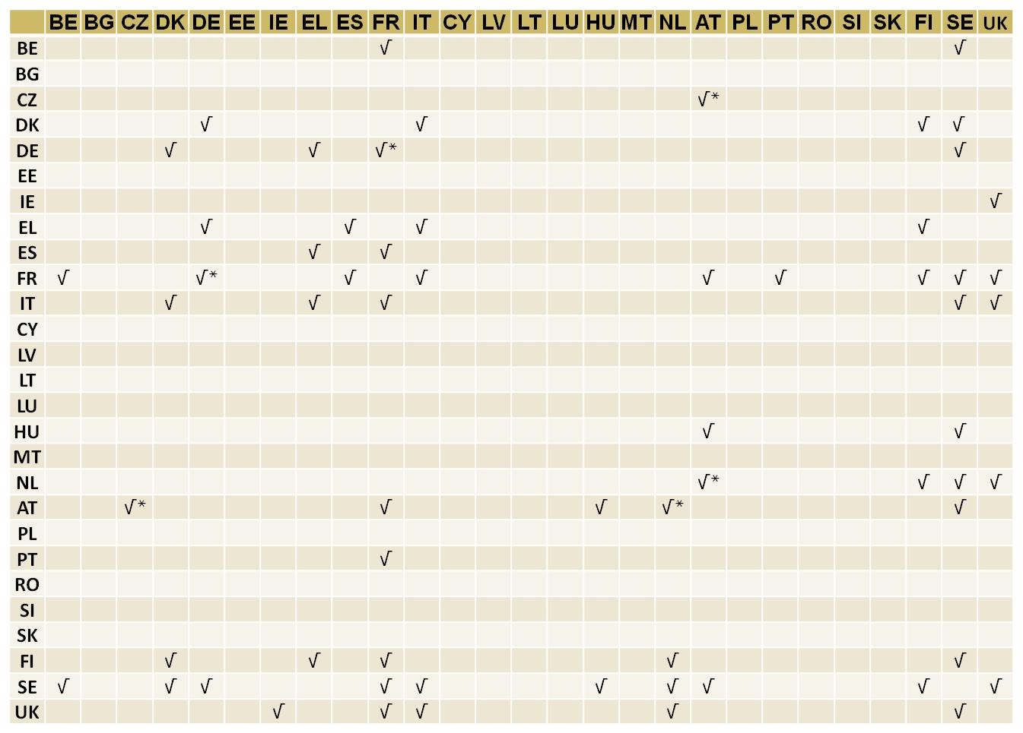
Note: √ means in force since before 1 January 2000; √* means new since 1 January 2000. The treaties between the Nordic countries are part of a multilateral agreement signed by the Nordic countries in 1983: Nordiska skatteavtalet (Nordic convention), signed in Helsinki on 22 March 1983. In the matrix each treaty is shown twice, e.g. a treaty between UK and SE is marked for both SE-UK and UK-SE.
Source: Copenhagen Economics based on IBF, Tax treaties database.

COM(2010) 2020
COM(2011) 206
COM(2010) 603
COM(2010) 769 and Staff Working Paper SEC(2010) 1576
The Single Market through the eyes of the people: a snapshot of citizens' and businesses' views and concerns - Staff Working Paper SEC(2011) 1003
COM(2011) 712
C(2011) 8819
SEC(2011) 1488, SEC(2011) 1489 and SEC(2011) 1490
Commission Communication on "Coordinating Member States' direct tax systems in the Internal Market" COM(2006) 823 of 19 December 2006
COM(2009) 154
Inheritance tax is taken to mean taxes levied upon the death of an individual, irrespective of the name of the tax, of the manner in which it was levied, whether it was applied at national, regional or local level and whether it was imposed on the estate or on the heir. It also includes taxes on gifts where these are made in anticipation of later inheritances and where they are taxed under the same or similar provisions as inheritances. See Annex I for non-exhaustive list of relevant taxes in Member States.
An individual could be "domiciled" (i.e. considered a permanent resident because of strong ties) in one country and at the same time be "habitually resident" in another country and be a national of a third country.
Eurostat data and the Copenhagen Economics Study on Inheritance Taxes in EU Member States and Possible Mechanisms to Resolve problems of Double Inheritance Taxation in the EU, August 2010,
See Copenhagen Economics Study for details of these other studies – page 63 - 64
See Impact Assessment on solutions to cross-border inheritance tax problems – SEC(2011) 1489.
Impact Assessment on solutions to cross-border inheritance tax problems – SEC(2011) 1489. Please note that the methodology used is likely to underestimate the actual figures because the figures indicated could only take account of cross-border cases of real estate ownership and not of other assets such as bank savings.
See European Family Businesses – GEEF contribution to the Commission's Consultation on possible approaches to tackling cross-border inheritance tax obstacles within the EU - http://www.efb-geef.eu/documents/EFB-EEF%20contribution%20to%20EU%20consultation%20on%20inheritance%20tax.pdf
The Block case (C-67/08)
See Impact Assessment on solutions to cross-border inheritance tax problems, pages 21-22, for other real-life examples
Annex II to the present Communication gives an overview of the existing double tax treaties on inheritances.
SEC(2011) 1488
Note that where an inheritance covers business assets and a selective advantage is granted in the form of a differential inheritance tax treatment, such a measure should also be in line with EU State aid rules which are not dealt with in detail in the Staff Working Paper.

