 | 
COUNCIL OF  THE EUROPEAN UNION |  |  | Brussels, 21 February 2012
 | Interinstitutional File:  2011/0358 (COD), 2011/0351 (COD), 2011/0352 (COD), 2011/0350 (COD), 2011/0353 (COD), 2011/0354 (COD), 2011/0349 (COD), 2011/0356 (COD), 2011/0357 (COD) |  | 6775/12
ENT 42
MI 119
CONSOM 22
CODEC 446
COMPET 103
INST 149
PARLNAT 109

COVER NOTE
from: | the Italian Senate
date of receipt: | 17 February 2012
to: | the Council of the European Union
No. Cion prop. | 17265/11 - COM(2011) 764 final, 17266/11 - COM(2011) 765 final, 17268/11 - COM(2011) 766 final, 17269/11 - COM(2011) 768 final, 17271/11 - COM(2011) 769 final, 17272/11 - COM(2011) 770 final, 17274/11 - COM(2011) 771 final, 17275/11 - COM(2011) 772 final, 17277/11 - COM(2011) 773 final
Subject: | Alignment of ten technical harmonisation directives to Decision No 768/2008/EC of the European Parliament and of the Council of 9 July 2008 on a common framework for the marketing of products  Proposals for a Directive of the European Parliament and of the Council  on the harmonisation of the laws of the Member States relating to  - the making available on the market of pyrotechnic articles  - electromagnetic compatibility  - making available on the market of non-automatic weighing instruments  - making available on the market of simple pressure vessels  - making available on the market of measuring instruments  - making available on the market of lifts and safety components for lifts  - making available on the market and supervision of explosives for civil uses  - equipment and protective systems intended for use in potentially explosive atmospheres  - the making available on the market of electrical equipment designed for use within certain voltage limits  -Opinion on the application of the Principles of Subsidiarity and Proportionality

Delegations will find attached for information a copy of the above opinion.

________________________

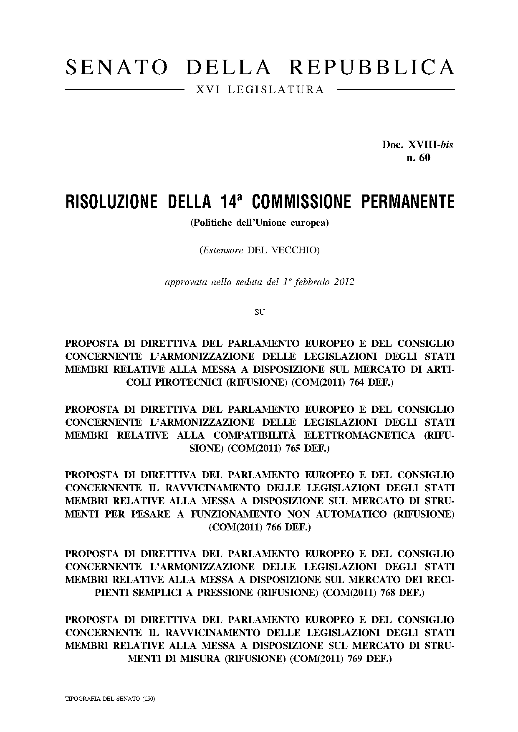
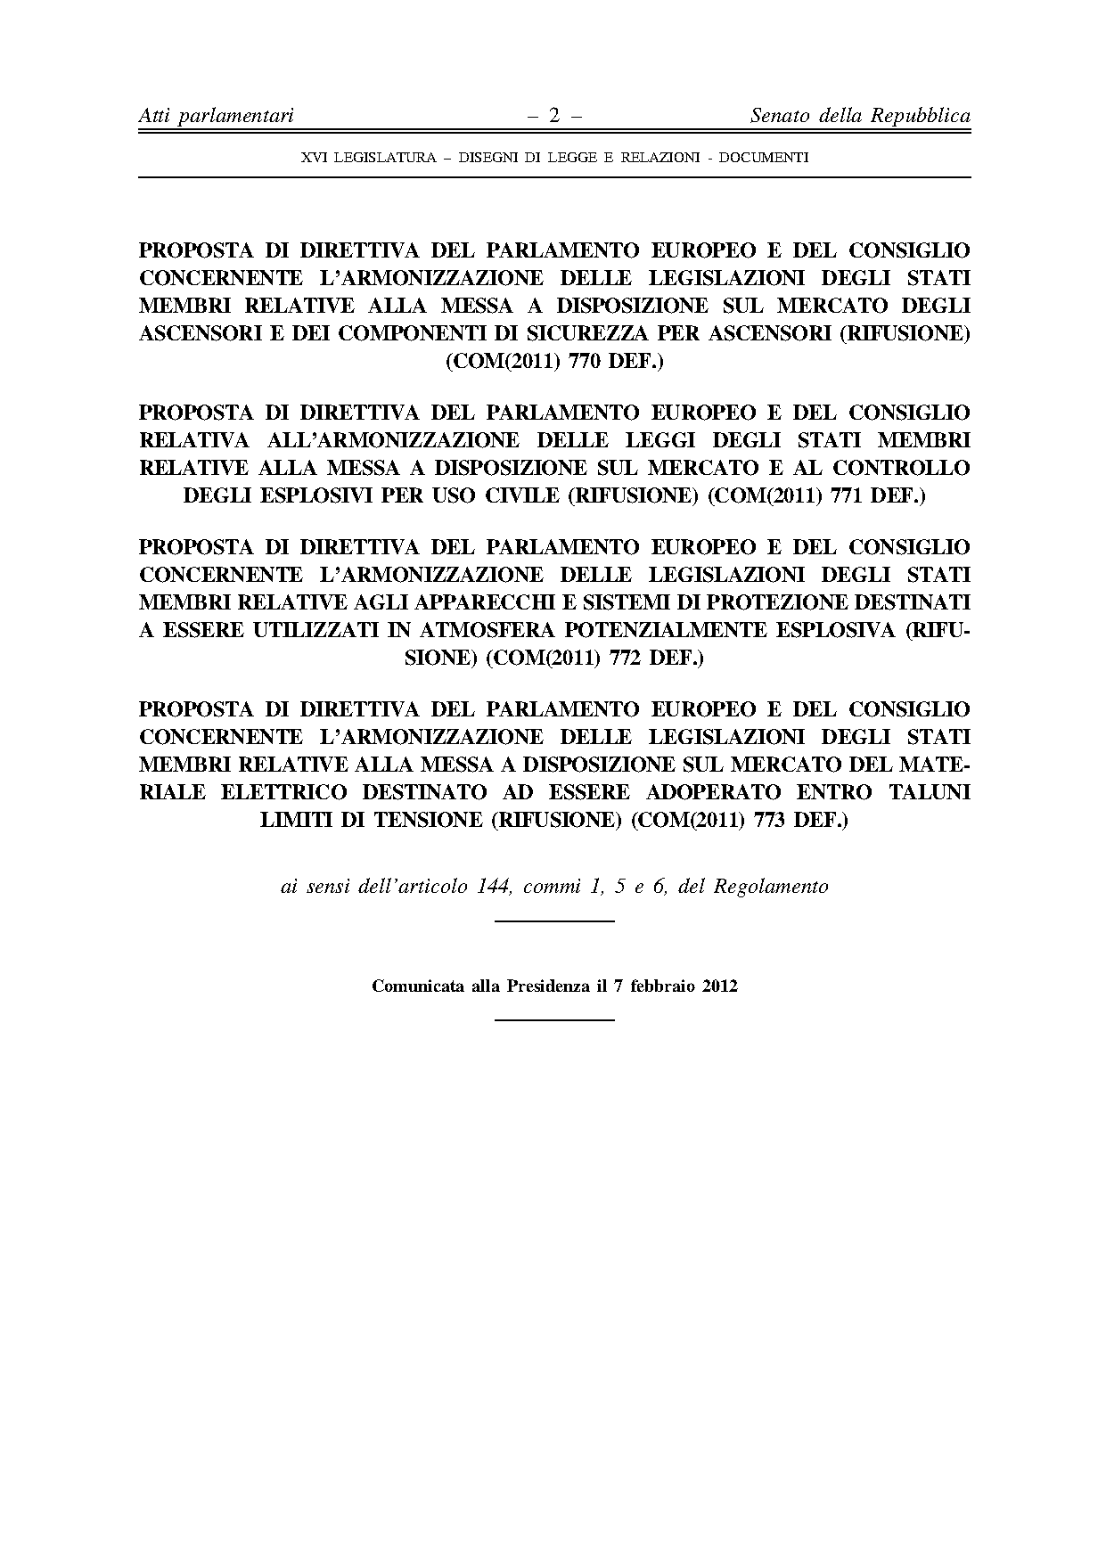
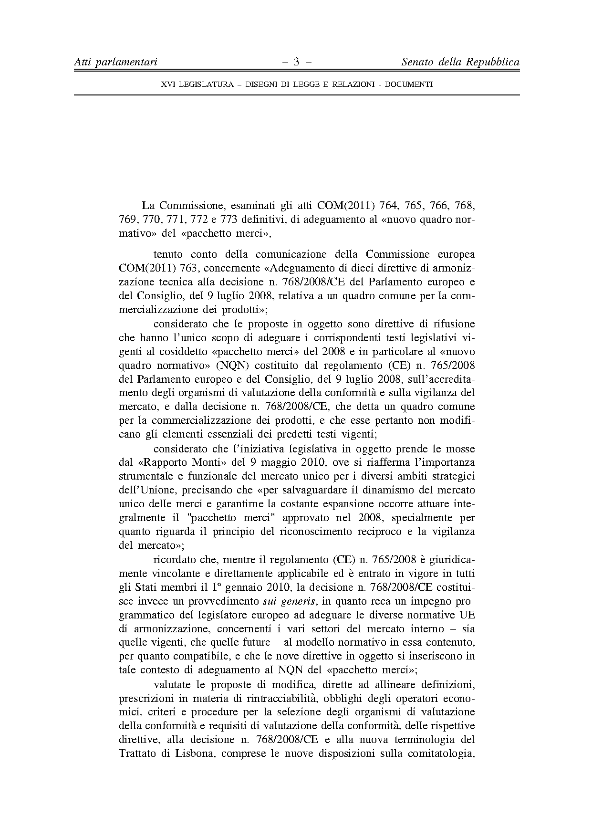
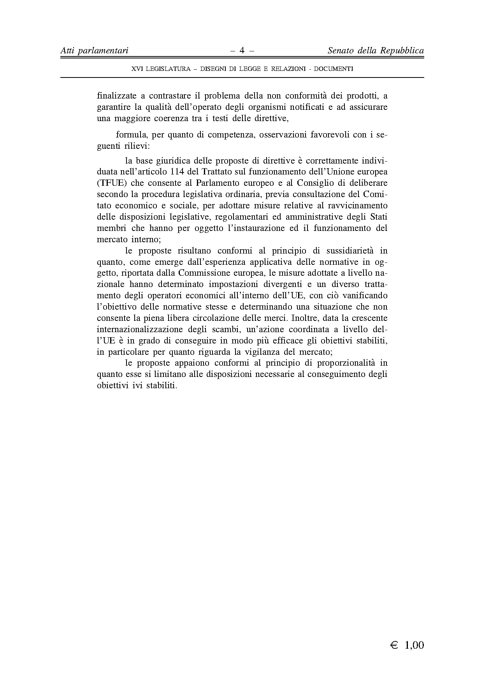

The translation can be found at the Interparliamentary EU information exchange site IPEX at the following address: http://www.ipex.eu/IPEXL-WEB/dossier/document/COM20110764.do#dossier-COD20110358 http://www.ipex.eu/IPEXL-WEB/dossier/document/COM20110765.do#dossier-COD20110351 http://www.ipex.eu/IPEXL-WEB/dossier/document/COM20110766.do#dossier-COD20110352 http://www.ipex.eu/IPEXL-WEB/dossier/document/COM20110768.do#dossier-COD20110350 http://www.ipex.eu/IPEXL-WEB/dossier/document/COM20110769.do#dossier-COD20110353 http://www.ipex.eu/IPEXL-WEB/dossier/document/COM20110770.do#dossier-COD20110354 http://www.ipex.eu/IPEXL-WEB/dossier/document/COM20110771.do#dossier-COD20110349 http://www.ipex.eu/IPEXL-WEB/dossier/document/COM20110772.do#dossier-COD20110356 http://www.ipex.eu/IPEXL-WEB/dossier/document/COM20110773.do#dossier-COD20110357

