 | 
COUNCIL OF  THE EUROPEAN UNION |  |  | Brussels, 17 February 2012
 | Interinstitutional File:  2011/0331 (NLE) |  | 6669/12
WTO 56
SERVICES 13
ACP 26
COASI 21
INST 145
PARLNAT 105

COVER NOTE
from: | the President of the Assembly of the Republic of Portugal
date of receipt: | 15 February 2012
to: | Ms Helle THORNING-SCHMIDT, President of the Council of the European Union
Subject: | Proposal for a Council Decision establishing the European Union position within the relevant instance of the World Trade Organization on the accession of Samoa to the World Trade Organization  [doc. 16785/11 WTO 408 SERVICES 122 ACP 221 COASI 204 - COM(2011) 732 final]  - Opinion on the application of the Principles of Subsidiarity and Proportionality

Delegations will find attached the above-mentioned opinion.

________________________

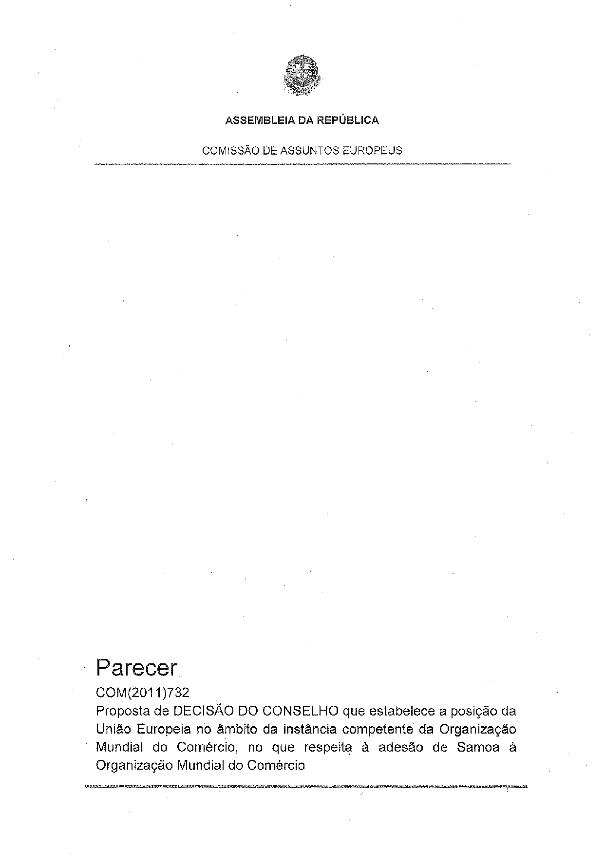
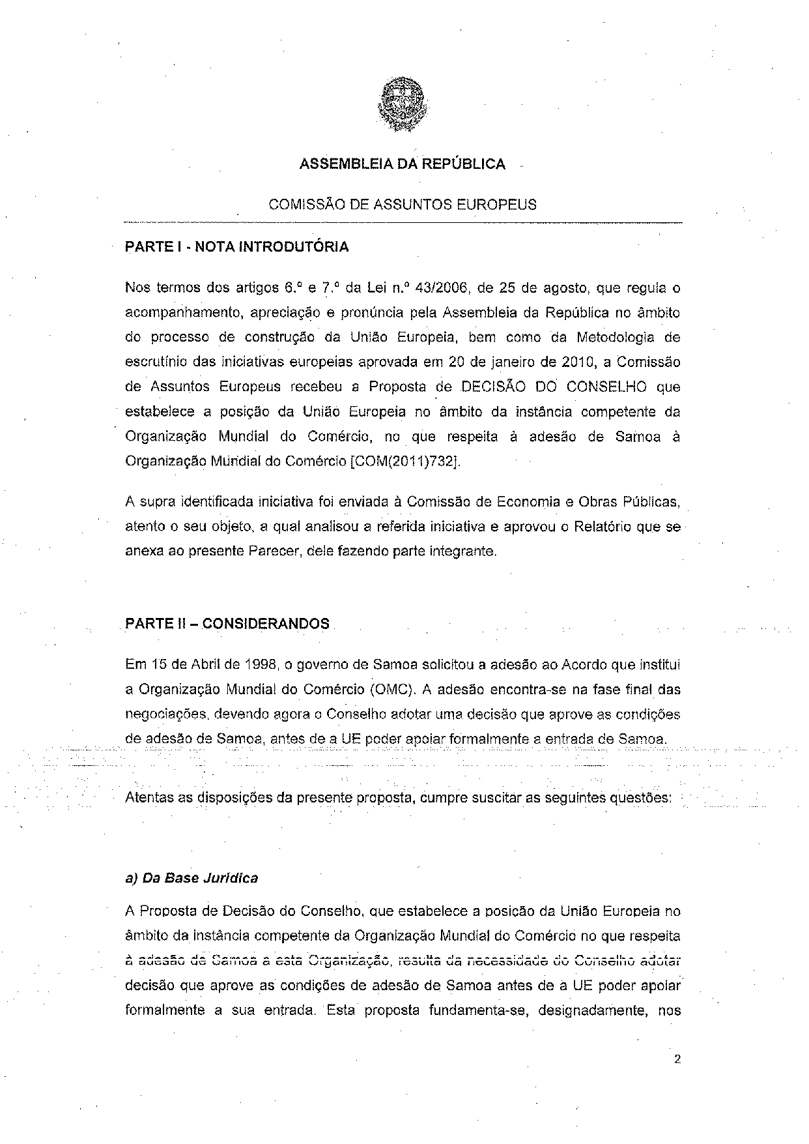
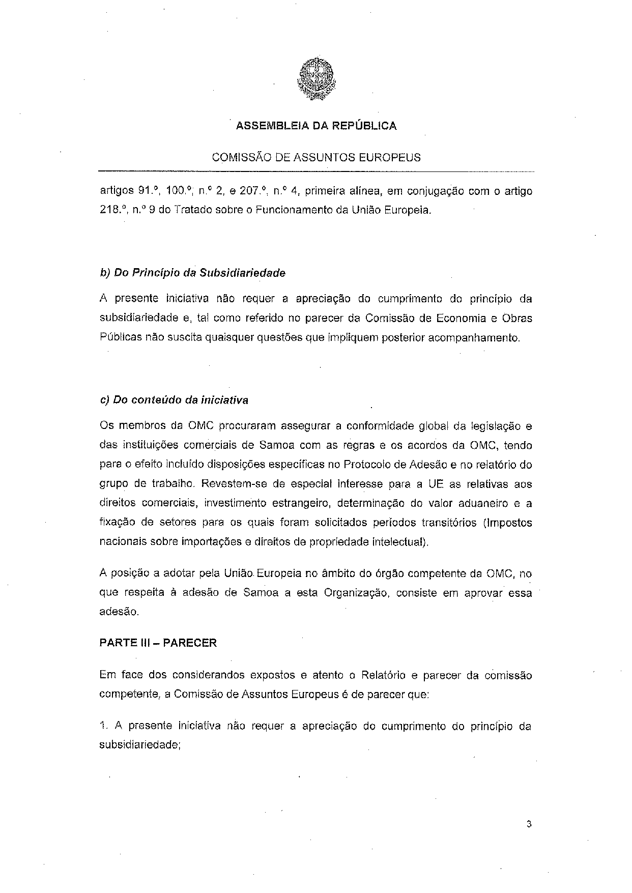
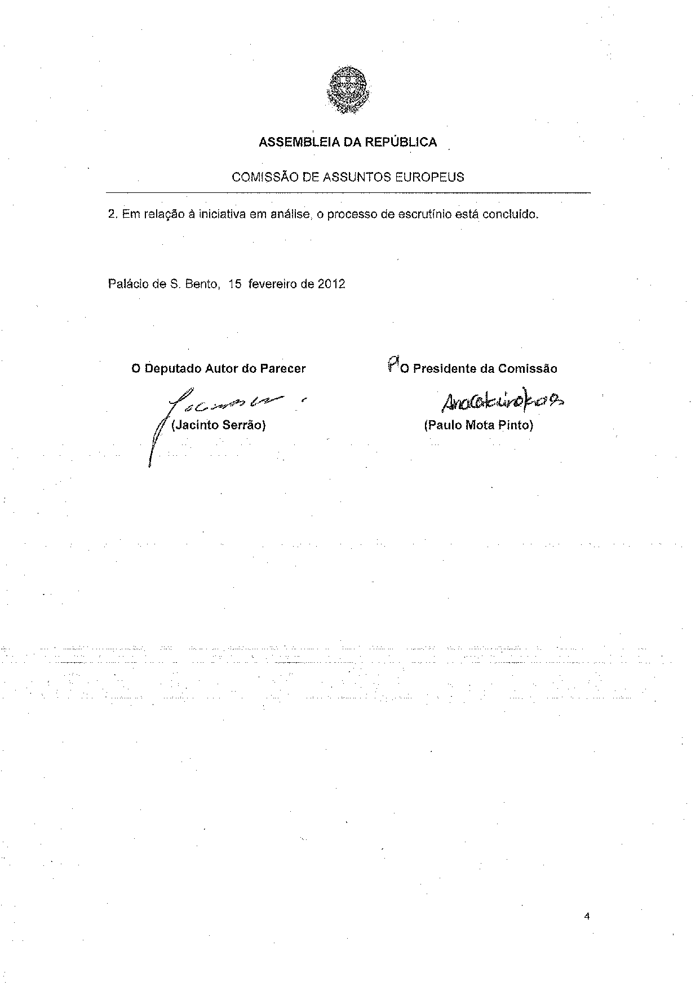
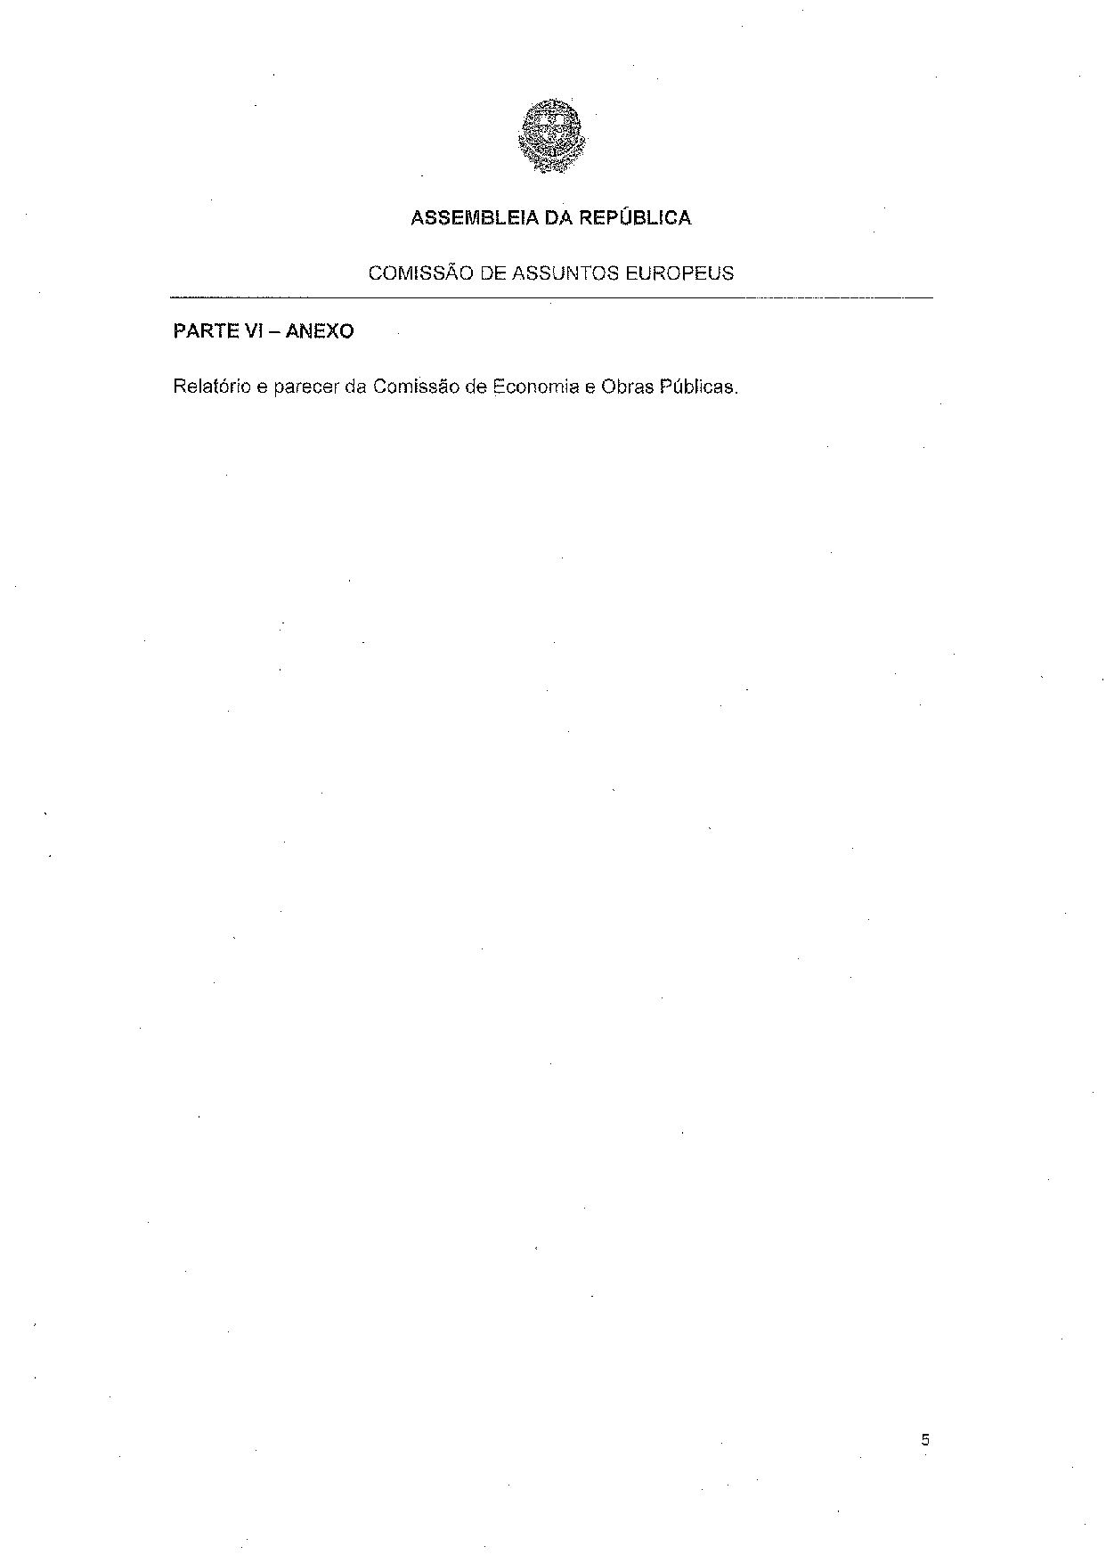
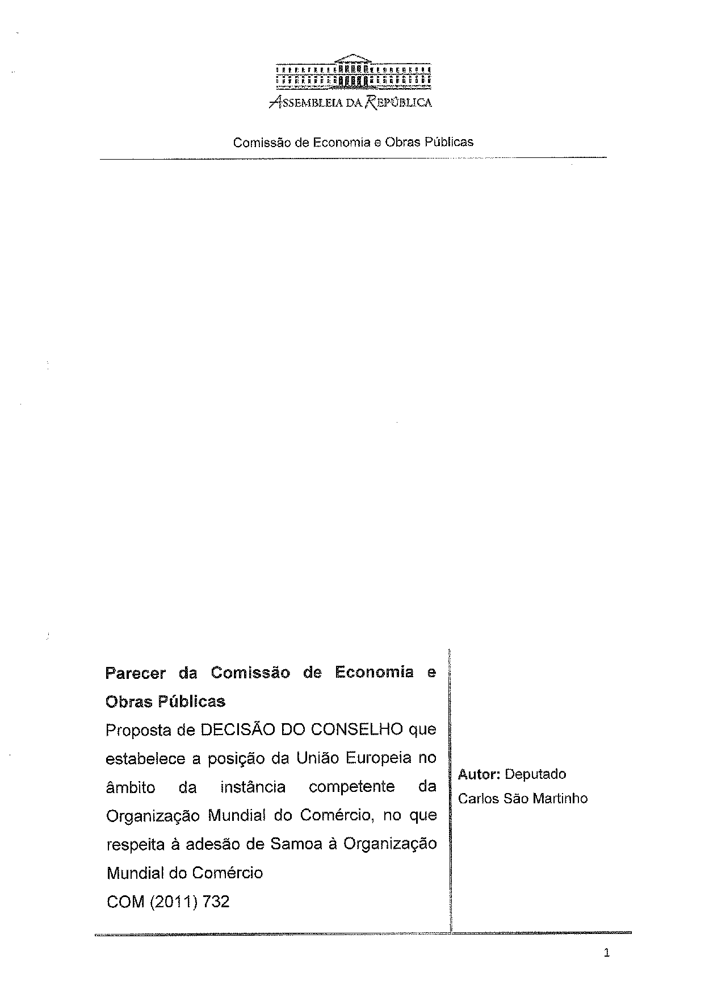
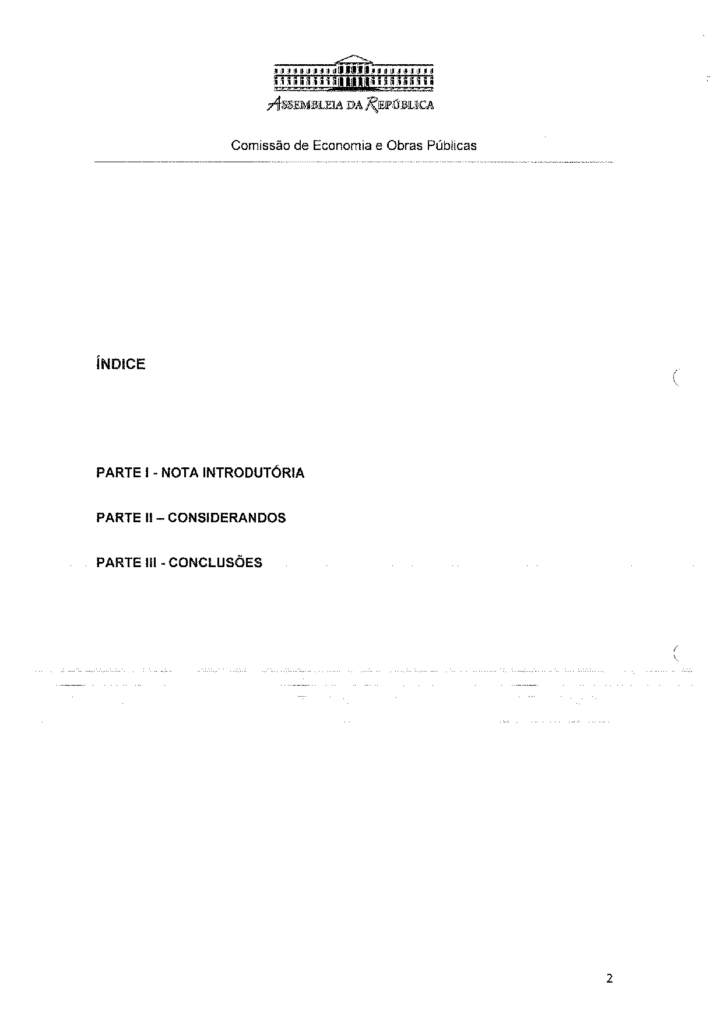
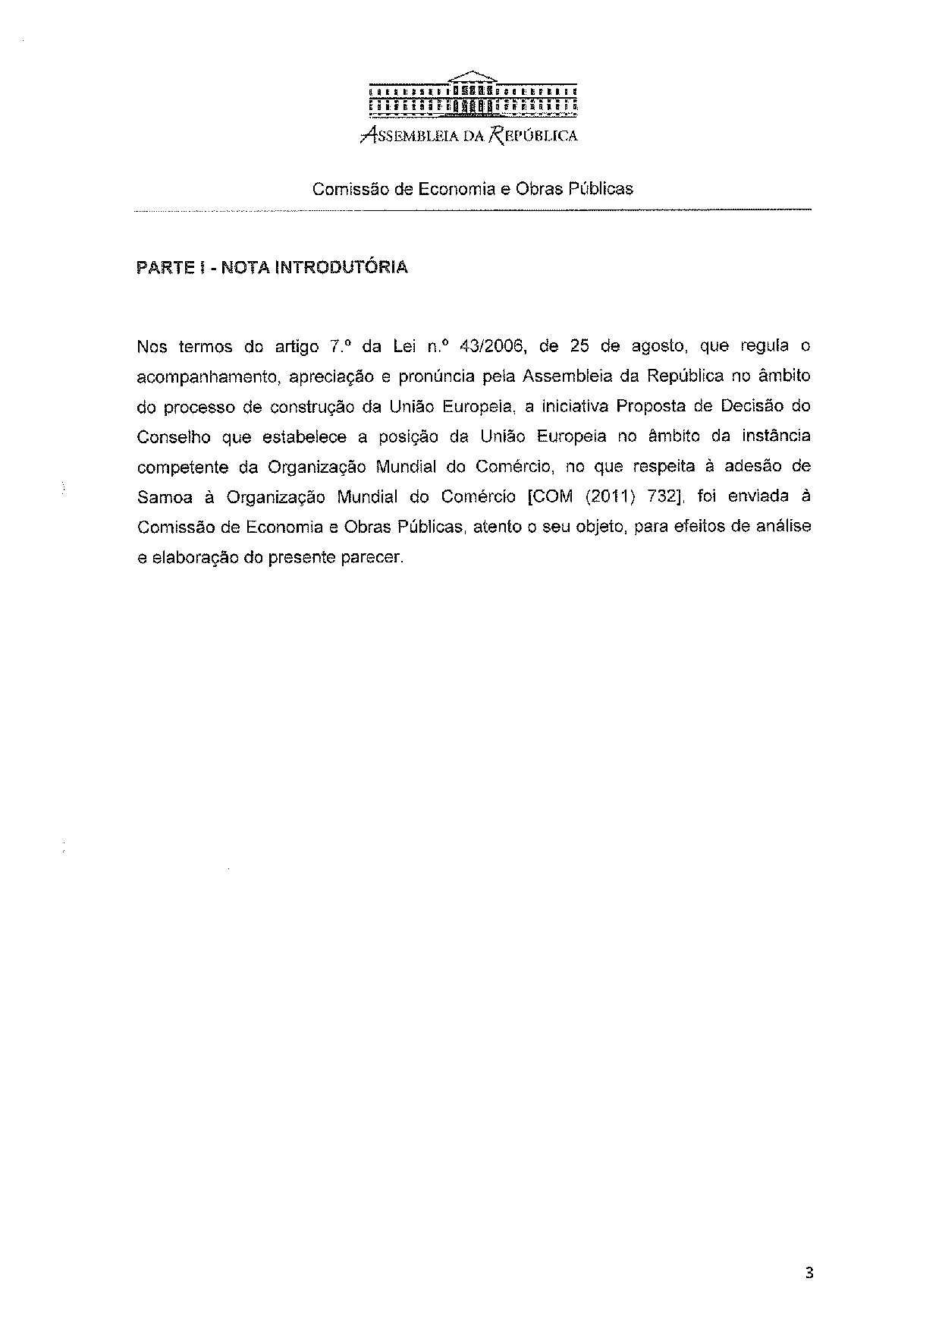
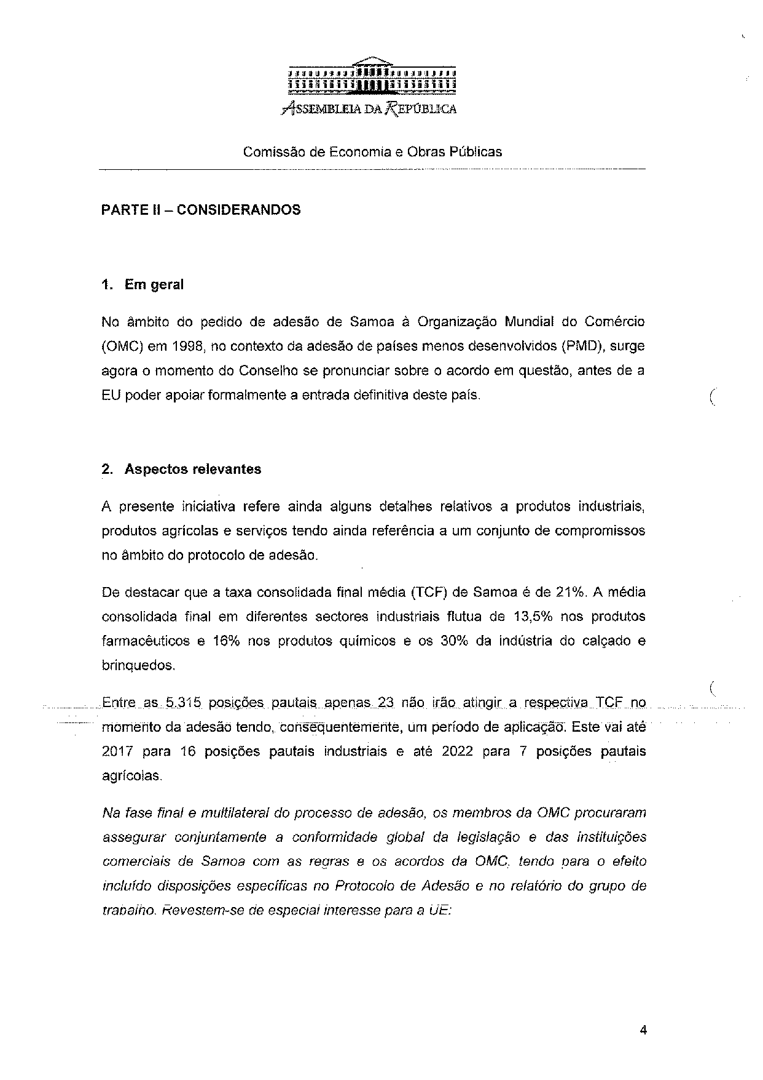
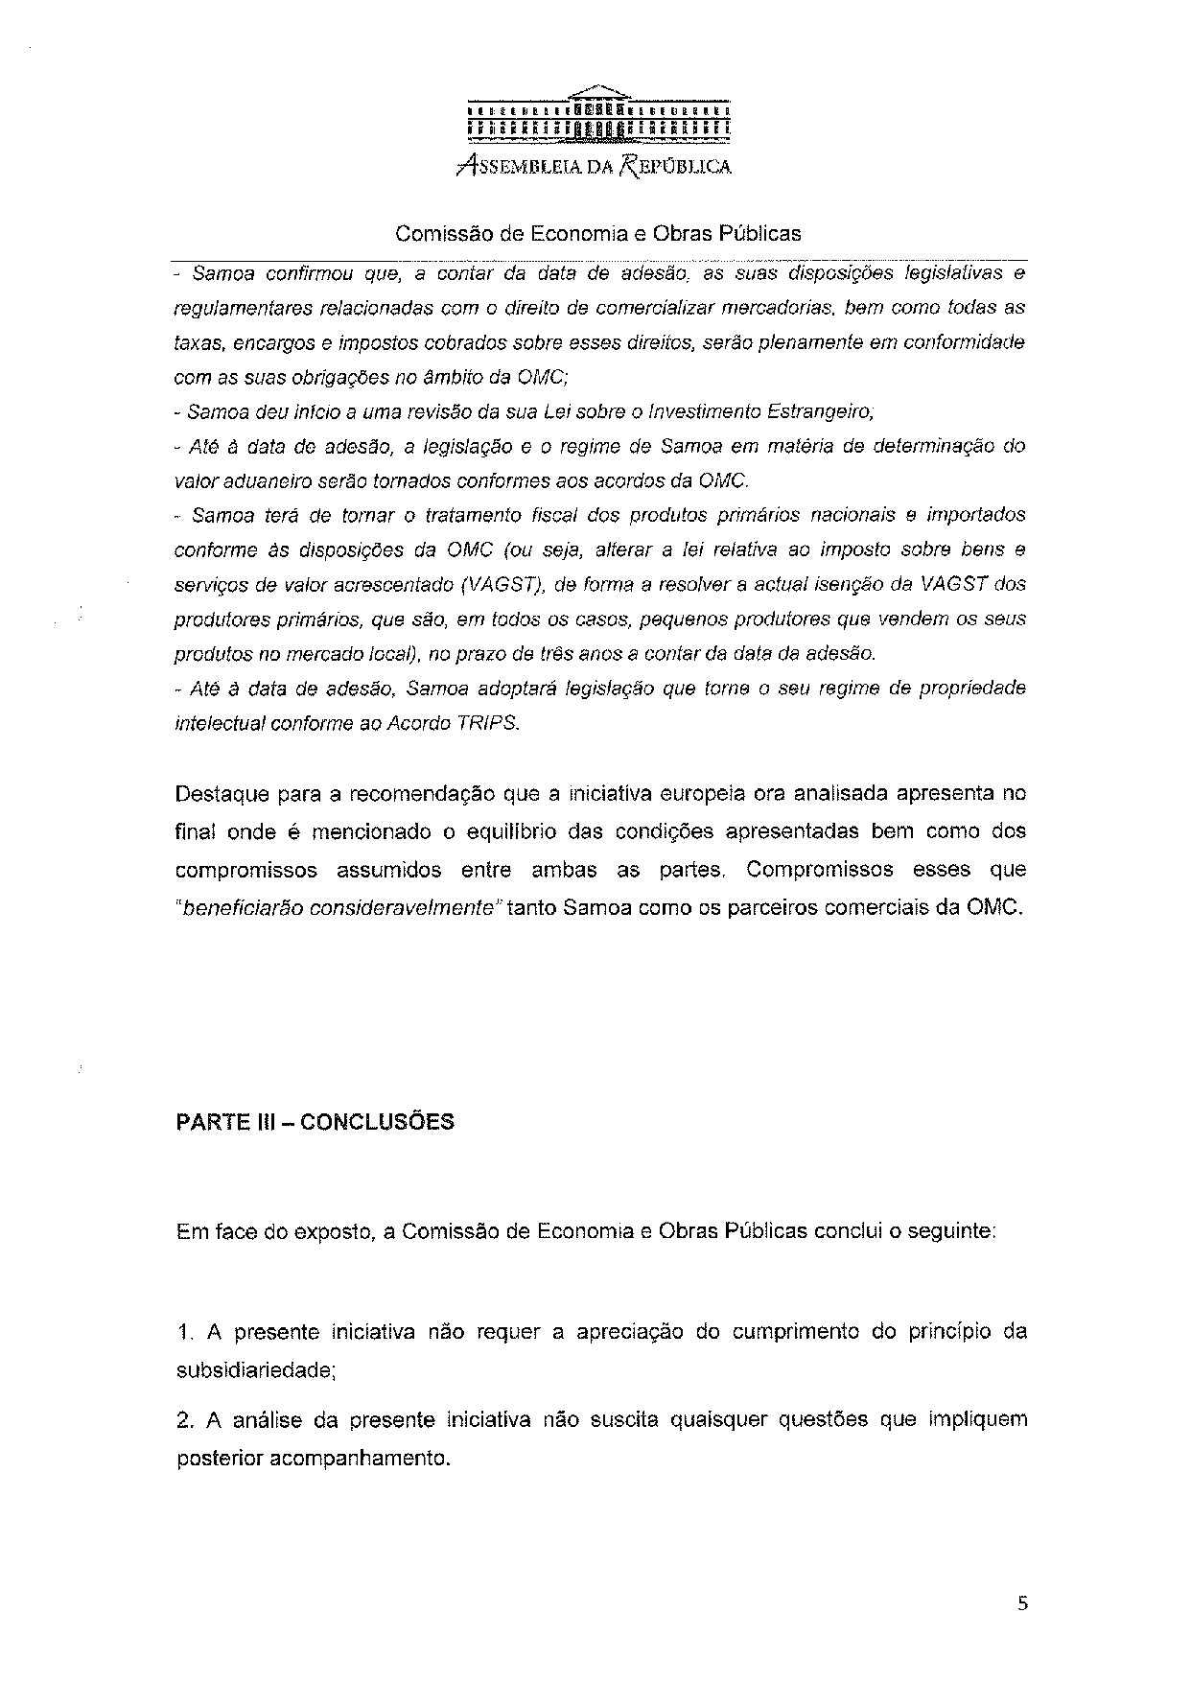
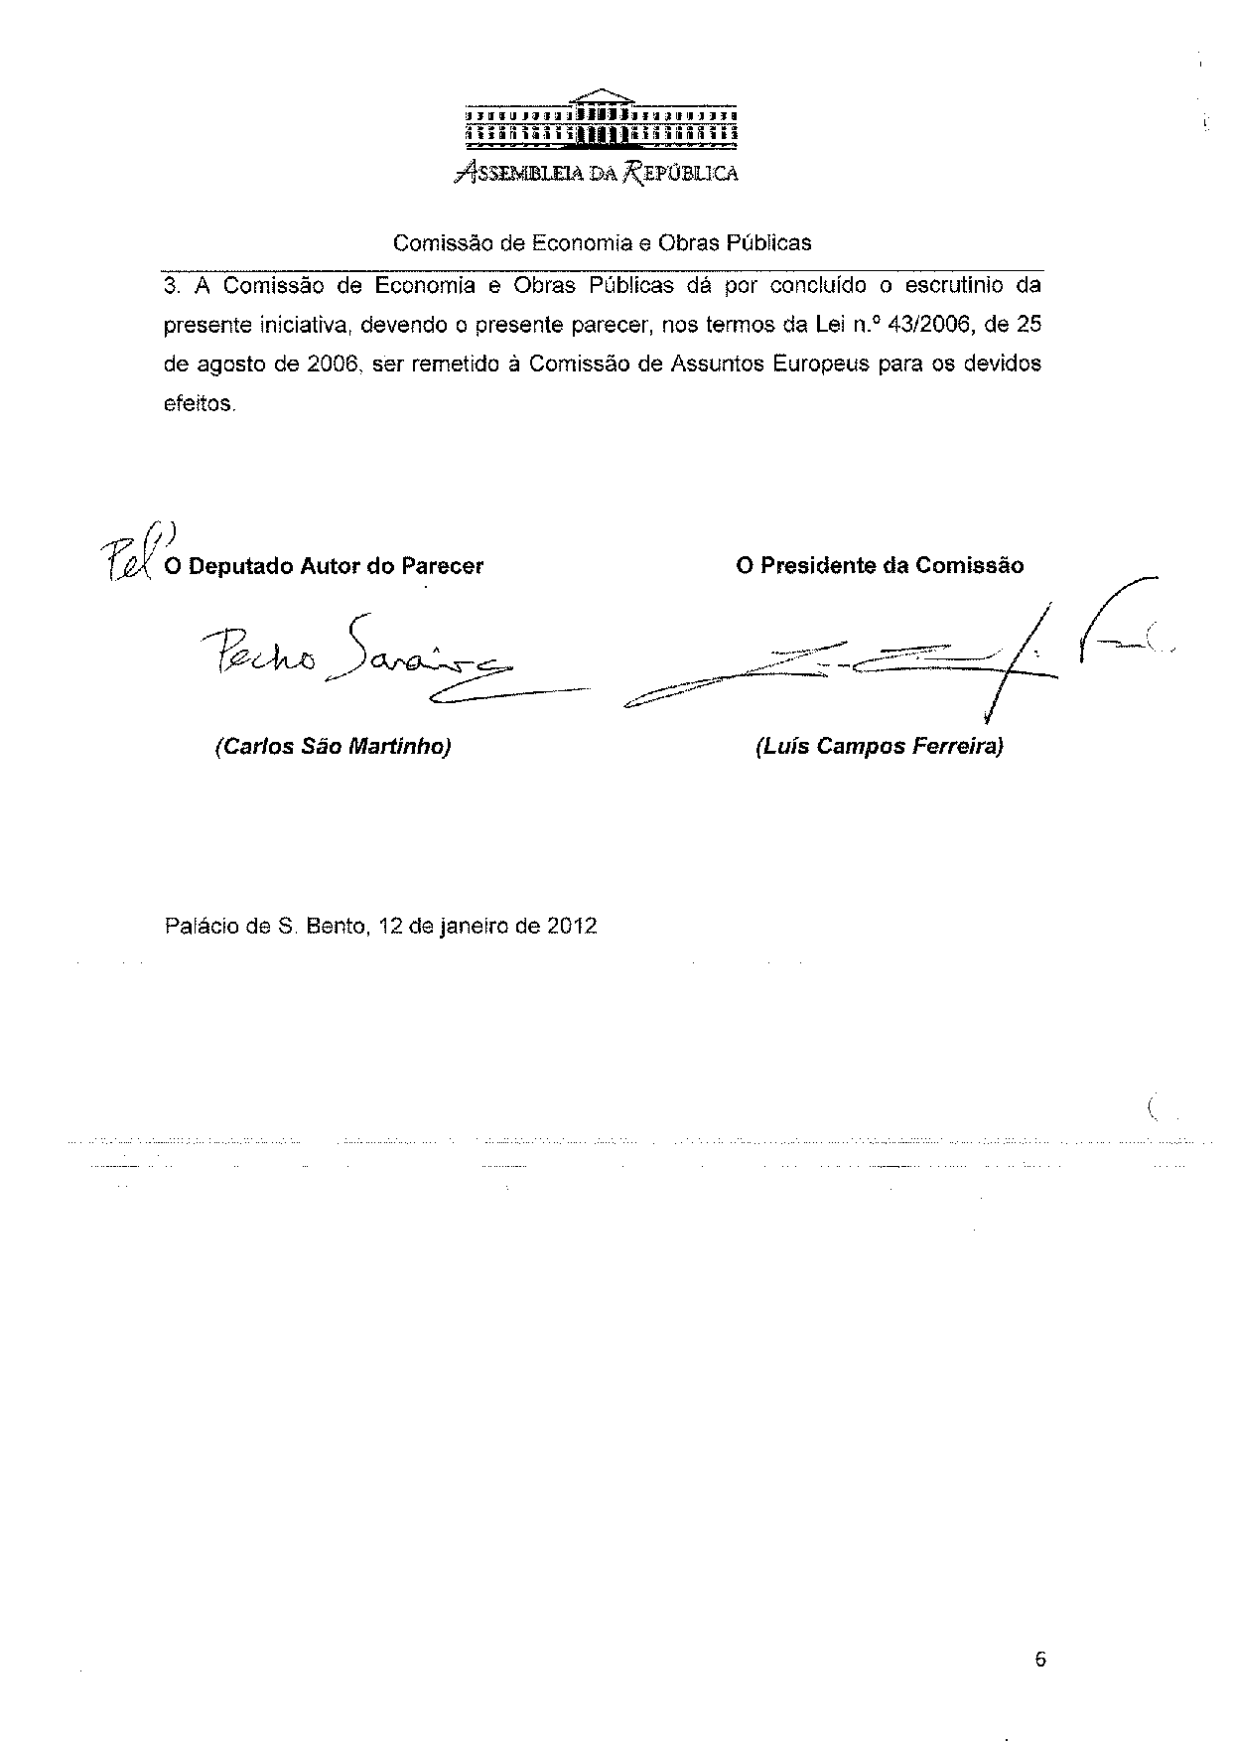

The translation of the opinion may be available at the Interparliamentary EU information exchange site IPEX, at the following address: http://www.ipex.eu/IPEXL-WEB/search.do.

