 | 
COUNCIL OF  THE EUROPEAN UNION |  |  | Brussels, 17 February 2012
 | Interinstitutional File:  2011/0458 (COD) |  | 6612/12
ECOFIN 164
RELEX 133
COEST 43
NIS 8
CODEC 407
INST 139
PARLNAT 99

COVER NOTE
from: | Portuguese Assembleia da República, Comissão de Assuntos Europeus
date of receipt: | 15 February 2012
to: | Mr Uwe CORSEPIUS, Secretary-General of the Council of the European Union
No Cion doc.: | COM(2011) 925 final
Subject: | Proposal for a decision of the European Parliament and of the Council providing macro-financial assistance to the Kyrgyz Republic [doc. ST 5075/12 ECOFIN 5 RELEX 12 COEST 4 NIS 1 CODEC 11 - COM(2011) 925 final]  - Opinion on the application of the Principles of Subsidiarity and Proportionality

Delegations will find attached the opinion of the Portuguese Parliament on COM (2011) 925 final - Council ST 5075/12.

________________________

Encl.:

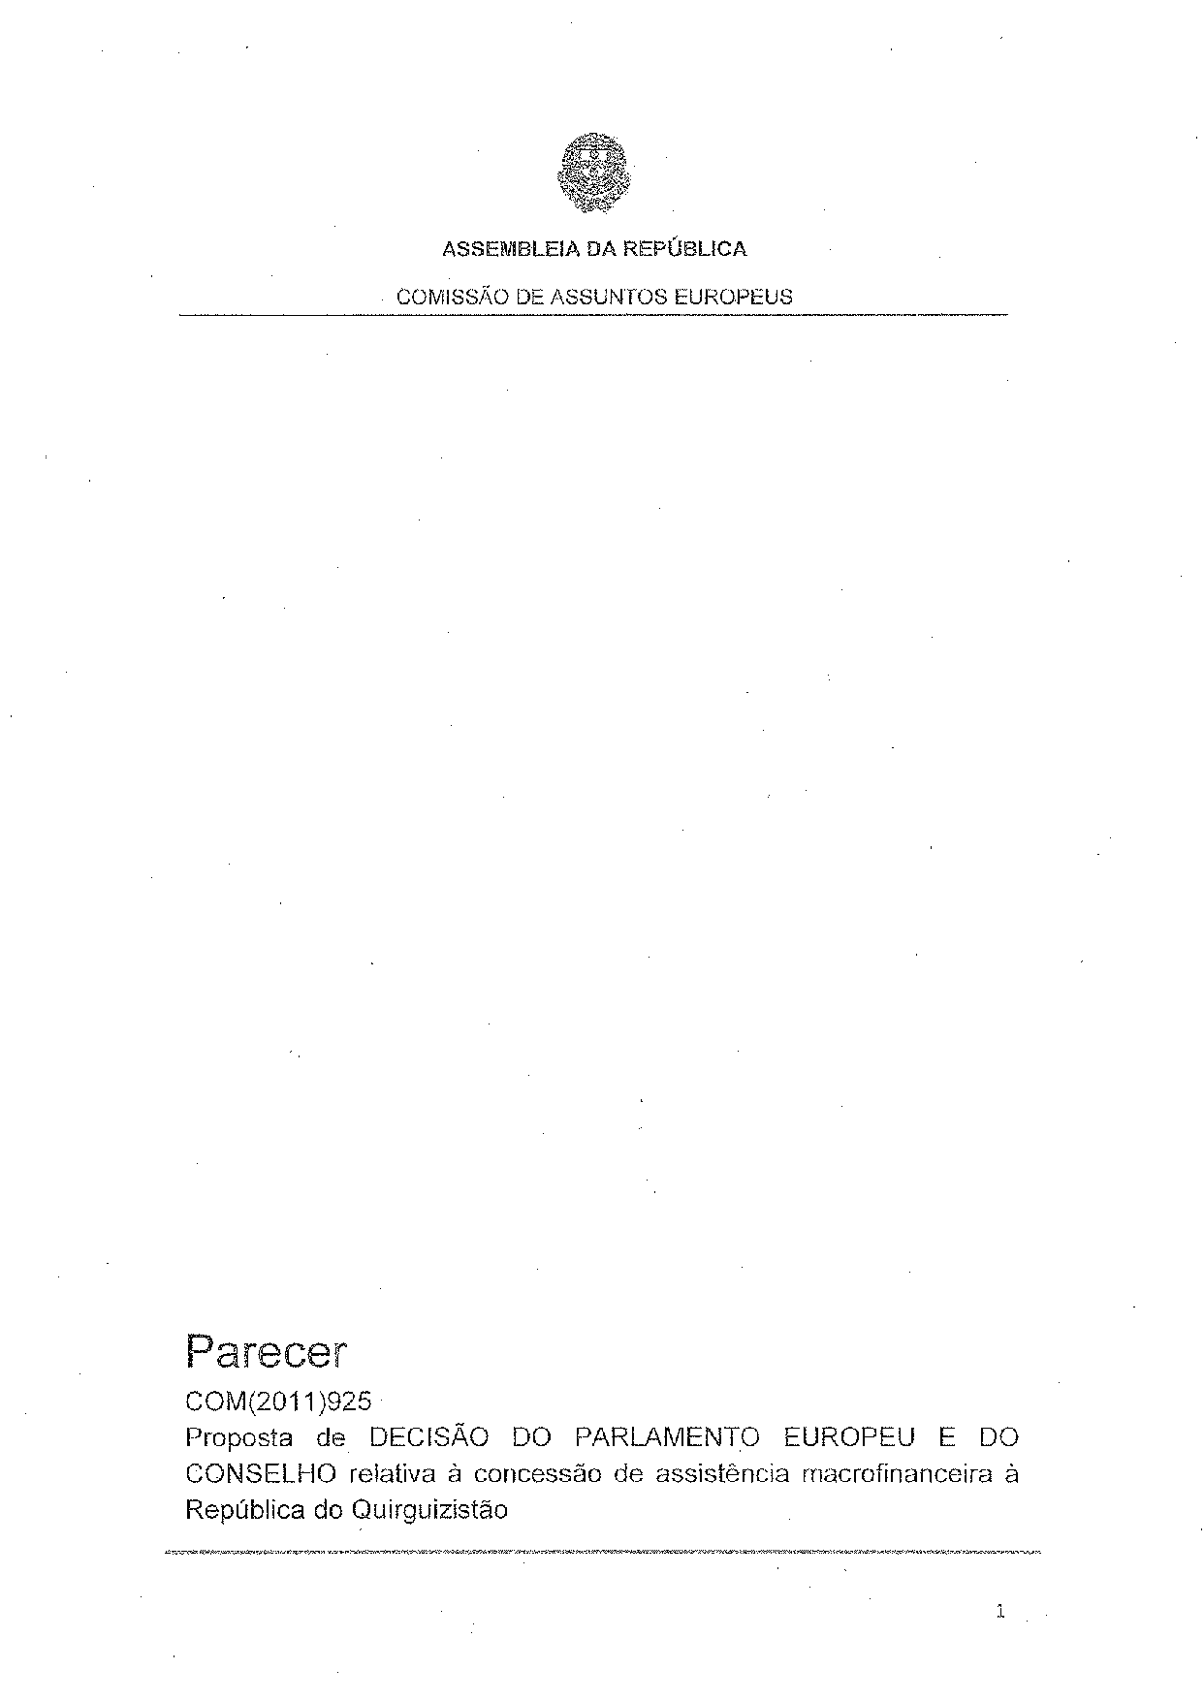
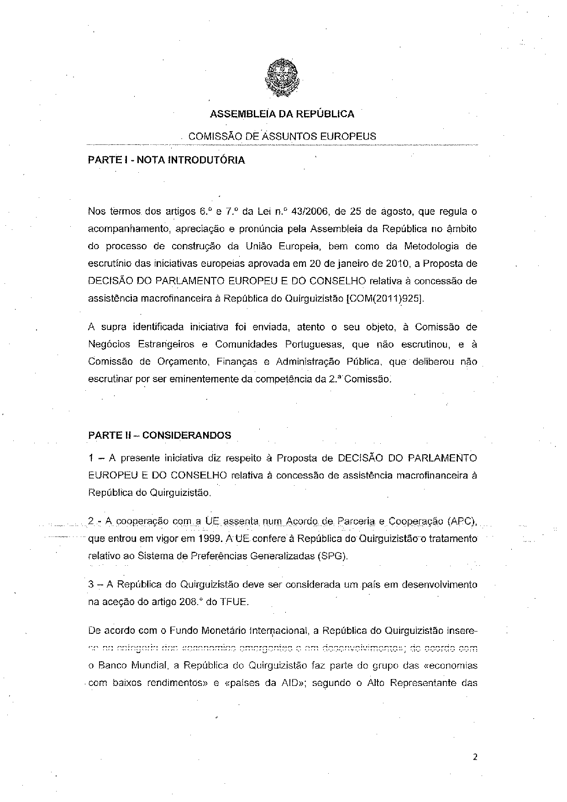
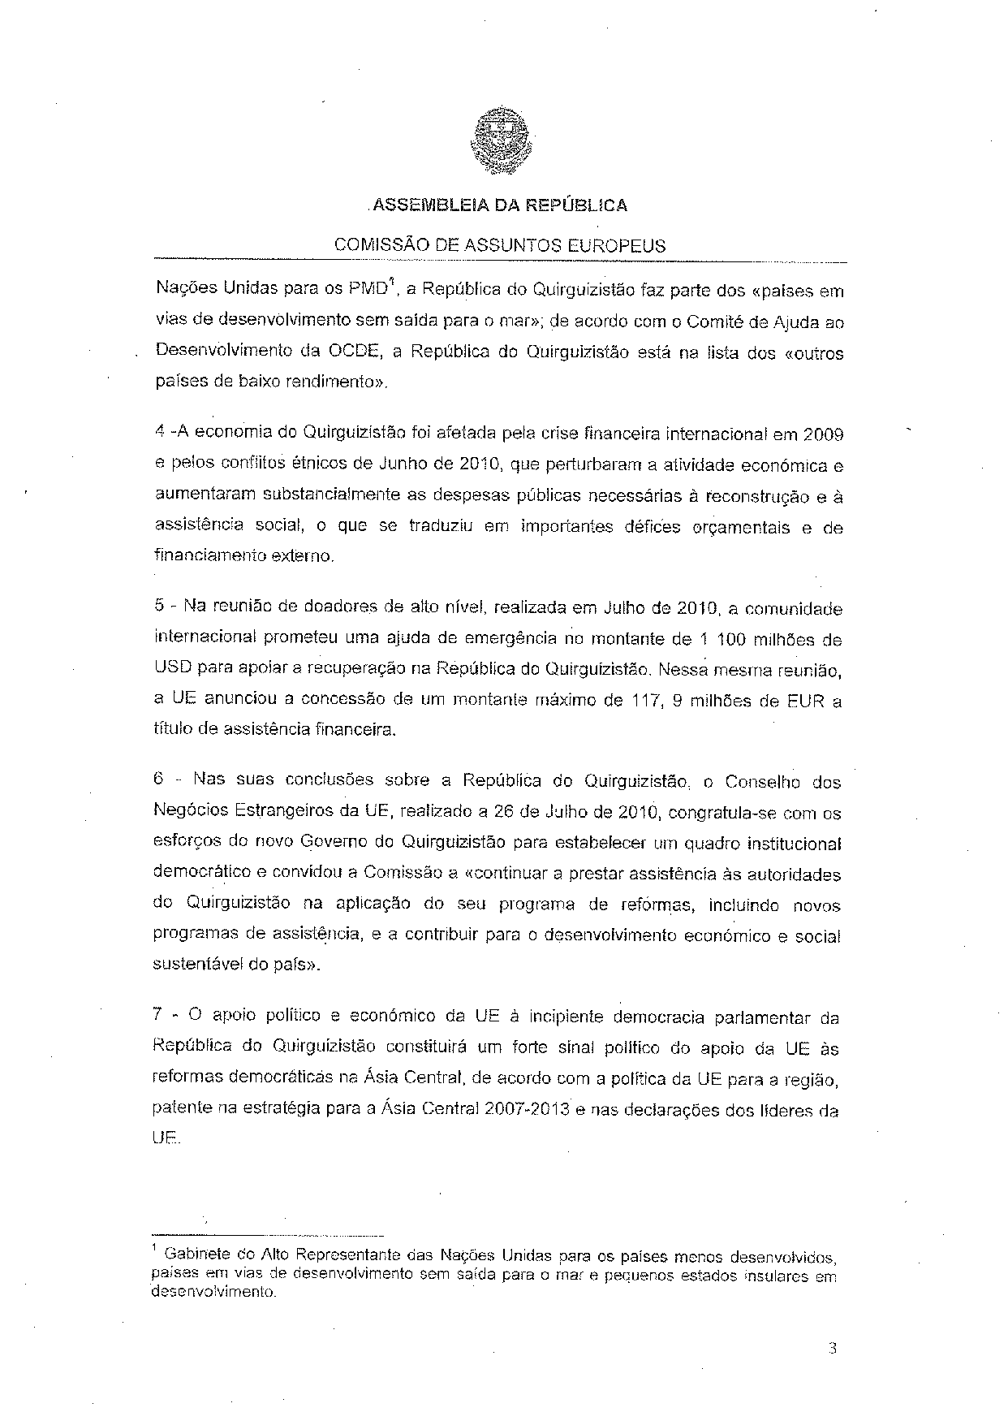
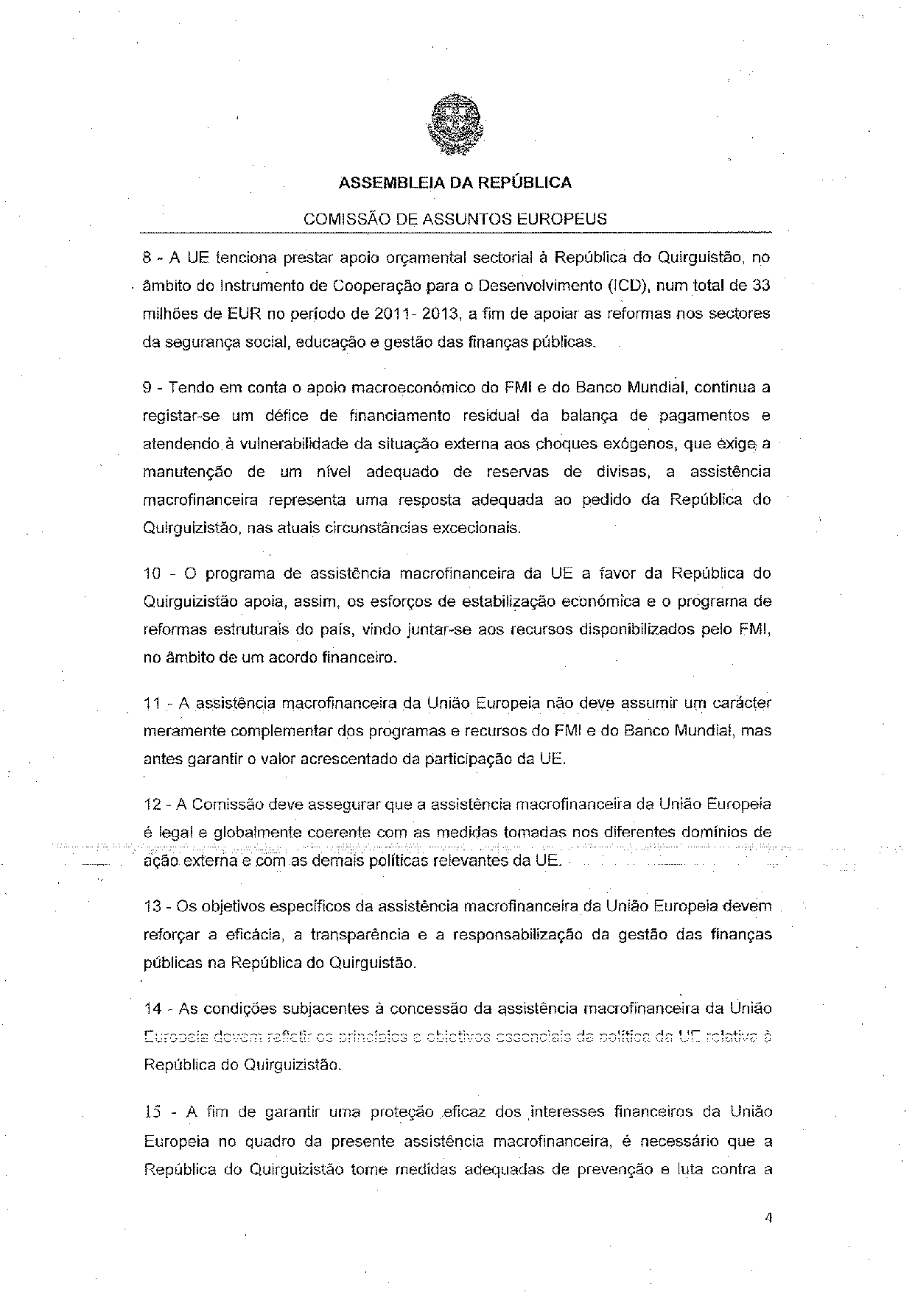
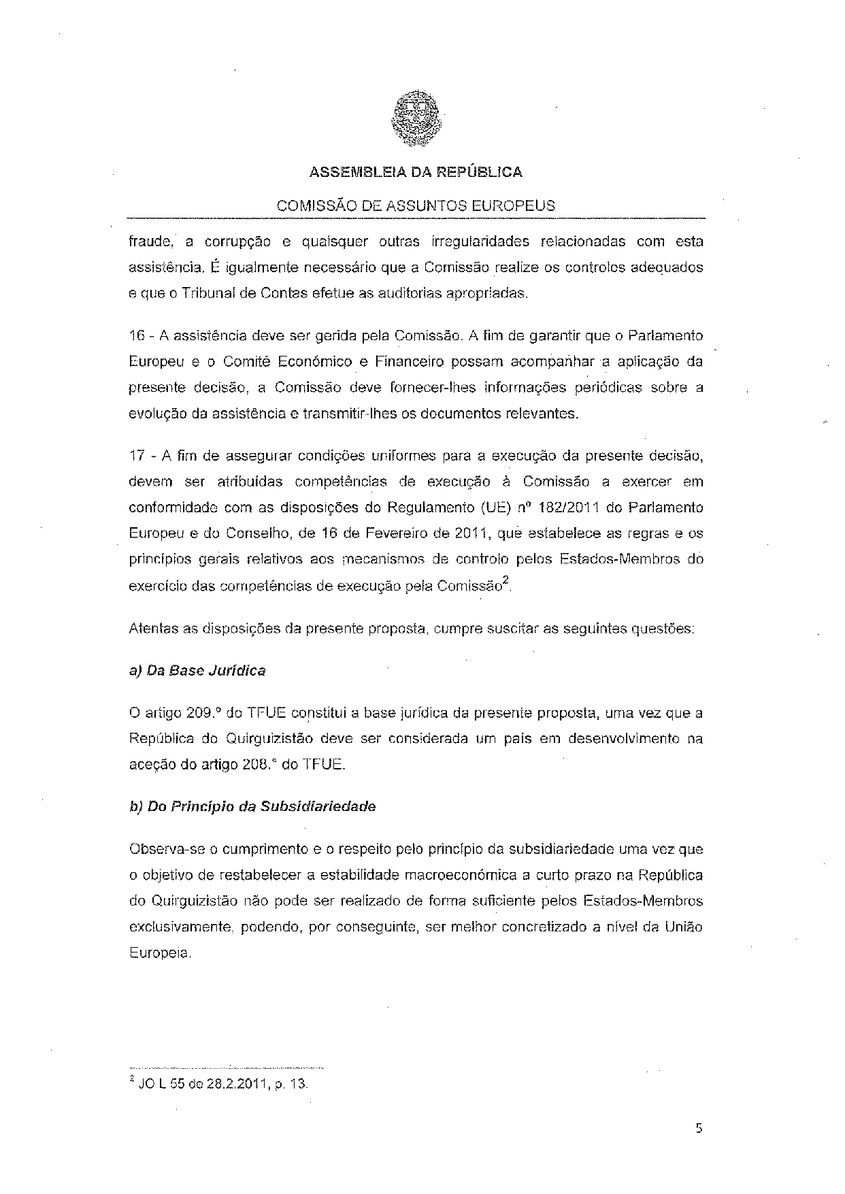
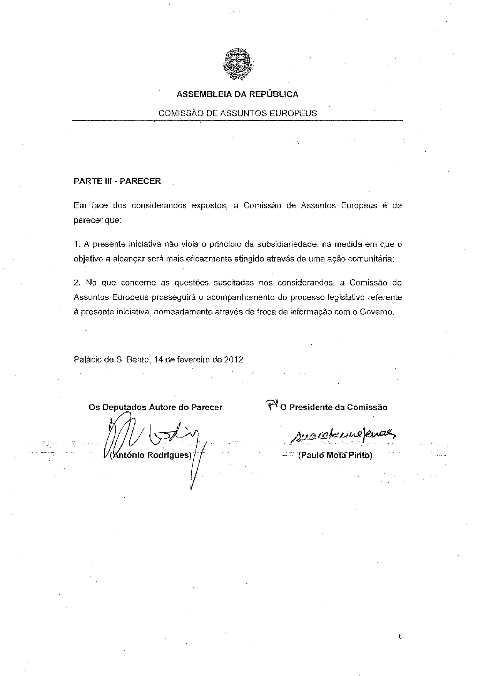

For other language versions of the opinion, reference is made to the Interparliamentary EU information exchange site IPEX at the following address: http://www.ipex.eu/IPEXL-WEB/search.do

