 | 
COUNCIL OF  THE EUROPEAN UNION |  |  | Brussels, 24 February 2012
 | Interinstitutional File:  2011/0301 (COD) |  | 6863/12
ECOFIN 193
COMPET 112
TRANS 62
RECH 70
ENER 75
ENV 149
TELECOM 38
ECO 25
CODEC 473
INST 153
PARLNAT 113

COVER NOTE
from: | The President of the Italian Senate
date of receipt: | 17 February 2012
to: | Mr Uwe CORSEPIUS, Secretary-General of the Council of the European Union
Subject: | Proposal for a Regulation of the European Parliament and of the Council amending Decision No 1639/2006/EC establishing a Competitiveness and Innovation Framework Programme (2007-2013) and Regulation (EC) No 680/2007 laying down general rules for the granting of Community financial aid in the field of the trans-European transport and energy networks [doc. ST 16627/11 ECOFIN 753 COMPET 498 TRANS 306 RECH 364 ENER 355 ENV 854 TELECOM 173 ECO 134 CODEC 1946- COM(2011) 659 final]  - Opinion on the application of the Principles of Subsidiarity and Proportionality

Delegations will find attached the opinion of the Italian Parliament on COM (2011) 659 final - Council ST 16627/11..
________________________

Encl.:
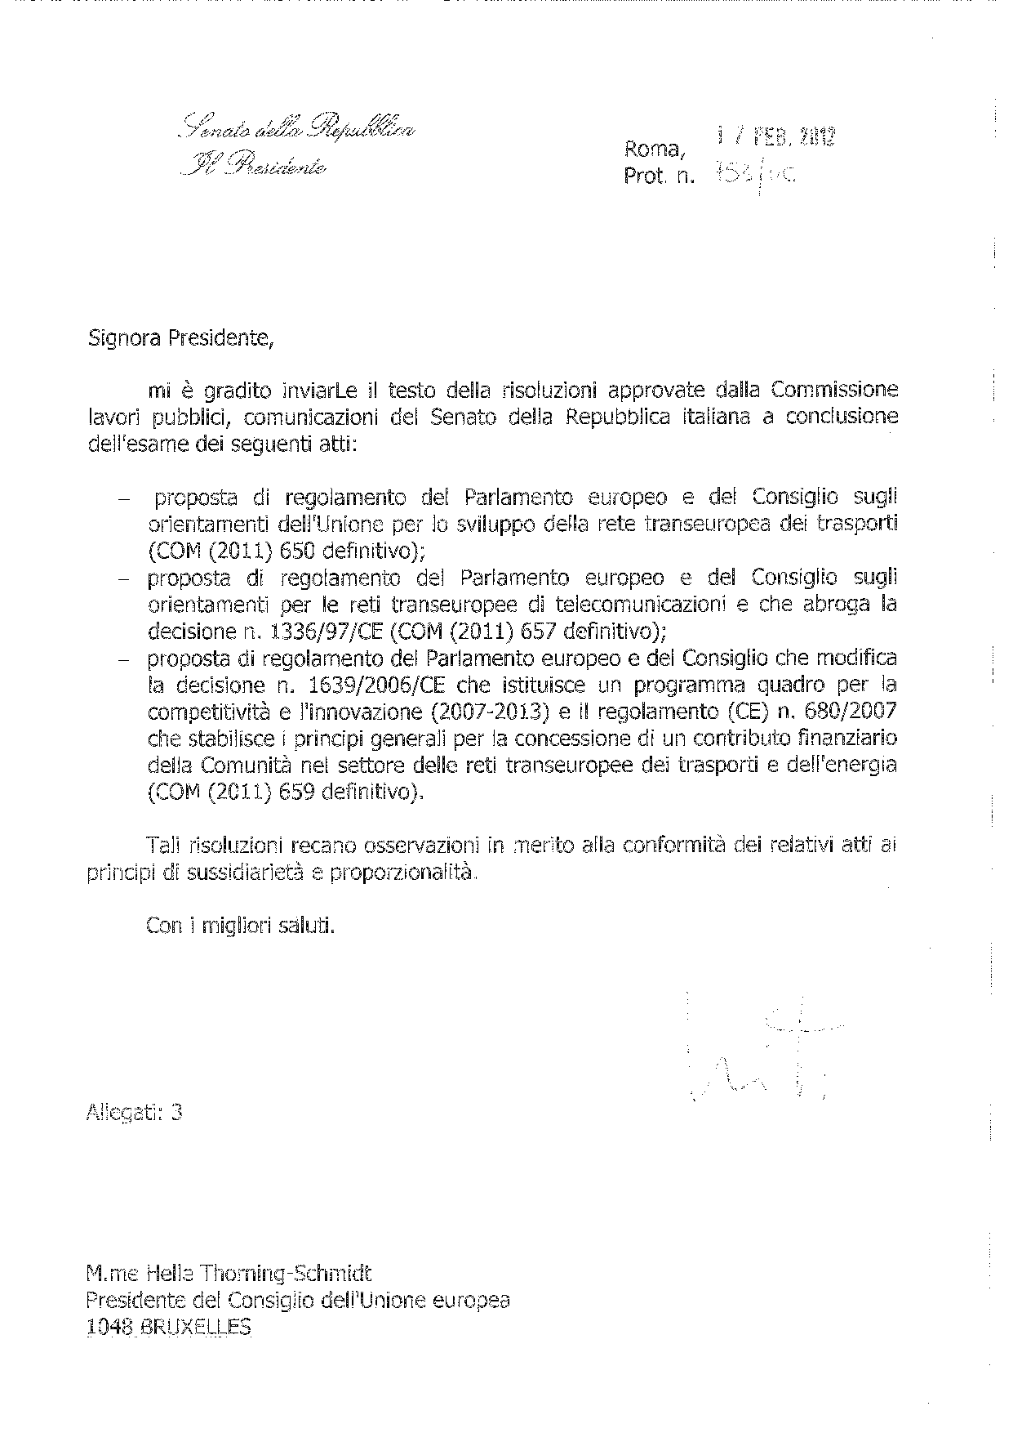

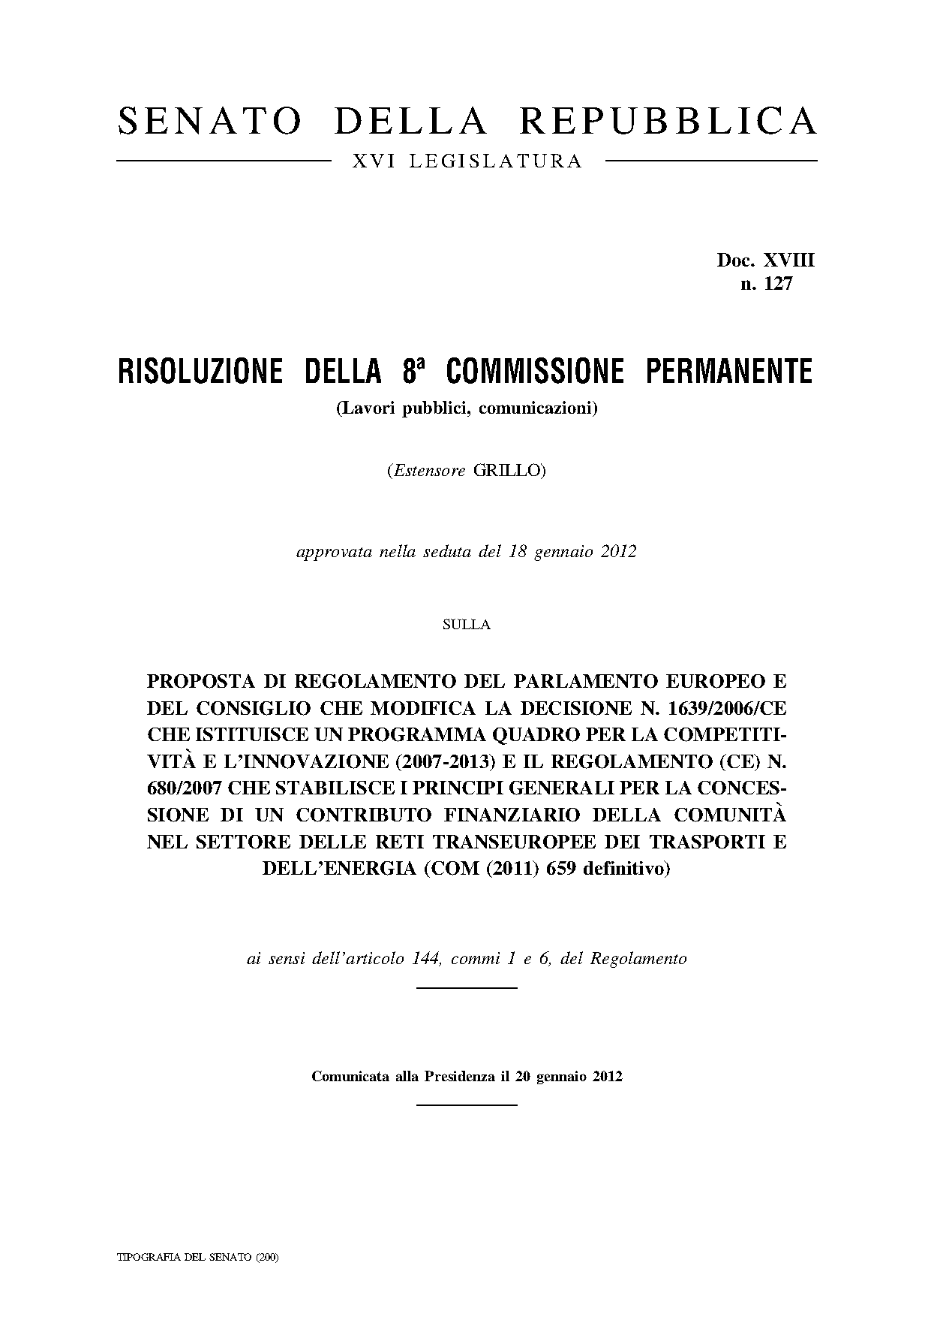
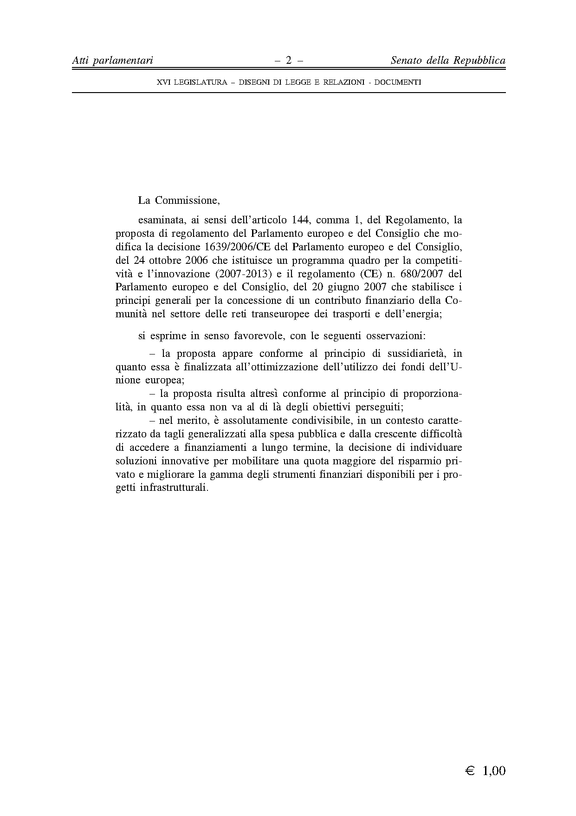

For other language versions of the opinion, reference is made to the Interparliamentary EU information exchange site IPEX at the following address: http://www.ipex.eu/IPEXL-WEB/search.do

