 | 
COUNCIL OF  THE EUROPEAN UNION |  |  | Brussels, 24 February 2012
 | Interinstitutional File:  2011/0303 (NLE) |  | 6926/12
AMLAT 8
PESC 228
WTO 68
INST 156
PARLNAT 116

COVER NOTE
from: | the President of the Assembly of the Republic of Portugal
date of receipt: | 23 February 2012
to: | Ms Helle THORNING-SCHMIDT, President of the Council of the European Union
Subject: | Proposal for a Council Decision on the conclusion of the Agreement establishing an Association between the European Union and its Member States, on the one hand, and Central America on the other  [doc. 16394/11 AMLAT 98 PESC 1389 WTO 387- COM(2011) 679 final]  - Opinion on the application of the Principles of Subsidiarity and Proportionality

Delegations will find attached the above-mentioned opinion.

________________________

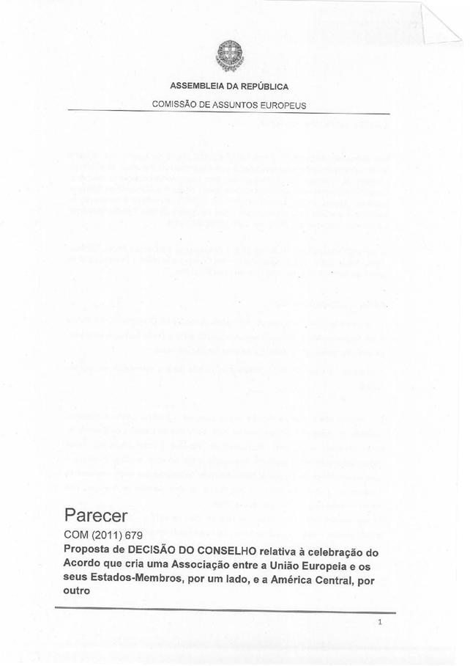
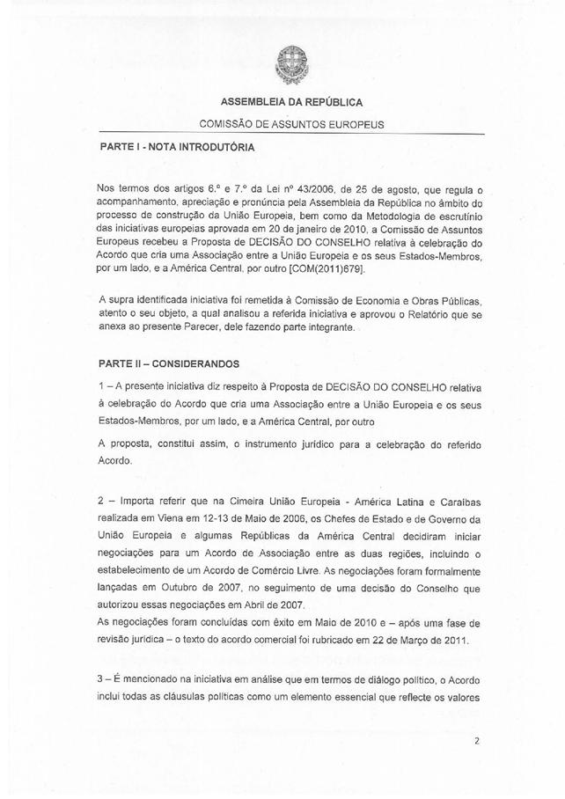
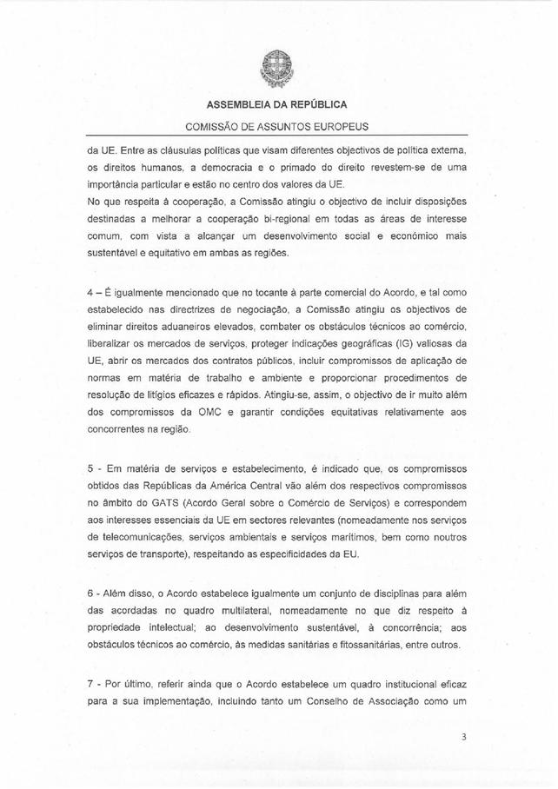
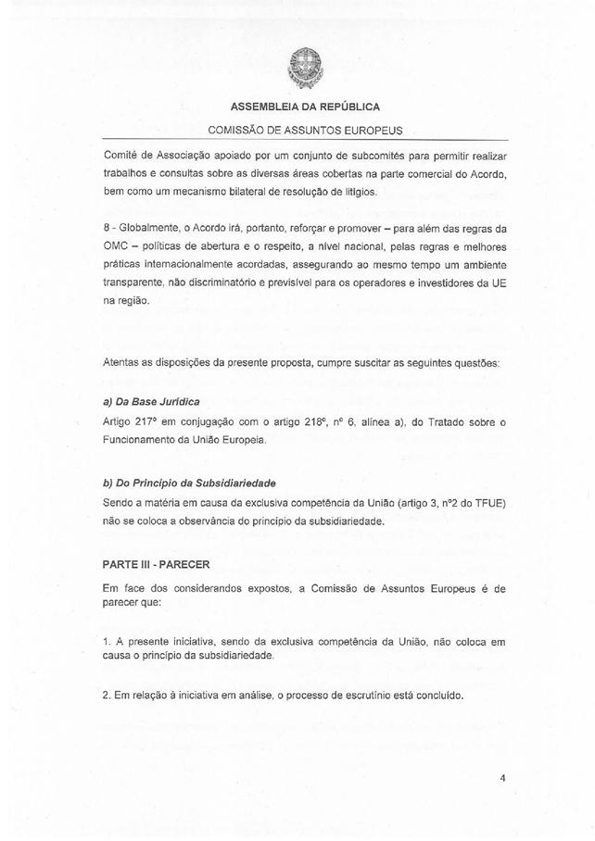
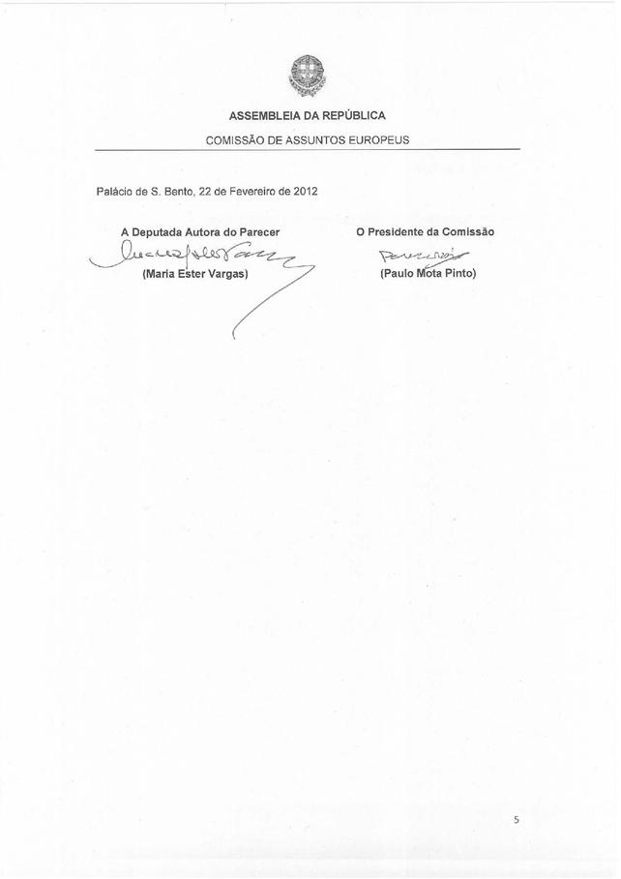

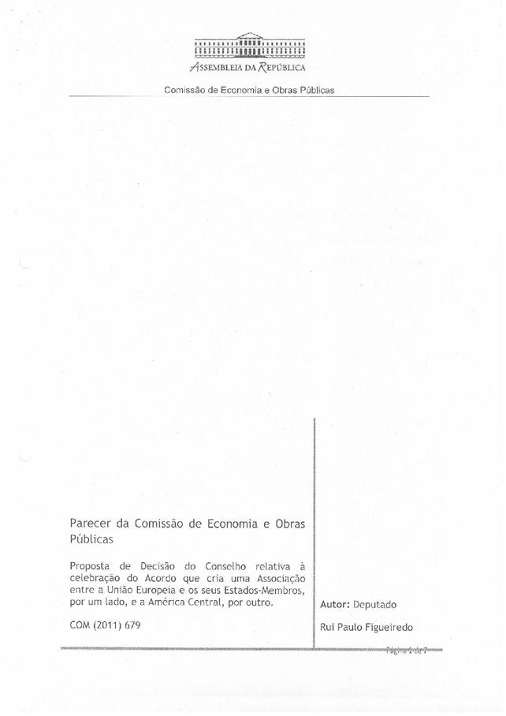
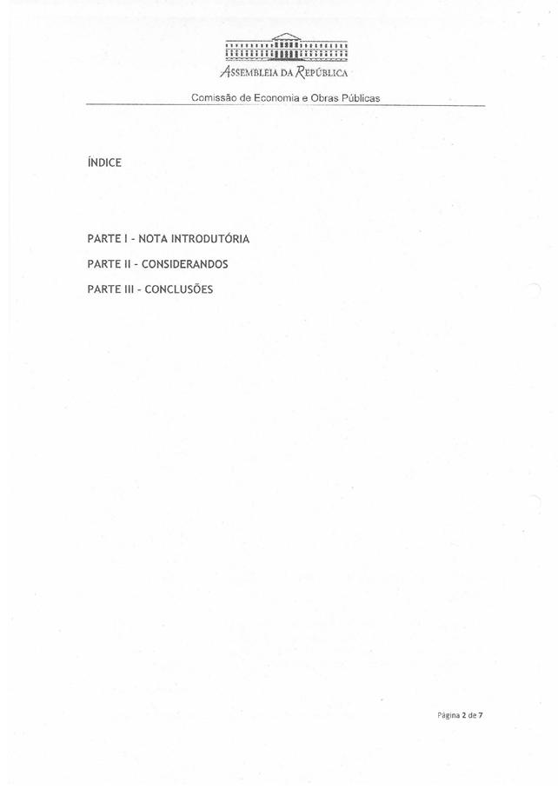
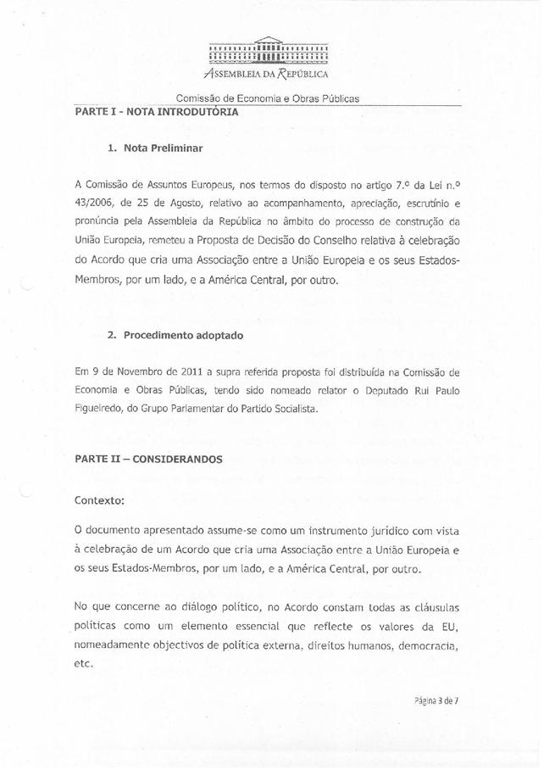
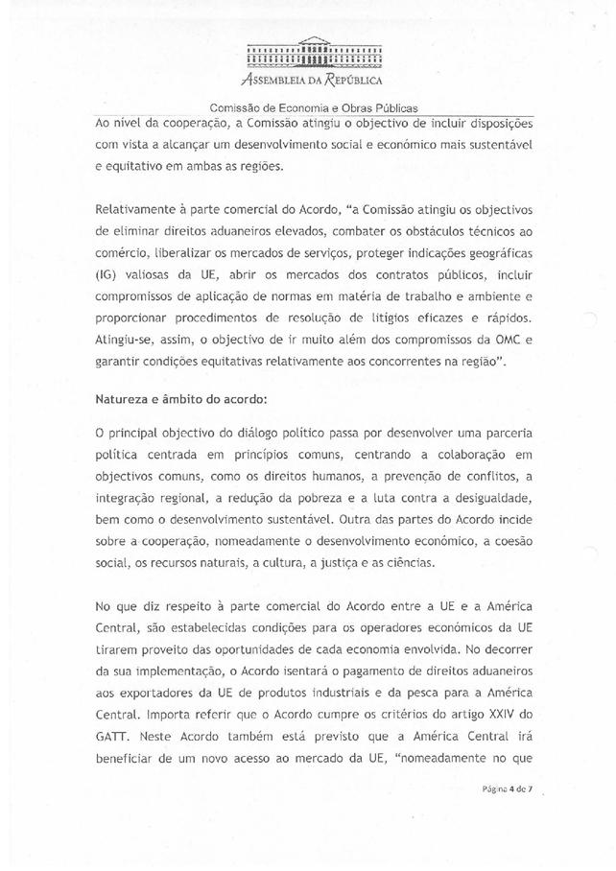
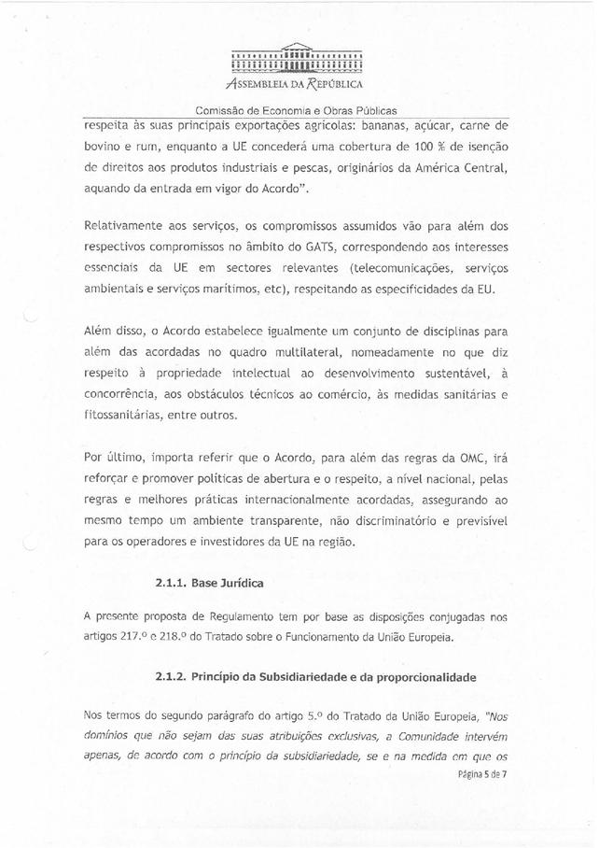
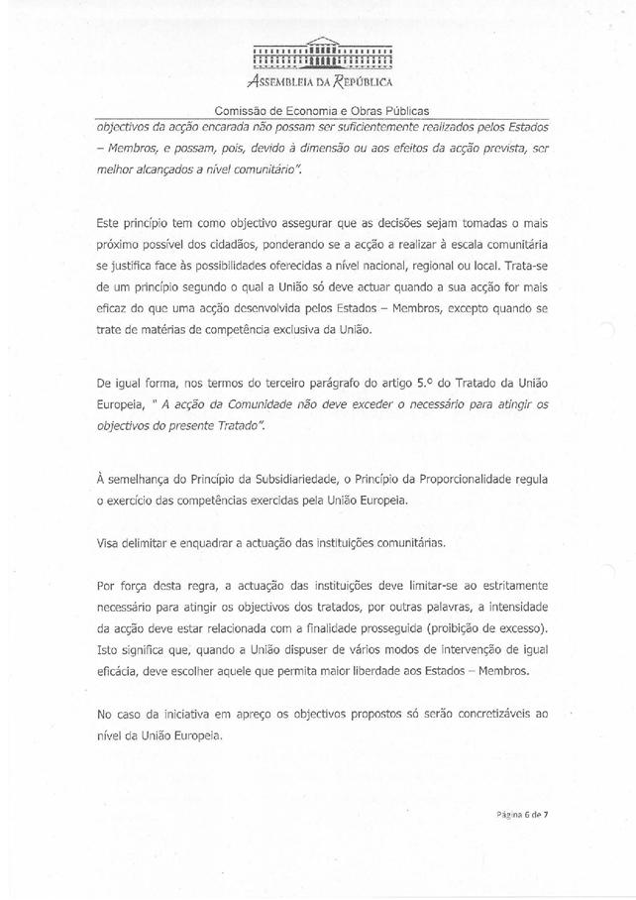
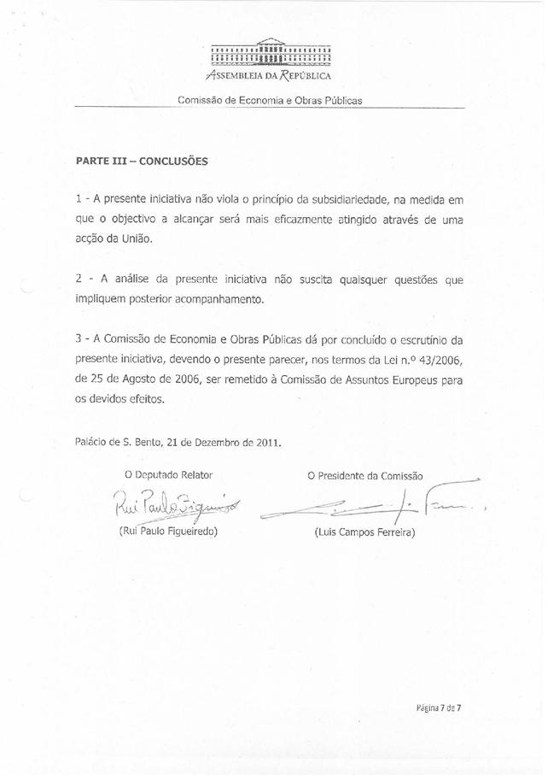

The translation of the opinion may be available at the Interparliamentary EU information exchange site IPEX, at the following address: http://www.ipex.eu/IPEXL-WEB/search.do.

