 | 
COUNCIL OF  THE EUROPEAN UNION |  |  | Brussels, 16 February 2012
 | Interinstitutional File:  2011/0412 (COD) |  | 6611/12
COHOM 35
DEVGEN 34
PESC 175
ACP 22
RELEX 134
FIN 111
NIS 9
CADREFIN 94
CODEC 410
INST 140
PARLNAT 100

COVER NOTE
from: | the President of the Assembly of the Republic of Portugal
date of receipt: | 15 February 2012
to: | Ms Helle THORNING-SCHMIDT, President of the Council of the European Union
Subject: | Proposal for a Regulation of the European Parliament and of the Council establishing a financing instrument for the promotion of democracy and human rights worldwide  [doc. 18621/11 COHOM 298 DEVGEN 351 PESC 1660 ACP 252 RELEX 1344 FIN 1061 NIS 158 CADREFIN 206 CODEC 2444 - COM(2011) 844 final + COR 1]  - Opinion on the application of the Principles of Subsidiarity and Proportionality

Delegations will find attached the above-mentioned opinion.

________________________

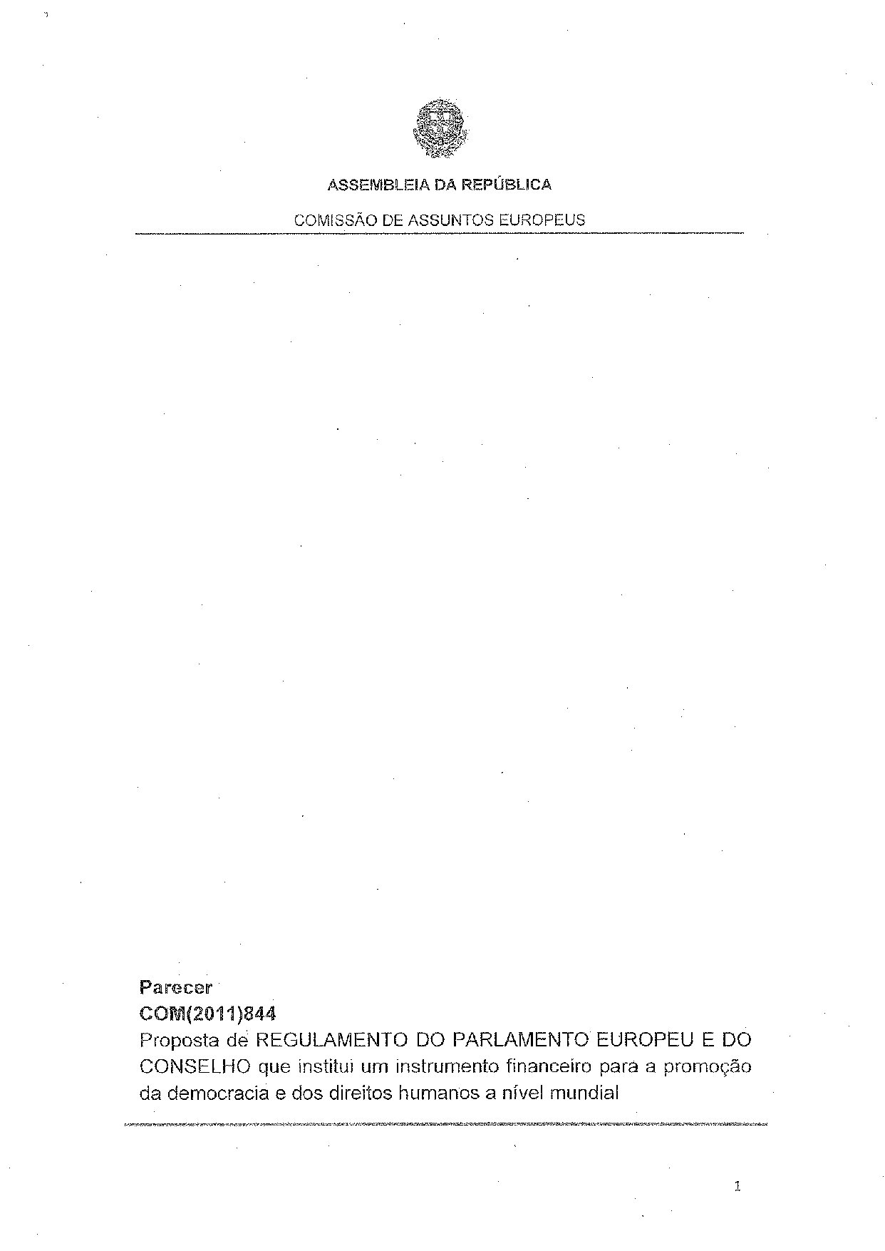
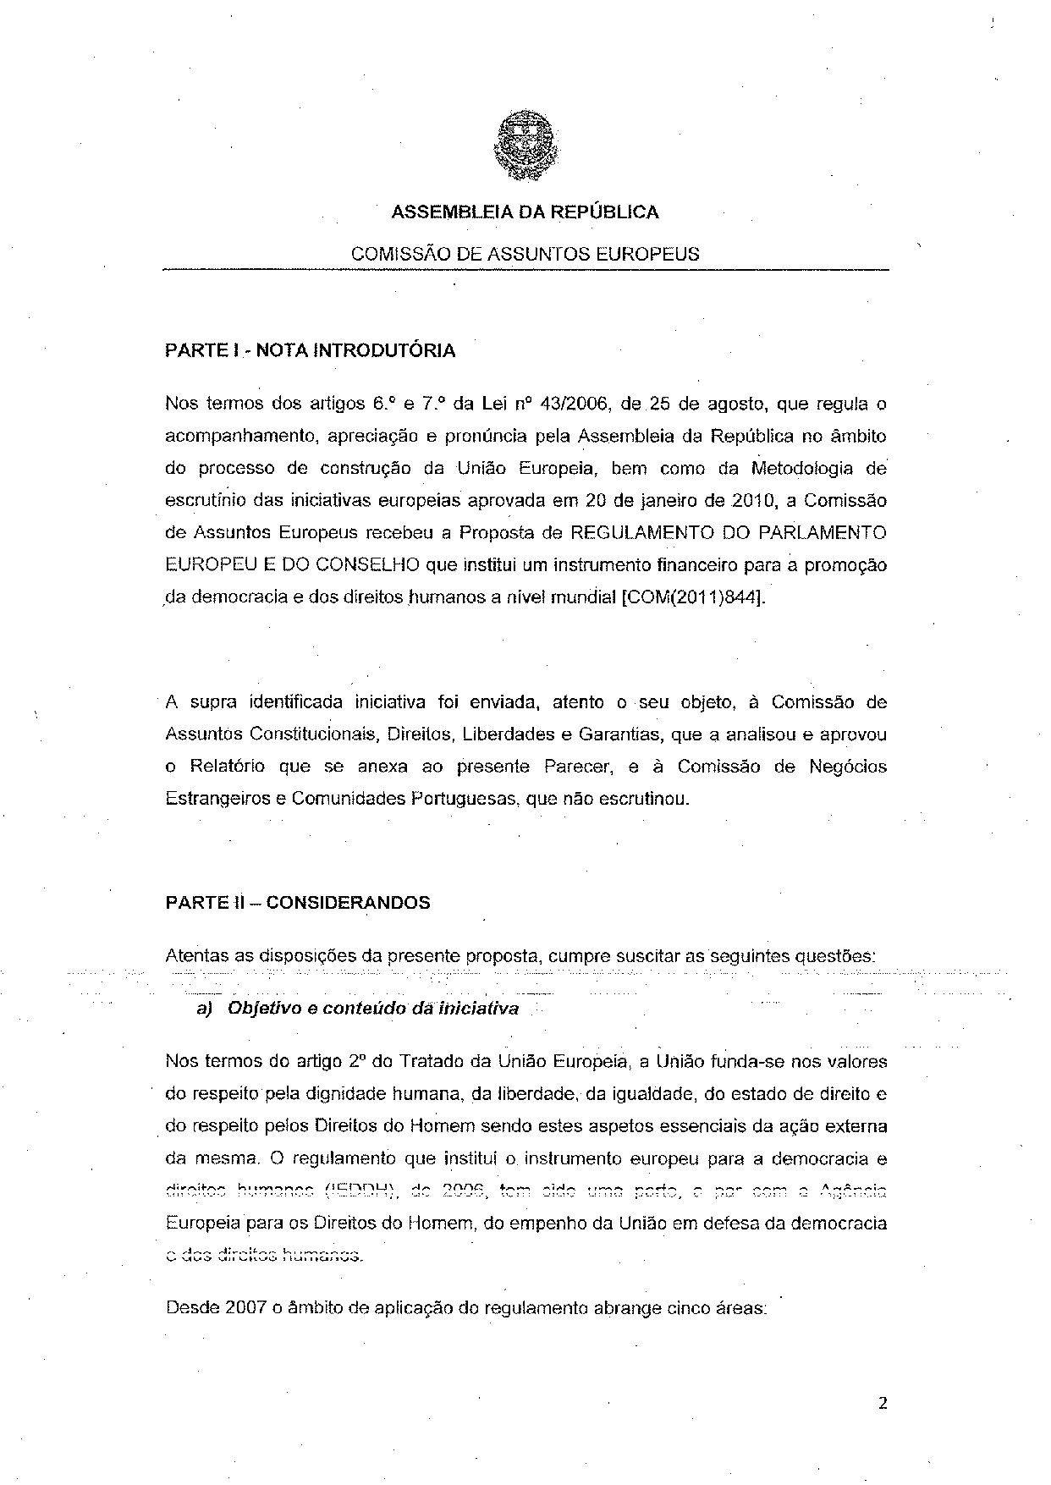
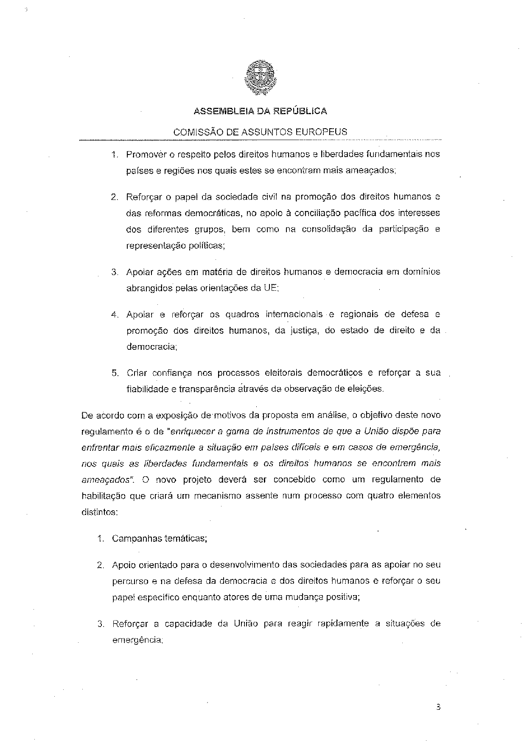
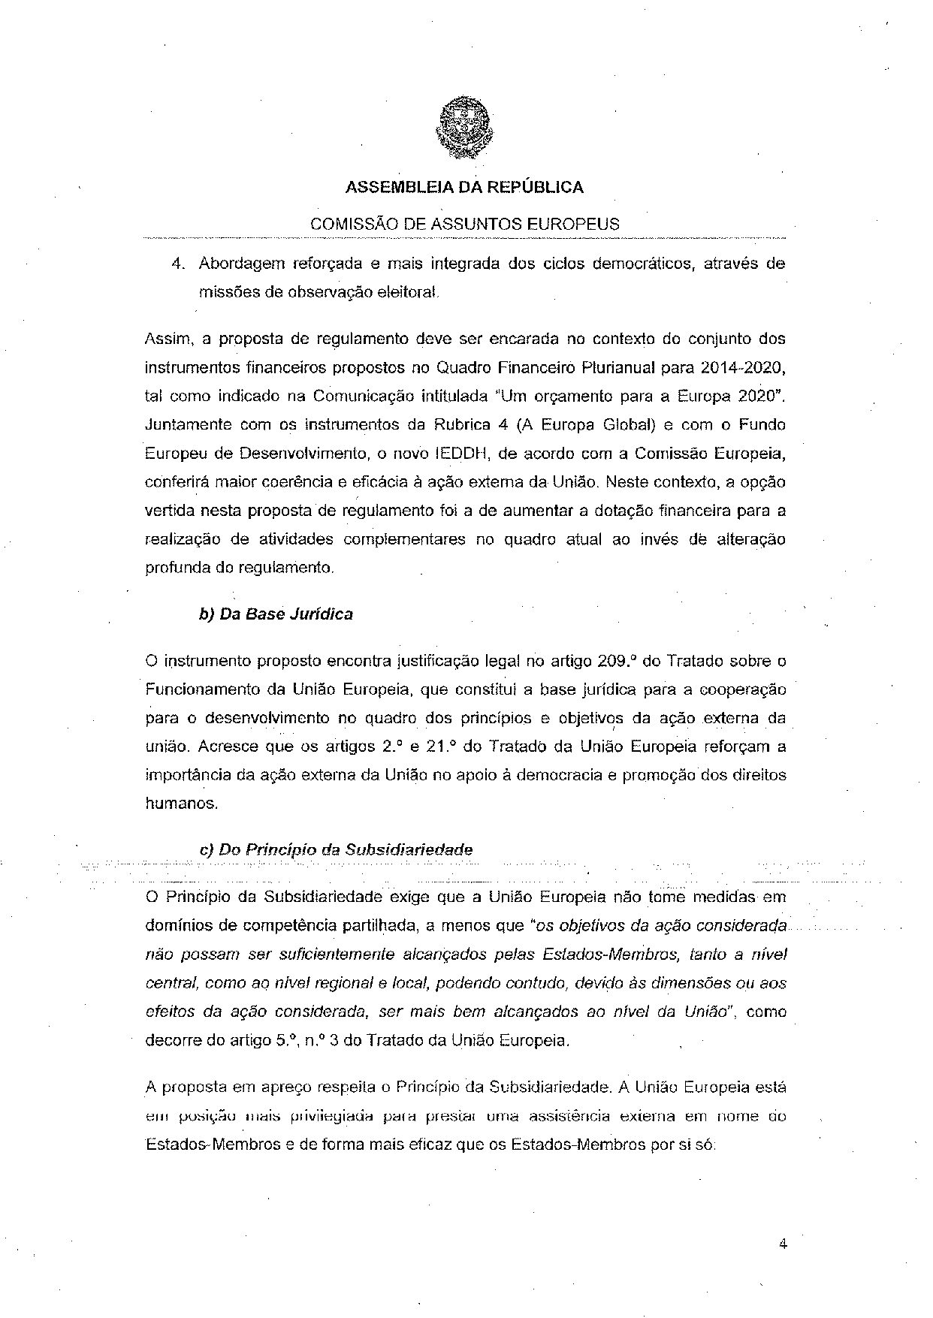
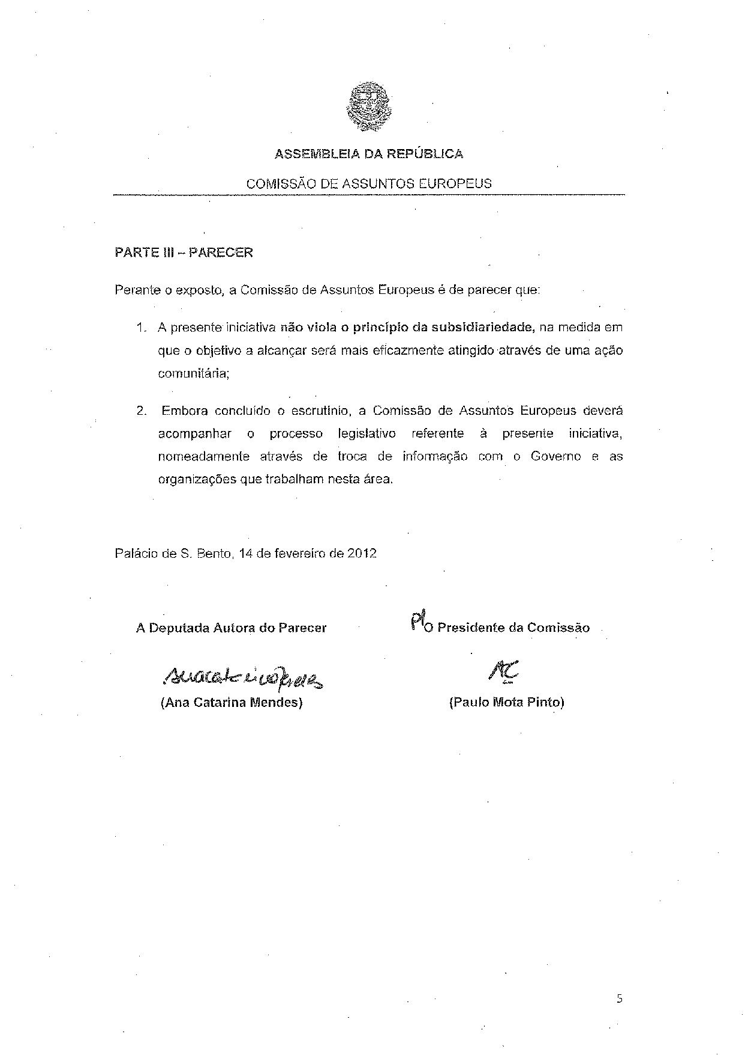

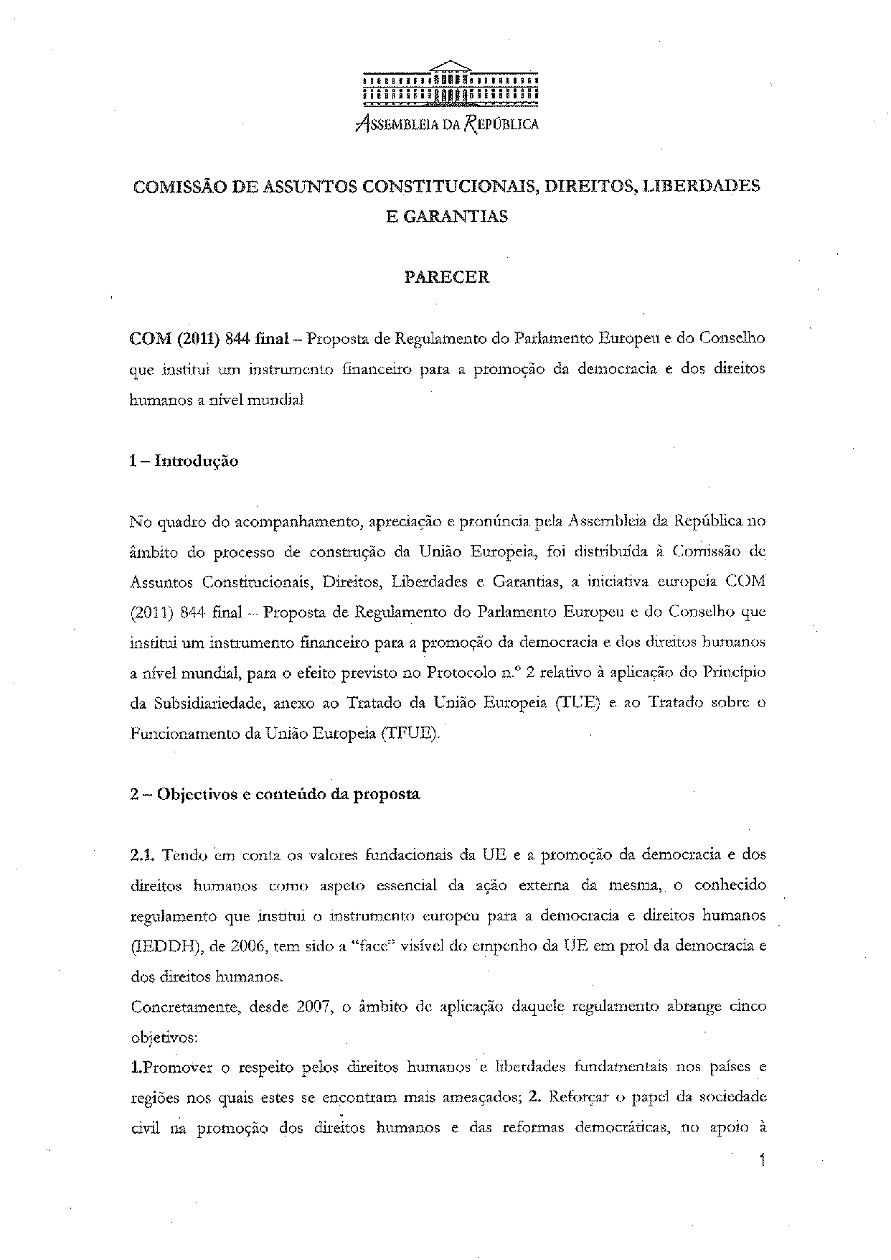
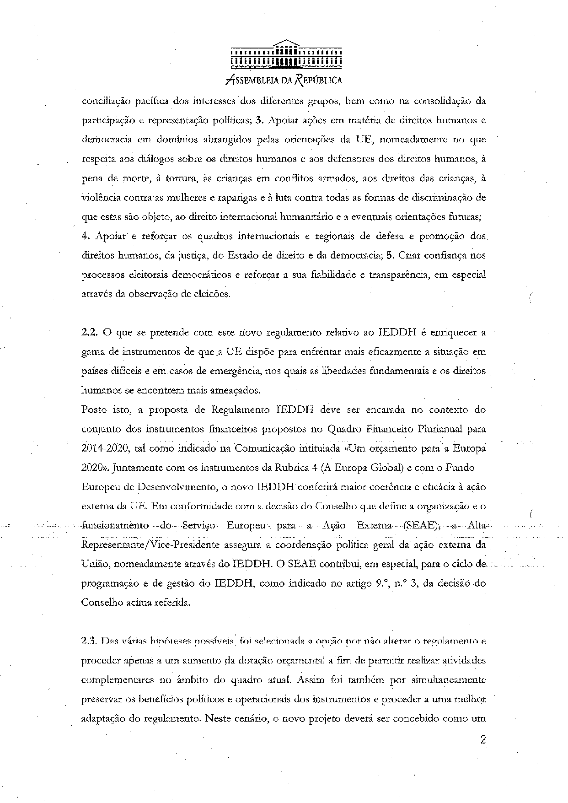
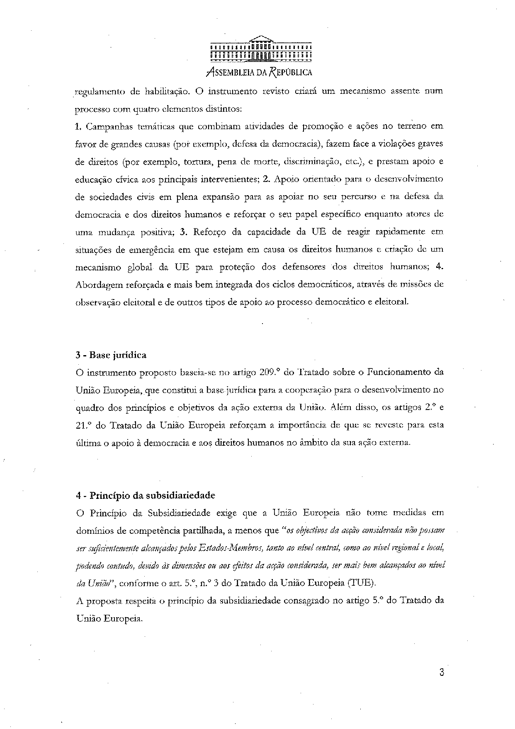
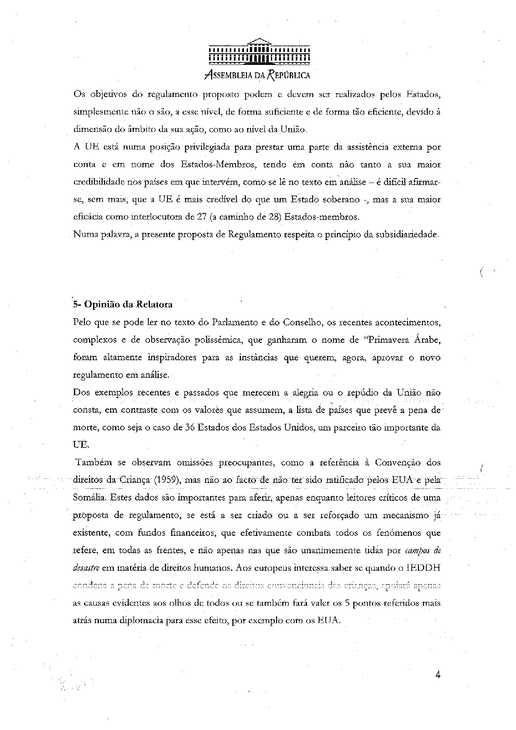
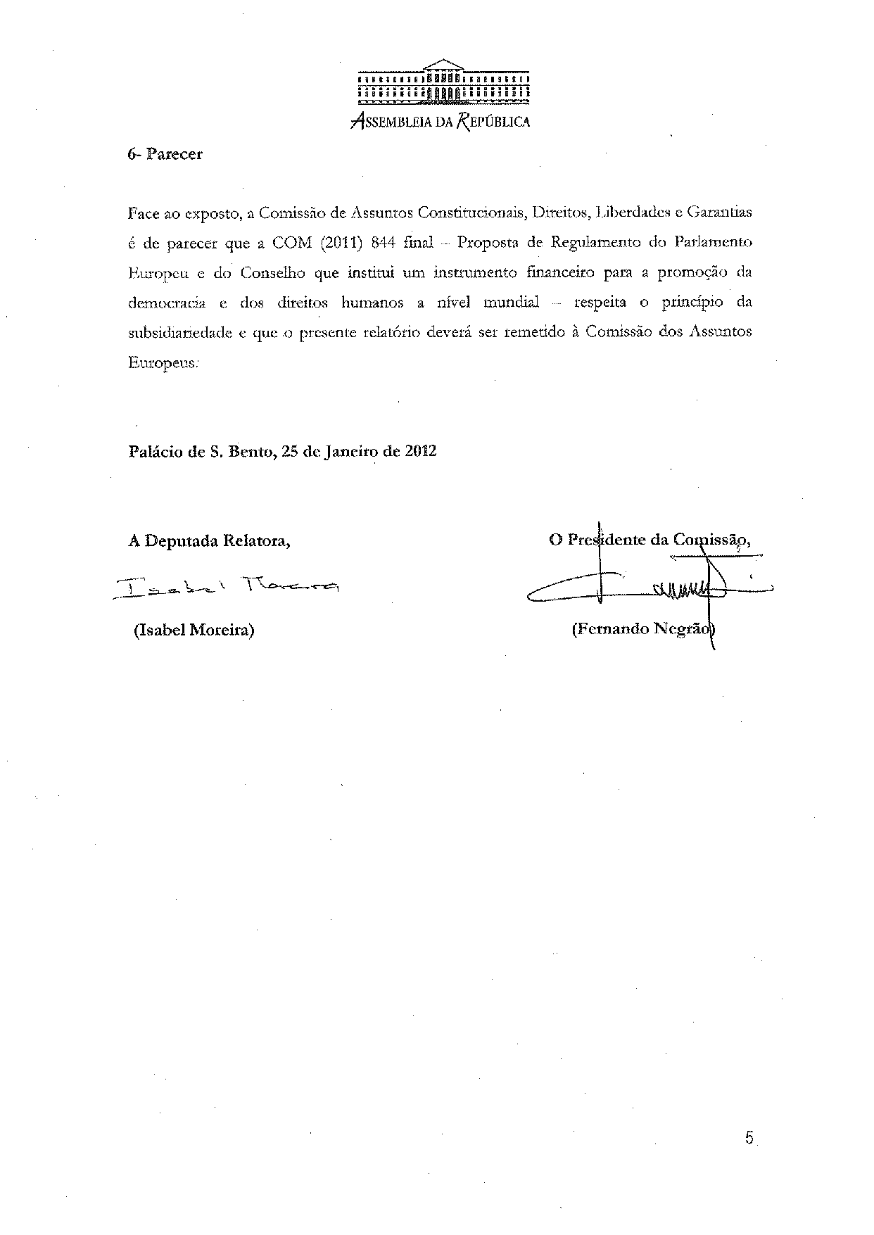

The translation of the opinion may be available at the Interparliamentary EU information exchange site IPEX, at the following address: http://www.ipex.eu/IPEXL-WEB/search.do.

