 | 
COUNCIL OF  THE EUROPEAN UNION |  |  | Brussels, 13 February 2012
 | Interinstitutional File:  2011/0324 (NLE) |  | 6432/12
WTO 45
COEST 39
INST 129
PARLNAT 95

COVER NOTE
from: | the President of the Assembly of the Republic of Portugal
date of receipt: | 9 February 2012
to: | Ms Helle THORNING-SCHMIDT, President of the Council of the European Union
Subject: | Proposal for a Council Decision on the conclusion, on behalf of the European Union, of the Agreement between the European Union and the Government of the Russian Federation on trade in parts and components of motor vehicles between the European Union and the Russian Federation  [doc. 16803/11 WTO 414 COEST 416 - COM(2011) 725 final]  - Opinion on the application of the Principles of Subsidiarity and Proportionality

Delegations will find attached the above-mentioned opinion.

________________________

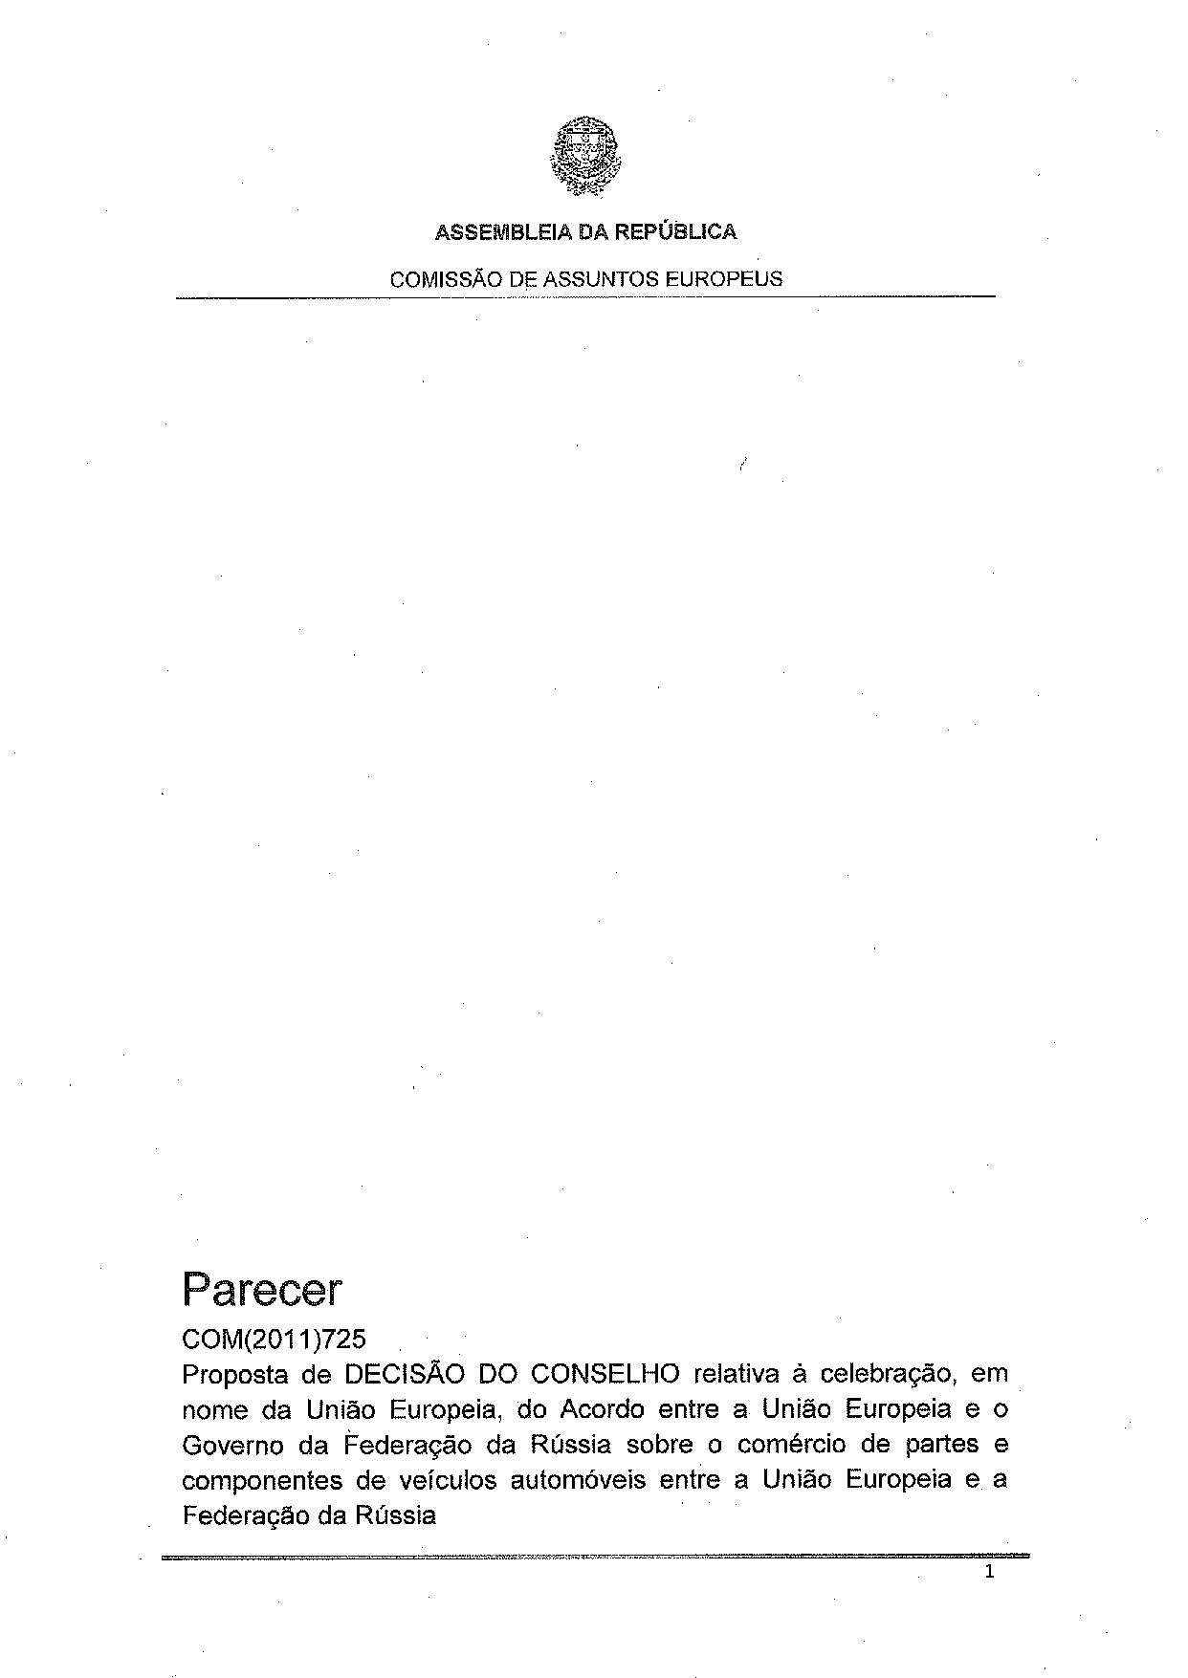
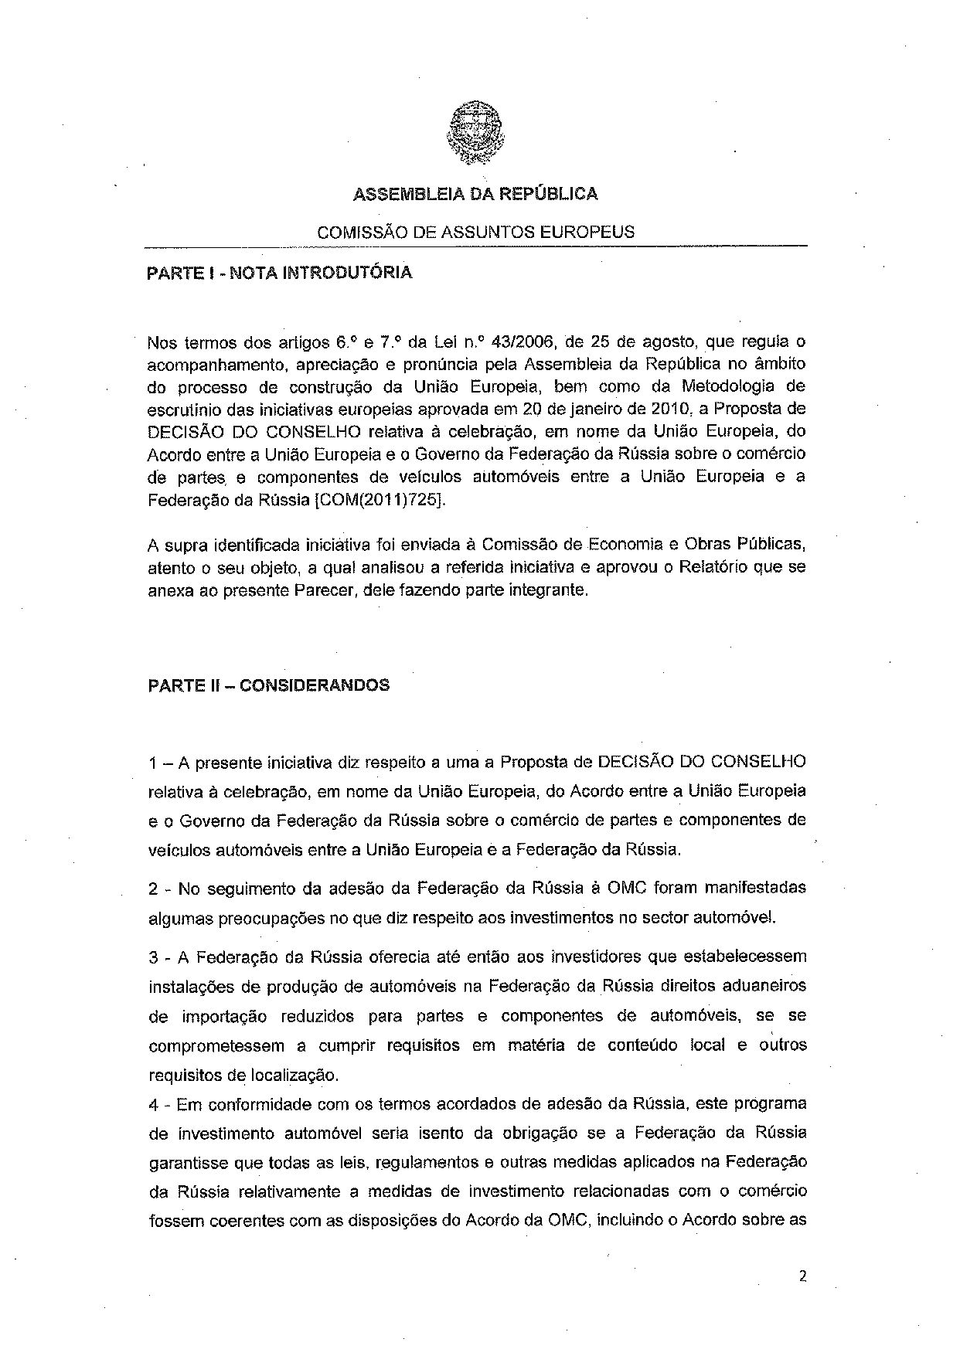
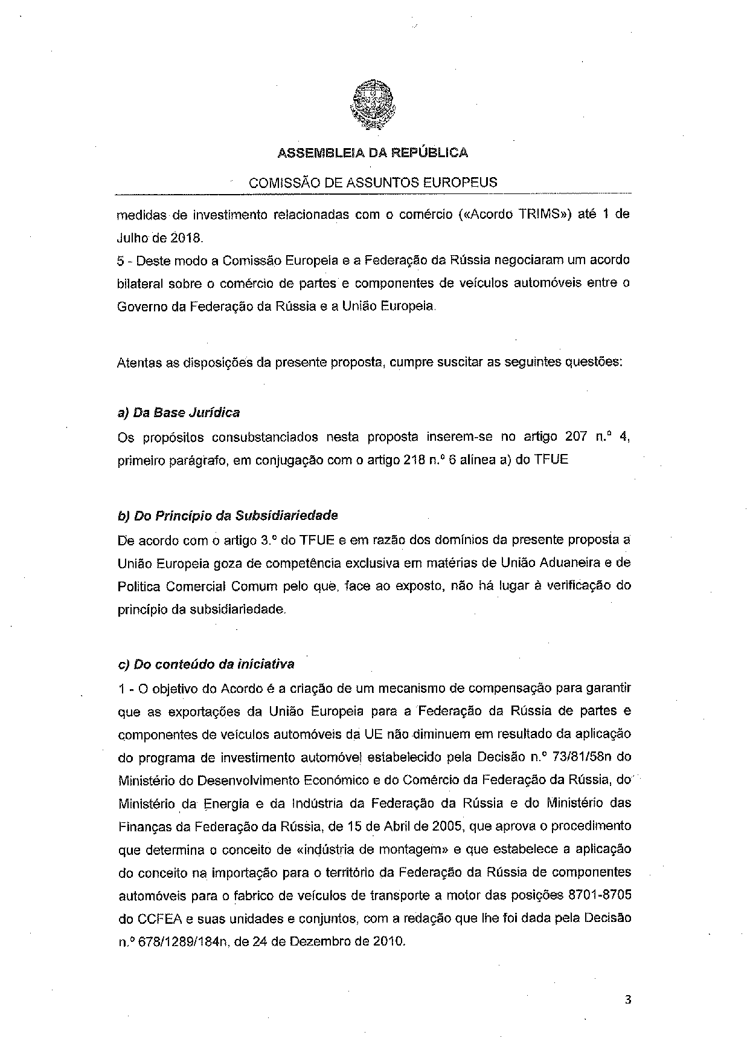
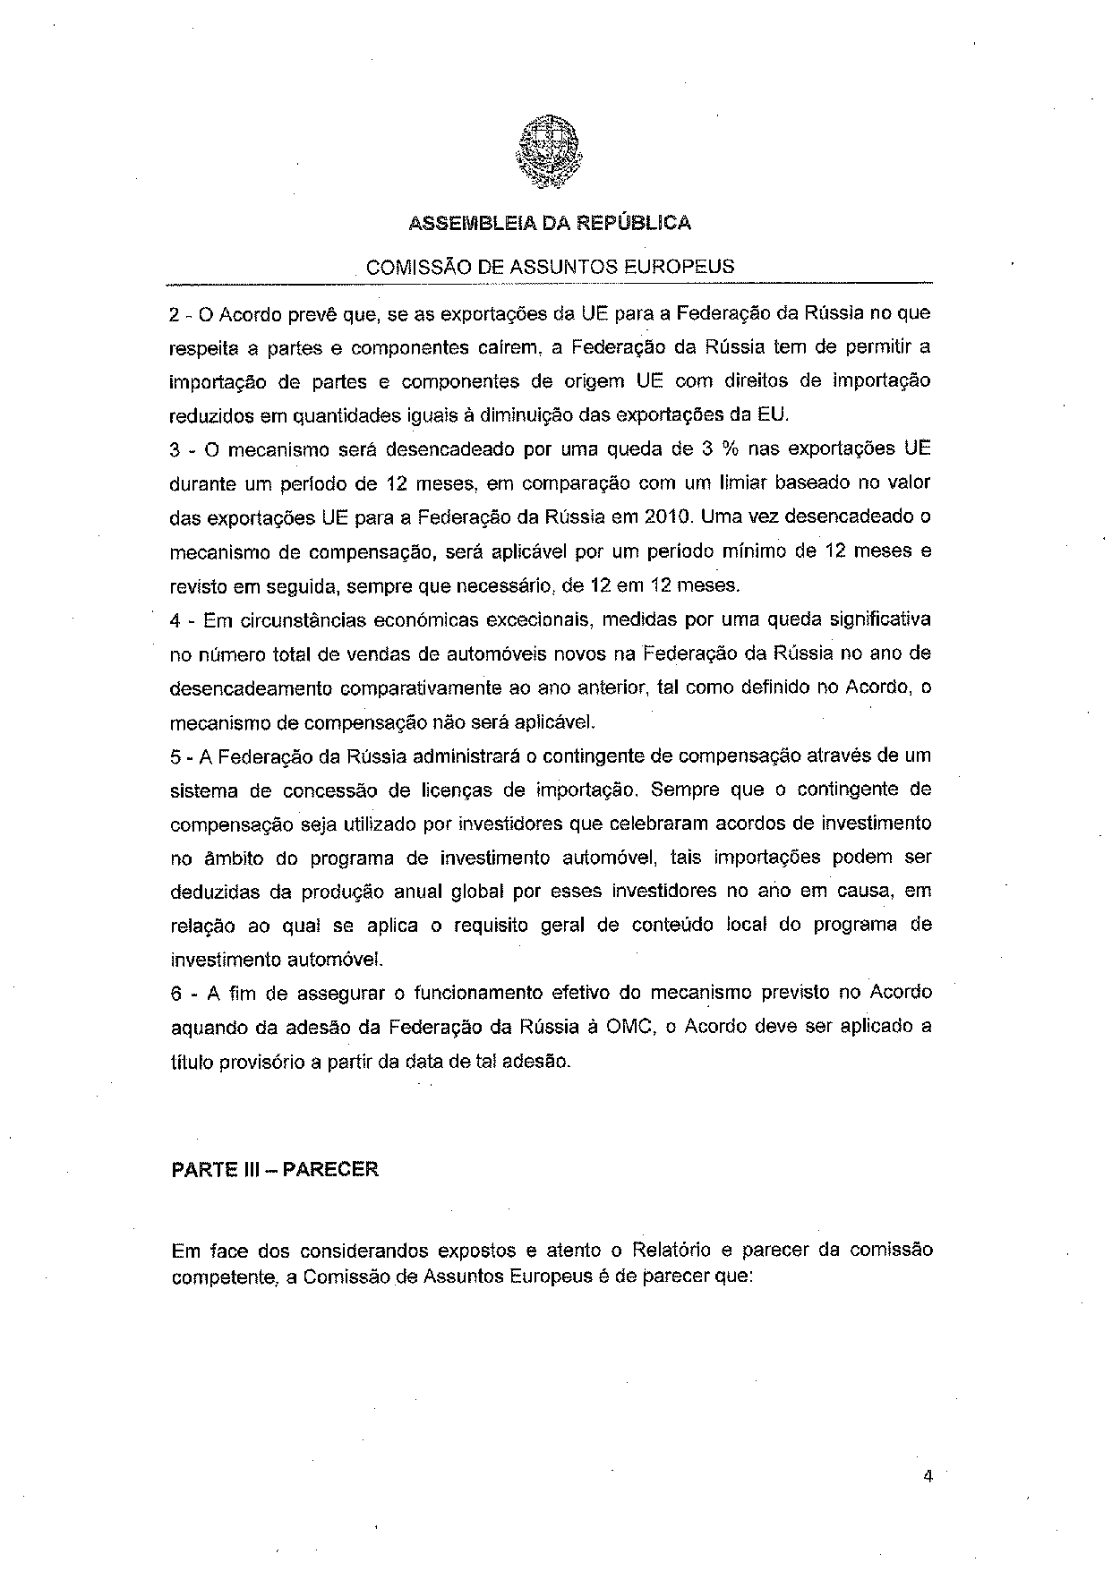
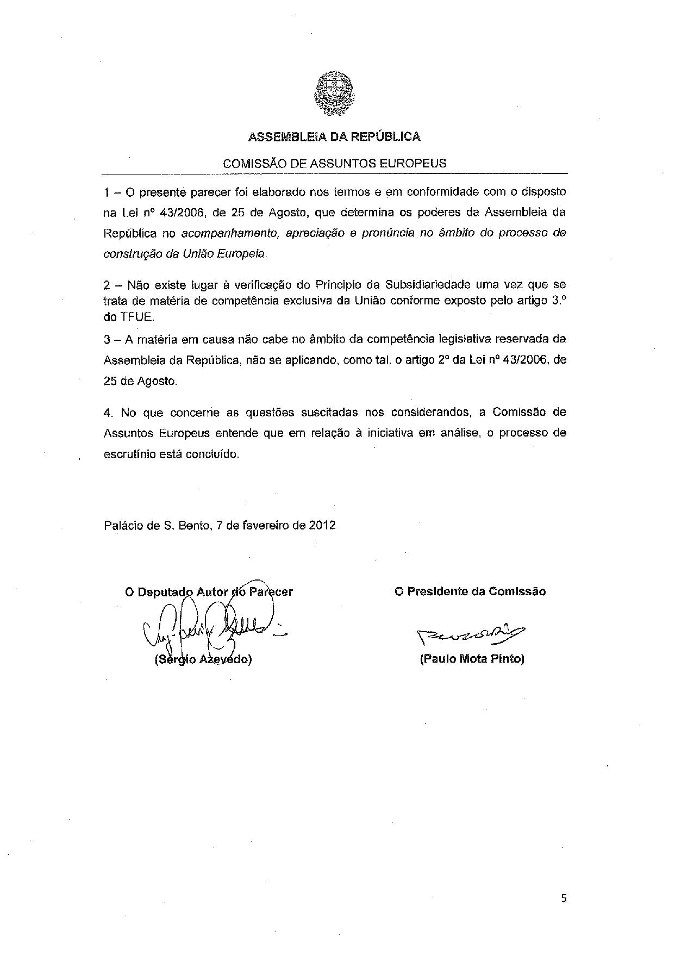
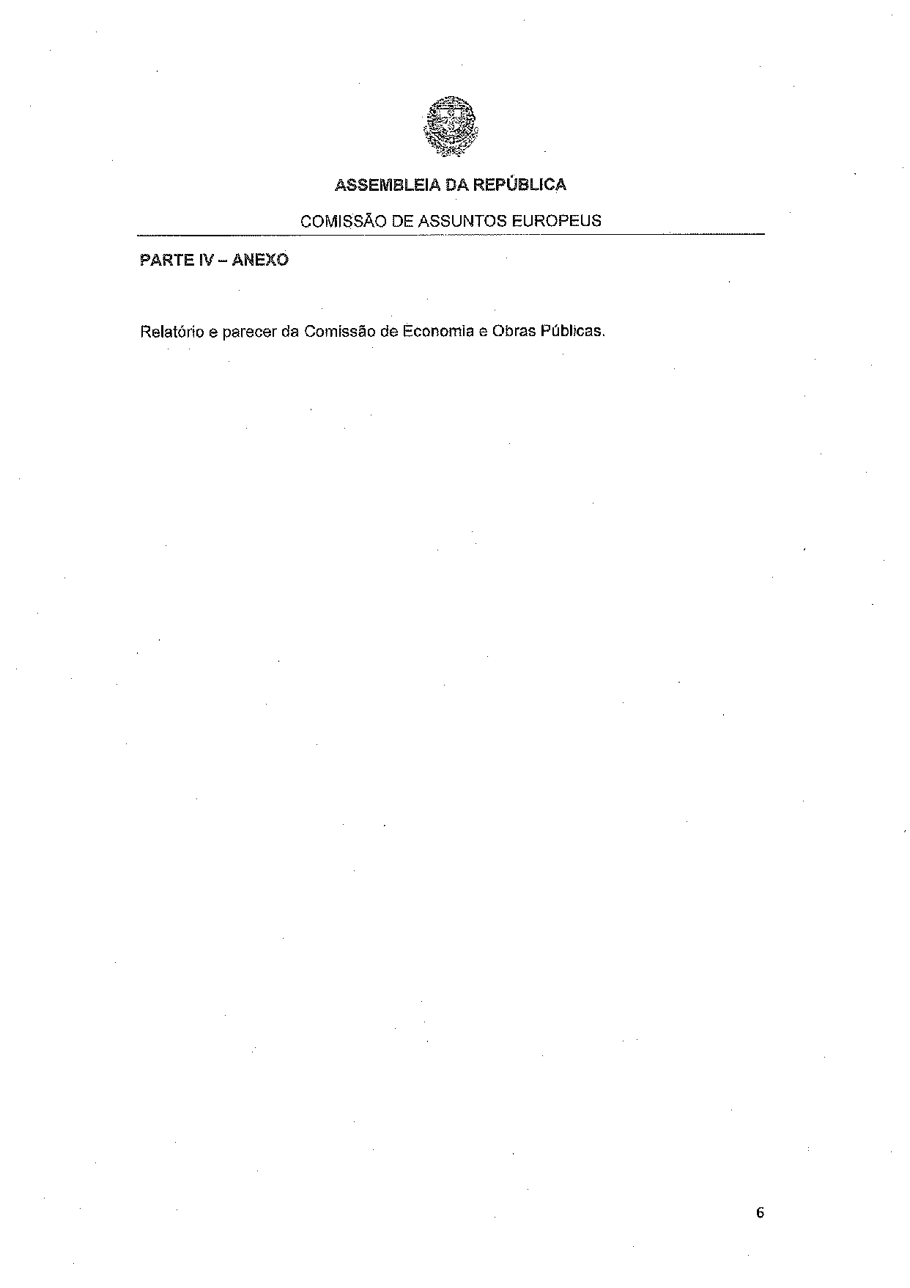
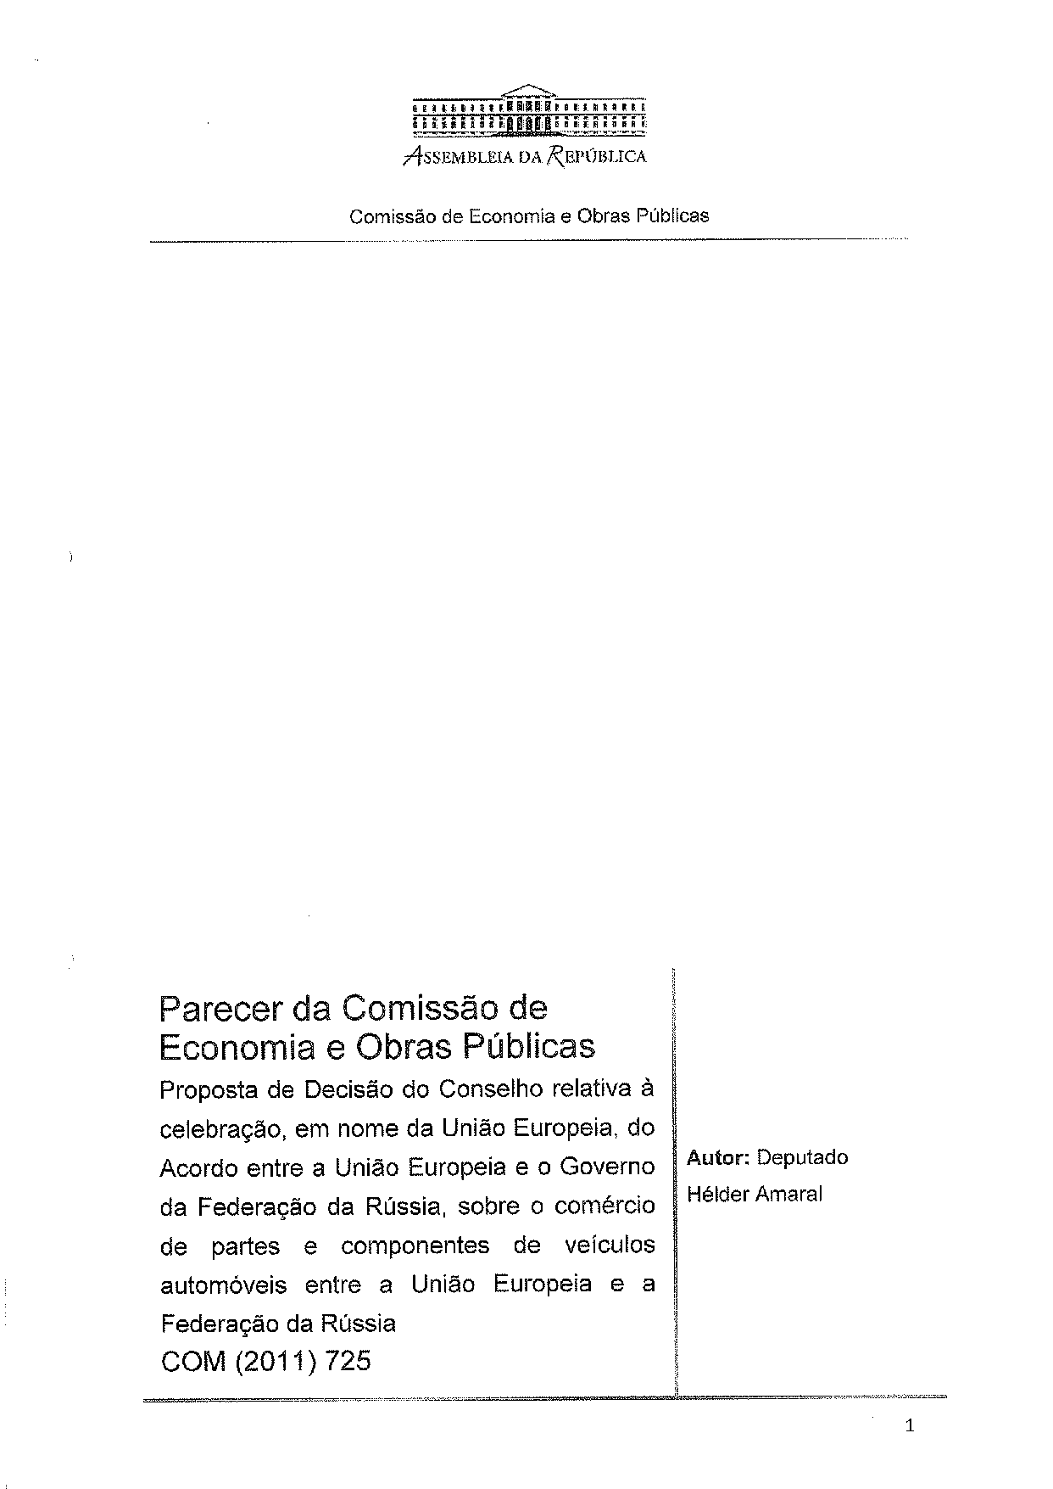
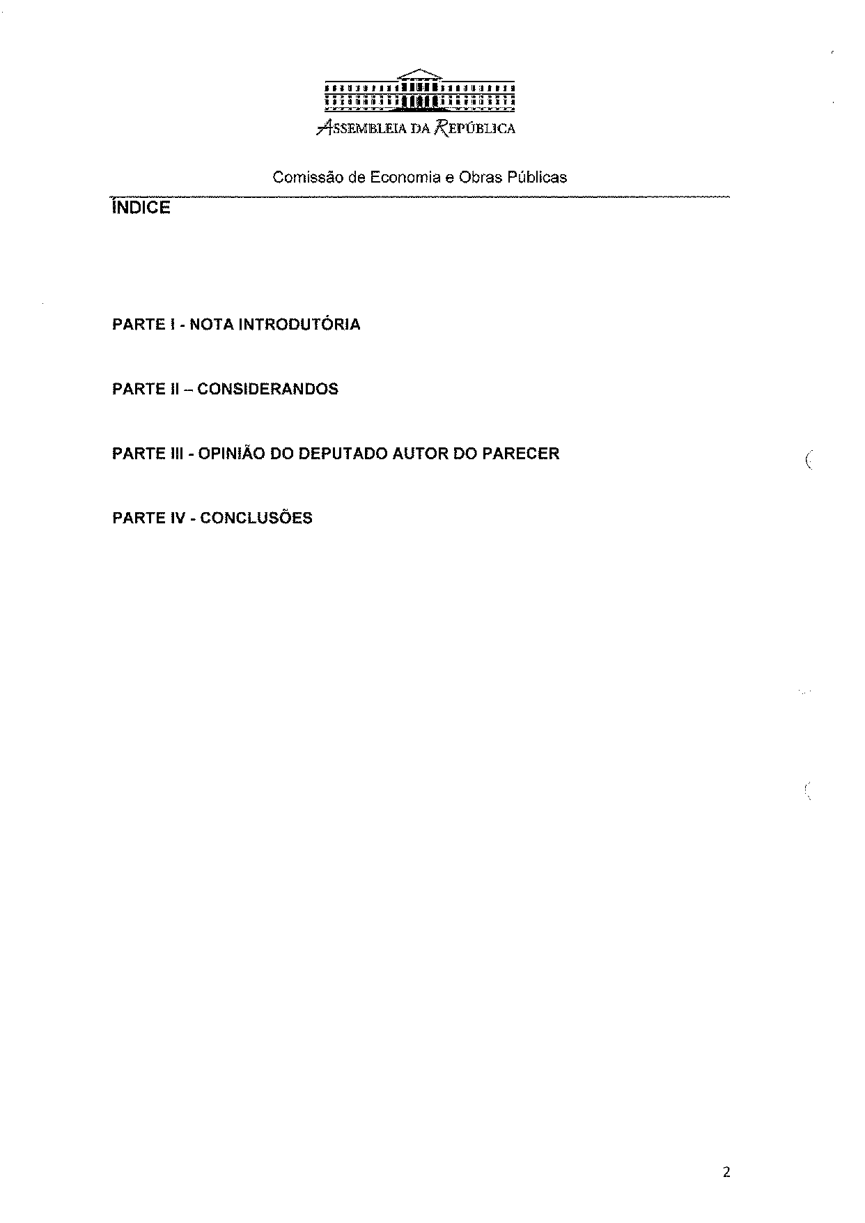
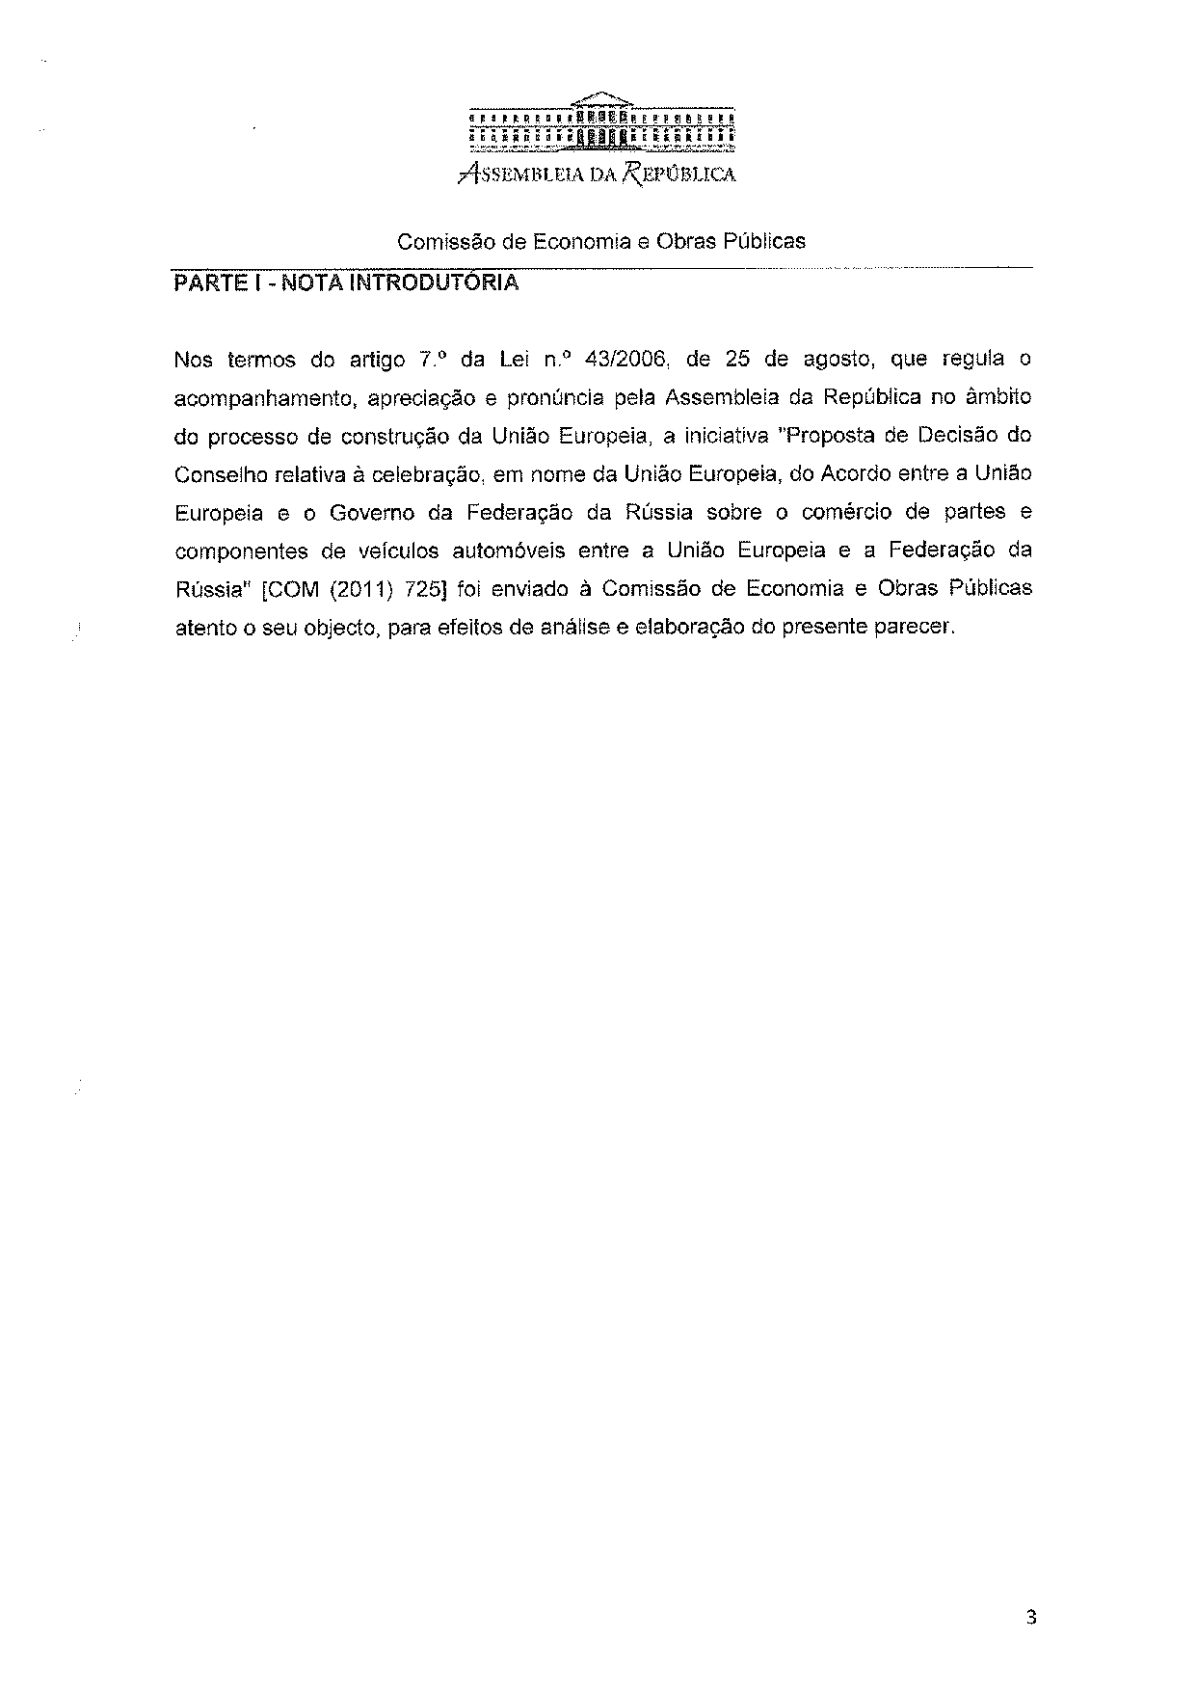
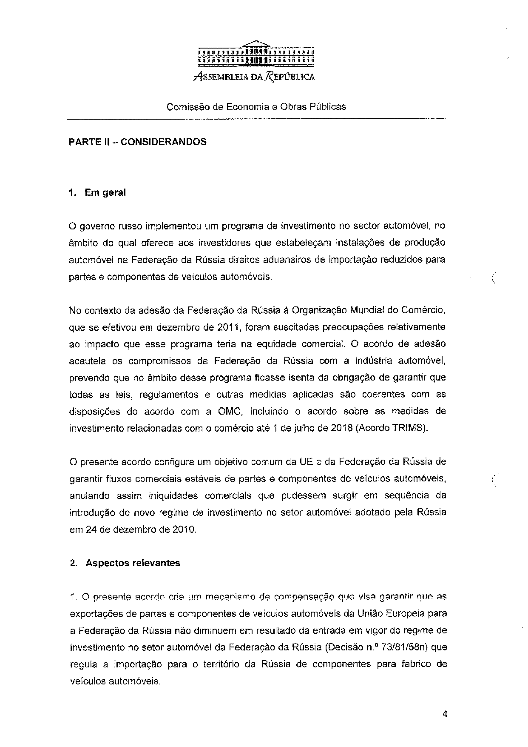
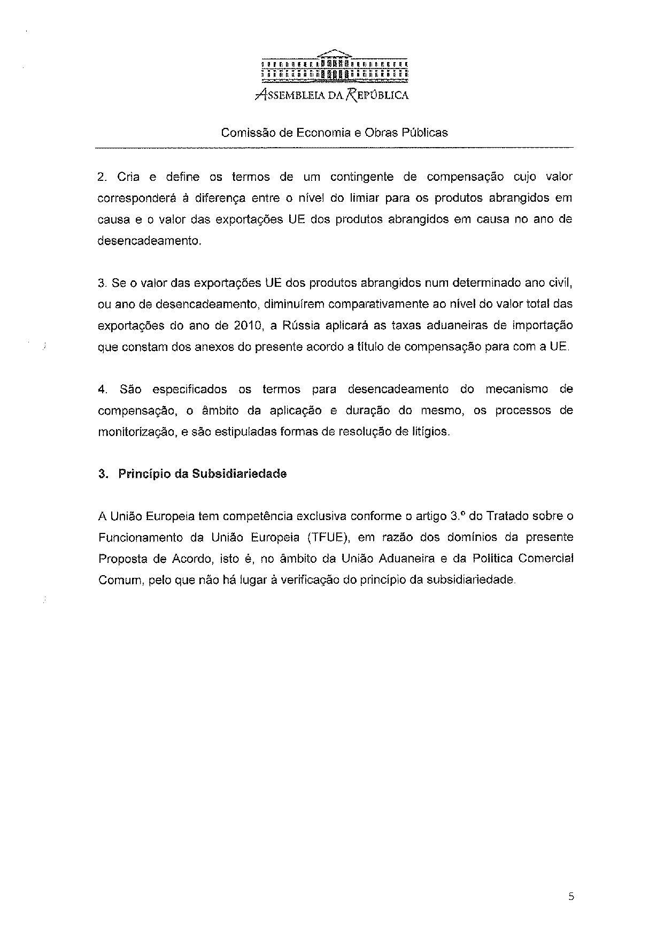
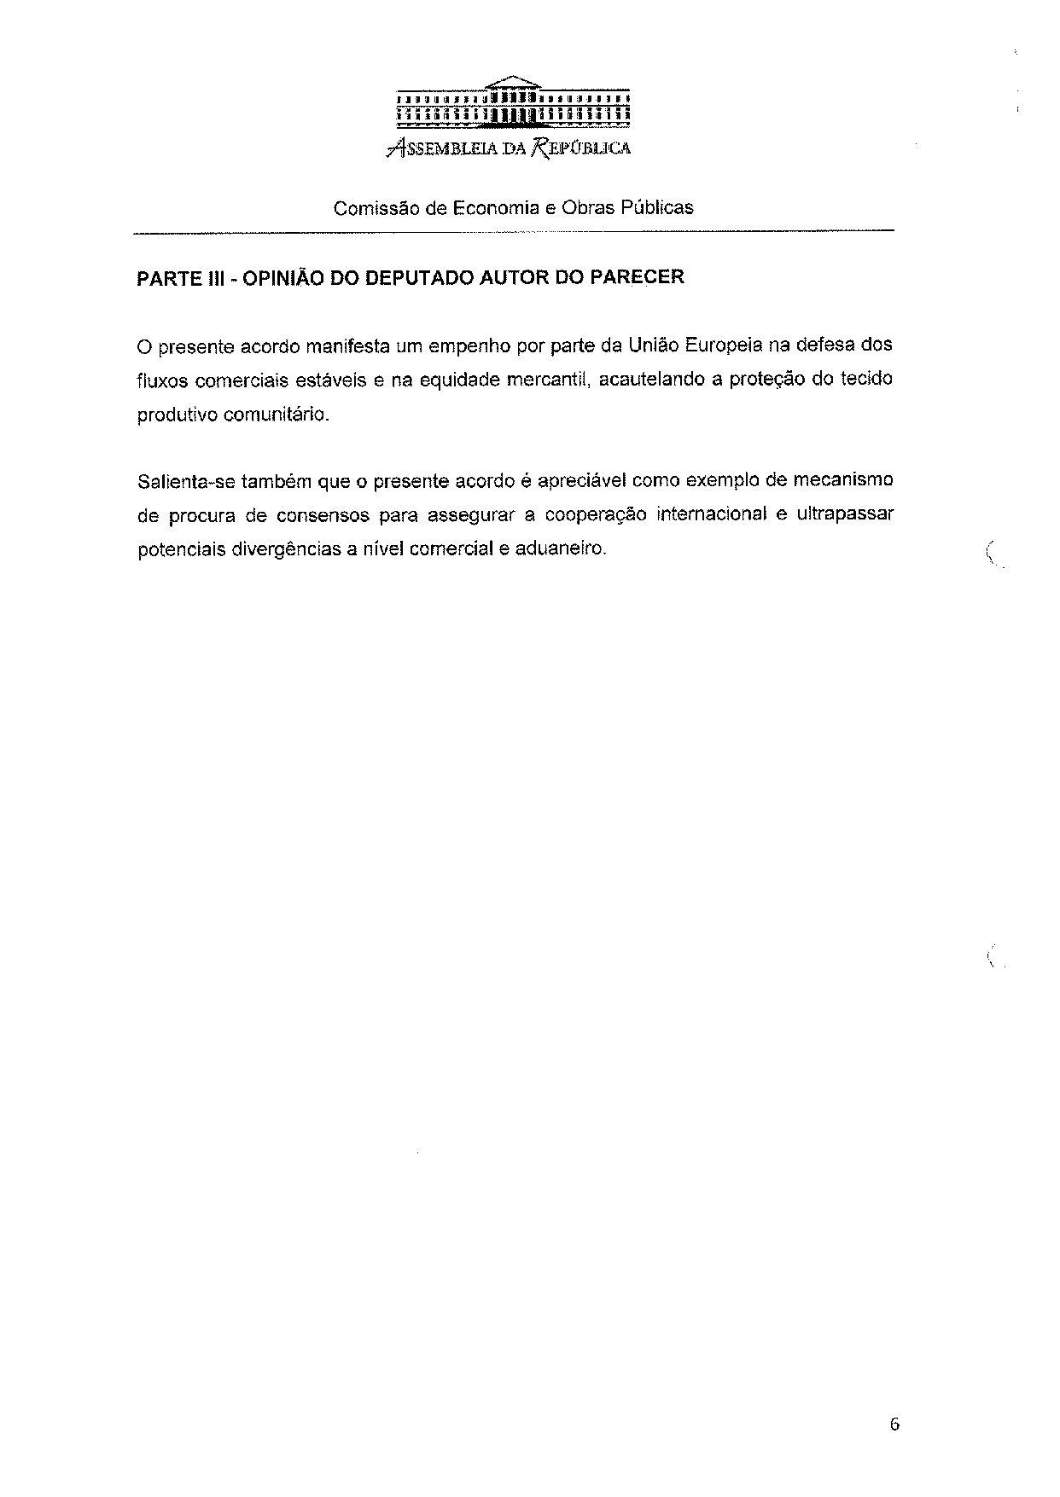
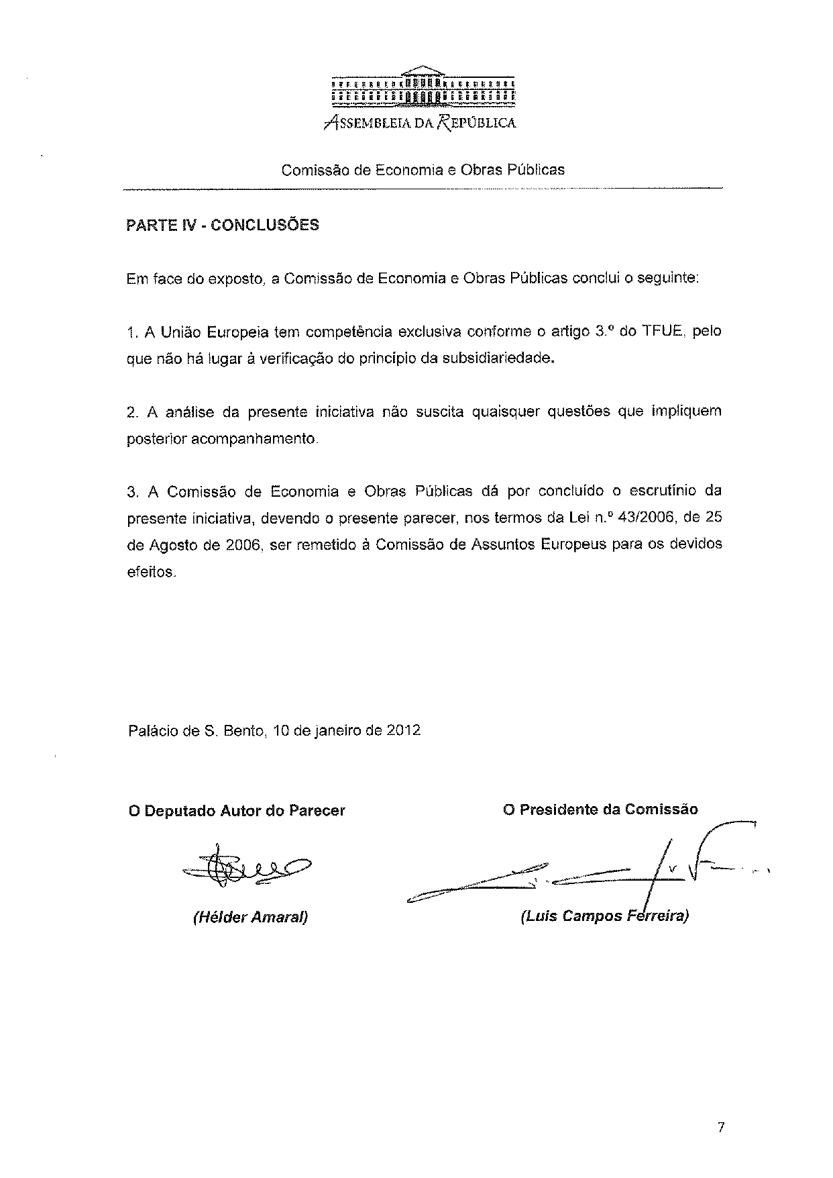

The translation of the opinion may be available at the Interparliamentary EU information exchange site IPEX, at the following address: http://www.ipex.eu/IPEXL-WEB/search.do.

