 | 
COUNCIL OF  THE EUROPEAN UNION |  |  | Brussels, 13 February 2012
 | Interinstitutional File:  2011/0320 (NLE) |  | 6431/12
WTO 44
SERVICES 9
COEST 38
INST 128
PARLNAT 94

COVER NOTE
from: | the President of the Assembly of the Republic of Portugal
date of receipt: | 9 February 2012
to: | Ms Helle THORNING-SCHMIDT, President of the Council of the European Union
Subject: | Proposal for a Council Decision on the position to be adopted on behalf of the European Union within the relevant instances of the World Trade Organization on the accession of the Russian Federation to the World Trade Organization  [doc. 16748/11 WTO 396 SERVICES 112 COEST 399 - COM(2011) 720 final]  - Opinion on the application of the Principles of Subsidiarity and Proportionality

Delegations will find attached the above-mentioned opinion.

________________________

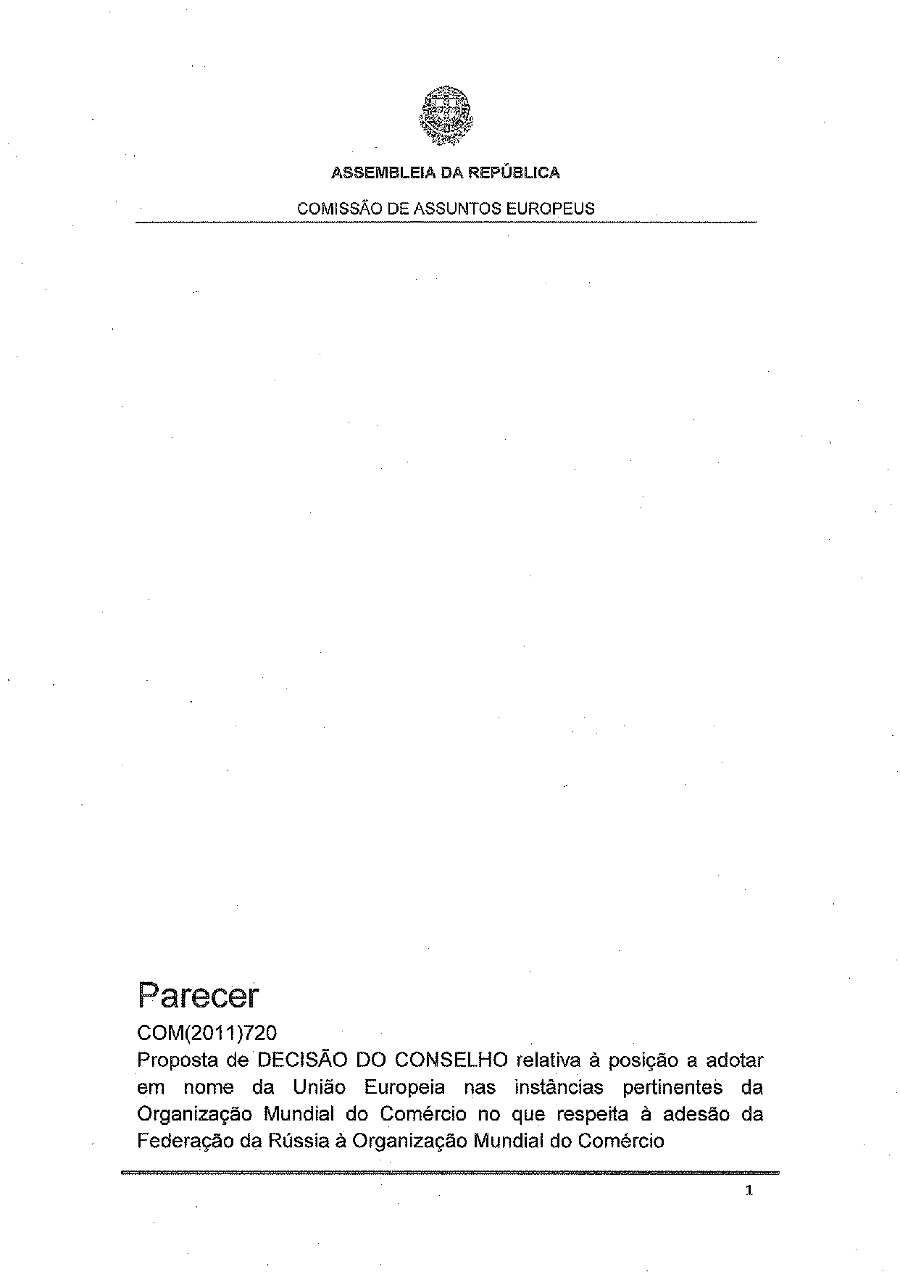
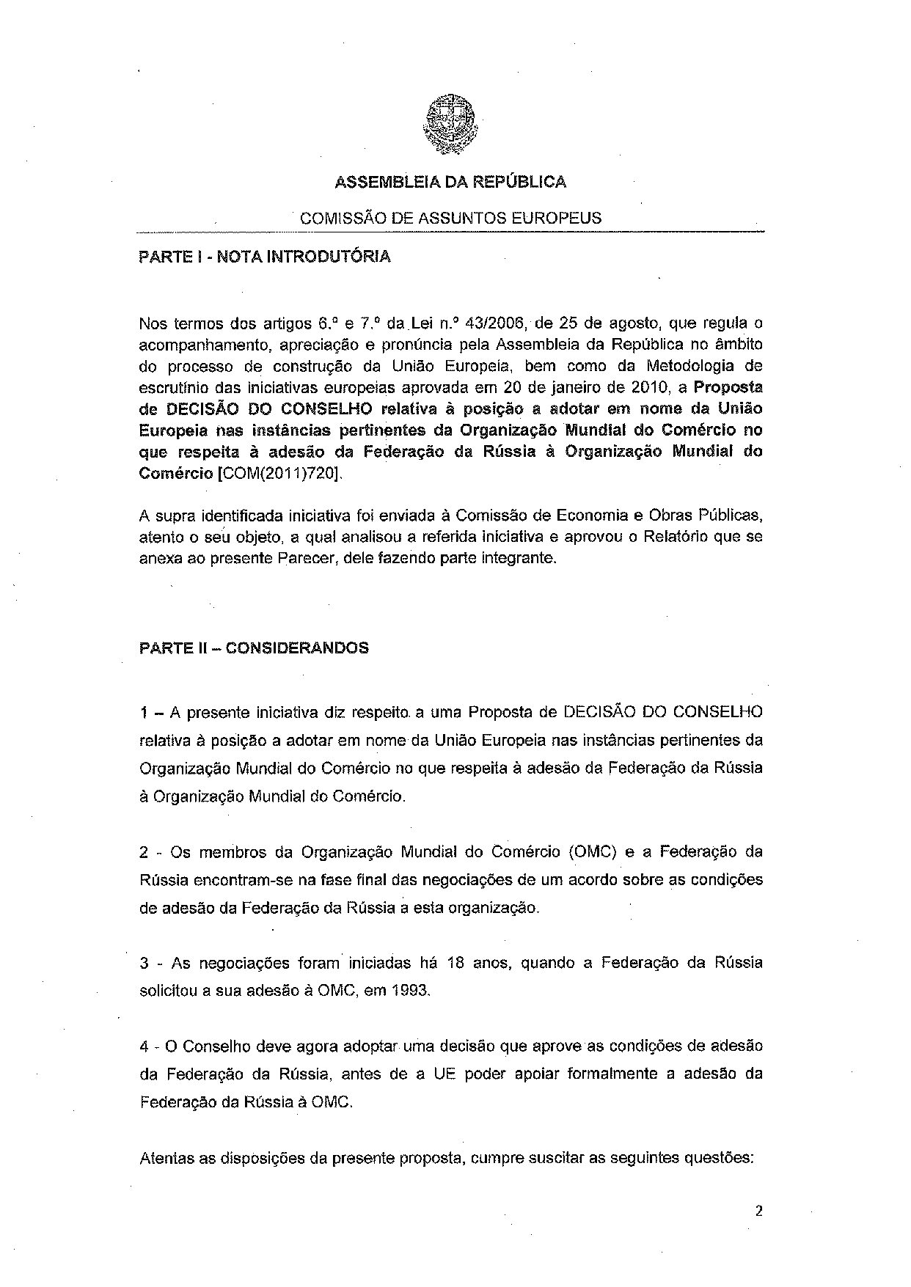
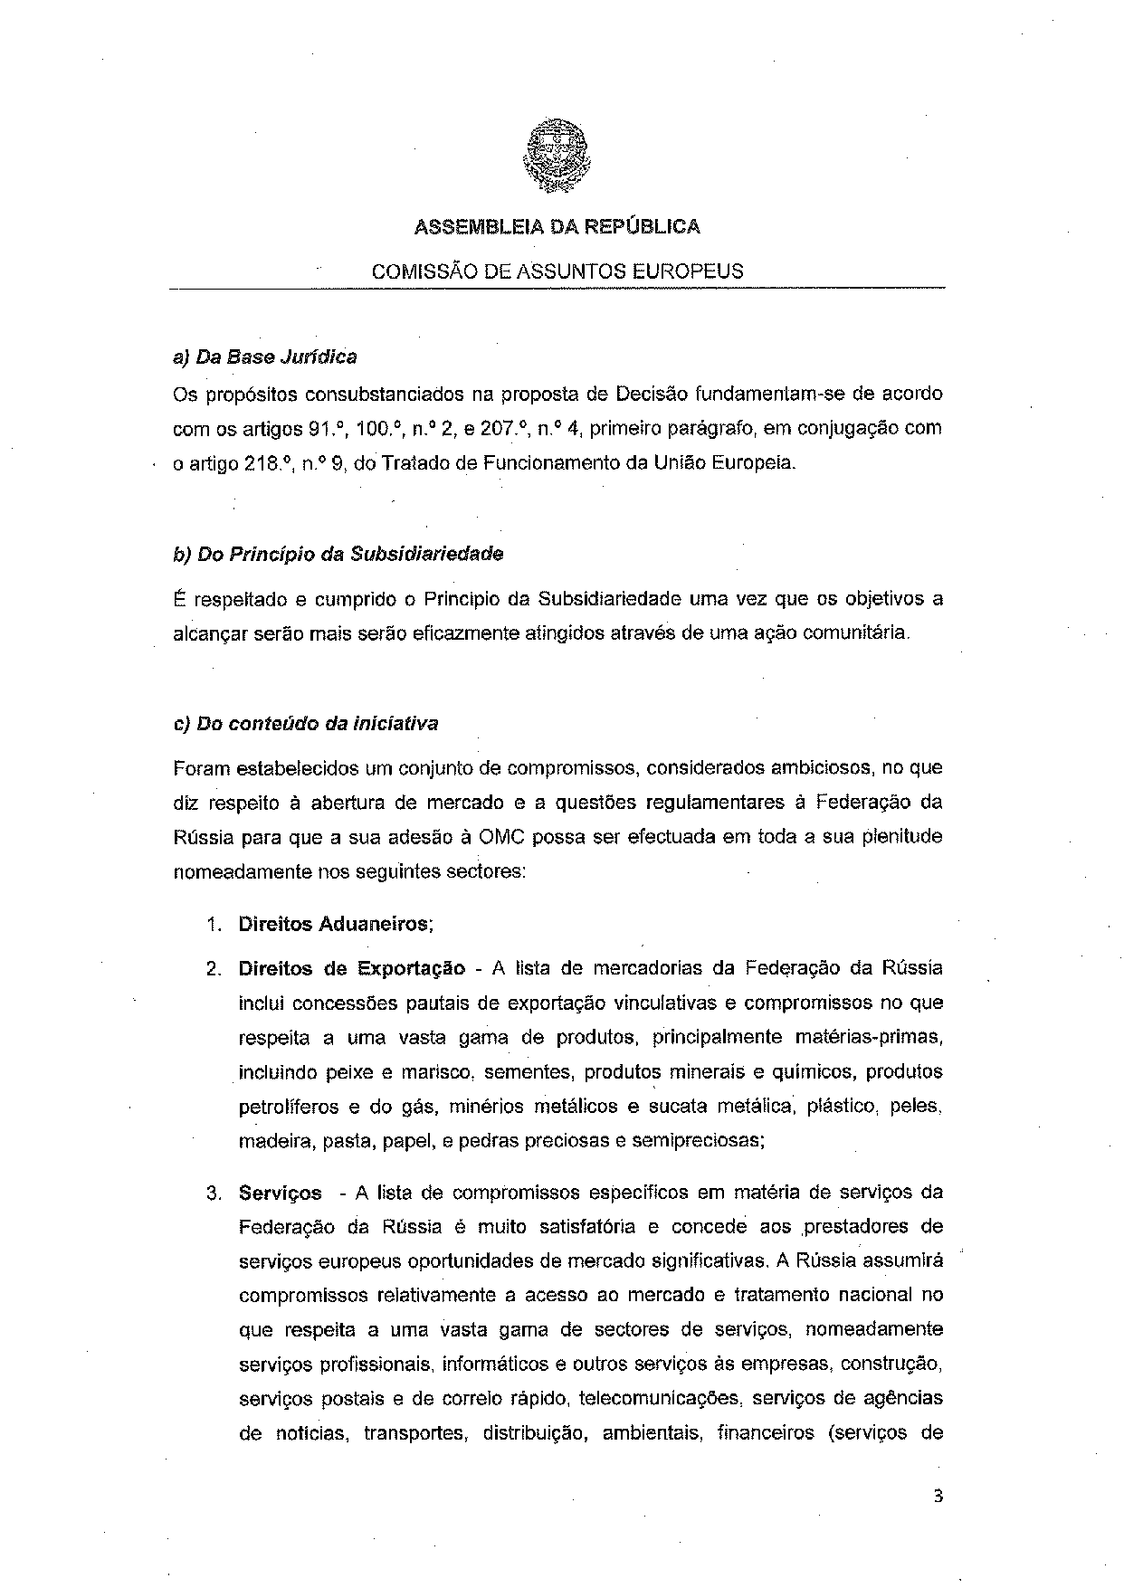
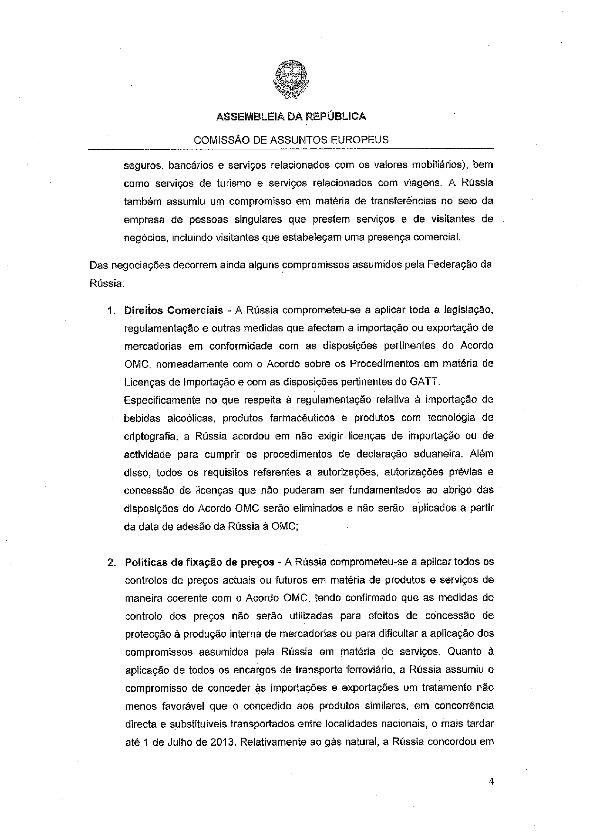
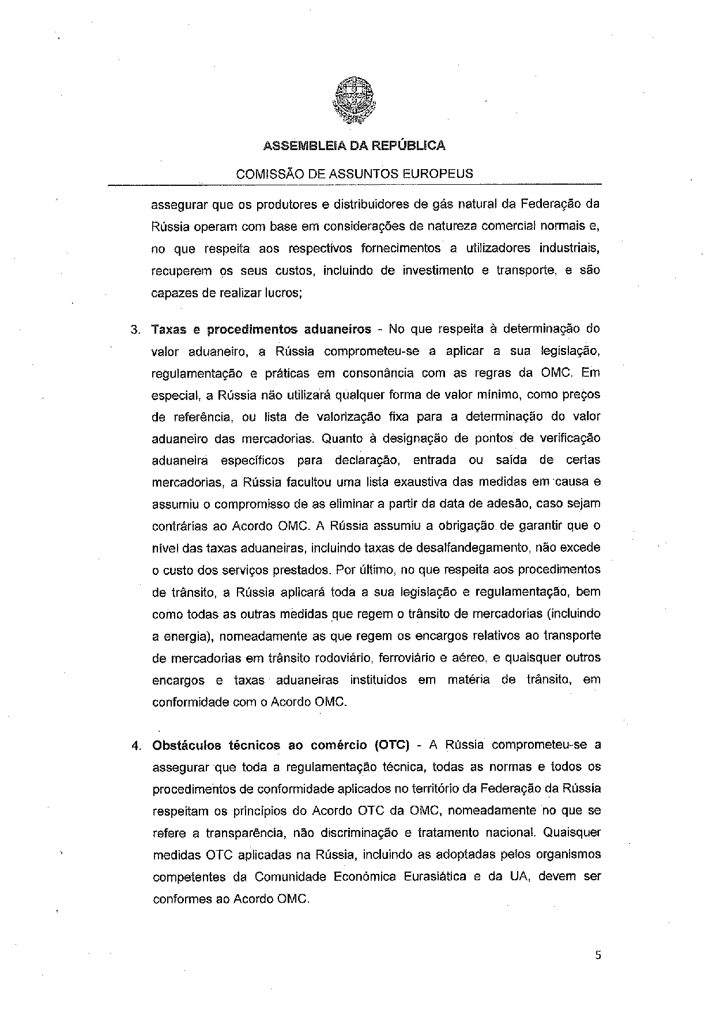
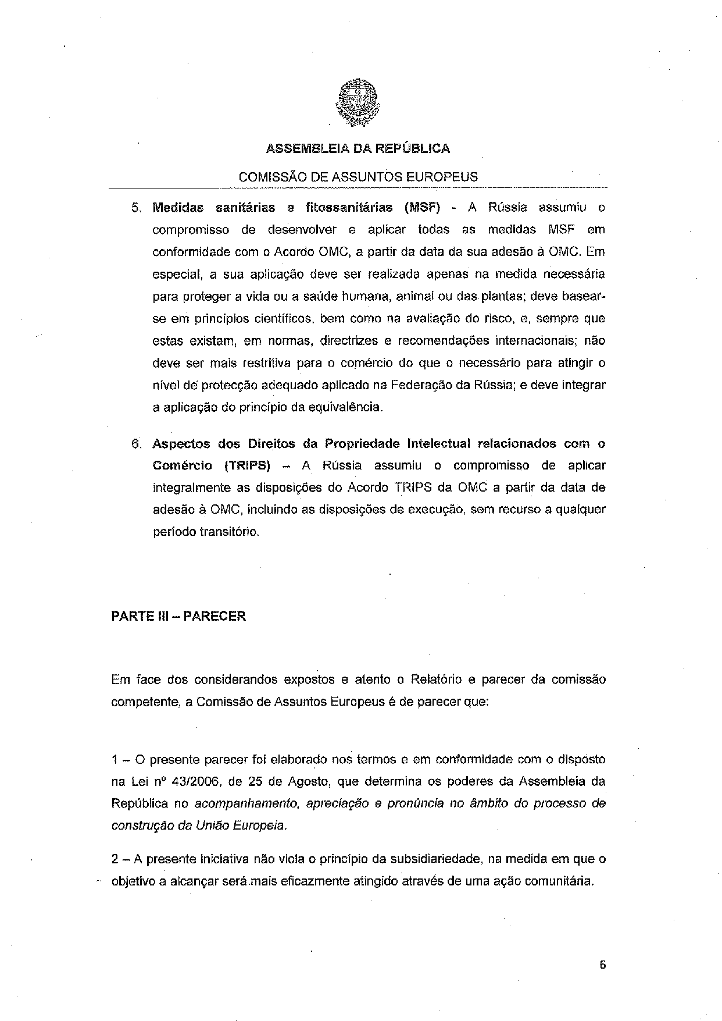
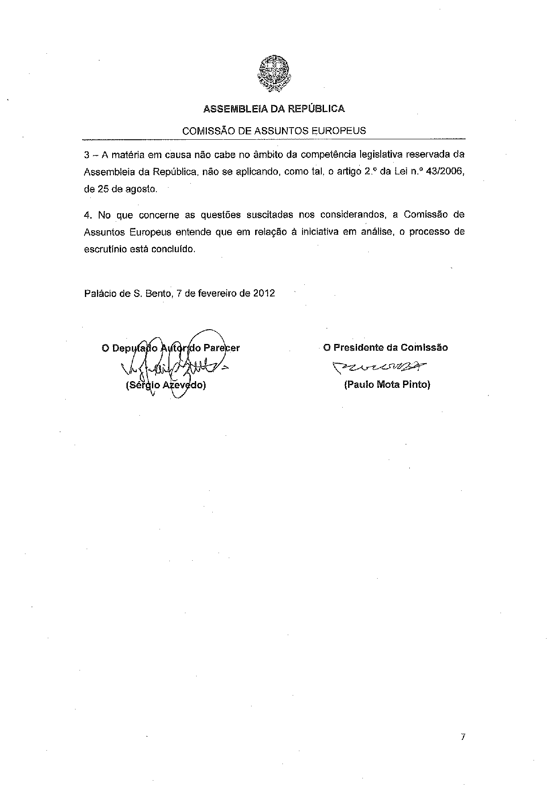
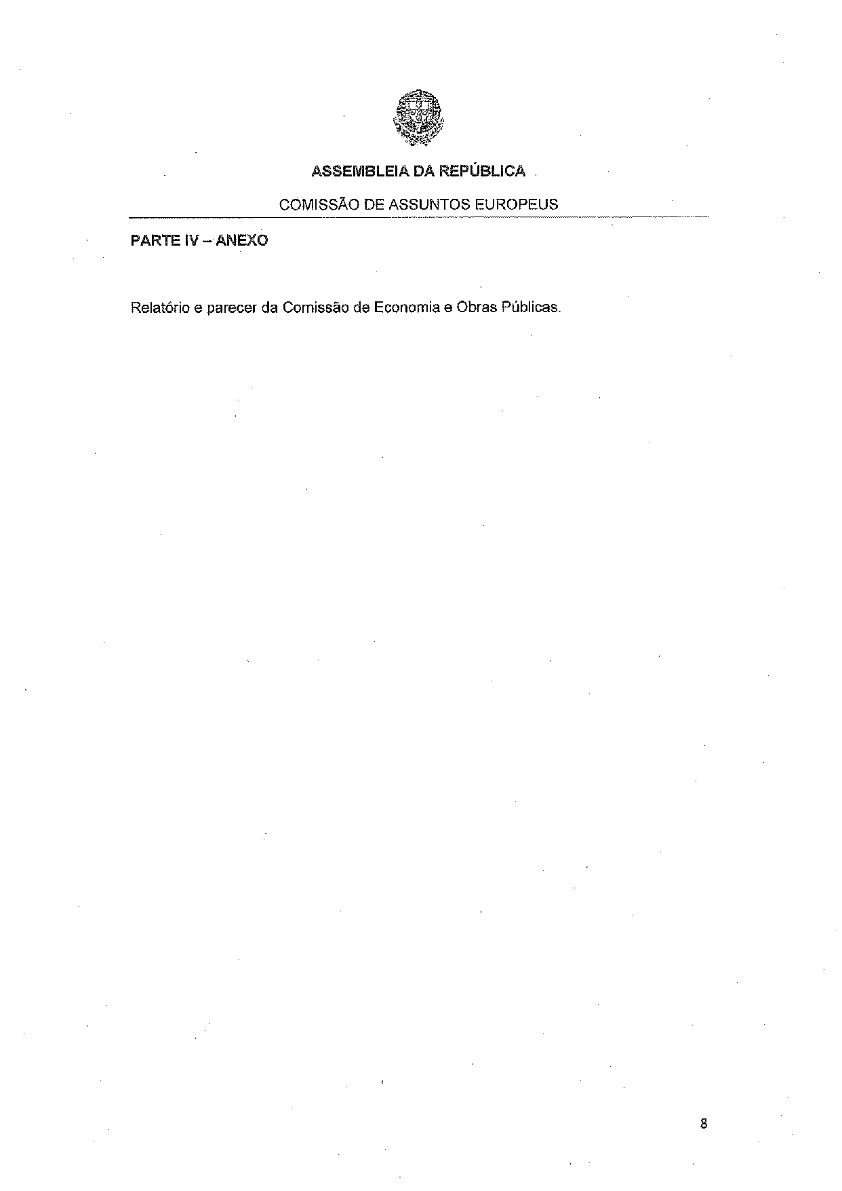
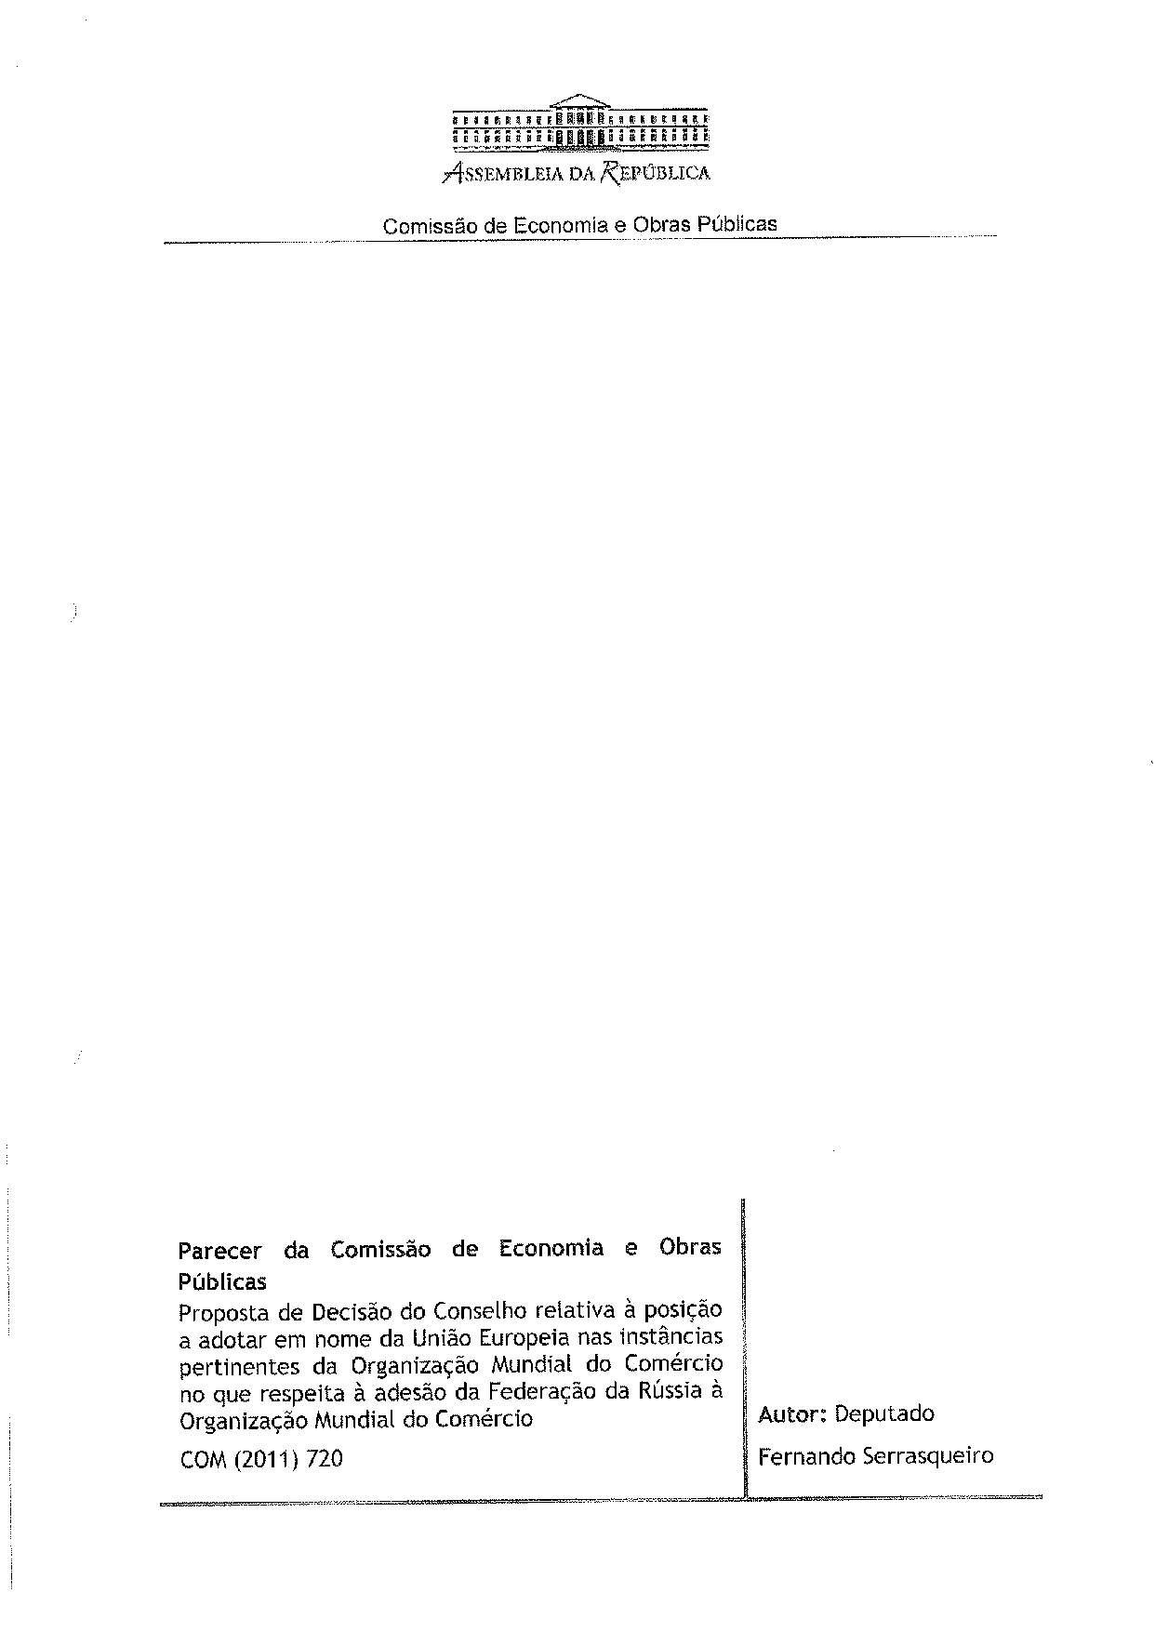
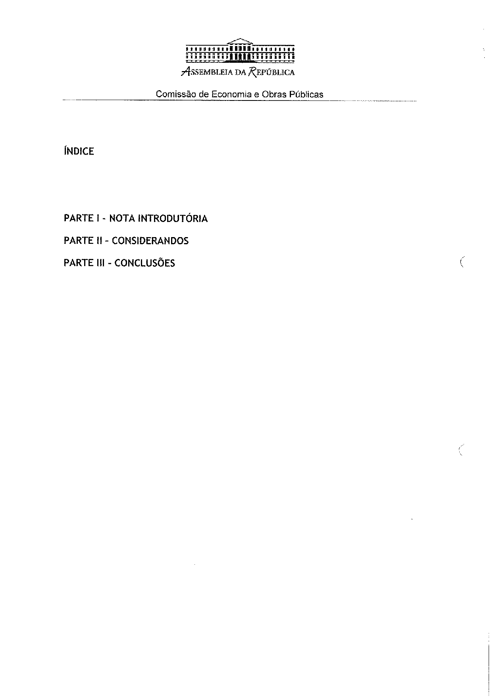
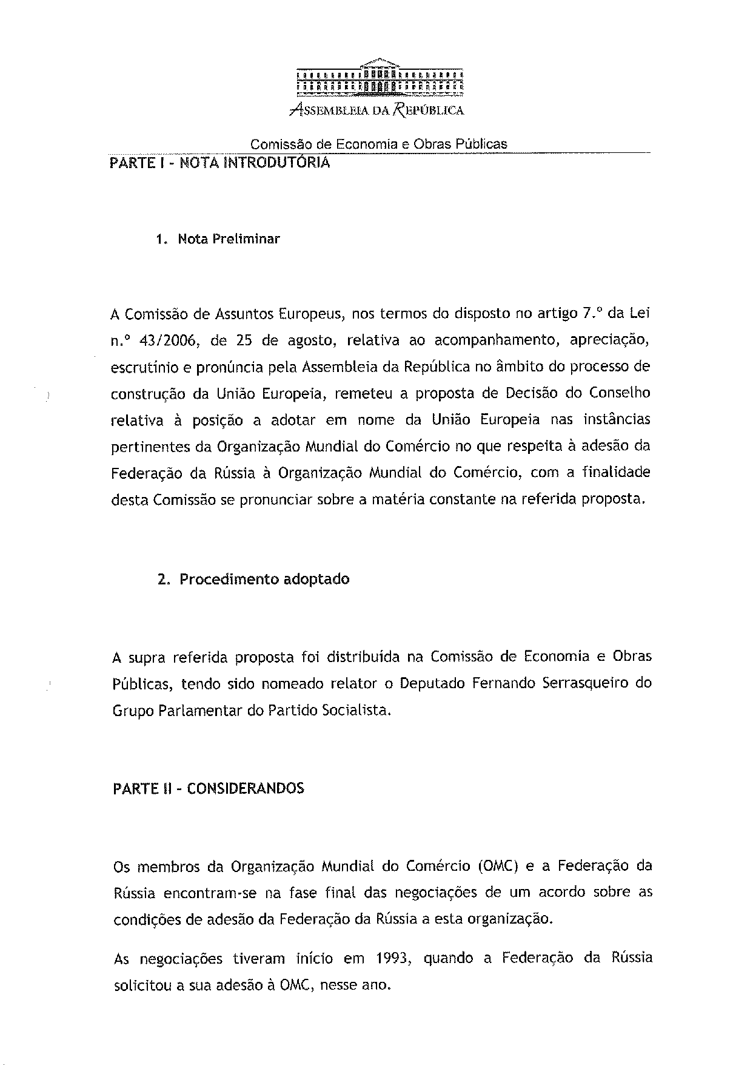
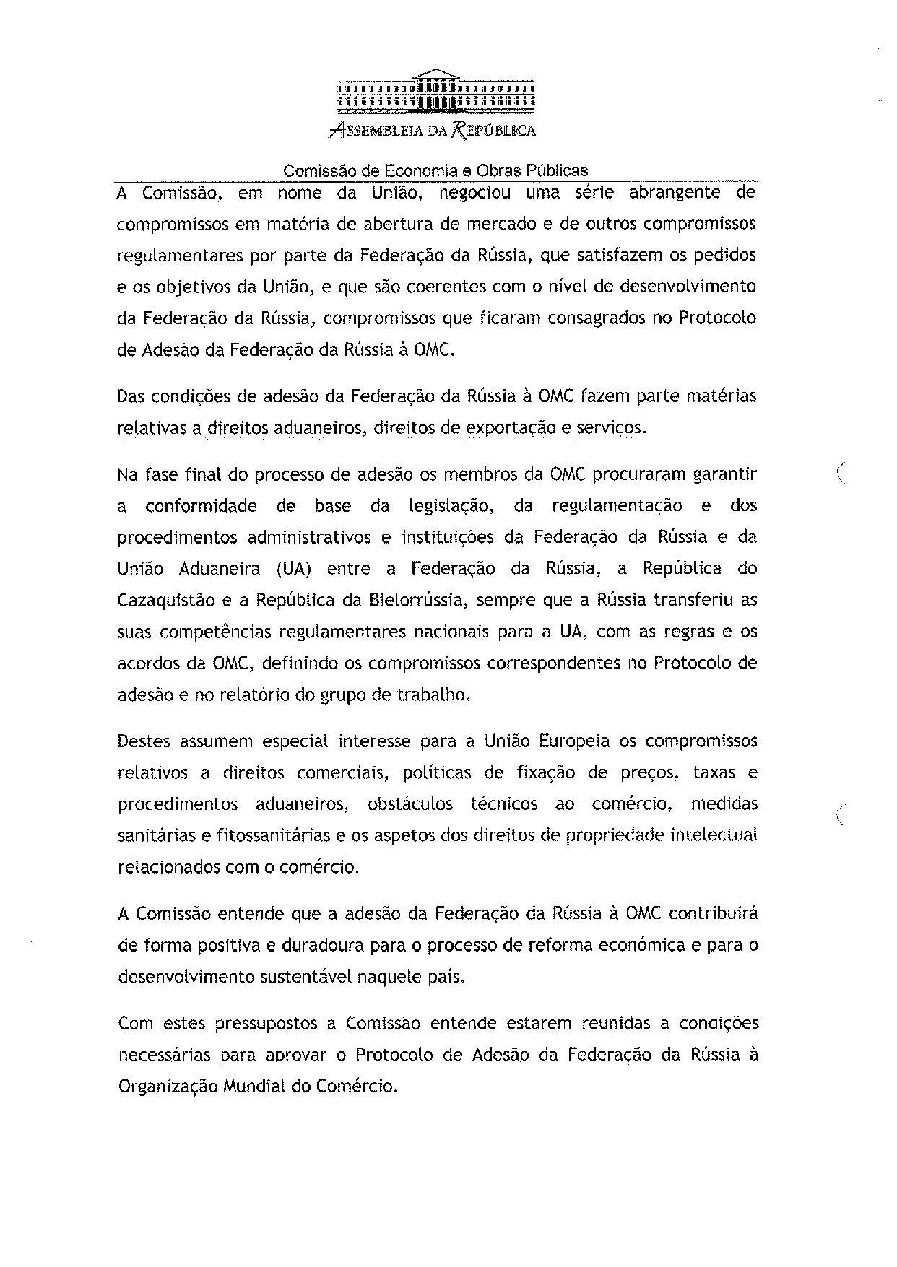
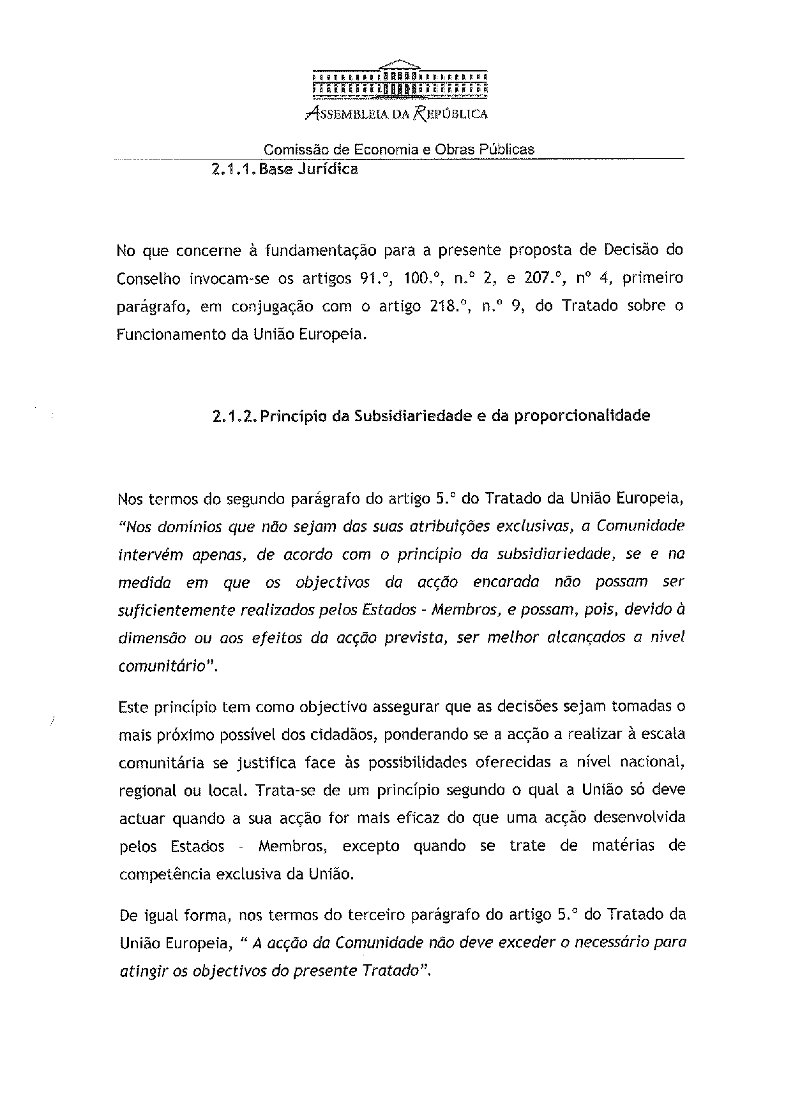
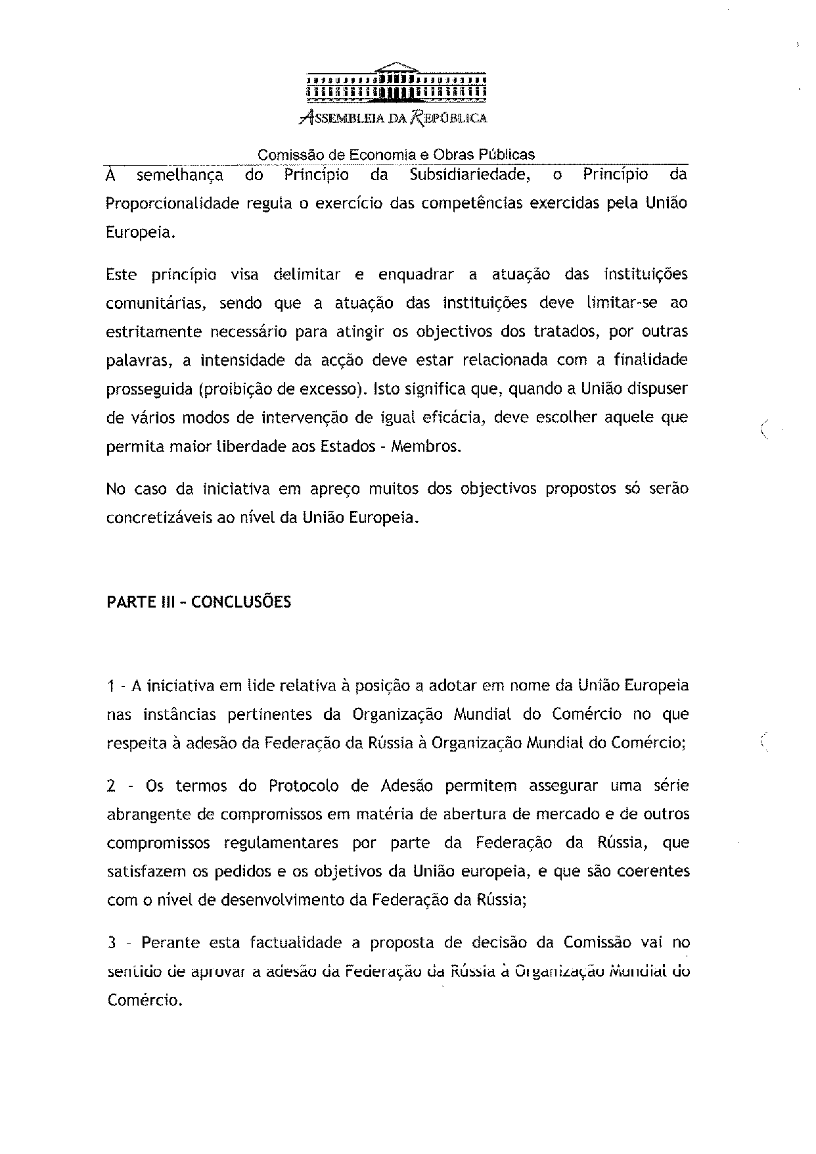
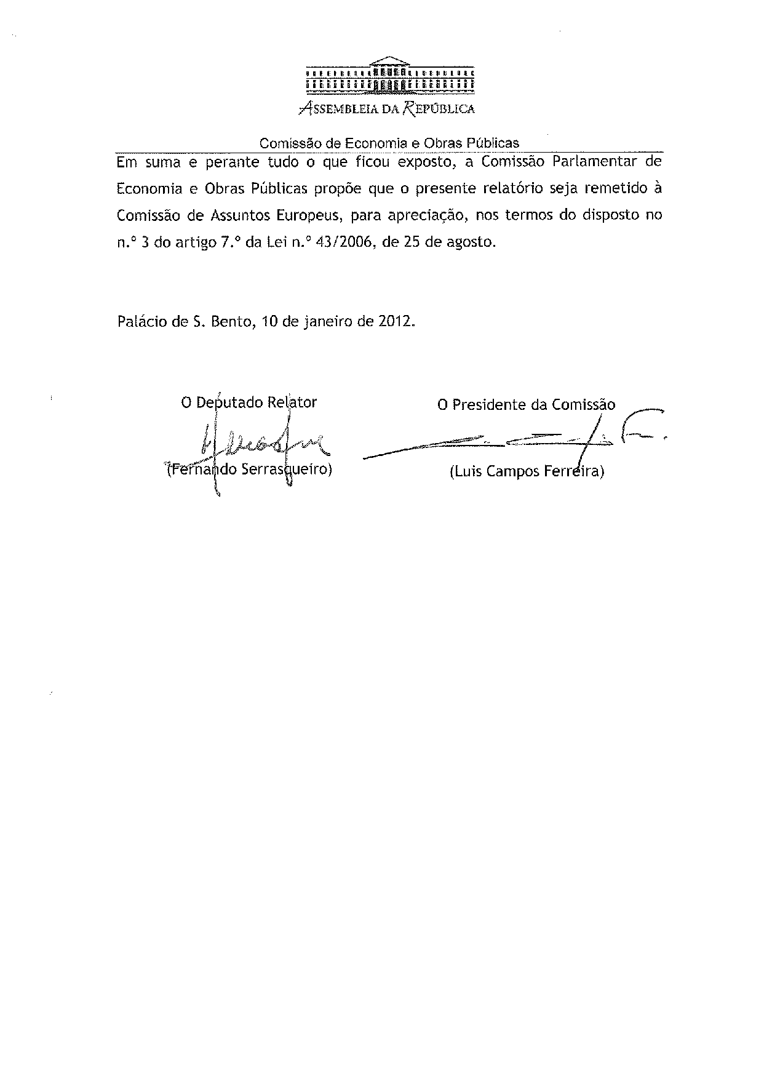

The translation of the opinion may be available at the Interparliamentary EU information exchange site IPEX, at the following address: http://www.ipex.eu/IPEXL-WEB/search.do.

