 | 
COUNCIL OF  THE EUROPEAN UNION |  |  | Brussels, 10 February 2012
 | Interinstitutional File:  2011/0385 (COD) |  | 6385/12
ECOFIN 136
UEM 32
CODEC 347
INST 122
PARLNAT 91

COVER NOTE
from: | Portuguese Assembleia da República, Comissão de Assuntos Europeus
date of receipt: | 9 February 2012
to: | President of the Council of the European Union
Subject: | Proposal for a Regulation of the European Parliament and of the Council on the strengthening of economic and budgetary surveillance of Member States experiencing or threatened with serious difficulties with respect to their financial stability in the euro area  [doc. ST 17230/11 ECOFIN 805 UEM 335 CODEC 2112 - COM(2011) 819 final]  - Opinion on the application of the Principles of Subsidiarity and Proportionality

Delegations will find attached the above mentioned opinion.

________________________

Encl.:

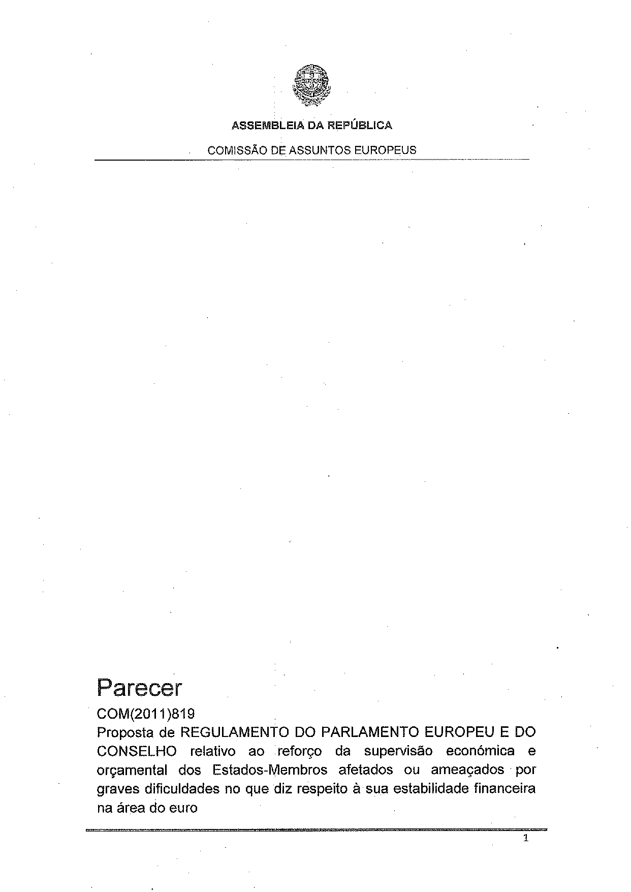
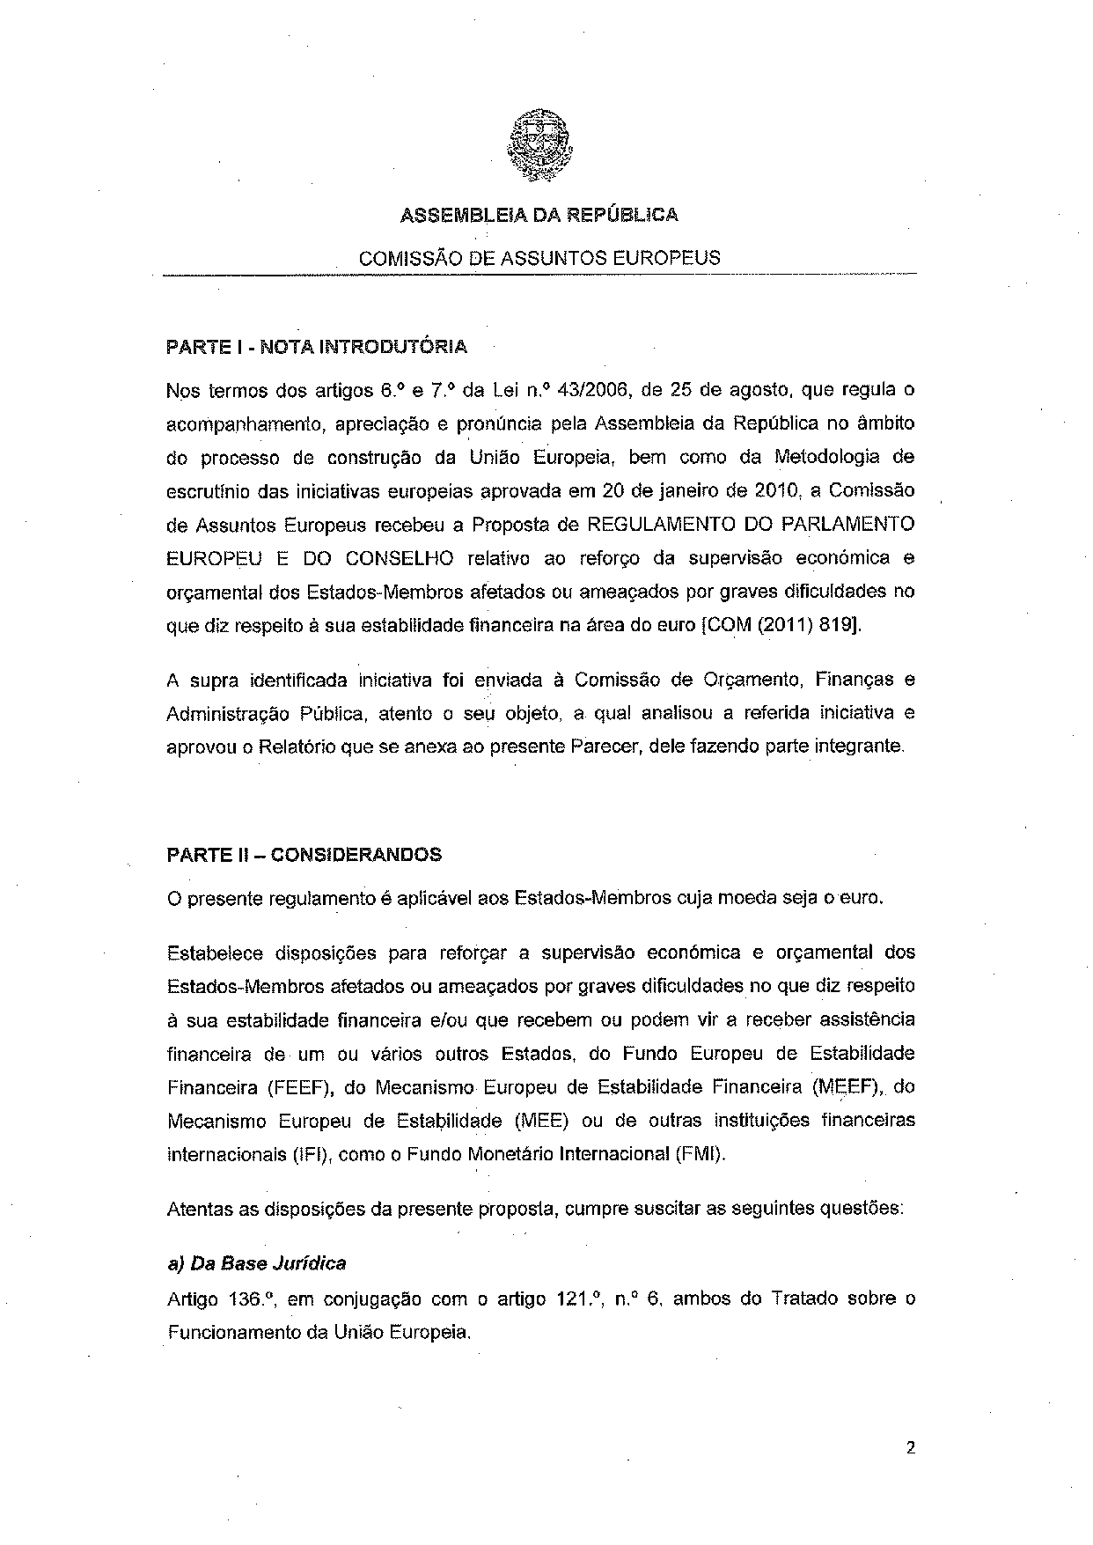
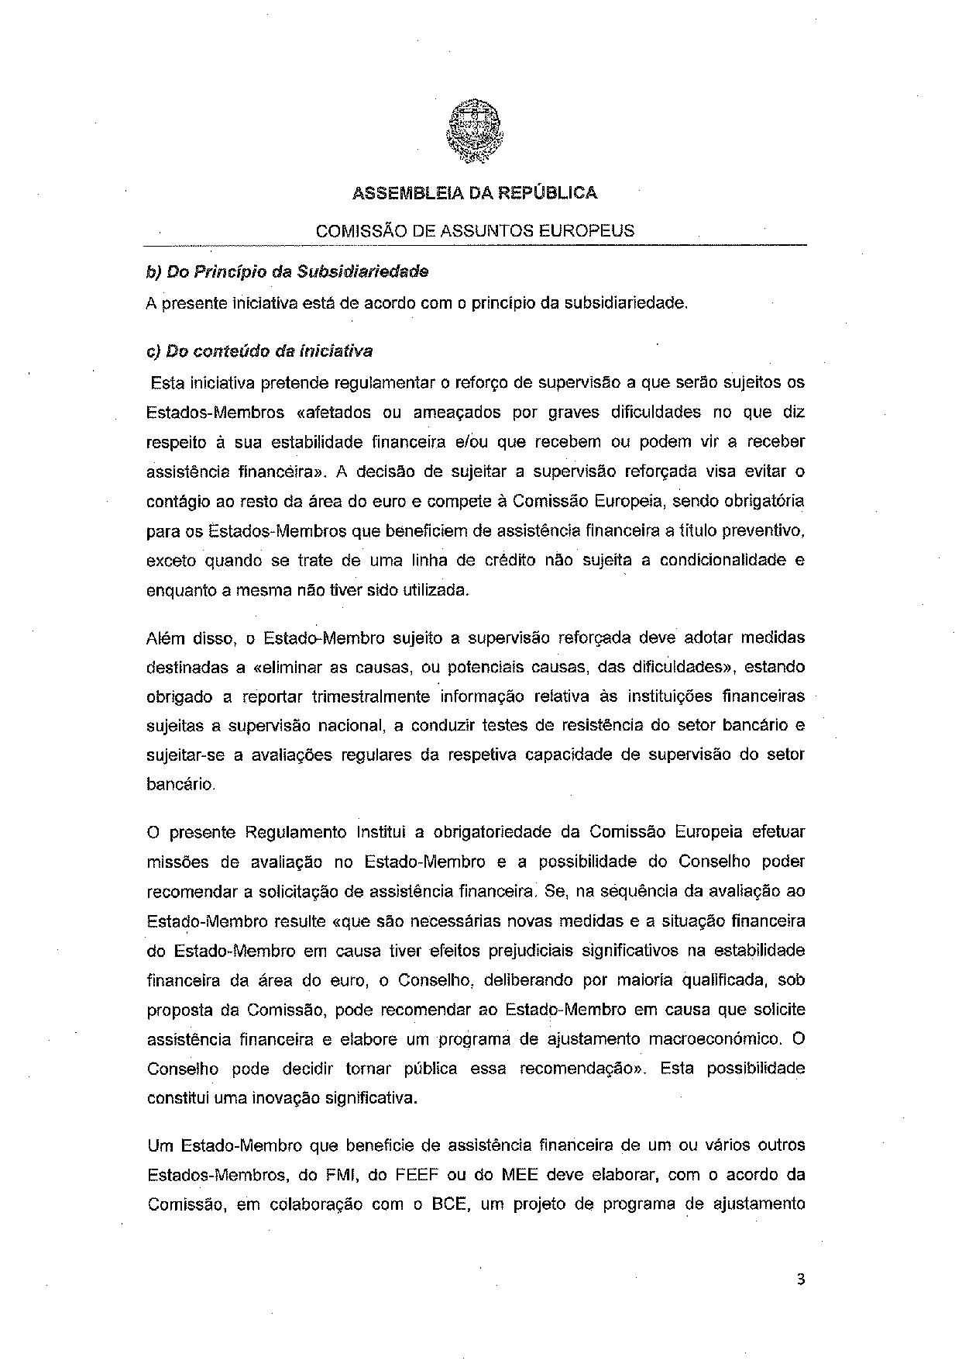
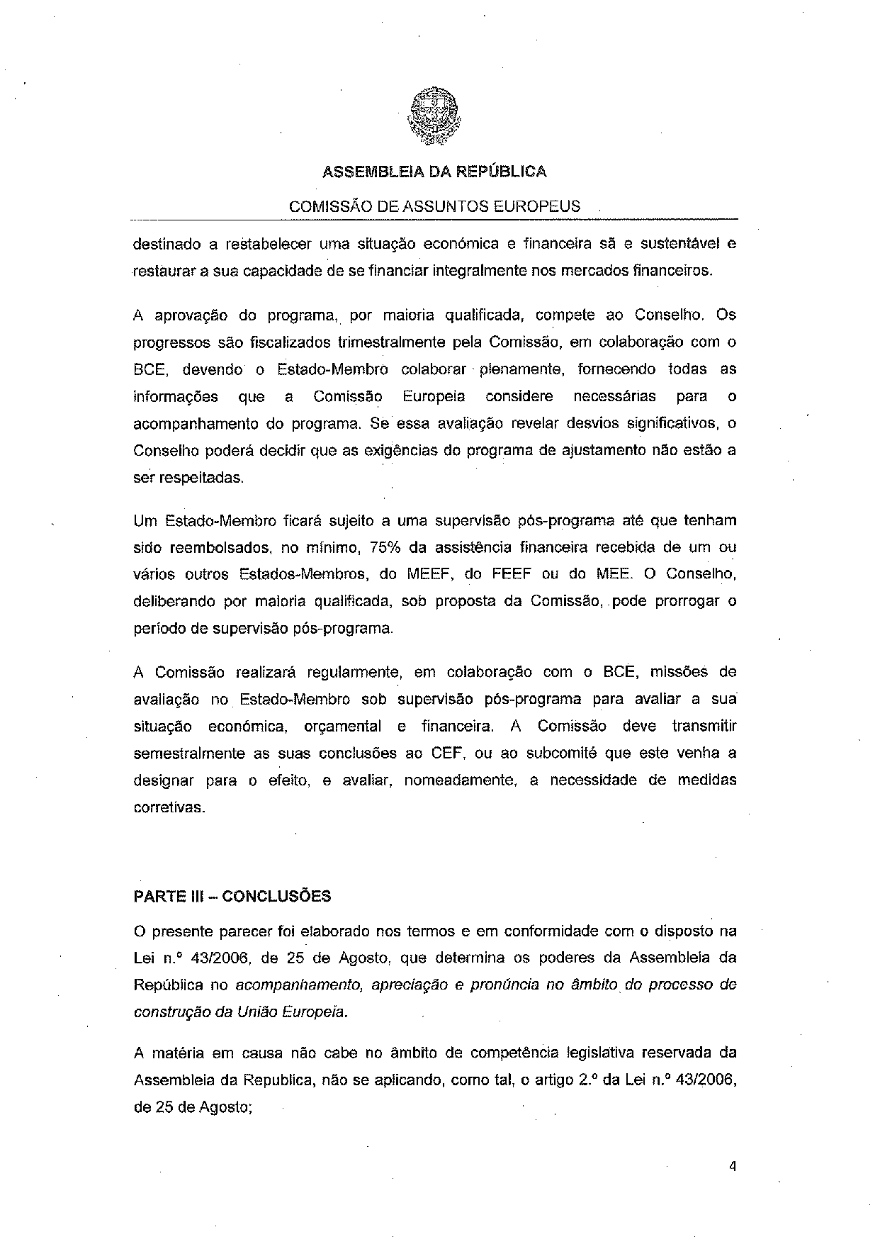
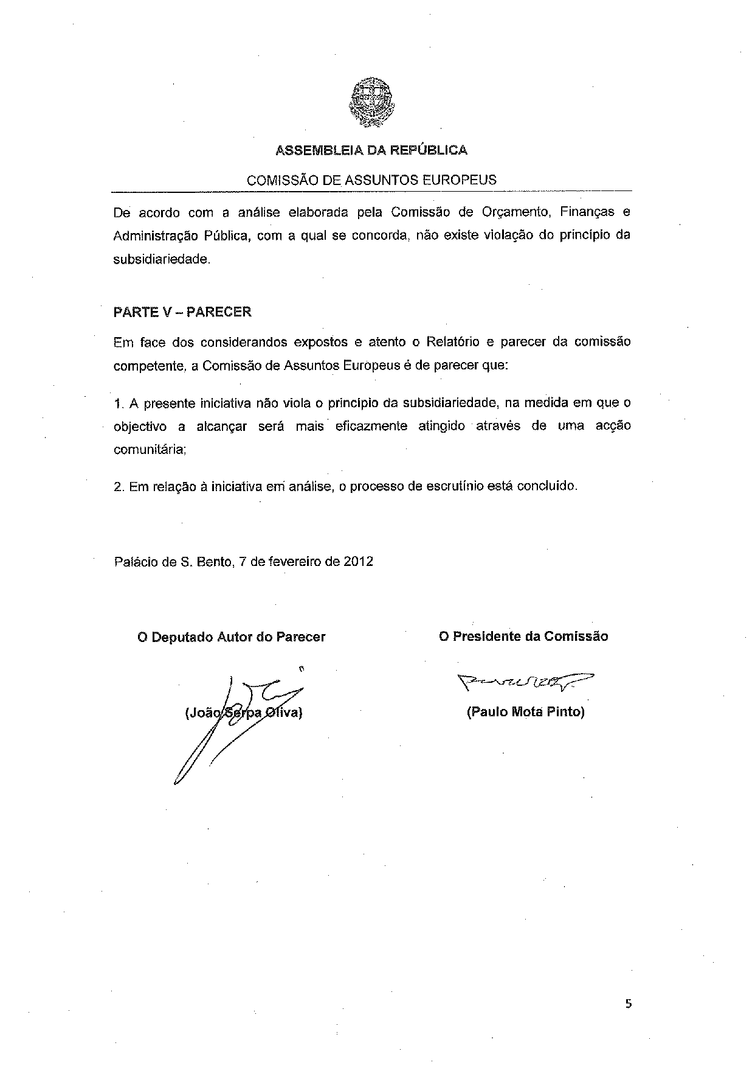

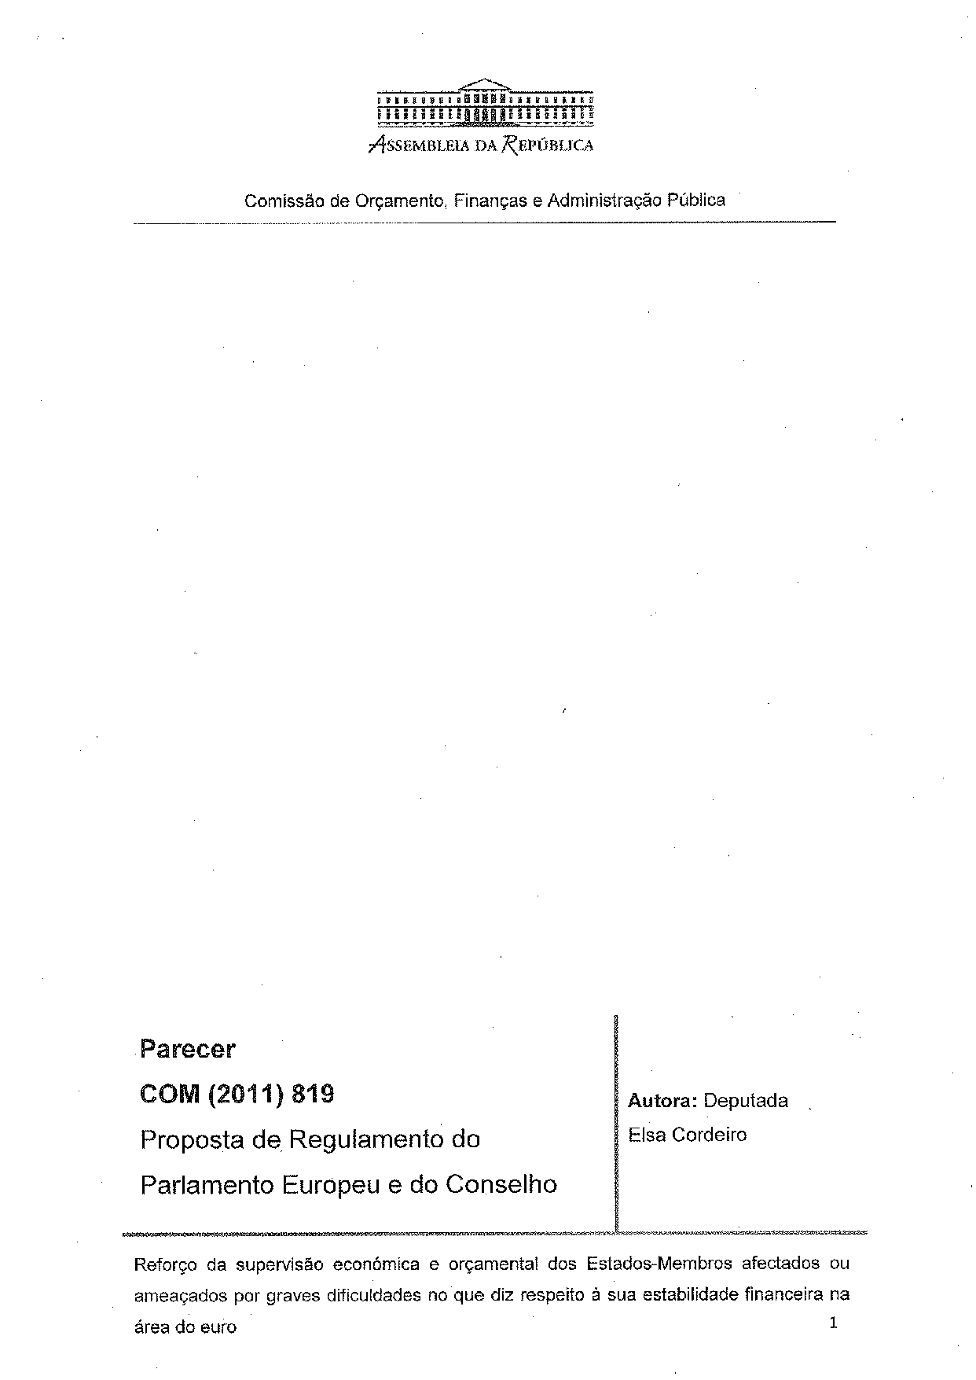
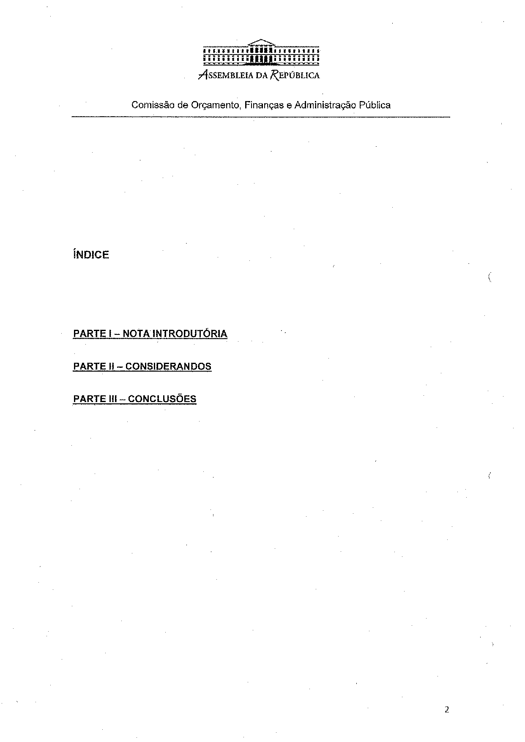
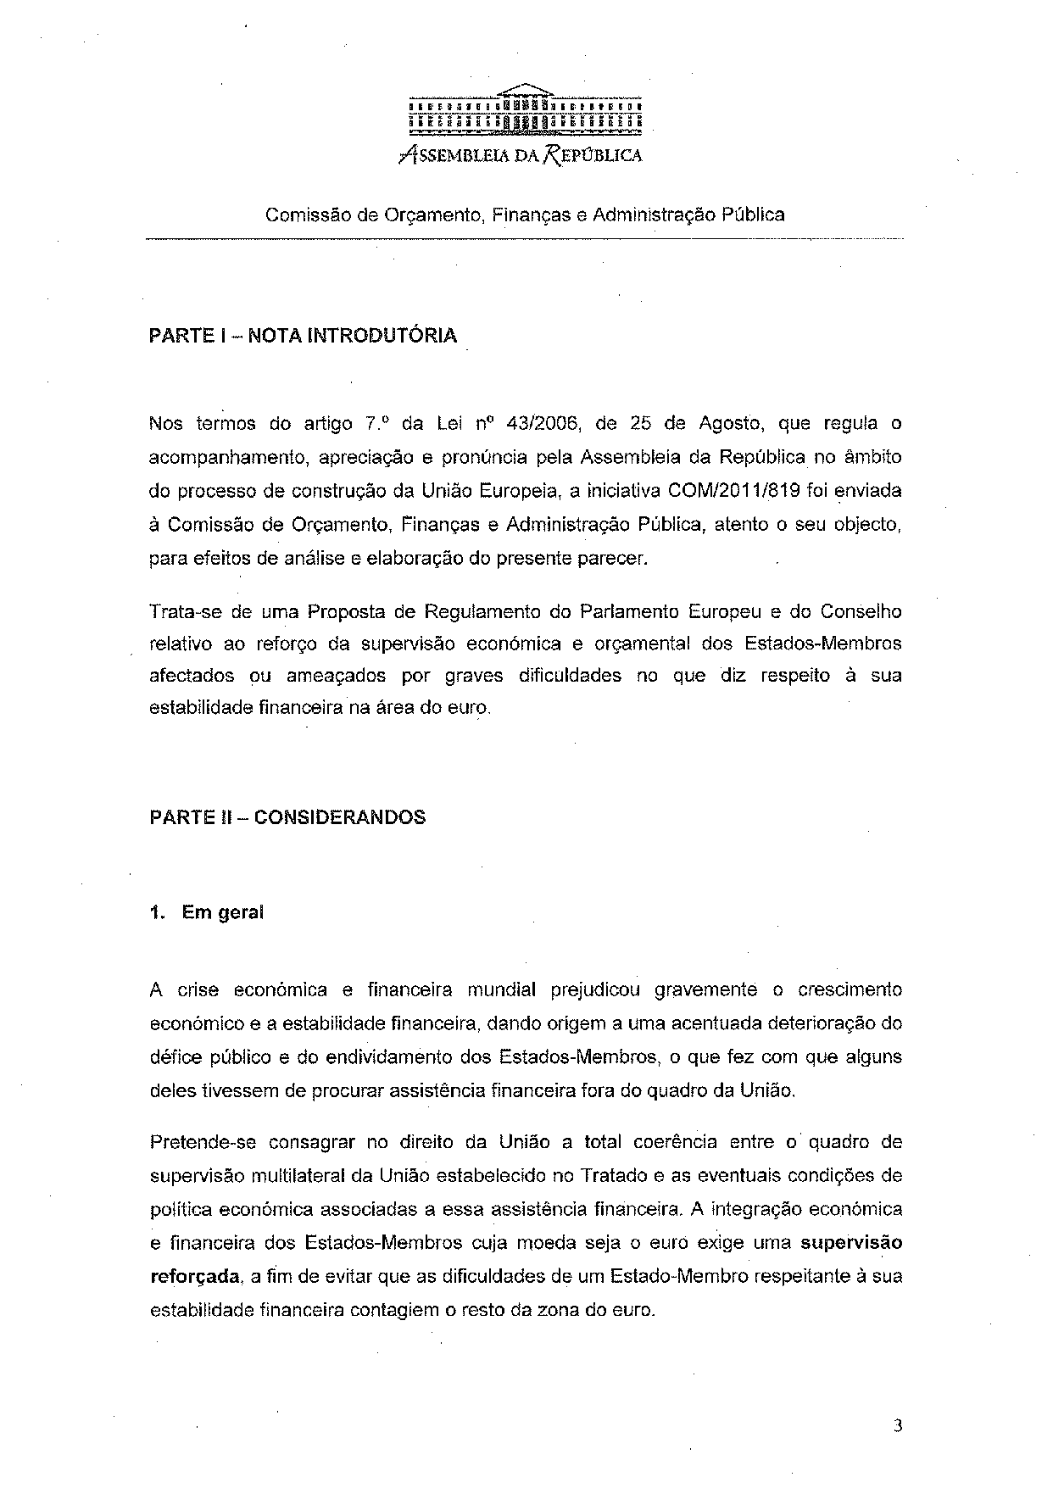
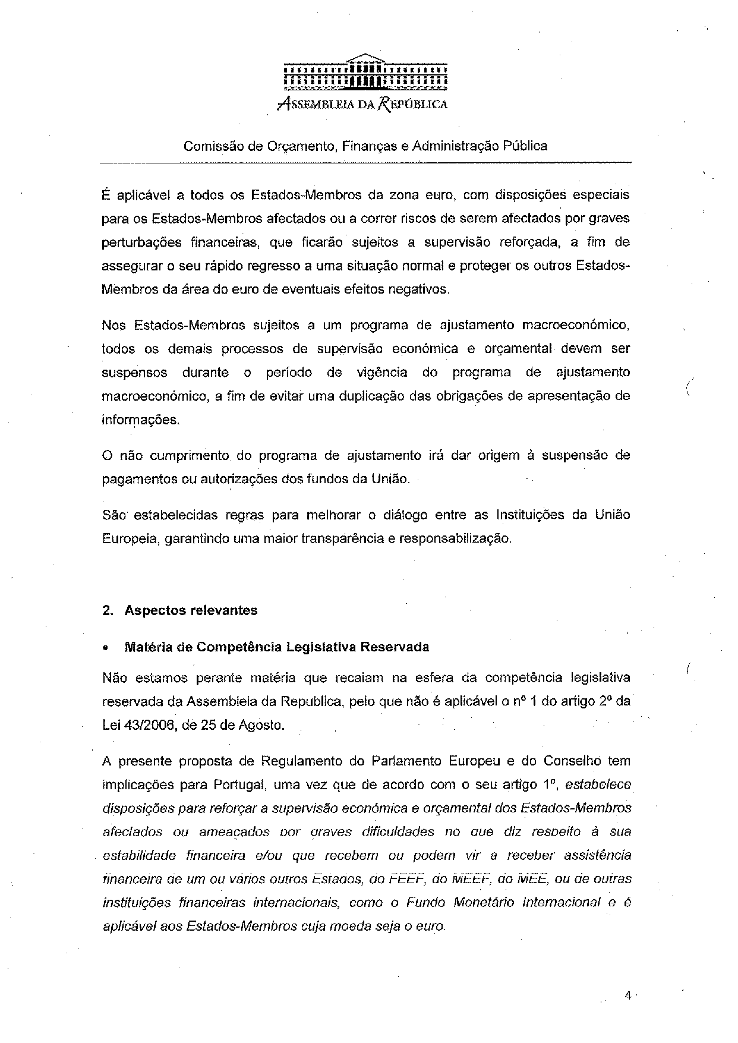
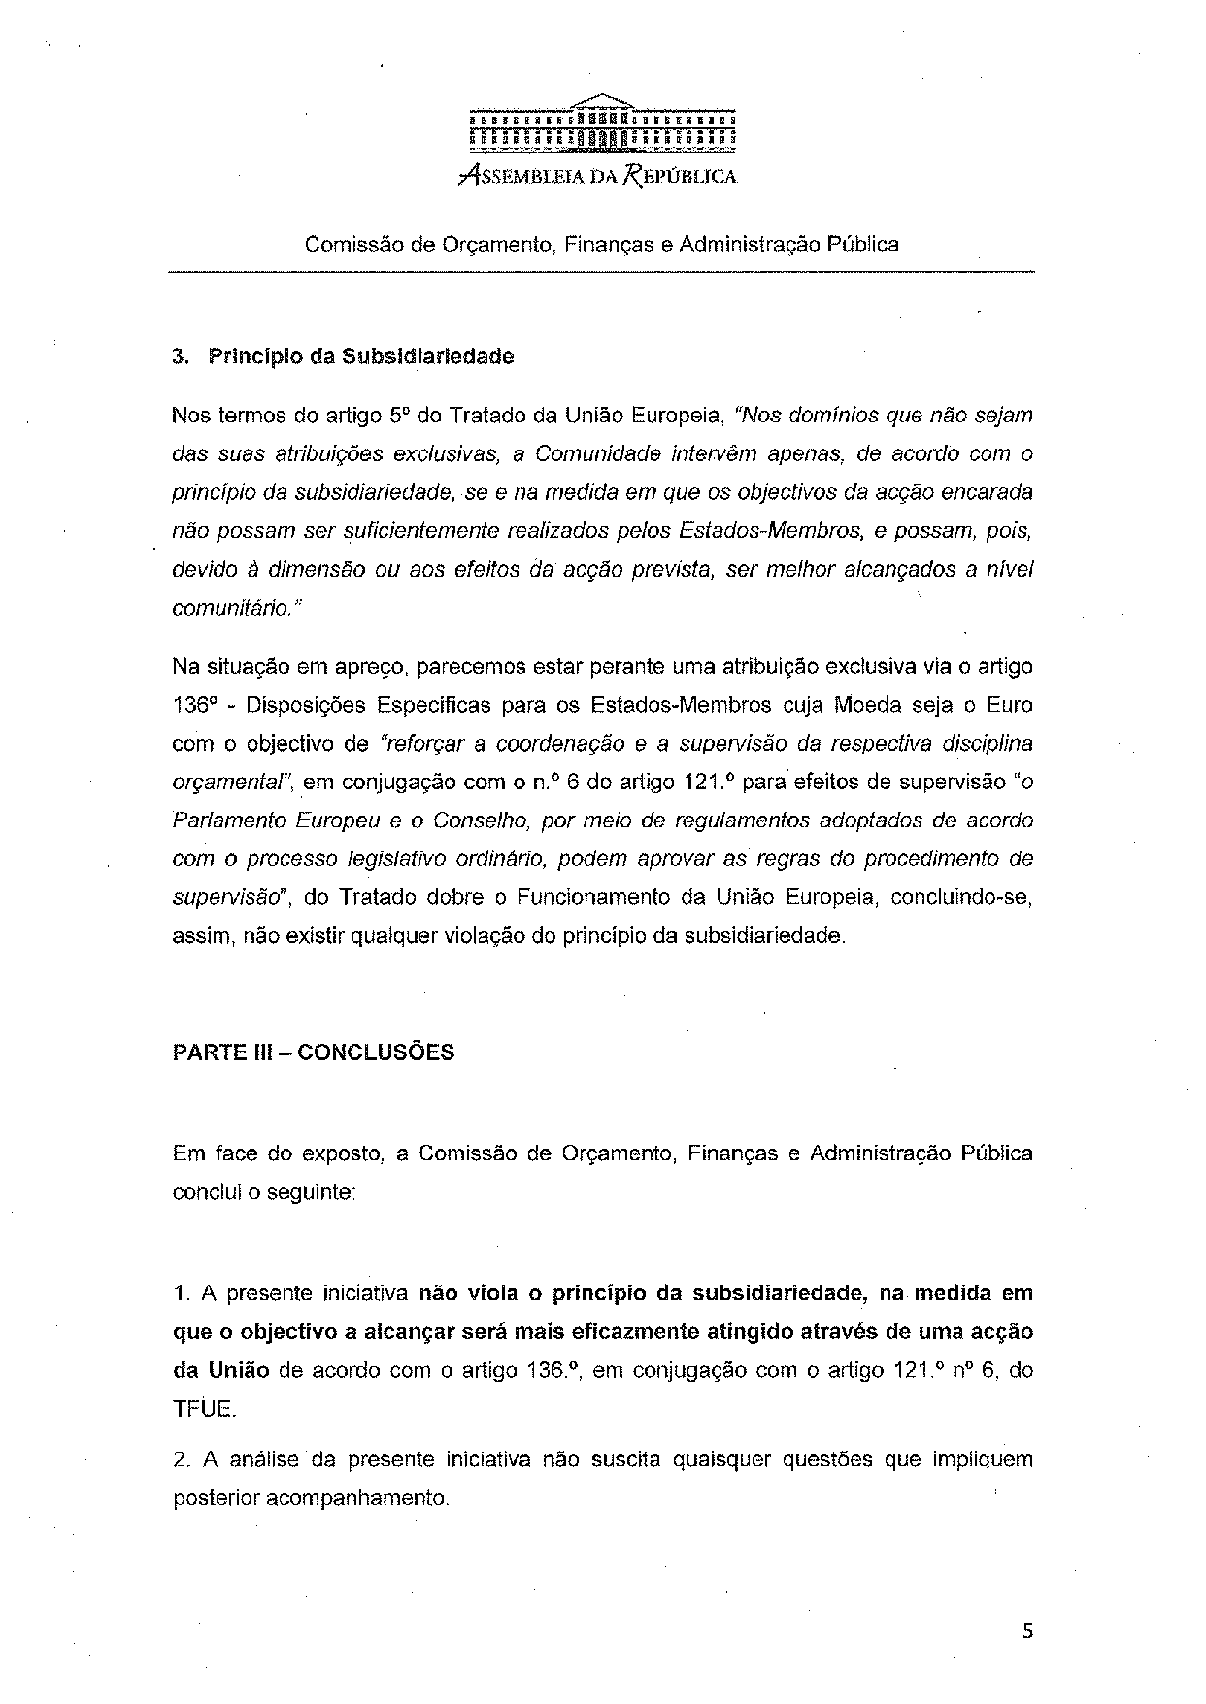
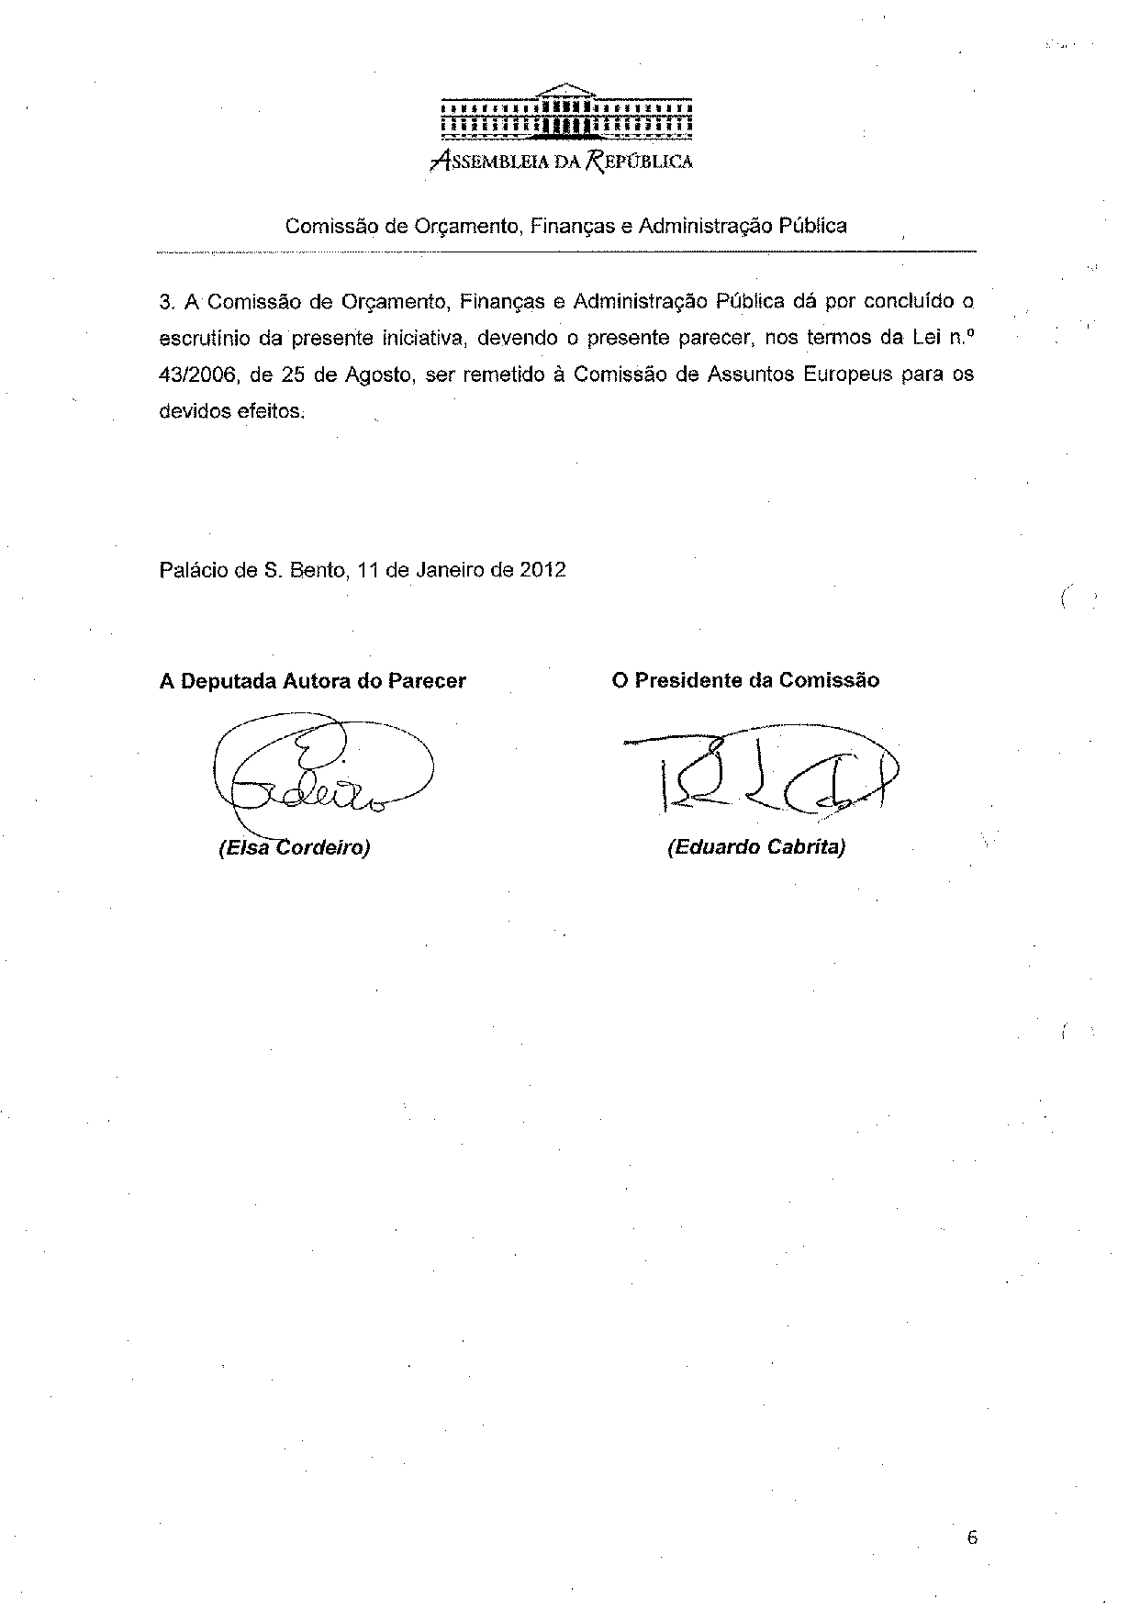

For other language versions of the opinion, reference is made to the Interparliamentary EU information exchange site IPEX at the following address: http://www.ipex.eu/IPEXL-WEB/search.do

