 | 
COUNCIL OF  THE EUROPEAN UNION |  |  | Brussels, 9 February 2012
 | Interinstitutional File:  2011/0409 (COD) |  | 6346/12
ENT 32
ENV 98
MI 89
CODEC 338
INST 120
PARLNAT 89

NOTE
from: | the Assembly of the Republic of Portugal
date of receipt: | 8 February 2012
to: | General Secretariat of the Council of the European Union
Subject: | Proposal for a Regulation of the European Parliament and of the Council on the sound level of motor vehicles  doc.18633/11 ENT 290 ENV 978 MI 673 CODEC 2448- COM(2011) 856 final  - Opinion on the application of the Principles of Subsidiarity and Proportionality

Delegations will find attached a copy of the above opinion.

________________________

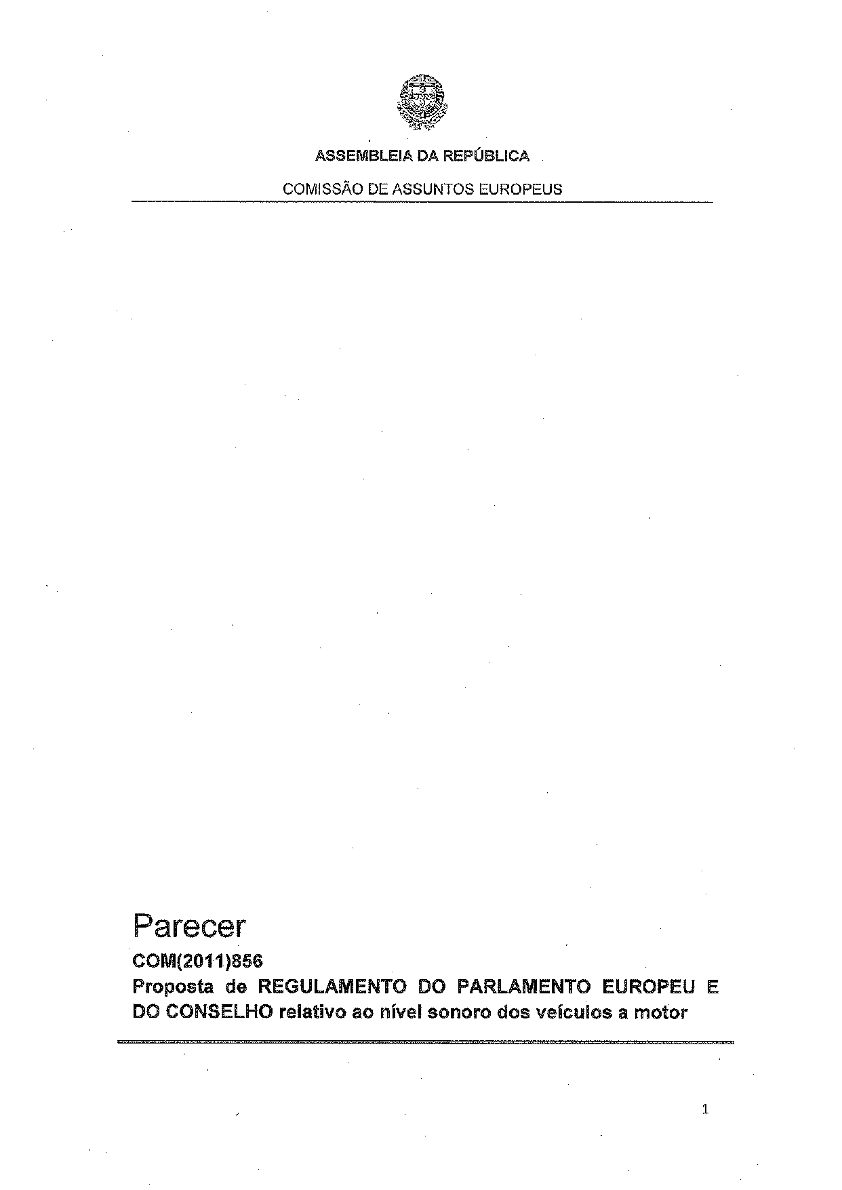
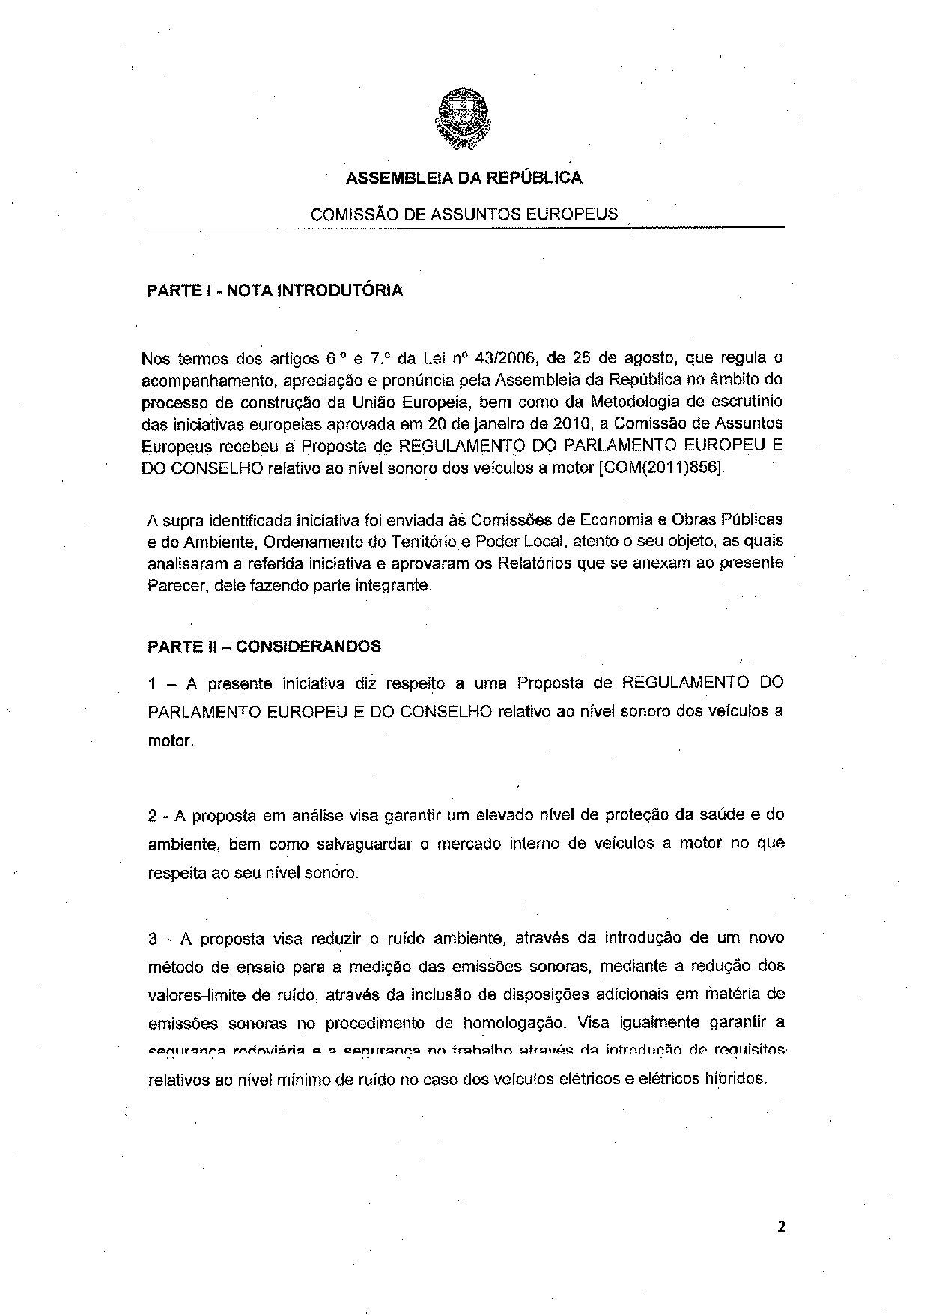
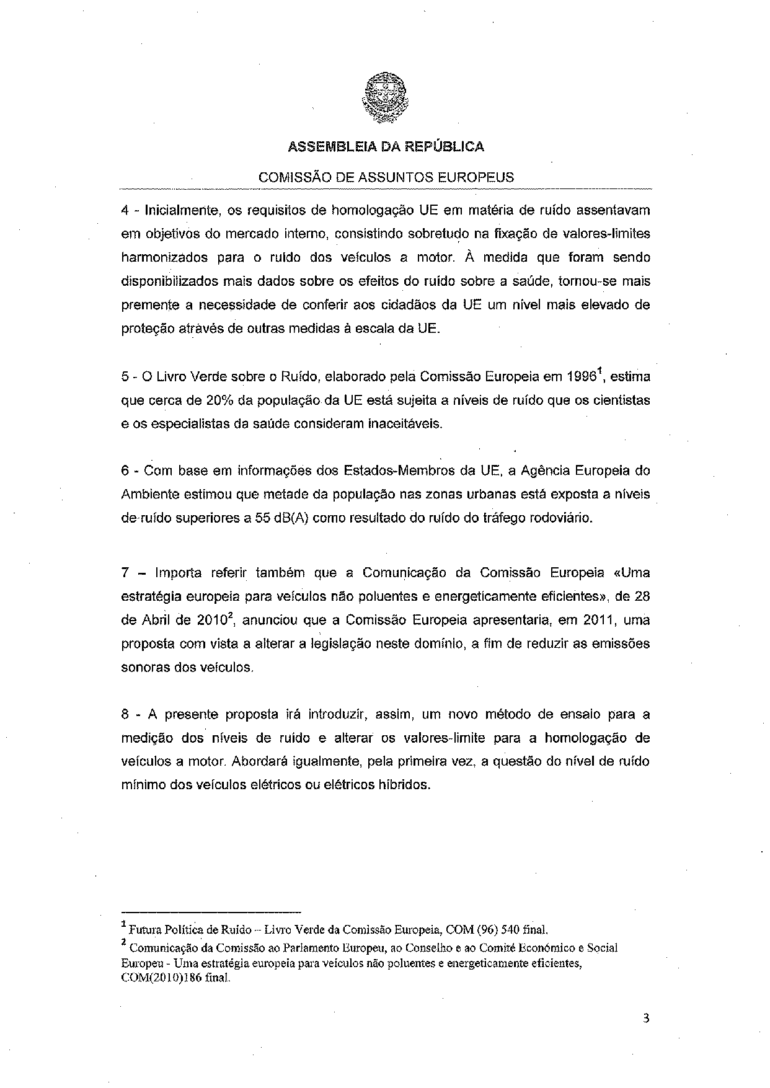
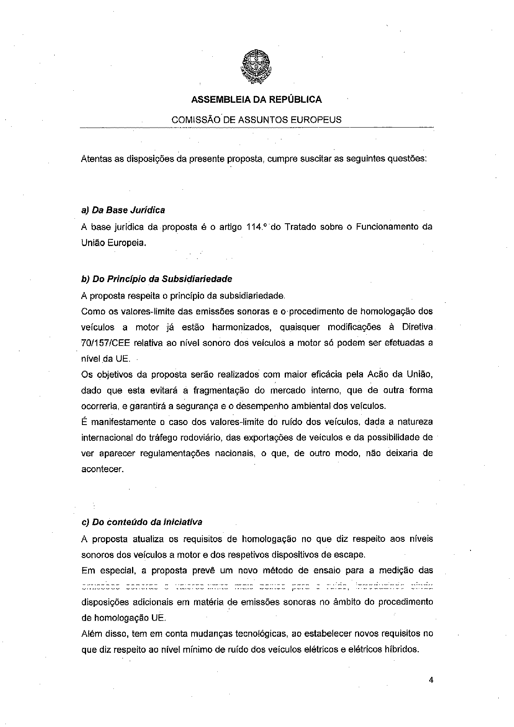
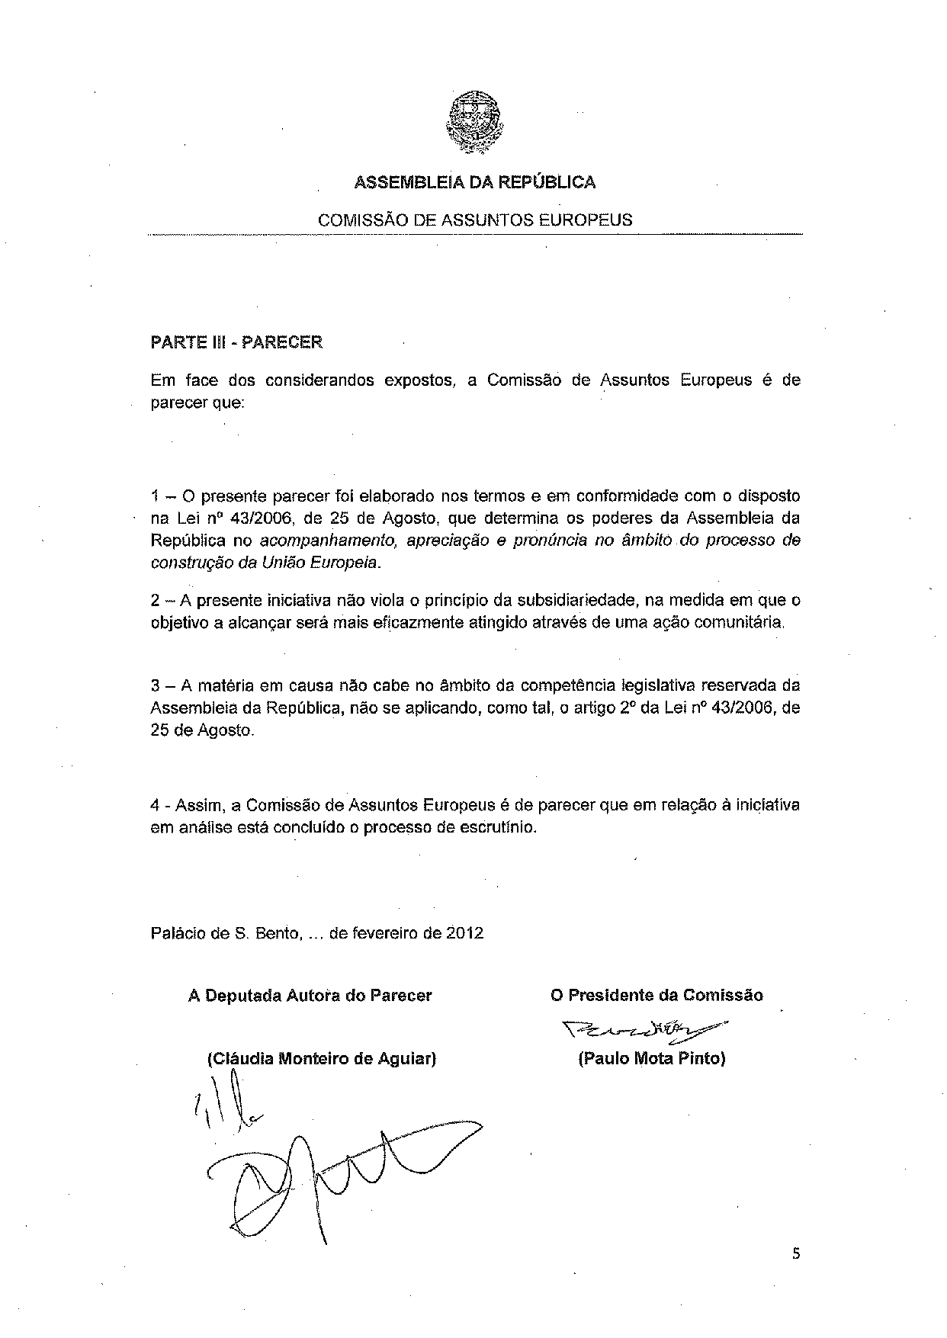

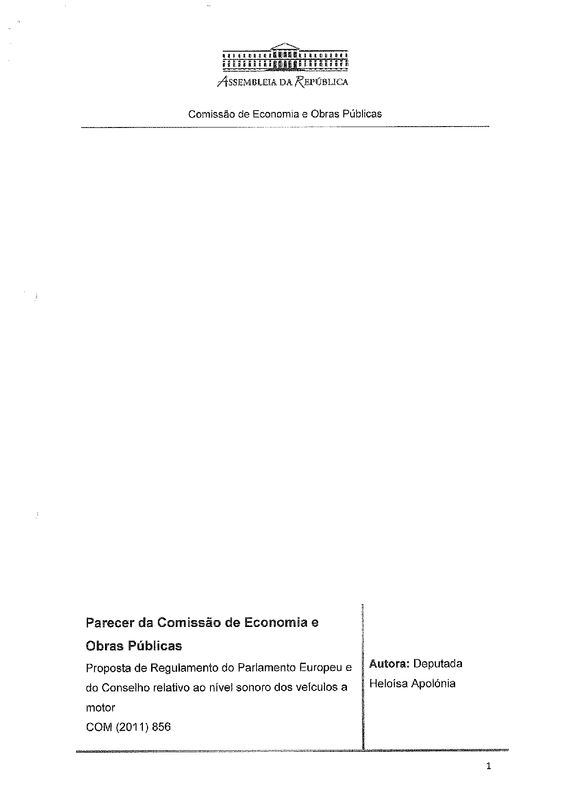
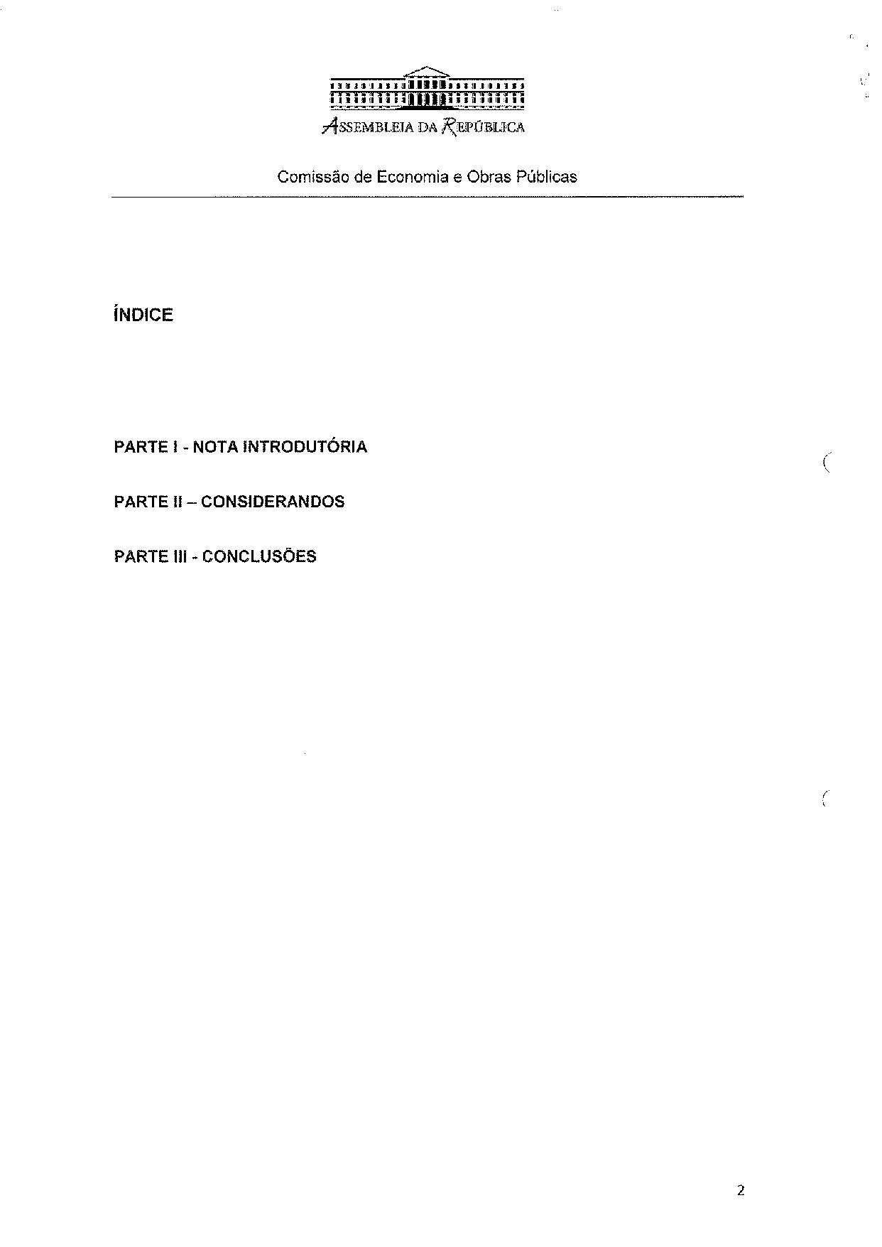
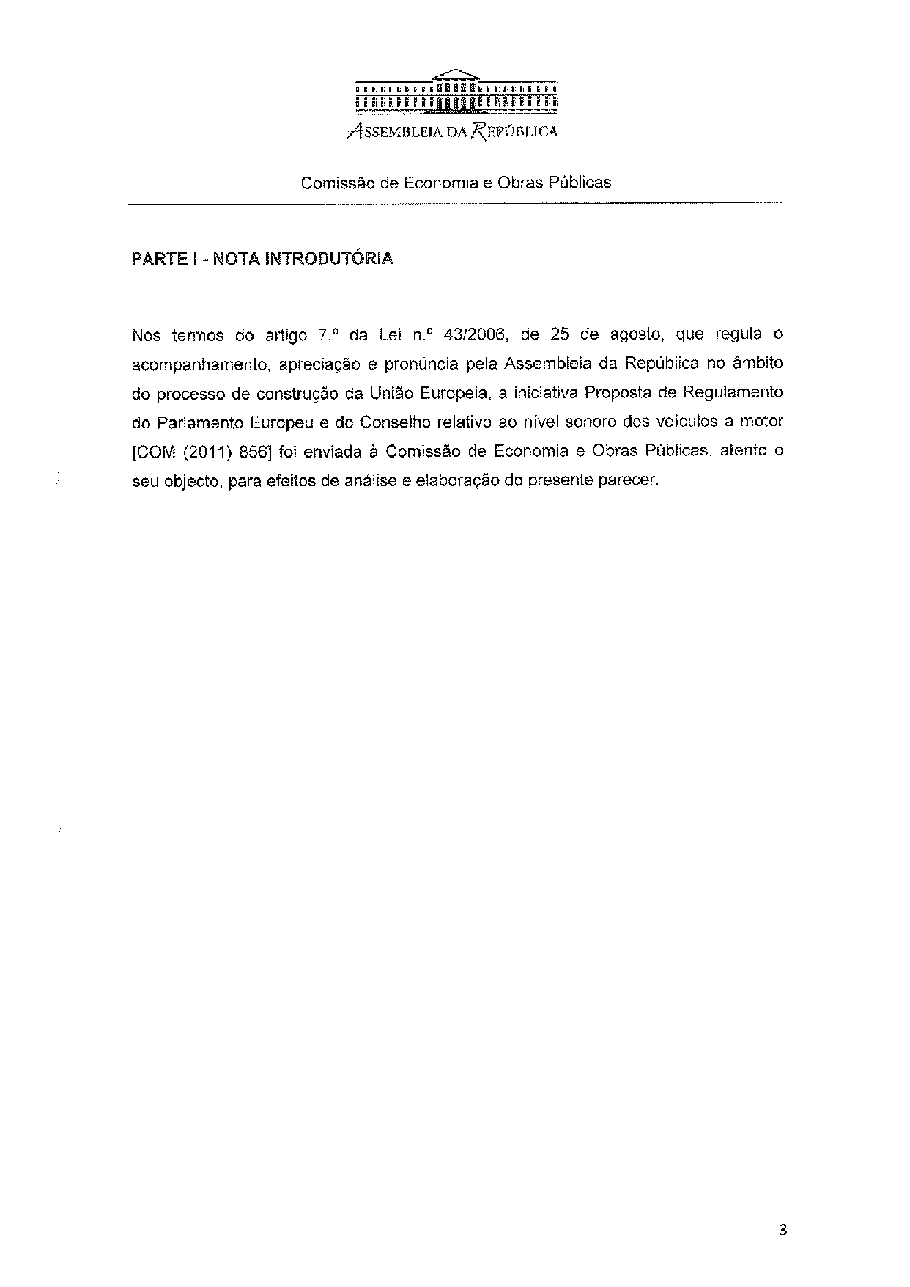
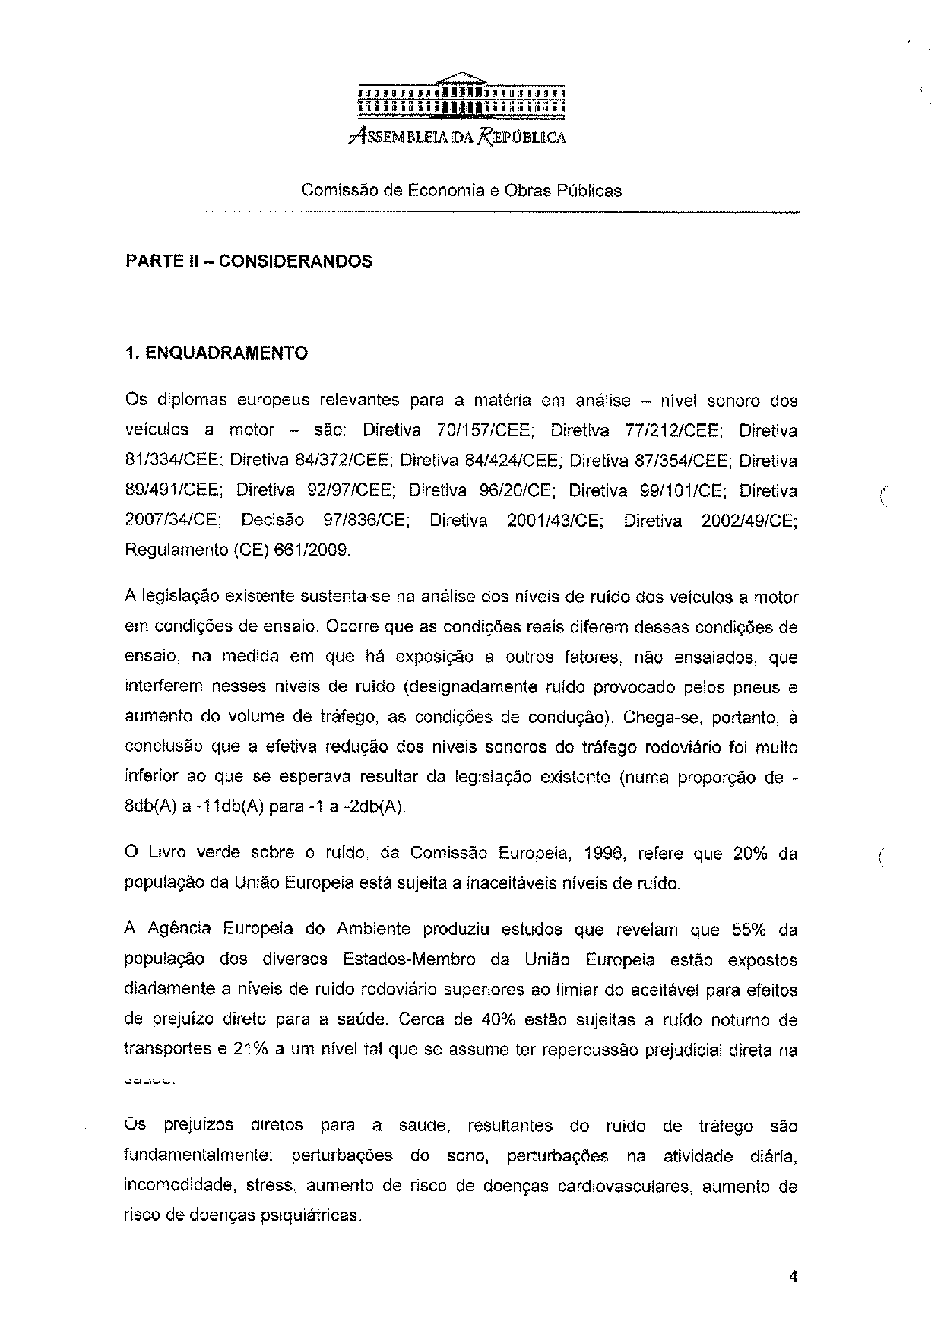
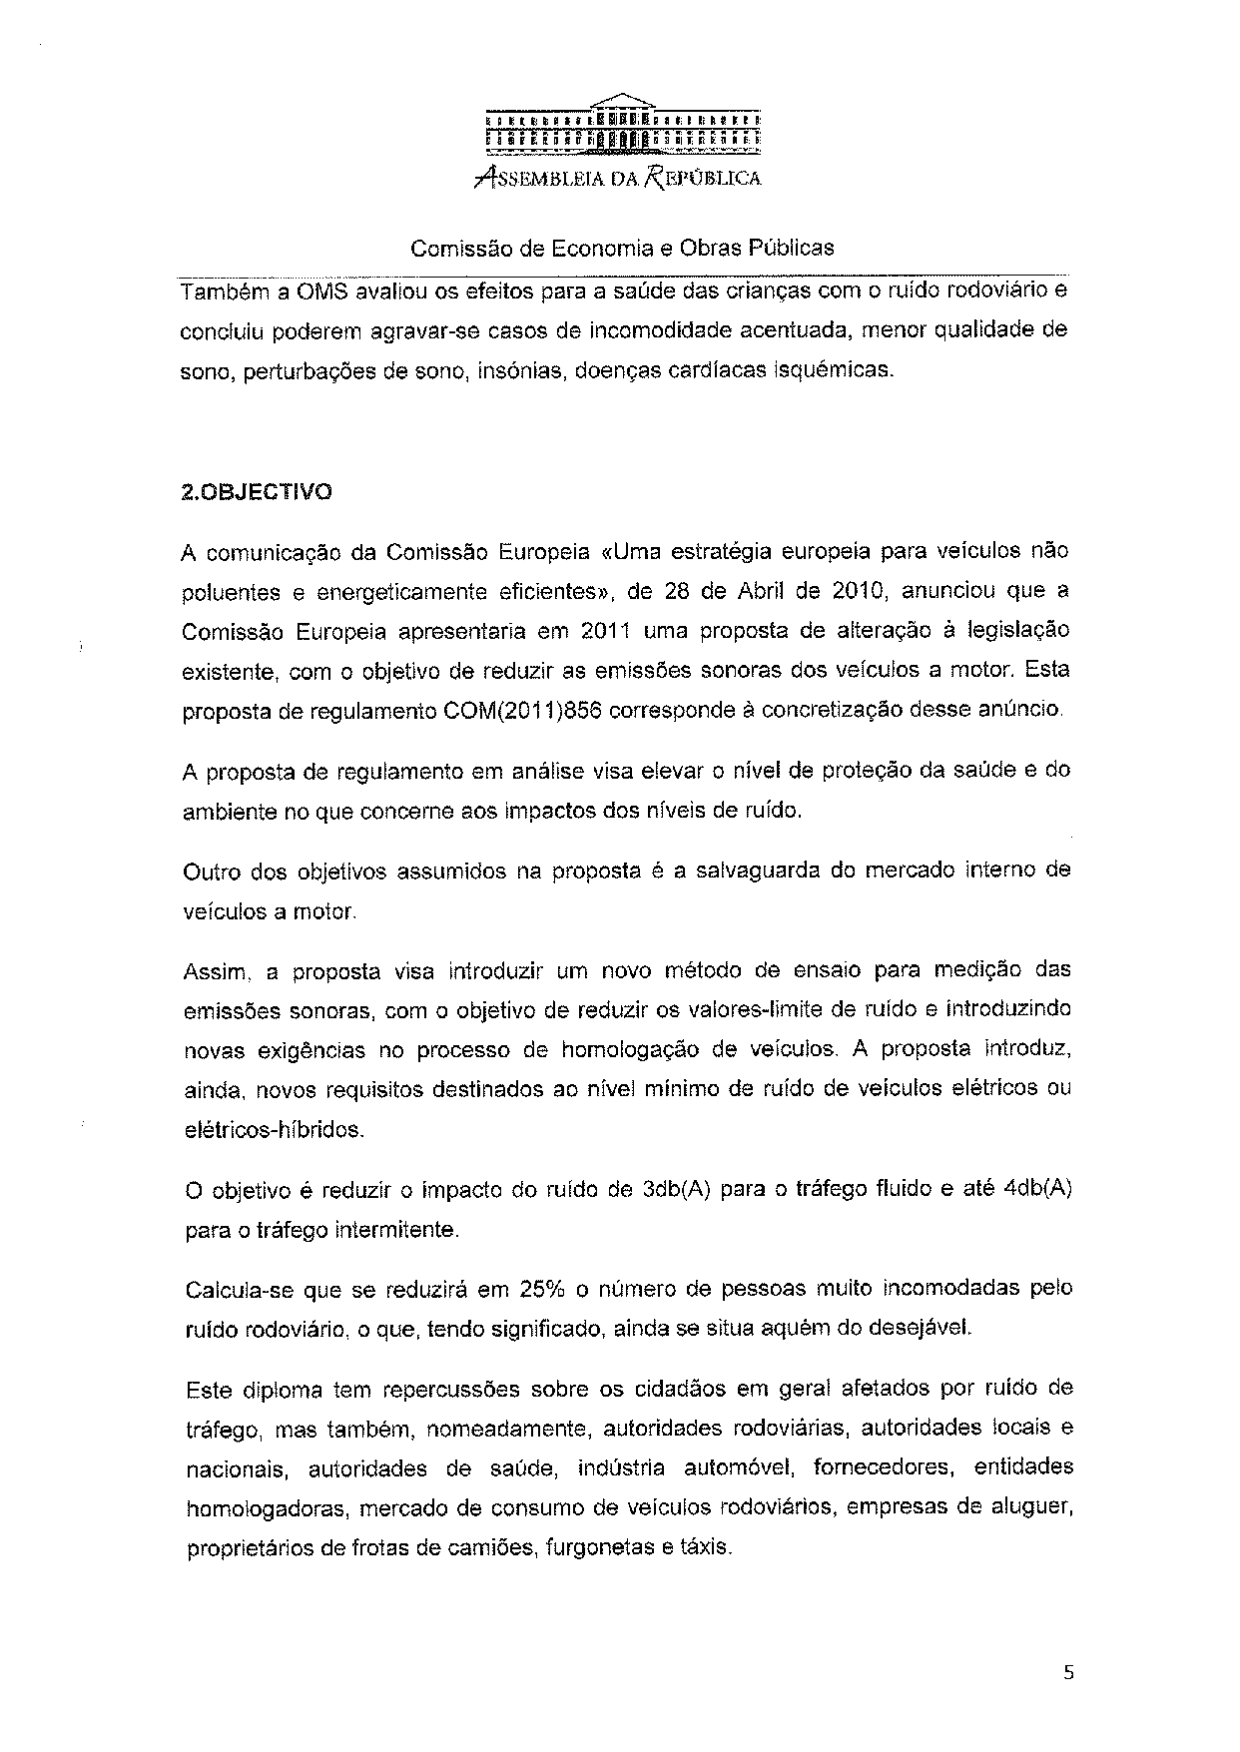
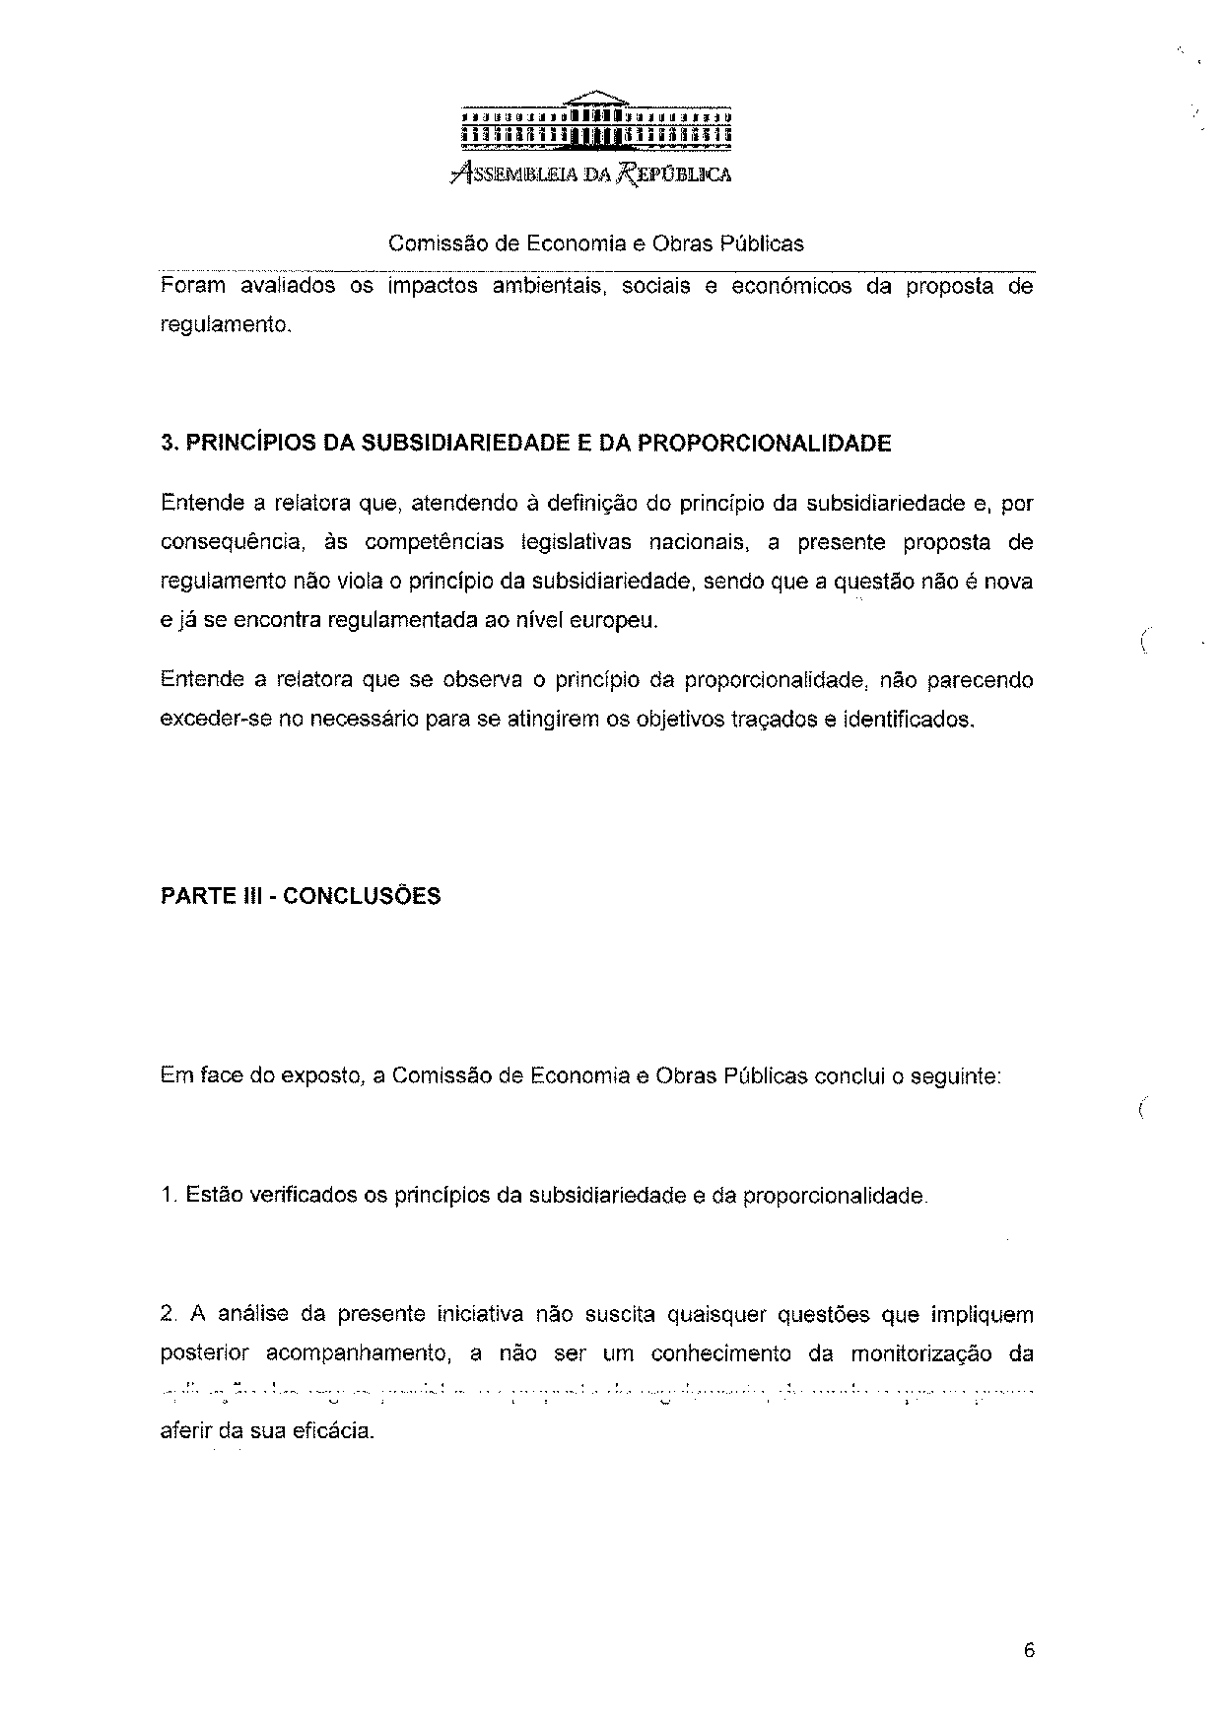
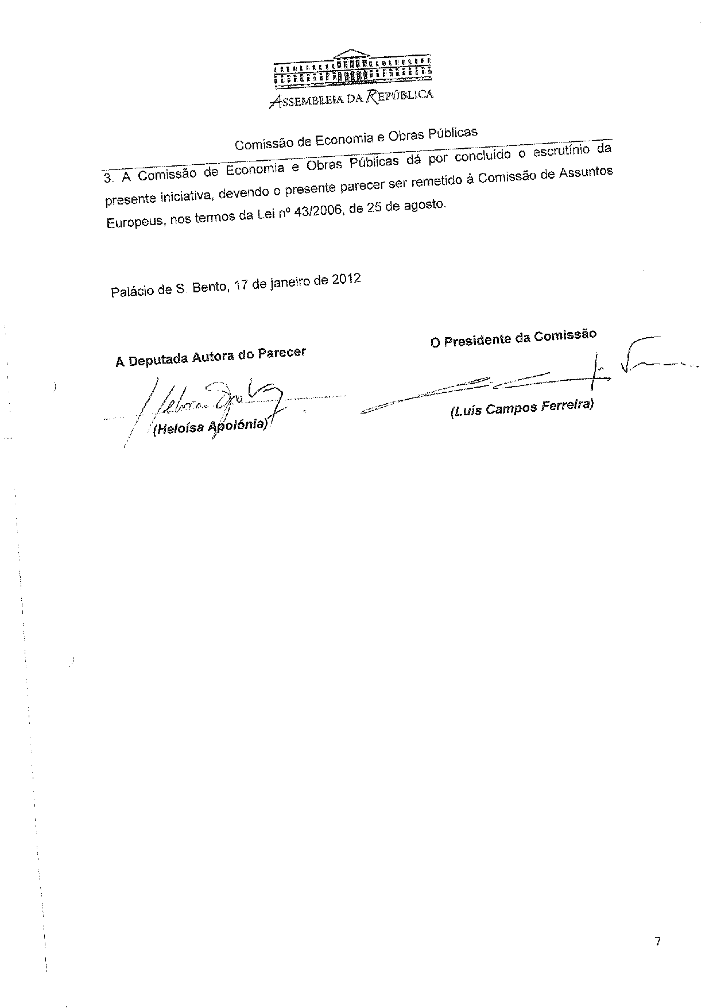
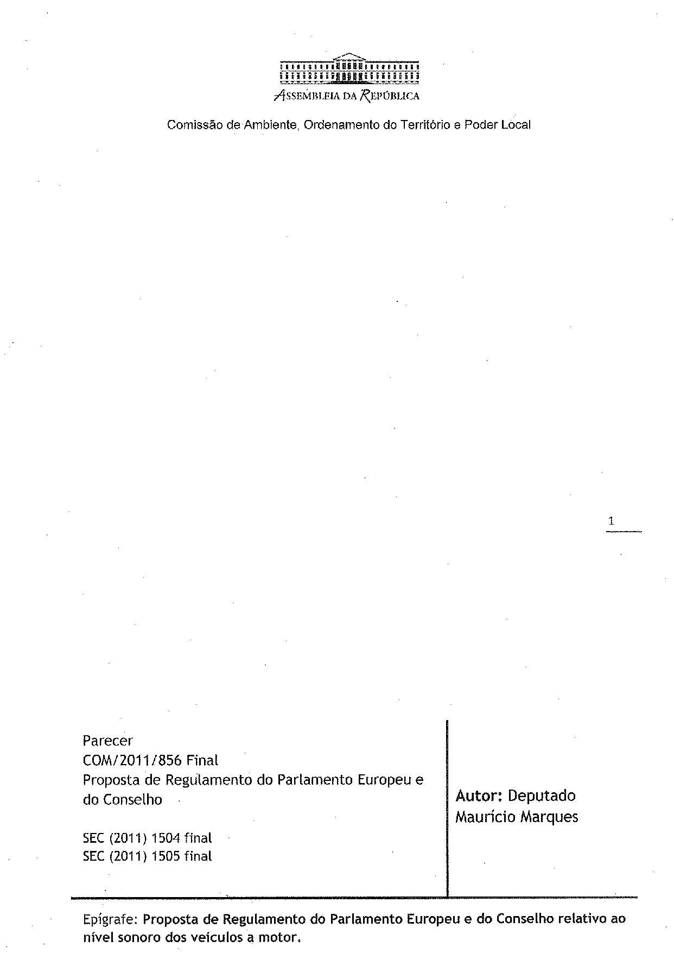
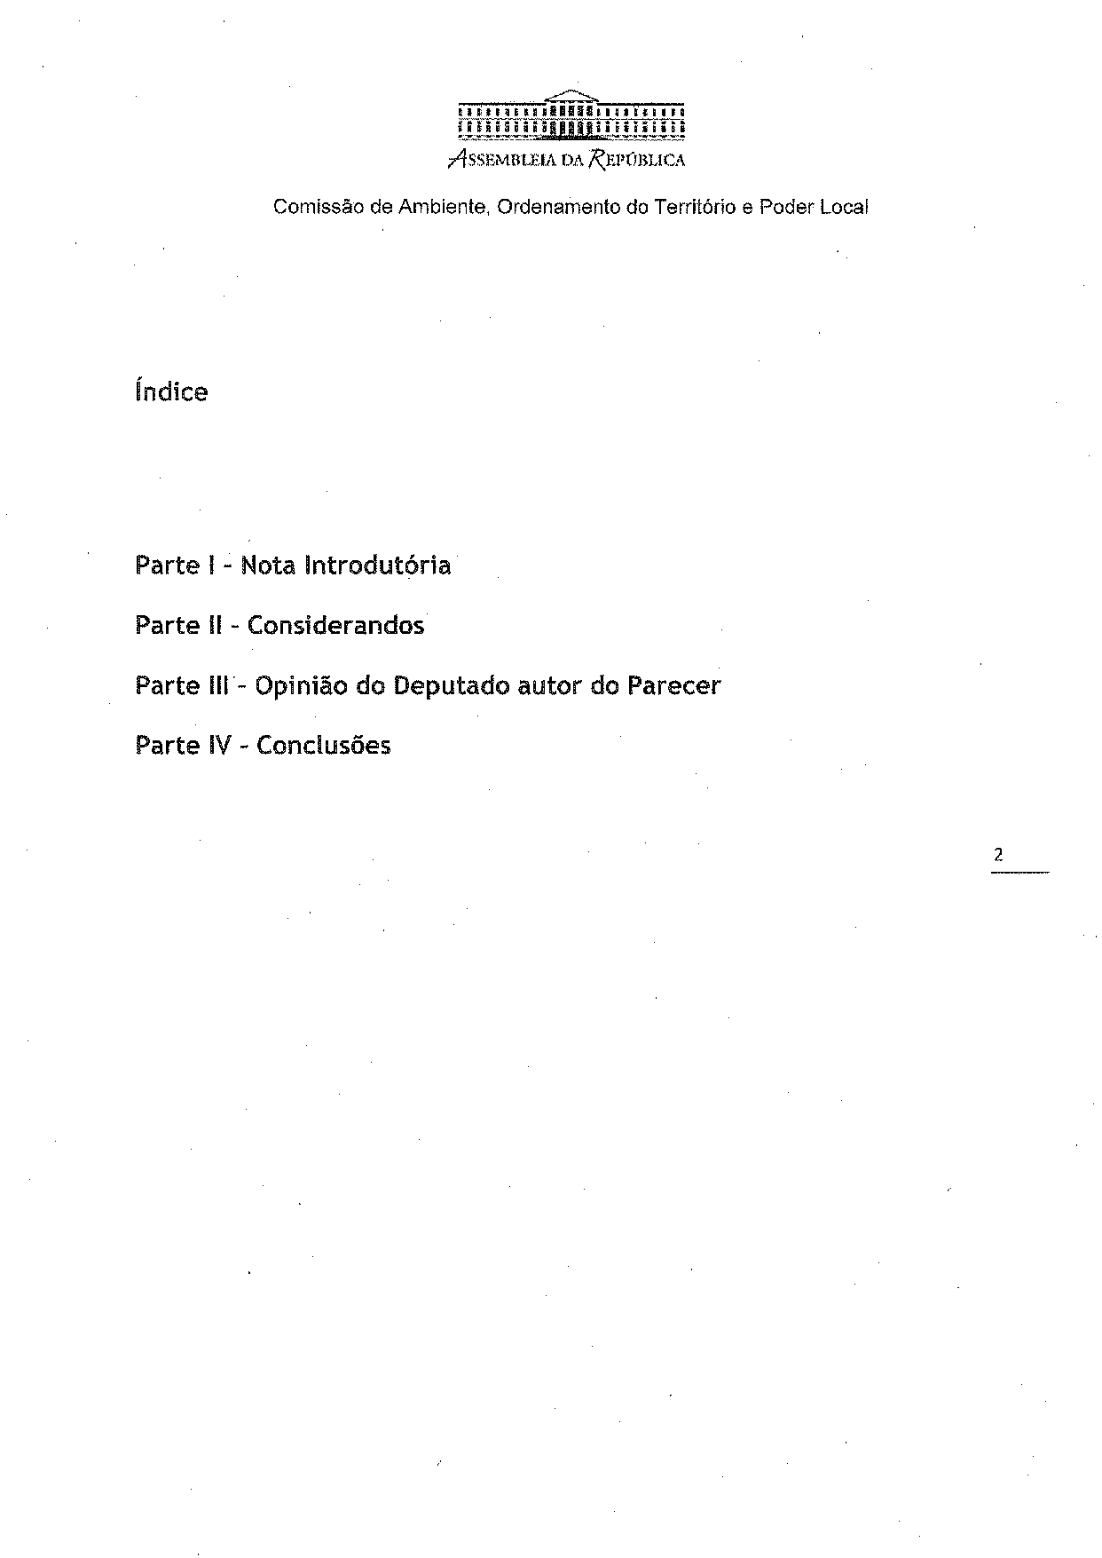
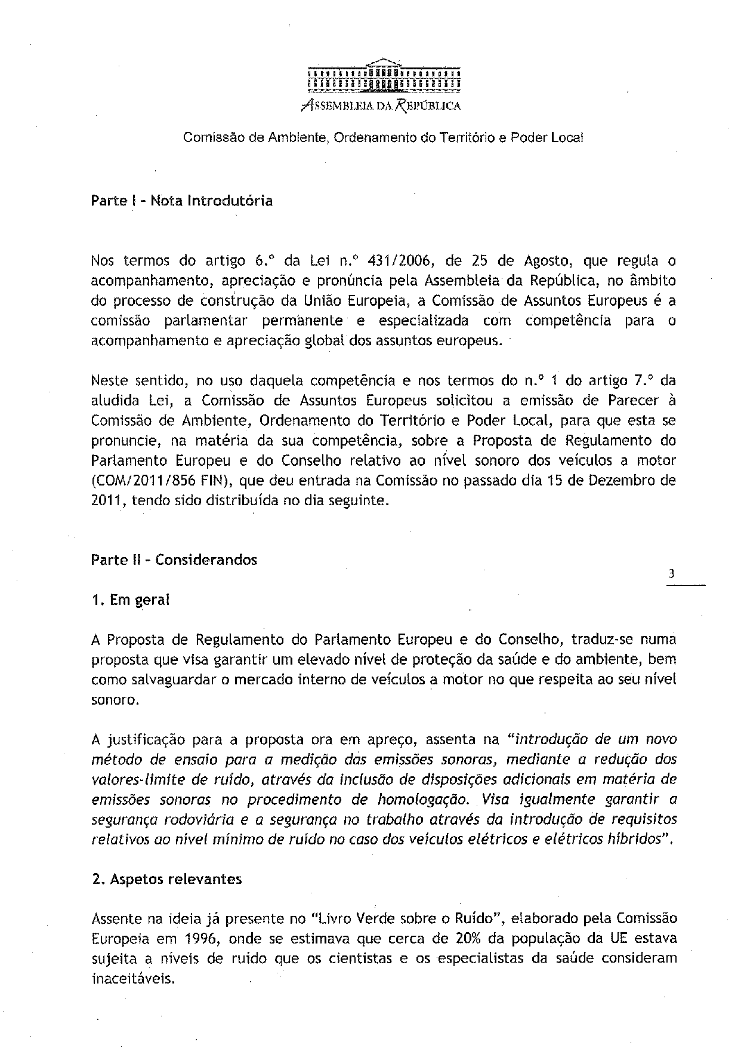
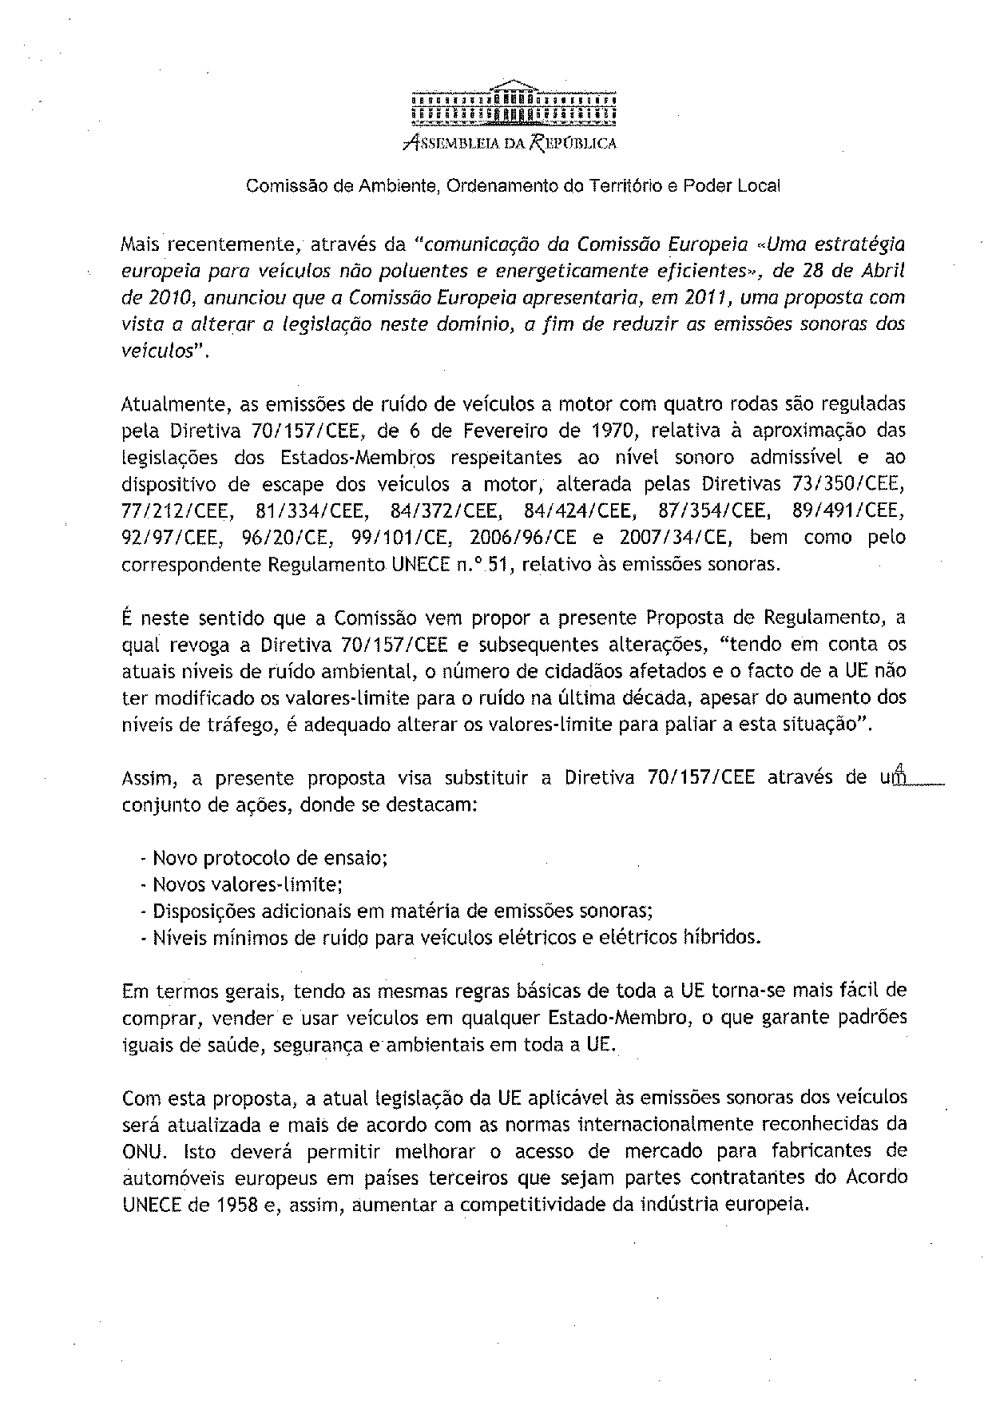
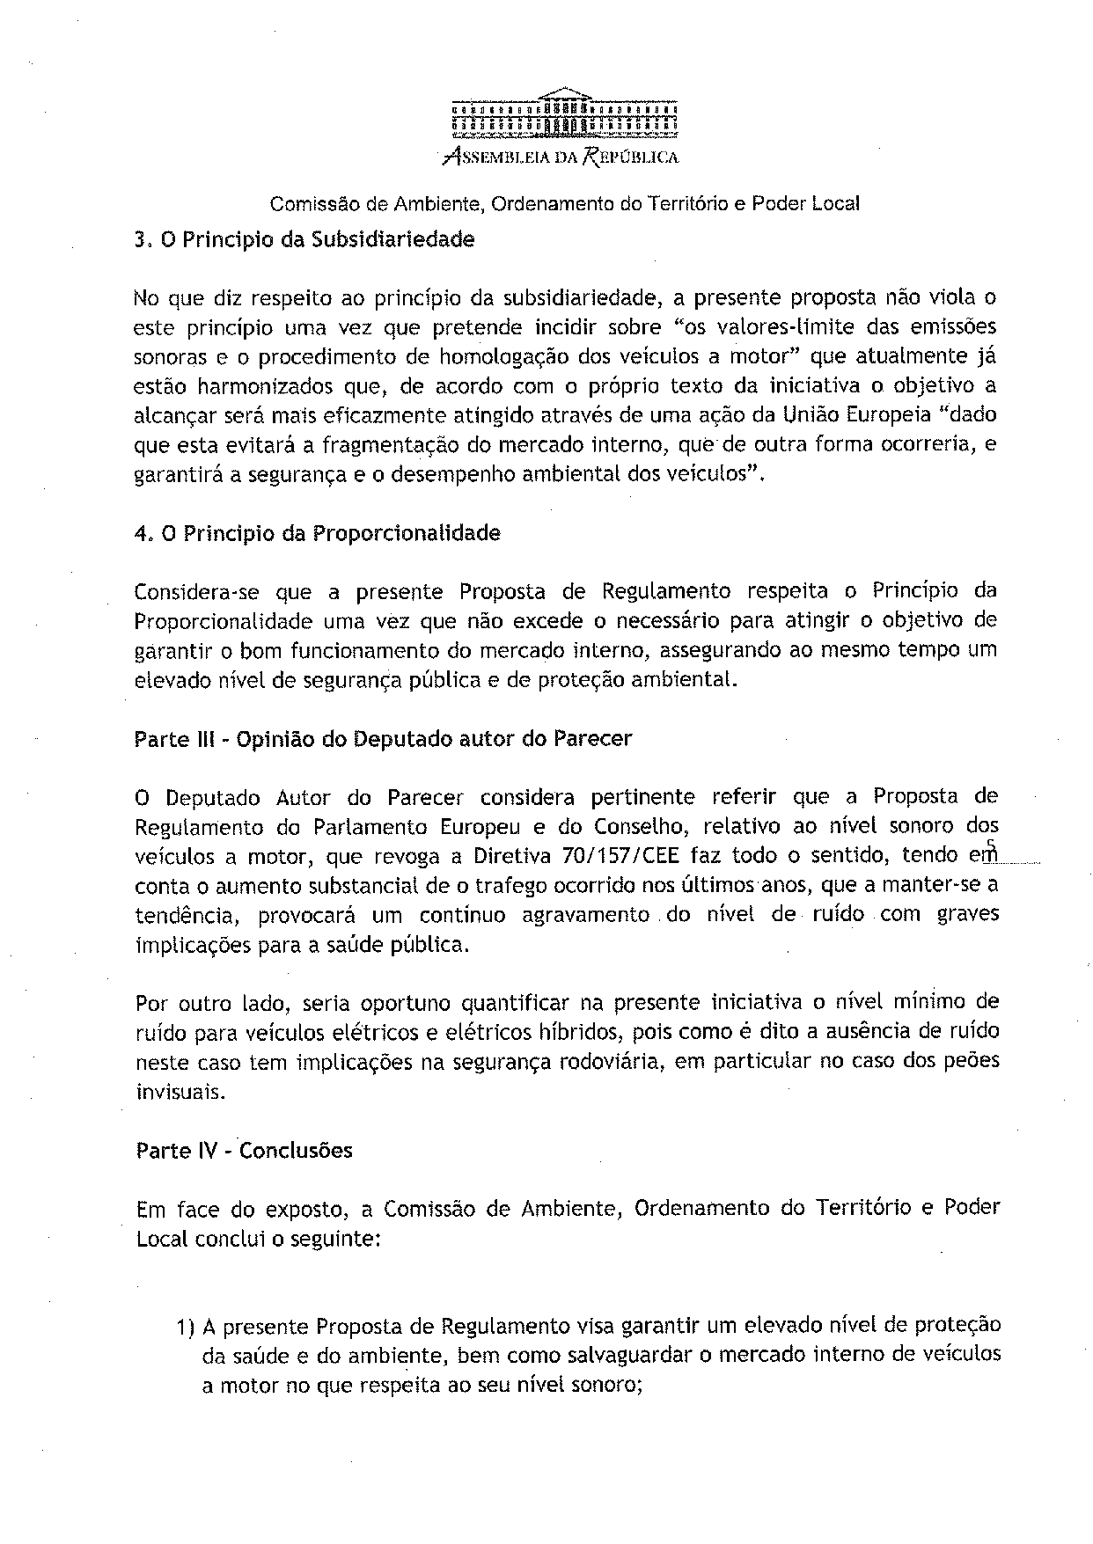
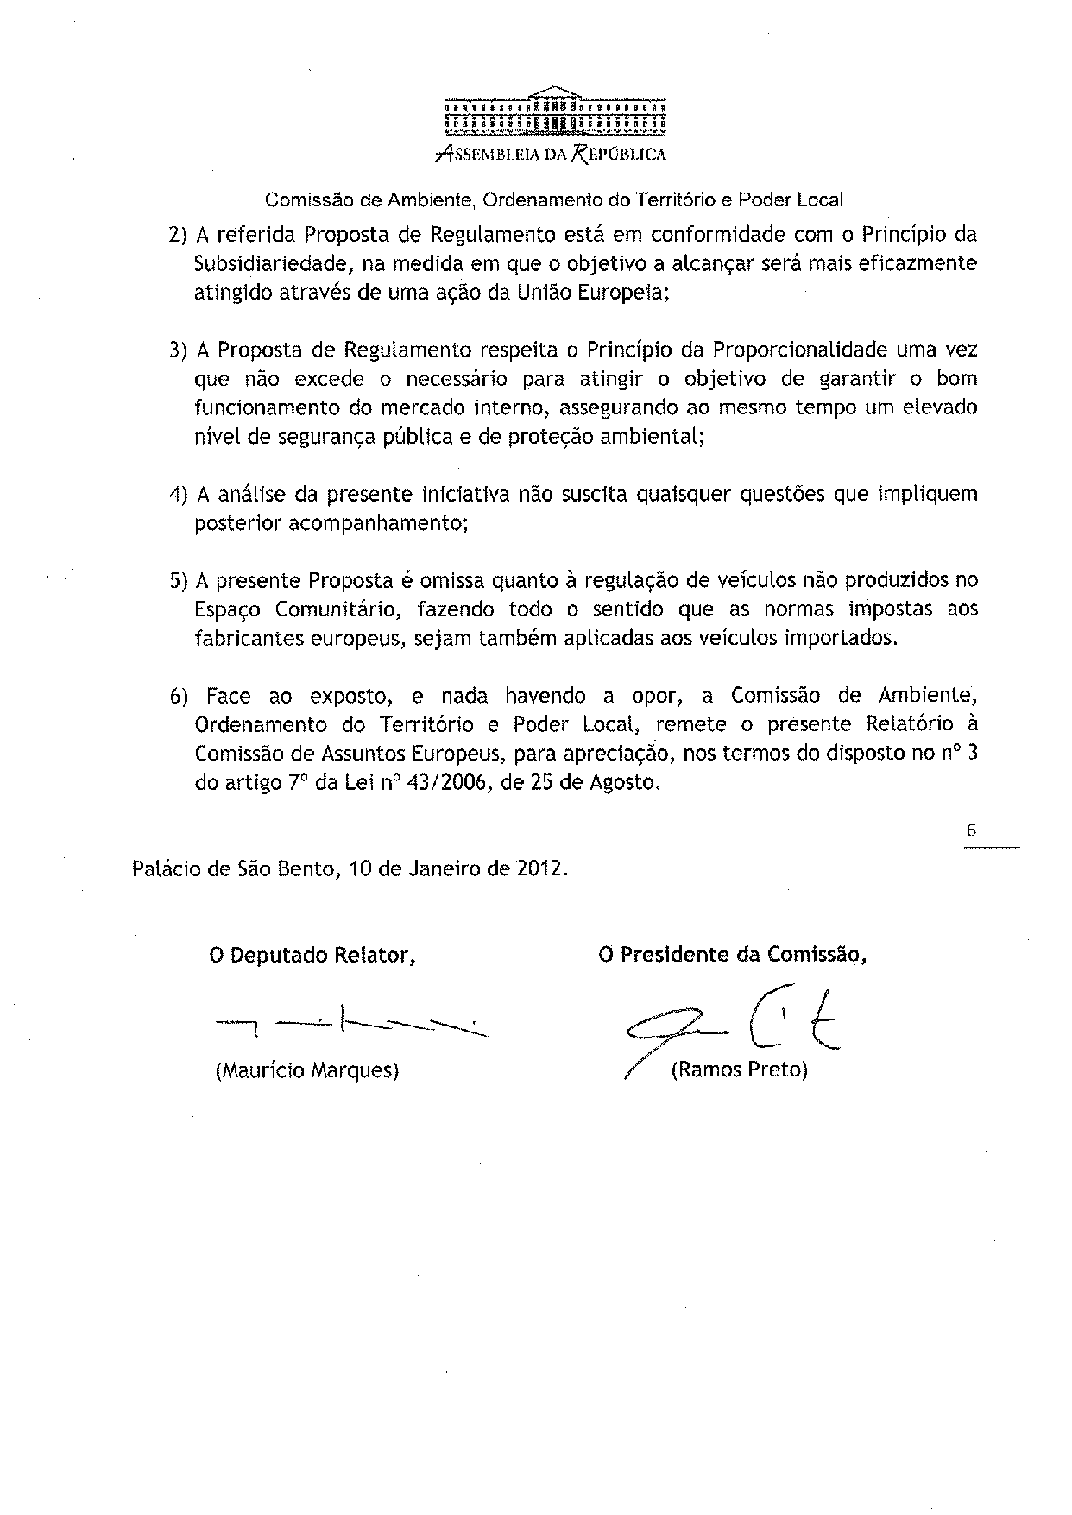

Translation of the opinion may be available at the Interparliamentary EU information exchange site IPEX at the following address: http://WWW.ipex.eu/IPEXL-WEB/search.do

