 | 
COUNCIL OF  THE EUROPEAN UNION |  |  | Brussels, 8 February 2012
 | Interinstitutional File:  2011/0308 (COD) |  | 6278/12
DRS 19
COMPET 74
ECOFIN 121
CODEC 318
INST 112
PARLNAT 82

COVER NOTE
from: | Portuguese Parliament
date of receipt: | 5 January 2012
No. Cion doc.: | 16250/11 DRS 111 COMPET 475 ECOFIN 733 CODEC 1862  + ADD 1 + ADD 2 + ADD 3 + ADD 4 - COM(2011) 684 final
Subject: | Proposal for a Directive of the European Parliament and of the Council on the annual financial statements, consolidated financial statements and related reports of certain types of undertakings  - Opinion on the application of the Principles of Subsidiarity and Proportionality

Delegations will find attached the Opinion of the Portuguese Parliament on the above proposal.

________________________

Encl.:

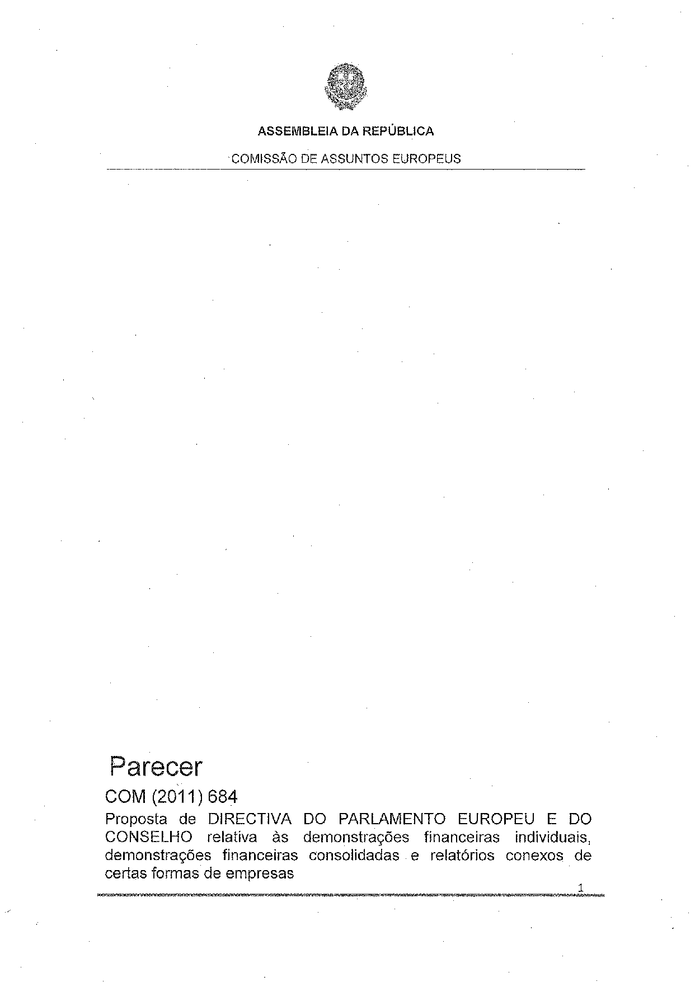
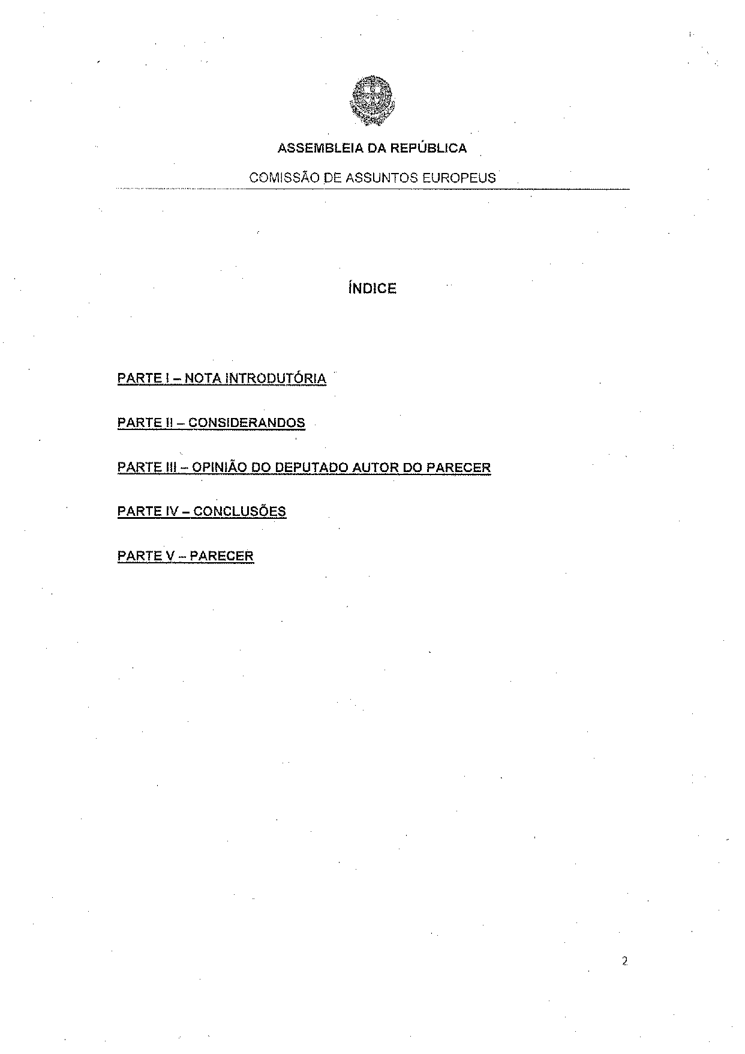
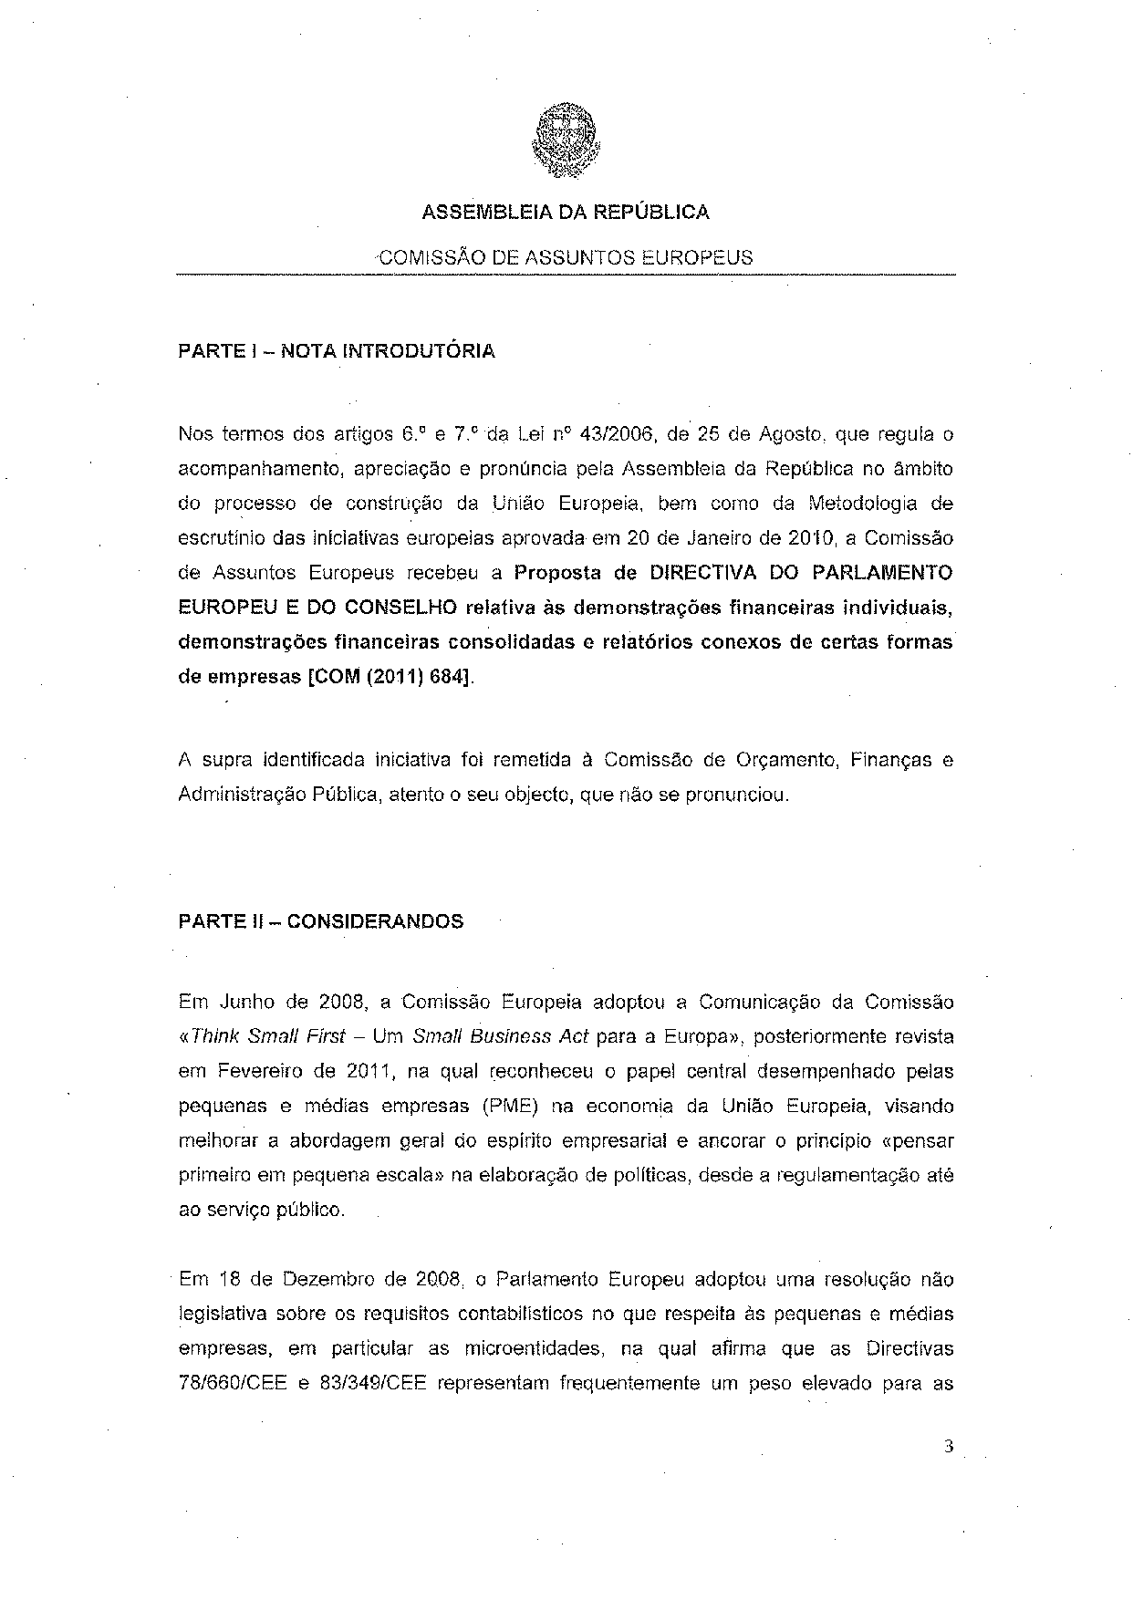
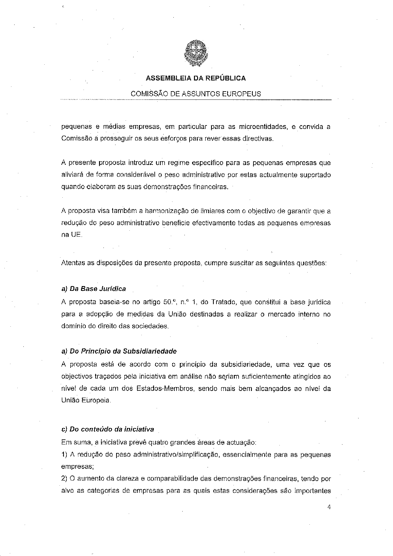
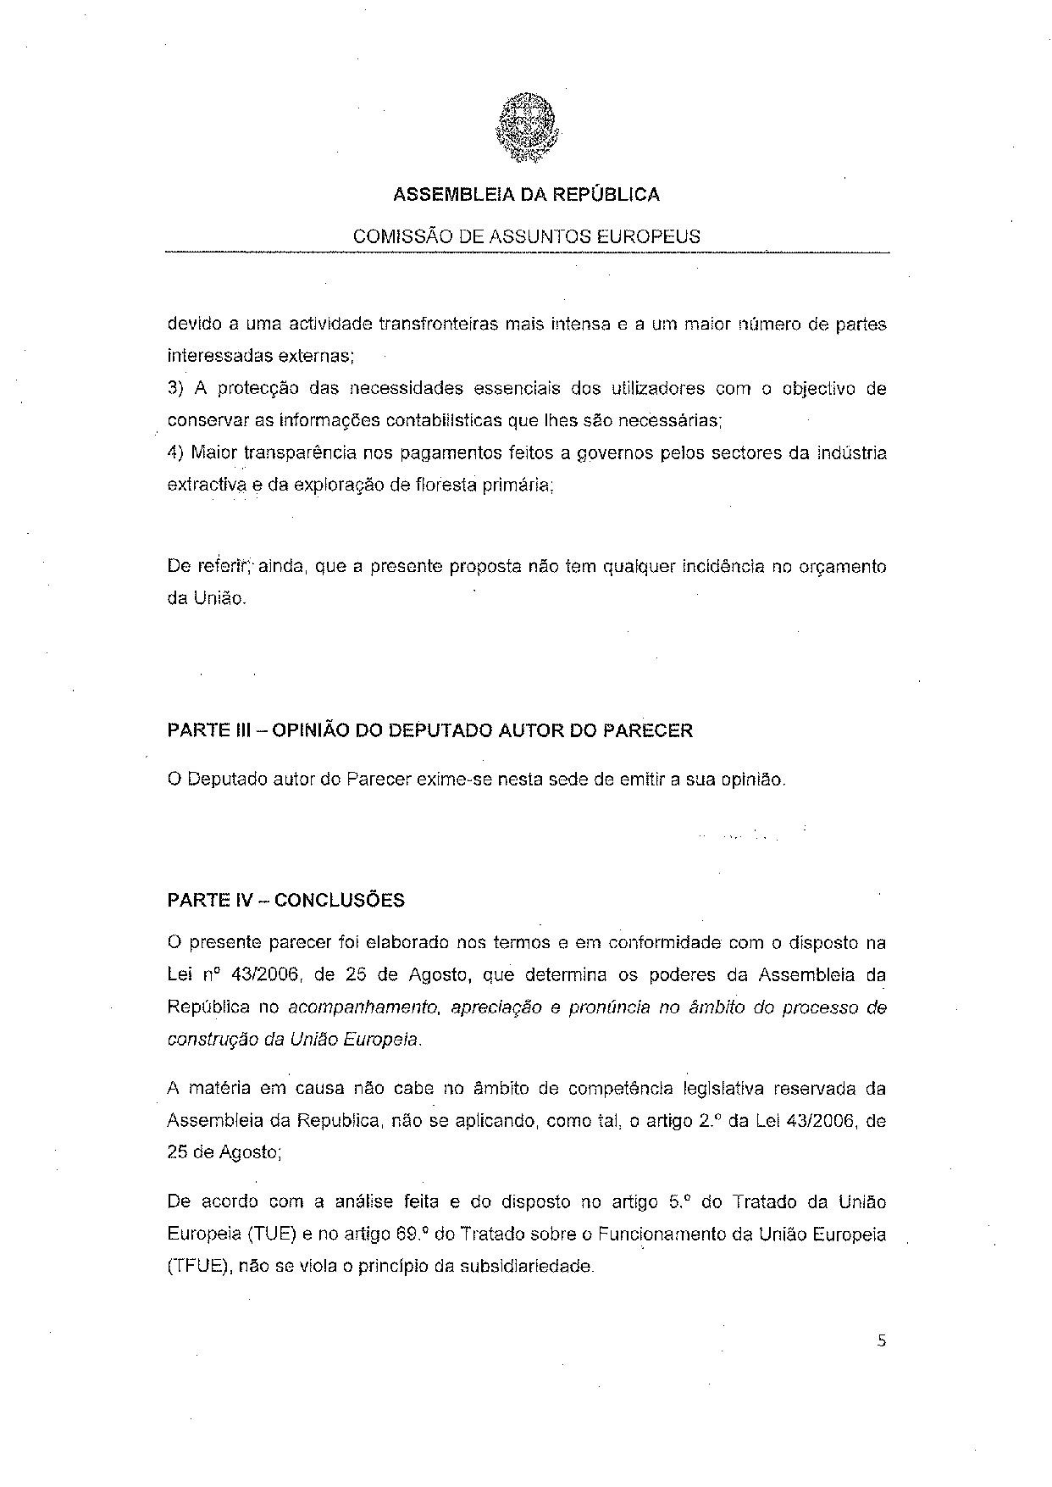
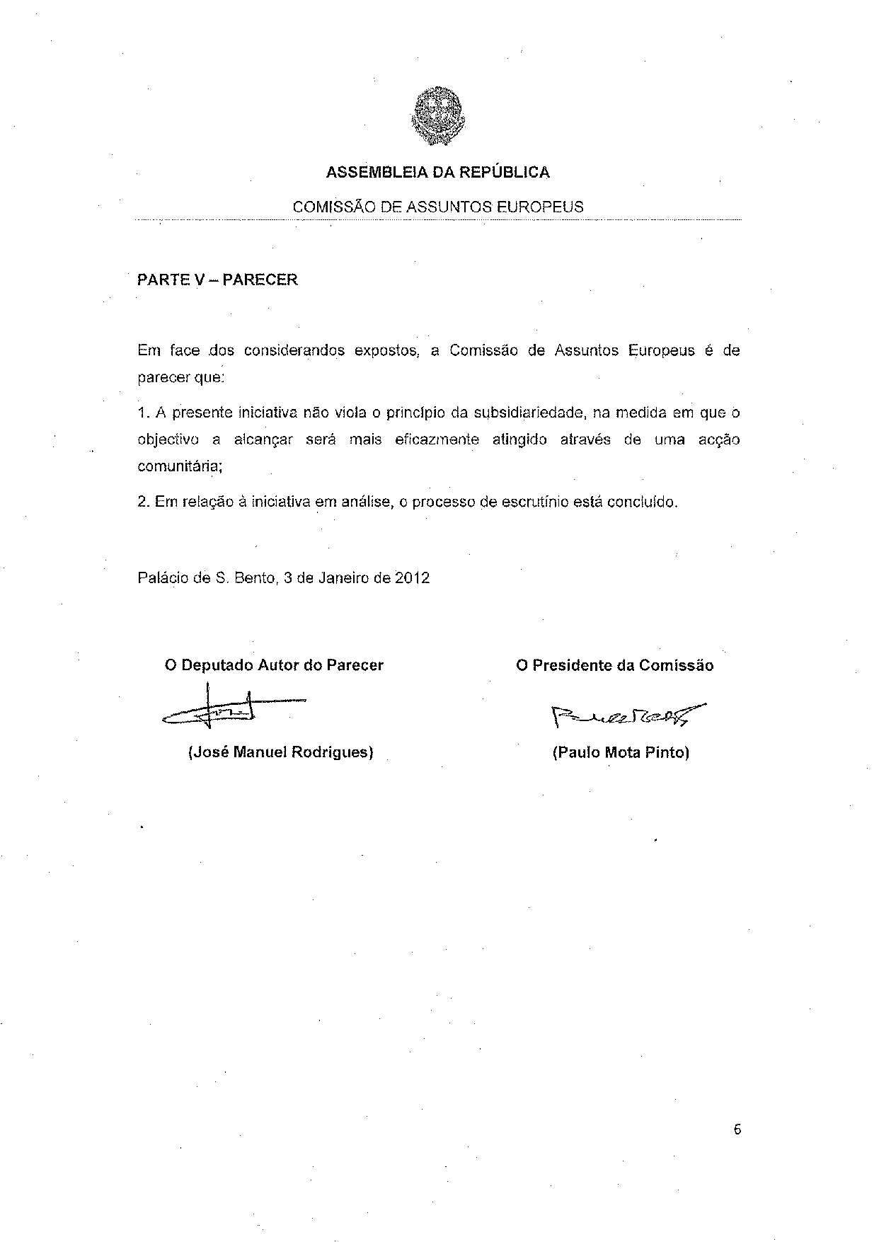

Translation may be available at the Interparliamentary EU information exchange site IPEX at the following address: http://www.ipex.eu/IPEXL-WEB/search.do.

