 | 
COUNCIL OF  THE EUROPEAN UNION |  |  | Brussels, 8 February 2012
 | Interinstitutional File:  2011/0359 (COD) |  | 6297/12
DRS 21
CODEC 325
INST 115
PARLNAT 85

COVER NOTE
from: | Portuguese Parliament
date of receipt: | 1 February 2012
No. Cion doc.: | 16972/11 DRS 122 CODEC 2040 - COM(2011) 779 final
Subject: | Proposal for a Regulation of the European Parliament and of the Council on specific requirements regarding statutory audit of public-interest entities  - Opinion on the application of the Principles of Subsidiarity and Proportionality

Delegations will find attached the Opinion of the Portuguese Parliament on the above proposal.

________________________

Encl.:

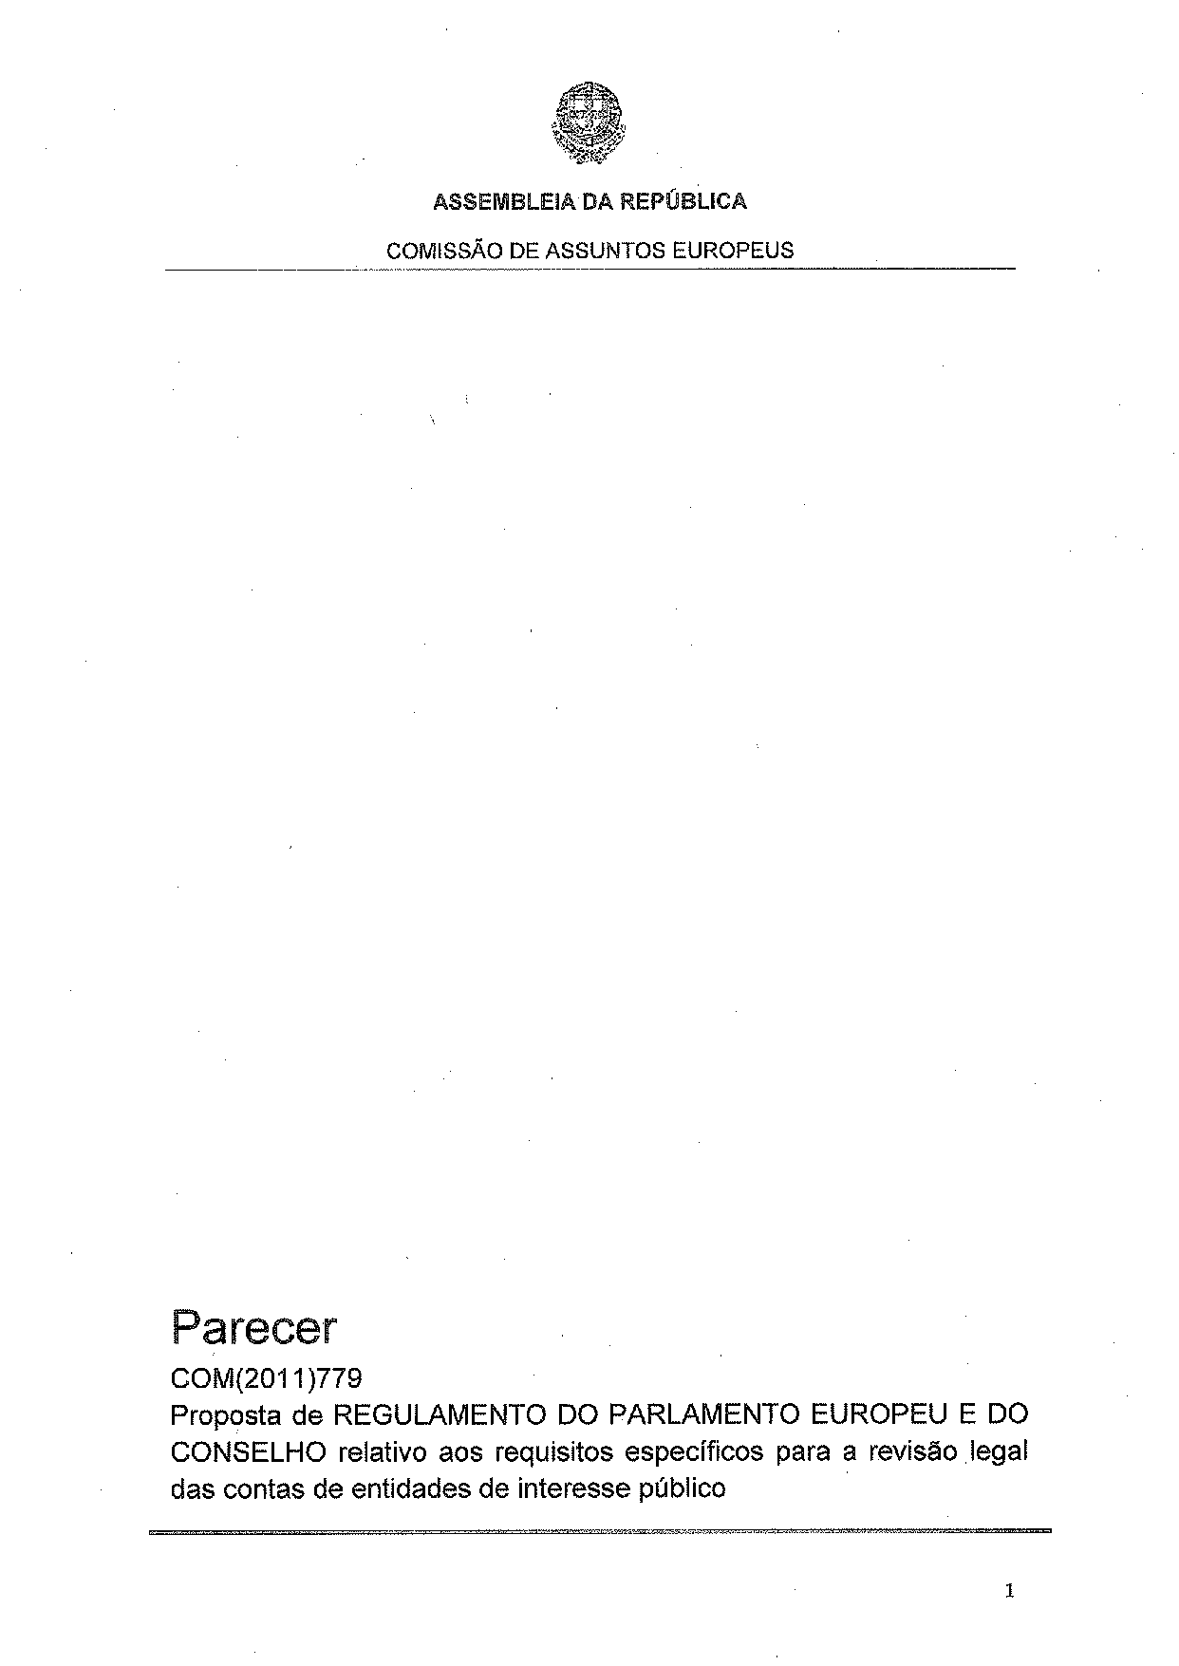
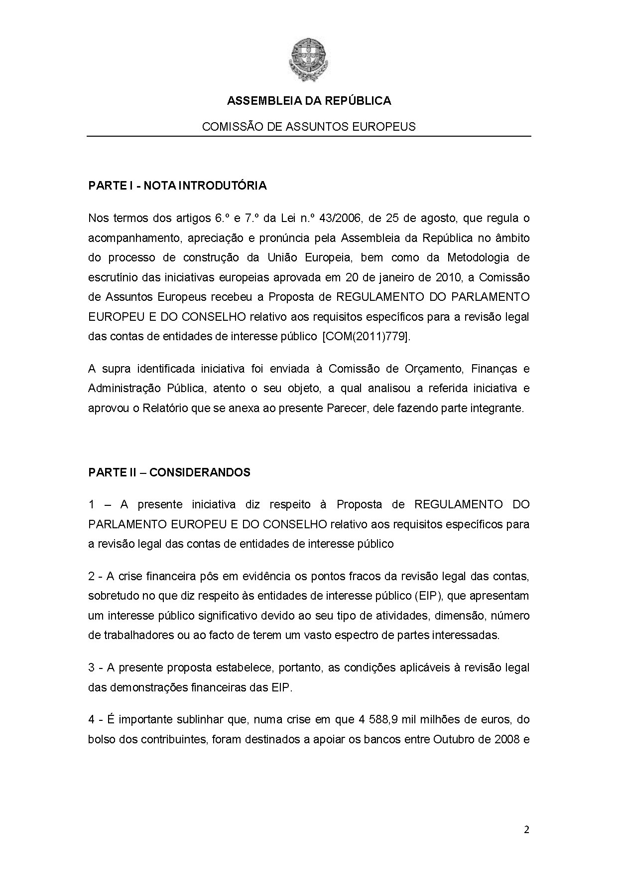
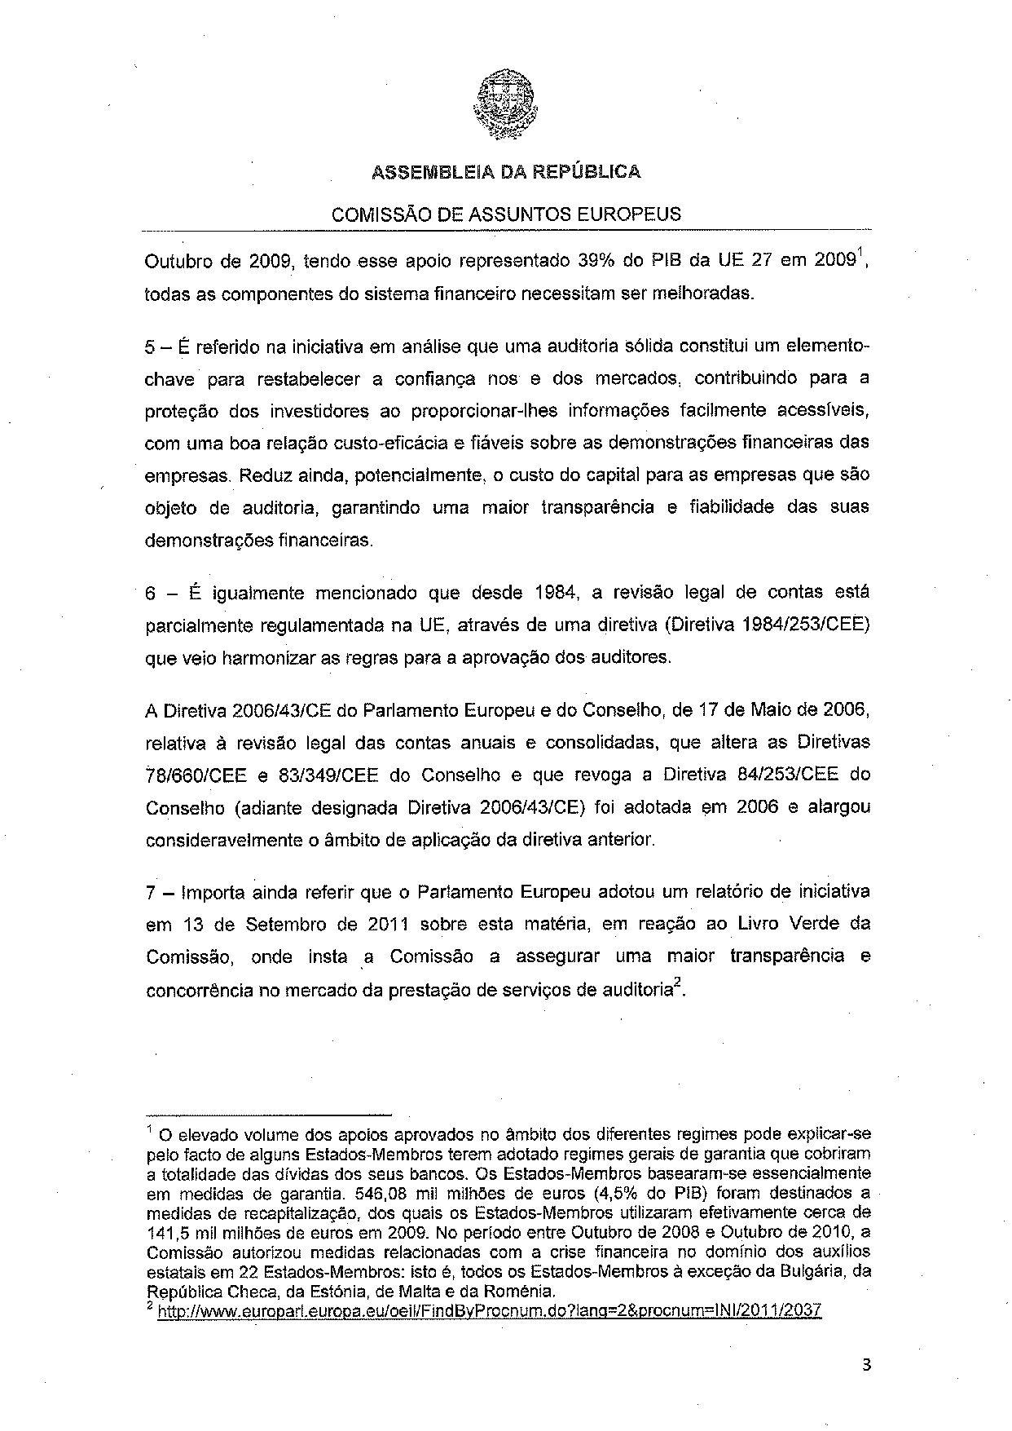
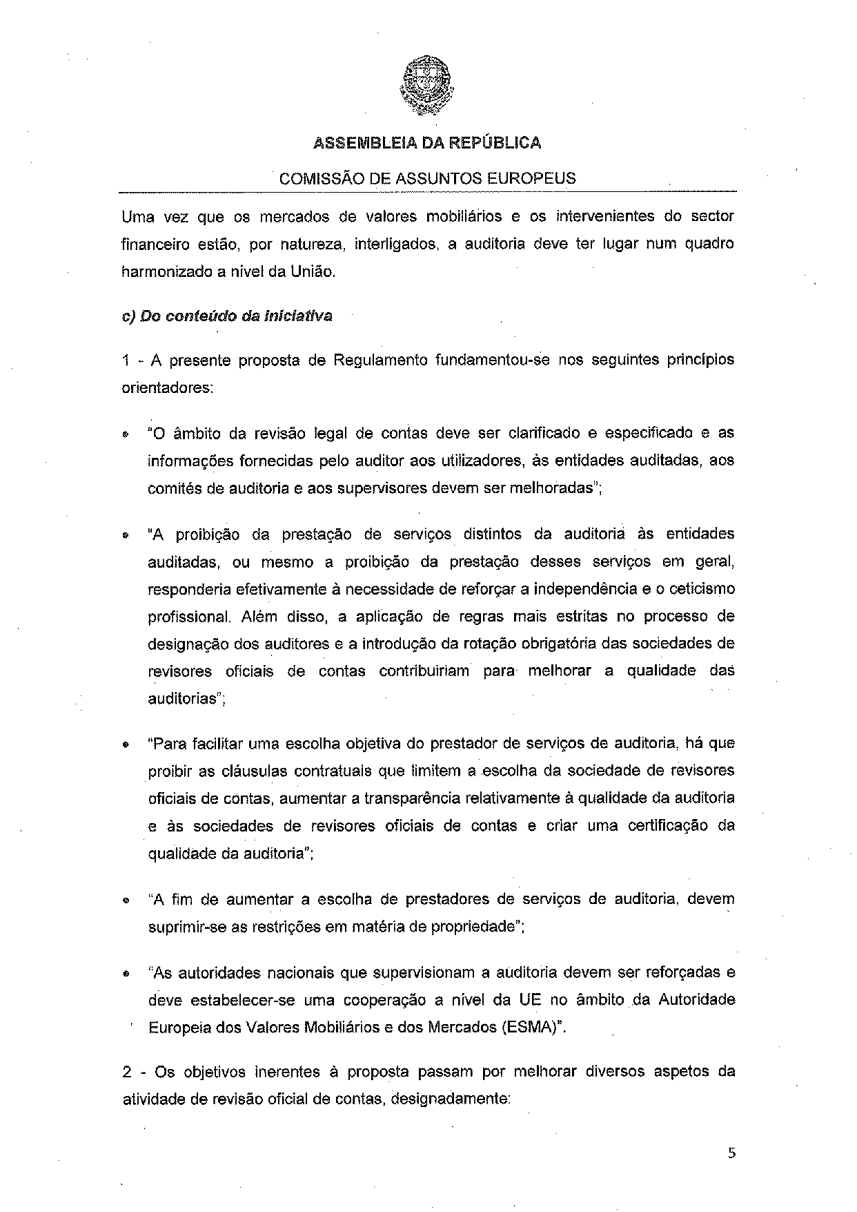
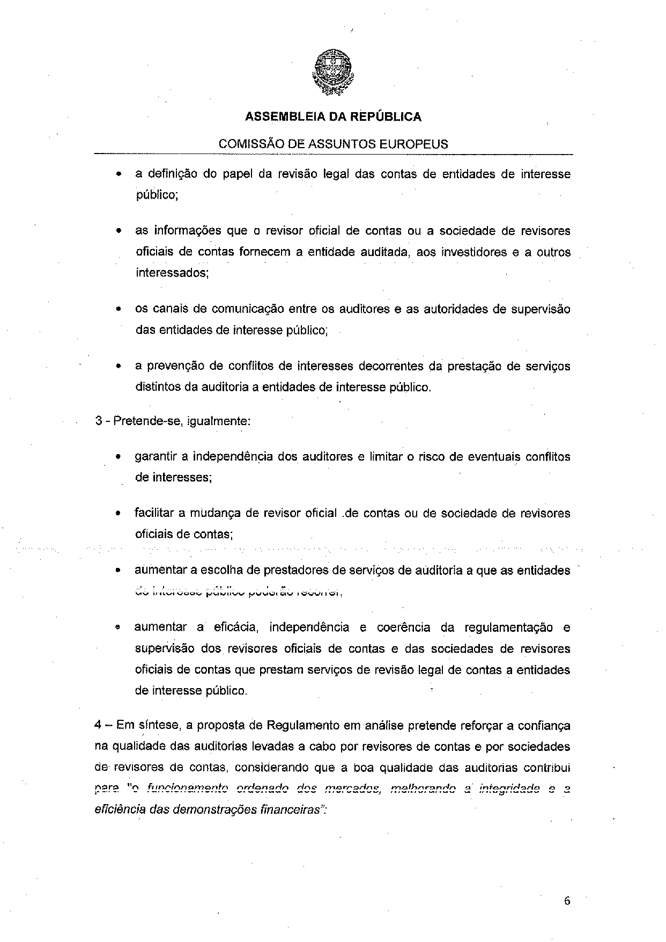
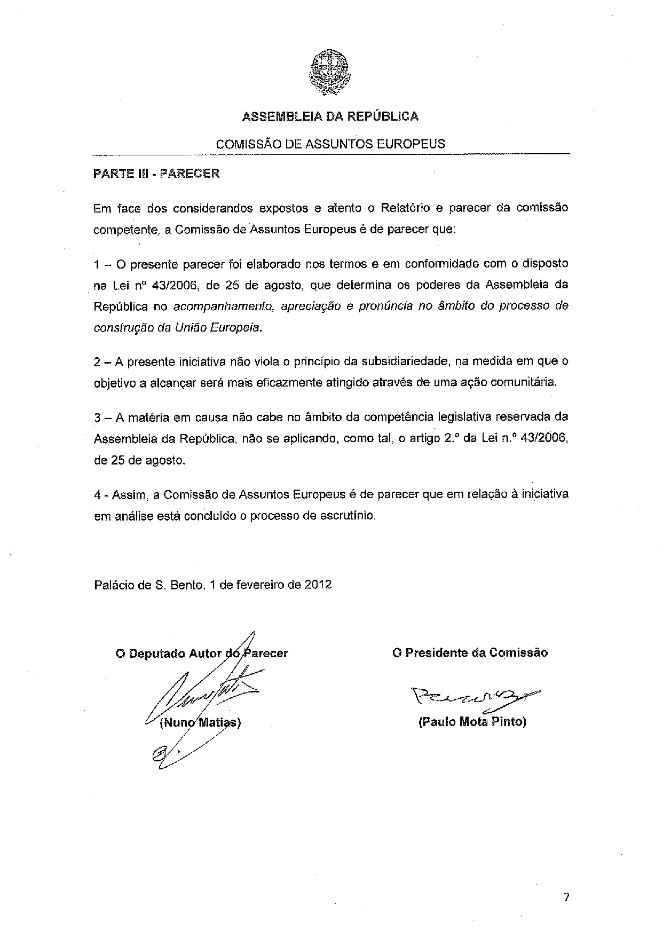
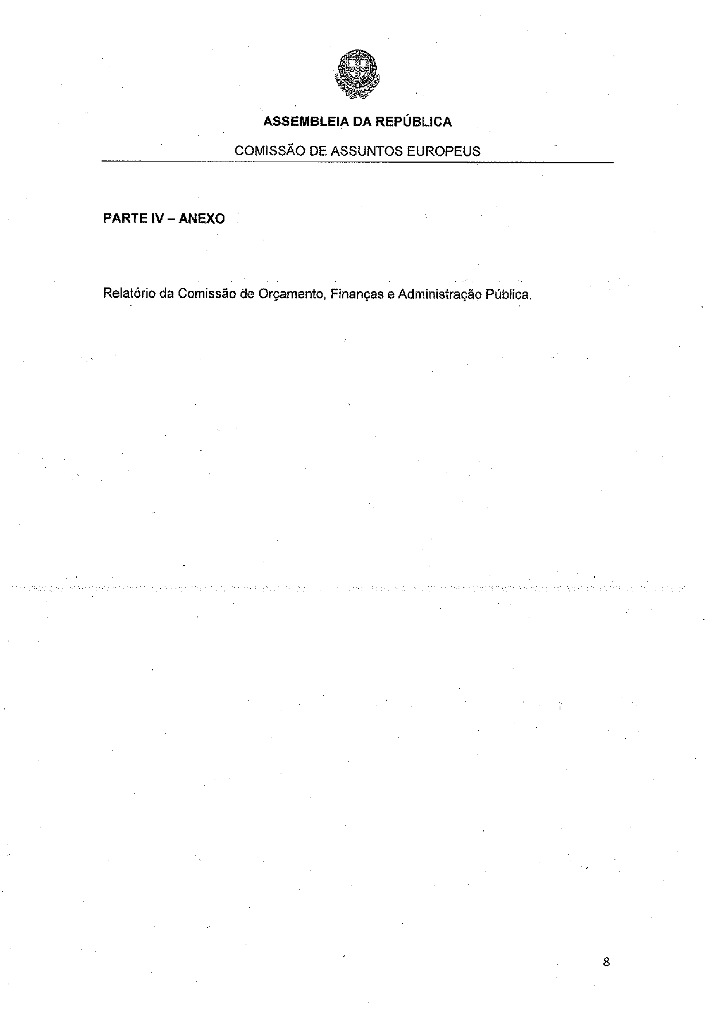
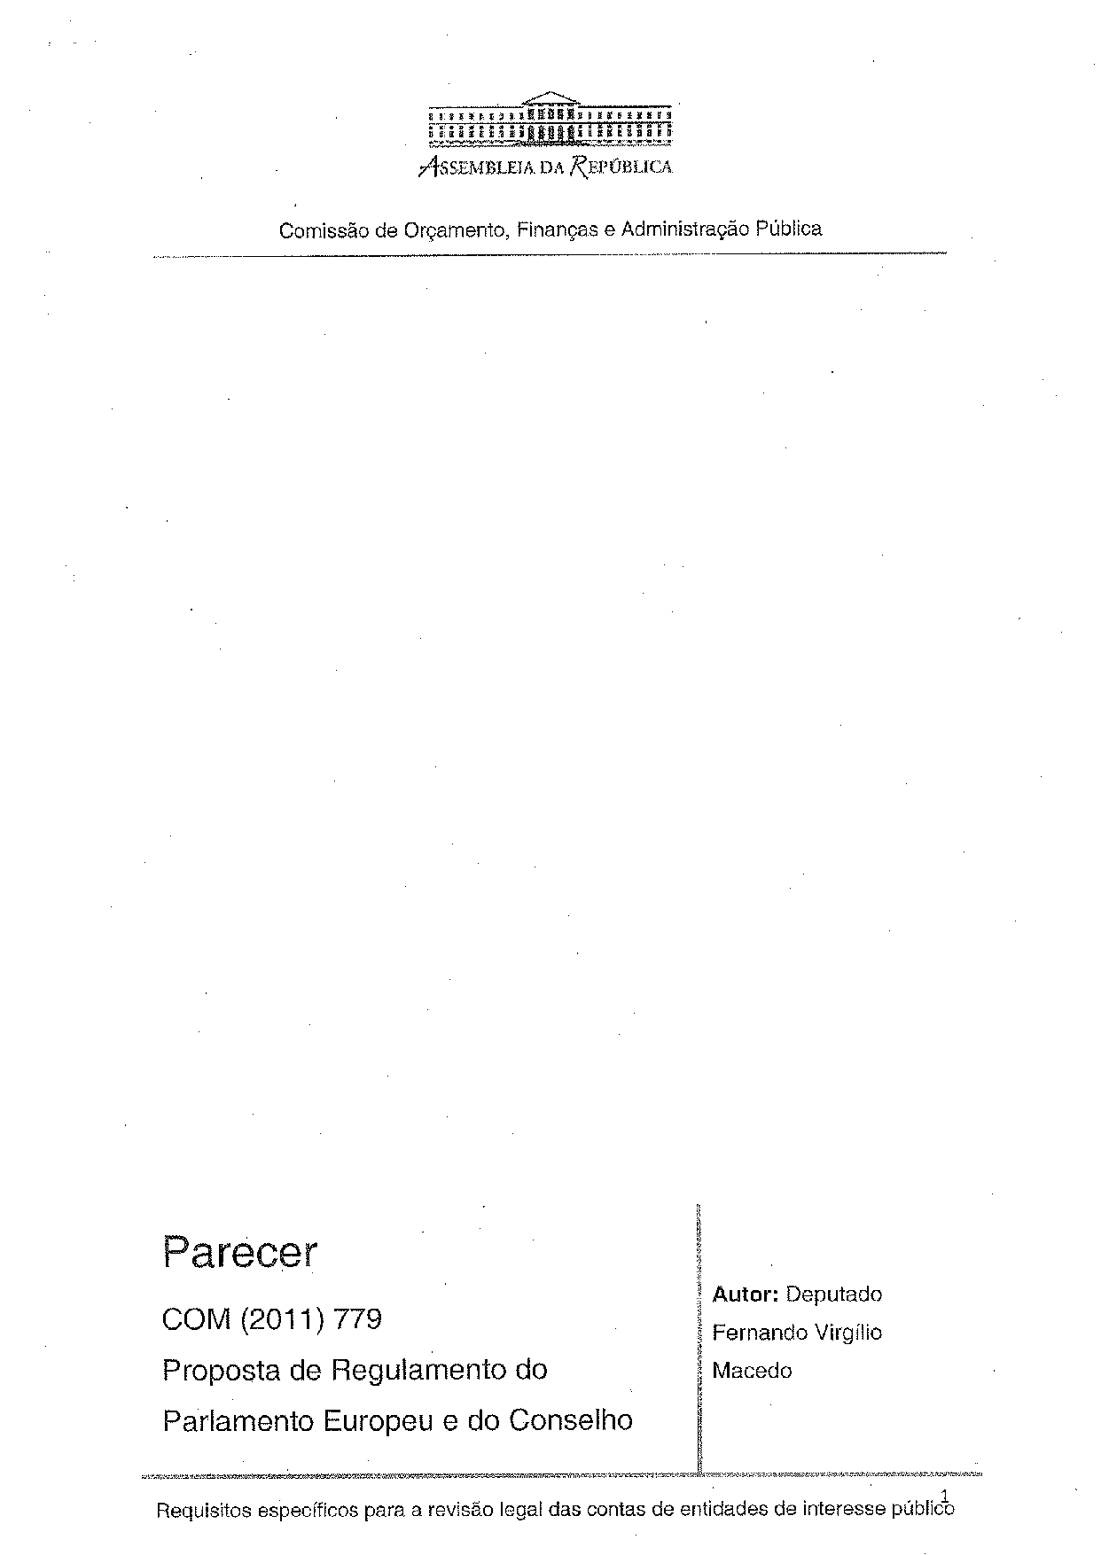
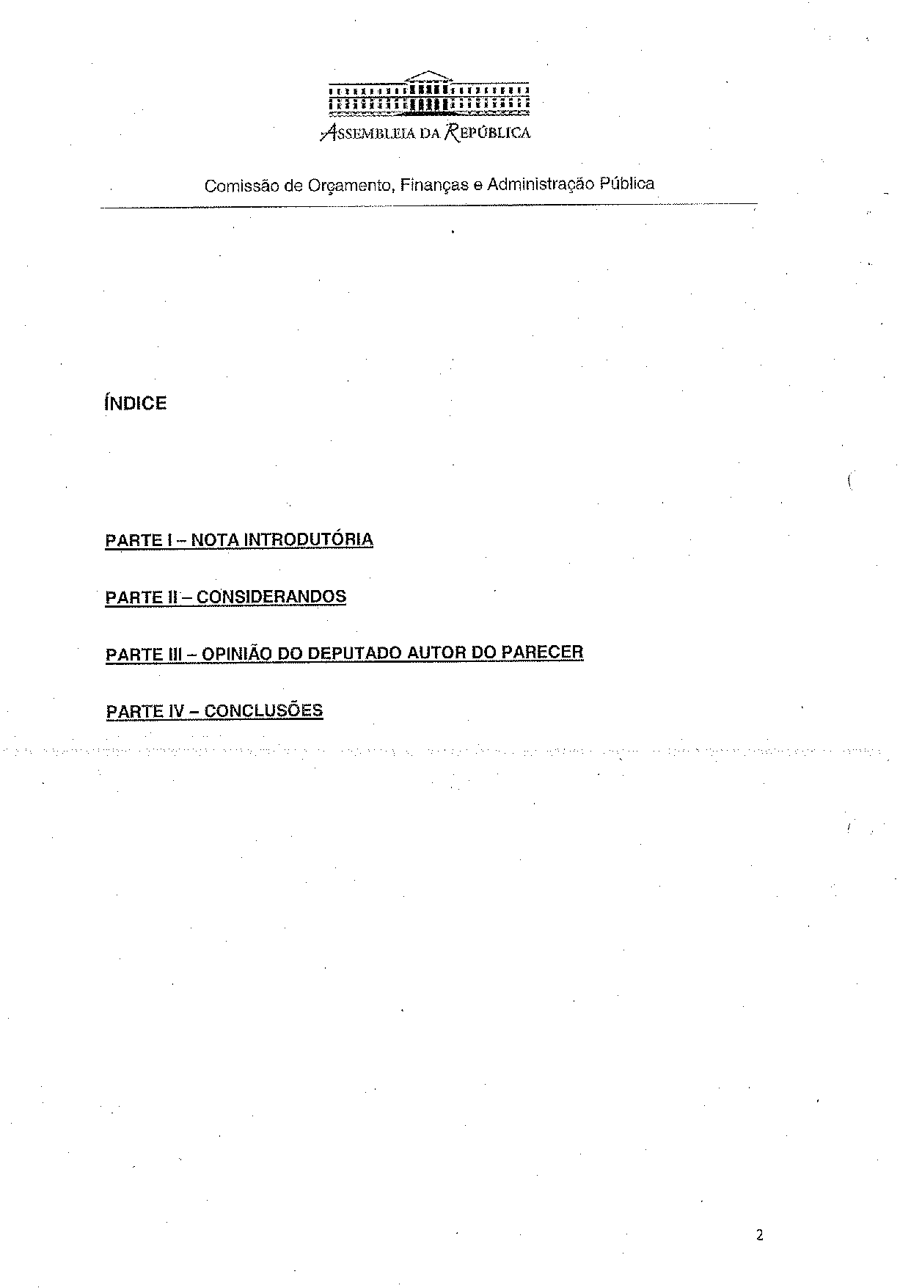
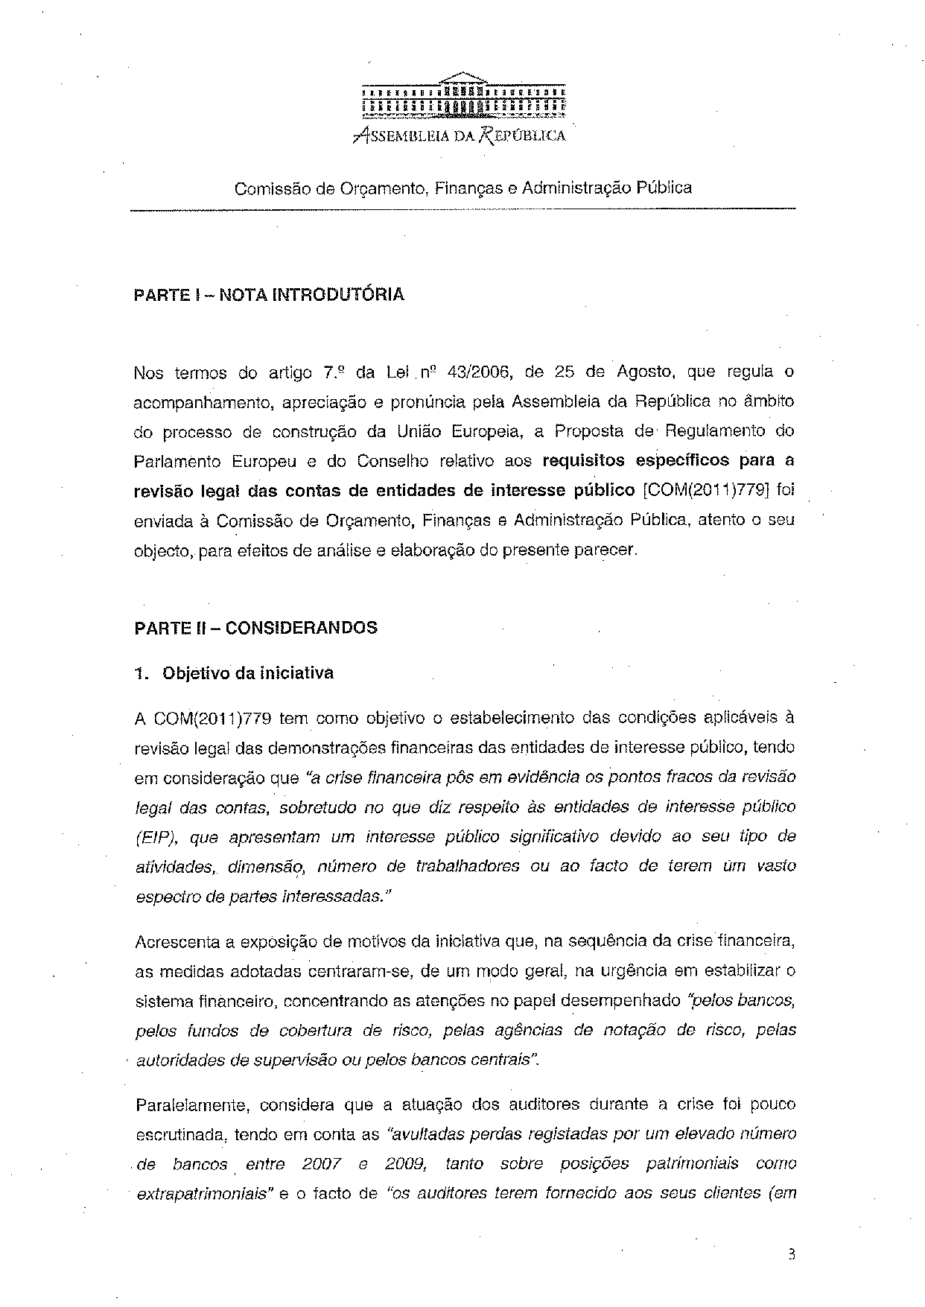
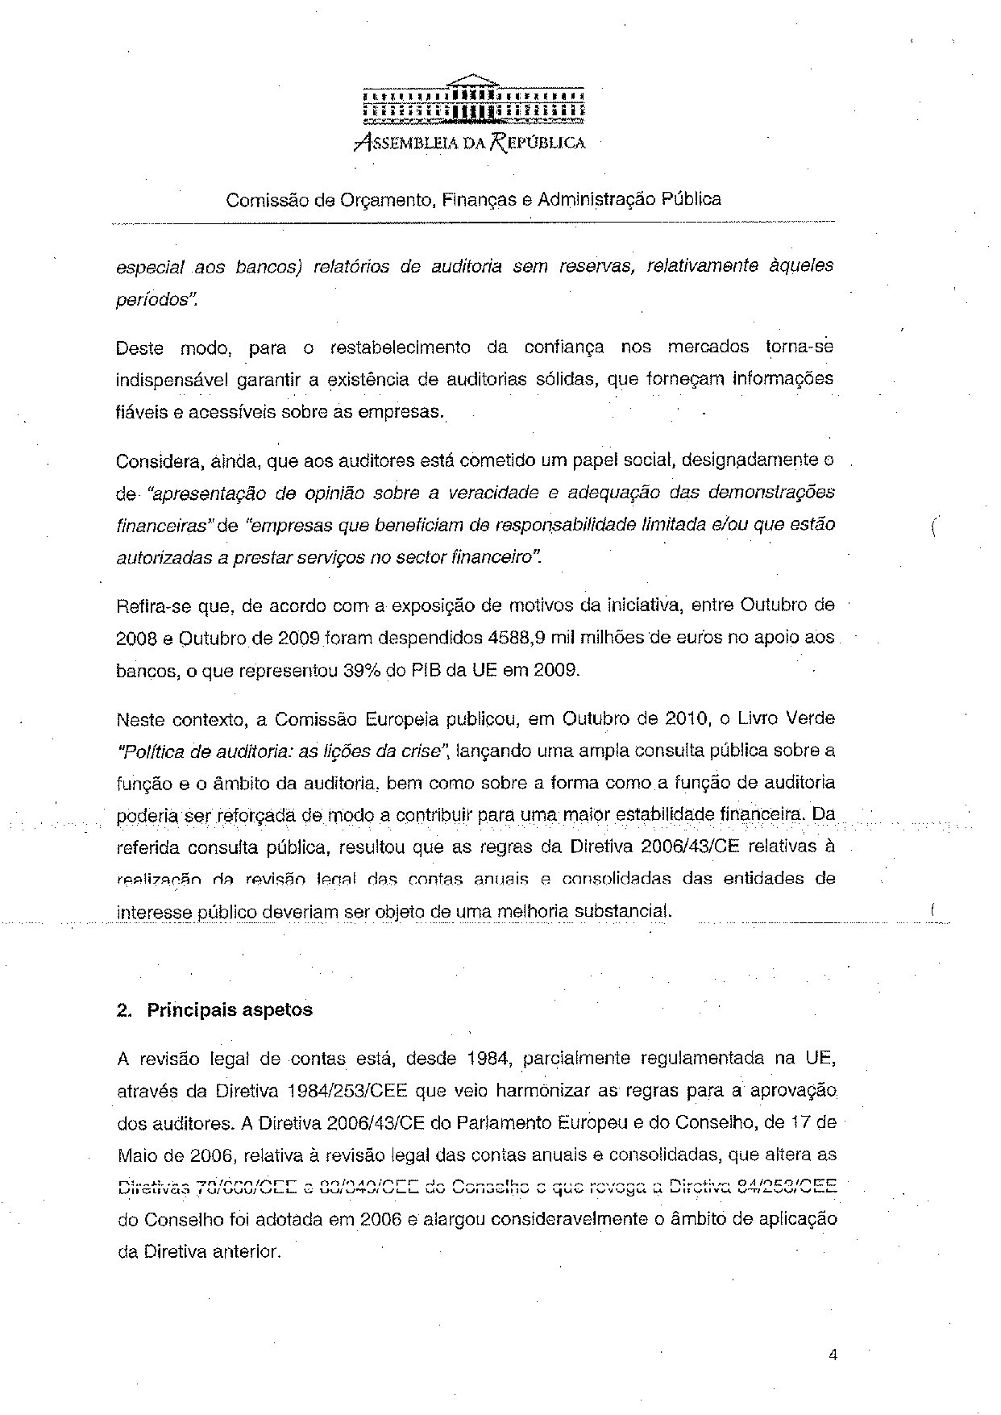
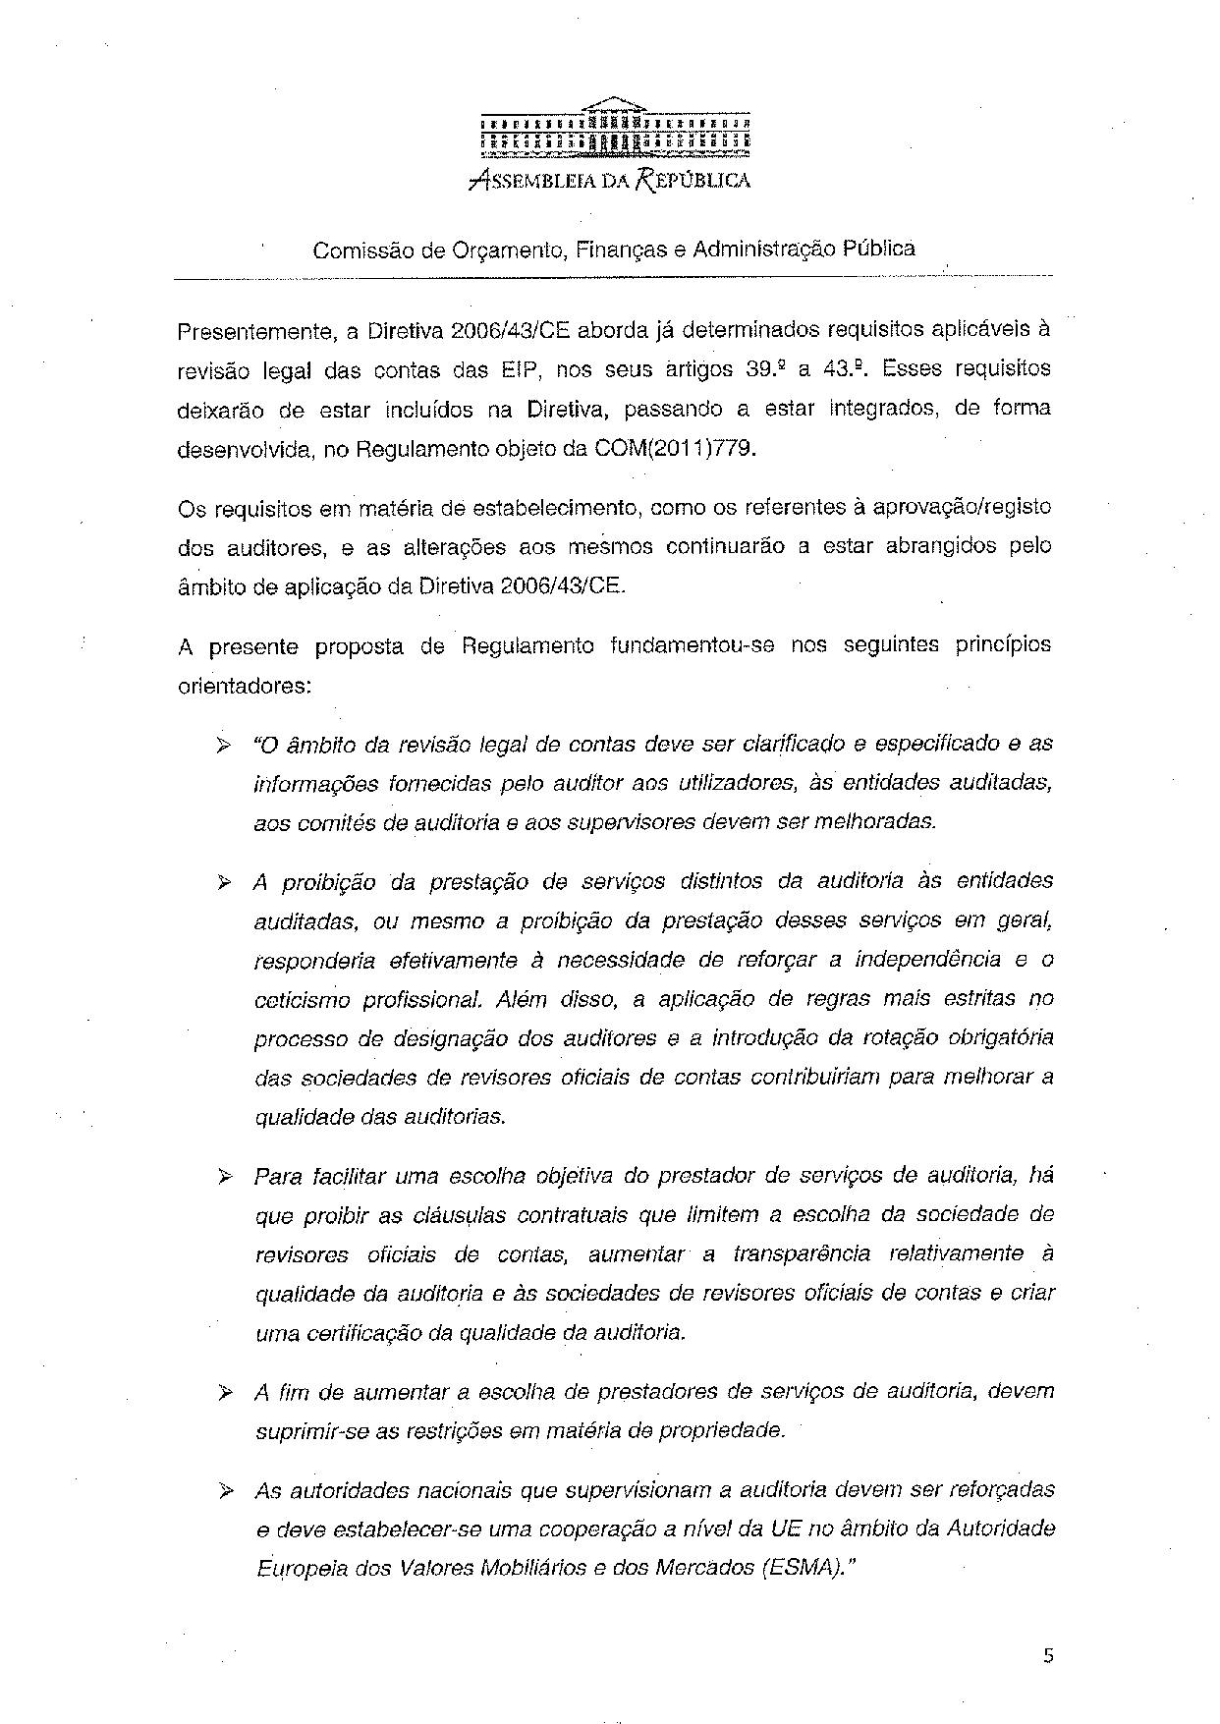
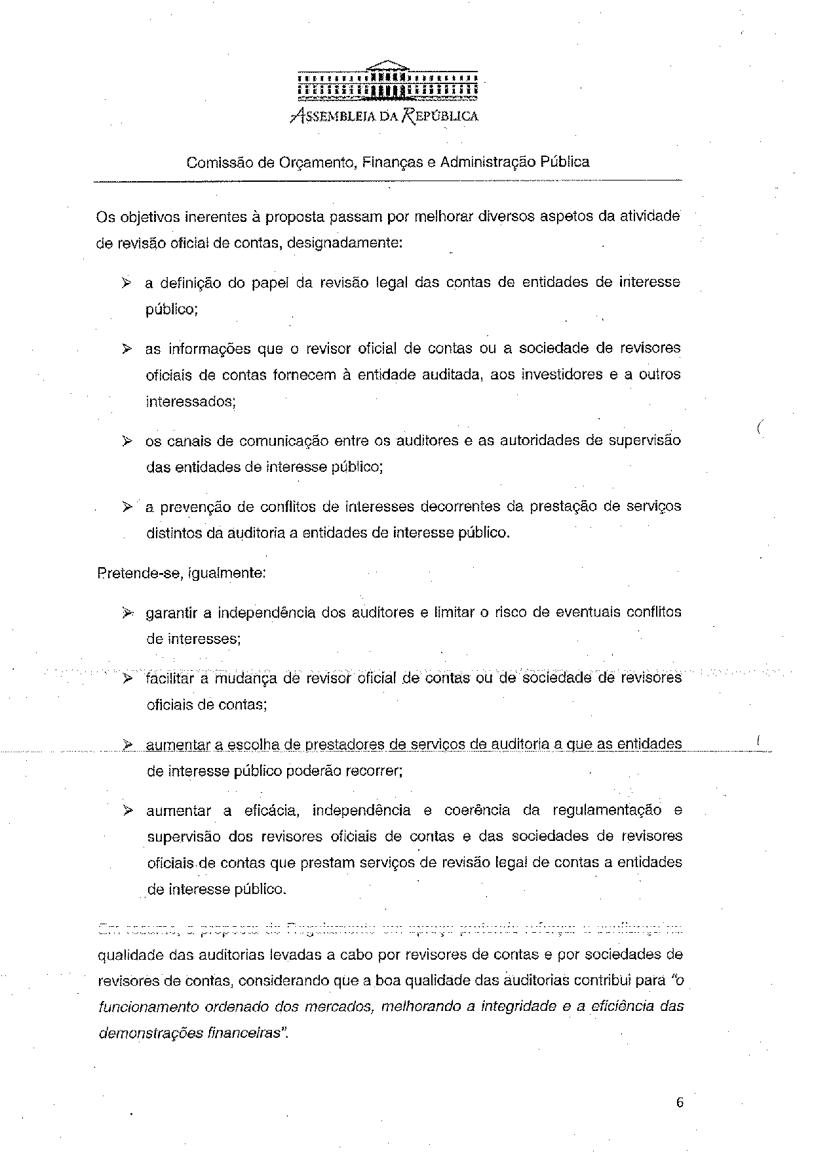
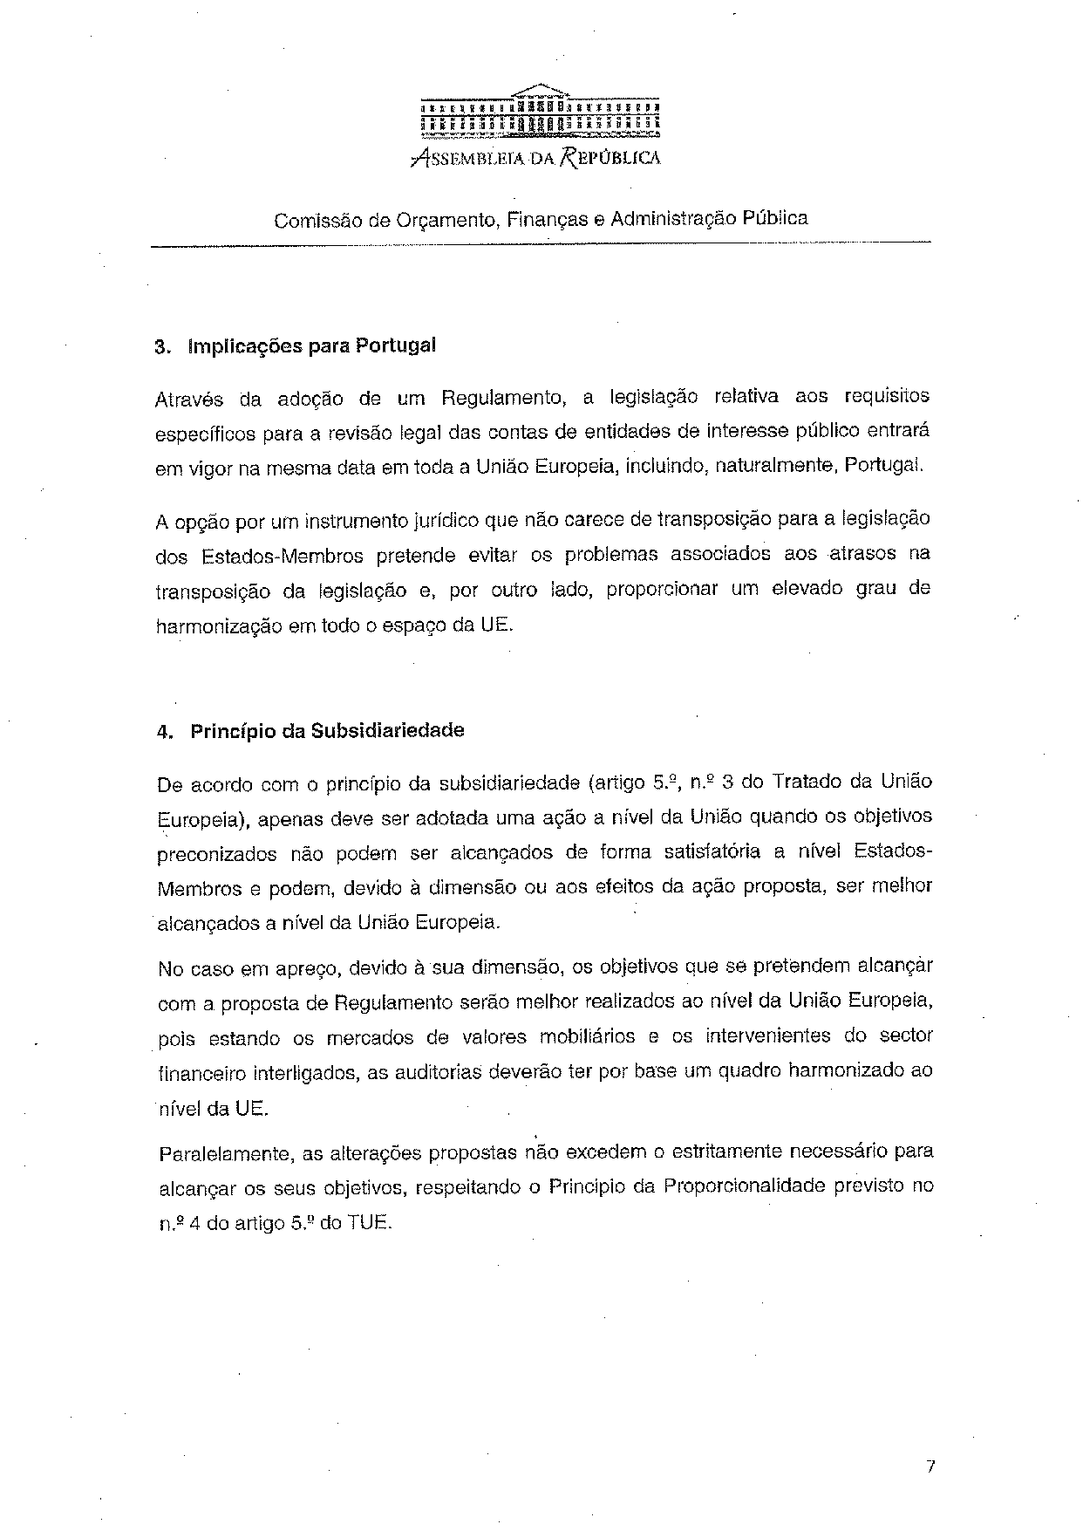
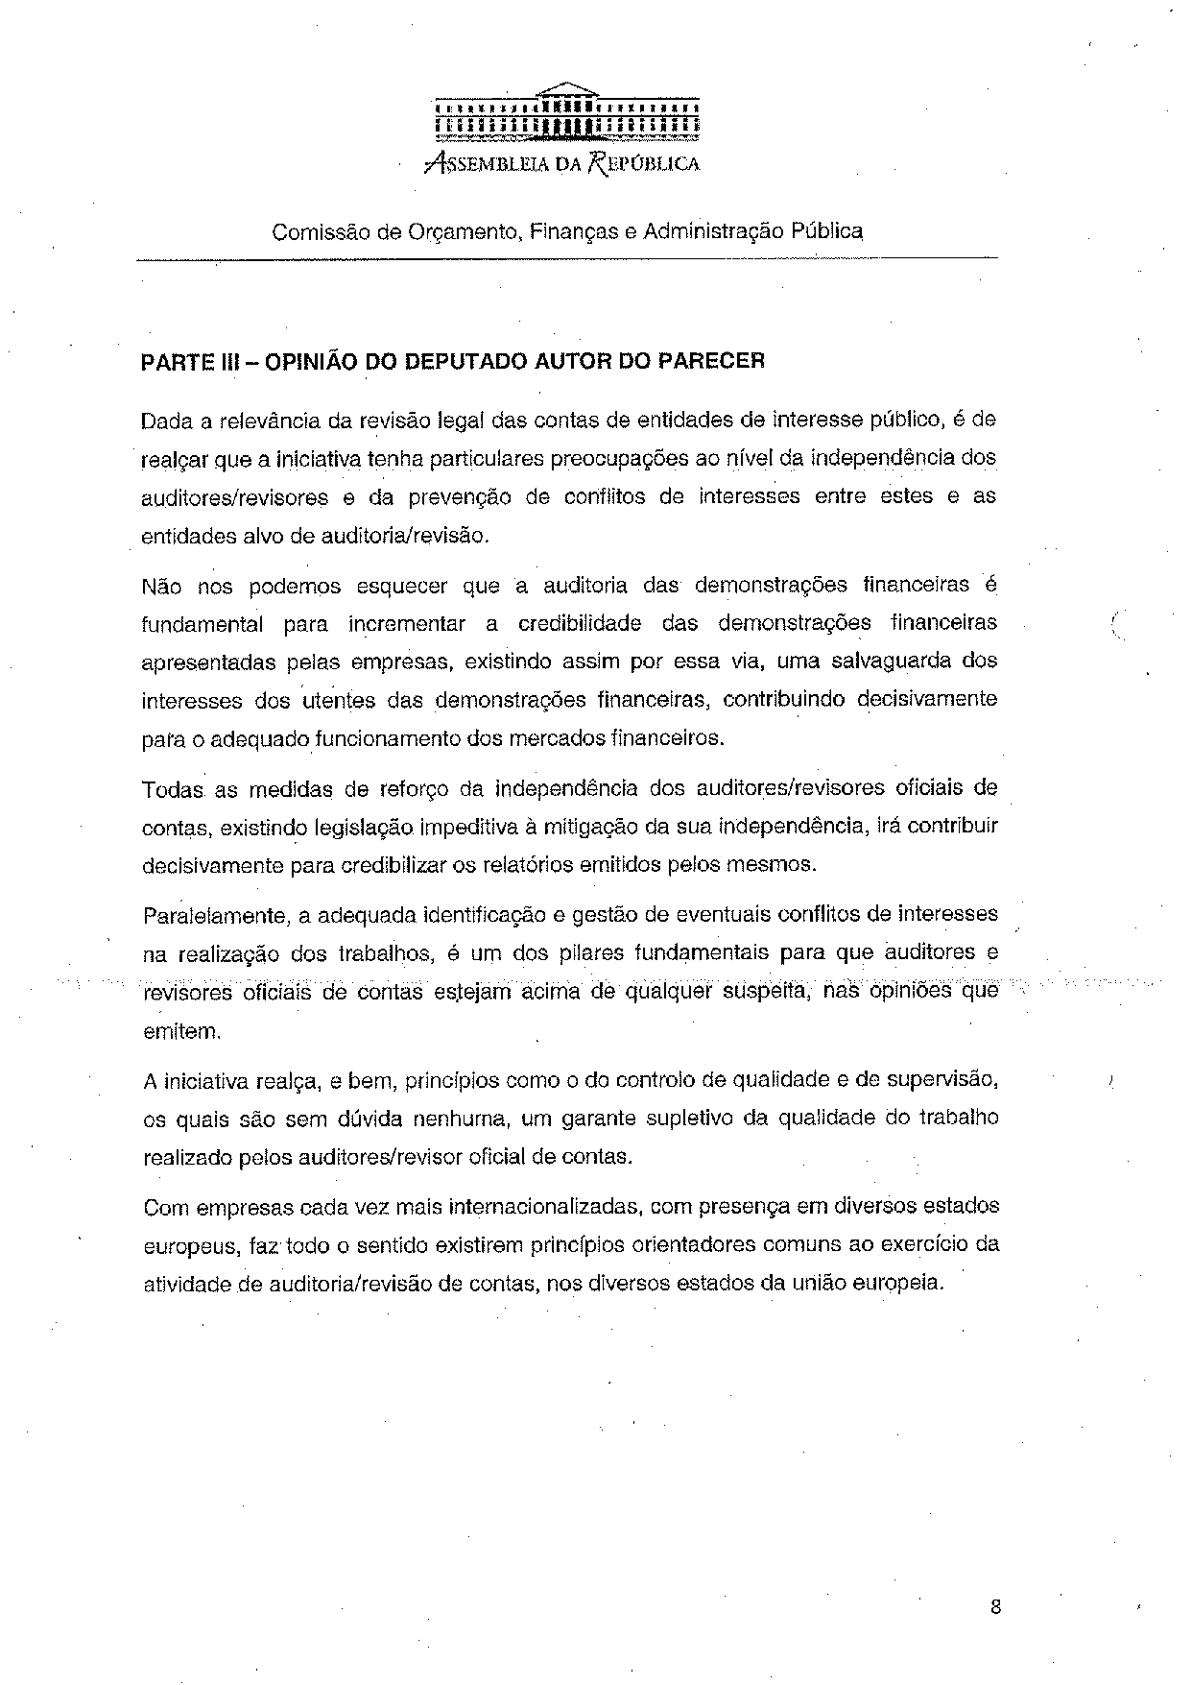
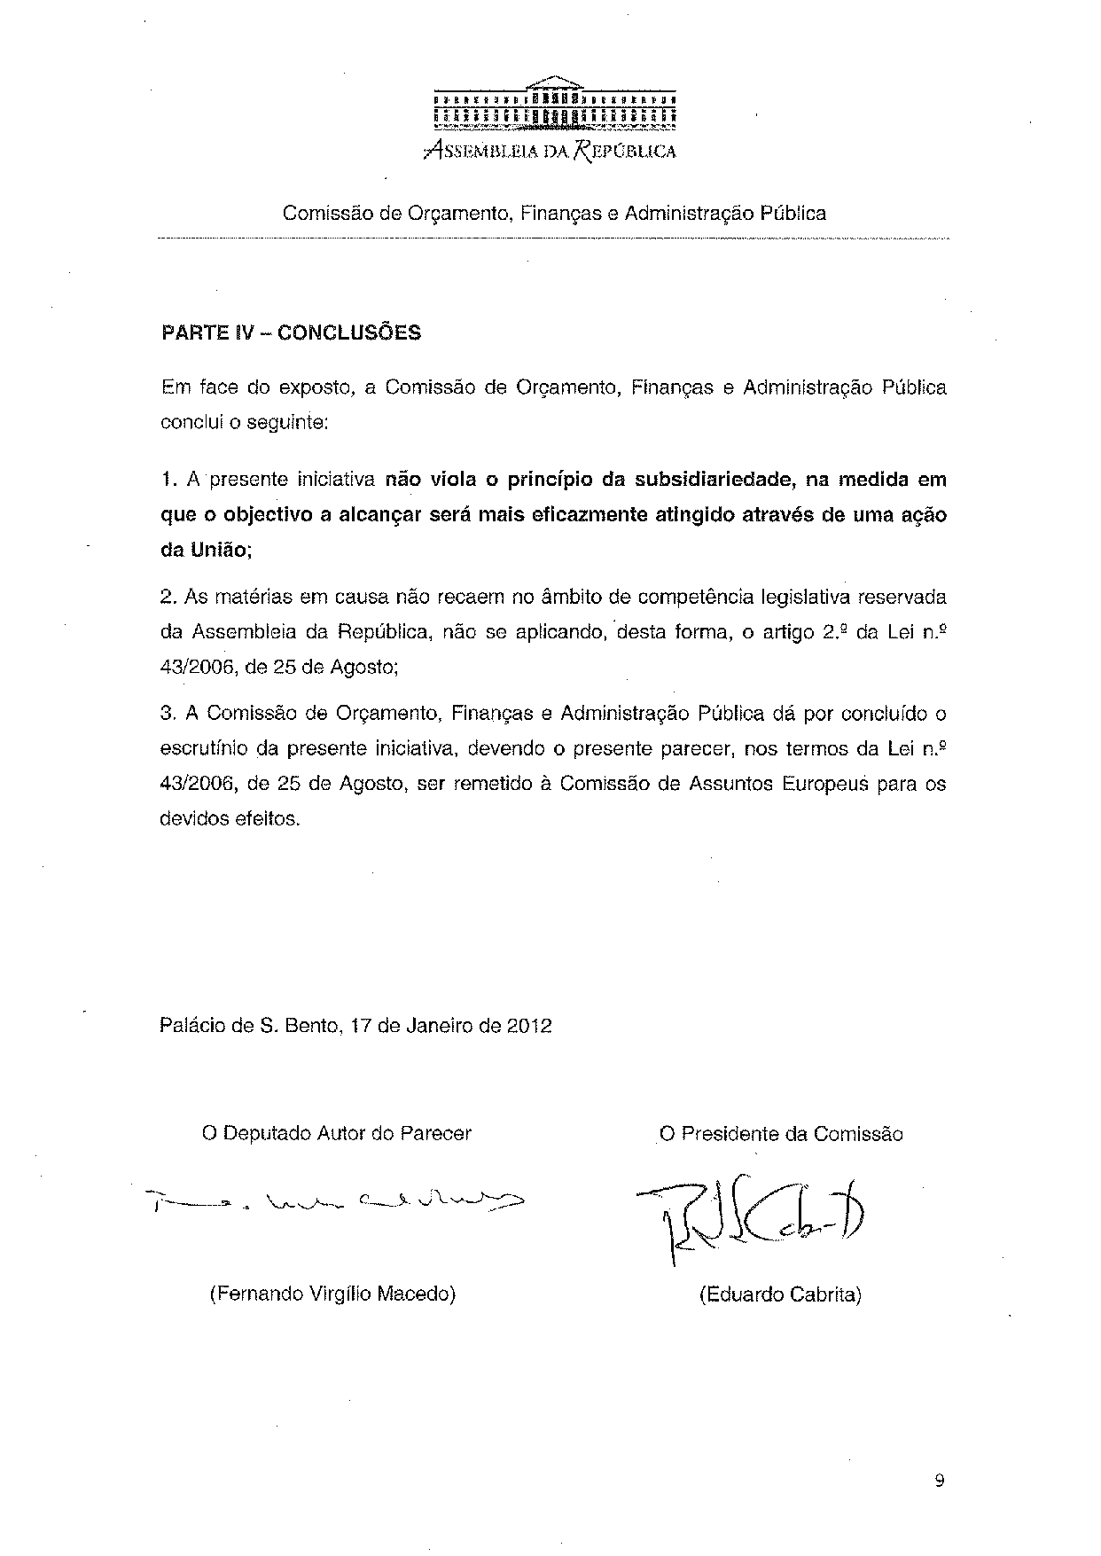

Translation may be available at the Interparliamentary EU information exchange site IPEX at the following address: http://www.ipex.eu/IPEXL-WEB/search.do.

