 | 
COUNCIL OF  THE EUROPEAN UNION |  |  | Brussels, 1 February 2012
 | Interinstitutional File:  2011/0344 (COD) |  | 5959/12
JAI 51
CADREFIN 53
FREMP 10
DATAPROTECT 11
CULT 7
SOC 74
CODEC 242
INST 84
PARLNAT 62

OPINION
from: | The Italian Parliament
date of receipt: | 30 January 2012
to: | Council
Subject: | Proposal for a Regulation of the European Parliament and of the Council establishing for the period 2014 to 2020 the Rights and Citizenship Programme  Doc. 17273/11 JAI 848 CADREFIN 143 FREMP 105 DATAPROTECT 133 CULT 108 SOC 1020 CODEC 2125  [COM(2011) 758 final]  - Opinion on the application of the Principles of Subsidiarity and Proportionality

Delegations will find attached the above mentioned opinion.

_____________

Encl.

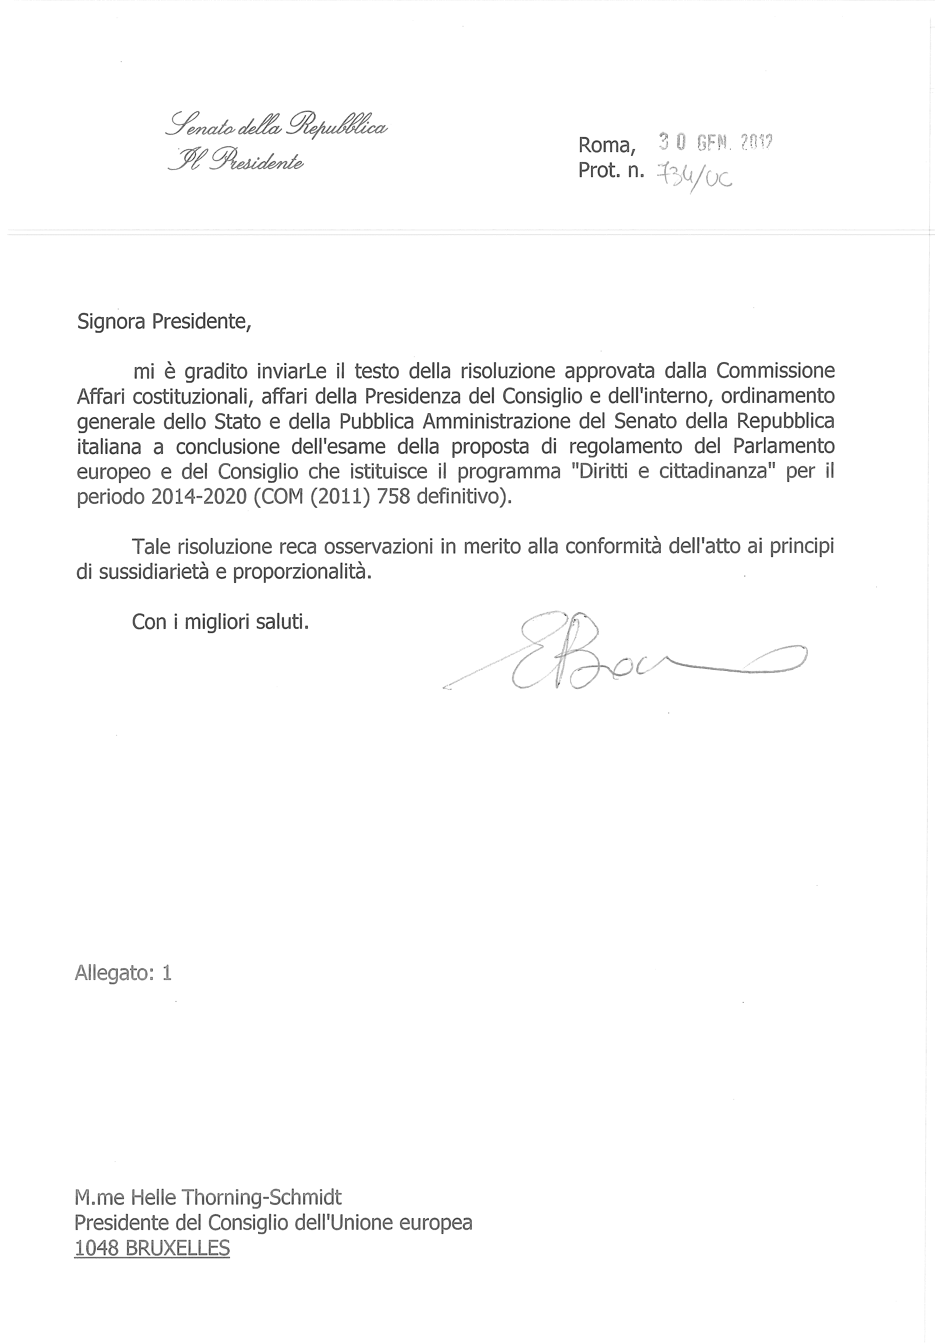
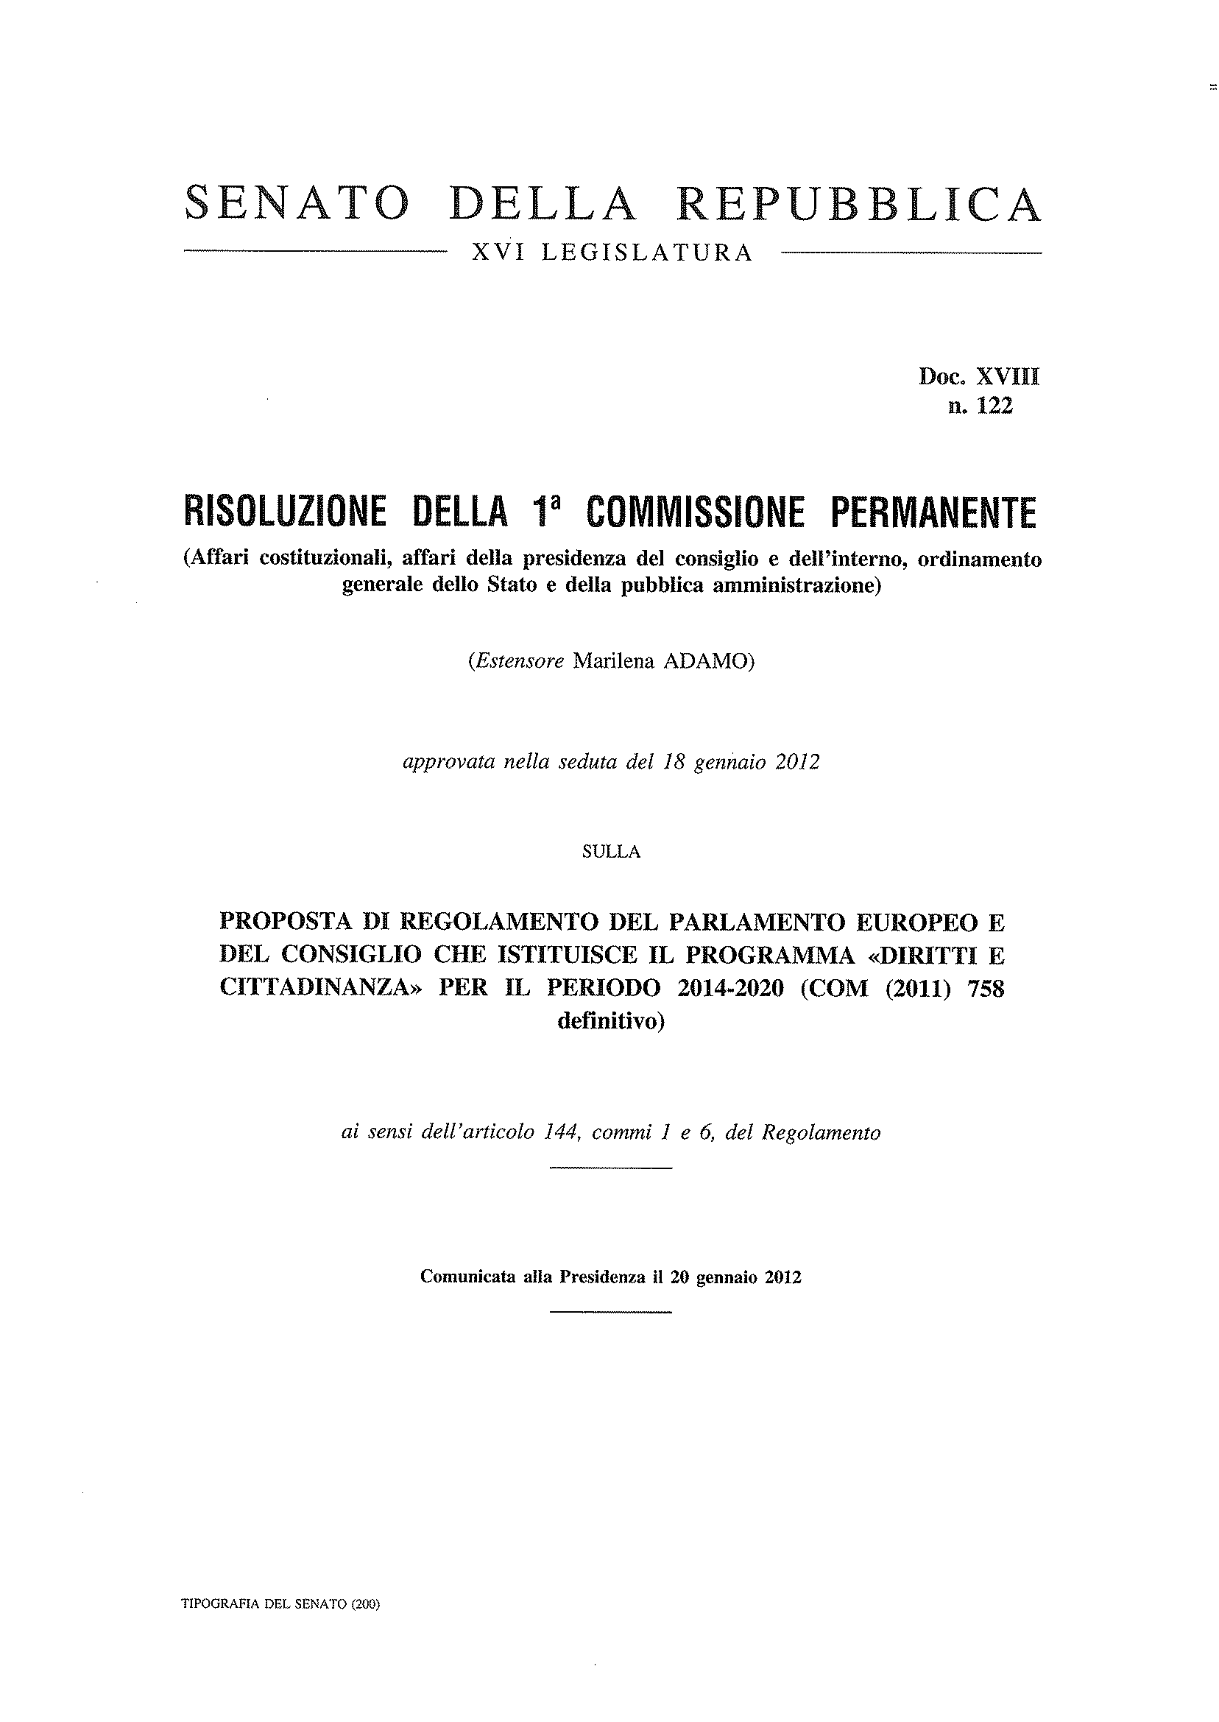
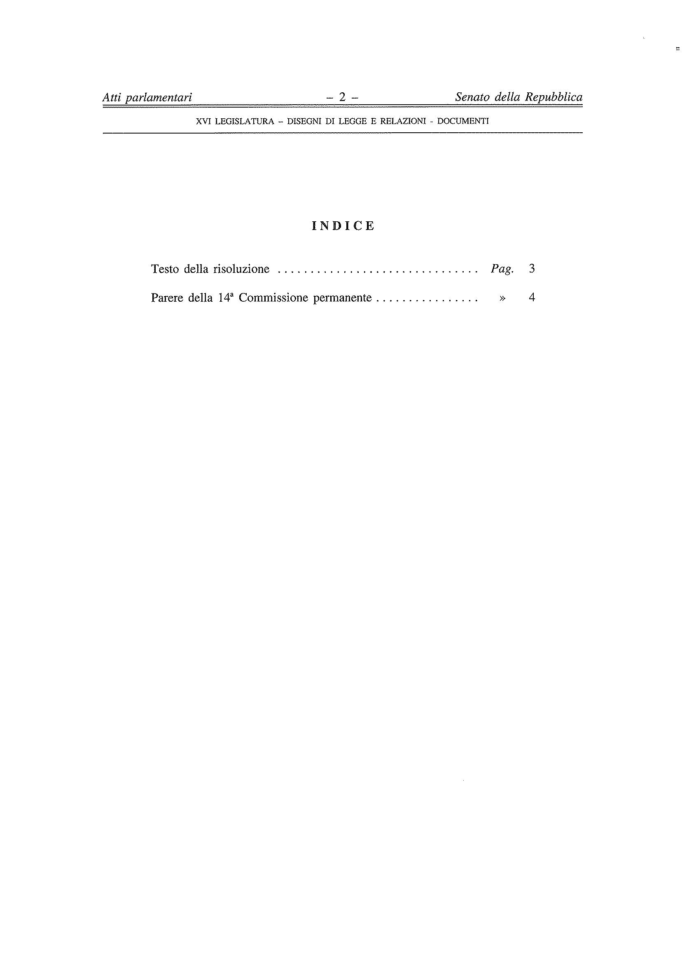
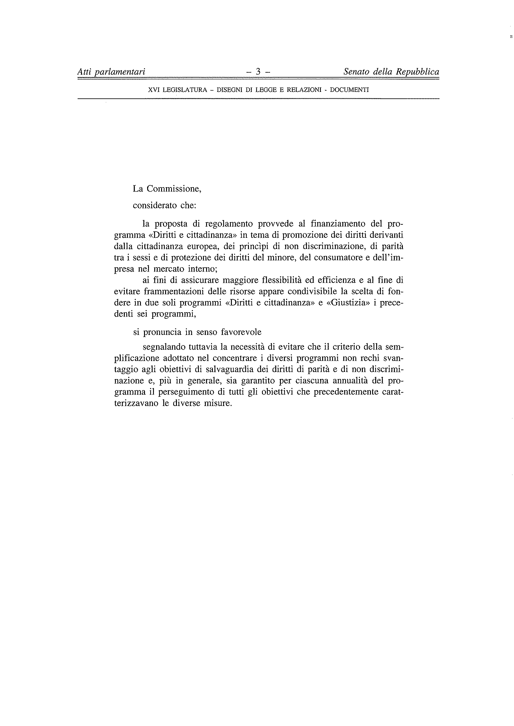
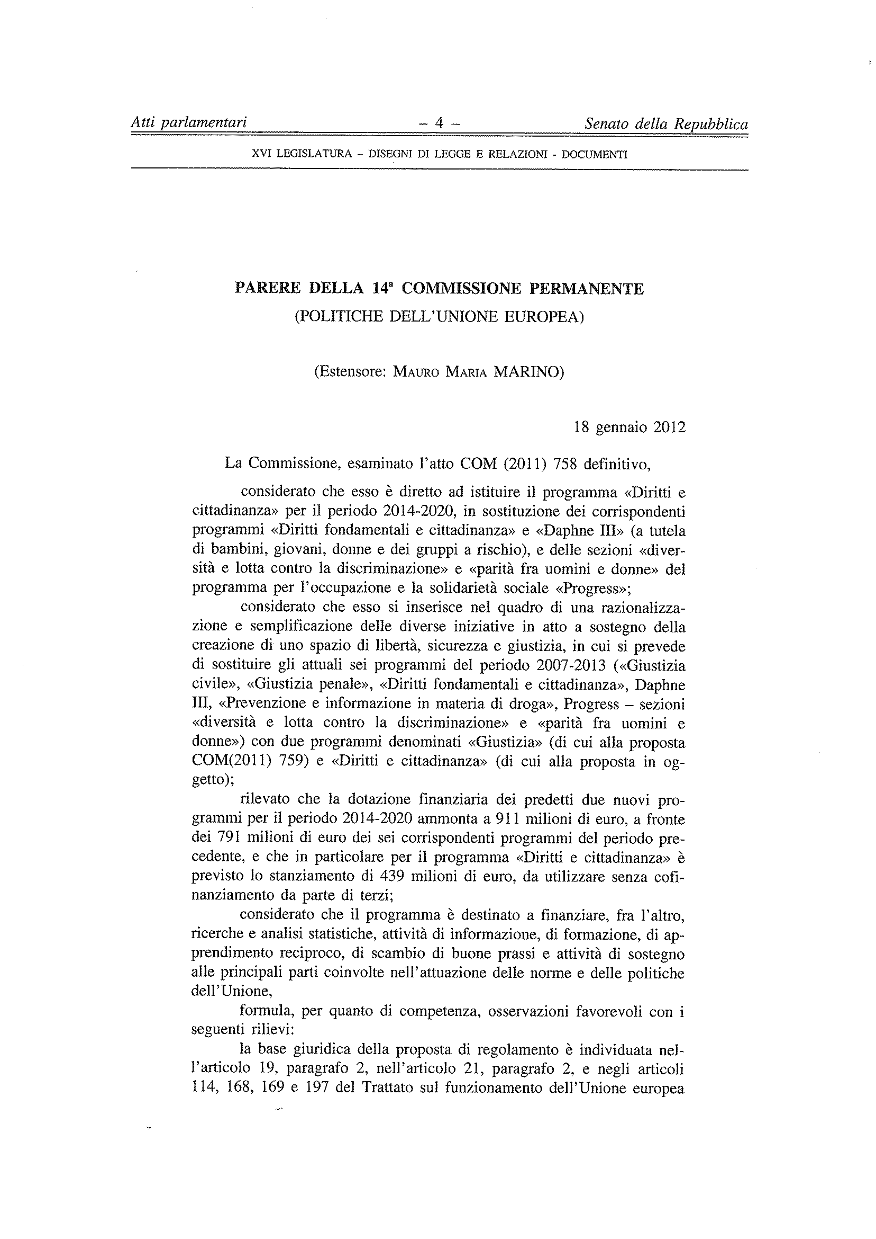
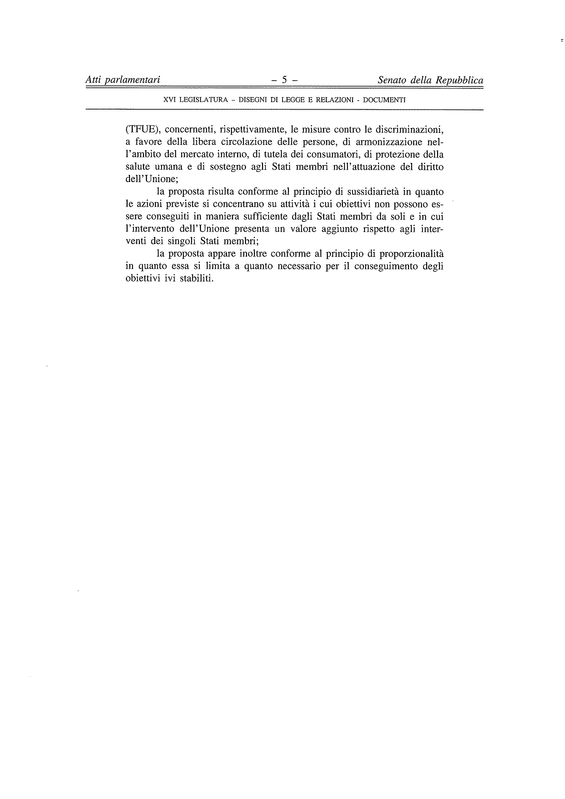
________________

Translation(s) of the opinion may be available at the Interparliamentary EU information exchange site IPEX at the following address: http://www.ipex.eu/IPEXL-WEB/search.do

