 | 
COUNCIL OF  THE EUROPEAN UNION |  |  | Brussels, 2 March 2012
 | Interinstitutional File:  2011/0439 (COD)  2011/0438 (COD) |  | 7206/12
MAP 20
MI 146
CODEC 546
INST 171
PARLNAT 125

COVER NOTE
from: | Portuguese Assembleia da República
date of receipt: | 29 February 2012
No. Cion doc. : | 18964/11 MAP 9 MI 685 + ADD 1 + ADD 2 - COM (2011) 895  18966/11 MAP 10 MI 686 + ADD 1 + ADD 2 - COM (2011) 896
Subject: | Proposal for a Directive of the European Parliament and of the Council  on procurement by entities operating in the water, energy, transport and postal services sectors  Proposal for a Directive of the European Parliament and of the Council on public procurement  - Reasoned Opinion on the application of the Principles of Subsidiarity and Proportionality

Delegations will find attached the Opinion of the Portuguese Assembleia da República on the above proposals.

Encl.:
________________________

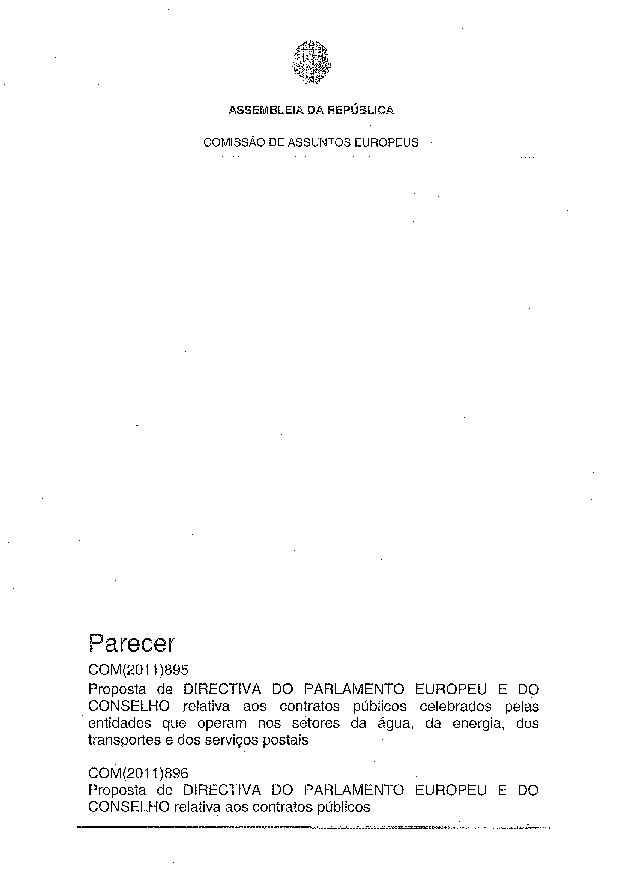
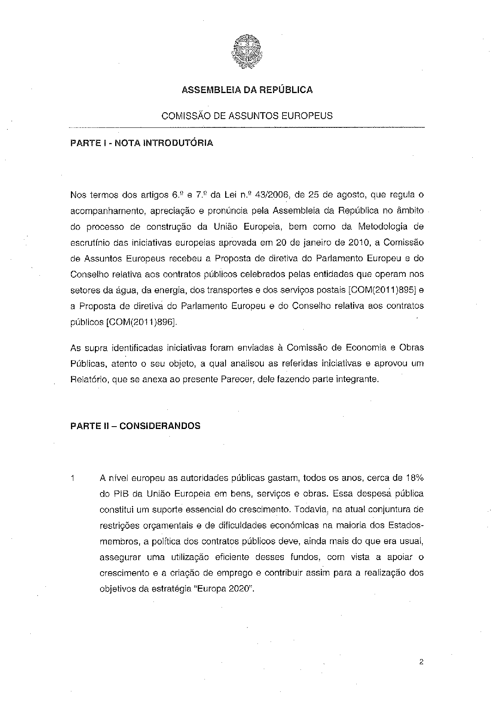
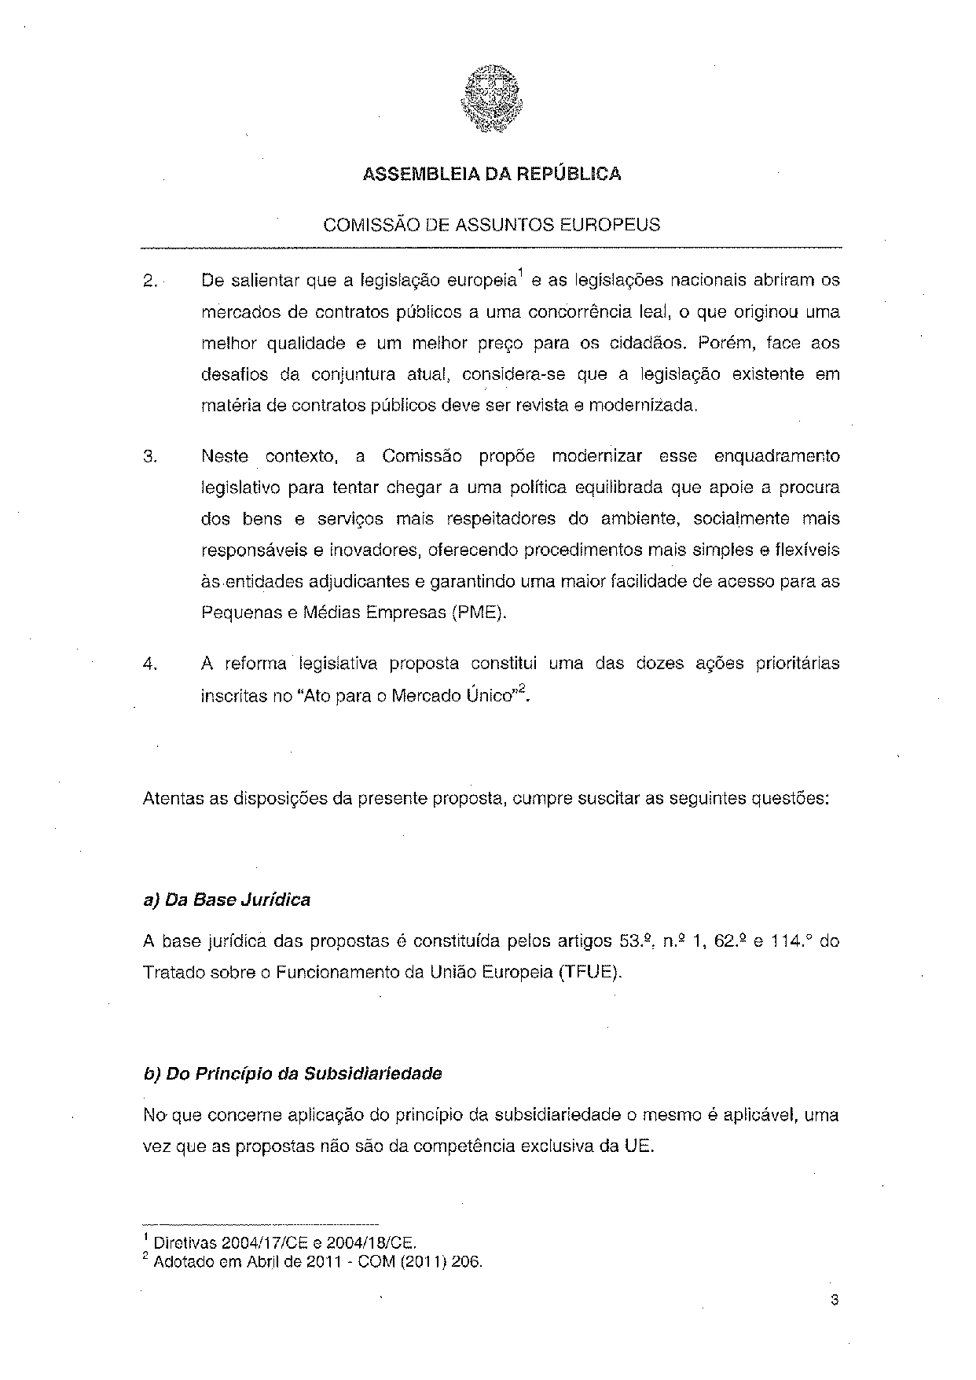
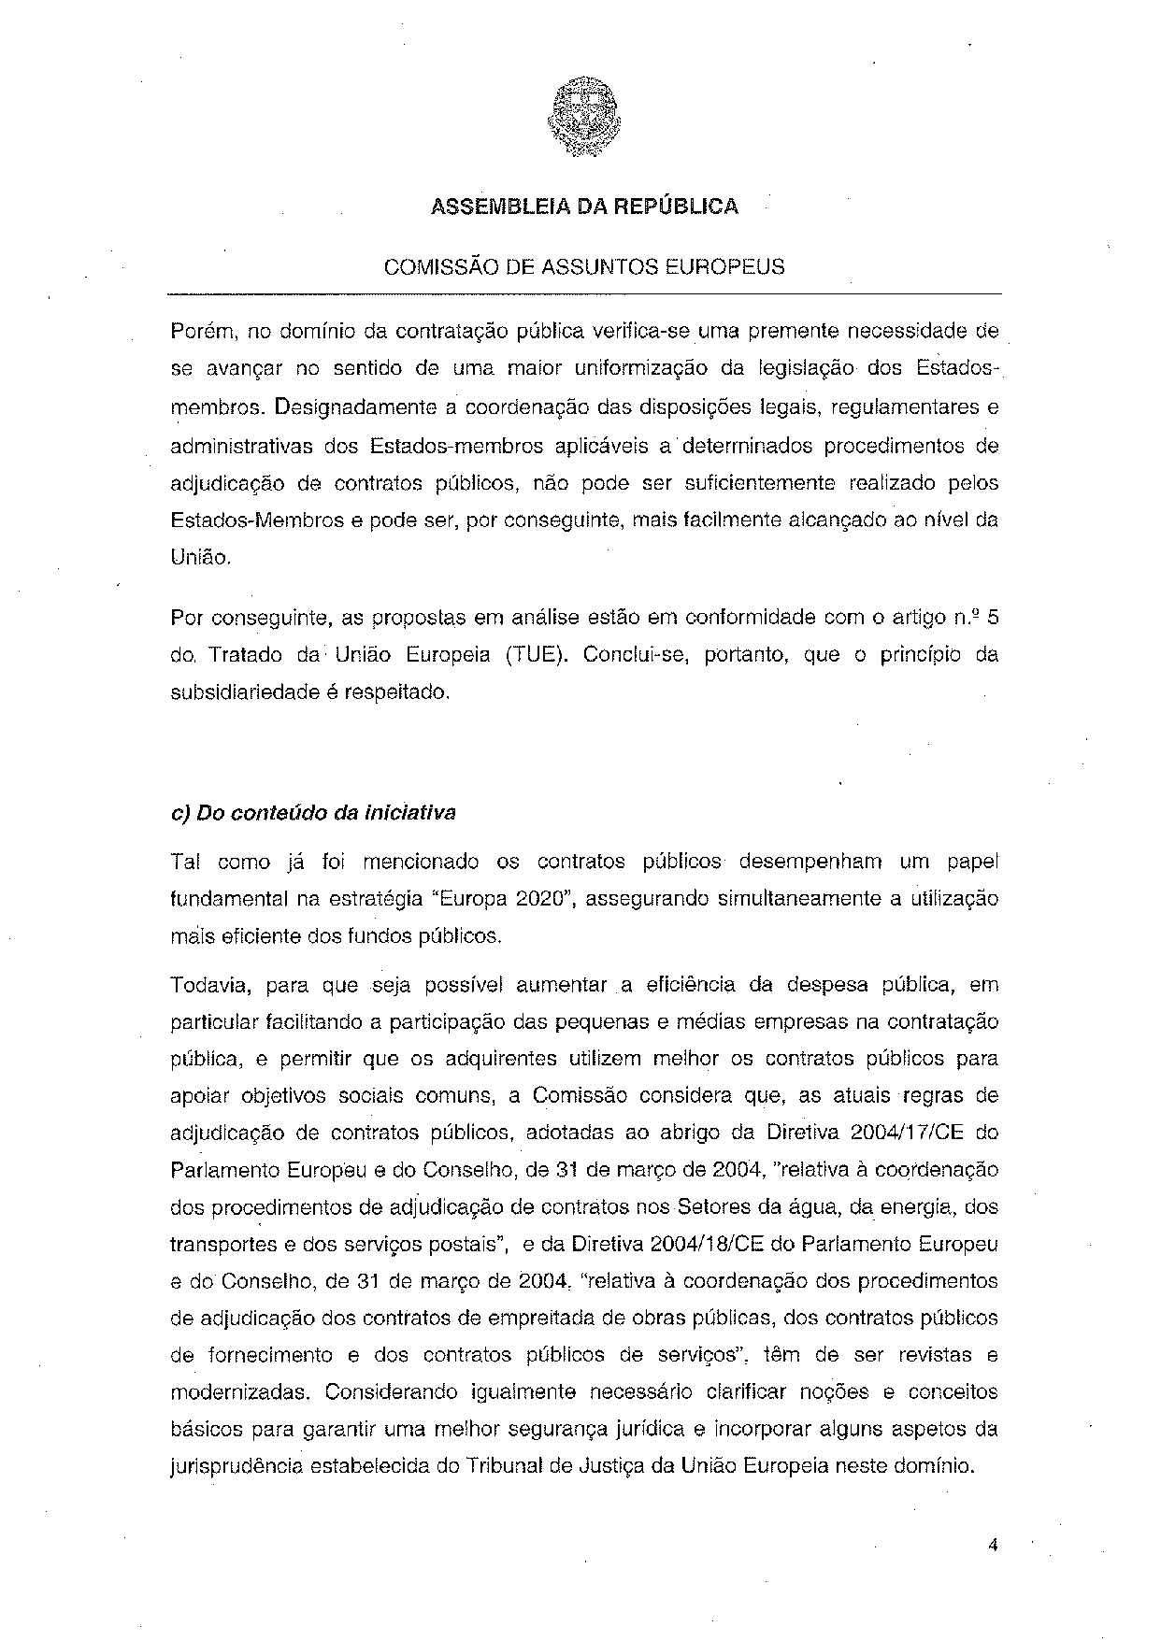
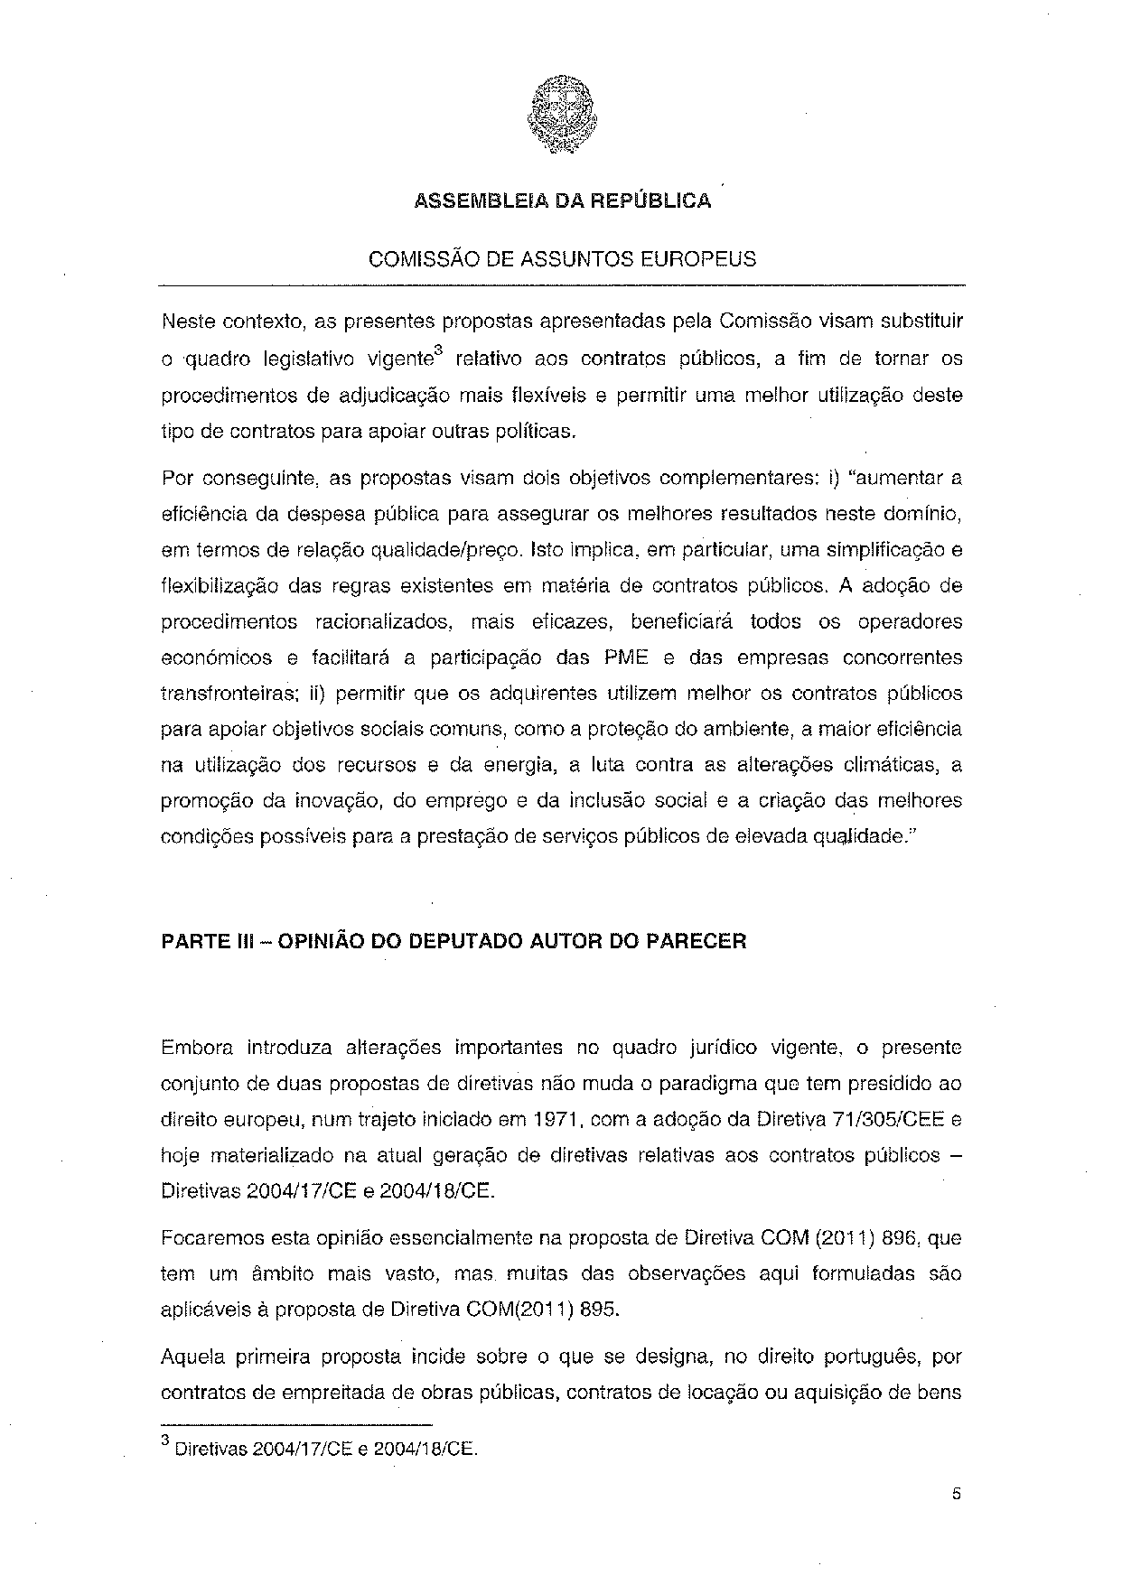
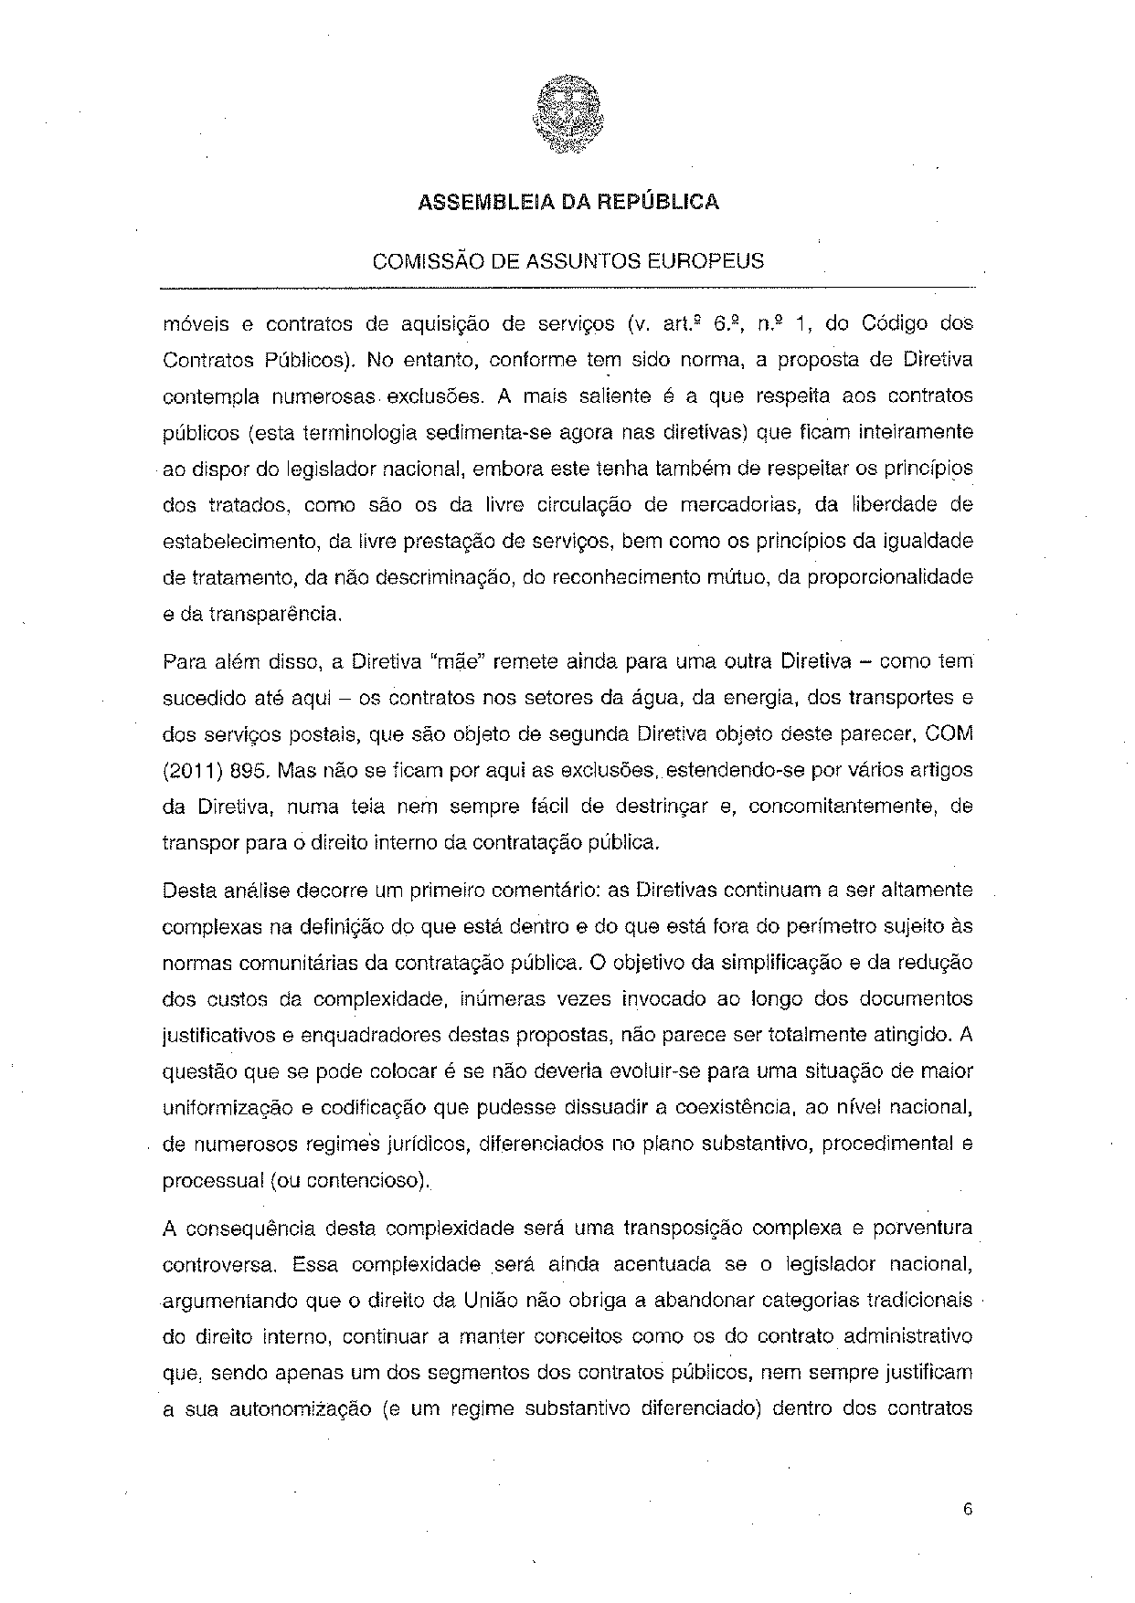
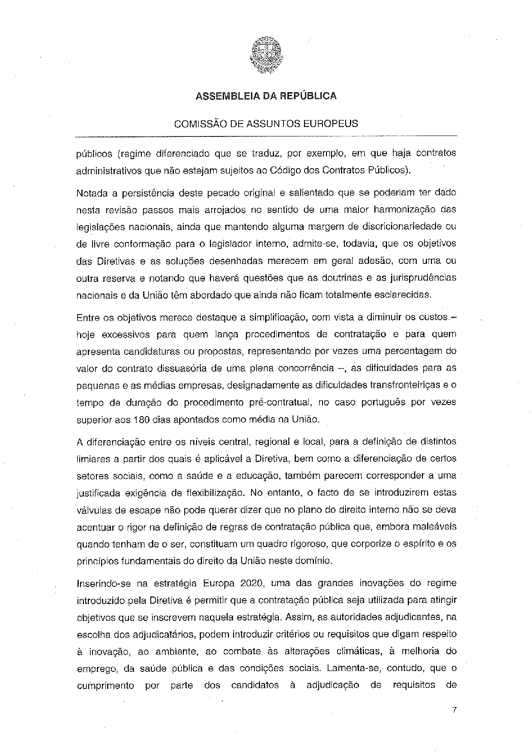
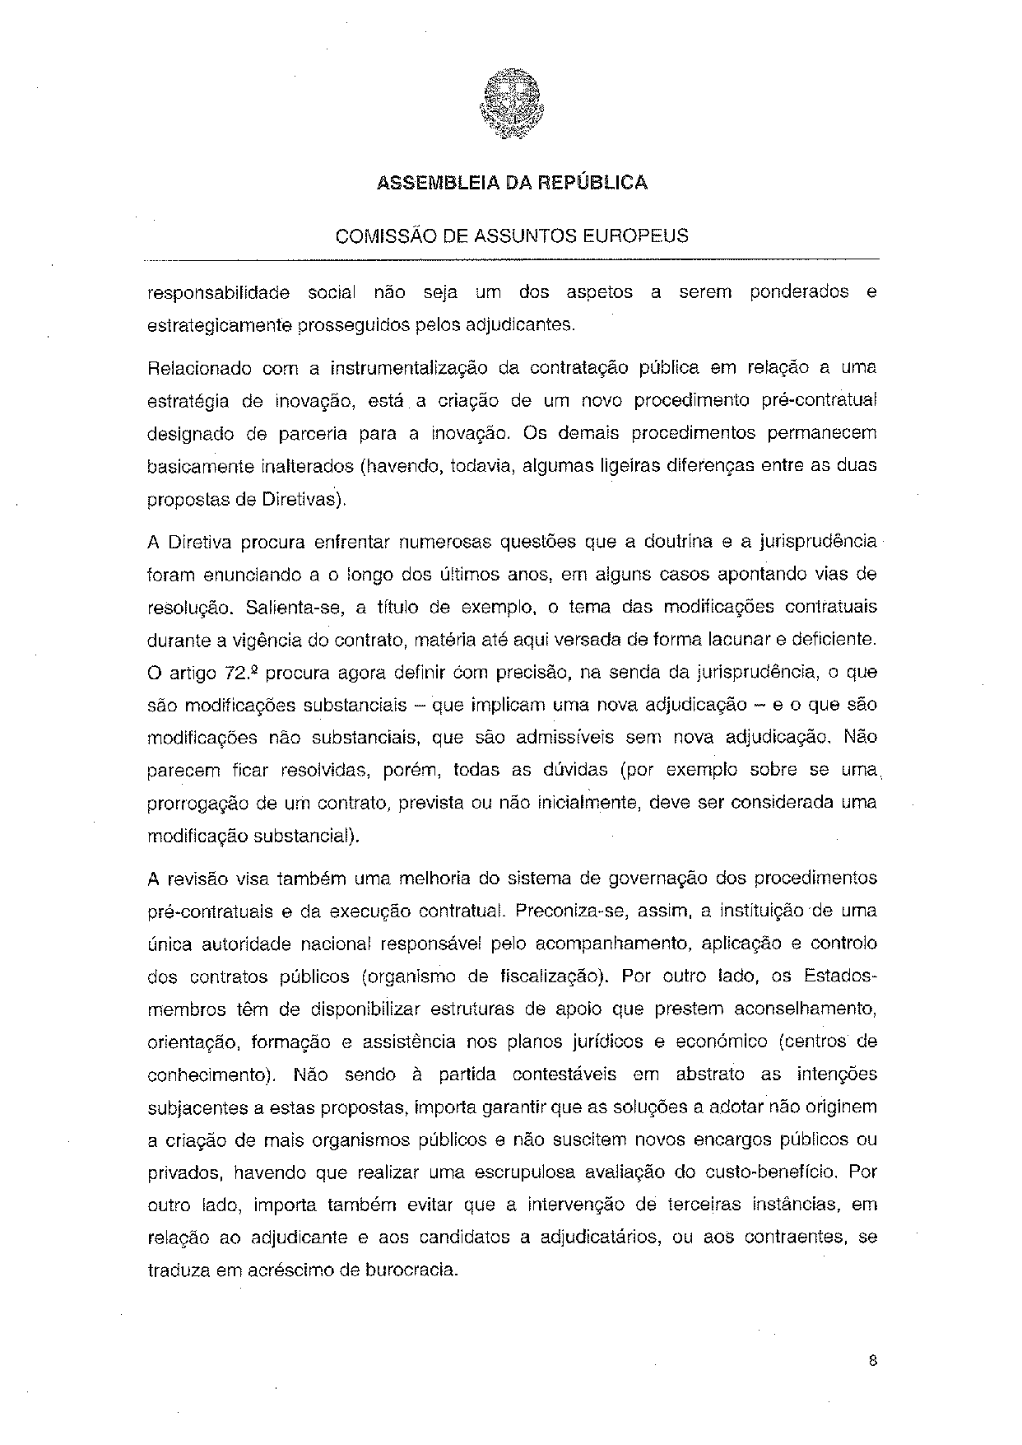
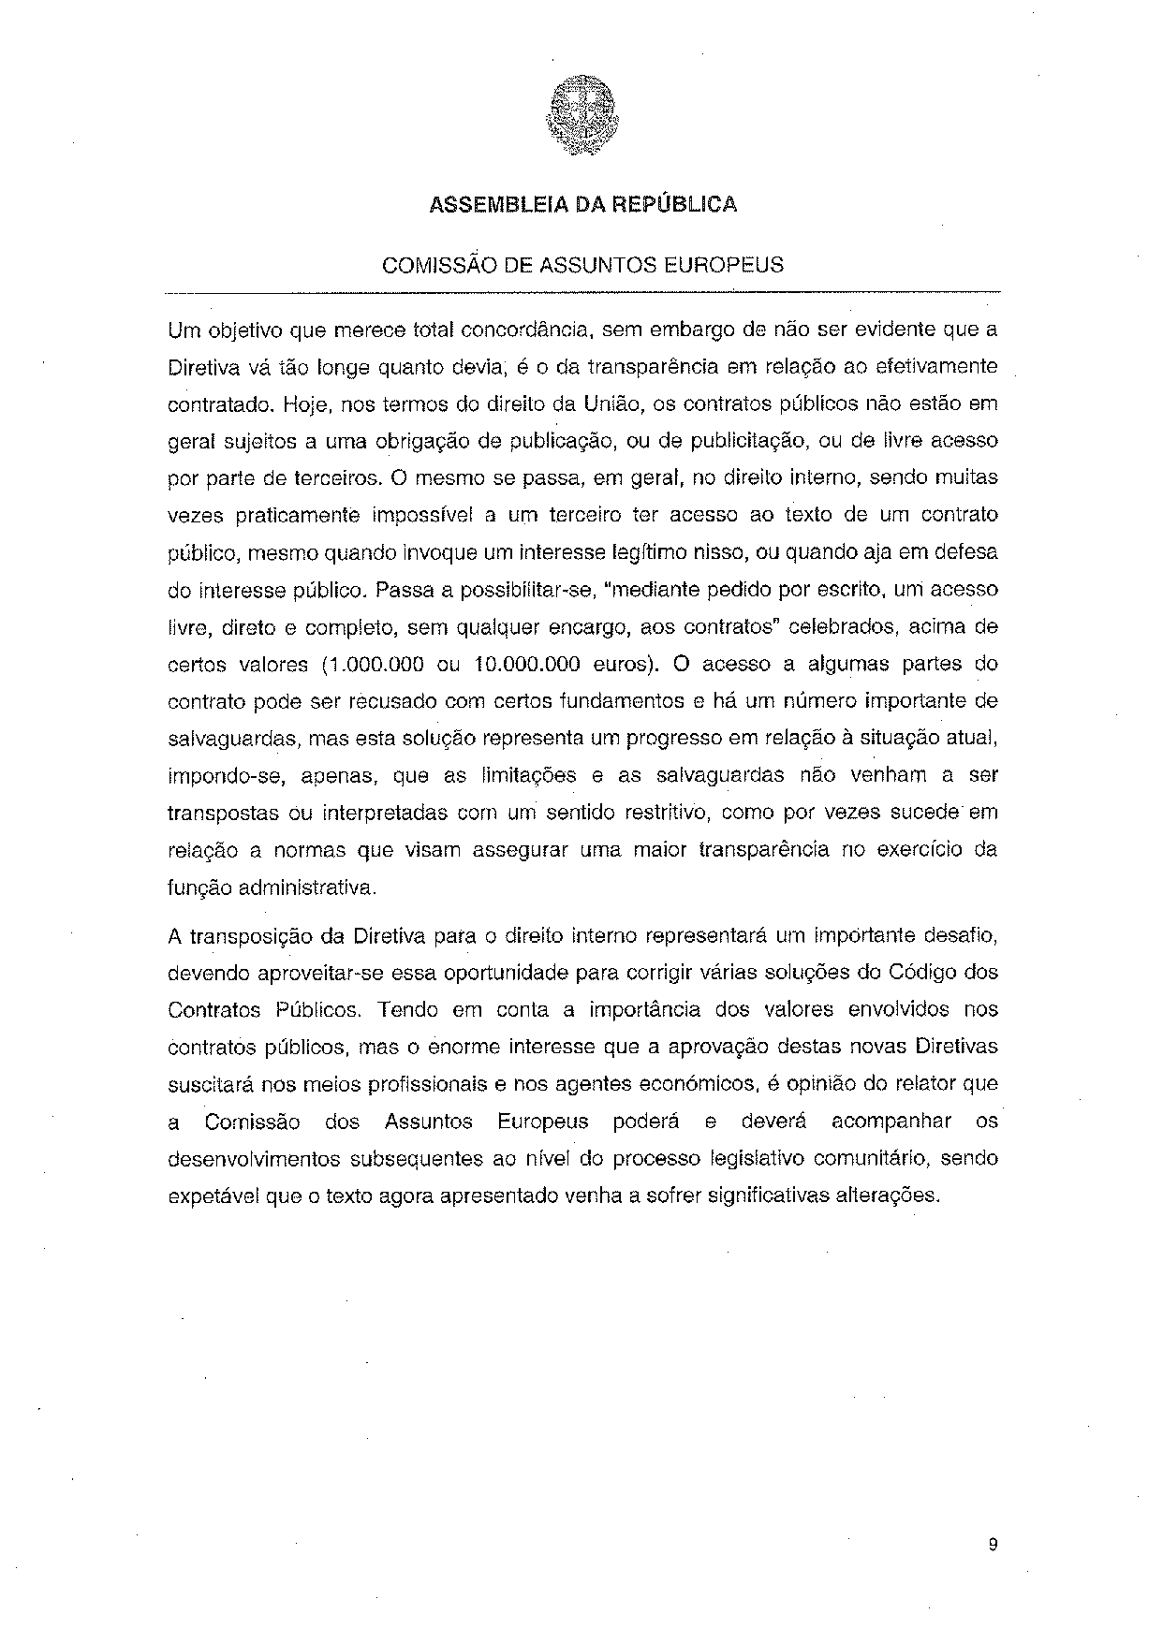
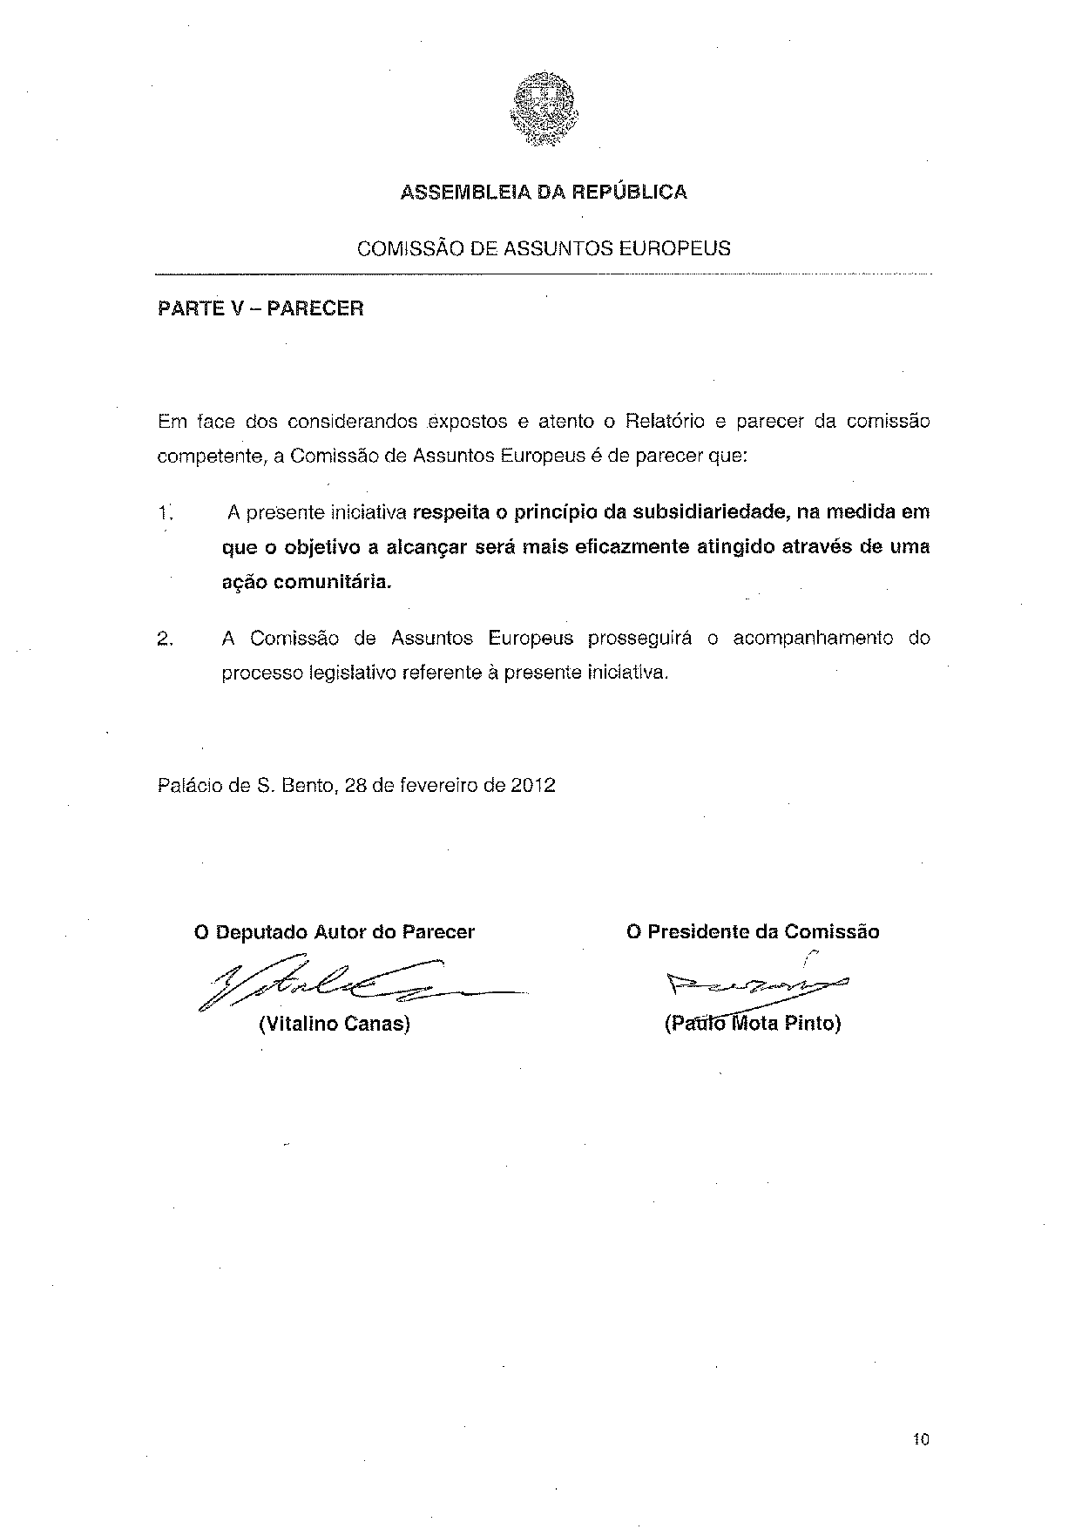

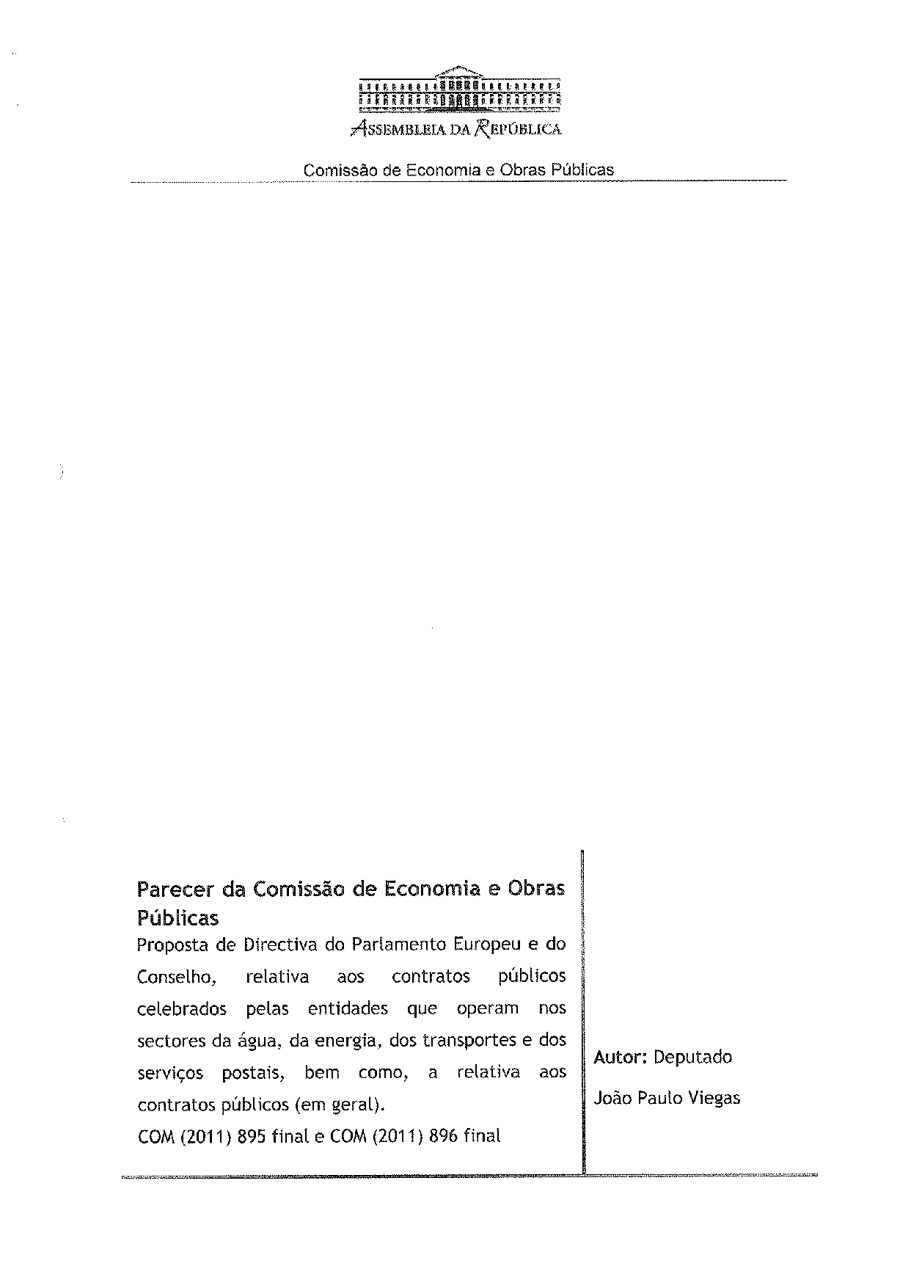
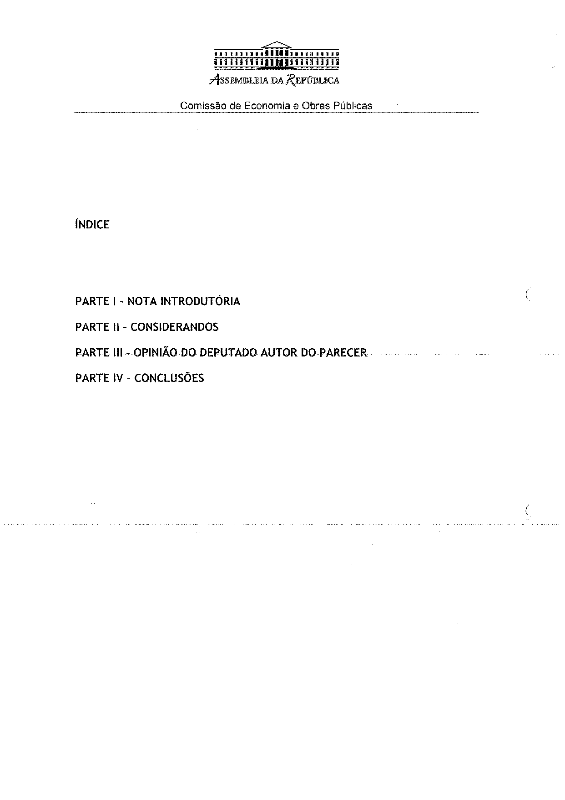
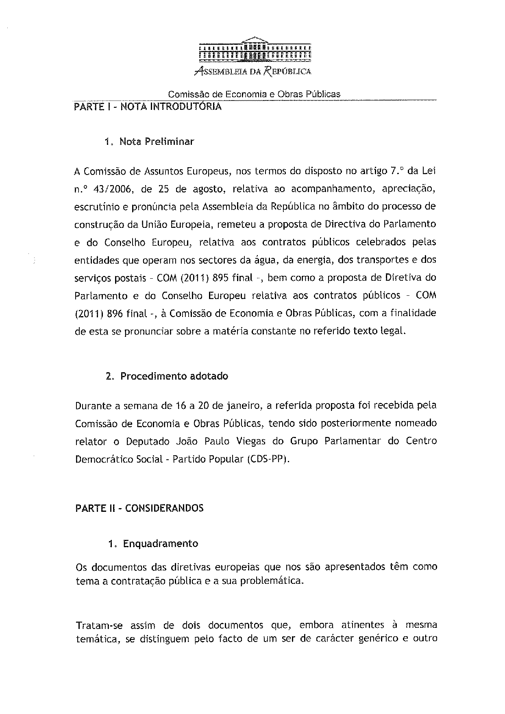
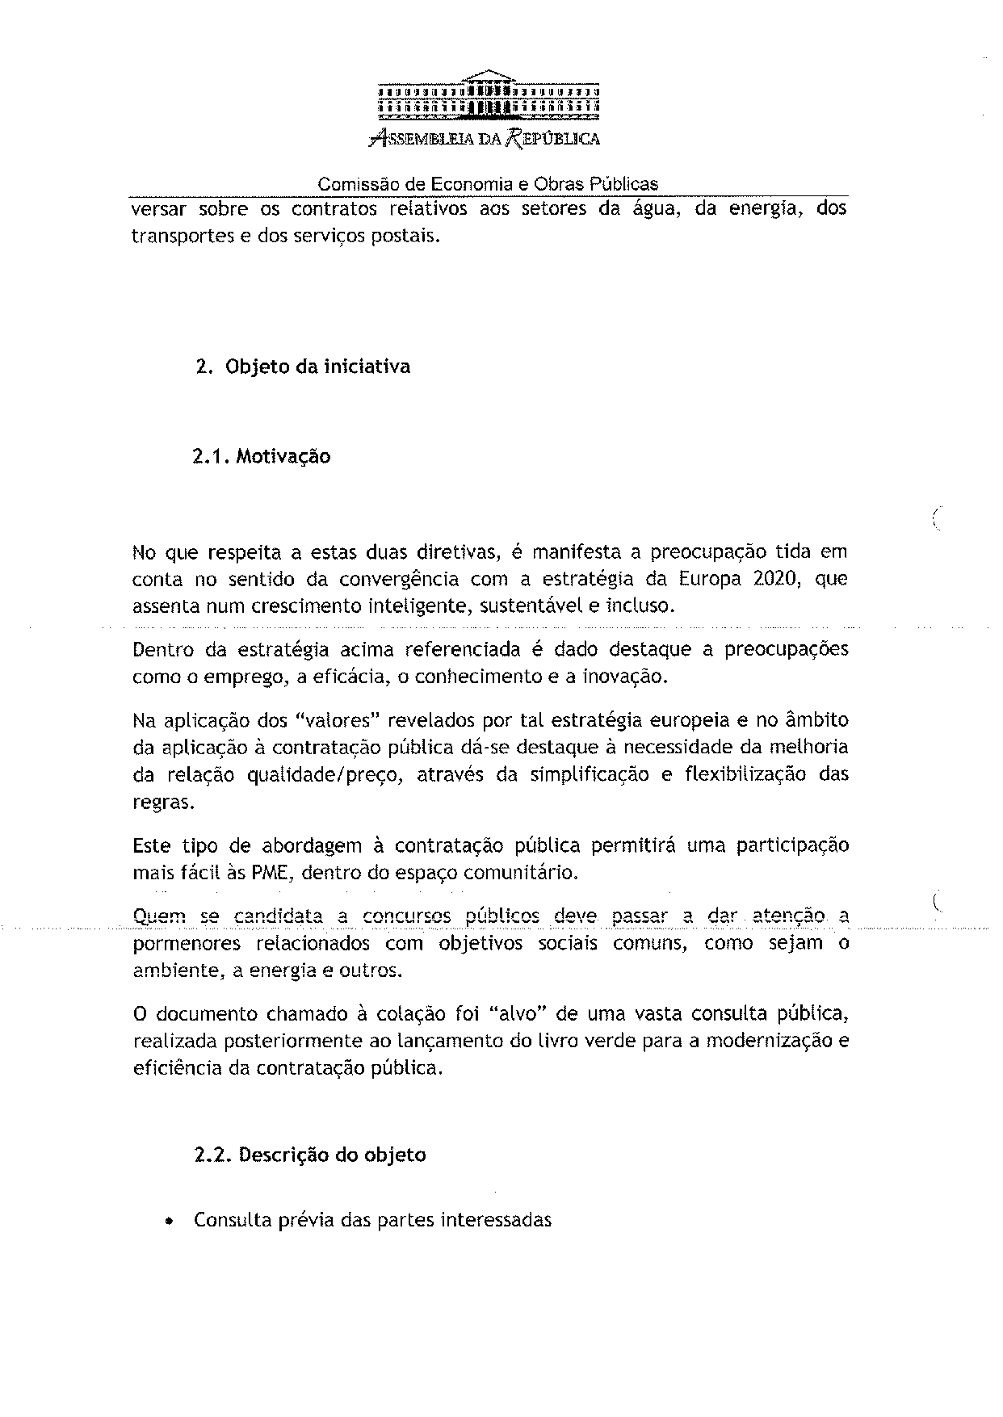
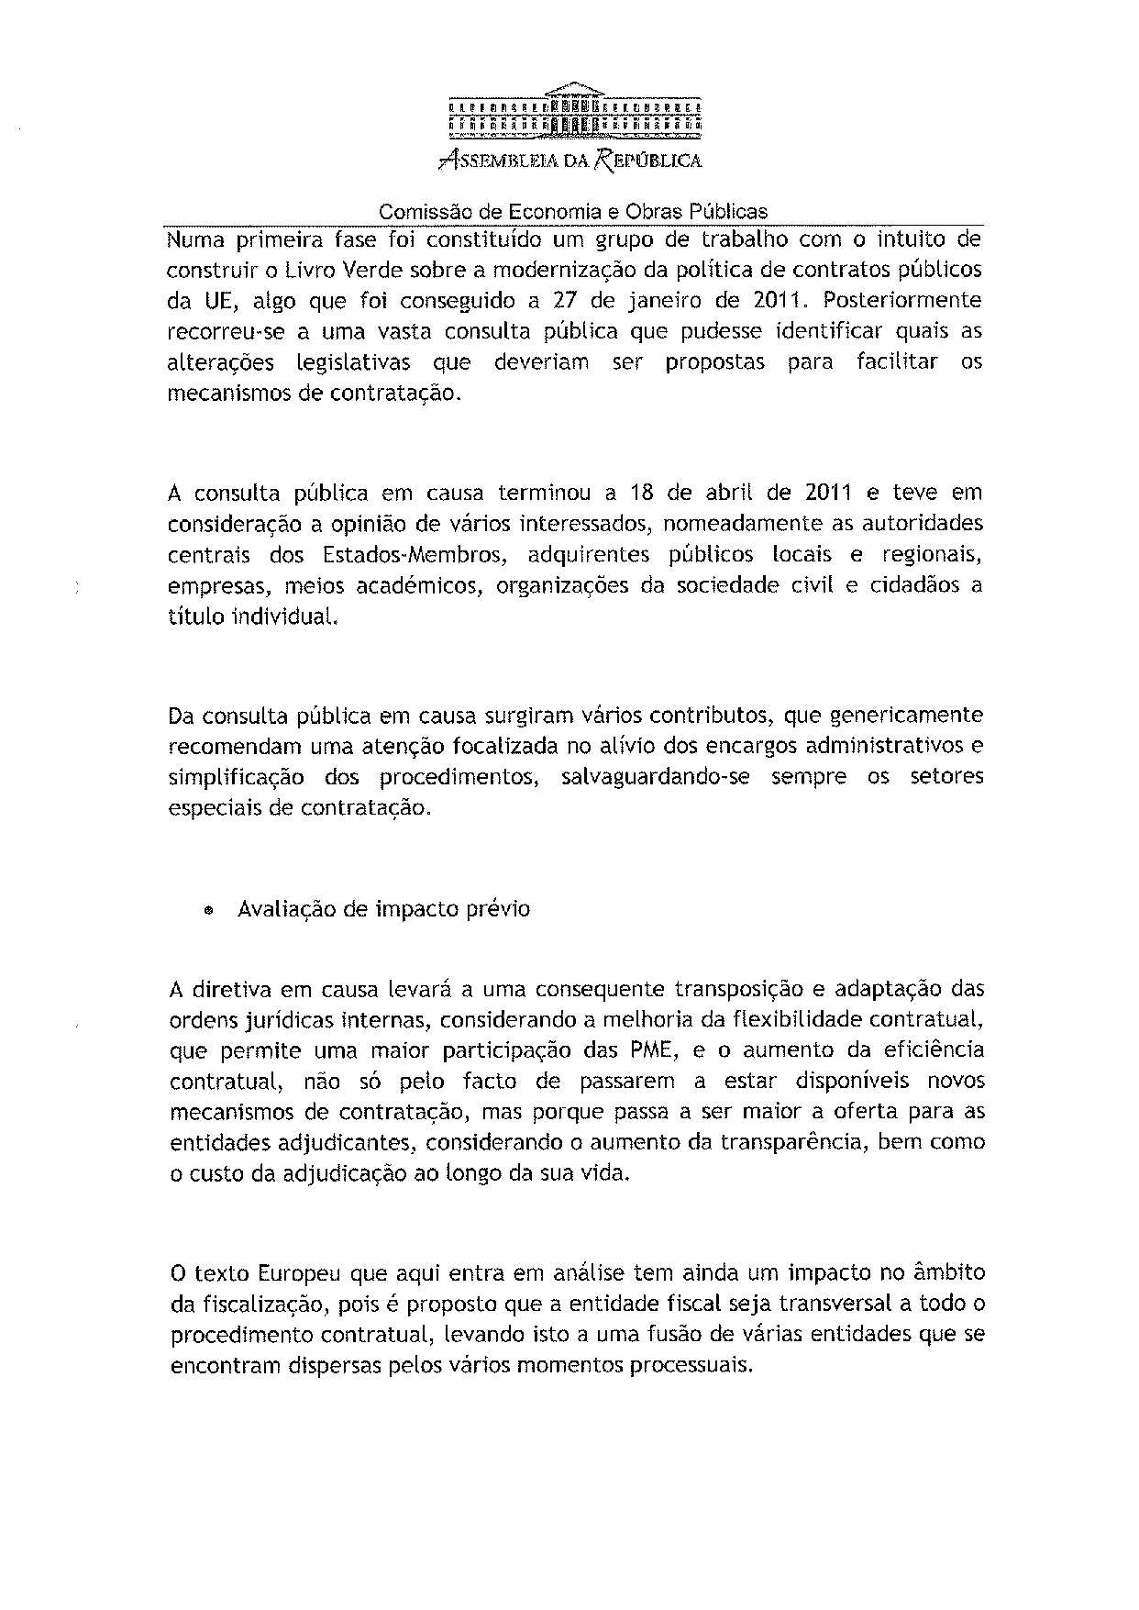
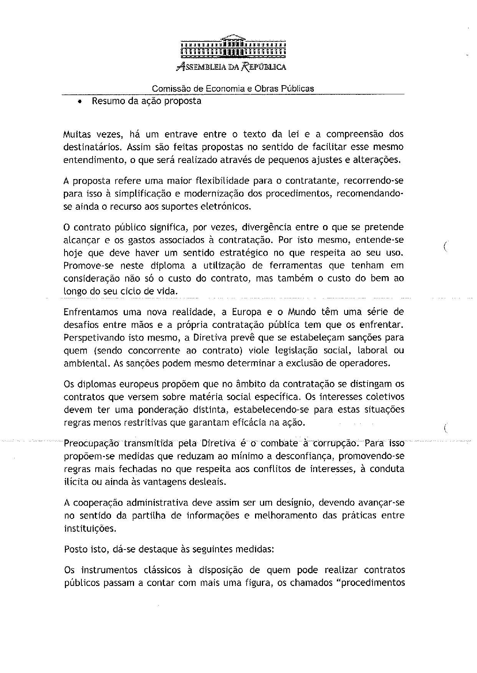
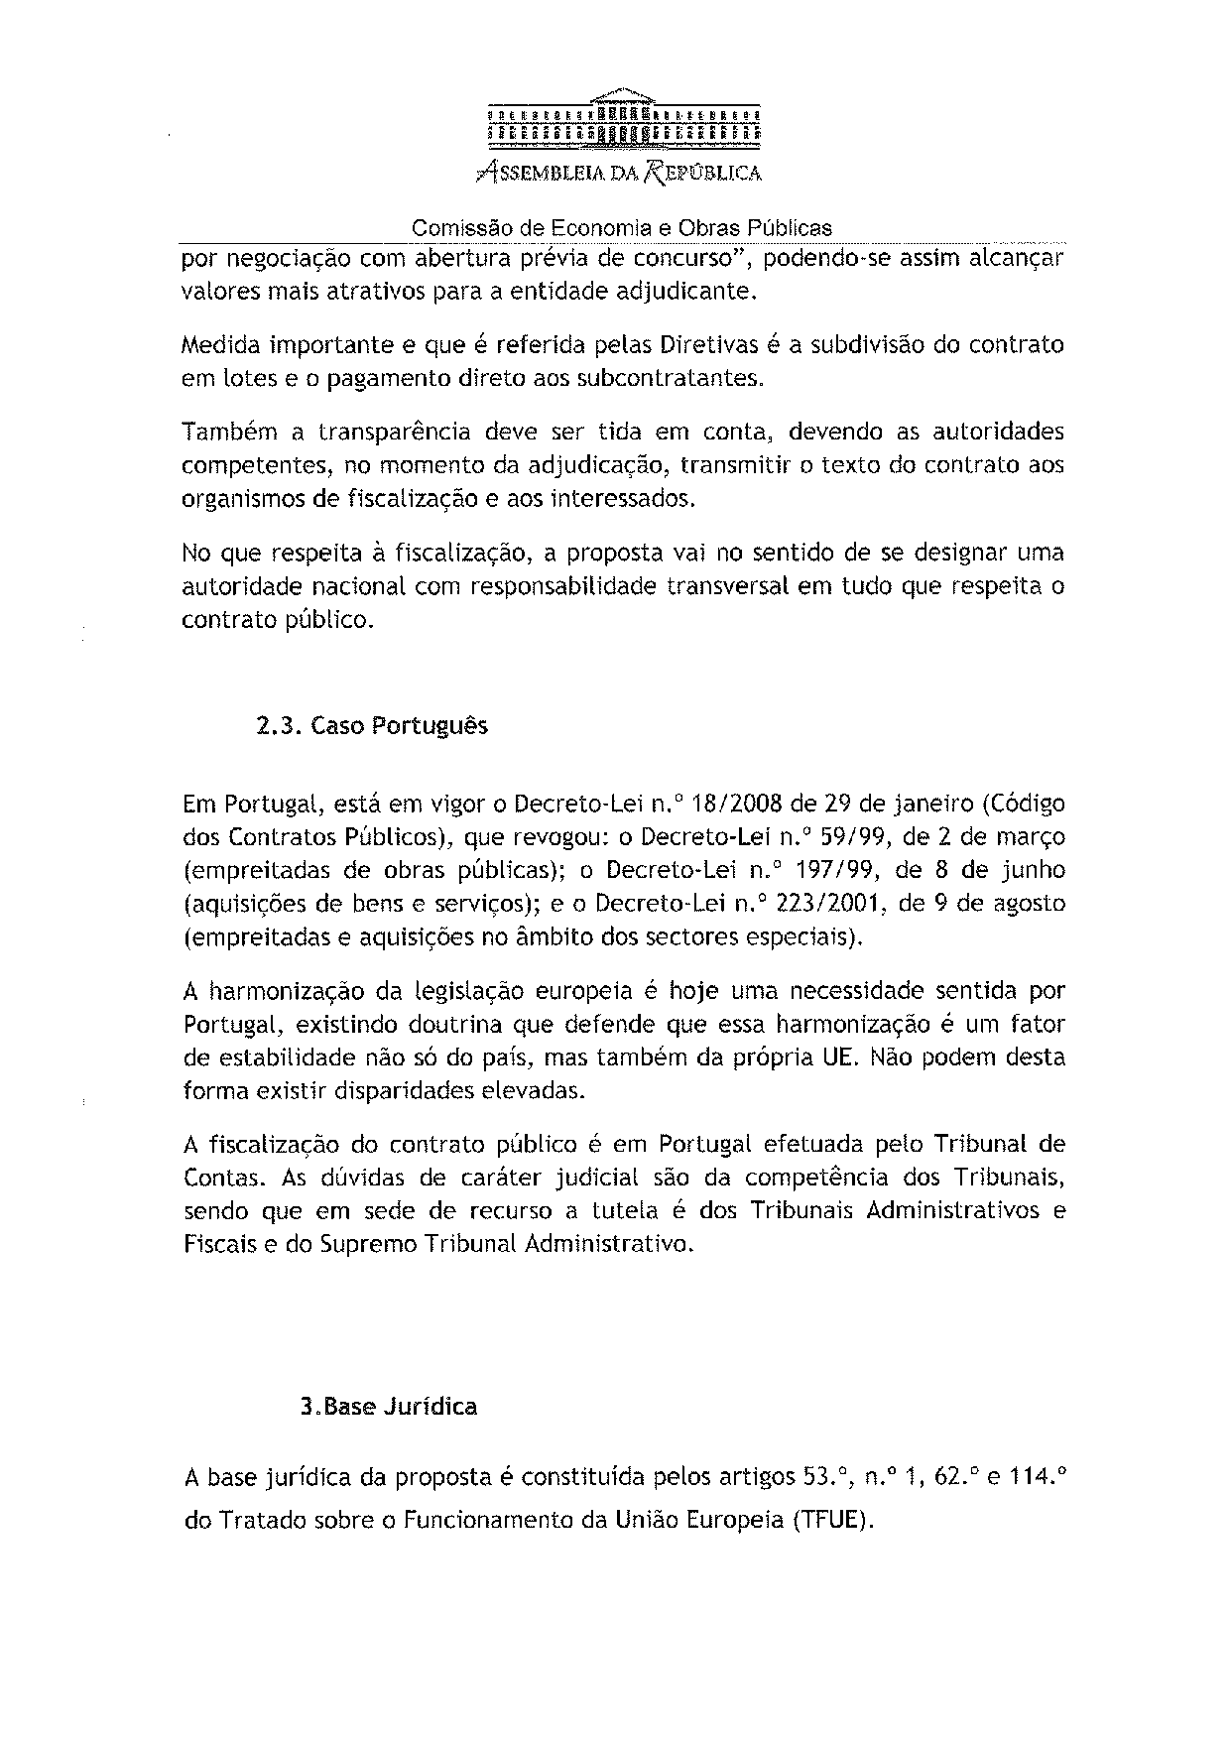
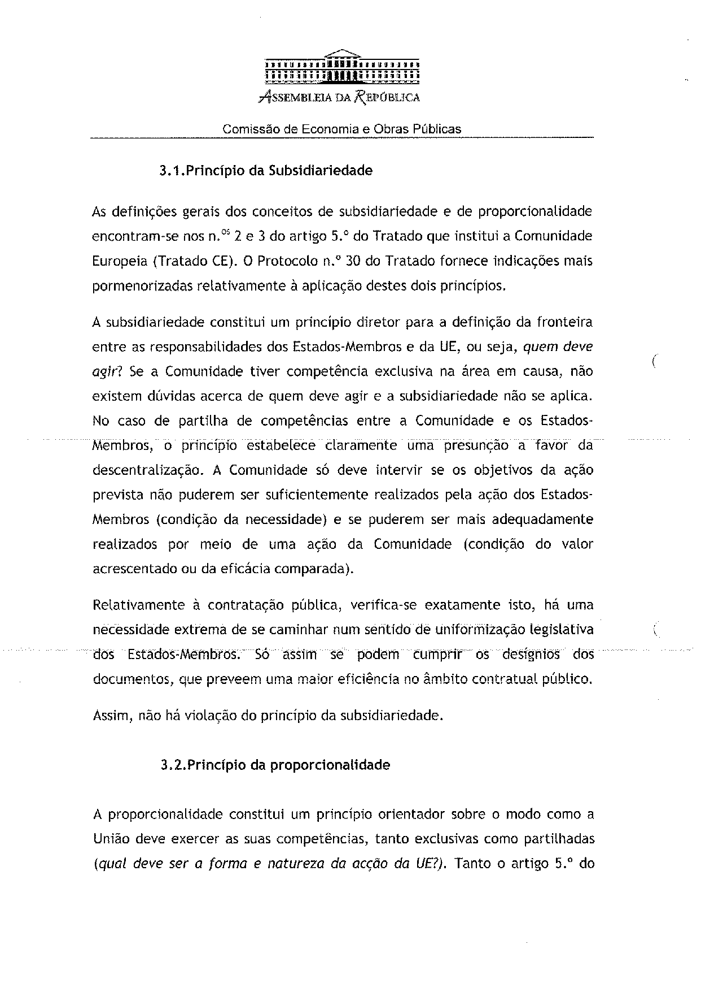
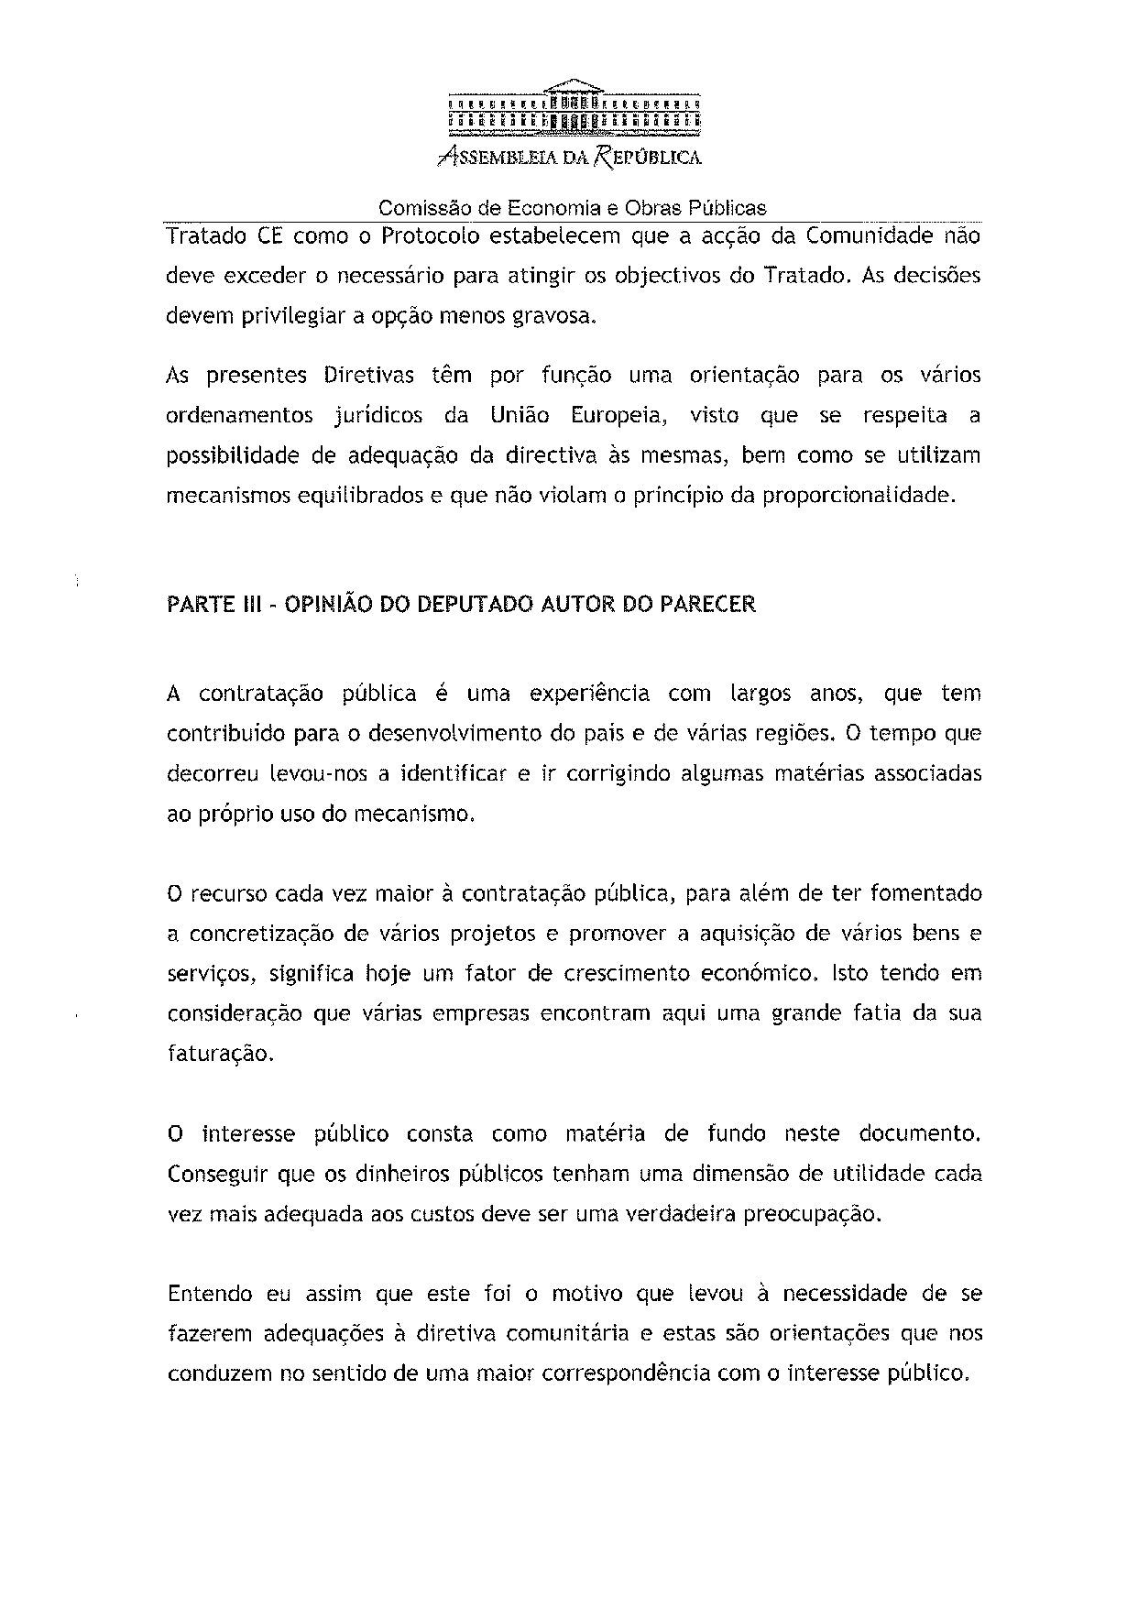
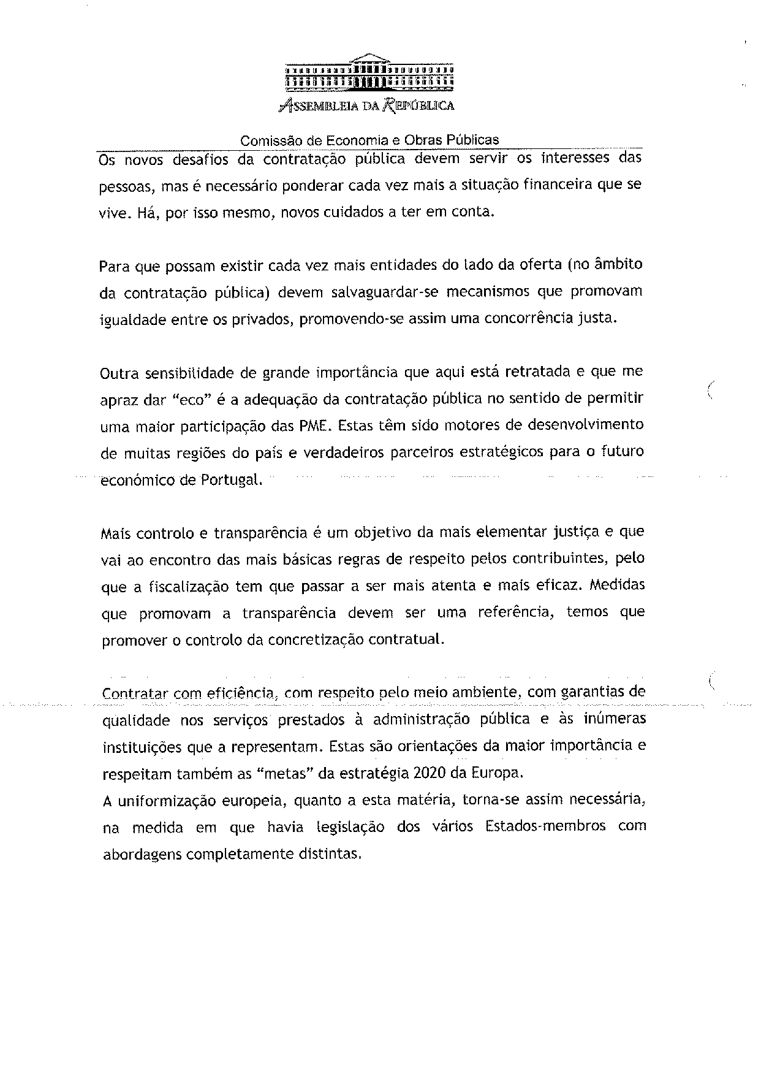
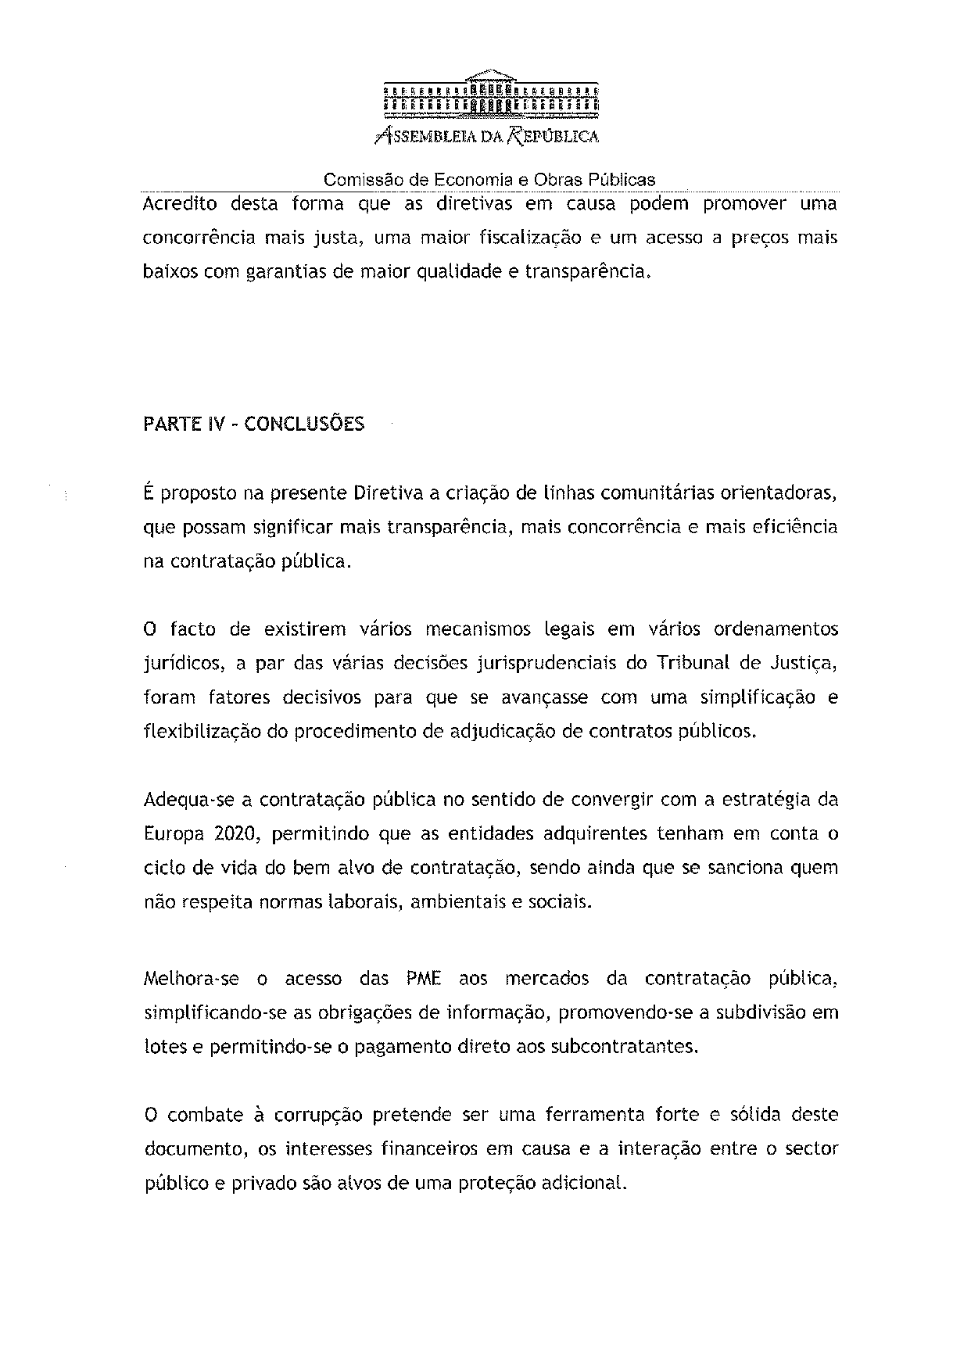
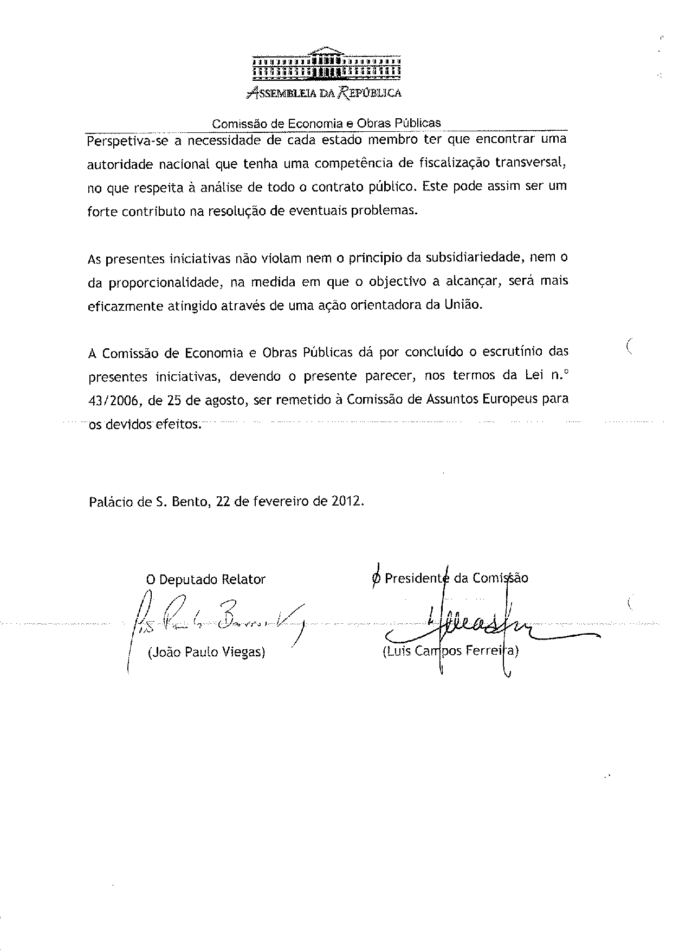
___________________

Translation may be available at the Interparliamentary EU information exchange site IPEX at the following address: http://www.ipex.eu/IPEXL-WEB/search.do.

