 | 
COUNCIL OF  THE EUROPEAN UNION |  |  | Brussels, 2 March 2012
 | Interinstitutional File:  2011/0439 (COD) |  | 7211/12
MAP 21
MI 147
CODEC 548
INST 172
PARLNAT 126

COVER NOTE
from: | Swedish Riksdag
date of receipt: | 1 March 2012
No. Cion doc. : | 18964/11 MAP 9 MI 685 + ADD 1 + ADD 2 - COM (2011) 895
Subject: | Proposal for a Directive of the European Parliament and of the Council on procurement by entities operating in the water, energy, transport and postal services sectors  - Reasoned Opinion on the application of the Principles of Subsidiarity and Proportionality

Delegations will find attached the Opinion of the Swedish Riksdag on the above proposal.

________________________

Encl.:
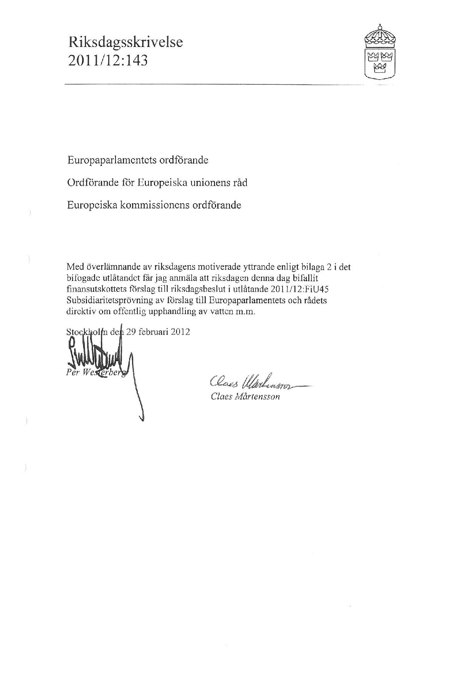
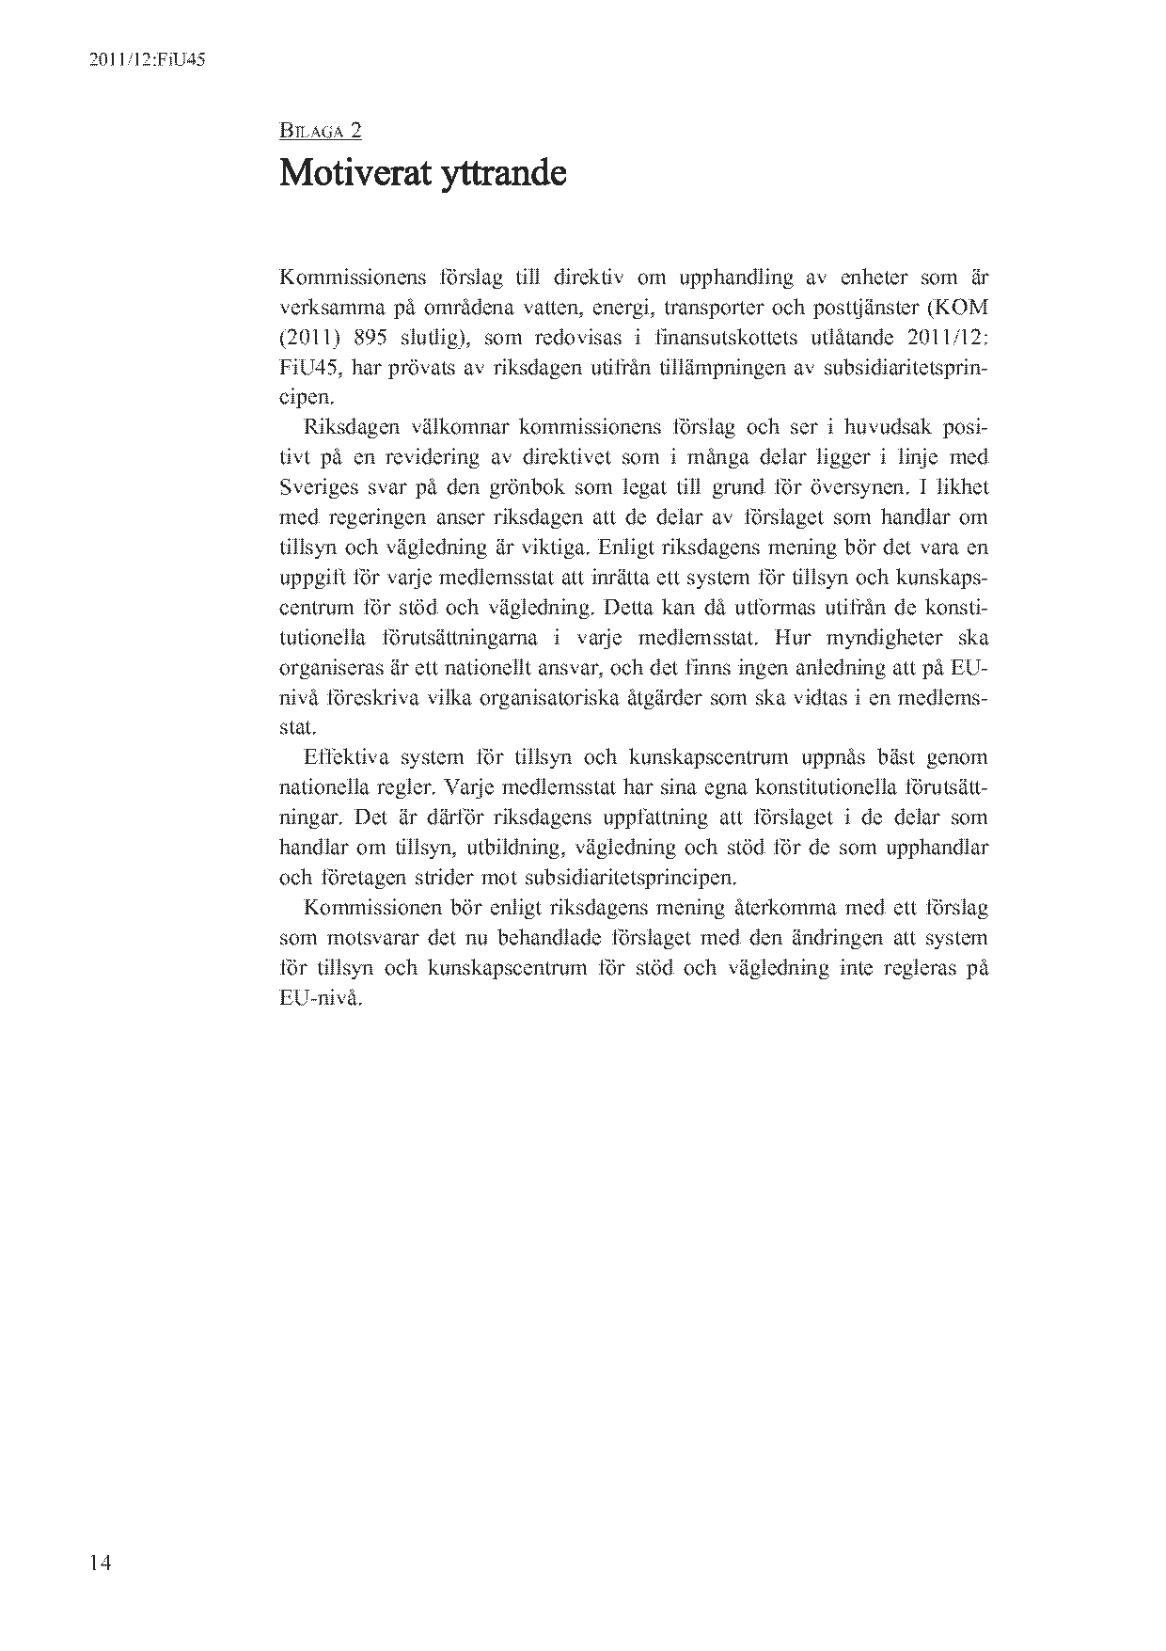

Translation may be available at the Interparliamentary EU information exchange site IPEX at the following address: http://www.ipex.eu/IPEXL-WEB/search.do.

